**CHAPTER 2 MESOPOTAMIA AND THE BRONZE AGE (6000–1200 BCE)**

**Type: multiple choice question**

**Title:** **Chapter** **02** **Question** **01**

1. Which of the following is not one of the early Mesopotamian cultures?

**Feedback:** **page** **reference:** (pp. 39–40)

a.The Halaf Culture

*b. The Jemdet Nasr Culture

c. The Hassuna Culture

d. The Samarra Culture

**Type: multiple response question**

**Title:** **Chapter** **02** **Question** **02**

2. Which of the following are features of the city of Uruk between 4000 and 2900 BCE?

**Feedback:** **page** **reference:** (p. 43)

a.Rudimentary but effective indoor plumbing

*b. The use of pictograms

*c. A centralized administration, perhaps overseen by a priest-king

*d. Long-distance commerce

**Type: multiple choice question**

**Title:** **Chapter** **02** **Question** **03**

3. By 2900 BCE _______ had as many as 50,000 inhabitants and was the largest city in the world.

**Feedback:** **page** **reference:** (p. 43)

*a. Uruk

b. Al-Ubaid

c. Samarra

d. Babylon

**Type: multiple response question**

**Title:** **Chapter** **02** **Question** **04**

4. The most representative Bronze Age cultures were defined by which of the following features?

**Feedback:** **page** **reference:** (p. 44)

*a. Large populations

*b. They were located in rich river valleys

*c. Extensive exploitation of agriculture

d. Written laws to prevent aristocratic abuses

**Type: multiple choice question**

**Title:** **Chapter** **02** **Question** **05**

5. The ancient Sumerians were ______, meaning that they believed in a multitude of gods.

**Feedback:** **page** **reference:** (p. 45)

a.sempiternal

*b. polytheistic

c. polyglot

d. deists

**Type: multiple response question**

**Title:** **Chapter** **02** **Question** **06**

6. Sumerian attempts to organize and control their world are reflected in which of the following practices?

**Feedback:** **page** **reference:** (pp. 47–48)

*a. Placing small statues of themselves in temples

b. Hymns sung at dawn and dusk by priest-king and his retinue

*c. Divination

*d. The use of magical charms to compel the gods to do their bidding

**Type: multiple choice question**

**Title:** **Chapter** **02** **Question** **07**

7. Which of the following best describes the Sumerian view of the afterlife?

**Feedback:** **page** **reference:** (p. 48)

a.A gathering in the sky, carrying out the will of An and Enlil

b. Essentially positive, but with eternal tortures reserved for some earthly crimes

c. A kind of purgatory, in which souls must be “cleansed” before being admitted to a paradisiacal realm

*d. Essentially negative, with souls weeping eternally as they eat clay and dust

**Type: multiple choice question**

**Title:** **Chapter** **02** **Question** **08**

8. The _______ preserves what Sumerians thought about their ancient history and also gives us an increasingly accurate record of who ruled Sumer and for how long.

**Feedback:** **page** **reference:** (p. 52)

a.Royal Record of Uruk

b. Damuzid Chronicle

*c. Sumerian King List

d. Royal Record of Zisudra

**Type: multiple response question**

**Title:** **Chapter** **02** **Question** **09**

9. The Sumerian system of weights, used for bartering commodities, employed which of the following designations?

**Feedback:** **page** **reference:** (p. 56)

*a. talent

*b. mina

*c. shekel

d. obol

**Type: multiple response question**

**Title:** **Chapter** **02** **Question** **10**

10. Sumerian slaves included which of the following categories of people?

**Feedback:** **page** **reference:** (pp. 57–58)

*a. War captives

*b. Condemned criminals

*c. Those who had been born as slaves

**d.** Aristocrats found guilty of any crime

**Type: multiple choice question**

**Title:** **Chapter** **02** **Question** **11**

11. Which ruler established the first Near Eastern empire?

**Feedback:** **page** **reference:** (p. 61)

a.Shar-Kalli-Sharri

b. Lugal-Ane

c. Gilgamesh

*d. Sargon

**Type: multiple choice question**

**Title:** **Chapter** **02** **Question** **12**

12. Who was Enheduanna?

**Feedback:** **page** **reference:** (p. 63)

*a. Daughter of Sargon, a priestess, and an important poet

b. The Sumerian queen of the Underworld

c. The first queen of Akkad

d. An Akkadian fertility goddess whom Naram-Sin credited with the success of his rule

**Type: multiple choice question**

**Title:** **Chapter** **02** **Question** **13**

13. The next powerful Akkadian ruler after Sargon was _______.

**Feedback:** **page** **reference:** (p. 61)

a.Ebla

*b. Naram-Sin

c. Enheduanna

d. Ilulu

**Type: multiple choice question**

**Title:** **Chapter** **02** **Question** **14**

14. The supreme god of the Babylonians is the storm god ______.

**Feedback:** **page** **reference:** (p. 66)

*a. Marduk

b. Enki

c. An

d. Tiamat

**Type: multiple choice question**

**Title:** **Chapter** **02** **Question** **15**

15. The most powerful and influential Babylonian ruler was _______.

**Feedback:** **page** **reference:** (p. 67)

a.Apsu

b. Hattusili I

c. Burnaburiash II

*d. Hammurabi

**Type: multiple choice question**

**Title:** **Chapter** **02** **Question** **16**

16. Which of the following was not one of the areas covered by the Code of Hammurabi?

**Feedback:** **page** **reference:** (p. 68)

a.Marital laws

b. Civil cases

*c. The succession of kings

d. Criminal cases

**Type: multiple choice question**

**Title:** **Chapter** **02** **Question** **17**

17. Which of the following established a powerful and sophisticated kingdom that they called the “land of the Hatti”?

**Feedback:** **page** **reference:** (p. 73)

a.The Hurrians

b. The Kassites

*c. The Hittites

d. The Egyptians

**Type: multiple choice question**

**Title:** **Chapter** **02** **Question** **18**

18. Which people ruled middle and lower Mesopotamia as the Bronze Age drew to a close around 1200 BCE?

**Feedback:** **page** **reference:** (p. 74)

*a. The Kassites

b. The Akkadians

c. The Hittites

d. The Aryans

**Type: multiple choice question**

**Title:** **Chapter** **02** **Question** **19**

19. Is the extent of the thirteenth-century BCE Kassite kingdom, as it is represented in this map, greater, lesser, or about the same as the extent of the Akkadian empire in the third millennium BCE?

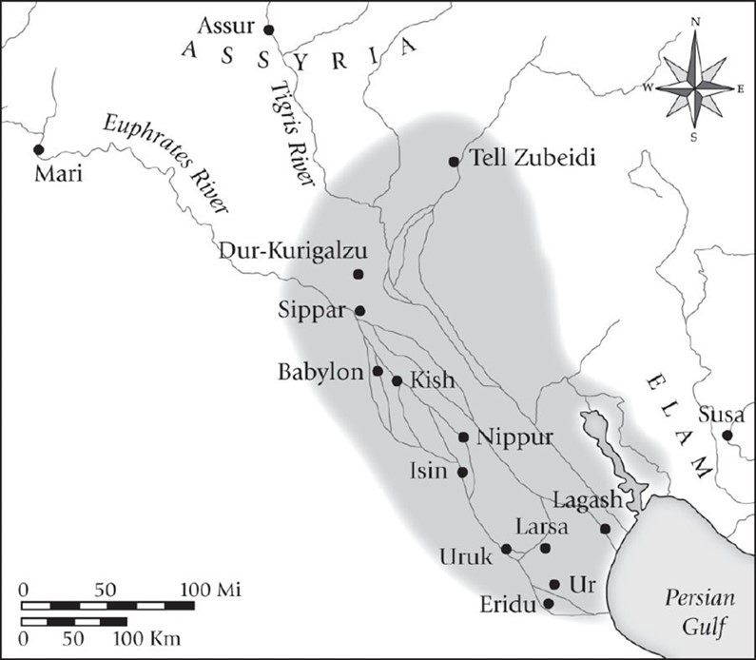

**Feedback:** **page** **reference:** (p. 64)

a.greater

*b. lesser

c. about the same

**Type: multiple choice question**

**Title:** **Chapter** **02** **Question** **20**

20. What is the name given to the script employed on this tablet?

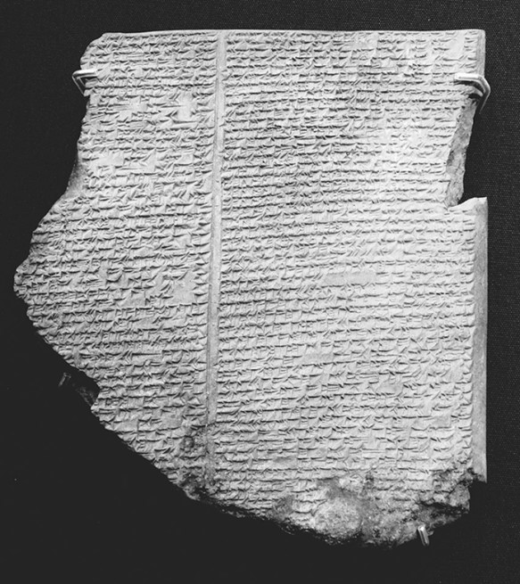

**Feedback:** **page** **reference:** (p. 50)

a.Hieroglyphs

b. Abjad

c. Proto-alphabetic

*d. Cuneiform