Student name:__________

**TRUE/FALSE - Write 'T' if the statement is true and 'F' if the statement is false.  
1)** Feeling for swollen lymph nodes is an example of auscultation.

⊚ true  
 ⊚ false

**2)** We can see through bones with magnetic resonance imaging (MRI).

⊚ true  
 ⊚ false

**3)** Histology is the study of structures that can be observed without a magnifying lens.

⊚ true  
 ⊚ false

**4)** Cells were first named by microscopist Robert Hooke.

⊚ true  
 ⊚ false

**5)** All functions of the body can be interpreted as the effects of cellular activity.

⊚ true  
 ⊚ false

**6)** The *hypothetico-deductive method* is common in physiology, whereas the *inductive* *method* is common in anatomy.

⊚ true  
 ⊚ false

**7)** An individual scientific fact has more information than a theory.

⊚ true  
 ⊚ false

**8)** Evolutionary (Darwinian) medicine traces some of our diseases to our evolutionary past.

⊚ true  
 ⊚ false

**9)** The terms *development* and *evolution* have the same meaning in physiology.

⊚ true  
 ⊚ false

**10)** Organs are made of tissues.

⊚ true  
 ⊚ false

**11)** A molecule of water is more complex than a mitochondrion (organelle).

⊚ true  
 ⊚ false

**12)** Homeostasis and occupying space are both unique characteristics of living things.

⊚ true  
 ⊚ false

**13)** Negative feedback is a self-amplifying chain of events that tends to produce rapid change in the body.

⊚ true  
 ⊚ false

**14)** Positive feedback helps to restore normal function when one of the body's physiological variables gets out of balance.

⊚ true  
 ⊚ false

**15)** Anatomists around the world adhere to a lexicon of standard international terms which stipulates both Latin names and accepted English equivalents.

⊚ true  
 ⊚ false

**16)** Lou Gehrig disease is the eponym for Amyotropic Lateral Sclerosis, made famous by the "ice bucket challege."

⊚ true  
 ⊚ false

**17)** Sometimes anatomical terms come from origins that do ***not*** lend any insight into their meaning.

⊚ true  
 ⊚ false

**MULTIPLE CHOICE - Choose the one alternative that best completes the statement or answers the question.  
18)** The study of normal body structures is called ___________.

A) physiology   
 B) anatomy  
 C) pathology  
 D) microscopy  
 E) biology

**19)** The study of how the body functions is called ___________.

A) neuroanatomy   
 B) anatomy  
 C) chemistry  
 D) histology  
 E) physiology

**20)** Feeling structures with your fingertips is called __________, whereas tapping on the body and listening for sounds of abnormalities is called __________.

A) palpation; auscultation   
 B) auscultation; percussion  
 C) percussion; auscultation  
 D) palpation; percussion  
 E) percussion; palpation

**21)** Which of these is the best imaging technique for routinely examining the anatomical development of a fetus?

A) Auscultation   
 B) PET scan  
 C) MRI  
 D) Sonography  
 E) Radiography

**22)** The study of the structure and function of cells is called __________.

A) cytology   
 B) gross anatomy  
 C) exploratory physiology  
 D) comparative physiology  
 E) radiology

**23)** Ultrastructure refers to the detailed structure to the level of the ___________.

A) molecule   
 B) cell  
 C) organelle  
 D) tissue  
 E) organ

**24)** The study of how hormones function is called ____________.

A) neuroanatomy   
 B) neurophysiology  
 C) endocrinology  
 D) histology  
 E) pathophysiology

**25)** The study of mechanism of disease is called __________.

A) neuroanatomy   
 B) neurophysiology  
 C) endocrinology  
 D) histology  
 E) pathophysiology

**26)** The terms  *physics, physiology,* and  *physician* come from a term __________ proposed to distinguish natural causes from supernatural causes.

A) Hippocrates   
 B) Plato  
 C) Schwann  
 D) Aristotle  
 E) Avicenna

**27)** Who was a physician to the Roman gladiators, learned by dissection of animals, and saw science as a method of discovery?

A) Hippocrates   
 B) Plato  
 C) Schwann  
 D) Aristotle  
 E) Galen

**28)** Knownas "the father of modern anatomy," __________ was the first to publish accurate drawings of the body.

A) Vesalius   
 B) Maimonides  
 C) Harvey  
 D) Aristotle  
 E) van Leeuwenhoek

**29)** The most influential medical textbook of the ancient era was written by __________.

A) Hippocrates   
 B) Aristotle  
 C) Galen  
 D) Vesalius  
 E) Avicenna

**30)** Who established a code of ethics for physicians and is considered the "father of medicine"?

A) Aristotle   
 B) Hippocrates  
 C) Galen  
 D) Vesalius  
 E) Hooke

**31)** What is the process of using numerous observations to develop general principles and predictions about a specific subject called?

A) Experimental design   
 B) The deductive method  
 C) The inductive method  
 D) A hypothesis  
 E) Statistical testing

**32)** Most people think that ulcers are caused by psychological stress. It was discovered that an acid-resistant bacterium, *Heliobacter pylori*, lives in the lining of the stomach. If these bacteria cause ulcers, then treatment with an antibiotic should reduce ulcers. This line of investigation is an example of __________.

A) hypothetical reasoning   
 B) hypothetico-deductive reasoning  
 C) the inductive method  
 D) experimental design  
 E) statistical analysis

**33)** The use of controls and statistical testing are two aspects of experimental design that help to ensure __________.

A) an adequate sample size   
 B) objective and reliable results  
 C) experimental bias  
 D) psychosomatic effects  
 E) treatment groups

**34)** Which process submits a scientist's ideas to the critical judgment of other specialists in the field before the research is funded or published?

A) Adjudication   
 B) Statistical testing  
 C) Falsification  
 D) Peer review  
 E) Hypothetico-deductive testing

**35)** A new drug apparently increases short-term memory. Students were divided randomly into two groups at the beginning of the semester. One group was given the memory pill once a day for the semester, and the other group was given a same-looking pill, but it was just sugar. The sugar pill is termed a(n) __________.

A) controlled pill   
 B) placebo  
 C) treatment pill  
 D) variable  
 E) effective dose

**36)** Two groups of people were tested to determine whether garlic lowers blood cholesterol levels. One group was given 800 mg of garlic powder daily for four months and exhibited an average 12% reduction in the blood cholesterol. The other group was not given any garlic and after four months averaged a 3% reduction in cholesterol. The group that was not given the garlic was the __________ group.

A) peer   
 B) test  
 C) treatment  
 D) control  
 E) double-blind

**37)** An educated speculation or a possible answer to a question is called a(n) __________.

A) scientific method   
 B) theory  
 C) law  
 D) hypothesis  
 E) fact

**38)** Which of the following would contain the greatest amount of information that scientists consider to be true to the best of their knowledge?

A) A fact   
 B) A law of nature  
 C) A hypothesis  
 D) An equation  
 E) A theory

**39)** If a species of animal evolves over generations to grow a large fan-blade like growth on its back to catch the wind and cool its body, this would be an example of responding to __________.

A) selection pressure   
 B) adaptation  
 C) natural selection  
 D) climate change  
 E) positive feedback

**40)** What is a change in the genetic composition of a population over time called?

A) Mutation   
 B) Natural selection  
 C) Selection pressure  
 D) Evolution  
 E) Adaptation

**41)** The constant appearance of new strains of influenza virus is an example of __________.

A) a model   
 B) evolution  
 C) selection pressure  
 D) survivorship  
 E) success

**42)** What is the principal theory of how evolution works?

A) Natural pressure   
 B) Selective pressure  
 C) Darwinian pressure  
 D) Natural adaptation  
 E) Natural selection

**43)** Stereoscopic vision provides __________.

A) opposable perception   
 B) color perception  
 C) depth perception  
 D) bipedalism  
 E) opposition of thumbs

**44)** Most primates are __________, meaning they live in trees.

A) prehensile   
 B) bipedal  
 C) cursorial  
 D) troglodytic  
 E) arboreal

**45)** Which of the following was an adaptation thatevolved in connection with human upright walking?

A) Hair   
 B) Fully opposable thumbs  
 C) Stereoscopic vision  
 D) Color vision  
 E) Spinal and pelvic anatomy

**46)** A human isborn before his/her nervous system has matured. This is traceable to __________.

A) their inability to regulate body temperature   
 B) skeletal adaptations to bipedalism  
 C) the arboreal habits of early primates  
 D) the conditions of modern civilization  
 E) the diet of early species of Homo

**47)** What is the species of modern humans?

A) *Homo erectus*   
 B) *Homo sapiens*  
 C) *Homo habilis*  
 D) *Neanderthal*  
 E) *Australopithecus*

**48)** An __________ is composed of two or more tissues types, whereas __________ are microscopic structures in a cell.

A) organ system; organs   
 B) organ system; organelles  
 C) organ; organelles  
 D) organ; molecules  
 E) organelle;molecules

**49)** Which of the following lists levels of human structure from the *most complex to the simplest*?

A) Organelle, cell, tissue, organ, organ system   
 B) Organ system, organ, cell, tissue, organelle  
 C) Organ system, organelle, tissue, cell, organ  
 D) Organ system, organ, tissue, cell, organelle  
 E) Organ, organ system, tissue, cell, organelle

**50)** Which of the followinglists examples of body structures from the *simplest to the most complex*?

A) Mitochondrion, connective tissue, protein, stomach, adipocyte (fat cell)   
 B) Protein, mitochondrion, adipocyte (fat cell), connective tissue, stomach  
 C) Mitochondrion, connective tissue, stomach, protein, adipocyte (fat cell)  
 D) Protein, adipocyte (fat cell), stomach, connective tissue, mitochondrion  
 E) Protein, stomach, connective tissue, adipocyte (fat cell), mitochondrion

**51)** A(n) __________ is a group of similar cells and their intercellular materials in a discrete region of an organ performing a specific function.

A) macromolecule   
 B) organ system  
 C) organelle  
 D) organism  
 E) tissue

**52)** All of the following are human organ systems *except __________.*

A) skeletal   
 B) endocrine  
 C) epidermal  
 D) reproductive  
 E) lymphatic

**53)** All of the following are organs *except __________.*

A) teeth   
 B) the skin  
 C) nails  
 D) the liver  
 E) the digestive system

**54)** Taking apart a clock to see how it works is similar to __________ thinking about human physiology.

A) comparative   
 B) evolutionary  
 C) holistic  
 D) inductive  
 E) reductionist

**55)** Which of the following approaches understanding the human body by studying the interactions of its parts?

A) Naturalism   
 B) Reductionism  
 C) Vitalism  
 D) Holism  
 E) Rationalism

**56)** What is the view that not everything about an organism can be understood or predicted from the knowledge of its components; that is, the whole is greater than the sum of its parts?

A) Naturalism   
 B) Reductionism  
 C) Holism  
 D) Materialism  
 E) Science

**57)** The fact that most of us have five lumbar vertebrae, but some people have six and some have four, is an example of what type of variation among organisms?

A) Cellular   
 B) Holistic  
 C) Physiological  
 D) Anatomical  
 E) Reductionist

**58)** Why does a surgeon need to be familiar with different versions of anatomy?

A) Cellular adaptation   
 B) Holistic medicine  
 C) Physiological variation  
 D) Anatomical variation  
 E) Evolutionary adaptation

**59)** What are the simplest body structures considered alive?

A) Organ systems   
 B) Organs  
 C) Cells  
 D) Organelles  
 E) Molecules

**60)** Metabolism is the sum of all __________ change.

A) external physical   
 B) external chemical  
 C) internal chemical  
 D) internal physical  
 E) internal integrative

**61)** The change in size of the bone marrow (where blood cells are produced) as an infant matures is an example of __________, whereas the transformation of blood stem cells into white blood cells is an example of __________.

A) development; differentiation   
 B) growth; development  
 C) growth; differentiation  
 D) differentiation; growth  
 E) differentiation; development

**62)** A hemoglobin level of 12g/dL is normal for an adult female, but low for an adult male. What is this is an example of?

A) Cellular adaptation   
 B) Holistic medicine  
 C) Physiological variation  
 D) Anatomical variation  
 E) Structural differentiation

**63)** Which of the following is *not* an aspectthat could result in physiological variation?

A) Age   
 B) Gender  
 C) Environment  
 D) Physical activity  
 E) These are all aspects that can cause physiological variation.

**64)** We live in an ever-changing environment outside of our body, yet our internal conditions remain relatively stable. This is called __________.

A) homeostasis   
 B) metastasis  
 C) responsiveness  
 D) adaptation  
 E) evolution

**65)** What are the three common components of a feedback loop?

A) Stimulus, integrating (control) center, and organ system   
 B) Stimulus, receptor, and integrating (control) center  
 C) Receptor, integrating (control) center, and effector  
 D) Receptor, organ, and organ system  
 E) Receptor, integrating (control) center, and organ system

**66)** During exercise, one generates excess heat and the body temperature rises. As a response, blood vessels dilate in the skin, warm blood flows closer to the body surface, and heat is lost. This is an example of__________.

A) negative feedback   
 B) positive feedback  
 C) dynamic equilibrium  
 D) integration control  
 E) set point adjustment

**67)** Blood glucose concentration rises after a meal and stimulates the pancreas to release the hormone insulin. Insulin travels in the blood and stimulates the uptake ofglucose by body cells from the bloodstream, thusreducing blood glucose concentration. This is an example of _________.

A) negative feedback   
 B) positive feedback  
 C) dynamic equilibrium  
 D) integration control  
 E) set point adjustment

**68)** Negative feedback loops are __________.

A) homeostatic mechanisms   
 B) not homeostatic mechanisms  
 C) associated with "vicious circles"  
 D) self-amplifying cycles  
 E) usually harmful

**69)** When a woman is giving birth, the head of the baby pushes against her cervix and stimulates therelease of the hormone oxytocin. Oxytocin travels in the blood and stimulates the uterus to contract. Labor contractions become more and more intense until the baby is expelled. This is an example of __________.

A) negative feedback   
 B) positive feedback  
 C) dynamic equilibrium  
 D) integration control  
 E) set point adjustment

**70)** Which of the following is *most likely* to cause disease?

A) Positive feedback   
 B) Negative feedback  
 C) Homeostasis  
 D) Equilibrium  
 E) Irritability

**71)** A physiological __________ is a difference in chemical concentration, electrical charge, physical pressure, temperature, or other variables between one point and another.

A) gradient   
 B) barrier  
 C) membrane  
 D) imbalance  
 E) feedback loop

**72)** Chemicals in a solution can move down a concentration gradient. This means the chemical will move from the area of__________ concentrationto the area of_________ concentration.

A) higher; lower   
 B) lower; higher  
 C) equal; equal  
 D) lower; lower  
 E) higher; higher

**73)** Which of the following is *not* an example of a physiological gradient?

A) Tissue   
 B) Thermal  
 C) Concentration  
 D) Pressure  
 E) Electrical

**74)** What type of gradient causes the movement of ions due to *both charge and concentration* differences?

A) Electrochemical gradient   
 B) Thermal gradient  
 C) Concentration gradient  
 D) Pressure gradient  
 E) Osmotic gradient

**75)** Modern anatomical language is based on what two languages because individuals speaking these languages made most of the early anatomical discoveries?

A) Greek and Latin   
 B) English and Japanese  
 C) English and Spanish  
 D) Roman and Latin  
 E) Latin and Chinese

**76)** The term *fallopian* tube (uterine tube) is an example of __________.

A) a Latin root used in medical terminology   
 B) the use of prefixes to name an anatomical structure  
 C) the use of suffixes to name an anatomical structure  
 D) an eponym  
 E) an acronym

**77)** The lexicon of standard international anatomical terms is __________.

A) called *Terminologia Anatomica* (TA)   
 B) called *Nomina Anatomica* (NA)  
 C) formed from thousands of English word roots  
 D) formed from thousands of Italian word roots  
 E) formed from thousands of French word roots

**78)** The prefix *hypo-* means __________, whereas *hyper-* means __________.

A) front; back   
 B) right; left  
 C) inside; outside  
 D) clear; dark  
 E) below; above

**79)** What does "hypercalcemia" mean?

A) Elevated calcium levels   
 B) Lowered calcium levels  
 C) Elevated sodium levels  
 D) Lowered sodium levels  
 E) Elevated potassium levels

**80)** DNA is an example of an __________, whereas PET scan is an example of an __________.

A) abbreviation; acronym   
 B) acronym; abbreviation  
 C) eponym; acronym  
 D) acronym; eponym  
 E) eponym; abbreviation

**81)** The plural of axilla (armpit) is __________, whereas the plural of appendix is __________.

A) axillae; appendices   
 B) axillides; appendages  
 C) axillies; appendi  
 D) axilli; appendices  
 E) axilles; appendices

**82)** The plural of villus (hair) is __________, whereas the plural of diagnosis is __________.

A) villuses; diagnosises   
 B) villi; diagnoses  
 C) villus; diagnosis  
 D) villi; diagnosis  
 E) villuses; diagnosis

**83)** Why is precise spelling important in anatomy?

A) It is important to practice language skills.   
 B) There are many different ways to spell certain terms.  
 C) Eponyms are difficult to memorize.  
 D) There are many similar terms in anatomy that refer to different structures.  
 E) It is easier to remember acronyms when spelled correctly.

**84)** The ileum is __________, whereasthe ilium is ____________.

A) part of the hip bone; part of the small intestine   
 B) part of the small intestine; part of the hip bone  
 C) a bone in the wrist; a muscle of the back  
 D) a muscle; a bone  
 E) a bone; a muscle

**85)** What is the name of the highlighted organ?   
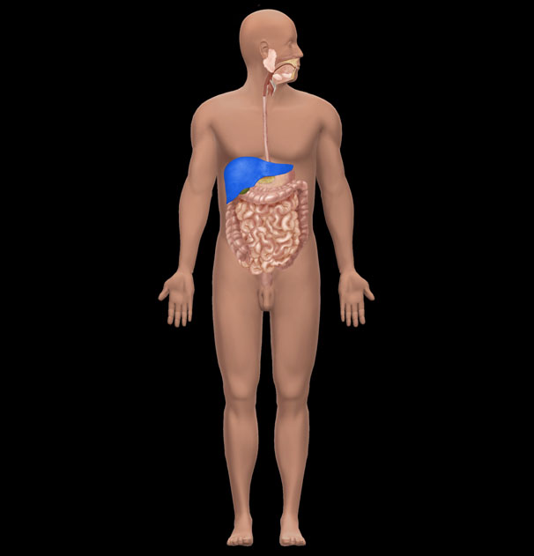

A) Small intestine   
 B) Stomach  
 C) Liver  
 D) Large intestine  
 E) Spleen

**86)** What is the name of the highlighted organ?   
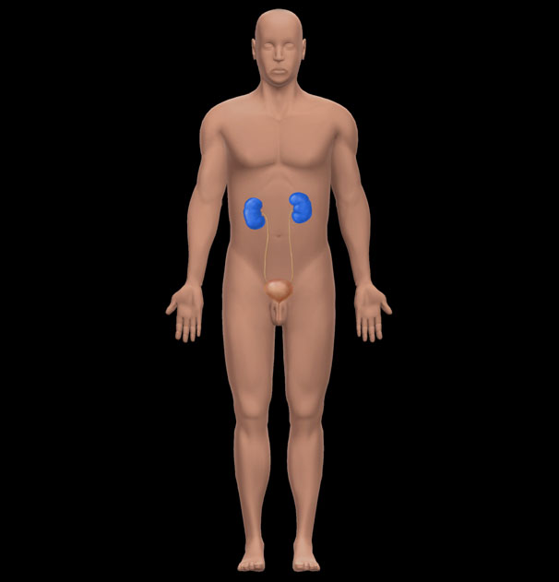

A) Adrenal gland   
 B) Spleen  
 C) Liver  
 D) Kidney  
 E) Pancreas

**SECTION BREAK. Answer all the part questions.  
87)** 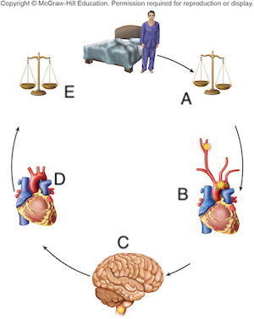

**87.1)** Which letter represents the *receptor* of this feedback loop?

A) A   
 B) B  
 C) C  
 D) D  
 E) E

**87.2)** Which letter represents the *effector*of this feedback loop?

A) A   
 B) B  
 C) C  
 D) D  
 E) E

**87.3)** Where in this feedback loop is homeostasis present?

A) A   
 B) B  
 C) C  
 D) D  
 E) E

**87.4)** This feedback loop is an example of which of the following?

A) Negative feedback   
 B) Positive feedback  
 C) Dynamic equilibrium  
 D) Thermal gradient  
 E) Natural selection

**88)** 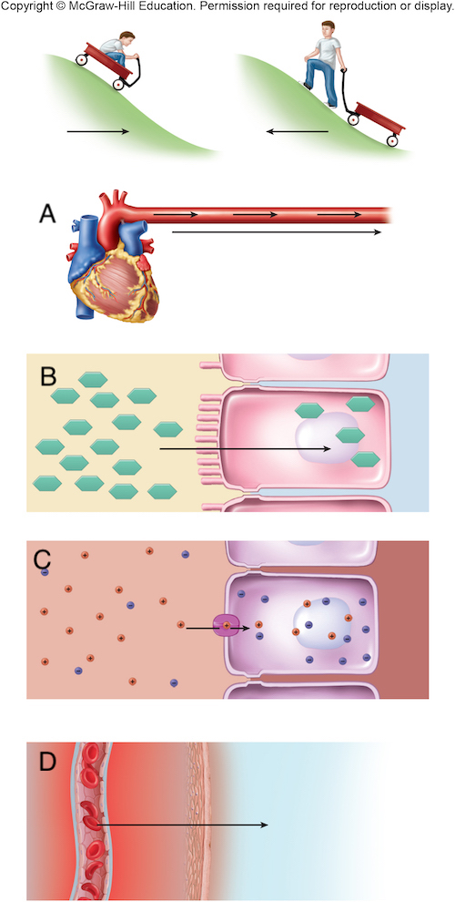

**88.1)** Which letter represents a *pressure*gradient?

A) A   
 B) B  
 C) C  
 D) D  
 E) All of these represent a pressure gradient.

**88.2)** Which letter represents a *thermal*gradient?

A) A   
 B) B  
 C) C  
 D) D  
 E) All of these represent a thermal gradient.

**88.3)** Glucose would move down which of these gradients?

A) A   
 B) B  
 C) C  
 D) D  
 E) Glucose can move via all of these mechanisms.

**88.4)** Ions would move down which of these gradients?

A) A   
 B) B  
 C) C  
 D) D  
 E) Ions can move via all of these mechanisms.

**89)** 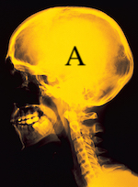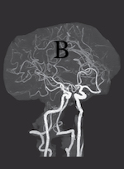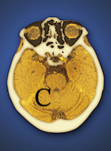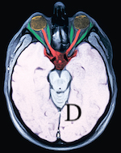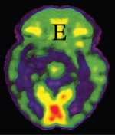a: U.H.B. Trust/The Image Bank/Getty Images; b: pang_oasis/Shutterstock; c: Miriam Maslo/Science  
 Source; d: UHB Trust/Getty Images; e: ISM/Sovereign/Medical Images

**89.1)** Which image is produced using an X-ray?

A) A   
 B) B  
 C) C  
 D) D  
 E) E

**89.2)** Which image is produced using Computed Tomography?

A) A   
 B) B  
 C) C  
 D) D  
 E) E

**89.3)** Which image is produced using Magnetic Resonance Imaging?

A) A   
 B) B  
 C) C  
 D) D  
 E) E

**89.4)** Which imaging technique would be used to determine the location of a blocked artery?

A) A   
 B) B  
 C) C  
 D) D  
 E) E

**89.5)** Which imaging technique would be used to determine the metabolically active areas of the brain?

A) A   
 B) B  
 C) C  
 D) D  
 E) E

**90)** 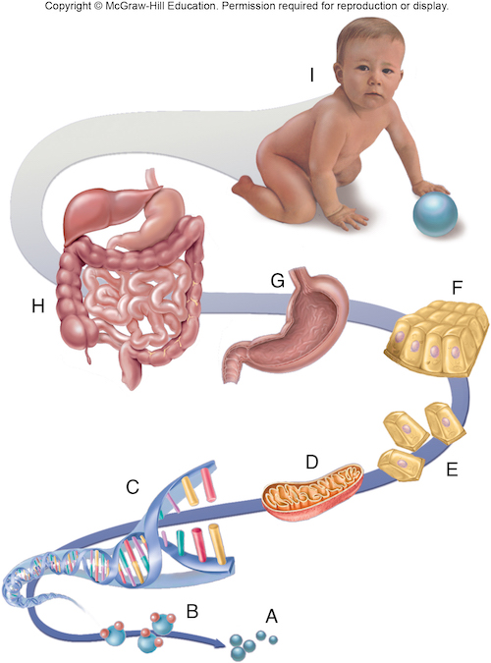

**90.1)** What level of structural hierarchy is represented by the letter E?

A) Organelle   
 B) Cell  
 C) Tissue  
 D) Organ  
 E) Molecule

**90.2)** What level of structural hierarchy is represented by the letter H?

A) Organ system   
 B) Cell  
 C) Tissue  
 D) Organ  
 E) Molecule

**90.3)** What is the study of the structure at E called?

A) Cytology   
 B) Histology  
 C) Physiology  
 D) Organismal biology  
 E) Pathology

**90.4)** What is the study of the structure at F called?

A) Cytology   
 B) Histology  
 C) Physiology  
 D) Organismal biology  
 E) Pathology

**90.5)** The integumentary system is an example of which level of structural hierarchy?

A) A   
 B) C  
 C) E  
 D) H  
 E) I

**90.6)** A lymph node is an example of which level of structural hierarchy?

A) G   
 B) C  
 C) E  
 D) H  
 E) I

**90.7)** A ribosome is an example of which level of structural hierarchy?

A) A   
 B) C  
 C) E  
 D) H  
 E) D

**91)** 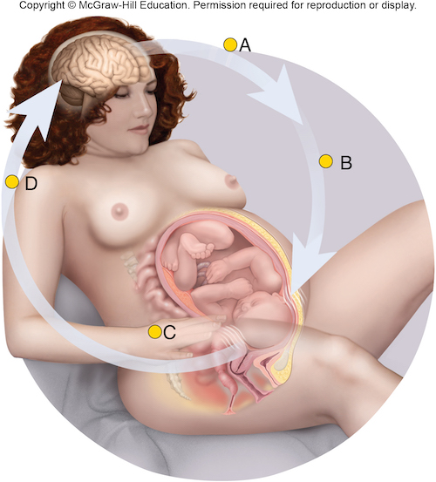

**91.1)** This is an example of which of the following?

A) Positive feedback   
 B) Negative feedback  
 C) Dynamic equilibrium  
 D) Adaptation  
 E) Natural selection

**91.2)** In this feedback loop, what is the receptor?

A) Brain   
 B) Oxytocin  
 C) Uterus  
 D) Ovaries  
 E) Adrenal gland

**91.3)** In this feedback loop, what is the effector?

A) Cervix   
 B) Brain  
 C) Oxytocin  
 D) Uterine muscles  
 E) Ovaries

**Answer Key**Test name: Chapter 01: Major Themes of Anatomy and Physiology

1) FALSE

2) TRUE

3) FALSE

4) TRUE

5) TRUE

6) TRUE

7) FALSE

8) TRUE

9) FALSE

10) TRUE

11) FALSE

12) FALSE

13) FALSE

14) FALSE

15) TRUE

16) TRUE

17) TRUE

18) B

19) E

20) D

21) D

22) A

23) A

24) C

25) E

26) D

27) E

28) A

29) C

30) B

31) C

32) B

33) B

34) D

35) B

36) D

37) D

38) E

39) A

40) D

41) B

42) E

43) C

44) E

45) E

46) B

47) B

48) C

49) D

50) B

51) E

52) C

53) E

54) E

55) B

56) C

57) D

58) D

59) C

60) C

61) C

62) C

63) E

64) A

65) C

66) A

67) A

68) A

69) B

70) A

71) A

72) A

73) A

74) A

75) A

76) D

77) A

78) E

79) A

80) A

81) A

82) B

83) D

84) B

85) C

86) D

87) Section Break

87.1) B

87.2) D

87.3) E

87.4) A

88) Section Break

88.1) A

88.2) D

88.3) B

88.4) C

89) Section Break

89.1) A

89.2) C

89.3) D

89.4) B

89.5) E

90) Section Break

90.1) B

90.2) A

90.3) A

90.4) B

90.5) D

90.6) A

90.7) E

91) Section Break

91.1) A

91.2) A

91.3) D