1. How were Spanish, French, and Dutch colonial strategies similar? How did they differ? In what ways were the similarities and differences reflected in the nations’ settlements in the New World?

ANSWER: | Answer would ideally include the following. Spanish Colonial Strategies and Settlements- Spain’s conquest of the Aztec and Inca empires shaped its approach to settlement in the New World. Spanish colonizers used the existing systems of tribute and labor discipline by granting encomiendas to the leading conquistadors. These leaders co-opted the indigenous mita system to coerce Indian laborers to serve Spain. Consequently, the gold and silver wealth of the Inca and Aztec societies poured into Spanish coffers. Spanish monarchs and conquistadors also transferred their institutions—municipal councils, legal codes, the Catholic Church—to the New World in order to control the people and territory there. The arrival of Spanish men and Africans created a new society in which racial mixture was common, and a system of complex racial categories developed. Spanish priests suppressed indigenous religious ceremonies and converted natives to Christianity. French Colonial Strategies and Settlements- The French focused on fur trading and Catholic missionary activity among the native population. Although New France became a center for fur trading and missionary work, it languished as a settlement until 1662, when King Louis XIV made it a royal colony and subsidized the migration of indentured servants, who were required to labor for three years in exchange for a salary. The population remained small, but New France’s possessions were expansive. New Orleans and settlements around the Great Lakes ultimately served as home to French merchants, soldiers, and missionaries who traded with and sometimes intermarried with Indians. Dutch Colonial Strategies and Settlements- Dutch settlement focused on New Netherland (now New York) and New Amsterdam (now Manhattan). The colony did not thrive, however, because its population was too small. Much of the territory was granted as large estates along the Hudson River, but these did not attract Dutch settlers. New Netherland flourished as a fur-trading enterprise. Conflicts with Indians in the seventeenth century ultimately led the Dutch to focus more on sugar plantations in Brazil. Similarities- All acquired new territories for nation, monarch, personal fortune, and Christianity. They justified takeovers in religious and economic terms. They traded with the native populations of the Americas. For all groups, colonization was a process of experimentation and adaptation that required political, social, and cultural innovations. The processes of transformation led to external and internal crises in each region. Differences- The Spanish and Dutch emphasized conquest, though the Dutch arrived as traders rather than mercenaries like the conquistadores. The French and Spanish used missions and religion as tools for colonizing native populations and acquiring resources. The Spanish and French utilized Indians as social agents of colonization, while the Dutch were interested only in trade with Indians. The Dutch created a small, commercially based colony compared to much larger territorial units controlled by Spain and France.

2. Explain why there were no major witchcraft scares in the Chesapeake colonies and no uprising like Bacon’s Rebellion in New England. Consider the possible social, economic, and religious causes of both phenomena.

ANSWER: | Answer would ideally include the following. Witchcraft- There were no witchcraft scares in the Chesapeake colonies mainly because of the lack of strong family formation, the development of towns and cities, and the absence of powerful and influential religious institutions. A high death rate and a lower population of women led to a male-oriented and orphan colony based more on secular economic pursuits than religious motivations. Without the focus on religion, which motivated New England’s witchcraft scares, conflict and dissent took other forms. Uprisings- No uprisings like Bacon’s Rebellion occurred in New England mainly because of the stable nature of family formation there, as well as a healthier climate and the existence of enough land for sons and daughters to maintain their independence. In Virginia, due to the surplus of landless laborers and indentured servants, land was scarcer and could not provide prosperity to the lower classes, leading to rebellion. The strong control of the Puritan church and the imposition of hierarchical control by local church authorities over towns and congregations met with relative acceptance by the Puritan population as part of the patriarchal family model of obedience; hence there were no widespread revolts.

3. What factors account for the success of the Puritans in establishing an ordered society in New England?

ANSWER: | Answer would ideally include the following. Environment and Geography- The cold climate of New England discouraged mosquitoes and the diseases they carried. Puritans successfully subdued local Indians, who might have posed an external threat. Religion- A spiritual mission empowered the Puritans to establish a structured church and a strong moral order that emphasized an organized and orderly society in which class differences, though present, were less apparent than in other settlements. Religion was the important motivation for migration and settlement; lack of focus on money making limited competition and conflict. When Puritan theology became too demanding, the Puritans changed the rules and regulations to enable a larger number of people to be church members. Social Organization- The Puritans were a homogenous group, which reduced the likelihood of serious tension and conflict. The Massachusetts Bay Company was a joint-stock corporation but was transformed into a representative political system with a governor, council, and assembly. When dissent arose, they banished the dissenters. Roger Williams and Anne Hutchinson were the two most prominent dissenters. Colonists arrived in family and community groups and the system of land division generally worked against stratification in landholding and social power.

4. What were the major social and environmental developments that made America a new world for both Europeans and Indians?

ANSWER: | Answer would ideally include the following. Disease- Outbreaks of European diseases, such as smallpox, measles, and influenza, diminished the Indian population and the ability of Indians to resist territorial takeover. At the same time, Europeans in the Chesapeake regions were exposed to mosquito-borne illnesses that were new for them and killed large numbers of settlers. Christianity- The influence of Christian churches made the Americas different for Native Americans. Europeans’ efforts to convert Indians to Catholicism in New France and New Spain provided important justifications for their exploitation. Yet Indians also transformed Christianity by infusing it with some of their own beliefs and traditions. Uniquely American forms of Christianity were different for both Native Americans and Europeans. Environment- Europeans confronted an environment that was totally new for them. Many of its plants and animals and all of its people were different from those of Europe. They adapted to new forms of food, such as maize and potatoes. For those Europeans who settled in tropical and subtropical regions, the climate was entirely new, and they adapted plantation agriculture to create their economic foundation. Indians also experienced new European dietary customs. The European fur trade decreased the populations of many fur-bearing animals in North America. Simultaneously, Europeans introduced new species, such as horses, to the Americas and altered elements of Native Americans’ lives. Slavery- The institution of slavery was new for many Europeans and Native Americans. In South America and Central America, the old tribute system was adapted to provide coerced labor for the Spanish. In the Chesapeake, black slavery was introduced to the English, who had not made use of it in England. Its introduction in North America created a new form of society for Native Americans, English settlers, and African slaves.

5. What were the factors that spurred people to leave England for the American colonies in the seventeenth century? Which factors influenced their decisions about where to settle in the British North American colonies?

ANSWER: | Answer would ideally include the following. Economic Motivations- Merchants took charge of English expansion in the early seventeenth century. The Virginia Company, hoping to emulate the Spanish example, sent a group to Jamestown. Many of these settlers hoped to make a quick profit. Once the region became a successful tobacco plantation colony, it attracted many more settlers who came to better their economic circumstances. The Virginia Company’s policy of allowing settlers to own land gave 100 acres to every freeman who could afford the journey and more to those who imported servants. Those who could not afford the journey came as indentured servants who worked the plantations. They also did so because they hoped to achieve greater economic security. Economic motivations were central for English citizens who settled in the Chesapeake and the Caribbean islands, where tobacco cultivation was successful. After New Netherland fell to English control in the 1660s, Englishmen seeking economic opportunity also settled in New York. Religious Motivations- English Catholics left their home country after the English Reformation in order to escape religious persecution. They settled in Maryland. English Pilgrims and Puritans who were critical of the Church of England left their home country to seek religious freedom in Plymouth and Massachusetts Bay, and later in other New England colonies. The Pilgrims sought to separate themselves from England. The Puritans sought to create a godly society that would serve as a model for other Anglicans. The stability of New England society and the land available in the region eventually drew other settlers as well. Adventurism- Early seventeenth-century settlements also attracted adventurers. Many of the men who came to Jamestown initially came for neither economic nor religious reasons but to make a quick profit from valuable commodities such as those in the Spanish colonies. These young men were sorely disappointed to find no gold, and the men fared poorly in their new environment.

6. Why did the Five Nations of the Iroquois unite? What were the goals of the confederation? How successful were the Iroquois in achieving those goals?

ANSWER: | Answer would ideally include the following. Reasons for Unity- Disease epidemics brought by the Europeans reduced tribal populations and the number of tribes in northeastern North America, forcing Indian refugees to migrate and reconfigure communities along new tribal lines. Goals- Fur-trade rivalries created by Europeans’ arrival necessitated unification for economic security through control of the fur trade and physical survival during times of incessant warfare. Analysis of Success- Iroquois’ location in central New York allowed them to dominate the region between the French and the Dutch colonies. Those who survived the conflicts with the French in the 1660s forged an alliance with the English and remained a dominant force in Northeast politics for generations afterward.

7. What were the characteristics of the population of Virginia in the seventeenth century and what accounted for them?

ANSWER: | Answer would ideally include the following. Characteristics of Virginia in 1600s- The major characteristics of Virginia society in the seventeenth century were the high death rate caused by malaria and contaminated water, and an economy based completely on tobacco cultivation due to the profitability of the crop and its control by English aristocracy. Other factors also inhibited population growth: lack of women meant that most men never married; there was a high rate of death among pregnant women; the number of children per family was low because of a high infant death rate; and families were often disrupted by the early death of both parents, resulting in many orphans throughout the communities. Survivors and their servants established and maintained a monocrop economy based on the cultivation and sale of tobacco. To attract more settlers, the Virginia Company allowed individuals to own land and created a system of representative government. The House of Burgesses passed laws and levied taxes and, by 1622, there was a judicial system based on English law.

8. What were the various systems of forced labor that took hold in the Chesapeake colonies?

ANSWER: | Answer would ideally include the following. Indentured Servitude- Poor English young men and women signed labor contracts in England to work for four or five years in exchange for passage and room and board in North America. The individuals were free upon completion of their contracts but were considered bound laborers with few rights under their indenture. Indentures were needed for immigrants to afford their transatlantic journey. Plantation agriculture required a substantial labor force, and tobacco cultivation occupied most of their miserable time. Black Chattel Slavery- Beginning in 1619, African laborers were imported to the Chesapeake. Some worked as servants for life, while others served labor contracts like white indentured servants. A few became freeholders and even bought other African slaves. Over time, white Virginia leaders used the legal system to take rights away from African workers, making them slaves, or chattel, for life.

9. Compare the Indian uprising in Virginia in 1622 with Bacon’s Rebellion in 1675. What were the consequences of each for Virginia’s economic and social development?

ANSWER: | Answer would ideally include the following. 1622 Uprising- The 1622 Indian uprising reduced the population of the colony by one-third and resulted in great property loss. It accelerated English invasion and territorial control by increasing English militancy and land-taking as a strategy to defeat Indians in a “just war.” Bacon’s Rebellion- The 1675 rebellion motivated landed planters to allow a political role for yeoman in the colony and to cut taxes of the yeomanry, and supported expansion of settlement onto Indian lands to provide more land for landless laborers. Planters also turned away from indentured servitude for fear of more uprisings as tobacco cultivation increased. They expanded black chattel slavery, making the Chesapeake a major source of slavery until the Civil War.

10. What were Puritans’ grievances against the Church of England? What beliefs made the Puritans different?

ANSWER: | Answer would ideally include the following. Puritan Grievances- A main problem was the corruption of the Catholic Church in the form of immorality and ostentatious display of wealth. The Puritans accepted the theology of John Calvin, believing that God saved only a few chosen people and that it was not possible to earn or buy salvation. They envisioned a reformed Christian society with “authority in magistrates, liberty in people, and Purity in the church.” Through their own lives, they hoped to inspire religious reform throughout Christendom. Puritans’ Practices- Puritans eliminated levels of church hierarchy, believing in a democratic church structure controlled by the laity. They saw themselves as forming a religious experiment of “pure” Christianity that could serve as a “city on a hill” and demonstrate the virtues in their society as a model for Christians everywhere.

11. The Puritans of Massachusetts Bay had fled an established church and religious persecution in England. Why, then, did they promptly establish their own church and persecute dissenters?

ANSWER: | Answer would ideally include the following. Reasons for Puritan Theocracy- Puritans established their own church in America to protect themselves from persecution from rival groups and to fulfill a divine mission to serve as a “City upon a Hill.” The Puritans sought to emulate the simplicity of the first Christians and placed power in their congregations’ members. The fear that God might not have placed them among the elect caused Puritans great anxiety. Puritan Orthodoxy and Approach to Dissent- To maintain God’s favor, the Puritans of North America sought to remove dissenters from their midst. People like Roger Williams, Anne Hutchinson, and others who threatened Puritan authority and dogma were ostracized and banished so they would not taint the “City upon a Hill” and weaken Puritan authority.

12. Describe the political structure that developed in the New England colonies. What was the relationship between local government and the Puritan churches?

ANSWER: | Answer would ideally include the following. New England Structures- The Puritans created representative political institutions that were locally based, with the governor as well as the assembly and council elected by the colony’s freemen, who also controlled the Puritan church hierarchy. Relationship Between Puritans’ Government/Churches- To ensure rule by the godly, the Puritans limited the right to vote and hold office to men who were also church members. Hence, there was no real separation between church and state institutions.

13. Why did the Virginia colony fail to thrive before 1624?

ANSWER: | Answer would ideally include the following. Environmental Factors- The siting of settlements left them easy prey to mosquitoes, which carried diseases that decimated the population. Social Factors- The English settlers were dependent on Powhatan’s confederacy. There was poor management of human and material resources. The adventurist ethic was not conducive to a stable, cooperative society capable of withstanding misfortune. Uneven distribution of land and the headright system created a society of planters and forced laborers, and thus established a social tradition of coercive force and inequality. Geographical Factors- The initial settlement was on a swampy peninsula with no access to fresh water. Dispersed settlements combined with limited, weak government left the settlers without protection and vulnerable to Indian attacks.

14. Outline the goals of the directors of the Virginia Company and the leaders of the Massachusetts Bay Company. Where did they succeed? In what ways did they fall short?

ANSWER: | Answer would ideally include the following. Virginia Company- The main goals included resource extraction through creation of a permanent colony that would increase in population over time under the direct control of the company’s directors. The company controlled all of the land. The colony became established and successful as a tobacco colony, but it suffered population losses from disease, starvation, and Indian attacks that challenged any real territorial or population expansion for fifty years. Massachusetts Bay Company- Their goal was to establish a self-controlled religious colony as a moral example to purify the Catholic Church. Political and religious concerns were controlled locally by a group of men elected by freemen of the community. The colony’s freemen elected the governor and colonial legislature. The experiment was largely successful, though the number of religious dissenters increased over time, as did Indian attacks due to territorial acquisition.

15. Given their very distinct English subcultures, how did Virginians and Puritans tend to treat the Native Americans differently? Similarly?

ANSWER: | Answer would ideally include the following. Virginians- Interest in the land, combined with initial suspicion of the Native Americans, made it difficult for Virginians to consider treaties as anything but short-term measures to maintain cooperation and peace, while the inevitable goal was encroachment on Indian land. Puritans- Puritans offered various rationales for their seizure of Native American land. They argued that their spiritual mission was proved by epidemics that cleared Indians from the land. They also claimed that Indians did not have the right to inhabit pristine wilderness. Similarities- Both groups believed that Christianity and their English heritage made them superior and thus justified their actions. When coercion led to resistance and violence, the English believed they were justified in retaliating by the right of self-defense. Both groups placed defeated Native Americans in reservations on the edge of settled areas, where they intensified conversion efforts.

16. In the sixteenth century, the Spanish crown granted encomiendas to which of the following groups?
 | a. | Catholic missionaries
 | b. | Conquistadors
 | c. | Mestizos
 | d. | Indians who converted to Catholicism

ANSWER: | b

17. The encomiendas granted by the Spanish crown in the sixteenth century consisted of
 | a. | large quantities of gold and silver.
 | b. | farming tools and herds of livestock.
 | c. | building supplies for New World churches.
 | d. | legal control over American land and Indian labor.

ANSWER: | d

18. By the mid-1500s, Spain’s main goal in North America was to
 | a. | discover new Indian kingdoms that could be conquered and exploited.
 | b. | maintain its dominance and power in the region.
 | c. | establish colonies of settlement along the Atlantic coast.
 | d. | control the fur trade of the North American interior.

ANSWER: | b

19. Which of the following diseases were introduced into Europe by Christopher Columbus’s sailors after their journey to the Americas in the 1490s?
 | a. | Smallpox
 | b. | Measles
 | c. | Influenza
 | d. | Syphilis

ANSWER: | d

20. Which of the following statements describes the significance of the arrival of New World crops, including maize and potatoes, in Europe and Asia after the 1500s?
 | a. | American crops increased agricultural yield and population growth in the Old World.
 | b. | Food crops from the Western Hemisphere brought devastating blights to Europe and Asia.
 | c. | New World foods reduced Europeans’ and Asians’ dependence on agricultural livestock.
 | d. | American foods had little influence on the dietary habits and nutrition of Asians and Europeans.

ANSWER: | a

21. What caused the Spanish Netherlands revolt against Spanish rule in 1566?
 | a. | Spain’s efforts to seize Dutch textile interests
 | b. | Dutch Protestants’ desire to protect their faith
 | c. | Spain’s attempts to intervene in Dutch trade with the Portuguese
 | d. | Dutch traders’ claims on sea routes between Europe and Africa

ANSWER: | b

22. King Henry VIII started the English Reformation by
 | a. | completely embracing Martin Luther’s teachings.
 | b. | getting a divorce approved by the pope in Rome.
 | c. | declaring himself supreme head of the new Church of England.
 | d. | encouraging the English clergy to preach John Calvin’s ideas of salvation.

ANSWER: | c

23. Which of the following was an outcome of Elizabeth I’s compromise on the Church of England in the late 1500s?
 | a. | The compromise largely resolved the conflicts over Christian faith in England.
 | b. | The Church of England was endorsed by both Martin Luther and John Calvin.
 | c. | The compromise gave official support to England’s growing Presbyterian movement.
 | d. | It angered English people who supported radical Protestantism.

ANSWER: | d

24. The main motive for King Philip II’s attack on England in 1588 was to
 | a. | eradicate Protestantism in England and Holland.
 | b. | capture Ireland, which the English had conquered.
 | c. | punish English pirates who preyed on Spanish ships.
 | d. | solidify Spain’s hold on its American colonies.

ANSWER: | a

25. More than 200,000 Spaniards from Castile migrated to America in the 1500s in order to escape
 | a. | King Philip II’s campaign to eliminate Protestantism from the region.
 | b. | England’s attempt to avenge King Philip through an invasion of Spain.
 | c. | high taxes on agriculture and military service.
 | d. | the starvation that came with the Castilian famine.

ANSWER: | c

26. Why was the influx of American gold and silver into the English economy during the sixteenth century significant?
 | a. | It led to increased power for the nobility and the House of Lords.
 | b. | It stimulated further economic expansion.
 | c. | It provoked parliamentary conflict over how to spend England’s new wealth.
 | d. | It led Spain to declare war on England.

ANSWER: | b

27. Which of the following is evidence that this is a depiction of the Columbian Exchange?
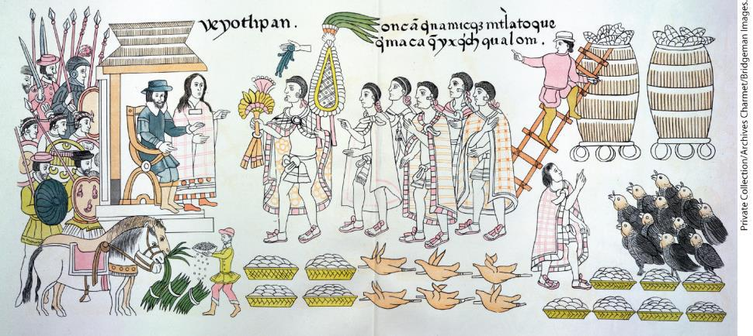
 | a. | The Native Americans are offering plants, animals, and food to the Europeans.
 | b. | Neither group appears to be taking an aggressive stance toward the other.
 | c. | The Native Americans appear to be assuming a ceremonial posture.
 | d. | The Europeans are not offering anything in exchange for the plants, animals, and food.

ANSWER: | a

28. Portuguese colonists in Brazil in the sixteenth century created an industry based on which of these resources?
 | a. | Gold
 | b. | Silver
 | c. | Sugar
 | d. | Coffee

ANSWER: | c

29. Which of the following groups provided the labor for Brazil’s profitable plantations in 1620?
 | a. | Indigenous people
 | b. | African slaves
 | c. | Indentured servants
 | d. | Spanish settlers

ANSWER: | b

30. Which of the following statements describes the English migrants who initially settled in the Jamestown colony in the early 1600s?
 | a. | The group consisted of English families who sought economic opportunity.
 | b. | Early Jamestown settlers expected to profit from gold, pearls, and Indian labor.
 | c. | They owned the Virginia Company, a tobacco-farming enterprise.
 | d. | The settlers were primarily criminals who chose relocation over prison.

ANSWER: | b

31. Powhatan, leader of a confederation of about two dozen tribes in Virginia,
 | a. | treated the English as potential allies and attempted to integrate them into his chiefdom.
 | b. | tried unsuccessfully to prevent his daughter, Pocahontas, from marrying John Rolfe.
 | c. | believed initially that the English settlers were gods and invited them into his community.
 | d. | welcomed the English warmly and supplied them with food, agricultural knowledge, and land.

ANSWER: | a

32. What accounted for the uneasy relations that persisted between Powhatan’s people and the Jamestown settlers for more than a decade after 1607?
 | a. | The constant turnover of the English population due to high death and immigration rates
 | b. | Jamestown’s colonists’ persistent efforts to seize Indian land for new sugar plantations
 | c. | Both groups’ inability to reach an agreement about who would pay tribute to whom
 | d. | English settlers’ decision to trade hatchets and guns with the Indians for maize

ANSWER: | c

33. The economic livelihood of the Virginia colony in the 1700s depended on which of the following products?
 | a. | Tobacco
 | b. | Cotton
 | c. | Fish
 | d. | Corn

ANSWER: | a

34. Which of the following developments fostered the flow of migrants into the Virginia colony between 1617 and 1622?
 | a. | The English crown granted sovereignty to the House of Burgesses.
 | b. | Powhatan’s tribes formally ceded their lands to the Virginia Company.
 | c. | Traders imported a huge number of African slaves to take over tobacco production.
 | d. | The Virginia Company began to allow individual settlers to own land.

ANSWER: | d

35. What effect did American tobacco have in England during the early colonial period?
 | a. | It became fashionable for the upper class to smoke, but tobacco was too expensive for most everyone else.
 | b. | Tobacco was so popular in England that large quantities were planted and grown in most rural English towns.
 | c. | King James I initially condemned it as a “vile weed,” but he tried it and soon became a heavy smoker.
 | d. | The English developed a huge appetite for tobacco, which stimulated the English economy and bolstered England’s treasury.

ANSWER: | d

36. Which of the following was the outcome of the surprise Indian attack on the Virginia colony in 1622?
 | a. | Opechancanough’s attacks killed nearly 75 percent of the English colonists in Virginia.
 | b. | James I revoked the Virginia Company’s charter and made it a royal colony.
 | c. | The English settlers abandoned their efforts to Christianize the local Indian people.
 | d. | English settlers agreed to use some of their tobacco profits to lease Indian land.

ANSWER: | b

37. Which of the following characteristics was a common feature of royal colonies throughout English America in the seventeenth century?
 | a. | Plantation agriculture
 | b. | Religious freedom
 | c. | An elected assembly
 | d. | Prohibitions against non-English settlers

ANSWER: | c

38. The presence of a young African behind Lord Baltimore in this painting is indicative of which of the following?
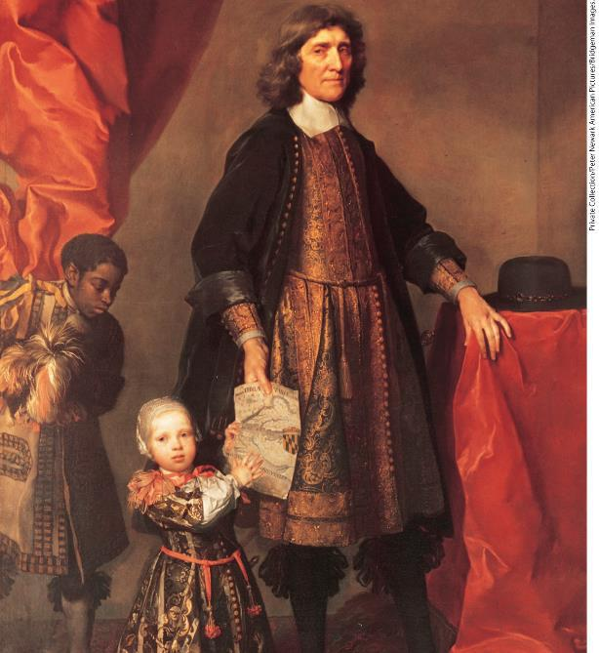
 | a. | The important role played by slave labor in the Chesapeake colonies
 | b. | Lord Baltimore’s role in the expansion of the African slave trade
 | c. | Lord Baltimore’s commitment to toleration in the New World
 | d. | Lord Baltimore’s disdain for indentured servitude and slavery

ANSWER: | a

39. Which of the following statements accurately characterizes life in the seventeenth-century North American plantation colonies?
 | a. | Unlike the mosquito-infested areas further south, the climate was mild and healthy.
 | b. | The much higher male death rate led to many children being raised by their birth mothers and stepfathers.
 | c. | Disease took such a toll on women that the colonies consisted largely of orphans and unmarried young men.
 | d. | Despite the effects of disease, enough settlers poured in to raise the population of Virginia from 2,000 in 1622 to 80,000 in 1640.

ANSWER: | c

40. In North America’s plantation colonies, most indentured servants
 | a. | were indistinguishable from slaves.
 | b. | emigrated from Germany and France.
 | c. | quickly broke their contracts with their masters.
 | d. | did not escape from poverty.

ANSWER: | d

41. In which of the following ways did the plantation colonies of Barbados differ from those in the Chesapeake in the seventeenth century?
 | a. | Barbados never adopted African slave labor.
 | b. | Barbados adopted slavery gradually and the Chesapeake did so rapidly.
 | c. | The Chesapeake adopted slavery gradually and Barbados did so quickly.
 | d. | Barbados always relied on slaves and never on indentured servants.

ANSWER: | c

42. Which of the following statements describes Africans in Virginia after the 1660s?
 | a. | Africans made up 75 percent of the workforce.
 | b. | Africans found themselves more entrenched in slavery as a permanent condition.
 | c. | Africans were required to join the local militias whenever a war with Indians erupted.
 | d. | Africans were able to purchase the labor contracts of white indentured servants.

ANSWER: | b

43. Based on this map, which of the following regions was struck the hardest by diseases spread via the Columbian Exchange?
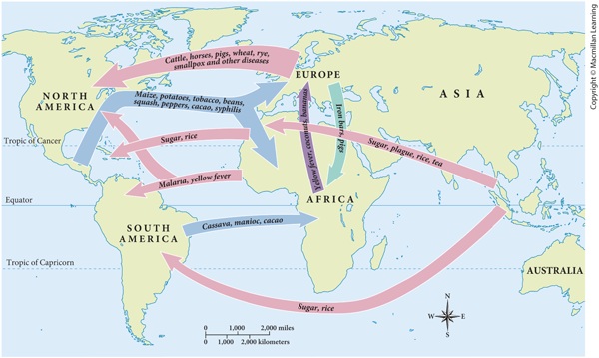
 | a. | Europe
 | b. | Africa
 | c. | The Americas
 | d. | Asia

ANSWER: | c

44. According to this map, which European colonial region experienced the greatest population density?
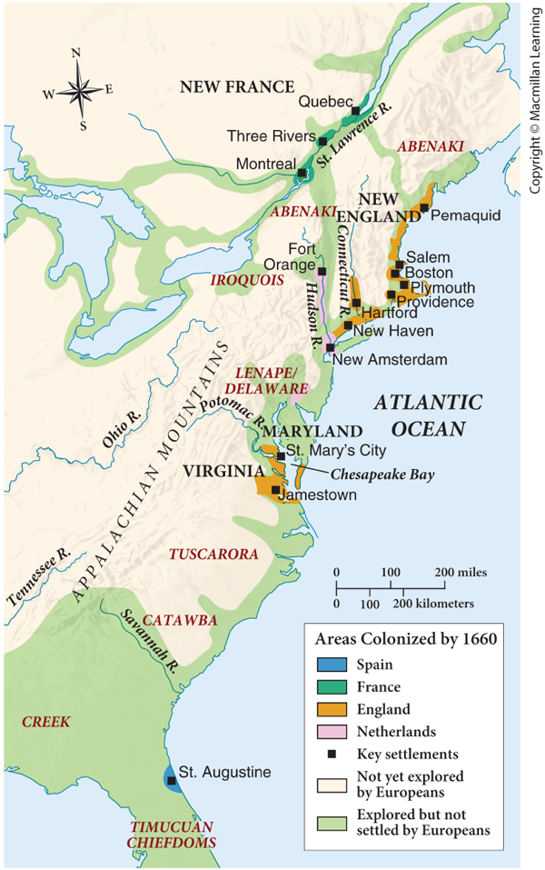
 | a. | France
 | b. | The Netherlands
 | c. | Spain
 | d. | England

ANSWER: | d

45. Which of the following describes the trade activities depicted in this map?
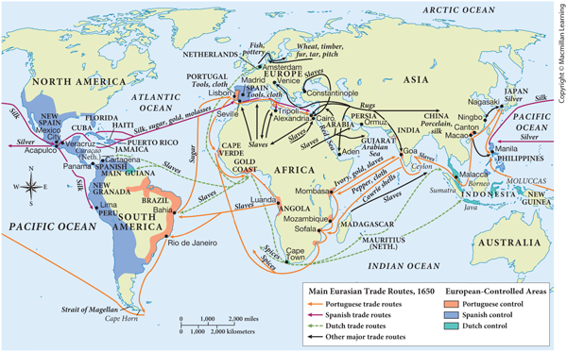
 | a. | The majority of routes involved in the slave trade originated in South Africa.
 | b. | The Portuguese maintained the most extensive network of seaborne trade during this era.
 | c. | The Dutch traded primarily in material goods.
 | d. | The Spanish were the sole traders in gold and silver.

ANSWER: | b

46. In contrast to the Spanish missionaries of the sixteenth century, the seventeenth-century French Jesuits
 | a. | did not live in the Indian villages but built separate dwellings.
 | b. | coerced the Indians to accept their teachings.
 | c. | were unable to adapt Christian theology to the Indians’ worldview.
 | d. | tried to understand the Indians’ values and worldview.

ANSWER: | d

47. Which of the following factors encouraged migrants to New France in the seventeenth century?
 | a. | Generous terms for indentured servitude
 | b. | The lack of a French military draft
 | c. | Religious freedom for Protestants
 | d. | The region’s temperate climate

ANSWER: | a

48. How was colonization similar for the French and Spanish?
 | a. | Both sent only families to settle in the colonies.
 | b. | The French and Spanish aimed to Christianize the native peoples.
 | c. | Both countries ruled with an iron fist.
 | d. | They focused primarily on fur trading.

ANSWER: | b

49. Which of the following describes the Dutch colony of New Netherland in the seventeenth century?
 | a. | The colony grew rapidly due to the success of slavery.
 | b. | Its settlers coexisted peacefully alongside the area’s Native people.
 | c. | The venture failed to attract many settlers.
 | d. | It quickly became the most profitable of Holland’s overseas colonies.

ANSWER: | c

50. Which of the following Native groups capitalized on its geographic location in central New York and remained a significant political force in North America long after colonization?
 | a. | Iroquois
 | b. | Algonquians
 | c. | Pequots
 | d. | Wampanoags

ANSWER: | a

51. Why did Plymouth begin to thrive after its first year while Jamestown struggled for many years?
 | a. | Plymouth’s long growing season allowed for greater agricultural productivity.
 | b. | The balanced sex ratio and community organization in Plymouth encouraged rapid expansion.
 | c. | Plymouth settlers’ religious ideals led them to coexist peacefully with the Wampanoag Indians.
 | d. | Unlike Jamestown, Plymouth began as a royal colony and benefitted from royal control.

ANSWER: | b

52. When they settled in the New World in 1630, the Puritans’ first priority was to
 | a. | establish the Anglican Church in New England.
 | b. | generate sufficient profits to repay their British investors.
 | c. | create a reformed society that would model true Christianity in America.
 | d. | escape from England and begin to pursue full political independence from the British crown.

ANSWER: | c

53. Anne Hutchinson was banished from Massachusetts Bay for
 | a. | teaching that believers did not need to obey church rules.
 | b. | engaging in adultery and sexual promiscuity.
 | c. | questioning the idea that good works led to salvation.
 | d. | claiming that women were the full equals of men.

ANSWER: | c

54. Which of the following New England colonies required church membership in order to be able to vote?
 | a. | Plymouth
 | b. | Massachusetts Bay
 | c. | Rhode Island
 | d. | Connecticut

ANSWER: | b

55. What caused the Puritans’ “errand into the wilderness” to become permanent?
 | a. | The failure of the Puritan Revolution in England
 | b. | Their reluctance to abandon their profitable businesses
 | c. | Their commitment to converting the Native Americans
 | d. | The long-term reverberations of the Salem witchcraft trials

ANSWER: | a

56. The worldview of devout Puritans, such as Cotton Mather, was based on which of the following?
 | a. | The tenets of rationalism and established science
 | b. | The belief that omens and premonitions were manifestations of Satan
 | c. | The notion that supernatural forces caused unusual events
 | d. | The assumption that every person was innately good

ANSWER: | c

57. Why did the largest landholdings in seventeenth-century New England towns usually belong to wealthier families?
 | a. | Religious discrimination by Protestants prevented Quakers and Catholics from holding land.
 | b. | Men of higher social status tended to receive the largest land grants from their towns.
 | c. | Governors of the colony consistently favored their supporters when making land grants.
 | d. | The colonial governments copied English feudal practices, which perpetuated social inequalities.

ANSWER: | b

58. Which of the following was characteristic of both the Massachusetts Bay and Connecticut colonies?
 | a. | Their governments were controlled by the landholding aristocracy.
 | b. | Ordinary farmers had more political power than most Chesapeake men.
 | c. | Religious toleration was widespread.
 | d. | They had a single-crop economy.

ANSWER: | b

59. Why did Pueblos decide to revolt in the early 1680s?
 | a. | Spanish officials persecuted Pueblo peoples for turning away from Christianity.
 | b. | Pueblo leaders had visions that told them to attack the Spanish.
 | c. | The Puritans were imposing the Catholic faith on the local natives.
 | d. | The Pueblo peoples never received promised payment for ceded lands.

ANSWER: | a

60. Which of the following statements is true of Metacom’s War (King Philip’s War), which took place in 1675-1676?
 | a. | It eliminated the presence of Native Americans in southern New England.
 | b. | The war eliminated conflicts among previously incompatible Puritan sects.
 | c. | It displaced Puritans from Boston’s south shore and concentrated Nipmuk power in the region.
 | d. | The war was a last-ditch attempt to save Indian lands and culture in New England.

ANSWER: | d

61. Which of the following statements describes life in the Chesapeake region after 1660?
 | a. | Many yeoman farmers prospered because their tobacco profits enabled them to acquire more land.
 | b. | A wealthy, planter-merchant elite dominated the Chesapeake economy and owned almost half the land in Virginia.
 | c. | Newly freed indentured servants were able to acquire land more easily than they could before this time.
 | d. | The lines separating the social classes blurred because wealth was more evenly distributed.

ANSWER: | b

62. Why was William Berkeley significant in the Chesapeake region in the seventeenth century?
 | a. | His rise from servitude to great wealth and power inspired the region’s landless men.
 | b. | He conceived of and founded the first college in North America in Virginia in 1642.
 | c. | He joined together with Nathaniel Bacon to demand better treatment of western settlers.
 | d. | His political favoritism during his governorship aroused great resentment in Virginia.

ANSWER: | d

63. Which of the following was a consequence of Bacon’s Rebellion of the 1670s?
 | a. | Slavery began to replace indentured servitude.
 | b. | Planters sought to insulate themselves from the poor white population.
 | c. | New treaties guaranteed the Indians protected land along the frontier.
 | d. | Massachusetts Bay and Virginia sought to join forces against Indian warriors.

ANSWER: | a

64. How were the Indian uprising in 1622 and Bacon’s Rebellion in 1675-1676 similar?
 | a. | Both events stemmed from excessive taxation and unfair land practices.
 | b. | The uprisings required the king’s soldiers to intervene on the colonists’ behalf.
 | c. | Both emerged out of religious differences between Native peoples and the English settlers.
 | d. | The rebellions led to changes in the structure of the colony’s government.

ANSWER: | d

65. How were the Spanish conquistadors, Nathaniel Bacon’s frontiersmen, and the Puritans similar?
 | a. | They all tried to Christianize the Native population.
 | b. | All the groups saw themselves as God’s chosen people.
 | c. | They believed that they would find great wealth in the New World.
 | d. | All treated the Native Americans brutally.

ANSWER: | d

