TEST BANK
21st Century Astronomy
SIXTH EDITION
TEST BANK
21st Century Astronomy
SIXTH EDITION
Laura Kay, Stacy Palen, and George Blumenthal
Matthew Newby
TEMPLE UNIVERSITY
 W • W • Norton & Company • New York • London
W. W. Norton & Company has been independent since its founding in 1923, when William Warder Norton and Mary D. Herter Norton first published lectures delivered at the People’s Institute, the adult education division of New York City’s Cooper Union. The firm soon expanded its program beyond the Institute, publishing books by celebrated academics from America and abroad. By mid-century, the two major pillars of Norton’s publishing program—trade books and college texts—were firmly established. In the 1950s, the Norton family transferred control of the company to its employees, and today—with a staff of four hundred and a comparable number of trade, college, and professional titles published each year—W. W. Norton & Company stands as the largest and oldest publishing house owned wholly by its employees.
Copyright © 2019, 2016, 2013, 2010, 2007, 2002 by W.W. Norton & Company, Inc.
All rights reserved.

Associate Digital Media Editor: Arielle Holstein Production Manager: Ashley Horna
Composition by Westchester Publishing Services
W. W. Norton & Company, Inc., 500 Fifth Avenue, New York, NY 10110
www.wwnorton.com

W. W. Norton & Company Ltd., 15 Carlisle Street, London W1D 3BS
1 2 3 4 5 6 7 8 9 0
CONTENTS
Preface ix
Part I: Test Bank
Chapter 1 | Thinking Like an Astronomer 3
Chapter 2 | Patterns in the Sky—Motions of Earth and the Moon 30
Chapter 3 | Motion of Astronomical Bodies 58
Chapter 4 | Gravity and Orbits 88
Chapter 5 | Light 121
Chapter 6 | The Tools of the Astronomer 151
Chapter 7 | The Formation of Planetary Systems 179
Chapter 8 | The Terrestrial Planets and Earth’s Moon 207
Chapter 9 | Atmospheres of the Terrestrial Planets 237
Chapter 10 | Worlds of Gas and Liquid—The Giant Planets 267
Chapter 11 | Planetary Moons and Rings 297
Chapter 12 | Dwarf Planets and Small Solar System Bodies 326
Chapter 13 | Taking the Measure of Stars 357
Chapter 14 | Our Star—The Sun 389
Chapter 15 | The Interstellar Medium and Star Formation 418
Chapter 16 | Evolution of Low-Mass Stars 450
Chapter 17 | Evolution of High-Mass Stars 481
Chapter 18 | Relativity and Black Holes 513
Chapter 19 | Galaxies 542
Chapter 20 | The Milky Way—A Normal Spiral Galaxy 570
Chapter 21 | The Expanding Universe 600
Chapter 22 | Cosmology 631
Chapter 23 | Large-Scale Structure in the Universe 662
Chapter 24 | Life 694
Part II: Test Bank for At Play in the Cosmos: The Videogame (broken down by Mission)
Mission 1 | Learn to Fly 727
Mission 2 | Lost in the Wreckage 729
Mission 3 | Time for Repairs 731
Mission 4 | Flying Through The Ashes 733
Mission 5 | Refuel the Reactor 735
Mission 6 | Rogue Comet Rescue 737
Mission 7 | Survey in Blue 740
Mission 8 | Alien Homeworld 742
Mission 9 | Surveying a Cluster 745
Mission 10 | Rendezvous at Saturn 748
Mission 11 | Defense for the Win 750
Mission 12 | Corporate Agenda 752
Mission 13 | Impending Doom 754
Mission 14 | Farther and Faster 756
Mission 15 | Hiding in Time 758
Mission 16 | More Power 760
Mission 17 | A Galaxy Far, Far Away 762
Mission 18 | Galactic Collisions 764
Mission 19 | Through a Fog 766
Mission 20 | Special Delivery 768
Credits 769
PREFACE
For each chapter, the learning objectives that students could be expected to master by reading the text are listed. The questions are identified as remembering, understanding, applying, analyzing, and evaluating. This classification is patterned after Bloom’s taxonomy of educational objectives. Bloom listed six levels of learning: knowledge (information), comprehension, application, analysis, synthesis, and evaluation. Questions are also posed at three difficulty levels: easy, medium, and difficult. By asking students questions that vary in both type and level of difficulty, instructors can gather different types of evidence, which will allow them to more effectively assess how well students understand specific concepts.
Five Question Types (classified according to Bloom’s taxonomy):
1. Remembering questions—Test declarative knowledge, including textbook definitions and relationships between two or more pieces of information. Can students recall or remember the information in the same form it was learned?
2. Understanding questions—Pose problems in a context different from the one in which the material was learned, requiring students to draw from their declarative and/or procedural understanding of important concepts. Can students explain ideas or concepts?
3. Applying questions—Ask students to draw from their prior experience and use critical-thinking skills to engage in qualitative reasoning about the real world. Can students use learned information in another task or situation?
4. Analyzing questions—Test students’ ability to break down information and see how different elements relate to each other and to the whole. Can students distinguish among the different parts?
5. Evaluating questions—Ask students to assess information as a whole and frame their own argument. Can students justify a stand or decision?
Three Difficulty Levels:
1. Easy questions—Require a basic understanding of the concepts, definitions, and examples.
2. Moderate questions—Direct students to use critical thinking skills, to demonstrate an understanding of core concepts independent of specific textbook examples, and to connect concepts across chapters.
3. Difficult questions—Ask students to synthesize textbook concepts with their own experience, making analytical inferences about topics discussed in the text.
Each question is linked to links to a specific learning objective and is written in clear, concise, and grammatically correct language appropriate for the learning objective and difficulty level being assessed. Every effort is made to eliminate bias (e.g., race, gender, cultural, ethnic, regional, handicap, age) to focus on the material and to ensure validity and reliability.
KEY TO THE METADATA:
Each question in the Test Bank is tagged with five pieces of information designed to help instructors create the most ideal mix of questions for their quiz or exam. These tags are:
ANS: This is the correct answer for each question (or, in the case of some short-answer questions, a possible correct answer to the question).
DIF: This is the difficulty assigned to the problem. Problems have been classified as Easy, Medium, or Difficult.
REF: This is the section in the textbook from which a question is drawn.
OBJ: This is the learning objective that the question is designed to test.
MSC: This is the knowledge type (described earlier) that the question is designed to test.
Test Bank files are available in Word, PDF, and Exam-View® Assesment Suite formats. Finally, we would like to thank Brett Bochner of Hofstra University and Ed Coppola of the College of Southern Nevada, whose careful review improved the accuracy and usefulness of this product.

Part I Test Bank
Chapter 1
Thinking Like an Astronomer
Learning Objectives
1.1 Earth Occupies a Small Place in the Universe
1.1a State our “cosmic address.”
1.1b Express astronomical distances and distance scales.
1.1c Explain basic astronomical terms and concepts.
1.2 Science Is a Way of Viewing the Universe
1.2a Explain the scientific usage of the terms fact, idea, hypothesis, theory, and law.
1.2b Distinguish between the common meanings of the terms fact, idea, hypothesis, theory, and law, and their scientific meanings.
1.2c Describe the steps of the scientific method.
1.2d Assess whether a given statement is scientific.
1.2e Demonstrate that scientific knowledge is provisional.
1.2f Explain the significance of the cosmological principle.
1.2g Evaluate competing hypotheses using Occam’s razor.
1.3 Astronomers Use Mathematics to Find Patterns
1.3a Identify patterns in nature.
1.3b Explain how natural patterns imply underlying physical laws.
Working it Out 1.1 Mathematical Tools
Working It Out 1.1a Express numbers in scientific and standard notation.
Working It Out 1.1b Describe the physical properties of objects using ratios.
Working It Out 1.1c Predict the change in proportional quantities with respect to each other.
Working it Out 1.2 Reading a Graph
Working It Out 1.2a Identify the major features of a graph: x-axis, y-axis, x scale, y scale, data points, slope.
Working It Out 1.2b Assess different curves on a graph.
Working It Out 1.2c Demonstrate the ability to read data from a graph.
Origins 1 An Introduction
Origins 1a Explain the goals and scope of the field of astrobiology.
MULTIPLE CHOICE

1. The Sun is a
a. | supercluster. | d. | star.
b. | moon. | e. | planet.
c. | galaxy.

ANS: D DIF: Easy REF: 1.1
OBJ: 1.1a State our “cosmic address.” MSC: Remembering

2. The number of planets in our Solar System is
a. | six. | d. | twelve.
b. | eight. | e. | twenty.
c. | nine.

ANS: B DIF: Easy REF: 1.1
OBJ: 1.1a State our “cosmic address.” MSC: Remembering

3. Milky Way is the name of
a. | our Solar System. | d. | the supercluster of galaxies we are in.
b. | the galaxy in which we live. | e. | the entire universe.
c. | the local group of galaxies we are in.

ANS: B DIF: Easy REF: 1.1
OBJ: 1.1a State our “cosmic address.” MSC: Understanding

4. Our galaxy and the few dozen nearest galaxies are known as the
a. | Solar System. | d. | Virgo Supercluster.
b. | Milky Way. | e. | Laniakea Supercluster.
c. | Local Group.

ANS: C DIF: Moderate REF: 1.1
OBJ: 1.1a State our “cosmic address.” MSC: Remembering

5. According to the figure below, if you were to specify your address in the universe, listing your membership from the smallest to largest physical structures, it would be
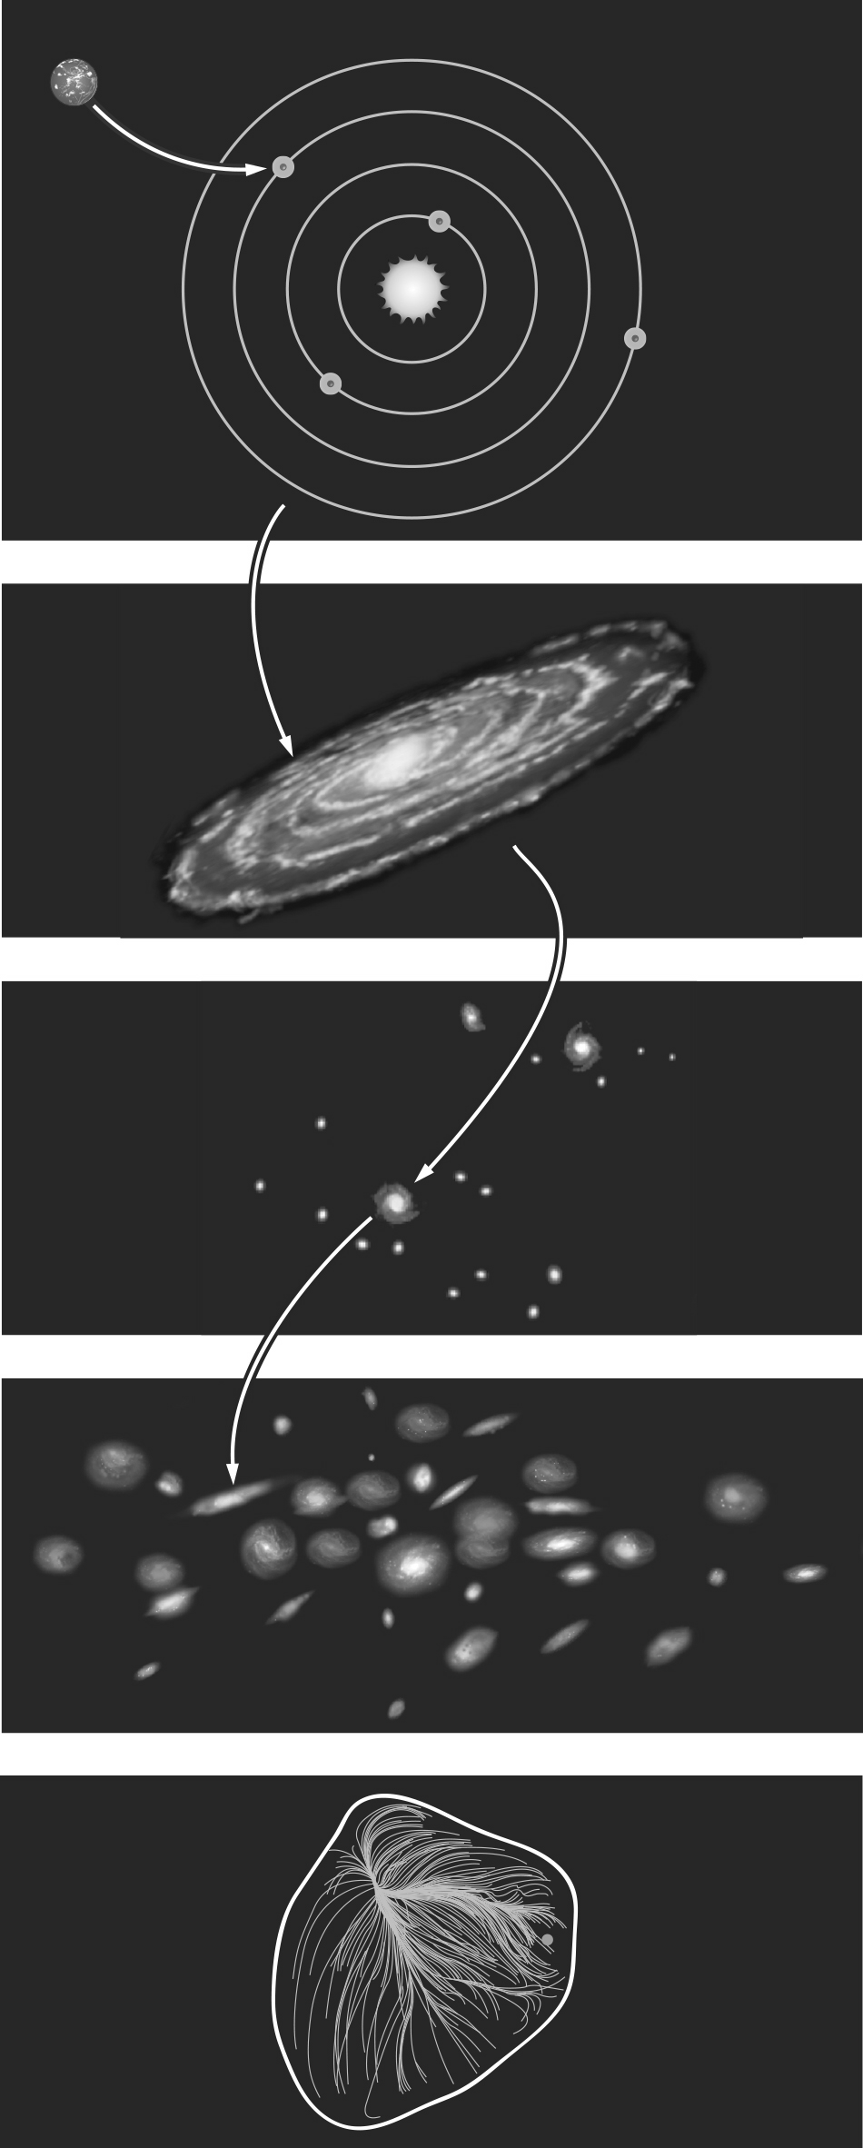
a. | Earth, Local Group, Solar System, Andromeda, the universe.
b. | Earth, Solar System, Local Group, Milky Way, the universe.
c. | Earth, Solar System, Milky Way, Local Group, Laniakea Supercluster, the universe.
d. | Earth, Solar System, Milky Way, Laniakea Supercluster, the universe.
e. | Earth, Laniakea Supercluster, Milky Way, Solar System, the universe.

ANS: C DIF: Difficult REF: 1.1
OBJ: 1.1a State our “cosmic address.” MSC: Understanding

6. The Andromeda Galaxy is also part of the Local Group, so it is also part of
a. | the Solar System. | d. | the Virgo Supercluster.
b. | the Milky Way. | e. | dark energy.
c. | the Moon.

ANS: D DIF: Difficult REF: 1.1
OBJ: 1.1a State our “cosmic address.” MSC: Understanding

7. According to the figure below, Earth is located approximately
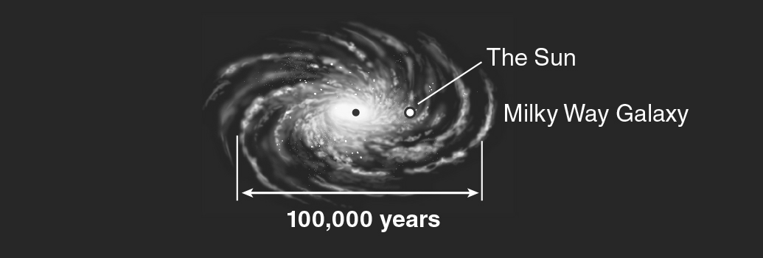
a. | at the center of the Milky Way.
b. | near the center of the Milky Way.
c. | about halfway out from the center of the Milky Way.
d. | at the farthest outskirts of the Milky Way.
e. | outside the Milky Way, which is why we can see it as a band across the night sky.

ANS: C DIF: Easy REF: 1.1
OBJ: 1.1b Express astronomical distances and distance scales. MSC: Analyzing

8. When a change occurs on the surface of the Sun, how long does it take before astronomers on Earth can see the change?
a. | 8 minutes | d. | 1 day
b. | 11 hours | e. | It reaches us instantaneously.
c. | 1 second

ANS: A DIF: Easy REF: 1.1
OBJ: 1.1b Express astronomical distances and distance scales. MSC: Applying

9. The average distance between Earth and the Sun is 1.5 × 10¹¹ m, and light from the Sun takes approximately ________ to reach Earth.
a. | 8 seconds | d. | 8 days
b. | 8 minutes | e. | 8 years
c. | 8 hours

ANS: B DIF: Easy REF: 1.1
OBJ: 1.1b Express astronomical distances and distance scales. MSC: Applying

10. One of the nearest stars, Alpha Centauri, is 4.4 light-years from Earth. The time it takes light to travel from Alpha Centauri to us is
a. | 1.25 seconds. | d. | 600 years.
b. | 8.3 minutes. | e. | 2.2 million years.
c. | 4.4 years.

ANS: C DIF: Easy REF: 1.1
OBJ: 1.1b Express astronomical distances and distance scales. MSC: Applying

11. The time it takes light to cross Neptune’s orbit is closest to which of the following?
a. | instantaneous
b. | a second
c. | a quick meal
d. | a night’s sleep
e. | the time between presidential elections

ANS: D DIF: Easy REF: 1.1
OBJ: 1.1b Express astronomical distances and distance scales. MSC: Analyzing

12. A light-hour is a measure of
a. | time. | d. | speed.
b. | distance. | e. | acceleration.
c. | energy.

ANS: B DIF: Easy REF: 1.1
OBJ: 1.1b Express astronomical distances and distance scales. MSC: Understanding

13. If one thinks about the distance between Earth and the Moon, 384,400 km, approximately how much of that distance would Saturn and its rings take up?
a. | much more than this distance
b. | less than half this distance
c. | more than half this distance
d. | exactly this distance
e. | None of these choices is correct.

ANS: B DIF: Moderate REF: 1.1
OBJ: 1.1b Express astronomical distances and distance scales. MSC: Understanding

14. The diameter of the Moon is
a. | larger than the distance across the continental United States.
b. | roughly equal to the longest distance across Texas.
c. | more than half the distance across the continental United States.
d. | less than half the distance across the continental United States.
e. | None of these choices is correct.

ANS: C DIF: Moderate REF: 1.1
OBJ: 1.1b Express astronomical distances and distance scales. MSC: Remembering

15. What is the approximate number of stars in the Milky Way?
a. | 10 million | d. | 300 billion
b. | 300 million | e. | 1 trillion
c. | 10 billion

ANS: D DIF: Moderate REF: 1.1
OBJ: 1.1b Express astronomical distances and distance scales. MSC: Remembering

16. The distance to the nearest large spiral galaxy, the Andromeda Galaxy, is 2.4 × 10²² m. How long does it take light to travel from Andromeda to us?
a. | 4.4 years | d. | 2.5 million years
b. | 360 years | e. | 4.5 billion years
c. | 1.2 thousand years

ANS: D DIF: Difficult REF: 1.1
OBJ: 1.1b Express astronomical distances and distance scales. MSC: Applying

17. One of the nearest stars is Alpha Centauri, whose distance from Earth is 4.2 × 10¹⁶ m. How long does it take light to travel from Alpha Centauri to us?
a. | 1.25 seconds | d. | 560 years
b. | 8.3 minutes | e. | 6,200 years
c. | 4.4 years

ANS: C DIF: Difficult REF: 1.1
OBJ: 1.1b Express astronomical distances and distance scales. MSC: Applying

18. A light-year is a unit commonly used in astronomy as a measure of
a. | time. | d. | distance.
b. | speed. | e. | acceleration.
c. | mass.

ANS: D DIF: Moderate REF: 1.1
OBJ: 1.1b Express astronomical distances and distance scales. MSC: Understanding

19. How many times larger is our galaxy (100,000 light-years across) than our Solar System (11 light-hours across)?
a. | 100 | d. | 10⁶
b. | 1,000 | e. | 10⁸
c. | 10,000

ANS: D DIF: Difficult REF: 1.1
OBJ: 1.1b Express astronomical distances and distance scales. MSC: Applying

20. After the Sun, the next nearest star to us is approximately ________ away.
a. | 8 light-seconds | d. | 4 light-years
b. | 80 light-minutes | e. | 200 light-years
c. | 40 light-hours

ANS: D DIF: Moderate REF: 1.1
OBJ: 1.1b Express astronomical distances and distance scales. MSC: Remembering

21. The figure below measures distances in the amount of time it takes light to travel. If the circumference of Earth is a snap of your fingers (1/7 second), the diameter of the Solar System is approximately equal to
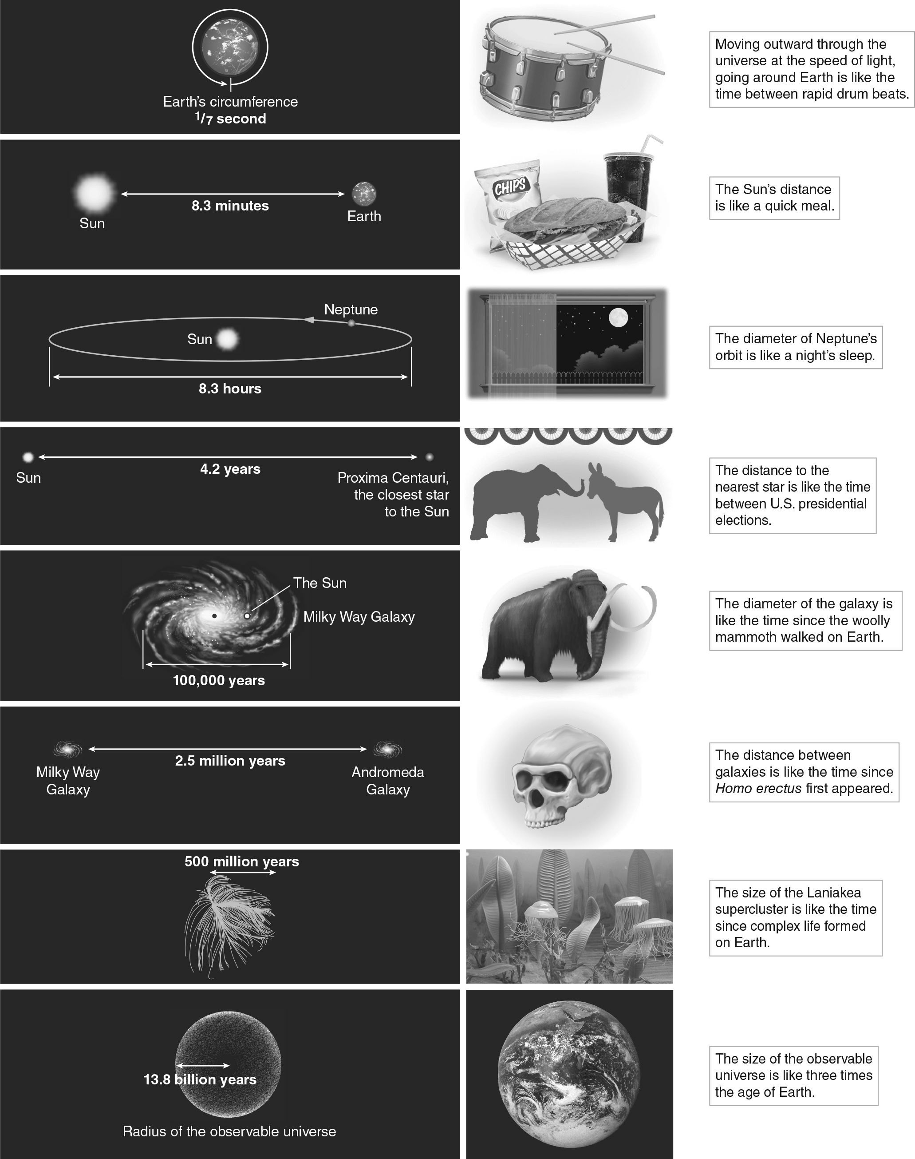
a. | the length of a quick lunch. | d. | the time you spent in high school.
b. | the time to turn a page in a book. | e. | a human lifetime.
c. | the length of the workday.

ANS: C DIF: Difficult REF: 1.1
OBJ: 1.1b Express astronomical distances and distance scales. MSC: Analyzing

22. Light from the Andromeda Galaxy that is just reaching us first left Andromeda when
a. | the woolly mammoth last walked the Earth.
b. | humans began exploring the skies with telescopes.
c. | Homo erectus first walked the Earth.
d. | the Solar System formed.
e. | the universe began.

ANS: C DIF: Difficult REF: 1.1
OBJ: 1.1b Express astronomical distances and distance scales. MSC: Applying

23. How long does it take light to travel from the center of the Laniakea Supercluster (5 × 10²³ m away) to us?
a. | 7,000 years | d. | 12 million years
b. | 54,000 years | e. | 54 million years
c. | 120,000 years

ANS: E DIF: Moderate REF: 1.1
OBJ: 1.1b Express astronomical distances and distance scales. MSC: Applying

24. The speed of light is approximately
a. | 3,000 km/s. | d. | 3 million km/s.
b. | 30,000 km/s. | e. | 3 billion km/s.
c. | 300,000 km/s.

ANS: C DIF: Easy REF: 1.1
OBJ: 1.1b Express astronomical distances and distance scales. MSC: Remembering

25. Our universe is approximately 13.7 ________ years old.
a. | hundred | d. | billion
b. | thousand | e. | trillion
c. | million

ANS: D DIF: Easy REF: 1.1
OBJ: 1.1c Explain basic astronomical terms and concepts. MSC: Remembering

26. The majority of the mass in our universe is made up of
a. | planets. | d. | dust.
b. | stars. | e. | dark matter.
c. | galaxies.

ANS: E DIF: Moderate REF: 1.1
OBJ: 1.1c Explain basic astronomical terms and concepts. MSC: Remembering

27. The majority of the energy in our universe is
a. | radiated by stars from the nuclear fusion going on in their cores.
b. | the kinetic energy found in the collisions of galaxies.
c. | the gravitational potential energy of superclusters.
d. | emitted in radioactive decays of unstable elements.
e. | made up of dark energy that permeates space.

ANS: E DIF: Difficult REF: 1.1
OBJ: 1.1c Explain basic astronomical terms and concepts. MSC: Remembering

28. The first event in the history of the universe is called the
a. | Great Beginning.
b. | Manhattan Project.
c. | Universal Spring.
d. | Big Bang.
e. | None of these are correct, as the universe had no beginning.

ANS: D DIF: Easy REF: 1.1
OBJ: 1.1c Explain basic astronomical terms and concepts. MSC: Remembering

29. A hypothesis is an idea that is
a. | Falsifiable. | d. | always part of a larger theory.
b. | undeniably true. | e. | absolutely untrue.
c. | not falsifiable.

ANS: A DIF: Easy REF: 1.2
OBJ: 1.2a Explain the scientific usage of the terms fact, idea, hypothesis, theory, and law.
MSC: Understanding

30. A hypothesis may become a theory
a. | automatically, as the terms mean the same thing.
b. | if a majority of scientists agree on its propositions.
c. | after it has been logically proved.
d. | if it makes at least one verifiable prediction.
e. | after many repeated attempts to falsify it fail.

ANS: E DIF: Easy REF: 1.2
OBJ: 1.2a Explain the scientific usage of the terms fact, idea, hypothesis, theory, and law.
MSC: Understanding

31. In the scientific method, a fact is a(n)
a. | opinion or an idea. | d. | opinion backed by an expert.
b. | observation or a measurement. | e. | rigorously tested theory.
c. | type of test.

ANS: B DIF: Easy REF: 1.2
OBJ: 1.2a Explain the scientific usage of the terms fact, idea, hypothesis, theory, and law.
MSC: Remembering

32. A theory is
a. | tied to known physical laws.
b. | able to make testable predictions.
c. | a hypothesis that has withstood many attempts to falsify it.
d. | subject to being revised by new evidence.
e. | all of these

ANS: E DIF: Easy REF: 1.2
OBJ: 1.2b Distinguish between the common meanings of the terms fact, idea, hypothesis, theory, and law, and their scientific meanings. MSC: Understanding

33. Which of the following is true?
a. | A scientific theory is an undisputed fact.
b. | If continual testing of a hypothesis shows it to be valid, it may become an accepted theory.
c. | A hypothesis must never have one or more testable predictions.
d. | A scientific theory must not be able to be proven wrong when scientists acquire new data.
e. | A hypothesis can become a theory without it being tested.

ANS: B DIF: Moderate REF: 1.2
OBJ: 1.2b Distinguish between the common meanings of the terms fact, idea, hypothesis, theory, and law, and their scientific meanings. MSC: Analyzing

34. A theoretical model is
a. | a made-up explanation.
b. | a detailed description in terms of known physical laws or theories.
c. | a testable assumption.
d. | a scientific law.
e. | a detailed computer simulation.

ANS: B DIF: Moderate REF: 1.2
OBJ: 1.2c Describe the steps of the scientific method. MSC: Understanding

35. Before you can scientifically test a hypothesis, you must use the hypothesis to develop a
a. | scientific theory. | d. | computer model.
b. | claim that cannot be falsified. | e. | new fact.
c. | prediction to test.

ANS: C DIF: Moderate REF: 1.2
OBJ: 1.2c Describe the steps of the scientific method. MSC: Understanding

36. The scientific method is a process by which scientists
a. | prove theories to be known facts.
b. | gain confidence in theories by failing to prove them wrong.
c. | show all theories to be wrong.
d. | test the ideas of Aristotle.
e. | survey what the majority of people think about a theory.

ANS: B DIF: Moderate REF: 1.2
OBJ: 1.2c Describe the steps of the scientific method. MSC: Understanding

37. A ________ becomes a ________ when repeated testing of its predictions does not disprove it.
a. | hypothesis; scientific method | d. | hypothesis; theory
b. | theory; scientific revolution | e. | law; theory
c. | phenomenon; theory

ANS: D DIF: Moderate REF: 1.2
OBJ: 1.2c Describe the steps of the scientific method. MSC: Applying

38. In science an idea that cannot be tested is
a. | a hypothesis. | d. | a principle.
b. | not a scientific idea. | e. | a law.
c. | a theory.

ANS: B DIF: Easy REF: 1.2
OBJ: 1.2d Assess whether a given statement is scientific. MSC: Understanding

39. The statement “our universe is but one of a multitude of isolated universes” is best characterized as a(n)
a. | speculative but unscientific idea.
b. | scientific fact.
c. | physical law.
d. | hypothesis that is currently being tested.
e. | impossible situation.

ANS: A DIF: Difficult REF: 1.2
OBJ: 1.2d Assess whether a given statement is scientific. MSC: Applying

40. A scientific theory can be shown to be wrong if
a. | cultural beliefs evolve to contradict it.
b. | scientists gather new data that contradict its predictions.
c. | it cannot explain all phenomena in the universe.
d. | it was first proposed as conjecture.
e. | a majority of people do not accept it.

ANS: B DIF: Easy REF: 1.2
OBJ: 1.2e Demonstrate that scientific knowledge is provisional.
MSC: Understanding

41. Albert Einstein’s theory of relativity replacing Isaac Newton’s theory of gravity is an example of
a. | a failure of the scientific method.
b. | Occam’s razor.
c. | the cosmological principle.
d. | the provisional nature of scientific knowledge.
e. | the need for creativity in scientists.

ANS: D DIF: Moderate REF: 1.2
OBJ: 1.2e Demonstrate that scientific knowledge is provisional.
MSC: Understanding

42. A scientific principle is
a. | a scientific law.
b. | a detailed description in terms of known physical laws or theories.
c. | a general idea or sense about the universe.
d. | an easily testable statement.
e. | the next step beyond a scientific theory.

ANS: C DIF: Easy REF: 1.2
OBJ: 1.2f Explain the significance of the cosmological principle.
MSC: Remembering

43. The cosmological principle states that
a. | the universe is expanding in all directions at the same rate.
b. | a unique center of the universe exists.
c. | the universe looks the same everywhere and in all directions as long as you look on large enough spatial scales.
d. | physical laws change from place to place in the universe.
e. | the universe is in a “steady state.”

ANS: C DIF: Moderate REF: 1.2
OBJ: 1.2f Explain the significance of the cosmological principle.
MSC: Remembering

44. Because of ________, we can conclude that gravity works the same way on Earth as it does on Mars.
a. | Newton’s theory of relativity | d. | the cosmological principle
b. | Einstein’s special theory of relativity | e. | the hypothetical statute
c. | Sagan’s planetary principle

ANS: D DIF: Moderate REF: 1.2
OBJ: 1.2f Explain the significance of the cosmological principle.
MSC: Applying

45. One of the central assumptions in astronomy is that the physical laws of nature
a. | change when objects move at high speed.
b. | change throughout the age of the universe.
c. | depend on the mass of the objects involved.
d. | are the same everywhere in the universe.
e. | change noticeably from place to place.

ANS: D DIF: Moderate REF: 1.2
OBJ: 1.2f Explain the significance of the cosmological principle.
MSC: Applying

46. If you have a stuffy nose, a fever, chills, and body aches and a doctor treats you for the flu rather than four separate diseases that account for each of your symptoms, this is an application of
a. | Newton’s hypothesis. | d. | Einstein’s relativity.
b. | Occam’s razor. | e. | the Copernican principle.
c. | Aristotle’s test.

ANS: B DIF: Difficult REF: 1.2
OBJ: 1.2g Evaluate competing hypotheses using Occam’s razor.
MSC: Applying

47. When two explanations describe something equally well, ________ says that we should assume the simpler one.
a. | Newton’s hypothesis | d. | Einstein’s biggest blunder
b. | Occam’s razor | e. | the Copernican principle
c. | Aristotle’s test

ANS: B DIF: Easy REF: 1.2
OBJ: 1.2g Evaluate competing hypotheses using Occam’s razor.
MSC: Remembering

48. The language of patterns, and therefore of science, is
a. | Greek. | d. | Java.
b. | mathematics. | e. | Latin.
c. | calculus.

ANS: B DIF: Easy REF: 1.3
OBJ: 1.3a Identify patterns in nature. MSC: Understanding

49. The figure below shows the night sky as it appears to an observer in the United States at the same time of the night but at four different seasons of the year. A reasonable conclusion that can be drawn from these images is that
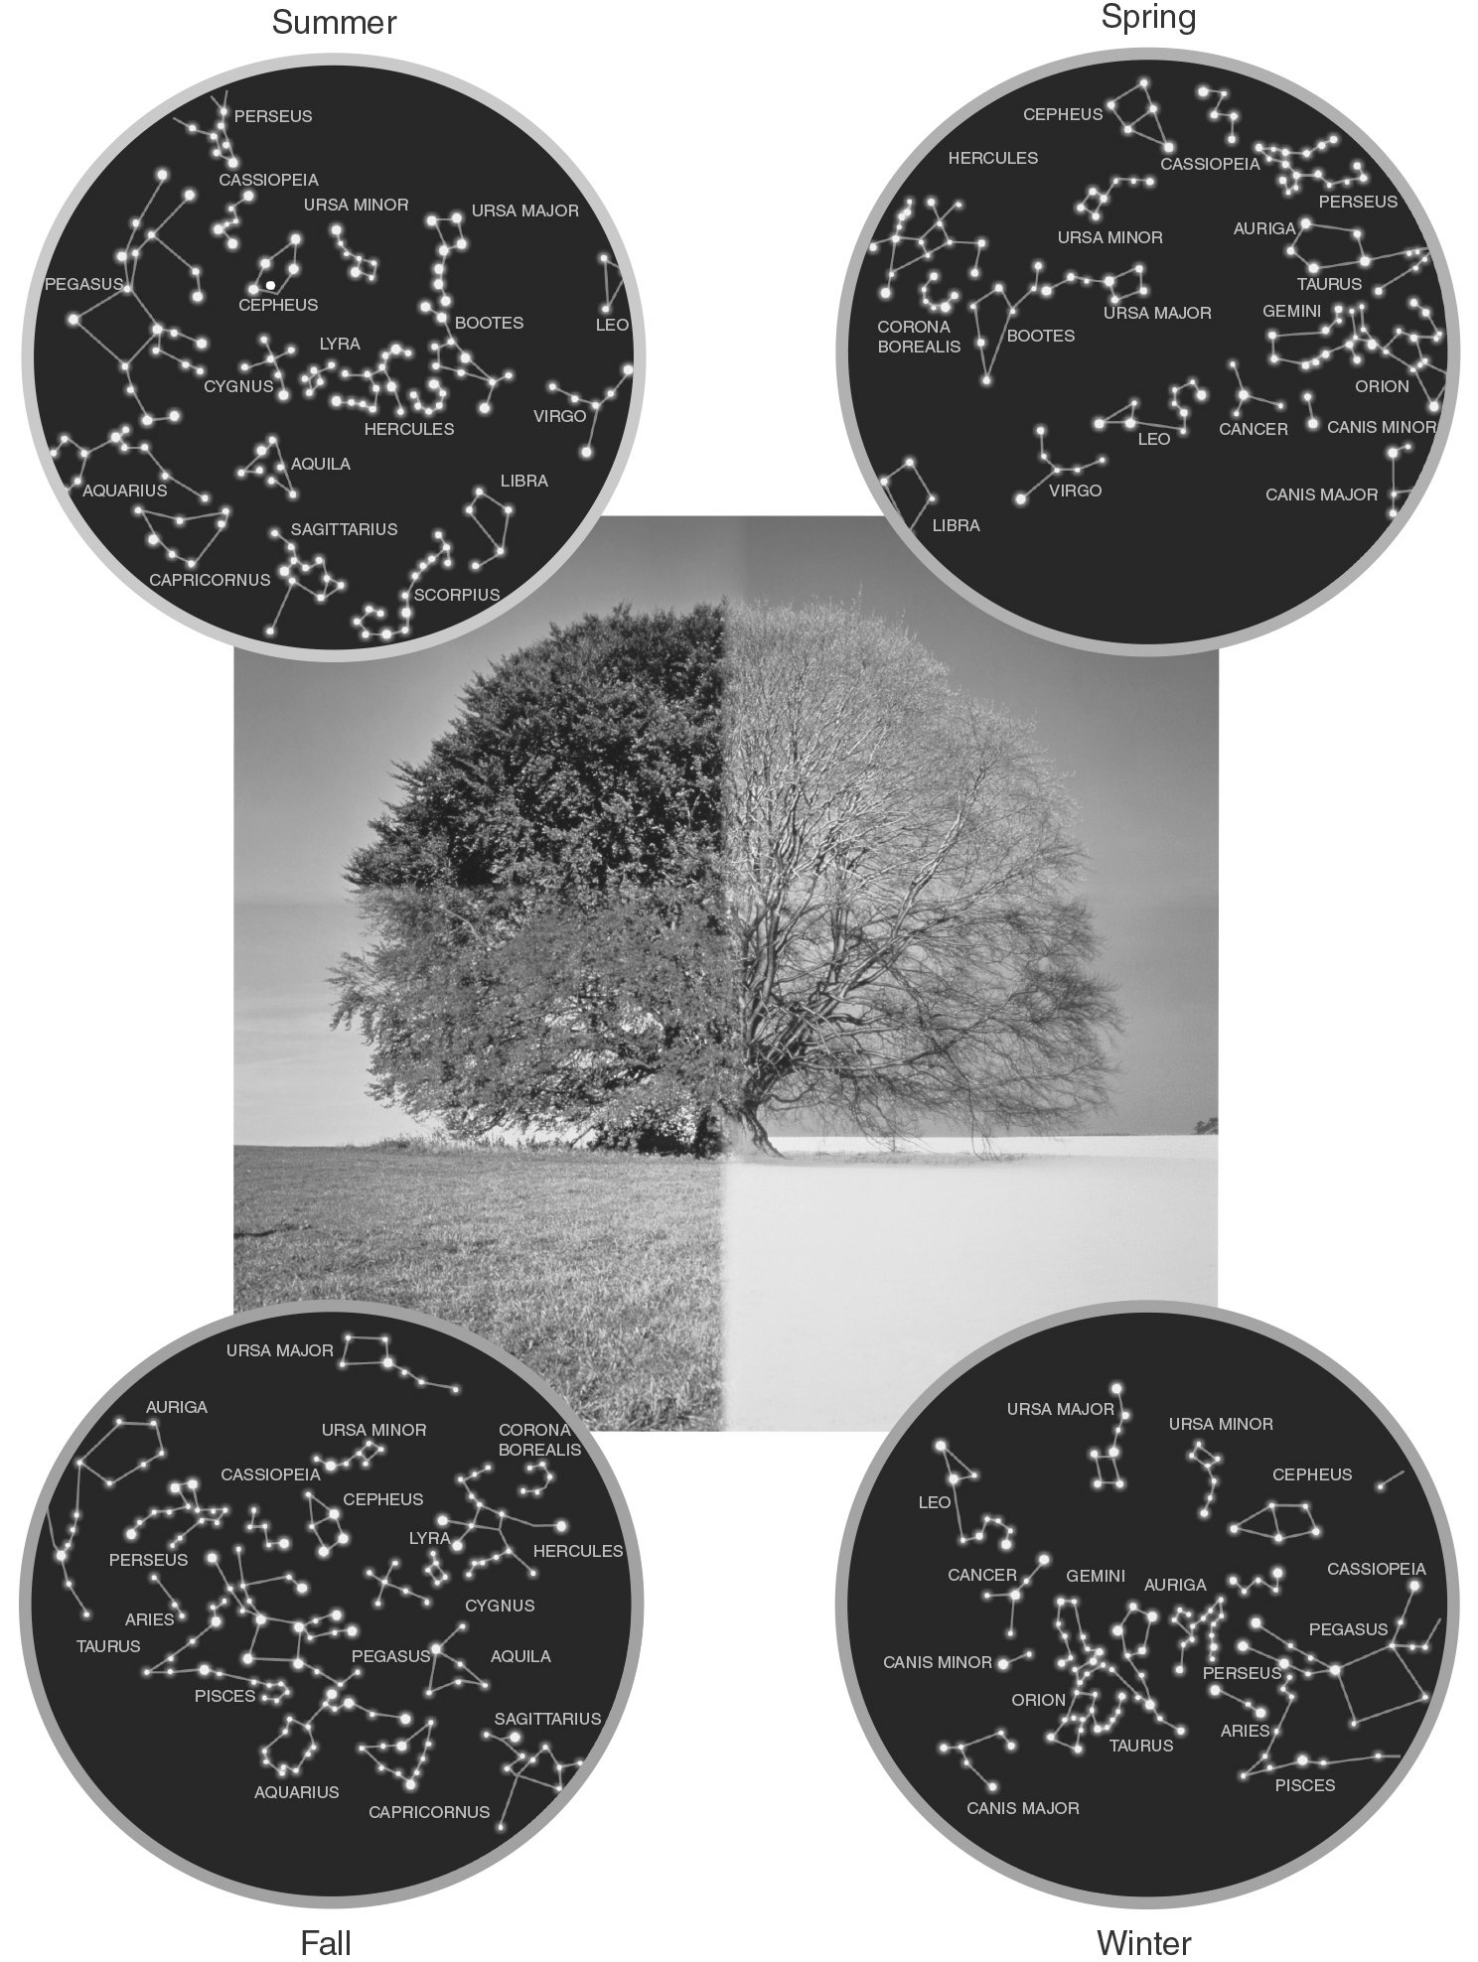
a. | the stars move about the sky randomly.
b. | the stars appear to rotate over the course of a year.
c. | the night sky is always the same.
d. | there are only four possible configurations of stars in the sky.
e. | the position of the stars changes the temperature of the Earth.

ANS: B DIF: Moderate REF: 1.3
OBJ: 1.3a Identify patterns in nature. MSC: Analyzing

50. When you let go of an apple, you expect it to fall to the ground. This is because
a. | down is the only direction it can go in.
b. | apples always move directly toward the largest object.
c. | your science teacher has told you that is the only possibility.
d. | red colors are attracted to green colors.
e. | there has been a past pattern of objects always falling toward the Earth.

ANS: E DIF: Moderate REF: 1.3
OBJ: 1.3a Identify patterns in nature. MSC: Applying

51. When you see a pattern in nature, it is usually evidence of
a. | a theory being displayed. | d. | an underlying physical law.
b. | quantum mechanics in action. | e. | a decrease in entropy.
c. | a breakdown of random clustering.

ANS: D DIF: Easy REF: 1.3
OBJ: 1.3b Explain how natural patterns imply underlying physical laws.
MSC: Understanding

52. If nature behaves according to a certain physical law, then that law should result in
a. | random behavior. | d. | quantum mechanics.
b. | repeating patterns. | e. | the Big Bang.
c. | Occam’s razor.

ANS: B DIF: Easy REF: 1.3
OBJ: 1.3b Explain how natural patterns imply underlying physical laws.
MSC: Understanding

53. Scientific notation is used in astronomy primarily because it allows us to
a. | write very large and very small numbers in a convenient way.
b. | talk about science in an easy way.
c. | change easy calculations into hard calculations.
d. | change hard calculations into easy calculations.
e. | explain science to engineers.

ANS: A DIF: Easy REF: 1.3
OBJ: Working It Out 1.1a Express numbers in scientific and standard notation.
MSC: Remembering

54. The number 123,000 written in scientific notation is
a. | 1.23 × 10⁶ | d. | 1.23 × 10⁻⁶
b. | 1.23 × 10⁵ | e. | 1.23 × 10⁻³
c. | 1.23 × 10³

ANS: B DIF: Easy REF: 1.3
OBJ: Working It Out 1.1a Express numbers in scientific and standard notation.
MSC: Applying

55. (6 × 10⁵) × (3 × 10⁻²) 
a. | 1.8 × 10³ | d. | 1.8 × 10⁸
b. | 1.8 × 10⁴ | e. | 1.8 × 10⁻³
c. | 1.8 × 10⁶

ANS: B DIF: Moderate REF: 1.3
OBJ: Working It Out 1.1a Express numbers in scientific and standard notation.
MSC: Applying

56. (1.2 × 10⁹) ÷ (4 × 10⁻³) 
a. | 3 × 10⁶ | d. | 3 × 10¹¹
b. | 3 × 10⁵ | e. | 3 × 10¹²
c. | 3 × 10¹⁰

ANS: D DIF: Moderate REF: 1.3
OBJ: Working It Out 1.1a Express numbers in scientific and standard notation.
MSC: Applying

57. The number 1.5 × 10⁴ can also be written as
a. | 0.00015 | d. | 15,000
b. | 0.0015 | e. | 150,000
c. | 1,500

ANS: D DIF: Easy REF: 1.3
OBJ: Working It Out 1.1a Express numbers in scientific and standard notation.
MSC: Applying

58. If the radius of circle B is twice the radius of circle A, and the area of a circle is proportional to the radius squared (A ∝ r²), then the ratio of the area of circle B to that of circle A is
a. | 4. | d. | 2.
b. | 0.5. | e. | 1.414.
c. | 0.25.

ANS: A DIF: Moderate REF: 1.3
OBJ: Working It Out 1.1b Describe the physical properties of objects using ratios.
MSC: Applying

59. If the radius of circle B is 5 times the radius of circle A, then the ratio of the area of circle B to that of circle A is
a. | 25. | d. | 0.04.
b. | 5. | e. | 0.025.
c. | 0.2.

ANS: A DIF: Moderate REF: 1.3
OBJ: Working It Out 1.1b Describe the physical properties of objects using ratios.
MSC: Applying

60. If the radius of sphere B is 5 times the radius of sphere A, then the ratio of the volume of sphere B to the volume of sphere A is
a. | 0.008. | d. | 25.
b. | 0.2. | e. | 125.
c. | 5.

ANS: E DIF: Moderate REF: 1.3
OBJ: Working It Out 1.1b Describe the physical properties of objects using ratios.
MSC: Applying

61. The area of a circle is related to its diameter by the 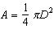 formula Using algebra to solve for D, we find that
a. | 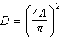 | d. | 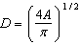
b. | 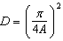 | e. | 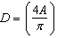
c. | 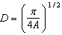

ANS: D DIF: Moderate REF: 1.3
OBJ: Working It Out 1.1c Predict the change in proportional quantities with respect to each other.
MSC: Applying

62. The volume of a sphere is related to its radius by the formula 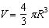. Using algebra to solve for R, we get
a. | 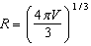 | d. | 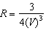
b. | 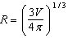 | e. | 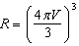
c. | 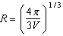

ANS: B DIF: Difficult REF: 1.3
OBJ: Working It Out 1.1c Predict the change in proportional quantities with respect to each other.
MSC: Applying

63. If the speed of light is 3 × 10⁵ km/s and 1 km = 0.62 mile, what is the speed of light in miles per hour (mph)?
a. | 670 million mph | d. | 186 thousand mph
b. | 670 thousand mph | e. | 3.2 billion mph
c. | 186 mph

ANS: A DIF: Difficult REF: 1.3
OBJ: Working It Out 1.1c Predict the change in proportional quantities with respect to each other.
MSC: Applying

64. The orbital period of Mercury is 88 days. What is its orbital period in units of seconds?
a. | 76,000 seconds | d. | 760 billion seconds
b. | 7.6 million seconds | e. | 76 million seconds
c. | 7.6 billion seconds

ANS: B DIF: Difficult REF: 1.3
OBJ: Working It Out 1.1c Predict the change in proportional quantities with respect to each other.
MSC: Applying

65. What are the units of the vertical axis in the figure below?
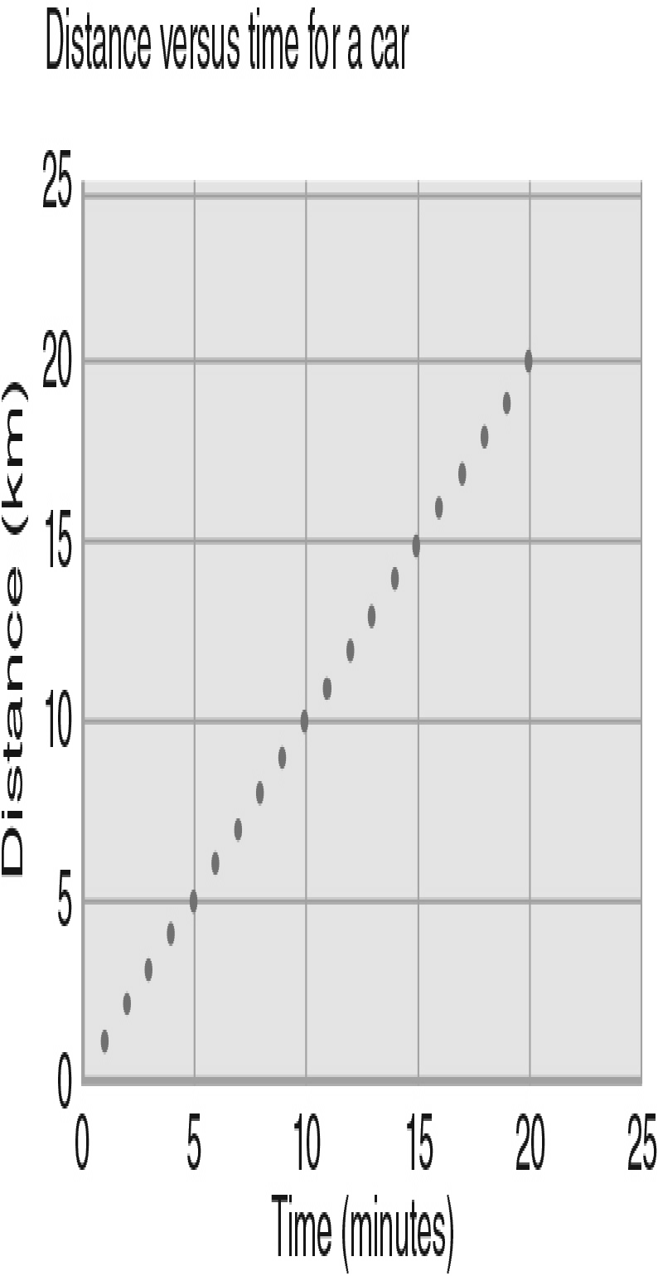
a. | km | d. | h/km
b. | hours | e. | There are no units on this axis.
c. | km/h

ANS: A DIF: Easy REF: 1.3
OBJ: Working It Out 1.2a Identify the major features of a graph: x-axis, y-axis, x scale, y scale, data points, slope. MSC: Understanding

66. What is the slope of line in the figure below?
a. | 0 km/h | d. | 60 km/h
b. | 6 km/h | e. | 60 h/km
c. | 6 h/km

ANS: D DIF: Moderate REF: 1.3
OBJ: Working It Out 1.2a Identify the major features of a graph: x-axis, y-axis, x scale, y scale, data points, slope. MSC: Analyzing

67. Which graph in the figures below is a plot of a linear behavior?
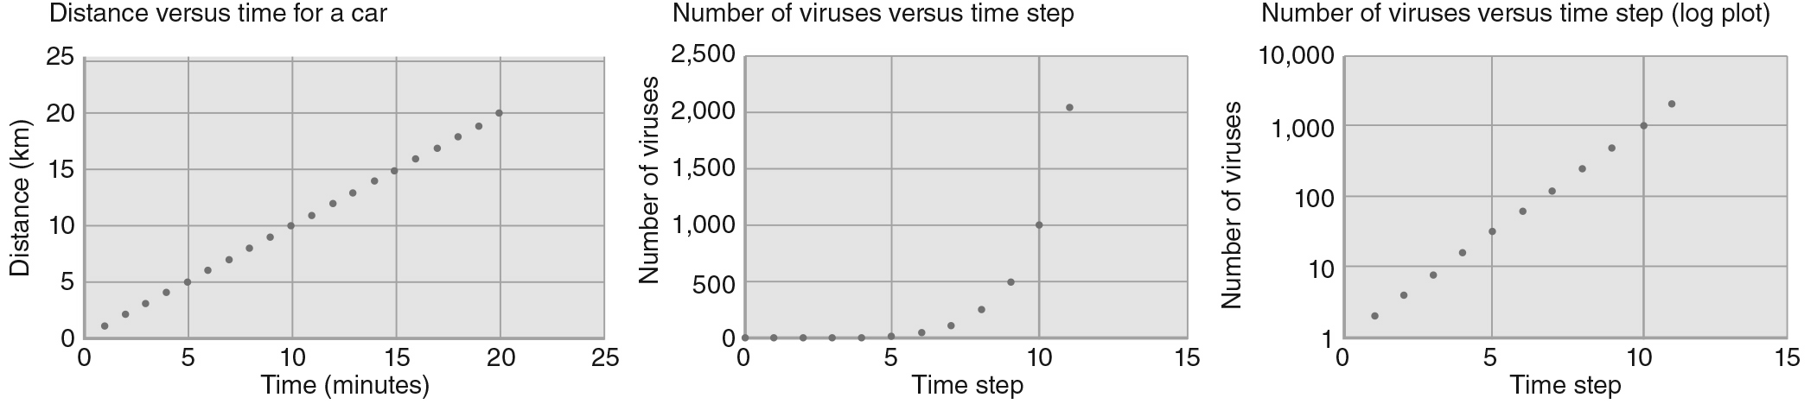
a. | figure (a) | d. | none of these
b. | figure (b) | e. | all three graphs
c. | figure (c)

ANS: A DIF: Moderate REF: 1.3
OBJ: Working It Out 1.2b Assess different curves on a graph. MSC: Analyzing

68. Approximately how many viruses are there at time step 10 in the figure below?
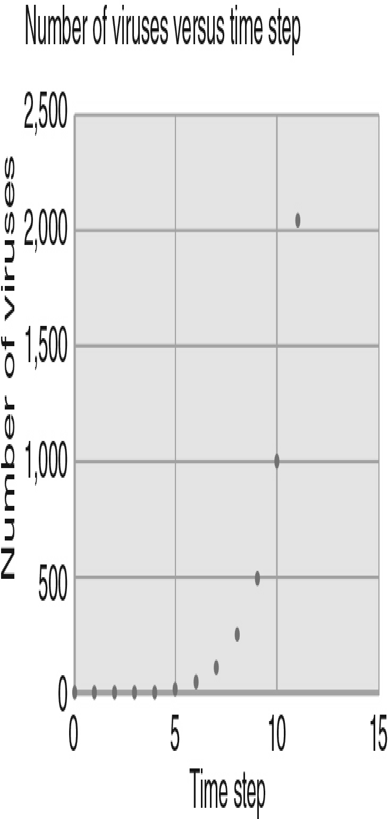
a. | 500 | d. | 2,000
b. | 1,000 | e. | 2,500
c. | 1,500

ANS: B DIF: Easy REF: 1.3
OBJ: Working It Out 1.2c Demonstrate the ability to read data from a graph.
MSC: Analyzing

69. Approximately how many viruses are there at time step 5 in the figure below?
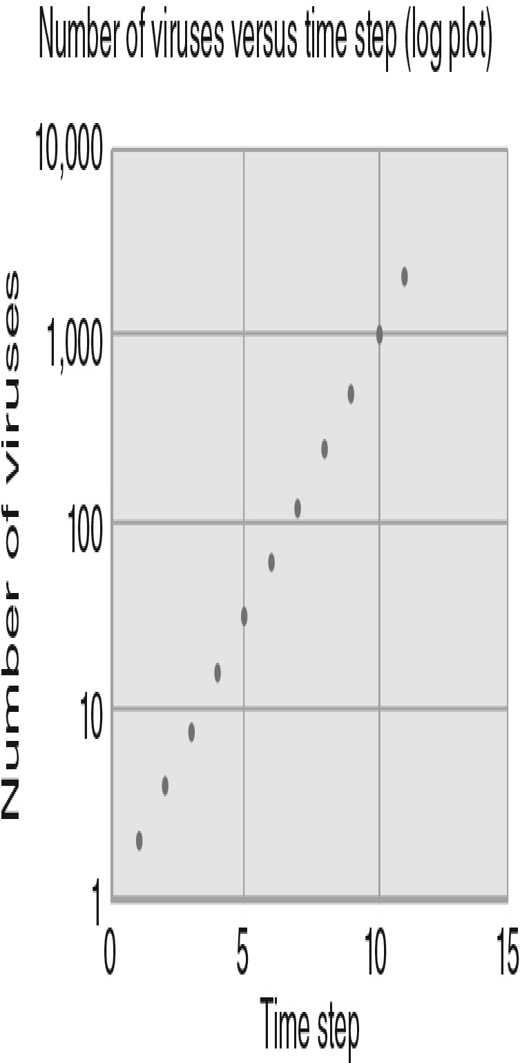
a. | 2 | d. | 90
b. | 10 | e. | 100
c. | 30

ANS: C DIF: Difficult REF: 1.3
OBJ: Working It Out 1.2c Demonstrate the ability to read data from a graph.
MSC: Analyzing

70. The study of whether or not life exists elsewhere in the Solar System and beyond is called
a. | origins. | d. | astrobiology.
b. | biochemistry. | e. | exoplanetology.
c. | cosmology.

ANS: D DIF: Moderate REF: Origins 1
OBJ: Origins 1a Explain the goals and scope of the field of astrobiology.
MSC: Understanding

SHORT ANSWER

1. What is the only thing that makes the Sun an exceptional star?

ANS:
The fact that it is our star!

DIF: Easy REF: 1.1 OBJ: 1.1a State our “cosmic address.”
MSC: Remembering

2. What is the Local Group?

ANS:
The group of a dozen or so galaxies including the Milky Way that are within a few million light-years of each other.

DIF: Easy REF: 1.1 OBJ: 1.1a State our “cosmic address.”
MSC: Remembering

3. Suppose you were writing to a pen pal in another universe. What address would you put on the envelope that included all the major structures in which we reside? (Hint: Your cosmic address should begin with “Earth” and end with “the universe.”)

ANS:
The address would be Earth, Solar System, Milky Way, Local Group, Laniakea Supercluster, the universe.

DIF: Moderate REF: 1.1 OBJ: 1.1a State our “cosmic address.”
MSC: Remembering

4. When we look at distant objects, we see them as they were in the past. Why is this?

ANS:
The finite speed of light means that objects observed at larger distances are observed as they existed in the past.

DIF: Easy REF: 1.1
OBJ: 1.1b Express astronomical distances and distance scales. MSC: Understanding

5. Describe how we can use travel times as a measure for distances.

ANS:
If speed is constant, a difference in time is directly related to a difference in distance. A time difference is easier to conceptualize.

DIF: Moderate REF: 1.1
OBJ: 1.1b Express astronomical distances and distance scales. MSC: Understanding

6. What would you say to someone who said, “It would take light-years to get to the Andromeda Galaxy”?

ANS:
You would tell them that a light-year is a unit of distance, not time.

DIF: Moderate REF: 1.1
OBJ: 1.1b Express astronomical distances and distance scales. MSC: Applying

7. If you compare the diameter of Earth to 1 minute of time, then what interval of time would represent the diameter of the Solar System? Assume the diameter of the Solar System is approximately 80 AU.

ANS:
The diameter of Earth is 2 × 6,378 km = 1.3 × 10⁷ m, and 80 AU = 80 × 1.5 × 10¹¹ m = 1.2 × 10¹³ m. Thus, the diameter of the Solar System would be represented by 1.2 × 10¹³ m ×
(1 minute)/(1.3 × 10⁷ m) = 9.4 × 10⁵ minutes = 1.8 years.

DIF: Difficult REF: 1.1
OBJ: 1.1b Express astronomical distances and distance scales. MSC: Analyzing

8. Using the method of comparing times to get a handle on the large distances in astronomy, compare the size of Earth to the size of the visible universe. Start by making the size of Earth comparable to a snap of your fingers, which lasts about 1/7 second. Show your computation.

ANS:
If the size of Earth is like a snap of your fingers (1/7 second), the size of the visible universe would be 13.7 billion years × (3.15 x 10⁷ seconds/year) / (1/7 seconds) = 18 x 10¹⁸ times the radius of Earth.

DIF: Moderate REF: 1.1
OBJ: 1.1b Express astronomical distances and distance scales. MSC: Analyzing

9. Using the method of comparing distances to time intervals to get a handle on the large distances in astronomy, compare the diameter of our Solar System, which is 6 × 10¹², to the diameter of the galaxy, which is 1.2 × 10²¹, by calculating the time it would take for light to travel these diameters. For reference, the speed of light is 3 × 10⁸ m/s.

ANS:
The time it takes light to travel across the diameter of the Solar System is t = d/v = 6 ×10¹²
m/ (33×10⁸ m/s) = 20,000 s × (1 h/3600 s) = 5.5 h. The time it takes light to travel across the diameter of the galaxy is t = 1.2 × 10²¹ m/(3 × 10⁸ m/s) = 4 × 10¹² s × (1 h/3600 s) × (1 day/24 h) × (1 y/365 day) = 130,000 y.

DIF: Difficult REF: 1.1
OBJ: 1.1b Express astronomical distances and distance scales. MSC: Analyzing

10. What implication does the finite speed of light have on what we observe in the universe?

ANS:
It means we see objects as they were when the light left them. Looking farther away from Earth is also looking farther back in time.

DIF: Difficult REF: 1.1
OBJ: 1.1b Express astronomical distances and distance scales. MSC: Applying

11. What does the word dark mean in the terms dark matter and dark energy?

ANS:
They are “dark” because they do not interact with light.

DIF: Moderate REF: 1.1
OBJ: 1.1c Explain basic astronomical terms and concepts. MSC: Remembering

12. Explain the scientific definitions for the terms idea, hypothesis, and theory, and how they are distinct concepts from one another.

ANS:
An idea can be any thought, a scientific hypothesis is a falsifiable or testable idea, and a scientific theory is a hypothesis that has been tested repeatedly and continues to hold in the face of criticism.

DIF: Easy REF: 1.2
OBJ: 1.2a Explain the scientific usage of the terms fact, idea, hypothesis, theory, and law.
MSC: Applying

13. How would you respond to someone who stated that “Evolution is not proven; it is just a theory”?

ANS:
You would need to explain that in science, a theory is not something that is proven; rather it our best explanation based on available data. Thus, calling something a theory does not diminish its importance.

DIF: Difficult REF: 1.2
OBJ: 1.2b Distinguish between the common meanings of the terms fact, idea, hypothesis, theory, and law, and their scientific meanings. MSC: Applying

14. An observation does not support your hypothesis. What do you do next?

ANS:
Make more observations, revise the hypothesis, or choose a new hypothesis.

DIF: Easy REF: 1.2 OBJ: 1.2c Describe the steps of the scientific method.
MSC: Understanding

15. What is a theoretical model?

ANS:
A theoretical model is a detailed description of the properties of a particular system in terms of known physical laws or theories, which can be used to make predictions.

DIF: Easy REF: 1.2 OBJ: 1.2c Describe the steps of the scientific method.
MSC: Remembering

16. Describe the main steps involved in the scientific method.

ANS:
First you make a hypothesis and then you make a prediction based on your hypothesis. Then you test your prediction through experimentation to prove or disprove your original hypothesis. You revise your hypothesis, if necessary, when the experiments disagree with it.

DIF: Moderate REF: 1.2 OBJ: 1.2c Describe the steps of the scientific method.
MSC: Understanding

17. What is required for an idea to be a scientific hypothesis?

ANS:
The idea must be testable and falsifiable.

DIF: Easy REF: 1.2 OBJ: 1.2d Assess whether a given statement is scientific.
MSC: Understanding

18. Why is the statement “The Big Bang was caused by a collision between other universes” not scientific?

ANS:
The statement is not scientific because it is not testable.

DIF: Easy REF: 1.2 OBJ: 1.2d Assess whether a given statement is scientific.
MSC: Applying

19. Before 2014 the supercluster we resided in was called the Virgo Supercluster. Based on a new way of classifying superclusters we are now a member of the Laniakea Supercluster. What is this change an example of?

ANS:
The provisional nature of scientific knowledge.

DIF: Easy REF: 1.2
OBJ: 1.2e Demonstrate that scientific knowledge is provisional.
MSC: Applying

20. Why does a theory that continues to be supported by the results of experimental tests need further tests?

ANS:
There may be observational tests or measurements that might be performed with greater precision for which the predictions of the theory might fail.

DIF: Moderate REF: 1.2
OBJ: 1.2e Demonstrate that scientific knowledge is provisional.
MSC: Understanding

21. What two pre-Renaissance beliefs are contradicted by the cosmological principle?

ANS:
(1) Earth is at the center of our universe, and (2) celestial objects are made of a different substance from Earth and obey different rules.

DIF: Moderate REF: 1.2
OBJ: 1.2e Demonstrate that scientific knowledge is provisional.
MSC: Remembering

22. Describe two ways in which Einstein’s new theories changed commonly accepted scientific views of his time.

ANS:
Mass and energy are manifestations of the same phenomenon. Thus, you can convert one into the other. Time and space are not separable but are intimately related to one another. Thus, Newton’s law of gravity is only a special case of a more general law Einstein called general relativity. However, Newton’s law of gravity is much easier for most calculations in our day-to-day lives.

DIF: Moderate REF: 1.2
OBJ: 1.2e Demonstrate that scientific knowledge is provisional.
MSC: Understanding

23. Describe the two main aspects of the cosmological principle.

ANS:
(1) What we see around us is representative of what the universe is like in general, and (2) the physical laws valid on Earth are valid everywhere.

DIF: Easy REF: 1.2
OBJ: 1.2f Explain the significance of the cosmological principle.
MSC: Remembering

24. In pre-Renaissance times, it was believed that celestial objects were made of a different substance from that of Earth and obeyed different rules. Which modern scientific principle is a better description of the universe?

ANS:
The cosmological principle.

DIF: Moderate REF: 1.2
OBJ: 1.2f Explain the significance of the cosmological principle.
MSC: Applying

25. A snowstorm hits New York City in June (a typically snow-free month), and three newscasters each claim a different reason: Newscaster A claims that this storm is a random variation in the weather; Newscaster B claims that the seasons are shifting, and summer is now the new winter; and Newscaster C claims that the entire Earth is cooling down. Compare the validity of these three hypotheses using Occam’s razor.

ANS:
Occam’s razor states that we cannot assume more than is necessary to describe the data we have. Because June is typically snow-free in New York City, Newscaster B requires us to assume the past pattern is changing, which requires more data than we have. Newscaster C is making a broad claim about the entire planet, and unless he or she can back this up with records of abnormal snowfalls in other parts of the world, and show a trend, this hypothesis would require even more data than we have. Newscaster A’s hypothesis is the simplest, as it requires no additional data, and is the one we should accept at this time.

DIF: Difficult REF: 1.2
OBJ: 1.2g Evaluate competing hypotheses using Occam’s razor.
MSC: Analyzing

26. There are many different areas of science, but a common factor in each is the evaluation and analysis of patterns. What patterns does astronomy deal with? Describe them in general and give at least one specific example.

ANS:
Astronomy deals with patterns related to celestial objects. One example is that patterns in the sky mark the changing of seasons, the coming of rains, the movement of herds, and the planting and harvesting of crops. An additional example is that the Sun rises and sets at a specific time because Earth orbits the Sun.

DIF: Easy REF: 1.3 OBJ: 1.3a Identify patterns in nature.
MSC: Understanding

27. It is often said that “mathematics is the language of science.” Explain why this is true.

ANS:
Math is a formal system used when describing and analyzing patterns, and explaining the reasons for patterns is the heart of science. Thus, math is the language of science.

DIF: Easy REF: 1.3 OBJ: 1.3a Identify patterns in nature.
MSC: Understanding

28. An observed pattern in nature is usually a sign of some underlying physical reason. Give an example of this in astronomy, citing the pattern and the reason behind it.

ANS:
The Sun rises and sets each day. This pattern is due to Earth’s daily rotation on its axis. The stars visible in the sky at a given time of day change throughout the year, but the pattern repeats every year. This is due to Earth’s orbital motion around the Sun in one year.

DIF: Easy REF: 1.3
OBJ: 1.3b Explain how natural patterns imply underlying physical laws.
MSC: Applying

29. The two panels in the figure below display the same data. Explain why the trends look different between the two graphs.
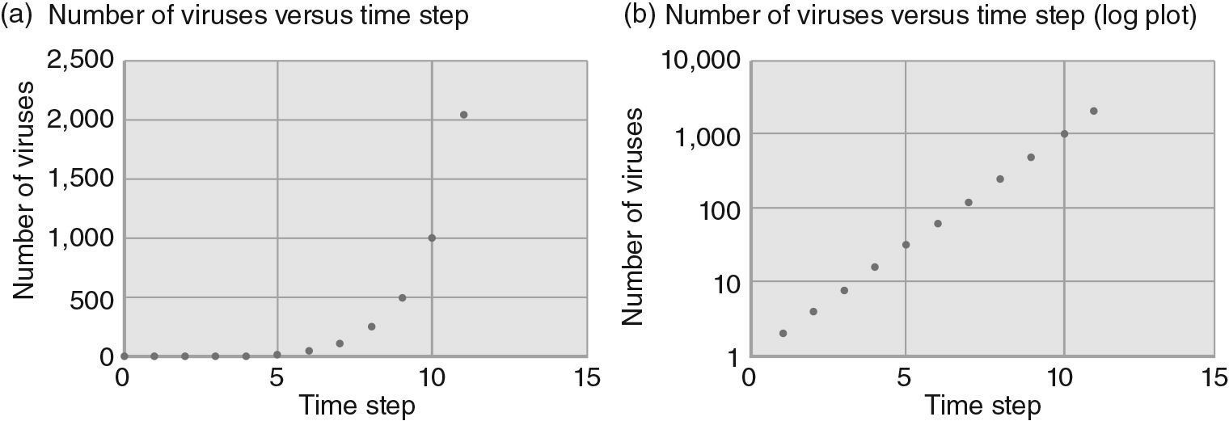

ANS:
The y-axes scales are different. In panel (a), a linear scale was used, resulting in a clear exponential curve. In panel (b), a logarithmic scale was used, making the exponential curve look like a linear one. Linear axes are often easier for humans to comprehend, but logarithmic ones are better for compactly showing large variations in values.

DIF: Moderate REF: 1.3
OBJ: Working It Out 1.2b Assess different curves on a graph. MSC: Evaluating

30. Explain what the field of astrobiology studies.

ANS:
Astrobiology is the study of life in the universe, and the origins of that life.

DIF: Easy REF: Origins 1
OBJ: Origins 1a Explain the goals and scope of the field of astrobiology.
MSC: Understanding

