Solutions Manual

Water Supply and Pollution Control

Eighth Edition

**Warren Viessman, Jr., P.E.**

*University of Florida*

**Mark J. Hammer, Emeritus Engineer**

*Lincoln, Nebraska*

**Elizabeth M. Perez, P.E.**

*Palm Beach Gardens, Florida*

**Paul A. Chadik, P.E.**

*University of Florida*

This work is protected by United States copyright laws and is provided solely for the use of instructors in teaching their courses and assessing student learning. Dissemination or sale of any part of this work (including on the World Wide Web) will destroy the integrity of the work and is not permitted. The work and materials from it should never be made available to students except by instructors using the accompanying text in their classes. All recipients of this work are expected to abide by these restrictions and to honor the intended pedagogical purposes and the needs of other instructors who rely on these materials.

**CHAPTER 1**

*NO SOLUTIONS REQUIRED*

**CHAPTER 2**

**WATER RESOURCES PLANNING AND MANAGEMENT**

* 1. The Internet is an excellent source of information on this topic. The level of integrated water resources management varies by state.
  2. Virtually all of the laws listed in Table 2.1 provide some protection for preventing and controlling water pollution. Information on each law may be found on the Internet. It is also important to note that the EPA only regulates at the Federal level and much of the cleanup and protection is now delegated to states and local governments.
  3. Point source pollution = Pollution that originates at one location with discrete discharge points. Typical examples include industrial and wastewater treatment facilities. Nonpoint source pollution = Pollution that is usually input into the environment in a dispersed manner. Typical examples include stormwater runoff that contains fertilizers, pesticides, herbicides, oils, grease, bacteria, viruses, and salts.
  4. Adverse health effects of toxic pollutants are numerous and can include a variety of conditions. Some pollutant-related conditions include asthma, nausea, and various cancers—among many others.
  5. Agencies that are responsible for water quantity and quality significantly vary by state.
  6. This is a subjective question and one that has been and will continue to be debated in the water resources community.
  7. Integrated water resources management is difficult to achieve because it involves both a financial and resources investment over time. It is also important to obtain concensus on this approach from all of the involved stakeholders. This difficulty is perhaps why there are so few examples of true integrated water resources management.
  8. This question is subjective but the student should research specific examples to support their argument.

**CHAPTER 3**

**THE HYDROLOGIC CYCLE AND NATURAL WATER SOURCES**

* 1. The answer to this question will vary by location.

3.2 reservoir area = 3900/640 = 6.1 sq. mi.

annual runoff = (14/12)(190 – 6.1)(640) = 137,704 ac-ft

annual evaporation = (49/12)(3900) = 15,925 ac-ft

draft = (100 X 365 X 106)/(7.48 X 43,560) = 112,022 ac-ft

precipitation on lake = (40/12)(3900) = 13,000 ac-ft

gain in storage = 137,704 + 13,000 = 150,704

loss in storage = 112,022 + 15,925 = 127,947

net gain in storage = 22,757 ac-ft

* 1. reservoir area = 1700 hec = 17 X 106 sq. meters

annual runoff = 0.3(500 X 106 – 17 X 106) = 144 X 106 sq. meters

annual evaporation = 1.2 X 17 X 106 = 20.4 X 106 sq. meters

draft = 4.8 X 24 X 60 X 60 X 365 = 151.37 X 106 m3

precipitation on lake = 0.97 X 17 X 106 = 16.49 X106 m3

gain in storage = 144 X 106 +16.49 X 106 = 160.49 106

loss in storage = 151.37 X 106 + 20.4 X 106 = 171.77 X 106

net loss in storage = 11.28 X 106 m3

* 1. To complete a water budget, it is first important to understand how the water budget will be used and what time step will be necessary to successfully model the system. Once the budget is conceptually designed, a variety of online sources can usually be used to collect the data. These sources include—but are not limited to:
* state regulatory agencies
* special water districts
* weather agencies,
* local governments
* geological surveys
* agricultural agencies

Historical data and previous reports can also yield important information on the system. Verification and calibration data should also be considered as part of the data collection effort.

* 1. The solution for this problem will vary based on location.

3.6

|  |  |  |  |
| --- | --- | --- | --- |
| Event (n) | Precip (inches) | Tr = n/m | Freq. (% years) |
| 1 | 33 | 10 | 10 |
| 2 | 29 | 5 | 20 |
| 3 | 28 | 3.33 | 30 |
| 4 | 28 | 2.5 | 40 |
| 5 | 27 | 2 | 50 |
| 6 | 26 | 1.67 | 60 |
| 7 | 22 | 1.4 | 70 |
| 8 | 21 | 1.25 | 80 |
| 9 | 19 | 1.1 | 90 |
| 10 | 18 | 1 | 100 |

n = 10, m = rank, Tr = n/m, Freq = (1/Tr) X 100 Then plot precipitation versus frequency.

3.7

|  |  |  |  |
| --- | --- | --- | --- |
| Event (n) | Precip (inches) | Tr = n/m | Freq. (% years) |
| 1 | 89 | 10 | 10 |
| 2 | 75 | 5 | 20 |
| 3 | 72 | 3.33 | 30 |
| 4 | 70 | 2.5 | 40 |
| 5 | 69 | 2 | 50 |
| 6 | 66 | 1.67 | 60 |
| 7 | 56 | 1.4 | 70 |
| 8 | 54 | 1.25 | 80 |
| 9 | 48 | 1.1 | 90 |
| 10 | 46 | 1 | 100 |

n = 10, m = rank, Tr = n/m, Freq = (1/Tr) X 100 Then plot precipitation versus frequency.

* 1. Once the data is organized in a table (see below), the solution can be found. Note that the cumulative max deficiency is 131.5 mg/mi2, which occurs in September. The number of months of draft is 131.5/(448/12) = 3.53. Therefore, enough storage is needed to supply the region for about 3.5 months.

|  |  |  |  |  |  |
| --- | --- | --- | --- | --- | --- |
| Month | Inflow *I* | Draft *O* | Cumulative Inflow Σ *I* | Deficiency  *O* - *I* | Cumulative Deficiency  Σ (*O* – *I*)* |
| Feb | 31 | 37.3 | 31 | 6.3 | 6.3 |
| March | 54 | 37.3 | 85 | -16.7 | 0 |
| April | 90 | 37.3 | 175 | -52.7 | 0 |
| May | 10 | 37.3 | 185 | 27.3 | 27.3 |
| June | 7 | 37.3 | 192 | 30.3 | 57.6 |
| July | 8 | 37.3 | 200 | 29.3 | 86.9 |
| Aug | 2 | 37.3 | 202 | 35.3 | 122.2 |
| Sep | 28 | 37.3 | 230 | 9.3 | 131.5 |
| Oct | 42 | 37.3 | 272 | -4.7 | 126.8 |
| Nov | 108 | 37.3 | 380 | -70.7 | 56.1 |
| Dec | 98 | 37.3 | 478 | -60.7 | 0 |
| Jan | 22 | 37.3 | 500 | 15.3 | 15.3 |
| Feb | 50 | 37.3 | 550 | -12.7 | 2.6 |

* Only positive values of cumulative deficiency are tabulated.

* 1. S = 128,000/10*100*640 = 0.20

3.10 S = 0.0002 = volume of water pumped divided by the average decline in piezometric head times surface area

0.0002 = V/(400 X 100)

Noting that there are 640 acres per square mile

V = 0.0002 X 400 X 100 X 640 = 5120 acre-feet

3.11 Draft = (0.726 mgd) X (30 days/mo) = 21.8 mg/month

|  |  |  |  |  |
| --- | --- | --- | --- | --- |
| Month | Inflow *I* | Draft *O* | Deficiency  *O* - *I* | Cumulative Deficiency  Σ (*O* – *I*)* |
| April | 97 | 21.8 | -75.2 | 0 |
| May | 136 | 21.8 | -114.2 | 0 |
| June | 59 | 21.8 | 37.2 | 0 |
| July | 14 | 21.8 | 7.8 | 7.8 |
| Aug | 6 | 21.8 | 15.8 | 23.6 |
| Sep | 5 | 21.8 | 16.8 | 40.43 |
| Oct | 3 | 21.8 | 18.8 | 59.2 |
| Nov | 7 | 21.8 | 14.8 | 74 |
| Dec | 19 | 21.8 | 2.8 | 76.8 |
| Jan | 13 | 21.8 | 8.8 | 85.6 |
| Feb | 74 | 21.8 | -52.2 | 33.4* |
| March | 96 | 21.8 | -74.2 | 0 |
| April | 37 | 21.8 | -15.2 | 0 |
| May | 63 | 21.8 | -41.2 | 0 |
| June | 49 | 21.8 | -27.2 | 0 |

*Maximum storage deficiency is January 85.6 mg/mo/sq. mi.

Storage capacity = 85.6 mg/mo/sq.mi.

* 1. Pn = (1 – 1/Tr)n

log Pn = n Log (1 – 1/Tr)

n = log Pn/log (1 – 1/Tr)

A straight line can be defined by this equation and the following probability curves will appear.

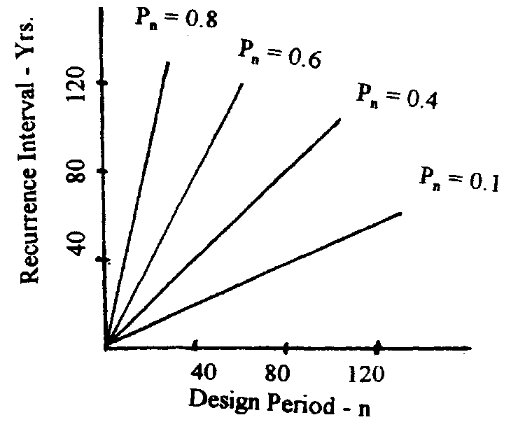

* 1. 20 month flow equals the sum of 12 + 11 + 10 + 12 + … + 6 + 7 + 9 = 169 cfs

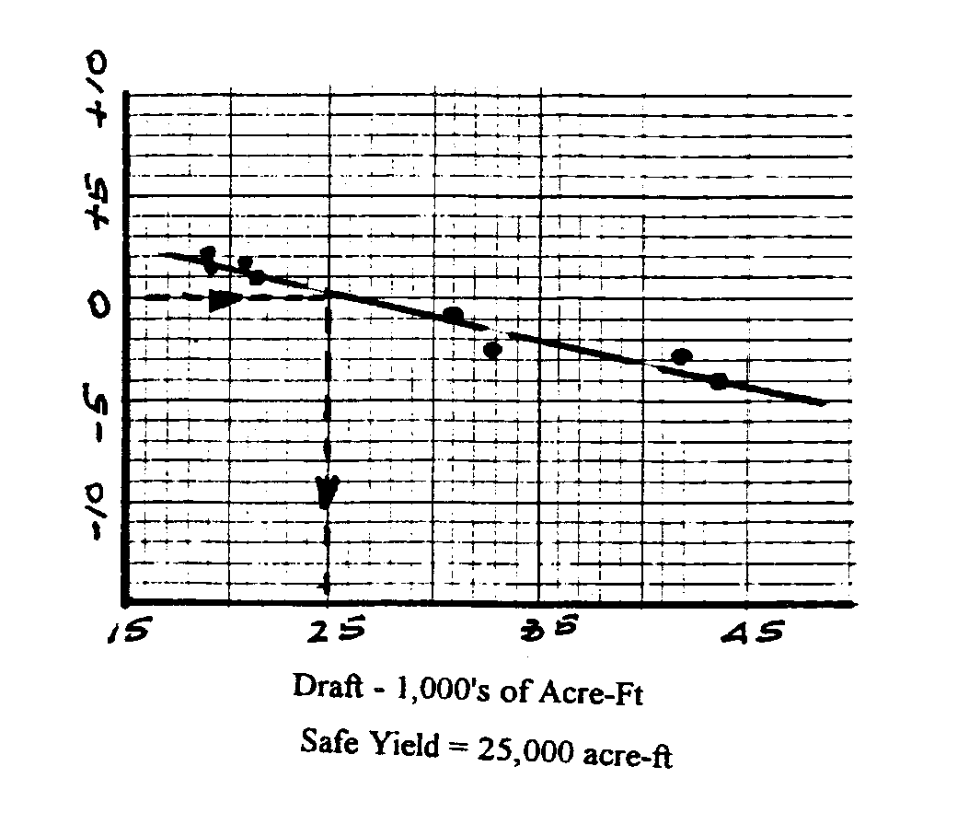

3.15

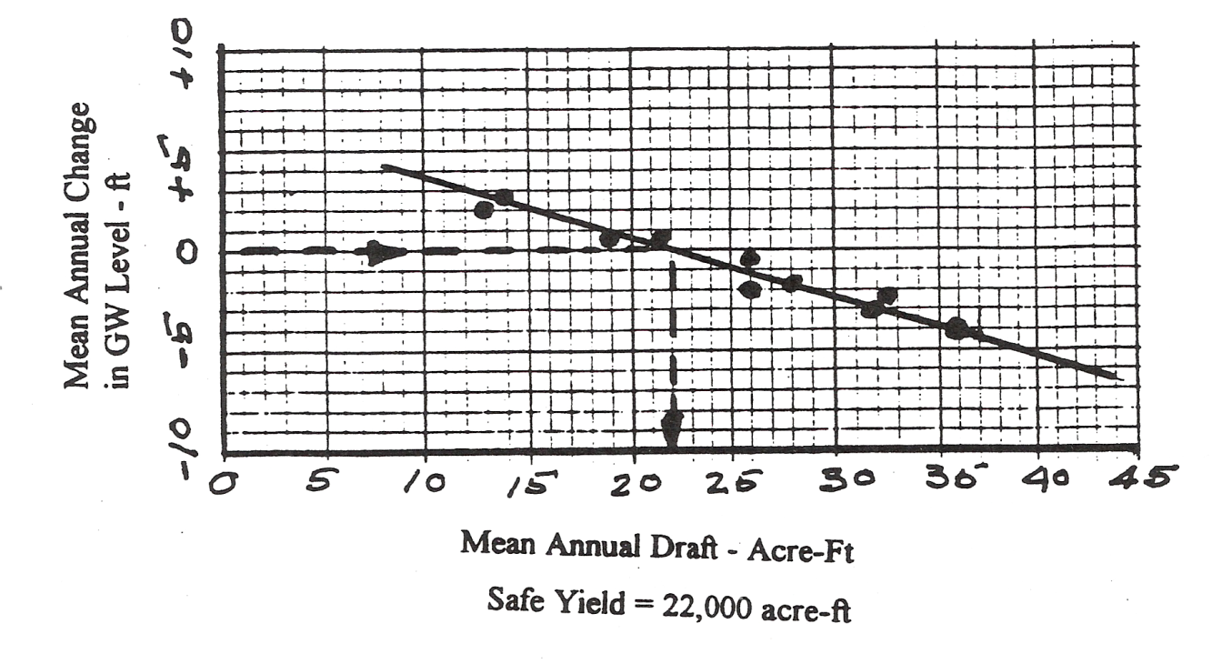

* 1. Reservoir capacity = 750 acre-feet

Reservoir yield is the amount of water which can be supplied during a specified time period. Assume the reservoir is to be operated continuously for 1 year without recharge. Also assume that evaporation, seepage, and other losses are zero.

Max continuous yield is 750 acre-ft/year

Or 750 X 43,560 X 0.304 = 917, 846 cubic meters per year

Or 750 X 43,560 X 7.48 X 365 X 24 X 60 = 465 gpm continuously for 1 year

* 1. Constant annual yield = 1500 gpm

Reservoir capacity = ? Time of operation without recharge = 1 yr

Res. Capacity = 1500 X 365 X 24 X 60 X 0.134 X (1/43,560) = 2,425 ac-ft/yr

This storage will provide a yield of 1,500 gpm for one year without any recharge

* 1. mean draft = 100 mgd, catchment area = 150 sq. mi., reservoir area = 4000 acres

rainfall = 38 inches, runoff = 13 inches, evaporation = 49 inches (mean annual)

1. gain or loss in storage = ?

ΔS = rainfall + runoff – evaporation – draft

rainfall = 38 X 4000 X (1/12) = 12,667 ac-ft

runoff = [(150 X 640) – 4000] X 13 X (1/12) = 99,967 ac-ft

evaporation = 49 X 4000 X (1/12) = 16,333 ac-ft

draft = 100,000,000 X 365 X 0.134 X (43,560) = 112,282 ac-ft

ΔS = 12,667 + 99,667 – 16,333 – 112,282 = -16,281 ac-ft

The net loss in storage is 16, 281 ac-ft

1. volume of water evaporated = 16,333 ac-ft

given a community of 100,000 people, assume a consumption of 150 gpcd

water demand = 100,000 X 150 X 365 = 5,475 mg/year

volume evaporated = 16,333 X 43,560 X 7.48 = 5,304 mg/year

evaporated water could supply the community with their water needs for

5304/5475 = 0.97 or for about one year

3.19 Use equation 3.29

K = 0.000287

h = 43

m = 8

n = 15

q = 0.000287*8*43/15 = 0.006582

Total Q is therefore 50*0.006582 = 0.325 cfs

3.20 q= 000084*8*22/15 = 0.000986

Q = 0.0007872*35 = 0.0345 m3/s

* 1. u = (1.87r2Sc)/Tt

= (1.87 * 1 * 6.4 * 10-4)/(6200 * 7.5 * 24 * 60) = 8.58 x 10 -10

Interpolating, W(u) = 20.3

S = (114.6 * 60,000 * 7.5 * 20.3)/(6,200 * 7.5 * 24 * 60) = 15.6

3.22 



* 1. Equation 3.20 is applicable









* 1. Using Equation 3.35, u can be computed



Referring to Table 3.5 and interpolating, we estimate W(u) to be 9.1. Then using Equation 3.34, the drawdown is found to be:



* 1. (a) Using Equation 3.35, u can be computed as follows:



Then from Table 3.5, W(u) is found to be 0.36. Applying Equation 3.33, the drawdown can be determined



1. Follow the procedure used in (a)



Then from Table 3.5, W(u) is found to be 4.06. Applying Eq. 3.33, the drawdown can be determined



* 1. (a) Using Equation 3.31, u can be computed as follows:



Then from Table 3.5, the drawdown can be determined,



(b) Follow the procedure used in (a)



Then from Table 3.5, W(u) is found to be 4.04

Applying Equation 3.33, the drawdown can be determined



* 1. (a) Using Equation 3.31, u can be computed as follows:



Then from Table 3.5, the drawdown can be determined,



(b) Follow the procedure used in (a)



Then from Table 3.5, W(u) is found to be 3.24

Applying Equation 3.33, the drawdown can be determined



3.28  gal/min

3.29  gpd/ft2

3.30 

From a plot of drawdown versus t, drawdown per log cycle is 28.2 – 10.5 = 17.1



Converting T to gal/day/ft

T=5100

 gpm

* 1. From plot of data, t0=1.25 minutes = 20.87 x 10-3 ft/day, and from plot,

Dh 14 feet

gpd/ft



3.32 

W(u)=-0.577216-ln(u)

Substituting and solving, using loge(u)

W(u)=8.537

feet

* 1. Use Equation 3.22



gpm

* 1. Use Equation 3.23



* 1. Use Equation 3.37 and refer to figure which follows

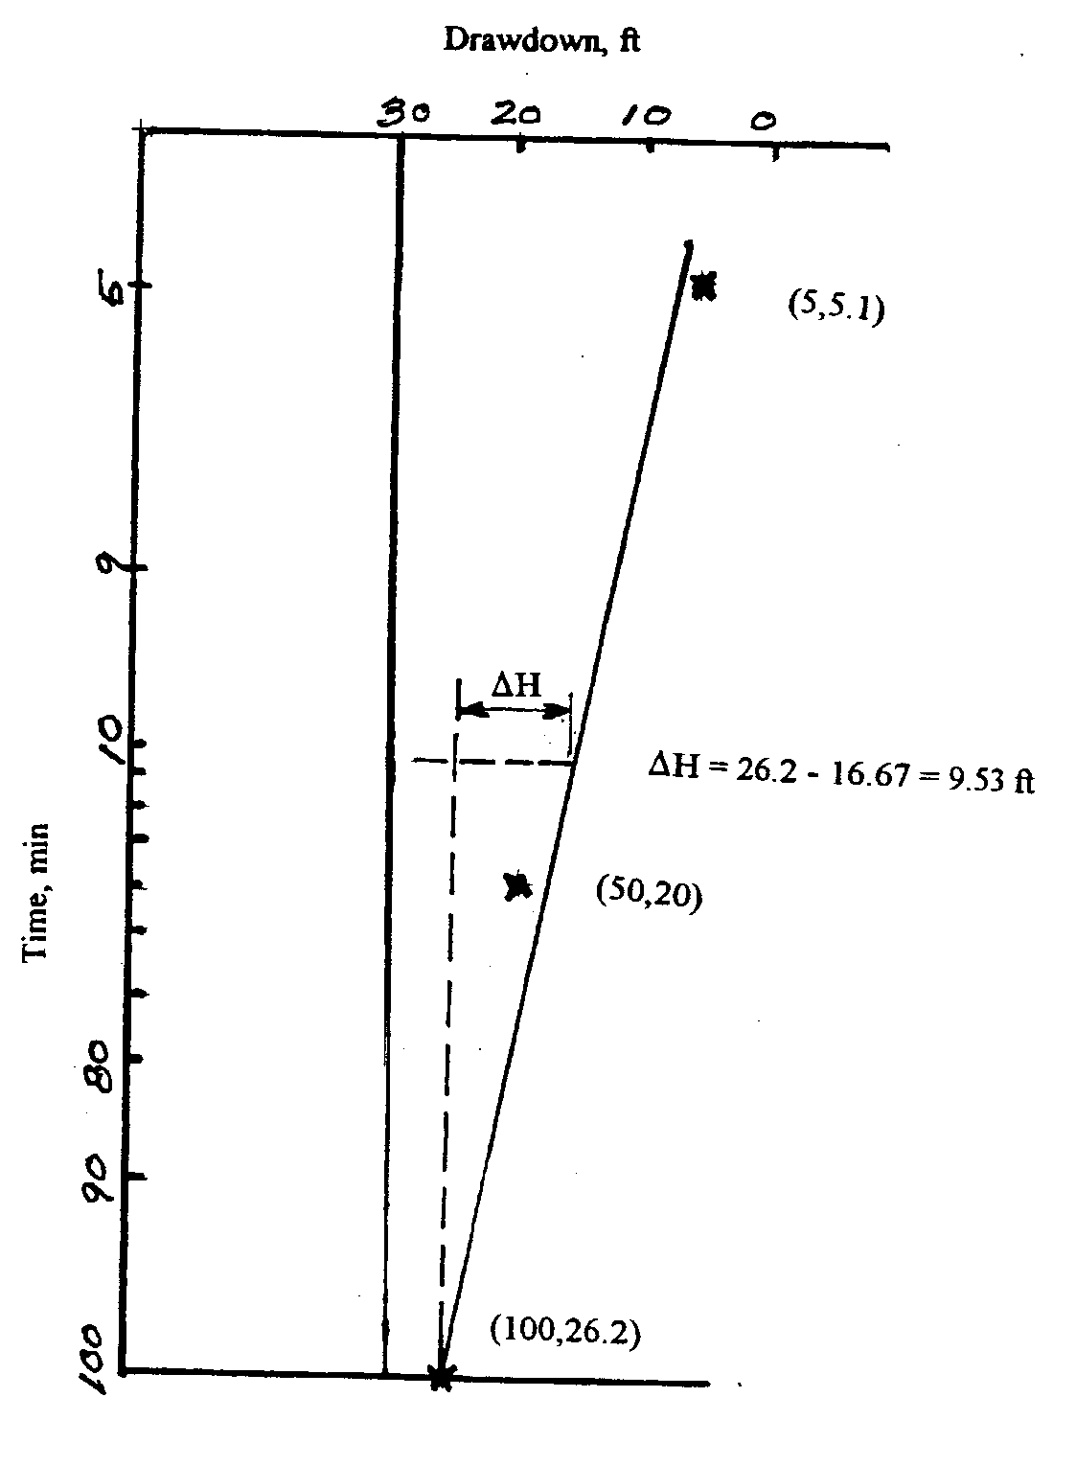

T=700*7.5 = 5250 gpd/ft

From Fig change in head is 9.53 feet

gpm

* 1. Use Equation 3.19



Q=gpm

* 1. Use Equations 3.34 and 3.35 refer to the following figure determine s and r2/t from the figure = 1.36 and 20,000

Determine u and W(u) from the figure = 0.09 and 1.9





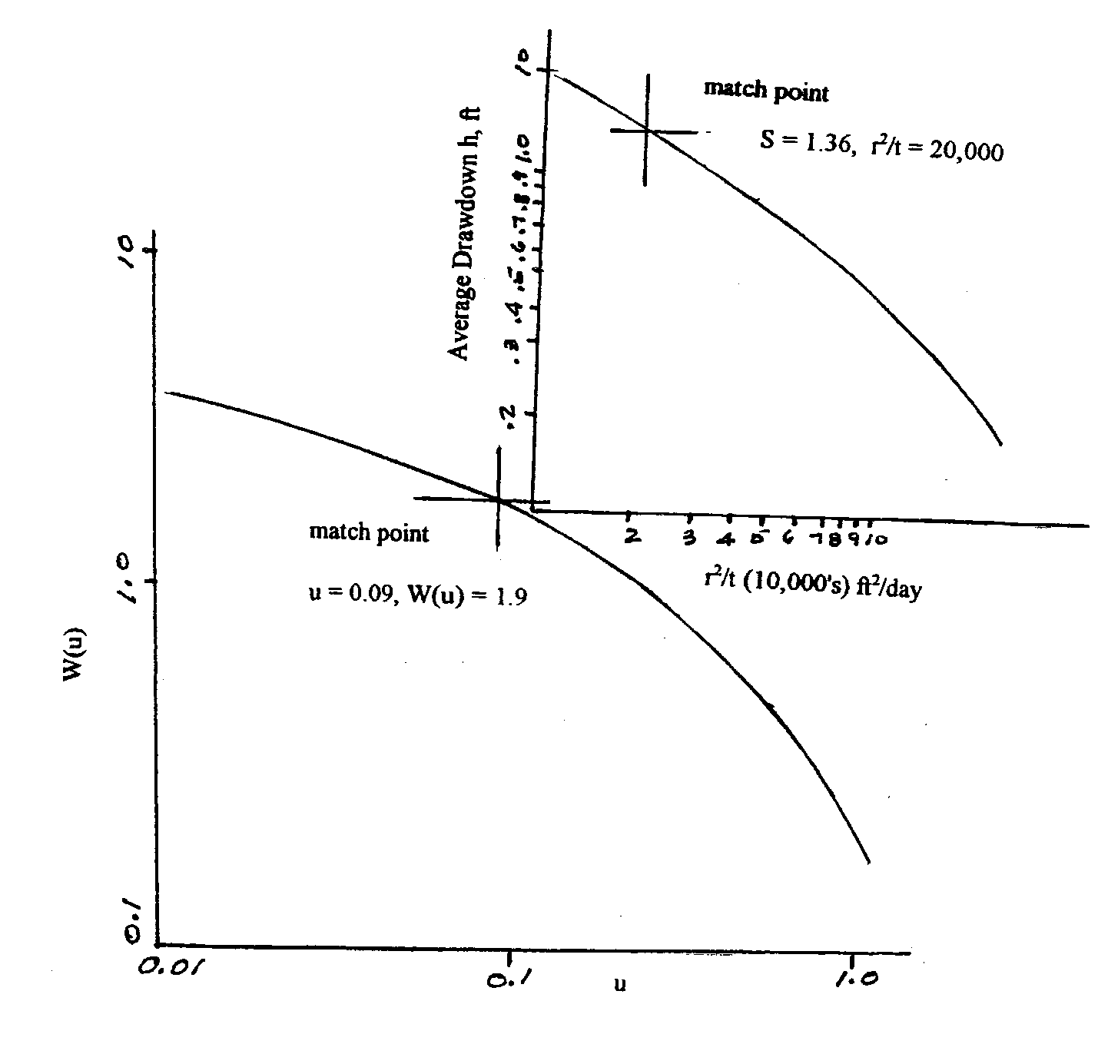

* 1. Use Equation 3.19



, y1=39.5

Drawdown is 100-39.5=60.5 feet

* 1. Use Equation 3.23

Log of the ratio = 0.1856

