2
Preparing a Balance Sheet Using QuickBooks Accountant
Chapters 1–5 are designed to help students get a top-down view of QuickBooks Accountant as a user-oriented accounting program. Students can be expected to work through these on their own. In Chapter 2, students learn, in an interactive way, how to create balance sheets for different dates, investigate detail supporting balance sheet items, and print balance sheets for distribution.

CHAPTER 2 QUESTIONS

- QuickBooks Accountant has four preset Balance Sheet reports: Standard, Detail, Summary, Balance Sheet by Class, and Prev Year Comparison.
- QuickBooks Accountant provides many time period alternatives for the balance sheet, including today, this week, last month, etc.
- To create a balance sheet for a date other than the system date, enter a new date in the As of edit box in the Balance Sheet window or select an alternate time period in the Dates edit box.
- To generate a balance sheet in QuickBooks Accountant, do the following:
a. Click Reports from the available menus.
b. Click Company & Financial from the sub menu shown.
c. Choose Balance Sheet Standard, Balance Sheet Detail, Balance Sheet Summary, Balance Sheet by Class, or Balance Sheet Prev Year Comparison from the sub menu provided.
- To resize the columns of a balance sheet, click and hold the mouse over the small diamond-shaped symbols to the right or left of any column and drag to the right or left to increase or decrease the column’s width.
- Two different types of transactions are found in an Accounts Receivable Transactions by Account report: invoice and payment. The first represents the billing of a customer; the second represents the receipt of payment on account from that customer.
- QuickZoom can provide more information from a balance sheet by providing detail which underlies a particular account balance. For instance, QuickZoom can be used to view transactions which support the Accounts Receivable account.
- A manager might use the QuickZoom feature to view transactions which underlie the Cash account. In this case, the QuickZoom result identifies all transactions for the period that created the ending balance reported in the balance sheet.
- A QuickBooks Accountant report can be modified in five ways:
a. Report dates can be changed.
b. From/To dates can be changed.
c. Report Basis can be either Accrual or Cash.
d. Columns can be changed from totals only to week, month, quarter, etc.
e. Other columns can be added, such as previous period, previous year, etc.
- You can add a column entitled % of column, which describes what percentage each asset, liability, and owners’ equity account was of the total assets amount, using the Customize Report button on the balance sheet.
CHAPTER 2 MATCHING

f When selected in the Modify Report window, this check box requires QuickBooks Accountant to add a column representing the percentage of each item compared to total assets.

i When selected in the Modify Report window, this check box requires QuickBooks Accountant to round amounts to the nearest whole dollar.

j The start of the reporting period.

a A financial statement reporting in detail the assets, liabilities, and equities of a business as of a certain date.

g A process in which modified reports are saved for later use.

h When selected in the Modify Report window, this check box requires QuickBooks Accountant to report amounts in thousands.

b The end of the reporting period.

d A QuickBooks Accountant feature that allows you to view the transaction details underlying amounts in a report.

e A report generated when using QuickZoom.

c A financial statement reporting in summary form the assets, liabilities, and equities of a business as of a certain date.
Chapter 2 assignments

- Creating a Summary Balance Sheet
  - 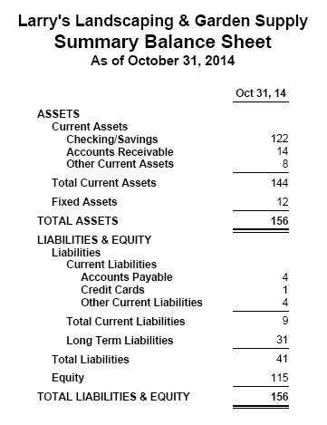
  - 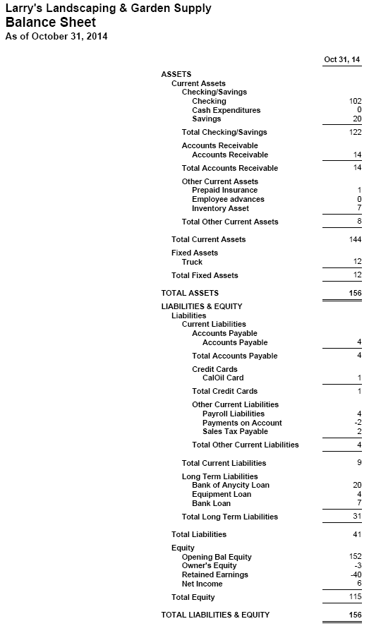
- Investigating the Balance Sheet Using QuickZoom
  - 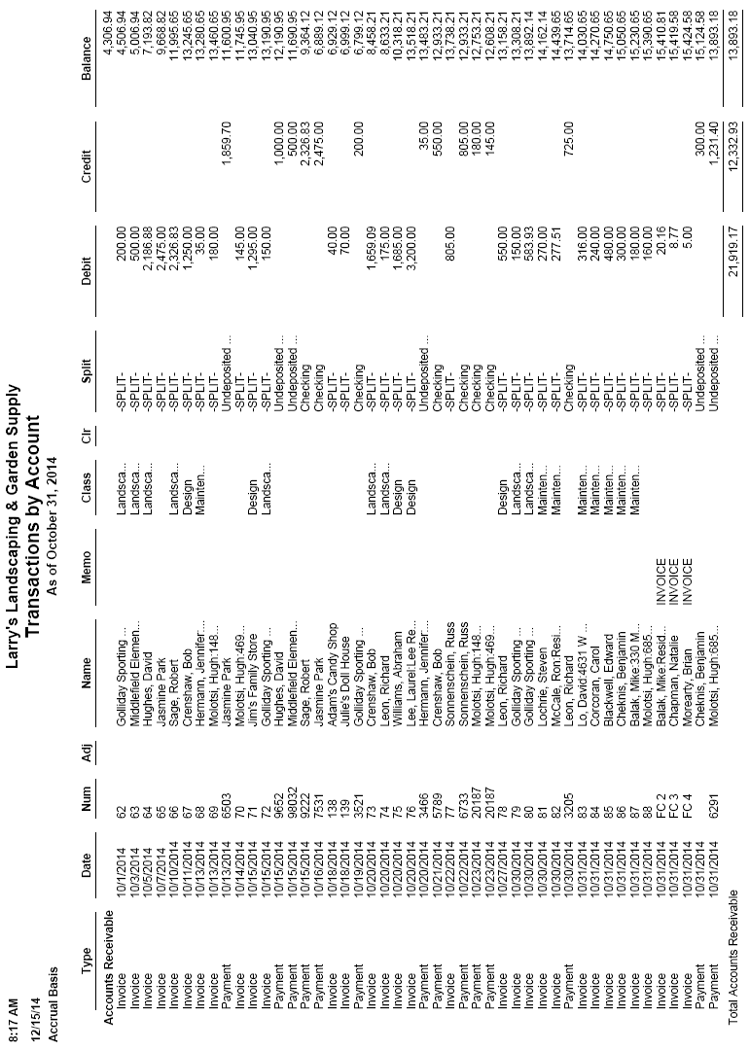
  - 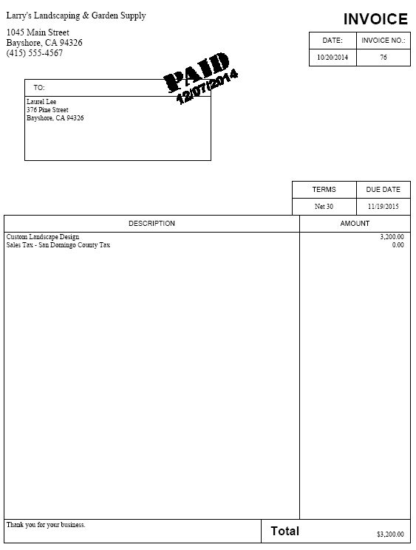
- Customizing a Balance Sheet
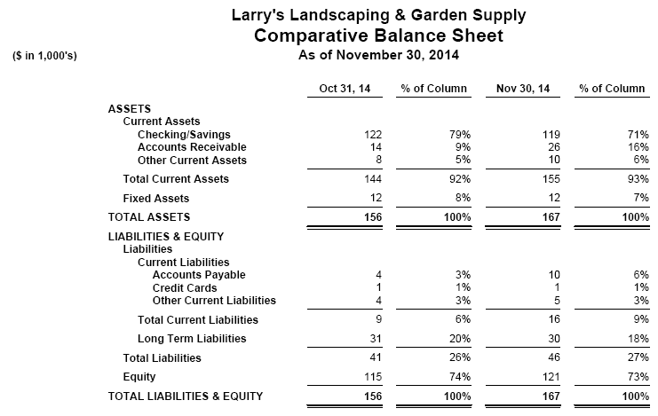

CHAPTER 2 CASE PROBLEM 1: SIERRA MARINA
1.
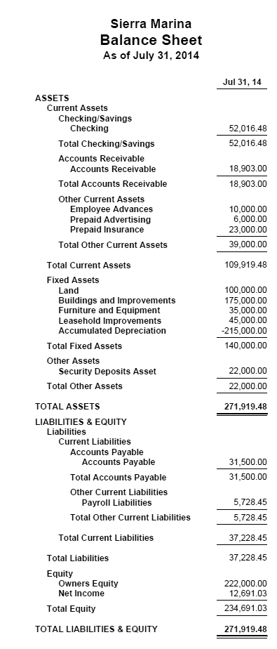

2.
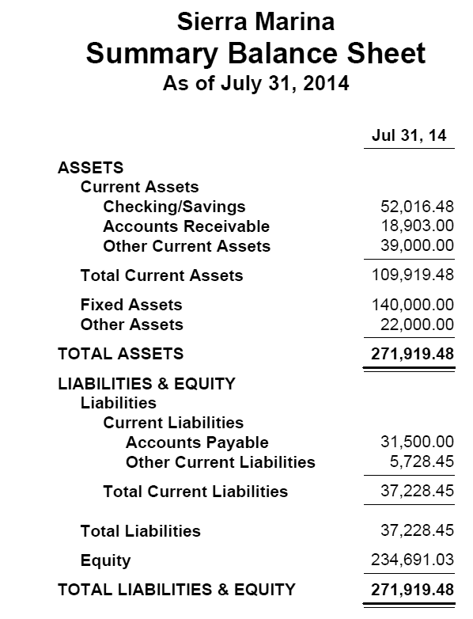

3.
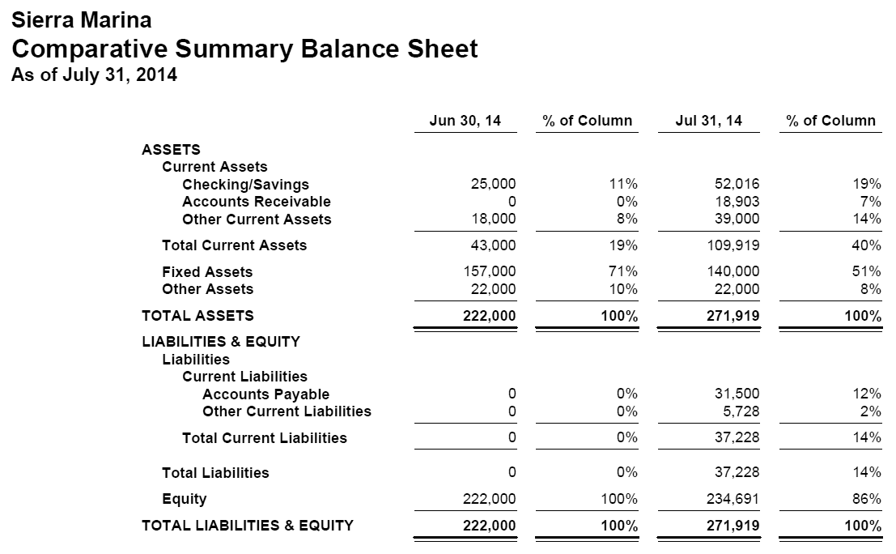
4.
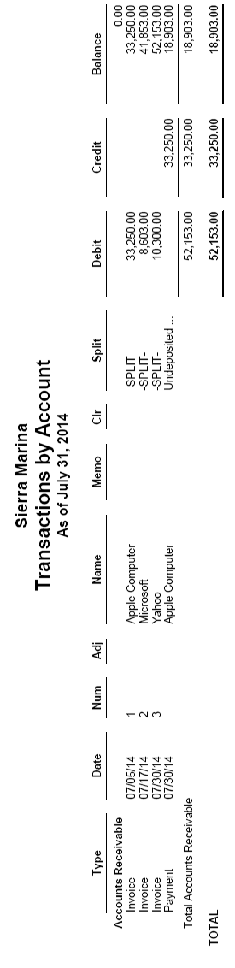

Chapter 2 case problem 2: Jennings & associates
- 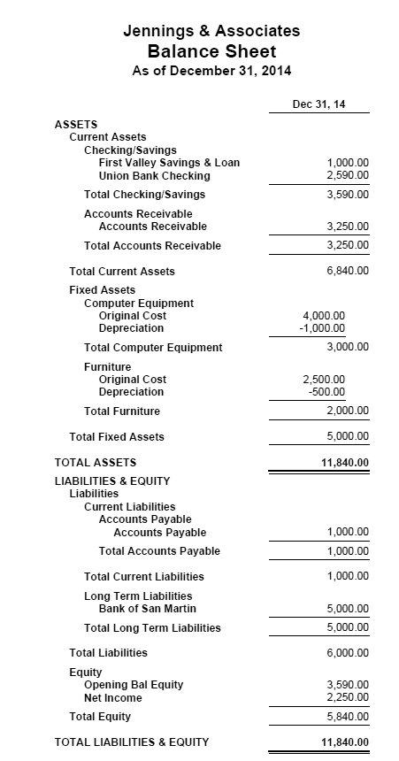
- 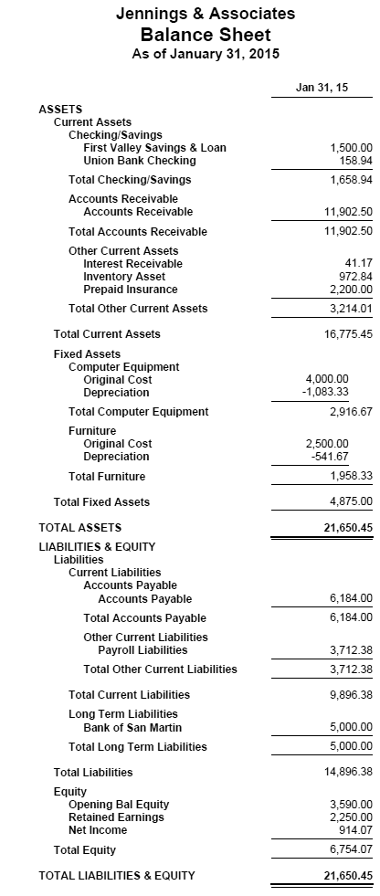
- 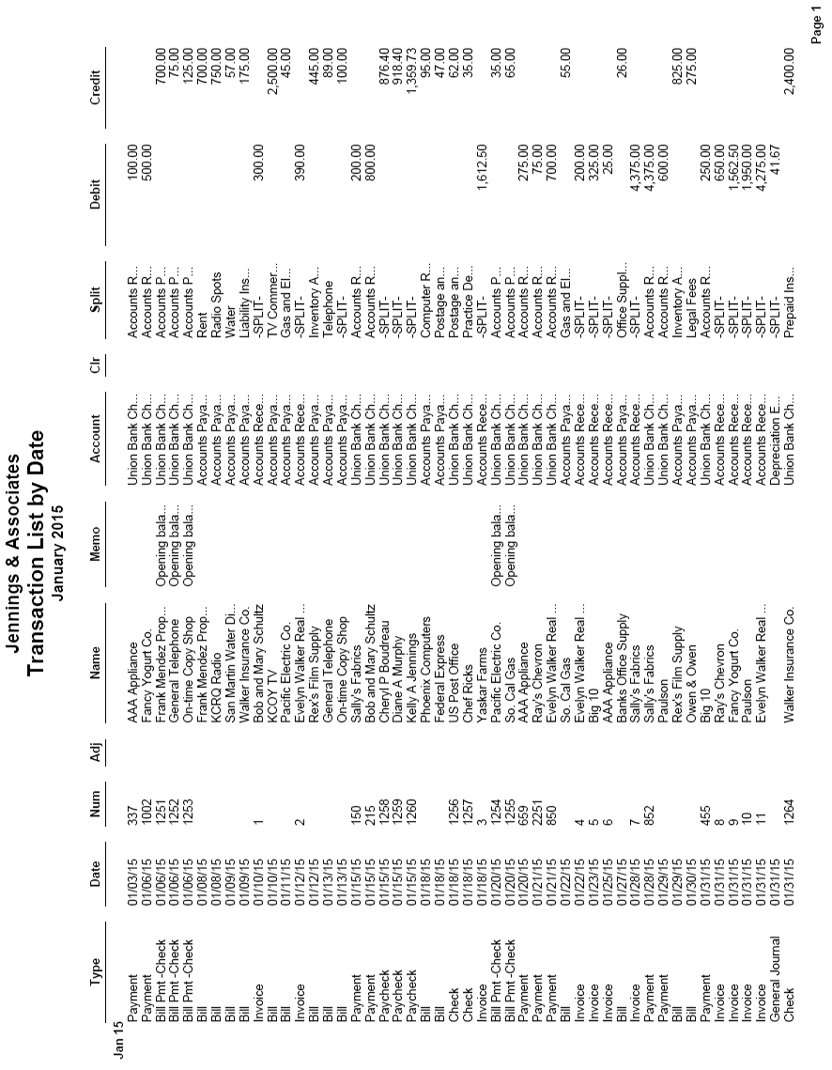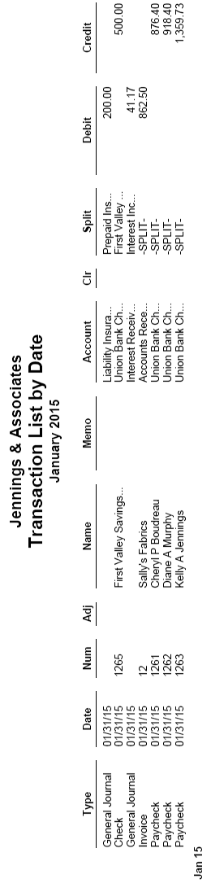
- 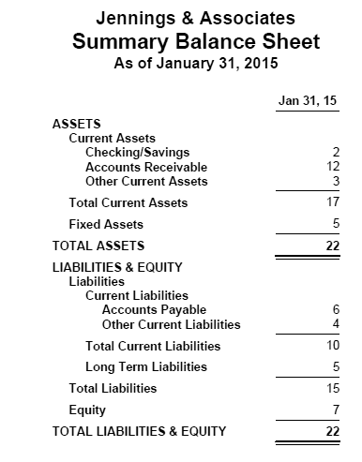

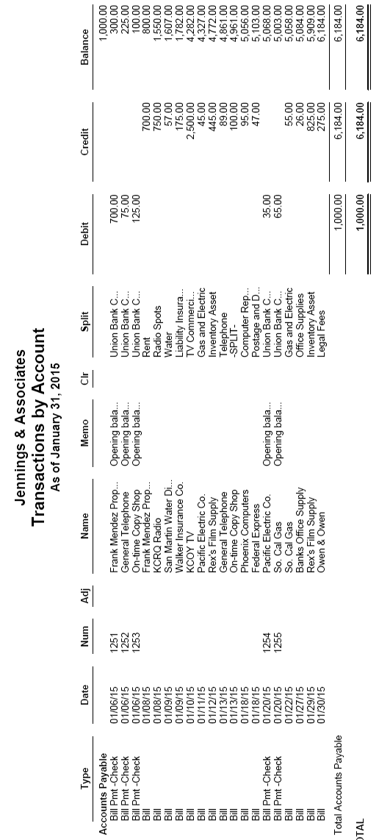

Chapter 2 case problem 3: Jason galas attorney at law pc

- 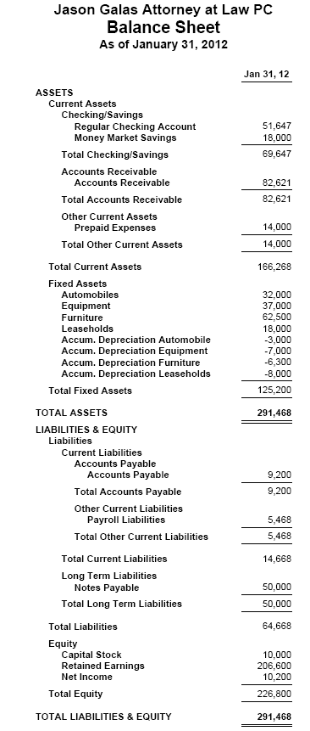
- 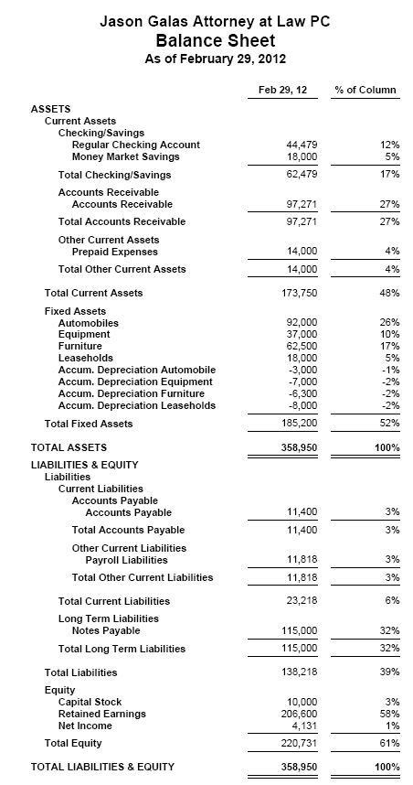
- 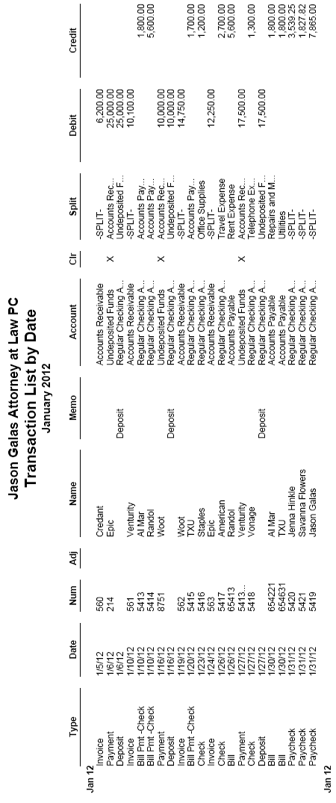
- 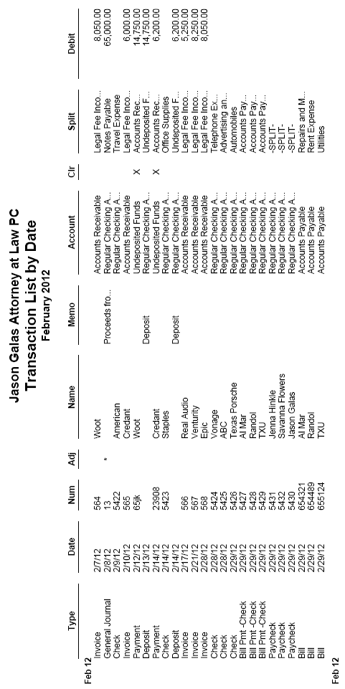
- 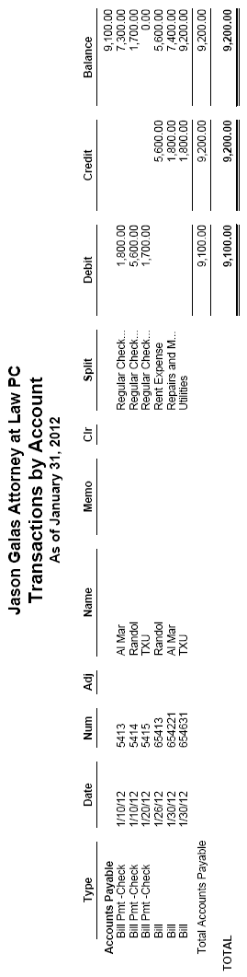
- This bill, from Randol, is for rent expense in the amount of $5,600.
- 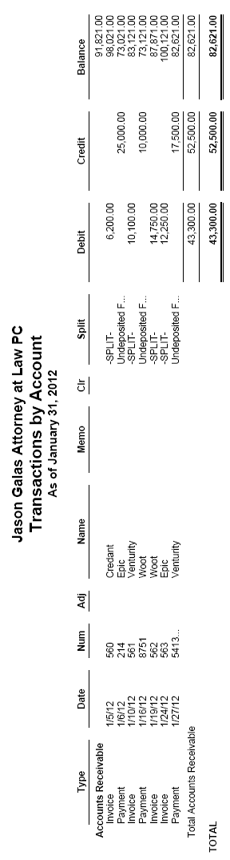
- Invoice 563 was billed to Epic for 29 hours of tax consulting and 14 hours of tax services.
- The customer payment on 1/27/12 was from Venturity for previous period services.

