Motion Along a Straight Line | 2
2.1. Identify:
Set Up: We know the average velocity is 6.25 m/s.
Execute:
Evaluate: In round numbers, 6 m/s × 4 s = 24 m ≈ 25 m, so the answer is reasonable.
2.2. Identify:
Set Up: At the release point,
Execute: (a)
(b) For the round trip, and The average velocity is zero.
Evaluate: The average velocity for the trip from the nest to the release point is positive.
2.3. Identify: Target variable is the time it takes to make the trip in heavy traffic. Use Eq. (2.2) that relates the average velocity to the displacement and average time.
Set Up: so and
Execute: Use the information given for normal driving conditions to calculate the distance between the two cities:
Now use for heavy traffic to calculate is the same as before:
and 30 min.
The trip takes an additional 1 hour and 10 minutes.
Evaluate: The time is inversely proportional to the average speed, so the time in traffic is
2.4. Identify: The average velocity is Use the average speed for each segment to find the time traveled in that segment. The average speed is the distance traveled by the time.
Set Up: The post is 80 m west of the pillar. The total distance traveled is
Execute: (a) The eastward run takes time and the westward run takes The average speed for the entire trip is
(b) The average velocity is directed westward.
Evaluate: The displacement is much less than the distance traveled and the magnitude of the average velocity is much less than the average speed. The average speed for the entire trip has a value that lies between the average speed for the two segments.
2.5. Identify: Given two displacements, we want the average velocity and the average speed.
Set Up: The average velocity is and the average speed is just the total distance walked divided by the total time to walk this distance.
Execute: (a) Let +x be east. and So
(b)
Evaluate: The average speed is much greater than the average velocity because the total distance walked is much greater than the magnitude of the displacement vector.
2.6. Identify: The average velocity is Use to find x for each t.
Set Up: and
Execute: (a)
(b)
(c)
Evaluate: The average velocity depends on the time interval being considered.
2.7. (a) Identify: Calculate the average velocity using Eq. (2.2).
Set Up: so use to find the displacement for this time interval.
Execute:
Then
(b) Identify: Use Eq. (2.3) to calculate and evaluate this expression at each specified t.
Set Up:
Execute: (i)
(ii)
(iii)
(c) Identify: Find the value of t when from part (b) is zero.
Set Up:
at
next when
Execute: so
Evaluate: for this motion says the car starts from rest, speeds up, and then slows down again.
2.8. Identify: We know the position x(t) of the bird as a function of time and want to find its instantaneous velocity at a particular time.
Set Up: The instantaneous velocity is
Execute: Evaluating this at gives
Evaluate: The acceleration is not constant in this case.
2.9. Identify: The average velocity is given by We can find the displacement for each constant velocity time interval. The average speed is the distance traveled divided by the time.
Set Up: For to For to In part (b), for to When the velocity is constant,
Execute: (a) For to For to For the first 3.0 s, The distance traveled is also 7.0 m. The average velocity is The average speed is also 2.33 m/s.
(b) For to 3.0 s, For the first 3.0 s, The dog runs 4.0 m in the +x-direction and then 3.0 m in the
−x-direction, so the distance traveled is still 7.0 m. The average speed is
Evaluate: When the motion is always in the same direction, the displacement and the distance traveled are equal and the average velocity has the same magnitude as the average speed. When the motion changes direction during the time interval, those quantities are different.
2.10. Identify and Set Up: The instantaneous velocity is the slope of the tangent to the x versus t graph.
Execute: (a) The velocity is zero where the graph is horizontal; point IV.
(b) The velocity is constant and positive where the graph is a straight line with positive slope; point I.
(c) The velocity is constant and negative where the graph is a straight line with negative slope; point V.
(d) The slope is positive and increasing at point II.
(e) The slope is positive and decreasing at point III.
Evaluate: The sign of the velocity indicates its direction.
2.11. Identify: Find the instantaneous velocity of a car using a graph of its position as a function of time.
Set Up: The instantaneous velocity at any point is the slope of the x versus t graph at that point. Estimate the slope from the graph.
Execute: A: B: C: D: E:
F: G:
Evaluate: The sign of shows the direction the car is moving. is constant when x versus t is a straight line.
2.12. Identify: is the slope of the versus t graph.
Set Up:
Execute: (a) (i) (ii)
(iii) and (iv) and
(b) At is constant and At the graph of versus t is a straight line and
Evaluate: When and have the same sign the speed is increasing. When they have opposite sign the speed is decreasing.
2.13. Identify: The average acceleration for a time interval is given by
Set Up: Assume the car is moving in the direction. so 200 mi/h89.40 m/s and
Execute: (a) The graph of versus t is sketched in Figure 2.13. The graph is not a straight line, so the acceleration is not constant.
(b) (i) (ii)
(iii) The slope of the graph of versus t decreases as t increases. This is consistent with an average acceleration that decreases in magnitude during each successive time interval.
Evaluate: The average acceleration depends on the chosen time interval. For the interval between 0 and 53 s,

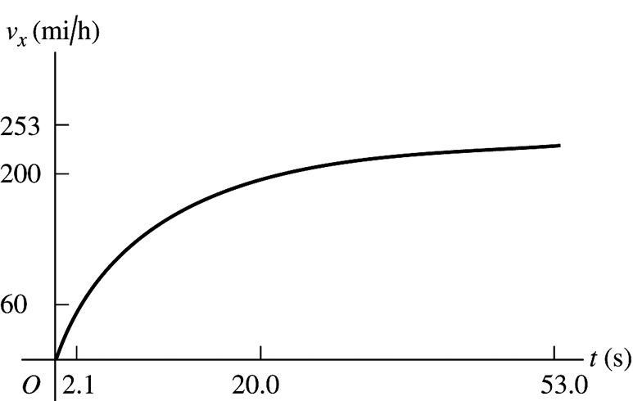
Figure 2.13

2.14. Identify: We know the velocity v(t) of the car as a function of time and want to find its acceleration at the instant that its velocity is 16.0 m/s.
Set Up:
Execute: When At this time,
Evaluate: The acceleration of this car is not constant.
2.15. Identify and Set Up: Use and to calculate and
Execute:
(a) At
(b) Set and solve for t:
(c) Set and solve for t. This gives and The turtle returns to the starting point after 32.0 s.
(d) The turtle is 10.0 cm from starting point when or
Set and solve for t: and
At
At
Set and solve for t: (other root to the quadratic equation is negative and hence nonphysical).
At
(e) The graphs are sketched in Figure 2.15.

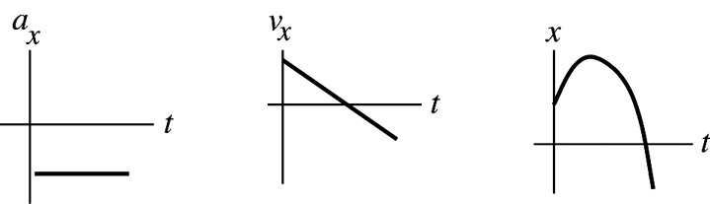
Figure 2.15

Evaluate: The acceleration is constant and negative. is linear in time. It is initially positive, decreases to zero, and then becomes negative with increasing magnitude. The turtle initially moves farther away from the origin but then stops and moves in the
2.16. Identify: Use Eq. (2.4), with in all cases.
Set Up: is negative if the motion is to the left.
Execute: (a)
(b)
(c)
Evaluate: In all cases, the negative acceleration indicates an acceleration to the left.
2.17. Identify: The average acceleration is Use to find at each t. The instantaneous acceleration is
Set Up: and
Execute: (a)
(b) At At
(c) Graphs of and are given in Figure 2.17.
Evaluate: is the slope of and increases as t increases. The average acceleration for to equals the instantaneous acceleration at the midpoint of the time interval, since is a linear function of t.

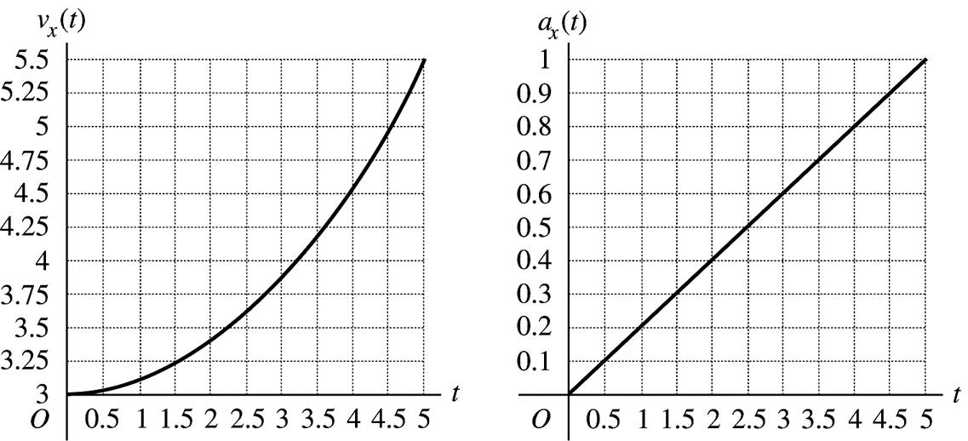
Figure 2.17

2.18. Identify: and
Set Up: for
Execute: (a) and Setting gives and At and At and
(b) The graphs are given in Figure 2.18.
Evaluate: For the entire time interval from to the velocity is positive and x increases. While is also positive the speed increases and while is negative the speed decreases.

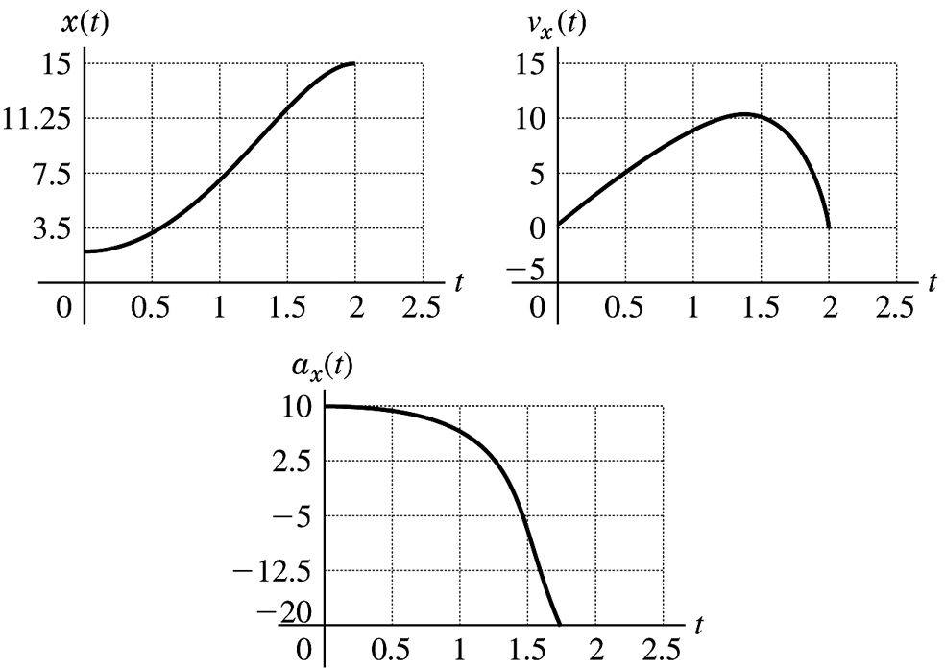
Figure 2.18

2.19. Identify: Use the constant acceleration equations to find and
(a) Set Up: The situation is sketched in Figure 2.19.

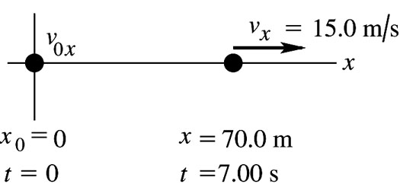
Figure 2.19

Execute: Use so
(b) Use so
Evaluate: The average velocity is The final velocity is larger than this, so the antelope must be speeding up during the time interval; and
2.20. Identify: In (a) find the time to reach the speed of sound with an acceleration of 5g, and in (b) find his speed at the end of 5.0 s if he has an acceleration of 5g.
Set Up: Let be in his direction of motion and assume constant acceleration of 5g so the standard kinematics equations apply so (a) and (b)
Execute: (a) and Yes, the time required is larger than 5.0 s.
(b)
Evaluate: In 5 s he can only reach about 2/3 the speed of sound without blacking out.
2.21. Identify: For constant acceleration, Eqs. (2.8), (2.12), (2.13) and (2.14) apply.
Set Up: Assume the ball starts from rest and moves in the
Execute: (a) and gives
(b) gives
Evaluate: We could also use to find which agrees with our previous result. The acceleration of the ball is very large.
2.22. Identify: For constant acceleration, Eqs. (2.8), (2.12), (2.13) and (2.14) apply.
Set Up: Assume the ball moves in the
Execute: (a) and gives
(b)
Evaluate: We could also use to calculate which agrees with our previous result. The acceleration of the ball is very large.
2.23. Identify: Assume that the acceleration is constant and apply the constant acceleration kinematic equations. Set equal to its maximum allowed value.
Set Up: Let be the direction of the initial velocity of the car.
Execute: gives
Evaluate: The car frame stops over a shorter distance and has a larger magnitude of acceleration. Part of your 1.70 m stopping distance is the stopping distance of the car and part is how far you move relative to the car while stopping.
2.24. Identify: In (a) we want the time to reach Mach 4 with an acceleration of 4g, and in (b) we want to know how far he can travel if he maintains this acceleration during this time.
Set Up: Let be the direction the jet travels and take With constant acceleration, the equations and both apply. and
Execute: (a) Solving for t gives
(b)
Evaluate: The answer in (a) is about ½ min, so if he wanted to reach Mach 4 any sooner than that, he would be in danger of blacking out.
2.25. Identify: If a person comes to a stop in 36 ms while slowing down with an acceleration of 60g, how far does he travel during this time?
Set Up: Let be the direction the person travels. (he stops), is negative since it is opposite to the direction of the motion, and The equations and both apply since the acceleration is constant.
Execute: Solving for v_{0x} gives Then gives
Evaluate: Notice that we were not given the initial speed, but we could find it:
2.26. Identify: In (a) the hip pad must reduce the person’s speed from 2.0 m/s to 1.3 m/s over a distance of 2.0 cm, and we want the acceleration over this distance, assuming constant acceleration. In (b) we want to find out how the acceleration in (a) lasts.
Set Up: Let be downward. and The equations and apply for constant acceleration.
Execute: (a) Solving for a_{y} gives
(b) gives
Evaluate: The acceleration is very large, but it only lasts for 12 ms so it produces a small velocity change.
2.27. Identify: We know the initial and final velocities of the object, and the distance over which the velocity change occurs. From this we want to find the magnitude and duration of the acceleration of the object.
Set Up: The constant-acceleration kinematics formulas apply. where and
Execute: (a) gives
(b) gives
Evaluate: (c) The calculated a is less than 450,000 g so the acceleration required doesn’t rule out this hypothesis.
2.28. Identify: Apply constant acceleration equations to the motion of the car.
Set Up: Let be the direction the car is moving.
Execute: (a) From Eq. (2.13), with
(b) Using Eq. (2.14),
(c)
Evaluate: The average velocity of the car is half the constant speed of the traffic, so the traffic travels twice as far.
2.29. Identify: The average acceleration is For constant acceleration, Eqs. (2.8), (2.12), (2.13) and (2.14) apply.
Set Up: Assume the shuttle travels in the +x direction. and
Execute: (a) (i)
(ii)
(b) (i) and (ii) and
Evaluate: When the acceleration is constant the instantaneous acceleration throughout the time interval equals the average acceleration for that time interval. We could have calculated the distance in part (a) as which agrees with our previous calculation.
2.30. Identify: The acceleration is the slope of the graph of versus t.
Set Up: The signs of and of indicate their directions.
Execute: (a) Reading from the graph, at to the right and at to the left.
(b) versus t is a straight line with slope The acceleration is constant and
equal to to the left. It has this value at all times.
(c) Since the acceleration is constant, For to 4.5 s, For to 7.5 s,
(d) The graphs of and x versus t are given in Figure 2.30.
Evaluate: In part (c) we could have instead used

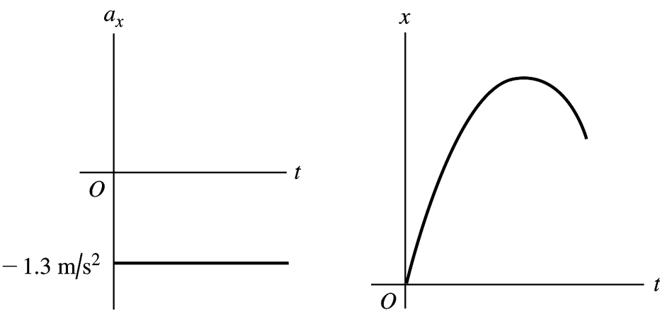
Figure 2.30

2.31. (a) Identify and Set Up: The acceleration at time t is the slope of the tangent to the versus t curve at time t.
Execute: At the versus t curve is a horizontal straight line, with zero slope. Thus
At the versus t curve is a straight-line segment with slope Thus
At the curve is again a straight-line segment, now with slope Thus
Evaluate: when is constant, when is positive and the speed is increasing, and when is positive and the speed is decreasing.
(b) Identify: Calculate the displacement during the specified time interval.
Set Up: We can use the constant acceleration equations only for time intervals during which the acceleration is constant. If necessary, break the motion up into constant acceleration segments and apply the constant acceleration equations for each segment. For the time interval to the acceleration is constant and equal to zero. For the time interval to the acceleration is constant and equal to For the interval to the acceleration is constant and equal to
Execute: During the first 5 seconds the acceleration is constant, so the constant acceleration kinematic formulas can be used.
so no term)
this is the distance the officer travels in the first 5 seconds.
During the interval to 9 s the acceleration is again constant. The constant acceleration formulas can be applied to this 4-second interval. It is convenient to restart our clock so the interval starts at time and ends at time (Note that the acceleration is not constant over the entire to interval.)
Thus
At the officer is at so she has traveled 230 m in the first 9 seconds.
During the interval to the acceleration is again constant. The constant acceleration formulas can be applied for this 4-second interval but not for the whole to interval. To use the equations restart our clock so this interval begins at time and ends at time
(at the start of this time interval)
Thus
At the officer is at so she has traveled 320 m in the first 13 seconds.
Evaluate: The velocity is always positive so the displacement is always positive and displacement and distance traveled are the same. The average velocity for time interval is For to 5 s, For to 9 s, For to 13 s, These results are consistent with Figure 2.37 in the textbook.
2.32. Identify: is the slope of the x versus t graph. Car B moves with constant speed and zero acceleration. Car A moves with positive acceleration; assume the acceleration is constant.
Set Up: For car B, is positive and For car A, is positive and increases with t.
Execute: (a) The motion diagrams for the cars are given in Figure 2.32a.
(b) The two cars have the same position at times when their x-t graphs cross. The figure in the problem shows this occurs at approximately and
(c) The graphs of versus t for each car are sketched in Figure 2.32b.
(d) The cars have the same velocity when their x-t graphs have the same slope. This occurs at approximately
(e) Car A passes car B when moves above in the x-t graph. This happens at
(f) Car B passes car A when moves above in the x-t graph. This happens at
Evaluate: When the graph of versus t is a horizontal line. When is positive, the graph of versus t is a straight line with positive slope.

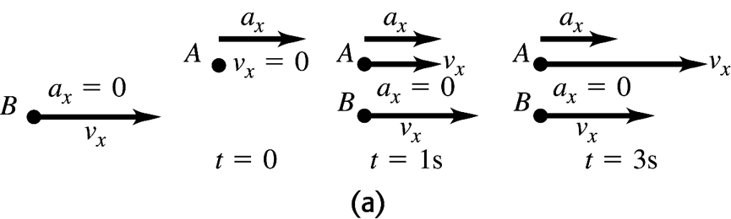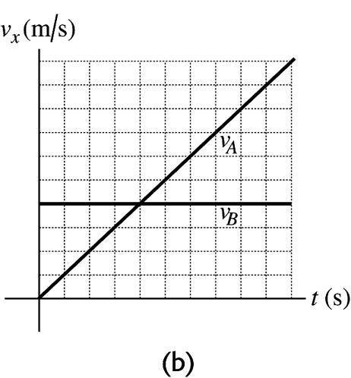
Figure 2.32a-b

2.33. Identify: For constant acceleration, Eqs. (2.8), (2.12), (2.13) and (2.14) apply.
Set Up: Take to be downward, so the motion is in the direction. and
Execute: (a) Stage A: gives
Stage B: gives
Stage C: gives In each case the negative sign means that the acceleration is upward.
(b) Stage A:
Stage B:
Stage C: The problem states that
The total distance traveled during all three stages is
Evaluate: The upward acceleration produced by friction in stage A is calculated to be greater than the upward acceleration due to the parachute in stage B. The effects of air resistance increase with increasing speed and in reality the acceleration was probably not constant during stages A and B.
2.34. Identify: Apply the constant acceleration equations to the motion of each vehicle. The truck passes the car when they are at the same x at the same
Set Up: The truck has The car has Let be in the direction of motion of the vehicles. Both vehicles start at The car has The truck has
Execute: (a) gives and Setting gives and so At this t, and The car and truck have each traveled 250 m.
(b) At the car has
(c) and The x-t graph of the motion for each vehicle is sketched in Figure 2.34a.
(d) The graph for each vehicle is sketched in Figure 2.34b.
Evaluate: When the car overtakes the truck its speed is twice that of the truck.

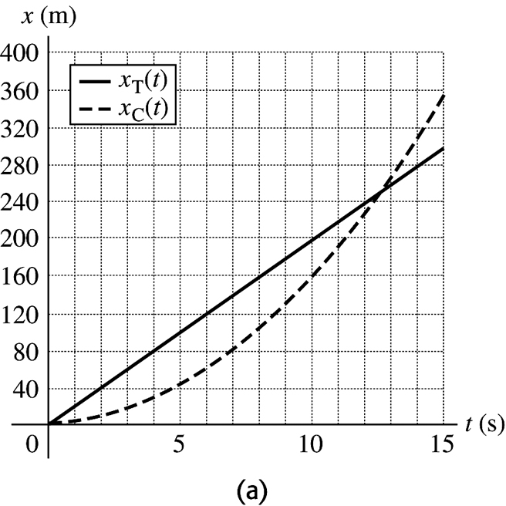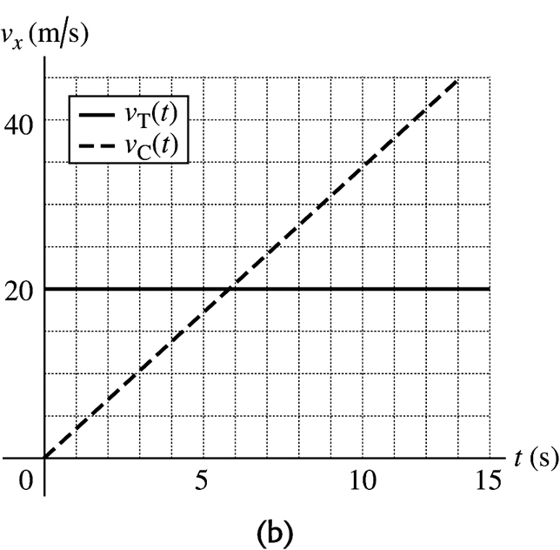
Figure 2.34a-b

2.35. Identify: Apply the constant acceleration equations to the motion of the flea. After the flea leaves the ground, downward. Take the origin at the ground and the positive direction to be upward.
(a) Set Up: At the maximum height
Execute:
(b) Set Up: When the flea has returned to the ground
Execute: With this gives
Evaluate: We can use to show that with after 0.300 s.
2.36. Identify: The rock has a constant downward acceleration of 9.80 m/s². We know its initial velocity and position and its final position.
Set Up: We can use the kinematics formulas for constant acceleration.
Execute: (a) The kinematics formulas give so the speed is 30.2 m/s.
(b) and
Evaluate: The vertical velocity in part (a) is negative because the rock is moving downward, but the speed is always positive. The 4.92 s is the total time in the air.
2.37. Identify: The pin has a constant downward acceleration of 9.80 m/s² and returns to its initial position.
Set Up: We can use the kinematics formulas for constant acceleration.
Execute: The kinematics formulas give We know that so
Evaluate: It takes the pin half this time to reach its highest point and the remainder of the time to return.
2.38. Identify: The putty has a constant downward acceleration of 9.80 m/s². We know the initial velocity of the putty and the distance it travels.
Set Up: We can use the kinematics formulas for constant acceleration.
Execute: (a) v_{0y} = 9.50 m/s and y – y₀ = 3.60 m, which gives
(b)
Evaluate: The putty is stopped by the ceiling, not by gravity.
2.39. Identify: A ball on Mars that is hit directly upward returns to the same level in 8.5 s with a constant downward acceleration of 0.379g. How high did it go and how fast was it initially traveling upward?
Set Up: Take upward. at the maximum height. The constant-acceleration formulas and both apply.
Execute: Consider the motion from the maximum height back to the initial level. For this motion and The ball went 33.5 m above its original position.
(b) Consider the motion from just after it was hit to the maximum height. For this motion and gives
(c) The graphs are sketched in Figure 2.39.

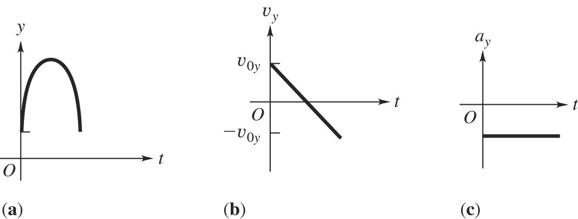
Figure 2.39

Evaluate: The answers can be checked several ways. For example, and in gives which agrees with the height calculated in (a).
2.40. Identify: Apply constant acceleration equations to the motion of the lander.
Set Up: Let be positive. Since the lander is in free-fall,
Execute: in gives
Evaluate: The same descent on earth would result in a final speed of 9.9 m/s, since the acceleration due to gravity on earth is much larger than on the moon.
2.41. Identify: Apply constant acceleration equations to the motion of the meterstick. The time the meterstick falls is your reaction time.
Set Up: Let be downward. The meter stick has and Let d be the distance the meterstick falls.
Execute: (a) gives and
(b)
Evaluate: The reaction time is proportional to the square of the distance the stick falls.
2.42. Identify: Apply constant acceleration equations to the vertical motion of the brick.
Set Up: Let be downward.
Execute: (a)
The building is 30.6 m tall.
(b)
(c) The graphs of and y versus t are given in Figure 2.42. Take at the ground.
Evaluate: We could use either or to check our results.

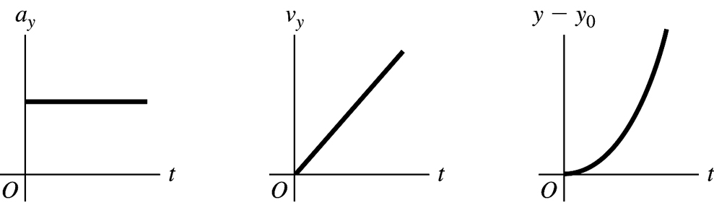
Figure 2.42

2.43. Identify: When the only force is gravity the acceleration is downward. There are two intervals of constant acceleration and the constant acceleration equations apply during each of these intervals.
Set Up: Let be upward. Let at the launch pad. The final velocity for the first phase of the motion is the initial velocity for the free-fall phase.
Execute: (a) Find the velocity when the engines cut off. gives
Now consider the motion from engine cut-off to maximum height: (at the maximum height), gives and
(b) Consider the motion from engine failure until just before the rocket strikes the ground:
gives
Then gives
(c) Find the time from blast-off until engine failure: gives The rocket strikes the launch pad after blast-off. The acceleration is from to It is from to applies during each constant acceleration segment, so the graph of versus t is a straight line with positive slope of during the blast-off phase and with negative slope of after engine failure. During each phase The sign of determines the curvature of At the rocket has returned to The graphs are sketched in Figure 2.43.
Evaluate: In part (b) we could have found the time from finding first allows us to avoid solving for t from a quadratic equation.

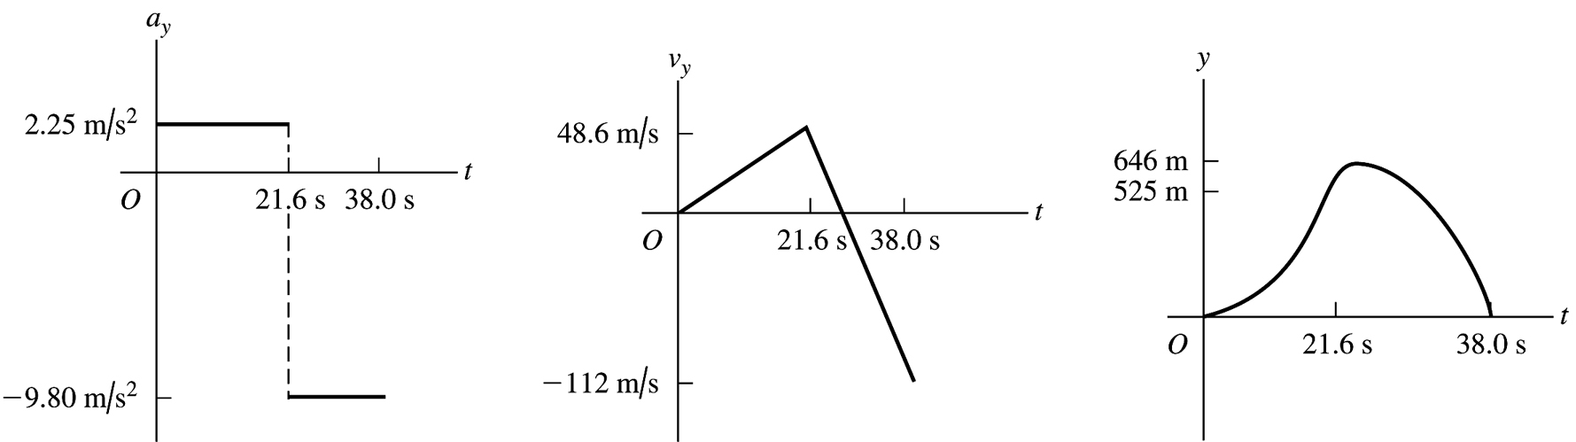
Figure 2.43

2.44. Identify: Apply constant acceleration equations to the vertical motion of the sandbag.
Set Up: Take upward. The initial velocity of the sandbag equals the velocity of the balloon, so When the balloon reaches the ground, At its maximum height the sandbag has
Execute: (a) The sandbag is 40.9 m above the ground.
The sandbag is 40.1 m above the ground.
(b) gives and t must be positive, so
(c)
(d) gives The maximum height is 41.3 m above the ground.
(e) The graphs of and y versus t are given in Figure 2.44. Take at the ground.
Evaluate: The sandbag initially travels upward with decreasing velocity and then moves downward with increasing speed.

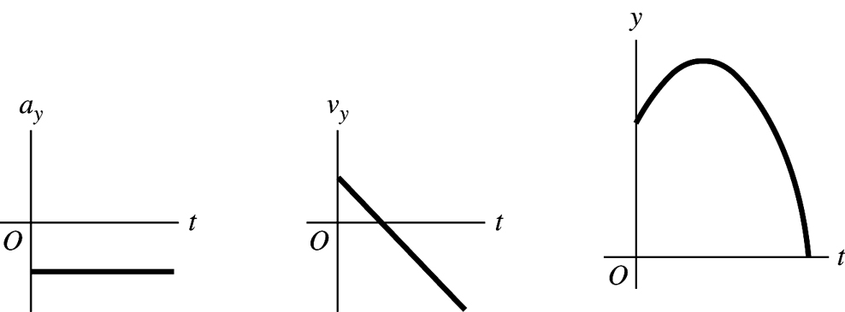
Figure 2.44

2.45. Identify: Use the constant acceleration equations to calculate and
(a) Set Up:
Execute:
(b)
(c)
(d) Set Up: Calculate the acceleration, assuming it is constant:
(stops),
Execute:
If the acceleration while the sled is stopping is constant then the magnitude of the acceleration is only 20.6g. But if the acceleration is not constant it is certainly possible that at some point the instantaneous acceleration could be as large as 40g.
Evaluate: It is reasonable that for this motion the acceleration is much larger than g.
2.46. Identify: Since air resistance is ignored, the egg is in free-fall and has a constant downward acceleration of magnitude Apply the constant acceleration equations to the motion of the egg.
Set Up: Take to be upward. At the maximum height,
Execute: (a) gives
(b) (at the maximum height), gives
(c) At the maximum height
(d) The acceleration is constant and equal to downward, at all points in the motion, including at the maximum height.
(e) The graphs are sketched in Figure 2.46.
Evaluate: The time for the egg to reach its maximum height is The egg has returned to the level of the cornice after 3.78 s and after 5.00 s it has traveled downward from the cornice for 1.22 s.

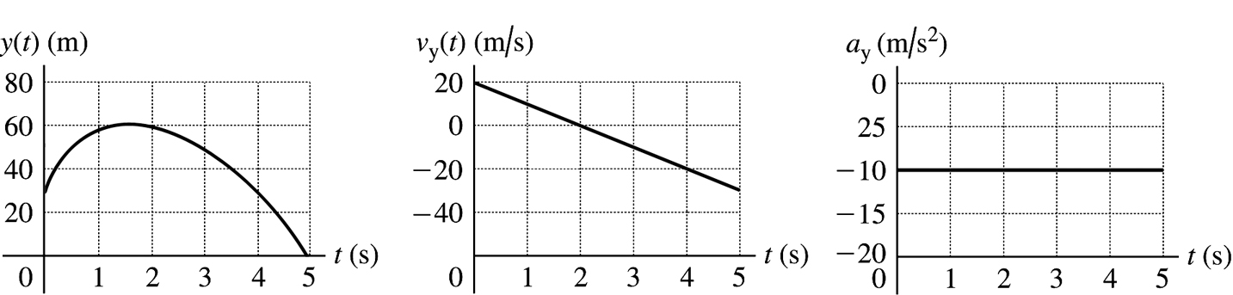
Figure 2.46

2.47. Identify: We can avoid solving for the common height by considering the relation between height, time of fall and acceleration due to gravity and setting up a ratio involving time of fall and acceleration due to gravity.
Set Up: Let be the acceleration due to gravity on Enceladus and let g be this quantity on earth. Let h be the common height from which the object is dropped. Let be downward, so
Execute: gives and Combining these two equations gives and
Evaluate: The acceleration due to gravity is inversely proportional to the square of the time of fall.
2.48. Identify: Since air resistance is ignored, the boulder is in free-fall and has a constant downward acceleration of magnitude Apply the constant acceleration equations to the motion of the boulder.
Set Up: Take to be upward.
Execute: (a) gives
(b)
(c) gives and
(d) gives
(e) The acceleration is downward, at all points in the motion.
(f) The graphs are sketched in Figure 2.48.
Evaluate: at the maximum height. The time to reach the maximum height is half the total time in the air, so the answer in part (d) is half the answer in part (c). Also note that The boulder is going upward until it reaches its maximum height and after the maximum height it is traveling downward.
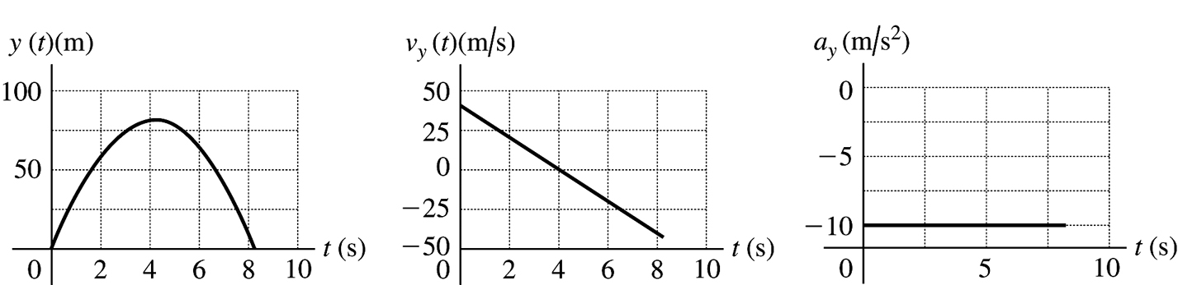
Figure 2.48

2.49. Identify: Two stones are thrown up with different speeds. (a) Knowing how soon the faster one returns to the ground, how long it will take the slow one to return? (b) Knowing how high the slower stone went, how high did the faster stone go?
Set Up: Use subscripts f and s to refer to the faster and slower stones, respectively. Take to be upward and for both stones. When a stone reaches the ground, The constant-acceleration formulas and both apply.
Execute: (a) gives Since both stones have the same and
(b) Since at the maximum height, then gives Since both have the same and
Evaluate: The faster stone reaches a greater height so it travels a greater distance than the slower stone and takes more time to return to the ground.
2.50. Identify: We start with the more general formulas and use them to derive the formulas for constant acceleration.
Set Up: The general formulas are and
Execute: For constant acceleration, these formulas give and
Evaluate: The general formulas give the expected results for constant acceleration.
2.51. Identify: The acceleration is not constant, but we know how it varies with time. We can use the definitions of instantaneous velocity and position to find the rocket’s position and speed.
Set Up: The basic definitions of velocity and position are and
Execute: (a)
For
(b) so and At this time
Evaluate: The time in part (b) is less than 10.0 s, so the given formulas are valid.
2.52. Identify: The acceleration is not constant so the constant acceleration equations cannot be used. Instead, use Eqs. (2.17) and (2.18). Use the values of and of x at to evaluate and
Set Up: for
Execute: (a) when gives Then, at
(b) at gives Then, at
(c) The graphs are sketched in Figure 2.52.
Evaluate: We can verify that and

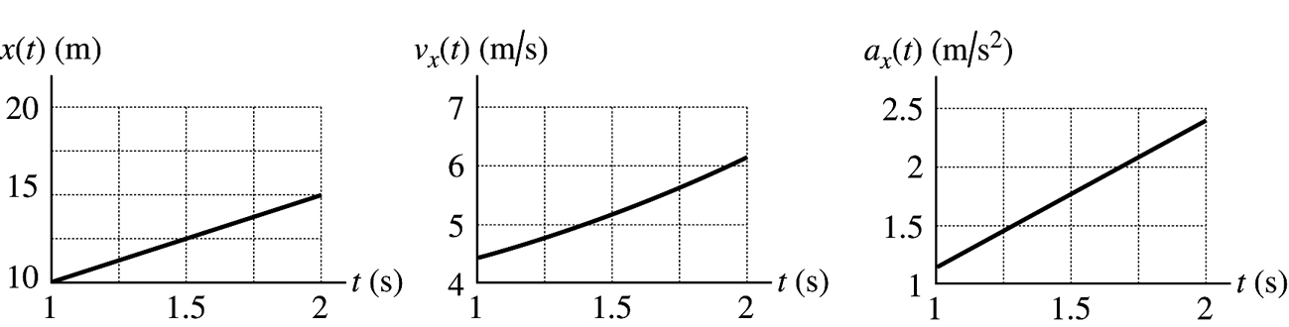
Figure 2.52

with and
2.53. (a) Identify: Integrate to find and then integrate to find
Set Up:
Execute:
At rest at says that so
Set Up:
Execute:
At the origin at says that so
Evaluate: We can check our results by using them to verify that and
(b) Identify and Set Up: At time t, when is a maximum, (Since the maximum velocity is when For earlier times is positive so is still increasing. For later times is negative and is decreasing.)
Execute: so
One root is but at this time and not a maximum.
The other root is
At this time gives
Evaluate: For and is increasing. For and is decreasing.
2.54. Identify: is the slope of the v versus t graph and the distance traveled is the area under the v versus t graph.
Set Up: The v versus t graph can be approximated by the graph sketched in Figure 2.54.
Execute: (a)
(b)
(c) of v-t graph.
(d) under v-t graph.
Evaluate: The acceleration is constant until and then it is zero. The acceleration during the first 1.3 ms is much larger than this and gravity can be neglected for the portion of the jump that we are considering.

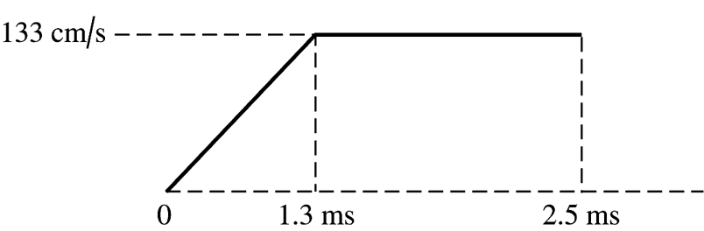
Figure 2.54

2.55. Identify: The sprinter’s acceleration is constant for the first 2.0 s but zero after that, so it is not constant over the entire race. We need to break up the race into segments.
Set Up: When the acceleration is constant, the formula applies. The average velocity is
Execute: (a)
(b) (i) 40.0 m at 10.0 m/s so time at constant speed is 4.0 s. The total time is 6.0 s, so
(ii) He runs 90.0 m at 10.0 m/s so the time at constant speed is 9.0 s. The total time is 11.0 s, so
(iii) He runs 190 m at 10.0 m/s so time at constant speed is 19.0 s. His total time is 21.0 s, so
Evaluate: His average velocity keeps increasing because he is running more and more of the race at his top speed.
2.56. Identify: The average speed is the total distance traveled divided by the total time. The elapsed time is the distance traveled divided by the average speed.
Set Up: The total distance traveled is 20 mi. With an average speed of 8 mi/h for 10 mi, the time for that first 10 miles is
Execute: (a) An average speed of 4 mi/h for 20 mi gives a total time of The second 10 mi must be covered in This corresponds to an average speed of
(b) An average speed of 12 mi/h for 20 mi gives a total time of The second 10 mi must be covered in This corresponds to an average speed of
(c) An average speed of 16 mi/h for 20 mi gives a total time of But 1.25 h was already spent during the first 10 miles and the second 10 miles would have to be covered in zero time. This is not possible and an average speed of 16 mi/h for the 20-mile ride is not possible.
Evaluate: The average speed for the total trip is not the average of the average speeds for each 10-mile segment. The rider spends a different amount of time traveling at each of the two average speeds.
2.57. Identify: and
Set Up: for
Execute: (a) The graphs are sketched in Figure 2.57.
(b) The particle is instantaneously at rest when and the quadratic formula gives and These results agree with the graphs in part (a).
(c) For For At the slope of the graph is negative and at it is positive, so the same answer is deduced from the graph as from the expression for
(d) is instantaneously not changing when This occurs at
(e) When the particle is at its greatest distance from the origin, and (so the particle is starting to move back toward the origin). This is the case for which agrees with the x-t graph in part (a). At
(f) The particle’s speed is changing at its greatest rate when has its maximum magnitude. The graph in part (a) shows this occurs at and at Since is always positive in this time interval, the particle is speeding up at its greatest rate when is positive, and this is for
The particle is slowing down at its greatest rate when is negative and this is for
Evaluate: Since is linear in t, is a parabola and is symmetric around the point where has its minimum value (). For this reason, the answer to part (d) is midway between the two times in part (c).

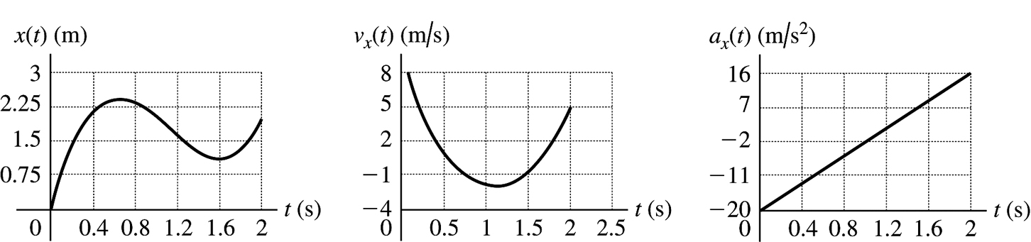
Figure 2.57

2.58. Identify: We know the vertical position of the lander as a function of time and want to use this to find its velocity initially and just before it hits the lunar surface.
Set Up: By definition, so we can find v_{y} as a function of time and then evaluate it for the desired cases.
Execute: (a) At The initial velocity is 60.0 m/s downward.
(b) says The quadratic formula says It reaches the surface at
At this time,
Evaluate: The given formula for y(t) is of the form y = y₀ + v_{0y}t + at². For part (a), v_{0y} = −c = −60m/s.
2.59. Identify: In time the S-waves travel a distance and in time the P-waves travel a distance
Set Up:
Execute:
Evaluate: The times of travel for each wave are and
2.60. Identify: The average velocity is The average speed is the distance traveled divided by the elapsed time.
Set Up: Let be in the direction of the first leg of the race. For the round trip, and the total distance traveled is 50.0 m. For each leg of the race both the magnitude of the displacement and the distance traveled are 25.0 m.
Execute: (a) This is the same as the average speed for this leg of the race.
(b) This is the same as the average speed for this leg of the race.
(c) so
(d) The average speed is
Evaluate: Note that the average speed for the round trip is not equal to the arithmetic average of the average speeds for each leg.
2.61. Identify: The average velocity is
Set Up: Let be upward.
Execute: (a)
(b)
Evaluate: For the first 1.15 s of the flight, When the velocity isn’t constant the average velocity depends on the time interval chosen. In this motion the velocity is increasing.
2.62. (a) Identify and Set Up: The change in speed is the area under the versus t curve between vertical lines at and
Execute: This area is
This acceleration is positive so the change in velocity is positive.
(b) Slope of versus t is positive and increasing with t. The graph is sketched in Figure 2.62.

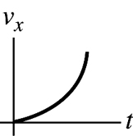
Figure 2.62
Evaluate: The calculation in part (a) is equivalent to Since is linear in t, Thus for the time interval to
2.63. Identify: Use information about displacement and time to calculate average speed and average velocity. Take the origin to be at Seward and the positive direction to be west.
(a) Set Up:
Execute: The distance traveled (different from the net displacement is
Find the total elapsed time by using to find t for each leg of the journey.
Seward to Auora:
Auora to York:
Total
Then
(b) Set Up: where is the displacement, not the total distance traveled.
For the whole trip he ends up west of his starting point.
Evaluate: The motion is not uniformly in the same direction so the displacement is less than the distance traveled and the magnitude of the average velocity is less than the average speed.
2.64. Identify: Use constant acceleration equations to find for each segment of the motion.
Set Up: Let be the direction the train is traveling.
Execute: to 14.0 s:
At the speed is In the next 70.0 s, and
For the interval during which the train is slowing down, and gives
The total distance traveled is
Evaluate: The acceleration is not constant for the entire motion but it does consist of constant acceleration segments and we can use constant acceleration equations for each segment.
2.65. (a) Identify: Calculate the average acceleration using Use the information about the time and total distance to find his maximum speed.
Set Up: since the runner starts from rest.
but we need to calculate the speed of the runner at the end of the acceleration period.
Execute: For the last the acceleration is zero and the runner travels a distance of (obtained using
During the acceleration phase of 4.0 s, where the velocity goes from 0 to the runner travels a distance
The total distance traveled is 100 m, so This gives
Now we can calculate
(b) For this time interval the velocity is constant, so
Evaluate: Now that we have we can calculate and So, which checks.
(c) Identify and Set Up: where now the time interval is the full 9.1 s of the race.
We have calculated the final speed to be so
Evaluate: The acceleration is zero for the last 5.1 s, so it makes sense for the answer in part (c) to be less than half the answer in part (a).
(d) The runner spends different times moving with the average accelerations of parts (a) and (b).
2.66. Identify: Apply the constant acceleration equations to the motion of the sled. The average velocity for a time interval is
Set Up: Let be parallel to the incline and directed down the incline. The problem doesn’t state how much time it takes the sled to go from the top to 14.4 m from the top.
Execute: (a) 14.4 m to 25.6 m: 25.6 to 40.0 m: 40.0 m to 57.6 m:
(b) For each segment we know and t but we don’t know or Let and For this interval and Solving for gives Let and For this second interval, and Solving for gives Setting these two expressions for equal to each other and solving for a gives
Note that this expression for a says where and are the average speeds for successive 2.00 s intervals.
(c) For the motion from to and gives
(d) For the motion from to and gives
(e) For this 1.00 s time interval,
Evaluate: With at the top of the hill, We can verify that gives gives 25.6 m, gives 40.0 m, and gives 57.6 m.
2.67. Identify: When the graph of versus t is a straight line the acceleration is constant, so this motion consists of two constant acceleration segments and the constant acceleration equations can be used for each segment. Since is always positive the motion is always in the direction and the total distance moved equals the magnitude of the displacement. The acceleration is the slope of the versus t graph.
Set Up: For the to segment, and For the to segment, and
Execute: (a) For to
For to The total distance traveled is 92.0 m.
(b)
(c) For to 10.0 s, For to 12.0 s, The graph of versus t is given in Figure 2.67.
Evaluate: When and are both positive, the speed increases. When is positive and is negative, the speed decreases.

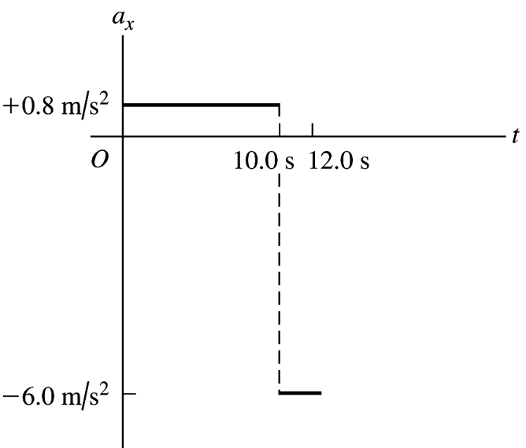
Figure 2.67

2.68. Identify: When the graph of versus t is a straight line the acceleration is constant, so this motion consists of two constant acceleration segments and the constant acceleration equations can be used for each segment. For to 5.0 s, is positive and the ball moves in the direction. For to 20.0 s, is negative and the ball moves in the −x direction. The acceleration is the slope of the versus
t graph.
Set Up: For the to segment, and For the to segment, and
Execute: (a) For to 5.0 s, The ball travels a distance of 75.0 m. For to 20.0 s, The total distance traveled is
(b) The total displacement is The ball ends up 75.0 m in the negative x-direction from where it started.
(c) For to 5.0 s, For to 20.0 s, The graph of versus t is given in Figure 2.68.
(d) The ball is in contact with the floor for a small but nonzero period of time and the direction of the velocity doesn’t change instantaneously. So, no, the actual graph of is not really vertical at 5.00 s.
Evaluate: For to 5.0 s, both and are positive and the speed increases. For to
20.0 s, is negative and is positive and the speed decreases. Since the direction of motion is not the same throughout, the displacement is not equal to the distance traveled.

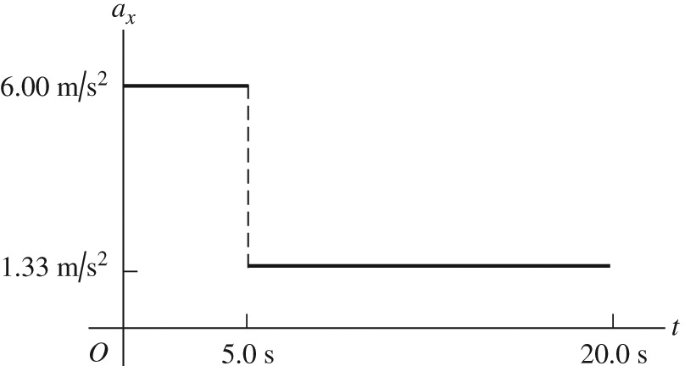
Figure 2.68
2.69. Identify and Set Up: Apply constant acceleration equations.
Find the velocity at the start of the second 5.0 s; this is the velocity at the end of the first 5.0 s. Then find for the first 5.0 s.
Execute: For the first 5.0 s of the motion,
gives
This is the initial speed for the second 5.0 s of the motion. For the second 5.0 s:
gives and
Use this and consider the first 5.0 s of the motion:
Evaluate: The ball is speeding up so it travels farther in the second 5.0 s interval than in the first. In fact, is proportional to since it starts from rest. If it goes 50.0 m in 5.0 s, in twice the time (10.0 s) it should go four times as far. In 10.0 s we calculated it went which is four times 50 m.
2.70. Identify: Apply to the motion of each train. A collision means the front of the passenger train is at the same location as the caboose of the freight train at some common time.
Set Up: Let P be the passenger train and F be the freight train. For the front of the passenger train and for the caboose of the freight train For the freight train and For the passenger train and
Execute: (a) for each object gives and Setting gives The quadratic formula gives The collision occurs at The equations that specify a collision have a physical solution (real, positive t), so a collision does occur.
(b) The passenger train moves 537 m before the collision. The freight train moves
(c) The graphs of and versus t are sketched in Figure 2.70.
Evaluate: The second root for the equation for t, is the time the trains would meet again if they were on parallel tracks and continued their motion after the first meeting.

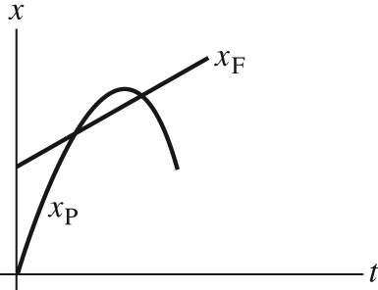
Figure 2.70

2.71. Identify: Apply constant acceleration equations to the motion of the two objects, you and the cockroach. You catch up with the roach when both objects are at the same place at the same time. Let T be the time when you catch up with the cockroach.
Set Up: Take to be at the location of the roach and positive x to be in the direction of motion of the two objects.
roach:
you:
Apply to both objects:
Execute: roach: so
you:
Evaluate: Your final velocity is Then which checks. You have to accelerate to a speed greater than that of the roach so you will travel the extra 0.90 m you are initially behind.
2.72. Identify: The insect has constant speed 15 m/s during the time it takes the cars to come together.
Set Up: Each car has moved 100 m when they hit.
Execute: The time until the cars hit is During this time the grasshopper travels a distance of
Evaluate: The grasshopper ends up 100 m from where it started, so the magnitude of his final displacement is 100 m. This is less than the total distance he travels since he spends part of the time moving in the opposite direction.
2.73. Identify: Apply constant acceleration equations to each object.
Take the origin of coordinates to be at the initial position of the truck, as shown in Figure 2.73a.
Let d be the distance that the auto initially is behind the truck, so and Let
T be the time it takes the auto to catch the truck. Thus at time T the truck has undergone a displacement so is at The auto has caught the truck so at time T is also at

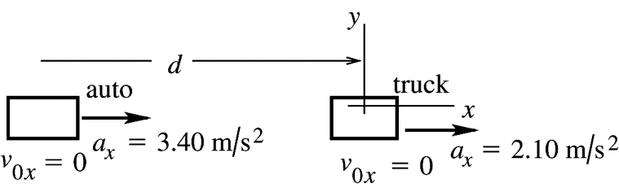
Figure 2.73a

(a) Set Up: Use the motion of the truck to calculate T:
(starts from rest),
Since this gives
Execute:
(b) Set Up: Use the motion of the auto to calculate d:
Execute:
(c) auto:
truck:
(d) The graph is sketched in Figure 2.73b.

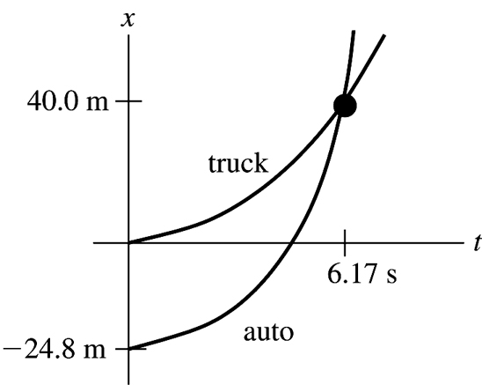
Figure 2.73b

Evaluate: In part (c) we found that the auto was traveling faster than the truck when they came abreast. The graph in part (d) agrees with this: at the intersection of the two curves the slope of the x-t curve for the auto is greater than that of the truck. The auto must have an average velocity greater than that of the truck since it must travel farther in the same time interval.
2.74. Identify: Apply the constant acceleration equations to the motion of each car. The collision occurs when the cars are at the same place at the same time.
Set Up: Let be to the right. Let at the initial location of car 1, so and The cars collide when and
Execute: (a) gives and gives The quadratic formula gives Only the positive root is physical, so
(b)
(c) The x-t and graphs for the two cars are sketched in Figure 2.74.
Evaluate: In the limit that and the time it takes car 2 to travel distance D. In the limit that the time it takes car 1 to travel distance D.

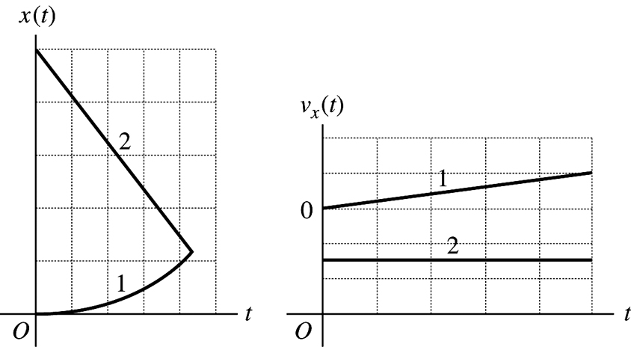
Figure 2.74

2.75. Identify: The average speed is the distance traveled divided by the time. The average velocity is
Set Up: The distance the ball travels is half the circumference of a circle of diameter 50.0 cm so is Let be horizontally from the starting point toward the ending point, so equals the diameter of the bowl.
Execute: (a) The average speed is
(b) The average velocity is
Evaluate: The average speed is greater than the magnitude of the average velocity, since the distance traveled is greater than the magnitude of the displacement.
2.76. Identify: The acceleration is not constant so the constant acceleration equations cannot be used. Instead, use and
Set Up: for
Execute: (a) at gives and
(b) The maximum positive x is when and gives and At this t, is negative. For
Evaluate: After the object starts to move in the direction and goes to as
2.77. Identify: Apply constant acceleration equations to each vehicle.
Set Up: (a) It is very convenient to work in coordinates attached to the truck.
Note that these coordinates move at constant velocity relative to the earth. In these coordinates the truck is at rest, and the initial velocity of the car is Also, the car’s acceleration in these coordinates is the same as in coordinates fixed to the earth.
Execute: First, let’s calculate how far the car must travel relative to the truck: The situation is sketched in Figure 2.77.

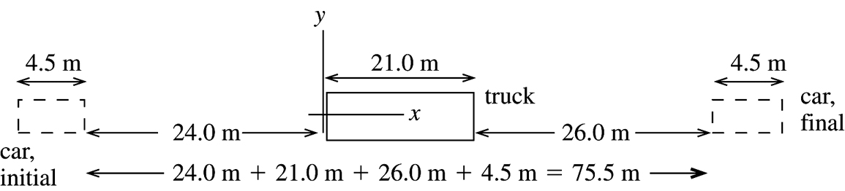
Figure 2.77

The car goes from to So for the car.
Calculate the time it takes the car to travel this distance:
It takes the car 15.9 s to pass the truck.
(b) Need how far the car travels relative to the earth, so go now to coordinates fixed to the earth. In these coordinates for the car. Take the origin to be at the initial position of the car.
(c) In coordinates fixed to the earth:
Evaluate: In 15.86 s the truck travels The car travels farther than the truck, which checks with part (a). In coordinates attached to the truck, for the car and in 15.86 s the car travels which checks with part (a).
2.78. Identify: Use a velocity-time graph to find the acceleration of a stone. Then use that information to find how long it takes the stone to fall through a known distance and how fast you would have to throw it upward to reach a given height and the time to reach that height.
Set Up: Take to be downward. The acceleration is the slope of the versus t graph.
Execute: (a) Since is downward, it is positive and equal to the speed The versus t graph has slope The formulas and apply.
(b) and let gives
(c) At the maximum height, Let gives gives
Evaluate: The acceleration is downward, throughout the motion. The velocity initially is upward, decreases to zero because of the downward acceleration and then is downward and increasing in magnitude because of the downward acceleration.
2.79. with and
(a) Identify and Set Up: Integrage to find and then integrate to find
Execute:
At
To have at requires that
Thus
(b) With as calculated in part (a) and
Evaluate: at For At the particle is moving in the and is speeding up. After when the acceleration is positive, the object slows down and then starts to move in the with increasing speed.
2.80. Identify: Find the distance the professor walks during the time t it takes the egg to fall to the height of his head.
Set Up: Let be downward. The egg has and At the height of the professor’s head, the egg has
Execute: gives The professor walks a distance Release the egg when your professor is 3.60 m from the point directly below you.
Evaluate: Just before the egg lands its speed is It is traveling much faster than the professor.
2.81. Identify: Use the constant acceleration equations to establish a relationship between maximum height and acceleration due to gravity and between time in the air and acceleration due to gravity.
Set Up: Let be upward. At the maximum height, When the rock returns to the surface,
Execute: (a) gives which is constant, so
(b) with gives which is constant, so
Evaluate: On Mars, where the acceleration due to gravity is smaller, the rocks reach a greater height and are in the air for a longer time.
2.82. Identify: Calculate the time it takes her to run to the table and return. This is the time in the air for the thrown ball. The thrown ball is in free-fall after it is thrown. Assume air resistance can be neglected.
Set Up: For the thrown ball, let be upward. when the ball returns to its original position.
Execute: (a) It takes her to reach the table and an equal time to return. For the ball, and gives
(b) Find when
Evaluate: It takes the ball the same amount of time to reach its maximum height as to return from its maximum height, so when she is at the table the ball is at its maximum height. Note that this large maximum height requires that the act either be done outdoors, or in a building with a very high ceiling.
2.83. (a) Identify: Use constant acceleration equations, with downward, to calculate the speed of the diver when she reaches the water.
Set Up: Take the origin of coordinates to be at the platform, and take the to be downward.
(since diver just steps off),
Execute:
We know that is positive because the diver is traveling downward when she reaches the water.
The announcer has exaggerated the speed of the diver.
Evaluate: We could also use to find The diver gains 9.80 m/s of speed each second, so has when she reaches the water, which checks.
(b) Identify: Calculate the initial upward velocity needed to give the diver a speed of 25.0 m/s when she reaches the water. Use the same coordinates as in part (a).
Set Up:
Execute:
is negative since the direction of the initial velocity is upward.)
Evaluate: One way to decide if this speed is reasonable is to calculate the maximum height above the platform it would produce:
(at maximum height),
This is not physically attainable; a vertical leap of 10.6 m upward is not possible.
2.84. Identify: The flowerpot is in free-fall. Apply the constant acceleration equations. Use the motion past the window to find the speed of the flowerpot as it reaches the top of the window. Then consider the motion from the windowsill to the top of the window.
Set Up: Let be downward. Throughout the motion
Execute: Motion past the window: gives This is the velocity of the flowerpot when it is at the top of the window.
Motion from the windowsill to the top of the window: gives The top of the window is 0.310 m below the windowsill.
Evaluate: It takes the flowerpot to fall from the sill to the top of the window. Our result says that from the windowsill the pot falls in which checks.
2.85. (a) Identify: Consider the motion from when he applies the acceleration to when the shot leaves
his hand.
Set Up: Take positive y to be upward.
Execute:
(b) Identify: Consider the motion of the shot from the point where he releases it to its maximum height, where Take at the ground.
Set Up: (free fall), (from part (a), at maximum height),
Execute:
(c) Identify: Consider the motion of the shot from the point where he releases it to when it returns to the height of his head. Take at the ground.
Set Up:
Execute: with t in seconds. Use the quadratic formula to solve for t: Since t must be positive,
Evaluate: Calculate the time to the maximum height: so It also takes 0.68 s to return to 2.2 m above the ground, for a total time of 1.36 s. His head is a little lower than 2.20 m, so it is reasonable for the shot to reach the level of his head a little later than 1.36 s after being thrown; the answer of 1.42 s in part (c) makes sense.
2.86. Identify: The motion of the rocket can be broken into 3 stages, each of which has constant acceleration, so in each stage we can use the standard kinematics formulas for constant acceleration. But the acceleration is not the same throughout all 3 stages.
Set Up: The formulas and apply.
Execute: (a) Let +y be upward. At and During the next 10.0 s the rocket travels upward an additional distance The height above the launch pad when the second stage quits therefore is
For the free-fall motion after the second stage quits:
The maximum height above the launch pad that the rocket reaches is
(b) gives From the quadratic formula the positive root is
(c) The rocket’s speed will be 246 m/s just before it hits the ground.
Evaluate: We cannot solve this problem in a single step because the acceleration, while constant in each stage, is not constant over the entire motion. The standard kinematics equations apply to each stage but not to the motion as a whole.
2.87. Identify and Set Up: Let be upward. Each ball moves with constant acceleration In parts (c) and (d) require that the two balls be at the same height at the same time.
Execute: (a) At ceiling, Solve for
gives
(b) with the information from part (a) gives
(c) Let the first ball travel downward a distance d in time t. It starts from its maximum height, so
gives
The second ball has In time t it must travel upward to be at the same place as the first ball.
gives
We have two equations in two unknowns, d and t. Solving gives and
(d)
Evaluate: In 0.59 s the first ball falls so is at the same height as the second ball.
2.88. Identify: The teacher is in free-fall and falls with constant acceleration downward. The sound from her shout travels at constant speed. The sound travels from the top of the cliff, reflects from the ground and then travels upward to her present location. If the height of the cliff is h and she falls a distance y in 3.0 s, the sound must travel a distance in 3.0 s.
Set Up: Let be downward, so for the teacher and Let at the top of the cliff.
Execute: (a) For the teacher, For the sound, which rounds to 530 m.
(b) gives
Evaluate: She is in the air for and strikes the ground at high speed.
2.89. Identify: The helicopter has two segments of motion with constant acceleration: upward acceleration for 10.0 s and then free-fall until it returns to the ground. Powers has three segments of motion with constant acceleration: upward acceleration for 10.0 s, free-fall for 7.0 s and then downward acceleration of
Set Up: Let be upward. Let at the ground.
Execute: (a) When the engine shuts off both objects have upward velocity and are at
For the helicopter, (at the maximum height), and gives which rounds to 380 m.
(b) The time for the helicopter to crash from the height of 250 m where the engines shut off can be found using and gives The quadratic formula gives Only the positive solution is physical, so Powers therefore has free-fall for 7.0 s and then downward acceleration of for After 7.0 s of free-fall he is at and has velocity After the next 6.9 s he is at Powers is 184 m above the ground when the helicopter crashes.
Evaluate: When Powers steps out of the helicopter he retains the initial velocity he had in the helicopter but his acceleration changes abruptly from upward to downward. Without the jet pack he would have crashed into the ground at the same time as the helicopter. The jet pack slows his descent so he is above the ground when the helicopter crashes.
2.90. Identify: Apply constant acceleration equations to the motion of the rock. Sound travels at constant speed.
Set Up: Let be the time for the rock to fall to the ground and let be the time it takes the sound to travel from the impact point back to you. Both the rock and sound travel a distance d that is equal to the height of the cliff. Take downward for the motion of the rock. The rock has and
Execute: (a) For the rock, gives
For the sound, Let and
(b) You would have calculated You would have overestimated the height of the cliff. It actually takes the rock less time than 10.0 s to fall to the ground.
Evaluate: Once we know d we can calculate that and The time for the sound of impact to travel back to you is 12% of the total time and cannot be neglected. The rock has speed 86 m/s just before it strikes the ground.
2.91. (a) Identify: Let be upward. The can has constant acceleration The initial upward velocity of the can equals the upward velocity of the scaffolding; first find this speed.
Set Up:
Execute: gives
Use this in to solve for
(b) Identify: Find the maximum height of the can, above the point where it falls from the scaffolding:
Set Up:
Execute: gives
The can will pass the location of the other painter. Yes, he gets a chance.
Evaluate: Relative to the ground the can is initially traveling upward, so it moves upward before stopping momentarily and starting to fall back down.
2.92. Identify: Both objects are in free-fall. Apply the constant acceleration equations to the motion of each person.
Set Up: Let be downward, so for each object.
Execute: (a) Find the time it takes the student to reach the ground: gives Superman must reach the ground in gives Superman must have initial speed
(b) The graphs of y-t for Superman and for the student are sketched in Figure 2.92.
(c) The minimum height of the building is the height for which the student reaches the ground in 5.00 s, before Superman jumps. The skyscraper must be
at least 122 m high.
Evaluate: so only Superman could jump downward with this initial speed.

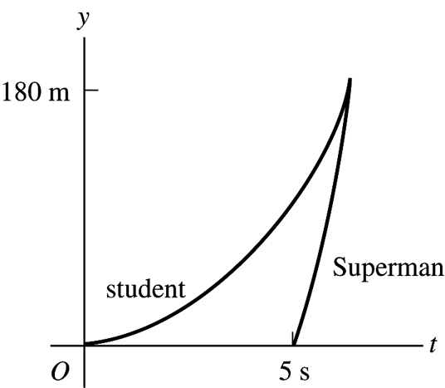
Figure 2.92

2.93. Identify: Apply constant acceleration equations to the motion of the rocket and to the motion of the canister after it is released. Find the time it takes the canister to reach the ground after it is released and find the height of the rocket after this time has elapsed. The canister travels up to its maximum height and then returns to the ground.
Set Up: Let be upward. At the instant that the canister is released, it has the same velocity as the rocket. After it is released, the canister has At its maximum height the canister has
Execute: (a) Find the speed of the rocket when the canister is released: gives
For the motion of the canister after it is released, gives The quadratic formula gives as the positive solution. Then for the motion of the rocket during this 12.0 s,
(b) Find the maximum height of the canister above its release point: gives After its release the canister travels upward 79.2 m to its maximum height and then back down to the ground. The total distance it travels is 393 m.
Evaluate: The speed of the rocket at the instant that the canister returns to the launch pad is We can calculate its height at this instant by with and which agrees with our previous calculation.
2.94. Identify: Both objects are in free-fall and move with constant acceleration downward. The two balls collide when they are at the same height at the same time.
Set Up: Let be upward, so for each ball. Let at the ground. Let ball A be the one thrown straight up and ball B be the one dropped from rest at height H.
Execute: (a) applied to each ball gives and gives and
(b) For ball A at its highest point, and gives Setting this equal to the time in part (a) gives and
Evaluate: In part (a), using in the expressions for and gives
H must be less than in order for the balls to collide before ball A returns to the ground. This is because it takes ball A time to return to the ground and ball B falls a distance during this time. When the two balls collide just as ball A reaches the ground and for H greater than this ball A reaches the ground before they collide.
2.95. Identify and Set Up: Use and to calculate and for each car. Use these equations to answer the questions about the motion.
Execute:
(a) Identify and Set Up: The car that initially moves ahead is the one that has the larger
Execute: At and So initially car A moves ahead.
(b) Identify and Set Up: Cars at the same point implies
Execute: One solution is which says that they start from the same point. To find the other solutions, divide by t:
So for and
Evaluate: Car A has constant, positive Its is positive and increasing. Car B has and that is initially positive but then becomes negative. Car B initially moves in thebut then slows down and finally reverses direction. At car B has overtaken car A and then passes it. At car B is moving in the as it passes car A again.
(c) Identify: The distance from A to B is The rate of change of this distance is If this distance is not changing, But this says (The distance between A and B is neither decreasing nor increasing at the instant when they have the same velocity.)
Set Up: requires
Execute:
so for and
Evaluate: At At Now car B is slowing down while A continues to speed up, so their velocities aren’t ever equal again.
(d) Identify and Set Up: requires
Execute:
Evaluate: At but is decreasing while is constant. They are equal at but for all times after that
2.96. Identify: Apply to the motion from the maximum height, where The time spent above on the way down equals the time spent above on the way up.
Set Up: Let be downward. when he is a distance above the floor.
Execute: The time from the maximum height to above the floor is given by The time from the maximum height to the floor is given by and the time from a height of to the floor is
Evaluate: The person spends over twice as long above as below His average speed is less above than it is when he is below this height.
2.97. Identify: Apply constant acceleration equations to the motion of the two objects, the student and the bus.
Set Up: For convenience, let the student’s (constant) speed be and the bus’s initial position be Note that these quantities are for separate objects, the student and the bus. The initial position of the student is taken to be zero, and the initial velocity of the bus is taken to be zero. The positions of the student and the bus as functions of time are then and
Execute: (a) Setting and solving for the times t gives
The student will be likely to hop on the bus the first time she passes it (see part (d) for a discussion of the later time). During this time, the student has run a distance
(b) The speed of the bus is
(c) The results can be verified by noting that the x lines for the student and the bus intersect at two points, as shown in Figure 2.97a.
(d) At the later time, the student has passed the bus, maintaining her constant speed, but the accelerating bus then catches up to her. At this later time the bus’s velocity is
(e) No; and the roots of the quadratic are imaginary. When the student runs at
Figure 2.97b shows that the two lines do not intersect:
(f) For the student to catch the bus, And so the minimum speed is She would be running for a time and covers a distance
However, when the student runs at the lines intersect at one point, at as shown in Figure 2.97c.
Evaluate: The graph in part (c) shows that the student is traveling faster than the bus the first time they meet but at the second time they meet the bus is traveling faster.

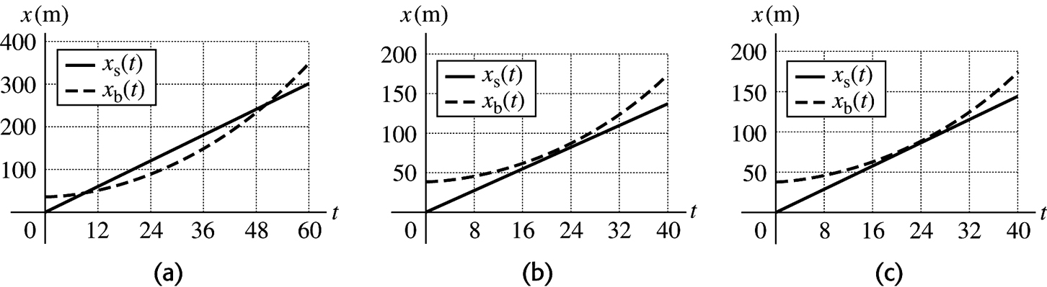
Figure 2.97

2.98. Identify: Apply constant acceleration equations to the motion of the boulder.
Set Up: Let be downward, so
Execute: (a) Let the height be h and denote the 1.30-s interval as the simultaneous equations can be solved for t. Eliminating h and taking the square root, and and substitution into gives
(b) The above method assumed that when the square root was taken. The negative root (with gives an answer of 2.51 m, clearly not a “cliff.” This would correspond to an object that was initially near the bottom of this “cliff ” being thrown upward and taking 1.30 s to rise to the top and fall to the bottom. Although physically possible, the conditions of the problem preclude this answer.
Evaluate: For the first two-thirds of the distance, and Then for the last third of the distance, and gives as required.
2.99. Identify: Apply constant acceleration equations to both objects.
Set Up: Let be upward, so each ball has For the purpose of doing all four parts with the least repetition of algebra, quantities will be denoted symbolically. That is, let In this case,
Execute: (a) Setting expanding the binomial and eliminating the common term Solving for t:
Substitution of this into the expression for and setting and solving for h as a function of yields, after some algebra, Using the given value
This has two solutions, one of which is unphysical (the first ball is still going up when the second is released; see part (c)). The physical solution involves taking the negative square root before solving for and yields The graph of y versus t for each ball is given in Figure 2.99.
(b) The above expression gives for (i), 0.411 m and for (ii) 1.15 km.
(c) As approaches the height h becomes infinite, corresponding to a relative velocity at the time the second ball is thrown that approaches zero. If the first ball can never catch the second ball.
(d) As approaches 4.9 m/s, the height approaches zero. This corresponds to the first ball being closer and closer (on its way down) to the top of the roof when the second ball is released. If the first ball will already have passed the roof on the way down before the second ball is released, and the second ball can never catch up.
Evaluate: Note that the values of in parts (a) and (b) are all greater than and less than

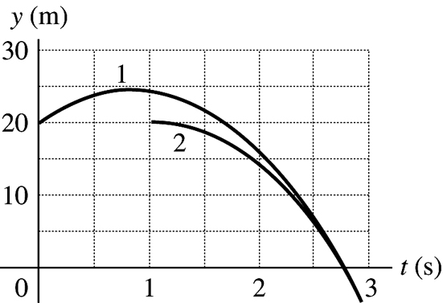
Figure 2.99

