PROBLEM 2.1

FIND: Define the term *signal* as it relates to measurement systems and provide examples of static and dynamic input signals to measurement systems.

SOLUTION: A *signal* carries information about the value and behavior of some physical phenomenon. Within a measurement system, a signal can be thought of as the information being carried from one place to another, such as between stages of the measurement system. Signals have a variety of forms, including electrical, optical, and mechanical.

Examples of static input signals are:

1. weight, such as weighing merchandise, etc.

2. body temperature, at the moment of interest

3. length or height, such as the length of a board or a person's height

Examples of dynamic input signals:

1. input signal to an automobile speed control

2. input signal to a music amplifier from a component such as a from a portable personal device

3. input signal to a printer from a computer

4. wind speed on a gusty day as input signal to an anemometer

# PROBLEM 2.2

FIND: List the important characteristics of input and output digital signals and define each.

SOLUTION:

1. *Magnitude* - generally refers to the maximum absolute value of a signal

2. *Range* - difference between maximum and minimum values of a signal. For a digital signal, it is represented as the maximum number of bits

3. *Amplitude* - indicative of signal magnitude fluctuations relative to the mean

4. *Frequency* - describes the time (or space) variation of a signal.

5. *Sampling frequency* – For a digital signal indicates how often a digital record is measured and recorded.

5. *Bit resolution or quantization error (see Chapter 7)*- smallest change that can be recorded by a digital system

COMMENT: The process of converting an analog signal to digital form is described in detail in Chapter 7.

PROBLEM 2.3

SOLUTION

An analog signal is continuous in time (or space or abscissa) and can assume any ordinate value (continuous) within its range.

* At any point in time (or space), an analog signal has a magnitude that is analogous to the magnitude of the physical value it represents.
  + As an example, an analog signal of the temperature of a mass in an oven would increase as temperature increases assuming any appropriate value within its range. The analog value of temperature is related to phase change of materials, such as the freezing point of water or the melting point of gold.

A discrete-time signal is a series having a magnitude associated with an interval in time.

* It is not continuous in time but rather is a sequence in values assigned at discrete time points.
  + As an example, a discrete time series can be represented as a table of magnitudes, each magnitude associated with a specific time point. The magnitude can assume any value within its range but time is discrete.

A digital signal is a series of discrete magnitude values having a finite set of possible values associated with a discrete time point (or abscissa point).

* As an example, a digital temperature readout provides a discrete reading of defined resolution at each time point. Hence, its magnitude is restricted to a set of possible values (i.e., non-continuous) assigned at discrete time points.

Analog: continuous ordinate value and continuous abscissa value.

Discrete-time: continuous ordinate value and discrete abscissa value.

Digital: discrete ordinate and discrete abscissa values.

PROBLEM 2.4

SOLUTION

The average value of a signal measures its mean value relative to zero. Here the portions of a signal that are greater than the average value are counteracted by the portions of the signal that are less than the average value. The average value of a signal is also called its DC (direct current) value and has the meaning of a signal that is constant in time with a magnitude having the DC value.

For example, consider a sinusoidal current signal with an average of zero. Because the signal is symmetrical about` the horizontal axis over a period, the portion of the signal greater than zero are counteracted by the portions of the signal below zero, resulting in the zero average. Offsetting (moving the signal up or down the vertical axis) the average value to some positive or negative value has the same effect but with non-zero average value.

The root-mean-square (rms) value is the “square-root of the mean of the signal squared.” It is a means of quantifying the variation of a time-varying signal. The time-varying portion of a signal is also called the AC (alternating current) value.

For example, consider a sinusoidal current signal with an average of zero. Because the signal is squared, the positive and negative portions of the signal contribute in the same way. So, unlike an average value, the effect is non-zero. The power (P = I2R) dissipated across a resistance will be non-zero and related to the square of the current signal. For time varying signals, it is equivalent to the DC current or voltage that creates the same power dissipation across a resistor.

The alternating current having some rms value Irms flowing through a resistor R will create the same amount of power dissipated as produced by a direct current (average value) Iavergae of same value through that resistor R. The rms value of a sinusoidal signal is 0.707 times its amplitude.

PROBLEM 2.5

**SOLUTION**

A time-based analog signal, such as *y(t)*, is continuous in time. That is, for each and any value of time *t*, there is an associated magnitude value of *y*.

A discrete-time series, such as {*y(rδt)*}, is discrete in time. Hence, the signal only has a value for *y* at each discrete time point *rδt,* where r is a counter 0, 1, 2, 3, … and *δt* is a time interval between points in the series. For each discrete time point, there is an associated magnitude value of *y*. Between discrete time point values, the magnitude value is not specified.

**COMMENT** In recreating the continuous time series, the value between discrete time points could be assumed to be constant between time points (called a sample-and-hold) – this is quite common - or be some interpolated value between time point values, or just be unknown.

An important parameter between analog and discrete-time series is the time step between each point in the discrete series.

PROBLEM 2.6

KNOWN: Need to transmit voice data in digital form

FIND: The importance of multiplexing and data compression in voice transmission

SOLUTION: Multiplexing is a term that represents the idea of transmitting several signals over the same medium at the same time. Historically, the need to transmit several conversations over the same telephone wires spurred the development of techniques for multiplexing, with the first applications occurring early in the 20th century.

When considering digital signals, there are several techniques available for multiplexing. The simplest to understand is termed time-division multiplexing where a time period is allocated to each of several signals being transmitted. Each receiver (or person hearing a conversation) will not “notice” that some of the time was allocated to another conversation. Implementation of this technique is made easier by the fact that there is much “dead” time in a conversation between two people that can be detected and used to advantage!

Voice data compression takes several forms. A simple voice compression scheme removes all of the frequency content that is not necessary for intelligibility. Frequency content outside of the range from 400 to 3000 Hz is generally not needed to understand speech. However, some loss of emotional content occurs as compression increases.

PROBLEM 2.7

KNOWN: Need to transmit and store digital image files

FIND: Compression schemes for image files

SOLUTION: Compression allows reducing the size of digital files for storage or transmission. The file and image resulting after compression may or may not contain all of the data present in the original file. For digital photography, a “raw” image from a 12-bit CCD allows 4096 brightness levels for each pixel. If compressed to a JPEG image, this output is only 8-bit where each pixel can have 256 brightness levels. The savings in required storage is dramatic.

Another possible scheme for compression can be termed “region of interest” compression. For example, images containing faces with a background can be reduced in size by storing less information about the background.

You may wish to research how color images are recorded and compressed to JPEG format.

PROBLEM 2.8

KNOWN:



FIND:  for the time periods *t*1 to *t*2 listed below

a) 0 to 0.1 sec

b) 0.4 to 0.5 sec

c) 0 to 1/3 sec

d) 0 to 20 sec

SOLUTION:

For the continuous function *y*(*t*), the average may be expressed



and the rms as



For , the average is given by



and the rms as



The resulting numerical values are

a) 

b) 

c) 

d) 

Comment: The average and rms values for the time period 0 to 20 seconds represents the long-term average behavior of the signal. The result in parts a) and b) are accurate over the specified time periods and for a measured signal may have specific significance. The period 0 to 1/3 represents one complete cycle of the simple periodic signal and results in average and rms values which accurately represent the long-term behavior of the signal.

PROBLEM 2.9

**KNOWN**: (a) y(t) = 3t for 0 ≤ t ≤ 2 s with T = 2 s

(b) y (t) = 1.5t [V] for 0 ≤ t ≤ 2 s and

y(t) = 0 [V] for 2 ≤ t ≤ 4 with T = 4 s

**FIND**:  , 

**SOLUTION**

1. The average (or mean) value of a continuous function is given by





1. The average (or mean) value of a continuous function is given by





**COMMENT** Keep in mind that the average and rms values are averaged over the entire signal period even if part of that period the signal is zero.

PROBLEM 2.10

**KNOWN:** *y(t) = 2sin 2πt*

**FIND**:  ,  for different signal intervals

**SOLUTION**

We note that this signal has a frequency of 1 Hz (i.e., *2πf = 2π,* if *f* = 1).

Hence, the signal has a period of *T = 1/f* = 1s.

The average (or mean) value is given by



The rms value is given by



1. 



(b) 



(c) 



PROBLEM 2.11

KNOWN: Discrete sampled data, corresponding to measurement every 0.4 seconds, as shown below.

|  |  |  |  |  |  |
| --- | --- | --- | --- | --- | --- |
| t | y1(t) | y2(t) | t | y1(t) | y2(t) |
| 0 | 0 | 0 |  |  |  |
| 0.4 | 11.76 | 15.29 | 2.4 | −11.76 | −15.29 |
| 0.8 | 19.02 | 24.73 | 2.8 | −19.02 | −24.73 |
| 1.2 | 19.02 | 24.73 | 3.2 | −19.02 | −24.73 |
| 1.6 | 11.76 | 15.29 | 3.6 | −11.76 | −15.29 |
| 2.0 | 0 | 0 | 4.0 | 0 | 0 |

FIND: The mean and rms values of the measured data.

SOLUTION:

For a discrete signal the mean and rms are given by

 

The mean value for *y*1 is 0 and for *y*2 is also 0.

However, the rms value of *y*1 is 13.49 and for *y*2 is 17.53.

COMMENT: The mean value contains no information concerning the time varying nature of a signal; both these signals have an average value of 0. But the differences in the signals are made apparent when the rms value is examined.

PROBLEM 2.12

KNOWN: The effect of a moving average signal processing technique is to be determined for the signal in Figure 2.22 and 

FIND: Discuss Figure 2.23 and plot the signal resulting from applying a moving average to *y*(*t*).

ASSUMPTIONS: The signal *y*(*t*) may be represented by making a discrete representation with δ*t =* 0.05.

SOLUTION:

a) The signal in Figure 2.23 clearly has a reduced level of high frequency content as compared to that of Figure 2.22. In essence, this emphasizes longer-term (low frequency) variations while removing shorter-term (high) fluctuations. It is clear that the peak-to-peak value in the original signal (Figure 2.22) is significantly higher than in the signal that has been averaged (Figure 2.23) as the higher frequency information imposed on the lower frequency is averaged (filtered) away.

1. The figures below show in the effect of applying a moving average to .

PROBLEM 2.13

KNOWN: A signal is known to contain random noise (*noisy.txt*).

FIND: Examine the effect of 2,3,and 4 point moving averages on the noisy signal.

ASSUMPTIONS: The time between each data point is the same.

SOLUTION:

The figures below show in the effect of applying a moving average to the data in the file *noisy.txt*.





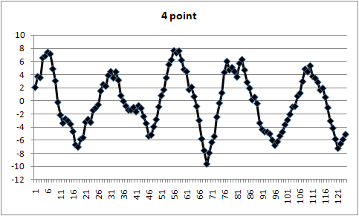PROBLEM 2.14

KNOWN: A spring-mass system, with

*m* = 1 kg

*T* = 2 s

FIND: Spring constant, *k*, and natural frequency *ω*

SOLUTION:

Since



(as shown in association with equation 2.7)

and



The natural frequency is then found as *ω* = π = 3.14 rad/s

And



PROBLEM 2.15

KNOWN: A spring-mass system having

*m* = 1 kg

*k* = 5000 N/cm

FIND: The natural frequency in rad/sec (*ω*) and Hz (*f* ).

SOLUTION:

The natural frequency may be determined,



PROBLEM 2.16

KNOWN: Functions:

a) 

b) 

c) 

FIND: The period, frequency in Hz, and circular frequency in rad/s are found from



SOLUTION:

a) ω = 2π rad/s *f* = 1 Hz *T* = 1 s

b) ω = 8 rad/s *f* =  Hz *T* =  s

c) ω = 5*n*π rad/s *f* = 5*n*/2 Hz *T* = 2/(5*n*) s

PROBLEM 2.17

**FIND:** Express each function in terms of sine terms and/or cosine terms only or as sine and cosine terms.

**SOLUTION**



1. 



1. 





1. 



PROBLEM 2.18

KNOWN: 

FIND: Equivalent expression containing a) a cosine term only, and b) a sine term only

SOLUTION:

a) From Equations 2.10 and 2.11



and with



we find





and



b) From Equations 2.10 and 2.11



and with



we find







and



PROBLEM 2.19

KNOWN: 

FIND:

a) Equivalent expression containing cosine terms only

SOLUTION: From Equations 2.15 and 2.17



PROBLEM 2.20

KNOWN:



FIND: a) fundamental frequency and period

b) express this series in as cosine terms only

SOLUTION:

a) The fundamental frequency corresponds to *n* = 1, so with the general form being *sin ωt* and *cos ωt*, then *ω* = 1 rad/s; and so *T* = 2π/ω = 2π

b) From equation 2.15 and 2.17



For this Fourier series



Thus the third partial sum may be written



PROBLEM 2.21

KNOWN:



FIND: Fourier series that represents the function 

SOLUTION: The function  has a period of  so that the Fourier coefficients may be found from Equation 2.18 as



The term  is zero as seen from



And  is given by



And  is given by



And all other  are given by

 for *n* > 1

The result of the Fourier coefficient equations is consistent with the expected result:



PROBLEM 2.22

**SOLUTION**

*Loudness* refers to a measure of sound intensity (akin to sound power level discussed in Chapter 9).

*Pitch* refers to the frequency of the fundamental component of the sound wave.

*Timbre* refers to the harmonic components in the sound wave.

Two signals with the same loudness and pitch can sound quite different. For example, consider “A below middle C” or a 220 Hz signal. We can create a pure 220 Hz sine wave using a sine wave generator. The sound will be a pure single frequency but this will be irritating or tiresome to listen to in a short time. Yet, a violinist playing a single note, ‘A below middle C’ or 220 Hz, at the same loudness, will produce a sound that is quite full and lovely. The violin sound will contain harmonics, 440 Hz, 660 Hz, 880 Hz and so on – adding timbre.

So these two sounds contain the same loudness and pitch, but not the same timbre. The timbre adds the richness or fullness to sound. It also makes similar sounds sound different (and thereby distinguishing between instruments). Interestingly, the shape of these two waveforms will also be a bit different: the sine wave generator produces a single sine wave, whereas the violin produces more of a sawtooth wave (pure tone plus harmonics), due in part to the resin applied to the bow and thus creating the many harmonics that comprise the sound. Similarly, the striking of the piano key also produces harmonics, but the difference in the harmonics allows one’s ear to distinguish between these two instruments.

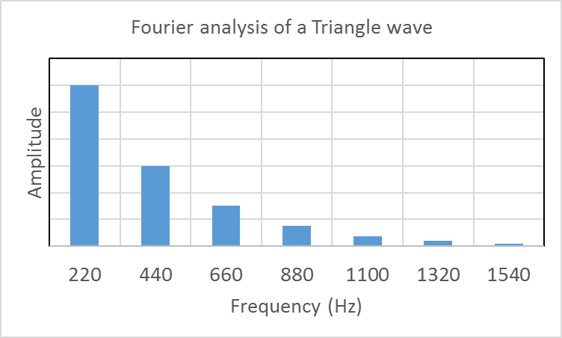Below, we plot the Fourier analysis of two signals, each having the same loudness and pitch. Plotted in this way, we can discern why two signals of the same intensity and fundamental frequency might ‘sound’ differently. In fact, we should see how Fourier analysis might be useful in discerning the different information both within and between signals.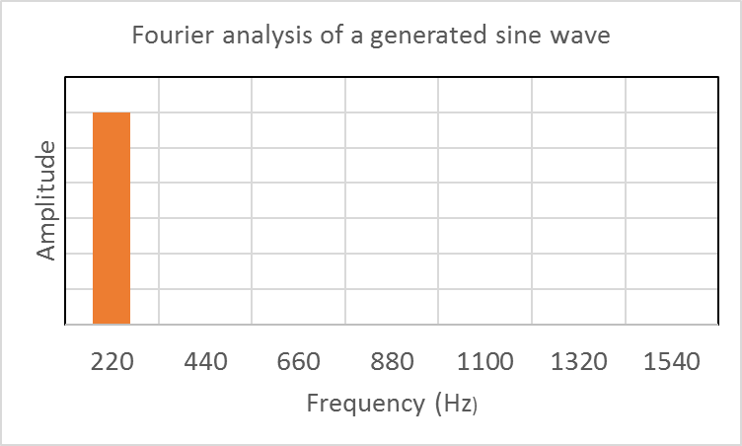

PROBLEM 2.23

KNOWN: 

FIND: Fourier series for the function *y*(*t*).

SOLUTION:

Since the function y(t) is an even function, the Fourier series will contain only cosine terms,



The coefficients are found as







for *n* even *A*n= 4/*n*2 for *n* odd *A*n = −4/*n*2 and the resulting Fourier series is



a series approximation for π is



PROBLEM 2.24

KNOWN: The given plot can be interpreted as



FIND: Fourier series for *y*(t) assuming that the function has a period of 

SOLUTION: Since the function is neither even nor odd, the Fourier series will contain both sine and cosine terms. The coefficients are found as



Note: Since the contribution from −π to 0 is identically zero, it will be omitted.





Noting that *A*n is zero for n even, and *B*n is zero for n odd, the resulting Fourier series is



PROBLEM 2.25

KNOWN:

y(t) = 

FIND: Fourier series representation of *y*(*t*)

ASSUMPTION: Utilize an odd periodic extension of *y*(*t*)

SOLUTION:

The function is extended as shown below with a period of 4.



The Fourier series for an odd function contains only sine terms and can be written





where



For the odd periodic extension of the function *y*(*t*) shown above, this integral can be expressed as the sum of three integrals



These integrals can be evaluated and simplified to yield the following expression for *Bn*



Since sin(*n*π) is identically zero, and sin(*n*π/2) is zero for *n* even, the Fourier series can be written



The first four partial sums of this series are shown below

PROBLEM 2.26

KNOWN: The function in Figure 2.25 can be interpreted as:

y(t) = 

FIND: Fourier series representation of *y*(*t*)

ASSUMPTION: *y*(*t*) is an odd function with a period 

SOLUTION:

Because the function is odd, we know that



And we can find *Bn* from



The integration yields the Fourier series



The first three partial sums of the series is plotted below



PROBLEM 2.27

KNOWN:

a) sin 10t V

b) 

c) 

d) 2 V

FIND: Classification of signals

SOLUTION:

a) Dynamic, deterministic, simple periodic waveform

b) Dynamic, deterministic periodic with a zero offset (of 5 m)

c) Dynamic, deterministic, unbounded as ; not periodic

d) Static, deterministic ; not periodic

PROBLEM 2.28

KNOWN: At time zero (*t* = 0)



FIND:

a) period, *T*

b) amplitude, *A*

c) displacement as a function of time, *x*(*t*)

d) maximum speed

SOLUTION:

The position of the particle as a function of time may be expressed



so that



Thus, at t = 0 

From these expressions we find

a) *T* = 1 s

b) amplitude, *A* = 5/2π

c) 

d) maximum speed = 5 cm/s

PROBLEM 2.29

FIND: Define the terms listed

a) Frequency content c) Magnitude

b) Amplitude d) Period

SOLUTION:

a) Frequency content - for a waveform, refers to the relative amplitude in terms of the associated frequencies of the signal. A Fourier series expresses the frequency content by associating amplitudes with frequency terms. A result of a Fourier transform does the same thing.

b) Amplitude – describes the range of variation of a particular frequency component in a waveform

c) Magnitude - the value of a signal, which may be a function of time (or space)

d) Period - the time for a signal to repeat (signal period), or the time associated with a particular frequency component (i.e., Tn = 2π/ωn).

PROBLEM 2.30

KNOWN:

Fourier series for the function *y*(*t*) = *t* in Problem 2.21



FIND:

Construct an amplitude spectrum plot for this series.

SOLUTION:

**DataSpect** can be used to generate the plot below. Alternatively, we can construct the amplitude spectrum directly from inspection of the Fourier series, as follows

Each term is of the form *Bn sin 2πfnt.*

So, for the first term*: B1 = 10/π* at a frequency *f1 = 1/10 = 0.1* Hz*.* And so forth…



PROBLEM 2.31

KNOWN: Signal sources:

a) thermostat on a refrigerator

b) input to a spark plug

c) input to a cruise control

d) a pure musical tone

e) note produced by a guitar string

f) AM and FM radio signals

FIND: Sketch representative signal waveforms.

SOLUTION:

a)

Signal

Time

This is a simple series of ‘on’ (high) or ‘off’ (low or zero) amplitudes (which act to cycle the refrigerator compressor on or off) occurring at alternating times corresponding to the temperatures inside the refrigerator relative to its set temperature.

b)

Signal

Time

This is a series of pulses to ignite the spark plug consistent with the rotational speed of the engine.

c)

This is a continuous correction signal (speed up or slow down) aimed at maintaining a constant speed relative to road conditions.

d)

A pure musical tone is a pure sine wave.

e)

A guitar string produces a sine wave of a fundamental frequency (pitch) plus harmonics (Timbre).

f)

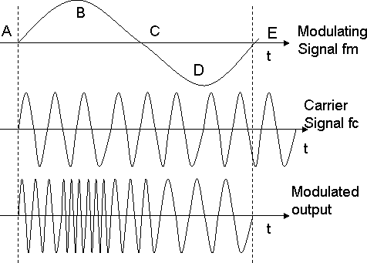

FM Radio Wave

AM signals are amplitude modulating; FM signals are frequency modulating.

PROBLEM 2.32

**SOLUTION**

Similarities:

Both the Fourier series and the Fourier transform represent general functions as a superposition of sines and cosines (or in terms of exponentials by using Euler’s identity ).

Differences:

The Fourier series is for periodic signals. It decomposes the signal into a series of harmonics that are integer multiples of a fundamental frequency. Not all frequencies are represented in the series.

The Fourier transform extends the concept to include aperiodic signals. It decomposes the signal into a continuous number of different frequencies and amplitudes, although any particular frequency may have zero amplitude.

Note: The discrete Fourier transform includes amplitude and phase information over a continuous number of frequency intervals.

By definition, a periodic signal extends to infinity by repeating itself every period. But the Fourier transform can be applied to real periodic signals because the data sets of the signals have a finite length; in effect, they are treated as being aperiodic signals.

PROBLEM 2.33

**KNOWN**: A0 = 5V A1 = 2V B2 = 1V A3 = 3V

f1 = 5 Hz f2 = 10 Hz f3 = 15 Hz

**FIND**: discrete series of 256 values of exactly two periods

**SOLUTION**

Here f1 = 5 Hz and we want m = 2 periods. We will create a discrete series of N = 256 data points with each data point separated by δt = m/Nf1 = 2/256*5 Hz = 0.001563 s. The first ten terms of the discrete series are shown. All 256 data points are shown in the plot.

|  |  |  |
| --- | --- | --- |
| r | t | y{rδt} |
| 0 | 0 | 10 |
| 1 | 0.001563 | 10.06314 |
| 2 | 0.003125 | 10.05628 |
| 3 | 0.004688 | 9.980606 |
| 4 | 0.00625 | 9.838663 |
| 5 | 0.007813 | 9.634313 |
| 6 | 0.009375 | 9.372631 |
| 7 | 0.010938 | 9.05979 |
| 8 | 0.0125 | 8.702916 |
| 9 | 0.014063 | 8.30993 |

PROBLEM 2.34

**KNOWN**: A0 = 1V A1 = 3V B2 = 1V

f1 = 2 Hz f2 = 4 Hz

**FIND**: discrete series of 64 values of three periods

**SOLUTION**

Here f1 = 2 Hz and we want m = 3 periods. We will create a discrete series of N = 64 data points with each data point separated by δt = m/Nf1 = 3/64*2 Hz = 0.023438 s. The first ten terms of the discrete series are shown. All 64 data points are shown in the plot.



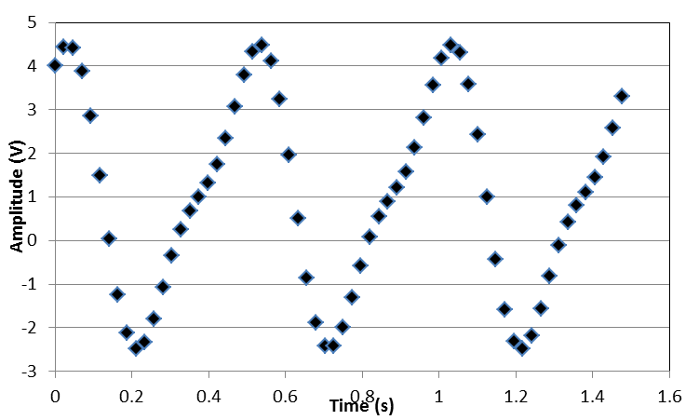

PROBLEM 2.35

KNOWN:  [V]

y{rδt} with N = 64 and δt = 0.023438 s

A0 = 1V A1 = 3V B2 = 1V

f1 = 2 Hz f2 = 4 Hz

**SOLUTION**

The first ten data points of the discrete series and the Fourier analysis are tabulated below. The amplitude and phase spectra are plotted for 32 coefficients. The spectra are consistent with the amplitude and frequency content. The f2 is 90o out of phase with f1. This is consistent with **cos**(x)=**sin**(x+pi/2).

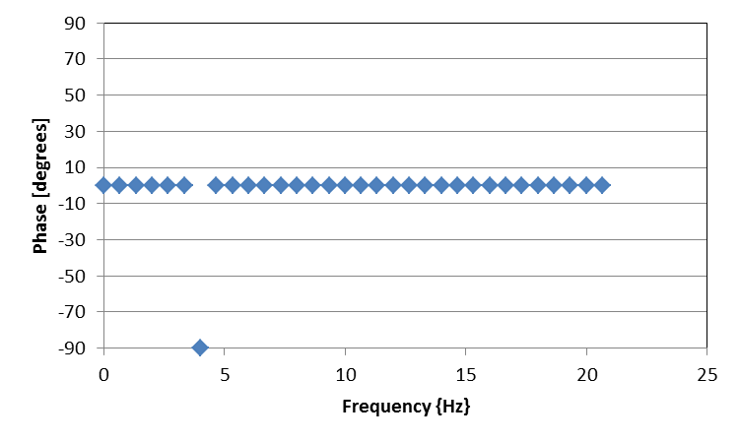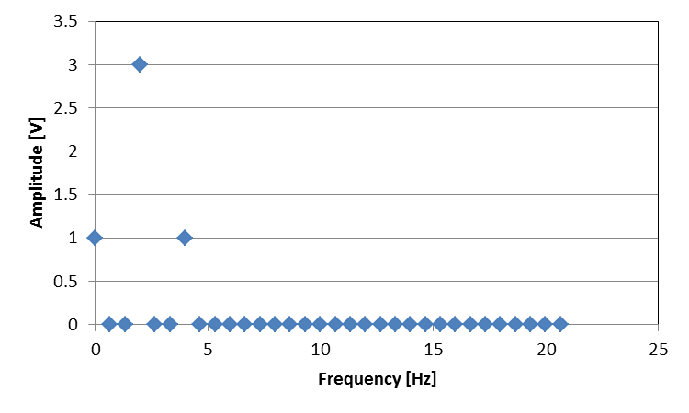

PROBLEM 2.36

**FIND:**  Discrete data set of 256 data points for three periods of a sinusoidal signal. Compare Fourier analysis for same signal with and without a DC component (0 Hz amplitude or signal mean value).

**SOLUTION**

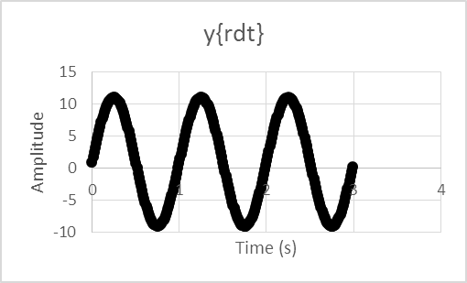(a) We create a data set of N = 256 points each separated by δt = 0.011719 s. Strategy: in order detail m = 3 exact periods, we need a time interval of δt = m/Nf1 = 3/(256*1) s. The first 10 terms are shown below. The discrete series is plotted in time domain. (b) The discrete Fourier transform (DFT) analysis is also shown in the table for the signal having A0 = 1 V. Here we used Excel (as instructed in a text example). The results of the Fourier analysis are plotted in frequency domain. The DFT provides the magnitude . The DC component reveals itself as the zeroth frequency term. The DC component refers to the static or non-time varying component of a signal, its mean value.

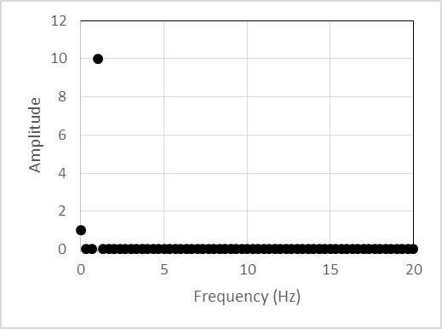

(c) If we extract the DC component (either subtract it from the signal or set it to zero), it adjusts the signal about zero amplitude in time domain and this is reflected by a change in the zero hertz component in the spectrum to zero (i.e., C(f0) = 0). However, there is no change to the remaining coefficients in the spectrum, as shown. **So the DC component (mean) value has no effect on the time-based signal information.**

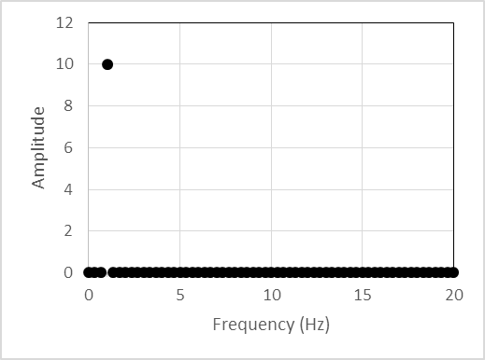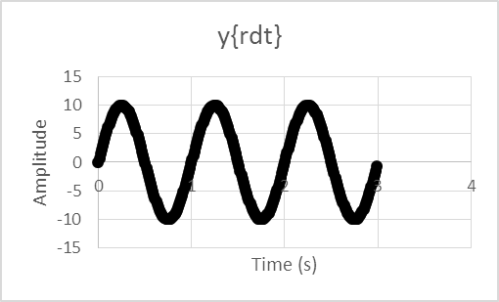

PROBLEM 2.37

KNOWN: 

FIND: *e*(*t*) as a discrete-time series of *N* = 128 numbers separated by a time increment of δ*t* . Find the amplitude-frequency spectrum.

SOLUTION:

With *N* = 128 and δ*t* = 1/*N*, the discrete-time series will represent a total time (or series length) of *N* δ*t* = 1 sec. The signal to be represented contains two fundamental frequencies,

*f*1 = 31.4/2π = 5 Hz and *f*2 = 44/2π = 7 Hz

We see that the total time length of the series will represent more than one period of the signal *e*(*t*) and, in fact, will represent 5 periods of the *f*1 component and 7 periods of the *f*2 component of this signal. This is important because if we represent the signal by a discrete-time series that has an exact integer number of the periods of the fundamental frequencies, then the discrete Fourier series will be exact.

**DataSpect** (or any DFT or FFT program; Matlab or Excel programmed for Fourier analysis) is used to solve this problem. The time series and the amplitude spectrum are plotted below.

PROBLEM 2.38

KNOWN: 

FIND: Discrete series using *N* = 256 and δ*t* = 1/256 s and δ*t* = 1/512 s; amplitude spectra

The resolution and number of data points changes but not the signal content or the spectrum quality. In Chapter 7, we study the relation between sample rate and discrete-series quality.





Problem 2.38 continued





PROBLEM 2.39

**KNOWN:** 



**FIND:** Coefficients *A0, An, Bn*

**SOLUTION**



*Ao* is simply the average of the signal over its period. This value is called the DC component.



This signal is symmetric about y-axis at *t* = 0 and is therefore even. Hence, *Bn* = 0.



If the signal were odd (opposite in sign and symmetrical about *t* = 0), the series would be made up of only sines instead, that is *An* = 0 but *Bn* ≠ 0. So the representation would differ only by the phase.

PROBLEM 2.40

**KNOWN:** Pulse train with A = 1 V, r = 0.2 and f = 1 Hz.

**FIND:** A1, A2, …, A10. Plot over two periods.

|  |  |  |  |
| --- | --- | --- | --- |
| *n* | *An* | *Bn* |  |
| 0 | 0.2 | 0 |  |
| 1 | 0.37420 | 0 |  |
| 2 | 0.30273 | 0 |  |
| 3 | 0.20182 | 0 |  |
| 4 | 0.09355 | 0 |  |
| 5 | 0.00000 | 0 |  |
| 6 | 0.06237 | 0 |  |
| 7 | 0.08649 | 0 |  |
| 8 | 0.07568 | 0 |  |
| 9 | 0.04158 | 0 |  |
| 10 | 0.00000 | 0 |  |

**SOLUTION**

We draw off the previous solution for A0, An, and Bn:

V



 V

*T = 1/f* = 1 s

As one adds increasing numbers of partial terms, the reconstruction improves.

* This reconstruction of the signal based on the first ten terms of the Fourier series, as plotted, does not yet have enough terms to adequately depict the sharp rise and fall of the pulse train. We can make out the pulse train but with some oscillations.
* The series is said to “converge slowly” requiring many more terms to capture its abrupt details accurately. Adding higher order terms improves the reconstruction of the rapid changes.

PROBLEM 2.41

**KNOWN:** Pulse train with A = 1 V, r = 0.5 and T = 1 s.

**FIND:** A1, A2, …, A7.

|  |  |  |  |
| --- | --- | --- | --- |
| *n* | *An* | *Bn* |  |
| 0 | 0.5 | 0 |  |
| 1 | 0.6366 | 0 |  |
| 2 | 0 | 0 |  |
| 3 | -0.2122 | 0 |  |
| 4 | 0 | 0 |  |
| 5 | 0.1273 | 0 |  |
| 6 | 0 | 0 |  |
| 7 | -0.0909 | 0 |  |
|  |  |  |  |
|  |  |  |  |
|  |  |  |  |
|  |  |  |  |

**SOLUTION**

We draw from the solution to the previous problems:

V



and



The signal has the reconstructed form:

 V

*T =* 1 s

PROBLEM 2.42

KNOWN: Data file heartbeat.xls

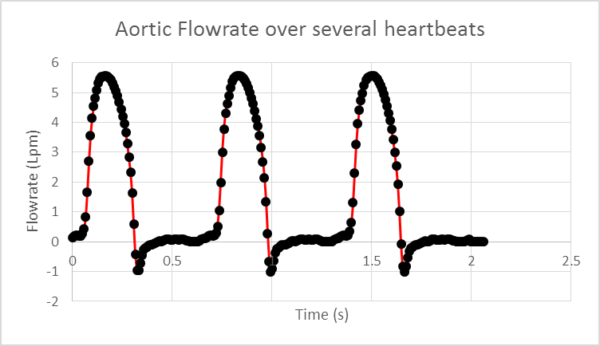

**SOLUTION**

The signal *heartbeat.xls* consists of 247 data points over about 2 seconds in length representing y{rδt} versus t. The Fourier analysis in both Excel and Matlab require data lengths to be powers of 2 (i.e., 2, 4, 8, 32, 64, 128, 256, …). Either truncate and analyze the first 128 data points (28) or add another 9 data points as ‘0’ zeros to make 27 or 256 data points. Either method works. Each data point is separated by δt = 0.008081 s.

Using Excel, Column A is the data point number (i.e., 0 to 255). Column B is y{rδt}, the discrete signal of the flowrate with time. Column C is the time each point in Column B was recorded relative to the start time. Column D presents the results of the Fourier transform Y(f) (in Excel: using Data/data analysis/Fourier Analysis ) on the data in Column B. Column E combines the imaginary and real coefficients using the IMABS (Y(f)) function and properly scales it to show the magnitude Cn. Column F determines each coefficient frequency (f = r/Nδt). The first 10 rows are shown below in tabular form. The amplitude spectrum is plotted for the first N/2 coefficients. Information at three frequencies dominates the spectrum. Critical information is extracted:

1. The mean flow rate is given by the ‘zero hertz or f = 0’ coefficient or DC component: **Q_avr = 1.494 liters/min**. The fundamental frequency is: **f1 = 1.45 Hz**. We would expect the heartbeat to be at this dominant frequency. So, the heartbeat rate is: **HR = f1* 60s/min = 87 beats/min**

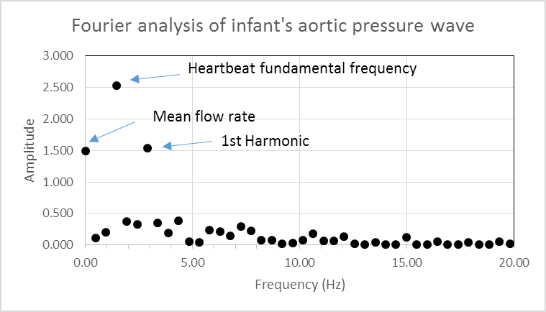(b) The first harmonic of the fundamental frequency is: **f2 = 2.90 Hz**

PROBLEM 2.43

**KNOWN:** y(t) = 2At/T for –T/2 < t < T/2

T = 2 s; A = 1 V

**FIND**: *Cn*

**SOLUTION**

The discrete series is developed for N = 128 points and a period of 2 s using δt = 2/128 s. The time domain signal is plotted below revealing the odd function. The first 10 points in the series are shown in the Table, as are the first ten coefficients from a discrete Fourier transform (DFT) analysis. The coefficient magnitudes, |Cn | are plotted against frequency. The zero harmonic or mean value is zero. The fundamental frequency is 0.5 Hz. The amplitude for each harmonic is a decrement of the fundamental frequency amplitude, that is C1/Cn = n. The Fourier analysis returns the magnitude of the coefficients,  , so that the sign is lost. The comparison of the DFT results to Fourier analysis (Bn) is essentially the same except for some roundoff (due to the inexact nature of the frequency spacing).

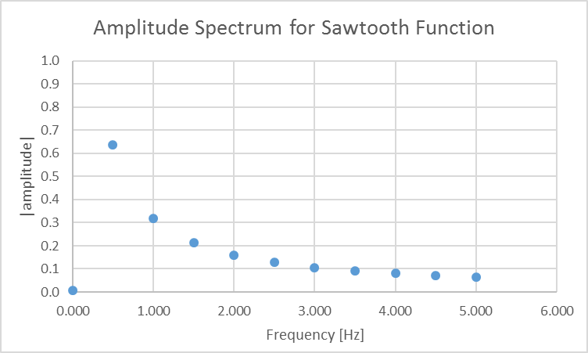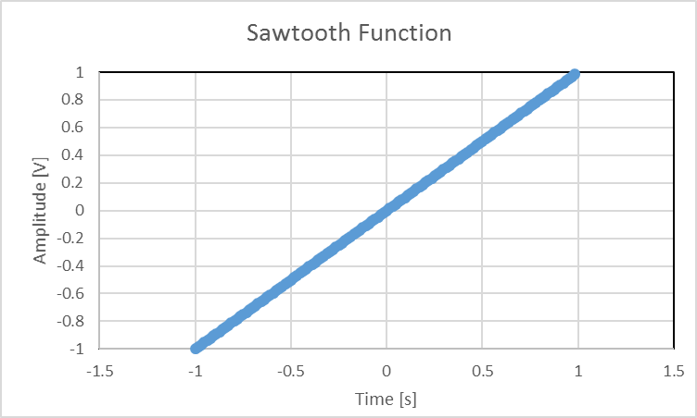

**COMMENT** The Fourier analysis of the sawtooth function is provided here for completeness but is studied in another practice problem



PROBLEM 2.44

KNOWN: A force input signal varies between 100 and 170 N () at a frequency of *ω* = 10 rad/s.

FIND: Signal average value, amplitude and frequency. Express the signal, *y*(*t*), as a Fourier series.

SOLUTION:

The signal characteristics may be determined by writing the signal as

*y*(*t*) = 135 + 35 sin 10*t* [N]

1. *A*o = Average (or static) value = (170 + 100)/2 = 135 N
2. *C*1 = (170 − 100)/2 = 135 N; *f*1 = ω/2π = 10/2π = 1.59 Hz
3. *y*(*t*) = 135 + 35 sin (10*t* ± π/2)

A discrete time series was created using 16 points each separated by 0.1571 s. The amplitude spectrum is shown below.



PROBLEM 2.45

KNOWN: Wall pressure is measured in the upward flow of water and air as provided in the file *gas_ liquid_data.txt*. The flow is in the slug flow regime, with slugs of liquid and large gas bubbles alternating in the flow, as shown in the text Figure 2.27. Pressure measurements were acquired at a sample frequency of 300 Hz, and the average flow velocity is 1 m/sec.

FIND: Construct an amplitude spectrum for the signal, and determine the length of the repeating bubble/slug flow pattern.

SOLUTION:

The figure below shows the amplitude spectrum for the measured data. There is clearly a dominant frequency at 0.73 Hz. Then with an average flow velocity of 1 m/sec, the length is determined as

 

PROBLEM 2.46

KNOWN: Sunspot data for the years 1746 to 2005, from the file *sunspot.txt*.

FIND: Plot the data and create an amplitude spectrum using the companion software program *Dataspect*.

SOLUTION:

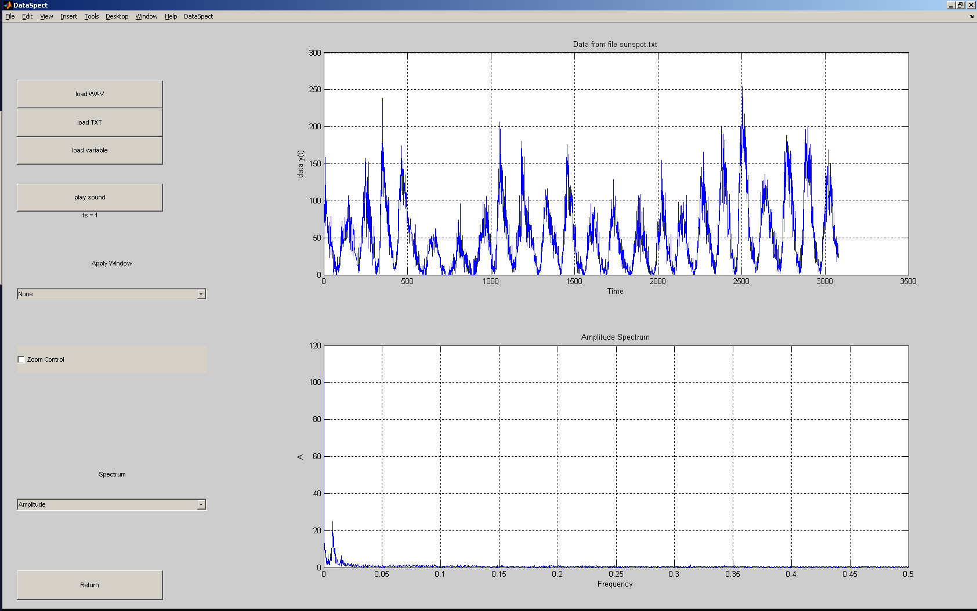

Using the zoom control, we can estimate that the amplitude peak occurs at approximately 0.008 which corresponds to a period in months of 125 and a period in years of 10.4. Most references quote an 11 year period.

PROBLEM 2.47

KNOWN: Amplitude and phase spectrum for {*y*(rδ*t*)} from Figure 2.28

FIND: {*y*(rδ*t*)}, 

SOLUTION:

By inspection of Figure 2.27:



and .

The signal can be reconstructed from the above information, as



The exact phase of the signal relative to *t* = 0 is not known, so *y*(*t*) is ambiguous within in terms of its overall phase.

A DFT returns N/2 values. Therefore 5 spectral values implies that *N* = 10. Then



Alternatively, by inspection of the plots



PROBLEM 2.48

KNOWN:



FIND: Show that the signal *y*(*t*) can be represented by the Fourier series



SOLUTION:

a) Since the function *y*(*t*) is an even function, the Fourier series will contain only cosine terms,



The value of Ao is determined from Equation (2.17)





integrating yields a value of zero for Ao



Then to determine An





Since sin(nπ) = 0, then the Fourier series is



The values of An are zero for n even, and the first three nonzero terms of the Fourier series are



The first term represents the fundamental frequency.







PROBLEM 2.49

KNOWN: Figure 2.14 illustrates the nature of spectral distribution or frequency distribution on a signal.

FIND: Discuss the effects of low amplitude high frequency noise on signals.

SOLUTION:

Assume that Figure 2.14a represents a signal, and that Figures 2.14 b-d represent the effects of noise superimposed on the signal. Several aspects of the effects of noise are apparent. The waveform can be altered significantly by the presence of noise, particularly if rates of change of the signal are important for specific purposes such as control. Generally, high frequency, low amplitude noise will not influence a mean value, and most of the signal statistics are not affected when calculated for a sufficiently long signal.

PROBLEM 2.50

SOLUTION

Use **Sound.vi** to study the amplitude spectra related to different sounds you can supply to your computers microphone.