Chapter 2
Supply and Demand: Market Forces
and the Environment

■ Chapter Overview and Key Lessons

Supply and how producers decide how much to produce
The supply curve represents how much producers of a good provide in response to a market price. It typically slopes upward, indicating that a higher price induces greater production. It can shift due to changes in the prices of inputs to production, changes in technology, changes in the number of producers, or the effects of outside forces such as the weather.

Consumer demand
The demand curve represents how much consumers purchase of a good when they face the market price. It almost always slopes downward, indicating that a higher price reduces the quantity demanded. It can shift because of changes in consumer income, changes in prices of substitute and complementary goods, changes in tastes and preferences, outside forces such as weather, or changes in population.

Market equilibrium
A market equilibrium occurs when the price in the market induces the quantity supplied by producers to equal the quantity demanded by consumers. If the market price leads to either excess demand or excess supply, in a competitive market the price tends to head back to the price that provides equilibrium. The equilibrium price and quantity change if either the supply curve shifts, causing a movement along the demand curve, or the demand curve shifts, causing a movement along the supply curve.

How to use supply and demand to understand the electricity market
Government programs can change the market equilibrium and affect the environment as well. Government can restrict production via a quota, or it can tax production. While these two policies can achieve the same quantity (or environmental) goals, they lead to different effects on producer profits and government revenues.

How to use supply and demand to study government policies affecting agricultural land
In agriculture, governments often set a price floor—ensuring a minimum price to producers—that can create excess supply at the same time that they create programs to reduce soil erosion and other damages from farming. The net effect of these programs on the environment is an area of continuing study.

■ Teaching Tips
Students typically grasp quickly the mechanics of supply and demand graphs, but often they think of the graphs as simple models unrelated to reality. As a result, they do not make a strong connection between the graphs and human behavior.
For instance, many students underestimate the power of prices as motivators. If asked, for instance, how
to control pollution, the first response is likely to be a quantity approach rather than a price approach. It is worth planting in students’ minds that both prices and quantities can be used to affect production and pollution, and that they should think about advantages and disadvantages to both these approaches, because these issues will recur throughout the text.
Shifts vs. movements along supply and demand curves are also underestimated tools for modeling behaviors. For instance, many environmentally oriented students seem to think that, if only people understood environmental problems, they would behave in greener ways. The students often do not recognize that “letting people know” is aimed at shifting the demand curve for a good. When put in the context of supply and demand, “getting the word out” about environmental problems becomes a matter of how effective the campaign is (how much the demand curve shifts) and the market impacts.
It is easy for students to assume that equilibrium is inevitable and instantaneous—after all, isn’t that what the graph indicates? It can be useful to point out that market forces aim prices and quantities toward equilibrium, but disequilibria can happen easily. For instance, prices or quantities may take time to get to equilibrium after a shift of a supply or demand curve. Any time a student has stood on line for something could be considered a disequilibrium.
The beauty of the supply and demand model is that two separate models combine to produce an equilibrium answer. Be watchful for students telling stories in which they conflate supply and demand—for instance, people’s income goes up and therefore producers shift their supply curve. The point is to keep the parts of the model separate.

■ Discussion Questions

Do market forces apply to environmental goods?

1. Water pollution comes from a number of sources: factories, farms, the fertilizers and pesticides that people apply to their yards, fluids that leak from automobiles on city streets, and even from air pollutants that get washed out of the air by rain and snow. How can these sources “supply” clean water? If cleaner water brought to the sources a higher price than dirtier water, would these sources increase the cleanliness of water? Can you think of examples of prices for cleaning water (such as bottled water)? What might shift the “supply” of cleaner water?

2. Why do people demand improvements in water quality? Do they demand one particular degree of cleanliness for water, or do they, too, respond to the “price” of cleaner water—that is, does the demand curve for water slope down? Give examples of things that might shift the demand curve for water.

3. Do you think there is an equilibrium in the market for cleaning water? Why or why not?
(Hint: Much of this book is about the issues embedded in this question.)

4. Are some taxes socially more productive than others? A tax, when applied to a good, increases the price of that good. Are there goods that merit taxation more than other goods? For instance, consider a tax on pollution compared to a tax on medications. Are there more reasons to tax one of these than the other?

5. The opposite of a tax is a subsidy. Does agricultural production merit subsidies more than other goods? Why or why not?

Why do economists use graphical models?

6. Economics deals with many of the same questions that other social scientists (such as sociologists, psychologists, and political scientists) address. The other social sciences commonly use verbal descriptions in approaching these questions. Economists use the model of supply and demand. From any other social science courses that students may have taken, what have they learned about such questions as:

(a) What motivates people to do what they do?

(b) What do people want?

(c) How do people interact with each other?

What do the supply and demand models say about these questions? Do they provide different answers than the other social sciences? If so, does that mean one discipline is right and the other discipline is wrong about human behavior? If not, what are the advantages and disadvantages of economics’ graphical approach compared to the verbal description common in other disciplines?

■ Solutions to Textbook Exercises

1. Consider the market for purchase of new cars.

(a) What factors likely influence the demand for cars? That is, either for an individual or in the aggregate, what factors will cause either movements along the demand curve for cars, or shifts
of the demand curve for cars? Identify at least four factors.

Demand is likely to be affected by consumers’ income, by taste and preferences (which are influenced by advertising and family size), by market price of cars, by substitutes (such as availability of public transportation or urban density) and complements (such as roads and availability of gas stations).

(b) If you were to draw a demand curve for cars, how would you label the axes—that is, what are you measuring along each axis? Would this demand curve slope up or down, be vertical, or be horizontal? Why?

I would label the horizontal axis with the quantity of cars, and the vertical axis with the price of cars (in $/car). I would expect the demand curve to slope downward: As the price of cars increases, I expect people to buy fewer cars.

(c) What factors likely affect the supply of cars? Identify at least three factors.

The supply of cars is likely to be affected by input costs (such as the prices of steel, labor, and energy and the availability of ways to get the cars to consumers), technology (such as the use of the assembly line), and the number of auto companies in business.

(d) If you were to graph the supply of cars, would it slope up or down, be vertical, or be horizontal? Why?

With quantity of cars on the horizontal axis and price (in $/car) on the vertical axis, I’d expect it to slope upward: If the price of a car increased, an automaker would want to produce more of it. As we will see later in the book, it is possible the supply curve might be flat.

(e) If the cost of steel goes up, which (if either) of these curves might be affected? How? What will happen to the equilibrium price and quantity of cars? Why?

The supply curve will be affected; it will shift up. Because it is more expensive to produce a car, an automaker will produce fewer for any given price. The equilibrium price will go up, and the equilibrium quantity will go down.

(f) If the cost of parking goes up, which (if either) of these curves might be affected? How? What will happen to the equilibrium price and quantity of cars? Why?

The cost of parking might reduce the demand for cars, since parking is a complement to cars. Because the demand curve will shift in, the equilibrium price and quantity will drop.

(g) The U.S. Environmental Protection Agency will require new light trucks and sport utility vehicles (SUVs) to install new pollution control devices that will increase their cost. For the purposes of this question and from the perspective of federal rules, these are not cars, even though people use them in the same way as they use cars. Which (if either) of the supply and/or demand curves for cars might be affected? How and why? What will happen to the equilibrium price and quantity of cars?

Now, a substitute for cars is becoming more expensive; as a result, the demand for cars will shift out/up, leading to increases in both price and quantity.

(h) Consider the difference between the short run of a few days or weeks and the long run of a few months or years. Suppose that the price of gasoline goes up. Which, if either, curve do you expect to be affected in the short run? How and why? What will happen to the equilibrium price and quantity of cars? Why?

In the short run, the demand for cars may decrease, since gasoline is a complement to cars. As a result, equilibrium price and quantity will decrease.

(i) In the long run, do you expect additional changes beyond those you identified in (h)? If so, what are they, and why?

In the long run, many things can change: Automakers can produce more fuel-efficient vehicles so that people spend less money on gasoline; this shift might increase (or reduce the decrease in) the demand for vehicles. Consumers can move closer to work, school, and shops, reducing the demand for vehicles.

2. Look again at textbook Figure 2.2. Trace it onto a piece of scrap paper. Now draw two demand curves on your figure. Draw one that is horizontal at P = $32/MWH and one that is vertical at quantity = 15,000 MWH.

(a) What happens to the equilibrium price when the supply curve shifts from S₀ to S₁ in each case?

When demand is horizontal at P = $32/MWH, the equilibrium quantity increases from roughly 12.5 GWH to about 15.25 GWH, with price constant (of course). When demand is vertical, quantity stays constant at 15 GWH, but price jumps from about $31/MWH to $34/MWH.

(b) A horizontal demand curve means that consumers will buy any amount produced at a price of $32/MWH or less, but they will buy none if the price goes higher. A vertical demand curve means that consumers do not respond at all to price—they will buy the same quantity regardless
of how much it costs. Which do you think is closer to how consumers buy electricity? That is,
do consumers pay a lot of attention to price (the horizontal curve), or do they ignore price
(the vertical curve)?

Consumers of electricity at their homes don’t notice price easily, since it comes in a bill once a month (or it is included in their rent). Thus the demand for electricity is likely to be a steep line.

(c) Compare your answer in (b) to the true demand curve in Figure 2.3. When the price shifted, did the quantity demanded change a lot or a little?

A large change in price led to a relatively small change in quantity, which means the demand curve is in fact steep.

3. This chapter explained one of the two main ways that money was transferred to farmers. Another method was called a target price-deficiency payment program. Let’s use textbook Figure 2.12 to examine that program as well, although the actual program operated a decade later and with higher prices. In the target price program, the government would set a price that it guaranteed to farmers; $1.78/bu in the example. Instead of buying wheat until the price reached the target price, the government would allow all of it to be purchased by consumers.

(a) Assuming that the producers decide how much wheat to grow based on the supply curve, find the quantity supplied. Now use that quantity and the demand curve to find the price that consumers would pay if they were to buy that much wheat.

Farmers will supply 1357 million bushels at a price of $1.78/bu. Consumers, however, would only be willing to pay about $1.57/bu to buy all 1357 million bushels.

(b) The government paid farmers the difference between the target price and the price that consumers paid. Find the amount that the government paid per bushel by subtracting the consumer price from the target price. Now find the total amount the government would have had to pay by multiplying the number of bushels by the government payment per bushel.

The government would have to pay $(1.78 − 1.57) = $0.21/bu. The government payment per bushel, multiplied by 1357 million bushels, yields a total government payment of $285 million.

(c) Compare your answer from (b) to the government’s cost under the loan program. Your comparison should explain why the government never used the target price program without other programs in place to limit production.

The loan program cost the government $144 million, about half of the cost of the target price-deficiency payment scheme.

(d) Compare the target price-deficiency payment plan to the tax on energy. In both cases, government creates a gap between the price consumers pay and the price producers receive. Does quantity supplied equal quantity demanded under these programs?

Quantity supplied equals quantity demanded, but consumers and producers face different prices due to the tax/subsidy.

(e) To address environmental problems, the government may tax pollution or subsidize a reduction in pollution. Based on what you have seen about a tax compared to a target price-deficiency payment scheme, which do you think that a producer would prefer? Which is more expensive for the government, and why?

A producer prefers to be subsidized, as in the target price-deficiency payment scheme, to being taxed. However, the target price-deficiency payment scheme is much more expensive for the government.

4. A chemical factory has leaked a toxic substance into the ground because fixing the leak was more expensive than the small amount of toxic substance was worth to them. Once it was discovered that the substance was contaminating local water supplies, though, the factory agreed to fix the leak.

(a) Draw supply and demand curves for the chemicals produced by the factory before the contamination was discovered.

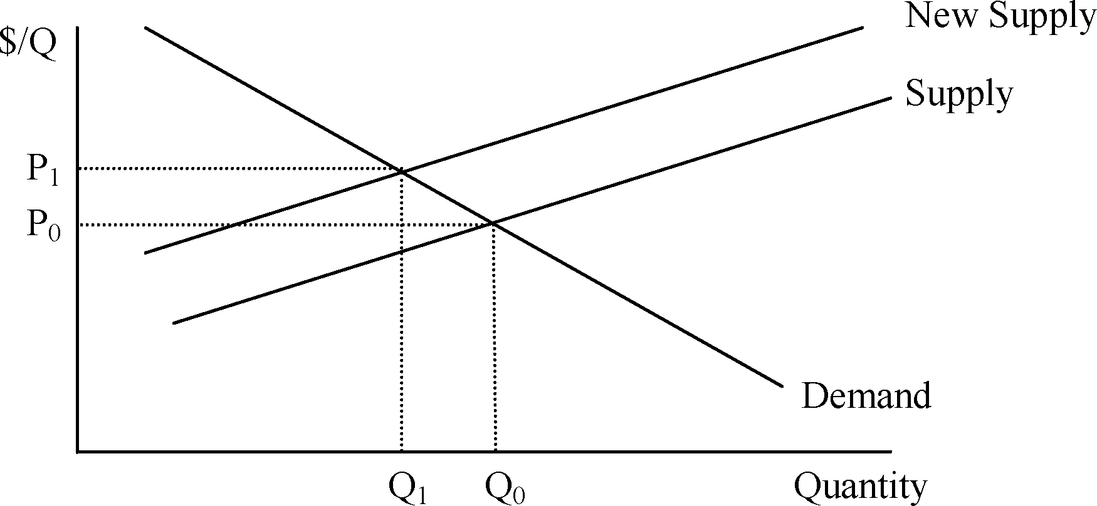

(b) Which, if either, of these curves will be affected by the decision to fix the leak? Adjust your diagram to reflect this change. What, if anything, has happened to the equilibrium price and quantity?

Fixing the leak will affect costs, and thus shift the supply curve up. As a result, equilibrium price will increase, and quantity will decrease.

(c) How have the buyers of chemicals from the factory (who live far away from the contamination) been affected by the decision to fix the leak? Why do they feel that effect? Do you think that this effect is appropriate? Why or why not?

They face a higher price for the chemicals, and they’re not happy about it. The price increase represents the environmental costs of producing chemicals, though, just like labor or materials costs are costs of chemical production. The consumers should understand that environmental costs are real. The higher price also reduces their quantity demanded, which leads them to buy less of the chemicals, which also reduces environmental impact.

