***Technology Ventures: From Idea to Enterprise***

**End-of-Chapter Exercises: Answer Key for Selected Exercises (in Red)**

**Authors: Byers, Dorf, and Nelson**

**5th Edition, McGraw-Hill Higher Education**

**Revised: January 2018**

**Chapter 1**

1. **What is the difference between an idea and an opportunity? Why is this difference important to entrepreneurs?**

The primary purpose of this question is to ensure the student understands the distinction between having an idea for a company and the process of assessing if the idea is a viable oppportunity. Many of the chapters and frameworks in this book address a number of the key questions an entrepreneur must answer about their idea to determine if it is worth pursuing and investing time and money to make happen. An opportunity can be considered a fully vetted idea where the customer need is clear, the market potential is assessed, the competitive landscape is understood, the market context is addressed, the barriers to competition and defensibility over time are understood, and the next steps that must be taken to start the new venture are clear. The business plan and business presentations are common methods of communicating and refining an idea to a specific, targetable opportunity. Figure 1.1 provides some of the key characteristics of an attractive opportunity.

* 1. Consider opportunities that have occurred to you over the past month and list them in a column. Then, describe your strong interests and passions, and list them in a second column. Finally, create a list of your capabilities in a third column. Is there a natural match of opportunity, interests, and capabilities? If so, does this opportunity appear to offer a good chance to build an enterprise? What would you need to do to make this opportunity an attractive chance to build an enterprise business?
  2. **Name an entrepreneur that you personally admire. Why do you consider this person to be an entrepreneur? What sets him or her apart from other business leaders? What path did this person take to entrepreneurship? What personal sacrifices or investments did this person make in the journey? What people were important to this person’s success?**

There is no right or wrong answer to this question. But hopefully the student takes the characteristics of an entrepreneur outlined in this chapter and apply these characteristics to a role model. Some of the founders of companies in Table 1.1 would be appropriate. Table 1.3, Table 1.5, Table 1.6 and Table 1.7 outline many of the key personality characteristics associated with being an entrepreneur. It would be helpful for students to think about founders that have emerged from different parts of the organization. Many founders come from engineering background. However there are also many successful entrepreneurs from sales and other parts of an organization. The opportunities entrepreneurs identify are in many cases heavily weighted to past experiences and what levels of customer interaction are experienced. Repeat successful entrepreneurs are also a unique breed given the repeatability of delivering on their visions.

Personal sacrafices hints at the potentially all-consuming nature of starting a new business. Being an entrepreneur in many cases requires a significant investment of time and effort, at the expense of other life activities. It is important to recognize this tradeoff and address it honestly. Many successful entrepreneurs also point to key mentors they have had throughout their carriers. Mentors can provide guidance and much needed sounding boards for ideas.

Entrepreneurs must have the ability to build a team of intelligent, passionate, hardworking people to help them fulfill their dream. Studensts should be able to recognize this skill in the entrepreneur that they personally admire.

* 1. Name a successful entrepreneurial team you personally admire. How would you classify it in the context of the entrepreneur types defined in Table 1.5? Do the elements of entrepreneurship apply to it?
  2. **Research the number of companies that either had an IPO (initial public offering) or have been acquired in the last five years. What industries were these companies in? Where is the number of IPOs vs. M&As (mergers and acquisitions) trend leading? What implications does this have on the number of new ventures being started?**

Since the dot com explosion and a tougher overall economic environment, it can be seen that acquisition is a more likely exit than IPO. The total number of exits has increased, however this should be weighed against the total exit valuations. IPOs have traditionally led to higher exit valuations than M&A. It is always dangerous for entrepreneurs to think too much or target specific types of exits. An entrepreneur should build his or her company as if it will be an independent stand-alone company. But it is relevant to consider the specific market dynamics the new venture is operating in and how value is being rewarded. For example, in the drug discovery space, it is unnecessary for the vast majority startups to create a go to market strategy, relying on a larger partner to take successful drugs to market (either in partnership or via acquisition).

Example charts:

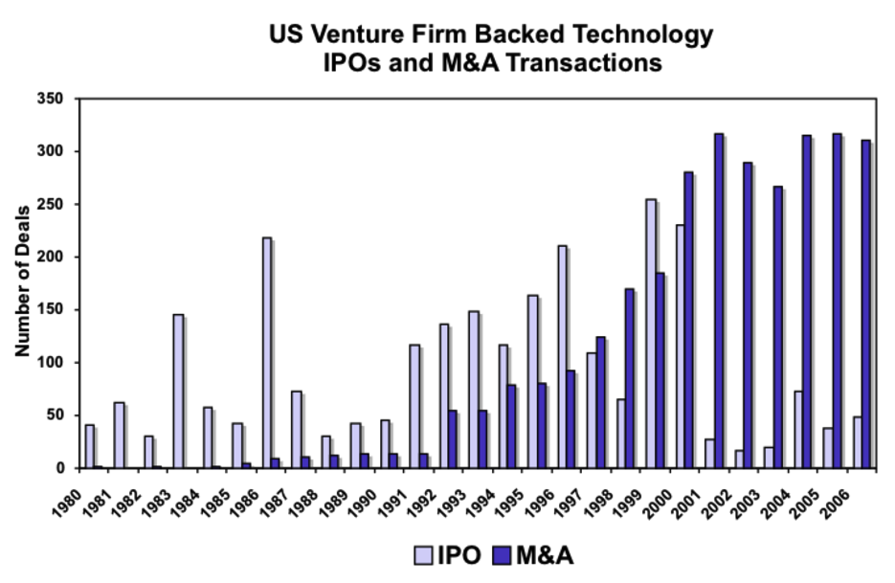

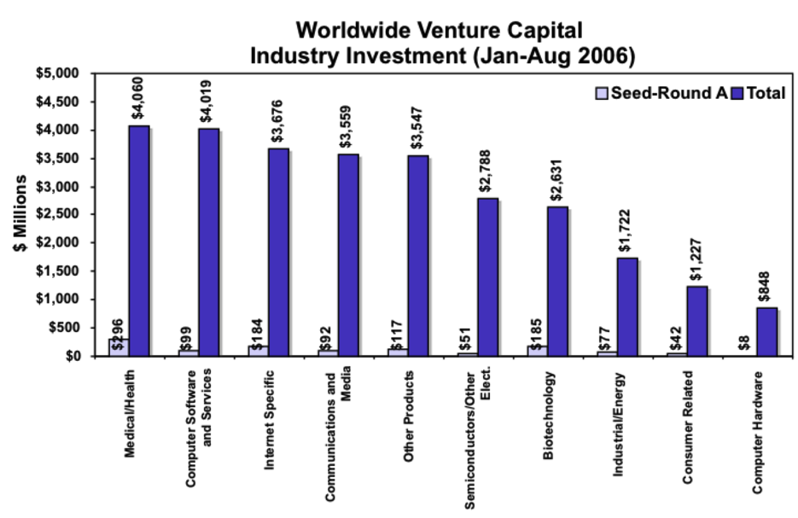

1. Given an understanding of the waves of innovation throughout history (Figure 1.5), explore opportunities that are created in a wave after the peak. For example, how can an entrepreneur take advanatge of a mature or declining market?

For example, the vending machine marketplace is a declining market but vendors selling into that market are creating demand by wirelessly enabling machines that accept credit cards, track specific cash put into the machine, and phone home when they are out of a particular product.