Chapter 2
Understanding and Modeling Organizational Systems

Key Points and Objectives

- Organizations are complex systems composed of interrelated and interdependent subsystems.

- System and subsystem boundaries and environments impact on information system analysis and design.

- Systems are described as either open, with free flowing information, or closed with restricted access to information.

- A virtual organization is one that has parts of the organization in different physical locations. They use computer networks and communications technology to work on projects. Advantages of a virtual organization are:

  - Reduced costs of physical facilities
  - More rapid response to customer needs
  - Flexibility for employees to care for children or aging parents

- Enterprise systems or Enterprise Resource Planning (ERP) describes an integrated organizational information system. The software helps the flow of information between the functional areas within the organization.

- A context-level data flow diagram is an important tool for showing data used and information produced by a system. It provides an overview of the setting or environment the system exists within: which entities supply and receive data/information.

- The context-level data flow diagram is one way to show scope, or what is to be included in the system. The project has a budget that helps to define scope.

- Entity-relationship diagrams help the analyst understand the organizational system and the data stored by the organization.

- There are three types of entities:

  - Fundamental entity, describing a person, place, or thing.
  - Associative entity (also called a gerund, junction, intersection, or concatenated entity), joining two entities. It can only exist between two entities.
  - Attributive entity, to describe attributes and repeating groups.

- Relationships are shown with a zero or circle representing none, a vertical line representing one, or crow’s foot representing many and can be:

  - One to one
  - One to many
  - Many to many

- A use case diagram reflects the view of the system from the perspective of a user outside of the system.

- A use case model partitions the way the system works into behaviors, services, and responses that are significant to the users of the system.

- A use case diagram has symbols for:

  - An actor, the role of a user of the system
  - The use case representing a sequence of transactions in a system

- There are two kinds of use cases:

  - Primary, the standard flow of events within a system that describe a standard system behavior
  - Use case scenarios that describe variations of the primary use case

- There are four active behavioral relationships:

A. Communicates—used to connect an actor to a use case.
B. Includes—describes the situation where a use case contains a behavior that is common to more than one use case.
C. Extends—describes the situation where one use case possesses the behavior that allows the new use case to handle a variation or exception.
D. Generalizes—implies that one thing is more typical than the other thing.

- The steps required to create a use case model are:

A. Review the business specifications and identify the actors within the problem domain.
B. Identify the high-level events and develop the primary use cases that describe the events and how actors initiate them.
C. Review each primary use case to determine possible variations of flow through the use case.
D. Develop the use case documents for all primary use cases and all important use case scenarios.

- Use case scenarios are text descriptions of the use case, and may contain the following:

A. The use case name and a unique ID
B. The area of the business
C. The actors
D. The stakeholders
E. The level
F. A brief description of the use case
G. The triggering event
H. The type of trigger, either external or temporal
I. The steps performed for the use case
J. Preconditions, what must have occurred before the use case can start to execute
K. Postconditions or what has been accomplished by the use case
L. Assumptions that have been made for the use case to execute
M. Requirements met by the use case
N. Minimum guarantee
O. Success guarantee
P. Any outstanding issues
Q. An optional priority
R. An optional risk

- Use case levels describe how global or detailed the use case description is. Levels are:

  - White (like clouds): enterprise level
  - Kite: business unit or department level
  - Blue (sea level): user goals
  - Indigo (or fish): functional or subfunctional
  - Black (or clam): most detailed

- Use case descriptions are created with these four steps:

  - Use agile stories, problem definition objectives, user requirements, or a features list.
  - Ask about the tasks that must be done.
  - Determine if there are any iterative or looping actions.
  - The use case ends when the customer goal is complete.

- Use cases are helpful because they:

  - Effectively communicate systems requirements.
  - Allow people to tell stories.
  - Make sense to nontechnical people.
  - Do not depend on a special language.
  - Can describe functional requirements.
  - Can describe nonfunctional requirements.
  - Help analysts define boundaries.
  - Can be traceable, allowing analysts to identify links between use cases and other design and documentation tools.

- The three levels of managerial control are:

  - Operations management
  - Middle management
  - Strategic management

- Each of the three levels of management, different organization structure, leadership style, technological considerations, organization culture, and human interaction all carry implications for the analysis and design of information systems.

Consulting Opportunity 2.1 (p. 26)

The E in Vitamin E Stands for Ecommerce

- The elements that are interrelated or interdependent are:

Elements 1 and 2: attracting customers and informing customers.

Elements 4, 5, 7, and 6: completing transactions, accepting payments, arranging for delivery of goods and services, and supporting customers after the sale.

- The items that are critical for initial development are elements 1, 2, 4, 5, 6, and 7, mentioned above. Elements 3 and 8: allowing customers to customize products online and personalizing the look and feel of the Web site may be done at a later date.

- The elements that should be handled in-house are:

Elements 1, 2, 3, 4, 6, and 8: attracting customers, informing customers, allowing customers to customize products online, completing transactions with customers, supporting customers after the sale, and personalizing the look and feel of the Web site.

These are best done in-house using corporate data and corporate systems. Performing the work in-house allows management to quickly change the information used and presented to the customers, as well as providing control over the system.

The elements that should be outsourced are 1, 5 and 7: attracting customers, accepting payments, and arranging for delivery of goods and services. Notice that attracting customers falls into both categories. This depends on the nature of advertisement and other ways of attracting customers. If banner ads, those on the top of a Web page, are used, they may be provided by a specialist. The same is true for radio, billboard, magazine, and television ads. Accepting payments is better outsourced, using one or more of the many Web-based payment options or using a traditional credit card.

Arranging for delivery of goods and services is better done by an outside shipping company (unless the corporation has its own shipping line).

Some of the other functions of the ecommerce may be outsourced as well. Some corporations have the Web development done by a consulting firm and some have a third party host the Web site.

Consulting Opportunity 2.2 (p. 44)

Where There’s Carbon, There’s a Copy

Richard and Harry had failed to consider the impact of tossing out the pink forms on the rest of the system. They did not realize that systems and subsystems are interrelated and interdependent.

In this case, boundaries must be large enough to encompass all affected subsystems. Envisioning system boundaries is not a trivial pursuit. In general, system boundaries that are too large or too small will result in systems being designed without realizing the impact of decisions on other parts of the organization.

Consulting Opportunity 2.3 (p. 46)

Pyramid Power

According to Paul and Ceil, a management information system that required people to share information in ways that were not consistent with the hierarchical structure makes the users of the system feel uncomfortable with the communication flow. This dissatisfaction results in some degree of resistance.

One method for addressing the problem is through the creation of staff positions, whose chief responsibility is to facilitate interdepartmental communication. Another possibility is to standardize as much decision making as possible. If software is handling more decision-making situations, there is less need for interdepartmental communication.

HyperCase Experience 2

- What major organizational change recently took place at MRE? What department(s) were involved, and why was the change made?

Model Solution: The Management Information Systems and Training departments were merged into a single department. This was done to slim down the organizational structure and increase operational efficiency. Also, top management felt that Training needed new leadership (see Hill, Evans, and Ketcham interviews), and appears to have hopes that the success of the old Management Systems department will now influence the new Training and Management Systems department (see Hill interview).

- What are the goals of the Training and Management Information Systems department?

Model Solution: Market leadership is a main goal of the organization, and maintaining high quality is a key to attaining this (see Hill). This quality depends upon the ability of MRE to deliver training in a timely fashion and to be able to reasonably keep costs under control while delivering the promised product.

- Would you categorize MRE as a service industry, a manufacturer, or both? What kind of “products” does MRE “produce.” Suggest how the type of industry MRE is affects the information system it uses.

Model Solution: MRE is primarily in a service industry. MRE offers consulting services (see corporate description, found on the coffee table in the reception area). They don’t “produce” material goods, but they do “create” plans for things like new buildings and computer information systems. They use project teams predominantly to offer consultation to clients. Because MRE offers services and does not engage in manufacturing, they don’t rely heavily on manufacturing control or inventory control systems. Instead, this suggests that they need information systems to facilitate project management and help top management monitor progress and trends in client needs and opportunities for new consulting services.

- What type of organizational structure does MRE have? What are the implications for MIS?

Model Solution: From the organizational structure charts in the case it appears that MRE follows a hierarchical structure. However, if one looks at the Training and Management Systems department, you can see that a project structure begins to emerge, because project teams are central to the services provided by each unit. Refer to the organizational chart found in the MRE Web site, found on the computer on the reception area coffee table. Therefore, the implications for MIS are somewhat complex. There needs to be consideration for the superior-subordinate relationships involved, but it may be more crucial here that a system can support the project structure in allowing many users (project team leaders and members, unit managers, and top management) to access and use the system. The central point here is that each user will have different reasons for using the system (updating project status, querying client or budget information, checking progress toward project completion, etc.) and access privileges. The superior/subordinate issue will most likely crop up in granting access rights (who gets to see/change what information).

- Describe in a paragraph the “politics” of the Training and Management Systems Department at MRE? Who is involved and what are some of the main issues?

Model Solution: A main political issue in Training and Management Systems is over the merger itself and the future of the new department. Snowden Evans was given the leadership because top management felt the old leadership (Ketcham) was not effective (see Hill interview). Ketcham seems to resent this decision (though he does not actually say that in words), and to some extent a power struggle is taking place (albeit a subdued one). Some of the Training staff also are concerned about being forced to accept changes to suit the Systems unit (see Blandford interview linked from Ketcham). A key factor in the power struggle is Evans’ proposal for a computerized project tracking system for Training, which Ketcham is opposed to (either out of spite, fear of change and computer-phobia, or a combination of these). Evans has strong support from division VP Hill, and Ketcham has his company experience and support from the Training staff. In summary, Evans seems to be a “mover,” working his way up through the ranks with new ideas and directions, while encountering opposition from the “old guard” like Ketcham. Jimmie Hyatt looms like a legend over the entire organization, and his influence seems to pervade the company (we find his model planes and magazines scattered all over MRE). It is likely that Jimmie will not interfere with many of the details of running MRE due to his “laid-back” nature, but that he will occasionally step in and use his authority, so having his support on major and controversial proposals (like the project tracking system) may be crucial for Evans. However, Hyatt seems difficult to predict and has not clearly chosen sides in the Evans-Ketcham power struggle.

- Draw a use case diagram representing the activities of the Webster Design group at MRE when developing site and facility master plans (use the MRE Web site to obtain your basic information.)?

Model Solution: The use case diagram is illustrated on the next page.

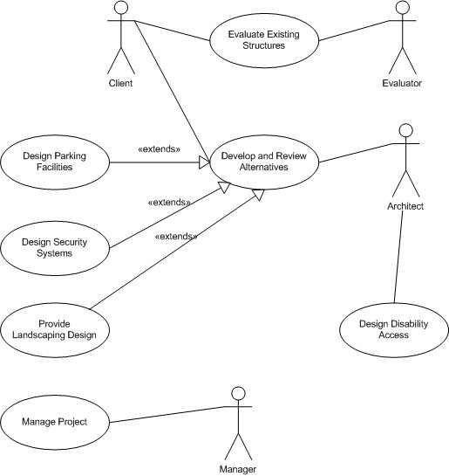

Answers to Review Questions

- What are the three groups of organizational fundamentals that carry implications for the development of information systems?

The three groups of organizational fundamentals include:

A. Level of management
B. Design of organizations
C. Other factors—leadership style, technology, and organizational subcultures

- What is meant by saying that organizational subsystems are interrelated and interdependent?

Organizational subsystems are said to be interrelated and interdependent when a change in one subsystem affects other subsystems.

- Define the term organizational boundary.

An organizational boundary separates the system from its environment.

- What are the two main purposes for feedback in organizations?

The two main purposes of feedback are (a) system control and (b) formulating and revising organizational goals.

- Define openness in an organizational environment.

Openness refers to an organization with a relatively free flow of information within its boundaries.

- Define closedness in an organizational environment.

Closedness refers to an organization with relatively little flow of information within its boundaries.

- What is the difference between a traditional organization and a virtual one?

A traditional organization is one that has a physical location, whereas a virtual organization has parts of the organization in different locations, connected electronically.

- What are the potential benefits and a drawback of a virtual organization?

The benefits of a virtual organization are: reduced costs of physical facilities, a more rapid response to customer needs, and flexibility for employees to care for children or aging parents. A drawback is that it is difficult to meet the social needs of virtual workers.

- Give an example of how systems analysts could work with users as a virtual team.

The example provided in the text allows the analyst to see the software and hardware configuration of the user requesting help.

- What are enterprise systems?

Enterprise systems, often referred to as Enterprise Resource Planning systems, is a term used to describe an integrated organizational (enterprise) information system.

- What is ERP, and what is its purpose?

ERP (Enterprise Resource Planning) is a system that is usually purchased from outside vendors and customized to fit the requirements of a particular company. Its purpose is to help the flow of information between the functional areas of an organization.

- What problems do analysts often encounter when they try to implement an ERP package?

The problems that the analyst encounters when trying to implement an ERP package are the difficulty of trying to analyze a system currently in use and then fit an ERP model to the system. Another problem is that the business model does not always match the ERP functionality. The impact is delayed implementation, higher costs, and the loss of user confidence.

- What are the two symbols on a use case diagram and what do they represent?

The two symbols are an actor, the role of a user of the system, and the use case representing a sequence of transactions in a system.

- What is a use case scenario?

A use case scenario is a text description of the flow of events in a use case. There may be alternate scenarios representing conditions that produce variations on the primary scenario.

- What are the three main parts of a use case scenario?

The three main parts of a use case scenario are the use case identifiers and initiators; the steps performed; and the conditions, assumptions, and questions.

- What are the four steps in creating a use case description?

Use case descriptions are created with these four steps:

A. Use agile stories, problem definition objectives, user requirements, or a features list.
B. Ask about the tasks that must be done.
C. Determine if there are any iterative or looping actions.
D. The use case ends when the customer goal is complete.

- What are the five altitude metaphors for describing use case on different levels? What do they represent?

The five altitude metaphors and what they represent are:

A. White (like clouds): enterprise level
B. Kite: business unit or department level
C. Blue (sea level): user goals
D. Indigo (or fish): functional or subfunctional
E. Black (or clam): most detailed

- What does a process represent on a context-level data flow diagram?

A process represents the whole system on a context-level data flow diagram.

- What is an entity on a data flow diagram?

An entity on a data flow diagram represents an entity that supplies and receives information that is outside of the system.

- What is meant by the term entity-relationship diagram?

An entity-relationship diagram is a graphical depiction of organizational system elements and the association among the elements.

- What symbols are used to draw E-R diagrams?

The three symbols used for E-R diagrams are (a) a rectangle to show the entity, (b) a diamond in a rectangle to join two many-to-many entities, and (c) an oval in a rectangle to represent an attribute, especially a repeating group.

- List the types of E-R diagrams.

The types of E-R diagrams are:

A. a one-to-one relationship
B. a one-to-many relationship
C. a many-to-one relationship
D. a many-to-many relationship

- How do an entity, an associative entity, and an attributive entity differ?

An entity represents a person, place, or thing. An associative entity can only join two fundamental entities. An attributive entity is used to represent an attribute of an entity, often a repeating group, and cannot exist without being linked to a fundamental entity.

- List the three broad, horizontal levels of management in organizations.

The three levels of management in organizations are (a) operations management, (b) middle management, and (c) strategic management.

- How can understanding organizational subcultures help in the design of information systems?

Organizational subcultures affect information requirements, information availability, use of information, and individual behavior.

Problems

- “It’s hard to focus on what we want to achieve. I look at what our real competitors, the convenience stores, are doing and think we should copy that. Then a hundred customers come in, and I listen to each of them, and they say we should keep our little store the same, with friendly clerks and old-fashioned cash registers. Then, when I pick up a copy of SuperMarket News, they say that the wave of the future is super grocery stores, with no individual prices marked and UPC scanners replacing clerks. I’m pulled in so many directions I can’t really settle on a strategy for our grocery store,” admits Geoff Walsham, owner and manager of Jiffy Geoff’s Grocery Store. In a paragraph, apply the concept of permeable organizational boundaries to analyze Geoff’s problem in focusing on organizational objectives.

Applying the concept of permeable organizational boundaries, Fred is experiencing the problem of defining his organizational boundary. Boundaries exist on a continuum, from extremely permeable, whereby Fred would change his store to function like those of his real competitors or super grocery stores as depicted in the trade journal, to almost impermeable, whereby the store would remain exactly as it is. Fred would like to accept new ideas from the outside, and change for better service to his customers. However, he is undecided to what extent, because if the boundary is too lax, he would endanger his market niche and control over performance is diminished.

- Write seven sentences explaining the right-to-left relationships in Figure 2.8.

The left to right relationships in Figure 2.8 are:

  - Each employee is assigned to one and only one office. Each office is occupied by one and only one employee.
  - Each cargo aircraft will serve from one to many distribution centers. Each distribution center is served by one and only one cargo aircraft.
  - One systems analyst is assigned to anywhere from zero to many projects. Each project will be developed by one and only one systems analyst.
  - One machine is undergoing anywhere from zero to one scheduled maintenance. Scheduled maintenance is being done to one and only one machine.
  - Each salesperson is assigned to anywhere from one to many customers. Each customer may have from one to many salespersons.
  - One home office has one to many employees. Each employee may be assigned from zero to one home office.
  - Each passenger is flying to many destinations. Each destination will be visited by many passengers.

- Draw an entity-relationship diagram of a patient–doctor relationship.
  - Which of the types of E-R diagrams is it?
  - In a sentence or two, explain why the patient–doctor relationship is diagrammed in this way.

a.
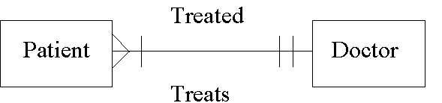

This E-R diagram is a many-to-one (M:1) relationship.

b. A PATIENT is usually treated by one DOCTOR only, but a DOCTOR can have more than one PATIENT.

- You began drawing E-R diagrams soon after your entry into the health maintenance organization for which you’re designing a system. Your team member is skeptical about using E-R diagrams before design of the database is begun. In a paragraph, persuade your team member that early use of E-R diagrams is worthwhile.

Early use of E-R diagram will help to:

A. Gain a better understanding of the organization.
B. Narrow the scope of the problem to make it more manageable and meaningful.
C. Identify the primary entity.

5. Neil is a decision maker for Pepe’s Atlantic Sausage Company. Because there are several suppliers of ingredients and their prices fluctuate, he has come up with several different formulations for the various sausages that he makes, depending on the availability of particular ingredients from particular suppliers. He then orders ingredients accordingly twice a week. Even though he cannot predict when ingredients will become available at a particular price, his ordering of supplies can be considered routine.
- On what level of management is Neil working? Explain in a paragraph.
- What attributes of his job would have to change before you would categorize him as working on a different level of management? List them.

Uncover any conflicting data collected through other data gathering methods.

A. Neil is working at the operations management level. He makes decisions using predetermined rules that have predictable outcomes. His responsibility is to manage inventories, a basic task of the organization, which must be accomplished on time and in accordance with organizational constraints.

B. The following is a list of attributes of Neil’s job which would have to change before he can be categorized as working on a different level of management:

a. Decision horizon of long range
b. Decision objectives increase
c. Problem identification becomes more difficult
d. Nature of problems become mainly semi-structured
e. Set of alternatives which are difficult to articulate
f. One-time decision nature
g. Mainly heuristic decision style

6. Many of the people who work at Pepe’s (Problem 5) are extremely dedicated to Pepe’s and have devoted their lives to the company. Others feel that the company is behind the times and should use more sophisticated production systems, information systems, and supply chain management to make the company more competitive. Members of a third group feel that what they do is unappreciated. Describe the various subcultures in words. Assign them a name based on their emotions.

The persons who are loyal to the organization might be called loyalists, best friends, or St. Bernards. Those behind the times may be called ancient, dinosaurs, and so on. Those who feel unappreciated might be called gophers, cogs in the wheel, and so on. Students will doubtless supply a menagerie of colorful descriptions.

7. Alice in the human resources department at the Cho Manufacturing plant is constantly being asked by employees how much is taken out of their paychecks for insurance, taxes, medical, mandatory retirement, and voluntary retirement. “It takes up to a few hours every day,” says Alice.

She would like a Web system that would allow employees to use a secure logon to view the information. Alice wants the system to interface with health and dental insurance companies to obtain the amount remaining in the employee’s account for the year. She would also like to obtain retirement amounts saved along with investment results. Alice has a high regard for privacy and wants the system to have employees register and give permission to obtain financial amounts from the dental insurance and retirement companies. Draw a use case diagram representing the activities of the Employee Benefit system.

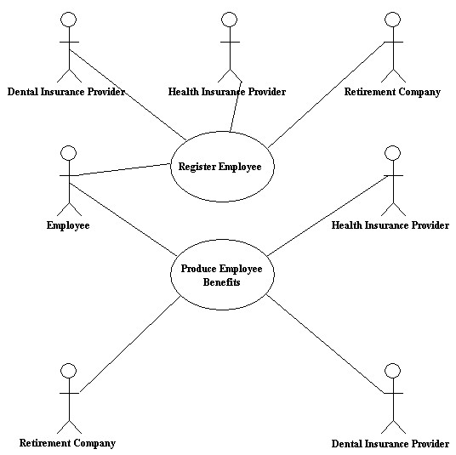

8. Write up a use case scenario for the use case diagram you constructed for Cho Manufacturing.

The use cases are illustrated below. They may vary from student to student. (Continued on the next page.)

Use case name: Register Employee
Area: Human Resources
Actors: Employee, Health Insurance Provider, Dental Insurance Provider, Retirement Company
Description: Employee registers to receive financial information about amounts spent
and remaining for insurance and retirement benefits
Stakeholder: Employee, Human Resources
Level: Blue
Triggering Event: Employee registers with Human Resources
Trigger Type: X External Internal
Steps Performed  - Employee registers for the benefits package program  - Employee is sent legal permission documents to sign  - Employee returns legal permission documents  - Permissions are sent to insurance and retirement companies | Information for Steps  - Employee Record  - Permission forms  - Permission forms  - Permission forms
Preconditions: Employee has logged on to the Human Resources Web site
Postconditions: Employee has successfully registered to receive financial information
Assumptions: Employee has been added to Employee database
Success Guarantee: Employee has been able to register
Minimum Guarantee: Employee was able to view the register Web page
Objectives Met: Allow employees to view updated personal financial information
Outstanding Issues: How do the insurance and retirement providers want legal permissions
sent? Do paper forms with signatures need to be sent, or are FAX or scan
copies sufficient?
Priority (optional): 8 (out of 10)
Risk (optional): 7 (out of 10)

Use case name: Produce Employee Benefits
Area: Human Resources
Actors: Employee, Health Insurance Provider, Dental Insurance Provider, Retirement Company
Description: Employee requests financial information about total amounts spent
and remaining annual amounts for insurance and retirement benefits
Stakeholder: Employee, Human Resources
Level: Blue
Triggering Event: Employee requests financial information
Trigger Type: X External Internal
Steps Performed  - Employee requests financial amounts  - Health insurance is sent a request for employee amounts  - Health insurance returns financial amounts  - Dental insurance is sent a request for employee amounts  - Dental insurance returns financial amounts  - Retirement company is sent a request for employee amounts  - Retirement company returns financial amounts  - Employee is sent comprehensive information | Information for Steps  - Employee Record  - Health Provider Number  - Dental Provider Number  - Retirement Provider Number  - Comprehensive information Web page
Preconditions: Employee has logged on to the Human Resources Web site
Postconditions: Employee has received financial information
Assumptions: Employee has successfully registered for the service and all permissions
have been received by the service providers
Success Guarantee: Employee has been able view their benefit information
Minimum Guarantee: Employee was able to logon
Objectives Met: Allow employees to view updated personal financial information
Outstanding Issues: How should information be transmitted securely to and from providers?
Priority (optional): 8 (out of 10)
Risk (optional): 10 (out of 10)

9. What level are you creating your use case at? Choose one of the four altitude metaphors and explain why you chose it.

The level is blue because it is for a user goal. It is of interest to the users and written for a business activity.

10. Create a context-level data flow diagram for the Employee Benefit system in Problem 7. Make any assumptions about the data to and from the central process. Do you find this to be better or not as good at explaining the system to Alice than the use case and use case scenarios?

The solution is on the next page.
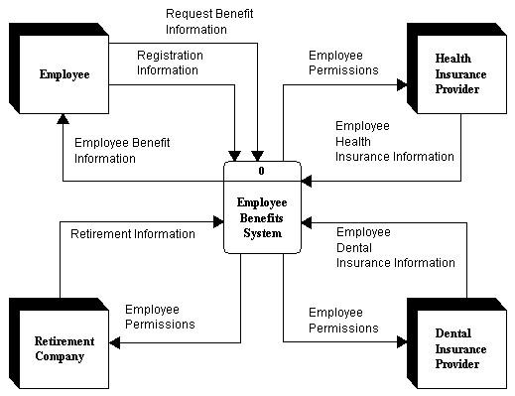

The answers will vary from student to student. Both diagrams present a useful view of the system. The context-level data flow diagram provides more information as a diagram, but may be too complex for Alice. The use case diagram is a simpler view, but the use case scenario will provide the details of the transactions.

11. Draw a use case and write up a use case scenario for getting two or three email accounts. Think about the steps that are needed to ensure security.

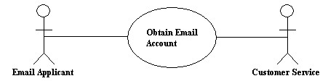

The use case scenario is on the next page.
Use case name: Obtain Email Account
Area: New Accounts
Actors: Email Applicant, Customer Service
Description: Applicant requests one or more email accounts
Stakeholder: Email Applicant
Level: Blue
Triggering Event: Submits Web form
Trigger Type: X External Internal
Steps Performed  - Applicant fills out Web form with personal information  - Applicant agrees to terms of use  - Applicant is given an email address and password  - Applicant changes password | Information for Steps  - New Account Web form  - Terms of use Web page  - Email Account Web page  - Password, Email Account record
Preconditions: Employee has logged on to the New Account Web site
Postconditions: Applicant has an email account
Assumptions: Applicant is over the minimum age limit for email accounts
Success Guarantee: Applicant has an email address and password
Minimum Guarantee: Applicant was able to view Web site
Objectives Met: Provide applicants with email accounts
Outstanding Issues: Can the age limit be verified?
Priority (optional): 9 (out of 10)
Risk (optional): 8 (out of 10)

Group Exercise

- Break up into groups of five. Assign one person to be the Web site designer, one to write copy for a company’s product, one to keep track of customer payments, one to worry about distribution, and one to satisfy customers who have questions about using the product. Then select a simple product (one that does not have too many different versions). Good examples are a disposable camera, a DVD player, a box of candy, and a specialty travel hat. Now spend 20 minutes trying to explain to the Web site designer what to put on the Web site. Describe in about three paragraphs what experience your group had in coordination. Elaborate on the interrelatedness of subsystems in the organization (your group).

The results from this exercise will vary from group to group, and with the product selected. The students should realize that the customer service, the inventory control system, shipping, and the accounts receivable system are interrelated with the operation of the Web site.

- In a small group, develop a use case and a use case scenario for making air, hotel, and car reservations for domestic travel.

The use case scenarios will vary from group to group. A suggested use case diagram is on the next page.
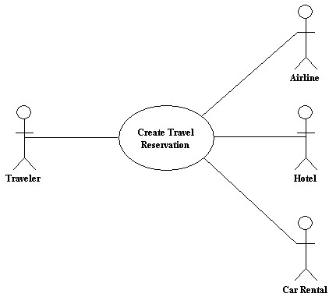

The use case scenario is on the next page. This may vary widely from group to group and in the amount of detail the group decides to include. Some groups may have car selection broken down into car features, such as GPS navigation and so on. There may also be airline meal selections. Hotels may have room selection pages as well.
Use case name: Create Travel Reservation
Area: Reservations
Actors: Traveler, Airline, Hotel, Car Rental
Description: Traveler makes an airline, hotel, and car rental reservation
Stakeholder: Traveler, Airline, Hotel, Car Rental Companies
Level: Kite
Triggering Event: Submits Reservation Web form
Trigger Type: X External Internal
Steps Performed  - Traveler submits a Web form with departing and arriving destinations, dates, and number of travelers  - Traveler selects flights  - Traveler makes flight seat selections  - Traveler selects hotel  - Traveler selects rental car  - Traveler confirms reservation  - Traveler receives confirmation numbers  - Traveler receives email confirmation | Information for Steps  - Preliminary Trip Web form  - Available Flights database table  - Flight Seat database table  - Available hotel database table  - Rental Car database table  - Credit Card Company Verification  - Reservation database tables  - Reservation database tables, Customer Record
Preconditions: Traveler has logged on to travel site
Postconditions: Traveler has multiple reservations
Assumptions: Traveler has a valid credit card with a sufficient balance to cover travel cost
Success Guarantee: Traveler has confirmed reservations
Minimum Guarantee: Traveler was able to view Web site
Objectives Met: Allow travelers to make a comprehensive reservation
Outstanding Issues: Should tour packages or cruise packages be included?
Should the traveler be prompted to enroll in trip insurance?
Priority (optional): 10 (out of 10)
Risk (optional): 8 (out of 10)

- Change your answer in Group Project 2 to include foreign travel. How does the use case and use case scenario change?

The use case diagram may include a currency conversion service. The use case scenario may change in the language that is chosen as well as currency conversion. Multiple currencies may be used if the traveler is flying to different countries. The accommodations may include bed and breakfast establishments as well.

- With your group, draw a context-level data flow diagram of your school’s or university’s registration system. Label each entity and process. Discuss why there appear to be different ways to draw the diagram. Reach consensus as a group about the best way to draw the diagram and defend your choice in a paragraph. Now, working with your group’s members, follow the appropriate steps for developing an E-R diagram and create one for your school or university registration system. Make sure your group indicates whether the relationship you depict is one-to-one, one-to-many, many-to-one, or many-to-many.

Please note that the solutions provided below are intentionally brief. Actual context-level data flow diagrams and entity-relationship diagrams will vary for each school or university.

The context diagram should have external entities of Student, Registration, an entity that collects the student fee, and so on. The entity-relationship diagram should include Student, Class, and perhaps Course and Textbook entities.

There are many different ways to draw the diagram since the data flow names may vary and external entities may be placed anywhere around the diagram. External entities may also appear on both sides of the central process.

Central Pacific University—Problems

1. Use Microsoft Visible or Analyst to view and print the context-level data flow diagram for the computer inventory system, as Chip and Anna did.

Students select CPU Context Level from the Visible Analyst open diagram dialogue box or open the CPU Context Level from Visio.

2. Use the Repository feature to view the entry for the central process.

Double click on the central process in Visible Analyst to view the repository entry for it. The first screen is shown on the next page. The corresponding Repository Web page name is Personal Computer System.

3. Use Visio or Visible Analyst to view and print the entity-relationship diagram for the computer inventory system.

The diagram name is Computer System First Draft.

4. Explain why the external entities on the context-level diagram are not found on the entity-relationship diagram.

The context diagram shows external entities, those that supply data or receive information from the system. The entity relationship diagram contains data entities, those that the system keeps track of. These become system files or portions of the database.

Sometimes external entities, such as the customer, become data entities because a file of customers is maintained. Other external entities, such as management, are not stored in a file (there would be no series of records for management).

5. Explain why the entities MANAGEMENT and FACULTY are found on both sides of the process on the context-level diagram.

Management and faculty are found on both sides of the context-level diagram because they are supplying and receiving information from the system. They could have been included only once with arrows wrapping around the sides of the diagram, but that would present a cluttered drawing.

6. Use Microsoft Visio or Visible Analyst to view and print the use case diagram for the computer inventory system.

The name of the diagram is CPU Use Case Diagram.

7. Add the following actors and use cases to the use case diagram:
A. FACULTY actor in the lower left side of the use case diagram.
B. Connect the FACULTY actor to the QUERY TRAINING CLASSES use case.
C. Because the computers may have software installed for a specific computer lab, the clerical support staff may be responsible for installing software on the computers. Connect the CLERICAL SUPPORT actor to the ADD SOFTWARE use case.
D. Add two new use cases below the QUERY TRAINING CLASSES use case: QUERY SOFTWARE EXPERT and below it, QUERY SOFTWARE INFORMATION.
E. Connect the FACULTY actor to the QUERY SOFTWARE EXPERT and QUERY SOFTWARE INFORMATION use cases.
F. Connect the MANAGEMENT actor to the QUERY SOFTWARE EXPERT use case.

The diagram is illustrated on the next page.

8. Add the INSTALL DESKTOP COMPUTER use case to the upper right area of the diagram. This use case extends the ADD NEW COMPUTER use case.

Refer to the diagram is illustrated on the next page.

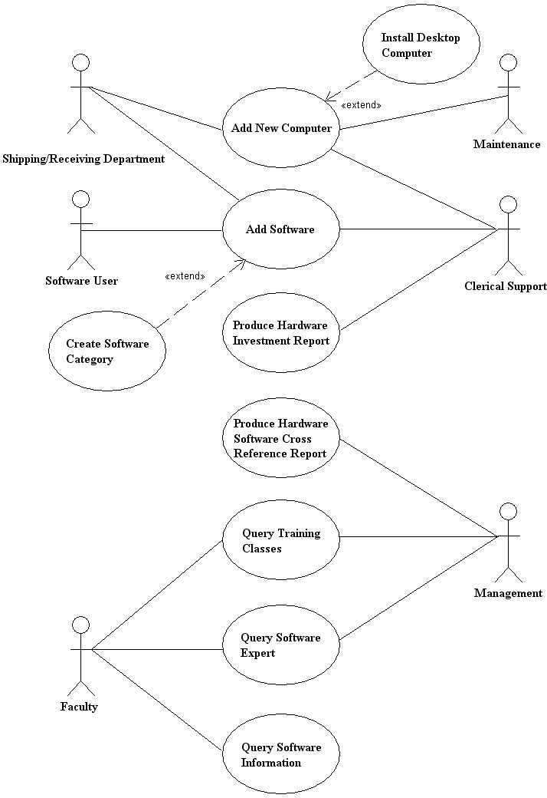

9. Add a use case description for the ADD SOFTWARE use case. It should contain the following information:
A. Obtain the use case name and actors from the use case diagram. The stakeholder and level are the same as those in Figure E2.4.
B. The description should be: add new software to the Software database table and print an installation listing.
C. The activity is started (triggered) when the user clicks the Add Software menu item.
D. The steps performed and information for steps are:
Software is keyed into the new system and validated Software received form
Software is added to the Software Master Software Master
The Software Installation List is produced Software Master, Order
The software user is notified about installed software Order
E. Preconditions are that software has been received. Postconditions are that the software has been added to the database and reports have been created. Assumptions are that the user has successfully logged on with access to Add Software entry screen. A success guarantee is that the software has been added to the database and required report printed. A minimum guarantee is that the software has been received. The objectives met are to add and install new software. The outstanding issue is how to determine which software to install on which machines. The priority is high and the risk is medium.
Use case name: Add Software
Area: Computer System
Actors: Software User, Clerical Support
Description: Adds new software to the computer system
Stakeholder: Faculty, Student, Staff
Level: Blue
Triggering Event: Add Software menu clicked
Trigger Type: X External Internal
Steps Performed  - Software is keyed into the new system and validated  - Software is added to the Software Master  - The Software Installation List is produced  - The software user is notified about installed software | Information for Steps  - Software received form  - Software Master  - Software Master, Order  - Order
Preconditions: Software has been received
Postconditions: Software has been added to the database
Assumptions: User has successfully logged on with access to Add Software screen
Success Guarantee: Software has been successfully added to the database
Minimum Guarantee: Software is available to add
Objectives Met: Add software to the Software Master
Outstanding Issues: Does the old software have to be retained
Priority (optional): High
Risk (optional): Medium
10. Write a use case description for the PRODUCE HARDWARE SOFTWARE CROSS REFERENCE REPORT use case. Use the use case diagram to determine the heading information, making any reasonable assumptions. The steps would be to read a software record, use that information to read the hardware-software relational table, then read the hardware record. Use the hardware record to print a line, accumulating totals. Print subtotals and grand totals.

This is a medium priority, low risk activity. Preconditions are that all the information must have been previously added to the appropriate database tables. Postconditions are that the report has been printed. Assumptions are that all the information on the database tables is correct. A success guarantee would be the report has been successfully created. A minimum guarantee would be the report could not be printed. The objectives met are to produce information about what software is found on which machine. Outstanding issues are what if the software is older and is not currently installed on any machines, how should the report be produced: printed, on a PDF file, or should it really be a query for one software package.

Use case name: Produce Hardware Software Cross Reference Report
Area: Computer System
Actors: Management
Description: Produces a report showing what software is included on which machines
Stakeholder: Management, Faculty, Staff
Level: Blue
Triggering Event: Reports: Software Cross Reference Report menu item clicked
Trigger Type: X External Internal
Steps Performed  - Read a software record  - Use the software record to read the hardware-software relational table  - Read the hardware record  - Use the hardware record to print a line, accumulating totals  - Print subtotals and grand totals | Information for Steps  - Software record  - Hardware-software relational table  - Hardware record  - Hardware record  - Accumulated totals
Preconditions: All the information must have been previously added to the appropriate database tables
Postconditions: The report has been printed
Assumptions: All the information on the database tables is correct
Success Guarantee: The report has been successfully created
Minimum Guarantee: The report could not be printed
Objectives Met: Produce information about what software is found on which machine
Outstanding Issues: What if the software is older and is not currently installed on any machines, how should the report be produced: printed, on a PDF file, or should it really be a query for one software package
Priority (optional): Medium
Risk (optional): Low

11. Write the use case description for the PRODUCE HARDWARE INVESTMENT REPORT use case. Use the use case diagram to define the header information. The steps involve reading each hardware record, counting the number of machines and totaling the amount invested in them for each computer model. When the computer brand changes, produce subtotals with a grand total at the end of the report. All information comes from the Hardware Master database table. Make any reasonable assumptions about preconditions, postconditions, assumptions, success guarantee, minimum guarantee, objectives met, outstanding issues, priority, and risk.

Use case name: Produce Hardware Investment Report
Area: Computer System
Actors: Clerical Support
Description: Produce a report showing the dollar amount invested in computer hardware
Stakeholder: Management
Level: Blue
Triggering Event: Reports: Hardware Investment Report menu item clicked
Trigger Type: X External Internal
Steps Performed  - Read each hardware record  - Count the number of machines and totaling the amount invested in them for each computer model  - When the computer brand changes, produce subtotals  - Produce a grand total at the end of the report | Information for Steps  - Hardware Master database table  - Hardware Master database table  - Hardware Master database table  - Hardware Master database table
Preconditions: All computer information must be up-to-date on the Hardware Master
Postconditions: The report has been printed
Assumptions: The information on the Hardware Master is valid
Success Guarantee: The report has been printed
Minimum Guarantee: The report has not been printed
Objectives Met: Report on the total amount invested in hardware
Outstanding Issues: None
Priority (optional): High
Risk (optional): Low

12. Write the use case description for the QUERY TRAINING CLASSES use case. Use the use case diagram to define the header information. The steps involve entering information on the Web form, validating the information, and storing the data on a Training Request database table. Make any reasonable assumptions about preconditions (such as if the software have to be already purchased), postconditions, assumptions, success guarantee, minimum guarantee, objectives met, outstanding issues, priority (would this be a high priority task), and risk.

Use case name: Query Training Classes
Area: Training
Actors: Faculty, Management
Description: Produce a Web query of all training classes offered
Stakeholder: Faculty, Staff, Training Staff
Level: Blue
Triggering Event: The Training Class Offering link has been clicked
Trigger Type: X External Internal
Steps Performed  - Enter information on the Web form  - Validate the Web form information  - Store the data on the Training Request database table | Information for Steps  - Training Request Web form  - Training Request Web form  - Training Request database table
Preconditions: Software must have been purchased and training staff available
Postconditions: Training class has been requested
Assumptions: User has successfully logged onto the system
Success Guarantee: Training class has been requested
Minimum Guarantee: User can logon to the system
Objectives Met: Allow faculty and staff to request training classes
Outstanding Issues: None
Priority (optional): Medium
Risk (optional): Low

