2

The Key Principles of Economics

Chapter Summary

Chapter 2 introduces the key principles that are central to all economic theory:

* The *principle of opportunity cost* states that the opportunity cost of something is what you sacrifice to get it. Opportunity costs in production are generally increasing, and thus, the production possibilities curve is bowed outward.
* The *marginal principle* states that any activity should be increased as long as the marginal benefits of the additional activity exceed the marginal costs.
* The *principle of voluntary exchange* states that a voluntary exchange between two people makes both people better off.
* The *principle of diminishing returns* states that, in the short run, if use of one input is increased while all others are held constant, production will eventually increase at a decreasing rate.
* The *real-nominal principle* states that what matters to people is the real value or purchasing power of money or income, not its face or nominal value.

Here are the key questions that students should be able to answer by the end of the chapter. These questions appear in the chapter opener of the main text and again near the Applications within the chapter:

1. What is the opportunity cost of running a business?
2. How do people think at the margin?
3. What is the rationale for specialization and exchange?
4. Do farmers experience diminishing returns?
5. How does inflation affect the real minimum wage?
6. How does inflation affect lenders and borrowers?

Approaching the Material

Continue the approach you developed in the first chapter, reaching students where they are. The decision to go to college is a great illustration of opportunity costs because students forgo earnings that they would have received from a full-time job. Apply the concept of diminishing returns to hours studying: if a student studies for five hours, will studying one additional hour really benefit him or her? Most of the students will have had jobs, so use the price of a gallon of gas or a burger per hour worked to explain real wages. Most students will have trouble with the marginal principle; so have plenty of examples ready. A seat on a bus or train that is not full works well. An extra passenger in a car for a road trip or another person watching a movie will also work.

Chapter Outline

2.1 The Principle of Opportunity Cost

* 1. Definition

1. The **opportunity cost** of something is what you sacrifice to get it.

2. What you sacrifice is the *next best* alternative.

3. For example, if you choose to buy a cup of coffee, you are giving up the money it costs to buy it. What else would you have used the $2.00 for? The opportunity cost of the coffee is the one thing (or next best alternative) that you would buy if not the coffee.

📚 Teaching Tip

Ask the students what they would be doing if they weren’t in class. Answers will range from sleeping, working, watching TV, studying, etc. You can make the point that the alternatives are infinite and computing the cost of them all is impossible. However, since they could only be doing one thing (not all of them) if they were not in class, determining the opportunity cost requires only knowing the one thing they would be doing.

* 1. The Cost of College
     + 1. The classic example of opportunity cost is the costs of going to college. Be sure to illustrate the implicit opportunity cost of foregone income as well as tuition, books, etc.

📚 Teaching Tip

It’s also helpful to have a discussion about whether room and board should be considered a cost of college. If the person has to pay the same amount for room and board whether he/she goes to college or works, it should not be considered a cost of college.

* 1. The Cost of Military Spending

D. Opportunity Cost and the Production Possibilities Curve

1. The **production possibilities curve**: A curve that shows the possible combinations of products that an economy can produce, given that its productive resources are fully employed and efficiently used. (See Figure 2.1 and show how an increase in the production of one good requires a decrease in the production of the other.)

2. Discussion of relevant points on the production possibilities graph

a. Points on the curve are efficient and indicate an economy is utilizing all resources.

b. Points inside the curve are inefficient and indicate an economy is not utilizing all resources or resources are not used in the least-cost manner.

c. Points outside the curve are not feasible given current technologies and resources.

3. Shifts in the Production Possibilities Curve (See Figure 2.2 and show how points outside the PPC are feasible in the future if it shifts out due to increases in resources or technological innovation. It is also useful to discuss what might make the PPC shift in: a natural disaster, the Y2K bug, etc.)

a. Increased resources

b. Technological innovation

📚 Teaching Tip

Use something students are familiar with to construct their first production possibilities curve. Pick two classes, such as Economics and Marketing. Tell them they are going to allocate study time to produce grades in the classes. The choice involves how much study time to allocate for each class. You can start with an all-or-nothing scenario producing an A|F outcome and make adjustments from there. Once they are comfortable, remind them that everything else was held constant. Ask them what would happen to the curve if the professors were better teachers, if students had better study skills, smaller classes, better textbooks, upgraded computers, more time to study.

Review the key question from the chapter opener and its related Application:

Question 1: What is the opportunity cost of running a business?

Application 1: DON’T FORGET THE COSTS OF TIME AND INVESTED FUNDS

This Application gives an example of a business to explain how we can use the principle of opportunity cost to compute a business’s costs. In a business, the total costs are affected by the costs of raw materials, the opportunity costs of funds invested and the opportunity costs of time. This Application shows that we must include not just the costs of materials but also the opportunity cost of funds invested, as well as the opportunity costs of time in computing the true cost of running a business.

2.2 The Marginal Principle

1. Definition

1. **Marginal benefit** is the additional benefit resulting from a small increase in some activity.

2. **Marginal cost** is the additional cost resulting from a small increase in some activity.

3. Choose a level of the activity such that marginal benefit of the last unit equals the marginal cost of the last unit.

1. Using the Marginal Principle: Movie Sequels (See Figure 2.3), Renting College Facilities, Automobile Emissions Standards

📚 Teaching Tip

There are several easy-to-understand examples of the Marginal Principle in the world of college students. An easy way to start is with examples where the marginal cost is zero: The amount of food consumed at a particular meal in the cafeteria; Internet minutes in the computer lab; cell phone weekend minutes with some plans. Given the marginal costs are zero, the student’s decision to consume is based on positive marginal benefits. You can then introduce situations where there are positive marginal costs, such as fast food that needs to be paid for.

Review the key question from the chapter opener and its related Application:

Question 2: How do people think at the margin?

Application 2: WHY NOT WALK UP AN ESCALATOR?

This Application explains the factors that go into our decision whether or not to walk up an escalator. We can use the marginal principle to see that whether we walk up the escalator or stand still on the escalator depends on the marginal benefit of what we will get out of walking up the escalator as opposed to standing still, compared to the cost of walking up the escalator. If the marginal benefit is greater than the marginal cost, we will stand still instead of walking up the escalator.

C. Driving Speed and Safety

2.3 The Principle of Voluntary Exchange

1. The assumption is that people act in their own self-interest**.** A voluntary exchange between two people makes both better off. Markets work because they are based on the principle of voluntary exchange.

📚 Teaching Tip

College students easily understand the principle of voluntary exchange because they are constantly engaged in voluntary exchanges. Work and consumption are two examples from their world. If they are employed, they voluntarily exchange their time and effort for the money they earn. Nobody kidnaps them and forces them to work. Their employer pays them voluntarily as well. Both the student and employer are better off. Any time individuals purchase anything, they exchange money for a product or a service, making both the buyer and the seller better off. Ask students what they purchased yesterday or today: Coffee or soda? Candy? Newspaper? Why did they purchase it?

1. Exchange and Markets
2. A market is an institution or arrangement that allows buyers and sellers to exchange goods and services.

📚 Teaching Tip

Create a market in the classroom. Do the experiment described in the book or in MyEconLab.

1. Online Games and Market Exchange
2. Online games such as EverQuest illustrate how markets and exchange develop on their own because of the desire to trade.

Review the key question from the chapter opener and its related Application:

Question 3: What is the rationale for specialization and exchange?

Application 3: JASPER JOHNS AND HOUSEPAINTING

This Application illustrates how we can use the principle of voluntary exchange to explain why Mr. Johns, a very productive art painter, should hire the less productive house painter to paint his house. The opportunity cost of Mr. Johns painting the house himself would be the income lost by spending time painting the house rather than painting art and earning money for it. Mr. Johns could hire the house painter to paint the house for less money than he would lose by painting the house himself and not earn money by painting art during that time.

2.4 The Principle of Diminishing Returns

A. **Principle of Diminishing Returns**: Suppose that output is produced with two or more inputs, and we increase one input while holding the others constant. Eventually, output will begin to increase at a decreasing rate.

📚 Teaching Tip

Have the students picture the front end of a fast food franchise, such as McDonald’s, Burger King, Wendy’s, or another franchise near you. Ask themwhat would happen if you kept on adding more and more workers at McDonald’s. All the equipment is fixed. The number of workers is the variable input. Ask students what would happen to the number of hamburgers served as you increased the number of workers from 1 to 3 to 5 to 50. Eventually the restaurant would be so crowded that none of the workers would be able to move or serve any hamburgers. (Make sure to point out that this is well beyond the point of diminishing returns.)

B. Diminishing Returns from Sharing a Production Facility

1. A good example of diminishing returns is when a company tries to add workers to an existing production facility. Eventually, the facility will become overcrowded and the additional output resulting from additional workers will fall.

Review the key question from the chapter opener and its related Application:

Question 4: Do farmers experience diminishing returns?

Application 4: Fertilizer and Crop Yields

This Application illustrates how the notion of diminishing returns applies to all inputs to the production process. For a farmer, continuously increasing the amount of fertilizer applied to a fixed amount of land eventually reduces the increases in output. The farmer will experience diminishing return because while even though the amount of fertilizer was not fixed, the other inputs to the production process are fixed.

📚 Teaching Tip

A classroom full of urban or suburban students might not relate very well to this example. You can use watering the lawn instead. An excessive amount of water will not help the lawn grow faster.

2.5 The Real-Nominal Principle

1. Definition

1. What matters to people is the real value or purchasing power of money or income, not its face value.

2. The **nominal value** of an amount of money is its face value. The **real value** is the value of an amount of money in terms of what it can buy.

When the government publishes statistics about the economy, it takes into account the real-nominal Principle. For example, the value of “real wages” shows what has happened to the purchasing power of workers over time. The nominal wage shows what has happened to the sum on the worker’s paycheck, but it cannot show what has happened to purchasing power.

Review the key questions from the chapter opener and their related Applications:

Question 5: How does inflation affect the real minimum wage?

Application 5: The Declining Real Minimum Wage

This Application uses the basket-of-goods approach to illustrate what has happened to the real minimum wage. Please describe the basket-of-goods approach. A worker earning the minimum wage in 2007 has lost more than a third of his purchasing power over the last 30 years.

📚 Teaching Tip

Ask the students how many of them would be happy to earn $500,000 per year. Most will say yes. Then tell them that a case of soda pop costs $100, a CD costs $250, and a new car costs $500,000. Are they still happy? You can now proceed to explain the difference between nominal and real variables.

Question 6: How does inflation affect lenders and borrowers?

Application 6: Repaying student Loans

This Application shows how inflation can impact the value of money paid back over time. Using changes in annual salaries, the Application demonstrates the work time it takes someone to pay back the loan under various inflation assumptions.

📚 Teaching Tip

Another way to illustrate this concept is to ask students if they know their parents’ monthly mortgage payments and when they purchased their homes. Inflation in home prices affects the amount that people will have to borrow. An older home usually will have a smaller nominal mortgage payment. However, your students’ parents’ salaries have presumably risen partly due to inflation. Therefore, inflation has helped those that have been debtors.

Additional Applications to Use in Class

Question: Has fish production reached the point of diminishing returns?

ADDITIONAL APPLICATION: So Long Seafood? Experts Warn of Disaster

MSNBC Staff and News Service Reports

“So Long Seafood? Experts Warn of Disaster”

Posted on MSNBC.com

Financial Times

http://www.msnbc.msn.com/id/15532333/

Posted 11/03/2006

Summary: Key Points in the Article

According to some experts, overfishing and pollution will virtually wipe out all the world’s fisheries by the year 2050. A team of economists and ecologists arrived at that conclusion by extrapolating current trends. The team warned that unless fisheries management practices radically change, we were in the “last century of wild seafood.”

The team spent four years using controlled experiments and existing data to arrive at their conclusions. However, industry professionals do not appear to share the concerns. The National Fisheries Institute issued a statement that said, “Fish stocks naturally fluctuate in population,” and “By developing new technologies that capture target species more efficiently and result in less impact on other species or the environment, we are helping to ensure our industry does not adversely affect surrounding ecosystems or damage native species.”

Seafood consumption is up in the U.S., with the average American eating 16.6 pounds of seafood in 2004 versus 15.2 pounds in 2002. Fishing accounts for over $80 billion in revenue worldwide.

Analyzing the News

Note that the National Fisheries Institute did not deny declining fish stocks. Instead the organization indicated the decline was part of a natural cycle. Could it be that the increasing global demand for seafood has pushed fishing to the point of diminishing returns?

Thinking Critically Questions

1. It appears that fish harvests are increasing but overall fish stocks may be declining. What economic principle is exhibited?
2. How can we increase production?
3. At what point would we cease to add fishing boats?

Question: How can people invest in themselves?

ADDITIONAL APPLICATION: “SHORT ON CASH, SOME PUT A PRICE ON THEMSELVES”  
Aleccia, JoNel

Posted 12/5/2008 on MSNBC.com

Summary: Key Points in the Article

The shrinking economy has had an impact on people’s willingness to donate plasma, sperm, and fertile eggs. Hair sales are up as well. While the practice of selling most body products is illegal in the U.S., there are instances where people are considered “compensated donors.” For example, many plasma centers will pay $20 for donor time and travel. The sudden spike in donor applications begs the question of whether the motives are altruistic or financial.

Donating fertile eggs can be lucrative. One nursing student reported being able to graduate from college debt free due to the $28,000 she received for 4 cycles of fertile eggs donated since February. Viable sperm donors can earn $600 a month for a cycle of ten donations.

While the practice can earn some cash only a small fraction of donors make it through the rigorous medical and life history screens for fertile eggs and sperm. In any case, applications to be donors are up 20 to 30 percent at most clinics with plasma donations up as much as 50 percent in some areas. The uptick appears to be consistent with the recession.

Analyzing the News

Since “price” appears fixed for these items you simply see an increase in overall quantity. However, this article begs the question of whether body parts and products should be available for sale instead of merely compensation for time and travel. What do you think?

Thinking Critically Questions

1. What is driving the increase on “donations” for certain body products?
2. How do clinics compensate donors, since it is illegal to buy plasma?
3. Should this practice be outlawed?

Solutions to End-of-Chapter Exercises

Chapter 2

Section 2.1: The Principle of Opportunity Cost

1.1 10, 180

1.2 arrow up

1.3 arrow up

1.4 $22,000

1.5 safe drinking water for 5 million people

1.6 outbidding, $1/hectare

1.7 $86,000 per year

1.8 Scientists and engineers will be used to execute the mission, so part of the opportunity cost might be measured in science and engineering education (or any other non-mission-related scientific productivity) foregone.

1.9 The cost of holding wealth in non-interest-bearing form is higher where the interest rate is higher.

1.10 a. The loan cost me the interest I could have earned by investing the $100.

b. The opportunity cost is the current market price, not the historical price.

c. The cost of the stadium is $50 million plus the foregone earnings from renting the land or the interest that could be earned on the proceeds from sale of the land (whichever is higher).

d. The cost would also include the time difference between alternative methods of commuting

1.11 a.

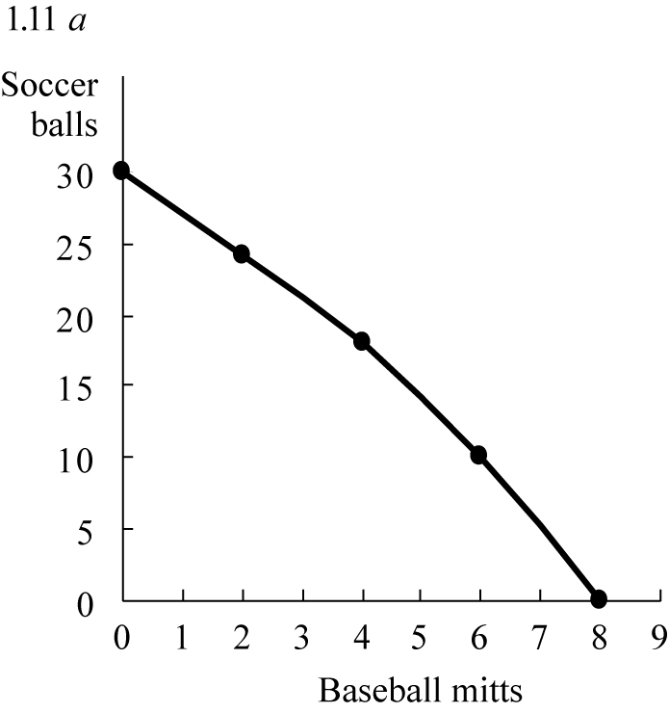

b.

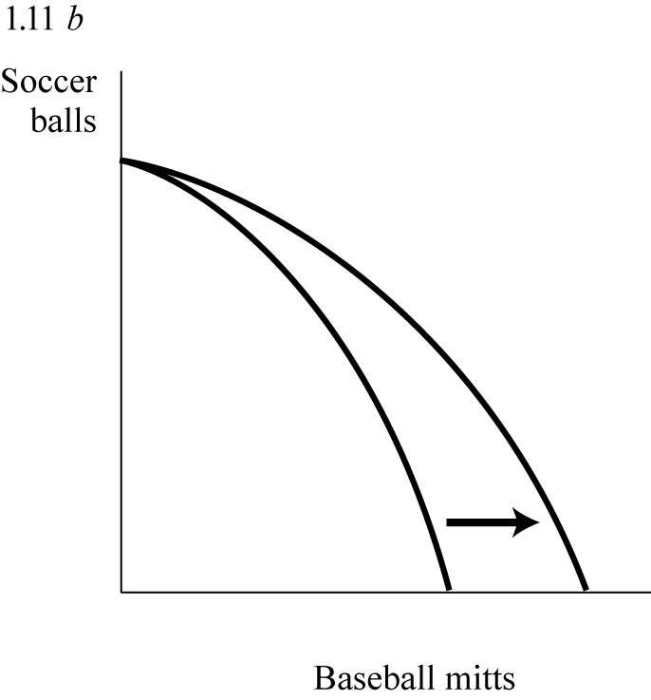

c. 6, 10

1.12 current value of the furniture, current rate of return on alternative investment(s)

Section 2.2: The Marginal Principle

2.1 Yes, the marginal benefit ($300) is less than the marginal cost ($200).

2.2 Yes, the marginal benefit ($135) exceeds the marginal cost ($125).

2.3 Yes, the marginal benefit ($50 million) exceeds the marginal cost ($30 million).

2.4 marginal, marginal

2.5 a. Draw MB and MC curves crossing at 40 mph

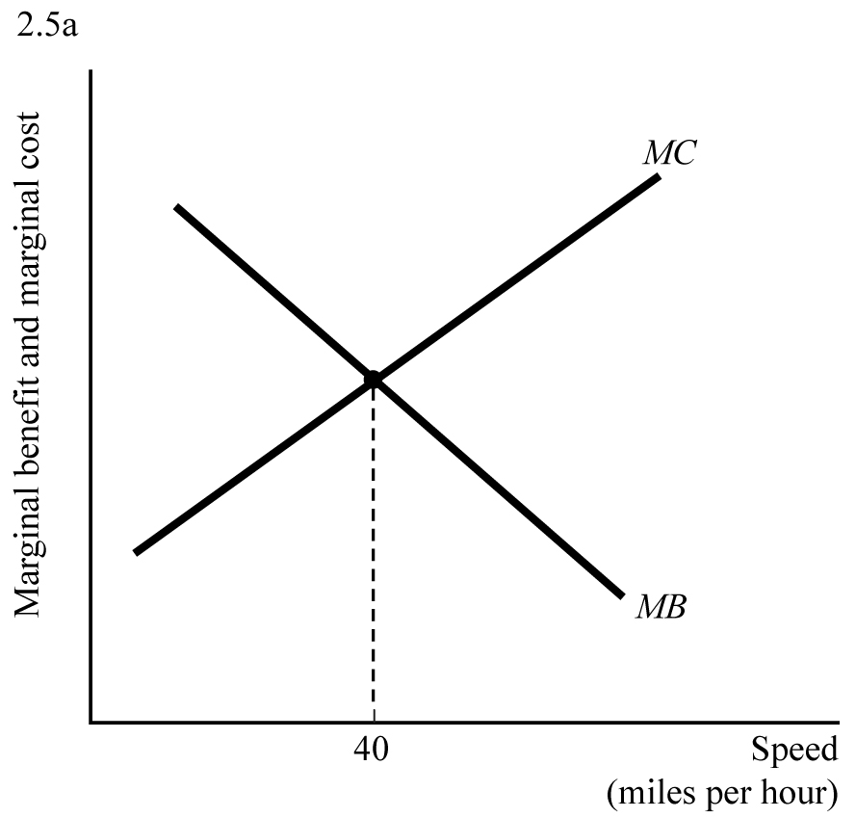

b. Shift MB to the right and show an increase in speed

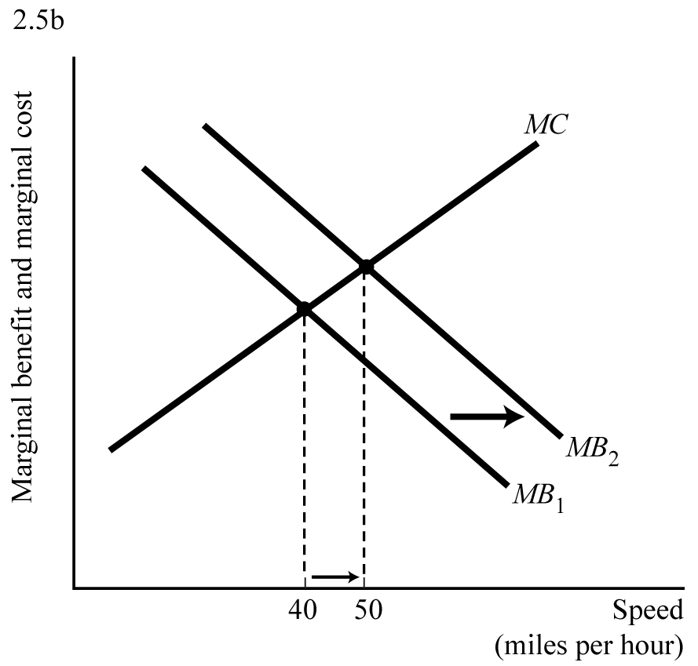

c. Shift MB to the left and show a decrease in speed

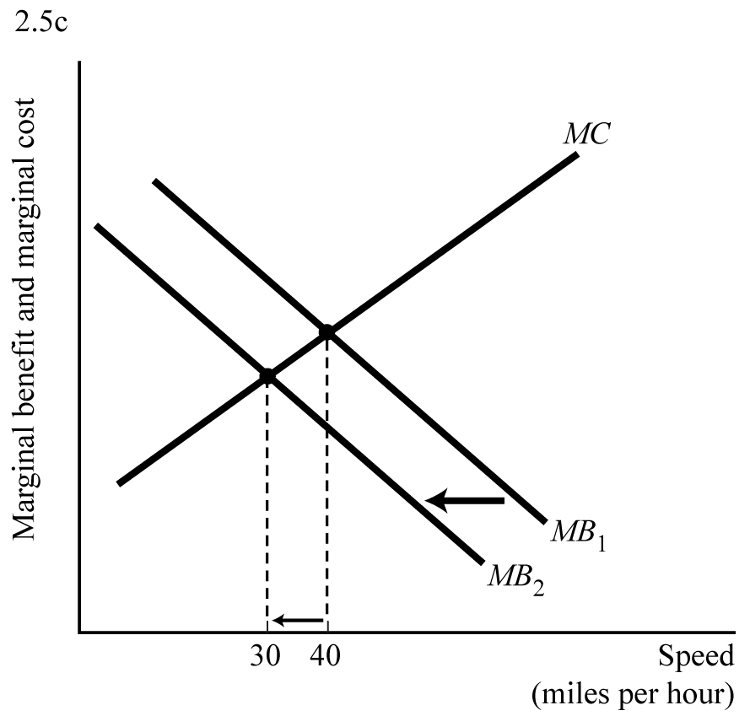

d. The MC curve should have a kink making it steeper to the right of 35mph. This lowers the speed that he drives.

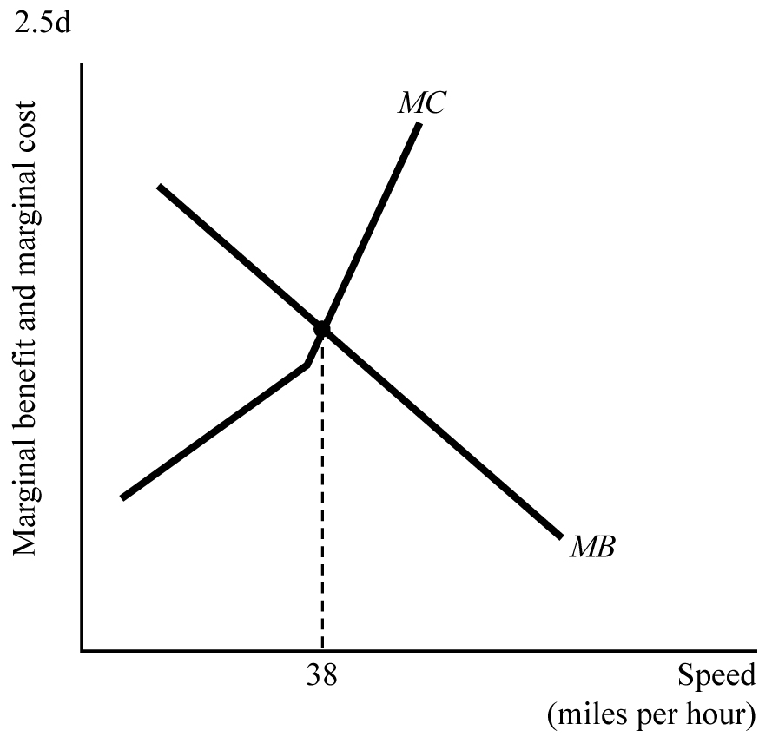

2.6 a. It made sense if the marginal revenue of $3,100 was greater than the marginal costs

b. cost, less, 3,100

2.7 a. yes, marginal revenue 2500 > marginal cost 2000

b. no, marginal revenue 1500< marginal cost 2000

2.8 Three officers should be hired, since the marginal benefit of the third officer ($40,000) equals the constant marginal cost of $40,000, but the marginal benefit of the fourth officer would fall below the constant marginal cost.

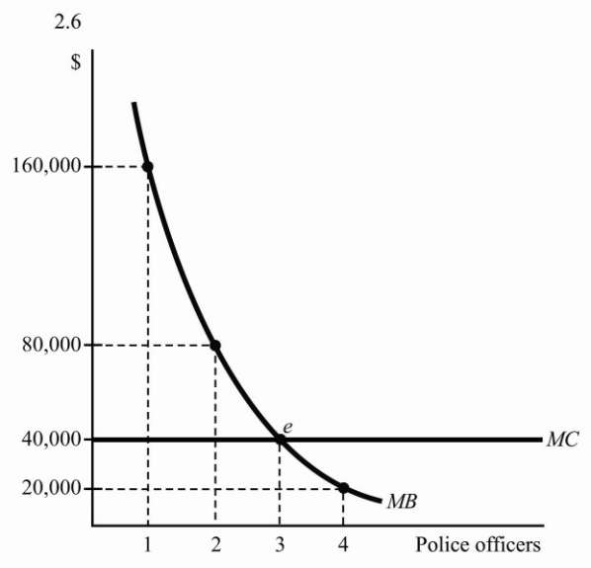

2.9 a. 26

b. yes

2.10 a. Pick 5 pints.

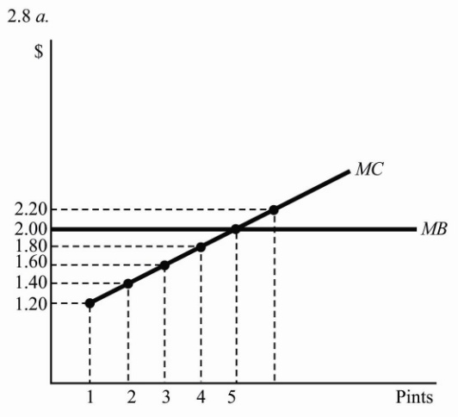

b. Pick 3 pints.

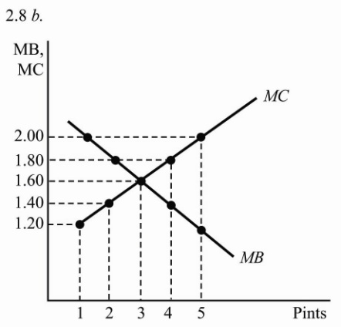

Section 2.3: The Principle of voluntary exchange

3.1 False

3.2 $15, $15

3.3 Up arrow

3.4 softer

3.5 a. No, the cost of foregone surgeries exceeds the benefit of clean drains.

b. $1,150 per hour (= ($20 per minute x 60 minutes/hour) - $50 per hour)

3.6 a. 50 fish

b. Assign the tribe’s least productive fishermen to build the boat. The cost of the boat decreases to 20 fish.

3.7 The tree-cutter paid the neighbor to compensate for lost shade

Section 2.4: The Principle of Diminishing Returns

4.1 300

4.2 False. Diminishing returns means that output increases at a decreasing rate.

4.3 less than, at least

4.4 inflexible, flexible

4.5 arrow up, arrow down

4.6 This is true, so long as there are no limitations on availability of resources other than soil.

4.7 a. Yes, because employment of some resources is inflexible within a week.

b. Possibly not, because employment of all resources used in production of memory chips is likely to be flexible over a period of two years.

4.8 a. No, because of the principle of diminishing returns

b. Yes

4.9 2, 154, 48, 11

3, 172, 36, 11

4, 184, 24, 11

5, 190, 12, 11

6, 193, 6, 11

Ted should work 5 hours, since MB<MC for the sixth hour of work.

Section 2.5: The Real-Nominal Principle

5.1 $1 in purchasing power

5.2 negative $20 in purchasing power

5.3 down arrow, 3%

5.4 $65,000

5.5 No

5.6 Inflation, since it lowers the real cost of the debt repayment.

5.7 Number of baskets per week: 4.10, 3.05

So the real value of welfare payments decreased

5.8 a. 130.488%, 117.287%, 136.497%, 122.469%, 120.753%

b. Wage increases lagged consumer price increase in three of four groups.

c. Real wages fell in every sector except professional services.

5.9 a. ---- , 5 months

$5,000, 4 months

$2,000, 10 months

b. Inflation

5.10 a. 55 tunes, $55, 10%

b. 55 tunes, 66 dollars, 32%