CHAPTER 2: Identifying and Selecting Projects

CHAPTER 2: Identifying and Selecting Projects 1
Chapter Concepts 2
Learning Outcomes 2
Project Management Knowledge Areas from PMBOK® Guide 2
Teaching Strategies 2
Lecture Notes 2
1. Real-World Project Management Examples 2
Vignette A: Procurement to Achieve Single-Team Strategy 2
Vignette B: Can Safety Mindedness Be Selected in a Contractor? 3
2. Project Identification 4
3. Project Selection 4
4. Project Charter 5
5. Preparing a Request for Proposal 6
6. Soliciting Proposals 7
7. Critical Success Factors 8
8. Summary 8
Questions 9
Internet Exercises 10
Case Study # 1 A Midsize Pharmaceutical Company 10
Answers to Case Questions 10
Group Activity 11
Case Study # 2 Transportation Improvements 11
Answers to Case Questions 11
Group Activity 12
Optional Supplemental Activities 12

Chapter Concepts
This chapter discusses the initiating phase of the project life cycle. Based upon this chapter, students will become familiar with:
- How projects are identified and selected
- A project charter
- How to outsource projects using a request for proposal
- The proposal solicitation process

Learning Outcomes
After studying this chapter, the learner should be able to:
- Discuss how projects are identified
- Explain how projects are prioritized and selected
- Identify and describe at least eight elements of a project charter
- Prepare a project charter
- Prepare a request for proposal

Project Management Knowledge Areas from PMBOK® Guide
Concepts in this chapter support the following Project Management Knowledge Areas of
A Guide to the Project Management Body of Knowledge (PMBOK® Guide):
Project Integration Management
Project Procurement Management

Teaching Strategies
- The first vignette reinforces the need for a stakeholder engagement when proposing a project, planning the solution, and execution. Have students describe the positives and negatives of stakeholder engagement.
- The second vignette reinforces that desired characteristics can be included in the RFP. Engaging students in a conversation of how to include desired characteristics in an RFP and how to evaluate those characteristics will help to reinforce the concepts related to RFP and proposal development.
- Have the students read the case studies in class and answer the questions in groups of three or four. Next, select five participants to act out the group activity. This is an excellent way to stimulate class discussion and interest. This is a good case study to do right before you lecture on this chapter and then again after you lecture on the chapter. The difference in responses “before” and “after” will reinforce the topics covered.
- Ask your students whether they have ever seen an RFP or written an RFP.
- Ask your students to identify situations in the real world that would require an RFP. Ask them to describe in detail what the RFP might look like.

Lecture Notes

1. Real-World Project Management Examples

Vignette A: Procurement to Achieve Single-Team Strategy
Launched in 2004, Building Schools for the Future (BSF) included the project goal to build new schools and refurbish existing schools such that each of the secondary schools in the United Kingdom was updated or new. The plan was to design new learning spaces and include the latest technology to meet the 21st-century standards for education.
- Background information about the procurement process
  - Differential methods for public/private partnerships for new construction
  - Traditional procurement for refurbishments
  - Developed regional requests instead of single school buildings
- One Region’s project
  - Local group with good stakeholder engagement
  - Large enough to be able to complete project
  - Flat organization structure
  - Focused on delivery
  - Had performance agreement for more customer engagement
  - All stakeholders and project members had a single team strategy
Have students discuss the risks and benefits of having increased stakeholder engagement and public/private partnerships when selecting contractors for public projects.

Vignette B: Can Safety Mindedness Be Selected in a Contractor?
Construction projects are fraught with hazards. Sites include large equipment, moving parts, shifting earth, or high places. Occupational accidents in the Chinese construction industry resulted in the death of more workers than any other industry including coal mining, and, worldwide, the construction industry is responsible for having the highest occupational injury rates
- Are there articular traits of management companies that would result in fewer accidents and reduced deaths due to occupational injuries?
  - Project safety culture
  - High-speed rail projects
  - Number of occupational injuries and deaths
- Outcomes
  - Occupational fatalities occur even though emphasizing accident prevention and introduced occupational health and safety provisions
  - Found a misalignment of management commitment and subordinates’ actions
  - Not disseminate to project teams
  - Lack of safety leadership
- Key findings
  - Demonstrated socialized characteristic behaviors including altruism, safety core value communication, support for employees with safe work habits, responsibility and accountability for safety incidents, and identification of safe practice
  - Project manager training programs in the companies with fewer occupational injuries emphasized these socialized charismatic behaviors
  - Project teams for the owners’ organizations as well as the subcontractors’ organizations with lower incidence reports of injuries and fatalities maintained effective communication channels within the teams and with stakeholders
Have students discuss how to include in the RFP the characteristics desired in a contractor. The researchers in the vignette found that Safety mindedness can be a selection criteria element. How would they create an evaluation to measure the desired characteristic?

2. Project Identification
- The initiating phase of the project life cycle starts with recognizing a need, problem, or opportunity for which a project or projects will be identified to address the need.
- Identified in various ways:
  - during an organization’s strategic planning, as part of its normal business operations,
  - in response to unexpected events,
  - or as a result of a group of individuals deciding to organize a project to address a particular need
- It is important to clearly define the need. This may require gathering data about the need or opportunity to help determine whether it is worth pursuing.
- Sometimes organizations identify several or many needs but have limited funds and people available to address all those needs. In such cases, the company must go through a decision-making process to prioritize and select those projects that will result in the greatest overall benefit.

3. Project Selection
- Project selection involves evaluating various needs or opportunities, and then deciding which of those should move forward as projects to be implemented.
- The benefits and consequences, advantages and disadvantages, plusses and minuses of each opportunity need to be considered and evaluated. These factors can be quantitative and qualitative, tangible and intangible. Each person's decision will be a combination of quantitative evaluation and "gut" feelings based upon experience.
- The steps in project selection are to:
  - Develop a set of criteria against which the opportunity will be evaluated. For example:
    - Alignment with company goals
    - Anticipated sales volume
    - Increase in market share
    - Establishment of new markets
    - Anticipated retail price
    - Investment required
    - Estimated manufacturing cost per unit
    - Technology development required
    - Return on investment
    - Human resources impact
    - Public reaction
    - Competitors’ reaction
    - Expected time frame
    - Regulatory approval
    - Risks
  - List assumptions that will be used as the basis for each opportunity.
    - For example, if one opportunity is to build an on-site day care center for children and elderly relatives of company employees, one assumption might be that the company would be able to obtain a bank loan to build such a center.
  - Gather data and information for each opportunity to help ensure an intelligent decision regarding project selection.
    - For example, it may be necessary to gather some preliminary financial estimates associated with each opportunity, such as estimated revenue projections and implementation and operating costs.
    - In addition to gathering hard data, it may also be necessary to obtain other information such as responses from various stakeholders who would be affected by the opportunity.
  - Evaluate each opportunity against the criteria.
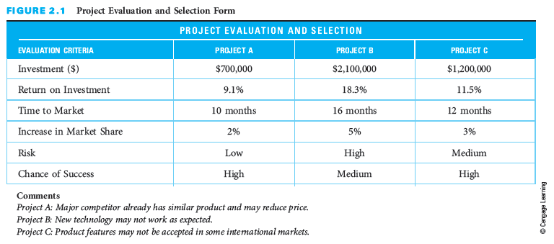
    - Once all the data and information has been collected, analyzed, and summarized for each opportunity, it should be given to all the individuals who are responsible for performing the evaluation. It is beneficial to have several individuals participating in the evaluation and selection decision in order to get various viewpoints.
- Figure 2.1 depicts a project evaluation and selection form to evaluate three possible projects. Have students describe the positive and negatives of possible scenarios for a development project.

4. Project Charter
- Once a project has been selected, it is formally authorized using a project charter, sometimes called a project authorization or project initiation document.
  - Provides sponsor approval to go forward with the project and commits the funding for the project
  - Summarizes the key conditions and parameters for the project and establishes the framework for developing a detailed baseline plan for performing the project
  - Includes many of the following elements
    - Project title
    - Purpose
    - Description
    - Objective
    - Success criteria or expected benefits
    - Funding
    - Major deliverables
    - Acceptance criteria
    - Milestone schedule
    - Key assumptions
    - Constraints
    - Major risks
    - Approval requirements
    - Project manager
    - Reporting requirements
    - Sponsor designee
    - Approval signature
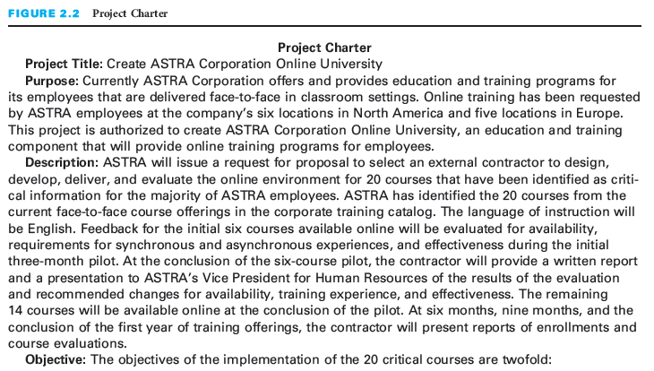
- Figure 2.2 depicts a project charter. The image here is only a section of the entire charter in the text. Have students review the parts of the project charter and comment on the completeness of the information and how it could be developed from the statements in an RFP and the evaluation criteria for the project.

5. Preparing a Request for Proposal
- If an organization does not have the expertise or staff capacity to plan and perform the project or major portions of the project, outsourcing the work to an external resource (contractor) is a choice. A request for proposals helps the organization decide which contractor to use.
- The purpose of preparing a request for proposal is to state, comprehensively and in detail, what is required, from the customer’s point of view, to address the identified need.
- A good RFP allows contractors or a project team to understand what the customer expects so that they can prepare a thorough proposal that will satisfy the customer’s requirements at a realistic price.
- In many situations a formal RFP might not be prepared; instead, the need is communicated informally—and sometimes orally rather than in writing. This is often the case when the project will be implemented by a firm's internal staff rather than by an external contractor.
- Following are some guidelines for drafting a formal request for proposal to external contractors:
  - The RFP must state the project objective or purpose, including any rational or background information that may be helpful to contractors so that they can prepare thorough and responsive proposals.
  - An RFP must provide a statement of work (SOW). An SOW deals with the scope of the project, outlining the tasks or work items the customer wants the contractor or project team to perform.
  - The RFP must include the customer requirements, which define specifications and attributes. Requirements cover size, quantity, color, weight, speed, performance, and other physical or operational parameters the contractor’s proposed solution must satisfy. The customer may also use these requirements as acceptance criteria.
  - The RFP should state what deliverables, or tangible items, the customer expects the contractor to provide. They can include periodic progress reports or a final report as well as a final product.
  - The RFP should state the acceptance criteria the customer will use to determine whether the project deliverables have been completed according to the customer’s requirements.
  - The RFP should list any customer-supplied items.
  - The RFP might state the approvals required by the customer.
  - Some RFPs mention the type of contract the customer intends to use. It could be fixed price, in which case the customer will pay the contractor a fixed amount regardless of how much the work actually costs the contractor. (The contractor accepts the risk of taking a loss.) Or the contract might be for time and materials. In this case, the customer will pay the contractor whatever the actual costs are.
  - An RFP might state the payment terms the customer intends to use. The customer may specify progress payments or pay when the entire project is finished.
  - The RFP should state the required schedule for completion of the project and key milestones. It might state simply a required completion date or it might give a more detailed schedule.
  - The RFP should provide instructions for the format and content of the contractor proposals. Instructions might state the maximum number of pages, the number of details the customer wants the contractor to show regarding the costs, and other specifications.
  - The RFP should indicate the due date by which the customer expects potential contractors to submit proposals.
  - An RFP may include the evaluation criteria that will be used to evaluate proposals from competing contractors. Criteria might include the following:
    - the contractor’s experience with similar projects
    - the technical approach proposed by the contractor
    - the schedule
    - the costs
  - In rare cases an RFP will indicate the amount of money the customer has available to spend on the project. Contractors can then submit proposals appropriate to that level of funding.
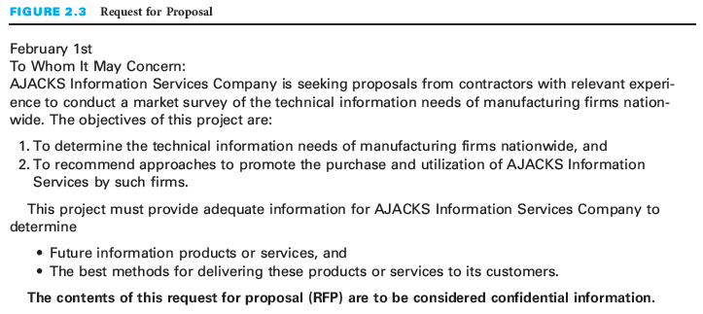
- Figure 2.3 depicts a request for proposal. The image here is a small section of the RFP in the text. Have students review the parts of the RFP and list any additional questions they would have. These are the types of questions that would be submitted in RFP clarification meetings. Have students suggest how they would respond to the RFP.

6. Soliciting Proposals
- Once the RFP has been prepared, the customer solicits proposals by notifying potential contractors that the RFP is available.
  - One way for customers to notify potential bidders is by identifying a selected group of contractors in advance and sending each of them a copy of the RFP.
  - Another approach to soliciting proposals is to advertise in certain business newspapers and on websites that the RFP is available. For example, federal government organizations advertise their RFPs in Commerce Business Daily.
- Business customers and contractors consider the RFP/proposal process to be a competitive situation.
  - Customers should be careful not to provide to any of the contractors information that is not provided to all.
  - Business or government customers may hold a bidders’ meeting to explain the RFP and answer questions from interested contractors.
- Not all project life cycles include the preparation of a written RFP. Some bypass the proposal steps and move right into planning and performing the project.
- There are other projects in which requirements are not written down in a formal RFP but are communicated verbally to several providers or suppliers (contractors).
- Although projects can be businesslike or informal, they all start with the identification of a need, problem, or opportunity.

7. Critical Success Factors
- The need must be clearly defined before preparing a request for proposal (RFP).
- When selecting a project from among several needs or opportunities, management should base the decision on which project will provide the greatest overall benefits compared to its costs and possible consequences.
- Having a well-understood evaluation and selection process and a well-rounded committee will increase the chances of making the best project selection decision.
- Establish quantitative project success criteria or expected benefits.
- A good RFP allows contractors to understand what the customer expects so that they can prepare a thorough proposal that addresses the customer’s needs and requirements.
- A request for proposal should include a statement of work, customer requirements, expected deliverables, and the criteria by which the customer will evaluate proposals.
- An RFP should provide instructions for the format and content of contractor proposals so that the customer will be able to make a consistent and fair comparison and evaluation of all the proposals.
- Customers must be careful not to provide information to only some of the contractors because it would give these contractors an unfair competitive advantage in preparing their proposals.

8. Summary
- The initiating phase of the project life cycle starts with recognizing a need, problem, or opportunity for which a project or projects are identified to address the need.
- Sometimes organizations identify several or many needs but have limited funds and people available to pursue potential projects to address all of those needs. In such cases, the company must go through a decision-making process to prioritize and select those projects that will result in the greatest overall benefit.
- Project selection involves evaluating potential projects and then deciding which of these should move forward to be implemented.
- Once a project has been selected, it is formally authorized using a project charter, sometimes called a project authorization or project initiation document.
- In some cases, an organization does not have the expertise or staff capacity to plan and perform the project or major portions of the project, and therefore decides to have the project done by an external resource (contractor) and prepares and RFP.
- Once the RFP has been prepared, the customer solicits proposals by notifying potential contractors that the RFP is available.
- Not all project life cycles include the preparation of a written request for proposal by a customer and subsequent submittal of proposals from contractors. Some endeavors move right from the initiating phase, where a project is identified and selected, into the planning and performing phases of the life cycle.

Questions
1. Why is it important to do a thorough and detailed job of needs identification?
It is important to thoroughly study the problem or opportunity in order to develop a quality RFP and/or quality solution. If the need isn’t clearly defined, you can’t expect the proposed solutions to be clearly defined either.
2. Describe a situation in your life in which you performed needs identification.
Answers will vary from student to student but should contain a description of why the student identified the need, problem, or opportunity.
3. Why is it important to select the right project before you begin working?
In reality too many projects are started that should never have been. It is wise to take the time to decide which plans to address identified needs, problems, or opportunities should go forward as a project before you start working.
4. Describe how a business selects which projects to work on when there are numerous projects that could be done.
A four-step process is recommended:
1) Develop a set of criteria against which the opportunity will be evaluated.
2) List assumptions that will be used as the basis for each project.
3) Gather data and information for each project
4) Evaluate each opportunity against the criteria.
5. Which elements of a project charter would you use to help plan if you had a project that did not require a project charter? Why?
Student responses will vary. Responses should include the elements of a project charter that describe the outcomes of the student's project with enough clarity for the contractor to deliver an approved product at the end of the project.
6. Give examples of situations in which a business might develop a request for proposal.
There are many possible answers to this question. Some examples might include an RFP for a new billing system, an RFP for a comprehensive management training program, an RFP for a new heating system for a major office building, etc. Responses should include a description of an activity that cannot be completed by the organization or is better completed by an external resource or contractor.
7. Give examples of situations in which an individual might develop a request for proposal.
There are many possible answers to this question. Some examples might include an RFP for a new in-ground pool, a new deck, or a new house. These may or may not be written. Responses should include a description of an activity that cannot be completed by the person or is better completed by an external resource or contractor.
8. Why is it important for a business to try to quantify the expected benefits of implementing a solution to a problem?
If a business did not do this in advance, it might find that the costs of the solution exceed the benefits. In addition, because most businesses have limited resources, they must prioritize their projects based on the expected benefits.
9. What should be contained in a statement of work?
A statement of work should define the scope of the project and outline the tasks or work items to be performed. The SOW should be very precise.
10. What is meant by customer requirements? Why must they be precise?
The RFP must include the customer requirements, which define specifications and attributes. Requirements cover size, quantity, color, weight, speed, performance, and other physical or operational parameters the contractor’s proposed solution must satisfy.

These requirements must be very precise because this is what the contractor will use as a guideline as he or she develops the proposal and/or solution, and the customer may also use it as acceptance criteria for the project.
11. Why would an RFP state the approvals that will be required during the project? Give some examples.
It is important to state the approvals required during the project so the final solution matches what the customer expects. Examples include reviewing the design specifications for a house before construction begins, reviewing a prototype user interface for a new software system before coding begins, etc. Student examples will vary and should include projects that have a level of complexity where changes as the project advances could result in high costs.
12. Why would a customer give contractors instructions in the RFP to submit their proposals according to a standard format?
This is done so all proposals have a standard form and are thus easier to evaluate. Otherwise, for example, one proposal might be 5 pages and another might be 50 pages. One might include technical specifications and another might not.
13. Develop an RFP for a real-world project such as landscaping the grounds surrounding a nearby business office, building a deck for your house, or holding a big graduation celebration. Be creative in specifying your needs. Feel free to come up with unique ideas for the RFP.
Answers will vary from student to student. Responses should include the guideline elements as the elements are appropriate for the need, problem, or opportunity defined by the student.

Internet Exercises
The Web Exercises can be a very valuable part of this course. You should assign these exercises to your students as homework or complete them with them in a computer lab. The Web exercises in this chapter involve investigating and evaluating a Request for Proposal found on the Web. Examination of RFPs found on the Internet could inform students about how to develop their own RFP and help to reinforce the elements of a clearly written RFP.

Case Study # 1 A Midsize Pharmaceutical Company
This case study involves an owner and Chief Executive Officer of a midsize global pharmaceutical company who states that profits for the year are expected to be $2,000,000 more than anticipated. She asks her three key managers to get together to develop a prioritized list of potential projects and then to meet with her to “sell” her on their ideas. A fourth manager also has some ideas for how to use this extra money.

Answers to Case Questions
1. How should Jennifer go about making her decision?
She has identified an opportunity. She has $2,000,000 of unexpected profits that she would like reinvest in the company. In this case, she is soliciting proposals from her internal managers. She should state comprehensively, and in detail, what she expects in the proposals including several of those items discussed in this chapter (due date for proposals, format required, evaluation criteria to be used, etc.). In this case, the RFP may or may not be in written form. She should then evaluate each proposal submitted based on the stated criteria.
2. What kind of additional data or information should she collect?
Among other things, information on cost and benefits should be collected. Costs should include one-time and on-going expenses. Additional data such as specific tasks and timeframes is also needed.
3. What exactly should Jennifer require the others to submit in the way of proposals?
Each proposal should include the cost and anticipated benefits of the project. At a minimum, it should also include the tasks to be performed, the resources used, and a schedule.
4. What do you think Jennifer should do with the $2,000,000? In explaining your answer, address the concerns and positions of Julie, Tyler, Jeff, and Joe.
At this point it is too early to tell. Jennifer must evaluate each of the proposals based on the established criteria and then select the proposal or proposals that provide the greatest benefit to the company. Responses should include a description of each person's position and additional information that Jennifer would need to evaluate their response. The responses should include why or why not Jennifer would fund the projects based upon the student's experiences and interpretation of the projects.

Group Activity
This is an excellent way to stimulate class discussion and interest. Take a few minutes and have some students act it out in class.
- Select five course participants to play the roles of Jennifer, Julie, Tyler, Jeff, and Joe. After Jennifer and Joe leave the room, have Julie, Tyler, and Jeff role-play (preferably in front of the remaining course participants) a meeting in which they discuss their proposed projects and develop a prioritized list to “sell” to Jennifer.
- After Jennifer and Joe re-enter the room, have all five participants role-play (preferably in front of the class) a meeting with Jennifer in which Julie, Tyler, and Jeff try to sell her on the prioritized list of projects and Joe promotes his agenda.
- Discuss what took place. What positions did the players take? How was the final decision made? What was the final decision?

Case Study # 2 Transportation Improvements
This case involves a large, mostly sparsely populated county that has a fairly mountainous terrain. Various road projects are being discussed.

Answers to Case Questions
1. What criteria should Zachary use to evaluate the projects?
Various options can be used as discussed in this chapter. The criteria should be defined in advance of evaluating the projects. Encourage students to explain why they chose particular criteria to evaluate the projects.
2. What assumptions should he make?
Zachary has to make assumptions regarding the safety to the entrance outside of Big John’s superstore, the need to widen and repair Elk Mountain Road, and the condition of County Route 1045 and the bridge. Each of Zachary's assumptions needs to be evaluated.
3. What data and information should he gather and how should he go about gathering the data and information?
Surveys and various types of research methods could be used to gather data related to the assumptions in the case study.
4. After he has evaluated each project against the evaluation criteria, how should he decide the priority of the three projects?
This is a great opportunity to get the class to walk through the four-step project selection process. Split the class into groups and have the students compare the outcomes and suggestions developed in each group with the others.

Group Activity
Ask each course participant to individually answer the first case question. Then, divide the course participants into groups of three or four to discuss the case questions. Each group must select a spokesperson to present its answers to the entire class.

Optional Supplemental Activities
- This is a good time to get your students to start reading some of PMI’s publications—either online or printed. These articles are typically very readable and might relate to something that interests your students. Have each student read one such article and prepare a one-page summary. If time permits, have each student discuss his or her article in class.
- Have students find a Request for Proposal on the Web and evaluate it against the guidelines in this book.
- Have a certified Project Management Professional make a presentation to the class and answer questions about the value of certification.
- Show the class a copy of the PMI Guide to the Project Management Body of Knowledge (PMBOK® Guide). Have students examine the sections on project integration management and project procurement management.

