Chapter 2

Describing Data: Frequency Distributions and Graphic Presentation

- Maxwell Heating & Air Conditioning far exceeds the other corporations in sales. Mancell Electric & Plumbing and Mizelle Roofing & Sheet Metal are the two corporations with the least amount of fourth quarter sales.

Maxwell has the highest sales, and Mizelle the lowest. (LO2-2)

- Three classes are needed, one for each player. (LO2-1)

- There are four classes: winter, spring, summer, and fall.
The relative frequencies are 0.1, 0.3, 0.4, and 0.2, respectively. (LO2-1)

- a.

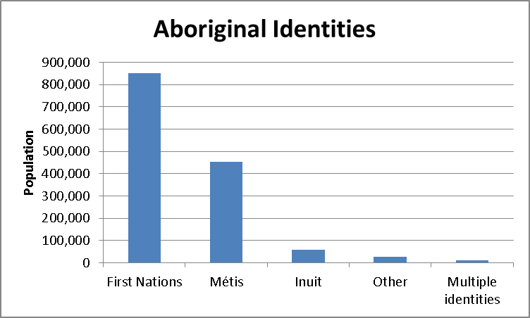 (LO2-2)

b.

Aboriginal Identity | Number | Relative Frequency |  | Percent
First Nations | 851 560 | 0.608 |  | 60.8
Métis | 451 795 | 0.323 |  | 32.3
Inuit | 59 445 | 0.042 |  | 4.2
Other | 26 475 | 0.019 |  | 1.9
Multiple identities | 11 415 | 0.008 |  | 0.8
Aboriginal Identity |  |  | Number |  | Percent
First Nations |  |  | 851 560 |  | 60.8
Métis |  |  | 451 795 |  | 32.3
Inuit |  |  | 59 445 |  | 4.2
Other |  |  | 26 475 |  | 1.9
Multiple identities |  |  | 11 415 |  | 0.8
(LO2-1)

c.

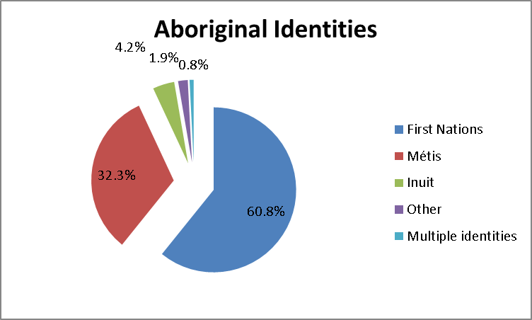 (LO2-3)

- a.

(LO2-2)

b.

Type | Number | Relative Frequencies
Bright white | 130 | 0.10
Metallic black | 104 | 0.08
Magnetic lime | 325 | 0.25
Tangerine orange | 455 | 0.35
Fusion red | 286 | 0.22
Total | 1300 | 1.00 (LO2-1)
c.
(LO2-3)

- Student loan amounts for 2014. Susan Chan’s loan is the largest.

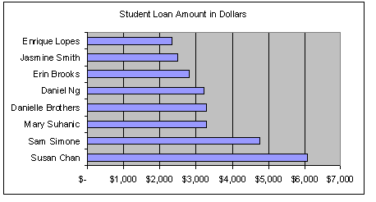 (LO2-2)

7. ; therefore 6 classes (LO2-4)

8. 2⁵ = 32, 2⁶ = 64 suggests 6 classes. Use interval of 5. (LO2-4)

9. 2⁷ = 128, 2⁸ = 256 suggests 8 classes .5 Use interval of 42 or 45. (LO2-4)

10. a. 2⁵ = 32, 2⁶ = 64 suggests 6 classes.
- Use interval of 15 and start first class at 40. (LO2-4)

11. a. 2⁴ =16 suggests 5 classes
- (31-25)/5 = 6/5 = 1.2 Use interval of 1.5
- 24
d. Units f Relative frequency
24 to under 25.5 2 0.125
25.5 to under 27 4 0.250
27 to under28.5 8 0.500
28.5 to under 30 0 0.000
30 to under 31.5 2 0.125
Total 16 1.000
e. The largest concentration is in the 27 up to 28.5 class (8). (LO2-4&5)

12. a. 2⁴ = 16, 2⁵ = 32, suggest 5 classes
b. 47/5 = 9.4 Use interval of 10.
c. 50
d. f Relative frequency
50 to under 60 4 0.20
60 to under 70 5 0.25
70 to under 80 6 0.30
80 to under 90 2 0.10
90 to under 100 3 0.15
Total 20 1.00
e. The fewest number is about 50, the highest about 100. The greatest concentration is in classes 60 up to 70 and 70 up to 80. (LO2-4&5)

Shoppers f
13. a. 0 to under 3 9
3 to under 6 21
6 to under 9 13
9 to under 12 4
12 to under 15 3
15 to under 18 1
Total 51
- The largest group of shopper’s (21) shop at BiLo Supermarket 3, 4 or 5 times during a month and one customer visits the store as many as 15 times in a month.
c. Number of Percent of Relative Frequency
Shoppers Total
0 to under 3 17.65 0.1765
3 to under 6 41.18 0.4118
6 to under 9 25.49 0.2549
9 to under 12 7.84 0.0784
12 to under 15 5.88 0.0588
15 to under 18 1.96 0.0196
Total 100.00 1.0000 (LO2-4&5)

14. a. An interval of 10 is more convenient to work with. The distribution using 10 is:
f
15 to under 25 1
25 to under 35 2
35 to under 45 5
45 to under 55 10
55 to under 65 15
65 to under 75 4
75 to under 85 3
Total 40
- Data tends to cluster in classes 45 up to 55 and 55 up to 65.
- Based on the distribution, the least spent is $15 (actually $18 from the raw data). The most spent was less than $85. The largest concentration of spending is between $45 up to $65.
d. $ Spent Percent of Relative Frequency
Total
15 to under 25 2.5 0.025
25 to under 35 5.0 0.050
35 to under 45 12.5 0.125
45 to under 55 25.0 0.250
55 to under 65 37.5 0.375
65 to under 75 10.0 0.100
75 to under 85 7.5 0.075
Total 100.0 1.000 (LO2-4&5)

15. a. Histogram
- 100
- 5
- 28
- 0.28
- 12.5
- 13 (LO2-5&6)

16. a. 3
- approximately 27
- 84
- 2
- frequency polygon (LO2-6)

17. a. 50
- 1.5 thousands or 1500 miles
- Using lower limits on the X-axis

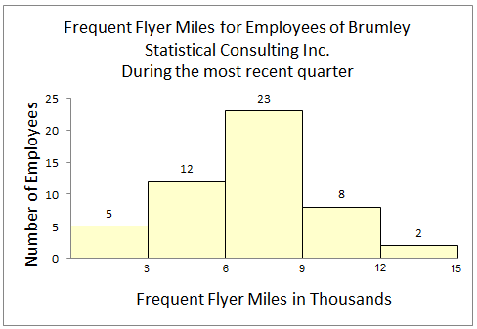

- 1.5, 5
e.

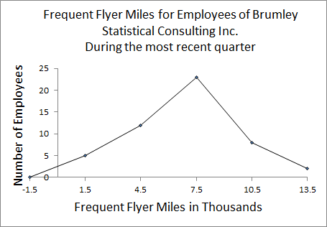

f. Most between 6000-9000, even spread on both sides (LO2-6)

18. a. 40
- 2.5
- 2.5, 6 (always draw a frequency polygon using the midpoints)
d.

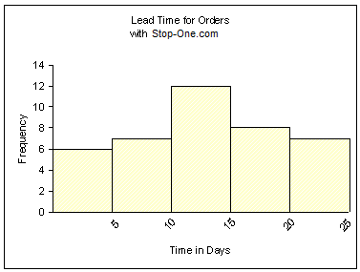

e.

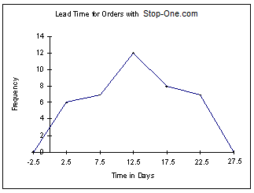

f. Most orders take around 10-15 days. (LO26)

19. a. 40
- 5
- 11 or 12
- about $18 per hour
- about $9 per hour
- about 75% (LO2-7)

20. a. 200
- b. 50 or $50,000
- c. approximately $175,000
- about $240,000
- about 60 homes
- about 130 homes (LO2-7)

21. a. 5
Cumulative Frequency
b. Miles f Less than
0 to under 3 5 5
3 to under 6 12 17
6 to under 9 23 40
9 to under 12 8 48
12 to under 15 2 50
c.

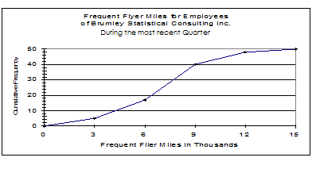

- about 8500 miles (LO2-7)

22. a. Miles f More than
0 to under 3 5 50
3 to under 6 12 45
6 to under 9 23 33
9 to under 12 8 10
12 to under 15 2 2
b.

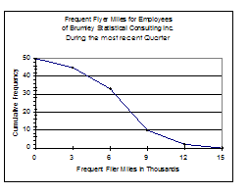

c. about 7500 miles (LO2-7)

23. a. 13, 25
Cumulative Frequency
b. Lead Time f Less than
0 to under 5 6 6
5 to under 10 7 13
10 to under 15 12 25
15 to under 20 8 33
20 to under 25 7 40
c.

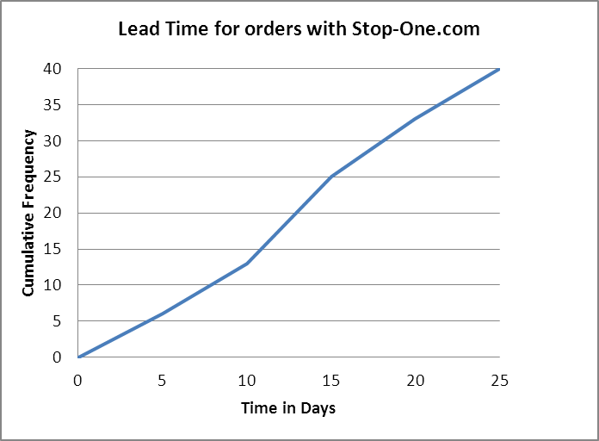
d. About 14 days
e. 27; 15 (LO2-7)

24. a. Lead Time f More than
0 to under 5 6 40
5 to under 10 7 34
10 to under 15 12 27
15 to under 20 8 15
20 to under 25 7 7
b.

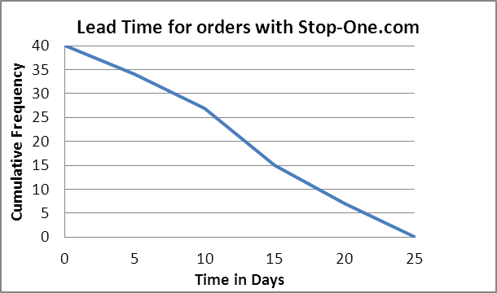

- About 18 days (LO2-7)

25. a. 621 to 629
- 5
- 621, 623, 623, 627, 629 (LO2-8)

26. a. 210 - 219
- 6
- 210, 211, 213, 215, 217, 219 (LO2-8)

27. a. 25
- 1
- 38, 106
- 60, 61, 63, 63, 65, 65, 69
- No values
- 9
- 9
- 76
- 16 (LO2-8)

28. a. 50
- one
- 126, 270
- 155, 158, 159
- No values
- 13
- 12
- 193.5
- 19 (LO2-8)

29. Stem Leaves
- 5
- 28

- 0024789
- 12366
- 2
There were a total of 16 calls studied. The number of calls ranged from 5 to 52 received. Typical was 30-39 calls, smallest was 5, largest was 52 (LO2-8)

30. Stem Leaves
- 6
- 7
- 22499
- 0113458
- 035678
- 0344447
- 055
The daily usage ranged from 36 to 95. In a typical day the ATM is typically used between 52-87 times, smallest was 36, largest was 95; clustered between 52-87 times (LO2-8)

      - a. Qualitative variables are ordinarily nominal level of measurement, but some are ordinal. Quantitative variables are commonly of interval or ratio level of measurement.
b. Yes, both types depict samples and populations. (LO2-1)

32. a.
(LO2-2)

b.
(LO 2-3)

- Both are readable, but the pie chart may be easier to comprehend. (LO2-2 & 2-3)
33. and suggest 7 classes (LO2-4)

34. 2⁷ = 128, 2⁸ = 256 suggests 8 classes. Use interval of 55. (LO2-4)

35. a. 5 because
- use interval of 7.
- 15
d. Class Frequency
15 to under 22 3
22 to under 29 8
29 to under 36 7
36 to under 43 5
43 to under 50 2
25
- The values are clustered between 22 and 36. (LO2-4)

36. a. 6 because
- 90, found by
- 40
d. Class Frequency
40 to under 130 6
130 to under 220 10
220 to under 310 17
310 to under 400 8
400 to under 490 3
490 to under 580 1
45 (LO2-4)

37. a. 70
- 1
- 0, 145
- 30, 30, 32, 39
- 24
- 21
- 77.5
- 25 (LO2-8)

38. a. 55
- two
- 91, 237
- 141, 143, 145
- 8
- 12
- three
- 180 (LO2-8)

39. a. 56
- 10 (found by 60 – 50)
- 55
- 17 (LO2-6)

40. a. less-than frequency diagram or ogive
- 250
- 50 (found by 100 – 50)
- approx $240,000
- approx $230,000 (LO2-7)

41. a. $36.60, (found by 265 – 82)/5
- approx $40
c. $80 to under $120 8
120 to under 160 19
160 to under 200 10
200 to under 240 6
240 to under 280 1
Total 44
d. The purchases ranged from a low of about $80 to a high of about $280. The concentration is in the $120 to under $160 class. (LO2-4)

42. a. Student Chequing Accounts End of Month Balances
Balance f CF
0 to under 100 9 9
100 to under 200 6 15
200 to under 300 6 21
300 to under 400 6 27
400 to under 500 5 32
500 to under 600 2 34
600 to under 700 1 35
700 to under 800 3 38
800 to under 900 1 39
900 to under 1000 1 40
Total 40
Probably a class interval of $200 would be better.
b.

c. About 67% have less than a $400 balance. Therefore, about 33% would be considered “preferred.”
d. Approx $50 would be a convenient cutoff point. (LO2-4 & 2-6)

43.
A pie chart is also acceptable. From the graph we can see that insurance and license fees are the highest expense at close to $1500 per year. (LO2-2)

44. a. Since 2² = 32, 2⁶ = 64, and 60 < 64, 6 classes are recommended. The interval should be at least (10.1 − 0.4)/6 = 1.6. So we will use 2 as a convenient value.

 |  | Personal Computer Usage (Hours) |  |  |  |  |  | cumulative
 | lower |  | upper | midpoint | width | frequency | percent | Frequency | percent
 | 0 | < | 2 | 1 | 2 | 7 | 11.7 | 7 | 11.7
 | 2 | < | 4 | 3 | 2 | 11 | 18.3 | 18 | 30.0
 | 4 | < | 6 | 5 | 2 | 19 | 31.7 | 37 | 61.7
 | 6 | < | 8 | 7 | 2 | 12 | 20.0 | 49 | 81.7
 | 8 | < | 10 | 9 | 2 | 10 | 16.7 | 59 | 98.3
 | 10 | < | 12 | 11 | 2 | 1 | 1.7 | 60 | 100.0
 |  |  |  |  |  | 60 | 100.0
b.

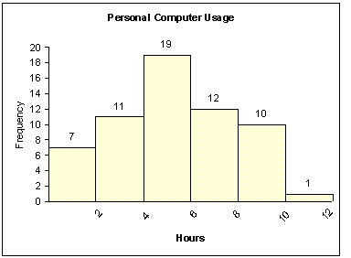

Interpretations will vary. The “typical” person used the computer about 5 hours per week and nearly everyone is within about five hours. (LO2-4&2-6)

45. a. Since , 7 classes are recommended. The interval should be at
least (1002.2 − 3.3)/7 = 142.7; use 150 as a convenient value.

 |  | Investment Portfolios |  |  |  |  |  | cumulative
 | lower |  | upper | midpoint | width | Frequency | percent | frequency | percent
 | 0 | < | 150 | 75 | 150 | 28 | 40.0 | 28 | 40.0
 | 150 | < | 300 | 225 | 150 | 19 | 27.1 | 47 | 67.1
 | 300 | < | 450 | 375 | 150 | 15 | 21.4 | 62 | 88.6
 | 450 | < | 600 | 525 | 150 | 2 | 2.9 | 64 | 91.4
 | 600 | < | 750 | 675 | 150 | 4 | 5.7 | 68 | 97.1
 | 750 | < | 900 | 825 | 150 | 1 | 1.4 | 69 | 98.6
 | 900 | < | 1,050 | 975 | 150 | 1 | 1.4 | 70 | 100.0
 |  |  |  |  |  | 70 | 100.0
b.
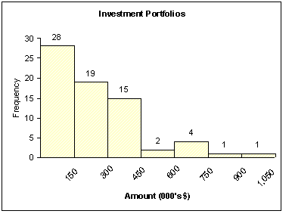
There will be many answers for the interpretation. (LO2-4&2-6)

46.

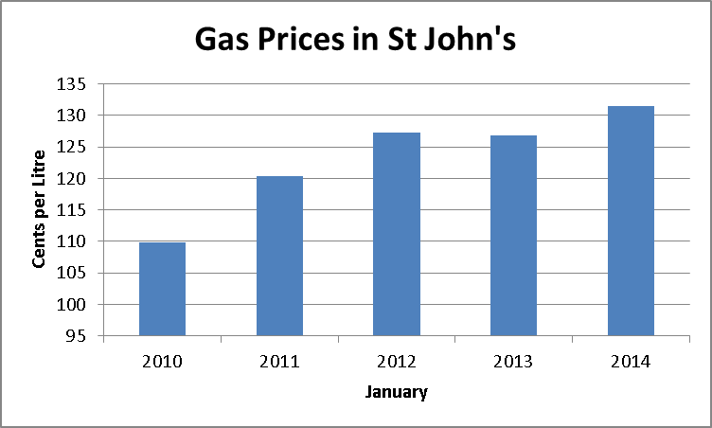 (LO2-2)

47.

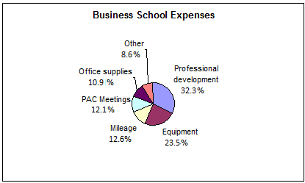

Professional development is the largest expense. (LO2-3)

48.
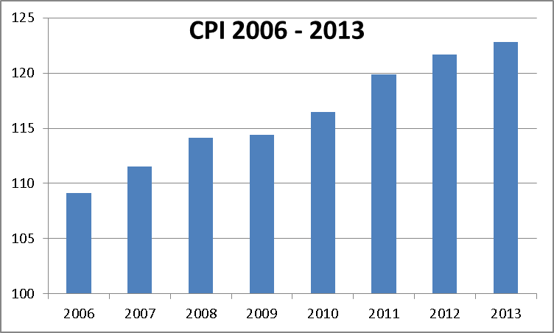 (LO 2-2)

49.

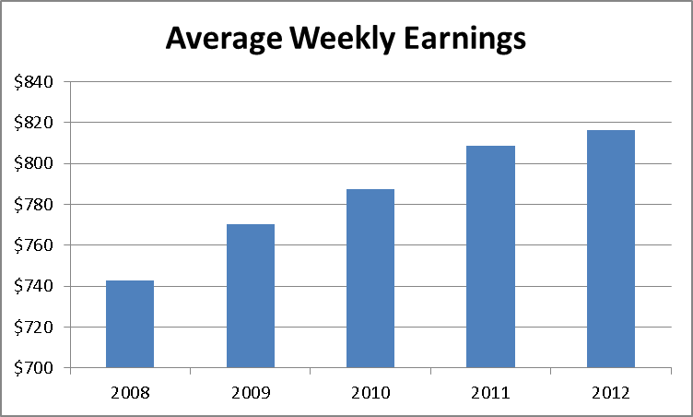 (LO2-2)

50. Canada won the most medals in 2010 at 26, but 2014 is a very close second with 25 medals won.

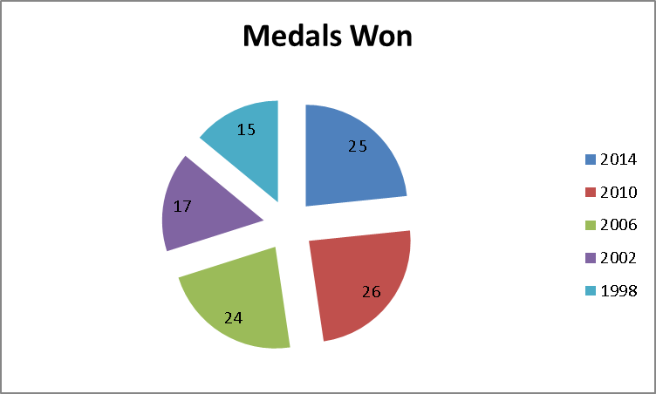 (LO 2-3)
Note: a bar chart is also acceptable.

51. There are 50 observations so the recommended number of classes is 6.

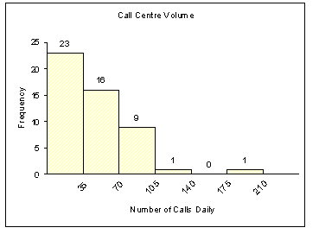

Twenty-three of the 50 days, or 46%, have fewer than 35 calls waiting. There are two days that have more than 105 calls waiting. (LO2-4,6&7)

52. There will be many answers. The following pie chart shows the breakdown of the six colours. About 77% of the candies are either brown, yellow or red. Each of these colours represents about 25% of the total. The percent of orange and blue is less than 10% each. About 4% of the candies are green.

(LO2-3)
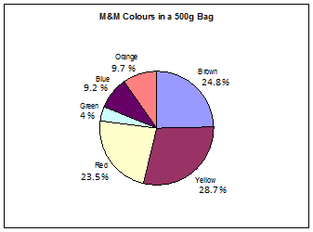

53. a. 2^5 = 32 <36 < 64 = 2^6. Thus 6 classes are recommended.
b. The interval width should be at least 2, found by (15-3) /6. Use 2.2 for convenience and to ensure there are only 6 classes
c. 2.2
d.

Class | Frequency
2.2 to under 4.4 | 2
4.4 to under 6.6 | 7
6.6 to under 8.8 | 11
8.8to under 11 | 7
11 to under 13.2 | 7
13.2 to under 15.4 | 2

- The distribution is slightly right-skewed with the largest concentration in the class of 6.6 up to 8.8. (LO2-4)

54. a. ordinal and qualitative.
b.
Performance | Relative Frequency
Early | .22
On-time | .67
Late | .09
Lost | .02

- 89% of the packages are either early or on-time and 2% of the packages are lost. So they are missing both of their objectives. They must eliminate all lost packages and reduce the late percentage to below 1%. (LO2-2, 2-3 & 2-5)

55. a. 2^5 = 32 <45 < 64 = 2^6. Thus 6 classes are recommended.
b. The interval width should be at least 1.5, found by (10-1) /6. Use 2 for simplicity.
c. 0
d.
Class | Frequency
0 to under 2 | 1
2 to under 4 | 5
- to under 6 | 12
6 to under 8 | 17
8 to under 10 | 8
10 to under 12 | 2

The distribution is fairly symmetric or “bell-shaped” with a large peak in the middle two classes of 4 up to 8.

e.
Class | Frequency
Less than 0 | 0
Less than 2 | 1
Less than 4 | 6
Less than 6 | 18
Less than 8 | 35
Less than 10 | 43
Less than 12 | 45

f.
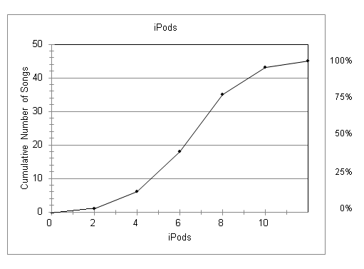

- About 28

Class | Frequency
More than 0 | 45
More than 2 | 44
More than 4 | 39
More than 6 | 27
More than 8 | 10
More than 10 | 2
More than 12 | 0

i.
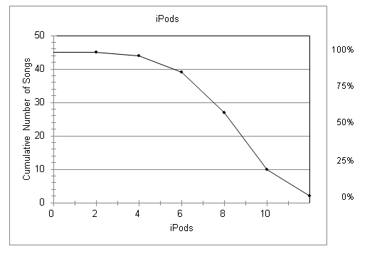
- About 32 (LO 2-4 & 2-7)

56.
Class | Frequency
0 to under 200 | 19
200 to under 400 | 1
400 to under 600 | 4
600 to under 800 | 1
800 to under 1000 | 2

This distribution is skewed with a large number of observations in the first class. Notice that the top 19 tunes account for 1323 plays out of a total of 5387 or about 73% of all plays. (LO2-4)

57. a. 2⁵ = 32 < 33 < 64 = 2⁶. Thus 6 classes are recommended.
b. The interval width should be at least 1253, found by (7829-312) /6. Use 1500 for simplicity.
c. 0
d.
Class | Frequency
0 to under 1500 | 1
1500 to under 3000 | 2
3000 to under 4500 | 0
4500 to under 6000 | 7
6000 to under 7500 | 20
- to under 9000 | 3

- This distribution is skewed with a few very small values which likely correspond to the “start up” phase of this publication. Most observations fall in the 6000 up to 7500 class which contains 20 of the 33 (60.6%) months. (LO 2-4)

58.
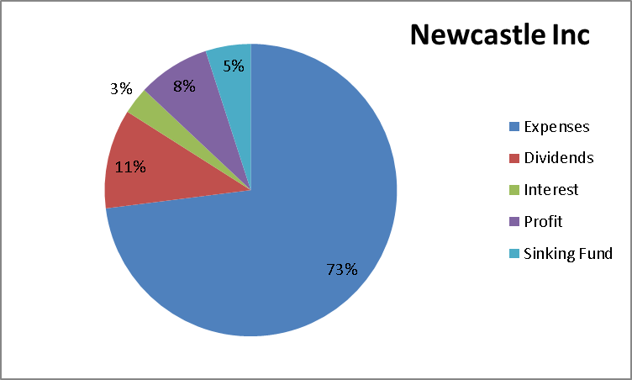
By far the largest part of sales revenue goes towards operating expenses. (LO2-3)

59.

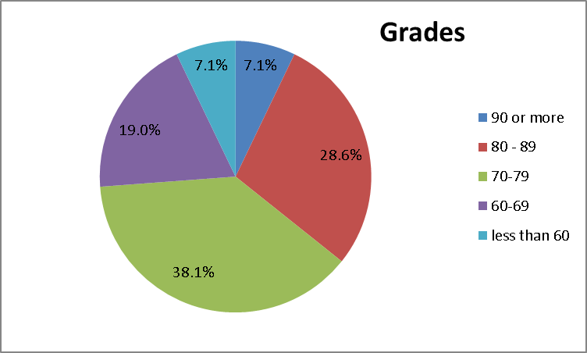
The largest group had grades between 70 and 79 (38.1%). Three students (7.1%) had grades at 90 or more and 3 students had grades less than 60. (LO 2-3)

60. a.

Class | Cumulative Frequency
Less than 0 | 0
Less than 15 | 1
Less than 30 | 6
Less than 45 | 15
Less than 60 | 26
Less than 75 | 30

b.
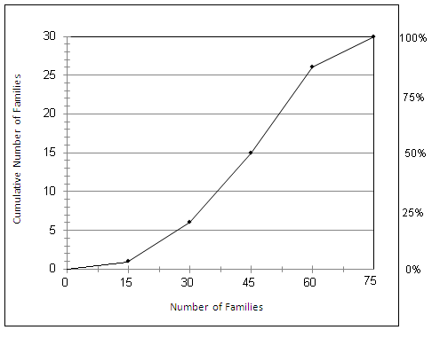

c. 6 days saw fewer than 30.
d. The highest 80% of the days had at least 30 families.
e.

Class | Cumulative Frequency
More than 0 | 30
More than 15 | 29
More than 30 | 24
More than 45 | 15
More than 60 | 4
More than 75 | 0

f.
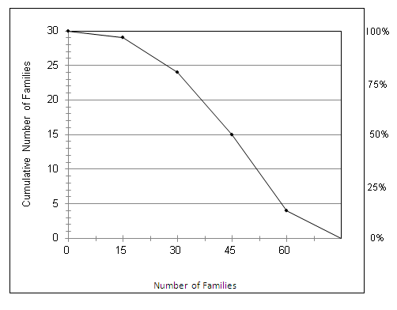

- About 27; about 12 (LO 2-7)

61.
City | Frequency | Relative Frequency
Vancouver | 100 | 0.05
Calgary | 450 | 0.225
Edmonton | 1300 | 0.65
Saskatoon | 150 | 0.075
 | 2000
The preference among frequent business travelers is definitely Edmonton (65%). The least preferred is Vancouver (5%). (LO 2-5)

62. a. approximately 180
b. 400
c. 23/180 = .128
d. (32+19)/180 = .283 = 28.3%
e. 2000,45 (LO2-2, 2-4, 2-5 & 2-6)

63. a.
 | frequency | cumulative frequency
Less than 0 | 0 | 0
Less than 5 | 4 | 4
Less than 10 | 15 | 19
Less than 15 | 27 | 46
Less than 20 | 18 | 64
Less than 25 | 6 | 70

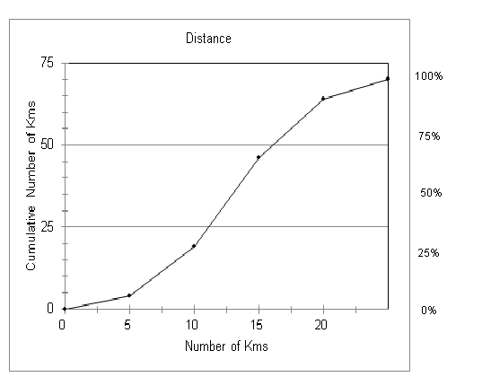
  - About 30; about 60

d.
 | frequency | cumulative frequency
More than 0 | 0 | 70
More than 5 | 4 | 66
More than 10 | 15 | 51
More than 15 | 27 | 24
More than 20 | 18 | 6
More than 25 | 6 | 0
e.
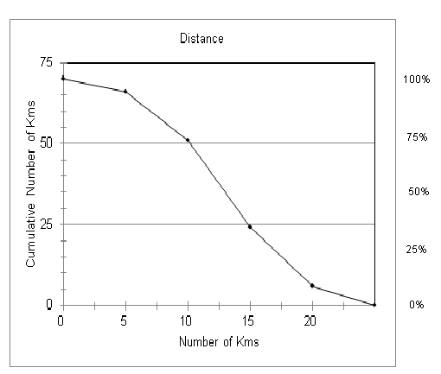
- About 25% (LO 2-7)

64. Answers will vary depending on how the data is organized. One possible frequency distribution created using MegaStat is:
a.
n = 172 | use 8 classes | interval = (1338000-3300)/8 = 163125
Frequency Distribution – Quantitative
 | List Price |  |  |  |  |  |  | cumulative
 | Lower |  | upper | midpoint | width | frequency | percent | frequency | percent
 | 0 | < | 200,000 | 100,000 | 200,000 | 19 | 11.0 | 19 | 11.0
 | 200,000 | < | 400,000 | 300,000 | 200,000 | 126 | 73.3 | 145 | 84.3
 | 400,000 | < | 600,000 | 500,000 | 200,000 | 18 | 10.5 | 163 | 94.8
 | 600,000 | < | 800,000 | 700,000 | 200,000 | 7 | 4.1 | 170 | 98.8
 | 800,000 | < | 1,000,000 | 900,000 | 200,000 | 0 | 0.0 | 170 | 98.8
 | 1,000,000 | < | 1,200,000 | 1,100,000 | 200,000 | 0 | 0.0 | 170 | 98.8
 | 1,200,000 | < | 1,400,000 | 1,300,000 | 200,000 | 2 | 1.2 | 172 | 100.0
 |  |  |  |  |  | 172 | 100.0

b.

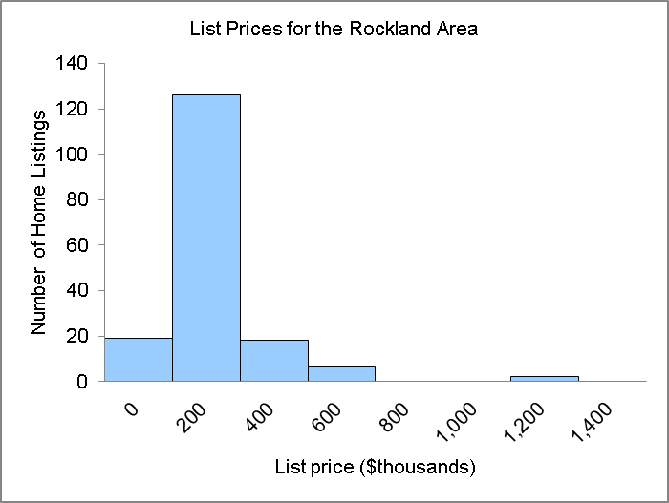

1. the list prices are clustered in the 2nd class between $200 000 to under $400 000.
2. the list prices range from $0 to under $1 400 000

c.

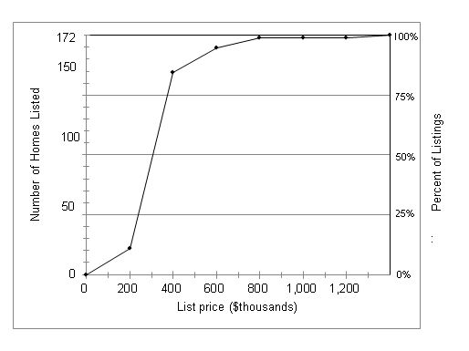

1. about 55 homes
2. about 88%.

d.

For the stem-and-leaf output, please see the data set exercise answers for this question.

1. list prices are clustered between $200 000 and $390 000.
2. the smallest value is $40 000; the largest is $1 300 000.
(LO2-4, 2-6, 2-7 & 2-8)

65. (LO 2-4)

a.
min = | 500
max = | 5200 |  | interval = (5200-500)/7 = 671
use 750 as the interval
 | Total Square Feet
lower |  | upper | frequency
0 | < | 750 | 11
750 | < | 1,500 | 48
1,500 | < | 2,250 | 18
2,250 | < | 3,000 | 8
3,000 | < | 3,750 | 6
3,750 | < | 4,500 | 2
4,500 | < | 5,250 | 5
1. A typical size is from 750 to 1500. The range of the data is from about 0 to under 5250.
2. There are 7 values between 3750 and 5250 square feet. These values are much larger than
the typical number of square feet.

b.

Total Square Feet

Lower |  |  | upper | frequency | less-than | more-than
0 | < |  | 750 | 11 | 11 | 98
750 | < |  | 1,500 | 48 | 59 | 87
1,500 | < |  | 2,250 | 18 | 77 | 39
2,250 | < |  | 3,000 | 8 | 85 | 21
3,000 | < |  | 3,750 | 6 | 91 | 13
3,750 | < |  | 4,500 | 2 | 93 | 7
4,500 | < |  | 5,250 | 5 | 98 | 5

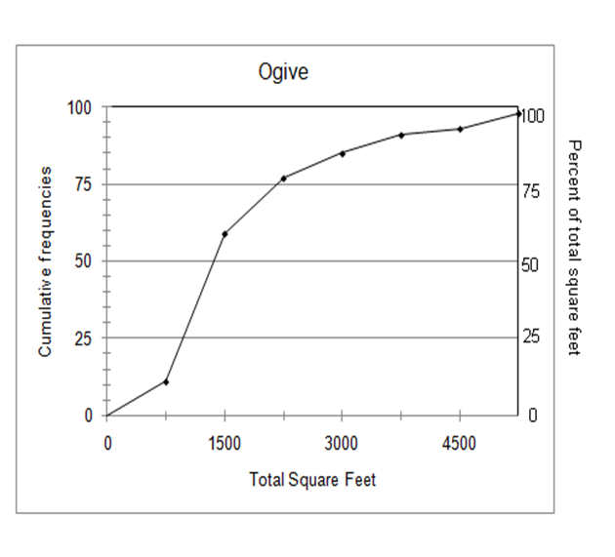

1. less than 1500 sq ft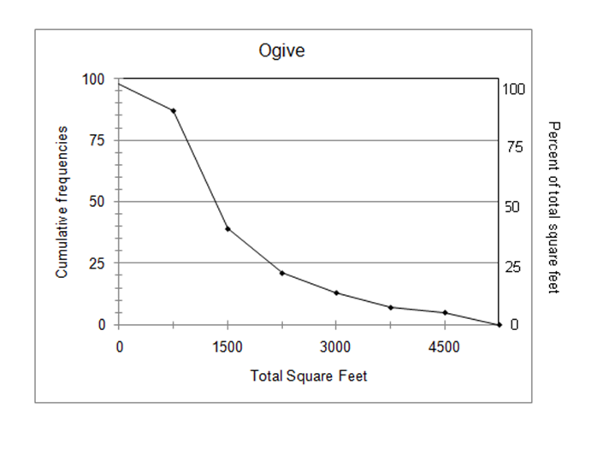
2. about 75
3. about 75%

c.

Stem and Leaf plot for | List Price
stem unit = | 1000000
leaf unit = | 100000
Frequency | Stem | Leaf
88 | 0 | 1 1 1 1 1 1 1 2 2 2 2 2 2 2 2 2 2 2 2 2 2 2 2 2 2 2 2 2 3 3 3 3 3 3 3 3 3 3 3 3 4 4 4 4
 | 0 | 4 4 4 4 4 4 4 4 4 4 4 4 4 4 4 4 4 4 4 4 5 5 5 5 5 5 5 6 6 6 6 6 7 7 7 7 7 7 8 9 9 9 9 9
9 | 1 | 1 3 3 3 4 5 5 5 8
4 | 2 | 4
98
1. The values are clustered between $100 000 and $900 000.
2. smallest value = 164 900; largest value = 2 490 000
3. Answers will vary but should contain the above information.

d.

Stem and Leaf plot for | Total Square Feet
stem unit = | 1000
leaf unit = | 100
Frequency | Stem | Leaf
19 | 0 | 5 5 5 5 6 6 7 7 7 7 7 7 7 8 8 8 8 9 9
53 | 1 | 0 0 0 0 0 0 0 0 0 0 0 1 1 1 1 1 1 1 1 1 2 2 2 2 2
13 | 1 | 3 3 3 3 3 3 3 3 3 3 3 3 3 4 4 5 5 6 6 6 6 6 6 6 7 8 9 9
6 | 2 | 1 1 1 1 1 2 2 2 3 4 4 5 8
4 | 3 | 0 2 2 3 5 6
3 | 4 | 0 3 7 8
98 | 5 | 0 2 2
1. The values are clustered between 1100 and 1900.
2. smallest = 500; largest = 5200

3. Answers will vary but should contain the above information.

d.

CASE (LO2-4 & 2-6)

Answers may vary.

 |  | Price |  |  |  |  |  | cumulative
 | lower |  | upper | Midpoint | width | frequency | percent | frequency | percent
 | 15,000 | < | 18,000 | 16,500 | 3,000 | 8 | 10.0 | 8 | 10.0
 | 18,000 | < | 21,000 | 19,500 | 3,000 | 23 | 28.8 | 31 | 38.8
 | 21,000 | < | 24,000 | 22,500 | 3,000 | 17 | 21.3 | 48 | 60.0
 | 24,000 | < | 27,000 | 25,500 | 3,000 | 18 | 22.5 | 66 | 82.5
 | 27,000 | < | 30,000 | 28,500 | 3,000 | 8 | 10.0 | 74 | 92.5
 | 30,000 | < | 33,000 | 31,500 | 3,000 | 4 | 5.0 | 78 | 97.5
 | 33,000 | < | 36,000 | 34,500 | 3,000 | 2 | 2.5 | 80 | 100.0
 |  |  |  |  |  | 80 | 100.0

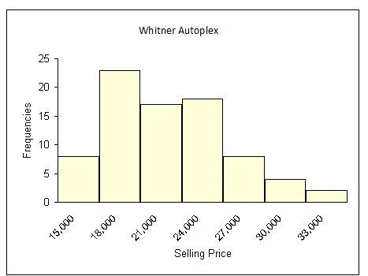

The selling prices range from about $15 000 to about $36 000. The selling prices are concentrated between $18 000 and $27 000. A total of 58, or 72,5%, of the vehicles sold within this range. The highest frequency is in the $18 000 to under $21 000 class. So we say that a typical selling price is $19 500. Six vehicles sold for less than $18 000, and two sold for more than $33 000.

