Chapter 1: Data and Statistics

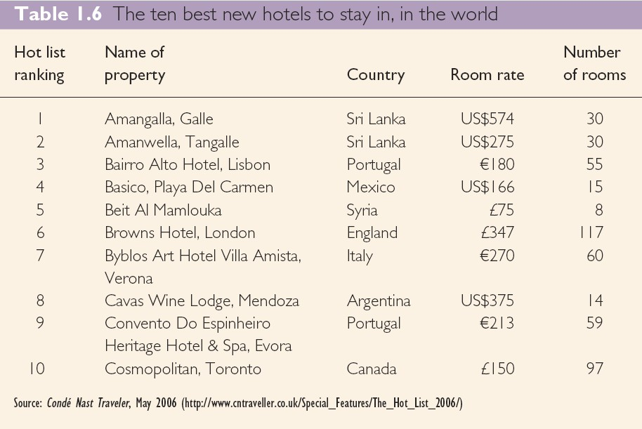

Textbook Exercises:

1. Discuss the differences between statistics as numerical facts and statistics as a discipline or   
 field of study.

2. Every year Condé Nast Traveler conducts an annual survey of subscribers to determine the   
 best new places to stay throughout the world. Table 1.6 shows the ten hotels that were most   
 highly ranked in their 2006 ‘hot list’ survey. Note that (daily) rates quoted are for double   
 rooms and are variously expressed in US dollars, British pounds or euros.

1. How many elements are in this data set?

2. How many variables are in this data set?

3. Which variables are categorical and which variables are quantitative?

4. What type of measurement scale is used for each of the variables?

3. Refer to Table 1.6.

a. What is the average number of rooms for the ten hotels?

b. If €1 = US$1.3149 = £0.8986 compute the average room rate in Euros.

c. What is the percentage of hotels located in Portugal?

d. What is the percentage of hotels with 20 rooms or fewer?

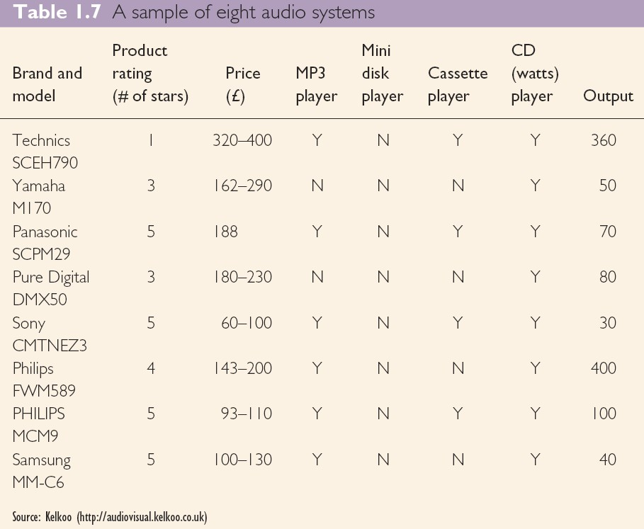

4. Audio systems are typically made up of an MP3 player, a mini disk player, a cassette   
 player, a CD player and separate speakers. The data in Table 1.7 shows the product rating   
 and retail price range for a popular selection of systems. Note that the code Y is used to   
 confirm when a player is included in the system, N when it is not. Output power (watts)   
 details are also provided (Kelkoo Electronics 2006).

a. How many elements does this data set contain?

b. What is the population?

c. Compute the average output power for the sample.

5. Consider the data set for the sample of eight audio systems in Table 1.7.

a. How many variables are in the data set?

b. Which of the variables are quantitative and which are categorical?

c. What percentage of the audio systems has a four star rating or higher?

d. What percentage of the audio systems includes an MP3 player?

6. Columbia House provides CDs to its mail-order club members. A Columbia House Music   
 Survey asked new club members to complete an 11-question survey. Some of the questions   
 asked were:

a. How many CDs have you bought in the last 12 months?

b. Are you currently a member of a national mail-order book club? (Yes or No)

c. What is your age?

d. Including yourself, how many people (adults and children) are in your household?

e. What kinds of music are you interested in buying? (15 categories were listed,   
 including hard rock, soft rock, adult contemporary, heavy metal, rap and country.)   
 Comment on whether each question provides categorical or quantitative data.

7. The Health & Wellbeing Survey ran over a three-week period (ending 19 October 2007)   
 and 389 respondents took part. The survey asked the respondents to respond to the   
 statement, ‘How would you describe your own physical health at this time?’   
 (<http://inform.glam.ac.uk/news/2007/10/24/health-wellbeing-staff-survey-results/>).   
 Response categories were strongly agree, agree, neither agree or disagree, disagree, and   
 strongly disagree.

a. What was the sample size for this survey?

b. Are the data categorical or quantitative?

c. Would it make more sense to use averages or percentages as a summary of the data   
 for this question?

d. Of the respondents, 57 per cent agreed with the statement. How many individuals   
 provided this response?

8. State whether each of the following variables is categorical or quantitative and indicate its   
 measurement scale.

a. Age.

b. Gender.

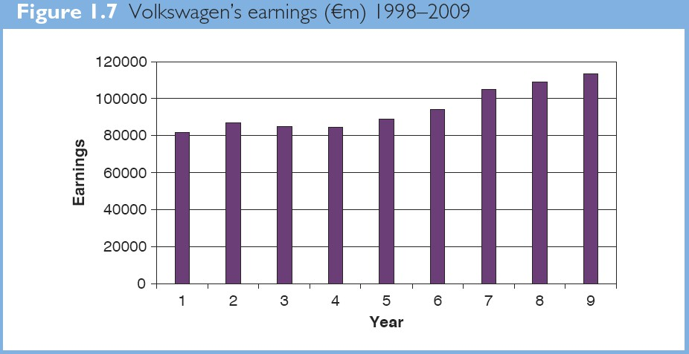

c. Class rank.

d. Make of car.

e. Number of people favouring closer European integration.

9. Figure 1.7 provides a bar chart summarizing the actual earnings for Volkswagen for the   
 years 2000 to 2008 (Source: Volkswagen AG Annual Reports 2001-2008).

a. Are the data categorical or quantitative?

b. Are the data times series or cross-sectional?

c. What is the variable of interest?

d. Comment on the trend in Volkswagen’s earnings over time. Would you expect to   
 see an increase or decrease in 2009?

10. The Hawaii Visitors Bureau collects data on visitors to Hawaii. The following questions   
 were among 16 asked in a questionnaire handed out to passengers during incoming airline   
 flights.

• This trip to Hawaii is my: 1st, 2nd, 3rd, 4th, etc.

• The primary reason for this trip is: (10 categories including vacation, convention,   
 honeymoon)

• Where I plan to stay: (11 categories including hotel, apartment, relatives, camping)

• Total days in Hawaii

a. What is the population being studied?

b. Is the use of a questionnaire a good way to reach the population of passengers on incoming   
 airline flights?

c. Comment on each of the four questions in terms of whether it will provide categorical or   
 quantitative data.

11. A manager of a large corporation recommends a $10,000 raise be given to keep a valued   
 subordinate from moving to another company. What internal and external sources of data   
 might be used to decide whether such a salary increase is appropriate?

12. In a recent study of causes of death in men 60 years of age and older, a sample of 120 men   
 indicated that 48 died as a result of some form of heart disease.

a. Develop a descriptive statistic that can be used as an estimate of the percentage of   
 men 60 years of age or older who die from some form of heart disease.

b. Are the data on cause of death categorical or quantitative?

c. Discuss the role of statistical inference in this type of medical research.

13. In 2007, 75.4 per cent of Economist readers had stayed in a hotel on business in the   
 previous 12 months with 32.4 per cent of readers using first/ business class for travel.

a. What is the population of interest in this study?

b. Is class of travel a categorical or quantitative variable?

c. If a reader had stayed in a hotel on business in the previous 12 months would this   
 be classed as a categorical or quantitative variable?

d. Does this study involve cross-sectional or time series data?

e. Describe any statistical inferences The Economist might make on the basis of the   
 survey.

Chapter 1: Data and Statistics

Textbook Exercises Solutions:

1. Statistics can be referred to as numerical facts. In a broader sense, statistics is

the field of study dealing with the collection, analysis, presentation and

interpretation of data.

2. a. 10

b. 4

c. Country is a categorical variable; hot list ranking, number of rooms and room   
 rate are quantitative variables.

d. Country is nominal; room rate and hot list ranking are ordinal; number of   
 rooms and room rate are ratio.

3. a. Average number of rooms = 485/10 = 48.5 or approximately 49 rooms

b. Average room rate (€) = 2356.66/10 = 235.67

c. 2 of 10 are located in Portugal; or 20%

d. 3 of 10 have 20 rooms or less; or 30%

4. a. 8

b. All brands of audio systems manufactured.

c. Average output power = 1130/8 = 141.25 watts

5. a. 7

b. Product rating, Price, Output are quantitative. MP3 player, Mini Disc player,   
 Cassette player and CD player are categorical.

c. Number of systems rated 4 stars or higher = 5/8 = 62.5%; approximately 63%.

d.

6

100 75%   
8

6. Questions a, c, and d provide quantitative data.

Questions b and e provide categorical data.

7. a. 389

b. The variable is categorical.

c. Percentages.

d. 222 respondents

8. a. Quantitative; ratio

b. Categorical; nominal

c. Categorical (Note: Rank is a numeric label that identifies the position of a

student in the class. Rank does not indicate how much or how many and is not quantitative.); ordinal

d. Categorical; nominal

e. Quantitative; ratio

9. a. Quantitative - Earnings measured in billions of euros.

b. Time series with 9 observations

c. Volkswagen's annual earnings.

d. Time series shows an increase in earnings. An increase would be expected in   
 2009, but it appears that the rate of increase may be slowing.

10.

a. All visitors to Hawaii

b. Yes

c. First and fourth questions provide quantitative data Second and third   
 questions provide-categorical data

11. Internal data on salaries of other employees can be obtained from the

personnel department. External data might be obtained from the Department of Labor or industry associations.

12. a. (48/120)100% = 40% in the sample died from some form of heart disease.

This can be used as an estimate of the percentage of all males 60 or older who die of heart disease.

b. The data on cause of death is categorical.

13. a. All readers of The Economist at the time the survey was conducted.

b. Categorical

c. Categorical (stayed in a hotel or not stayed in a hotel)

d. Cross-sectional - all the data relate to the same time.

e. Using the sample results, we could infer or estimate that in 2007, 75.4% per

cent of the population of Economist readers had stayed in a hotel on business in the previous 12 months; also 32.4% of the population of readers used first / business class for travel.

Chapter 1: Data and Statistics

Supplementary Exercises:

14. Statistics released by Emerald, the publisher of TQM Magazine

([www.brad.ac.uk/acad/management/ectqm](http://www.brad.ac.uk/acad/management/ectqm/)), indicate that: the UK provides 30 per cent of

contributions to the TQM Magazine; north America and Europe provide 20 per cent; south

and east Asia provide 19 per cent; Australasia provides 9 per cent; the Middle East and Africa provide 1 per cent.

a. Would the geographical source of contributions be described as nominal or ratio data?

b. What percentage of the applications come from Europe (including the UK) and North   
 America?

15. State whether each of the following variables is categorical or quantitative and indicate its   
 measurement scale.

a. Annual sales

b. Soft-drink size (small, medium, large)

c. European Socio-economic Classification (Class 1 through Class 10)

d. Earnings per share

e. Method of payment (cash, cheque, credit card)

16. The Hawaii Visitors Bureau collects data on visitors to Hawaii. The following questions were   
 among 16 asked in a questionnaire handed out to passengers during incoming airline flights in   
 June 2001.

• This trip to Hawaii is my: 1st, 2nd, 3rd, 4th, etc.

• The primary reason for this trip is: (10 categories including vacation, convention,

honeymoon)

• Where I plan to stay: (11 categories including hotel, apartment, relatives, camping)

• Total days in Hawaii

a. What is the population being studied?

b. Is the use of a questionnaire a good way to reach the population of passengers on incoming   
 airline flights?

c. Comment on each of the four questions in terms of whether it will provide categorical or   
 quantitative data.

17. IPFI regularly releases definitive statistics on the global recorded music industry. For 2005,   
 a breakdown of Total Music Sales (physical & digital) by Market ([www.ifpi.org/site-](http://www.ifpi.org/site-/)  
 content/library/worldsales2005-ff.pdf ) was confirmed by IPFI as follows:

US$m Local Currency

1 USA 7,012 USD

2 Japan 3,718 JPY

3 UK 2,162 GBP

4 Germany 1,457 EUR

5 France 1,248 EUR

6 Canada 544 CAD

7 Australia 440 AUD

8 Italy 428 EUR

9 Spain 369 EUR

10 Brazil 265 BRL

11 Mexico 263 MXP

12 Netherlands 246 EUR

13 Switzerland 206 CHF

14 Russia 194 RUB

15 Belgium 162 EUR

16 South Africa 159 ZAR

17 Sweden 148 SEK

18 Austria 139 EUR

19 Norway 133 NOK

20 Denmark 113 DKK

Other 1,387

Total 20,795

a. Is local currency a categorical or quantitative variable?

b. Construct a bar graph for music sales by country in 2005. Is this graph based on cross-  
 sectional data or time series data?

18. A Business Week North American subscriber study collected data from a sample of 2861   
 subscribers. Fifty-nine percent of the respondents indicated an annual income of $75,000 or   
 more, and 50% reported having an American Express credit card.

a. What is the population of interest in this study?

b. Is annual income a categorical or quantitative variable?

c. Is ownership of an American Express card a categorical or quantitative variable?

d. Does this study involve cross-sectional or time series data?

e. Describe any statistical inferences Business Week might make on the basis of the survey.

19. A Fall 2002 sample survey of 131 investment managers in Barron's Big Money poll revealed the   
 following (Barron's, October 28, 2002):

• 43% of managers classified themselves as bullish or very bullish on the stock market.

• The average expected return over the next 12 months for equities was 11.2%.

• 21% selected health care as the sector most likely to lead the market in the next 12 months.

• When asked to estimate how long it would take for technology and telecom stocks to resume sustainable growth, the managers' average response was 2.5 years.

a. Cite two descriptive statistics.

b. Make an inference about the population of all investment managers concerning the average return expected on equities over the next 12 months.

c. Make an inference about the length of time it will take for technology and telecom stocks to resume sustainable growth.

20. A seven-year medical research study reported that women whose mothers took the drug DES

during pregnancy were twice as likely to develop tissue abnormalities that might lead to cancer as were women whose mothers did not take the drug.

a. This study involved the comparison of two populations. What were the populations?

b. Do you suppose the data were obtained in a survey or an experiment?

c. For the population of women whose mothers took the drug DES during pregnancy, a sample   
 of 3980 women showed 63 developed tissue abnormalities that might lead to cancer. Provide   
 a descriptive statistic that could be used to estimate the number of women out of 1000 in this   
 population who have tissue abnormalities.

d. For the population of women whose mothers did not take the drug DES during pregnancy,   
 what is the estimate of the number of women out of 1000 who would be expected to have   
 tissue abnormalities?

e. Medical studies often use a relatively large sample (in this case, 3980). Why?

21. A firm wants to test the advertising effectiveness of a new television commercial. As part of the   
 test, the commercial is shown on a local evening TV news programme in the Czech republic.   
 Two days later, a market research firm conducts a telephone survey to obtain information on   
 recall rates (percentage of viewers who recall seeing the commercial) and impressions of the   
 commercial.

a. What is the population for this study?

b. What is the sample for this study?

c. Why would a sample be used in this situation? Explain.

22. AC Nielsen is the world's leading marketing information company with 21,000 employees   
 worldwide offering services in more than 100 countries. Recently AC Nielsen contributed data

to a study on internet usage in Europe ([www.internetworldstats.com/stats4.htm](http://www.internetworldstats.com/stats4.htm)) - selected

details from which are summarised below:

Population

EUROPE (m)

European Union 462 7.1%

EU Candidate Countries 110

Rest of Europe 235

TOTAL EUROPE 807

Rest of World 5,692

TOTAL WORLD 6,500 100.0%

% Pop. Internet Penetration Usage Use Growth   
of World Users (m) % of World 2000-2006

240 51.9% 22.1% 157.5%

1.7% 25 22.7% 2.3% 622.1%

3.6% 44 18.7% 4.0% 417.5%

12.4% 309 38.2% 28.4% 193.7%

87.6% 778 13.7% 71.6% 203.9%

1,086 16.7% 100.0% 200.9%

a. How many populations were involved in this study and how do you think it / they would be   
 defined?

b. Do you think the internet usage figures here were calculated by census or sample surveys?   
 How do you think such surveys would be carried out?

c. Where is the fastest and slowest growth in internet usage taking place? Any comments on   
 this?

23. The Broadcasters' Audience Research Board (BARB) is responsible for providing estimates of   
 the number of people watching television. This includes which channels and programmes are   
 being watched, at what time, and the type of people who are watching at any one time. BARB   
 provides television audience data on a minute-by-minute basis for channels received within the   
 UK. The data is available for reporting nationally and at ITV and BBC regional level and covers   
 all analogue and digital platforms.

For the years 1990-2005, BARB confirms the Annual % Shares of Viewing (Individuals) to be   
as follows:

Channel

Year BBC1 BBC2 ITV 1* C4 five Others

1990 37 10 44 9 - -

1991 34 10 42 10 - 4

1992 34 10 41 10 - 5

1993 33 10 40 11 - 6

1994 32 11 39 11 - 7

1995 32 11 37 11 - 9

1996 33.5 11.5 35.1 10.7 - 10.1

1997 30.8 11.6 32.9 10.6 2.3 11.8

1998 29.5 11.3 31.7 10.3 4.3 12.9

1999 28.4 10.8 31.2 10.3 5.4 14.0

2000 27.2 10.8 29.3 10.5 5.7 16.6

2001 26.9 11.1 26.7 10.0 5.8 19.6

2002 26.2 11.4 24.1 10.0 6.3 22.1

2003 25.6 11.0 23.7 9.6 6.5 23.6

2004 24.7 10.0 22.8 9.7 6.6 26.2

2005 23.3 9.4 21.5 9.7 6.4 29.6

* inc GMTV

Here, the Channel “Others” signifies non-terrestrial channels.

a. Is channel a categorical or quantitative variable?

b. Construct a graph of BBC (BBC1 and BBC2) viewing share over the sixteen year period. Use   
 the horizontal axis to display the year and the vertical axis to display the percentage   
 viewing share. Is this graph based on cross-sectional or time series data?

c. Construct a graph for viewing shares in 2005. Is the graph based on cross-sectional or time   
 series data?

24. In a recent research study ([www.springerlink.com/content/3hbfafkg8pnp2uq2/](http://www.springerlink.com/content/3hbfafkg8pnp2uq2/)) of TV   
 viewing habits by Greek children, 4876 questionnaires - completed by children with the   
 assistance of their parents - were analysed. Key results were as follows:

• The mean time spent watching TV ranged from 21-32 hours per week.

• The age when children started watching TV correlated with their later educational

achievement: good students started watching TV earlier. Bad students, however, watched more TV, as did children from urban areas, and from lower socioeconomic groups.

• Children from households with more than one TV (especially if it was in the child's

bedroom) also watched more.

• Children who watched more TV were less compliant with TV restrictions and more likely   
 to imitate TV characters.

• Eating while watching TV was associated with obesity in teenagers.

• Most children watched TV from appropriate distances, with the lights on, and with the   
 sound at medium volume.

a. What do you think the researchers were attempting to measure here?

b. What is the population?

c. Why would a sample be used for this situation?

d. What kinds of decisions or actions are likely to be based on this study?

25. A sample of course percentages for five students showed the following results: 72, 65, 82, 90,

76. Which of the following statements are correct, and which should be challenged as being too generalized?

a. The average course percentage for the sample of five students is 77.

b. The average course percentage for all students who took the exam is 77.

c. An estimate of the average course percentage for all students who took the exam is 77.

d. More than half of the students who take this exam will achieve a percentage of between 70   
 and 85.

e. If five other students are included in the sample, their course percentage will be between 65   
 and 90.

26. Recent figures by the European Council on Refugees and Exiles ([www.ecre.org/](http://www.ecre.org/)) on illegal   
 immigration into Europe are summarized below.

Country/ region

of asylum 2001 2002 2003 2004 2005

Albania 160 110 30 20 30

Austria 30,140 39,350 32,360 24,630 22,470

Belarus 220 160 140 170 210

Belgium 24,550 18,810 16,940 15,360 15,960

Bosnia and Herzegovina 730 580 740 200 150

Bulgaria 2,430 2,890 1,550 1,130 820

Croatia 90 100 60 160 190

Cyprus 1,770 950 4,410 9,860 7,770

Czech Rep. 18,090 8,480 11,400 5,460 4,020

Denmark 12,510 6,070 4,590 3,240 2,260

Estonia 10 10 10 10 10

Finland 1,650 3,440 3,220 3,860 3,560

France 54,290 58,970 59,770 58,550 50,050

Germany 88,290 71,130 50,560 35,610 28,910

Greece 5,500 5,660 8,180 4,470 9,050

Hungary 9,550 6,410 2,400 1,600 1,610

Ireland 10,330 11,630 7,900 4,770 4,320

Italy 9,620 16,020 13,460 9,720 9,500

Latvia 10 30 10 10 20

Liechtenstein 110 100 100 70 50

Lithuania 260 290 180 170 120

Luxembourg 690 1,040 1,550 1,580 800

Malta 120 350 570 1,000 1,170

Moldova, Rep. of 250 110 90 110 110

Netherlands 32,580 18,670 13,400 9,780 12,350

Norway 14,780 17,480 15,960 7,950 5,400

Poland 4,530 5,170 6,910 8,080 5,440

Portugal 230 250 90 110 110

Romania 2,430 1,150 1,080 660 590

Russian Federation 1,680 880 740 910 960

Serbia and Montenegro 150 170 140 60 90

Slovak Republic 8,150 9,700 10,360 11,390 3,490

Slovenia 1,510 700 1,100 1,280 1,600

Spain 9,490 6,310 5,920 5,540 5,260

Sweden 23,520 33,020 31,350 23,160 17,530

Switzerland 20,630 26,130 20,810 14,250 10,060

TfYR Macedonia 200 120 2,280 100 10

Turkey 5,040 3,800 3,950 3,910 3,910

Ukraine 920 460 1,370 1,360 1,740

United Kingdom 91,600 103,080 60,050 40,620 30,460

EU-"Old" (15) 394,990 393,450 309,340 241,000 212,590

EU-"New" (10) 44,000 32,090 31,350 38,860 25,250

EU-Total (25) 438,990 425,540 346,690 279,860 237,840

Nordic countries (5) 52,510 60,130 55,200 38,290 28,840

Western Europe (19) 430,560 437,280 346,290 263,350 228,190

Former Yugoslavia (5) 2,680 1,670 4,320 1,800 2,040

Former USSR (7) 6,620 3,450 3,300 3,620 3,980

Total Europe (44) 492,410 481,740 396,770 312,070 263,210

a. Are these time series or cross-sectional data?

b. What are the elements and variables here?

c. Give an example of an observation in this example.

d. Is the scale of measurement used for the quantitative details here interval or ratio?

e. Comment on any trends revealed by the summary.

27. In January 2005, the European Consumer Centre, Dublin ([www.ecic.ie](http://www.ecic.ie/)) commissioned Insight   
 Statistical Consulting (ISC), a marketing research company, to undertake research on airline   
 complaints in Ireland. Subsequently a telephone survey of a total of 1067 adults in Ireland was   
 conducted. Amongst the questions asked by ISC were the following:

• Did you take a flight-only journey within the last year i.e. not any part of a package   
 holiday?

• Do you know your rights as an airline passenger? • Have you heard of the small claims court?

a. What is the population being studied?

b. Do you think the choice of a telephone survey a good way to reach the population of interest?

c. Comment on each of the sample questions in terms of whether it will provide categorical or   
 quantitative data.

28. In a survey in 2001, ([www.uri.edu/personal/awel5922/gambling.index.html](http://www.uri.edu/personal/awel5922/gambling.index.html)) nearly 500

customers of the online casinos kennyrogers.com, casinoaustralia.com and goodluck.com were

asked by Inland Entertainment Corporation (IEC) to confirm their

Primary language Gender and

Age range

The questionnaire was used for the survey was in English.

Comment on

a. the quality of the survey design employed by IEC and - following on -

b. the validity / precision of results arising from the survey.

Chapter 1: Data and Statistics

Supplementary Exercises Solutions:

14. a. Nominal

b. 50%

15. a. Quantitative; ratio

b. Categorical; ordinal

c. Categorical; ordinal (assuming employees can be ranked by classification)

d. Quantitative; ratio

e. Categorical; nominal

16. a. The population is all visitors coming to the state of Hawaii.

b. Since airline flights carry the vast majority of visitors to the state, the use of   
 questionnaires for passengers during incoming flights is a good way to reach   
 this population. The questionnaire actually appears on the back of a   
 mandatory plants and animals declaration form that passengers must complete   
 during the incoming flight. A large percentage of passengers complete the   
 visitor information questionnaire.

c. Questions 1 and 4 provide quantitative data indicating the number of visits and   
 the number of days in Hawaii. Questions 2 and 3 provide categorical data   
 indicating the categories of reason for the trip and where the visitor plans to   
 stay.

17. a Categorical

b.

8000   
7000   
6000   
5000   
4000   
3000   
2000   
1000

0

Cross-sectional

18. a. All subscribers of Business Week in North America at the time the survey was conducted.

b. Quantitative

c. Categorical (yes or no)

d. Crossectional - all the data relate to the same time.

e. Using the sample results, we could infer or estimate 59% of the population of   
 subscribers have an annual income of $75,000 or more and 50% of the   
 population of subscribers have an American Express credit card.

19. a. 43% of managers were bullish or very bullish.

21% of managers expected health care to be the leading industry over the next

12 months.

b. We estimate the average 12-month return estimate for the population of   
 investment managers to be 11.2%.

c. We estimate the average over the population of investment managers to be 2.5   
years.

20. a. The two populations are the population of women whose mothers took the

drug DES during pregnancy and the population of women whose mothers did not take the drug DES during pregnancy.

b. It was a survey.

c. 63 / 3.980 = 15.8 women out of each 1000 developed tissue abnormalities.

d. The article reported “twice” as many abnormalities in the women whose

mothers had taken DES during pregnancy. Thus, a rough estimate would be

15.8/2 = 7.9 abnormalities per 1000 women whose mothers had not taken DES during pregnancy.

e. In many situations, disease occurrences are rare and affect only a small portion   
 of the population. Large samples are needed to collect data on a reasonable   
 number of cases where the disease exists.

21. a. All adult viewers reached by the Czech television station.

b. The viewers contacted in the telephone survey.

c. It would clearly be too costly and time consuming to try to contact all viewers.

22. a. One. All computers in Europe available to the public for internet usage

b. Sample. A statistically representative panel of internet users.

c. EU candidate countries. One measure of the rapid convergence of candidate   
 states with existing EU countries

23. a. Categorical

BBC

50

45   
40   
35   
30

25 BBC

20   
15   
10

5

0

b.

Time series data

1990

1991

1992

1993

1994

1995

1996

1997

1998

1999

2000

2001

2002

2003

2004

2005

35   
30   
25   
20   
15   
10

5

0

BBC1 BBC2 ITV 1* C4 five Others

Channel

c.

Cross-sectional

24. a. Percent of television sets that were tuned by Greek children to a particular   
 television show and/or total viewing audience.

b. All television sets in Greece which are available for the children to view. Note   
 this would not include television sets in store displays.

c. A sample is used because it would be too costly to collect data on all   
 television sets in Greece.

d. A demographic understanding of Greek children’s TV viewing and possible   
 problems associated with viewing habits.

25. a. This is a statistically correct descriptive statistic for the sample.

b. An incorrect generalization since the data was not collected for the entire population.

c. An acceptable statistical inference based on the use of the word “estimate.”

d. While this statement is true for the sample, it is not a justifiable conclusion for   
 the entire population.

e. This statement is not statistically supportable. While it is true for the

particular sample observed, it is entirely possible and even very likely that at least some students will be outside the 65 to 90 range of grades.

26. a No

b. Country; annual illegal immigration totals

% Viewing

c. United Kingdom 91,600 103,080 60,050 40,620

30,460

d. Ratio

e. Between 2001 and 2005 illegal immigration into the European countries listed   
 as almost halved.

27. a. The population of Irish airline travellers

b. Yes on the not unreasonable assumption that airline travellers are likely to   
 have phones.

c. All categorical

28. a. Non-English respondents may have difficulty answering a questionnaire in   
 English.

There may also be a bias resulting from the particular casinos chosen for the

study.

b. A sample size of 500 is comparatively small by many survey standards so the   
 results are likely to be comparatively imprecise.