Answers to Review Questions

Chapter 1

1. Main memory, or RAM, is volatile, which means its contents are erased when power is removed from the computer. Secondary memory, such as a disk, does not lose its contents when power is removed from the computer.
2. An operating system is a set of programs that manages the computer's hardware devices and controls their processes. Application software consists of programs that users use to solve specific problems or perform general operations.
3. An operating system
4. Because the computer only processes machine language instructions.
5. Because high level languages are more like natural language.
6. An object file contains machine language instructions, but it does not contain code for any library routines that may be necessary. An executable file is a program, ready to run. It contains the machine language code translated from the programmer's source file, as well as the code for any necessary library routines.
7. A syntax error is the misuse of a key word, operator, punctuation, or other part of the programming language. A logical error is a mistake that causes the program to produce the wrong results.
8. programmed
9. CPU
10. Arithmetic Logic Unit and Control Unit
11. disk
12. Operating Systems and Application Software
13. instructions
14. programming language
15. machine language
16. high-level
17. low-level
18. portability
19. key words
20. programmer-defined symbols
21. operators
22. punctuation
23. syntax
24. variable
25. defined
26. input, processing, output
27. input
28. output
29. hierarchy chart
30. Hierarchy chart:
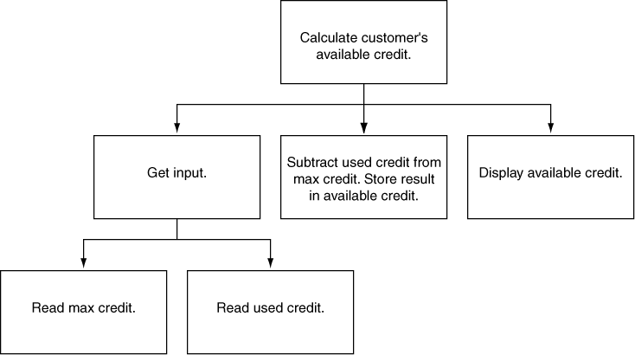

31. Hierarchy chart:
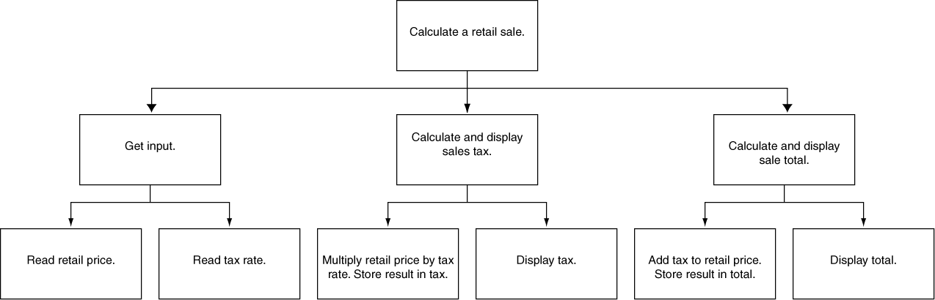

32. Hierarchy chart:

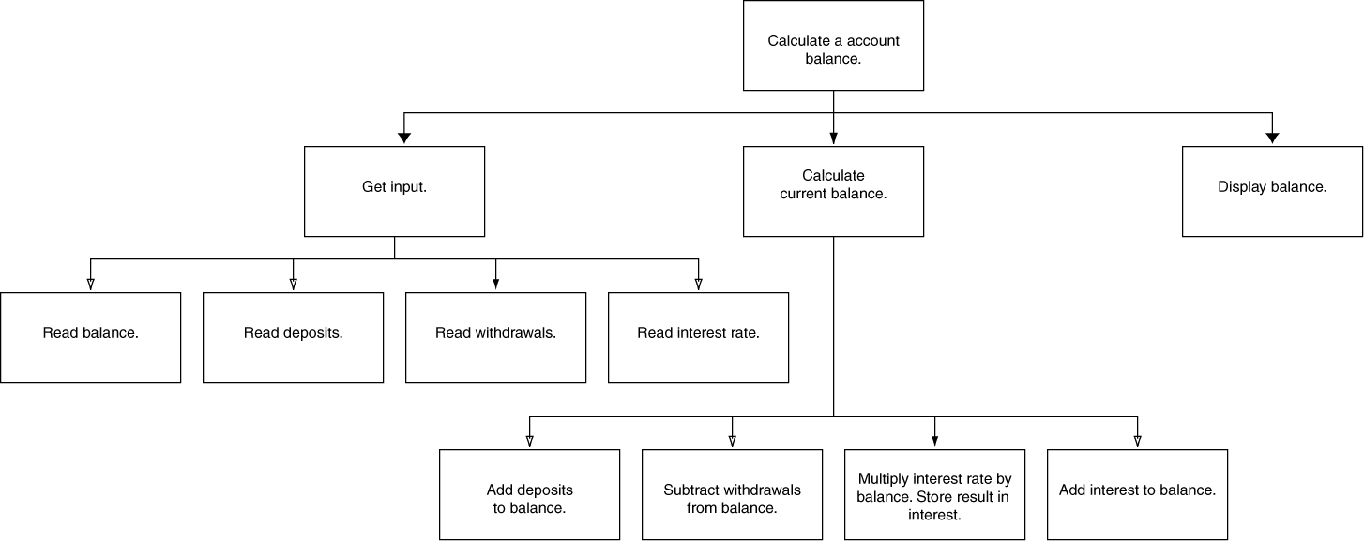

33. 7
34. 28
35. 365
36. The error is that the program performs its math operation before the user has entered values for the variables length and width.

