**Chapter 2**

**Introduction to Optimization & Linear Programming**

1. If an LP model has more than one optimal solution it has an ***infinite*** number of alternate optimal solutions. In Figure 2.8, the two extreme points at (122, 78) and (174, 0) are alternate optimal solutions, but there are an infinite number of alternate optimal solutions along the edge connecting these extreme points. This is true of all LP models with alternate optimal solutions.

2. There is no guarantee that the optimal solution to an LP problem will occur at an integer-valued extreme point of the feasible region. (An exception to this general rule is discussed in Chapter 5 on networks).

3. We can graph an inequality as if they were an equality because the condition imposed by the equality corresponds to the boundary line (or most extreme case) of the inequality.

4. The objectives are equivalent. For any values of X1 and X2, the absolute value of the objectives are the same. Thus, maximizing the value of the first objective is equivalent to minimizing the value of the second objective.

5. a. linear

b. nonlinear

c. linear, can be re-written as: 4 X1 - .3333 X2 = 75

d. linear, can be re-written as: 2.1 X1 + 1.1 X2 - 3.9 X3 0

e. nonlinear

6.



7.



8.



9.



10.



11.



12.



13. X1 = number of softballs to produce, X2 = number of baseballs to produce

MAX 6 X1 + 4.5 X2

ST 5X1 + 4 X2 6000

6 X1 + 3 X2 5400

4 X1 + 2 X2 4000

2.5 X1 + 2 X2 3500

1 X1 + 1 X2 1500

X1, X2 0

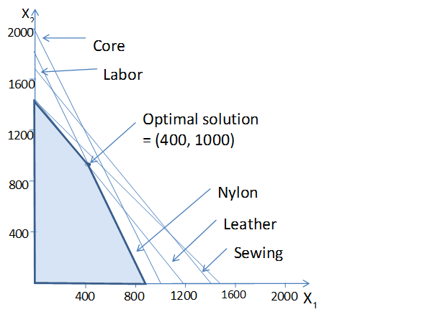

14. X1 = number of His chairs to produce, X2 = number of Hers chairs to produce

MAX 10 X1 + 12 X2

ST 4 X1 + 8 X2 1200

8 X1 + 4 X2 1056

2 X1 + 2 X2 400

4 X1 + 4 X2 900

1 X1 - 0.5 X2 ≥ 0

X1, X2 ≥ 0

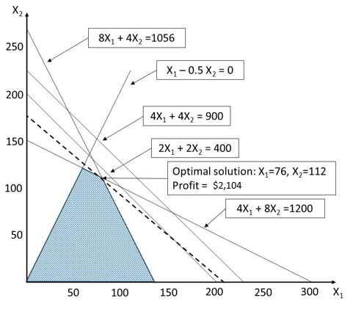

15. X1 = number of propane grills to produce, X2 = number of electric grills to produce

MAX 100 X1 + 80 X2

ST 2 X1 + 1 X2 2400

4 X1 + 5 X2 6000

2 X1 + 3 X2 3300

1 X1 + 1 X2 1500

X1, X2 ≥ 0

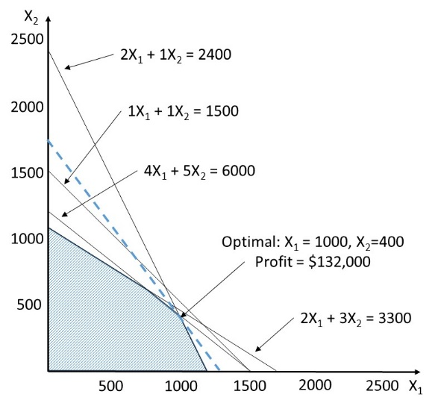

16. X1 = number of generators, X2 = number of alternators

MAX 250 X1 + 150 X2

ST 2 X1 + 3 X2 260

1 X1 + 2 X2 140

X1, X2 0



17. X1 = number of generators, X2 = number of alternators

MAX 250 X1 + 150 X2

ST 2 X1 + 3 X2 260

1 X1 + 2 X2 140

X1 20

X2 20



d. No, the feasible region would not increase so the solution would not change -- you'd just have extra (unused) wiring capacity.

18. X1 = proportion of beef in the mix, X2 = proportion of pork in the mix

MIN .85 X1 + .65 X2

ST 1X1 + 1 X2 = 1

0.2 X1 + 0.3 X2 0.25

X1, X2 0



19. T= number of TV ads to run, M = number of magazine ads to run

MIN 500 T + 750 P

ST 3T + 1P 14

-1T + 4P 4

0T + 2P 3

T, P 0

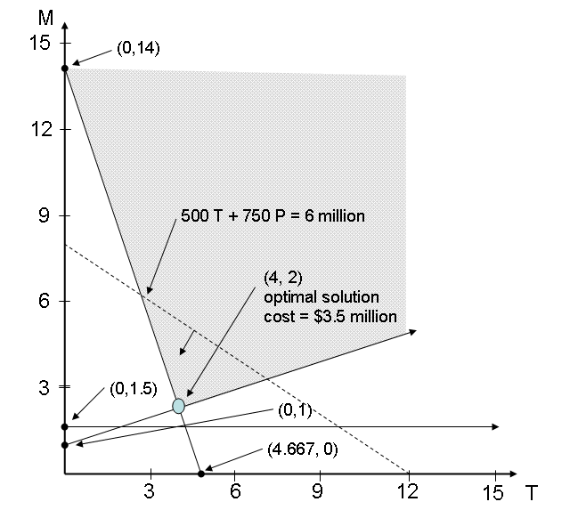

20. X1 = # of TV spots, X2 = # of magazine ads

MAX 15 X1 + 25 X2 (profit)

ST 5 X1 + 2 X2 < 100 (ad budget)

5 X1 + 0 X2 70 (TV limit)

0 X1 + 2 X2 50 (magazine limit)

X1, X2 0

X1

(14,15)

X2

10

20

10

20

30

40

(14,0)

(0,25)

(10,25)

15X1+25X2=400

15X1+25X2=775

21. X1 = tons of ore purchased from mine 1, X2 = tons of ore purchased from mine 2

MIN 90 X1 + 120 X2 (cost)

ST 0.2 X1 + 0.3 X2 > 8 (copper)

0.2 X1 + 0.25 X2 > 6 (zinc)

0.15 X1 + 0.1 X2 > 5 (magnesium)

X1, X2 0

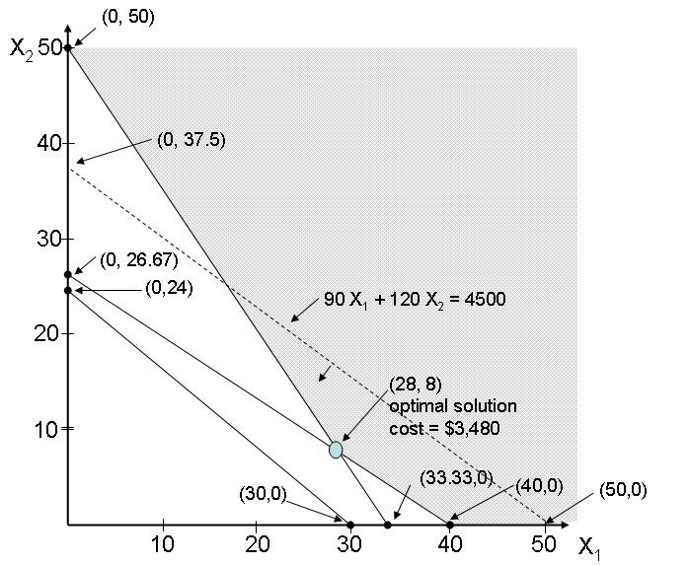

22. R = number of Razors produced, Z = number of Zoomers produced

MAX 70 R + 40 Z

ST R + Z 700

R – Z 300

2 R + 1 Z 900

3 R + 4 Z 2400

R, Z 0

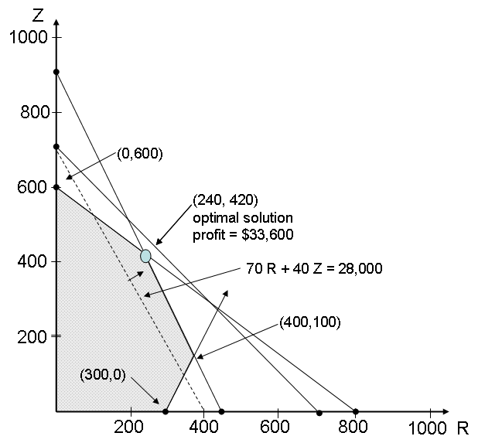

23. P = number of Presidential desks produced, S = number of Senator desks produced

MAX 103.75 P + 97.85 S

ST 30 P + 24 S 15,000

1 P + 1 S 600

5 P + 3 S 3000

P, S 0

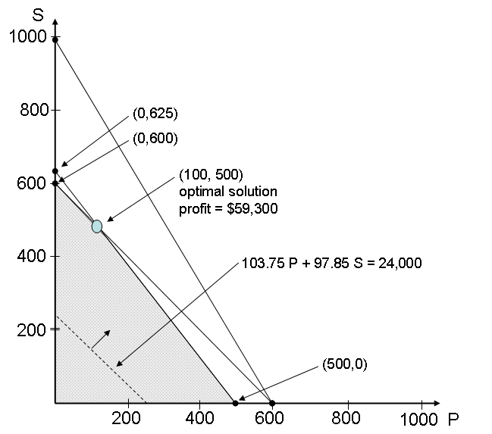

24. X1 = acres planted in watermelons, X2 = acres planted in cantaloupes

MAX 256 X1 + 284.5 X2

ST 50 X1 + 75 X2 6000

X1 + X2 100

X1, X2 0

**X**

**1**

**X**

**2**

**0**

**25**

**50**

**75**

**100**

**125**

**25**

**50**

**75**

**100**

**(0, 80) obj = 22760**

**(60, 40) obj =26740**

**(optimal solution)**

**(100, 0) obj = 25600**

**0**

25. D = number of doors produced, W = number of windows produced

MAX 500 D + 400 W

ST 1 D + 0.5 W 40

0.5 D + 0.75 W 40

0.5 D + 1 W 60

D, W 0

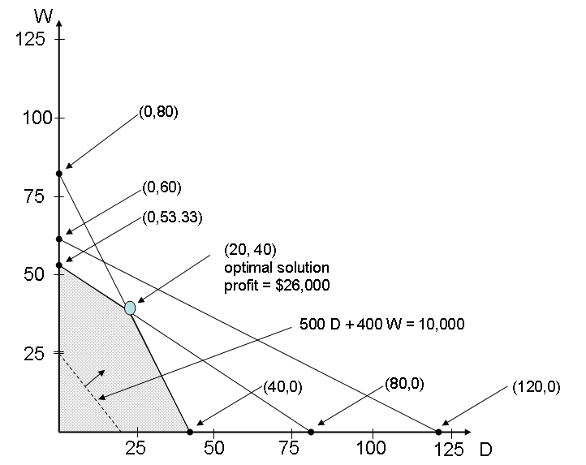

26. X1 = number of desktop computers, X2 = number of laptop computers

MAX 600 X1 + 900 X2

ST 2 X1 + 3 X2 300

X1 80

X2 75

X1, X2 0



**Case 2-1: For The Lines They Are A-Changin’**

1. 200 pumps, 1566 labor hours, 2712 feet of tubing.
2. Pumps are a binding constraint and should be increased to 207, if possible. This would increase profits by $1,400 to $67,500.
3. Labor is a binding constraint and should be increased to 1800, if possible. This would increase profits by $3,900 to $70,000.
4. Tubing is a non-binding constraint. They’ve already got more than they can use and don’t need any more.
5. 9 to 8: profit increases by $3,050

8 to 7: profit increases by $850

7 to 6: profit increases by $0

1. 6 to 5: profit increases by $975

5 to 4: profit increases by $585

4 to 3: profit increases by $390

1. 12 to 13: profit changes by $0

13 to 14: profit decreases by $760

14 to 15: profit decreases by $1,440

1. 16 to 17: profit changes by $0

17 to 18: profit changes by $0

18 to 19: profit decreases by $400

1. The profit on Aqua-Spas can vary between $300 and $450 without changing the optimal solution.
2. The profit on Hydro-Luxes can vary between $233.33 and $350 without changing the optimal solution.