CHAPTER 2

Tools of the Trade

This chapter introduces some of the necessary terminology and reviews some of the basic techniques the student is assumed to have at the start of a typical QM course. Inevitably, students’ numerical ability will be varied and I tend to use this material as self-study for students rather than formally teach it in a class context. I find it helpful to encourage students to work on this material in small self-support groups so that they can assist one another in the basics. I do tend, however, to have a tutorial focused on a number of the end-of-chapter exercises to ensure students have the basic skills required.

In particular, I try to ensure that students are comfortable with, and competent in, dealing with   
proportions, percentages, fractions and decimals. I also ensure they can formulate simple   
models using symbols and can accurately draw simple graphs. I tend to encourage students to   
draw the first few graphs by hand to check whether they understand the principles of co-  
ordinates and can extract information directly from the graph they have produced. The simple   
break-even model introduced in this chapter is easy for students to grasp and useful in   
highlighting the necessary principles.

Other concepts that I try to ensure they understand from the beginning are the difference between real and money terms and the concept of a simple index.

The Cap Gemini Ernst and Young (CGEY) case on pp. 42-43 should help students appreciate that these basic Tools of the Trade are of practical use.

As I mention in the text itself, there is another text I have written for Financial Times   
Management: *Foundation Quantitative Methods for Business* (1996, ISBN 0273607650) which   
is aimed primarily at the student at the undergraduate (or equivalent) level for those with little,   
or no, real experience of business or management. In that text I have a much expanded *Tools of   
the Trade* chapter which includes self-assessment tasks for the student to complete to help them   
assess their numerical ability in a number of key areas. Students who are less comfortable with   
quantitative data and basic arithmetic could be encouraged to use this as remedial material.

Figures are given at the end-of-the-chapter solutions.

10

© Mik Wisniewski 2016

Mik Wisniewski, *Quantitative Methods for Decision Makers*, 6e, Instructor’s Manual

Solutions

1. With the original equations the break-even solution was derived as:   
 Q = 15000

Taking each part in turn, the new break-even level is derived as follows:

(a) Overheads increase by 15 per cent

This will affect C but not R. Since we know that the C equation comprises an element for fixed costs (45000) and one for variable costs (6.99Q) an increase in overheads will affect only fixed costs. The new C equation will be:

C = 51750 + 6.99Q

giving:

F = R − C

= 9.99Q − (51750 + 6.99Q) = −51750 + 3Q Break-even occurs when F = 0

F = −51750 + 3Q = 0

or 3Q = 51750

or Q = 17250 as the new break-even level of output.

Students should be encouraged to understand why Q has increased as overheads increase: as   
the firm’s costs have increased but its selling price has not, it needs to sell more to achieve   
the same profit levels. We could also derive the new solution by determining that the   
change in fixed costs is £6750 (51750 − 45000). Since each item sold generates a profit of   
£3, the company must sell an extra 2250 units (6750 ⁄ 3) to generate the same profit it had   
before the overhead increase. The student should realise that this increase of 2250 units will   
apply at any level of production not just at break-even. If they’re not sure, get them to   
calculate profit, F, before and after the overhead increase for two or three arbitrary   
production levels.

(b) Costs increase by £1.50 per item

Again, the C equation is affected, not R, but this time it is the variable cost element of the C equation which changes. We now have:

C = 45000 + 8.49Q

and require:

F = 9.99Q − (45000 + 8.49Q) = 0 Solving gives:

Q = 45000 ⁄ 1.50 = 30000

as the new break-even level of output.

11

© Mik Wisniewski 2016

Mik Wisniewski, *Quantitative Methods for Decision Makers*, 6e, Instructor’s Manual

(c) Selling price increases to £11.99

Now R changes while C does not, giving: F = 11.99Q − (45000 + 6.99Q) = 0   
and solving gives:

Q = 45000 ⁄ 5 = 9000

as the new break-even level of output.

Although not part of the question, it can also be worthwhile asking students to consider how   
the relevant graph of C and R would change in each case. This will allow an early   
introduction of the concepts of intercept and slope of linear equations and their business   
implications. The three graphs, with each showing the original C and R equations together   
with the new, are shown in Figs. 2X1A−2X1C. In Fig. 2X1A, the new C equation causes an   
upward shift in the C line equal to the increase in overheads. At any level for Q, costs have   
increased by a constant amount. In Fig. 2X1B, the new C line increases its slope/gradient as   
the variable costs increase but has the same intercept or constant value as overheads have   
not changed. In Fig. 2X1C, it is the R line which changes again with the slope/gradient   
increasing with the increase in selling price.

2. Although the use of logarithms is introduced in this chapter they are not used again

extensively until Chapter 15 and the tutor may wish to delay their coverage until then.

This exercise is simply to give students some practice at the use of logarithmic calculations.   
Table 2X2 shows the relevant calculations. The amount at the start of each year is shown in   
the second column, followed by the interest earned on that amount at 8 per cent. These two   
added together then give the amount at the end of the year. So, at the start of year 1 £15000   
is invested, earns £12000 interest and the savings fund has a value of £16200 at the end of   
year 1. The value of the fund at the end of a year is then the value of the fund at the start of   
the following year. So, by the end of the 10-year period the fund is worth £32384. The   
logarithms of the Amount at end figures are shown in the final column (base 10).

*Table 2X2 Investment over time*

Year Amount at start Interest Amount at end Log of amount at end

1 15000 1200 16200 4.2095

2 16200 1296 17496 4.2429

3 17496 1400 18896 4.2764

4 18896 1512 20407 4.3098

5 20407 1633 22040 4.3432

6 22040 1763 23803 4.3766

7 23803 1904 25707 4.4101

8 25707 2057 27764 4.4435

9 27764 2221 29985 4.4769

10 29985 2399 32384 4.5103

Fig. 2X2 shows the graph of both the actual monetary series and its log equivalent. Note   
that this graph uses both the Y axes to show both series together (this type of graph is   
discussed in more detail in Chapter 3). From the graph we see that the actual monetary   
value of the fund is not only increasing each year, it is increasing by an ever-increasing   
amount (thanks to the principle of compound interest). This can be related back directly to

12

© Mik Wisniewski 2016

Mik Wisniewski, *Quantitative Methods for Decision Makers*, 6e, Instructor’s Manual

the Interest column in the table. However, the graph of the log of the amount values is clearly linear. This might puzzle some students, but what the log graph is actually showing is that *the rate of change* in the amount is constant over time (at 8 per cent). Students should be asked to consider the implications of a log graph where the log values produced an upward curve (like that of the actual amount values) or a downward curve. The use of log graphs where management interest lies primarily in growth rates rather than actual values could also be discussed: examples from sales, market penetration/market share, change in customer numbers, etc. could be used to illustrate this further.

The exercise is readily extended to look at the effect of different rates of interest on the final fund value and the impact of inflation on fund value (allowing a discussion of real versus money value terms).

3. (a) We have a linear equation:

Qd = 1000 − 5P

Given it is linear, in order to graph it we need two sets of co-ordinates (normally taken as those corresponding to the two ends of the X axis scale). Here the variable on the vertical, Y, axis will be Qd and price, P, will be on the horizontal or X axis.

We are told that price (P) will vary from 0 to 200. So, using P = 0 we have: Qd = 1000 − 5P

Qd = 1000 − 5(0) = 1000

That is, when P = 0 Qd = 1000   
Similarly, when P = 200   
Qd = 1000 − 5P

Qd = 1000 − 5(200) = 1000 − 1000 = 0

Our two sets of co-ordinates then for plotting on the graph are: P = 0, Qd = 1000

P = 200, Qd = 0

We then have a graph as in Fig. 2X3A.

If you are drawing the graph manually it is clearly logical to have the X scale from 0 to 200 and the Y scale from 0 to 1000 with suitable ‘tick’ marks to make the scales easy to read. If you are using a spreadsheet then scales, etc. will automatically be calculated, although it is still worthwhile encouraging students to override the automatic settings from time to time to see the effect this has on the diagram.

I also tend to encourage students to produce one or two graphs at this stage manually rather   
than relying totally on a spreadsheet package. This allows me - and the student - to assess   
their grasp of plotting co-ordinates and their ability to plot and read information from a   
graph accurately.

(b) Clearly, from the graph the equation is linear and slopes downwards as we look at it from   
 left to right. That is, as P increases (from 0 to 200), Qd decreases (from 1000 to 0). In the

context of the demand for some product this clearly makes sense: the higher the price charged then, normally, the lower the demand for that product.

Some discussion of the realism of a linear demand equation, as opposed to a non-linear one,   
is often helpful in encouraging students to connect the implications of the mathematics to

13

© Mik Wisniewski 2016

Mik Wisniewski, *Quantitative Methods for Decision Makers*, 6e, Instructor’s Manual

the real world and in appreciating the implications of the difference between linear and nonlinear relationships.

(c) Revenue is defined as quantity sold times price. Quantity sold will effectively be Qd so we   
 have:

R = Qd × P

But Qd = 1000 − 5P so we have:

R = Qd × P = (1000 − 5P) × P = 1000P − 5P2

Take care that students multiply both parts of the equation for Qd by P. The use of brackets helps remind them to do this. So we have:

R = 1000P − 5P2

as the revenue equation.

(d) The revenue equation involves a term to the power 2 (P2) and is not a linear equation. In   
 order to draw a graph, we have to determine more than two sets of points. The text suggests

between 10 and 12. Using P from 0 to 200 again, we can work out R for values of P at 0, 20, 40, 60, 80, 100, 120, 140, 160, 180, 200. These would be:

*Table 2X3 Values for P and Q*

P Q

0 0

20 18000

40 32000

60 42000

80 48000

100 50000

120 48000

140 42000

160 18000

180 32000

200 0

It would make sense to have a Y axis from 0 to 50000 and the corresponding graph is shown in Fig. 2X3D. It is important that students should be able to assess the business implications of the graph (and its function) and not simply draw the graph. R starts at zero (where P is zero also). We already know from the demand equation that when the firm charges a price of zero it will ‘sell’ 1000 units. However, its revenue will be zero since it is effectively giving these units away for nothing and revenue shows the income it receives from sales. From the graph we see that revenue gradually climbs up to a maximum of £50000 and then gradually falls away again to zero (since at a price of 200 we know the firm will sell nothing and hence its revenue will also be nothing).

If students are drawing this type of graph manually, ensure that they join the points together   
(for each P, R combination) with a smooth line and that the co-ordinates are correctly

14

© Mik Wisniewski 2016

Mik Wisniewski, *Quantitative Methods for Decision Makers*, 6e, Instructor’s Manual

plotted. Technically, this type of equation/graph is known as a *quadratic* and is commonly   
used in business and economic modelling because of its shape and the implied consumer   
behaviour.

(e) From the graph we already know that revenue will be at its maximum at £50000. This   
 corresponds to a price of £100.

4. (a) This question requires us to derive relevant equations for this problem and then use these

equations to help answer the questions posed. We shall refer to the two alternatives as A   
and B.

For A we have:

a charge of £45 per day For B we have:

a charge of £30 per day plus 5p per mile.

In both cases we require the car for four days. The cost (C) of the two alternatives will then   
be:

CA = 180 (four days at £45) CB = 120 + 0.05M

where M is the number of miles we would travel.

It is clear that if our mileage is low then CB is likely to be less than CA. Equally, if our mileage is high, the reverse will be true. What is not clear, however, is the exact mileage that would make one cheaper than the other. It will help, though, if we can calculate what we can refer to as the break-even mileage: the mileage covered such that both companies would cost the same. This would mean that:

CA = CB

but substituting the two equations we get:   
CA = CB

180 = 120 + 0.05M

We need to collect all the numerical terms on one side of this equation and the unknown

(M) on the other. Using the idea that we can alter the left-hand side of an equation (LHS) as   
long as we also alter the right-hand side (RHS) in the same way, let us subtract 120 from   
both sides:

180 − 120 = 120 + 0.05M − 120   
to give:

60 = 0.05M

Let us now divide both sides by 0.05:

60 0.05 M

=

0.05 0.05

to give:

1200 = M (since any number divided by itself equals 1)

15

© Mik Wisniewski 2016

Mik Wisniewski, *Quantitative Methods for Decision Makers*, 6e, Instructor’s Manual

that is, the break-even mileage is 1200 miles. If I travel exactly 1200 miles, the two companies will charge me exactly the same for hire of the car. We can easily check (and you should do until you’re more used to this type of calculation):

CA = £180 (since there is no mileage charge)

CB = £120 + 0.05(M) = 120 + 0.05(1200) = 120 + 60 = £180

So, if my mileage is likely to be less than 1200, company B would be cheaper. If I expect to do more than 1200 miles, company A would be cheaper.

Some students typically encounter difficulty in manipulating equations to derive the   
numerical solution to some unknown variable. It is worthwhile encouraging them to adopt   
the method illustrated even though there may be quicker ways of finding a solution.

(b) Fig. 2X4B shows the corresponding graph.

We note that CA is a horizontal line since it remains unchanged no matter what value M   
takes. We also see that the two equations intersect (or cross) when M is 1200. We also see

that CB is always below CA when M is less than 1200 and always above CA when M is above 1200.

(c) Imposition of VAT at 17.5 per cent will clearly affect both costs and, potentially, the break-  
 even mileage solution. We now have:

CA = 211.50 (180 × 1.175)

CB = 141 + 0.05M

Re-solving the two equations for break-even gives M = 1410 (211.5, 141 divided by 0.05).

5. From the information given we can put together an equation to represent the cost, C, of a   
 flight. We know that there is a fixed cost per flight of £25000 and a cost per passenger of

£75. Denoting passengers as P we have:

C = 25000 + 75P

(a) Using the equation, break-even occurs when revenue equals cost. Revenue here would be:   
 R = 225P

and C = 25000 + 75P   
We require R = C:   
R = C

225P = 25000 + 75P 150P = 25000

P = 25000 ⁄ 150 = 166.7

as the number of passengers required to break-even (which we would need to round to 167 to give a sensible result).

(b) The flights have a capacity of 200 passengers. If only 80 per cent of seats are sold this   
 equates to 160 passengers. From the cost equation, C, we know that costs will be:

C = 25000 + 75P = 25000 + 75(160) = 25000 + 12000 = 37000

16

© Mik Wisniewski 2016

Mik Wisniewski, *Quantitative Methods for Decision Makers*, 6e, Instructor’s Manual

To break-even, the company must generate revenue equal to its costs. With 160 seats to sell it must charge a price for each of £37000 ⁄ 160 or £231.25.

(c) With only 190 seats available, the number of seats sold will now be 152 (80 per cent of   
 190). However, the firm now has extra revenue of £5000, which can be offset against the

costs. We have:

C = 25000 + 75P = 25000 + 75(152) = 36400

but only have to recover £31400 of this from seat income since £5000 is received from the cargo contract. So, the break-even ticket price should be £31400 ⁄ 152 = £206.58.

6. No answer is given here as the data collected by students will vary depending on source.

7. We have:

F = −100 + 100Q − 5Q2 C = 100 + 2Q2

(a) To obtain an equation for revenue, R, we must add costs, C, to profit, F:   
 R = F + C

R = (−100 + 100Q − 5Q2) + (100 + 2Q2)

Note the use of brackets to keep the arithmetic clear. Multiplying out the C term we have: R = (−100 + 100Q − 5Q2) + 100 + 2Q2

R = 100Q − 3Q2

For students not used to this type of manipulation, encourage them where you can to check their result. Here, for example, we can reverse the calculations since F = R − C. By subtracting the C equation (which we know to be correct) from the R equation we have obtained we should, if our answer is correct, obtain the F equation.

The graph for the profit equation is shown in Fig. 2X7B, plotted from Q = 0 to 20 in units of

1 (000). The profit equation (taking the standard quadratic shape) starts with negative   
values, increases to break-even, climbs to a maximum and then starts to fall away. It will be   
worthwhile for students to consider the implications of this general shape in terms of   
business and management (some may have encountered the principles already in   
economics). Fig. 2X7C, not specifically required by this exercise, shows all three equations   
together and can be used to help students see the inter-relationships between the equations.

(b) From Fig. 2X7B the profit maximising level of output can be seen to be when Q=10 (000).

(c) When X = 10, from the C equation we can confirm that the firm’s costs will be 300 and   
 profit, F, 400.

17

© Mik Wisniewski 2016

Mik Wisniewski, *Quantitative Methods for Decision Makers*, 6e, Instructor’s Manual

Fig. 2X1A Overheads increase by 15%

250000

200000

150000

R

C

100000 C(a)

50000

0

0 2000 4000 6000 8000 10000 12000 14000 16000 18000 20000

Q

18

© Mik Wisniewski 2016

R,C

Mik Wisniewski, *Quantitative Methods for Decision Makers*, 6e, Instructor’s Manual

Fig. 2X1B Cost increase by £1.50 per item

250000

200000

150000

R

C

100000

50000

0

0 2000 4000

6000 8000 10000

Q

19

© Mik Wisniewski 2016

12000 14000 16000

C(b)

18000 20000

R,C

Mik Wisniewski, *Quantitative Methods for Decision Makers*, 6e, Instructor’s Manual

Fig. 2X1C Price increases to £11.99

300000

250000

200000

R

150000 C

R(c)

100000

50000

0

0 2000 4000 6000 8000 10000 12000 14000 16000 18000 20000

Q

20

© Mik Wisniewski 2016

R,C

Mik Wisniewski, *Quantitative Methods for Decision Makers*, 6e, Instructor’s Manual

Fig. 2X2 Monetary series and the log equivalent

35000

30000

25000

20000

15000

10000

5000

0

0

1 2 3

4 5 6

Year

21

© Mik Wisniewski 2016

4.5500

4.5000

4.4500

4.4000

4.3500

4.3000

Amount at end 4.2500

Log of Amount

4.2000

4.1500

7 8 9 10

Log of amount

Amount (£)

Mik Wisniewski, *Quantitative Methods for Decision Makers*, 6e, Instructor’s Manual

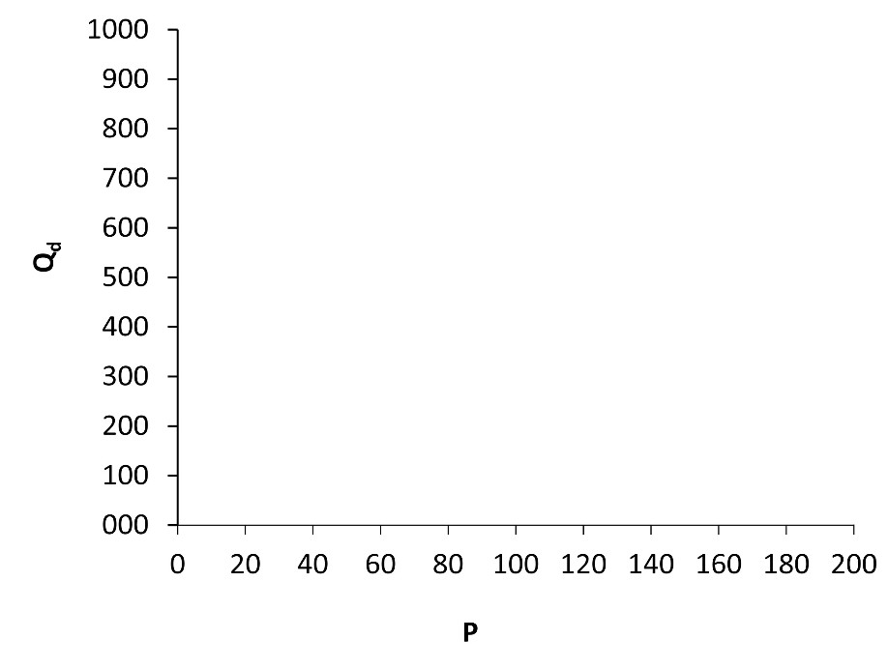

Fig. 2X3A Qd = 1000 - 5p

22

© Mik Wisniewski 2016

Mik Wisniewski, *Quantitative Methods for Decision Makers*, 6e, Instructor’s Manual

Fig. 2X3D Revenue equation

50000

45000   
40000   
35000   
30000   
25000   
20000   
15000   
10000

5000

0

0 20 40 60 80 100 120 140 160 180 200

P

23

© Mik Wisniewski 2016

R

Mik Wisniewski, *Quantitative Methods for Decision Makers*, 6e, Instructor’s Manual

Fig. 2X4B Hire costs

250

200

150

Ca

100

Cb

50

0

0 200 400 600 800 1000 1200 1400 1600 1800 2000

Mileage, M

24

© Mik Wisniewski 2016

Cost (£)

Mik Wisniewski, *Quantitative Methods for Decision Makers*, 6e, Instructor’s Manual

Fig. 2X7B Profit equation

500

400

300

200

100

0

-100

-200

0 2 4 6 8 10 12 14 16 18 20

Q

25

© Mik Wisniewski 2016

F

Mik Wisniewski, *Quantitative Methods for Decision Makers*, 6e, Instructor’s Manual

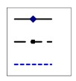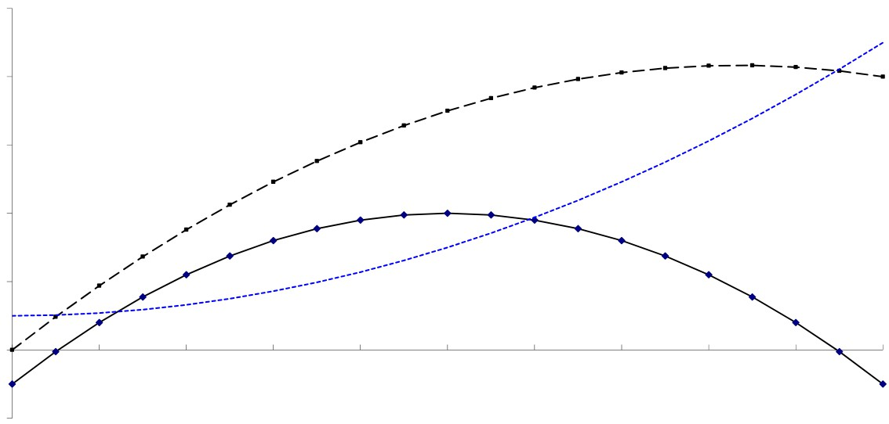

Fig. 2X7C Profit, cost and revenue

1000

800

600

F

400 R

C

200

0

-200

0 2 4 6 8 10 12 14 16 18 20

Q

26

© Mik Wisniewski 2016

F,R,C