# Chapter 2 Organization Strategy and Project Selection

## Chapter Outline

1. Why Project Managers Need to Understand Strategy

2. The Strategic Management Process: An Overview

A. Four Activities of the Strategic Management Process

i. Review and Define the Organizational Mission

ii. Analyze and Formulate Strategies

iii. Set Objectives to Achieve Strategies

iv. Implement Strategies through Projects

3. The Need for a Project Priority System

A. Problem 1: The Implementation Gap

B. Problem 2: Organizational Politics

C. Problem 3: Resource Conflicts and Multitasking

4. Project Classification

5. Phase Gate Model

6. Selection Criteria

A. Financial Criteria

i. Financial Models

B. Nonfinancial Criteria

C. Two Multi-Criteria Selection Models

i. Checklist Models

ii. Multi-Weighted Scoring Models

7. Applying a Selection Model

A. Project Classification

i. Selecting a Model

B. Sources and Solicitation of Project Proposals

C. Ranking Proposals and Selection of Projects

i. Responsibility for Prioritizing

8. Managing the Portfolio System

A. Senior Management Input

B. Governance Team Responsibilities

C. Balancing the Portfolio for Risks and Types of Projects

9. Summary

10. Key Terms

11. Review Questions

12. Snapshot from Practice: Discussion Questions

13. Exercises

14. Case 2.1: Hector Gaming Company

15. Case 2.2: Film Prioritization

16. Case 2.3: Fund Raising Project Selection

## Chapter Learning Objectives

After reading this chapter you should be able to:

|  |  |
| --- | --- |
| LO 2-1 | Explain why it is important for project managers to understand their organization's strategy. |
|  |  |
| LO 2-2 | Identify the significant role projects contribute to the strategic direction of the organization. |
|  |  |
| LO 2-3 | Understand the need for a project priority system. |
|  |  |
| LO 2-4 | Distinguish among three kinds of projects. |
| LO 2-5 | Describe how the phase gate model applies to project management. |
|  |  |
| LO 2-6 | Apply financial and nonfinancial criteria to assess the value of projects. |
|  |  |
| LO 2-7  LO 2-8  LO 2-9 | Understand how multi-criteria models can be used to select projects.    Apply an objective priority system to project selection.  Understand the need to manage the project portfolio. |
|  |  |

## Review Questions

**1. Describe the major components of the strategic management process.**

The strategic management process involves assessing what we are, what we want to become, and how we are going to get there. The major generic components of the process include the following:

a. Defining the mission of the organization

b. Analysis of the external and internal environments

c. Setting objectives

d. Formulating strategies to reach objectives

e. Implementing strategies through projects

**2. Explain the role projects play in the strategic management process.**

Strategy is implemented primarily through projects. Successful implementation of projects means reaching the goals of the organization and thus meeting the needs of its customers. Projects that do not contribute to the strategic plan waste critical organization resources.

**3. How are projects linked to the strategic plan?**

Projects are linked to the strategic plan because projects represent *how* a strategy is to be implemented. Since some projects are more important than others, the best way to maximize the organization’s scarce resources is through a priority scheme which allocates resources to a portfolio of projects which balance risk and contribute the most to the strategic plan.

**4. The portfolio of projects is typically represented by compliance, strategic, and operations projects. What impact can this classification have on project selection?**

By carefully aligning your project proposal with one classification, you may increase the chances of it being selected. Remember, senior management typically allots budgets for each category independent of actual project selection. Knowledge of funds available, risk portfolio, senior management bias, etc. may cause some to attempt to move their project proposal to a different classification to improve the chances of the project being selected.

**5. Why does the priority system described in this chapter require that it be open and published? Does the process encourage bottom-up initiation of projects? Does it discourage some projects? Why?**

An open, published priority system ensures projects are selected on the basis of their contribution to the organization. If the priority system is not open, squeaky wheels, strong people, and key departments all get their projects selected for the wrong reasons. Bottom-up evaluation is encouraged because every organization member can self-evaluate their project idea against priorities – and so can everyone else in the organization. To some, this approach may look intimidating, but it rarely is in practice; however, it does discourage projects that clearly will not make positive, significant contributions to the organization vision.

**6. Why should an organization not rely only on ROI to select projects?**

Financial criteria, like ROI alone, will not ensure that selected projects contribute to the mission and strategy of a firm. Other considerations such as developing new technology, public image, brand loyalty, ethical position, and maintaining core competencies should be considered. Furthermore, it is difficult or next to impossible to assess ROI for many important projects (e.g., projects to develop new technologies). While ROI is likely to be a key consideration for many organizations, multiple screening criteria are recommended for selecting and prioritizing projects.

**7. Discuss the pros and cons of the checklist versus the weighted factor methods of selecting projects.**

**Checklist Model**

* Flexible
* Applies over a wide range of different types of projects, divisions, and locations
* Impossible to rigorously compare and rank project by priority
* Politics, power, and manipulation of project selection is very possible

**Weighted Factor Model**

* Allows comparison and ranking of potential projects
* Open system
* Allows for self-evaluation of proposed project
* Power and politic games are exposed

**Snapshot from Practice: Discussion Questions**

*2.1* *Does IBM’s Watson’s Jeopardy Project Represent a Change in Strategy?*

1. Why would IBM want to move from computer hardware to service products?

IBM realizes that hardware had low profit margins given competition and subject to disruptive technology. The tendency to outsource IT service provides a reliable income stream and allows IBM to invest in its competitive advantage.

2. What impact will Artificial Intelligence (AI) have on the field of project management?

Experts have announced AI as the second tech revolution (the first being digital). This will lead to an increase in the number of projects as AI transforms existing products as well as create new products. AI should improve estimating and risk management on projects.

* 1. *Crisis IT*

1. What are the benefits of Frontier Airlines using a weighted scoring scheme to assess the value of projects?

Weighted scoring schemes reduce politics and provide a basis for evaluating projects in terms of a firm’s priorities and mission. This allowed them to quickly identify low priority projects to cut.

* 1. *Project Code Names*

1. Can you think of a project code name not mentioned in the Snapshot? What function did it serve?

Usually one or more students can draw upon their own experience to identify a code name to analyze. Microsoft was known for location names: Vienna (Windows 7), Cairo (Windows NT 4.). Google prefers to deserts/candy: Jelly Bean (Android 4.1-3), KitKat (Android 4.4). In both cases, the code names appear to be used primarily to identify the project within the organization.

## Exercises

**1. You manage a hotel resort located on the South Beach on the Island of Kauai in Hawaii. You are shifting the focus of your resort from a traditional fun-in-the-sun destination to eco-tourism. (Eco-tourism focuses on environmental awareness and education.) How would you classify the following projects in terms of compliance, strategic, and operational?**

**a. Convert the pool heating system from electrical to solar power.**

**b. Build a four-mile nature hiking trail.**

**c. Renovate the horse barn.**

**d. Launch a new promotional campaign with Hawaii Airlines.**

**e. Convert 12 adjacent acres into a wildlife preserve.**

**f. Update all the bathrooms in condos that are 10 years or older.**

**g. Change hotel brochures to reflect eco-tourism image.**

**h. Test and revise disaster response plan based on new requirements.**

**How easy was it to classify these projects? What made some projects more difficult than others?**

Most students classify the projects as follows:

Compliance: f., h.

Operational: a., c.

Strategic: b., d., e., g.

Most students claim it was not too difficult to classify the projects other than they had to make judgment calls given the limited information. In real life, they would have such information. Debates occur around whether converting the heating system to solar was an operational necessity or to fit the eco-friendly image. Likewise, launching the promotional campaign with Hawaii Airlines would be considered strategic if it promoted the eco-tourism theme; otherwise, it could be considered operational.

**What do you think you now know that would be useful for managing projects at the hotel?**

By classifying the projects, prioritizing is more easily done. Different selection criteria can be used for selecting strategic versus operational projects. Financially, senior management would have more information to divide the total money pie allocated to projects.

**2. Two new software projects are proposed to a young, start-up company. The Alpha project will cost $150,000 to develop and is expected to have annual net cash flow of $40,000. The Beta project will cost $200,000 to develop and is expected to have annual net cash flow of $50,000. The company is very concerned about their cash flow. Using the payback period, which project is better from a cash flow standpoint? Why?**

$$Payback=\frac{Inverstment}{Annual savings}$$

$${Payback}_{Project Alpha}=\frac{\$150,000}{\$40,000}=3.75 years$$

$${Payback}_{Project Beta}=\frac{\$200,000}{\$50,000}=4.00 years$$

A lower payback is better. Project Alpha has the lower payback and so has the better payback.

**3. A five-year project has a projected net cash flow of $15,000, $25,000, $30,000, $20,000, and $15,000 in the next five years. It will cost $50,000 to implement the project. If the required rate of return is 20 percent, conduct a discounted cash flow calculation to determine the NPV.**

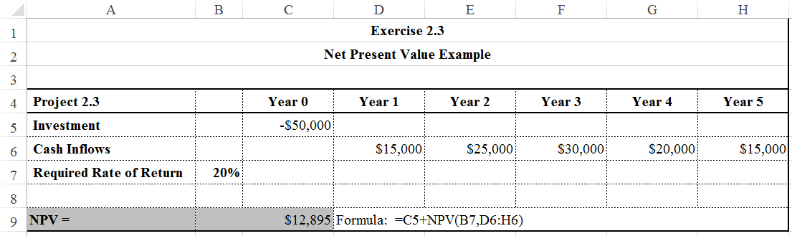

Since the NPV is positive, accept the project.

**4. You work for the 3T company, which expects to earn at least 18 percent on its investments. You have to choose between two similar projects. The following chart shows the cash information for each project. Which of the two projects would you fund if the decision is based only on financial information? Why?**

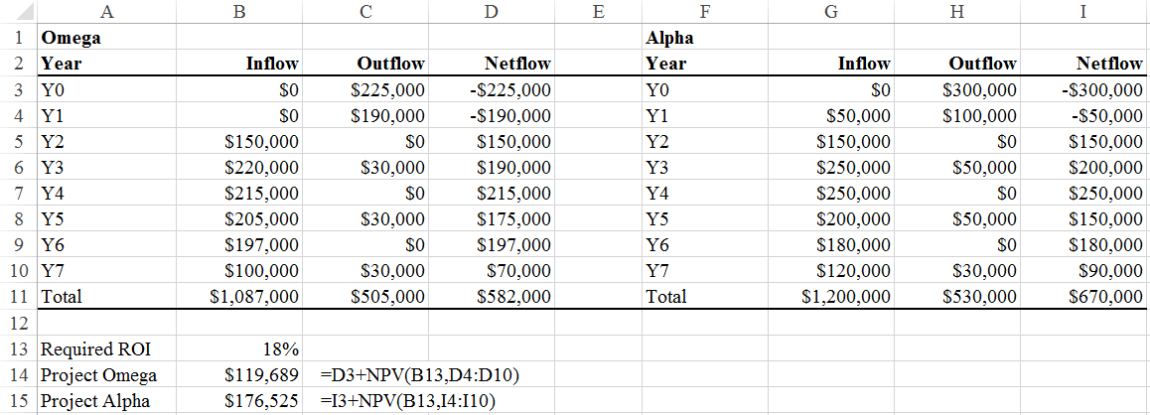

The worksheet shown above shows the inflows (columns B and G), the outflows (columns C and H), and the sum of those two values (columns D and I). Row 11 provides the column totals.

Based on this, the Alpha Project provides the largest cash inflow. However, the time value of money is not included in the calculations so far.

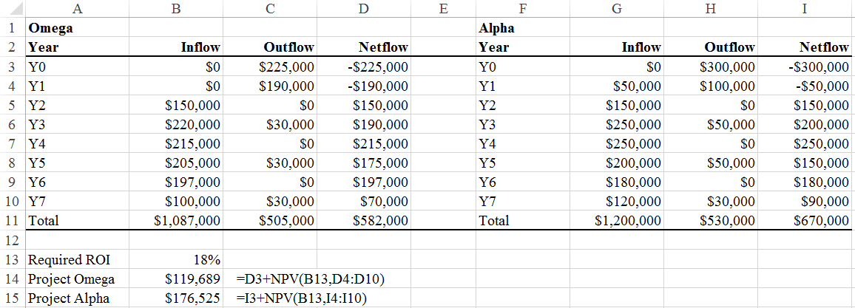

The worksheet shown above modifies the original worksheet to calculate the net present value of the two net cash flows. The formulas used are shown to the right of the actual formulas. The net present value of $176,525 for Project Alpha is higher than the net present value of $119,689 for Project Omega. However, they are both positive and exceed the required 18 percent return so both should be accepted.

**5. You are the head of the project selection team at SIMSOX. Your team is considering three different projects. Based on past history, SIMSOX expects at least a rate of return of 20 percent.**

**Given the following information for each project, which one should be SIMSOX’s first priority? Should SIMSOX fund any of the other projects? If so, what should be the order of priority based on return on investment?**

$$Project NPV=I_{0}+\sum_{t=1}^{n}{\frac{F_{t}}{{\left(1+k\right)}^{t}}}$$

For Dust Devils Project using the NPV equation:

$$NPV=-\$500,000+\frac{\$50,000}{{\left(1+.20\right)}^{1}}+\frac{\$250,000}{{\left(1+.20\right)}^{2}}+\frac{\$350,000}{{\left(1+.20\right)}^{3}} \\ =-\$500,000+\$41,667+\$173,611+\$202,546=-\$82,176$$

For Dust Devils Project using Excel:

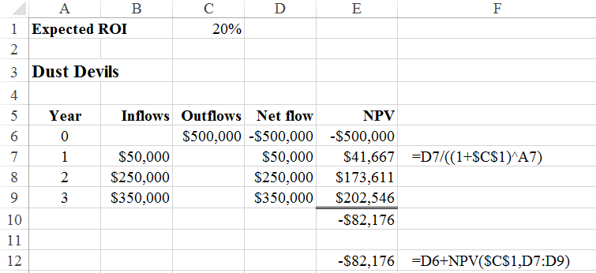

The expected ROI is entered in cell C1 and that will be referenced in the worksheets for the next two projects. Cells E6 to E10 repeat the calculations shown in the equations above, only using Excel. Cells E7 to E9 perform the three discounting calculations. The equation used is shown in cell F7. The dollar signs in “$C$1” keep that cell from changing when this formula is copied up or down. In Excel, this is called an absolute reference.

Cell E12 performs the NPV calculations as shown in the textbook. Excel gives the same answer either way. Cell F12 shows the formula for the direct NPV calculations.

For Osprey Project using the NPV equation:

$$NPV=-\$250,000+\frac{\$75,000}{{\left(1+.20\right)}^{1}}+\frac{\$75,000}{{\left(1+.20\right)}^{2}}+\frac{\$75,000}{{\left(1+.20\right)}^{3}}+\frac{\$50,000}{{\left(1+.20\right)}^{4}} \\ =-\$250,000+\$62,500+\$52,083+\$43,403+\$24,113=-\$67,901$$

For Osprey Project using Excel:

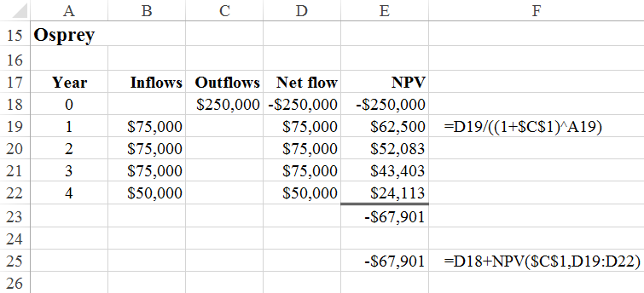

For Voyagers Project using the NPV equation:

$$NPV=-\$75,000+\frac{\$15,000}{{\left(1+.20\right)}^{1}}+\frac{\$25,000}{{\left(1+.20\right)}^{2}}+\frac{\$50,000}{{\left(1+.20\right)}^{3}}+\frac{\$50,000}{{\left(1+.20\right)}^{4}}+\frac{\$150,000}{{\left(1+.20\right)}^{5}} \\ =-\$75,000+\$12,500+\$17,361+\$28,935+\$24,113+\$60,282=\$68,191$$

For Voyagers Project using Excel:

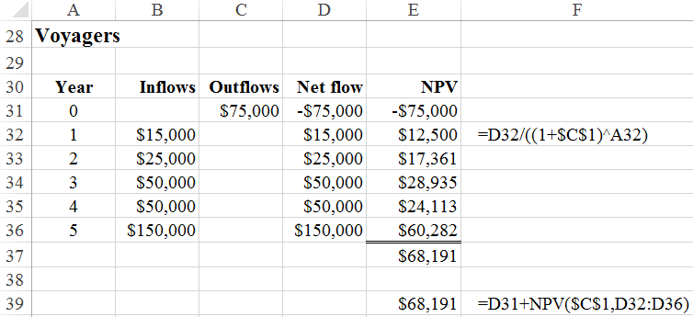

The only project SIMSOX should consider is Voyagers. Each of the other two projects would not satisfy the high rate of return SIMSOX expects from its projects.

**6. You are the head of the project selection team at Broken Arrow Records. Your team is considering three different recording projects. Based on past history, Broken Arrow expects at least a rate of return of 20 percent.**

**Given the following information for each project, which one should be Broken Arrow’s first priority? Should Broken Arrow fund any of the other projects? If so, what should be the order of priority based on return on investment?**

The first recording Broken Arrow should choose to undertake is **Tonight’s the Night,** followed by **On the Beach**. The **Time Fades Away** project does not satisfy the high rate of return Broken Arrow expects from its projects.

**Time Fades Away**

$$NPV=-\$600,000+\frac{\$600,000}{{\left(1+.20\right)}^{1}}+\frac{\$75,000}{{\left(1+.20\right)}^{2}}+\frac{\$20,000}{{\left(1+.20\right)}^{3}}+\frac{\$15,000}{{\left(1+.20\right)}^{4}}+\frac{\$10,000}{{\left(1+.20\right)}^{5}} \\ =-\$600,000+\$500,000+\$52,083+\$11,574+\$7,234+\$4,019=-\$25,090$$

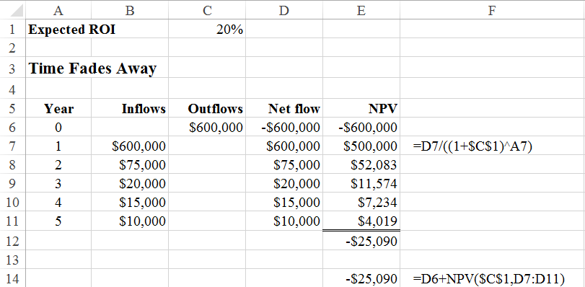

**On the Beach**

$$NPV=-\$400,000+\frac{\$400,000}{{\left(1+.20\right)}^{1}}+\frac{\$100,000}{{\left(1+.20\right)}^{2}}+\frac{\$25,000}{{\left(1+.20\right)}^{3}}+\frac{\$20,000}{{\left(1+.20\right)}^{4}}+\frac{\$10,000}{{\left(1+.20\right)}^{5}} \\ =-\$400,000+\$333,333+\$69,444+\$14,468+\$9,645+\$4,019=\$30,909$$

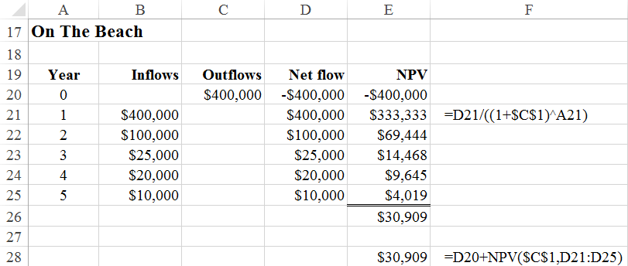

**Tonight’s the Night**

$$NPV=-\$200,000+\frac{\$200,000}{{\left(1+.20\right)}^{1}}+\frac{\$125,000}{{\left(1+.20\right)}^{2}}+\frac{\$76,000}{{\left(1+.20\right)}^{3}}+\frac{\$20,000}{{\left(1+.20\right)}^{4}}+\frac{\$10,000}{{\left(1+.20\right)}^{5}} \\ =-\$200,000+\$166,667+\$86,806+\$43,403+\$12,506+\$4,019=\$112,950$$

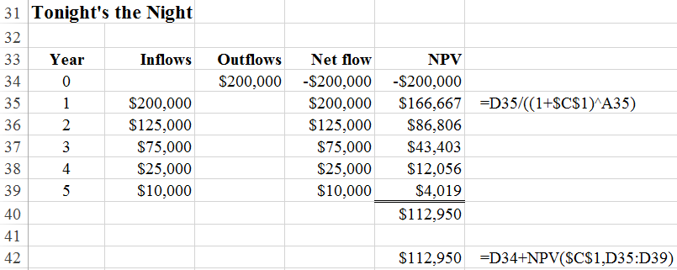

**7. The Custom Bike Company has set up a weighted scoring matrix for evaluation of potential projects. Following are five projects under consideration.**

**a. Using the scoring matrix below, which project would you rate highest? Lowest?**

**b. If the weight for “Strong Sponsor” is changed from 2.0 to 5.0, will the project selection change? What are the three highest weighted project scores with this new weight?**

**c. Why is it important that the weights mirror critical strategic factors?**

Using original weights

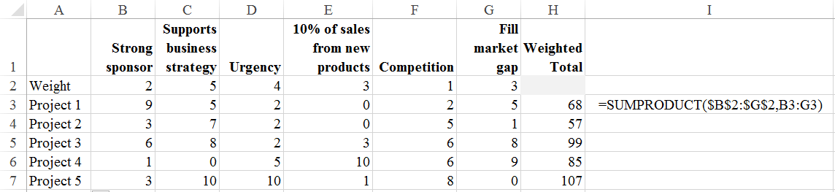

1. Rate Project 5 the highest and Project 2 the lowest.

Using revised weights

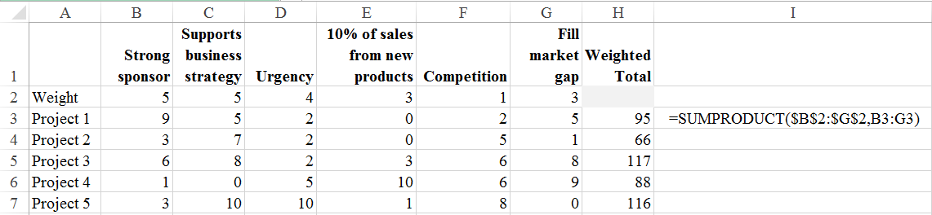

b. Yes. The three highest are Projects 3, 5, and 1. Given the new strong sponsor weight, Project 3 becomes the first choice. However, note that Project 5 is still the near equivalent of Project 3 by the weighting scheme.

c. It is important that the weights mirror critical strategic factors because failure to do so will cause selection of projects that do not contribute the most to the strategic plan.

## Case 2.1 Hector Gaming Company

**Hector Gaming Company (HGC) is an educational gaming company specializing in young children’s educational games. HGC has just completed their fourth year of operation. This year was a banner year for HGC. The company received a large influx of capital for growth by issuing stock privately through an investment banking firm. It appears the return on investment for this past year will be just over 25 percent with zero debt! The growth rate for the last two years has been approximately 80 percent each year. Parents and grandparents of young children have been buying HGC’s products almost as fast as they are developed. Every member of the 56-person firm is enthusiastic and looking forward to helping the firm grow to be the largest and best educational gaming company in the world. The founder of the firm, Sally Peters, has been written up in *Young Entrepreneurs* as “the young entrepreneur to watch.” She has been able to develop an organization culture in which all stakeholders are committed to innovation, continuous improvement, and organization learning.**

(Rest of case not shown due to length.)

This case brings up a very common problem found in many businesses. Implementing organization strategy, in a large part, represents projects. In many firms there is no *interdependent* way to prioritize projects. This gap causes conflicts similar to those noted in the HGC case. Proposed projects typically come from functional areas such as marketing, production, information systems, finance, and so on, with no central clearing house to ensure that resources are adequate, and projects are prioritized with the strategic plan.

Students are generally good at recognizing the problem. If they fall short, it will be in showing a selection process which might work in this dynamic environment of HGC. The process and generic example shown in Figures 2.1 and 2.2 are typically used as a basis for their recommendations. For those who have had some business experience, answers vary from highly creative criteria to simple, general statements. The authors find those who have doubts about a project priority system working (“It would not work in my company.”) will stimulate the class discussion.

We find asking students to discuss examples from their work experience fruitful. The outcome usually indicates most businesses do not use a clear method for prioritizing projects to the strategic plan. The obvious question is, “Would the company be better off if it had a priority system closely linked to the strategic plan?” We end the discussion by reviewing the important role projects play in implementing strategy, the interdependence of functional groups and projects rather than independence, and the changing role of the project manager in the project driven organization.

## Case 2.2 Film Prioritization

**The purpose of this case is to give you experience in using a project priority system that ranks proposed projects by their contribution to the organization’s objectives and strategic plan.**

(Rest of case not shown due to length.)

The objective of this in-class exercise is to demonstrate how a project priority system can be used to select and prioritize projects according to an organization’s objectives and strategic plan. The exercise involves a film division of a large entertainment conglomerate and the priority team’s decision to review and prioritize different film proposals. The priority system used is consistent with the one described in Chapter 2.

### Step 1 Introduction (10 minutes)

Students read the scenario and ask questions before starting Step 2. Students who have read Chapter 2 have few problems understanding what they are supposed to do. For those who did not, you may have to explain the difference between a “must” and “want” objective and that they are to multiply the impact rating with the relative importance score. For example, if the film proposal is considered to have a high potential for being nominated for an Academy Award for Best Picture of the Year, then it would receive a weighted score of 120 (2 × 60). You may also have to explain the ROI probability information included with each proposal. For example, for proposal #1 (*My Life with Dalai Lama*), there is an eighty percent chance that it will earn 8 percent return on investment, a fifty-fifty chance the ROI will be 18 percent, and a 20 percent chance that the ROI will be 24 percent.

### Step 2 Individual assessment (10 minutes)

Students use the Project Priority Evaluation Form provided in the text to assess and rank the seven proposals on their own.

### Step 3 Priority team assessment (15-20 minutes)

Students meet in small groups of four to five students to collectively assess and rank the seven film proposals. Students should be instructed to not simply vote or calculate the average ranking for each proposal but to discuss their ratings and to try to reach a group consensus for each proposal.

### Step 4 Priority team report ratings (5 minutes)

Students select a leader to report their final rankings either on a whiteboard.

### Step 5 Discuss results (10-15 minutes)

As a class, students should compare and contrast the rankings of each group. Where there is disagreement across groups, students should be asked to explain the rationale behind their ratings. The intent is not to reach a class consensus but rather to explore how different groups interpreted the information.

The one proposal that there is likely to generate the biggest disagreement is proposal #1 (*My Life with Dalai Lama*). Astute students will reject this proposal for not meeting the must objective of having “no adverse effect on other operations.” They will point out that the company has plans to open a theme park in mainland China, and the Chinese government would frown upon a film on the Dalai Lama since he is a focal point for resistance to China’s control of Tibet. This is based on an actual incident involving the Disney Corporation. Under pressure from the Chinese government, Disney withdrew active support of filmmaker Martin Scorsese’s biographical account of the Dalai Lama’s life entitled “Kundun” in 1997.

After discussing the differing results, the students should be encouraged to discuss the value of using this kind of approach to select and prioritize projects. Here it should be emphasized that this approach reduces the role that organizational politics can play in project selection and aligns projects with the strategy and objectives of the firm.

If the class includes students from industry, then this would be an opportune time to ask them how their organization selects and prioritizes projects and whether such a system would be appropriate for their organization.

In general, this exercise has proven to be a fun and easy exercise to implement and does a good job of demonstrating how a project priority system can be used to select projects that meet the objectives of a firm.

### Variation on the exercise:

To conserve time, Step 2 can be skipped, and the students can immediately work in groups to rank the proposals.

## Case 2.3 Fund Raising Project Selection

**The purpose of this “case exercise” is to provide you with experience in using a project selection process that ranks proposed projects by their contribution to an organization’s mission and strategy.**

(Rest of case not shown due to length.)

The objective of this in-class exercise is to demonstrate how a project priority system can be used to select and prioritize projects according to an organization’s objectives and strategic plan. The exercise is an alternative to the Film Prioritization case featured in this chapter. The exercise involves a class on project management and the priority team’s decision to review and prioritize different fund-raising proposals. The priority system used is consistent with the one described in Chapter 2.

This exercise is based on the author’s experiences using fund raising projects to teach project management fundamentals and is based on actual projects and proposals.

### Step 1 Introduction (10 minutes)

Students read the case and ask questions before starting Step 2. Students who have read Chapter 2 have few problems understanding what they are supposed to do. For those who did not, you may have to explain the difference between a “must” and “want” objective and that they are to multiply the impact rating with the relative importance score. For example, if the proposal is considered to have a high potential for earning more than $1,000, then it would receive a weighted score of 180 (2 × 90). Proposals which fail to meet a “must objective” are to be rejected without further evaluation.

### Step 2 Individual assessments (10 minutes)

Students use the Project Priority Evaluation Form provided in the text to assess and rank the six proposals on their own.

### Step 3 Priority team assessments (15-20 minutes)

Students meet in small groups of four to five students to collectively assess and rank the six fund raising proposals. Students should be instructed to not simply vote or calculate the average ranking for each proposal but to discuss their ratings and to try to reach a group consensus for each proposal.

### Step 4 Priority team report ratings (5 minutes)

Students select a leader to report their final rankings.

### Step 5 Discuss results (10-15 minutes)

As a class, students should compare and contrast the rankings of each group. Where there is disagreement across groups, students should be asked to explain the rationale behind their ratings. The intent is not to reach a class consensus but rather to explore how different groups interpreted the information.

After discussing the differing results, the students should be encouraged to discuss the value of using this kind of approach to select and prioritize projects. Here it should be emphasized that this approach reduces the role that organizational politics can play in project selection and aligns projects with the strategy and objectives of the firm.

If the class includes students from industry, then this would be an opportune time to ask them how their organization selects and prioritizes projects and whether such a system would be appropriate for their organization.

In general, this exercise has proven to be a fun and easy exercise to implement and does a good job of demonstrating how a project priority system can be used to select projects that meet the objectives of a firm.

### Variation on the exercise:

To conserve time, Step 2 can be skipped, and the students can immediately work in groups to rank the proposals. Alternatively, students could do Step 2 before class.

### What really happened?

This case is based on actual projects proposed by students in our project management classes. With the exception of Raffle for Life, additional information can be found about these and other projects at <http://business.oregonstate.edu/faculty-and-staff-bios/erik-larson>. The Raffle of Life proposal was rejected for failing to meet the “must objective” of providing opportunity to experience and learn about project management. The lack of coordination involved in conducting a raffle was deemed inadequate.

**Hoops for Life** raised $1,575. There were several Asian Americans on this project team who were active in state-wide Asian American community. They used their contacts and social capital to attract teams from up and down the Willamette Valley.

**Singing for Smiles** raised $607. The night spot that hosted their event did not allow them to charge a cover fee and they had to rely on donations from patrons. They were not able to capture the imagination of the campus and relied on regular Karaoke participants.

**Halo for Heroes** raised $1,458. This event has been done twice with the second one attracting several participants from the first event. A key to their financial success was switching from individual competition to team competition.

**Hold’em for Hunger** raised $705. This is one of several poker projects. Others raised between $405 and $1,010. Students realized that they would have made much more money if they had used product donations instead of cash for prizes.

**Build your own Box** raised $110. To promote the event and counter the argument that students would be having fun at the expense of the homeless, three members of this team actually went homeless for three nights and were featured in local newspaper and news. On the night of the event, a severe rainstorm hit the campus and only three participants showed up.