Programming Logic and Design, 9th Edition
Chapter 1

Review Questions

- Computer programs also are known as____________.
- data
- hardware
- software
- information
- The major computer operations include ____________.
  - input, processing, and output
  - hardware and software
  - sequence and looping
  - spreadsheets, word processing, and data communications
- Visual Basic, C++, and Java are all examples of computer ____________.
- operating systems
- programming languages
- hardware
- machine languages
- A programming language’s rules are its ____________.
- syntax
- logic
- format
- options
- The most important task of a compiler or interpreter is to ____________.
  - create the rules for a programming language
  - translate English statements into a language such as Java
  - translate programming language statements into machine language
  - execute machine language programs to perform useful tasks
- Which of the following is temporary, internal storage?
  - CPU
  - hard disk
  - keyboard
  - memory
- Which of the following pairs of steps in the programming process is in the correct order?
  - code the program, plan the logic
  - test the program, translate it into machine language
  - put the program into production, understand the problem
  - code the program, translate it into machine language
- A programmer’s most important task before planning the logic of a program is to ____________.
  - decide which programming language to use
  - code the problem
  - train the users of the program
  - understand the problem
- The two most commonly used tools for planning a program’s logic are _____.
  - ASCII and EBCDIC
  - Java and Visual Basic
  - flowcharts and pseudocode
  - word processors and spreadsheets
- Writing a program in a language such as C++ or Java is known as _______ the program.
  - translating
  - coding
  - interpreting
  - compiling
- An English-like programming language such as Java or Visual Basic is a ________ programming language.
  - machine-level
  - low-level
  - high-level
  - binary-level
- Which of the following is an example of a syntax error?
  - producing output before accepting input
  - subtracting when you meant to add
  - misspelling a programming language word
  - all of the above
- Which of the following is an example of a logical error?
  - performing arithmetic with a value before inputting it
  - accepting two input values when a program requires only one
  - dividing by 3 when you meant to divide by 30
  - all of the above
- The parallelogram is the flowchart symbol representing ____________.
  - input
  - output
  - either a or b
  - none of the above
- In a flowchart, a rectangle represents ____________.
  - input
  - a sentinel
  - a question
  - processing
- In flowcharts, the decision symbol is a ____________.
- parallelogram
- rectangle
- lozenge
- diamond
- The term eof represents ____________.
  - a standard input device
  - a generic sentinel value
  - a condition in which no more memory is available for storage
  - the logical flow in a program
- When you use an IDE instead of a simple text editor to develop a program, ____________.
  - the logic is more complicated
  - the logic is simpler
  - the syntax is different
  - some help is provided
- When you write a program that will run in a GUI environment as opposed to a command-line environment, ____________.
  - the logic is very different
  - some syntax is different
  - you do not need to plan the logic
  - users are more confused
- As compared to procedural programming, with object-oriented programming, ____________.
  - the programmer’s focus differs
  - you cannot use some languages, such as Java
  - you do not accept input
  - you do not code calculations; they are created automatically

Programming Exercises
- Match the definition with the appropriate term.
1. | Computer system devices | a. | compiler
2. | Another word for program | b. | syntax
3. | Language rules | c. | logic
4. | Order of instructions | d. | hardware
5. | Language translator | e. | software

Answer:
1. | Computer system equipment | → | d. | hardware
2. | Another word for program | → | e. | software
3. | Language rules | → | b. | syntax
4. | Order of instructions | → | c. | logic
5. | Language translator | → | a. | compiler

- In your own words, describe the steps to writing a computer program.

Answer:
The programmer must understand the problem that the user is trying to solve. Next, the programmer plans the logic, often using a flowchart or pseudocode. Then, the program is coded in a language, such as Visual Basic or Java, and translated to machine language using a compiler or interpreter. Finally, the program is tested and then put into production and maintained over the ensuing months or years.

- Draw a flowchart or write pseudocode to represent the logic of a program that allows the user to enter a value. The program multiplies the value by 10 and outputs the result.

Answer:
Flowchart
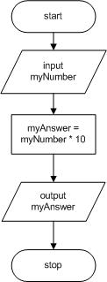

Pseudocode

start
input myNumber
myAnswer = myNumber * 10
output myAnswer
stop

- Draw a flowchart or write pseudocode to represent the logic of a program that allows the user to enter a value for one edge of a cube. The program calculates the surface area of one side of the cube, the surface area of the cube, and its volume. The program outputs all the results.
Answer:
Flowchart
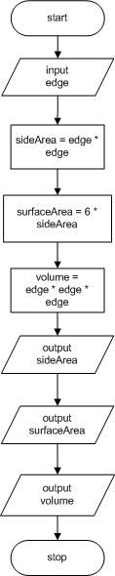

Pseudocode

start
input edge
sideArea = edge * edge
surfaceArea = 6 * sideArea
volume = edge * edge * edge
output sideArea
output surfaceArea
output volume
stop

- Draw a flowchart or write pseudocode to represent the logic of a program that allows the user to enter a value for hours worked in a day. The program calculates the hours worked in a five-day week and the hours worked in a 252-day work year. The program outputs all the results.

Answer:
Flowchart
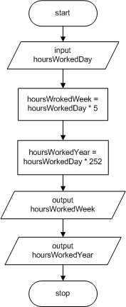

Pseudocode

start
input hoursWorkedDay
hoursWorkedWeek = hoursWorkedDay * 5
hoursWorkedYear = hoursWorkedDay * 252
output hoursWorkedWeek
output hoursWorkedYear
stop

- Draw a flowchart or write pseudocode to represent the logic of a program that allows the user to enter two values. The program outputs the sum of and the difference between the two values.

Answer:
Flowchart
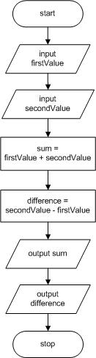

Pseudocode

start
input firstValue
input secondValue
sum = firstValue + secondValue
difference = secondValue - firstValue
output sum
output difference
stop

- Draw a flowchart or write pseudocode to represent the logic of a program that allows the user to enter values for the current year and the user’s birth year. The program outputs the age of the user this year.

Answer:
Flowchart
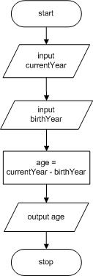

Pseudocode

start
input currentYear
input birthYear
age = currentYear - birthYear
output age
stop

- a. Draw a flowchart or write pseudocode to represent the logic of a program that allows the user to enter an hourly pay rate and hours worked. The program outputs the user’s gross pay.
Answer:
Flowchart
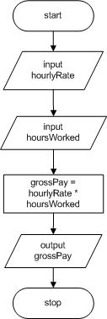

Pseudocode

start
input hourlyRate
input hoursWorked
grossPay = hourlyRate * hoursWorked
output grossPay
stop

b. Modify the program that computes gross pay to allow the user to enter the withholding tax rate. The program outputs the net pay after taxes have been withheld.

Answer:
Flowchart
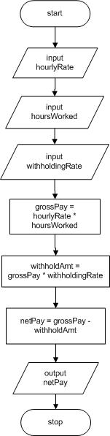

Pseudocode

start
input hourlyRate
input hoursWorked
input withholdingRate
grossPay = hourlyRate * hoursWorked
withholdAmt = grossPay * withholdingRate
netPay = grossPay - withholdAmt
output netPay
stop

- Research current rates of monetary exchange. Draw a flowchart or write pseudocode to represent the logic of a program that allows the user to enter a number of dollars and convert it to Euros and Japanese yen.

Answer:
Flowchart
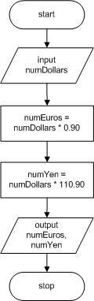

Pseudocode

start
input numDollars
numEuros = numDollars * 0.90
numYen = numDollars * 110.90
output numEuros, numYen
stop

(Please note that these exchange rates are valid as of the time of this writing)

- A mobile phone app allows a user to press a button that starts a timer that counts seconds. When the user presses the button again, the timer stops. Draw a flowchart or write pseudocode that accepts the elapsed time in seconds and displays the value in minutes and remaining seconds. For example, if the elapsed time was 130 seconds, the output would be 2 minutes and 10 seconds.

Answer: (Please note this solution assumes minutes is an integer and has been truncated.)
Flowchart
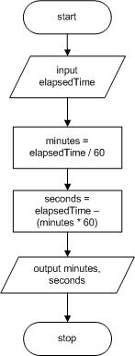

Pseudocode

start
input elapsedTime
minutes = elapsedTime / 60
seconds = elapsedTime – (minutes * 60)
output minutes, seconds
stop

Performing Maintenance

- In this chapter you learned that some of the tasks assigned to new programmers frequently involve maintenance—making changes to existing programs because of new requirements. A file named MAINTENANCE01-01.txt is included with your downloadable student files. Assume that this program is a working program in your organization and that it needs modifications as described in the comments (lines that begin with two slashes) at the beginning of the file. Your job is to alter the program to meet the new specifications.

Answer:
// This program accepts a user's monthly pay
// and rent, utilities, and grocery bills
// and displays the amount available for discretionary spending
// (which might be negative)
// Modify the program to output the pay and the total bills
// as well as the remaining discretionary amount

start
input pay
input rent
input utilities
input groceries
bills = rent + utilities + groceries
discretionary = pay - bills
output pay
output bills
output discretionary
stop

Find the Bugs

- Your downloadable files for Chapter 1 include DEBUG01-01.txt, DEBUG01-02.txt, and DEBUG01-03.txt. Each file starts with some comments (lines that begin with two
slashes) that describe the program. Examine the pseudocode that follows the
introductory comments, then find and correct all the bugs.

Answer:
DEBUG01-01
// This pseudocode is intended to describe
// computing the price of an item on sale for 10% off
start
input origPrice
discount = origPrice * 0.10
finalPrice = origPrice - discount
output finalPrice
stop

DEBUG01-02
// This pseudocode is intended to compute the number
// of miles per gallon you get with your automobile.
start
input milesTraveled
input gallonsOfGasUsed
milesPerGallon = milesTraveled / gallonsOfGasUsed
// milesPerGallon is computed using division
output milesPerGallon
// miles is misspelled, and the P in milesPerGallon should be uppercase
stop
// Program should end with stop

DEBUG01-03
// This pseudocode is intended to describe
// computing the per day cost of your rent
// in a 30-day month
start
input rent
costPerDay = rent / 30
// Comment indicates 30-day month
output costPerDay
// output should be costPerDay
stop

- Your downloadable files for Chapter 1 include a file named DEBUG01-04.jpg that contains a flowchart that contains syntax and/or logical errors. Examine the flowchart and then find and correct all the bugs.

Answer:
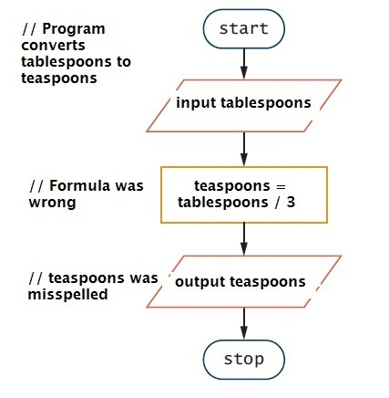

Game Zone

- Create the logic for a Mad Lib program that accepts five words from input, then creates and displays a short story or nursery rhyme that uses them.

Answer:
Students’ answers will vary. But a simple solution could be:

start
input word1
input word2
input word3
input word4
input word5
output “Jack and Jill went up the ”, word1,
“ to fetch a pail of ”, word2,
“. “Jack ”, word3, “ down and broke his ”, word4,
“ and Jill came ”, word5, “ after.”
stop

