Chapter 2
The Financial Market Environment

■ Instructor’s Resources

Overview
Money and capital markets and their major components are introduced in this chapter. Firms need to raise capital in order to survive. Financial institutions give firms access to the money they need to grow. However, greed can drive financial managers and institutions to commit actions that get them into trouble and even force bankruptcy. These bankruptcies result in limited capital flows to firms and both they and the whole economy can suffer. The final section covers a discussion of the impact of taxation on the firm’s financial activities.

■ Answers to Review Questions

1. The key participants in financial transactions are individuals, businesses, and governments. These parties participate both as suppliers and demanders of funds. Individuals are net suppliers, which means that they save more dollars than they borrow, while both businesses and governments are net demanders since they borrow more than they save. One could say that individuals provide the excess funds required by businesses and governments.

Financial institutions include commercial banks and investment banks. The former assists both individuals and companies with their banking needs, while the latter concentrates efforts in the area of assisting corporations with raising funds. Until the late 1990s, the Glass-Steagall Act created a separation between the two. A shadow banking system, where non-deposit-taking enterprises lend money to firms needing cash, has grown to be as large as the traditional banking system.

2. Financial markets provide a forum in which suppliers of funds and demanders of loans and investments can transact business directly.

Primary market is the name used to denote the fact that a security is being issued by the demander
of funds to the supplier of funds. An example would be Microsoft Corporation selling new shares of common stock to the public.

Secondary market refers to the trading of securities among investors subsequent to the primary market issuance. In secondary market trading, no new funds are being raised by the demander of funds. The security is trading ownership among investors. An example would be individual “A” buying common stock of Microsoft through a broker from individual “B.”

Financial institutions and financial markets are not independent of each other. It is quite common to find financial institutions actively participating in both the money market and the capital market as both suppliers and demanders of funds. Financial institutions often channel their investments and obtain needed financing through the financial markets. This relationship exists since these institutions must use the structure of the financial marketplace to find a supplier of funds.

3. The money market is a financial relationship between the suppliers and demanders of short-term debt securities maturing in one year or less, such as U.S. Treasury bills, commercial paper, and negotiable certificates of deposit. The Eurocurrency market is the international equivalent of the U.S. money market and is used for short-term bank time deposits denominated in dollars or other major currencies.

4. The capital market is a financial relationship created by a number of institutions and arrangements that allows the suppliers and demanders of long-term funds (with maturities greater than one year)
to make transactions. The key securities traded in the capital markets are bonds plus common and preferred stock.

5. The broker market consists of national and regional securities exchanges. These organizations provide a location, such as the New York Stock Exchange, to bring together the buyers and sellers of debt and equity. They create a continuous market for securities, allocate scarce capital, determine and publicize security prices, and aid in new financing.

By contrast, dealer markets are electronic markets for the buyers and sellers of securities not listed on the major exchanges. In a broker market, physical trading locations are replaced by security dealers who offer to buy or sell securities at stated bid/ask prices. Dealers buy securities from clients, sell them to other dealers, who in turn sell them to their clients. A majority of shares traded in the dealer market are listed on Nasdaq, the National Association of Securities Dealers Automated Quotation System.

6. In addition to the U.S. capital markets, corporations can raise debt and equity funds in capital markets located in other countries. The Eurobond market is the oldest and largest international debt market. Corporate and government bonds issued in this market are denominated in dollars or other major currencies and sold to investors outside the country in whose currency the bonds are denominated. Foreign bond markets also provide corporations with the opportunity to tap other capital sources. Corporations or governments issue bonds denominated in the local currency and sold only in that home market. The international equity market allows corporations to sell blocks of stock to investors in several countries, providing a diversified investor base and additional opportunities to raise larger amounts of capital.

7. An efficient market will allocate funds to their most productive uses due to competition among wealth-maximizing investors. Prices are assumed to be a function of information about the firm and economy. Only new, unexpected information will cause investors to buy or sell securities. Investors determine the price of assets through their participation in the financial markets. Changes in supply and demand continually impact prices in an efficient market.

An alternative view of market pricing is put forth by advocates of behavioral finance. This explanation of market prices combines finance and psychology. Though prices may deviate from true value for psychological and other reasons, few investors have been able to earn a risk-adjusted, positive rate of return.

8. Securitization is the process of pooling mortgages and then selling claims against that pool in the secondary market. Investors buying these securities extend a loan to the homeowner.

9. Mortgage-backed securities represent claims on the cash flows generated by a pool of mortgages. As the homeowners pay off their mortgages, the money serves as income to the investors. The primary risk associated with mortgage-backed securities is that homeowners may not repay their loans.

10. When a homeowner borrows money to buy a home, he borrows a fixed amount of money. As
housing prices rise, the gap between what he owes and what the house is worth widens. Lenders will allow borrowers who have difficulty making mortgage payments tap this built-up equity. Therefore, mortgage default rates are relatively low.

11. As home prices decline, the value of homes may be less than the amount owed to the bank. Hence, many borrowers will simply walk away from their homes and let lenders repossess them. There will be an added supply of housing. If multiple homes in the area are facing foreclosure, the value of remaining homes will drop. At the same time, borrowers having trouble making mortgage payments will not be able to tap into any built-up equity. These homes will also be repossessed, and the number of homes for sale in an area will rise. Excess home availability will make the remaining homes less valuable, increasing the number of homeowners with houses worth less than the amount owed to the bank. It is a vicious cycle.

12. As mortgage-backed security delinquency rates rose, the value of still solvent mortgage-back securities fell. This fall, led to the questions about the solvency of investors, including financial institutions. Financial institutions cut back on the amount of lending, requiring higher standards for those borrowing money. Unable to obtain money easily in the money market, firms began to hoard cash and cut back expenditures. This decline hurt suppliers and curtailed employment at companies. Throughout the economy revenues fall as financial institutions cut back on lending.

13. Due to their enormous impact, governments typically regulate financial institutions more than most economic sectors. Banking sector troubles and other factors contributed to the worst economic contraction in U.S. history during the Great Depression. Consequently, it is not surprising that an above-average amount of legislation was enacted in the 1930s.

14. The Securities Act of 1933 was designed to regulate activity in the primary market, ensuring that sellers of new securities provided extensive disclosure. The Securities Exchange Act of 1934 regulates the trading of securities in secondary markets. The latter legislation also created the Securities Exchange Commission to enforce federal securities laws.

15. The ordinary income of a corporation is income earned through the sale of a firm’s goods or services. Taxes on corporate ordinary income have two components: a fixed amount on the base figure for its income bracket level, plus a progressive percentage, ranging from 15% to 39%, applied to the excess over the base bracket figure. A capital gain occurs when a capital asset is sold for more than its initial purchase price. Capital gains are added to ordinary income and taxed at the regular corporate rates. The average tax rate is calculated by dividing taxes paid by taxable income. For firms with taxable income of $10 million or less, it ranges from 15% to 34%. For firms with taxable income in excess of $10 million, it ranges between 34% and 35%. The marginal tax rate is the rate at which additional income is taxed.

16. Dividends received from another corporation, in which the shareholding firm’s position is less than one-fifth of outstanding shares, is subject to a 70% exclusion for tax purposes. The tax rate is only 30% of what it would be on fully taxable income.

17. The tax deductibility of corporate expenses reduces their actual after-tax cost. Corporate interest is a tax-deductible expense, while dividends are not.

■ Suggested Answer to Focus on Practice Box: Berkshire Hathaway—Can Buffet Be Replaced?
The share price of BRKA has never been split. Why might the company refuse to split its shares
to make them more affordable to average investors?
The primary reason that Berkshire Hathaway does not split the price of its common stock is because Warren Buffett’s philosophy is that a stock split is meaningless financially and only serves as a way to lower the stock price so that more investors are able to purchase the stock. Mr. Buffett has stated his
belief that true investors are long-term investors who hold a stock through thick and thin. With fewer shareholders, there are less people that the company management must answer to, and investors who
can afford the steep price of the Berkshire Hathaway stock are likely to be serious individual investors or institutional investors, such as mutual funds.

■ Answers to Warm-Up Exercises

E2-1. Suppliers and demanders of funds

Answer: Individuals as a whole spend less than they consume. The excess is invested, making it available for businesses. If individuals consume more, fewer dollars will be available for investment. This would reduce the amount of money available for new projects and drive up the required return (i.e., required return of investors buy bonds). Over time, employment, salaries, and gross domestic product would decline.

E2-2 Raising funds

Answer: Financial institutions, such as investment banks, provide expertise in the acquisition of funds. Investment banking institutions are able to use the expertise developed through the acquisition of funds for many firms to reduce the effort and cost of acquiring funds for any single business. The investment banking institution will allow the Gaga Enterprises CFO to raise more money at a lower cost per dollar raised.

E2-3 Money market vs. capital market

Answer: Money markets are short-term markets, so firms using these would be in need of funds for
less than a year. Perhaps the business needs to increase inventory for a season, such as RV dealerships building inventory prior to the spring/summer sales period. Immediately after a large sale, a business may need to finance the presence of accounts receivable on their balance sheet. Capital markets, by contrast, are typically used for fixed assets, which a company will use over several years.

E2-4 Mortgage-backed securities

Answer: Questions you would ask include:

a. Real estate location (after all, the three most important determinants of real estate price are “location, location, location”)

b. Percentage of properties in the region that are “under water” (homeowners owe more than they borrowed) or in foreclosure

c. Type of real estate (commercial properties offer less liquidity if the market turns sour, because empty homes can be rented for revenue)

d. Precedence in bankruptcy (would other lenders have a senior claim to properties in bankruptcy?)

e. Quality of real estate (is it in a good condition, or would there need to be repairs prior to sale?)

f. Creditworthiness of borrowers (how likely is it that borrowers will lose their job and be unable to make payments on a timely basis?)

g. What percentage of borrowers are behind on their mortgage payments

h. Will borrowers soon be experiencing an interest rate increase because they took out a mortgage with a low initial rate that was adjustable after a period of time

E2-5. Dividends received exclusion

Answer: While 100% of corporate interest income is taxed at ordinary tax rates, only 30% of corporate dividend income is treated as taxable income. This would be the equivalent of recognizing
only 1.5% [ 5% (1 − 0.7)] of the 5% annual dividend for tax purposes. Based solely on the tax treatment of corporate dividend income versus interest income, Pruro, Inc. would have greater after-tax income if it chooses the Reston stock paying 5% dividends over the promissory note paying 5% interest.

■ Solutions to Problems

P2-1. Corporate taxes

LG 6; Basic

a. Firm’s tax liability on $92,500 (from Table 2.1):

Total taxes due = $13,750 + [0.34 × ($92,500 – $75,000)]

= $13,750 + (0.34 × $17,500)

= $13,750 + $5,950

= $19,700

b. After-tax earnings: $92,500 – $19,700 = $72,800

c. Average tax rate: $19,700 ÷ $92,500 = 21.3%

d. Marginal tax rate: 34%

P2-2. Average corporate tax rates

LG 6; Basic

a. Tax calculations using Table 2.1:

$10,000: Tax liability: $10,000 × 0.15 = $1,500

After-tax earnings: $10,000 – $1,500 = $8,500

Average tax rate: $1,500 ÷ $10,000 = 15%

$80,000: Tax liability: $13,750 + [0.34 × (80,000 – $75,000)]

$13,750 + (0.34 × $5,000)

$13,750 + $1,700

$15,450 = Total tax

After-tax earnings: $80,000 – $15,450 = $64,550

Average tax rate: $15,450 ÷ $80,000 = 19.3%

$300,000: Tax liability: $22,250 + [0.39 × ($300,000 – $100,000)]

$22,250 + (0.39 × $200,000)

$22,250 + $78,000

$100,250 = Total tax

After-tax earnings: $300,000 – $100,250 = $199,750

Average tax rate: $100,250 ÷ $300,000 = 33.4%

$500,000: Tax liability: $113,900 + [0.34 × ($500,000 – $335,000)]

$113,900 + (0.34 × $165,000)

$113,900 + $56,100

$170,000 = Total tax

After-tax earnings: $500,000 – $170,000 = $330,000

Average tax rate: $170,000 ÷ $500,000 = 34%

$1,500,000: Tax liability: $113,900 + [0.34 × ($1,500,000 – $335,000)]

$113,900 + (0.34 × $1,165,000)

$113,900 + $396,100

$510,000 = Total tax

After-tax earnings: $1,500,000 – $510,000 = $990,000

Average tax rate: $510,000 ÷ $1,500,000 = 34%

$10,000,000: Tax liability: $113,900 + [0.34 × ($10,000,000 – $335,000)]

$113,900 + (0.34 × $9,665,000)

$113,900 + $3,286,100

$3,400,000 = Total tax

After-tax earnings: $10,000,000 – $3,400,000 = $6,600,000

Average tax rate: $3,400,000 ÷ $10,000,000 = 34%

$20,000,000: Tax liability: $6,416,667 + [0.35 × ($20,000,000 – $18,333,333)]

$6,416,667 + (0.35 × $1,666,667)

$6,416,667 + 583,333

$7,000,000 = Total tax

After-tax earnings: $20,000,000 – $7,000,000 = $13,000,000

Average tax rate: $7,000,000 ÷ $20,000,000 = 35%

b.

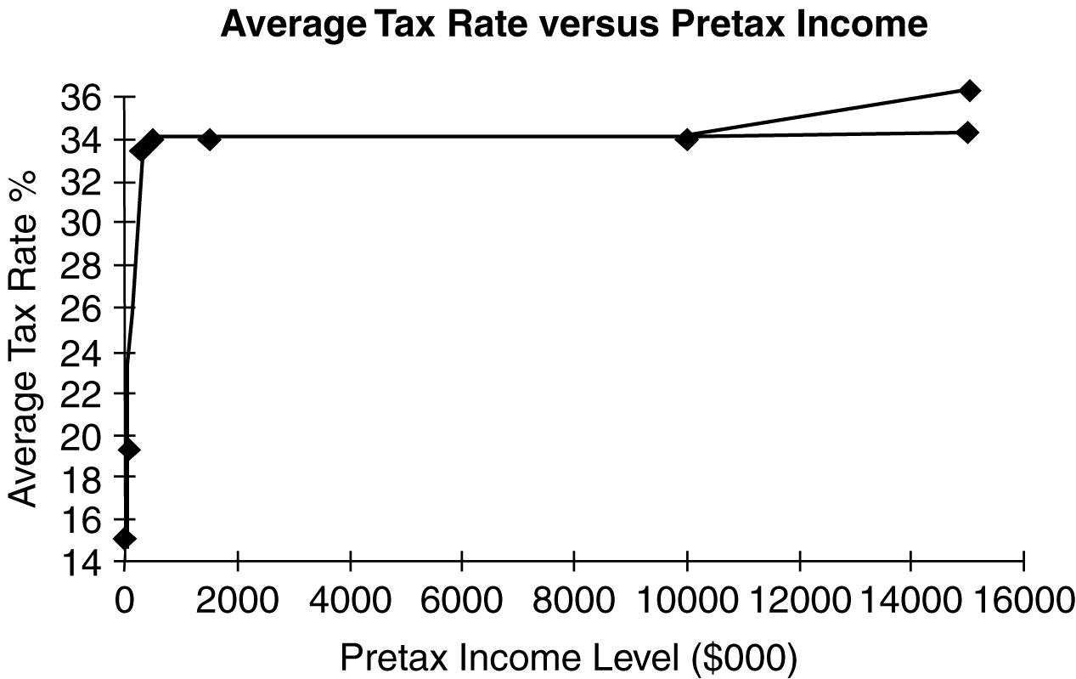

As income increases, the rate reaches 35%.

P2-3. Marginal corporate tax rates

LG 6; Basic

a.
 | Tax Calculation
Pre-tax  Income | Base Tax | + | % | × | Amount  over Base | = | Total  Tax | Marginal  Rate
$ 15,000 | $ 0 |  | (0.15 |  | 15,000) |  | $ 2,250 | 15.0%
60,000 | 7,500 |  | (0.25 |  | 10,000) |  | 10,000 | 25.0%
90,000 | 13,750 |  | (0.34 |  | 15,000) |  | 18,850 | 34.0%
200,000 | 22,250 |  | (0.39 |  | 100,000) |  | 61,250 | 39.0%
400,000 | 113,900 |  | (0.34 |  | 65,000) |  | 136,000 | 34.0%
1,000,000 | 113,900 |  | (0.34 |  | 665,000) |  | 340,000 | 34.0%
20,000,000 | 6,416,667 |  | (0.35 |  | 1,666,667) |  | 700,000 | 35.0%

b.

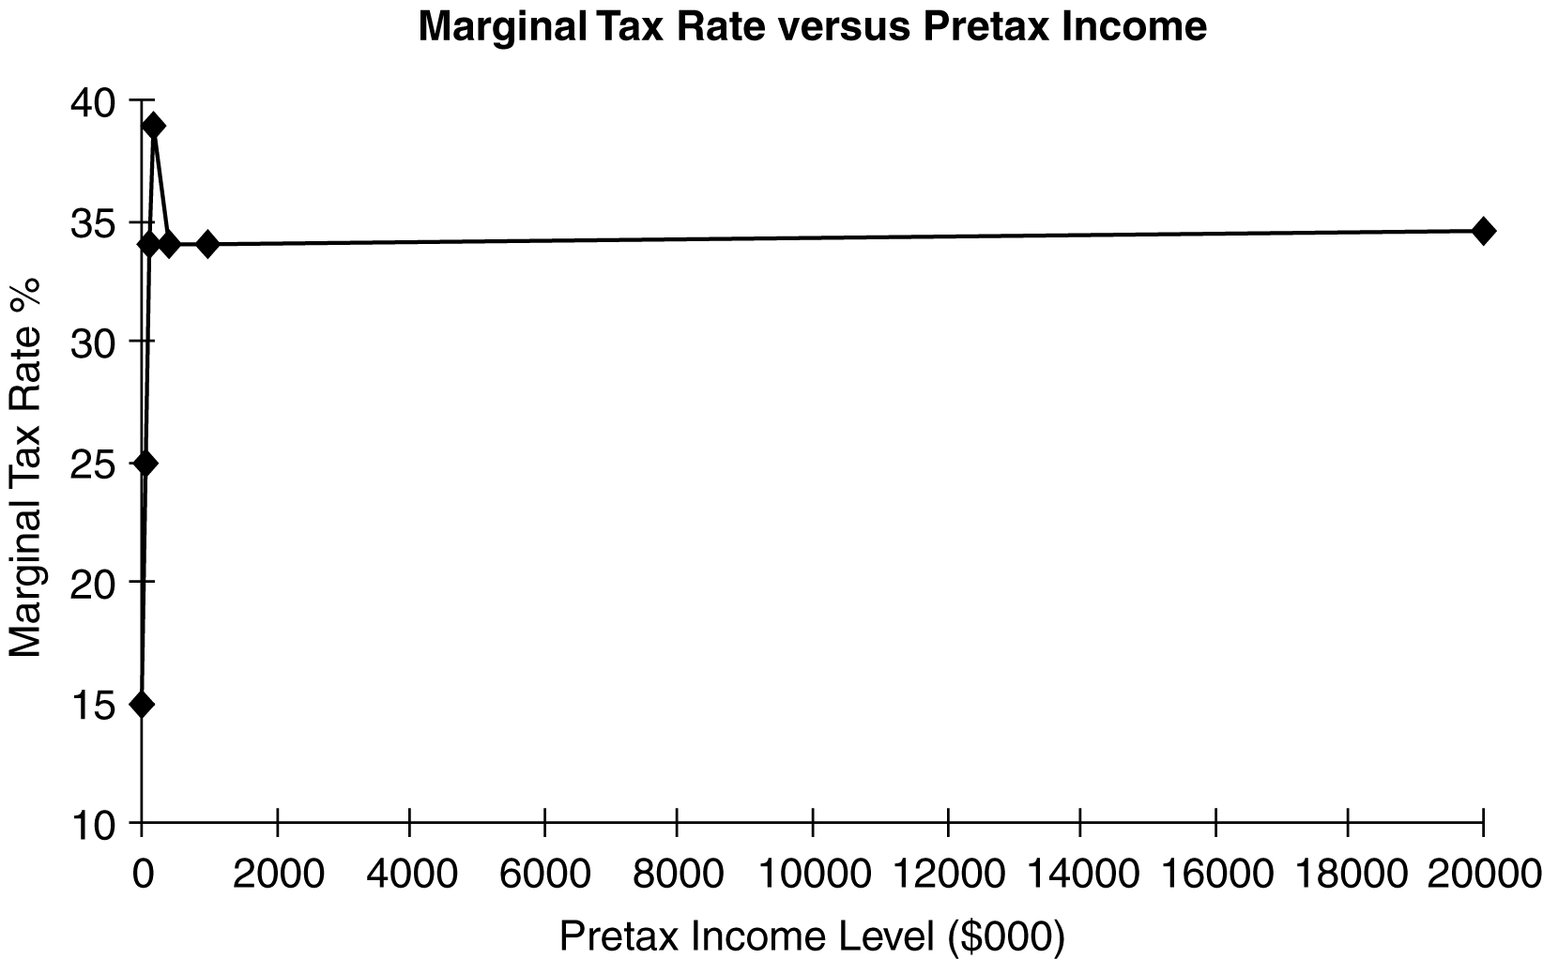

As income increases to $335,000, the marginal tax rate approaches and peaks at 39%. For income in excess of $335,000, the marginal tax rate declines to 34%, and after $10 million
the marginal rate increases slightly to 35%.

P2-4. Interest vs. dividend income

Lg 6; Intermediate

a. Tax on operating earnings: $490,000 × 0.40 tax rate = $196,000

b. and c.
 | (b)  Interest Income | (c)  Dividend Income
Before-tax amount | $20,000 | $20,000
Less: Applicable exclusion | 0 | 14,000 | (0.70 × $20,000)
Taxable amount | 20,000 | 6,000
Tax (40%) | 8,000 | 2,400
After-tax amount | 12,000 | 17,600

d. The after-tax amount of dividends received, $17,600, exceeds the after-tax amount of interest, $12,000, due to the 70% corporate dividend exclusion. This increases the attractiveness of stock investments by one corporation in another relative to bond investments.

e. Total tax liability:
Taxes on operating earnings (from a.) | $196,000
+ Taxes on interest income (from b.) | 8,000
+ Taxes on dividend income (from c.) | 2,400
Total tax liability | $206,400

P2-5. Interest versus dividend expense

LG 6; Intermediate
a. | EBIT | $40,000
 | Less: Interest expense | 10,000
 | Earnings before taxes | $30,000
 | Less: Taxes (40%) | 12,000
 | Earnings after taxes* | $18,000

*This is also earnings available to common stockholders.
b. | EBIT | $40,000
 | Less: Taxes (40%) | 16,000
 | Earnings after taxes | $24,000
 | Less: Preferred dividends | 10,000
 | Earnings available for
 | common stockholders | $14,000

P2-6. Capital gains taxes

LG 6; Basic

a. Capital gain:

Asset X = $2,250 – $2,000 = $250

Asset Y = $35,000 – $30,000 = $5,000

b. Tax on sale of asset:

Asset X = $250 × 0.40 = $100

Asset Y = $5,000 × 0.40 = $2,000

P2-7. Capital gains taxes

LG 6; Basic

a. and b.
Asset | Sale Price  (1) | Purchase Price  (2) | Capital Gain  (1) – (2)  (3) | Tax  (3) × 0.40  (4)
A | $3,400 | $3,000 | $400 | $160
B | 12,000 | 12,000 | 0 | 0
C | 80,000 | 62,000 | 18,000 | 7,200
D | 45,000 | 41,000 | 4,000 | 1,600
E | 18,000 | 16,500 | 1,500 | 600

P2-8. Ethics problem

LG 5; Intermediate

The primary ethical issue is whether the insider is basing his buy or sale of company shares on internal information. If he is basing his decisions on information not available to the general public, he would be making decisions in an unethical manner. The insider may for instance be aware of the likelihood of a favorable acquisition, and unethically buy company shares on that knowledge. On the other hand, insider sales based upon soon-to-be-released information about
the loss of an important contract to a competitor, would also be unethical.

■ Case
Case studies are available on www.myfinancelab.com.

The Pros and Cons of Being Publicly Listed

a. Being a publicly-listed company provides access to the money it needs to grow. Shareholders also provide cash without having an ability to take the company to bankruptcy court if a payment is not made. Going public gives the owner the chance to get a return for his or her hard effort. By going public, the owner can diversify his or her portfolio. In fact, without going public, it is difficult to determine the value of the firm.

b. There are many disadvantages to going public. One, there is no guarantee that shareholders will want to invest in one’s firm. If they avoid its shares, it will be priced below expected value. There also may be low trading volume. Another disadvantage is that going public leaves the owner open to the potential that an individual or firm might purchase all the publicly available shares, or at least enough to control the board of directors and remove the founder from the management team.

c. Not enough information is provided to determine whether Robo-Tech meets the listing requirements to be on the NYSE Euronext. That would be the goal because it is the largest and has the largest number of potential investors.

d. Capital market efficiency is important for many reasons. If the market is efficient, prices are an unbiased estimate of firm value. The better the estimate of fair value the more confidence investors have in the market place. Having an increased number of potential investors helps Robo-Tech sell shares now and in the future, as it continues to need funds to finance expansions.

(Students may expand on these answers.)

■ Spreadsheet Exercise
The answer to Chapter 2’s Monsanto spreadsheet problem is located on the Instructor’s Resource Center
at www.pearsonhighered.com/irc under the Instructor’s Manual.

