**COPYRIGHT PAGE**:

Published by:

FlatWorld

© 2017 by FlatWorld. All rights reserved. Your use of this work is subject to the License Agreement available here <https://catalog.flatworldknowledge.com/legal>. No part of this work may be used, modified, or reproduced in any form or by any means except as expressly permitted under the License Agreement.

**Chapter 1**

**The Central Idea**

**Chapter Summary**

This chapter introduces the concepts of **scarcity**, **choice**, and **opportunity cost,** first for individuals and later for an entire economy. The interactions between these concepts are demonstrated through the production possibilities curve. The chapter also posits that people benefit from free exchange and shows several examples of **gains from trade**. Part 3 outlines the main elements of a market economy.

**Chapter Objectives**

* Introduce the field of **economics** and the idea that people make purposeful choices with scarce resources.
* Introduce the concepts of **scarcity,** **choice**, and **opportunity cost.**
* Discuss **economic interactions** and explain how they take place in a **market.**

**1.1 Scarcity and Choice for Individuals**

**Section Objectives**

* Show that all consumers and producers must make decisions about how to allocate their resources. Emphasize that these choices represent opportunity costs.
* Introduce the concepts of **consumption** and **production.**
* Argue that trade between individuals benefits all parties involved. Discuss the division of labor, specialization, and comparative advantage.

**Section Outline**

* People must make choices when they have a scarcity of time or resources. We see this in many areas; in this section we apply the basic principle to the fundamental economic question of what to consume and what to produce.
  + Because the resources used to satisfy wants are limited, all choices have **opportunity costs**—the next best alternative given up.
* In a world of scarcity, trade can make everyone better off – one person can trade excess goods of one type for goods of another type that they lack
  + An example is shown in **Figure 1.1** of the text.
  + By reallocating goods, trade benefits all parties; trade is not a zero-sum game.
* Trade also permits producers to **specialize** and take advantage of a **division of labor**.
  + This can been seen in the concept of **comparative advantage**: producers (whether people or firms) specialize in the things they can do more quickly or efficiently than another producer.
  + This minimizes opportunity costs.
* **International trade** is trade that takes place between people residing in two different countries. Gains from international trade are the same as gains from trade within a country’s own borders.

**1.2 Scarcity and Choice: The Economy as a Whole**

**Section Objectives**

* Show that scarcity, choice, and opportunity cost scale from the individual to an entire economy.
* Explain the construction of the production possibilities curve. Describe various points on, inside, and beyond the curve. Relate its shape to increasing opportunity costs. Use the production possibilities curve to depict economic growth.
* Identify inefficient, efficient, and impossible points on the production possibilities curve.

**Section Outline**

* We can look at scarcity, choice, and opportunity cost from the perspective of an entire economy. You can show this with a production possibilities curve.
  + The data in **Table 1.1** in the text shows the **production possibilities** for computers in a simple economy. As you can see, making more of one product means making less of something else.
  + This data is used to construct the production probabilities curve in **Figure 1.2**.
    - The shape of the production possibilities curve is determined by the ease with which resources may be switched between the two goods listed on the axes.
    - The curve bows outward because resources are not equally productive in all uses. This is called increasing opportunity costs.
    - For example, in **Figure 1.2,** computer production decreases by 1000 when we go from making 0 to making 100 movies, but farther down the table computer production decreases by 13,000 when we go from making 400 movies to 500.
  + We can identify efficient, inefficient, and impossible points on the production possibilities curve. The curve shifts to depict growth; growth can make impossible points possible.

**1.3 Market Economies and the Price System**

**Section Objectives**

* Explain the difference between a **market economy** and a **command economy.**
* Show that prices and markets permeate the framework of a free market economy.
* Discuss prices as signals; show how prices provide incentives.

**Section Outline**

* All economies must answer three essential questions: **what** is to be produced, **how** are these goods to be produced, and **for whom** are the goods to be produced.
  + These questions exist because of scarcity and in all economic systems.
* Two general types of economies are seen in the world today: **market economies** and **command economies**.
  + Command economies have not been very successful in addressing the three essential questions.
    - There are far fewer command economies than there were in the mid-twentieth century.
    - The Chinese economy has evolved from a command economy to a very successful market-based economy.
* In a market economy:
  + Prices are freely determined.
  + Individuals own property. Private property rights are protected.
  + Individuals are able to trade in domestic and foreign markets.
  + All market economies have a role for government.
    - This is especially true in areas of **market failure** like police and fire protection and guaranteeing property rights.
    - If the government regulates the market poorly, economists say there is **government failure.**
  + Private organizations such as corporations have a role in market economies. Some of their interactions are external (like hiring lawyers from outside as needed) and some are internal (like retaining a lawyer on staff.)
  + Prices play a central role in market economies. They send **signals**, provide incentives, and affect the distribution of income. In a sense, a market is a messenger and price is the message.
  + Markets are not confined to face-to-face transactions. Market transactions also happen online (Amazon) or by phone (pizza).

**1.4 End-of-Chapter Material: Key Points**

* Everyone faces a scarcity of something, usually time or resources.
* Scarcity leads to choice, and choice leads to opportunity costs.
* Trade leads to gains because it allows goods and services to be reallocated in a way that improves people’s well-being.
* Trade also leads to gains because it permits people to specialize in what they are relatively good at.
* The production possibilities curve summarizes the trade-offs in the whole economy because of scarcity.
* Economic production is efficient if the economy is on the production possibilities curve. Production is inefficient if the economy is inside the production possibilities curve.
* Points outside the production possibilities curve currently are impossible. More investment, more workers, or better technology can shift the production possibilities curve out and make the impossible possible.
* The three basic questions that any economy must face are what, how, and for whom production should take place.
* A well-functioning market system, involving freely determined prices, property rights, freedom to trade, and a role for government and private organizations, can answer these basic questions.
* Prices transmit signals, provide incentives, and affect the distribution of income in a market economy. If prices are set at incorrect levels by government, waste and inefficiency—such as feeding bread to livestock—will result.

**End-of-Chapter Problems with Solutions**

1. Suppose that you are president of the student government, and you have to decide how to allocate a $20,000 fund for guest speakers for the year. Conan O’Brien and Will Ferrell each cost $10,000 per appearance, Stephen Colbert costs $20,000 per appearance, and former economic advisers to the government charge $1,000 per lecture. Explain the economic problem of choice and scarcity in this case. What issues would you consider in arriving at a decision?

With $20,000, you can invite 1) Steven Colbert one time, 2) Will Ferrell and Conan O’Brien each one time, 3) Either Will Ferrell or Conan O’Brien twice, 4) Either Will Ferrell or Conan O’Brien once plus up to ten former economic advisers, or 5) twenty former economic advisers. When making this decision, you have to weigh the excitement each speaker will generate in the student body and the effects on your popularity as the student body president. If you are attending a school of politics and economics, your choice may be very different than your choice if you are attending a clown college, UCLA, or Juliard.

1. Michelle Wie, a teenage golf prodigy who earned $16 million in endorsements and $4 million in prize money and appearance fees in 2006, announced that she would enroll as a student at Stanford University in the fall of 2007. What was her opportunity cost of a year of college? How does it compare to your opportunity cost of a year of college?

You and Michelle Wie are both giving up the money you would have earned by working for a year. For Ms. Wie, that is approximately 20 million dollars. For you, it is probably substantially less.

1. Allison will graduate from high school next June. She has ranked her three possible post-graduation plans in the following order: (1) work for two years at a consulting job in her hometown paying $20,000 per year, (2) attend a local community college for two years, spending $5,000 per year on tuition and expenses, and (3) travel around the world tutoring a rock star’s child for pay of $5,000 per year. What is the opportunity cost of her choice?

Allison‘s choice to take the consulting job at $20,000 a year for two years has an opportunity cost of -$5000 (the money she saves on a year of tuition) and the unquantified costs of delaying her education by two years (or more, if she continues to work at the consulting firm when two years have passed). Choice 3 is not an opportunity cost, as only the next most desirable option is given up.

1. Suppose you have two boxes of chocolate chip cookies and a friend of yours has 2 gallons of milk. Explain how you can both gain from trade. Is this a gain from trade through *better allocation*or *greater production*?

If my friend keeps both gallons of milk, he can probably only drink one before the other goes bad. If I keep both boxes of cookies, I can probably only eat one before the other goes stale. If I trade him a box of cookies for one of his gallons of milk, we can each enjoy many delicious cookies-and-milk experiences and not waste resources. This is an example of better allocation; neither I nor my friend are producing anything.

1. Suppose Tina and Julia can produce brownies and romantic poems (which can be combined to make a lovely gift) in the following combinations in a given week:

| **Tina** | | **Julia** | |
| --- | --- | --- | --- |
| *Brownies* | *Poems* | *Brownies* | *Poems* |
| 50 | 0 | 25 | 0 |
| 40 | 1 | 20 | 1 |
| 30 | 2 | 15 | 2 |
| 20 | 3 | 10 | 3 |
| 0 | 4 | 5 | 4 |
| 0 | 5 | 0 | 5 |

* 1. If Tina and Julia are each currently producing two poems per week, how many brownies are they producing? What is the total production of brownies and poems between them?

If Tina and Julia are each producing 2 poems, Tina will produce 30 brownies and Julia will produce 15 brownies.

* 1. Is there a possibility for increasing production? Why or why not?

If Tina writes no poems, she will make 50 brownies. Julia can increase the number of poems she writes to 4 poems per week, but her brownie productivity will only go down to 5. This will hold poems constant, but increase brownies

* 1. Suppose Julia completely specializes in producing poems and Tina completely specializes in producing brownies. What will be their total production of brownies and poems?

Total production will be 5 poems and 50 brownies

1. Suppose you must divide your time between studying for your math final and writing a final paper for your English class. The fraction of time that you spend studying math and its relation to your grade in the two classes given in the table below.

| **Fraction of Time  Spent on Math** | **Math Grade** | **English Grade** |
| --- | --- | --- |
| 0 | 0 | 97 |
| 20 | 45 | 92 |
| 40 | 65 | 85 |
| 60 | 75 | 70 |
| 80 | 82 | 50 |
| 100 | 88 | 0 |

* 1. Draw a trade-off curve for the math grade versus the English grade.



* 1. What is the opportunity cost of increasing the time spent on math from 80 to 100 percent? What is the opportunity cost of increasing the time spent on math from 60 to 80 percent?

The opportunity cost of increasing the time spent on math from 80 to 100 percent is 50 points on the English paper, a decrease in the English grade from 50 points to 0 points. The opportunity cost of increasing the time spent on math from 60 to 80 percent is 20 points on the English paper, a decrease from 70 to 50 points.

* 1. Are there increasing opportunity costs from spending more time on math? Explain.

Yes, the more time spent studying math, the greater the percentage decline in the English grade, which represents a substantial increase in the opportunity cost. The decrease for the first 20% reduction in time spent on the English paper (from 100% to 80%) is only 5 points; the decrease for the last 20% time reduction on the paper (from 20% to 0% time) is a full 50 points.

* 1. Suppose your parents want you to get a 92 percent in both subjects. What would you tell them?

You would tell your parents that you cannot divide your time between English and math in a way that will create a grade of 92 on both. Given the current state of your talent and resources, a 92% is never possible in math.

1. A small country produces only two goods, cars and cakes. Given its limited resources, this country has the following production possibilities:

| **Cars** | **Cakes** |
| --- | --- |
| 0 | 200 |
| 25 | 180 |
| 50 | 130 |
| 75 | 70 |
| 100 | 0 |

* 1. Draw the production possibilities curve.
  2. Suppose car production uses mainly machines and cake production uses mainly labor. Show what happens to the curve when the number of machines increases, but the amount of labor remains unchanged.

The outer line shows that with the addition of machines, but not labor, the production possibilities curve for car production increases much more than cake production. Adding machines to the economy primarily increases car production but it may also permit some labor in car production to shift to cake production, adding to the overall production of cakes.

1. Tracy tells Huey that he can improve his economics grade without sacrificing fun activities or his grades in other courses. Can you imagine ways in which this might be possible? What does that imply about the initial situation? If Huey is taking just two courses and he can improve his economics grade without hurting his math grade, how could you represent this situation graphically?

Tracey is telling Huey he is not using his time efficiently. Perhaps he is studying economics in his dorm room while his roommate is always watching television and playing music loudly. By moving to a more conducive study environment such as the library, Huey could get more out of his study time. Alternately, it’s possible Huey has been doing other activities that are neither work for other courses nor fun, and that he could improve his economics grade by reducing time spent in one or more of those activities.

The following graph shows Huey improving his economics course without hurting his math grade:

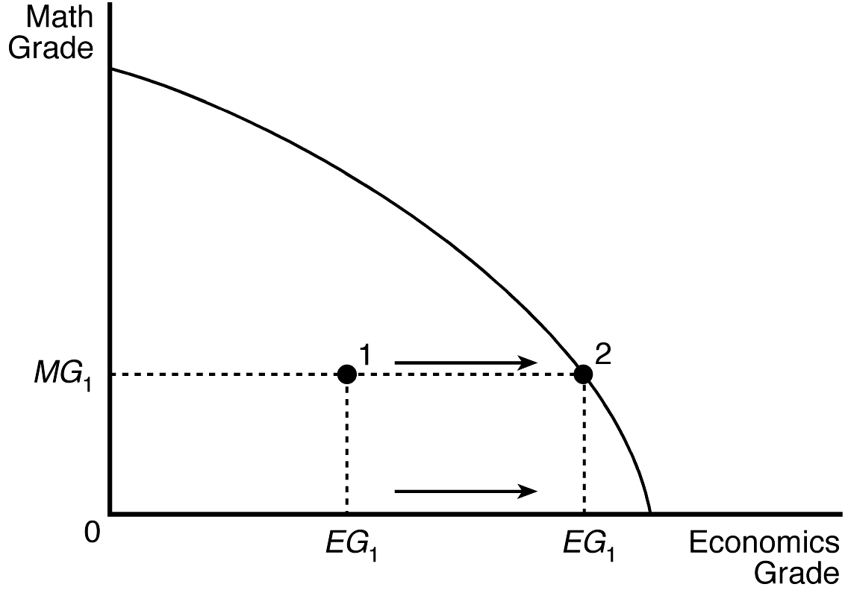

1. Suppose decreased production of oil in the Middle East causes the price of oil to rise around the world. Explain how this change in the price signals information to U.S. producers of various goods, provides incentives to U.S. producers of various goods, and affects the distribution of income.

A higher price of oil signals makers of products where oil is an input, such as in the production of gasoline, which the cost of production will increase. This increase lowers incentives to produce these types of goods. At the same time, there is more incentive to explore for and drill for oil in the United States. Income will shift from oil users to oil producers, and the cost of goods that require shipping will also increase.

1. When you look at the economies of the United States, Europe, or Japan, you see most of the ingredients of a market economy. For example, consider bicycles. Prices in the bicycle market are free to vary; people have property rights to the bicycles they buy; many people sell bicycles; many bicycles sold in the United States, Europe, and Japan come from other countries; the government regulates bicycle use (no bicycles on the freeways, for example); and bicycle production takes place within firms with many workers. Replace bicycles with another good or service of your choosing and comment on whether the statement is still true.

“Bicycle” can be replaced here by any of thousands of items, such as food, clothing, appliances, and electronics. Decisions about what, how, and for whom to produce are largely made by individual consumers and firms, with the government providing 1) broad rules for activity and 2) some goods and services that may not result from market activity.