**Chapter 2**

**Thinking Like an Economist**

**SOLUTIONS TO TEXTBOOK PROBLEMS**

**Quick Quizzes**

1. *In what sense is economics like a science? • Draw a production possibilities frontier for a society that produces food and clothing. Show an efficient point, an inefficient point, and an infeasible point. Show the effects of a drought. • Define* microeconomics *and* macroeconomics*.*

Economics is like a science because economists devise theories, collect data, and analyze the data in an attempt to verify or refute their theories. In other words, economics is based on the scientific method.

Figure 1 shows the production possibilities frontier for a society that produces food and clothing. Point A is an efficient point (on the frontier), point B is an inefficient point (inside the frontier), and point C is an infeasible point (outside the frontier).

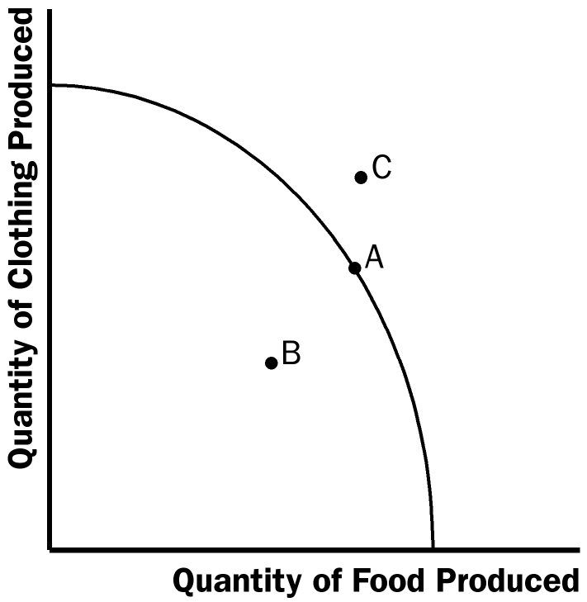

**Figure 1**

The effects of a drought are shown in Figure 2. The drought reduces the amount of food that can be produced, shifting the production possibilities frontier inward.

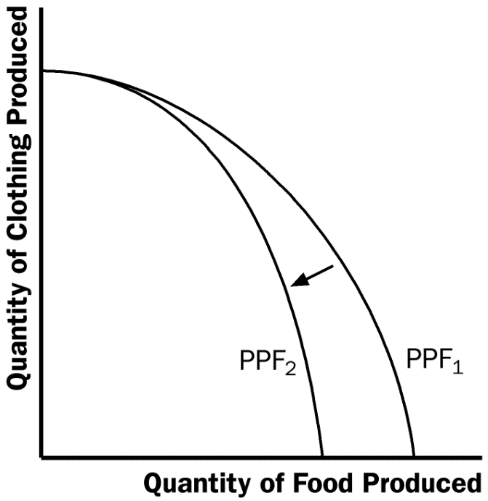

**Figure 2**

Microeconomics is the study of how households and firms make decisions and how they interact in markets. Macroeconomics is the study of economy-wide phenomena, including inflation, unemployment, and economic growth.

2. *Give an example of a positive statement and an example of a normative statement. • Name three parts of government that regularly rely on advice from economists.*

An example of a positive statement is “higher taxes discourage work effort” (many other answers are possible). That is a positive statement because it describes the effects of higher taxes, describing the world as it is. An example of a normative statement is “the government should reduce tax rates.” That is a normative statement because it’s a claim about how the world should be.

Parts of the government that regularly rely on advice from economists are Finance Canada in designing tax policy, Industry Canada in designing and enforcing Canada’s antimonopoly laws, and International Trade Canada in helping to negotiate trade agreements with other countries.

3. *Why might economic advisers to the Prime Minister disagree about a question of policy?*

Economic advisers to the Prime Minister might disagree about a question of policy because of differing scientific judgments or differences in values.

**Questions for Review**

1. *How is economics like a science?*

Economics is like a science because economists use the scientific method. They devise theories, collect data, and then analyze these data in an attempt to verify or refute their theories about how the world works. Economists use theory and observation like other scientists, but they are limited in their ability to run controlled experiments. Instead, they must rely on natural experiments.

2. *Why do economists make assumptions?*

Economists make assumptions to simplify problems without substantially affecting the answer. Assumptions can make the world easier to understand.

3. *Should an economic model describe reality exactly?*

An economic model cannot describe reality exactly because it would be too complicated to understand. A model is a simplification that allows the economist to see what is truly important.

4.*Name a way that your family interacts in the factor market and a way that it interacts in the product market.*

There are many possible answers.

5. *Name one economic interaction that isn’t covered by the simplified circular-flow diagram.*

There are many possible answers.

6. *Draw and explain a production possibilities frontier for an economy that produces milk and cookies. What happens to this frontier if disease kills half of the economy’s cow population?*

Figure 3 shows a production possibilities frontier between milk and cookies (PPF1). If a disease kills half of the economy’s cow population less milk production is possible, so the PPF shifts inward (PPF2). Note that if the economy produces all cookies, so it doesn’t need any cows, then production is unaffected. But if the economy produces any milk at all, then there will be less production possible after the disease hits.

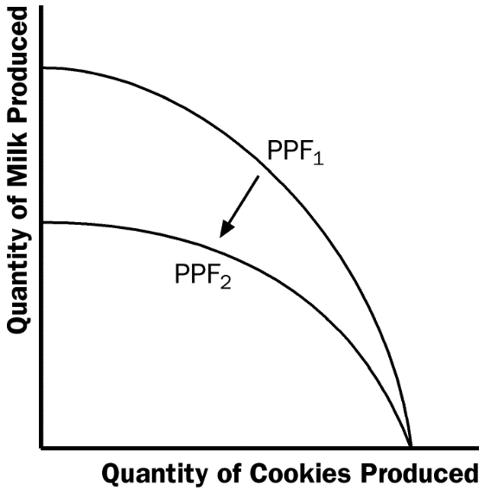

**Figure 3**

7. *Use a production possibilities frontier to describe the idea of “efficiency.”*

The idea of efficiency is that an outcome is efficient if the economy is getting all it can from the scarce resources it has available. In terms of the production possibilities frontier, an efficient point is a point on the frontier, such as point A in Figure 4. A point inside the frontier, such as point B, is inefficient since more of one good could be produced without reducing the production of another good.

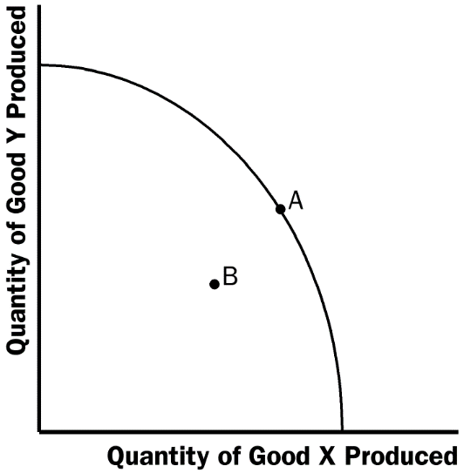

**Figure 4**

8. *What are the two subfields into which economics is divided? Explain what each subfield studies.*

The two subfields in economics are microeconomics and macroeconomics. Microeconomics is the study of how households and firms make decisions and how they interact in specific markets. Macroeconomics is the study of economy-wide phenomena.

9. *What is the difference between a positive and a normative statement? Give an example of each.*

Positive statements are descriptive and make a claim about how the world is, while normative statements are prescriptive and make a claim about how the world ought to be. Here is an example. Positive: A rapid growth rate of money is the cause of inflation. Normative: The government should keep the growth rate of money low.

**Quick Check Multiple Choice**

*1. What is an economic model?*

*a. a mechanical machine that replicates the functioning of the economy*

*b. a fully detailed, realistic description of the economy*

*c. a simplified representation of some aspect of the economy*

*d. a computer program that predicts the future of the economy*

*2. What does the circular-flow diagram illustrate in terms of markets for the factors of production?*

*a. households are sellers and firms are buyers*

*b. households are buyers and firms are sellers*

*c. households and firms are both buyers*

*d. households and firms are both sellers*

*3. Is a point inside the production possibilities frontier efficient and feasible?*

*a. efficient but not feasible*

*b. feasible but not efficient*

*c. both efficient and feasible*

*d. neither efficient nor feasible*

*4. An economy produces hot dogs and hamburgers. If a discovery of the remarkable health benefits of hot dogs were to change consumers’ preferences, what would happen?*

*a. it would expand the production possibilities frontier*

*b. it would contract the production possibilities frontier*

*c. it would move the economy along the production possibilities frontier*

*d. it would move the economy inside the production possibilities frontier*

*5. Which of the following topics does NOT fall within the study of microeconomics?*

*a. the impact of cigarette taxes on the smoking behaviour of teenagers*

*b. the role of Microsoft’s market power in the pricing of software*

*c. the effectiveness of antipoverty programs in reducing homelessness*

*d. the influence of the government budget deficit on economic growth*

*6. Which of the following is a positive, rather than a normative, statement?*

*a. Law X will reduce national income.*

*b. Law X is a good piece of legislation.*

*c. Parliament ought to pass law X.*

*d. Law X will change the distribution of income unfairly.*

1. c

2. a

3. b

4. c

5. d

6. a

**Problems and Applications**

1. *Draw a circular-flow diagram. Identify the parts of the model that correspond to the flow of goods and services and the flow of dollars for each of the following activities.*

*a. Selena pays a storekeeper $1 for a litre of milk.*

*b. Stuart earns $7 per hour working at a fast-food restaurant.*

*c. Shanna spends $30 to get a haircut.*

*d. Salma earns $10 000 from her 10 percent ownership of Acme Industrial.*

See Figure 5, where the four transactions are shown.

a. $1

c. $30

a. $1

c. $30

Markets for

Goods and Services

a. litre of milk

c. haircut

a. litre of milk

c. haircut

Households

Firms

b. one hour of work

d. Acme’s capital

b. one hour of work

d. Acme’s capital

Markets for

Factors of Production

b. $7

d. $10,000

b. $7

d. $10,000

**Figure 5**

2. *Imagine a society that produces military goods and consumer goods, which we’ll call “guns” and “butter.”*

*a. Draw a production possibilities frontier for guns and butter. Explain why it most likely has a bowed-out shape.*

*b. Show a point that is impossible for the economy to achieve. Show a point that is feasible but inefficient.*

*c. Imagine that the society has two political parties, called the Hawks (who want a strong military) and the Doves (who want a smaller military). Show a point on your production possibilities frontier that the Hawks might choose and a point the Doves might choose.*

*d. Imagine that an aggressive neighbouring country reduces the size of its military. As a result, both the Hawks and the Doves reduce their desired production of guns by the same amount. Which party would get the bigger “peace dividend,” measured by the increase in butter production? Explain.*

a. Figure 6 shows a production possibilities frontier between guns and butter. It is bowed out because when most of the economy’s resources are being used to produce butter the frontier is steep, and when most of the economy’s resources are being used to produce guns the frontier is very flat. When the economy is producing a lot of guns, workers and machines best suited to making butter are being used to make guns, so each unit of guns given up yields a large increase in the production of butter. Thus, the production possibilities frontier is flat. When the economy is producing a lot of butter, workers and machines best suited to making guns are being used to make butter, so each unit of guns given up yields a small increase in the production of butter. Thus, the production possibilities frontier is steep.

b. Point A is impossible for the economy to achieve; it is outside the production possibilities frontier. Point B is feasible but inefficient because it’s inside the production possibilities frontier.

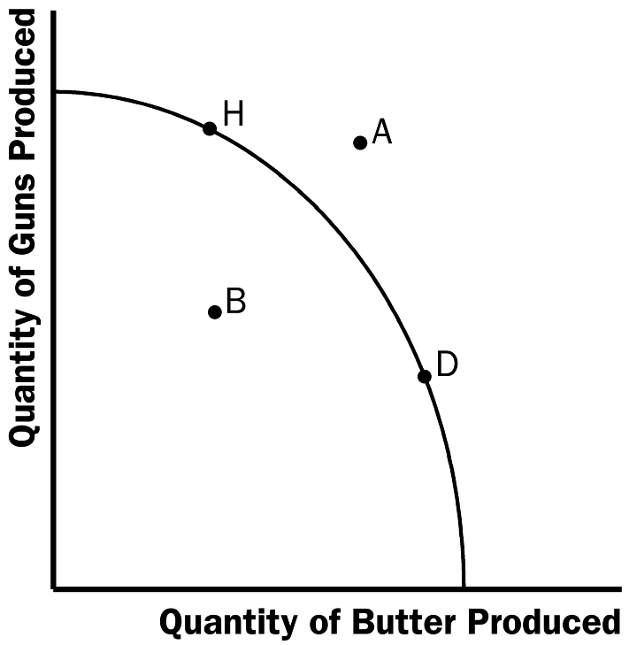

**Figure 6**

c. The Hawks might choose a point like H, with many guns and not much butter. The Doves might choose a point like D, with a lot of butter and few guns.

d. If both Hawks and Doves reduced their desired quantity of guns by the same amount, the Hawks would get a bigger peace dividend because the production possibilities frontier is much flatter at point H than at point D. As a result, the reduction of a given number of guns, starting at point H, leads to a much larger increase in the quantity of butter produced than when starting at point D.

3. *The first principle of economics discussed in Chapter 1 is that people face tradeoffs. Use a production possibilities frontier to illustrate society’s tradeoff between a clean environment and the quantity of industrial output. What do you suppose determines the shape and position of the frontier? Show what happens to the frontier if engineers develop an automobile engine with almost no emissions.*

See Figure 7. The shape and position of the frontier depend on how costly it is to maintain a clean environment⎯the productivity of the environmental industry. Gains in environmental productivity, such as the development of a no-emission auto engine, lead to shifts of the production possibilities frontier, like the shift from PPF1 to PPF2 shown in the figure.

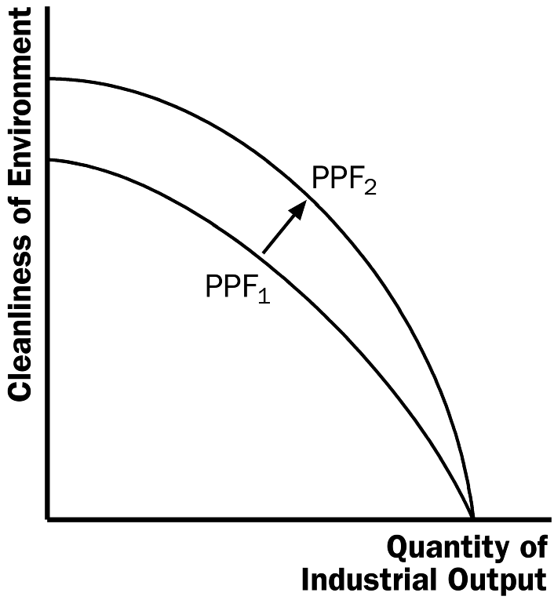

**Figure 7**

4. *Classify the following topics as relating to microeconomics or macroeconomics.*

*a. a family’s decision about how much income to save*

*b. the effect of government regulations on auto emissions*

*c. the impact of higher national saving on economic growth*

*d. a firm’s decision about how many workers to hire*

*e. the relationship between the inflation rate and changes in the quantity of money*

a. A family’s decision about how much income to save is microeconomics.

b. The effect of government regulations on auto emissions is microeconomics.

c. The impact of higher national saving on economic growth is macroeconomics.

d. A firm’s decision about how many workers to hire is microeconomics.

e. The relationship between the inflation rate and changes in the quantity of money is macroeconomics.

5. *Classify each of the following statements as positive or normative. Explain.*

*a. Society faces a short-run tradeoff between inflation and unemployment.*

*b. A reduction in the rate of growth of money will reduce the rate of inflation.*

*c. The Bank of Canada should reduce the rate of growth of money.*

*d. Society ought to require welfare recipients to look for jobs.*

*e. Lower tax rates encourage more work and more saving.*

a. The statement that society faces a short-run tradeoff between inflation and unemployment is a positive statement. It deals with how the economy is, not how it should be. Since economists have examined data and found that there is a short-run negative relationship between inflation and unemployment, the statement is a fact, thus it is a positive statement.

b. The statement that a reduction in the rate of growth of money will reduce the rate of inflation is a positive statement. Economists have found that money growth and inflation are very closely related. The statement thus tells how the world is, and so it is a positive statement.

c. The statement that the Bank of Canada should reduce the rate of growth of money is a normative statement. It states an opinion about something that should be done, not how the world is.

d. The statement that society ought to require welfare recipients to look for jobs is a normative statement. It doesn’t state a fact about how the world is. Instead, it is a statement of how the world should be and is thus a normative statement.

e. The statement that lower tax rates encourage more work and more saving is a positive statement. Economists have studied the relationship between tax rates and work, as well as the relationship between tax rates and saving. They have found a negative relationship in both cases. The statement reflects how the world is, and is thus a positive statement.

6. *If you were Prime Minister, would you be more interested in your economic advisers’ positive views or their normative views? Why?*

As the Prime Minister, you’d be interested in both the positive and normative views of economists, but you’d probably be *most* interested in their positive views. Economists are on your staff to provide their expertise about how the economy works. They know many facts about the economy and the interaction of different sectors. So you would be most likely to call on them about questions of fact⎯positive analysis. Since you are the prime minister, you are the one who has to make the normative statements as to what should be done, with an eye to the political consequences. The normative statements made by economists represent their own views, not necessarily your views or the electorate’s views.

7. *An economy consists of three workers: Larry, Moe, and Curly. Each works for ten hours per day and can produce two services: mowing lawns and washing cars. In an hour, Larry can either mow one lawn or wash one car, Moe can either mow one lawn or wash two cars, and Curly can either mow two lawns or wash one car.*

*a. Calculate how much of each service is produced under the following circumstances, which we label A, B, C, and D:*

*● All three spend all their time mowing lawns. (A)*

*● All three spend all their time washing cars. (B)*

*● All three spend half their time on each activity. (C)*

*● Larry spends half his time on each activity, while Moe only washes cars and Curly only mows lawns. (D)*

*b. Graph the production possibilities frontier for this economy. Using your answers to part (a), identify points A, B, C, and D on your graph.*

*c. Explain why the production possibilities frontier has the shape it does.*

*d. Are any of the allocations calculated in part (a) inefficient? Explain.*

a. The following table gives the outcomes in the four cases. For example, when each uses half their time in each sector, Larry washes 5 cars and mows 5 lawns in 10 hours, etc.

|  |  |  |  |  |
| --- | --- | --- | --- | --- |
|  | **A** | **B** | **C** | **D** |
| Lawn mowing | 40 | 0 | 20 | 25 |
| Car washing | 0 | 40 | 20 | 25 |

b. The following graph shows the production possibilities frontier based on the numbers in the table.



**Figure 8**

c. The upper part is flatter because the opportunity cost of increasing the number of cars from 0 to 25 is less than 1 lawn per car; moving from 0 cars takes advantage of Moe’s better ability to wash cars than to mow lawns. However, when the number of cars exceeds 25, we start losing Curly’s better skill in mowing lawns; therefore, the opportunity cost of an extra car increases above 1 forgone mowed lawn per extra washed car.

d. Allocation C is inefficient. Although all workers use all their time, they do not use their specific skills wisely.

**Appendix Problems and Applications**

A1. *Consider the linear demand curve:*

Q*D = 56 − 4*P

1. *Determine the* x*- and* y*-intercepts of this demand curve.*
2. *Determine the slope of this demand curve.*

a. To determine the *x*-intercept, set *P* = 0 and solve for *Q*D, giving *Q*D= 56; so the *x*-intercept is 56. To determine the *y*-intercept, set *Q*D= 0 and solve for *P*, giving 0 = 56 – 4*P*, *P* = 56/4, *P* = 14.

b. The slope is the rise over the run, where “rise” is the *y*-intercept and “run” is the *x*-intercept. Thus, slope = –14/56 = –1/4.

A2. *Using the general functional form for a linear demand curve,* Q*D=* a *–* bP*, and the data in Table 2A.1,*

1. *Determine the values for* a *and* b *for Emma when her income is $20 000.*
2. *Determine the* x- *and* y-*intercepts of this demand curve.*
3. *Determine the slope of this demand curve.*
4. *Draw it on a diagram along with the demand curves when her income is $30 000 and $40 000, identifying the* x- *and* y-*intercepts in each case.*

a. At *P* = 10, *Q* = 2 and at *P* = 9, *Q* = 6. Therefore,

2 = *a* – 10*b*

6 = *a* – 9*b*

Solve simultaneously for *a* and *b*: the first equation gives *a* = 2 + 10*b*; substitute into the second equation to get 6 = 2 + 10*b* – 9*b*, and solve for *b* = 4; therefore *a* = 2 + (10)(4) = 42. Thus, *Q*D = 42 – 4*b*.

b. *x*-intercept = 42, *y*-intercept = 4

c. slope = 4/42