**CHAPTER 2 COMPARATIVE ADVANTAGE**

**Answers to Review Questions**

1. An individual has a comparative advantage in the production of a particular good if

she can produce it at a lower opportunity cost than other individuals. An individual has an absolute advantage in the production of a good if she can produce more of that good than another individual, using comparable amounts of time, raw materials and effort.

Learning Objective: 02-01

AACSB: Reflective Thinking

Bloom’s: Understand

1. According to Principle of Comparative Advantage, people will perform their own

services when the opportunity cost of doing so is low. This implies that performing services yourself is not a matter of whether you are rich or poor but rather the opportunity cost of your time. Furthermore, limited specialization will mean less overall production for a nation, which is usually interpreted as poverty.

Learning Objective: 02-02

AACSB: Reflective Thinking

Bloom’s: Understand

1. A reduction in the number of hours worked each day will shift all points on the

production possibilities curve inward, toward the origin, as this reduces the maximum amount that can be produced of either good. The graph below illustrates this situation.



Learning Objective: 02-03

AACSB: Reflective Thinking

Bloom’s: Understand

1. Technological innovations that boost labor productivity will shift all points on the

production possibilities curve outward, away from the origin. The graph below illustrates this situation.



Learning Objective: 02-03

AACSB: Reflective Thinking

Bloom’s: Understand

1. The fact that English has become the *de facto* international language has done much

to stimulate international demand for American-made books, movies and popular music. The large size of the American market has given the United States an additional advantage over other English-speaking countries, like England, Canada, and Australia.

Learning Objective: 02-03

AACSB: Reflective Thinking

Bloom’s: Remember

**Answers to Problems**

1. In the time it takes Ted to wash a car he can wax three cars, which is also his

opportunity cost of washing one car. In the time it takes Tom to wash one car, he can wax two cars, which is his opportunity cost of washing one car.

Alternatively, you can compute how many cars each person can wash or wax in a certain time period, such as an hour, and then use these quantities to compute their respective opportunity costs: Ted can wash one car or wax three, so his opportunity cost of washing one car is 3 / 1, or 3. Likewise, Tom can wash two cars or wax four, so his opportunity cost of washing one car is 4 / 2, or 2.

Because Tom’s opportunity cost of washing a car is lower than Ted’s, Tom has a comparative advantage in washing cars.

Learning Objective: 02-01

AACSB: Analytic

Bloom’s: Apply

1. In the time it takes Nancy to replace a set of brakes she can complete one-third of a

clutch replacement her opportunity cost of replacing a set of brakes is therefore one-third of a clutch replacement.



Alternatively, you can compute how many clutches or brakes each person can replace in a certain time period, such as 6 hours, and then use these quantities to compute their respective opportunity cost: Nancy can replace 1.5 clutches or 3 sets of brakes in that time, so her opportunity cost of replacing one set of brakes is one-half of a clutch replacement (1.5 / 3). Likewise, Bill can replace 1 clutch or 3 sets of brakes, so his opportunity cost of replacing one set of brakes is one-third of a clutch replacement

(1/3).

Bill’s opportunity cost of replacing a set of brakes is lower than Nancy’s, so Bill has a comparative advantage in replacing brakes.  This also implies that Nancy has a comparative advantage in replacing clutches.  Finally, Nancy has an absolute advantage over Bill in replacing clutches since it takes her two hours less than it takes Bill to perform that job.  Since Nancy and Bill take

Learning Objective: 02-01

AACSB: Analytic

Bloom’s: Apply

1. a. Helen's production possibilities curve would look like the following:



1. As the graph below shows, 28 dresses per day and 16 loaves of bread per day is outside the production possibilities curve (PPC) and is therefore an unattainable combination for Helen. The combination of 16 dresses per day and 32 loaves of bread per day is both attainable and efficient. Finally, 18 dresses per day and 24 loaves of bread per day is a combination that lies beneath the PPC, which is attainable but inefficient. Here, Helen could either complete more dresses or more loaves of bread per day.



Learning Objective: 02-03

AACSB: Analytic

Bloom’s: Apply

1. a. As shown below, the new machine doubles the value of the vertical intercept of

Helen’s PPC.



1. Since Helen can sew twice as many dresses per hour as before, she can now sew any given number of dresses in half as much time as before. With the time saved, she can bake additional loaves of bread.
2. The upward rotation of Helen’s PPC means that she is now able for the first time to produce at any of the points in the shaded region of the graph above.  Note that her menu of opportunity increased with respect to dresses *and* with respect to bread as well. For example, she can now produce 32 dresses and 32 loaves of bread instead of 32 dresses and no loaves.

Learning Objective: 02-03

AACSB: Analytic

Bloom’s: Apply

1. a. Their maximum possible coffee output is 36 pounds per day (12 from Tom and 24

from Susan).

b. Their maximum possible output of nuts is also 36 pounds per day (12 from Susan and 24 from Tom).

1. Tom should be sent to gather nuts, since his opportunity cost (half a pound of coffee per pound of nuts) is lower than Susan’s (2 pounds of coffee per pound of nuts). Since it would take Tom only one hour to gather four pounds of nuts, he can still pick 10 pounds of coffee in his 5 working hours that remain. Added to Susan’s 24 pounds, they will have a total of 34 pounds of coffee per day.
2. Susan should be sent to pick coffee, since her opportunity cost (half a pound of nuts per pound of coffee) is lower than Tom’s (2 pounds of nuts per pound of coffee).  It will take Susan 2 hours to pick 8 pounds of coffee, which means that she can still gather 8 pounds of nuts. So they will have a total of 32 pounds per day of nuts.
3. To gather 26 pounds of nuts per day, Tom should work full time gathering nuts (24 pounds per day) and Susan should spend one hour per day gathering nuts (2 pounds per day).  Susan would still have 5 hours available to devote to picking coffee, so she can pick 20 pounds of coffee per day.
4. The point 30 pounds of coffee per day and 12 pounds of nuts per day can be produced by having Susan work full time picking coffee (24 pounds of coffee per day) while Tom spends 3 hours picking coffee (6 pounds of coffee) and 3 hours gathering nuts (12 pounds of nuts).
5. The point 24 pounds of coffee per day and 24 pounds of nuts per day can be achieved if each works full time at his or her activity of comparative advantage. Both points are attainable and efficient.
6. The points and the straight lines connecting them are shown in the graph below. The production possibilities curve for the two-person economy consisting of Susan and Tom shows the maximum possible amount of coffee production on the vertical axis for any given quantity of daily nut production on the horizontal axis.

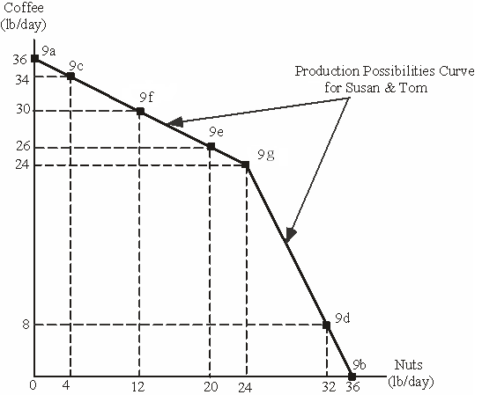

Learning Objective: 02-03

AACSB: Analytic

Bloom’s: Apply

6. a. By specializing completely, they can produce 24 pounds of coffee per day and 24 pounds of nuts (the point at which the kink occurs in the PPC in the diagram). If they sell this output in the world market at the stated prices, they will receive a total of $96 per day.

b. With $96 per day to spend, the maximum amount of coffee they could buy is 48 pounds per day, or they could buy 48 pounds of nuts per day.

The combination of 40 pounds of coffee and 8 pounds of nuts would be unattainable for Susan and Tom, as the maximum amount of coffee that can be picked is 36 pounds. However, 40 pounds of coffee would cost $80, and 8 pounds of coffee would cost $16, so they would have just enough money ($96 per day) to buy this combination of goods

c. The points and the straight lines connecting them are shown in the diagram below. The resulting line is the production possibilities curve for the two-person economy consisting of Susan and Tom.

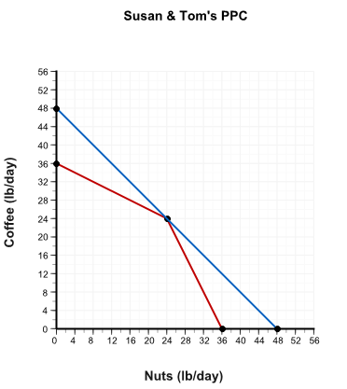

Learning Objective: 02-04

AACSB: Analytic

Bloom’s: Apply