2

THINKING LIKE AN ECONOMIST

WHAT’S NEW IN THE FIFTH EDITION?

A new In The News box, “Environmental Economists” replaces the old “Why Should You Study Economics” box.

LEARNING OBJECTIVES

By the end of this chapter, students should understand:

- how economists apply the methods of science.

- how assumptions and models can shed light on the world.

- two simple models—the circular flow and the production possibilities frontier.

- the difference between microeconomics and macroeconomics.

- the difference between positive and normative statements.

- the role of economists in making policy.

- why economists sometimes disagree with one another.

WHY IS THIS CHAPTER IMPORTANT TO STUDENTS?

Chapter 2 is the second chapter in a three chapter section that serves as the introduction of the text. Chapter 1 introduced ten principles of economics that will be revisited throughout the text. Chapter 2 develops how economists approach problems while Chapter 3 will explain how individuals and countries gain from trade.
The purpose of Chapter 2 is to familiarize students with how economists approach economic problems. With practice, they will learn how to approach similar problems in this dispassionate systematic way. They will see how economists employ the scientific method, the role of assumptions in model building, and the application of two specific economic models. Students will also learn the important distinction between two roles economists can play: as scientists when we try to explain the economic world and as policymakers when we try to improve it.

IF NOTHING ELSE, MY STUDENTS SHOULD LEARN…

- Economists try to address their subject with a scientist’s objectivity. Like all scientists, they make appropriate assumptions and build simplified models in order to understand the world around them. Two simple economic models are the circular-flow diagram and the production possibilities frontier.

- The field of economics is divided into two subfields: microeconomics and macroeconomics. Microeconomists study decisionmaking by households and firms and the interaction among households and firms in the marketplace. Macroeconomists study the forces and trends that affect the economy as a whole.

- A positive statement is an assertion about how the world is. A normative statement is an assertion about how the world ought to be. When economists make normative statements, they are acting more as policy advisers than scientists.

- Economists who advise policymakers offer conflicting advice either because of differences in scientific judgments or because of differences in values. At other times, economists are united in the advice they offer, but policymakers may choose to ignore it.

WHAT CAN I DO IN CLASS?

I. The Economist as Scientist

A. The Scientific Method: Observation, Theory, and More Observation

1. Observations help us to develop theory.

2. Data can be collected and analyzed to evaluate theories.

- Using data to evaluate theories is more difficult in economics than in physical science because economists are unable to generate their own data and must make do with whatever data are available.

4. Thus, economists pay close attention to the natural experiments offered by history.

B. The Role of Assumptions

- Assumptions can simplify the complex world and make it easier to understand.

- Example: to understand international trade, it may be helpful to start out assuming that there are only two countries in the world producing only two goods. Once we understand how trade would work between these two countries, we can extend our analysis to a greater number of countries and goods.

3. One important role of a scientist is to understand which assumptions one should make.

4. Economists use different assumptions to answer different questions.
C. Economic Models

1. Economists use economic models to explain the world around us.
To illustrate to the class how simple but unrealistic models can be useful, bring a road map to class. Point out how unrealistic it is. For example, it does not show where all of the stop signs, gas stations, or restaurants are located. It assumes that the earth is flat and two-dimensional. But, despite these simplifications, a map usually helps travelers get from one place to another. Thus, it is a good model.

2. Most economic models are composed of diagrams and equations.

3. The goal of a model is to simplify reality in order to increase our understanding. This is where the use of assumptions is helpful.

Activity 1 — Realism and Models: An Analogy

Type: In-class demonstration
Topics: Models
Materials needed: Airplane kit, sheet of paper, whirl-a-gig wing toy (Note: the whirl-a-gig wing toy is a helicopter wing on a stick; it is often sold in museum gift shops as well as toy stores.)
Time: 5 minutes
Class limitations: Works in any class size

Ask the class if a realistic model is better than an unrealistic model.

Show them the airplane model kit. Describe some of the details included in model (rivets, canopy, struts, etc.). Shake the box to rattle the large number of parts. This is a fairly realistic model, although obviously not a real airplane. Its complexity adds realism, but at a cost; assembling the model is very time consuming. Drop the box on the floor. Tell the class, “This model, even when completed, cannot fly.”

Take a sheet of paper and fold it into a paper airplane. Show the class this new model. Its virtues include simplicity and ease of assembly, but it is less realistic than the airplane model kit. Throw the airplane and explain, “While less detailed, this model can glide through the air.”

Show the students the whirl-a-gig wing toy. This model looks nothing like an airplane – just a T-shaped piece of wood. Yet, this model does something that the other two models cannot do: it actually generates lift. This toy demonstrates the same aerodynamic principles as a real airplane wing. Twirl the stick between your palms and the whirl-a-gig wing toy will fly over your head.

Economic models are like the whirl-a-gig wing toy. They are much less complex than the real world, but they can show how markets actually work.

D. Our First Model: The Circular Flow Diagram

Figure 2.1

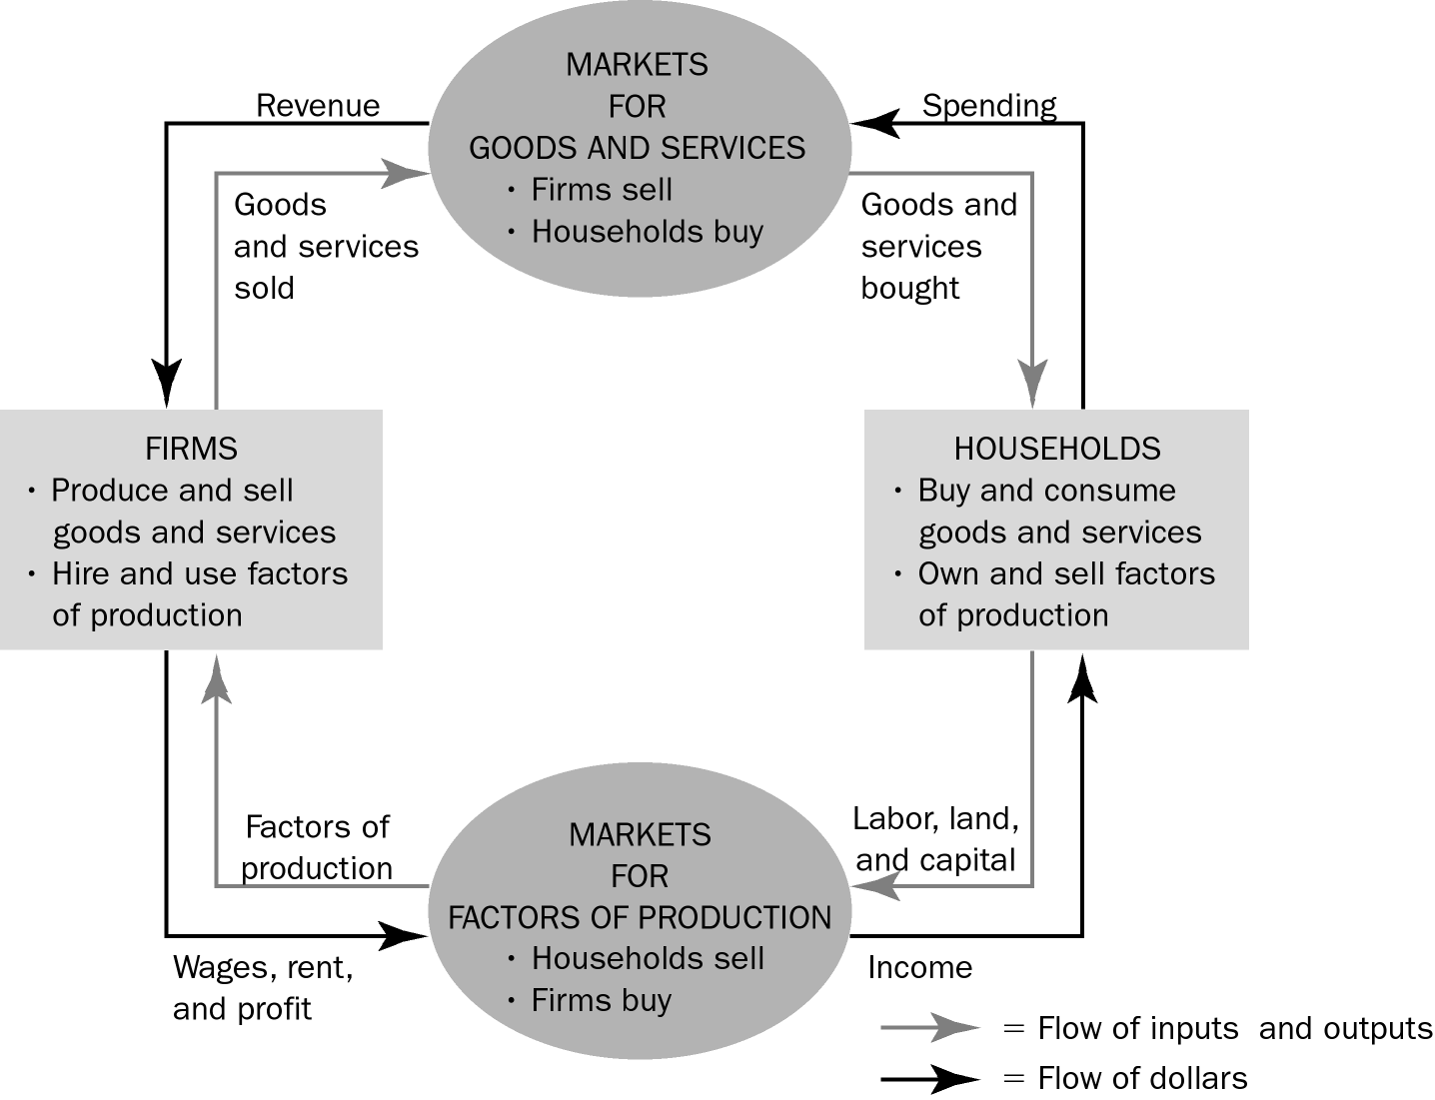

1. Definition of circular-flow diagram: a visual model of the economy that shows how dollars flow through markets among households and firms.

2. This diagram is a very simple model of the economy. Note that it ignores the roles of government and international trade.

a. There are two decisionmakers in the model: households and firms.

b. There are two markets: goods market and factor market.

c. Firms are sellers in the goods market and buyers in the factor market.

d. Households are buyers in the goods market and sellers in the factor market.

e. The inner loop represents the flows of inputs and outputs between households and firms.

f. The outer loop represents the flows of dollars between households and firms.

E. Our Second Model: The Production Possibilities Frontier

1. Definition of production possibilities frontier: a graph that shows the combinations of output that the economy can possibly produce given the available factors of production and the available production technology.

Spend more time with this model than you think is necessary. Be aware that the math skills of most of your students will be limited. It is important for the students to feel confident with this first graphical and mathematical model. Be deliberate with every point. If you lose them with this model, they may be gone for the rest of the course.

2. Example: a country that produces two goods, cars and computers.

a. If all resources are devoted to producing cars, the economy can produce 1,000 cars and zero computers.

b. If all resources are devoted to producing computers, the economy can produce 3,000 computers and zero cars.

c. If resources are divided between the two industries, the feasible combinations of output are shown on the curve.

Figure 2.2
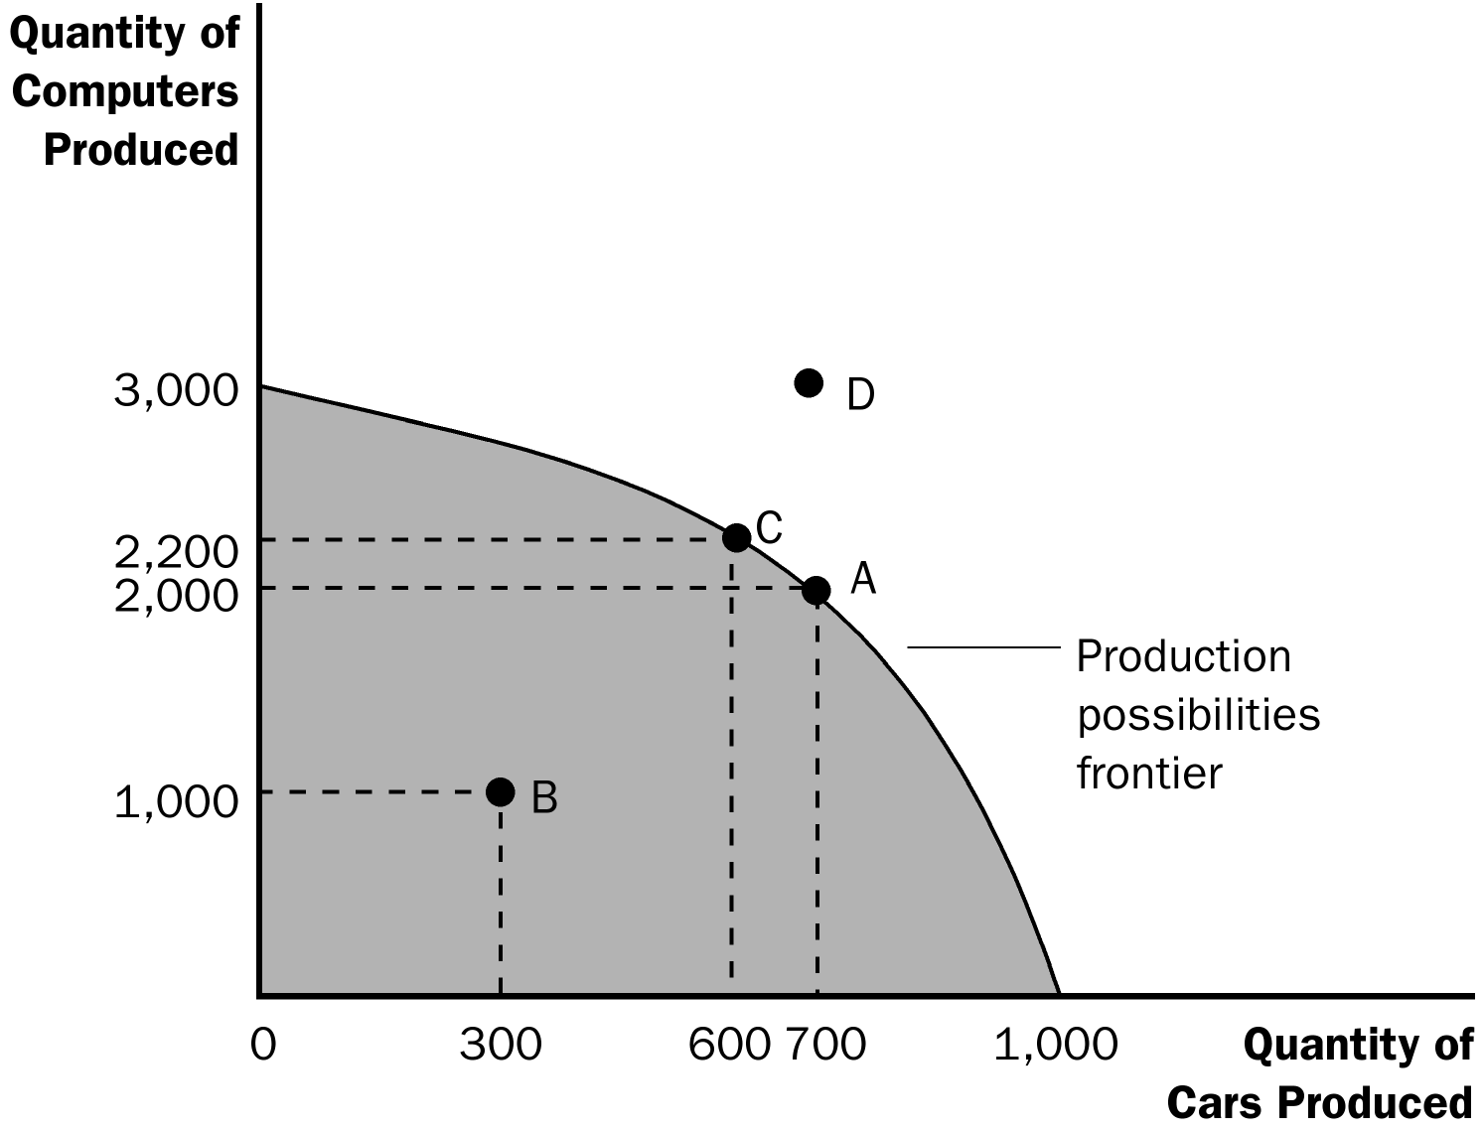

You may want to include time dimensions for variables to make it clear that the production data are measured in terms of annual flows. This will help students to realize that a new production possibilities frontier occurs for each year. Thus, the axes show the level of output per year.

It is useful to point out that the production possibilities curve depends on two things: the availability of resources and the level of technology.

ALTERNATIVE CLASSROOM EXAMPLE:
A small country produces two goods: corn (measured in bushels) and trucks. Points on a production possibilities frontier can be shown in a table or a graph:

 | A | B | C | D | E
Trucks | 0 | 10 | 20 | 30 | 40
Corn | 70 | 60 | 45 | 25 | 0

The production possibilities frontier should be drawn from the numbers above.

Students should be asked to calculate the opportunity cost of increasing the number of trucks produced by ten:
- between 0 and 10
- between 10 and 20
- between 20 and 30
- between 30 and 40

Points inside the curve, points on the curve, and points outside of the curve can also be discussed.

3. Production is efficient at points on the curve. This implies that the economy is getting all it can from the scarce resources it has available.

4. Production at a point inside the curve is inefficient.

5. Production at a point outside of the curve is not possible given the economy’s current level of resources and technology.

6. The production possibilities frontier reveals Principle #1: People face tradeoffs.

a. Suppose the economy is currently producing 600 cars and 2,200 computers. To increase the production of cars to 700, the production of computers must fall to 2,000.

7. Principle #2 is also shown on the production possibilities frontier: The cost of something is what you give up to get it (opportunity cost).

a. The opportunity cost of increasing the production of cars from 600 to 700 is 200 computers.

Be aware that students often have trouble understanding why opportunity costs rise as the production of a good increases. You may want to use several specific examples of resources that are more suited to producing cars than computers (e.g., an experienced mechanic) as well as examples of resources that are more suited to producing computers than cars (e.g., an experienced computer programmer).

8. The shape of the production possibilities frontier indicates that the opportunity cost of cars in terms of computers increases as the country produces more cars and fewer computers. This occurs because some resources are better suited to the production of cars than computers (and vice versa).

9. The production possibilities frontier can shift if resource availability or technology changes.

Activity — Screwdrivers and Bloody Marys

Type: In-class discussion
Topics: Graphing, opportunity cost, tradeoffs
Materials needed: None
Time: 10 minutes
Class limitations: Works in any class size

Instructions
Draw a graph with Bloody Marys on the horizontal axis and Screwdrivers on the vertical axis.

A Bloody Mary contains tomato juice and one shot of vodka. A screwdriver contains orange juice and one shot of vodka. Assume that we have plenty of orange juice and tomato juice, but only one small bottle of vodka containing 6 shots.

How many Bloody Marys can we make, if we only make Bloody Marys?

How many Screwdrivers can we make if we only make Screwdrivers?

Could we make 6 of both drinks? Why not?

On your graph, show all of the possible combinations of Bloody Marys and Screwdrivers that can be made, given a small bottle of vodka.

Points for Discussion
The combinations will make a linear production possibilities curve that is continuous since we could make half drinks, quarter drinks, or any fraction of either drink.

Several basic graphing techniques can be demonstrated: inverse relation, negative slope, etc.

The economic points are more interesting: We can produce any combination on or inside the line. If we produce inside the line, we are not fully using our resources. This is inefficient.

If we do use all of our scarce resources, increasing the production of one drink requires sacrificing production of the other. This lost production is opportunity cost.

You may also want to teach students about budget constraints at this time (call them “consumption possibilities frontiers”). This reinforces the idea of opportunity cost, and allows them to see how opportunity cost can be measured by the slope. Also, it will introduce students to the use of a straight-line production possibilities frontier (which is used in Chapter 3). However, be careful if you choose to do this as students find the difference between straight-line and concave production possibilities curves challenging.

F. Microeconomics and Macroeconomics
ALTERNATIVE CLASSROOM EXAMPLE:
Ivan receives an allowance from his parents of $10 each week. He spends his entire allowance on two goods: ice cream cones (which cost $1 each) and tickets to the movies (which cost $5 each).

Students should be asked to calculate the opportunity cost of one movie and the opportunity cost of one ice cream cone.

Ivan’s consumption possibilities frontier (budget constraint) can be drawn. It should be noted that the slope is equal to the opportunity cost and is constant because the opportunity cost is constant.

Ask students what would happen to the consumption possibilities frontier if Ivan’s allowance changes or if the price of ice cream cones or movies changes.

1. Economics is studied on various levels.

a. Definition of microeconomics: the study of how households and firms make decisions and how they interact in markets.

b. Definition of macroeconomics: the study of economy-wide phenomena, including inflation, unemployment, and economic growth.

2. Microeconomics and macroeconomics are closely intertwined because changes in the overall economy arise from the decisions of millions of individual households and firms.

3. Because microeconomics and macroeconomics address different questions, they sometimes take different approaches and are often taught in separate courses.

II. The Economist as Policy Adviser

A. Positive Versus Normative Analysis

1. Example of a discussion of minimum-wage laws: Polly says, “Minimum-wage laws cause unemployment.” Norma says, “The government should raise the minimum wage.”

2. Definition of positive statements: claims that attempt to describe the world as it is.

3. Definition of normative statements: claims that attempt to prescribe how the world should be.

4. Positive statements can be evaluated using data, while normative statements involve personal viewpoints.
Use several examples to illustrate the differences between positive and normative statements and stimulate classroom discussion. Possible examples include the minimum wage, budget deficits, tobacco taxes, legalization of marijuana, and seat-belt laws.

Have students bring in newspaper articles and in groups, identify each statement in an editorial paragraph as being a positive or normative statement. Discuss the difference between straight news stories and editorials and the analogy to economists as scientists and as policy advisers.

B. Economists in Ottawa

1. Economists are aware that tradeoffs are involved in most policy decisions.

2. Several federal government departments rely on the advice of economists – Finance Canada, Foreign Affairs Canada, International Trade Canada, Human Resources and Skills Developments and Statistics Canada.

3. The World Wide Web addresses, at the end of this chapter, the organizations that hire economists and influence economic policy.

4. The research and writings of economists can also indirectly affect public policy.

- In The News: Super Bowl Economics

  - Sometimes economists offer advice to football coaches.

  - This article from the New York Times discusses the application of “incremental analysis” in a football game.

6. Case Study: Mr. Mankiw Goes to Washington

a. Mr. Mankiw talks about the process by which economic policy is made.

b. Economists offer crucial input into the policy process, but their advice is only one ingredient of a complex recipe.

III. Why Economists Disagree

A. Differences in Scientific Judgments

1. Economists often disagree about the validity of alternative theories or about the size of the effects of changes in the economy on the behaviour of households and firms.

2. Example: some economists feel that a change in the tax system that would eliminate a tax on income and create a tax on consumption would increase saving in this country. However, other economists feel that the change in the tax system would have little effect on saving behaviour and therefore do not support the change.

- Differences in Values

1. Economists give advice based on different values rather than being based on scientific grounds only.

C. Perception Versus Reality

1. While it seems as if economists do not agree on much, this is in fact not true. Table 2.1 contains ten propositions that are endorsed by a majority of economists.
Emphasize that there is more agreement among economists than most people think. The reason for this is probably that the things that are generally agreed upon are boring to most non-economists.

2. Almost all economists believe that rent control adversely affects the availability and quality of housing.

3. While most economists oppose barriers to trade, Parliament has chosen to restrict the importation of certain goods.

- In The News: Why You Should Study Economics

  - The broken window fallacy is used here to address the non-intuitive reality about how real progress comes from job destruction.

  - This article from the Wall Street Journal makes the case for studying economics.

IV. Appendix—Graphing: A Brief Review
Many instructors may be unaware of how much trouble beginning students have grasping the most basic graphs. It is important for instructors to make sure that students are comfortable with these techniques.

When reviewing graphing with the students, it is best to bring students to the board to be “recorders” of what the other students say as you give a series of instructions like “Draw a pie chart” or ask questions like “How tall should the bar be if the value is 120 million?” Do not make the student at the board responsible for the answer. Instead, he or she should be simply recording what the other students say. Students are often uneasy about graphing at first and need to see that they are not alone.

A. Graphs of a Single Variable

1. Pie Chart

2. Bar Graph

3. Time-Series Graph

B. Graphs of Two Variables: The Coordinate System

1. Economists are often concerned with relationships between two or more variables.

2. Ordered pairs of numbers can be graphed on a two-dimensional grid.

a. The first number in the ordered pair is the x-coordinate and tells us the horizontal location of the point.

b. The second number in the ordered pair is the y-coordinate and tells us the vertical location of the point.

3. The point with both an x-coordinate and y-coordinate of zero is called the origin.

4. Two variables that increase or decrease together have a positive correlation.

- Two variables that move in opposite directions (one increases when the other decreases) have a negative correlation.

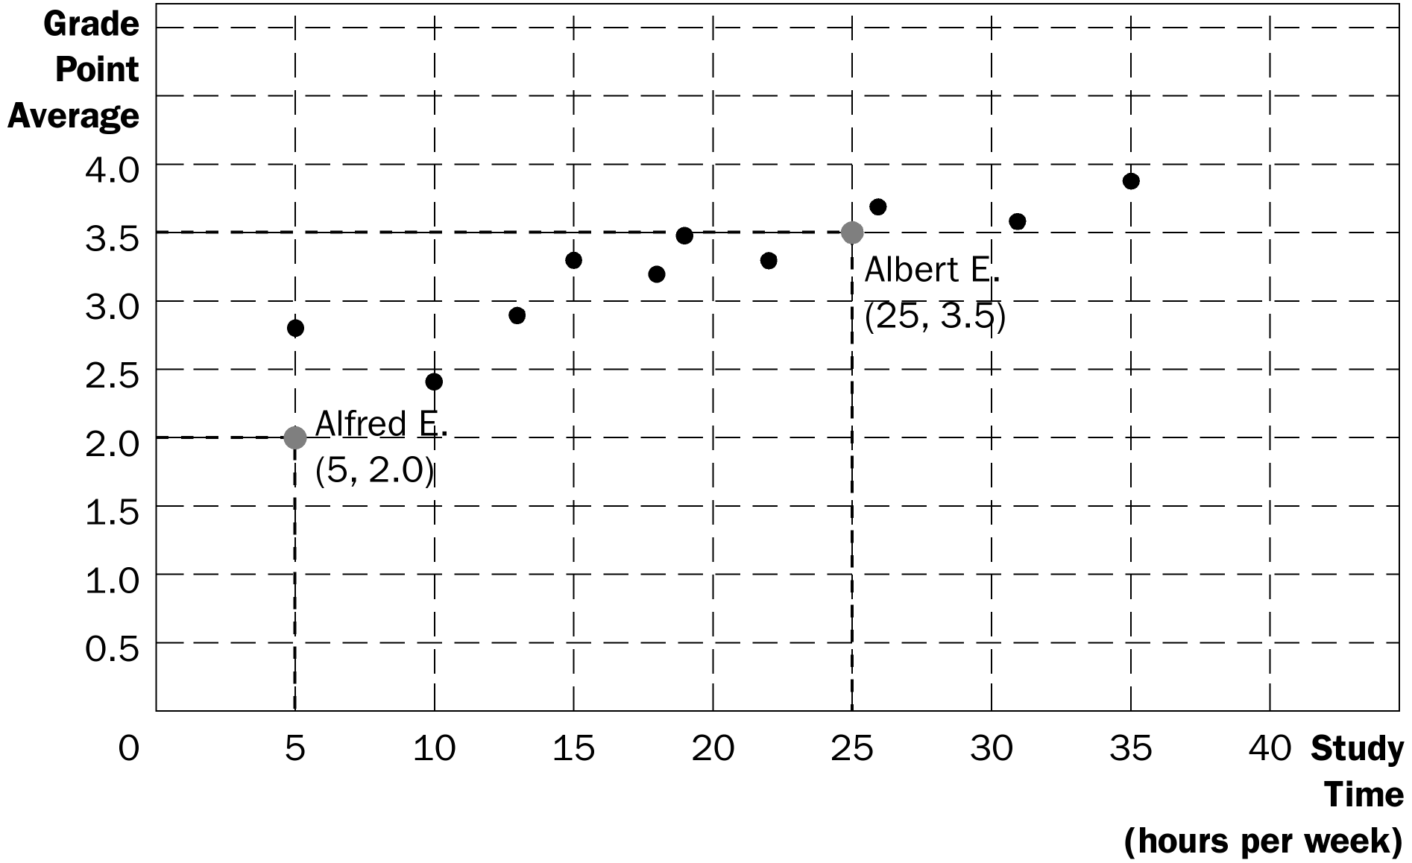
C. Curves in the Coordinate System

1. Often, economists want to show how one variable affects another, holding all other variables constant.

a. An example of this is a demand curve.

- The demand curve shows how the quantity of a good a consumer wants to purchase varies as its price varies, holding everything else (such as income) constant.

- If income does change, this will alter the amount of a good that the consumer wants to purchase at any given price. Thus, the relationship between price and quantity desired has changed and must be represented as a new demand curve.

- A simple way to tell if it is necessary to shift the curve is to look at the axes. When a variable that is not named on either axis changes, the curve shifts.

D. Slope

1. We may want to ask how strongly a consumer reacts if the price of a product changes.

a. If the demand curve is very steep, quantity desired does not change much in response to a change in price.

b. If the demand curve is very flat, quantity desired changes a great deal when the price changes.

2. The slope of a line is the ratio of the vertical distance covered to the horizontal distance covered as we move along the line (“rise over run”).

3. A small slope means that the demand curve is relatively flat; a large slope means that the demand curve is relatively steep.

E. Cause and Effect

1. Economists often make statements suggesting that a change in Variable A causes a change in Variable B.

2. Ideally, we would like to see how changes in Variable A affect Variable B, holding all other variables constant.

3. This is not always possible and could lead to a problem caused by omitted variables.

a. If Variables A and B both change at the same time, we may conclude that the change in Variable A caused the change in Variable B.
b. But, if Variable C has also changed, it is entirely possible that Variable C is responsible for the change in Variable B.

4. Another problem is reverse causality.

a. If Variable A and Variable B both change at the same time, we may believe that the change in Variable A led to the change in Variable B.

b. However, it is entirely possible that the change in Variable B led to the change in Variable A.

c. It is not always as simple as determining which variable changed first because individuals often change their behaviour in response to a change in their expectations about the future. This means that Variable A may change before Variable B but only because of the expected change in Variable B.

SOLUTIONS TO TEXT PROBLEMS:

Quick Quizzes

1. Economics is like a science because economists devise theories, collect data, and analyze the data in an attempt to verify or refute their theories. In other words, economics is based on the scientific method.

Figure 1 shows the production possibilities frontier for a society that produces food and clothing. Point A is an efficient point (on the frontier), point B is an inefficient point (inside the frontier), and point C is an infeasible point (outside the frontier).

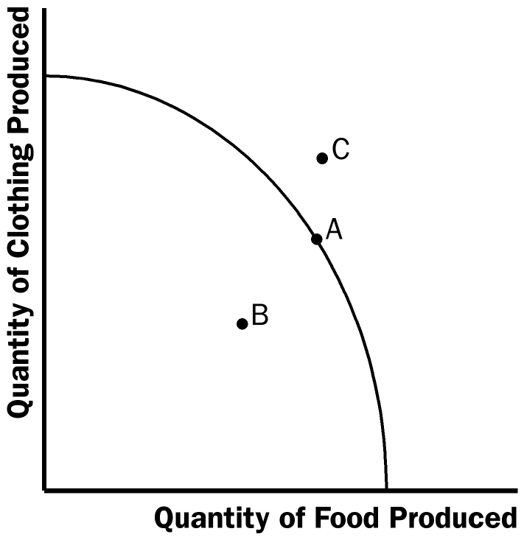

Figure 1

The effects of a drought are shown in Figure 2. The drought reduces the amount of food that can be produced, shifting the production possibilities frontier inward.

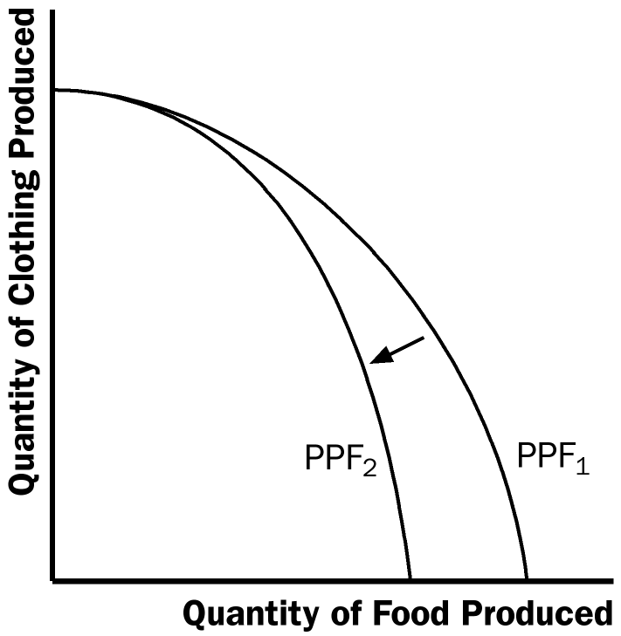

Figure 2

Microeconomics is the study of how households and firms make decisions and how they interact in markets. Macroeconomics is the study of economy-wide phenomena, including inflation, unemployment, and economic growth.

2. An example of a positive statement is “higher taxes discourage work effort” (many other answers are possible). That’s a positive statement because it describes the effects of higher taxes, describing the world as it is. An example of a normative statement is “the government should reduce tax rates.” That is a normative statement because it’s a claim about how the world should be.

Parts of the government that regularly rely on advice from economists are Finance Canada in designing tax policy, Industry Canada in designing and enforcing Canada’s antimonopoly laws, and International Trade Canada in helping to negotiate trade agreements with other countries.

3. Economic advisers to the prime minister might disagree about a question of policy because of differing scientific judgments or differences in values.

Questions for Review

1. Economics is like a science because economists use the scientific method. They devise theories, collect data, and then analyze these data in an attempt to verify or refute their theories about how the world works. Economists use theory and observation like other scientists, but they are limited in their ability to run controlled experiments. Instead, they must rely on natural experiments.

2. Economists make assumptions to simplify problems without substantially affecting the answer. Assumptions can make the world easier to understand.

3. An economic model cannot describe reality exactly because it would be too complicated to understand. A model is a simplification that allows the economist to see what is truly important.

4. Figure 3 shows a production possibilities frontier between milk and cookies (PPF₁). If a disease kills half of the economy's cow population, less milk production is possible, so the PPF shifts inward (PPF₂). Note that if the economy produces all cookies, so it doesn't need any cows, then production is unaffected. But if the economy produces any milk at all, then there will be less production possible after the disease hits.

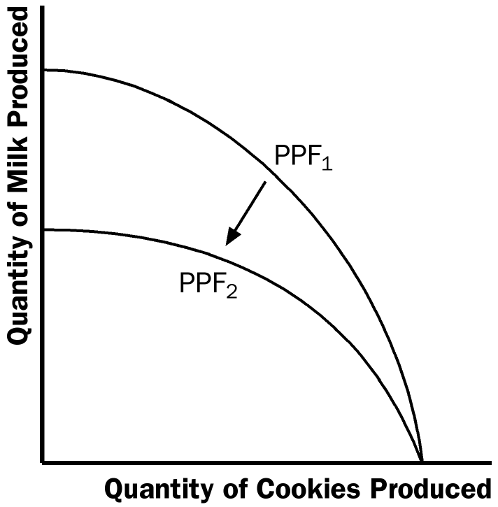

Figure 3

5. The idea of efficiency is that an outcome is efficient if the economy is getting all it can from the scarce resources it has available. In terms of the production possibilities frontier, an efficient point is a point on the frontier, such as point A in Figure 4. A point inside the frontier, such as point B, is inefficient since more of one good could be produced without reducing the production of another good.

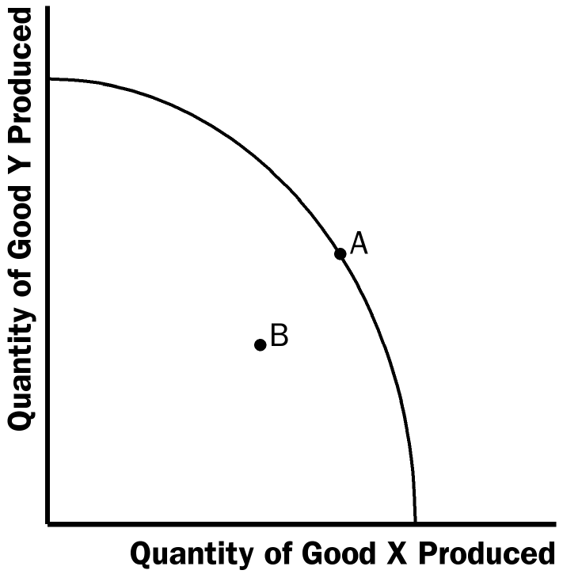

Figure 4

6. The two subfields in economics are microeconomics and macroeconomics. Microeconomics is the study of how households and firms make decisions and how they interact in specific markets. Macroeconomics is the study of economy-wide phenomena.

7. Positive statements are descriptive and make a claim about how the world is, while normative statements are prescriptive and make a claim about how the world ought to be. Here is an example. Positive: A rapid growth rate of money is the cause of inflation. Normative: The government should keep the growth rate of money low.

8. The Bank of Canada sets Canada’s monetary policy. It employs more than 200 economists to analyze financial markets and macroeconomic developments.

9. Economists sometimes offer conflicting advice to policymakers for two reasons:
(1) economists may disagree about the validity of alternative positive theories about how the world works; and (2) economists may have different values and, therefore, different normative views about what public policy should try to accomplish.

Problems and Applications

1. Many answers are possible.

2. a. Steel is a fairly uniform commodity, though some firms produce steel of inferior quality.

b. Novels are each unique, so they are quite distinguishable.

c. Wheat produced by one farmer is completely indistinguishable from wheat produced by another.

d. Fast food is more distinguishable than steel or wheat, but certainly not as much as novels.

3. See Figure 5, where the four transactions are shown.

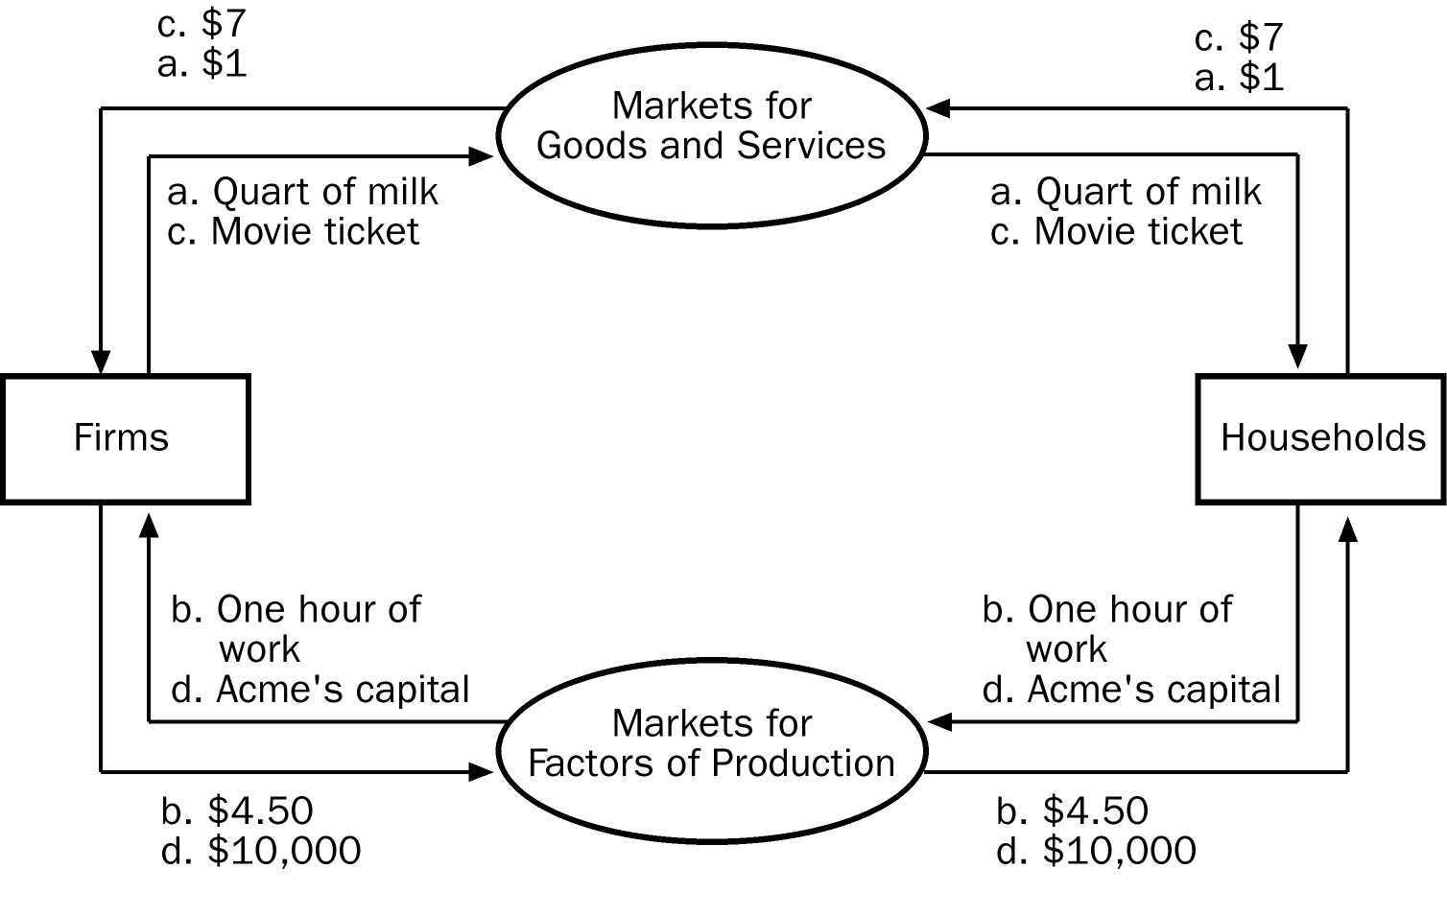

Figure 5

4. a. Figure 6 shows a production possibilities frontier between guns and butter. It is bowed out because when most of the economy’s resources are being used to produce butter, the frontier is steep and when most of the economy’s resources are being used to produce guns, the frontier is very flat. When the economy is producing a lot of guns, workers and machines best suited to making butter are being used to make guns, so each unit of guns given up yields a large increase in the production of butter. Thus, the production possibilities frontier is flat. When the economy is producing a lot of butter, workers and machines best suited to making guns are being used to make butter, so each unit of guns given up yields a small increase in the production of butter. Thus, the production possibilities frontier is steep.

b. Point A is impossible for the economy to achieve; it is outside the production possibilities frontier. Point B is feasible but inefficient because it’s inside the production possibilities frontier.

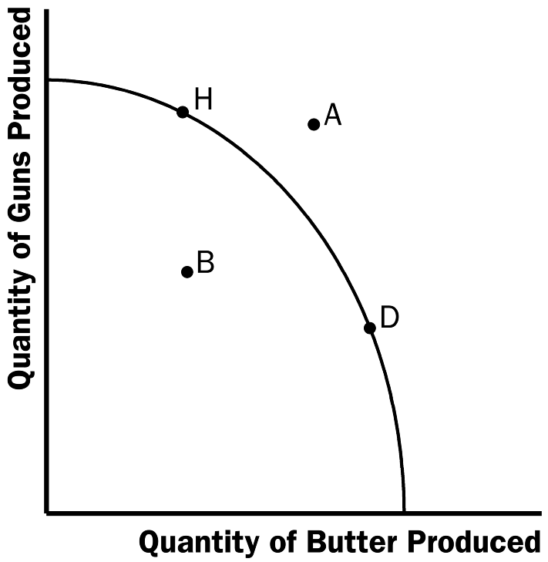

Figure 6

c. The Hawks might choose a point like H, with many guns and not much butter. The Doves might choose a point like D, with a lot of butter and few guns.

d. If both Hawks and Doves reduced their desired quantity of guns by the same amount, the Hawks would get a bigger peace dividend because the production possibilities frontier is much steeper at point H than at point D. As a result, the reduction of a given number of guns, starting at point H, leads to a much larger increase in the quantity of butter produced than when starting at point D.
5. See Figure 7. The shape and position of the frontier depend on how costly it is to maintain a clean environment⎯the productivity of the environmental industry. Gains in environmental productivity, such as the development of a no-emission auto engine, lead to shifts of the production-possibilities frontier, like the shift from PPF₁ to PPF₂ shown in the figure.

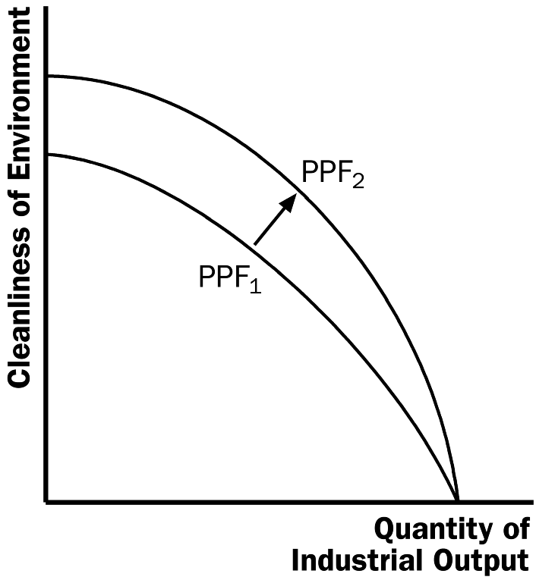

Figure 7

6. a. A family's decision about how much income to save is microeconomics.

b. The effect of government regulations on auto emissions is microeconomics.

c. The impact of higher saving on economic growth is macroeconomics.

d. A firm's decision about how many workers to hire is microeconomics.

e. The relationship between the inflation rate and changes in the quantity of money is macroeconomics.

7. a. The statement that society faces a short-run tradeoff between inflation and unemployment is a positive statement. It deals with how the economy is, not how it should be. Since economists have examined data and found that there is a short-run negative relationship between inflation and unemployment, the statement is a fact, thus it is a positive statement.

b. The statement that a reduction in the rate of growth of money will reduce the rate of inflation is a positive statement. Economists have found that money growth and inflation are very closely related. The statement thus tells how the world is, and so it is a positive statement.

c. The statement that the Bank of Canada should reduce the rate of growth of money is a normative statement. It states an opinion about something that should be done, not how the world is.

d. The statement that society ought to require welfare recipients to look for jobs is a normative statement. It doesn't state a fact about how the world is. Instead, it is a statement of how the world should be and is thus a normative statement.

e. The statement that lower tax rates encourage more work and more saving is a positive statement. Economists have studied the relationship between tax rates and work, as well as the relationship between tax rates and saving. They have found a negative relationship in both cases. The statement reflects how the world is, and is thus a positive statement.

8. Two of the statements in Table 2 are clearly normative. They are: "5. If the federal budget is to be balanced, it should be done over the business cycle rather than yearly" and "9. The government should restructure the welfare system along the lines of a 'negative income tax.'" Both are suggestions of changes that should be made, rather than statements of fact, so they are clearly normative statements.

The other statements in the table are positive. All the statements concern how the world is, not how the world should be. Note that in all cases, even though they are statements of fact, fewer than 100 percent of economists agree with them. You could say that positive statements are statements of fact about how the world is, but not everyone agrees about what the facts are.

9. As the prime minister, you'd be interested in both the positive and normative views of economists, but you'd probably be most interested in their positive views. Economists are on your staff to provide their expertise about how the economy works. They know many facts about the economy and the interaction of different sectors. So you would be most likely to call on them about questions of fact⎯positive analysis. Since you are the prime minister, you are the one who has to make the normative statements as to what should be done, with an eye to the political consequences. The normative statements made by economists represent their own views, not necessarily your views or the electorate’s views.

10. There are many possible answers.

- As of this writing, the governor of the Bank of Canada is Mark J. Carney and the current minister of Finance Canada is Jim Flaherty. Lawrence Cannon is the minister of Foreign Affairs Canada and Peter Van Loan is the minister of International Trade Canada. Carney is the only economist. Having a background in economic theory would be of significant benefit in understanding the issues and policy recommendations from each ministry to solve specific economic problems.

12. As time goes on, you might expect economists to disagree less about public policy because they will have opportunities to observe different policies that are put into place. As new policies are tried, their results will become known, and they can be evaluated better. It's likely that the disagreement about them will be reduced after they've been tried in practice. For example, many economists thought that wage and price controls would be a good idea for keeping inflation under control, while others thought it was a bad idea. But when the controls were tried in the early 1970s, the results were disastrous. The controls interfered with the invisible hand of the marketplace and shortages developed in many markets. As a result, most economists are now convinced that wage and price controls are a bad idea for controlling inflation.

But it is unlikely that the differences between economists will ever be completely eliminated. Economists differ on too many aspects of how the world works. Plus, even as some policies get tried out and are either accepted or rejected, creative economists keep coming up with new ideas.

