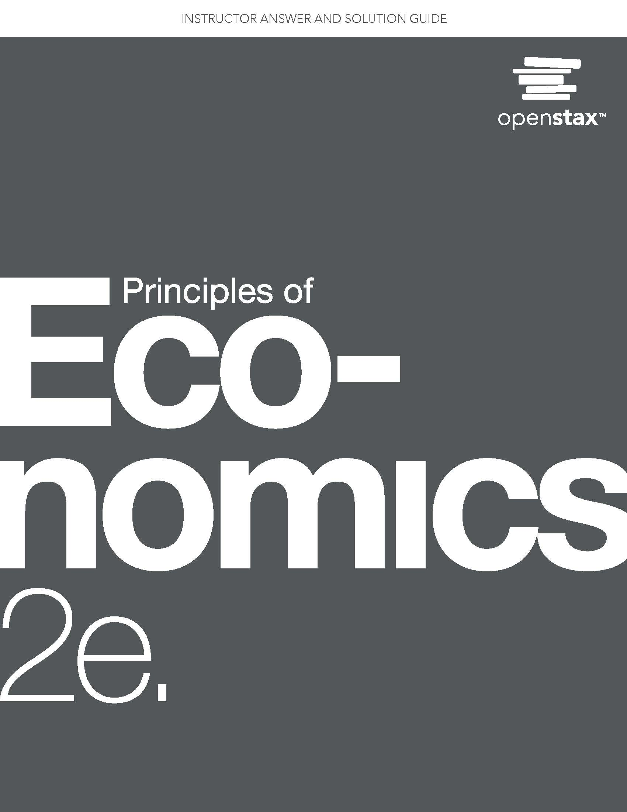

Chapter 1: Welcome to Economics!

Self-Check Questions

1. What is scarcity? Can you think of two causes of scarcity?

Solution: Scarcity means human wants for goods and services exceed the available supply. Supply is limited because resources are limited. Demand, however, is virtually unlimited. Whatever the supply, it seems human nature to want more.

1. Residents of the town of Smithfield like to consume hams, but each ham requires 10 people to produce it and takes a month. If the town has a total of 100 people, what is the maximum amount of ham the residents can consume in a month?

Solution: 100 people / 10 people per ham = a maximum of 10 hams per month if all residents produce ham. Since consumption is limited by production, the maximum number of hams residents could consume per month is 10.

1. A consultant works for $200 per hour. She likes to eat vegetables, but is not very good at it. Why does it make more economic sense for her to spend her time at the consulting job and shop for her vegetables?

Solution: She is very productive at her consulting job, but not very productive growing vegetables. Time spent consulting would produce far more income than it what she could save growing her vegetables using the same amount of time. So on purely economic grounds, it makes more sense for her to maximize her income by applying her labor to what she does best (i.e. specialization of labor).

1. A computer systems engineer could paint his house, but it makes more sense for him to hire a painter to do it. Explain why.

Solution: The engineer is better at computer science than at painting. Thus, his time is better spent working for pay at his job and paying a painter to paint his house. Of course, this assumes he does not paint his house for fun!

1. What would be another example of a “system” in the real world that could serve as a metaphor for micro and macroeconomics?

Solution: There are many physical systems that would work, for example, the study of planets (micro) in the solar system (macro), or solar systems (micro) in the galaxy (macro).

1. Suppose we extend the circular flow model to add imports and exports. Copy the circular flow diagram onto a sheet of paper and then add a foreign country as a third agent. Draw the flows of imports, exports, and the payments for each on your diagram.

Solution: Draw a box outside the original circular flow to represent the foreign country. Draw an arrow from the foreign country to firms, to represents imports. Draw an arrow in the reverse direction representing payments for imports. Draw an arrow from firms to the foreign country to represent exports. Draw an arrow in the reverse direction to represent payments for imports.

1. What is an example of a problem in the world today, not mentioned in the chapter, that has an economic dimension?

Solution: There are many such problems. Consider the AIDS epidemic. Why are so few AIDS patients in Africa and Southeast Asia treated with the same drugs that are effective in the United States and Europe? It is because neither those patients nor the countries in which they live have the resources to purchase the same drugs.

1. The chapter defines private enterprise as a characteristic of market-oriented economies. What would public enterprise be? Hint: It is a characteristic of command economies.

Solution: Public enterprise means the factors of production (resources and businesses) are owned and operated by the government.

1. Why might Belgium, France, Italy, and Sweden have a higher export to GDP ratio than the United States?

Solution: The United States is a large country economically speaking, so it has less need to trade internationally than the other countries mentioned. (This is the same reason that France and Italy have lower ratios than Belgium or Sweden.) One additional reason is that each of the other countries is a member of the European Union, where trade between members occurs without barriers to trade, like tariffs and quotas.

Review Questions

1. Give the three reasons that explain why the division of labor increases an economy’s level of production.

Solution: First, division of labor allows for specialization, in which workers do what they do best, second, workers learn to be more efficient, and third, businesses can take advantage of economies of scale.

1. What are three reasons to study economics?

Solution: Economics factors into every major policy decision, economics encourages good citizenship, and economics makes for a well-rounded education.

1. What is the difference between microeconomics and macroeconomics?

Solution: Microeconomics focuses of individual actors within an economy, whereas macroeconomics focuses on the economy as a whole, or the sum of all individual actions.

1. What are examples of individual economic agents?

Solution: Individuals, households and businesses are all economic agents.

1. What are the three main goals of macroeconomics?

Solution: Growth in the standard of living, low unemployment and low inflation.

1. How did John Maynard Keynes define economics?

Solution: As a method of thinking that help people draw correct conclusions.

1. Are households primarily buyers or sellers in the goods and services market? In the labor market?

Solution: Households are primarily buyers in the goods and services market, as they use their income to purchase food, housing, education, transportation and many other items. Households are typically sellers in the labor market, offering their labor for a salary or hourly wage in order to earn a living.

1. Are firms primarily buyers or sellers in the goods and services market? In the labor market?

Solution: Firms are primarily sellers in the goods and services market, offering their wares to consumers. They are primarily buyers in the labor market, hiring employees to produce for them.

1. What are the three ways that societies can organize themselves economically?

Solution: As a command economy, a market economy, or a mixture of the two.

1. What is globalization? How do you think it might have affected the economy over the past decade?

Solution: Globalization is an increase in connections and economic activity across international lines. Globalization allows small economies to take fuller advantage of the division of labor.

Critical Thinking Questions

1. Suppose you have a team of two workers: one is a baker and one is a chef. Explain why the kitchen can produce more meals in a given period of time if each worker specializes in what they do best than if each worker tries to do everything from appetizer to dessert.

Solution: The baker and the chef have specialized skills that allow them to be more productive in certain areas than in others. The baker will be able to make a pie faster than the chef, and the chef will be better at cooking the main course. By each worker doing what he does best, productivity and efficiency are maximized and total output is greater.

1. Why would division of labor without trade not work?

Solution: With no trade, each individual must produce all the goods and services he wants to consume. Therefore, by definition, he cannot specialize and so he can obtain the benefits of specialization. With trade, on the other hand, by specializing on what the individual does best, he can maximize product and income and trade for whatever else he wants to consume. In short, specialization results in a net gain rather than a loss.

1. Can you think of any examples of *free* goods, that is, goods or services that are not scarce?

Solution: Air for breathing is, in most cases, not scarce. Of course, for the scuba diver or the astronaut, this is far from the case. Even goods that are not scarce for most practical purposes can become scarce under certain circumstances.

1. A balanced federal budget and a balance of trade are considered secondary goals of macroeconomics, while growth in the standard of living (for example) is considered a primary goal. Why do you think that is so?

Solution: A Balanced federal budget and the balance of trade do not have direct effects on the well-being of individuals. While we can argue about what their long term effects are, the standard of living (as measured by economic growth, for example) is directly responsible for how well off people are within an economy, so that is what economists care about.

1. Macroeconomics is an aggregate of what happens at the microeconomic level. Would it be possible for what happens at the macro level to differ from how economic agents would react to some stimulus at the micro level? *Hint:* Think about the behavior of crowds.

Solution: While the macroeconomy is ultimately the sum of individual actions, we can sometimes see a different result from collective action than we do for individual action. This can happen for a number of reasons, including crowd psychology, concentrated benefits and dispersed costs, and difficulties in coordination.

1. Why is it unfair or meaningless to criticize a theory as “unrealistic?”

Solution: Economic models and the accompanying theories typically employ simplifying assumptions that, by definition, make the models less than perfectly realistic. If the models are good ones, they are still useful for understanding how a system works, in the same way that a physicist might assume an absence of friction to simplify his understanding of how a ball rolls across a surface. By making models simple, we can understand the basic mechanisms of how things like supply and demand work without having to worry too much about all the real world complications

1. Suppose, as an economist, you are asked to analyze an issue unlike anything you have ever done before. Also, suppose you do not have a specific model for analyzing that issue. What should you do? *Hint:* What would a carpenter do in a similar situation?

Solution: In this situation, most economists would attempt to construct a model to describe the issue in question, using observation and reasonable assumptions. This model can then be applied to the problem to get a consistent answer.

1. Why do you think that most modern countries’ economies are a mix of command and market types?

Solution: Markets have historically been very good at creating wealth and innovation, but the governments of most modern countries have decided that certain market outcomes, for extreme wealth inequality, are undesirable, and therefore intervene for the sake of what they view as fair or humane treatment of their citizens

1. Can you think of ways that globalization has helped you economically? Can you think of ways that it has not?

Solution: Some people may have benefitted from the inexpensive and diverse goods made available through global trade, while others may feel that they have lost jobs or opportunities due to competition from producers in foreign countries.