Principles of Accounting, Volume 1: Financial Accounting
Chapter 2: Introduction to Financial Statements

Multiple Choice

1. LO 2.1 Which of these statements is not one of the financial statements?
- income statement
- balance sheet
- statement of cash flows
- statement of owner investments
Solution
D
2. LO 2.1 Stakeholders are less likely to include which of the following groups?
- owners
- employees
- community leaders
- competitors
Solution
D
3. LO 2.1 Identify the correct components of the income statement.
- revenues, losses, expenses, and gains
- assets, liabilities, and owner’s equity
- revenues, expenses, investments by owners, distributions to owners
- assets, liabilities, and dividends
Solution
A
4. LO 2.1 The balance sheet lists which of the following?
- assets, liabilities, and owners’ equity
- revenues, expenses, gains, and losses
- assets, liabilities, and investments by owners
- revenues, expenses, gains, and distributions to owners
Solution
A
5. LO 2.1 Assume a company has a $350 credit (not cash) sale. How would the transaction appear if the business uses accrual accounting?
- $350 would show up on the balance sheet as a sale.
- $350 would show up on the income statement as a sale.
- $350 would show up on the statement of cash flows as a cash outflow.
- The transaction would not be reported because the cash was not exchanged.
Solution
B
6. LO 2.2 Which of the following statements is true?
- Tangible assets lack physical substance.
- Tangible assets will be consumed in a year or less.
- Tangible assets have physical substance.
- Tangible assets will be consumed in over a year.
Solution
C
7. LO 2.2 Owners have no personal liability under which legal business structure?
- a corporation
- a partnership
- a sole proprietorship
- There is liability in every legal business structure.
Solution
A
8. LO 2.2 The accounting equation is expressed as ________.
- Assets + Liabilities = Owner’s Equity
- Assets – Noncurrent Assets = Liabilities
- Assets = Liabilities + Investments by Owners
- Assets = Liabilities + Owner’s Equity
Solution
D
9. LO 2.2 Which of the following decreases owner’s equity?
- investments by owners
- losses
- gains
- short-term loans
Solution
B
10. LO 2.2 Exchanges of assets for assets have what effect on equity?
- increase equity
- may have no impact on equity
- decrease equity
- There is no relationship between assets and equity.
Solution
B
11. LO 2.2 All of the following increase owner’s equity except for which one?
- gains
- investments by owners
- revenues
- acquisitions of assets by incurring liabilities
Solution
D
12. LO 2.3 Which of the following is not an element of the financial statements?
- future potential sales price of inventory
- assets
- liabilities
- equity
Solution
A. The future sales price of an asset is not an element of a financial statement until it is actually sold.
13. LO 2.3 Which of the following is the correct order of preparing the financial statements?
- income statement, statement of cash flows, balance sheet, statement of owner’s equity
- income statement, statement of owner’s equity, balance sheet, statement of cash flows
- income statement, balance sheet, statement of owner’s equity, statement of cash flows
- income statement, balance sheet, statement of cash flows, statement of owner’s equity
Solution
B
14. LO 2.3 The three heading lines of financial statements typically include which of the following?
- company, statement title, time period of report
- company headquarters, statement title, name of preparer
- statement title, time period of report, name of preparer
- name of auditor, statement title, fiscal year end
Solution
A
15. LO 2.3 Which financial statement shows the financial performance of the company on a cash basis?
- balance sheet
- statement of owner’s equity
- statement of cash flows
- income statement
Solution
C. While all four statements can be used to reflect financial performance, all but the cash flow statement use accrual accounting. The cash flow statement is the only financial statement that uses the cash basis.
16. LO 2.3 Which financial statement shows the financial position of the company?
- balance sheet
- statement of owner’s equity
- statement of cash flows
- income statement
Solution
A
17. LO 2.3 Working capital is an indication of the firm’s ________.
- asset utilization
- amount of noncurrent liabilities
- liquidity
- amount of noncurrent assets
Solution
C

Questions

1. LO 2.1 Identify the four financial statements and describe the purpose of each.
Solution
Income statement shows the financial performance of a business for a period of time; statement of owner’s equity shows the change in net worth of a business for a period of time; balance sheet shows the financial position of a business on a specific date; statement of cash flows shows the cash inflows and outflows of the business for a period of time.
2. LO 2.1 Define the term stakeholders. Identify two stakeholder groups, and explain how each group might use the information contained in the financial statements.
Solution
Stakeholders are those with an interest in the activities of an organization. Stakeholders include employees (including managers and directors), creditors, lenders, owners (potential and current), and the community. Each group would use the financial information to make decisions. Employees would use the information to determine future changes, if any, to make in the organization. Creditors and lenders would use the information to assess granting financing to the organization. Owners would decide whether to invest or maintain ownership. The community would use the financial and nonfinancial information to assess the relationship between the organization and the community.
3. LO 2.1 Identify one similarity and one difference between revenues and gains. Why is this distinction important to stakeholders?
Solution
Both revenues and gains represent inflows to the business, making it more valuable. Revenues relate to the primary purpose of the business, while gains represent incidental or peripheral activities. This is important to stakeholders because revenues represent ongoing or permanent activities, while gains represent infrequent or transient activities. Stakeholders should focus on permanent earnings and put peripheral or incidental earnings into the proper context.
4. LO 2.1 Identify one similarity and one difference between expenses and losses. Why is this distinction important to stakeholders?
Solution
Both expenses and losses represent outflows from the business, making it less valuable. Expenses are related to the primary purpose of the business, while losses represent incidental or peripheral activities. This is important to stakeholders because expenses represent ongoing or permanent activities, while losses represent infrequent or transient activities. Stakeholders should focus on permanent earnings and put transient earnings into the proper context.
5. LO 2.1 Explain the concept of equity, and identify some activities that affect equity of a business.
Solution
Equity is the net worth of the business. It can also be thought of as the net assets (assets minus liabilities) of the business. Activities that affect equity include revenues, expenses, gains, losses, and investment by and distributions to owners.
6. LO 2.2 Explain the difference between current and noncurrent assets and liabilities. Why is this distinction important to stakeholders?
Solution
Current assets and liabilities will be settled (generally) in one year or less; noncurrent assets and liabilities will be settled (generally) in more than one year. This is important to stakeholders as it helps them assess the liquidity and solvency of the business.
7. LO 2.2 Identify/discuss one similarity and one difference between tangible and intangible assets.
Solution
Both tangible and intangible assets have value to the company and can be bought, sold, or impaired; tangible assets have physical substance, while intangible assets do not.
8. LO 2.2 Name the three types of legal business structure. Describe one advantage and one disadvantage of each.
Solution
Sole proprietorship—advantages include ease of formation, favorable tax treatment, and a high level of control; disadvantages may include unlimited personal liability, inseparability between the owner and the business, fairly limited ability to raise capital, and limited expertise.
Partnership—advantages include favorable tax treatment, the longevity of the business, and better access to capital and expertise; disadvantages may include unlimited personal liability and increased complexity to form.
Corporation—advantages include owners do not have personal liability, owners have relatively easy access to large amounts of capital, and the business operates beyond the life of the shareholders; the primary disadvantage is double taxation.
9. LO 2.2 What is the “accounting equation”? List two examples of business transactions, and explain how the accounting equation would be impacted by these transactions.
Solution
Assets = Liabilities + Owner’s Equity. Answers will vary and should include a combination of revenues/gains (increases), expenses/losses (decreases), investments (increases), and distributions (decreases). It is important to understand the following transactions/exchanges will not change equity: an asset for an asset, liability for liability, asset acquisitions by incurring liabilities, and asset reductions to reduce liabilities.
10. LO 2.3 Identify the order in which the four financial statements are prepared, and explain how the first three statements are interrelated.
Solution
The four financial statements are prepared in this order: income statement, statement of owner’s equity, balance sheet, and statement of cash flows. The net income from the income statement is carried forward to the statement of owner's equity and is added to the beginning owner's equity balance, as one step in arriving at the ending balance in owner's equity. (The other steps are to add in owner's investments and subtract owner's withdrawals.) Once computed, the ending balance in owner's equity is carried forward to the balance sheet as the balance for the owner's equity section of the balance sheet.
11. LO 2.3 Explain how the following items affect equity: revenue, expenses, investments by owners, and distributions to owners.
Solution
Revenues and investments increase equity, while expenses and distributions decrease equity.
12. LO 2.3 Explain the purpose of the statement of cash flows and why this statement is needed.
Solution
The statement of cash flows provides details regarding the changes in the cash balance throughout the period. It is needed because the other statements are prepared using accrual accounting.

Exercise Set A

EA1. LO 2.1 For each independent situation below, calculate the missing values.
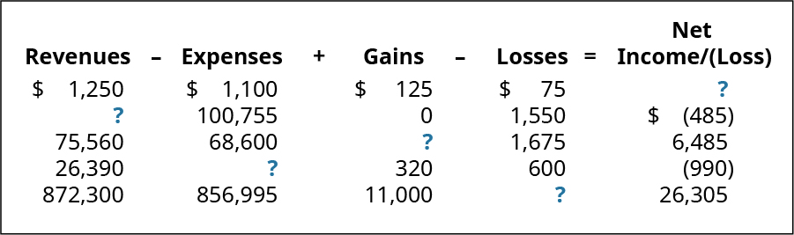
Solution
Revenues | – | Expenses | + | Gains | – | Losses | = | Net Income/(Loss)
$1,250 |  | $1,100 |  | $125 |  | $75 |  | $200
$101,820 |  | $100,755 |  | $0 |  | $1,550 |  | ($485)
$75,560 |  | $68,600 |  | $1,200 |  | $1,675 |  | $6,485
$26,390 |  | $27,100 |  | $320 |  | $600 |  | ($990)
$872,300 |  | $856,995 |  | $11,000 |  | $0 |  | $26,305

EA2. LO 2.1 For each independent situation below, calculate the missing values for owner’s equity
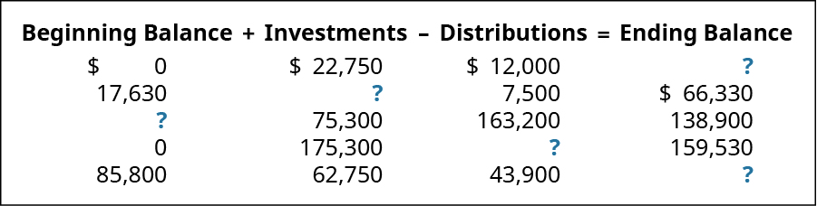
Solution
Beginning Balance | + | Investments | – | Distributions | = | Ending Balance
$0 |  | $22,750 |  | $12,000 |  | $10,750
$17,630 |  | $56,200 |  | $7,500 |  | $66,330
$226,800 |  | $75,300 |  | $163,200 |  | $138,900
$0 |  | $175,300 |  | $15,770 |  | $159,530
$85,800 |  | $62,750 |  | $43,900 |  | $104,650

EA3. LO 2.1 For each independent situation below, calculate the missing values.
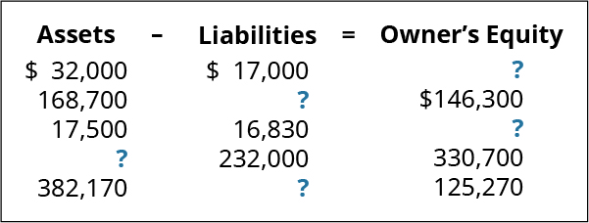
Solution
Assets | – | Liabilities | = | Owner’s Equity
$32,000 |  | $17,000 |  | $15,000
$168,700 |  | $22,400 |  | $146,300
$17,500 |  | $16,830 |  | $670
$562,700 |  | $232,000 |  | $330,700
$382,170 |  | $256,900 |  | $125,270

EA4. LO 2.1 For each independent situation below, place an (X) by the transactions that would be included in the statement of cash flows.
Transaction | Included
Sold items on account
Wrote check to pay utilities
Received cash investment by owner
Recorded wages owed to employees
Received bill for advertising
Table 2.3
Solution
Transaction | Included
Sold items on account
Wrote check to pay utilities | X
Received cash investment by owner | X
Recorded wages owed to employees
Received bill for advertising

EA5. LO 2.2 For each of the following items, identify whether the item is considered current or noncurrent, and explain why.
Item | Current or Noncurrent?
Cash
Inventory
Machines
Trademarks
Accounts Payable
Wages Payable
Owner, Capital
Accounts Receivable
Table 2.4
Solution
Item | Current or Noncurrent?
Cash | Current
Inventory | Current
Machines | Noncurrent
Trademarks | Noncurrent
Accounts Payable | Current
Wages Payable | Current
Owner, Capital | Noncurrent
Accounts Receivable | Current
Current items will be settled in cash in a year or less; noncurrent items in greater than one year.
EA6. LO 2.2 For the items listed below, indicate how the item affects equity (increase, decrease, or no impact.
Item | Increase? Decrease? or No Impact?
Expenses
Assets
Gains
Liabilities
Dividends
Table 2.5
Solution
Item | Increase? Decrease? No Impact?
Expenses | Decrease
Assets | No Impact
Gains | Increase
Liabilities | No Impact
Dividends | Decrease

EA7. LO 2.2 Forest Company had the following transactions during the month of December. What is the December 31 cash balance?
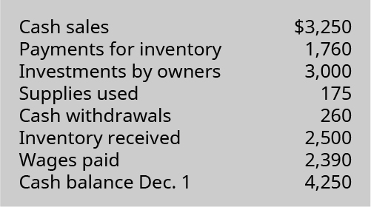
Solution
The December 31 balance is $6,090 ($4,250 + $3,250 – $1,760 + $3,000 – $260 – $2,390).
EA8. LO 2.2 Here are facts for the Hudson Roofing Company for December.
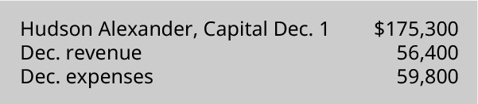
Assuming no investments or withdrawals, what is the ending balance in the owners’ capital account?
Solution
The December 31 balance is $171,900 ($175,300 + $56,400 –$59,800).
EA9. LO 2.3 Prepare an income statement using the following information for DL Enterprises for the month of July 2018.
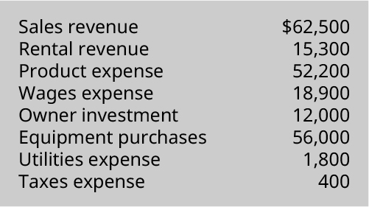
Solution
DL Enterprises
Income Statement
For the Month Ended July 31, 2018
Sales Revenue | $62,500
Rental Revenue | $15,300
Total Revenue |  | $77,800
Expenses
Product Expense | $52,200
Wages Expense | $18,900
Utilities Expense | $1,800
Taxes Expense | $400
Total Expenses |  | $73,300
Net Income |  | $4,500

EA10. LO 2.3 Prepare a statement of owner’s equity using the information provided for Pirate Landing for the month of October 2018.
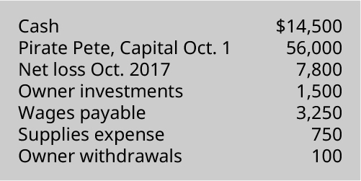
Solution
Pirate Landing
Statement of Owner’s Equity
For the Month Ended Oct. 31, 2018
Pirate Pete, Capital Oct. 1 |  | $56,000
Increases:
Owner Investments | $1,500
Total Increases |  | $1,500
Decreases:
Net Loss October 2018 | $7,800
Owner Withdrawals | $100
Total Decreases |  | $7,900
Pirate Pete, Capital October 31 |  | $49,600

EA11. LO 2.3 Prepare a balance sheet using the following information for the Ginger Company as of March 31, 2019.
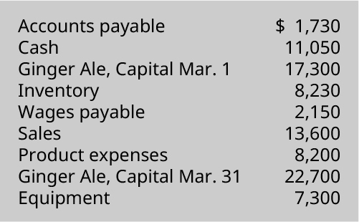
Solution
Ginger Company
Balance Sheet
Mar. 31, 2019
Assets: |  | Liabilities:
Cash | $11,050 | Accounts Payable | $1,730
Inventory | $8,230 | Wages Payable | $2,150
Equipment | $7,300 | Total Liabilities |  | $3,880
 |  | Owner’s Equity
 |  | Ginger Ale, Capital March 31 |  | $22,700
Total Assets | $26,580 | Total Liabilities and Owner’s Equity |  | $26,580

Exercise Set B

EB1. LO 2.1 For each independent situation below, calculate the missing values.
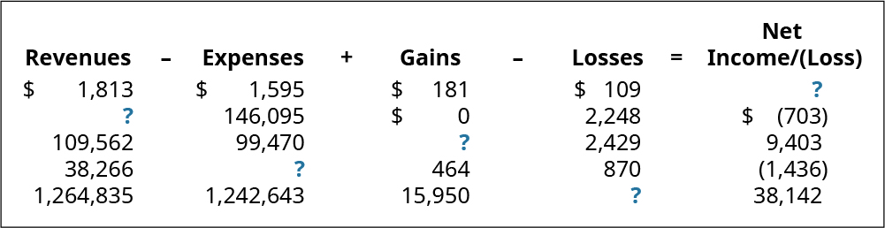
Solution
Revenues | – | Expenses | + | Gains | – | Losses | = | Net Income/(Loss)
$1,813 |  | $1,595 |  | $181 |  | $109 |  | $290
$147,640 |  | $146,095 |  | $0 |  | $2,248 |  | ($703)
$109,562 |  | $99,470 |  | $1,740 |  | $2,429 |  | $9,403
$38,266 |  | $39,296 |  | $464 |  | $870 |  | ($1,436)
$1,264,835 |  | $1,242,643 |  | $15,950 |  | $0 |  | $38,142

EB2. LO 2.1 For each independent situation below, calculate the missing values for Owner’s Equity.
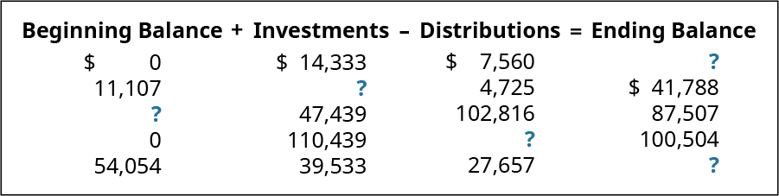
Solution
Beginning Balance | + | Investments | – | Distributions | = | Ending Balance
$0 |  | $14,333 |  | $7,560 |  | $6,773
$11,107 |  | $35,406 |  | $4,725 |  | $41,788
$142,884 |  | $47,439 |  | $102,816 |  | $87,507
$0 |  | $110,439 |  | $9,935 |  | $100,504
$54,054 |  | $39,533 |  | $27,657 |  | $65,930

EB3. LO 2.1 For each independent situation below, calculate the missing values.
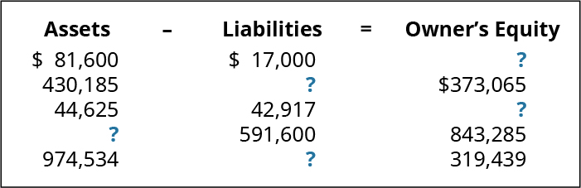
Solution
Assets | – | Liabilities | = | Owner’s Equity
$81,600 |  | $17,000 |  | $64,600
$430,185 |  | $57,120 |  | $373,065
$44,625 |  | $42,917 |  | $1,708
$1,434,885 |  | $591,600 |  | $843,285
$974,534 |  | $655,095 |  | $319,439

EB4. LO 2.1 For each of the following independent situations, place an (X) by the transactions that would be included in the statement of cash flows.
Transaction | Included
Purchased supplies with check
Received inventory (a bill was included)
Paid cash to owner for withdrawal
Gave cash donation to local charity
Received bill for utilities
Table 2.6
Solution
Transaction | Included
Purchased supplies with check | X
Received inventory (a bill was included)
Paid cash to owner for withdrawal | X
Gave cash donation to local charity | X
Received bill for utilities

EB5. LO 2.2 For each of the following items, identify whether the item is considered current or noncurrent, and explain why.
Item | Current or Noncurrent?
Inventory
Buildings
Accounts Receivable
Cash
Trademarks
Accounts Payable
Wages Payable
Common Stock
Table 2.7
Solution
Item | Current or Noncurrent?
Inventory | Current
Buildings | Noncurrent
Accounts Receivable | Current
Cash | Current
Trademarks | Noncurrent
Accounts Payable | Current
Wages Payable | Current
Common Stock | Noncurrent
Current items will be settled in a year or less; noncurrent items in greater than one year.
EB6. LO 2.2 For the items listed below, indicate how the item affects equity (increase, decrease, or no impact).
Item | Increase? Decrease? or No Impact?
Revenues
Gains
Losses
Drawings
Investments
Table 2.8
Solution
Item | Increase? Decrease? No Impact?
Revenues | Increase
Gains | Increase
Losses | Decrease
Drawings | Decrease
Investments | Increase

EB7. LO 2.2 Gumbo Company had the following transactions during the month of December. What was the December 1 cash balance?
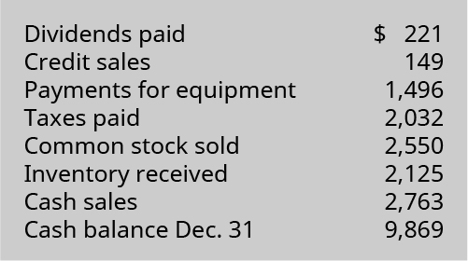
Solution
The December 1 balance is $8,305 ($9,869 – $2,550 – $2,763 + $221 + $1,496 + $2,032).
EB8. LO 2.2 Here are facts for Hailey’s Collision Service for January.
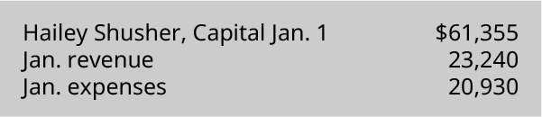
Assuming no investments or withdrawals, what is the ending balance in the owners’ capital account?
Solution
The January 31 balance is $63,665 ($61,355 + $23,240 – $20,930).
EB9. LO 2.3 Prepare an income statement using the following information for CK Company for the month of February 2019.
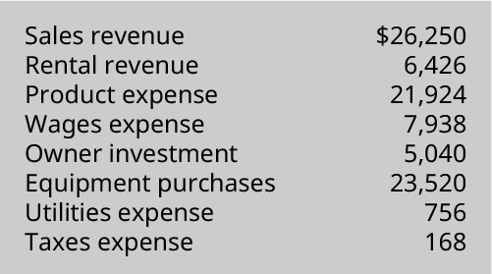
Solution
CK Company
Income Statement
For the Month Ended Feb. 28, 2019
Sales Revenue | $26,250
Rental Revenue | $6,426
Total Revenue |  | $32,676
Expenses
Product Expense | $21,924
Wages Expense | $7,938
Utilities Expense | $756
Taxes Expense | $168
Total Expenses |  | $30,786
Net Income |  | $1,890

EB10. LO 2.3 Prepare a statement of owner’s equity using the following information for the Can Due Shop for the month of September 2018.
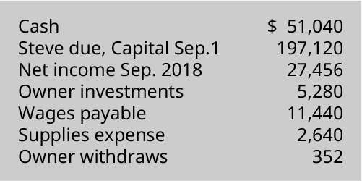
Solution
Can Due Shop
Statement of Owner’s Equity
For the Month Ended Sep. 30, 2018
Steve Due, Capital September 1 |  | $197,120
Increases:
Net Income September 2018 | $27,456
Owner Investments | $5,280
Total Increases |  | $32,736
Decreases:
Owner Withdrawals | $352
Total Decreases |  | $352
Steve Due, Capital September 30 |  | $229,504

EB11. LO 2.3 Prepare a balance sheet using the following information for Mike’s Consulting as of January 31, 2019.
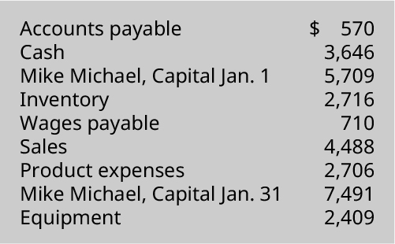
Solution
Mike’s Consulting
Balance Sheet
January 31, 2019
Assets: |  | Liabilities:
Cash | $3,646 | Accounts Payable | $570
Inventory | $2,716 | Wages Payable | $710
Equipment | $2,409 | Total Liabilities |  | $1,280
 |  | Owner’s Equity
 |  | Mike Michael, Capital January 31 |  | $7,491
Total Assets | $8,771 | Total Liabilities and Owner’s Equity |  | $8,771

Problem Set A

PA1. LO 2.1 The following information is taken from the records of Baklava Bakery for the year 2019.
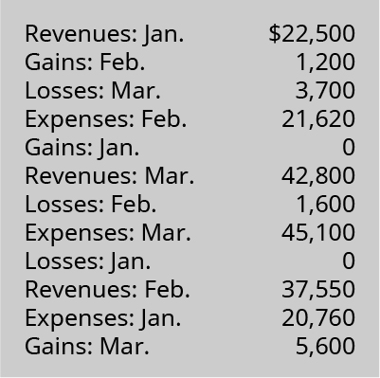
- Calculate net income or net loss for January.
- Calculate net income or net loss for February.
- Calculate net income or net loss for March.
- For each situation, comment on how a stakeholder might view the firm’s performance. (Hint: Think about the source of the income or loss.)
Solution
 | Revenues/Expenses | Gains/Losses | Net Income (Loss) | D. Comments
A. January | $1,740 | $0 | $1,740 | Earnings from ongoing (core) portion of business
B. February | $15,930 | ($400) | $15,530 | Strong earnings from ongoing (core) portion of business; minor loss from peripheral activities
C. March | ($2,300) | $1,900 | ($400) | Poor earnings from core business; masked by gain, which is peripheral
Note: Responses may also observe the strong month of February (Valentine’s Day).
PA2. LO 2.1 Each situation below relates to an independent company’s owners’ equity.
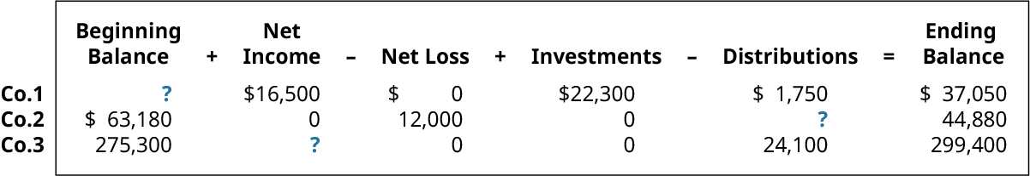
- Calculate the missing values.
- Based on your calculations, make observations about each company.
Solution
A.
Beginning Balance | + | Net Income | – | Net Loss | + | Investments | – | Distributions | = | Ending Balance
$0 |  | $16,500 |  | $0 |  | $22,300 |  | $1,750 |  | $37,050
$63,180 |  | $0 |  | $12,000 |  | $0 |  | $6,300 |  | $44,880
$275,300 |  | $48,200 |  | $0 |  | $0 |  | $24,100 |  | $299,400
B. Observations: Company 1: brand new company with net income during the first period, strong investment with little taken out of the business; Company 2: established company that is trending unfavorably—net loss and owner withdraws; Company 3: mature company with a strong financial performance that allows for owner withdrawals without the need for investment.
PA3. LO 2.1 The following information is from a new business. Comment on the year-to-year changes in the accounts and possible sources and uses of funds (how were the funds obtained and used).
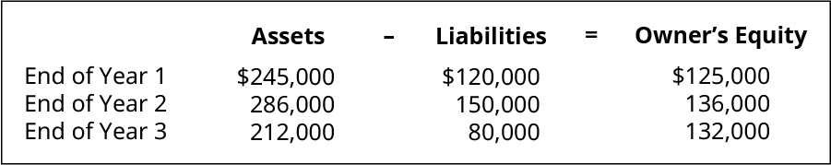
Solution
End of Year 1: Asset increase of $245,000 financed by increase of liabilities of $120,000 and combination of net income and net owner investments of $125,000.
End of Year 2: Asset increase of $41,000 financed by increase of liabilities of $30,000 and combination of net income and net owner investments of $11,000.
End of Year 3: Assets of $74,000 used to reduce $70,000 of liabilities. Company also had combination of net loss and net withdrawals of $4,000 (or small net income offset by large withdrawals).
PA4. LO 2.1 Each of the following situations relates to a different company.
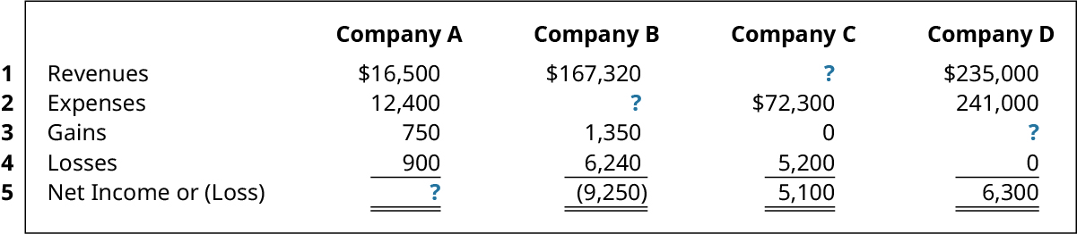
- For each of these independent situations, find the missing amounts.
- How would stakeholders view the financial performance of each company? Explain.
Solution
A.
 |  | Company A | Company B | Company C | Company D
1 | Revenues | $16,500 | $167,320 | $82,600 | $235,000
2 | Expenses | $12,400 | $171,680 | $72,300 | $241,000
3 | Gains | $750 | $1,350 | $0 | $12,300
4 | Losses | $900 | $6,240 | $5,200 | $0
5 | Net Income or (Loss) | $3,950 | ($9,250) | $5,100 | $6,300
 |  | 24% | –6% | 6% | 3%
B. Stakeholders’ views:
Company A has strong core business and minor impact from gains/losses.
Company B has poor core business and unfavorable gains/losses.
Company C has solid core business negatively impacted by large loss.
Company D has poor core business results that were hidden by large gain.
Note: Answers will vary but may include observations about each company’s performance for ongoing operations (revenues-expenses) versus incidental activities (gains and losses). Instructors may also consider introducing the concept of profit margin to highlight differences between dollar value and percentages.
PA5. LO 2.2 For each of the following independent transactions, indicate whether there was an increase, a decrease, or no impact for each financial statement element.
Transaction | Assets | Liabilities | Owners’ Equity
Paid cash for expenses
Sold common stock for cash
Owe vendor for purchase of asset
Paid owners for dividends
Paid vendor for amount previously owed
Table 2.9
Solution
Transaction | Assets | Liabilities | Owners’ Equity
Paid cash for expenses | Decrease | No Impact | Decrease
Sold common stock for cash | Increase | No Impact | Increase
Owe vendor for purchase of asset | Increase | Increase | No Impact
Paid owners for dividends | Decrease | No Impact | Decrease
Paid vendor for amount previously owed | Decrease | Decrease | No Impact

PA6. LO 2.2 Olivia’s Apple Orchard had the following transactions during the month of September, the first month in business.
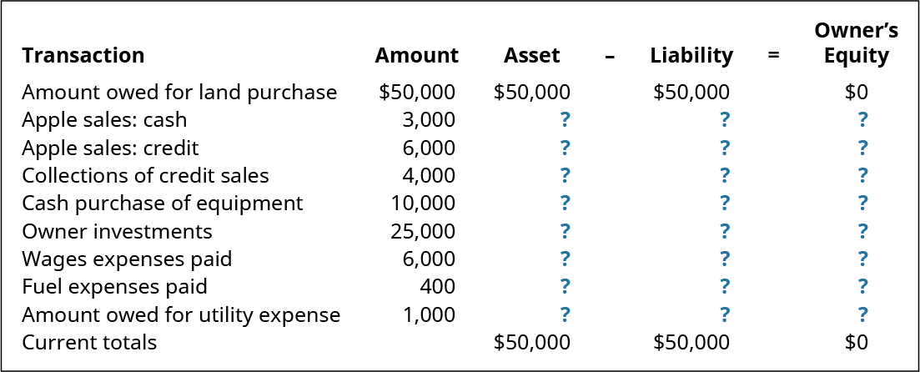
Complete the chart to determine the ending balances. As an example, the first transaction has been completed. Note: Negative amounts should be indicated with minus signs (–) and unaffected should be noted as $0.
(Hints: 1. each transaction will involve two financial statement elements; 2. the net impact of the transaction may be $0.)
Solution
Transaction | Amount | Asset | Liability | Owner’s Equity
Amount owed for land purchase | $50,000 | $50,000 | $50,000 | $0
Apple sales: cash | $3,000 | $3,000 | $0 | $3,000
Apple sales: credit | $6,000 | $6,000 | $0 | $6,000
Collections of credit sales | $4,000 | $0 | $0 | $0
Cash purchase of equipment | $10,000 | $0 | $0 | $0
Owner investments | $25,000 | $25,000 | $0 | $25,000
Wages expenses paid | $6,000 | ($6,000) | $0 | ($6,000)
Fuel expenses paid | $400 | ($400) | $0 | ($400)
Amount owed for utility expense | $1,000 | $0 | $1,000 | ($1,000)
 |  | $77,600 | $51,000 | $26,600

PA7. LO 2.2 Using the information in Exercise PA6, determine the amount of revenue and expenses for Olivia’s Apple Orchard for the month of September.
Solution
Revenue is $9,000 ($3,000 + $6,000); expenses are $7,400 ($6,000 + 400 + $1,000).
PA8. LO 2.3 The following ten transactions occurred during the July grand opening of the Pancake Palace. Assume all Retained Earnings transactions relate to the primary purpose of the business.
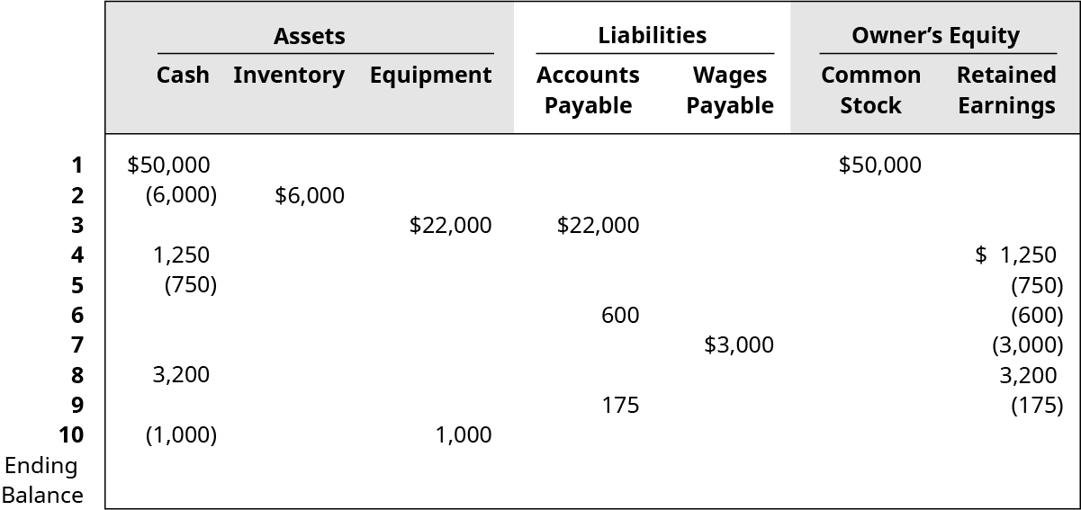
- Calculate the ending balance for each account.
- Create the income statement.
- Create the statement of owner’s equity.
- Create the balance sheet.
Solution
(Condensed):
A.
 | Assets |  |  | Liabilities |  | Owner’s Equity
 | Cash | Inventory | Equipment | Accounts Payable | Wages Payable | Common Stock | Retained Earnings
1 | $50,000 |  |  |  |  | $50,000
2 | ($6,000) | $6,000
3 |  |  | $22,000 | $22,000
4 | $1,250 |  |  |  |  |  | $1,250
5 | ($750) |  |  |  |  |  | ($750)
6 |  |  |  | $600 |  |  | ($600)
7 |  |  |  |  | $3,000 |  | ($3,000)
8 | $3,200 |  |  |  |  |  | $3,200
9 |  |  |  | $175 |  |  | ($175)
10 | ($1,000) |  | $1,000
A. Ending Balance | $46,700 | $6,000 | $23,000 | $22,775 | $3,000 | $50,000 | ($75)
 |  | $75,700 |  | $75,700
B.
Income Statement
Revenues | $4,450
Expenses | ($4,525)
Net Loss | ($75)
C.
Beginning Balance | $0
Sale of Common Stock | $50,000
Retained Earnings | ($75)
Ending Balance | $49,925
D.
Balance Sheet
Cash | $46,700 | Accounts Payable | $22,775
Inventory | $6,000 | Wages Payable | $3,000
Equipment | $23,000 | Total Liabilities | $25,775
 |  | Common Stock | $50,000
 |  | Retained Earnings | ($75)
 |  | Total Equity | $49,925
Total Assets | $75,700 | Total Liability and Owner’s Equity | $75,700

Problem Set B
PB1. LO 2.1 The following information is taken from the records of Rosebloom Flowers for the year 2019.
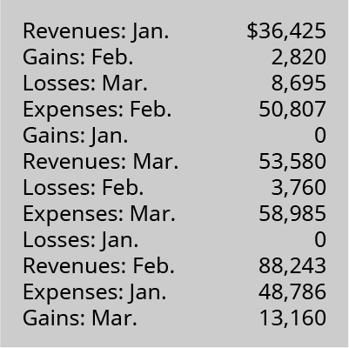
- Calculate net income or net loss for January.
- Calculate net income or net loss for February.
- Calculate net income or net loss for March.
- For each situation, comment on how a stakeholder might view the firm’s performance. (Hint: think about the source of the income or loss.)
Solution
 | Revenues/Expenses | Gains/Losses | Net Income (Loss) | D. Comments
A. January | ($12,361) | $0 | ($12,361) | Earnings from ongoing (core) portion of business
B. February | $37,436 | ($940) | $36,496 | Strong earnings from ongoing (core) portion of business; minor loss from peripheral activities
C. March | ($5,405) | $4,465 | ($940) | Poor earnings from core business; masked by gain, which is peripheral
Note: Responses may also observe the strong month of February (Valentine’s Day).
PB2. LO 2.1 Each situation below relates to an independent company’s Owners’ Equity.
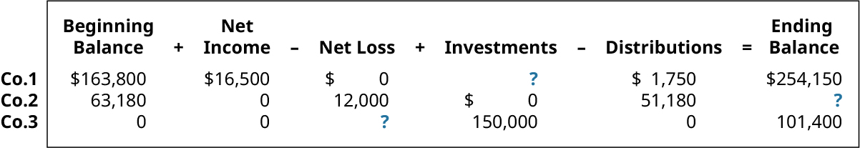
- Calculate the missing values.
- Based on your calculations, make observations about each company.
Solution
A.
 | Beginning Balance | Net Income | Net Loss | Investments | Distributions | Ending Balance
Co.1 | $163,800 | $16,500 | $0 | $75,600 | $1,750 | $254,150
Co.2 | $63,180 | $0 | $12,000 | $0 | $51,180 | $0
Co.3 | $0 | $0 | $48,600 | $150,000 | $0 | $101,400
- Observations: Company 1: strong performing company that is still attracting new investment with owners leaving all but a small portion in business; Company 2: business that has ended; Company 3: new business with poor financial performance—a sense of urgency due to rapidly declining equity.
PB3. LO 2.1 The following information is from a new business. Comment on the year-to-year changes in the accounts and possible sources and uses funds (how were the funds obtained and used).
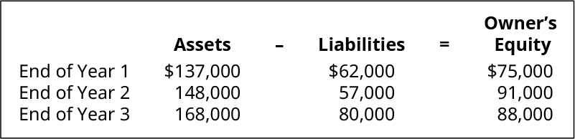
Solution
End of Year 1: Asset increase of $137,000 financed by increase of liabilities of $62,000 and combination of net income and net owner investments of $75,000.
End of Year 2: Combination of net income and net owner investments of $16,000 financed asset increase of $11,000 and decrease of liabilities of $5,000.
End of Year 3: Assets increase of $20,000 financed by $23,000 increase in liabilities, which also covered a combination of net loss and net withdrawals of $3,000.
PB4. LO 2.1 Each of the following situations relates to a different company.
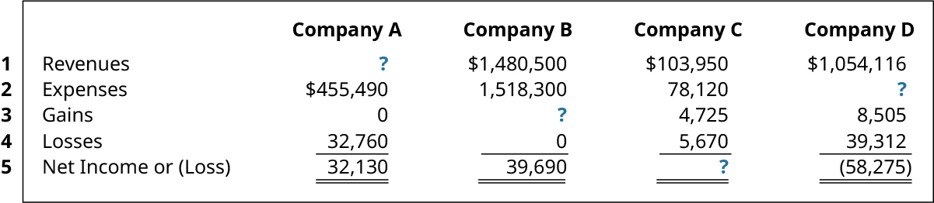
- For each of these independent situations, find the missing amounts.
- How would stakeholders view the financial performance of each company? Explain.
Solution
A.
 |  | Company A | Company B | Company C | Company D
1 | Revenues | $520,380 | $1,480,500 | $103,950 | $1,054,116
2 | Expenses | $455,490 | $1,518,300 | $78,120 | $1,081,584
3 | Gains | $0 | $77,490 | $4,725 | $8,505
4 | Losses | $32,760 | $0 | $5,670 | $39,312
5 | Net Income or (Loss) | $32,130 | $39,690 | $24,885 | ($58,275)
 |  | 6% | 3% | 24% | −6%
B. Stakeholders’ views:
Company A has solid core business negatively impacted by large loss.
Company B has poor core business results that were hidden by large gain.
Company C has strong core business and minor impact from gains/losses.
Company D has poor core business and unfavorable gains/losses.
Note: Answers will vary but may include observations about each company’s performance for ongoing operations (revenues-expenses) versus incidental activities (gains and losses). Instructors may also consider introducing the concept of profit margin to highlight differences between dollar value and percentages.
PB5. LO 2.2 For each of the following independent transactions, indicate whether there was an increase, decrease, or no impact on each financial statement element.
Transaction | Assets | Liabilities | Owners’ Equity
Received cash for sale of asset (no gain or loss)
Cash distribution to owner
Cash sales
Investment by owners
Owe vendor for inventory purchase
Table 2.10
Solution
Transaction | Assets | Liabilities | Owners’ Equity
Received cash for sale of asset (no gain or loss) | No Impact | No Impact | No Impact
Cash distribution to owner | Decrease | No Impact | Decrease
Cash sales | Increase | No Impact | Increase
Investment by owners | Increase | No Impact | Increase
Owe vendor for inventory purchase | Increase | Increase | No Impact

PB6. LO 2.2 Mateo’s Maple Syrup had the following transactions during the month of February, its first month in business.
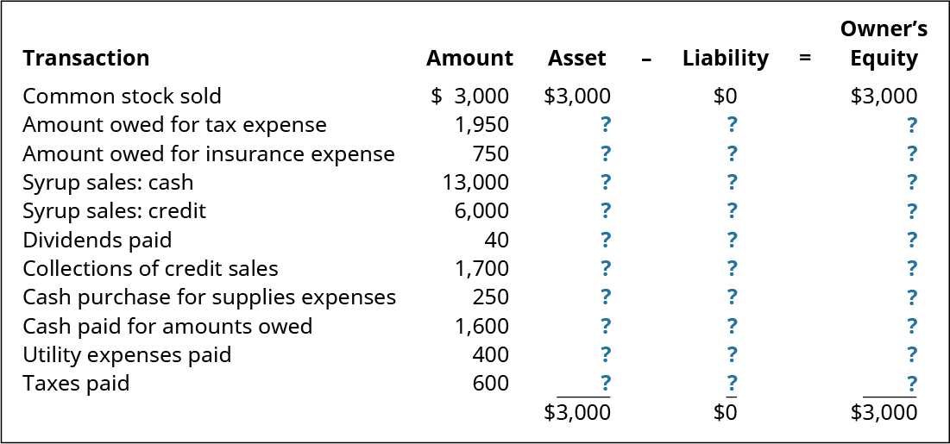
Complete the chart to determine the ending balances. As an example, the first transaction has been completed. Note: negative amounts should be indicated with minus signs (–).
(Hints: 1. each transaction will involve two financial statement elements; 2. the net impact of the transaction may be $0.)
Solution
Transaction | Amount | Asset | – | Liability | = | Owner’s Equity
Common stock sold | $3,000 | $3,000 |  | $0 |  | $3,000
Amount owed for tax expense | $1,950 | $0 |  | $1,950 |  | ($1,950)
Amount owed for insurance expense | $750 | $0 |  | $750 |  | ($750)
Syrup sales-cash | $13,000 | $13,000 |  | $0 |  | $13,000
Syrup sales-credit | $6,000 | $6,000 |  | $0 |  | $6,000
Dividends paid | $40 | ($40) |  | $0 |  | ($40)
Collections of credit sales | $1,700 | $0 |  | $0 |  | $0
Cash purchase for supplies expenses | $250 | ($250) |  | $0 |  | ($250)
Cash paid for amounts owed | $1,600 | ($1,600) |  | ($1,600) |  | $0
Utility expenses paid | $400 | ($400) |  | $0 |  | ($400)
Taxes paid for amount owed | $600 | ($600) |  | ($600) |  | $0
 |  | $19,110 |  | $500 |  | $18,610

PB7. LO 2.2 Using the information in Exercise PB6, determine the amount of revenue and expenses for Mateo’s Maple Syrup for the month of February.
Solution
Revenue is $19,000 ($13,000 + $6,000); expenses are $3,350 ($1,950 + $750 + $250 + $400).

Thought Provokers

TP1. LO 2.1 Choose three stakeholders (or stakeholder groups) for Walmart and prepare a written response for each stakeholder. In your written response, consider the factors about the business the particular stakeholder would be interested in. Consider the financial and any nonfinancial factors that would be relevant to the stakeholder (or stakeholder group). Explain why these factors are important. Do some research and see if you can find support for your points.
Solution
Answers will vary. Responses should include investors, creditors, employees, and communities.
TP2. LO 2.1 Assume you purchased ten shares of Roku during the company’s IPO. Comment on why this might be a good investment. Consider factors such as what you expect to get from your investment, why you think Roku would become a publicly traded company, and what you think is the landscape of the industry Roku is in. What other factors might be relevant to your decision to invest in Roku?
Solution
Answers will vary. Responses should include the desire to get dividends and increase in stock value, Roku’s growth goals, competitors, and future of the streaming market.
TP3. LO 2.2 A trademark is an intangible asset that has value to a business. Assume that you are an accountant with the responsibility of valuing the trademark of a well-known company such as Nike or McDonald’s. What makes each of these companies unique and adds value? While the value of a trademark may not necessarily be recorded on the company’s balance sheet, discuss what factors you think would affect (increase or decrease) the value of the company’s trademark? Consider your answer through the perspective of various stakeholders.
Solution
Nike has a distinctive advantage of product development and high performance. McDonald’s has historically been an innovator in the fast-food industry. Considerations of a company’s trademark would include trademark recognition, investments in trademark development (legal, branding), market structure/competitors, financial performance of the firm, opportunity for growth in sectors, and products.
TP4. LO 2.3 For each of the following ten independent transactions, provide a written description of what occurred in each transaction. Figure 2.4 might help you.
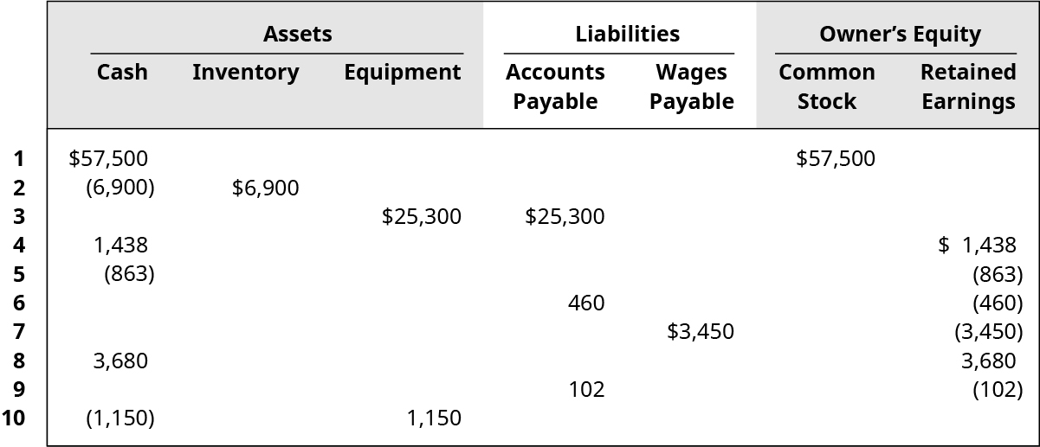
Solution
1 | Sold common stock for cash
2 | Purchased inventory for cash
3 | Purchased equipment on account
4 | Cash sales
5 | Paid cash for expenses (or dividends)
6 | Purchased expense items on account
7 | Wages to be paid
8 | Cash sales
9 | Purchased expense items on account
10 | Purchased equipment for cash

TP5. LO 2.3 The following historical information is from Assisi Community Markets.
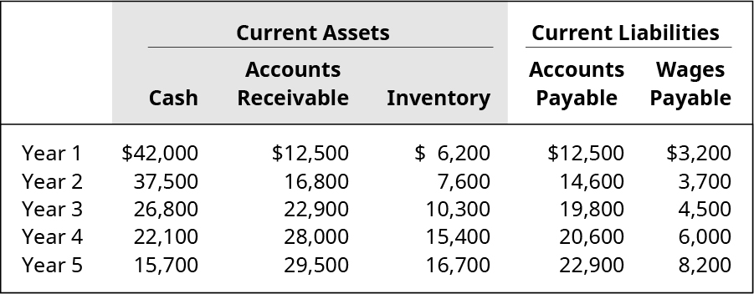
Calculate the working capital and current ratio for each year. What observations do you make, and what actions might the owner consider taking?
Solution
Working Capital | Current Ratio
$45,000 | 3.87
$43,600 | 3.38
$35,700 | 2.47
$38,900 | 2.46
$30,800 | 1.99
Answers will vary. Sample answer: The trend is that working capital generally trends down.
- The current ratio trends downward every year.
- The owner could look at improving accounts receivable collections and moving to lowering inventory levels (just-in-time).
- The owner could look at terms with vendors—perhaps the terms are out of line with industry norms.
Instructors may also use this as an opportunity to calculate (and graph) rates of change within each category.

Feature Boxes

Your Turn: Business Owners as Decision Makers
Solution
Business owners will use financial information for many decisions, such as comparing sales from one period to another, determining trends in costs and other expenses, and identifying areas in which to reduce or reallocate expenses. This information will be used to determine, for example, staffing and inventory levels, streamlining of operations, and advertising or other investment decisions.

Your Turn: Coffee Shop Products
Solution
Many coffee shops earn revenue through multiple revenue streams, including coffee and other specialty drinks, food items, gift cards, and merchandise.

Your Turn: Coffee Shop Expenses
Solution
Costs of the coffee shop that might be readily observed would include rent; wages for the employees; and the cost of the coffee, pastries, and other items/merchandise that may be sold. In addition, costs such as utilities, equipment, and cleaning or other supplies might also be readily observable. More obscure costs of the coffee shop would include insurance, regulatory costs such as health department licensing, point-of-sale/credit card costs, advertising, donations, and payroll costs such as workers’ compensation, unemployment, and so on.

Think It Through: Borrowing
Solution
Based on their research, students will likely find that payments for student loans do not typically begin until after the student graduates. Based on this, the student will not be delinquent on a student loan payment because there is no expectation for repayment while the student is pursuing his degree. It is typically expected, however, that the student will not miss a car payment (without incurring interest or penalties).

Your Turn: The Accounting Equation
Solution
Answers will vary but may include vehicles, clothing, electronics (include cell phones and computer/gaming systems, and sports equipment). They may also include money owed on these assets, most likely vehicles and perhaps cell phones. In the case of a student loan, there may be a liability with no corresponding asset (yet). Responses should be able to evaluate the benefit of investing in college is the wage differential between earnings with and without a college degree.

This resource file is copyright 2019, Rice University. All Rights Reserved.

