**Chapter**

**2**

**Values and Attitudes:**

**How Do They Affect Work-Related Outcomes**

**CHAPTER CONTENTS**

Major Questions the Student Should Be Able to Answer 2

Overview of the Chapter 3

Lecture Outline 5

Revisiting the Integrative Framework 42

Challenge: Major Questions 44

Problem-Solving Application Case 46

Legal/Ethical Challenge 48

Group Exercise 50

Video Resources 52

Manager’s Hot Seat 52

**MAJOR QUESTIONS THE STUDENT SHOULD BE ABLE TO ANSWER**

**2.1 Personal Values**

**MAJOR QUESTION:** **What role do values play in influencing my behavior?**

**2.2 Personal Attitudes and Their Impact on Behavior and Outcomes**

**MAJOR QUESTION:** How do personal attitudes affect workplace behavior and work-related outcomes?

**2.3 Key Workplace Attitudes**

**MAJOR QUESTION:** Why is it important for management to pay attention to workplace attitudes?

**2.4 The Causes of Job Satisfaction**

**MAJOR QUESTION:** How can changes in the workplace improve job satisfaction?

**2.5 Major Correlates and Consequences of Job Satisfaction**

**MAJOR QUESTION:** What work-related outcomes are associated with job satisfaction?

Chapter 2 explores how values and personal attitudes influence a host of important outcomes. **Values** are abstract ideals that guide one’s thinking and behavior across all situations. Figure 2.1 profiles the 10 core values that guide behavior, as proposed by Schwartz. Values are relatively stable across time and situations and can vary across generations.

**OVERVIEW OF THE CHAPTER**

**Attitudes** represent our feelings or opinions about people, places, and objects, and range from positive to negative. Personal values represent global beliefs that influence behavior across all situations, while personal attitudes relate only to behavior directed toward specific objects, persons, or situations. Attitudes have **affective**, **cognitive**, and **behavioral** components. People experience **cognitive dissonance** when their attitudes or beliefs are incompatible with their behavior. **Ajzen’s theory of planned behavior** is commonly used to explain the relationship between attitudes and behaviors. The strength of an intention is influenced by one’s attitude toward the behavior, by subjective norms regarding exhibiting the behavior, and by perceived behavioral control.

It is important for managers to understand the causes and consequences of the key **work attitudes** of organizational commitment, employee engagement, perceived organizational support, and job satisfaction. **Organizational commitment** reflects the extent to which an individual identifies with an organization and is committed to its goals. **Psychological contracts** represent an individual’s perception about the terms and conditions of a reciprocal exchange between him- or herself and another party. Managers can increase employees’ commitment by hiring people whose personal values align with the organization’s, by not breaching psychological contracts, and by enhancing the level of trust throughout the organization.

**Employee engagement** is defined as the harnessing of organization members’ selves to their work roles; in engagement, people employ and express themselves physically, cognitively, and emotionally during role performance. Person factors such as personality and conscientiousness can contribute to employee engagement. The environmental factors of job characteristics, leadership and stressors contribute to employee engagement. Organizational-level factors that contribute to employee engagement include career opportunities, managing performance, organization reputation, communication, and recognition. Research has demonstrated that employee engagement is associated with important organizational-level outcomes such as customer satisfaction/loyalty, more productivity, and greater profitability.

**Perceived organizational support (POS**) is the extent to which employees believe their organization values their contributions and genuinely cares about their well-being. People are willing to work hard and commit to their organizations when they believe that the company “truly” cares about their best interest. The **norm of reciprocity** obliges us to return the favorable treatment when someone treats us well. Managers can foster POS by treating employees fairly, avoiding political behavior, providing job security, giving people more autonomy, reducing stressors in the work environment, and eliminating abusive supervision.

**Job satisfaction** is an affective response toward various facets of one’s job. Different models specify distinct causes of job satisfaction. **Need fulfillment models** propose that satisfaction is determined by the extent to which the characteristics of a job allow an individual to fulfill his or her needs. **Met expectations** represent the difference between what individuals expect to receive from a job and what they actually do. An individual will be satisfied when he or she attains outcomes above and beyond expectations. The idea underlying **value attainment** is that satisfaction results from the perception that a job allows for fulfillment of an individual’s important work values. According to the **equity model**, satisfaction is a function of how “fairly” an individual is treated at work. The **dispositional/genetic perspective** contends that job satisfaction is partly a function of both personal traits and genetic factors.

Job satisfaction has been correlated with many different attitudes and behaviors. Four attitudinal outcomes of job satisfaction that are important to OB researchers are motivation, job involvement, withdrawal cognitions, and perceived stress. **Employee motivation** represents a psychological process that arouses our interest in doing something, and it directs and guides our behavior. **Job involvement** is the extent to which an individual is personally involved with his or her work role. **Withdrawal cognitions** are an individual’s overall thoughts and feelings about quitting. **Perceived stress** has a strong, negative relationship with job satisfaction.

Key behavioral outcomes of job satisfaction are job performance, organizational citizenship behavior, counterproductive work behavior, and turnover. Research has shown that job satisfaction and job performance are moderately related and the relationship between job satisfaction and performance is much more complex than originally thought. **Organizational citizenship behavior (OCB)** represents individual behavior that is discretionary, not directly or explicitly recognized by the formal reward system, and that in the aggregate promotes the effective functioning of the organization. **Counterproductive work behaviors (CWBs)** are defined as types of behavior that harm employees, the organization as a whole, or organizational stakeholders such as customers and shareholders. **Turnover** can be beneficial when it involves a low-performing employee, but losing a good employee can be costly. **Onboarding programs**, which are designed to help employees integrate, assimilate, and transition to new jobs and can help to avoid voluntary turnover.

**LECTURE OUTLINE**

**POWERPOINT SLIDE 1**

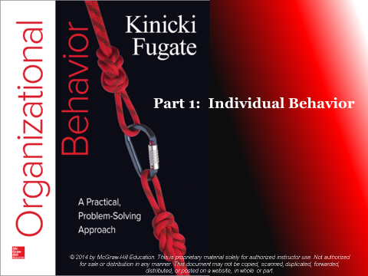

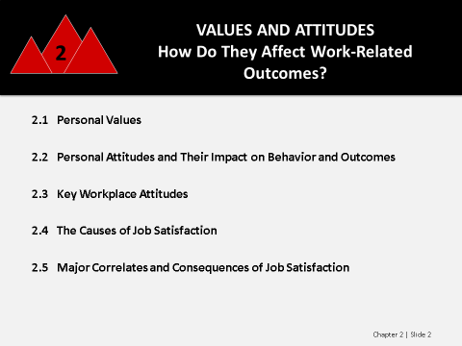**POWERPOINT SLIDE 2**

**Winning at Work: Learning to Combat Bullying**

Bullying is the repeated mistreatment of an individual or individuals by aggressive or unreasonable behavior, including persistent abuse and humiliation by verbal, nonverbal, psychological, or physical means. Bullying includes physical aggression, verbal aggression, relational aggression, and cyber-aggression. Bullying is partly driven by an individual’s values and it is an important OB topic because many people are either victims of or impacted by bullying. Targets or victims of bullying tend to experience stress-related health problems. Bullied employees are less satisfied at work and are more likely to quit and exhibit counterproductive behaviors.

**Possible Topics for Discussion:**

Assume you are being bullied by one of your coworkers, but only when others are not around so there are no witnesses to his actions. How would you handle the situation?

Assume that one of your co-workers, whom you consider a good friend, is being bullied by another co-worker. You want to help your co-worker but you also don’t want to be the bully’s next target. How would you handle the situation?

What factors do you think contribute to bullying in the workplace?

**2.1 Personal Values**

What role do values play in influencing my behavior?

This section of the chapter introduces students to how values affect workplace attitudes and behaviors. One way to begin your coverage of these topics is to profile the decision of CVS Caremark (CVS) to no longer sell cigarettes and tobacco products. This decision will cost the company approximately $2 billion in annual revenue. The CEO of CVS, Larry Merlo, defended the move by stating that the sale of sale of tobacco products is inconsistent with the company’s purpose, which is helping people on a path to better health. *CBS This Morning* aired a 4-minute video entitled “CVS CEO: It’s a ‘Contradiction’ to Help People Be Healthier and Sell Tobacco Products” describing the firm’s decision. The video is currently available at: <http://www.cbsnews.com/news/cvs-ceo-larry-merlo-on-plan-to-stop-selling-tobacco-products/>

**Possible Topics for Discussion:**

Analyze the short-term and long-term implications of CVS’ decision to discontinue the sale of tobacco products.

Assume you are an employee of CVS and part of your compensation package is a profit-sharing program whereby your compensation is influenced by the financial performance of the company. Do you support the company’s decision to discontinue the sale of tobacco products? Explain your response.

Assume you are a stockholder of CVS and the return on your investment is influenced by the profitability of the company. Do you support the company’s decision to discontinue the sale of tobacco products? Explain your response.

**Section 2.1 Key Concepts:**

**Values**

* **Values:** abstract ideals that guide one’s thinking and behavior across all situations.
* Managers need to understand an employee’s values because they encompass concepts, principles, or activities for which people are willing to work hard.
* All workers need an understanding of values to work effectively with others and manage themselves.
* Values are motivational in that they “represent broad goals that apply across contexts and time.”
* Values are relatively stable and can influence behavior outside our awareness.

**POWERPOINT SLIDE 3**

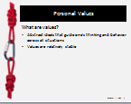

**Schwartz’s Value Theory**

* As indicated in Figure 2.1, Shalom Schwartz proposed that 10 broad values guide behavior including:
  + Power: social status and prestige, control or dominance over people and resources.
  + Achievement: personal success through demonstrating competence according to social standards.
  + Hedonism: pleasure and sensuous gratification for oneself.
  + Stimulation: excitement, novelty, and challenge in life.
  + Self-direction: independent thought and action choosing, creating, exploring.
  + Universalism: understanding, appreciation, tolerance and protection of the welfare of all people and of nature.
  + Benevolence: preservation and enhancement of the welfare of people with whom one is in frequent personal contact.
  + Tradition: respect, commitment, and acceptance of the customs and ideas that traditional culture or religion provides the self.
  + Conformity: restraint of actions, inclinations, and impulses likely to upset or harm others and violate social expectations or norms.
  + Security: safety, harmony, and stability of society, of relationships, and of self.
* Figure 2.1 organizes values by showing the patterns of conflict and congruity among them.
  + Adjacent values are positively related, whereas values that are further apart are less strongly related.
  + Values that are in opposing directions from the center conflict with each other.
  + The model presented here identifies two bipolar dimensions that summarize the relationships among all 10 values: self-enhancement versus self-transcendence and openness to change versus conservation.
* Managers can better supervise workers by using Schwartz’s model to understand their values and motivation.

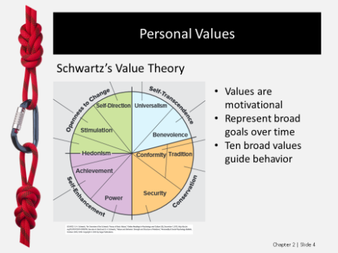**POWERPOINT SLIDE 4**

**POWERPOINT SLIDE 5**

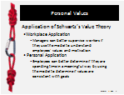

|  |
| --- |
| **SELF-ASSESSMENT 2.1: What Are My Core Values?**  This Self-Assessment encourages students to reflect on how they subscribe to each of Schwartz’s 10 values.  **Questions:**  **Rank the values from high to low; do you agree with the rank order?**  *Responses will vary based on students’ scores.*  **What are your top five values? Which of these do you think has the greatest impact on your personal goals?**  *Responses will vary based on students’ scores. Students may believe that their self-direction through independent thought and action may drive their personal goals. They may believe that their need for power impacts their goals given their need for social status. Students’ needs for security may cause them to set and focus on more secure goals. Alternatively, students with high scores for benevolence may believe that their goals can only be achieved if others achieve their goals as well.*  **Do you think that you may want to focus more on any of the five lowest-rated values as you graduate from school and pursue a career? Explain.**  *Responses will vary.**Students may believe that they will become more conservative as they graduate from school, pursue a career, get married, start a family, etc. In contrast, they may believe that they will place more emphasis on openness to change as they begin the exciting and varied life of a young professional. They may believe that they will place more emphasis on self-enhancement after graduation, with the ability to demonstrate personal success and competence in their professional field. Alternatively, they may believe they will place more emphasis on self-transcendence since their increased income may allow them to place less focus on their own needs.*  **Additional Activities:**  One way to build on this Self-Assessment is for students to research positions or professions most compatible with their values. The O*Net website classifies various positions based on compatibility with six work values, or global aspects of work that are important to a person's satisfaction. Have the students go to the O*Net website at <http://www.onetonline.org/find/descriptor/browse/Work_Values/> and read the descriptions of the work values. Have them decide which of the six values are most important to them. Have the students read through a few of the position descriptions for their top two most important values. Consider using the following discussion questions:  Based on what you learned about your values, what types of positions do you think best suit you?  What is likely to happen if there is a mismatch between your work values and the demands of your chosen profession?  How will the knowledge you have gained about work values impact your career choices?  You can also consult the Connect Instructors Manual for the post-assessment activity and corresponding PowerPoint slides used for this Self-Assessment in Connect. In this activity, place students into four groups based on their value dimensions scores. Students with the highest value dimension scores should be placed in a group together. Each group discusses how the value at hand may impact their preferred jobs, leadership style and approach to teamwork. You can then reveal the groups’ value dimensions and spur class discussion. |

|  |
| --- |
| **TAKE-AWAY APPLICATION—TAAP**  This Take-Away Application (TAAP) encourages students to reflect on the extent to which their personal values are aligned with important goals they have set for themselves.  **Questions:**  **Identify the three most important goals in your life.**  *Responses will vary.*  **Now consider the extent to which your personal goals are aligned with the top five values identified in the Self-Assessment. Are your goals and values aligned?**  *Students may experience cognitive dissonance if they realize some of their values are inconsistent with their goals. For instance, students may realize that their desire for authority and prestige (i.e., power) may conflict with their goal of working in an environment with good, cohesive co-worker relationships.*  **For those values that are inconsistent with your goals, theory suggests that you need to either change your values or change your goals. Because values don’t easily change, it typically is wise to change your goals. Identify what you might do to make your goals more aligned with your values.**  *Students may need to reframe their goals or question the importance of their goals to resolve the cognitive dissonance since values are not easily changed.*  **Additional Activities:**  One way to build on this TAAP is to have students consider if their personal values are consistent with the stated values of their employer (or a company they want to work for in the future). Have the students locate the core values of their employer (or those of a target employer). Most companies prominently display value statements on the company website. Consider using the following discussion questions:  Are the company’s core values something that you would support?  Are the values something that you would enjoy spending time working toward?  Do these values represent something that you would be willing to fight for or sacrifice for?  Based on your answers to these questions, do you consider the company’s values to truly be aligned with your personal values? |

**The Dynamics of Values**

* Values are relatively stable across time and situations.
* Positive employee attitudes and motivation are greatest when the work environment is consistent with employee values.
* 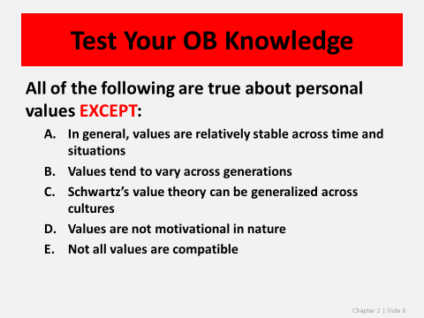Values tend to vary across generations because they are influenced by events occurring during childhood (e.g., Vietnam War versus September 11).

**POWERPOINT SLIDE 6**

**2.2 Personal Attitudes and Their Impact on Behavior and Outcomes**

How do personal attitudes affect workplace behavior and work-related outcomes?

This section of the chapter describes personal attitudes and examines the connection between personal attitudes and behavior. One way to begin your coverage of these topics is to discuss the *Better Money Habits Millennial Report* published by Bank of America/USA TODAY in November of 2014. The report is summarized in a 2-minute video currently available at: <http://www.usatoday.com/media/cinematic/video/19231535/millennials-optimistic-about-money-but-have-little-savings-youngmoney/>. The report shows that Millennials are confident in their ability to manage their finances, but their actions tell a different story. Even though two-thirds of the Millennials surveyed say they have good financial habits, the report results indicate that many have less-than-ideal financial situations. The report shows that 53% of millennials are living paycheck to paycheck and many are probably not preparing for the long term.

**Possible Topics for Discussion:**

Discuss the reasons why many Millennials have great confidence in their financial situations but yet many are not doing enough to prepare for their financial future.

Assume that you are a Millennial and you are trying to save money for a house but you also want money to go on vacation with your friends. What insights does the theory of cognitive dissonance provide about your potential actions?

If you were a financial planner for a Millennial, how could you apply OB concepts to get your client to save more money?

**Section 2.2 Key Concepts:**

**Personal Attitudes**

* Personal values represent global beliefs that influence behavior across all situations, while personal attitudes relate only to behavior directed toward specific objects, persons, or situations.
* Personal attitudes affect behavior via intentions.
* **Attitudes:** our feelings or opinions about people, places, and objects, and range from positive to negative.
* **Workplace attitudes:** an outcome of various OB-related processes, such as leadership.
* Managers conduct attitude surveys to monitor workplace attitudes like job satisfaction and employee engagement, and to determine the causes of employee turnover.

**POWERPOINT SLIDE 7**

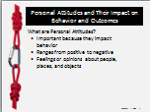

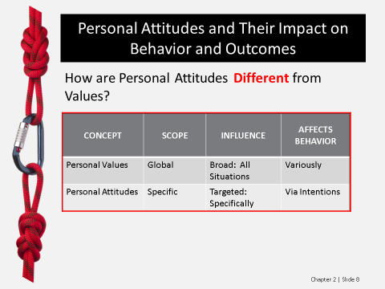

**POWERPOINT SLIDE 8**

**Components of Attitudes**

* **Affective component:** the feelings or emotions one has about a given object or situation; (i.e., I feel).
* **Cognitive component:** the beliefs or ideas one has about an object or situation; (i.e., I believe).
* **Behavioral component:** how one intends or expects to act toward someone or something; (i.e., I intend).

**POWERPOINT SLIDE 9**

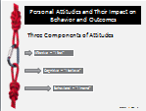

**Cognitive Dissonance**

* **Cognitive dissonance:** the psychological discomfort a person experiences when simultaneously holding two or more conflicting cognitions (ideas, beliefs, values, or emotions).
* People are motivated to maintain consistency among their attitudes and beliefs and will seek to reduce cognitive dissonance, or psychological tension, through:
  + Changing their attitude or behavior, or both.
  + Belittling the importance of the inconsistent behavior.
  + Finding consonant elements that outweigh the dissonant ones.

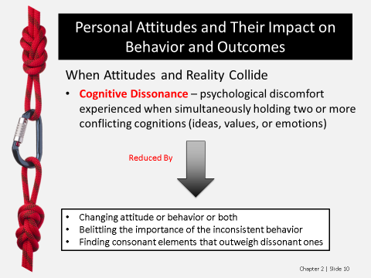**POWERPOINT SLIDE 10**

**Attitudes Affect Behavior via Intentions**

* Ajzen developed a model that focuses on intentions as the key link between attitudes and planned behavior.
* Figure 2.2 shows three separate but interacting determinants of one’s intention to exhibit a specific behavior:
  + Attitude toward the behavior is the degree to which a person has a favorable or unfavorable evaluation or appraisal of the behavior in question.
  + Subjective norm is a social factor representing the perceived social pressure for or against the behavior.
  + Perceived behavioral control is the perceived ease or difficulty of performing the behavior.
* Managers may be able to influence behavioral change by doing or saying things that affect these determinants of employees’ intentions to exhibit a specific behavior.
* One of the simplest levers managers can use to change behavior is information.

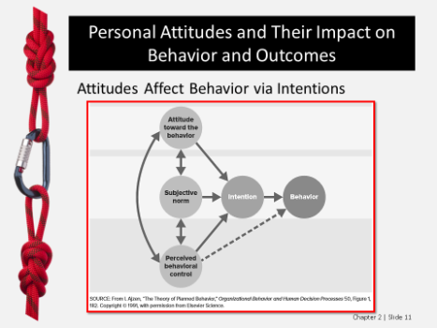**POWERPOINT SLIDE 11**

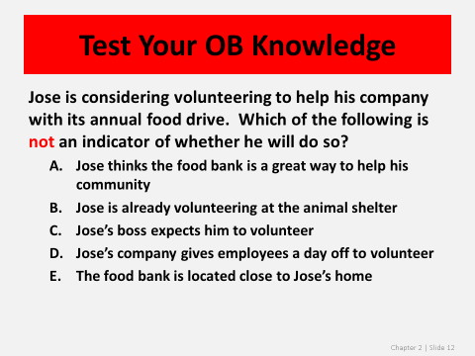**POWERPOINT SLIDE 12**

|  |
| --- |
| **PROBLEM-SOLVING APPLICATION: Why Do Patients Lie To Doctors and Doctors Lie To Patients?**  This Problem-Solving Application gives students an opportunity to apply Ajzen’s theory when analyzing why patients lie to doctors and why doctors lie to patients.  **Your Call:**  **Stop 1: What is the problem in this example?**  *The problem in this example is that the doctor is not receiving accurate information about the amount of alcohol the patient consumes. If the doctor assumes that the patient is accurately reporting his alcoholic consumption, this may cause the doctor to recommend an inappropriate treatment plan, perhaps by prescribing a medication whose side-effects can be made worse by consuming alcohol.*  **Stop 2: What are the causes of the problem?**  *The cause of the problem is that the patient does not have a negative attitude toward lying to his doctor about alcohol consumption. If the patient faces the subjective norms that society may not approve of his level of alcoholic consumption and that everyone lies to their doctor, he would have greater intentions to lie. If he has successfully lied to his doctor in the past, he would have greater intentions of lying this time.*  **Stop 3: What would you do to correct this situation?**  *A doctor who wanted to change the patient’s behavior would need to change the patient’s attitude about lying to the doctor. The doctor may want to appeal to the patient’s values. If the patient values security under Schwartz’s Theory, the doctor may remind the patient that he risks the safety of his personal health by lying or not fully disclosing the facts about his behavior. The doctor needs to increase the cognitive dissonance the patient feels about his attitudes toward lying to his doctor and his values for living a health life. Increasing his cognitive dissonance would hopefully encourage the patient to change his attitude about lying to his doctor and/or his behaviors regarding alcohol consumption.*  **Additional Activities:**  One way to build on this Problem-Solving Application is to have the students view Dr. Leana Wen’s TED talk “What your Doctor Won’t Disclose.” In this 16-minute presentation, Dr. Wen addresses what happened when she started “Who's My Doctor: The Total Transparency Manifesto,” a campaign to help patients learn vital information about their own doctors’ values on such things as end-of-life decisions. The reactions by some doctors to the voluntary program were surprising and disheartening. Consider using the following discussion questions:  How could supporters of the “Who’s My Doctor” campaign encourage doctors to have more favorable attitudes toward participating in the campaign?  How could supporters of the “Who’s My Doctor” campaign encourage more patients to select their medical providers based on their participation in the campaign?  Assume you are a strong believer in trying alternative treatments first before resorting to traditional medicine. What does the theory of cognitive dissonance say you would do if you researched your doctor’s views on alternative medicine and learned that he or she considers alternative medicine to be “quackery?” |

|  |
| --- |
| **EXAMPLE: Alston & Bird Engages Employees through Its Words and Deeds**  This example profiles a firm’s efforts to change employees’ beliefs about the value of staying at the firm by increasing communication and introducing new employee-valued benefits.  **YOUR THOUGHTS?**  **What beliefs do you have about Alston & Bird?**  *Responses will vary but students will likely have positive attitudes toward the firm’s actions.*  **What type of performance intentions would the company’s actions help create?**  *Students may indicate that the firm is trying to increase employee engagement, organizational commitment, job satisfaction, and perceived organizational support. The firm may believe that its actions will change the employees’ counterproductive work behavior (CWB), withdraw cognitions and/or their turnover.*  **Would you like to work at Alston & Bird?**  *Responses will vary.*  **Additional Activities:**  One way to build on this Example is to have the students read the article “Come on, get happy” from the October 2014 issue of *HRMagazine.* This article describes employee happiness, and two employees from Alston & Bird are interviewed for the article. Consider using the following discussion questions:  How do the factors that contribute to job satisfaction differ from those that foster employee engagement?  What contributes to your level of happiness at your job (or at a previous job)?  Discuss how your company could implement some of the recommendations to increase employees' happiness described in the article.  Article Citation:  Woodward, N. H. (2014). Come on, get happy. *HRMagazine, 59*(10), 46-50, 52.  ProQuest document ID: 1610041876 |

|  |
| --- |
| **TAKE-AWAY APPLICATION—TAAP**  This Take-Away Application (TAAP) encourages students to consider how they could use the theory of planned behavior to improve their performance in the course and land a good job after graduation.  **Questions:**  **Based on the theory of planned behavior, how might you improve your attitude about studying for this course?**  *In order for students to improve their attitude about studying for the course, the theory of planned behavior contends that their attitudes would be influenced by subjective norms and perceived behavioral control. Students would need to believe that there was social pressure to have a more favorable evaluation of the desire to perform well in the class. The students would also need to believe that they have the ability to perform the behavior. Past experience and anticipated obstacles influence one’s perceived behavioral control. Therefore, students who have had previous success in changing their performance level in classes and those who do not face any anticipated obstacles, such as peak season at their workplaces, would have greater perceived behavioral control.*  **How can you influence the social norms about studying for classes?**  *According to the theory of planned behavior, social norms for studying for classes would be influenced by attitudes via intentions. Students must intend to change their studying behavior for that behavior to actually change. The model also contends that the strength of those intentions would be influenced by students’ attitudes toward the behavior, their subjective norms, and their perceived behavioral control. Student attitudes about studying for class would be influenced by how they feel about studying (i.e., the affective component), what they believe about studying (i.e., the cognitive component), and how they intend to act about studying (i.e., the behavioral component). Thus, a student who wanted to influence the social norms for studying for class would need to change how others feel about studying, what they believe about studying and how they intend to behave about studying.*  **Assume you want to get a good job upon graduation. What does the theory of planned behavior suggest that you should start or continue doing?**  *The theory of planned behavior argues that behavior is determined by intentions, and the strength of intentions are determined by attitudes toward the behavior, subjective norms, and perceived behavioral control. Students looking to get good jobs after graduation would need to have favorable evaluations about getting good jobs, would need to have social pressure supporting getting good jobs, and would need to believe that they have the ability to perform the behavior necessary for getting a good job.*  **Additional Activities:**  One way to build on this TAAP is to have the students reflect on how they could use the theory of planned behavior to change their health-related behaviors, such as their fitness efforts. Consider using the following discussion questions:  Assume that you have decided that you want to exercise for at least 30 minutes, three times a week, for the next three months. Discuss how the theory of planned behavior would explain if you will be able to achieve this goal.  Discuss specific ways that you could increase your perceptions of the perceived behavioral control of your fitness goal.  Discuss specific sources of information that you might consult to help you achieve your fitness goals. |

**2.3 Key Workplace Attitudes**

Why is it important for management to pay attention to workplace attitudes?

This section of the chapter introduces students to the work-related attitudes of organizational commitment, employee engagement, and perceived organizational support (POS). One way to begin your discussion of these topics is to present content from the research report “*Employee Job Satisfaction and Engagement: The Road to Economic Recovery*” published by the Society for Human Resource Management. The study assesses 35 aspects of employee job satisfaction and 34 aspects of employee engagement. These aspects are categorized into the following eight areas: career development, relationship with management, compensation and benefits, work environment, conditions for engagement, engagement opinions and engagement behaviors. The report is currently available at: <http://www.shrm.org/Research/SurveyFindings/Documents/14-0028%20JobSatEngage_Report_FULL_FNL.pdf>.

**Possible Topics for Discussion:**

How would you rank order the following factors as aspects of your job satisfaction?

* Benefits
* Compensation/pay
* Job security
* Opportunities to use skills/abilities
* Organization’s financial stability
* Relationship with immediate supervisor
* The work itself

Do your rankings mirror that of the SHRM report? What factors explain any differences?

The following represents the top five employee engagement opinions and behaviors from the SHRM report. To what extent would you agree with the statements?

* I am determined to accomplish my work goals and confident I can meet them.
* I frequently feel that I’m putting all my effort into my work.
* While at work I’m almost always completely focused on my work projects.
* I am highly motivated by my work goals.
* I have passion and excitement about my work.

**Section 2.3 Key Concepts:**

**Organizational Commitment**

* **Organizational commitment**: the extent to which an individual identifies with an organization and commits to its goals.
* Committed individuals are likely to continue their employment with the organization and will have greater motivation toward pursuing organizational goals and decisions.
* Personal values, personality, leader behavior, organizational culture, meaningfulness, and organizational climate can drive organizational commitment.
* Commitment depends on the quality of an employee’s psychological contracts.
* **Psychological contracts:** an individual’s perception about the terms and conditions of a reciprocal exchange between him- or herself and another party.
* Best practices for how managers can increase employees’ commitment are to:
  + Hire people whose personal values align with the organization’s.
  + Make sure that management does not breach its psychological contracts.
  + Explicitly and conscientiously enhance the level of trust throughout the organization.
* **Flextime:** giving employees flexible work hours that allow people to come and go at different times, as long as they work the normal number of hours.

**POWERPOINT SLIDE 13**

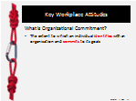

**POWERPOINT SLIDE 14**

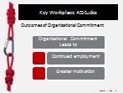

**POWERPOINT SLIDE 15**

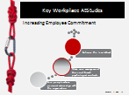

**Employee Engagement**

* **Employee engagement:** the harnessing of organization members’ selves to their work roles; in engagement, people employ and express themselves physically, cognitively, and emotionally during role performance.
* The four components of employee engagement are urgency, being focused, intensity and enthusiasm.
* Personal factors that contribute to employee engagement include positive or optimistic personalities, proactive personality, and conscientiousness.
* Environmental characteristics that contribute to employee engagement include job characteristics, leadership and stressors.
* Key engagement drivers on the organizational level are career opportunities, managing performance, organization reputation, communication and recognition.
* Organizations can increase engagement by measuring, tracking, and responding to surveys of employee engagement and by making sure the inputs in the Integrative Framework are positively oriented.

**POWERPOINT SLIDE 16**

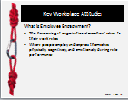

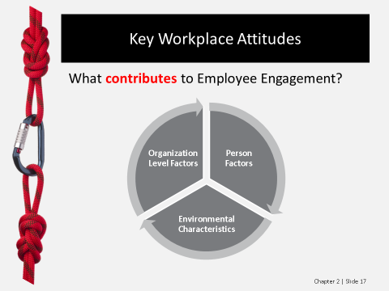**POWERPOINT SLIDE 17**

**POWERPOINT SLIDE 18**

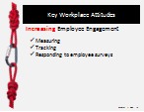

|  |
| --- |
| **SELF-ASSESSMENT 2.2: To What Extent Am I Engaged in My Studies?**  This Self-Assessment encourages students to reflect on their level of engagement for their studies so they can improve their performance in the classroom.  **Questions:**  **Is your level of engagement what you expected?**  *Responses will vary.*  **How might you increase your level of engagement?**  *Student engagement can be influenced by person factors, environmental characteristics or organizational-level factors. On the person level, students may comment on their need to increase their conscientiousness and/or strive for a more proactive personality. For environmental characteristics, students may comment that they prefer classes where they are able to use a variety of their skills and they receive effective feedback about their performance. Students may note that more charismatic professors or ones with whom they have developed better relationships may increase their engagement. Students may realize that the number of stressors they face in their personal and professional activities may be impacting their level of engagement.*  **To what extent do your professors influence your level of engagement? How might they foster more engagement from you?**  *A professor’s approach to the class is an environmental characteristic that can influence student engagement. How the course is structured, the types of assignments used, and how performance is evaluated and rewarded can have a profound impact on student engagement. Students may comment on the need for varied assignments, engaging approaches for presenting the material, timely and accurate performance feedback, the “real world” applicability of the material they are learning, and other factors which may be student-specific.*  **Additional Activities:**  One way to build on this Self-Assessment is to have students watch a 6-minute video clip that profiles how Providence College fosters student engagement in its Global Studies program. The clip is currently available at: <https://www.youtube.com/watch?v=vIwDAgkHNlk>. Consider using the following discussion questions:  Have any of your professors had the students help to craft the class syllabus? If so, did that increase your level of engagement in the course? If not, would it be a process that you would find engaging?  Describe your experiences with service learning projects and whether they have helped to increase your engagement in the course.  If you were able to participate in the selection process for a new faculty member, what factors would be most important to you in making the selection decision?  You can also consult the Connect Instructors Manual for the post-assessment activity and corresponding PowerPoint slides used for this Self-Assessment in Connect. In this activity, the class should be split into small groups based on their Self-Assessment engagement scores. The group discusses examples of personal and organizational-level factors that contribute to employee engagement. Students can then write examples on the board and the class can compare the examples with the groups’ engagement scores. Have the students consider if there is a relationship between the examples and the Self-Assessment scores. You can also discuss how the class thinks about pay as an organizational-level factor. |



|  |
| --- |
| **PROBLEM-SOLVING APPLICATION: Companies Foster Employee Engagement in Different Ways**  This Problem-Solving Application profiles the actions of three companies to create positive workplace attitudes.  **Your Call:**  **Stop 1: What is the implied problem in this example?**  *The implied problem in this case is that without the company efforts profiled, the firms might face lower levels of employee engagement and organizational commitment.*  **Stop 2: Which OB concepts are these managers using to explain the causes of the implied problem?**  *At Red Bull, the managers would likely contend that they are removing stressors so that employees will be more engaged. By providing the game area and the Friday night events, the company is providing an outlet for reducing its employees’ stress. In contrast, CHG Healthcare Services is focusing on leadership. It is focused on creating positive, trusting relationships between its managers and employees. Duke Energy is focusing on the organizational-level factor of communication and also leadership.*  **Stop 3: What other recommendations can you make?**  *Student recommendations may vary based on their personalities and values. Look for an understanding of the factors that contribute to organizational commitment and employee engagement.*  **Additional Activities:**  One way to build on this Problem-Solving Application is to profile the article “Red Bull's New York HQ Is Office Normcore” published by *Businessweek* on November 18, 2014. The article is a commentary on how the firm’s new office space in New York City is surprisingly low profile. The space doesn’t celebrate the company’s brand, nor does it seem consistent with the extreme sports associated with the brand. The space has no “playgrounds for grownups, or vending machines stocked with silver cans of caffeinated beverages.” Consider using the following discussion questions:  Discuss the reasons why Red Bull opted for a different layout for its New York offices compared to other locations.  How do you think the firm’s decision about how to partition the workspace into three types of fixed spaces (i.e., large, medium and small) will help to foster employee engagement?  Article Link:  <http://www.businessweek.com/articles/2014-11-18/red-bulls-new-york-hq-is-office-norm-core> |

**Perceived Organizational Support**

* **Perceived organizational support (POS):** the extent to which employees believe their organization values their contributions and genuinely cares about their well-being.
* Perceptions of support can either be positive or negative.
* People are willing to work hard and commit to their organizations when they believe that the company “truly” cares about their best interest.
* We are motivated by the norm of reciprocity, which obliges us to return the favorable treatment when someone treats us well.
* The outcomes associated with POS include increased organizational commitment, job satisfaction, organizational citizenship behavior and task performance, and lower turnover.
* Managers can foster POS by treating employees fairly, avoiding political behavior, providing job security, giving people more autonomy, reducing stressors in the work environment, and eliminating abusive supervision.

**POWERPOINT SLIDE 19**

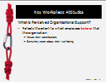

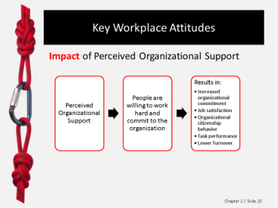**POWERPOINT SLIDE 20**

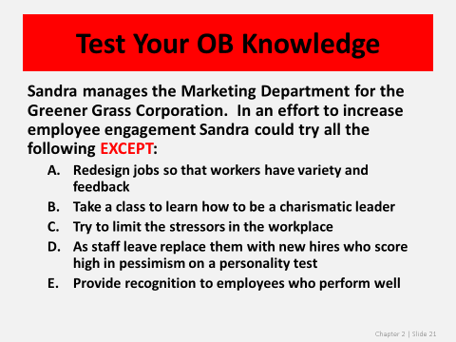**POWERPOINT SLIDE 21**

|  |
| --- |
| **PROBLEM-SOLVING APPLICATION: POS Can Be Positive or Negative**  This Problem-Solving Application profiles the actions two firms, one of which fostered positive POS, the other negative POS.  **Your Call:**  **Stop 2: What OB concepts or theories explain the causes of these different experiences?**  *John Greene experienced POS at Salesforce.com since the norm of reciprocity was met. Even though John had worked at the company for only one year, everyone at the firm, including the CEO, seemed to be concerned about John’s health. Employees signed up with the bone marrow registry and the company covered some of John’s medical expenses. Thus, John would have felt that his hard work and dedication to the firm were rewarded with favorable treatment. In contrast, Naiel experienced negative POS as a result of abusive supervision and political behavior by Dr. Levine. Naiel would be unlikely to respond to Dr. Levine’s actions with hard work and dedication. The fact that Naiel attempted to get another position illustrates how negative POS can contribute to turnover.*  **Additional Activities:**  One way to build on the topic of negative POS is to profile the actions of Amy and Samy Bouzaglo, owners of Amy's Baking Company in Scottsdale, Arizona. The two appeared on the reality program "Kitchen Nightmares" with Chef Gordon Ramsay. The owners demonstrated behaviors that did not portray them in a favorable light, including yelling at a customer, arguing with Chef Gordon Ramsay, refusing to accept criticism, and belittling employees. The segment includes an employee quitting and Chef Ramsay walking away without being able to help the restaurateurs. After the episode, the two took to the social media to defend their actions. A short summary of the situation is available from the today show at the following link: <http://www.today.com/video/today/51889856#51889856>. The segment relevant to Amy’s bakery airs from the 2:47 mark to the 6:00 mark. The full-length episode of "Kitchen Nightmares" may be available online, but it probably has too many “bleeps” to be aired in class. Consider using the following discussion questions:  Discuss the likely consequences of the negative POS that the employees of Amy’s Baking Company most likely feel.  After the episode aired, Amy’s Baking Company began selling t-shirts and hats using some of the catchphrases from the episode and with the phrase “I survived Amy’s Baking Company” Critique the advantages and disadvantages of the restaurant trying market itself as the sort of restaurant where poor service is part of the appeal.  Provide recommendations for Amy and Samy on how to best handle the situation now. |



**2.4 The Causes of Job Satisfaction**

How can changes in the workplace improve job satisfaction?

This section of the chapter introduces students to five predominant models of job satisfaction. One way to begin your discussion of job satisfaction is to have the students consider the importance of this factor to the study of OB.

**Possible Topics for Discussion:**

Discuss why job satisfaction is the most frequently studied outcome in the Integrative Framework.

Thinking about either your current position or a previous job, describe the factors that contributed most significantly to your job satisfaction or dissatisfaction.

Describe a time when your job (either current or past) failed to meet your expectations. How did you address the situation?

**Section 2.4 Key Concepts:**

**Job Satisfaction**

* **Job satisfaction:** an affective or emotional response toward various facets of one’s job.
* Job satisfaction is not a unitary concept, as a person can be relatively satisfied with one aspect of his or her job and dissatisfied with one or more other aspects.

**POWERPOINT SLIDE 22**

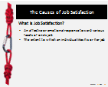

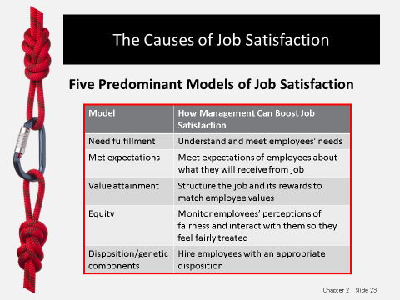**POWERPOINT SLIDE 23**



|  |
| --- |
| **SELF-ASSESSMENT 2.3: How Satisfied Are You With Your Present Job?**  This Self-Assessment encourages students to reflect on their level of job satisfaction and ways to improve their current job situation.  **Questions:**  **What is the relative satisfaction among the aspects of recognition, compensation, and supervision?**  *Responses will vary.*  **Which of these three aspects of satisfaction are most important to you? Explain.**  *Responses will vary.*  **What can you do to increase your level of satisfaction?**  *Students’ action plans will vary. Students might focus on receiving more recognition by looking for recognition from places other than their supervisor. For instance, employees might seek out recognition from colleagues in other departments or from teammates. Students can focus on increasing satisfaction with pay by negotiating with their boss as to why their pay should be increased. As discussed later in the book, employees can seek to manage up and attempt to influence their supervisors’ behavior. These tactics might help employees to increase their satisfaction with their supervisors.*  **Additional Activities:**  One way to build on this Self-Assessment is to have the students watch the “resignation” video posted by Marina Shifrin. Marina decided to tell her boss that she was quitting by posting “An Interpretive Dance for my Boss” on YouTube. In the 2-minute video, which does contain explicit lyrics in the background, Marina dances around the office with written subtitles as to why she was quitting. The clip is currently available at: <https://www.youtube.com/watch?v=Ew_tdY0V4Zou>. Consider using the following discussion questions:  What factors likely contributed to Marina resigning her position the way she did?  Critique the advantages and disadvantages of her unique resignation approach.  How could Marina’s manager have applied the Integrative Framework to foster her job satisfaction?  You can also consult the Connect Instructors Manual for the post-assessment activity and corresponding PowerPoint slides used for this Self-Assessment in Connect. In this activity, the class should be split into groups of five to six based on their satisfaction with their current or past jobs. Ask each group to come up with examples of each model of job satisfaction and put their examples on the board under columns for each model. The class can then discuss as a group and identify differences between examples based on group job satisfaction. |

**Need Fulfillment**

* Need fulfillment models propose that satisfaction is determined by the extent to which the characteristics of a job allow an individual to fulfill her or his needs.
* **Needs:** physiological or psychological deficiencies that arouse behavior.
* Research by the Society for Human Resource Management found that aspects of jobs that were very important to job satisfaction were opportunities to use skills and abilities, job security, compensation, communication between employees and senior management, and the relationship with the immediate supervisor.
* 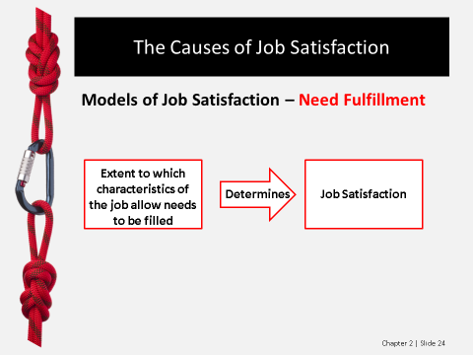It is generally accepted that need fulfillment is correlated with job satisfaction.

**POWERPOINT SLIDE 24**

**Met Expectations**

* **Met expectations:** the difference between what an individual expects to receive from a job, such as good pay and promotional opportunities, and what she or he actually receives.
* When expectations are greater than what is received, a person will be dissatisfied, while an individual will be satisfied when he or she attains outcomes above and beyond expectations.
* Research supports the conclusion that met expectations are significantly related to job satisfaction.

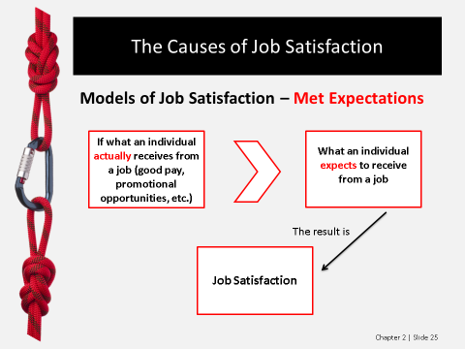**POWERPOINT SLIDE 25**

**Value Attainment**

* **Value attainment:** satisfaction results from the perception that a job allows for fulfillment of an individual’s important values.
* Research consistently supports the prediction that value fulfillment relates positively to job satisfaction.
* Managers can thus enhance employee satisfaction by structuring the work environment and its associated rewards and recognition to reinforce employees’ values.

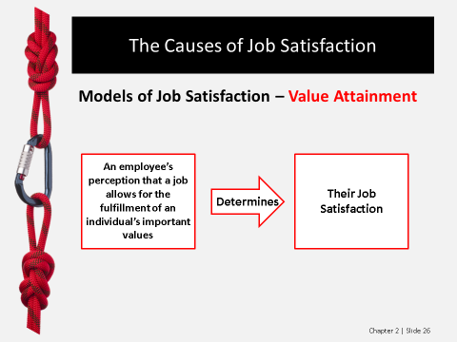

**POWERPOINT SLIDE 26**

**Equity**

* Satisfaction is a function of how “fairly” an individual is treated at work.
* Satisfaction results from one’s perception that work outcomes, relative to inputs, compare favorably with a significant other’s outcomes/inputs.
* Managers are encouraged to monitor employees’ fairness perceptions and to interact with employees in such a way that they feel equitably treated.

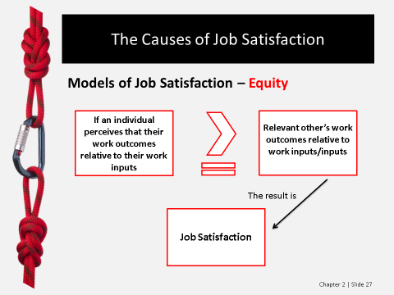**POWERPOINT SLIDE 27**

**Dispositional/Genetic Components**

* This model is based on the belief that job satisfaction is partly a function of both personal traits and genetic factors.
* Stable individual differences may be just as important in explaining job satisfaction as are characteristics of the work environment.
* Researchers estimate that 30% of an individual’s job satisfaction is associated with dispositional and genetic components.

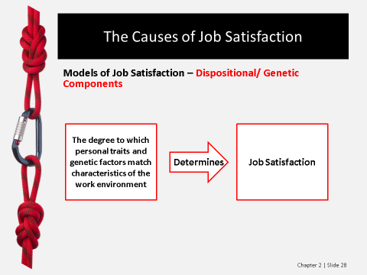

**POWERPOINT SLIDE 28**

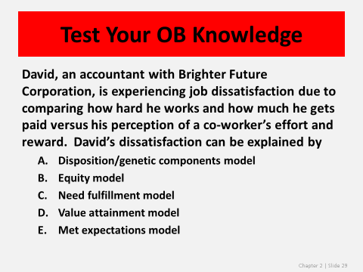

**POWERPOINT SLIDE 29**

**Telecommuting**

* **Telecommuting:** employees are allowed to do all or some of their work from home, using advanced telecommunications technology and Internet tools to send work electronically from home to the office, and vice versa.
* Telecommuting allows people to balance their work and family lives.
* Studies confirm telecommuting enhances productivity and retention, and decreases absenteeism.

|  |
| --- |
| **PROBLEM-SOLVING APPLICATION: Yahoo CEO Marissa Mayer Bans Telecommuting**  This Problem-Solving Application encourages students to consider the advantages and disadvantages of telecommuting.  **Your Call:**  **Stop 1: What is the problem in this example?**  *The problem in this example is that Yahoo!’s organizational performance has not met expectations. In the CEO’s mind, the company needs to achieve greater group-level task performance, which she believes can only be accomplished through face-to-face interactions at work.*  **Stop 2: What OB concepts explain Yahoo! employees’ response to Mayer’s decision?**  *With respect to job satisfaction, Yahoo! employees are likely to feel that the lack of telecommuting will make it difficult to achieve their needs for work/family balance. They may also feel that their expectations are not being met since they likely accepted their job at Yahoo! under the assumption that they would be able to telecommute. If employees feel like telecommuting sends a signal to the workers that their employer trusts them to get their work done with minimal supervision, they may feel their values are not being addressed with the new policy. Employees may feel that they have not been equitably treated, and this may reduce their job satisfaction.*  **Stop 3: If you were CEO, what would you recommend?**  *Students may suggest that the CEO of the company should have used a contingency approach to determine which, if any, jobs could continue to operate using telecommuting and which ones were too dependent on face-to-face interactions to be conducted remotely. It may also have been better to dramatically reduce telecommuting rather than take it away all together. If employees were allowed to telecommute even one day per week, this might allow the employees to have their needs and expectations met, with limited negative impact on the productivity of the firm. Applying the one-size-fits-all approach that Mayer used is likely to negatively impact key workplace attitudes at Yahoo!*  **Additional Activities:**  One way to build on this Problem-Solving Application is to have the students watch the *Sunday Morning* segment “When the Workplace Is Your Own Home.” This 8-minute segment profiles several employees who are able to telecommute and discusses why not all employers embrace telecommuting. Consider asking the following discussion questions:  Analyze the advantages and disadvantages of telecommuting, from the perspective of the employer and the employee.  Assuming you were able to telecommute for your position, what actions would you need to take to ensure that your productivity remained as high as if you worked in the office?  Assume you are Marissa Mayer and you have decided to no longer allow Yahoo! employees to continue to telecommute. Draft a memo or email to your employees explaining the strategic rationale for your decision.  Video Link:  [**http://www.cbsnews.com/news/when-the-workplace-is-your-own-home/**](http://www.cbsnews.com/news/when-the-workplace-is-your-own-home/) |



|  |
| --- |
| **TAKE-AWAY APPLICATION—TAAP**  This Take-Away Application (TAAP) encourages students to consider how they could change their level of job satisfaction.  **Questions:**  **Which causes of job satisfaction are impacting your level of satisfaction?**  *Responses will vary. When critiquing students’ responses, look for an understanding of the predominant models of job satisfaction (i.e., need fulfillment, met expectations, value attainment, equity, and dispositional/genetic components).*  **Describe two things you might do to improve your job satisfaction.**  *Responses will vary but look for an understanding of what workers can do to change the factors that drive job satisfaction. For example, a student might be able to engage in job crafting, as described in Chapter 5, to change the scope of his job responsibilities, allowing for greater need fulfillment or met expectations. Since values are resistant to change, students may need to change their jobs if their current position does not foster value attainment. According to the principles of equity theory, as described in Chapter 5, people can change their inputs (e.g., work less), seek to change their outputs (e.g., ask for a pay raise), change their comparison other (e.g., use a different co-workers) or change their psychological processes to foster greater feelings of equity. Students may also note that dispositional and genetic components are an important factor in predicting job satisfaction, but these are factors that are difficult to change.*  **If you could ask your boss or employer to change one thing to improve your job satisfaction, what would you suggest?**  *Managers can improve job satisfaction by understanding and meeting employees’ needs, meeting the expectations of employees about what they will receive from the job, structuring jobs and rewards to match employee values, and monitoring employees’ perceptions of fairness, and interacting with them so they feel fairly treated. Suggestions as to which one(s) to focus on would be unique to each student.*  **Additional Activities:**  One way to build on this TAAP is to profile one of the recipients of a ‘Best Practices Honor’ from the American Psychological Association at its Healthy Workplace Awards ceremony. Framework, a Connecticut consulting company, has created a positive environment for employees. The company was profiled in a 3-minute video that aired on channel WTNH (see link below). Consider using the following discussion questions:  Discuss some of the actions that Framework has done to foster higher job satisfaction of its employees.  Describe examples of the five predominant models of job satisfaction which were profiled in the segment.  Discuss reasons why it might be difficult for employers to foster job satisfaction.  Video Link:  <http://wtnh.com/2014/06/23/stamford-company-proving-happy-workers-make-for-more-productivity/> |



**2.5 Major Correlates and Consequences of Job Satisfaction**

What work-related outcomes are associated with job satisfaction?

This section of the chapter describes the major correlates and consequences of job satisfaction. One way to begin your coverage of these topics is to have the students consider what attitudes and behaviors a person with low levels of job satisfaction is likely to display.

**Possible Topics for Discussion:**

Remember a time when you no longer enjoyed your job and when you had low levels of job satisfaction. Discuss the attitudes (i.e., feelings opinions about people, places, and objects) that you displayed.

When you were experiencing this job dissatisfaction, how did your behaviors change as a result of this job dissatisfaction?

Discuss examples of counterproductive work behavior that you have either engaged in or observed at the workplace.

**Section 2.5 Key Concepts:**

**Attitudinal Outcomes of Job Satisfaction**

* Motivation
  + Employee motivation represents a psychological process that arouses our interest in doing something, and it directs and guides our behavior.
  + Employee motivation positively correlates to job satisfaction.
  + Managers can potentially enhance employees’ motivation through various attempts to increase job satisfaction.

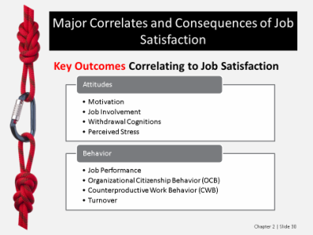**POWERPOINT SLIDE 30**

**POWERPOINT SLIDE 31**

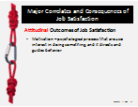

* Job Involvement
  + **Job involvement:** the extent to which an individual is personally involved with his or her work role.
  + Job involvement is moderately related to job satisfaction.

**POWERPOINT SLIDE 32**

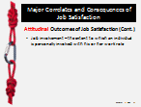

* Withdrawal Cognitions
  + **Withdrawal cognitions:** an individual’s overall thoughts and feelings about quitting.
  + Job satisfaction is believed to be one of the most significant contributors to thoughts of quitting.
  + Managers can indirectly help to reduce employee turnover by enhancing employee job satisfaction.

**POWERPOINT SLIDE 33**

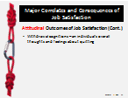

* Perceived Stress
  + Stress can have very negative effects on organizational behavior and an individual’s health.
  + Stress is positively related to absenteeism, turnover, coronary heart disease, and viral infections.
  + Perceived stress has a strong, negative relationship with job satisfaction.

**POWERPOINT SLIDE 34**

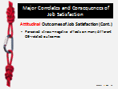

|  |
| --- |
| **PROBLEM-SOLVING APPLICATION: What to do about Bullying**  In this Problem-Solving Application, students apply the 3-Stop approach to a situation of workplace bullying.  **Your Call:**  **Stop 1: What is the problem in this case?**  *The problem in this case is that the group dynamics and the organizational climate faced by Stuart are negatively impacting his workplace attitudes. He is experiencing unprofessional behaviors by his colleagues that will negatively impact his job satisfaction.*  **Stop 2: What OB concepts or theories help explain Stuart’s situation and reaction?**  *When reflecting on Stuart’s situation, students may comment on the factors that are contributing to the bullying by his colleagues. It may be that low levels of job satisfaction are contributing to the counterproductive work behavior exhibited by his colleagues. If the needs, expectations, and values of his colleagues are not being met, this may be part of the reason why they are treating Stuart inappropriately. There may also be issues with equity or dispositional factors contributing to their actions. From Stuart’s perspective, he is probably experiencing low levels of organizational commitment, little employee engagement, and low levels of perceived organizational support. His needs, expectations and values are likely not being met. This will negatively impact his motivation and job involvement, while increasing his withdraw cognitions and perceived stress. This will likely negatively impact his job performance and organizational citizenship behavior, while increasing his counterproductive work behavior. Even though Stuart denied being bullied, the likely end result of his treatment would eventually be turnover from the firm.*  **Stop 3: What would you do if you were Stuart? What would you do as a manager of the restaurant?**  *Students’ responses about how Stuart or the manager should approach the situation will vary. Look for an understanding of the causes of job satisfaction (i.e., need fulfillment, met expectations, value attainment, equity, and dispositional/genetic components). Further, look for an understanding of the attitudinal and behavioral reactions to low levels of job satisfaction. Students should reflect on how Stuart likely has low levels of perceived organizational support (POS), and the likely end result of this treatment will be turnover. Rather than strike back against his abusers, Stuart may be better served to seek social support from friends and family.*  **Additional Activities:**  One way to build on this Problem-Solving Application is to have the students read the article “Workplace Bullying: A Silent Epidemic” from the October 2014 issue of *HRMagazine.* This article discusses how bullying is an issue that managers should not ignore. Consider using the following discussion questions:   * Discuss the concerns with attempting to legislate workplace bullying. * Discuss how you as a manager could make the business case that preventing bullying is something that your company should prioritize. * Describe best practices of bullying prevention that companies should implement.   Article Citation:  McLaughlin, K., P.H.R. (2014). Workplace bullying: A silent epidemic. *HRMagazine, 59*(10), 22-23.  ProQuest document ID: 1610041891 |

**Behavioral Outcomes of Job Satisfaction**

* Job Performance
  + Dominant beliefs are that either job satisfaction causes performance or performance causes job satisfaction.
  + The relationship between job satisfaction and performance is much more complex than originally thought, as both variables indirectly influence each other through a host of individual differences and work-environment characteristics.
  + Managers can indirectly or directly positively affect a variety of important organizational-level outcomes such as job performance and customer satisfaction by increasing employee job satisfaction.

**POWERPOINT SLIDE 35**

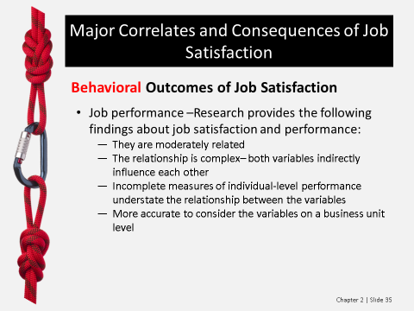

* Organizational Citizenship Behavior
  + Organizational citizenship behavior (OCB): individual behavior that is discretionary, not directly or explicitly recognized by the formal reward system, and that in the aggregate promotes the effective functioning of the organization.
  + OCBs are voluntary and help work groups and the organization to effectively achieve goals.
  + OCBs have a moderately positive correlation with job satisfaction.

**POWERPOINT SLIDE 36**

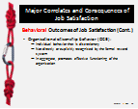

**POWERPOINT SLIDE 37**

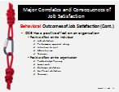

* Counterproductive Work Behavior (CWB)
  + Counterproductive work behavior (CWB): behavior that harms other employees, the organization as a whole, or organizational stakeholders such as customers and shareholders.
  + Examples of CWBs include bullying, theft, gossiping, backstabbing, drug and alcohol abuse, destroying organizational property, violence, purposely doing bad or incorrect work, surfing the Internet for personal use, excessive socializing, tardiness, sabotage, and sexual harassment.
  + CWB has a strong, negative relationship with job satisfaction.

**POWERPOINT SLIDE 38**

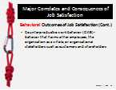

**POWERPOINT SLIDE 39**

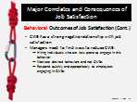

* Turnover
  + Turnover can be beneficial when it involves a low-performing employee, but losing a good employee is bad because the organization loses valuable human and social capital and it can be costly.
  + Job satisfaction has a moderately strong, negative relationship with turnover.
  + Managers can reduce voluntary turnover if they hire people who “fit” within the organization’s culture, spend time fostering employee engagement, provide effective onboarding and recognize and reward high performers.
  + Managers should consider the value of offering flexible work schedules to enhance job satisfaction and reduce turnover.

**POWERPOINT SLIDE 40**

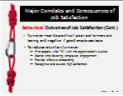

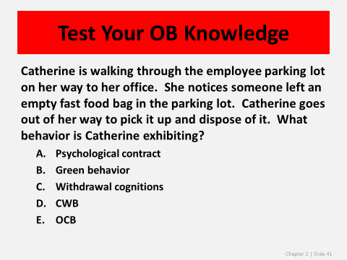**POWERPOINT SLIDE 41**

|  |
| --- |
| **TAKE-AWAY APPLICATION—TAAP**  This Take-Away Application (TAAP) encourages students to consider what they want from future job opportunities and what would they do if their needs were not being met.  **Questions:**  **What are the three most important things you want from a job and its associated working conditions?**  *Students’ views about what they want from a job will differ, but flexibility will likely be a common theme. Encourage students to think back to their scores on Self-Assessment 2.1 and reflect on if their core values match what they listed as important things they want from a job.*  **How can you determine if a future job opportunity offers these things?**  *Students should emphasize their social networks to determine if their future job opportunities will offer the things they value. Websites such as Glassdoor.com would provide valuable insights into the workplace environment of a potential employer. Students should know to use their LinkedIn connections to obtain valuable information about potential employers.*  **Assume that you are in a job that is not meeting your needs and that you cannot quit. How would you improve your workplace attitudes in this situation?**  *If a person is unable to quit to escape a job he does not like, he should focus on changing those elements of job satisfaction that are under his control. The person could change what he needs, lower his expectations about what he will get from his employer, change his values, or change his perceptions about inputs and outcomes in equity considerations. Job crafting, discussed in Chapter 5, further elaborates on how employees can engage in behavioral and cognition changes to increase their job satisfaction. If a person is unable to make these changes, he will likely experience lower organizational commitment, lower employee engagement, lower motivation, less job involvement, greater withdraw cognitions and greater perceived stress. Behavioral outcomes of the situation would include lower job performance, fewer organizational citizenship behaviors, and more counterproductive work behaviors.*  **Additional Activities:**  One way to build on this TAAP is to have the students watch the *Sunday Morning* segment “Former Football Player Turns to Farming.” This 3-minute clip profiles the decision of Jason Brown, who walked away from a lucrative career with the NFL to pursue farming. Consider using the following discussion questions:  Assume you earn a lot of money working a job you find meaningless. What would you do?  If you were Jason Brown, would you have made the same career choice? Discuss why or why not.  Discuss actions you should take now to try to determine if the career path you are considering will meet your needs and foster job satisfaction.  Video Link:  <http://www.cbsnews.com/videos/former-football-player-turns-to-farming/> |



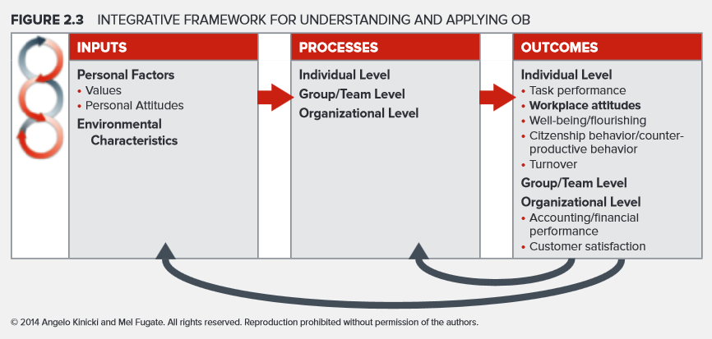

**REVISITING THE INTEGRATIVE FRAMEWORK: FIGURE 2.3**

This chapter focuses on how values and attitudes impact important outcomes in the Integrative Framework. To briefly review these connections, values and personal attitudes impact key factors on the individual-level and the organizational level of the Integrative Framework. Values are abstract ideals that guide one’s thinking and behavior. The 10 broad values of Schwartz’s value theory can have a profound impact on the type of tasks or jobs that a person prefers. Our values can thus impact our task performance and workplace attitudes. Personal attitudes represent our feelings or opinions about people, places, and objects. Our attitudes affect our behavior via intentions. Our attitudes toward a behavior, our subjective norms, and our perceived behavioral control influence our intentions, and thus our planned behavior. Individuals will experience cognitive dissonance if they have conflicting cognitions, ideas, beliefs, values or emotions. Since people seek to avoid cognitive dissonance, it can cause people to change their attitudes or behavior or both.

Four critical workplace attitudes are organizational commitment, employee engagement, perceived organizational support and job satisfaction. Individuals with higher levels of organizational commitment are less likely to quit the company and will display greater motivation for pursuing organizational goals. Individuals with higher levels of employee engagement will have better task performance and better well-being. Positive perceived organizational support is associated with more organizational citizenship behavior, greater task performance, and lower turnover. Job satisfaction correlates with several attitudinal and behavioral outcomes. Specifically, job satisfaction is positively correlated with the attitudinal variables of motivation and job involvement and negatively correlated with withdrawal cognitions and perceived stress. It is also positively correlated with job performance and organizational citizenship behavior and negatively correlated with counterproductive work behavior and turnover.

There are five predominant models of job satisfaction. Managers can boost job satisfaction through need fulfillment and understanding and meeting employees’ needs. Managers can meet the expectations of employees about what they will receive from the job. A third cause of job satisfaction is value attainment, which managers can foster by structuring a job and its rewards to match employee values. Managers should monitor employees’ perceptions of fairness since perceptions of equity foster job satisfaction. Dispositional and genetic components can foster job satisfaction and thus it is important to hire employees with an appropriate disposition, being mindful of any discriminatory results.

To apply the 3-Stop approach to the content of this chapter, the first stop is to define the problem. Low levels of task performance, negative work attitudes, poor well-being, counterproductive work behavior and high levels of turnover are all individual-level outcomes that indicate a problem. There can also be problems linked to financial performance or customer satisfaction. For Stop 2, the chapter material provides great insights into the factors that can be negatively these outcomes. For instance, if there is a poor fit between a person’s values and the type of work that he performs, his workplace attitudes will be negatively impacted. Attitudes are an important factor to consider in Stop 2 since they are predictors of likely behavior. If we want to change behavior, we need to consider intentions and how we might modify them by either changing attitudes toward the behavior, subjective norms, or perceived behavioral control. Stop 3 is to generate effective recommendations based on OB concepts. The content in the chapter on what drives the key workplace attitudes of organizational commitment, employee engagement, perceived organizational support and job satisfaction is particularly relevant. A key takeaway from this chapter is that these four workplace attitudes are linked to many important outcomes in the Integrative Framework and managers must understand how they can be fostered.

**CHALLENGE: MAJOR QUESTIONS**

**2.1 What role do values play in influencing my behavior?**

*Values are abstract ideals that guide your thinking and behavior across all situations. Your values are relatively stable and can influence your behavior outside of your awareness. Values encompass concepts, principles, or activities for which you would be willing to work hard. Your motivation would be greatest when your work environment is consistent with your values. For example, if you place a high priority on the stimulation value from the Schwartz model, it is unlikely that you would experience high levels of employee engagement working in a job that requires you to perform the same tasks day after day, month after month. You would likely look for another job to avoid this cognitive dissonance. In contrast, if there was a compatible fit between your values and your work environment, your employer would likely enjoy lower turnover and better customer satisfaction, while you would display more employee engagement. Thus, your values play a key role in influencing outcomes that are important to you and to your employer.*

**2.2 How do personal attitudes affect workplace behavior and work-related outcomes?**

*Attitudes represent your feelings or opinions about people, places, and objects, and range from positive to negative. According to Ajzen’s theory of planned behavior, your behaviors are influenced by attitudes via intentions. The strength of your intentions is determined by your attitude toward the behavior, your subjective norms, and your perceived behavioral control. Your personal attitudes can impact your workplace behaviors such as citizenship behavior, counterproductive behavior, and turnover. For example, if you have negative attitudes about autocratic leadership styles and that is the approach that your supervisor uses, you would be unlikely to do anything “extra” in the name of the organization, you may display counterproductive behaviors such as gossiping, and you may quit the firm. These behaviors could impact work-related outcomes such performance and customer satisfaction.*

**2.3 Why is it important for management to pay attention to workplace attitudes?**

*Savvy managers will track the workplace attitudes of organizational commitment, employee engagement, perceived organizational support and job satisfaction. These represent important outcomes that managers may be working to enhance directly. They link to other significant outcomes that managers will want to improve where possible. Managers can increase employees’ commitment by hiring people whose personal values align with the organization’s, by not breaching psychological contracts, and by enhancing the level of trust throughout the organization. Savvy managers will understand the person factors (e.g., proactive personality), environmental characteristics (e.g., job characteristics), and organization-level factors (e.g., recognition) that contribute to employee engagement. Managers who foster employee engagement are likely to observe enhanced customer satisfaction/loyalty, more productivity, and greater profitability. Finally, savvy managers understand the importance of fostering positive perceived organizational support (POS). When employees feel like their organization values their contributions and genuinely cares about their well-being, they are willing to work hard and commit to their organizations. Positive POS will increase organizational commitment, job satisfaction, organizational citizenship behavior and task performance, and decrease turnover. Managers can foster positive POS by treating employees fairly, avoiding political behavior, providing job security, giving people more autonomy, reducing stressors in the work environment, and eliminating abusive supervision.*

**2.4 How can changes in the workplace improve job satisfaction?**

*Job satisfaction is a function of need fulfillment, met expectations, value attainment, equity, and dispositional/genetic components. If managers were to better understand and meet employees’ needs, this would boost job satisfaction. By meeting expectations of employees about what they will receive from the job, job satisfaction would be improved. By structuring the job and its rewards to match employee values, managers could improve job satisfaction. Since employees’ perceptions of fairness can impact job satisfaction, managers should monitor these perceptions and interact with employees so they feel fairly treated. In the hiring process, managers may want to consider hiring employees with an appropriate disposition, so long as the hiring practices do not discriminate against any protected class.*

**2.5 What work-related outcomes are associated with job satisfaction?**

*Job satisfaction has been correlated with many different attitudes and behaviors. Four attitudinal outcomes of job satisfaction that are important to OB researchers are motivation, job involvement, withdrawal cognitions, and perceived stress. Employee motivation positively correlates to job satisfaction. Job involvement is moderately related to job satisfaction. Job satisfaction is believed to be one of the most significant contributors to withdraw cognitions. Perceived stress has a strong, negative relationship with job satisfaction. Key behavioral outcomes of job satisfaction are job performance, organizational citizenship behavior (OCB), counterproductive work behavior (CWB), and turnover. Research has shown that job satisfaction and performance are moderately related. OCBs have a moderately positive correlation with job satisfaction. CWB has a strong, negative relationship with job satisfaction. Job satisfaction has a moderately strong, negative relationship with turnover.*

**PROBLEM-SOLVING APPLICATION CASE (PSAC): A Good Stock to Own, a Bad Place to Work?**

**Apply the 3-Stop Problem-Solving Approach to OB**

**Stop 1: What is the problem?**

Use the Integrative Framework shown in Figure 2.3 to help identify the outcomes that are important in this case.

*Arguably the most important individual-level outcomes addressed in the case include work attitudes, task performance, counterproductive behavior and turnover. Group-level outcomes might include group performance, satisfaction or cohesion. Important organizational-level outcomes include financial performance, customer satisfaction and reputation.*

Which of these outcomes are not being achieved in the case?

*Positive work attitudes are not being fostered. Employees at DISH likely have low levels of organizational commitment, little employee engagement, low levels of perceived organizational support, and little job satisfaction. Customer satisfaction appears to be low, given the loss in net subscribers. The firm’s reputation might be suffering because of comments on Glassdoor.com and the firm’s placement on the worst employer to work for list. Although not necessarily true at the time of the case, it seems logical that eventually these issues will negatively impact the firm’s financial performance.*

Based on considering the above two questions, what is the most important problem in this case?

*Given the emphasis of this chapter, arguably the most important problem in the case is the poor work attitudes, but student responses may vary.*

**Stop 2: Use the Integrative Framework in Figure 2.3 to help identify the OB concepts or theories that help you to understand the problem in this case.**

What person factors are most relevant?

*Values and needs are important personal factors linked to the content in this chapter. Individuals who value openness to change in Schwartz’s values theory are likely to have negative work attitudes as a result of working for DISH. It appears that the top management at DISH places little emphasis on meeting the needs of its employees or on attempting to meet their expectations. Individuals with greater levels of human and social capital may be the most likely to quit the company.*

What environmental characteristics are most important to consider?

*Relevant environmental characteristics include leadership, organizational culture, job design, and human resource policies.*

What concepts or tools discussed in Chapter 1 and in this chapter are most relevant for solving the key problem in this case?

*Concepts that should be addressed here are the key workplace attitudes of organizational commitment, employee engagement, perceived organizational support and job satisfaction. Action steps for increasing employees’ commitment, including the use of flextime, should be addressed. The person (i.e., personality and conscientiousness) and environmental characteristics (i.e., job characteristics, leadership, and stressors) that contribute to employee engagement should be discussed. Fostering perceived organizational support through the norm of reciprocity should be explored. The predominant models of job satisfaction and the consequences of job satisfaction should be mentioned.*

**Stop 3: What are your recommendations for solving the problem?**

Review the material in the chapter that most pertains to your proposed solution and look for practical recommendations.

*Responses will vary. Look for an understanding of workplace attitudes and what managers can do to foster organizational commitment, employee engagement, perceived organizational support and job satisfaction. Fostering these attitudes will increase motivation and job involvement, decrease withdraw cognitions, and reduce stress. Fostering positive workplace attitudes will also increase job performance, encourage organizational citizenship behavior, reduce counterproductive work behavior, and reduce turnover.*

Use any past OB knowledge or experience to generate recommendations.

*Responses will vary.*

Outline your plan for solving the problem in this case.

*Responses will vary.*

**LEGAL/ETHICAL CHALLENGE: Social Media in the Hiring Process**

**Addressing the Challenge**

1. What would you do if an interviewer requested that you provide private login information? Be sure to explain or justify your answer.
   1. Don’t provide the information. Private is private, and the employer has no right to view this information.
   2. If you want the job, provide the information.
   3. Withdraw your application. Who wants to work for a company that wants to see such private information?
   4. Invent other options.
2. What information about a person’s values or attitudes might be gleaned from a Facebook page?
3. If you were running a company, would you want to review potential employees’ social media pages? Why or why not?

**Discussion:**

Managers may see several advantages to accessing a potential employee’s social media pages. One advantage is that it may help them to verify information that the person used as part of the application process. Given the number of candidates who lie or provide inaccurate information on their resumes, this may be a way for managers to verify the skills and experiences of a potential employee. Employers also see benefits in seeing the “true” candidate to gauge the organizational fit of the potential candidate. Values such as person’s openness to change and motivation to learn may be evident in their social media posts. Whether the person is self-motivated and always displays a professional image may become obvious. If the potential employee is highly critical of his or her former employer, it may indicate a negative dispositional attitude the employer should avoid. If the corporate culture emphasizes collaboration and team work, but everything on the potential employee’s social media posts indicates a highly competitive individualistic orientation, this may not be the best candidate for the company. The person’s level of emotional intelligence may be determined from his or her posts. Since it can sometimes be possible for candidates to “fake” their way through the traditional selection process of an interview, using the individual’s social media posts can help managers get to know the true person and his or her values and attitudes.

A key reason why employers may wish to avoid reviewing a potential employee’s social media accounts is legal compliance. Even if the state where the firm is operating has no law against requiring applicants to provide social media passwords, the practice may not be wise for trying to avoid employment discrimination charges. If an employer learns about an applicant’s protected class status as a result of information posted in the person’s social media accounts and this information negatively impacted the person’s hiring, an employer may be guilty of illegal discrimination. If for instance a company learns that the person is Jewish and the employer decides that it does not want to hire a Jewish person because of concerns about potential scheduling conflicts, this would be an example of illegal employment discrimination in the United States. Employers may come to learn about an applicant’s protected class status, such as their age, religion, disability or sexual orientation, as a result of reading social media posts. Then the employer might have the burden of proving that the protected class status played no role in the hiring process.

Another reason why employers might want to avoid searching social media is that it may send the message to potential applicants that the firm does not trust them. This may deter talented people from accepting positions. Some applicants may refuse to provide the information or will withdraw from the selection process if they feel the employer is intruding into their personal space. Increasingly, states are making this decision easier for firms by passing state legislation preventing firms from requiring applicants to provide passwords to social media accounts as part of the hiring process.

**GROUP EXERCISE: The Paper Airplane Contest**

In this exercise, teams are asked to design a paper airplane, whose performance will be evaluated based on how far it flies, how far it flies with a payload, and design characteristics.

**Questions for Discussion**

1. How did the group decide to design the plane?
   1. *Student responses will vary. Some teams may jump right into the design and testing stage by building a paper airplane based on their past experience and then seeing how it flies. Other teams may spend more time on the research phase and may attempt to discuss aerodynamic principles that will help planes perform better prior to building their first prototype plane. Other teams may place more emphasis on the design characteristics and will consider the aesthetics of how the plane will look.*
2. Did the team consider each member’s abilities when designing and flying the plane? Explain.
   1. *Student responses will vary. Analytical reasoning and creative-thinking skills are likely linked to success on this exercise. Teams with individuals with effective time management and planning skills would likely perform better. The extent to which the teams considered their members’ skills and abilities prior to beginning the task and distributing task responsibilities likely impacted each team’s success.*
3. Were all team members equally involved in the task and equally satisfied with the team’s final product? Discuss why or why not.
   1. *Student responses will vary. Individuals with a low need for achievement may not be motivated to perform well on the assignment, while those individuals with a high need for achievement might be disappointed if their plane is not deemed the winner. Similarly, those who value independence may not be motivated by a group project, but those who value harmony and group interactions may be motivated to perform.*
4. What did you notice or infer about the attitudes of each group member based on how they approached the group exercise?
   1. *Student responses will vary. Students may note that some of the team members displayed strong work ethics, positive attitudes, adaptability, and/or were motivated to learn. They may notice differences in the level of interest in collaboration and the extent to which their teammates were detail oriented.*
5. How could the team have increased its members’ job involvement, engagement, and task performance? Provide specific recommendations.
   1. *Student responses will vary. Look for an understanding of the factors that foster positive workplace attitudes. Students should comment on the five predominate models of job satisfaction (i.e., need fulfillment, met expectations, value attainment, equity, and dispositional/genetic components) and how job satisfaction is correlated with specific attitudes and behaviors.*
6. What values in the Schwartz model (discussed early in the chapter; see Figure 2.1) do you see as predicting successful participation in this group exercise?
   1. *Student responses will vary. Students may believe that values linked to openness to change may foster creative thinking, which would contribute to successful participation in the group exercise. Others may believe that an emphasis on self-enhancement and the need for achievement would be linked to successful participation. Others may argue that self-transcendence would be more important if they believed that a cohesive team was needed for effective task performance.*

**VIDEO RESOURCES**

The video “Hiring and Individual Differences at Zappos” from the Organizational Behavior Instructor Video: Volume Two is recommended for this chapter. The segment profiles the values of the online retailer and discusses how it hires employees to fit the firm’s corporate culture. Consider using the following discussion questions:

Discuss how Zappos’ core values likely contribute to the success of the firm.

How do Zappos’ hiring practices help to support the key values of the firm?

Evaluate the reasons why Zappos offers $3,000 to any candidate who at the end of their initial training program decides Zappos is not for them.

**MANAGER’S HOT SEAT**

Students may complete the “Bullying in the Workplace” Manager’s Hot Seat exercises in Connect for this chapter.

**Introduction:** This scenario explores the complexities of bullying in the workplace. Bullying is a serious form of workplace violence, though workplace bullies typically use words and actions on their victims. This case shows one example of bullying, while adding a second dimension of nepotism since the one bullying is the boss’s sister.

**Learning Objectives:**

1. To analyze approaches for handling a bully.
2. To recognize effective ways to deal with bullying.
3. To understand why threats are ineffective when trying to persuade.

**Scenario Description**

*Overview*

Susan Sheppard, Creative Design Manager at Word-of-Mouth Marketing Group, is consistently bullied by her colleague, Alexandra Woodward, the boss's sister. Alexandra has been working at the firm a little over a month, after quitting her job as a Rare Artifacts Curator at the Museum of Indigenous Culture. During her short time at Word-of-Mouth, she has shown a propensity for “self-governance” and defiance. Extra work has been heaped on Sheppard, and she has had to face sarcasm and a constant barrage of inappropriate comments from her newly appointed subordinate.

*Profile*

* Susan Sheppard, Creative Design Manager, Word-of-Mouth. Sheppard has been at Word-of-Mouth for four and a half years and was appointed manager of the Creative Design Department seven months ago.
* Alexandra Woodward, Creative Design, Word-of-Mouth. Woodward is the boss’s sister and is the newest and least qualified recruit.

*Backstory*

The Word-of-Mouth Marketing Department is eight people strong, including Sheppard and her new colleague Woodward, the newest and least qualified recruit.

Woodward shares the boss’s family name, and presumably feels she shares the boss’s default authority, too. She came to the company six months after leaving her job as a museum curator. Only one month into her new career, she is already dictating her own workload and that of others; she dumps work onto Sheppard and is bullying and inappropriate.

In the last two weeks, Sheppard’s desk has been littered with unfinished work originally assigned to Woodward, including design layouts, annual report figures, copyright disputes, and print schedules.

Twice, Sheppard was left with design layouts to complete within three hours of their deadline. On one of those occasions, Woodward had done barely more than sketch text boxes, leaving Sheppard with more than a day’s work to accomplish within an hour and twenty minutes.

When asked to obtain the copyright to publish a particular photograph (featuring a celebrity’s home), Woodward skipped over the details (not even filing the request), almost trashing a print-run of 70,000 brochure covers as well as leaving Word-of-Mouth open to possible legal action. Luckily, Sheppard picked up on Woodward’s oversight and gained permission from the relevant parties before any damage was done.

Woodward point-blank refused to write the annual report figures, saying that as an “Artistic Consultant” it was insulting to ask her to file facts and figures. In fact, Woodward doesn’t have a job title, which is something Sheppard cannot address.

The print schedules, which Woodward was supposed to deliver a week before the commencement of the Approval Stage, arrived on Sheppard’s desk with one day to spare, and, as with the design layouts, were so incomplete, they required Sheppard to put aside her own work and concentrate on getting the schedules out in time.

During a recent meeting with a photographer, Woodward undermined Sheppard continually either by contradicting her suggestions or through disrespectful gestures and sighs.

Whenever Sheppard approaches Woodward’s desk, Woodward initially completely ignores her and then does little to engage in conversation, deliberately avoiding eye contact.

Just four days ago, when Sheppard issued instructions to another member of the team, Woodward took it upon herself to approach the team member and, on “Sheppard’s behalf”, retract the instructions.

When Sheppard initially asked Woodward into her office for a discussion, Woodward created such a scene of angry complaints and accusations of bullying, that Sheppard had to back out of her intention to diffuse the situation.

At every opportunity, Woodward has been bad-mouthing Sheppard to other members of the Creative Design Department.

*Scene Setup*

Sheppard has scheduled a meeting with Woodward to discuss the completion of one of their big projects—the creation of a new brochure for the home furnishings giant, Soft Landings. More importantly, she hopes to confront Woodward about her bullying behavior.

*Scene Location*

Sheppard’s office.

*The Meeting—Summary*

Throughout the meeting, Woodward continues her bullying of Sheppard by making verbal threats and complaining she is a bad superior. In addition to the bullying behavior, she also is rude to Sheppard by answering her cellphone and her overall tone of voice. Sheppard tries to level with Woodward to outline what she sees as her position with Word-of-Mouth. However, Woodward refuses to give a direct answer and constantly plays the “my brother is your boss” card. She continues to skirt around taking any responsibility and suggests she is “above” the work that has been assigned to her. The meeting concludes with Sheppard notifying Woodward that she will be notifying human resources and will be talking with the boss.

*Afterthoughts—Summary*

Sheppard believes the meeting went poorly. She had a framework in place and Woodward derailed the entire plan. Sheppard is worried about the nepotism issue and notes that she wishes she had recorded the meeting. She concludes by noting that if nothing changes in the firm, she will possibly leave and seek legal action.

**Discussion Questions**

**Learning Objective #1: To analyze approaches for handling a bully.**

**How effective was Sheppard in handling the meeting with Woodward?**

*Sheppard made the right choice to host a meeting with Woodward before talking to the boss. She conducted herself professionally most of the time and did not sink to Woodward’s level. Bullies usually look for situations to become escalated, such as yelling or threatening, and they thrive on this type of environment. Sheppard was assertive, yet remained as calm as possible throughout the confrontation. She also refrained from showing weakness and tried to outline how Woodward’s behavior was impacting the work environment.*

**Learning Objective #2: To recognize effective ways to deal with bullying.**

**Sheppard called a meeting with Woodward to discuss a current project and her bullying. What are others ways Sheppard might handle the bully situation?**

*Calling the meeting with Woodward to confront her as a bully is a good first step. Other effective ways that Sheppard can deal with the bully situation would be to:*

* *Keep notes of the bullying behavior.*
* *Document all of the bully’s actions (or in this case, inactions).*
* *Ask co-workers to observe and/or document the bullying situations.*
* *Check company policies related to employee conduct.*
* *Seek advice from someone in human resources.*
* *Tell the boss (though this situation is tricky given the relationship).*

**Learning Objective #3: To understand why threats are ineffective when trying to persuade.**

**Throughout the meeting, Woodward constantly threatens Sheppard. Why are threats ineffective?**

*Threats are statements—either implicit or explicit—that suggest someone will be punished for doing (or not doing) something. In general, threats are ineffective for many reasons: 1) they don’t produce permanent change, 2) they won’t necessarily produce the desire action, 3) they make people abandon action, 4) they produce tension, 5) they provoke counter-aggression, and 6) people dislike and avoid anyone who threatens them.*