**OM 5 Chapter 2: Value Chains**

**Discussion Questions**

1. Provide an example where you have compared a good or service by its value and compared perceived benefits and price. How did your assessment of value led to a purchase (or non-purchase) decision?

Students should easily be able to provide examples from their personal experience, such as computers, automobiles, iPods, pizza delivery, and cell phones. This question helps them to internalize the notion of value and better understand how organizations should understand the “voice of the customer.” It is also important for the students to understand the importance of the words “perceived benefits.” What the customer “perceives” is the true benefit(s). Make sure you tie this class discussion to the definition of value in Section 1, discuss the numerator and denominator of value, ways to increase value, and what role OM plays.

(2) What implications have the three waves of outsourcing had on the U.S. economy?

***Outsourcing*** *is the process of having suppliers provide goods and services that were previously provided internally.* Vertical integration is essentially the opposite. The three waves of outsourcing – moving goods-producing jobs abroad, then moving simple service work, and finally moving skilled knowledge work – has certainly improved the global economy and created much technical expertise in other companies, but they have also had detrimental effects for many U.S. domestic workers and in some cases, customers, who have had difficulties communicating with foreign employees, such as call center representatives. Students may consider the role of government in job displacement and shift such as training programs and tax incentives to keep jobs in the USA, and the role of corporations in keeping core competencies at home and considering costs other than initial labor and overhead costs per employee in the USA versus other countries. (You may also have to clarify the difference between outsourcing versus off shoring if it comes up in class.)

1. One study that focused on the impact of China trade on the U.S. textile industry noted that 19 U.S. textile factories were closed and 26,000 jobs lost in 2004 and 2005. If these factories had not closed, it would have cost U.S. consumers $6 billion more in higher textile prices. Assuming these facts are true, offer an argument for or against off-shoring U.S. jobs.

This is a difficult issue with economic, social, and political consequences. How does one trade off the loss of domestic jobs with global economics? This question can trigger a robust class debate, and students will most likely have strong opinions in either direction. Other issues may come up such as the role of firms and government in retraining people who lose their jobs, the importance of an educated workforce in today’s information society, etc. One student made a very convincing argument that the “true cost” to U.S. society of losing 26,000 jobs far exceeds $6 billion and placed much of the blame on government policies such as taxes, regulatory laws, lack of retraining programs, etc.

(4) Explain why it is important for operations managers to understand the local culture and practices of the countries in which a firm does business. What are some of the potential consequences if they don’t?

Culture defines the unique lifestyle for a nation or region. Since businesses locate their factories, call centers, warehouses, and offices around the world, operations managers need to be sensitive and understand the local culture. Notions of authority, time, color, value, respect, humor, work ethic, manners, and social status may be quite different from one’s own norms. See Sections 5.2 in Chapter 2, for example, for cultural differences that impact business operations.

(5) Explain Apple’s value proposition and why they can charge more than competitors for similar products.

Value is perceived benefits divided by price (See Chapter 2 Section 2). Apple customers perceive superior goods (iPad, Mac Pro, etc.) and services (iTunes, Genius Bar, etc.) and a highly innovative customer benefit package that is leading the marketplace. Therefore, Apple enjoys a world-class brand image with premium pricing.

Apple’s stock price hovers around $600 per share in early 2012. They recently announced a large quarterly dividend and a $10 billion share buyback plan. The dividend and share buyback plan costs Apple $45 billion but they have it and more (some estimates in early 2012 were up to $100 billion). As for CEO Tim Cook's thoughts on the matter?

*"We have used some of our cash to make great investments in our business through increased research and development, acquisitions, new retail store openings, strategic prepayments and capital expenditures in our supply chain, and building out our infrastructure. You'll see more of all of these in the future. Even with these investments, we can maintain a war chest for strategic opportunities and have plenty of cash to run our business. So we are going to initiate a dividend and share repurchase program."*

**Problems and Activities**

(Note: an asterisk denotes problems for which an Excel spreadsheet template on the CourseMate Web site may be used.)

1. What is the best way to increase value the most given the information below for one customer?

* Base Case: Perceived benefits = $50 and Price = $10.00
* Improvement Option A: Perceived benefits = $65 and Price = $13.00
* Improvement Option B: Perceived benefits = $65 and Price = $12.50
* Improvement Option C: Perceived benefits = $60 and Price = $12.50

Using the equation Value = Perceived Benefits/Price we have ratios of

* Base Case: Perceived benefits = $50 and Price = $10.00 Value Ratio = 5.0
* Improvement Option A: PB = $65 and Price = $13.00 Value Ratio = 5.0
* Improvement Option B: PB = $65 and Price = $12.50 Value Ratio = 5.2
* Improvement Option C: PB = $60 and Price = $12.50 Value Ratio = 4.8

Option B with a price of perceived benefit of $65 and a price of $12.50 is the best option to maximize value. Then ask, “How do we achieve this increase in value?” Answer: improve perceived benefits and reduce price through better operations and logistics management, service management, supply chain management, outsourcing, sustainability practices, service encounters, and so on.

2. Describe a value chain based upon your work experience, summer job, or as a customer. Sketch a picture of it (as best you can). List suppliers, inputs, resources, outputs, customers, and target markets similar to Exhibits 2.1 or using the pre- and post-production paradigm similar to Exhibit 2.3.

This is a good exercise for students to apply the ideas to an organization with which they are familiar. Three to six major stages of the value chain are the focus here. Make sure you emphasize the differences between value chain versus supply chain. For example, the value chain for a hospital is much broader than just the supply of physical goods (i.e., supply chain). It also includes the supply of resources such as information services, janitorial services, nurses, doctors, training programs, temporary employees, insurance claims and processing, equipment manufacturers and maintenance services, community programs, hospice services, transportation services, and hospital volunteers, and so on.

3. Research current articles relating to offshoring or outsourcing and focus on business, operations, and political issues. Summarize your findings in a one- to two-page page typed paper.

This exercise is intended to get students reading contemporary business literature and tie the text material to current events.

4. Research and write a short paper on companies that have recently reshored their operations back to the United States or another host country.

A Google search reveals about 17,000 hits on the word “reshoring” including the Reshore Initiative ([www.reshorenow.org](http://www.reshorenow.org)). Many articles cite the reasons for bringing work back to the USA such as this Chicago-Tribune article (03.27/2012) partly cited as follows:

The Bison Gear & Engineering Corp. in Chicago had workers inserted copper wires, tested the assembly and then readied them for the next step, the addition of a gearbox. The end products, gear motors, are used in everything from ice machines to solar panels. At one time it made sense for Bison to import motors from China, but no longer. Global supply disruptions and a changing economics made it profitable to bring this work back to the USA.

5. Select two organizations and provide examples of their value chains using the framework in Exhibit 2.2.

Below are some more examples not in the book. This is a good exercise for students to learn to “think OM.”

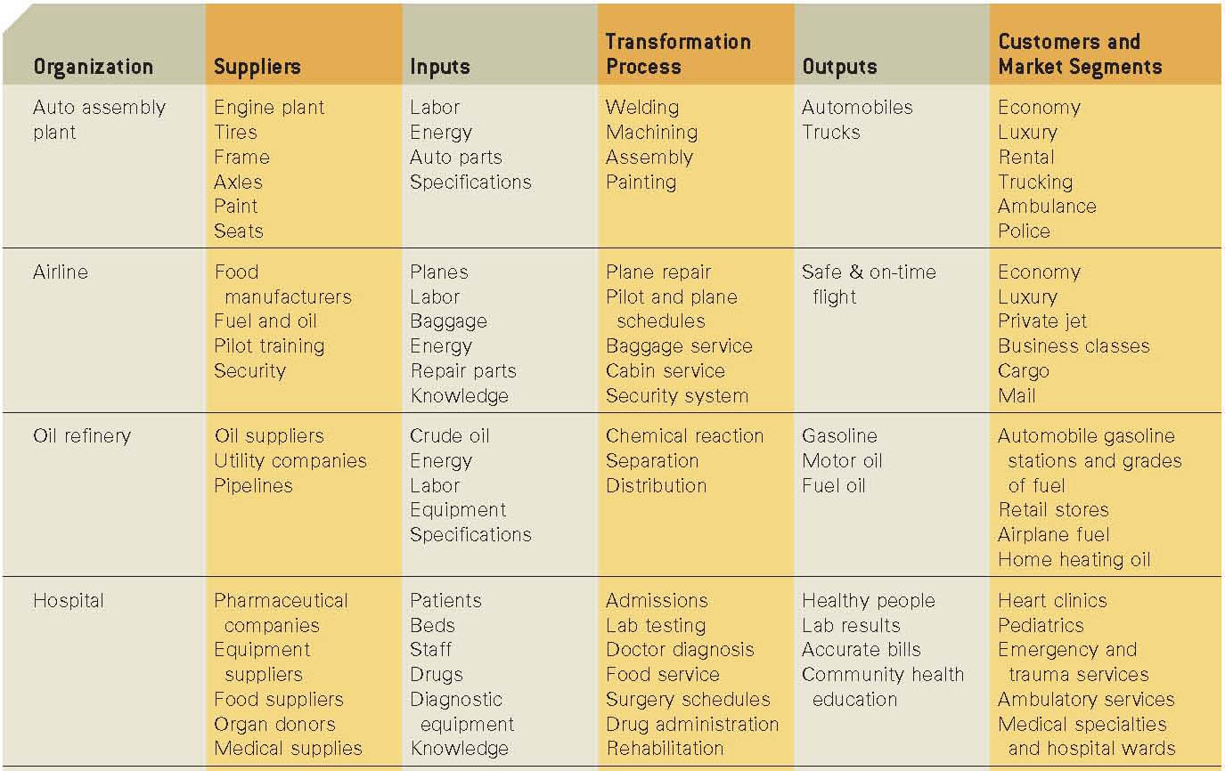

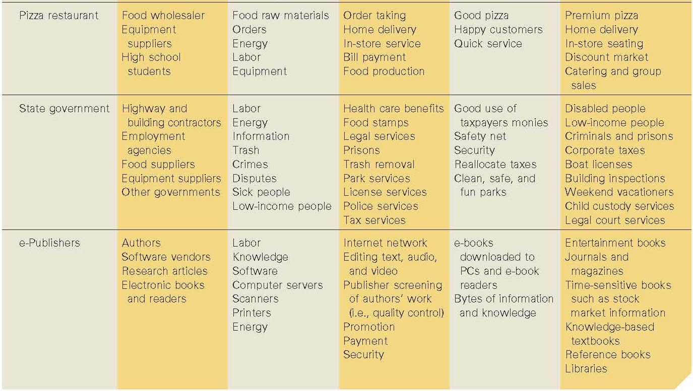

6.* Marine International manufactures an aquarium pump and is trying to decide whether to produce the filter system in-house or sign an outsourcing contract with Bayfront Manufacturing to make the filter system. Marine’s expertise is producing the pumps themselves but they are considering producing the filter systems also. To establish a filter system production area at Marine International, the fixed costs is $400,000 per year and they estimate their variable cost of production in-house at $12.25 per filter system. If Marine outsources the production of the filter system to Bayfront, Bayfront will charge Marine $30 per filter system. Should Marine International outsource the production of the filter system to Bayfront if marine sells 25,000 pumps a year?

The total cost of in-house production is $400,000 + 25,000*($12.25) = $706,250

The total cost of outsourcing is 25,000*($30) = $750,000

So the best decision is to manufacture in-house.

Using Equation 2.1 we compute

Q* = ______FC_______ = $400,000 = **22,535** filter systems

VC2 - VC1 $30 - $12.25

* If demand is greater than 22,535, then produce in-house (make)
* If demand is less than 22,535, then outsource
* For a quantity of 25,000 pumps, Marine should produce in-house. See the calculations below for confirmation.

Using the Break-Even spreadsheet template:

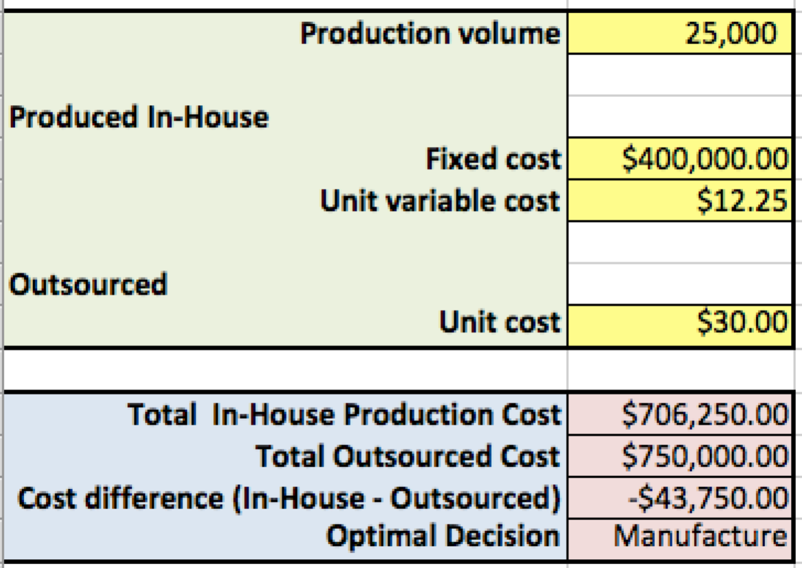

 7.* A firm is evaluating the alternative of manufacturing a part that is currently being outsourced from a supplier. The relevant information is provided below:

For in-house manufacturing:

Annual fixed cost = $100,000

Variable cost per part = $140

For purchasing from supplier:

Purchase price per part = $160

1. Using this information, find the best decision if the demand is 4,000.

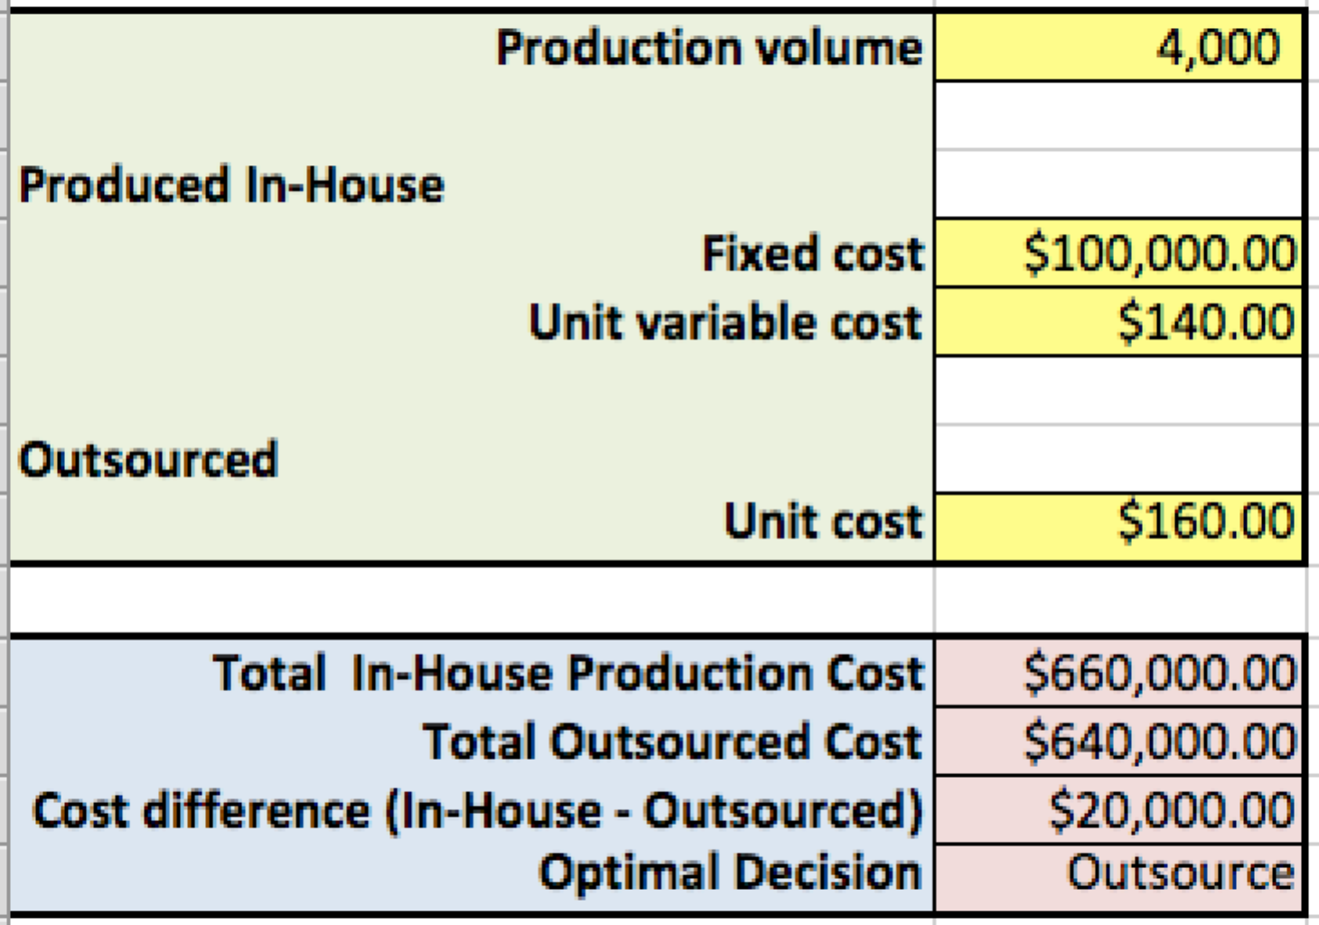

1. Determine the break-even quantity for which the firm would be indifferent between manufacturing the part in-house or outsourcing it.

Using Equation 2.1 we compute

Q* = ______FC_______ = $100,000 = **5,000 parts**

VC2 - VC1 $160 - $140

If demand is greater than 5,000, then produce in-house (manufacture)

If demand is less than or equal to 5,000, then outsource

We may also use the Break-Even spreadsheet template to identify the break-even point, either by experimentation or using Excel’s Goal Seek tool (instructors might wish to illustrate this).

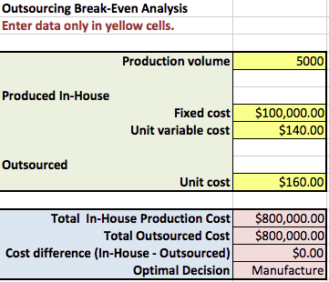

8.* Refer to the information provided in question 7 to answer the following:

a. If demand is forecast to be 5,500 parts, should the firm make the part in-house or purchase it from a supplier?

b. The marketing department forecasts that the upcoming year’s demand will be 5,500 parts. A new supplier offers to make the parts for $156 each. Should the company accept the offer?

c. What is the maximum price per part the manufacturer should be willing to pay to the supplier if the forecast is 5,500 parts, using the information in the original problem (Question #7).

1. If demand is greater than 5,000, then produce in-house (manufacture). In this case, the part should be made in-house. (It is also greater than the break-even point)

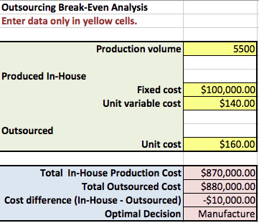

b. The marketing department forecasts that the upcoming year’s demand will be 5,500 units. A new supplier offers to make the parts for $158 each. Should the company accept the offer? If so, how much can they save?

The new break-even point is

Q* = ______FC_______ = $100,000 = **5,555.5 parts** VC2 - VC1 $158 - $140

Whenever the anticipated demand (volume) is less than Q*, the firm should outsource (purchase) the part. Since 5,500 is less than Q* the part should be outsourced to the new supplier (accept the offer). However, the savings will only be $1000.

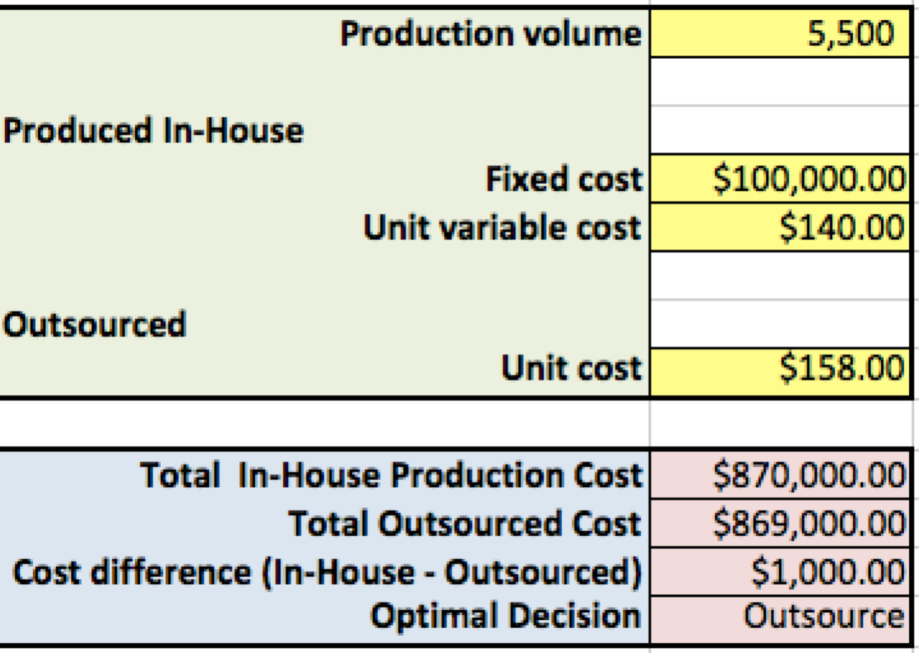

c. What is the maximum price per part the manufacturer should be willing to pay to the supplier if the forecast is 5,500 parts using the information in the original problem (Question #7)?

Q(VC2 - VC1) = FC or

5,500(VC2 - $140) = $100,000

5,500VC2 - $770,000 = $100,000

5,500VC2 = $870,000

**VC2 = $158.18**

This may also be solved using the spreadsheet template and Excel’s Goal Seek tool:

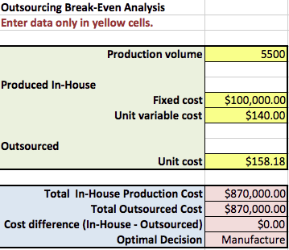

9. * A university currently has a recycling program for paper waste. The fixed cost of running this program is $10,000 per year. The variable cost for picking up and disposing of each ton of recyclable paper is $40. If the work is outsourced to a recycling company, the cost would be $65 per ton.

1. If the forecasted demand is 275 tons, what should the university do?

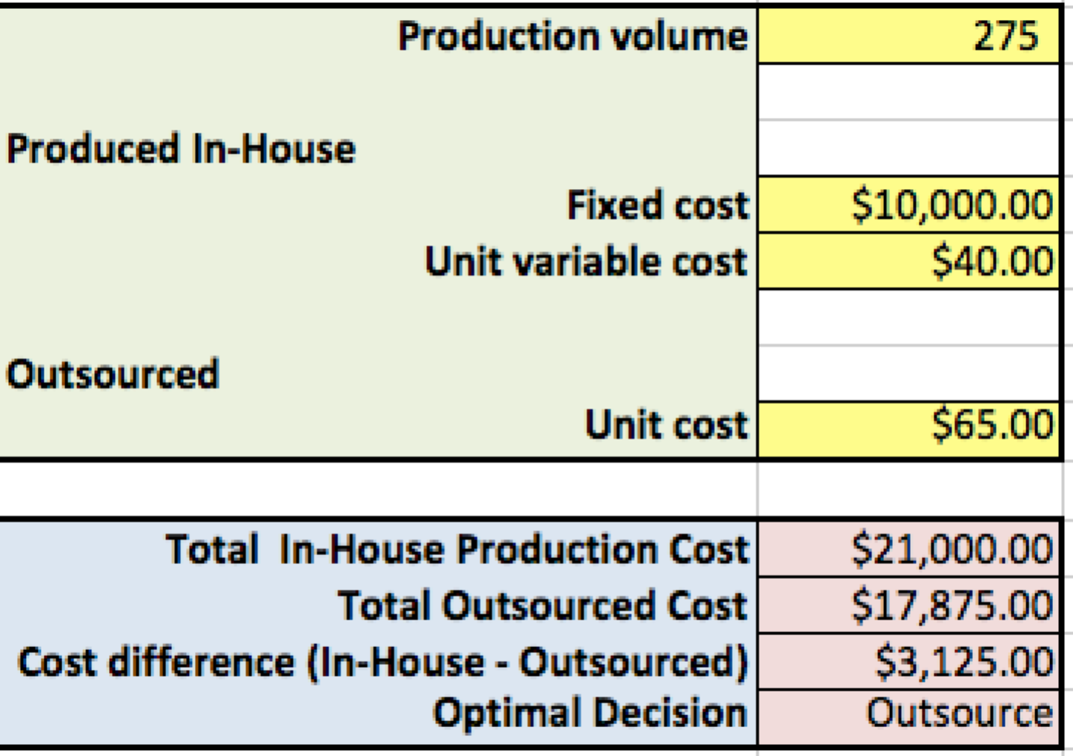

b. Find the break-even point.

Using Equation 2.1 we compute

Q* = ______FC_______ = $10,000 = **400 tons**

VC2 - VC1 $65- $40

If demand is larger than 266.67 tons, recycle in-house; if demand is less than 266.67 tons, then outsource. We may also use the Break-Even spreadsheet template with Excel’s Goal Seek tool to identify the break-even point.

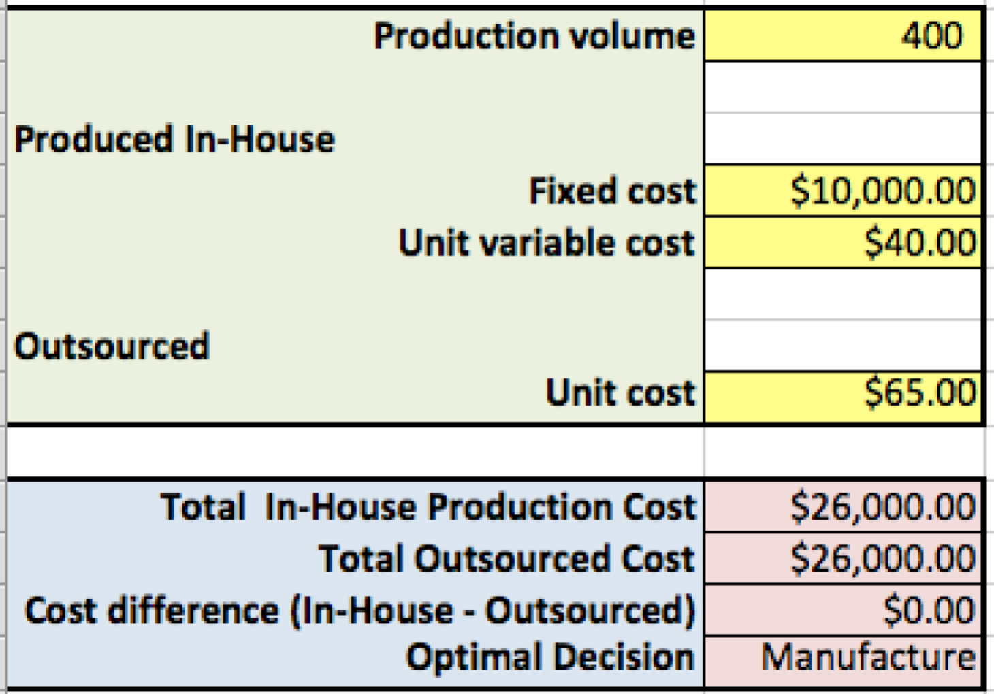

10. Research and find a value chain integrator in a goods or service focused value chain and write a short paper (maximum of two typed pages) on how it does its job within the supply chain. What value does the integrator bring to the supply chain and its suppliers and customers?

Excel Logistics, iTunes, Orbitz, Verizon, Priceline, are just a few value chain integrators students can write a paper on. The most significant “value chain integrator” is probably your Smartphone with hundreds of thousands of “apps” each of which does a specific task that integrates parts of a value chain and provides “convenience” to customers.

11. Summarize the key issues that managers face with global value chains in comparison with domestic value chains. What must an organization do to address these issues?

These issues are discussed in Sections 5 and 6 such as

* Global supply chains face higher levels of risk and uncertainty, requiring more inventory and day-to-day monitoring to prevent product shortages.
* Transportation is more complex in global value chains.
* The transportation infrastructure may vary considerably in foreign countries.
* Global purchasing can be a difficult process to manage when sources of supply, regional economies, and even governments change.
* International purchasing can lead to disputes and legal challenges relating to such things as price fixing and quality defects.
* Privatizing companies and property is another form of major changes in global trade and regulatory issues.
* Explain why it is important for operations managers to understand the culture and practices of the countries in which a firm does business. What are some of the political consequences if they don’t?
* Why go global?
* What are different global customer and market segments?
* Which functions need to be present in the region?
* How will you enter a region?
* Who will do the globalization work in your company?
* Is core staff willing to relocate overseas?

You can also tie in Rocky Brands, globalization, and Exhibit 2.6 into this discussion.

12. Research and find an organization that has a disaster or emergency readiness plan and write a short paper (maximum of two typed pages) on the topic. Focus your discussion on value chain operations and logistic (supply chain) capability. Cite your sources.

Nearly every organization addresses emergency readiness as a result of terrorist acts, foreign and domestic, as well as natural disasters such as hurricanes or the oil platform explosion in the Gulf of Mexico in 2010. Students should readily find updated government and corporate disaster and emergency plans. One excellent example is DynMcDermott, the company that manages the US Strategic Petroleum Reserve. Their readiness and emergency plans were put to the test when hurricane Katrina hit the New Orleans area. The key point for students is that “*value (supply) chain and process and operational capability*” is necessary to respond to such disasters.

13. Research and find a good or service with a quantifiable carbon footprint. Write a short paper (maximum of two typed pages) on the topic, and if possible, how they compute the carbon footprint. Cite your sources.

This is a challenging assignment since many organizations and governments are only recently trying to quantify carbons emissions and footprints for a good or service. Governments in Europe are probably ahead of everyone else but the gap is closing quickly. For example, go to [www.ntm.a.se](http://www.ntm.a.se) to see example initiatives (hit the English button). Wal-Mart, IBM, MIT’s Center of Transportation & Logistics, the US Department of Energy, the Environmental Protection Agency, and many state governments are also working on this topic.

14. Research and find a good or service that is biodegradable or carbon neutral. Be prepared to present your findings to the class in a short 2- to 5-minute discussion.

A Web search reveals over 10,900,000 hits for “carbon neutral”, for example, so students will have no problems researching these issues. Packaging, plastics, chemicals, and so on tend to lead this list. If you go to http://www.bizrate.com/skincare-products/biodegradable/you will find many examples. If your students search “carbon neutral” the result is about one million hits!

15. Research any topic discussed in this chapter and write a box feature similar to those in the book about what you found. Develop a creative title, cite your sources, and explain to the class what lessons can be learned from the box (maximum of two typed pages).

This is an open-ended question that allows students to write about what interests them. And if you like their example box, please send it to us! We’ll consider it for a future edition and credit both you and your students. Thanks!

**Case Teaching Notes: Bookmaster Case Study**

The objective of the case is to study bricks and mortar versus internet-based value chains for acquiring books. Students should be familiar with the issues and alternative value chain structures and policies. Book, music, apps, and video downloading have become a very controversial subject. For example, the Recording Industry Association of America (RIAA) argues that 2.6 billion music files are illegally downloaded each month and this law is needed to identify downloading culprits. Controversies abound over how to protect intellectual property when downloading music, magazines, and books.

Kindle and iPad, for example, are restructuring industries and their value chains. The e-book revolution is upon us, much like the e-music revolution of past years. For example, one New England boarding school, Cushing Academy, found that only about 0.15 percent of its library books were circulated. So, they now are eliminating printed books and use 65 Kindle ebooks in the library. “It is really to save libraries five, ten, fifteen years down the road,” noted a school library manager. “What the students are telling us is, ‘We’re not using the print books. You can keep giving them to us, but they’re just going to collect dust.’ You can search the Web for such information and stories.

**Case Questions and Brief Answers**

1. Draw the “bricks and mortar” process stages by which hard copy books are created, distributed, and sold in retail stores. How does each player in the value chain make money? (You can use the exhibits in the chapter to help you identify major stages in the value chain.)

The case begins by describing the huge number of physical and inconvenient tasks involved in a customer going to a bookstore in your vehicle to search for and buy a book. Such a process is a series of queues with many wait times and face-to-face service encounters. Not such an efficient value chain design. Next begin to draw the bricks and mortar value chain with your students.

**Suppliers**

Authors, artists, editors, marketing, paper, ink, box mfgrs

**Distributors**

Warehouses, shipping, transport

**Retail Stores**

Books, help desks, shelves, service encounters, **etc.**

**Traditional Book Bricks and Mortar Value Chain (5 stage view)**

**Customers**

Novels,

Self-Help, Textbooks, etc.

**Manufacturers**

Factories for printing books and packaging

Students can describe how the traditional value chains works. **Advantages** of this bricks and mortar value chain include *control over the artistic content and entire value chain, high prices for suppliers, distributors and retail stores; easier to catch cheaters duplicating content, and control, control and control by management*, etc.

**Disadvantages** of this value chain structure include *the difficulty finding the right book, the physical act of going to and from the store, high price for the customer in terms of price and time, slower speed of service and more waiting time, less convenient with more trips, customer-labor intensive self-service, many face-to-face service encounters with store employees,* etc. Hardcopy novels, for example, sell in a physical store for $20 to $50 while virtual bookstores charge about $4 to $10 per book or two to five times less.

2. Draw the process stages for creating and downloading an eBook today. How does each player in this electronic/digital value chain make money?

**Suppliers**

Authors, Marketing, Editors,

Art design, etc.

**Internet**

**Distributors**

Amazon, Publishers, ebooks, etc.

**Today’s Book Internet-based (Digital) Value Chain (3 stages)**

**Customers**

Novels, Textbooks, Self-Help, etc.

In such an Internet-based on-line value chain, there is little need for expensive and physical retail stores. Customers can download books in their homes, automobile, office, or when walking around the wireless neighborhood or city at their convenience. *The Internet is a disruptive technology that is dramatically reducing the costs (price) as it restructures the value chain.*

*Note: Often we just cross out the eliminated value chain bricks and mortar stages with a red marker and rewrite the Internet Distributor stage. As we mark out – we are eliminating jobs and costs in the value chain. AND point out to your students, if they don’t mention it in class discussion, that Borders filed for bankruptcy and closed hundreds of bricks and mortar stores.*

3. Compare and contrast value chain design and structure in the previous two questions from customer and management viewpoints. What are the advantages and disadvantage to each value chain design?

**Advantages of an Internet-based value chain** include (1) much lower prices for suppliers, distributors *and customers*; (2) ability to customize to meet individual tastes including selling a novel chapter by chapter (*mass customization using self-service*) and (3) referring the customer to similar content such as other romance novels (i.e., cross-selling based on buyer behavioral Web analysis), (4) much less need for packaging material, store shelves, and no physical shipping services, (5) incredibly fast download speeds and extraordinary customer convenience with no trips to a store, (6) less energy used to obtain content, (7) apps can complement the book, and (8) the nature of the service encounter has dramatically changed.

**Disadvantages of an Internet-based value chain** focus on (1) eliminating the economic incentive for artists to write books (Can e-providers protect the author’s intellectual property?), (2) jobs lost at retail stores, factories, transportation firms all along the value chain (I take a red marker and cross out stages in traditional value chain – they are gone!), (3) less chance to cross-sell and interact with the customer face-to-face, and a (4) total restructuring of the worldwide book, music and video (digital) value chain(s). Students will most likely know more about how the new Internet-based value chains work than the instructor so let them explain it to the class.

Have fun discussing this case! The students know much more about this value chain than you do so let them describe how it works, the advantages and disadvantages, etc. Ask questions such as

(1) How long does it take a customer to buy a book in a store?

(2) How long does it take you to download one book on-line?

(3) What is the percent improvement in processing time?

(4) What is the cost of a downloaded?

(5) Is there value to the convenience of downloading a book at 3 am in your own apartment?

(6) How does the nature of the service encounter change between the two value chains?

(7) Would you buy stock in a publishing company?

The answer to the last question focuses on customer to service provider in a retail store setting while today when you download a book on-line it is customer to computer/technology interaction.

4. What is the role of operations in each of these value chain designs and structures?

**What role does operations management play in this traditional bricks and mortar value chain?** Students may give examples and mention OM areas such as (1) scheduling recording sessions, delivery trucks, and retail store staff, (2) inventory management (physical assets--books), (3) project management in getting book to market, (4) forecasting demand by region by store, (5) quality management of physical goods, (6) quality of service encounters at retail stores, (7) purchasing raw materials and packaging, (8) preventive maintenance of equipment in factory, and (9) warehousing and logistics.

**What role does operations management play in an e-based value chain?** Students may give examples and mention OM areas such as (1) scheduling recording sessions and on-line and telephone customer service staff, (2) inventory management of files on a computer, (3) project management in getting digital content to market, (4) author payment processes, (5) quality management of digital downloads, (6) quality of service encounters at telephone and on-line customer contact centers, (7) capacity management for on-line servers, and number of telephone and on-line customer service center staff, (8) preventive maintenance of networks and equipment, and so on. Much OM work is now on-line and requires “information system and operations management” skills.

5. What other criteria and issues are important in critiquing these two different value chain designs?

The previous questions cover this question very well but here are some more summary thoughts you can use here or in a summary of the case. You might emphasize the nature of service encounters and sustainability here.

**(a) A disruptive technology called the Internet is redefining the value chain in this industry,**

Note: *Bloomberg Businessweek*, February 5, 2012 has a cover titled “Amazon Wants to Burn the Book Business.” The following two quotes are from this article.

***“It was a choice between publishers embracing technology and a world-class technology company embracing publishing.”***

***“Publishers are selling drinks on the Titanic.”***

**(b) Price, cost and speed reductions are dramatic hundreds and thousands of percent improvements),**

**(c) The nature of the service encounters are greatly changed (bricks and mortar stores use people to people service encounters while virtual stores use people to people (call centers) and people to technology (customer to Web orders)---from low tech and soft touch to high tech and technology touch.**

**(d) Economic, social, and environmental sustainability have been improved, and the carbon footprint along the digital supply chain is much less than the traditional bricks and mortar (physical good) supply chain,**

**(e) Value chain capability now exists to do mass customization, using self-service at the customer’s convenience,**

**(f) Operations plays a major role in the old and new value chain designs and execution with OM and IT integrated in the Internet value chain, and**

**(g) This is an example of “physical assets beginning replaced by information.” (See some advantages and disadvantages below)**

**Teaching Plan**

You can read this case in class in 5 minutes and then discuss. We teach this case early in an OM course and it works very well. Some of your students may have iPads and Kindle’s with them in the classroom!!

We put much of this on the board especially the two drawing of a five versus three stages value chain, and advantages of each. You can get prices of actual books on-line versus hardcopy to highlight prices. Some general lessons include:

(a) A disruptive technology called the Internet is redefining the value chain in this industry,

Note: *Bloomberg Businessweek*, February 5, 2012 has a cover titled “Amazon Wants to Burn the Book Business.” Everything in this article documents how the value chain is being radically restructured. Two quotes in the article are as follows:

*“It was a choice between publishers embracing technology and a world-class technology company embracing publishing.”*

*“Publishers are selling drinks on the Titanic.”*

(b) Price and cost and speed reductions are dramatic,

(c) The nature of the service encounters are greatly changed,

(d) Value chain capability now exists to do mass customization, using self-service at the customer’s convenience,

(e) operations plays a major role in the old and new value chain designs and execution with OM and IT integrated in the Internet value chain, and

(f) This is an example of “physical assets beginning replaced by information.”

This case also ties to the Chapter 5 discussion of high or low scalability so use it as an example if you teach OM2-Chapter 5 later. Today’s on-line downloading value chain is **highly scalable** (i.e., the incremental cost of one additional book download is close to zero for the on-line provider). Have fun with this case!