# Chapter 2

# Money and the Payments System

**Conceptual and Analytical Problems**

1. Describe at least three ways you could pay for your morning cup of coffee. What are the advantages and disadvantages of each? (*LO2*)

Answer: You could use money, a check, or a debit card.

Money: This is the most likely to be accepted, but it means you have to replenish your supply periodically.

Check: The least likely to be accepted, and it means you have to walk around with your checkbook. But the funds remain in your bank account for the time it takes the check to make its way through the clearing system.

Debit Card: This is very convenient, and likely to be accepted. But when the electronic signal arrives at your bank later in the day, the funds are withdrawn immediately from your account. (This is probably the cheapest option for the merchant).

1. You are the owner of a small sandwich shop. A buyer may offer one of several payment methods: cash, a check drawn on a bank, a credit card, or a debit card. Which of these is the least costly for you? Explain why the others are more expensive. (*LO2*)

Answer: Cash is the cheapest option for the merchant; no information is required about the buyer and no additional costs are imposed (though the merchant may need to guard against counterfeiting). Most merchants will ask for a government-issued photo ID in order to accept payment by check, requiring more time per transaction. Even with appropriate identification, the merchant does not know if funds are actually available in the check writer’s account. If not, the merchant will likely undergo a costly process of contacting the buyer and trying to coax the funds from the individual. A payment by credit card provides the merchant with more protection than does a check because the payment is made by the financial institution issuing the card. However, the merchant pays the card issuer a fee (usually a percentage of the transaction value) for the certainty of the payment. Finally, while a debit card electronically transfers funds from the buyer’s account to the merchant’s, this transfer is not instantaneous and the buyer is likely already gone when the merchant may discover that the buyer did not have the funds available.

1. Explain how money encourages specialization, and how specialization improves everyone’s standard of living. (*LO1*)

Answer: Without money, people have to barter to exchange goods and services. This requires a “double coincidence of wants,” which makes it difficult to specialize. In the example in the text, a plumber is buying groceries; if the grocer doesn’t need a plumbing repair, but does need the outside of his store painted, the plumber may decide to paint the store in order to pay for his groceries even though it is not what he does best. When money is used, people are free to specialize in areas in which they have a comparative advantage, increasing the production of society as a whole, and improving everyone’s standard of living.

1. *Could the dollar still function as the unit of account in a totally cashless society? (*LO2*)

Answer: Yes. Using dollars and cents to quote prices and record debts does not depend on cash being used as a means of payment. Dollars and cents may still serve as the standard measurement of value even if they are not themselves exchanged.

1. Give four examples of ACH transactions you might make. (*LO2*)

Answer:

1. You receive your paycheck as an electronic transfer from your employer’s account into your account, which may be at a bank different from your employer’s.
2. You schedule your monthly electric bill payment to be made automatically.
3. You make your payments on your credit card to your bank by scheduling the payment each month for the outstanding balance.
4. You make your monthly car payment by arranging for the amount to be deducted from your checking account on the fourth day of each month.

1. As of July 2016, 19 European Union countries have adopted the euro, while the remaining member countries have retained their own currencies. What are the advantages of a common currency for someone who is traveling through Europe? (*LO1*)

Answer: Each country has the same unit of account, making it easier for a traveler to compare prices in different countries. The traveler also saves the costs of exchanging currencies.

1. Why might each of the following commodities not serve well as money? (*LO2*)
   1. Tomatoes
   2. Bricks
   3. Cattle

Answer:

1. Tomatoes are perishable and thus would not serve as a store of value.
2. Bricks are heavy and bulky and will break easily. In addition, even though bricks break easily, they are not easily divisible into usable units.
3. Cattle are not standardized in terms of weight and other potentially important characteristics.
4. Despite the efforts of the United States Treasury and the Secret Service, someone discovers a cheap way to counterfeit $100 bills. What will be the impact of this discovery on the economy? (*LO3*)

Answer: People will be unwilling to accept $100 bills as payment and will require payment via check, credit card, debit card, or electronic transfer instead, all of which are more costly. Theoretically, inflation could result if the supply of money was increased by a large enough amount.

1. You receive a check drawn on another bank and deposit it into your checking account. Even though this is a “demand deposit” the funds are not immediately available for your use. Why? Would your answer change if the check is drawn on the account of another customer of your own bank? (*LO2*)

Answer: Funds drawn on another bank are not immediately available (i.e., “on demand”) until the funds are transferred through the check-clearing process. So, when you deposit a check drawn on another bank, you must wait until your bank obtains the funds from the other bank. However, if the check is drawn on an account at your own bank, then the funds are internally transferred from the check writer’s account into your account, so the funds may be available almost immediately.

1. Over a nine-year period in the 16th century, King Henry VIII reduced the silver content of the British pound to one-sixth its initial value. Why do you think he did so? What do you think happened to the use of pounds as a means of payment? If you held both the old and new pounds, which would you use first, and why? (*LO1*)

Answer: King Henry needed to silver to pay for wars. The use of pounds as a means of payment declined because people could not be sure how much silver each coin contained. People spent the new coins first since the old coins had a higher intrinsic value.

1. Under what circumstances might you expect barter to reemerge in an economy that has fiat money as a means of payment? (*LO2*)

Answer: You might expect an economy to revert to barter when the public loses confidence in the fiat money issued by the government, perhaps because of over-use of the printing presses.

1. You visit a tropical island that has only four goods in its economy – oranges, pineapples, coconuts and bananas. There is no money in this economy. (*LO1*)
   1. Draw a grid showing all the prices for this economy. (You should check your answer using the *n*(*n* - 1)/2 formula where *n* is the number of goods.)
   2. An islander suggests designating oranges as the means of payment and unit of account for the economy. How many prices would there be if her suggestion were followed?
   3. Do you think the change suggested in part *b* is worth implementing? Why or why not?

Answer:

1. There would be six prices in total.

|  |  |  |  |  |
| --- | --- | --- | --- | --- |
|  | *Oranges* | *Pineapples* | *Coconuts* | *Bananas* |
| *Oranges* |  |  |  |  |
| *Pineapples* | Pineapples/Oranges |  |  |  |
| *Coconuts* | Coconuts/Oranges | Coconuts/Pineapples |  |  |
| *Bananas* | Bananas/Oranges | Bananas/Pineapples | Bananas/Coconuts |  |

1. There would be three prices—pineapples/oranges, coconuts/oranges and banana/oranges.
2. In the case of this four-good economy, there is only a small gain by using oranges as a unit of account. The gains would be significantly bigger in an economy with more goods. If the islanders think the range of goods in their economy is likely to expand, then it is probably worth implementing the change. One of the drawbacks to consider would be the danger that more people would grow oranges, due to their special status, thus pushing up the prices of the other fruits in terms of oranges.
3. Consider again the tropical island described in Problem 12. Under what circumstances would you recommend the issue of a paper currency by the government of the island? What advantages might this strategy have over the use of oranges as money? (*LO1*)

Answer: The islanders must have enough confidence in their government to accept notes backed only by a government decree that have no intrinsic value themselves. The have to believe that these notes will be widely accepted by other islanders as final payment for goods and services and in settlement of debts. They must trust that the government will not print too much of the money and undermine its value.

Some advantages of the paper money over commodity money in the form of oranges include: being easier to carry, longer lasting and more divisible. Most importantly, it would be the government that would control the supply of money on the island as only the government could print new notes, while any of the islanders might decide to grow more oranges.

1. What factors should you take into account when considering using the following assets as stores of value? (LO1)
2. Gold
3. Real estate
4. Stocks
5. Government bonds

Answer:

1. The potential for the price of gold to rise, the ability to buy and sell gold easily and any costs associated with storage and security.
2. The rate at which real estate is appreciating and is likely to appreciate in the future; how easy or difficult it is to sell real estate; the housing services you could receive from holding the real estate.
3. The potential appreciation in nominal value of the stock; the historical volatility of the stock price; the volume of the stock being traded on the secondary market to gauge its liquidity.
4. The rate of return on the bonds – including any potential capital gain as well as interest payments.

When assessing an asset as a store of value, the primary things to consider are the risk and return of the asset and its liquidity.

1. *Under what circumstances might money in the form of currency be the best option as a store of value? (*LO1*)

Answer: If there were deflation in the economy, then paper currency would increase in value. When deflation occurs, overall prices in the economy are falling and so the currency you hold has more purchasing power. During periods of falling prices of goods and services, prices of assets often fall too and so currency might be an attractive option as a store of value.

1. Suppose a significant fall the price of certain stocks caused the market makers in those stocks to experience difficulties with their funding liquidity. Under what circumstances might that development lead to liquidity problems in markets for other assets? (*LO3*)

Answer: Faced with difficulties in borrowing money, the market makers in the stocks may decide to hold more cash to ensure their ability to meet clients’ demands. This, in turn, reduces loans available for other market participants potentially causing them to alter their behavior and could lead to funding liquidity problems throughout the financial system. Moreover, to fund itself, the market maker might try to sell other assets, depressing their prices and spreading the disruption.

1. *Consider an economy that only produces and consumes two goods - food and apparel. Suppose the inflation rate based on the consumer price index is higher during the year than that based on the GDP deflator. Assuming underlying tastes and preferences in the economy stay the same, what can you say about food and apparel price movements during the year? (*LO3*)

Answer: Since the two price indices yield different inflation rates with preferences remaining constant, the relative price of the two goods must have changed. In other words, the price of one of the goods must have gone up by a greater percentage than the other. For example, suppose the price of food went up by 10% while the price of apparel went up by 20%. This would induce consumers to substitute away from apparel to food. As a fixed weight index, the CPI would not take this substitution into account while the GDP deflator would, as it is calculated on the basis of what is actually purchased. Therefore, the CPI inflation rate would be higher than the rate calculated from the GDP deflator.

1. Assuming no interest is paid on checking accounts, what would you expect to see happen to the relative growth rates of M1 and M2 if interest rates rose significantly? (*LO3*)

Answer: When interest rates rise, you would expect that people would shift funds from checking accounts into savings accounts, as the opportunity cost of holding funds in a non-interest bearing account has risen. Checking accounts are a component of M1 while both checking and some savings accounts are included in M2. Therefore, any shift from checking to savings accounts would depress growth in M1 to a greater degree than growth in M2, leading to a relative increase in the M2 growth rate.

1. If money growth is related to inflation, what would you expect to happen to the inflation rates of countries that join a monetary union and adopt a common currency such as the euro? (*LO3*)

Answer: Once countries join a monetary union, they effectively share a common money supply. Given the link between money growth and inflation, you would expect the inflation rates of these countries to converge.

1. Why might one doubt that current new forms of digital money, such as Bitcoin, will replace more traditional fiat currencies? (*LO2*)

Answer: These private digital currencies currently do not fulfill the three key functions of money—means of payment, unit of account, and store of value

1. Is the challenge of making “time consistent” policy unique to fiat-based paper money? (*LO2*)

Answer: No. Even if the value of money is linked to a commodity such as gold, the government could abolish this current commitment at a point in the future such as in a time of crisis. For example, the United States exited the Gold Standard in 1933, allowing the price of gold to vary in dollar terms for the first time in a century.

**Data Exploration**

1. Find the most recent level of M2 (FRED code: M2SL) and of the U.S. population (FRED code: POP). Compute the quantity of money divided by the population. (Note that M2 is measured in billions of dollars and population is in thousands of individuals.) Do you think your answer is large? Why? *(LO1)*

Answer: In June 2016, the value of M2 was $12,811 billion. The total population was 323.9 million, resulting in M2 per capita of $39,551. This seems like a lot, but M2 includes money market mutual fund shares, money market deposit accounts, small-denomination time deposits, checking accounts, and traveler’s checks in addition to currency in the hands of the public. It also includes holdings by businesses, in addition to households.

1. Reproduce Figure 2.3 from 1960 to the present, showing the percent change from a year ago of M1 (FRED code: M1SL) and M2 (FRED code: M2SL). Comment on the pattern over the last five years. Would it matter which of the two monetary aggregates you looked at? *(LO3)*

Answer: The data plot of Figure 2.3 is:

[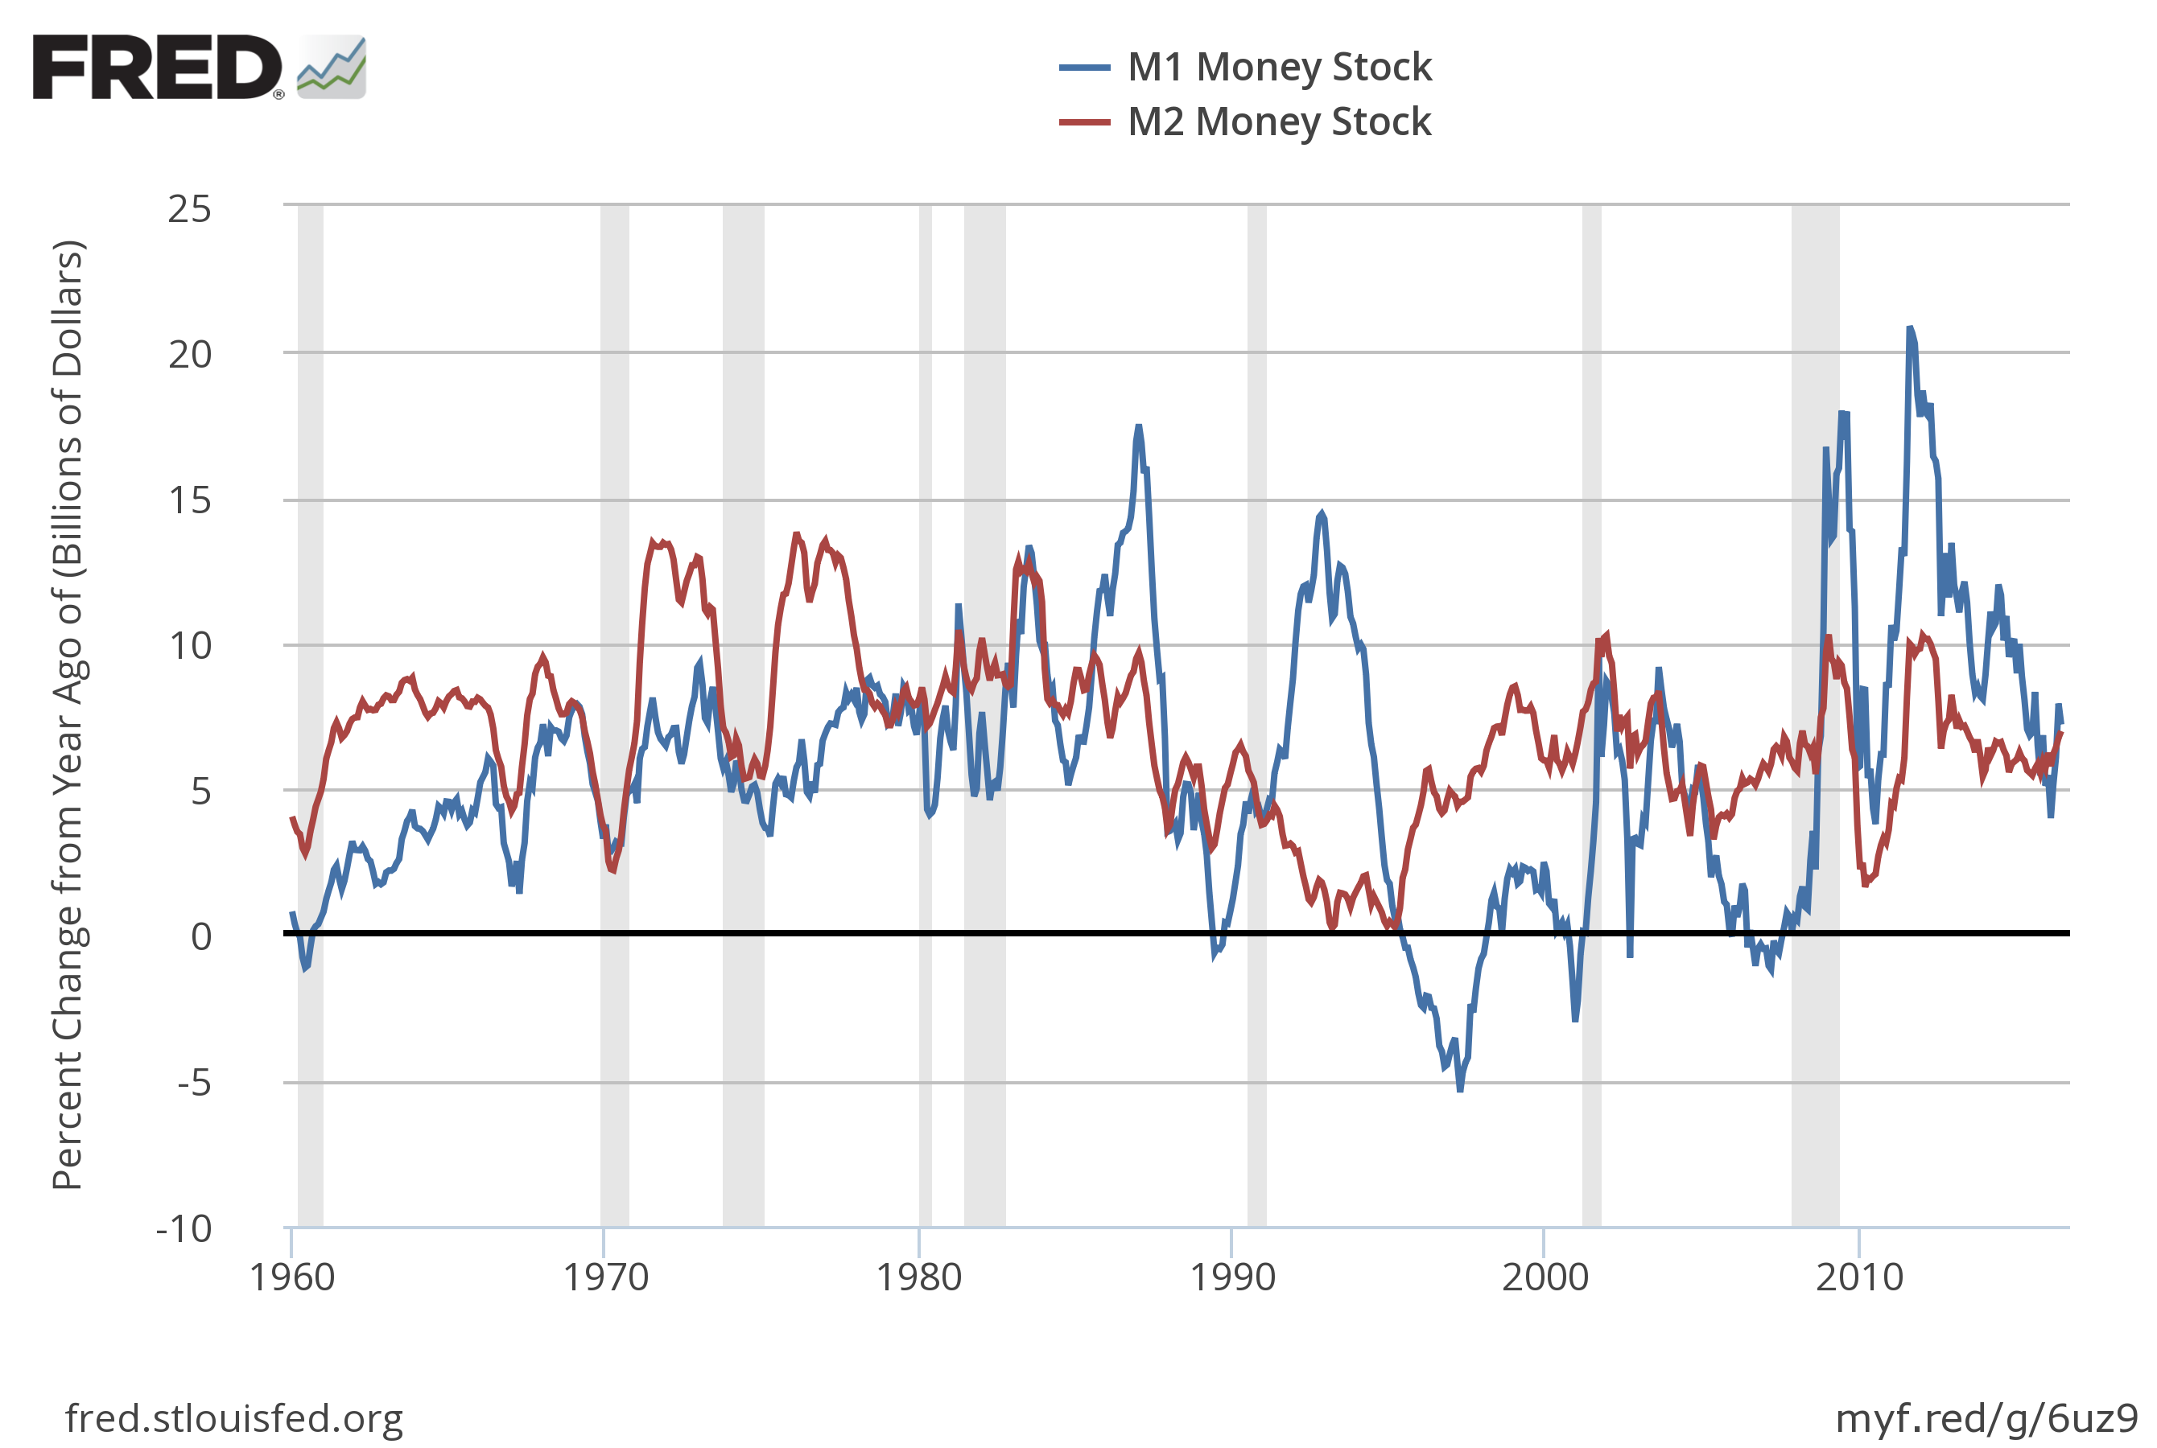](https://fred.stlouisfed.org/graph/?g=6uz8)

M1 is relatively volatile so it may be less reliable for indicating important underlying trends.

1. Which usually grows faster: M1 or M2? Produce a graph showing M2 (FRED code: M2SL) divided by M1 (FRED code: M1SL). When this ratio rises, M2 outpaces M1, and vice versa. What is the long-run pattern? Is the pattern stable?  *(LO3)*

Answer: The plot of the ratio M2/M1 appears below. Over the long run, M2 has usually grown faster than M1, but this pattern is not stable. In particular, M2 growth fell relative to M1 growth after the recession of the early 1990s and after the financial crisis of 2007-09. Later in the book, we will see that both periods were characterized by heightened caution on the part of banks.

[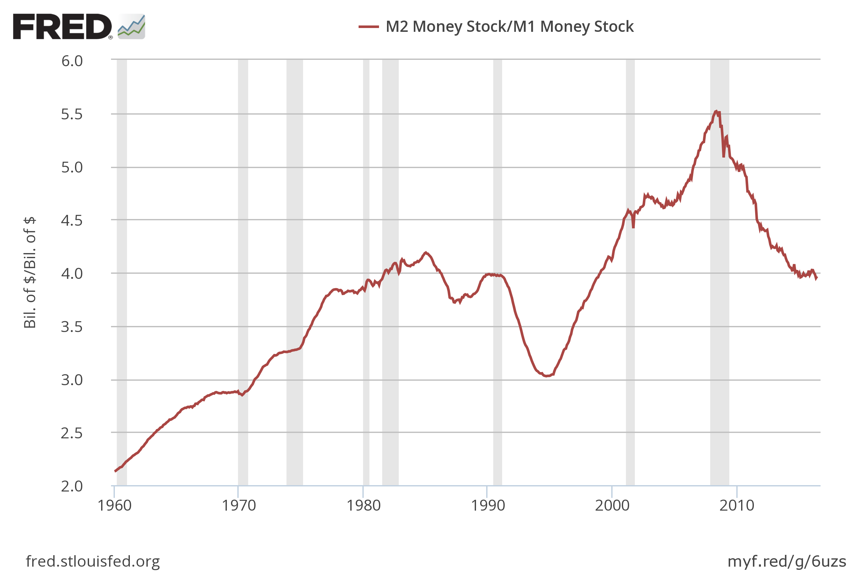](https://fred.stlouisfed.org/graph/?g=6uzr)

1. Traveler’s checks are a component of M1 and M2. Using FRED, produce a graph of this component of the monetary aggregates (FRED code: TVCKSSL). Explain the pattern you see. *(LO1)*

Answer: The indicated data plot is:

[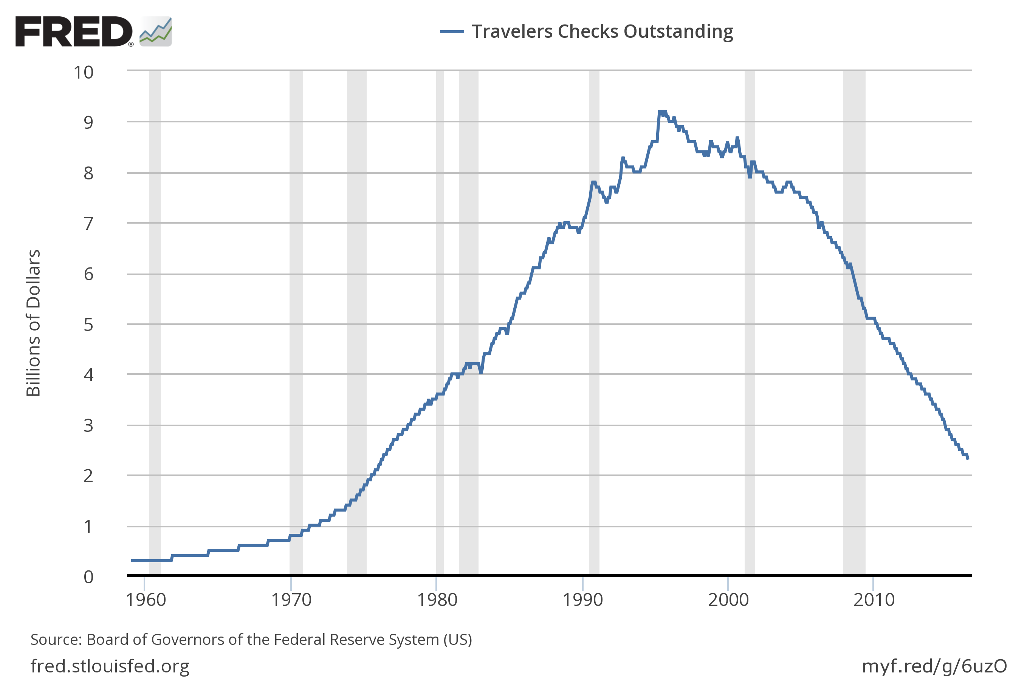](https://fred.stlouisfed.org/graph/?g=6uzN)

The use of traveler’s checks has declined since the mid-1990s. Traveler’s checks were essentially prepaid checks drawn on the account of a widely-recognized issuer. As such, they were convenient for making payments when voyaging away from the geographical area covered by your bank. Merchants in other areas who lacked familiarity with banks outside their own locations might be unwilling to accept your personal check. The rise of nationwide banking and the proliferation of credit and debit cards have reduced the demand for traveler’s checks.

1. Plot the annual inflation rate based on the percent change from a year ago of the consumer price index (FRED code: CPIAUCSL). Comment on the average and variability of inflation in the 1960s, the 1970s, and the most recent decade. *(LO3)*

Answer: The indicated data plot is:

[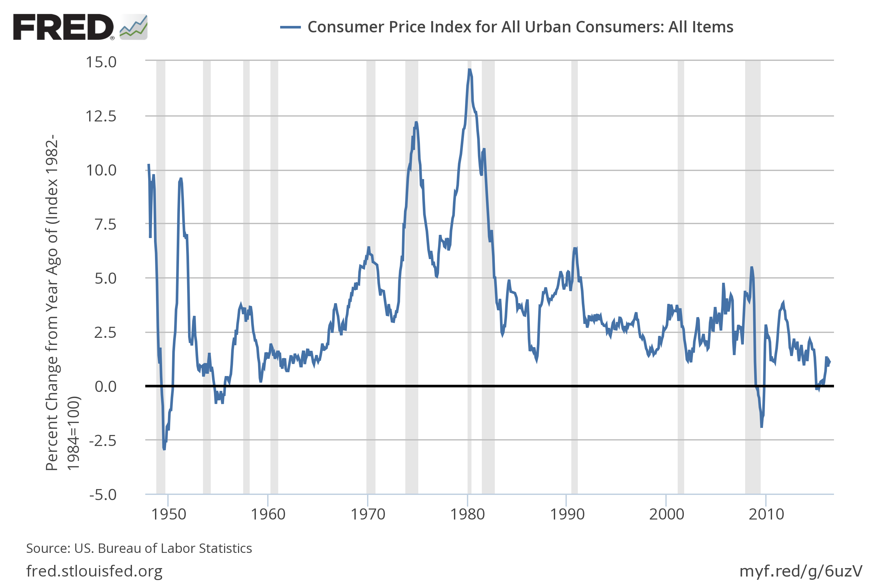](https://fred.stlouisfed.org/graph/?g=6uzU)

The variability of inflation in the 1960s was reasonably low in the first part of the decade, then rising with the trend of inflation toward the end. In the 1970s, inflation was highly variable and averaged well above the 1960s norm. Over the decade to 2016, inflation was variable mostly during the financial crisis of 2007-2009. In general, periods with low average inflation – such as the first half of the 1960s and the long interval from the mid-1980s to the financial crisis – also were periods of relatively low inflation variability.

* indicates more difficult problems