CHAPTER 2
Special Relativity
- According to Anna, if clocks at the train’s ends sent light signals when they read noon, the signals would reach Anna together somewhat after noon. According to Bob outside, the signals must start at different times, so that both reach the moving Anna together. The clocks read noon at different times according to Bob.
- She decides to turn on the lights simultaneously. According to her, light signals leave her brain together and reach her hands simultaneously, so her hands act simultaneously. According to Bob outside, the light signal heading toward her trailing hand will reach that hand first, for the hand moves toward the signal. This hand acts first. The signal heading toward her front hand has to catch up with that hand, taking more time and causing that hand to act later.
- By symmetry, if an observer in S sees the origin of frame S´ moving at speed v, an observer in S´ must see the origin of S moving at the same speed.
- (a) Slower.
(b) Later.
(c) Ground observers must see my clock running slowly, so their clock at Y must be ahead. I don’t see clocks X and Y as synchronized, so when I pass by X, the clock at Y certainly does not read zero, so even though it does run slowly according to me, it might (must) nevertheless be ahead of mine when I pass it.
- If it passes through in one frame, it must do so in all others. Moving parallel to the ground is an issue of simultaneity. If you are “on the disk,” the plate has both x- and y-components of velocity and it will not be equal distances from the ground at the same time—it will be slanted. If slanted, the disk can pass through it without collision.
- Physical laws are not the same if you are not in an inertial frame. If you are in an accelerating frame, you know it, no matter what others may be doing. Objects in your frame would appear to change velocity without cause. The physical laws are always obeyed for the observer in the inertial frame, but not for the twin who turns around. There is an asymmetry.
- No, clocks run at different rates no matter how low the relative velocity, though considerable total travel time might be required before a significant effect is noticed.
- I am inertial, so I must see this moving clock running slowly. Each time the space alien passes in front of me I will see his clock getting further and further behind. Passing observers always agree on the readings of local clocks, so he will agree that his clock is getting further and further behind—that my clock is running faster than his. He is in a frame constantly accelerating toward me, so according to him, my clock is continuously “jumping ahead,” as in the Twin Paradox.
- Sound involves a medium, and three speeds—wave, source, and observer—relative to that. Light has no medium. The only speeds are the relative velocity of the source and observer, and of course the speed of light.
- First, for a massive object, E = mc² is incomplete. If something is moving, it is E = γ_{u}mc², which would invalidate the argument. Second, some things have energy and no mass, so if any of these are generated, the energy and mass of what remains could change.
- No, for if we consider a frame in which the initial object is at rest, kinetic energy clearly increases, so mass would have to decrease.
- No, for if we consider a frame in which the final object is at rest, kinetic energy clearly decreases, so mass would have to increase.
- Yes, of course. We could consider a frame in which it is either at rest or moving, giving different values for KE. No, for mass/internal energy is the same in any frame of reference, so the change in mass is the same, and so the corresponding opposite change in kinetic energy must be the same.
- Yes, if it loses internal energy—in whatever form it may be taken away—it loses mass.
- No, the light was emitted in a frame that, relative to me, is moving away, so I see a longer wavelength (a very slight change). The observer at the front waits longer to see the light, so a greater relative velocity is involved, and thus a larger red shift. Simply turn the bus up on end and let gravity accomplish the same thing.
- No electron travels from one side of the screen to the other. Nothing that can have any information about the left-hand-side of the screen moves to the right-hand-side. The events (electrons hitting phosphors) are all planned ahead of time, and have no effect upon one another.
- γ_{v} ≥ 1. Classical mechanics applies when v << c, and γ_{v} = 1. At what speed will γ_{v} be 1.01?
= 1.01 ⇒ 0.14c
- Inserting x´ = –vt´ and x = 0 into (2-4) yields –vt´ = 0 + Bt and t´ = 0 + Dt. Dividing these equations gives –v = B/D. Inserting x´ = ct´ and x = ct into (2-4) yields ct´ = Act + Bt = At(c – v) or t´ = At(1 – v/c) and t´ = Cct + Dt = t(Cc + A). Setting these two equations equal gives A (1 – v/c) = Cc + A or C = –v/c² A.
- If I am in frame S and say that the post in S´ is shorter, then my saw will not slice off any of the post in frame S´, but the saw in frame S´ will slice off some of the post in my frame S. An observer in frame S´, where the relative speed (if not direction) is the same, would also have to say that the post in the “other frame,” frame S, is shorter. Therefore, the saw in frame S will slice off some of the post in frame S´. This is a contradiction. Thus, the posts cannot be contracted in either frame. The same argument would work if we supposed that the post in the “other frame” were elongated rather than contracted.
- Your time is longer. Δt_{you} = γ_{v} Δt_{Carl} → 60s = Δt_{Carl} ⇒ Δt_{Carl} = 52s
- L = L₀ → 35m = L₀ ⇒ L₀ = 43.75m
- Let Anna be S′, Bob S. It is simplest to let t = t′ = 0 be the time when Anna passes Earth. According to Bob, the explosion event occurs at x = 5ly, t = 2yr.
According to Anna,
x′ = γ_{v} (x − v t) = = 5.67ly,
and t′ = γ_{v} = = −3.33yr.
Negative!? How can this be? To gain some appreciation of the Lorentz transformation, let’s see how involved it is to solve the problem without it. According to Bob: The planet explodes at t = 2yr. At this time, Anna will have moved (0.8c) (2yr) = 1.6ly. Bob sees a distance between Anna and Planet Y of 3.4ly and a relative velocity between Anna and the light from the explosion of 1.8c. So the light from the explosion will reach Anna in another t = 3.4ly/1.8c = 1.89yr—at the time, according to Bob, of 2 + 1.89 = 3.889yr. The distance he now sees between Anna and Planet Y (or the center of the debris) is 5ly − (0.8c) (3.889yr) = 1.889ly. Meanwhile he will have seen less time go by on Anna’s clock: 3.889yr = 2.33yr. According to Anna: The distance Planet Y is from herself when she receives the bad news will be shorter: 1.889ly = 1.133ly. The big question: If Planet Y moves toward Anna at 0.8c, and the light from the explosion moves toward Anna at c, how long will it take for the light to get 1.133ly in front of the planet? The relative velocity between Planet Y and the light from the explosion is 0.2c, and 0.2cΔt′ = 1.133ly ⇒ Δt′ = 5.667yr. If Anna’s clock reads 2.33yr when she gets the bad news, and it took 5.667yr for the news to reach her, the explosion must have occurred at t′ = −3.33yr. The problem is a good example of two events that occur in a different order in two frames of reference. The explosion (one event) occurs before Anna and Bob cross (another event) according to Anna, but after according to Bob.
- Let Anna be S′, Bob S. The flash of the flashbulb is the event in question here. We seek Bob’s time. We know that it is 100ns ± 27ns, i.e., either 127ns or 73ns. ==x′ + 125ns. If x′ is positive (Anna’s arm is stretched out in the positive direction), then it must be 127ns.
Later. We might be tempted to use time dilation to answer this, but care is necessary. There is no doubt that the wristwatch on Anna’s hand reads 100ns when the flash goes off. But Bob will not agree that it reads zero when Anna passed him. It is set back a bit according to Bob (like the front clocks in Example 2.4). Thus, Bob sees slightly more than 100ns go by on the wristwatch. Time dilation would then give the time Bob sees go by on his own: slightly more than γ_{0.6}(100ns) = 125ns.
(b) Now knowing that t must be 127ns, we can solve for x′, the location in Anna’s frame where the flash occurs (i.e., her hand). 127×10⁻⁹s = x′ + 125×10⁻⁹s ⇒ x′ = 0.8m. (A reasonable arm length.)
- Bob, standing in the barn/S, sees a length L = L′. 10ft = ⇒ v = 0.78c.
(b) The observer stationary in the barn. Pole−vaulter Anna, S′, will never agree that the pole fits in all at once; the barn is shorter than 10ft!
(c) We seek Δt′, knowing that, according to a barn observer, the ends of the pole are at the doors simultaneously, i.e., Δt = 0, and that the distance between these events is 10ft = 3.048m. = = −1.27×10⁻⁸s.
Why negative? Since we chose x₂−x₁ as positive, it must be that the front of the pole reaching its door is Event 2, the back reaching its door Event 1. The answer shows that the front time is a smaller time; it occurs earlier, as it must. According to the pole−vaulter/S′, front leaves before back enters.
- γ_{0.8c} = =Bob sees Anna’s ship contracted to 100m/γ_{v} = 100m/ = 60m, so Bob Jr. will have to be at x = 60m.
(b) We seek t′, knowing x, x′, and t. = = −2.67 × 10⁻⁷s.
- Calling the front light Event 2, Anna frame S′, = . Since this is positive, the front time is the larger (later), so back light must go on first.
(b) 40×10⁻⁹s = → ² c²
= (v²/c²) (60m)² → (40×10⁻⁹s)² (3×10⁸m/s)²
= v²/c²
⇒ v/c = 0.196
- Bob and Bob Jr. see a 25m−long plane. L = L₀ / γ_{v} → 25m = 40m⇒= 0.781
(b) If zero on Anna’s clock is the front of her spaceplane (where Bob is), then the time at the back occurs at
x′ = −40m, as well as at x = −25m and t = 0.
=
= 1.04×10⁻⁷s.
A positive number. Sensible. Back enters after front leaves.
(c) We know that t′ = 104ns (“at this time”) and x = 0 (Bob’s location), and seek x′. x = γ_{v} (x′ + v t′) → ⇒ x′ = −24.375m. The front of her ship is the origin, so 24.375m sticks out. Note: “at this time”, observers at the back (x′ = −40m) and at x′ = −24.375m, i.e., 15.625m apart in Anna’s frame, see the ends of Bob’s hangar. This is correct: Anna should see a hangar length of L = 25m/γ_{v} = 25m = 15.625m.
- Since Bob moves to the right, let’s make his frame S′. Thus, we seek times in frame S. γ_{v} = 2 → = 2 ⇒ . The clock at the back of Anna’s ship is presently at x′ = L₀. (It is also at x = L₀.) Bob looks at this clock at t′ = 0 on his own clock. Call this Event a. With x_{a}′ = L₀, t_{a}′ = 0, we may find t_{a}, the time in Anna’s frame. = L₀. The clock at the center of Anna’s ship is at x′ = L₀ (rather than L₀) in Bob’s frame. The time on this clock, t_{b}, will therefore simply be half the previous result.
t_{b} = L₀.
- If it takes light 40ns to travel half the length of Bob’s ship, then:L₀ = (3×10⁸m/s)(40×10⁻⁹s) ⇒ L₀ = 24m.
(b) The origins are at the center. We know that the event at x′ = 12m (i.e., the front of Anna’s ship) and
t′ = −24ns occurs at t = 0.
→ ⇒ = 0.6c.
(c) γ_{0.8c} = . Logically, at the initial instant, if the front clock says −24ns, the back has to say +24ns. Now consider Anna’s origin at t = 20ns. → 20×10⁻⁹s =⇒ t′ = 16×10⁻⁹s. Agrees. Another route: If 20ns passes for Bob, he must see less time pass on the clock’s in Anna’s frame. Since γ_{v} = , he must see 80% as much time pass, and 80% of 20ns is 16ns. Similarly, Bob must see 16ns pass on all of Anna’s clocks, as diagram shows. At t = 40ns, Bob must see that 80% of 40ns, 32ns, has passed on Anna’s clocks, as shown. Finally, 80ns for Bob must show 80% of 80ns, or 64ns, pass on Anna’s clocks.
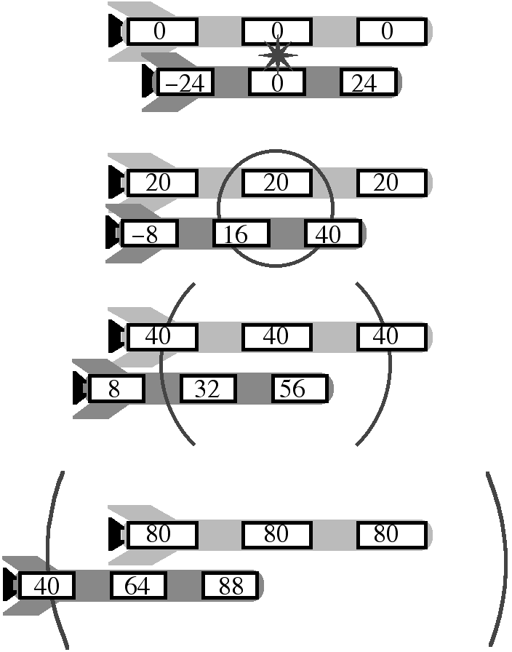
- It is tricky to use time dilation to relate readings on two different clocks moving relative to you. You would never agree that the gas station clocks were synchronized. However, gas station observers (S) watch a single clock (yours, S′) and must observe time dilation. When you get to the second station, observers there must see your clock as having registered less time than in their frame: the gas station clock must be ahead.
(b) In the frame of the gas stations, Δt = 900m/20m/s = 45s. Δt = γ_{v} Δt′ → 45s = ⇒ Δt′ = ≅ = 45s − 10⁻¹³s. Yours is behind by 10⁻¹³s. Another route: Time zero is you (S′) passing first station. What would an observer in your frame and abreast the second station at t′ = 0 (it’s a long bus) see on the second station’s clock? x = 900m, t′ = 0 ⇒ t = ? → ⇒ t = 2×10⁻¹³s. According to you, then, the second station’s clock is ahead of the first’s by 2×10⁻¹³s. Now, you do see less time pass on those clocks than on your own—10⁻¹³s less—but this will still leave the second station’s clock ahead of yours by 10⁻¹³s when you get there. Yet another route: What t′ will your clock read when you pass the second station, at x = 900m, t = 45s?
=
≅ = 45s − 2×10⁻¹³s + 1×10⁻¹³s − 2×10⁻²⁶s
≅ 45s − 1×10⁻¹³s, i.e., 10⁻¹³s behind.
- According to those on the ground, this is simple classical mechanics: a speed and distance according to a ground observer are used to find a time according to a ground observer. Let’s call the ground frame S. Δt = = 1.67×10⁻²s. There are two ways to find the time on the spaceplane—time dilation, or length contraction. Time dilation: The ground observer will see more time pass on his clock than on the plane. His is Δt, the plane’s Δt′. (Note: γ_{0.8c} = 1.67) Δt = γ_{v} Δt′ → 1.67×10⁻²s = (1.67) Δt′ ⇒ Δt′ = 0.0100s.
Length contraction: The plane observer sees a different coast−to−coast distance. He sees L = = 2.4×10⁶m. How much time will it take a 2,400m object to pass at 0.8c? Classical mechanics: Δt′ = = 0.0100s. The clock seen on the plane from the ground will be 0.0167s − 0.0100s = 0.0067s behind. But how can it be behind if the people on the plane must see time on ground clocks passing more slowly? Should they not see the ground clocks behind? Assuming the plane and ground clocks read zero as the plane started across the country, the plane clock will indeed be behind the ground clock on the other coast, just as we calculated. The people on the plane will by no means agree that the clock on the far coast was synchronized, that it read zero when the plane started across country (relative simultaneity). In fact, they will say that it was significantly ahead, so that, even though they “see” less time pass on this far−off clock, they will agree that it is ahead when they pass it.
- Passengers see a 5km-long object shrunk to L = L_{Rest}/γ_{v} == 3km. If the ends of this object are at the train’s ends simultaneously (according to observers on the train), the train must be 3km long.
(b) Look at it from the ground’s point of view, the train is not 5km long; it’s not even 3km long, but L = L_{Rest}/γ_{v} = = 1.8km. Surely the back end will pass its station before the front end passes its, so the front station is the more current information. No reason to slow down.
(c) From the ground point of view, the train travels 5km – 1.8km = 3.2km from the time the employee at the back sees his sign to the time the conductor sees his: t = dist/speed = 3.2×10³m / (0.8 × 3 × 10⁸m/s) = 13.3µs.
- According to the muons, the distance from the mountaintop to sea level is According to a muon, this distance would pass in .
And
- We may “work in either frame”. Muon’s frame: τ = 2.2μs. Distance to Earth is shorter: 4km
= 1.47km. t = = 5.27×10⁻⁶s. = e^{−(5.27/2.2)} = e^{−2.4} or 9.1%.
Earth frame: Distance to Earth is 4km. Lifetime is longer. = 5.99μs.
t = = 1.43×10⁻⁵s. = e^{−(14.3/5.99)} = e^{−2.4} or 9.1%
(b) τ = 2.2μs. t = = 1.43×10⁻⁵s. = e^{−(14.3/2.2)} = e^{−6.5} or 0.14%
- According to observers on the plane, these two events occur at the same location. Their times differ by Δt₀. ≅ = 10s − 9.8×10⁻¹²s.
The plane’s clock will read 9.8ps earlier. May also solve in plane frame, where 4.2 km is contracted.
- L = L′ → 50m − 0.1×10⁻⁹m = . Must use the approximation, since v/c is apparently small.
≅ 1 − .
50m − 0.1×10⁻⁹m =
⇒ 0.1×10⁻⁹m = (50m)
⇒ v = 2×10⁻⁶c = 600m/s.
- There are two equivalent routes. First: Anna doesn’t see a distance of 20ly, but rather a length−contracted one of 20ly/γ, and it passes in twenty years of her life, so its speed is v = = . Solving, = or = 1 − or v = c.
Second: From Bob’s perspective, Planet Y is 20ly away. But Bob, seeing Anna age twenty years, must, owing to time−dilation, see more time go by on his own clock: γ_{v} 20yr. Anna’s speed is thus v = = . Same equation.
- The plank has moved to a different frame, frame S′. The length along the x′−axis is L_{x}′ = L_{o} cos θ₀, and along the y′−axis it is L_{y}′ = L_{o} sin θ_{o}. An observer in S will see the x−leg contracted, but not the y. L_{x} = L_{x}′/γ_{v} = L_{o} cos θ_{o} and L_{y} = L_{y}′ = L_{o} sin θ_{o}. L = = But sin²θ_{o} = 1− cos²θ_{o}. L = L_{o} = L_{o} As the angle θ_{o} goes from zero to 90º, the length of the plank to an observer in S goes from L_{o} (simple length contraction) to merely L_{o} (no contraction perpendicular to axes of relative motion). Now, tan θ === tan θ_{o} = γ tan θ_{o}. As the speed increases, the angle θ seen by an observer in S increases. This makes sense in view of the fact that the faster the relative motion, the shorter the x−component of the plank will be. The y−component doesn’t change, so the angle is larger.
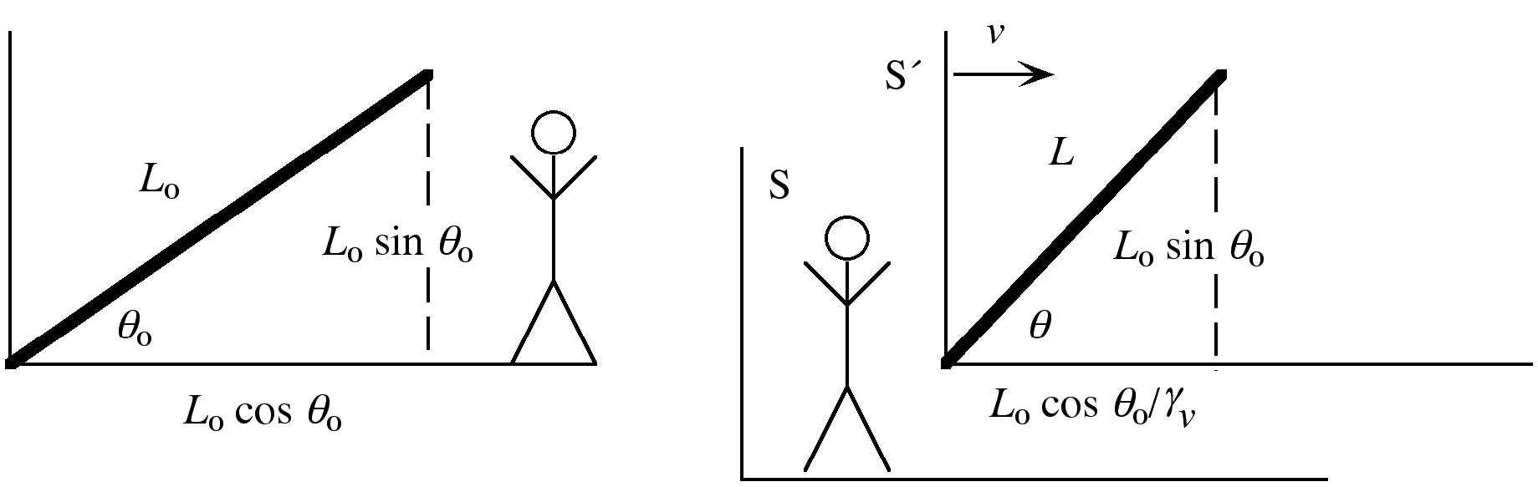
- If it can pass through according to one observer it must be able to pass through according to the other! There cannot be a collision in one frame and not in the other! It’s just a matter of when. One argument is that its dimensions perpendicular to the direction of relative motion don’t change—its height is the same in either frame, so it cannot hit. Another argument is that while Bob sees a plank and doorway at the same angle θ, Anna, at rest with respect to the plank, sees a plank at a smaller angle, θ₀. She also sees a wall moving toward her, contracted along the direction of relative motion and therefore at a larger angle than the θ seen by Bob. The top will pass through first! Let’s say that the bottom passes through at time zero on both clocks. According to Bob, the top will also (simultaneously) pass through at time zero: t = 0. It can’t according to Anna! The top passing through (an event) occurs at t = 0 and at x′ = L₀cosθ₀. Find t′. → ⇒ t′= − L₀ cosθ₀. According to Anna, in frame S′, the top passes throughL₀ cosθ₀ earlier. This adds up! We know that Anna sees a smaller angle than Bob. If it passes through at once according to Bob, the top must pass through first according to Anna. If it does not go through all at once according to Anna, it can indeed be larger than the “hole”.
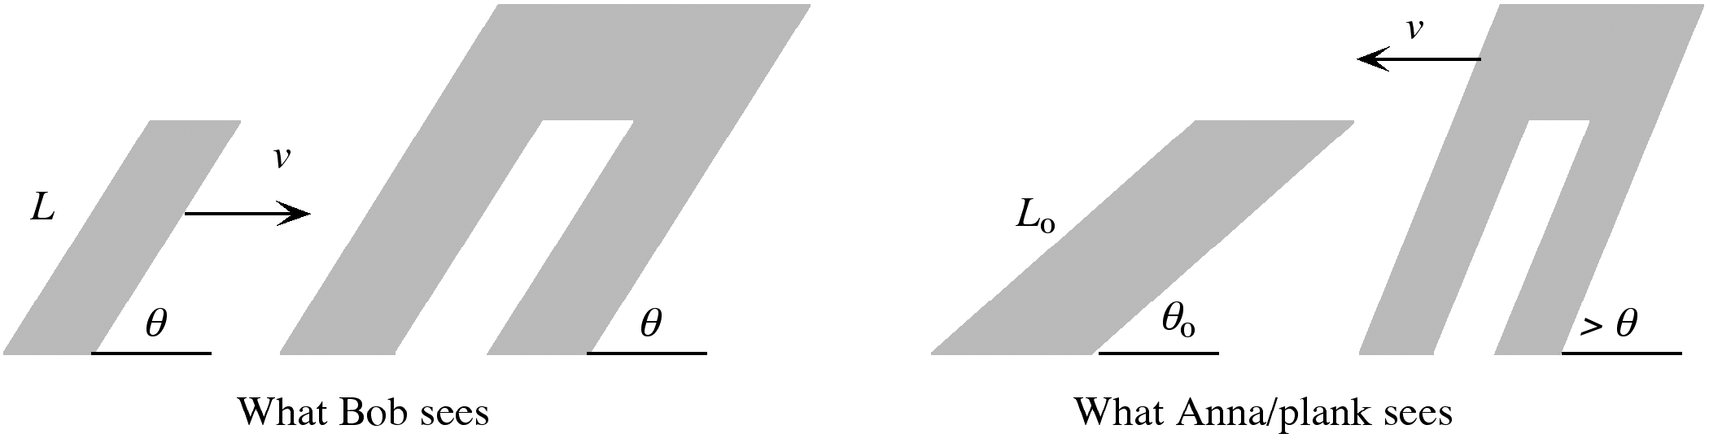
- We have a speed and time according to the lab and wish to know a distance according to that frame.
distance = (0.94 × 3×10⁸m/s)(0.032×10⁻⁶s) = 9.02m.
(b) If the experimenter sees 0.032μs pass on his own clock, he will see less pass on the clock glued to the particle.
Δt = → 0.032μs = ⇒ Δt′ = 0.011μs.
(c) Length contraction. According to the particle, the lab is = 3.08m long. Let’s see, if 3.08m of lab passes by in 0.011μs, how fast is the lab moving? = .94c. It all fits!
- According to Earth observer, muon “lives” longer.
Δt = = 2.2μs = 2.55(2.2μs) = 5.61μs.
Dist = speed × time = (0.92 × 3×10⁸m/s)(5.61×10⁻⁶s) = 1,549m.
- According to an observer in the lab, the pion survives Δt = But moving a distance of 13m at speed v, this time must also be Δt = . Thus: = → v = →
= → = 1 − ⇒ v = 2.57×10⁸m/s.
- Calling to the right positive and Anna frame S′, we know that this tick of the clock/event occurs at t = 0 and
x =  according to Bob. We seek t′. t′ = . γ_{v} = = .
Thus t′ = = − = −10⁻⁷s = −100ns.
(b) We have a distance traveled according to Bob, 30m, and a speed, and so find a time according to Bob via classical mechanics. t = = = 1.41×10⁻⁷s = 141ns.
(c) If Anna’s back clock has moved to the middle of Bob’s ship, Anna’s front clock, formerly at Bob’s middle, will now be at Bob’s front, x = 60m. Thus the locations, according to Bob, are x = 30 and x = 60m. The times are both 141ns.
For Anna’s back clock: t′ = = − +×141×10⁻⁹s = 100ns.
For Anna’s front: t′ = = − +×141×10⁻⁹s = 0.
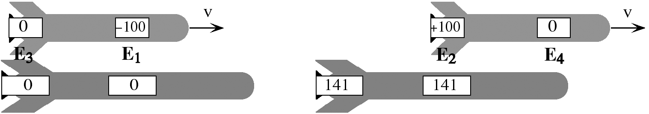
(d) In the diagrams, Event 1 shows an observer in Anna’s ship, at t′ = −100ns by her wristwatch, looking at a clock at the middle of Bob’s, which reads zero. Event 2 shows another observer in Anna’s ship, at t′ = + 100ns by her wristwatch, looking at the same clock in Bob’s, which reads 141ns. The time elapsing between these events in Anna’s frame is +100−(−100) = 200ns, but they see this single clock at a fixed location in Bob’s ship mark off only 141ns, which is less than 200ns by the usual factor: γ_{v}. That is, 200ns = × 141ns. Events 3 and 4 show observers in Anna’s frame, who are less than 60m apart (not both being at the very ends of their own ship) viewing at the same time (t′ = 0) the very ends of Bob’s ship. It is less than 60m long according to them. How much less? According to Bob, the two clocks on Anna’s ship are 30m apart, but this is a length−contracted observation, so they must be more than 30m apart in their own frame: × 30m = 42.4m. As noted, this is how long Bob’s ship appears from Anna’s frame. This fits! Anna should see the length of Bob’s ship as = = × 30m = 42.4m.
- When v  c, γ_{v} approaches 1, so equations (2-12) become x´ = x − vt and t´ = t − x, while equations (2-13) become x = x´ + vt´ and t = t´ + x´. So long as neither x nor x´ is large, the two time equations become equivalent, t´ = t, and then the two position equations are also equivalent, x´ = x – vt. These are equations (2-1). If, however, we are talking about events at such large x that x is not negligible, then the correspondence fails.
- Bob will wait t = = 20yr for Anna to get there and 20yr for her to return. Bob ages 40yr. Bob, always in an inertial frame, will observe Anna’s aging slowly the whole way.
= = 32yr.
Anna “sees” Bob age slower than herself on the way out and on the way back, but “sees” Bob age horribly during the interval in which she accelerates. We need not calculate from Anna’s perspective. Both must agree on their respective ages when they reunite. Bob is 20 + 40 = 60yr. Anna is 20 + 32 = 52yr.
- A distance of 30ly is traveled at 0.9c.
Time in Bob’s frame = = = 33.3yr.
(b) Anna will see Bob age less than herself, but how much does Anna age? She sees a distance of 30ly = 13.08ly pass by her window at 0.9c.
Time in Anna’s frame = = = 14.5yr.
This is Anna’s age according to herself, reckoned via length contraction. It is also Anna’s age according to Bob, for Bob ages 33.3yr, but will determine that Anna ages less (events transpire less rapidly):
33.3yr = 14.5yr.
Anna, aging 14.5yr, will determine that Bob ages less than herself, by the same factor. 14.5yr
= 6.33yr. (c) and (d) already answered: 14.5yr. Yes, each says, correctly, that the other is younger.
- For Anna in S´, where the planets are 24ly apart, (2-12b) evaluated for two events is
= .
(b) Relative to Earth, Carl simply has a v that is the opposite of Anna’s, so in this case the time interval is
–32yr.
(c) Bob waits 50yr, so the Planet X clock (synchronized in his frame at least) reads 50yr. All observers agree that the clock on Planet X reads 50yr when they pass. According to Anna, the clock on Planet X (event 2) is 32 yr ahead of that on Earth, so she says that the Earth clock is chiming 18yr now. Carl says that the Planet X clock is 32yr behind, so the Earth clock is right now chiming 82yr.
- Calling to the right positive and Anna frame S′, we know that this tick of the clock/event occurs at t = 0 and x = −24m according to this observer in Bob’s frame. We seek t′.
t′ = and γ_{v} = = 1.25.
Thus,
t′ = = = 6×10⁻⁸s = 60ns.
(b) Before your friend steps on, Anna, at the center of her ship, is seen from Bob’s frame to be age zero. Afterward, your friend is in Anna’s frame, where the clock reads 60ns. But once in Anna’s frame, all clocks are synchronized in that frame. Specifically, the clock right at Anna’s location now also must read 60ns. Anna’s age jumps forward by 60ns.
(c) x would be +24m rather than −24m, so the new time would be −60ns and Anna’s age, starting at zero, jumps backward by 60ns.
(d) In part (b) your friend is accelerating toward Anna, and Anna’s age jumps forward. In part (c) your friend accelerates away from Anna (before the ship-changing, Anna was approaching your friend, but afterward is no longer doing so), and Anna’s age jumps backward. If you think about this with relative simultaneity in mind, it makes sense. If your two friends jump off your ship at the same time (t₁ = t₂ = 0), they cannot possibly arrive on Anna’s ship at the same time (t₁′ ≠ t₂′). They must necessarily arrive there at two different times (ages) of Anna.
- The whole idea here is that you are jumping into a new frame, and the clocks in the now moving Earth−Centaurus A frame are unsynchronized. How out of synch is the one on Centaurus A? Let us call the Earth−Centaurus A system frame S, with their separation given the symbol W. You are initially in frame S, but at the passing of the origins you instantly jump into frame S′, moving at 5m/s toward Centaurus A. We know that your time is t′ = 0, and we seek t, the time on a clock in Centaurus A at x = + W in frame S.
t′ = → 0 = , or t = W.
This being positive, the clocks in front of you will all be ahead.
= = 5.56×10⁻¹⁷s/m.
Thus, t = W× 5.56×10⁻¹⁷s/m
(a) If W = 2×10²³m then clock jumps ahead by t = 1.11×10⁷s = 128days.
(b) If W = 4.5×10⁹m then t = 250ns.
(c) Need only reverse the sign of x. Clocks will be behind by same amounts.
(d) If the traveler is moving away from Earth, then decelerates to a stop (stopping being the reverse of starting to jog away from a planet), he moves to a frame in which clocks back on Earth are immediately advanced. If he furthermore turns around and jumps to a frame moving back toward Earth, he moves to a frame in which clocks back on Earth are again immediately advanced. Acceleration toward Earth causes clocks there to advance. The effect depends not only on the speed involved, but also on the distance away; as we see, by merely jogging this way and that at ordinary speeds, we move through frames in which clocks on heavenly bodies very far away change by a great deal. Readings on local clocks, those around the solar system, don’t vary much.
- I am S´. At t´ = 0, I seek t on a clock at the 100cm mark, i.e., x = 50cm (with origin at meterstick center).
t′ = → 0 = or t = .
The clock at 0cm, or x = –50cm, would read .
(b) Changing direction would simply change the sign on each value calculated.
(c) When I turn around, the clock at the 0cm mark jumps forward by , as I accelerate toward it, just as Bob’s clock on Earth jumps forward as Anna accelerates toward it.
- Toward is θ = 180º, cosθ = − 1. f_{obs} = f_{source} = f_{source} = f_{source}
- f_{obs} = f_{source} → = ⇒ λ_{obs} = λ_{source} = λ_{source} = 4.36 λ_{source}
- If we see a shorter wavelength, a higher frequency, it must be moving toward.
= → = → = → 1.667 = ⇒ = 0.25.
(b) Away: = → = ⇒ λ_{obs} = 687nm.
(c) If θ = 90º, f_{obs} = f_{source} → = ⇒ λ_{obs} = 549nm.
A period in the observer’s frame is longer than for 532nm light, due solely to time dilation.
- Since the observed frequency is larger (wavelength smaller) than the source, the galaxy must be moving toward Earth. f_{obs} = f_{source} → = → = → = → 1.00136 = ⇒ = 0.000681. The wavelength shift is about one part in a thousand, and the speed is roughly one−thousandth that of light.
- Yes—movement partially toward must be compensating for time dilation effect.
f_{obs} = f_{source} but f_{obs} = f_{source} ⇒ 1 + (v/c) cosθ =
→ 1+ 0.8 cosθ = ⇒ θ = 120º. This fits, for the movement is partially toward.
- Toward:=→=
Away:=→=
Divide first equation by second: = ⇒ = 0.0924
Plug back in: = ⇒ λ_{source} = 592nm (Yellow.)
- When moving away, f_{obs} = f_{source}or= or λ_{obs} = λ_{source} (1 + v/c)^{1/2} (1 − v/c)^{−1/2} ≅ λ_{source} (1 +v/c)(1 +v/c) ≅ λ_{source} + λ_{source} (v/c). Moving toward would just change the sign. The total range is thus 2 λ_{source} v/c = .
(b) v_{rms} = = 3.5×10⁴m/s.
Thus,
Δλ = = 0.15nm.
- The car moving away would detect a frequency f_{obs} = f_{source} = f_{source} (1 − v/c)^{1/2}(1 + v/c)^{−1/2} ≅ f_{source}
(1−v/c) (1−v/c) ≅ f_{source} (1− v/c). It then becomes a source of this frequency, moving away from the final observer (i.e., the radar gun). The final observed frequency would be f'_{obs} = f'_{source}
=
≅ ≅ f_{source} (1−2 v/c) = 900MHz (1−2) = 900MHz − 180Hz.
The beat frequency (the difference) is 180Hz.
- The “object” here is the projectile. Let’s choose away from Earth as positive. Therefore Bob, on Earth, is frame S, while Anna (moving in the positive direction) is frame S′. We are given that the velocity is v = 0.6c between the frames, and that the object moves in the positive (away from Earth) direction at u = 0.8c relative to frame S/Bob. u′ = = = 0.385c.
(b) The relativistic velocity transformation works for light just as for a massive object. Thus, u = c, and u′ = = = c. This had better be the case! Light traveling at c in both frames is built in to the Lorentz Transformation equations, from which the velocity transformation is derived.
- The “object” here is Carl. Let’s choose Anna, on Earth, as frame S and Bob as frame S′. (Since the S′ frame by definition moves in the positive direction relative to S, we’ve chosen toward Earth as positive.) We are given that the velocity is v = 0.8c between the frames, and that the object Carl moves in the positive (toward Earth) direction at u = 0.9c relative to frame S/Anna. We seek the velocity u′ of the object/Carl relative to frame S′/Bob. u′ = = = 0.357c. Positive means toward Earth.
(b) Bob sees Carl moving at 0.357c in one direction and Earth moving at 0.8c in the other (i.e., toward Bob). These are both velocities according to Bob. They may be added using the classical expression to find a relative velocity according to Bob. 1.157c. Note: This is a velocity of Carl relative to Earth according to Bob. It is not said that an observer sees something else moving at greater than c relative to him or herself.
- (c−u′)(c−v) > 0 ⇒ c²− (u′+ v)c + u′v > 0 → c²+ u′v > (u′+ v)c → c > = u
- The lab is S; Particle 2 is S′, moving at v = + 0.99c relative to the lab; and Particle 1 is the object, which moves at u = − 0.99c through the lab. u′ = = = −0.9995c
- u_{y} =
(b) = = = 0 and = = = = c.
The light beam has no x-component, and its speed overall must be c.
- In frame S, the velocity components of the light beam are u_{x} = c cosθ and u_{y} = c sinθ. Equations (2-20) apply.
= and = .
Plugging in: =, =
= + = .
Multiplying out the numerator, c² cos²θ − 2 c v cosθ + v² + c² sin²θ − v² sin²θ = c² cos²θ − 2 c v cosθ + v² + c² (1−cos²θ ) − v² (1−cos²θ ) = − 2 c v cosθ + c² + v² cos²θ. Multiplying out the denominator, 1 − 2 (v/c) cosθ + (v²/c²) cos²θ. The numerator is c² times the denominator. Conclusion: Though the components may be different, the light beam moves at c in both frames of reference.
- u_{x} = – c cos 60° = – c/2. u_{y} = c sin 60° = = and
== =
θ´ = tan⁻¹ (–3/4) = 36.9° north of west. u´ = = c, as it must be.
(b) Would change only the sign of v. Thus, = = 0, and
= = c. Again, speed is c, but direction is along y´.
- When = is zero, it divides positive x´−components from negative ones according to an observer in S´. This occurs when u_{x} = v or u cos θ = v. But the “object” moving in frame S here is light, for which u = c. Thus c cos θ = v or θ = cos⁻¹(v/c).
(b) At v = 0, this is 90°, which makes sense. The beacon and Anna are in the same frame, and light emitted on the +x side would be on the +x side according to both. At v = c, the angle is 0°. Only the light emitted by the beacon directly along the horizontal axis would appear to Anna to be moving in the positive direction. All the rest would appear to have a negative component according to Anna.
(c) According to Anna, the beacon shines essentially all of its light in front of it, in the direction it is moving relative to Anna.
- γ_{u′} ≡ = =
=
=
= = = γ_{v}γ_{u}
- We suppress the index i for clarity. γ_{v}γ_{u} m = γ_{v}γ_{u}mu_{x} – vγ_{v}γ_{u}m. Summing this over all particles of the system would reproduce equation (2-23).
- = γ_{u}. This becomes significant when u nears c.
- p = γ_{u}mu = = 6.68×10⁻¹⁹kg⋅m/s.
(b) E = γ_{u}mc² = = 2.51×10⁻¹⁰J.
(c) KE = mc² = = 1.00×10⁻¹⁰J.
- E_{internal} = mc² = (1kg) (3×108m/s)² = 9×10¹⁶J (Huge!);
KE = (γ_{u}−1)mc² = (−1)(1kg) (3×10⁸m/s)² = 6×10¹⁶J;
E_{total} = γ_{u}mc² = E_{internal}+KE = 1.5×10¹⁷J.
- To melt ice, energy (heat) must be added. This increases the internal thermal energy, hence the mass. It takes 3.33×10⁵J/kg to change ice at 0ºC to water at 0ºC. Water is 18g/mol, so, with one mole, we have 18g. 3.33×10⁵× 0.018kg = 6×10³J. ΔE = Δm c² ⇒ Δm = = = 6.7×10⁻¹⁴kg. The mass of the ice is less, by 67pg. Not much!
- k x² = (18N/m) (0.5m)² = 2.25J. If it gains this much internal energy, its mass increases correspondingly:
ΔE_{internal} = Δm c² ⇒ Δm = (2.25J)/9×10¹⁶m²/s² = 2.5×10⁻¹⁷kg.
- 500×10³W×3,600s = 1.8×10⁹J. E = mc² → m = = 2×10⁻⁸kg or 20μg.
- p = γ_{u}mu == (1.000000003) (9.11×10⁻³¹kg) (2.4×10⁴m/s)
= 2.19×10⁻²⁶kg⋅m/s.
(b) p = γ_{u}mu =
= (1.667) (9.11×10⁻³¹kg)(2.4×10⁸m/s) = 3.64×10⁻²²kg⋅m/s.
(c) % error = × 100%
= × 100% = × 100%. In the first case, × 100%
= (0.999999997 − 1) × 100% = − 3×10⁻⁷% or 3×10⁻⁷% low.
In the second case, × 100% = (0.6 − 1) × 100% = − 40% or 40% low.
Simply put, the classical expression is good so long as γ_{u} is not significantly different from 1.
- Before: p_{total} = γ_{0.6}(16)(0.6c) + γ_{0.8}(9)(−0.8c) = (16)(0.6c) + (9)(0.8c) = 0
(b) v = 0.6c and we seek u′, given various u. u′ = .
Given u = +0.6c: u′ = = 0. Given u = −0.8c: u′ = = −0.946c.
Given u = −0.6c: u′ = = −0.882c. Given u = +0.8c: u′ = = 0.385c.
(c) Before: p_{total} = + = −26.25c.
After: p_{total} = + = −26.25c.
- Momentum can be arbitrarily large. p = γ_{u}mu = m c ⇒ γ_{u}u = c ⇒ u = c ⇒ u = c/
- (γ_{u}−1) mc² = mc² ≅ mc² = mu²
- The area that Earth presents to (and that absorbs) the incoming sunlight is simply a circle whose radius is that of Earth. area = π R_{E}² = π (6.37×10⁶m)² = 1.27×10¹⁴m². The power absorbed is thus power = area = (1.5×10³W/m²)(1.27×10¹⁴m²) = 1.91×10¹⁷W. = = = 2.1kg/s or 1.83×10⁵kg/day.
- In orbit: F = ma → = m or v² =. If r = R_{earth} (i.e., 6.37×10⁶m) then
v = = 7913m/s. The Empire State Building is of mass 365×10³ton×
8890× = 3.31×10⁸kg. Thus its KE needs to be (3.31×10⁸kg) (7913)² = 1×10¹⁶J. But 1kg converts to (1kg)(3×10⁸m/s)² = 9×10¹⁶J. More than enough.
- Intensity ≡ = ⇒ Power = Intensity × 4πR² = (1.5×10³W/m²) = 4.24×10²⁶W. So every second, 4.24×10²⁶J of energy is put out by the sun. Δm = = = 4.71×10⁹kg per second.
- If one kilogram explodes, 10⁶J is released. But how much mass must actually be converted to produce such energy?
Δm = = = 1.11×10⁻¹¹kg. = 1.11×10⁻¹¹
(b) Suppose we have one kilogram. If one part in ten−thousand is converted, = 0.0001kg is converted. How much energy is released? ΔE_{int} = Δm c² = (0.0001kg) (9×10¹⁶m²/s²) = 9×10¹²J. Explosive yield: 9×10¹²J/kg. A much greater percent is converted, so it is much more powerful.
- (γ_{u}−1)mc² = mc² ⇒ γ_{u} = 2 → = 2 ⇒ u = c /2. Fast! Internal energy is large.
- ΔKE =m_{e}c² − m_{e}c² = m_{e}c²
= = 1.65×10⁻¹⁴J
(b) = 8.56×10⁻¹⁴J
If mu² were correct, the second one would require only 67% more energy. Here we see it is more than five times as much. This is due to the steep rise in KE near c.
- ΔKE = KE_{f} = = 4.02×10⁻¹²J = 25.1MeV, requiring an accelerating potential of 25.1MV.
- First find the kinetic energy from = ; then either (1) solve for u, then find p, or (2) calculate E from KE, then use (2−28).
Let’s do (1). = → qV = (γ_{u}−1)m_{p}c² → (1.6×10⁻¹⁹C)(10⁹V)
= ⇒ u = 0.875c.
p = γ_{u} mu = = 9.05×10⁻¹⁹kg⋅m/s.
- It acquires a KE of 500MeV = 8×10⁻¹¹J. KE = (γ_{u}−1)mc² →
8×10⁻¹¹J = ⇒ u = 0.759c
(b) 4×8×10⁻¹¹J = ⇒ u = 6.21×10⁸m/s = 2.07c
(c) 4 × = ⇒ u = 0.948c
- Momentum conserved: γ_{0.6} m₀ (0.6c) = γ_{0.8} (0.66m₀)(0.8c) + γ_{u} m u
Energy conserved: γ_{0.6} m₀ c² = γ_{0.8} (0.66m₀)c² + γ_{u} m c². The physics is done; the rest is math. We wish to solve for u. Divide energy equation by c², and rearrange the equations:
(1) γ_{0.6} m₀ (0.6c) − γ_{0.8} (0.66m₀)(0.8c) = γ_{u} m u (2) γ_{0.6} m₀ − γ_{0.8} (0.66m₀) = γ_{u} m
Divide (1) by (2): u = = = − 0.867c.
It moves at 0.867c in the opposite direction. Plug back into either (1) or (2) to find m.
Using (2): γ_{0.6} m₀ − γ_{0.8} (0.66m₀) = γ_{u} m → (5/4)m₀ − (5/3)(0.66m₀) = m
⇒ m = 0.0748m₀. Much mass is lost, because there is a significant increase in kinetic energy.
- Since carbon−14 is “slow”, γ ≅ 1. P_{f} = P_{i} → m_{C} u_{C} + γ_{e} m_{e} u_{e} = 0. E_{f} = E_{i} → m_{C} c² + γ_{e} m_{e} c² = m_{B}c²
→ (13.99995) + = (14.02266) ⇒ u_{e} = 0.99971c. Plug back in to momentum equation:
(13.99995)u_{C} + = 0 ⇒ u_{C} = −1.62×10⁻³c (~ the electron’s speed).
KE_{e} = (γ − 1)mc² = = 3.3×10⁻¹²J = 20.6MeV.
KE_{C}= mu² = (13.99995u×1.66×10⁻²⁷kg/u) (1.62×10⁻³×3×10⁸m/s)² = 2.75×10⁻¹⁵J = 17.1keV
(about of KE_{e}).
- Let’s use m₀ for an “atomic mass unit”, rather than u (for obvious reasons).
Momentum: γ_{0.8} (3m₀) (+0.8c) + γ_{0.6} (4m₀)(−0.6c) = γ₀ (6m₀)(0) + γ_{u} m u → 1m₀ c = γ_{u} m u
Energy: γ_{0.8} (3m₀)c² + γ_{0.6} (4m₀)c² = +10m₀c² = γ₀ (6m₀)c² + γ_{u} mc² → +4m₀ = γ_{u} m
Divide the two: u = c/4. Plug back in: 4m₀ = γ_{0.25} m ⇒ m = 3.87u
(b) Since mass/internal energy increases, KE must decrease. The long way: KE_{final} = (γ_{0.25}−1) (3.87m₀) c² = 0.127m₀ c². KE_{initial} = (γ_{0.8}−1) (3m₀) c² + (γ_{0.6}−1) (4m₀)c² = 3m₀ c²
ΔKE = −2.87m₀⋅c². The short way: ΔKE = − Δm c² = − ((3.87+6) − (3+4))m₀ c² = −2.87m₀ c²
= −2.87u×1.66×10⁻²⁷kg/u × (3×10⁸m/s)² = − 4.29×10⁻¹⁰J
- Momentum: γ_{0.6}(10kg)(0.6c) = γ_{0.6}m₁(−0.6c) + γ_{0.8}m₂(0.8c) → 7.5kg = −0.75m₁+1.33m₂
Energy: γ_{0.6} (10kg) c² = γ_{0.6} m₁c² + γ_{0.8} m₂c² → 12.5kg = 1.25m₁ + 1.67m₂
Solve: Multiply E−equation by 0.6, then add: 15kg = 2.33 m₂ ⇒ m₂ = 6.43kg. Reinsert: m₁ = 1.43kg
(b) ΔKE = − Δmc² = − (6.43kg + 1.43kg − 10kg) (9×10¹⁶m²/c²) = 1.93×10¹⁷J
- Momentum: γ_{0.8} m₁(0.8c) + γ_{0.6} m₂ (−0.6c) = 0 ⇒ 1.33 m₁ = 0.75 m₂ ⇒ m₂ = 1.78 m₁
(b) Energy: γ_{0.8} m₁c² + γ_{0.6} m₂c² = γ₀ m_{f}c² → 1.67 m₁ + 1.25 m₂ = m_{f} →
1.67 m₁ + 1.25(1.78m₁) = m_{f} ⇒ m_{f} = 3.89m₁.
(c) ΔKE = − Δmc² = − (3.89m₁ − m₁ − 1.78m₁)c² = −1.11m₁c²
- (γ_{0.9}−1) m₀c² = m₀c² = 1.29m₀c²
(b) 2 × (γ_{u}−1) m₀c² = 1.29m₀c² ⇒ γ_{u} = + 1 = 1.647. = 1.647 ⇒ u = 0.795c.
(c) Experiment A: Momentum: γ_{0.9} m₀ (0.9c) = γm u_{f} . Energy: γ_{0.9} m₀c² + m₀c² = γm c²
Divide equations: u_{f} = = = 0.627c. Plug back in to momentum equation: m₀ (0.9c) = m (0.627c) ⇒ m = 2.57m₀
Experiment B: Momentum: γ_{0.795} m₀ (−0.795c) + γ_{0.795} m₀ (+0.795c) = γm u_{f} .
Energy: 2 × γ_{0.795} m₀c² = γmc². From p-equation, u_{f} = 0. E-equation becomes: 2 × γ_{0.795} m₀ = 1 m ⇒
m = 2m₀ = 3.29m₀. Though mass increases in the both completely inelastic collisions, Experiment B, the collider, with the same initial kinetic energy input, yields more mass, simply because u_{f} = 0. There is no final kinetic energy.
- Energy: γ_{u} (8.87×10⁻²⁸kg) c² = γ_{0.9} (2.49×10⁻²⁸kg)c²+ γ_{0.8} (2.49×10⁻²⁸kg)c²
= ⇒ u = 0.437c.
Momentum_{x}: γ_{0.437} (8.87)(0.437c) = γ_{0.9} (2.49)(0.9c cos θ₁) + γ_{0.8} (2.49)(0.8c cos θ₂)
Momentum_{y}: 0 = γ_{0.9} (2.49)(0.9c sin θ₁) − γ_{0.8} (2.49)(0.8c sin θ₂)
Or: 4.312 − 5.141 cos θ₁ = 3.32 cos θ₂ and 5.141 sin θ₁ = 3.32 sin θ₂. Square both:
18.591 − 44.335 cos θ₁ + 26.432 cos²θ₁ = 11.022 cos²θ₂ and 26.432 sin²θ₁ = 11.022 sin²θ₂.
Add: 18.591 − 44.335 cos θ₁ + 26.432 = 11.022 ⇒ θ₁ = 39.9º (the 0.9c π⁺)
Plug back in: 5.141 sin 39.9º = 3.32 sin θ₂ ⇒ θ₂ = 83.6º (the 0.8c π⁻)
Mass decreases, so KE must increase. As is often the case, this can be seen another way: There is a frame of reference moving with the kaon in which the process is simply a stationary object (i.e., the kaon) exploding into two parts. KE_{i} = 0, KE_{f} > 0.
- In the new frame, the initial particle moves left at 0.6c and the right-hand fragment is stationary. The left-hand fragment moves at u′ = = = −0.882c.
In the new frame, P_{initial} = γ_{0.6} m₀(–0.6c) = –1.25m₀0.6c = –0.75 m₀c
P_{final} = γ_{0.882} m (–0.882c) = –2.125 m 0.882c. Can relate m₀ and m via energy conservation, and using original frame is easiest: m₀c² = 2(1.25)mc² ⇒ m = 0.4 m₀. Plug back in: P_{final} = –2.125 (0.4 m₀) 0.882c = –0.75 m₀c
- . ΔE = 0 → or
- E = γ_{u} m c² and p = γ_{u}mu. Squaring both: E² = m² c⁴ and p² = m² u².
E² − p² c² = m² c⁴ − m² u² c² = m² c² = m² c⁴
- In the product, all terms but cancel.
(b) In multiplying out the product, any term with a fraction squared or higher order will be negligible. Thus, only the leading 1 and terms with a fraction to the first power survive. . The terms beyond the 1 define the integral of g(r) from r₁ to r₂.
(c) mg(r) = ⇒ g(r) = . So,
or. This is analogous to equation (2-29), where the satellite is the higher point r₂ and Earth is the lower point r₁. Thus, analogous to (2-30), we have or
- Although the satellite appears not to move in the sky, it is moving, and the point on Earth’s equator is also moving. For geosynchronous orbit, and T =
. Solving this for v gives v = 3.07×10³m/s. Subtracting the tangential speed of 460m/s at Earth’s surface gives a relative speed of 2.61×10³m/s. The orbit radius is given by , or r = 4.23×10⁷m/s. Now, as in the GPS example, for the speed-dependent part, and for the gravitational part, . Accounting for both (5.89 – 0.38 ≅ 5.5), . The difference in a day is (86,400s) (5.5×10⁻¹⁰)
= 4.8×10⁻⁵s = 48µs.
- Radius is of dimensions [L], mass [M], c , and G (N⋅m²/kg²)
r = Mª G^{b} c^{d} → [L] = [M]ª . Considering mass gives 0 = a − b, or a = b
Considering time gives 0 = −2b − d, or d = −2b. Considering length gives 1 = 3b + d. But since d = −2b this becomes 1 = 3b − 2b, b = 1. This in turns gives d = −2 and a = 1. Thus r = MG/c²
- KE + PE = E + = 0. The pulse’s energy cancels, leaving r = .
- Those of velocity +1m/s will be at 1m, of velocity +2m/s at 2m, of velocity −1m/s at −1m, etc.
(b) If the observer jumps to v meters from the origin, on a particle moving at v meters per second, he will find particles moving at v+1 meters per second one meter further away, and particles moving at v−1 meters per second one meter closer to the origin. But if moving at v meters per second himself, he will see relative velocities, respectively, of +1m/s and −1m/s, just as does the person at the origin.
- or
.
(b) If u₀ < c, then > 1. Thus, for to be negative means that , but, as noted, v is not allowed to exceed u₀.
(c) or
- . Divide both sides by Δt: . If the time intervals are of opposite sign, then or The speed needed to travel the Δx in time Δt is greater than c. Using the complementary Lorentz transformation equation gives or . This too implies a speed greater than c.
- As → 0, γ_{v} → 1, so the matrix in (1−15) becomes:
(b) = =.
In the limit → 0, the term xv/c can be ignored, leaving x′ = x−vt and t′ = t.
- The matrix to find (x′, t′) values from (x, t) is of the form: =
γ_{0.8c} = and × 0.8 = , so this matrix is . The space−time point is in Bob’s frame S. Thus, in Anna’s frame S′: =. The position is 5.67ly and the time −3.33yr, in agreement with Exercise 22.
Squaring, and
Subtracting, the middle terms cancel: .
But γ_{v}² = , so this becomes , and since and , equation (2-36) follows.
- p = γ_{0.8} m(0.8c) = (1kg)(0.8c) = (1kg) c = 4×10⁸kg⋅m/s. E = (1kg)c² = 1.5×10¹⁷J
The matrix to find from is of the form =
Since γ_{0.8c} = and × 0.8 = , the matrix is . Momentum−energy in S is and matrix multiplication gives for momentum−energy in S′. In its rest frame, its momentum is zero; and E′/c = (1kg)c ⇒ E′ = (1kg)c². Its energy is internal only; no KE.
- = m = γ_{u} m u_{y} = p_{y}. The z−component follows similarly.
- . If then γ_{v} ≅ 1 and E ≅ mc². Thus, becomes p_{x} – mv, essentially equation
(2-21). . In the same limit, this becomes m´c = mc, simply confirming that the mass is the same in both frames.
- p = γ_{0.8} 3m₀(0.8c) = 3m₀ (0.8c) = 4m₀c. E = 3m₀c² = 5m₀c².
(b) = =
p´ = γ_{0.5} 3m₀(0.5c) = 3m₀ (0.5c) = m₀c. E´ = 3m₀c² = 2m₀c².
=
- The frame in which the final single object is at rest is simplest, in which case the invariant is just (Mc²/c)²= M²c².
(b) In the lab frame there are two terms in the total energy. Inserting both and using the relationship suggested to eliminate P_{total}, gives = = 2(mE_{i} + m²c²). The invariant is the same no matter which frame is considered, so M²c² = 2(mE_{i} + m²c²) ⇒ M = .
(c) Momentum and energy conservation are and . If we square both sides of both we have and . If we now subtract c² times the former from the latter we have . The identify can now be used on each side, yielding , or . Noting that is E_{i}, this is the same result as before.
- = = =
= . Dividing top and bottom by dt yields
But, and 1− = and − +1 = 1 − , so
= =.
Dividing top and bottom by dt,
But , and − +1 = 1 − , so.
- γ_{0.5c} = = and γ_{v} is therefore. Thus, the matrix is.
Now multiplying,
= . The upper−left element is γ_{v}, which in this case is . = ⇒ v = 0.8c. This is as it should be: If S′′ moves at 0.5c relative to S′, which moves at 0.5c relative to S, the velocity addition formula gives a velocity of = 0.8c for S′′ relative to S.
- In the new frame, the right-moving stream is stationary, so the distance between the charges is larger by γ_{v} and the charge density thus smaller by γ_{v}. λ_{right} = λ/γ_{v} = . This is the charge density in the rest frame of the charges in the stream. The charges in the left-moving stream move at c/3 relative to the “lab,” and the lab moves at c/3 relative to the stationary stream, so the speed of the left-moving stream relative to the stationary stream, by the relativistic velocity transformation, is = 0.6c. Relative to the stationary stream, the left-moving charges are close together, so the density is higher by γ_{0.6}.
Thus, λ_{left} = γ_{0.6}λ_{right} = = .
(b) The streams push in opposite directions on the point charge and are the same distance away, so the net electric force will depend only on the difference between the charge densities. For the magnetic force, only the left-moving stream is indeed moving, thus producing a magnetic field. The current is the charge per distance times the distance per unit time. In the new frame, the point charge is moving at speed c/3, so it experiences a magnetic force
Noting that we see that this is the same as the electric force. Because the point charge would not experience a net force in the “lab” frame, it must not experience one in the new frame. The electric and magnetic forces must be equal and opposite.
- W = = =
= = =
=
- F = = =
= = = .
(b) F =only when γ_{u} is essentially unity, at speeds much less than c.
(c) F = → (F/m) dt = → (F/m) → (F/m) t
=→→
⇒ ⇒ u = .
(d) u → c.
- t = = 3.03×10⁷s = 0.96yr.
(b) u = t → 0.99 × 3×10⁸m/s =
→ (0.99 × 3×10⁸m/s)² = (9.8m/s²)² t²
⇒ t = = 2.15×10⁸s = 6.8yr. Because when u approaches c the momentum begins to grow much more rapidly with speed than classically, force must be applied for a much greater time.
- x = = =
=
- dt′ = dt = dt = dt = .
Integrating both sides, t′ = = or t =
(b) t = sinh = 1.42×10¹⁶s = 4.5×10⁸yr.
(c) x = . But is, so x = , which, using the identity cosh²−sinh² = 1, becomes: x = .
(d) In twenty years of Anna’s life, Bob will see her travel
x = = 4.25×10²⁴m = 4.5×10⁸ly.
This is the same value as in part (b) because Bob sees Anna moving at essentially c the whole time. (Anna would be moving very close to c in just the first year alone.) Bob will see Anna move the same distance while she slows down, so the total journey is 9.0×10⁸ly. Meanwhile Bob and his descendants will have aged 9×10⁸yr.
- =
(c) See at right  (d) (0,1): Both functions are zero throughout time interval. Δτ is necessarily identical to Δt on ground.  (7,3): Speed starts large, passes through zero, then grows again. Its negative effect causesτ to trail t initially and to diminish near end. Height peaks in middle. Its positive effect contributes to τ exceeding t for a while after midpoint. Total: –2.67×10^{–17}s.  (–7,3): Speed is qualitatively same as previous. Height, which goes negative, reaches minimum in middle, so lowers τ most effectively near midpoint of journey. Total: –4.09×10^{–16}s.  (20,4): Similar to (7,3) only more extreme. Total: –2.20×10^{–15}s.  (1,20): Speed starts small and has little effect, till end when it decreases τ greatly. Increasing height progressively increases τ until overwhelmed by speed factor. Total: –2.01×10^{–18}s. | 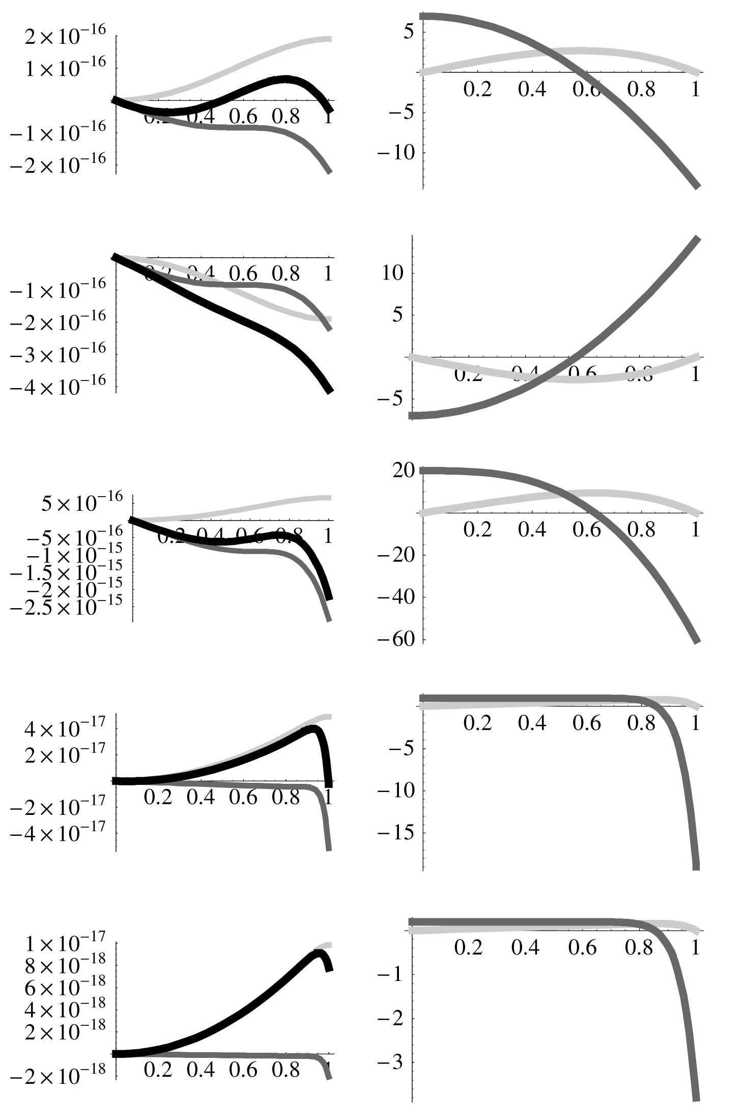
(0.2, 20): Speed factor is qualitatively similar to (1, 20), but height factor still succeeds in producing overall higher τ. Total: 7.82×10^{–18}s.
(e) k = = 4.9 and b = 2 fits the kinematic equations. Inserting these gives total time difference of
4.45×10^{–17}s. Varying either factor lowers the amount by which the proper time exceeds that on surface.

