2

Making Smart Choices

Te Law of Demand

Learning Objectives

1. Describe what determines your willingness and ability to pay for a product or service.

2. Identify why smart choices depend on marginal benefits, not total benefits, and explain what changes marginal benefits.

3. Explain the law of demand, and describe the roles of substitutes and willingness and ability to pay.

4. Explain the difference between a change in quantity demanded and a change in demand, and identify five factors that

change demand.

Lecture Narrative

Tis chapter explains demand as a response to two questions: “How badly do you want it?” and “How much are you willing and able to give up for it?” Demands are smart choices when expected benefits are greater than costs, and I emphasize the importance of marginal benefit (Key 2). I develop quantity demanded and the law of demand from examples of choices among substitutes, focusing on what happens to buying decisions when prices change. To help students understand the importance of marginal benefit for smart choices, I illustrate the two ways to read a demand curve. Reading from price to quantity (over and down), highlights the effects of substitution. Reading from quantity to marginal benefit (up and over), highlights willingness and ability to pay at the margin.

Te final section on the five factors that change demand (including substitutes, complements, and normal/inferior goods)

begins with an apparent contradiction to the law of demand, when gas prices rise and the quantity of gasoline bought and sold increases. Tis motivates the distinction between a change in quantity demanded and a change in demand, which allows us to “save” the law of demand from the apparent contradiction. Because there are no further chapters on consumer choice, this chapter contains all of the intuition behind consumers’ willingness and ability to pay for products and services.

Graphs, Tables and Illustrations

|  |  |  |  |
| --- | --- | --- | --- |
| Figure | Title | G, I, T | Page |
| 2.1 | Your Demand for Beats Headphones | T | 34 |
| 2.2 | Market Demand for Water | T, G | 35 |
| 2.3 | Two Ways to Read a Demand Curve  a) Reading the Demand Curve as a Demand Curve  b) Reading the Demand Curve as a Marginal Benefit Curve | G  G | 36 |
| 2.4 | An Increase in Demand for Beats Headphones | T, G | 40 |
| 2.5 | More Consumers Increase the Market Demand for Water | T, G | 44 |
| 2.6 | Change in Quantity Demanded versus a Change in Demand  a) Change in Quantity Demanded  b) Change in Demand | G  G | 45 |
| 2.7 | Law of Demand and Changes in Demand | T | 46 |

Key:

G - Graph(s)

For titles in blue, Narrated Dynamic Graph videos are available online on each Chapter Resources page.

T - Table

*Graphs follow on the next page.*

*Narrated Dynamic Graphs are identified with a blue video button. To access them, log into the Pearson course website (pearsonmylab.com), click on Chapter Resources, and then Chapter 2.*

13 MICROECONOMICS FOR LIFE INSTRUCTOR’S MANUAL CHAPTER 2: THE LAW OF DEMAND

[www.economicsforlife.ca](http://www.economicsforlife.ca/)

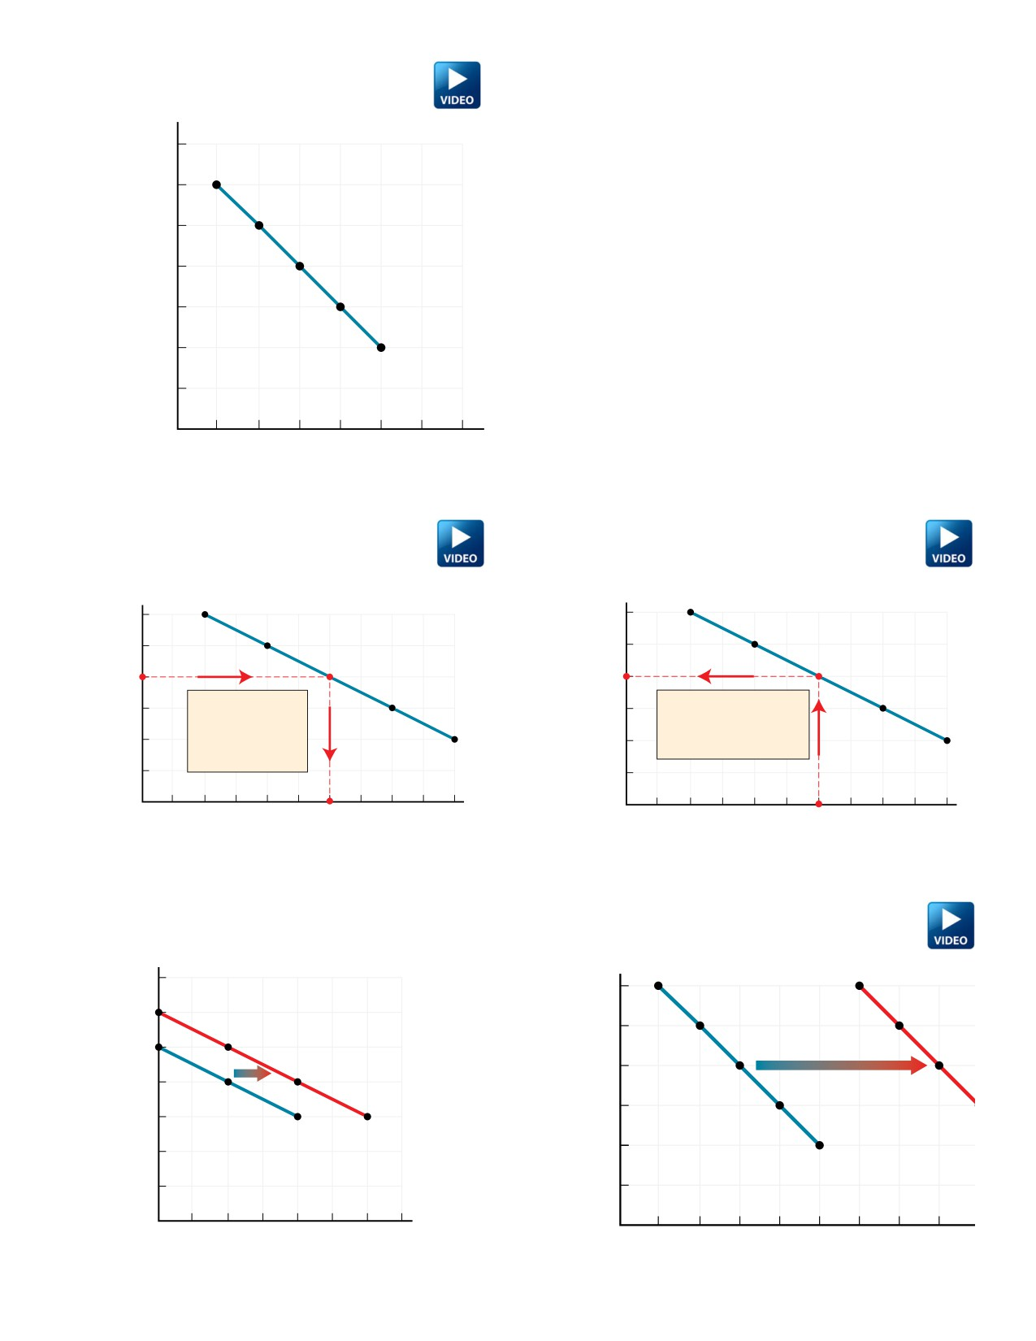

2.2 Market Demand for Water

$3.50

*E*

$3.00

*D*

$2.50

*C*

$2.00

*B*

$1.50

*A*

$1.00

Market Demand Curve   
$0.50

0 1 2 3 4 5 6

2.3a Reading the Demand Curve as a Demand Curve

*E*

7

Quantity

2.3b Reading the Demand Curve as a   
 Marginal Benefit Curve

*E*

$3.00

$2.50

$2.00

$1.50

$1.00

$0.50

0

$3.00

*D*

$2.50

*C*

$2.00

From any price on the *B*

vertical axis, go over $1.50

to the demand curve *A*

$1.00

and down to the Demand for Water

quantity demanded.

$0.50

1000 2000 3000 4000 5000 0

Quantity

*D*

*C*

From any quantity on the *B*

horizontal axis, go up to the

marginal bene t curve and *A*

over to the price.

Marginal Benefit of Water

1000 2000 3000 4000 5000

Quantity

2.4 An Increase in Demand for Beats Headphones

$300

$200

*D*0 *D*1$100

2.5 More Consumers Increase the Market Demand

for Water

$3.00

$2.50

$2.00

$1.50

$1.00

*D*0

$0.50

0 1 2 3

Quantity

14 MICROECONOMICS FOR LIFE INSTRUCTOR’S MANUAL   
 [www.economicsforlife.ca](http://www.economicsforlife.ca/)

0 1 2 3 4 5 6 7 8 9

Q

CHAPTER 2: THE LAW OF DEMAND

Price

Price

Price

Price

Price

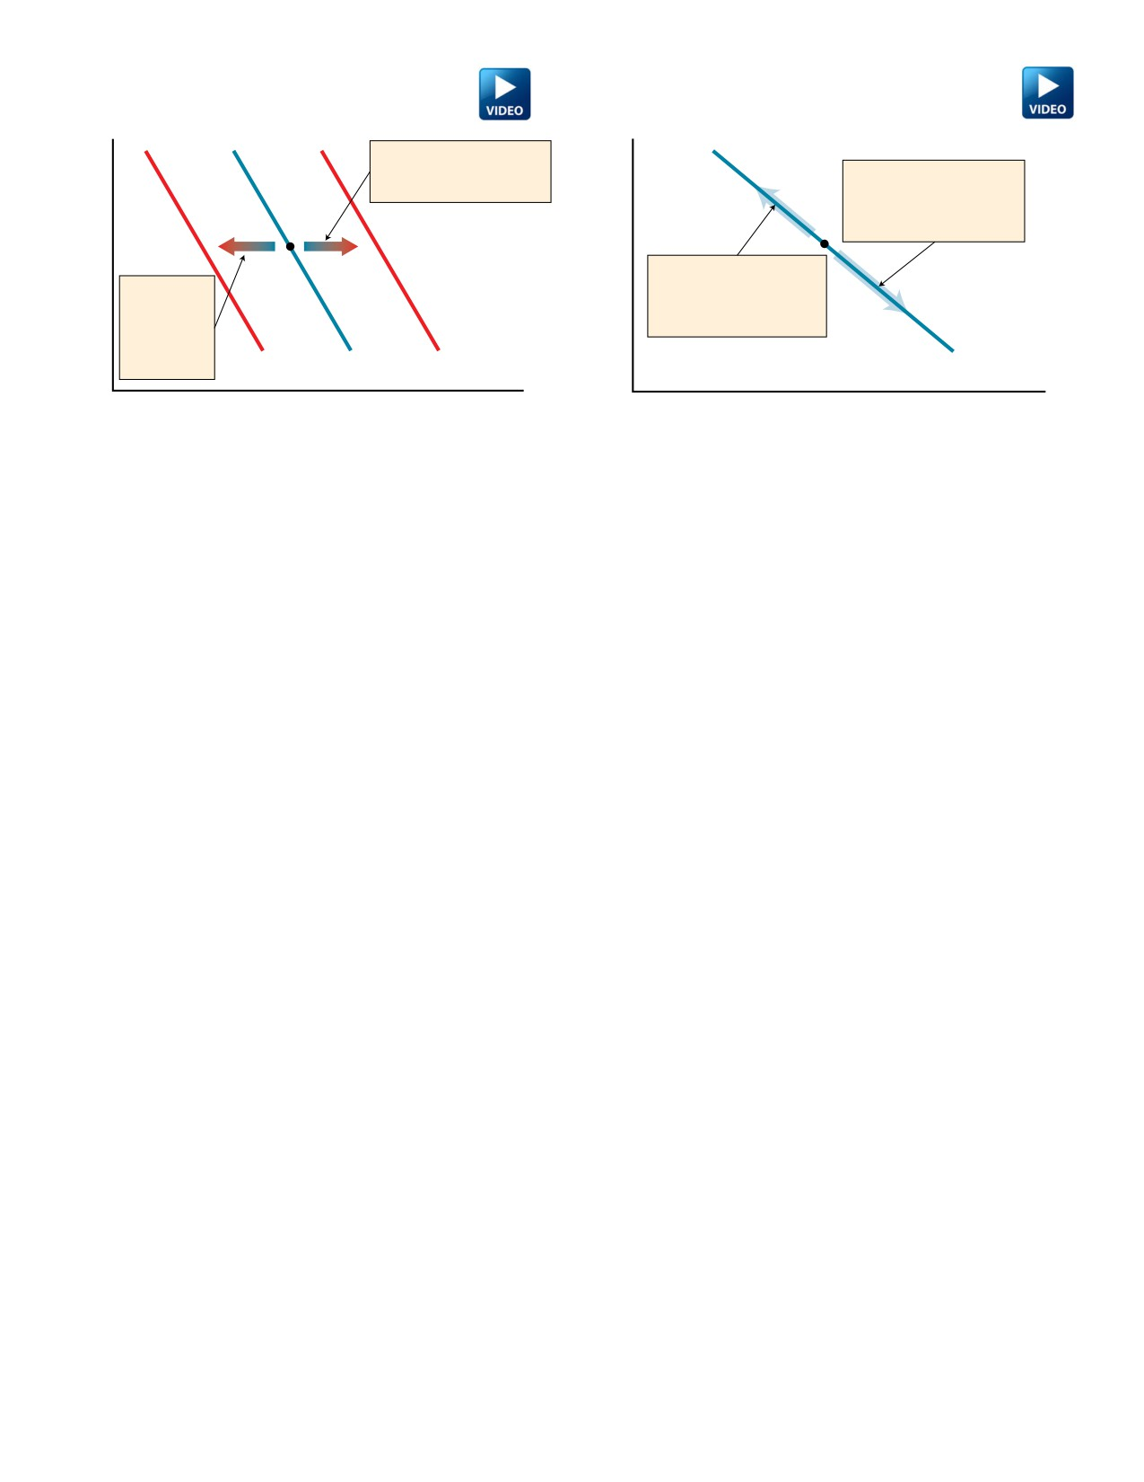

2.6a Change in Quantity Demanded

Decrease in   
demand is   
le ward shi

2.6a

Increase in demand is   
rightward shi of demand   
curve.

Change in Demand

Increase in quantity   
demanded is a movement down along an unchanged demand curve.

Decrease in quantity   
demanded is a movement up along an unchanged demand curve.

of demand

curve.

*D*2 *D*0 *D*1 *D*0

Quantity Quantity

Active Learning Suggestions

Top Choice Te best way to introduce the law of demand is to hold a real auction in class. I bring something students like (a Coke on a

Pepsi-only campus, cookies from the bakery where my daughter works, ….) and start playing promoter, selling a wonderful (ice-cold Coke! Cookies made with real ginger!) product. Te rules are that I put prices on the board, starting at $0, and   
ask students who are willing and able to pay that price to raise their hands. Ten I count (very roughly in large classes) the number of hands and write that quantity next to the price. Te key rule is that students must have the cash (no debit or VISA) and must buy the product if they are the highest bidder. I usually start with 50 cent increments, but use my judgment about jumping to larger increments. What appears on the board is the inverse relation between price and quantity demanded. At prices get really high, this ofen turns into a “pissing contest” between a few student who want to win and come up to the front of the class to claim their prize, and the number of hands can increase at the highest prices.

Afer the fun and shouting (the more the better) subside (you should do your best imitation of a game show host), the

teaching part of the activity comes from asking students what factors went into their decisions, at each price, to raise their

hand or not. From their answers, you get all of the assumptions behind the law of demand. One important answer that always emerges is that the quantity demanded drops off dramatically as you pass the price most students think the product sells for elsewhere. Tis emphasizes the importance of substitutes for the law of demand. Even the bidding at the end that violates the law of demand allows discussion of status goods (see Refresh question 2.4.3).

Come prepared with lots of change, and let students know you are donating the money to a scholarship fund or student association at your school. I have sold a Coke for $20 and a box of 6 cookies for $50!

Dynamic Study Modules

Teaching Blog

Te online Dynamic Study Modules ([http://media.pearsoncmg.com/intl/pec/mylab/2016c/cohen2ce/micro/mmnd_html/](http://media.pearsoncmg.com/intl/pec/mylab/2016c/cohen2ce/micro/mmnd_html/dynamic_study_modules.html) dynamic_study_modules.html) are created generically for any Canadian economics text. Modules students can work through with some (not all) content related to Chapter 2:

• Te Market Forces of Supply and Demand

• Te Teory of Consumer Choice

• Te Basis of Consumer Behaviour

Check out economicsforlife.ca for new media stories, related discussion questions, and other active learning ideas. All posts are tagged by textbook chapters and topics.

15 MICROECONOMICS FOR LIFE INSTRUCTOR’S MANUAL CHAPTER 2: THE LAW OF DEMAND

[www.economicsforlife.ca](http://www.economicsforlife.ca/)

Price

Price

2.1

Put Your Money Where Your Mouth Is:

Weighing Benefits, Costs, and Substitutes

Learning Objective

Describe what determines your willingness and ability to pay for a product or service.

Main Point **Your willingness to buy a product or service depends on your ability to pay, comparative benefits and costs, and the**

**availability of substitutes.**

Key Terms

**Preferences**

your wants and their intensities

**Demand**

consumers’ willingness and ability to pay for a particular product or service

Discussion or Homework Q&A

**1. Q. What is a smart choice?**

**A.** • when making a decision consider only additional (marginal) costs and additional (marginal) benefits

• all the sunk costs are ignored

• a smart choice is very important when facing scarcity

**2. Q. If you don’t have enough money to get a product, can you still have a demand for it?**

**A.** • no

• demand is a willingness and ability to pay

• if you can’t pay, your willingness alone does not count

Refresh Q&A

**2.1.1 Q. What is the difference between wants and demands?**

A. Wants are much greater than demands. Your wants for products or services are limitless, and economists describe your

wants and their intensities as your *preferences. Demand* describes your willingness and ability to pay for a particular product

or service. You must put your money (or time) where your mouth is in order to demand a product or service.

**2.1.2 Q. What is the key factor that would make you choose to download a song for free rather than pay for it on iTunes? Explain**

**your choice.**

A. Answers will differ, but whatever the students’ personal decision between buying music and downloading music for free,

some factors that are likely to influence their choice are:

• how much they like the song (their preferences and expected benefits from listening)

• whether the song is available for free

• how much it costs to buy

• what they can afford to pay

• their values about the ethics of downloading

**2.1.3 Q. You have just started at a school that is a 30-minute drive from home or a 90-minute transit ride. What is your smart**

**choice, taking the transit or buying a car? Justify your choice.**

A. In making the choice between transit or buying a car, you should determine what the marginal benefits will be and if they

are greater than the costs.

In choosing between taking transit to school or driving, the benefits comparison includes:

• the convenience and speed of driving versus the fixed transit schedule and longer ride

• how much you value your time

• the costs of owning and driving a car versus transit fares

If you are concerned about the environment, you might also consider the environmental advantages of public transit in making your choices.

16 MICROECONOMICS FOR LIFE INSTRUCTOR’S MANUAL CHAPTER 2: THE LAW OF DEMAND

[www.economicsforlife.ca](http://www.economicsforlife.ca/)

2.2

Living on the Edge:

Smart Choices are Marginal Choices

Learning Objective

Identify why smart choices depend on marginal benefits, not total benefits, and explain what changes marginal benefits.

Main Point

Key Term

**Key 2 states, “Count only additional benefits and additional costs.” Additional benefits mean marginal benefits — not total benefits — and marginal benefits change with circumstances.**

**Marginal benefit**

the additional benefit from a choice, changing with circumstances

Discussion or Homework Q& A

**1. Q. Consider the diamond/water paradox — diamonds are very expensive but not required for life, but water, a necessity for**

**life, is relatively inexpensive. What if you are Bill Gates walking through the desert alone with pockets full of diamonds?**

**How will this affect your marginal benefits?**

**A.** Water is scarce in the desert, so its marginal benefit is very high while having pockets full of diamonds makes their marginal

benefit low. In this situation, the price of water may exceed the price of diamonds.

**2. Q. A demand curve shows visually the relationship between two variables - price and quantity demanded. Explain what it**

**means to “read” this relationship in two ways.**

**A.** Tere are correlations between the two variables. Reading two ways is to attach different causation stories to the relationship.

Te demand curve story tells for any price, what quantities consumers will demand. Te marginal benefit story tells for any

quantity, how much someone is willing to pay.

Refresh Q&A

**2.2.1 Q. In your own words, define marginal benefit.**

A. Answers may vary but should include the following concepts. *Marginal benefit* is the *additional* benefit from a choice.

Marginal benefit changes with circumstances. For example, the additional benefit you get from studying for one more hour

depends on if you have hardly studied at all (marginal benefit will then be high) or if you have studied your brains out

already (marginal benefit will then be low).

**2.2.2 Q. Explain why we are willing to pay more for a diamond than a glass of water even though water is essential for survival**

**and diamonds are an unnecessary luxury.**

A. Te difference in willingness to pay more for a diamond than a glass of water is connected to the difference between

marginal benefit and total benefit. Willingness to pay depends on marginal benefit, not total benefit. Because water is

abundant, the marginal benefit of an additional glass of water is low, even though the total benefit of all water consumed, including the first lifesaving glass, is high. Because diamonds are scarce, marginal benefit is high, even though total benefit of the few diamonds available is low.

**2.2.3 Q. You and your entrepreneurial buddy have a concession stand on the beach. It is a hot, sunny, crowded day, and you are**

**selling a few $5 collapsible umbrellas as sun shades. Te skies suddenly darken, rain begins to pour, and your buddy**

**quickly switches the umbrella price sign to $10. Will you sell more or fewer umbrellas? Explain your thinking, including**

**your analysis of the customer’s decision.**

A. Even though you raise the price of umbrellas from $5 to $10, you might still sell more umbrellas as it starts raining. Te rain

dramatically increases the marginal benefit of an umbrella to customers, so they might still be making a smart choice to

buy an umbrella, even at the $10 price. Two factors for consumers’ choices have changed — increased cost (leading to fewer   
sales) and increased benefits (leading to higher sales) — so it is hard to predict if you will sell more or fewer umbrellas.

17 MICROECONOMICS FOR LIFE INSTRUCTOR’S MANUAL CHAPTER 2: THE LAW OF DEMAND

[www.economicsforlife.ca](http://www.economicsforlife.ca/)

2.3

Move on When the Price Isn’t Right:

Te Law of Demand

Learning Objective

Explain the law of demand and describe the roles of substitutes and willingness and ability to pay.

Main Point

**Te demand curve combines two forces — switch to substitutes; willingness and ability to pay — determining quantity demanded, and can be read as a demand curve and as a marginal benefit curve.**

Key Terms

**Quantity demanded**

the amount you actually plan to buy at a given price

**Market demand**

the sum of demands of all individuals willing and able to buy a particular product or service

**Law of demand**

if the price of a product or service rises, quantity demanded decreases, other things remaining the same

**Demand curve**

shows the relationship between price and quantity demanded, other things remaining the same

Discussion or Homework Q&A

**1. Q. Advertising is designed to increase your preference for a product or service. Give an example of a slogan that changed or**

**shaped your preference.**

A. • “Tere’s always Coca-Cola” (you should keep on having colas)

• “You’ve always got time for Tim Hortons” (go out of your way but come to the doughnut shop)

• “Harveys: Have it your way” (have a customized burger every time)

**2. Q. Suppose a city is considering the idea of returning to a flat monthly rate payment scheme for water usage instead of its**

**current fee for use structure. Explain what will happen to the demand for the following products: water, orange juice, soap, rubber ducky bath toys.**

A. Water: quantity demanded will increase because price has fallen

Orange juice: demand will decrease because, water, a substitute good, is now cheaper

Soap: demand will increase because water, a complement good, is now cheaper. Longer showers! Rubber ducky bath toys: demand will increase because it is a complement good

Refresh Q&A

**2.3.1 Q. In just a couple of sentences, explain the law of demand to a friend who is not taking this economics course.**

A. Answers may differ, but should include all or most of the following:

• If the price of a product or service rises, quantity demanded decreases.

• At a higher price, fewer consumers are willing and able to pay for the product or service.

• Some consumers switch to cheaper substitutes as prices rise.

**2.3.2 Q. You own a car and work at a job that you cannot get to by public transit. If the price of gasoline goes up dramatically,**

**does the law of demand apply to you? Explain the choices you might make in responding to this price rise.**

A. As the price of gasoline goes up, your commute to work becomes more expensive. Although public transit is not available as

a substitute, there are still choices you can make to reduce the quantity demanded of gasoline. You might arrange a carpool with other employees, which would reduce the total quantity demanded of gasoline. You might also keep your car tuned up to save gas, or turn off the engine instead of idling. With more time to adjust, you might move closer to this job, find a different job that is closer to home or accessible by transit, or buy a hybrid or more fuel-efficient car. All of these choices will decrease your quantity demanded of gasoline.

*More questions follow on the next page.*

18 MICROECONOMICS FOR LIFE INSTRUCTOR’S MANUAL CHAPTER 2: THE LAW OF DEMAND

[www.economicsforlife.ca](http://www.economicsforlife.ca/)

Refresh Q&A (continued)

**2.3.3 Q. You have tickets for a concert tonight that you have been looking forward to. Your mother, who is helping you pay your**

**tuition, phones and says that it’s very important to her that you come to Grandma’s birthday party tonight. Using the law of demand, explain your decision — the concert or Grandma’s party? [Hint: Tink about opportunity cost]**

A. According to the law of demand, as the price rises, quantity demanded decreases. Te “price” of going to the concert

includes the ticket price, but also includes the opportunity cost of what you give up to attend the concert. Your mother’s request to come to Grandma’s birthday party increases the opportunity cost of going to the concert. As the concert “price” rises, your choice to go to the party decreases your quantity demanded of concert tickets from 1 to 0.

19 MICROECONOMICS FOR LIFE INSTRUCTOR’S MANUAL CHAPTER 2: THE LAW OF DEMAND

[www.economicsforlife.ca](http://www.economicsforlife.ca/)

2.4

Moving the Margins:

What Can Change Demand?

Learning Objective

Explain the difference between a change in quantity demanded and a change in demand, and identify five factors that change   
demand.

Main Point

**Quantity demanded is changed only by a change in price. Demand is changed by all other influences on consumer choice.**

Key Terms **Increase in demand**

increase in consumers’ willingness and ability to pay. Rightward shif of demand curve.

**Decrease in demand**

decrease in consumers’ willingness and ability to pay. Lefward shif of demand curve.

**Substitutes**

products or services used in place of each other to satisfy the same want

**Complements**

products or services used together to satisfy the same want

**Normal goods**

products or services you buy more of when your income increases

**Inferior goods**

products or services you buy less of when your income increases

Discussion or Homework Q&A

**1. Q. Identify the factor responsible for changing demand - i.e. preferences, prices of related goods, income, expected future**

**prices or the number of consumers - afer the following events take place:**

**a. Te impact on the demand for groceries at a local store afer a new 120-unit apartment building is built.**

**b. Te impact of downloading music on the demand for CDs.**

**c. Te impact on the demand for cars and houses in anticipation of a 1% decrease in GST.**

**d. A popular band’s last year’s album that became a bestseller can suddenly be found in a discount bin at the music**

**store for only $1.99.**

A. a. number of consumers

b. prices of related goods

c. expected future prices

d. preferences

**2. Q. Young drivers account for more than 35% of all drivers involved in fatal accidents, despite only representing 20% of all**

**licensed drivers. Explain how each of the following policies would affect the demand for alcohol:**

**a. increasing the minimum age for drinking**

**b. raising the price (e.g. through higher taxes) of alcohol**

**c. using advertising campaigns to deter alcohol usage**

A. a. decrease demand

b. decrease in quantity demanded

c. decrease demand

Refresh Q&A

**2.4.1 Q. Explain the difference between a change in quantity demanded and a change in demand. Identify the five factors that can**

**change demand.**

A. A change in the quantity demanded of a product or service is due to a change in the price of that product or service.

A change in demand for a product or service is caused by a change in anything else. Te five (“anything else”) factors that can change market demand are changes in preferences, prices of related products, income, expected future prices, and number of consumers.

20 MICROECONOMICS FOR LIFE INSTRUCTOR’S MANUAL CHAPTER 2: THE LAW OF DEMAND

[www.economicsforlife.ca](http://www.economicsforlife.ca/)

Refresh Q&A (continued)

**2.4.2 Q. Roses sell for about $40 a bouquet most of the year, and worldwide sales are 6 million bouquets per month. Every**

**February, the price of roses doubles to $80 a bouquet, but the quantity of roses demanded and sold also increases, to 24**

**million bouquets per month. Te cost of producing roses doesn’t change throughout the year. Can you explain what else**

**is going on that saves the law of demand?**

A. A rise in price decreases quantity demanded, as long as other factors besides price do not change. Te key “other factor” that

changes in February is Valentine’s Day. Because of the Valentine’s Day tradition of giving roses as gifs, preferences for roses increase (a greater willingness to pay for roses) in February. It is this increase in preferences that saves the law of demand and accounts for the increase in sales of roses even though the price of roses is higher.

**2.4.3 Q. Tere are some “status goods,” like Rolex watches, that people want to own because they are expensive. In contradiction**

**to the law of demand, if Rolex watches were less expensive, few “status-seeking” consumers would demand them.**

**Reconcile status products or services with the law of demand. How does the existence of cheap “knock-off ” imitations of**

**Rolex watches fit with the law of demand?**

A. Consumers who demand “status goods” like Rolex watches are mostly demanding the status of appearing able to afford the

expensive watch, rather than the time-keeping qualities of the watch itself. A cheap, non-Rolex watch is not a substitute for a   
status-seeking consumer. But knockoff Rolex watches illustrate the law of demand for status goods. As long as the consumer   
believes that others cannot tell the difference between a real Rolex and a knockoff, the knockoff supplies the same status at a   
lower price. Te fact that more knockoffs are sold than real Rolex watches illustrates the law of demand for status goods.