

2 | THE ECONOMIC PROBLEM
Chapter
Chapterr

Answers to the Review Quizzes
Page 36
1. How does the production possibilities frontier illustrate scarcity?
The unattainable combinations of production that lie beyond the PPF illustrate the concept of scarcity. There are not enough resources to produce any of these combinations. And moving along the PPF to increase the production of one good requires that the production of another good be reduced, which also illustrates scarcity.
2. How does the production possibilities frontier illustrate production efficiency?
The production points that lie on the PPF illustrate the concept of production efficiency. These points are attained only by producing the goods and services at the lowest possible cost. At any point inside the frontier, we are giving up more than necessary of one good to produce a given quantity of the other good. Such points cannot be production efficient.
3. How does the production possibilities frontier show that every choice involves a tradeoff?
Movements along the PPF illustrate that producing more of one good requires producing less of the other good. This observation reflects the result that a tradeoff must be made when producing efficiently.
4. How does the production possibilities frontier illustrate opportunity cost?
The negative slope of the production possibilities frontier illustrates the concept of opportunity cost. Moving along the production possibilities frontier, producing additional units of a good requires that the output of the other good must fall. This tradeoff is the opportunity cost of producing more of the first good.
5. Why is opportunity cost a ratio?
The slope of the PPF is a ratio that expresses the quantity of lost production of the good on the y-axis to the increase in the production of the good on the x-axis moving downward along the PPF. The steeper the slope, the greater is the ratio, and the greater is the opportunity cost of increasing the output of the good measured on the horizontal axis.
6. Why does the PPF bow outward and what does that imply about the relationship between opportunity cost and the quantity produced?
Some resources are better suited to produce one type of good or service, like pizza. Other resources are better suited to produce other goods or services, like smartphones. If society allocates resources wisely, it will use each resource to produce the kind of output for which it is best suited. Consider a PPF with pizza measured on the x-axis and smartphones measured on the y-axis. A small increase in pizza output when pizza production is relatively low requires only a small increase in the use of those resources still good at making pizza and not good at making smartphones. This yields a small decrease in smartphone production for a large increase in pizza production, creating a relatively low opportunity cost reflected in the gentle slope of the PPF over this range of output. However, the same small increase in pizza output when pizza production is relatively large will require society to devote to pizza production those resources that are less suited to making pizza and more suited to making smartphones. This reallocation of resources yields a relatively small increase in pizza output for a large decrease in smartphone output, creating a relatively high opportunity cost reflected in the steep slope of the PPF over this range of output. The opportunity cost of pizza production increases with the quantity of pizza produced as the slope of the PPF becomes ever steeper. This effect creates the bowed-out effect and means that as more of a good is produced, the opportunity cost of producing additional units increases.
Page 39
1. What is marginal cost? How is it measured?
Marginal cost is the opportunity cost of producing one more unit of a good or service. The magnitude of the slope of the PPF is the marginal cost of a unit of the good measured on the x-axis. As the magnitude of the slope changes moving along the PPF, the marginal cost changes.
2. What is marginal benefit? How is it measured?
The marginal benefit from a good or service is the benefit received from consuming one more unit of it. It is measured by what an individual is willing to give up (or pay) for an additional unit.
3. How does the marginal benefit from a good change as the quantity produced of that good increases?
As more of a good is consumed, the marginal benefit received from each unit is smaller than the marginal benefit received from the unit consumed immediately before it, and is larger than the marginal benefit from the unit consumed immediately after it. This set of results is known as the principle of decreasing marginal benefit.
4. What is allocative efficiency and how does it relate to the production possibilities frontier?
Allocative efficiency is a situation in which goods and services are produced at the lowest possible cost and in the quantities that provide the greatest possible benefit. We cannot produce more of any good without giving up some of another good that we value more highly. The allocative efficient level of output is the point on the PPF for which marginal benefit equals marginal cost.
5. What conditions must be satisfied if resources are used efficiently?
Resources are used efficiently when more of one good or service cannot be produced without producing less of some other good or service that is valued more highly. This is known as allocative efficiency and it occurs when: 1) production efficiency is achieved, and 2) the marginal benefit received from the last unit produced is equal to the marginal cost of producing the last unit.
Page 44
1. What gives a person a comparative advantage?
A person has a comparative advantage in an activity if that person can perform the activity at a lower opportunity cost than anyone else. If the person gives up the least amount of other goods and services to produce a particular good or service, the person has the lowest opportunity cost of producing that good or service.
2. Distinguish between comparative advantage and absolute advantage.
A person has a comparative advantage in an activity if that person can perform the activity at a lower opportunity cost than anyone else. A person who is more productive than others has an absolute advantage. Absolute advantage involves comparing productivities—production per hour—and comparative advantage involves comparing opportunity costs.
3. Why do people specialize and trade?
People can compare consumption possibilities from producing all goods and services through self-sufficiency against specializing in producing only those goods and services that reflect their comparative advantage and trading their output with others who do the same. Consumption possibilities from specialization and trade are greater than under self-sufficiency. So it is in people’s own self-interest to specialize.
4. What are the gains from specialization and trade?
From society’s standpoint, the total output of goods and services available for consumption is greater with specialization and trade. From an individual’s perspective, each person who specializes enjoys being able to consume a larger bundle of goods and services after trading with others who have also specialized, than would otherwise be possible under self-sufficiency. These increases are the gains from specialization and trade for society and for individuals.
5. What is the source of the gains from trade?
As long as people have different opportunity costs of producing goods or services, total output is higher with specialization and trade than if each individual produced goods and services under self-sufficiency. This increase in output that arises from divergent opportunity costs is the gains from trade.
6. Why do specialization and the gains from trade make the economy’s PPF bow outward?
Initially, a good is produced by the producers with the lowest opportunity costs of production.
But as more and more of the good is produced, producers with higher opportunity costs of production begin to produce the good. The slope of the PPF increases as producers with higher opportunity costs begin production, giving the PPF a bowed-out shape.
7. Why is not specializing and reaping the gains from trade inefficient?
Failure to specialize and trade means that producers are not producing the good in which they have a comparative advantage, and production occurs inside the PPF—a point of inefficiency. All the economy’s resources are fully employed, but they are misallocated.
Page 47
1. What generates economic growth?
The two key factors that generate economic growth are technological change and capital accumulation. Technological change is the development of new goods and of better ways of producing goods and services. Capital accumulation is the growth of capital resources, including human capital.
2. How does economic growth influence the production possibilities frontier?
Economic growth shifts the PPF outward.
3. What is the opportunity cost of economic growth?
When a society devotes more of its scarce resources to research and development of new technologies, or devotes additional resources to produce more capital equipment, both decisions lead to increased consumption opportunities in future periods at the cost of less consumption today. The loss of consumption today is the opportunity cost borne by society for creating economic growth.
4. Explain why Hong Kong has experienced faster economic growth than Canada.
Hong Kong devotes a greater proportion of its available resources to the production of capital than Canada. Canada devotes one-fifth of its resources to accumulating capital. Hong Kong devotes one-third of its resources to accumulating capital. This allows Hong Kong to grow at a faster rate than Canada.
5. Does economic growth overcome scarcity?
Scarcity reflects the inability to satisfy all our wants. Regardless of the amount of economic growth, scarcity will remain present because it will never be possible to satisfy all our wants. Economic growth allows more wants to be satisfied but it does not eliminate scarcity.
6. How does economic growth change the patterns of production?
In a low-income country, a large percentage of production is agriculture. As a country invests in capital and uses more advanced technologies, its production possibilities expand and it can easily satisfy the want for food, so most of the increase in production is in manufacturing.
With advances in technology used in manufacturing, industrial production increases, but the industrial labour force shrinks. The labour released from industrial jobs is the source of expanded production possibilities in services. So in a high-income country like Canada, technological advances release labour from industrial production and move the labour into service production.
7. Why does economic growth destroy and create jobs?
As a country experiences economic growth, investment in capital and advances in technology increase industrial production but the industrial labour force shrinks. Labour is released from industrial jobs and increases production possibilities in services. Many of the industrial workers lack the skills needed for the new service jobs so training in new skills is required. Most of the new jobs are in different places from those in which jobs are lost. Job training and relocating are costly and slow activities, so a large number of people avoid these costs and remain unemployed.
Page 49
1. Why are social institutions such as firms, markets, property rights, and money necessary?
These social institutions are necessary for a decentralized economy to coordinate production. Firms are necessary to allow people to specialize. Without firms, specialization would be limited because a person would need to specialize in the entire production of a good or service. With firms people are able to specialize in producing particular bits of a good or service. For a society to enjoy the fruits of specialization and trade, the individuals who comprise that society must voluntarily desire to specialize in the first place. Discovering trade opportunities after a person has specialized in his or her comparative advantage in production is what allows that person to gain from his own specialization efforts. Trading opportunities can only take place if a market exists where people observe prices to discover available trade opportunities. Money is necessary to allow low-cost trading in markets. Without money, goods would need to be directly exchanged for other goods, a difficult and unwieldy situation. Finally people must enjoy social recognition of and government protection of property rights to have confidence that their commitments to trade arrangements will be respected by everyone in the market.
2. What are the main functions of markets?
The main function of a market is to enable buyers and sellers to get information and to do business with each other. Markets have evolved because they facilitate trade, that is, they facilitate the ability of buyers and sellers to trade with each other.
3. What are the flows in the market economy that go from firms to households and the flows from households to firms?
On the real side of the economy, goods and services flow from firms to households. On the money side of the economy, payments for factors of production, wages, rent, interest, and profits, flow from firms to households. Flowing from households to firms on the money side of the economy are the expenditures on goods and services and on the real side are the factors of production, labour, land, capital, and entrepreneurship.
Answers to the Study Plan Problems and Applications
Use the following information to work Problems 1 to 3. Brazil produces ethanol from sugar, and the land used to grow sugar can be used to grow food crops. The table sets out Brazil’s production possibilities for ethanol and food crops.
Ethanol  (barrels per day) |  | Food crops  (tonnes per day)
70 | and | 0
64 | and | 1
54 | and | 2
40 | and | 3
22 | and | 4
0 | and | 5
1. a. Draw a graph of Brazil’s PPF and explain how your graph illustrates scarcity.
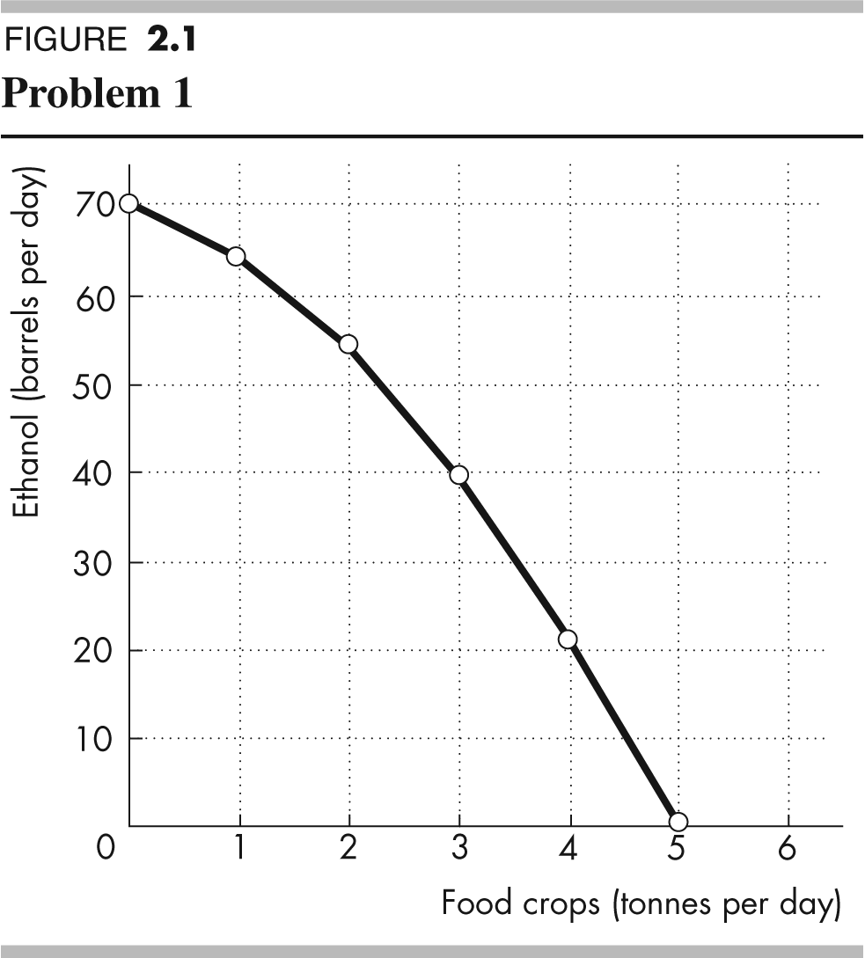
Figure 2.1 shows Brazil’s PPF. The production possibilities frontier indicates scarcity because it shows the limits to what can be produced. In particular, production combinations of ethanol and food crops that lie outside the production possibilities frontier are not attainable.
b. If Brazil produces 40 barrels of ethanol a day, how much food must it produce to achieve production efficiency?
If Brazil produces 40 barrels of ethanol per day, it achieves production efficiency if it also produces 3 tonnes of food per day.
c. Why does Brazil face a tradeoff on its PPF?
Brazil faces a tradeoff on its PPF because Brazil’s resources and technology are limited. For Brazil to produce more of one good, it must shift factors of production away from the other good. To increase production of one good requires decreasing production of the other—a tradeoff.
2. a. If Brazil increases ethanol production from 40 barrels a day to 54 barrels a day, what is the opportunity cost of the additional ethanol?
When Brazil is production efficient and increases its production of ethanol from 40 barrels a day to 54 barrels a day, it must decrease its production of food crops from 3 tonnes a day to 2 tonnes a day. The opportunity cost of the additional ethanol is 1 tonne of food a day for the entire 14 barrels of ethanol or 1/14 of a tonne of food per barrel of ethanol.
b. If Brazil increases food production from 2 tonnes per day to 3 tonnes per day, what is the opportunity cost of the additional food?
When Brazil is production efficient and increases its production of food crops from 2 tonnes per day to 3 tonnes per day, it must decrease its production of ethanol from 54 barrels per day to 40 barrels per day. The opportunity cost of the additional 1 tonne of food crops is 14 barrels of ethanol.
c. What is the relationship between your answers to parts (a) and (b)?
The opportunity cost of an additional barrel of ethanol and the opportunity cost of an additional tonne of food crops are reciprocals of each other. That is, the opportunity cost of 1 tonne of food crops is 14 barrels of ethanol and the opportunity cost of 1 barrel of ethanol is 1/14 of a tonne of food crops.

3. Does Brazil face an increasing opportunity cost of ethanol? What feature of Brazil’s PPF illustrates increasing opportunity cost?
Brazil faces an increasing opportunity cost of ethanol production. For example, when increasing ethanol production from 0 barrels per day to 22 barrels the opportunity cost of a barrel of ethanol is 1/22 of a tonne of food crops. Increasing ethanol production by another 18 barrels per day (to a total of 40 barrels per day) has an opportunity cost of 1/18 of a tonne of food crops per barrel of ethanol. The PPF’s bowed-out shape reflects increasing opportunity cost.
Use the above table (for Problems 1 to 3) to work Problems 4 and 5.
4. Define marginal cost and calculate Brazil’s marginal cost of producing a tonne of food when the quantity produced is 2.5 tonnes per day.
The marginal cost of a good is the opportunity cost of producing one more unit of the good. When the quantity of food produced is 2.5 tonnes, the marginal cost of a tonne of food is the opportunity cost of increasing the production of food from 2 tonnes per day to 3 tonnes per day. The production of ethanol falls from 54 barrels per day to 40 barrels per day, a decrease of 14 barrels per day. The opportunity cost of increasing food production is the decrease in ethanol production, so the opportunity cost of producing a tonne of food when 2.5 tonnes of food per day are produced is 14 barrels of ethanol per day.
5. Define marginal benefit. Explain how it is measured and why the data in the table does not enable you to calculate Brazil’s marginal benefit from food.
The marginal benefit from a good is the benefit received from consuming one more unit of the good. The marginal benefit from a good or service is measured by the most people are willing to pay for one more unit of it. The data in the table do not provide information on how much people are willing to pay for an additional unit of food. The table has no information on the marginal benefit from food.
6. Distinguish between production efficiency and allocative efficiency. Explain why many production possibilities achieve production efficiency but only one achieves allocative efficiency.
Production efficiency occurs when goods and services are produced at the lowest possible cost. This definition means that production efficiency occurs at any point on the PPF. Therefore all of the production points on the PPF are production efficient. Allocative efficiency occurs when goods and services are produced at the lowest cost and in the quantities that provide the greatest possible benefit. The allocatively efficient production point is the single point on the PPF that has the greatest possible benefit.
In an hour, Sue can produce 40 caps or 4 jackets and Tessa can produce 80 caps or 4 jackets.
7. a. Calculate Sue’s opportunity cost of producing a cap.
Sue forgoes 4 jackets to produce 40 caps, so Sue’s opportunity cost of producing one cap is (4 jackets)/(40 caps) or 0.1 jackets per cap.
b. Calculate Tessa’s opportunity cost of producing a cap.
Tessa forgoes 4 jackets to produce 80 caps, so Tessa’s opportunity cost of producing one cap is (4 jackets)/(80 caps) or 0.05 jackets per cap.
c. Who has a comparative advantage in producing caps?
Tessa’s opportunity cost of a cap is lower than Sue’s opportunity cost, so Tessa has a comparative advantage in producing caps.
d. If Sue and Tessa specialize in producing the good in which each of them has a comparative advantage, and they trade 1 jacket for 15 caps, who gains from the specialization and trade?
Tessa specializes in caps and Sue specializes in jackets. Both Sue and Tessa gain from trade. Sue gains because she can obtain caps from Tessa at a cost of (1 jacket)/(15 caps), which is 0.067 jackets per cap, a cost that is lower than what it would cost her to produce caps herself. Tessa also gains from trade because she trades caps for jackets for 0.067 jackets per cap, which is higher than her cost of producing a cap.
8. Suppose that Tessa buys a new machine for making jackets that enables her to make 20 jackets an hour. (She can still make only 80 caps per hour.)
a. Who now has a comparative advantage in producing jackets?
Sue forgoes 40 caps to produce 4 jackets, so Sue’s opportunity cost of producing one jacket is (40 caps)/(4 jackets) or 10 caps per jacket. Tessa forgoes 80 caps to produce 20 jackets, so Tessa’s opportunity cost of producing one jacket is (80 caps)/(20 jackets) or 4 caps per jacket. Tessa has the comparative advantage in producing jackets because her opportunity cost of a jacket is lower than Sue’s opportunity cost.
b. Can Sue and Tessa still gain from trade?
Tessa and Sue can still gain from trade because Tessa (now) has a comparative advantage in producing jackets and Sue (now) has a comparative advantage in producing caps. Tessa will produce jackets and Sue will produce caps.
c. Would Sue and Tessa still be willing to trade 1 jacket for 15 caps? Explain your answer.
Sue and Tessa will not be willing to trade 1 jacket for 15 caps. In particular, Sue, whose comparative advantage lies in producing caps, can produce 1 jacket at an opportunity cost of only 10 caps. So Sue will be unwilling to pay any more than 10 caps per jacket.
9. A farm grows wheat and produces pork. The marginal cost of producing each of these products increases as more of it is produced.
a. Make a graph that illustrates the farm’s PPF.
Measure the quantity of pork produced on the x-axis and measure the quantity of wheat produced on the y-axis. Because the marginal cost of both wheat and pork increase as more of the good is produced, the PPF has a bowed-out shape.
b. The farm adopts a new technology that allows it to use fewer resources to fatten pigs. On your graph, illustrate the impact of the new technology on the farm’s PPF.
The new technology rotates the PPF outward. If the farm puts all of its resources into pork production, it can produce more pork. But if the farm puts all of its resources into wheat production, it still produces the same quantity of wheat.
c. With the farm using the new technology in part (b), has the opportunity cost of producing a tonne of wheat changed? Explain and illustrate your answer.
With the new technology, the opportunity cost of producing pork decreases. To increase pork production, the production of wheat decreases by less than prior to the implementation of the new technology. The opportunity cost of producing wheat is the inverse of the opportunity cost of producing pork. So the opportunity cost of producing wheat increases.
d. Is the farm more efficient with the new technology than it was with the old one? Why?
The farm is able to produce more with the new technology than with the old, but it is not necessarily more efficient. If the farm was producing on its PPF before the new technology and after, the farm was production efficient both before the new technology and after.
10. For 50 years, Cuba has had a centrally planned economy in which the government makes the big decisions on how resources will be allocated.
a. Why would you expect Cuba’s production possibilities (per person) to be smaller than those of Canada?
Cuba’s economy is almost surely less efficient than the Canadian economy. The Cuban central planners do not know people’s production possibilities or their preferences. Because firms in Cuba are owned by the government rather than individuals, no one in Cuba has the self-interested incentive to operate the firm efficiently and produce goods and services that consumers desire. Additionally Cuba does not actively trade so Cuba produces most of its consumption goods rather than buying them from nations with a comparative advantage. Because Cuba uses its resources to produce consumption goods, it cannot produce many capital goods so its economic growth rate has been low.
b. What are the social institutions that Cuba might lack that help Canada to achieve allocative efficiency?
Of the four social institutions, firms, money, markets, and property rights, Cuba’s economy has firms and money. Markets, however, are less free of government intervention in Cuba. But the major difference is the property rights in the Cuban economy. In Cuba the government owns most of the firms; that is, the government has the property right to run the producers. Because the firms are not motivated to make a profit, the managers of these firms have little incentive to operate the firm efficiently or to produce the goods and services that consumers desire. In Canada, firms are owned by individuals; that is, people have the property right that allows them to run firms. These owners have the self-interested incentive to operate the firm efficiently and to produce the goods and services people want—an incentive lacking in the Cuban economy.

Answers to Additional Problems and Applications
Use the table to work Problems 11 and 12. Suppose that Yucatan’s production possibilities are given in the table.
Food  (kilograms per month) |  | Sunscreen  (litres per month)
300 | and | 0
200 | and | 50
100 | and | 100
0 | and | 150
11. a. Draw a graph of Yucatan’s PPF and explain how your graph illustrates a tradeoff.
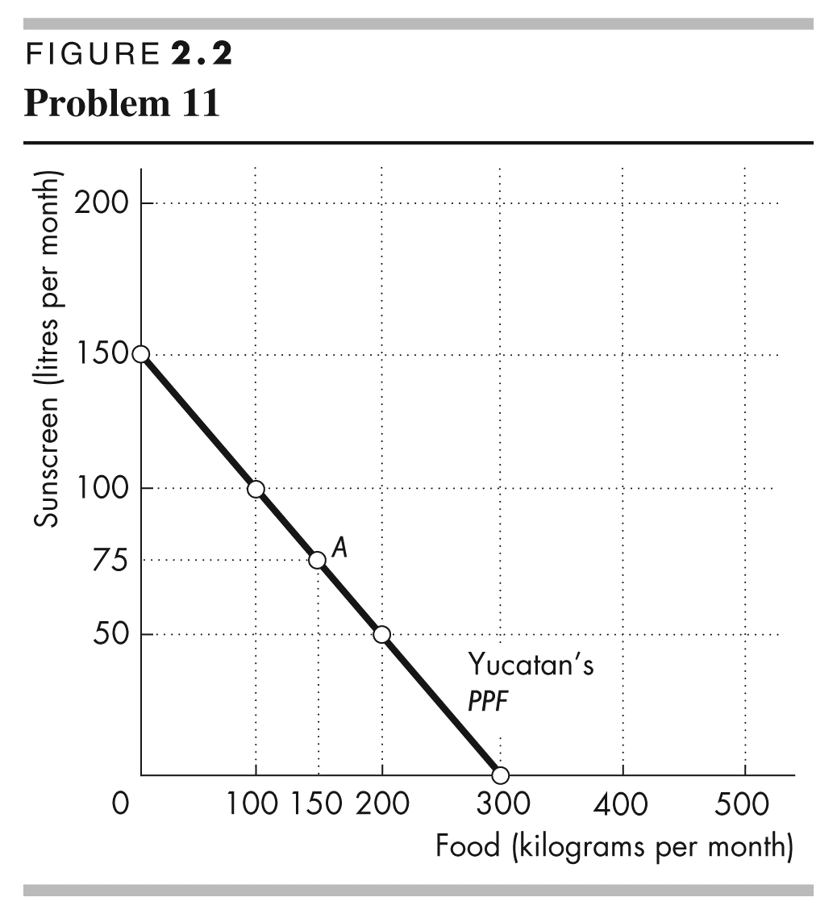
Yucatan’s PPF is illustrated in Figure 2.2. The figure illustrates a tradeoff because moving along Yucatan’s PPF producing more of one good requires producing less of the other good. Yucatan trades off more production of one good for less production of the other.
b. If Yucatan produces 150 kilograms of food per month, how much sunscreen must it produce if it achieves production efficiency?
If Yucatan produces 150 kilograms of food per month, then the point labelled A on the PPF in Figure 2.2 shows that Yucatan must produce 75 litres of sunscreen per month to achieve production efficiency.
c. What is Yucatan’s opportunity cost of producing (i) 1 kilogram of food and (ii) 1 litre of sunscreen?
Yucatan’s PPF is linear so the opportunity cost of producing 1 kilogram of food is the same at all quantities. Calculate the opportunity cost of producing 1 kilogram of food when increasing the production of food from 0 to 100 kilograms per month. The quantity of sunscreen produced falls from 150 litres per month to 100 litres per month, a decrease of 50 litres. The opportunity cost is 50 litres of sunscreen to gain 100 kilograms of food. The opportunity cost per kilogram of food equals (50 litres of sunscreen)/(100 kilograms of food), which is an opportunity cost of 0.5 litres of sunscreen per kilogram of food.
Similarly, the opportunity cost of producing 1 litre of sunscreen is the same at all quantities. Calculate the opportunity cost of producing 1 litre of sunscreen when increasing the production of sunscreen from 0 to 50 litres per month. The quantity of food produced falls from 300 kilograms per month to 200 kilograms per month, a decrease of 100 kilograms. The opportunity cost is 100 kilograms of food to gain 50 litres of sunscreen, or (100 kilograms of food)/(50 litres of sunscreen) which is an opportunity cost of 2.0 kilograms of food per litre of sunscreen.
d. What is the relationship between your answers to part (c)?
The answer to part (c) reflects the fact that opportunity cost is a ratio. The opportunity cost of gaining a unit of a good moving along the PPF equals the quantity of the other good or service forgone divided by the quantity of the good or service gained. The opportunity cost of one good, food, is equal to the inverse of the opportunity cost of the other good, sunscreen.
12. What feature of a PPF illustrates increasing opportunity cost? Explain why Yucatan’s opportunity cost does or does not increase.
If opportunity cost increases as more of a good is produced, the PPF bows outward. Yucatan’s PPF is linear and along a linear PPF the opportunity cost is constant. Yucatan’s opportunity cost of food remains constant, equal to 0.5 litres of sunscreen per kilogram of food. Yucatan’s resources are equally productive in both activities.
13. In problem 11, what is the marginal cost of 1 kilogram of food in Yucatan when the quantity produced is 150 kilograms per day? What is special about the marginal cost of food in Yucatan?
The marginal cost of a kilogram of food in Yucatan is constant at all points along Yucatan’s PPF and is equal to 0.5 litres of sunscreen per kilogram of food. The special point about Yucatan’s marginal cost is the fact that the marginal cost is constant. This result reflects Yucatan’s linear PPF.
14. The table describes the preferences in Yucatan.
Sunscreen  (litres per month) | Willingness to pay  (kilograms of food per litre)
25 | 3
75 | 2
125 | 1
a. What is the marginal benefit from sunscreen and how is it measured?
The marginal benefit from sunscreen is the benefit enjoyed by the person who consumes one more litre of sunscreen. It is equal to the willingness to pay for an additional litre.
b. What does Yucatan produce to achieve allocative efficiency?
When allocative efficiency is achieved, Yucatan is producing at the point on the PPF that is most preferred. At this point, the marginal benefit from sunscreen equals the marginal cost of sunscreen. The marginal cost of sunscreen is 2 kilograms of food per litre. The table shows that the marginal benefit from sunscreen is 2 kilograms of food per litre when the quantity produced is 75 litres of sunscreen per month.
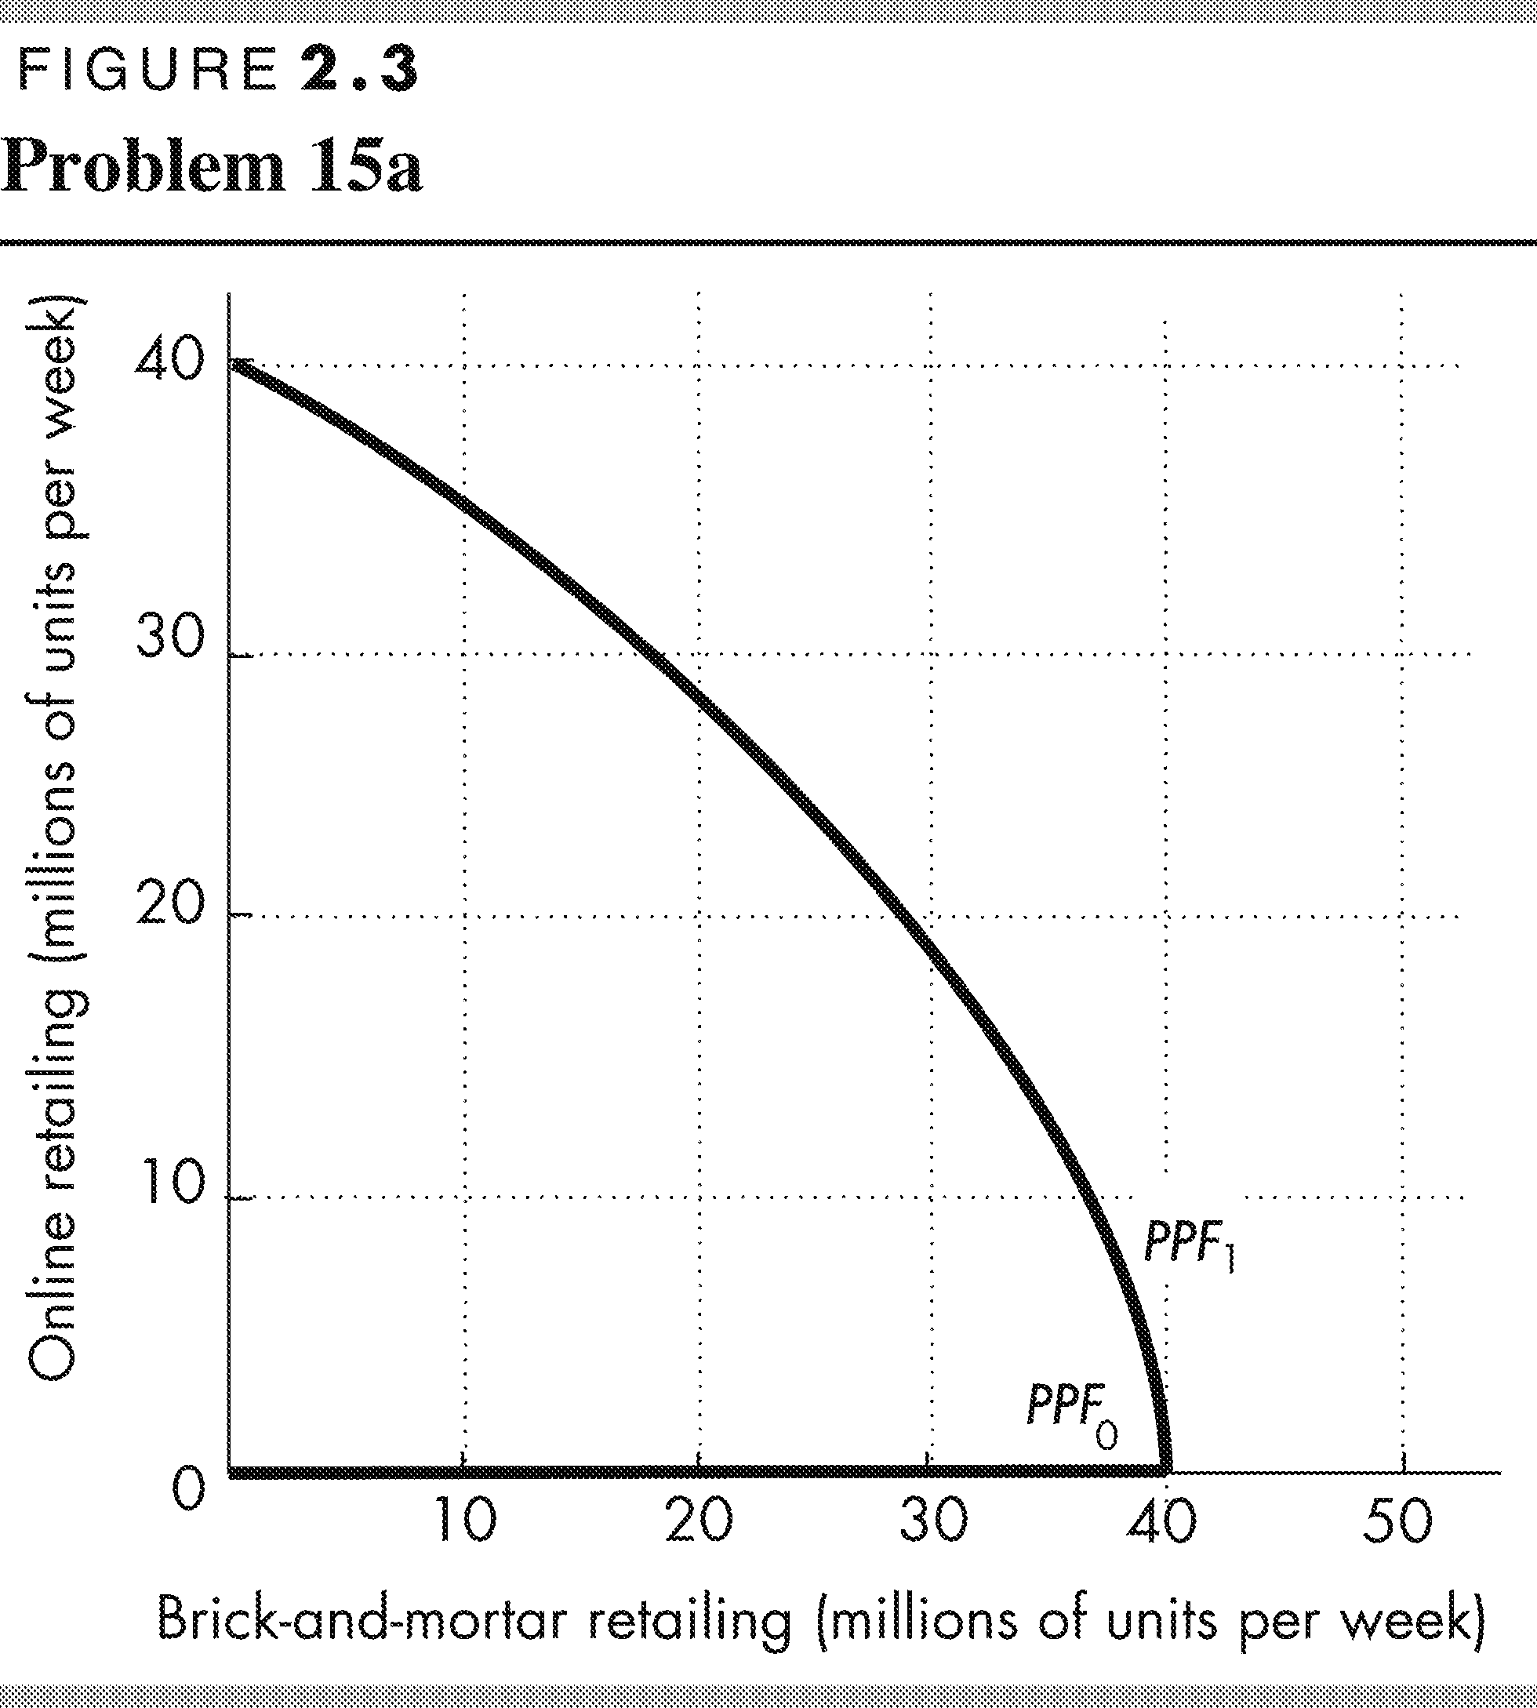
Macy’s Kmart, JCPenney: More retailers Closing Brick-and-Mortar Stores
As more people choose online shopping over brick-and-mortar stores, Macy’s, Kmart, JCPenney and others are closing stores.
Source: Springfield News-Sun, March 24, 2017
15. a. Draw the PPF curves for brick-and-mortar retailers and online retailers before and after the Internet became available.
Before the introduction of the Internet, it is not possible to produce online retailing. In Figure 2.3, PPF₀ runs along the x-axis. After the Internet, there is a tradeoff between online retailing and brick-and-mortar retailing. PPF₁ intersects both axes, slopes downward, is bowed outward, and the same maximum quantity of brick-and-mortar retailing can be produced as before the Internet.
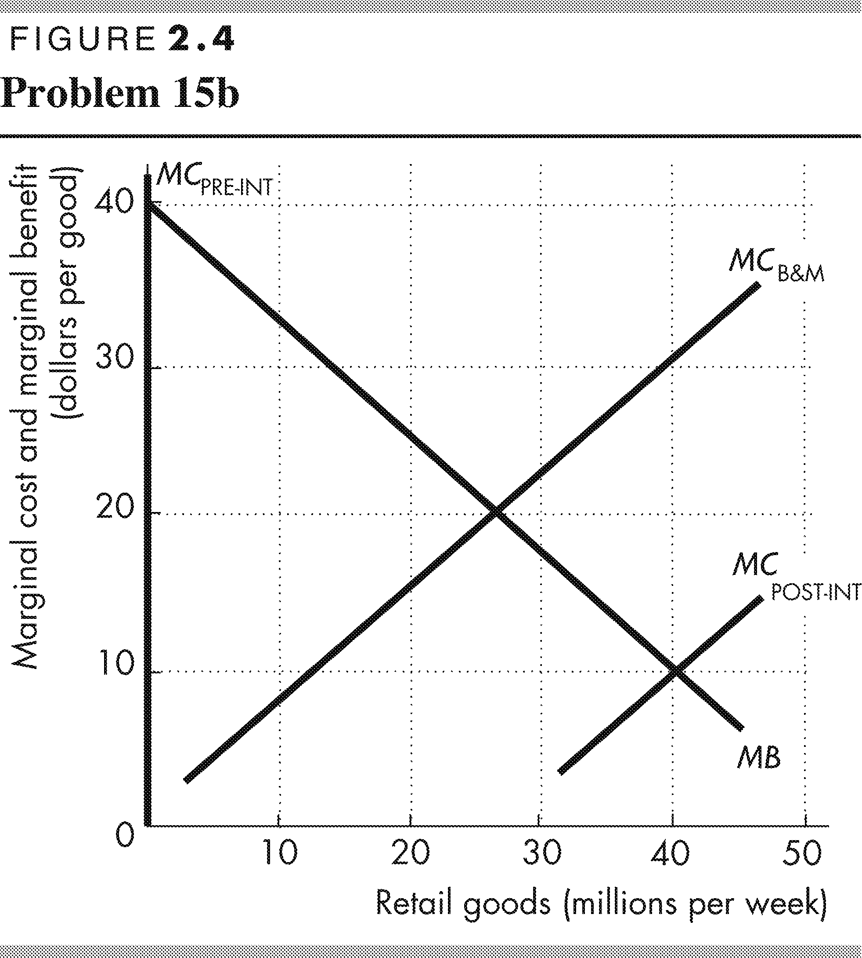
b. Draw the marginal cost and marginal benefit curves for brick-and-mortar retailers and online retailers before and after the Internet became available.
In Figure 2.4, the MB curve shows decreasing marginal benefit from retailing. The MC_{B&M} curve shows the increasing marginal cost of brick-and-mortar retailing. The MC_{Pre-Int} curve along the y-axis shows that no matter how great the marginal cost, no online retailing can occur before the Internet. The MC_{Post}-_{Int} curve shows that the marginal cost of online retailing is lower than the marginal cost of brick-and-mortar retailing.
c. Explain how changes in production possibilities, preferences or both have changed the way in which goods are retailed.
The expansion of production possibilities lowers the cost of retailing. The expansion of production possibilities does not influence preferences, which are buyers' likes and dislikes. With the lower cost of retailing, the quantity of retailing increases. But with online retailing less expensive than brick-and-mortar retailing, retailing in stores decreases.
Use the following news clip to work Problems 16 and 17.
Gates Doubles Down on Malaria Eradication
The End Malaria Council, convened by Bill Gates and Ray Chambers, seeks to mobilize resources to prevent and treat malaria. The current level of financing is too low to end malaria. Bruno Moonen, deputy director for malaria at the Gates Foundation, says that more resources, more leadership, and new technologies are need to eradicate malaria in the current generation.
Source: Catherine Cheney, Devex, January 20, 2017
16. Is Bruno Moonen talking about production efficiency or allocative efficiency or both?
We achieve production efficiency if we produce goods and services at the lowest possible cost. All points on the production possibilities frontier achieve production efficiency. And all points on the production possibilities frontier involve a tradeoff. Bruno Moonen is discussing a point on the PPF. To eradicate malaria would require "more resources, more leadership, and new technologies". Some other good or service would have to be given up to eradicate malaria.

Allocative efficiency occurs when goods and services are produced at the lowest possible cost and in the quantities that provide the greatest possible benefit. Allocative efficiency occurs when marginal cost equals marginal benefit. Bruno Moonen is also discussing allocative efficiency. The allocatively efficient quantity is the current quantity of malaria cases. To further eradicate malaria would mean a reduction that is greater than the allocatively efficient quantity. Marginal cost would exceed marginal benefit.

17. Make a graph with the percentage of malaria cases eliminated on the x-axis and the marginal cost and marginal benefit of driving down malaria cases on the y-axis. On your graph:
(i) Draw a marginal cost curve and marginal benefit curve that are consistent with Bruno Moonen’s opinion.
(ii) Identify the quantity of malaria eradicated that achieves allocative efficiency.
As the percentage of malaria cases that are eradicated increases, the marginal cost of each additional percentage increases. So the marginal cost curve is upward sloping. Marginal benefit from malaria eradication is the benefit received from eradicating one more percent of malaria cases. As the percentage of malaria cases that are eradicated increases, the marginal benefit from each additional percentage decreases. So the marginal benefit curve is downward sloping. The point of allocative efficiency is the point at which the marginal cost of malaria eradication equals the marginal benefit from malaria eradication.
Use the following data to work Problems 18 and 19.
Kim can produce 40 pies or 400 cakes an hour. Liam can produce 100 pies or 200 cakes an hour.
18. a. Calculate Kim’s opportunity cost of a pie and Liam’s opportunity cost of a pie.
If Kim spends an hour baking pies, she gains 40 pies but forgoes 400 cakes. Kim’s opportunity cost of 1 pie is (400 cakes)/(40 pies), or 10 cakes. If Liam spends an hour baking pies, he gains 100 pies but forgoes 200 cakes. Liam’s opportunity cost of 1 pie is (200 cakes)/(100 pies), or 2 cakes.
b. If each spends 30 minutes of each hour producing pies and 30 minutes producing cakes, how many pies and cakes does each produce?
Kim produces 20 pies and 200 cakes. Liam produces 50 pies and 100 cakes. The total number produced is 70 pies and 300 cakes.
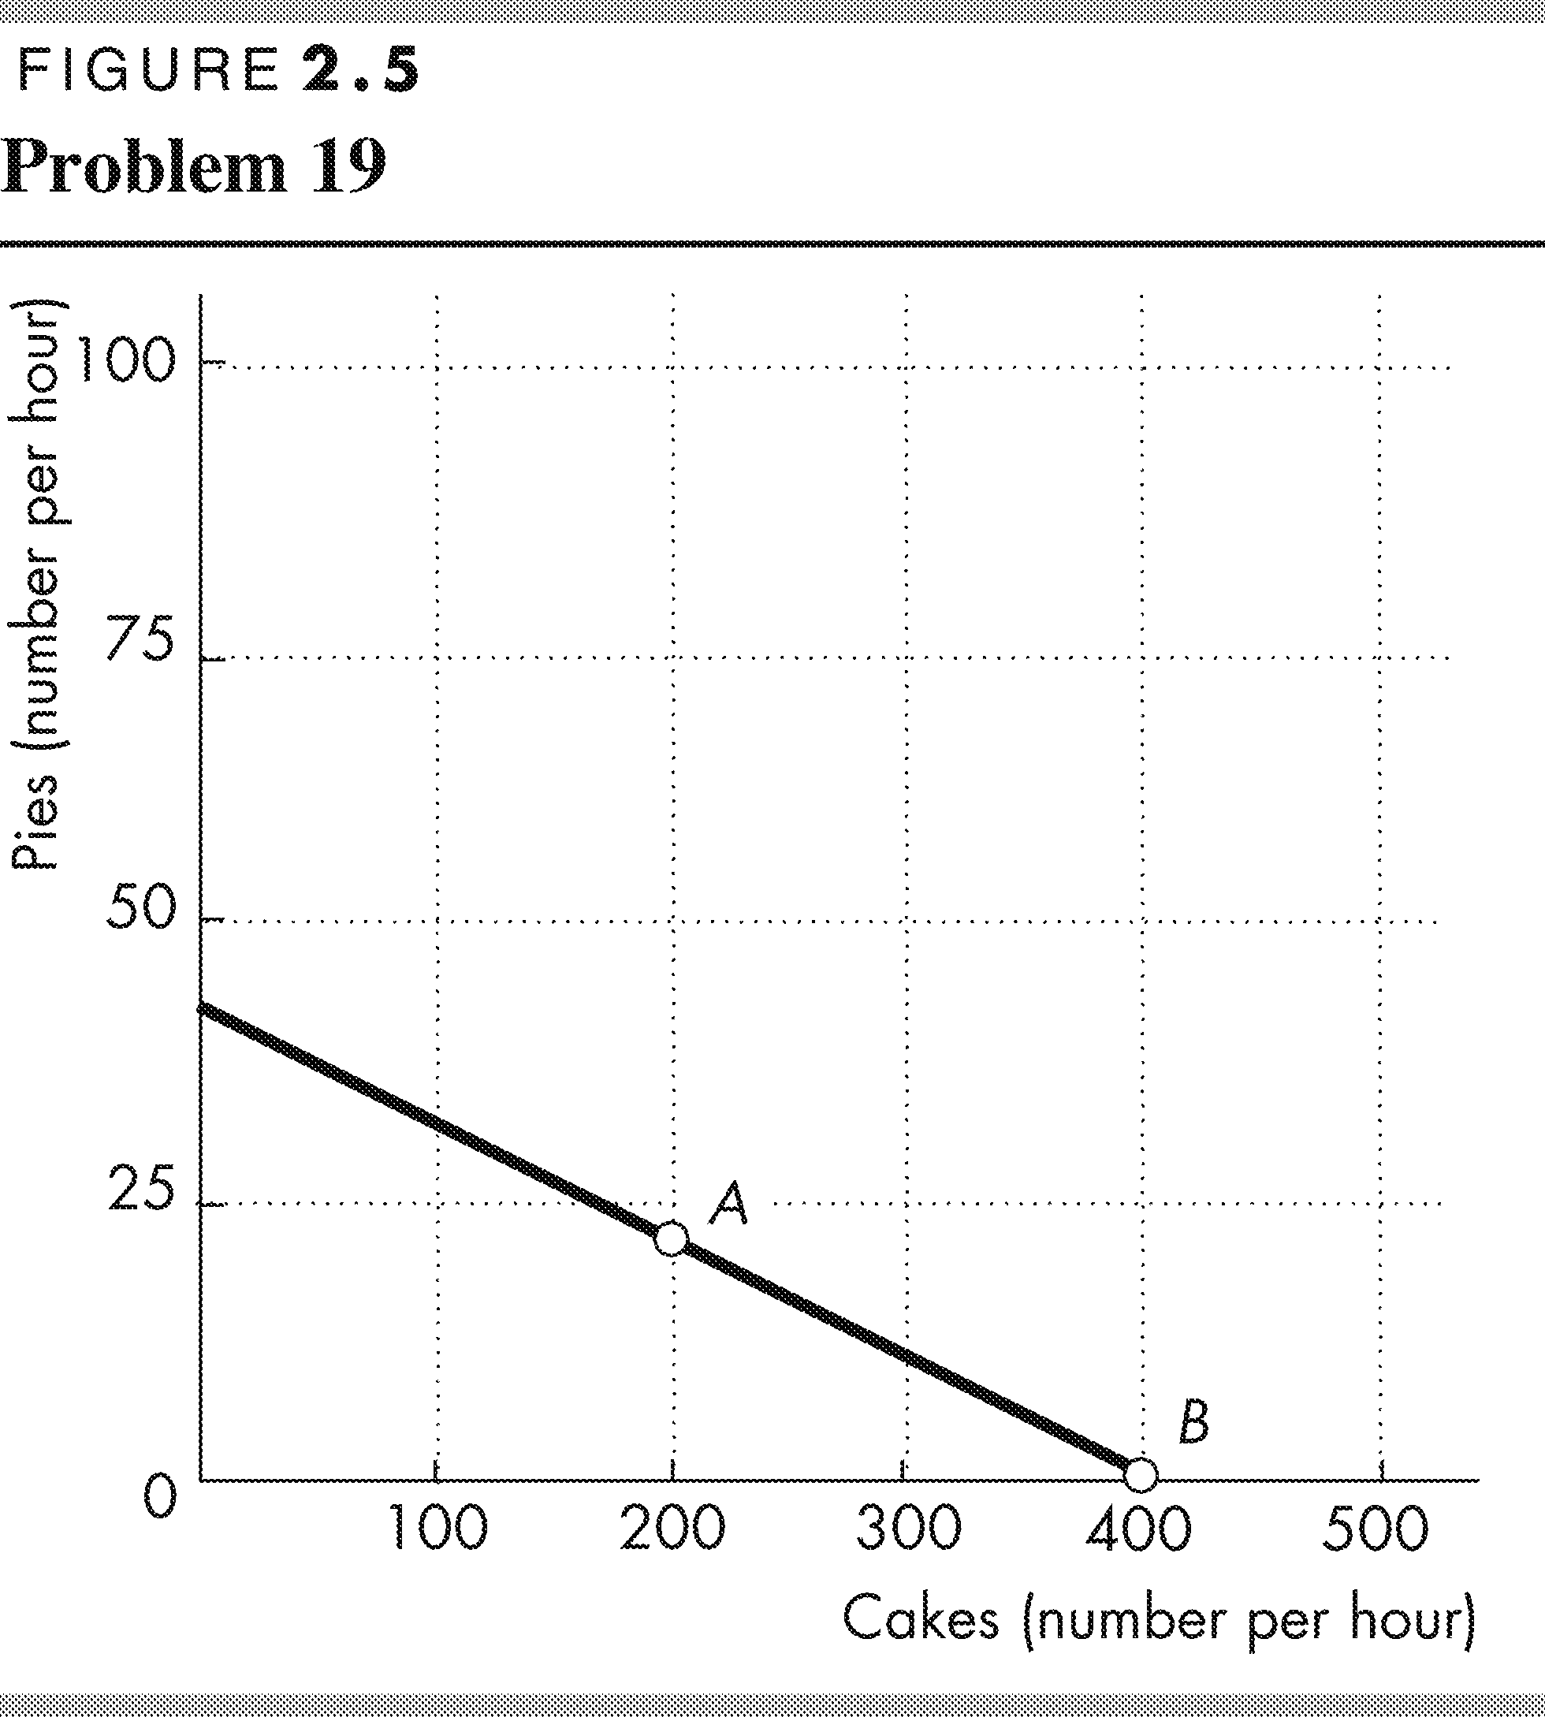
c. Who has a comparative advantage in producing (i) pies and (ii) cakes?
Liam has the comparative advantage in producing pies because his opportunity cost of producing a pie is less than Kim’s opportunity cost of producing a pie. Kim has the comparative advantage in producing cakes because her opportunity cost of producing a cake is less than Liam’s opportunity cost of producing a cake.
19. a. Draw a graph of Kim’s PPF and Liam’s PPF and show the point at which each produces when they spend 30 minutes of each hour producing pies and 30 minutes producing cakes.
Kim’s PPF is illustrated in Figure 2.5; Liam’s PPF is illustrated in Figure 2.6 .
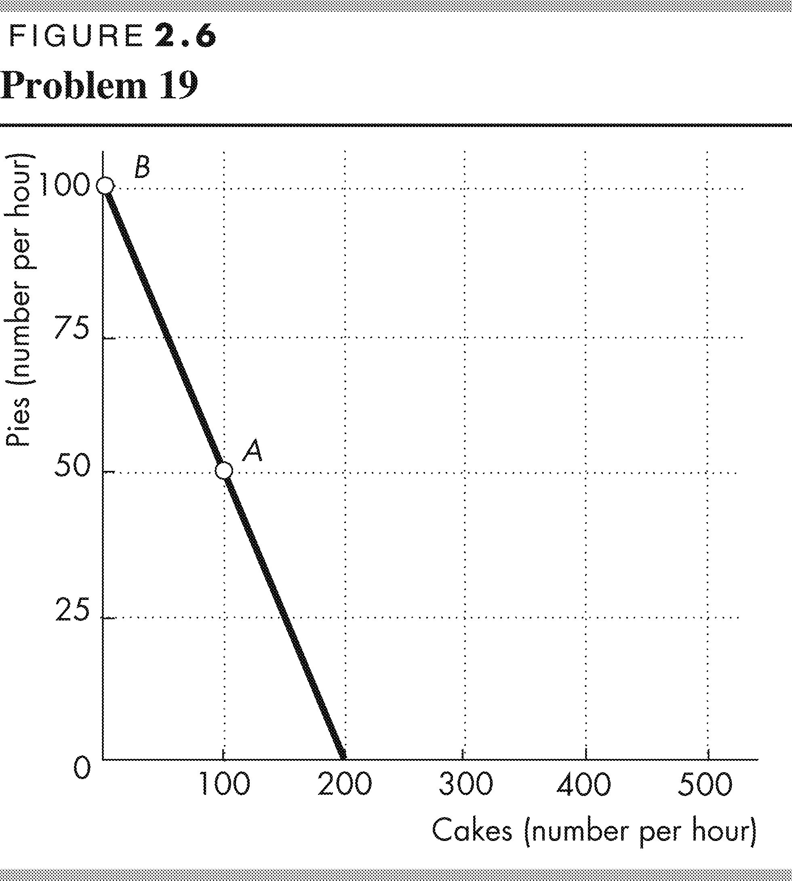
Point A in both figures shows their production points when each spends 30 minutes making cakes and 30 minutes making pies.
b. On your graph, show what Kim produces and what Liam produces when they specialize.
Kim will specialize in cakes and Liam will specialize in pies. Point B in both figures shows the production points when each specializes.
c. When they specialize and trade, what are the total gains from trade?
Kim will specialize in cakes and Liam will specialize in pies. If they specialize and trade, the total production of both cakes and pies increase. When each spends 30 minutes making cakes and 30 minutes making pies, together they produce 300 cakes and 70 pies. When they specialize, together they produce 400 cakes and 100 pies. The 100 increase in cakes and the 30 increase pies is the gains from trade.
d. If Kim and Liam share the total gains equally, what trade takes place between them?
Kim will trade 50 cakes (half of the gain in cake production) to Liam in exchange for 15 pies (half of the increase in pie production).

20. Tony and Patty produce skis and snowboards. The top table shows Tony’s production possibilities and the bottom table shows Patty’s production possibilities. Each week Tony produces 5 snowboards and 40 skis; Patty produces 10 snowboards and 5 skis.
Snowboards  (per week) |  | Skis  (per week)
25 | and | 0
20 | and | 10
15 | and | 20
10 | and | 30
5 | and | 40
0 | and | 50
a. Who has a comparative advantage in producing (i) snowboards and (ii) skis?
The person with a comparative advantage in producing snowboards is the person who has the lower opportunity cost of producing a snowboard. Tony’s production possibilities show that to produce 5 more snowboards he must produce 10 fewer skis. So Tony’s opportunity cost of producing a snowboard is 2 skis.
Patty’s production possibilities show that to produce 10 more snowboards, she must produce 5 fewer skis. So Patty’s opportunity cost of producing a snowboard is ½ of a ski. Patty has a comparative advantage in producing snowboards because her opportunity cost of producing a snowboard is less than Tony’s opportunity cost of producing a snowboard.
Snowboards  (per week) |  | Skis  (per week)
20 | and | 0
10 | and | 5
0 | and | 10
Tony has a comparative advantage in producing skis. For each ski produced, Tony must give up making 1/2 a snowboard, whereas for each ski that Patty produces, she must give up making 2 snowboards.
So Tony’s opportunity cost of a producing ski is lower than Patty’s opportunity cost of producing a ski.
b. If Tony and Patty specialize and trade 1 snowboard for 1 ski, what are the gains from trade?
Patty has a comparative advantage in producing snowboards, so she specializes in snowboards. Tony has a comparative advantage in producing skis, so he specializes in producing skis. Patty produces 20 snowboards and Tony produces 50 skis.
Before specializing, they produced 15 snowboards (Patty’s 10 plus Tony’s 5) and 45 skis (Tony’s 40 plus Patty’s 5). By specializing, they increase their total output by 5 snowboards and 5 skis. They can share this gain by trading 1 ski for 1 snowboard. Patty can obtain skis from Tony for less than it costs her to produce them. Tony can obtain snowboards from Patty for less than it costs him to produce them. The gains from trade are the additional 5 snowboards and 5 skis.

21. Capital accumulation and technological change bring economic growth: Production that was unattainable yesterday becomes attainable today; production that is unattainable today will become attainable tomorrow. Why doesn’t economic growth bring an end to scarcity one day?
People’s wants are infinite—regardless of what a person already possesses, everyone can easily visualize something else he wants. Because people’s wants are insatiable, scarcity will always exist regardless of economic growth.
SpaceX Plans to Send Two People Around the Moon
SpaceX CEP Elon Musk announced that SpaceX plans to send two citizens on a one-week 350,000 mile trip around the moon in 2018.
Source: The Verge, February 27, 2017
22. What is the opportunity cost of creating the technology for trips around the moon?
When SpaceX puts resources into creating technology for trips around the moon in the future, SpaceX has fewer resources to produce other goods and services today. The decrease in the production of goods and services today is the opportunity cost of SpaceX creating the technology for trips around the moon.
23. Sketch SpaceX’s PPF for trips around the moon and other goods and services and its planned production in 2018.
Measure other goods and services on the y-axis and trips around the moon on the x-axis. SpaceX's PPF is a downward-sloping curve that is bowed outward showing the tradeoff between other goods and services and moon trips. In 2018, SpaceX produces 1 moon trip, so the production point in 2018 is on its PPF at one moon trip.
24. Indicate on a graph of the circular flows in the market economy, the real and money flows in which the following items belong:
a. You buy an iPad from the Apple Store.
Figure 2.7 shows the circular flows in a market economy. Your purchase of an iPad from Apple is the purchase of a good from a firm. This flow is the black arrow labelled a in the figure. When you pay for the iPad, the money flow is the grey arrow in the opposite direction to the black arrow labelled a.
b. Apple Inc. pays the designers of the iPad.
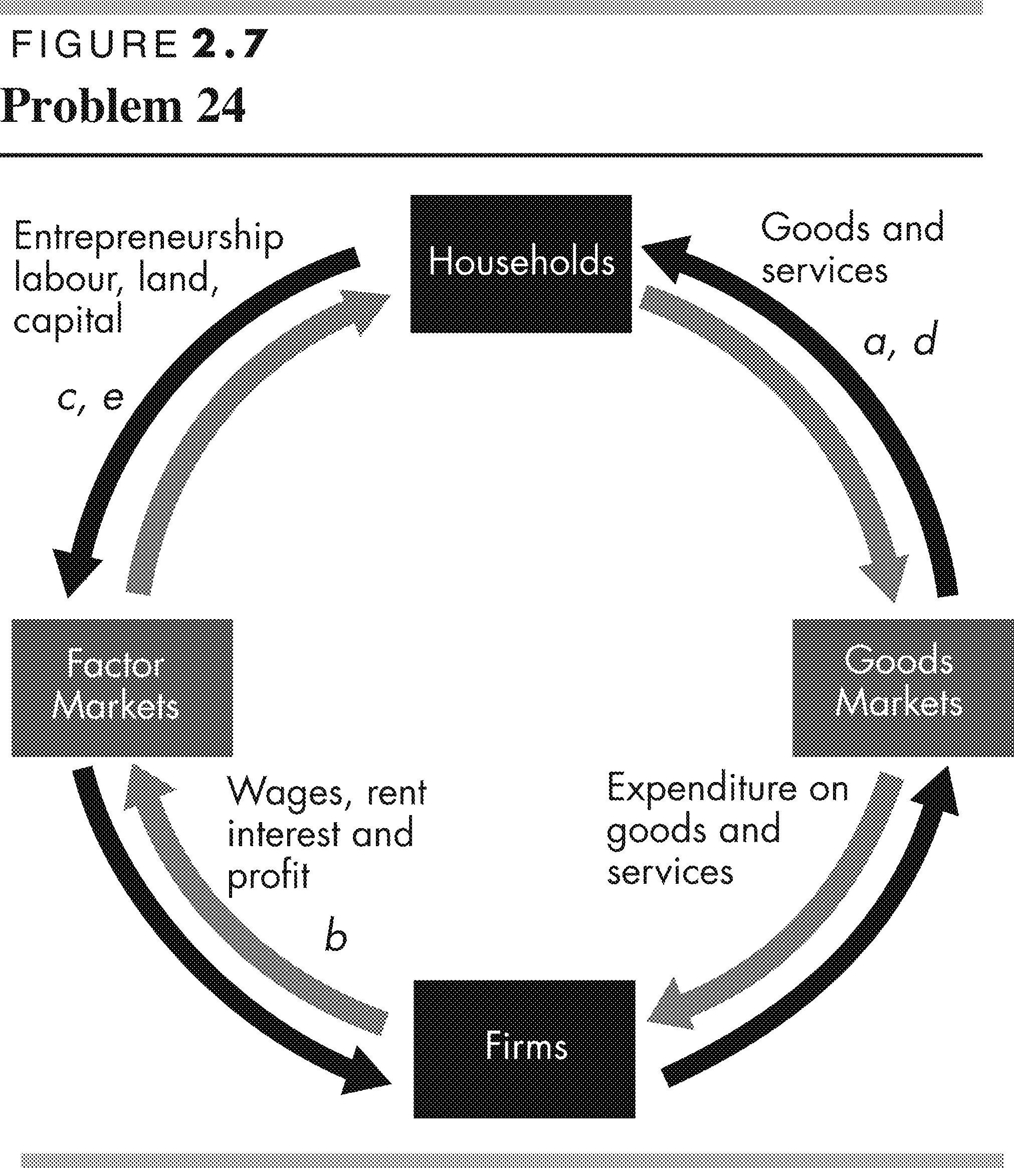
Apple’s payment to the designers of the iPad is the payment of a wage to a factor of production. This flow is the grey arrow labelled b in the figure. The flow of design services from the designer to Apple is the black arrow in the opposite direction to the grey arrow labelled b.
c. Apple Inc. decides to expand and rents an adjacent building.
Apple’s decision to expand by renting a building means that Apple is increasing the capital it uses. This flow is the black arrow labelled c in the figure. The flow of the payment for the rental services of the building is the grey arrow in the opposite direction to the black arrow labelled c.
d. You buy a new e-book from Amazon.
Your purchase of an e-book from Amazon is the purchase of a good from a firm. This flow is the black arrow labelled d in the figure. When you pay for the e-book, the money flow is the grey arrow in the opposite direction to the black arrow labelled d.
e. Apple Inc. hires a student as an intern during the summer.
Apple’s decision to hire a student intern is Apple increasing the labour it uses. The flow of labour services is the black arrow labelled e in the figure. The flow of the payment for the labour services is the grey arrow in the opposite direction to the black arrow labelled e.
Economics in the News
25. After you have studied Economics in the News on pp. 50–51, answer the following questions.
a. How does investing in LNG production and export facilities change Canada’s PPF?
If we measure LNG production on the x-axis of Canada's PPF and other goods and services on the y-axis of Canada's PPF, then with the investment in LNG production and export facilities, Canada's PPF rotates outward. At every quantity of other goods and services produced, Canada can produce more LNG.
b. How do technological advances in the production of other goods and services change Canada’s PPF?
If we measure LNG production on the x-axis of Canada's PPF and other goods and services on the y-axis of Canada's PPF, then with technological advances in the production of other goods and services, Canada's PPF rotates outward. At every quantity of LNG produced, Canada can produce more other goods and services.
c. How will the deal between Huu-ah-aht First Nation and Steelhead LNG change Canada’s opportunity cost of exporting LNG?
The deal between Huu-ah-aht First Nation and Steelhead LNG is rotating Canada's PPF outward. Fewer other goods and services must be given up to produce an additional million cubic metres of LNG. The opportunity cost of producing LNG is decreasing.

d. When technological advances in the production of other goods and services occur, how does the opportunity cost of producing LNG change? Does it increase or decrease?
Technological discoveries in the production of other goods and services means that less production of LNG must be given up to produce more other goods and services. The opportunity cost of producing other goods and services decreases. The opportunity cost of producing LNG is the inverse of the opportunity cost of producing other goods and services. So the opportunity cost of producing LNG increases.
26. YouTube Launches Live TV in the U.S.
Google has launched YouTube TV, a $35-a-month service that carries live streaming from all the major broadcast and sports networks as well as some cable networks and local sports and news channels. Users will be able to record an unlimited amount of content and multiple shows simultaneously, without using up any data space on mobile devices.
Source: Mediatel, March 1, 2017
a. How has live streaming changed the production possibilities of video entertainment and other goods and services?
With live streaming, more video entertainment can be produced when all resources are used to produce video entertainment. But the quantity of other goods and services does not change when all resources are used to produce the other goods and services.
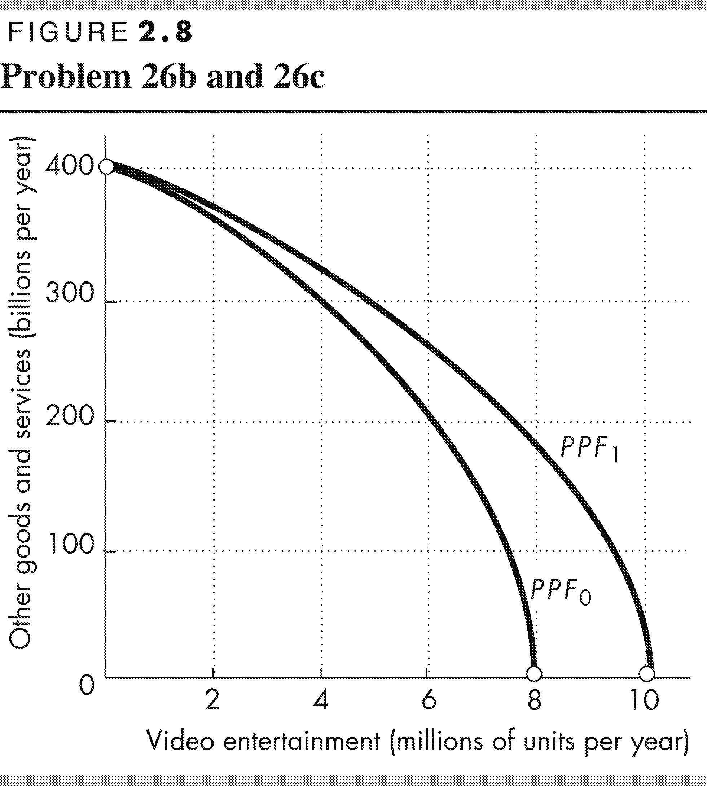
b. Sketch a PPF for video entertainment and other goods and services before live streaming.
In Figure 2.8, PPF₀ measures video entertainment on the x-axis and other goods and services on the y-axis before live streaming. The PPF is bowed outward.
c. Show how the arrival of inexpensive live streaming has changed the PPF.
With live streaming, more video entertainment can be produced when all resources are used to produce video entertainment. But the quantity of other goods and services does not change when all resources are used to produce the other goods and services. In Figure 2.8, with live streaming, the production possibilities frontier rotates outward from PPF₀ to PPF₁. The y-axis intercept does not change and the x-axis intercept increases.
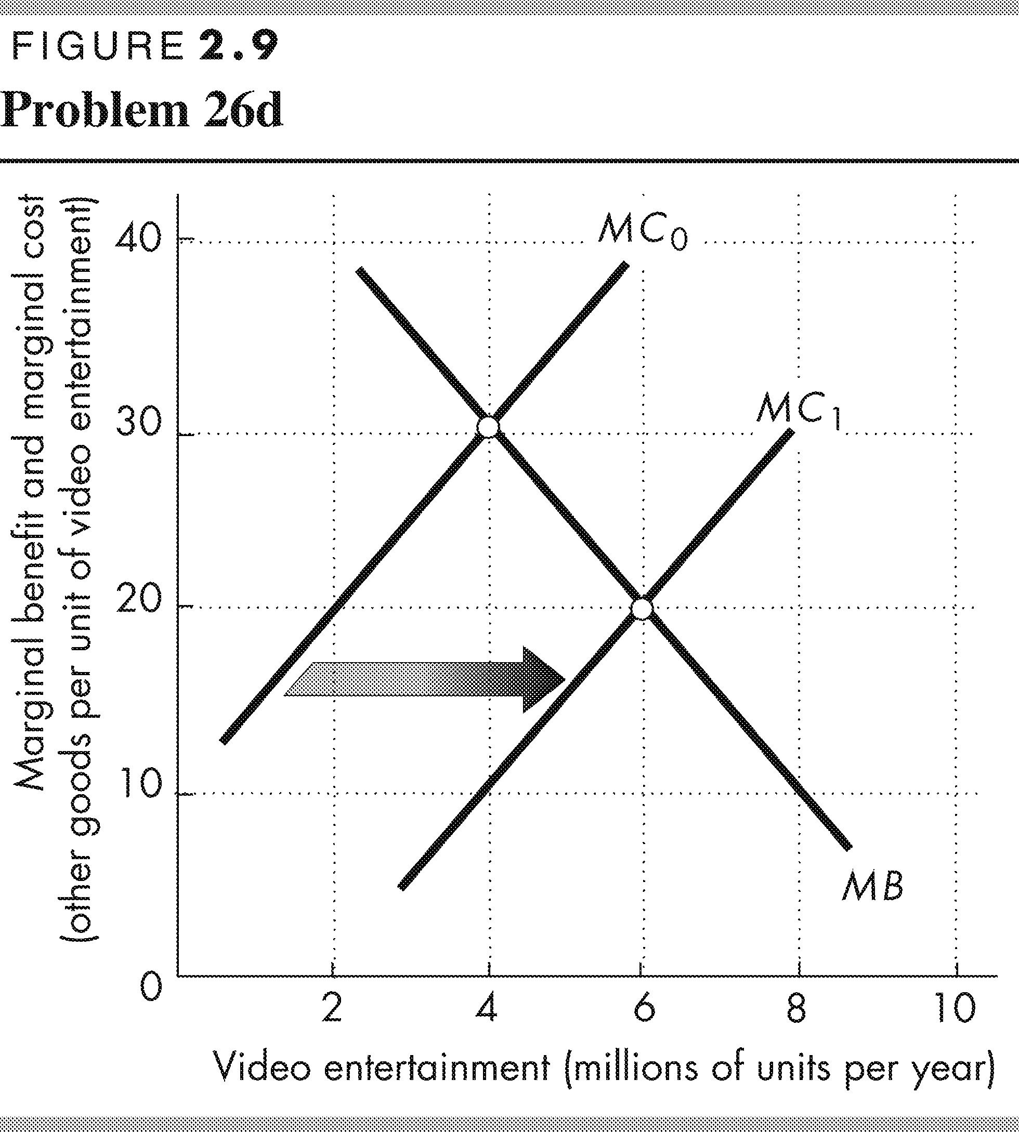
d. Sketch a marginal benefit curve and marginal cost curve for video entertainment before and after live streaming.
Figure 2.9 shows the curves. The marginal benefit curve is a downward-sloping curve. The introduction of live streaming does not change the marginal benefit received from each additional unit of video entertainment. The marginal cost curve is an upward-sloping curve. Live steaming decreases the marginal cost of each additional unit of video entertainment. With live streaming the marginal cost curve shifts rightward from MC₀ to MC₁.
e. Explain how the efficient quantity of video entertainment has changed.
With live streaming, the marginal cost of producing video entertainment decreases. The marginal cost curve shifts rightward and the quantity of video entertainment that achieves allocative efficiency increases. In Figure 2.9, the efficient quantity of video entertainment increases from 4 million units a year to 6 million units a year.

