Chapter 2  
Supply and Demand

◼ Chapter Outline

**Challenge: *Quantities and Prices of Genetically Modified Foods***

2.1 Demand

The Demand Curve

Effect of Prices on the Quantity Demanded

Effect of Other Factors on Demand

**Application**: Calorie Counting

The Demand Function

**Solved Problem 2.1**

Summing Demand Curves

**Application**: Aggregating Corn Demand Curves

2.2 Supply

The Supply Curve

Effect of Price on Supply

Effect of Other Variables on Supply

The Supply Function

Summing Supply Curves

How Government Import Policies Affect Supply Curves

**Solved Problem 2.2**

2.3 Market Equilibrium

Using a Graph to Determine the Equilibrium

Using Math to Determine the Equilibrium

Forces That Drive a Market to Equilibrium

2.4 Shocking the Equilibrium

Effects of a Shock to the Supply Curve

**Solved Problem 2.3**

Effects of a Shock to the Demand Curve

2.5 Effects of Government Interventions

Policies That Shift Supply Curves

Licensing Laws

**Application**: Occupational Licensing

Quotas

**Solved Problem 2.4**

Policies That Cause the Quantity Demanded to Differ from the Quantity Supplied

Price Ceilings

**Application:** Venezuelan Price Ceilings and Shortages

Price Floors

**Solved Problem 2.5**

Why the Quantity Supplied Need Not Equal the Quantity Demanded

2.6 When to Use the Supply-and-Demand Model

◼ **Teaching Tips**

This chapter reviews basic supply-and-demand concepts from the principles level. Your interactions with the class from the first session or two should give you a good indication of how much class time to spend on it. If it has been some time since their principles course, students may need fairly consistent prompting to recall the basic supply-and-demand model. For example, many will remember that there is a Law of Demand but will not remember the law itself. Encourage students in the strongest terms to read the chapter carefully. It is well worth the time spent at this stage to make sure everyone has solid recognition of these basic tools and concepts.

A good way to motivate the chapter is by beginning with the genetically modified food example found in the Challenge. Try to keep the conversation focused on possible effects of entry or of the ban. Let students brainstorm about which parties might be in favor of a ban and who would be opposed and why.

When reviewing demand, be sure students are clear on the difference between movement along the curve and a shift of the entire curve. Two points should be helpful. First, note to them that both in Equation 2.1 and on the graph in Figure 2.1, price is the only independent variable present. Thus, only price can cause a movement along the curve. Second, underscore the role of other variables. After compiling a list of the factors that can shift the demand curve (once they get started, the class as a group should be able to provide you with this list), I ask what factors are held constant along a single demand curve. Surprisingly, this question is often greeted by a protracted silence. By realizing that it is the same factors that shift the curve when they change, students develop a more solid understanding. The text makes this point well in Equations 2.2 and 2.3.

The introduction of demand curves and equations is a good opportunity to review the basic geometric concepts of slope and intercept. This does not take much time, as most students can recognize slope and intercept of a written equation, but there is sometimes a surprising lack of connection between what appears in an equation and the resulting graph. Draw a demand curve and tell the class that the slope of this curve is   
–2. Then ask the students what will happen in the graph if the slope changes to 4. Although it is likely that several, perhaps most students will know immediately, some will not.

Rather than referring to the slope increasing or decreasing, I tend to refer to it as becoming steeper or flatter, and thus this way I can talk about the shift in supply and demand curve slopes the same way (an *increase* in slope would cause the demand curve to become flatter and the supply curve to become steeper, which can be confusing for students). I try to use the simple algebra and geometry in these early chapters to help me to gauge what portion of the class is likely to struggle when the material gets tougher. Assigning some of the quantitative problems at the end of the chapter and collecting them (even if you do not intend to collect homework throughout the term) is another good diagnostic. Alternatively use five minutes of lecture time to ask students to answer two or three basic quantitative questions and collect their responses. Assure the students that their answers will not be graded and will simply be used to gauge comprehension. This will allow you to adjust your next lecture if necessary, and by walking around while students are working, you can answer any basic questions they might have.

It is also valuable to discuss the inverse demand curve and the process of inversion. I usually motivate this review by noting that this process will be needed later when formulating a total revenue equation from a demand equation. I combine this with the discussion of the problem of the reversed axes. At this point, you can refer back to the graph and show how to find the intercept and slope from Equation 2.3

I try to keep the discussion of supply parallel to that of demand. For factors that can shift the entire supply curve, note that they can all be lumped together under the broader heading of costs, government rules and regulations, and other variables (as is done in the text). The text notes that there is no “Law of Supply,” and most students have learned this in their principles course. Be aware, however, that some principles instructors refer to the upward slope of supply curves in the short run as the “Law of Supply.” Adopting a uniform taxonomy and vocabulary reduces confusion. This includes uniformity with the text with respect to symbols and upper- versus lower-case labeling.

When combining supply and demand in the discussion of equilibrium, press the students for a usable definition of the term. You will likely receive the suggestion of “where supply equals demand.” Though incorrect, this definition is useful in the introduction of price floors and ceilings where the quantity supplied does not equal demanded at the equilibrium quantity. An important point regarding equilibrium solutions of supply-and-demand problems is that they are typically stable and self-correcting. To illustrate this point, use examples of commonly purchased items such as discounted clothing where reduced prices reflect excess supply.

Now that students have an idea of what a market looks like in equilibrium, I might ask for examples of markets that are not in equilibrium. This leads in to the discussion of government interventions and how they distort the market. This is also a good place to use a news article to show students how to use graphs to explain effects mentioned in the article.

When discussing floors and ceilings, I stress the definitions using simple graphs as illustrations. Although it seems counterintuitive to some students that an effective floor must be *above* the equilibrium price and an effective ceiling must be *below,* suggest that they use this as a mnemonic device. In this section, I try to engage the class in a discussion of unintended or secondary effects of government intervention. This issue deserves significant class discussion time. Most students have not thought much about the consequences of ceilings and floors beyond the simple price effects. The text has a good description of the unintended effects of price controls in Zimbabwe. A discussion on the initial reaction to the price controls, and then the actual effect of the controls, would lead students to realize the importance of looking beyond the initial effect and using economic models to predict outcomes.

Another good example for discussing secondary effects is rent control. On the supply side, landlords’ incentives to provide efficient levels of upkeep and safety measures in rent-controlled buildings are distorted. On the demand side, time spent searching and undesired doubling-up reduce consumer satisfaction. Secondary effects of floors are also worth noting. I recommend that you discuss the text’s example of the possible negative effects of minimum wages. Again, students are likely to view minimum wages as strictly a benefit to workers because they have not considered that job loss will mean that some workers are harmed rather than helped by the establishment of minimums or increases in their level.

These policy issues provide an opportunity to use current affairs in class. Using an article from a newspaper or online source, I often break down the predictions in the article and use the theory learned in class to determine their veracity.

In the section on when to use the supply-and-demand model, be sure to define and discuss transaction costs. Most students will not be familiar with this term from principles, and it has important implications on the functioning of thin markets and markets where there is substantial uncertainty.

At the end of the chapter, you can return to the discussion of genetically modified foods (or another appropriate example) and use the supply and demand model to analyze the effects of entry.

◼ Discussion Questions

1. Can you think of any reasons why the Law of Demand might not hold?

2. Would you expect most supply curves to have an upward slope? Why or why not?

3. What are some examples of markets that are competitive?

4. In which markets that would otherwise be competitive would you expect transaction costs to be   
very high?

5. Can you think of situations where the government would want to take actions that cause shortages?

6. In what markets and situations would you expect that the quantity demanded would not equal   
the quantity supplied?

7. Can you think of an example where a good is sold below equilibrium price without government intervention causing excess demand? Which property of perfect competition is violated?

◼ Additional Questions and Problems

1. Suppose you are planning to conduct a study of the running shoe market. List the factors that you believe would cause changes in the demand for running shoes. In each case, note whether the relationship would be positive (direct) or negative (inverse). Also list the factors that you believe would affect the supply, again noting the nature of the relationship.

2. In each case below, identify the effect on the demand curve for steak (a normal good).

a. An increase in the price of lamb

b. A decrease in the population

c. An increase in consumer income

d. A decrease in the price of steak sauce

e. An increase in advertising by chicken producers

3. In each case below, identify the effect on the supply curve for coal.

a. The development of a new, lower cost mining technique

b. An increase in wages paid to coal miners

c. The imposition of a $2 per ton tax on coal

d. A government ban on all imports of coal

e. A new government regulation requiring air purifiers in all work areas

4. In a competitive labor market, demand for workers is *QD*  10,000 – 100*W*, and supply is *QS*  2,000  1,900*W*, where *Q* is the quantity of workers employed and *W* is the hourly wage. What is the initial equilibrium wage and employment level? Suppose that the government decides that $5 per hour is the minimum allowable wage in any market. How would this new minimum wage alter this market? What would the new employment level be? What would happen to total payments to labor? Would there be any excess supply of labor? If so, how much?

5. For each of the following sentences describing changes in the tangerine market, note whether the statement is true, false, or uncertain, and explain your answer. You will find it helpful to draw a graph for each case.

a. If consumer income increases and worker wages fall, quantity will rise, and prices will fall.

b. If orange prices decrease and taxes on citrus fruits decrease, quantity will fall, and prices will rise.

c. If the price of canning machinery (a complement) increases and the growing season is unusually cold, quantity and price will both fall.

6. If demand for show tickets is described by the equation *QD*  100 – *p*, and supply is *QS*  20  *p*,   
find the equilibrium price and quantity. How would your answer change if the supply curve shifted   
to  due to increases in actor salaries? What would the supply curve look like if the capacity of the theatre was 50 people?

7. Suppose the demand for onion ice cream was described by the equation *QD*  20 – *p* and the supply was described by *QS*  –40  *p*. What are the equilibrium price and quantity? Show your answer using a graph.

8. If demand for toy drums is described by the equation *QD*  300 – 5*p* and supply is *QS*  60  3*p*, find the equilibrium price and quantity. How would your answer change if a decrease in consumer income shifted the demand curve to 

9. Suppose the United States does not produce any baseball hats domestically but imports them from foreign producers. Initially, demand is  and supply (from foreign producers) is . Determine the equilibrium price and quantity. The government then decides that no more than 300 baseball hats should be imported per period and imposes a quota at that level. How does this quota affect the equilibrium price and quantity? Show the solution using a graph and calculate the numerical answer. How might this quota affect the market for cowboy hats (a substitute good)?

10. Demand for park visits is  If park visits are free, how many visitors will attend? How will your answer change if the park adds a $20.00 admission fee? Show using a graph.

11. A firm introduces a new model of MP3 player that can play both audio and video files. The price is the same as that of a previous model that can only play audio files. What would happen to the market of the previous model? What if the new model is more expensive than the previous one?

12. In a competitive labor market, demand for workers is *QD*  9,900  100*W*, and supply is *QS*  2,000  1,900*W*, where *Q* is the quantity of workers employed and *W* is the hourly wage. Suppose the government decides to impose a wage ceiling of $3 per hour. What would the equilibrium be in this labor market?

13. New York requires all taxis to be licensed and limits the number of licenses available. Suppose the market is currently in equilibrium. If the city no longer requires licenses, what will happen to the equilibrium price and quantity supplied? Why?

◼ Answers to Additional Questions and Problems

1. Possible responses include:

Demand: The price of running shoes (–)

Sock prices (–)

Prices of other sneaker types ()

Number of people who are regular runners ()

Income ()

Supply: Worker wages (–)

Increases in leather prices (–)

Removal of import tariffs ()

A unit tax on running shoes (–)

2. a. The demand curve shifts to the right.

b. The demand curve shifts to the left.

c. The demand curve shifts to the right.

d. The demand curve shifts to the right.

e. The demand curve shifts to the left.

3. a. The supply curve shifts to the right.

b. The supply curve shifts to the left.

c. The supply curve shifts to the left.

d. The supply curve shifts to the left.

e. The supply curve shifts to the left.

4. Without minimum wages, the equilibrium is



With the new minimum wage of $5, employment will equal the amount of labor demanded at the minimum wage.



Total payments to labor would increase from $38,400 to $47,500. Excess supply of labor would equal 2,000  2,000  1,900(5)  9,500. Thus, in addition to the 100 people who would lose jobs that they had before the minimum, an additional 1,900 would now want jobs that would be unobtainable at the higher wage rate.

5. In each case, you must draw a graph that shows the original supply and demand curves, plus the new curves after the changes. You must then consider whether it matters or not how far the curve shifts in response to the change in the parameter indicated.

a. Uncertain. In this case, both the supply and the demand curves shift to the right. Quantity will definitely increase, but whether prices rise, fall, or remain constant depends on the relative sizes of the supply and demand shifts. See Figure 2.1; because the demand shift is relatively larger than the shift in supply, prices increase.

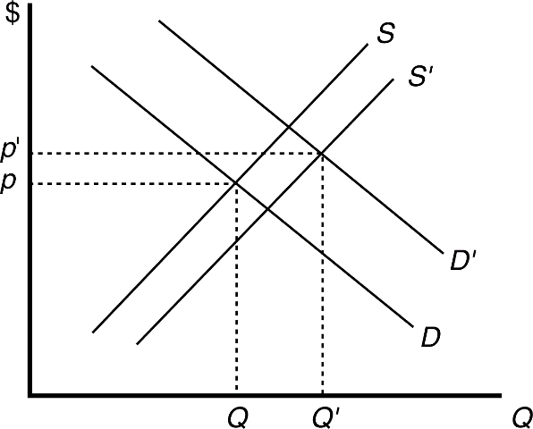

Figure 2.1

b. False. The supply curve shifts right due to the decrease in taxes, and the demand curve shifts left due to the decrease in orange prices. Prices will be lower, and the change in quantity depends on the magnitude of the shifts. See Figure 2.2. In the case of Figure 2.2, the large rightward shift in supply compared to the relatively small shift of the demand curve causes quantity to increase.

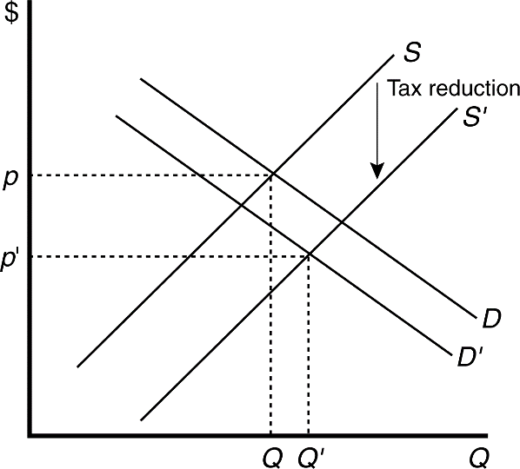

*Figure 2.2*

c. Uncertain. In this case, the demand and supply curves both shift to the left. Quantity decreases, but price may rise, fall, or remain unchanged depending on the relative magnitude of the shifts. See Figure 2.3. In this case, price remains unchanged.

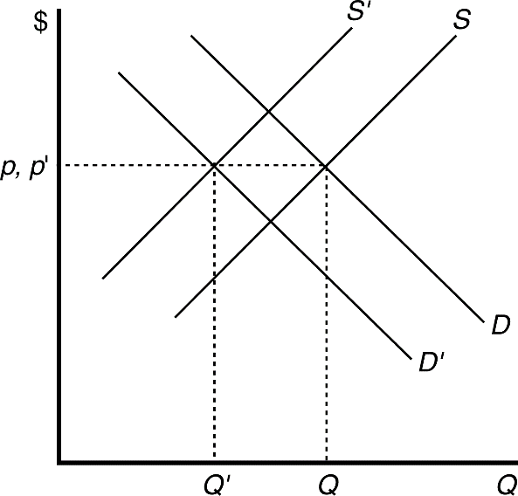

Figure 2.3

6. Set and solve.

For 

For 

$

Q

20 50

30

*S*

When the capacity of the theater has been reached at 50 tickets, the supply curve becomes vertical; increases in price will have no effect on the number of tickets the theater will supply.

7. Set and solve.



Equilibrium quantity is zero because the demand curve lies below the supply curve at all prices where output is positive. See Figure 2.4.

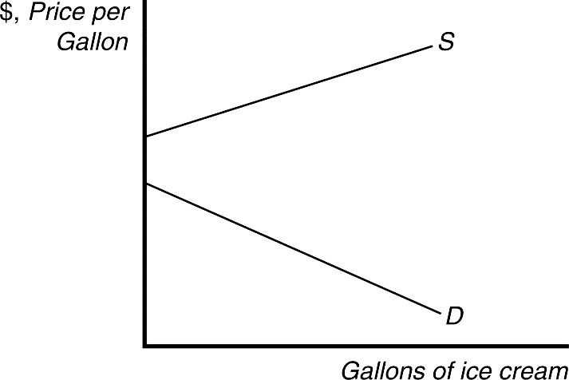

Figure 2.4

8. Set  and solve.

For 

For 

9. The equilibrium solution with no government intervention is



When the quota is imposed at 300 units, supply cannot exceed that level, regardless of price.   
Thus, the supply curve becomes vertical at 300 units. The new equilibrium quantity is 300, and   
price is determined by where the supply curve with the quota (*S*quota) intersects the demand curve   
(see Figure 2.5). To solve for the price, plug the quota value (300) into the demand equation.



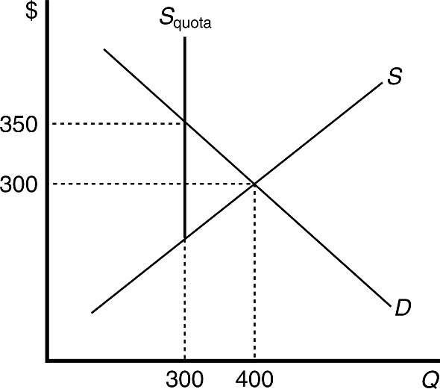

Figure 2.5

A quota on baseball hats would increase the price of baseball hats, which are a substitute for cowboy hats. As a result, demand for cowboy hats would increase (shift upwards), and the equilibrium price for cowboy hats would increase.

1. When park visits are free, the equilibrium quantity is 10,000  10,000 – 100(o). With a $20.00 entrance fee quantity falls to 8,000. See Figure 2.6.

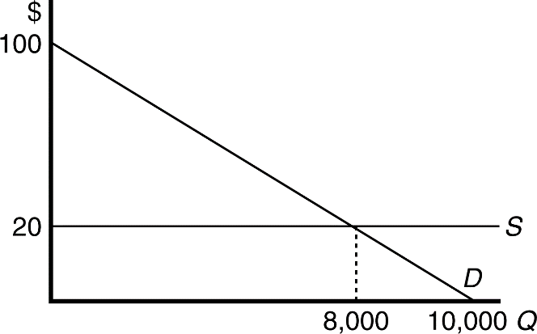

Figure 2.6

1. The demand curve of the previous model shifts to the right. If the new model is more expensive, the demand curve for the previous model still shifts to the right, but with a smaller magnitude.

12. Without the wage ceiling, the equilibrium is given by



where

*W*  4 and *Q*  9,600.

With the wage ceiling of $3 per hour, the market wage rate will be *W*  3, and the amount of labor employed will be 7,700.

13. If the government limits the number of licenses available, new taxis can no longer enter the market if the price increases. As a result, once the number of taxis equals the number of licenses available, the supply curve becomes steeper, as any additional taxi rides must be supplied by taxis currently in the market. When the government eliminates the restriction, the supply curve no longer has a kink and becomes flatter, and the equilibrium price decreases, while the equilibrium quantity increases.   
See Figure 2.7.

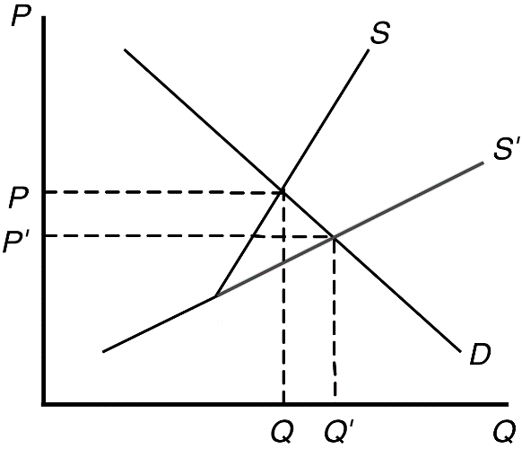

Figure 2.7

◼ Answers to Textbook Questions

**Chapter 2**

**Supply and Demand**

1.1 Substituting the values for price and income into the demand function, we find that *Q*  63  *p*  *pb*  *pc*  2*Y* = 63 – 11*p* + 7(19) + 3(6) + 2(78) = 370 – 11*p.*

* 1. Holding prices constant,  million kg, where *Y* is in thousands of Australian dollars. Thus, a AU$200 increase in annual per capita income would cause demand to change by  million kg per year. The demand curve shifts to the right (that is, demand would increase) by 400,000 kg per year (from *Q* = 370 – 11*p* to *Q* = 370.4 – 11*p*).
  2. The demand for Starbucks’ coffee will shift to the left (decrease), assuming that consumers were unaware of the calorie content prior to the signage and view high calorie drinks negatively.
  3. Substituting in the price of tomatoes and the original level of income gives *Q =* 160 – 40*p* or *p* = 4– 0.025*Q*. With the new level of income, *Q* = 170 – 40*p* or *p* = 4.25 – 0.025*Q*. The demand curve shifts to the right.

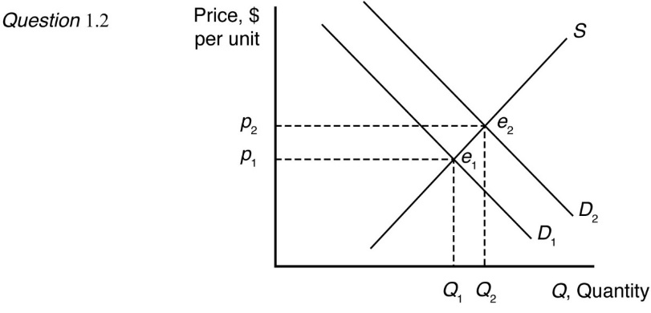

* 1. . If ∆*Q* = –2 (that is, 2 million kg less per year), the price would have to change by ∆*p* = –0.09∆Q = –0.09(–2) = 0.18. Thus, the price would have to rise by AU$0.18 per kg for consumers to want to buy 2 million kg of lamb less per year.

1.6 The total demand curve is the horizontal sum of the individual demand curves for food and feed:

*Q* = *Q*food + *Q*feed.

Since *Q*feed = 0 at prices above $27.56, for *p* > 27.56;

Q = 1,487 – 22.1*p*

and for *p* < 27.56

Q = 7,735 – 248.8*p*.



1.7 *Q* = *Q*1 + *Q*2 = (120 – *p*) + (60 – 1/2*p*) = 180 – 1.5*p.*

1.8 The total demand function is *Q* = *Qs* + *Q*l = 15.6*p*–0.563 + 16*p*–0.296.

1.9 The total demand function is *Q* =  At a price of $1.00, Apple Store customers demand , and Google Play customers demand , for a total of 2.8 million apps.

2.1 Holding the price of lamb constant,  million kg per year. If the price of sheep rises by AU$0.50 per kg, then supply changes by ∆*Q* = –9∆*ps* = –9 × 0.5 = –4.5. The supply curve shifts to the left at any price (that is, supply would increase) by 4.5 million kg per year (from *Q*1 = 104 + 8p to *Q*2 = 99.5 + 8p).

2.2 The change in avocadoes supplied with respect to a change in the price of fertilizer is . Thus a $1.10 increase in income results a 22 unit decrease in avocadoes supplied. Graphically, this would be a leftward shift of the supply curve.

2.3 The world supply is *Q* = *Qj* + *Q*row = (–2 + 4*p*) + (25 + 8*p*) = 23 + 12*p*. Note that the Jordanian quantity supplied is zero at any price equal to or less than 0.5.

2.4 The no-quota total supply curve for wheat is the horizontal sum of the domestic supply curve and the no-quota foreign supply curve is 

The no-quota total supply curve equals the foreign supply curve at a price of IRR3 per ton or less, as  when *p* ≤ 3. With a quota of , the foreign supply curve is for prices up to and including IRR3 (the same as the no-quota foreign supply curve). At prices above IRR3 per ton, the foreign supply curve with a quota is vertical; foreign suppliers would like to supply more but cannot. Thus, the total supply curve with the quota is the foreign supply curve for *p* ≤ 3, and the domestic supply curve for *p* > 3 shifts 6 million tons to the right. Less is supplied with the quota at prices above IRR3 per ton, so the total supply curve with a quota is steeper, indicating that a given increase in price raises less of the quantity supplied with a quota than without one.

At a price of IRR5 per ton, 20 million tons of wheat would be supplied without the quota (10 million tons by domestic producers and 10 million tons by foreign producers), and 16 million tons would be supplied with the quota (10 million tons by domestic producers and 6 million tons by foreign producers).

2.5 The effect of a change in *pf* on *Q* is

 = –20*pf*

 = –20(1.10)

 = –22 units.

Thus, an increase in the price of fertilizer will shift the avocado supply curve to the left.

3.1 The statement “Talk is cheap because supply exceeds demand” makes sense if we interpret it to mean that the quantity supplied of talk exceeds the quantity demanded at a price of zero. Imagine a downward-sloping demand curve that hits the horizontal, quantity axis to the left of where the upward-sloping supply curve hits the axis. (The correct aphorism is “Talk is cheap until you hire a lawyer.”)

3.2 a. We know that the town consumes 9000 gallons per day at no cost; thus, there is a point on the demand curve at *p* = 0, *q* = 9,000. Thus (becauase we assume there is no negative demand), a linear demand curve would be along the horizontal axis, where *p* = 0.

1. The supply curve is drawn along the horizontal axis from the point where *q* = 0 until *q* = 10,000. To the right of where *q* = 10,000, the supply curve is upward sloping.
2. Quantity supplied and demanded reach an equilibrium at any point under *q* = 10,000, where *p* = 0.

3.3 The supply curve is upward sloping and intersects the vertical price axis at $6. The demand curve is downward sloping and intersects the vertical price axis at $4. When all market participants are able to buy or sell as much as they want, we say that the market is in equilibrium: a situation in which no participant wants to change its behavior. Graphically, a market equilibrium occurs where supply equals demand. An equilibrium does not occur at a positive quantity because supply does not equal demand at any price.

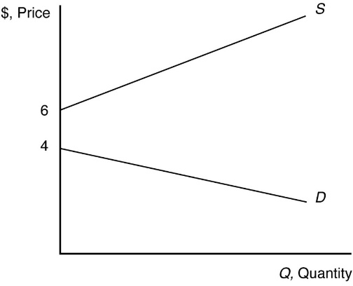

3.4 Substitute the price and income information into the demand and supply functions to obtain the demand curve, *Qd* = 370  11p, and the supply curve, *Qs* = 104 + 8*p*. Set quantity demanded equal to quantity supplied, *Qd* = *Qs* = *Q*, to solve for the equilibrium price, *p*:

370 – 11*p* = 104 + 8*p*

19*p* = 266

*p* = 14

Substitute *p* = 14 into either the demand or supply curve to solve for the equilibrium quantity, *Q*:

Q = 370 – 11 × 14 = 104 + 8 × 14 = 216.

3.5 In equilibrium, the quantity demanded, *Q* = *a* – *bp*, equals the quantity supplied, *Q* = *c* + *ep*, so *a* – *bp* = *c* + *ep*. By solving this equation for *p*, we find that the equilibrium price is

*p* = (*a* – *c*)/(*b* + *e*).

By substituting this expression for *p* into either the demand curve or the supply curve, we find that the equilibrium quantity is

*Q* = (*ae* – *bc*)/(*b* + *e*).

3.6 Substitute the price of coffee cherries in the supply function: *Qs* = 3.15 + 0.1*p* – 0.5 × 0.8 = 2.75 + 0.1*p*.

Set *Qd* = *Qs* and solve for the equilibrium price, *p*:

4.1 − 0.2*p* = 2.75 + 0.1*p*

0.3*p* = 1.35

*p* = 4.5 million pesos per thousand 60-kg bags.

Substitute *p* = 4.5 into either the demand or supply curve to solve for the equilibrium quantity *Q*:

*Q* = 4.1 − 0.2p = 2.75 + 0.1*p* = 3.2 thousand 60-kg bags.

4.1 The supply shock is unusually good luck or an unexpected increase in the number of lobsters in the ocean. The supply curve shifts to the rights, and thus the price falls.

4.2 Because it is now more attractive to rent an apartment (because you can more easily sublet for short periods of time), demand for apartments increases, which, all other things equal, increase the equilibrium rental price and quantity of apartments rented. (Note that an alternative answer might be that it reduces the supply of apartments on the market because if owners of apartments can make more money through Airbnb than through renting conventionally, they may withhold apartments from the market. In this case, supply decreases as well, reinforcing the rental price increase but making the effect on the quantity indeterminate.

4.3 As shown in the diagram below, the demand curve shifts left from *D*1 to *D*2 by 50% (the distance between *Q*0 and *Q*4). For supply curve *S*1, the equilibrium price falls from *p*0 to *p*1, a change of less than 50%. For a steeper supply curve *S*2, the equilibrium price falls further to *p*2, but the decrease is still less than 50%. In both cases, the equilibrium quantity also falls by less than 50%.

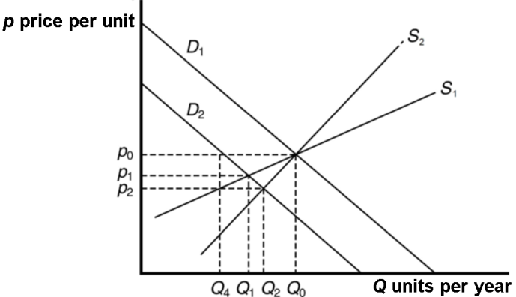

4.4 The eradication program shifted the U.K. supply curve for beef significantly to the left, thereby increasing the equilibrium price of beef in the United Kingdom and reducing the equilibrium quantity.

4.5 a. Health benefits from drinking red wine shift the demand curve for red wine in the Italian market to the right because more red wine is now demanded at each price. The new market equilibrium is where the original supply curve intersects the new demand curve at a higher price and higher quantity.

b. Imports shift the supply curve for red wine to the right because more red wine is now supplied at each price. The new market equilibrium is where the original demand curve intersects the new supply curve, at a lower price and higher quantity.

c. A recession shifts the demand curve for red wine left because less red wine is now demanded at each price. The new market equilibrium is where the original supply curve intersects the new demand curve, at a lower price and lower quantity.

d. Technological improvements shift the supply curve for red wine right because more red wine is now supplied at each price. The new market equilibrium is where the original demand curve intersects the new supply curve, at a lower price and higher quantity.

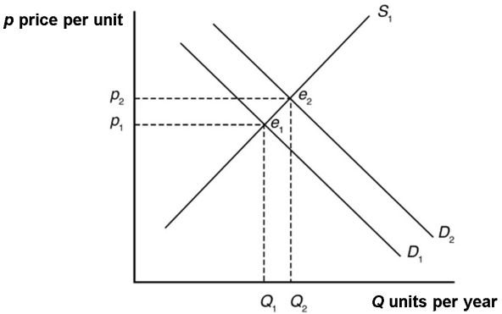

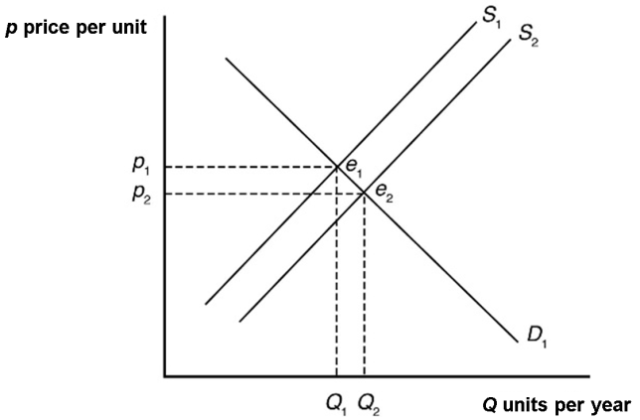

4.6 The Internet shifts the demand curve for newspaper advertising to the left because fewer companies demand newspaper advertising with online advertising available. The Internet may force some newspapers out of business, so the supply curve for newspaper advertising will shift to the left some. The new market equilibrium is where the new demand curve intersects the new supply curve. At the new equilibrium, there is less newspaper advertising.

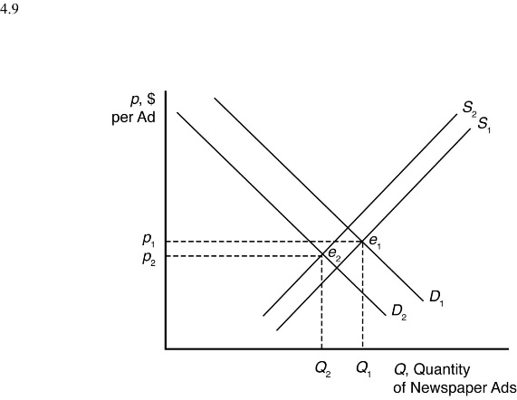

4.7 The increased use of corn for producing ethanol will shift the demand curve for corn to the right. This increases the price of corn overall, reducing the consumption of corn as food.

4.8 Setting quantity supplied equal to quantity demanded gives *p* = 40 + 4*r*. As the price of capital increases, the equilibrium price rises. Likewise, inverting the demand and supply curves and solving now for quantity, *Q* = 140 – 8*r*. The equilibrium quantity falls as the price of capital increases. (The increase in the price of capital reduces supply.)

4.9 When *pc* = 0.8, the Mexican supply curve for coffee beans is *Qs* = 3.15 + 0.1*p* – 0.5*pc* = 2.75 + 0.1*p*. The Mexican demand curve for coffee beans is *Qd* = 4.1 – 0.2*p*. Setting *Qd* = *Qs*, the equilibrium price is *p* = 4.5 and the equilibrium quantity is *Q* = 3.2.

If the price of coffee cherries falls by 25% to *pc* = 0.6, the Mexican supply curve for coffee beans shifts right to *Qs* = 3.15 + 0.1*p* – 0.5 × 0.6 = 2.85 + 0.1*p*. Setting *Qd* = *Qs*, the new equilibrium price is *p* = 4.17 and the new equilibrium quantity is *Q* = 3.26.

5.1 An increase in demand due to higher quality professionals will shift the demand curve to the right, further raising prices. The equilibrium quantity could be more, less, or the same as before the licensing restriction, depending on whether the supply or the demand effect is greatest. However, it will be more than the quantity would be with only the licensing change in place.

5.2 A ban has no effect if foreigners supply nothing at the pre-ban equilibrium price. Thus, if imports occur only at prices above those actually observed, a ban has no practical effect.

5.3 A ban on imports of genetically modified products from non-E.U. countries by one member country might not cause much of a fall in demand within that country or have a significant effect on their price or quantity if the member country represents only a small percentage of the world market or if non-E.U. producers simply shipped the products to other non-E.U. countries. More of the products might also be imported by other E.U. countries and resold to the E.U. country that imposed the ban in the first place. The effectiveness of a ban by one E.U. member state might also give rise to legal concerns, with the World Trade Organization, for example, and monitoring the ban could be challenging.

5.4 The quota causes the supply curve to become steeper at the price where foreign imports are impacted by the quota, above which foreign imports cannot be increased and the foreign supply curve becomes vertical. Below that price, the supply curve is unaffected. If the demand curve intersects the supply curve at a price below the kink, the equilibrium is unaffected, and the quota does not bind. If the quota is binding (the demand curve intersects supply above the kink), the equilibrium price will be higher and the quantity will be lower than without the quota.

5.5 Tighter certification requirements for foreign-trained physicians would increase the costs they face when migrating to the country imposing the policy and shift their supply curve to the left at each price, S1. The new supply curve for foreign-trained physicians intersects the wage axis at a higher point than the supply curve for domestically trained physicians does, causing a kink in the total supply curve for physicians, as shown in the diagram below. To the right of the kink, the total supply curve becomes steeper (more inelastic). If the demand curve intersects the new total supply curve above the kink, the prices for medical services rise due to higher salaries for physicians, most of whom would be domestically trained. Consumers are at a disadvantage because of the increase in price and decrease in quantity of physicians. If the demand curve intersects the new total supply curve below the kink, tighter certification requirements will have no effect on equilibrium supply and demand.

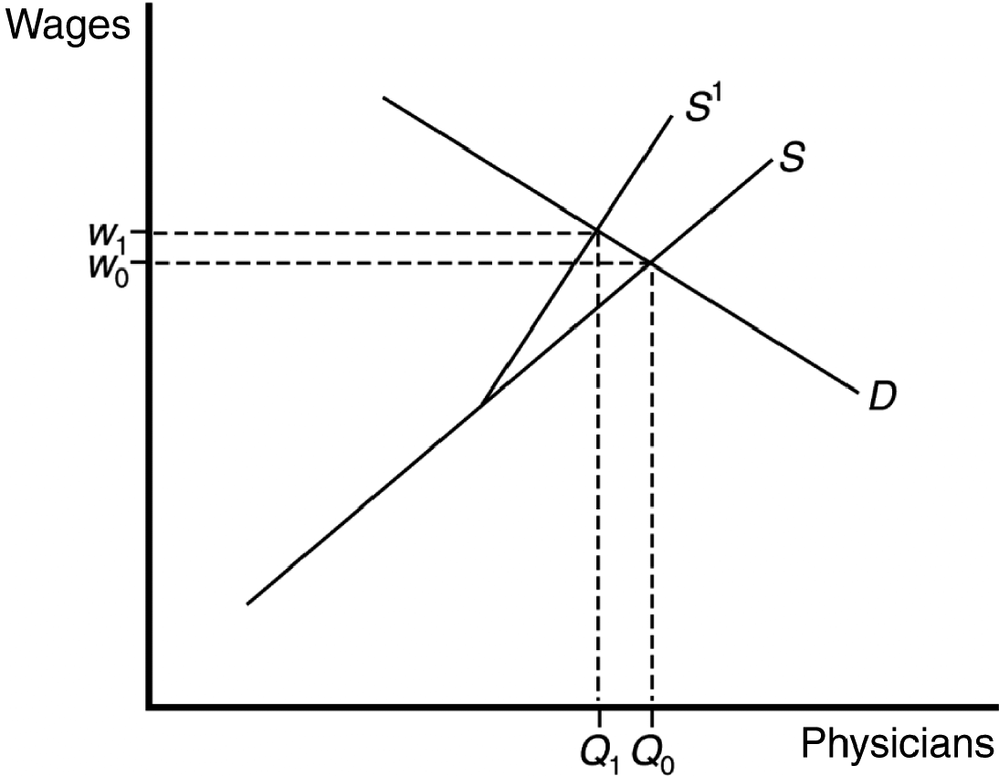

5.6 With a binding price ceiling, such as a ceiling on the rate that can be charged on loans, some consumers who demand loans at the rate ceiling will be unable to obtain them. This is because the demand for bank loans is greater than the supply of bank loans to low-income households with the usury law.

5.7 a. The minimum wage raises the wage above the equilibrium level. This reduces the quantity of labor demanded (where the Bt300 minimum wage intersects the labor demand curve) and increases the quantity of labor supplied (where the Bt300 minimum wage intersects the labor supply curve).

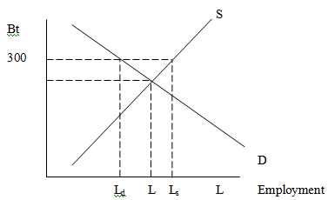

Unemployment equals excess labor. That is, unemployment equals the quantity of labor supplied minus the quantity of labor demanded: *L*s – *L*d.

b. The minimum wage shifts the supply curve up, as production costs increase, until the point where the demand curve intersects the new supply curve is at a price of Bt40 for ready-to-eat meals.

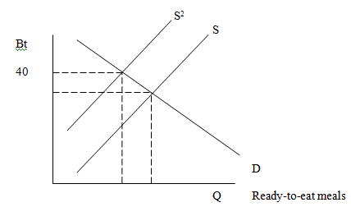

1. The price controls lower the price of meals below the equilibrium level. This increases the quantity demanded (where the maximum price with the price controls intersects the demand curve) and decreases the quantity supplied (where the maximum price intersects the supply curve).
2. As the price of meals demanded decreases, owners of restaurants will demand fewer workers, shifting the labor demand curve to the left.

5.8 Rent control is a type of price ceiling. A binding price ceiling that is set below the equilibrium price causes the quantity of rental properties supplied to fall below the equilibrium level in the market and the quantity of rental properties demanded to rise above the market-clearing level. The quantity supplied is less than the quantity demanded and the rent control law prevents equilibrium adjustment from occurring, therefore there is persistent excess demand or shortage of rental properties.

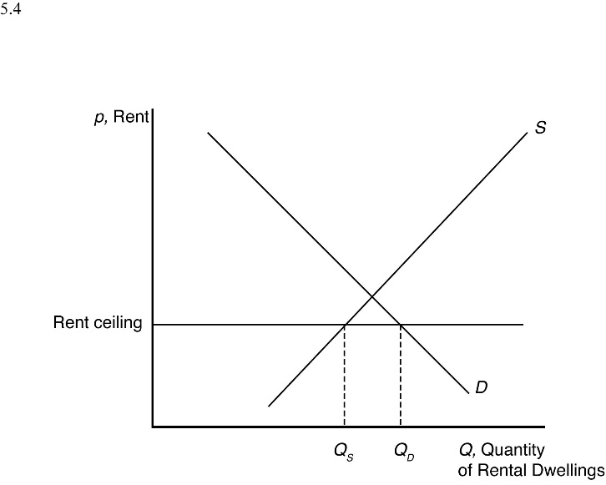

5.9 In the absence of price controls, the leftward shift of the supply curve as a result of a severe disruption in the supply of a product would push the market price up and reduce the equilibrium quantity. A legal requirement to keep the price below its market-clearing level—a binding price ceiling—causes consumers to demand a larger quantity of the product than the quantity supplied. The resulting shortage imposes significant search costs on consumers and harm those unable to obtain the product. The reduced quantity and price also reduces profits for firms selling the product. This policy would benefit the consumers who are able to acquire the product at the lower price.

5.10 The supply curve for coffee beans is *Qs* = 2.75 + 0.1*p* and the demand curve is *Qd* = 4.1 – 0.2*p*. When *p* = 7.5, the quantity supplied is *Qs* = 2.75 + 0.1 × 7.5 = 3.5 thousand 60-kg bags and the quantity demanded is 2.6 thousand 60-kg bags. The excess supply, or surplus, of coffee beans which the government buys is *Qs* – *Qd* = 3.5 – 2.6 = 0.9 thousand 60-kg bags.

5.11 In the Venezuelan corn flour market, there is a price ceiling, and thus there is a shortage (graph is the same as the rent ceiling graph in Question 5.8). If corn flour is smuggled to Columbia, the supply of corn flour increases there, resulting in a lower price and higher quantity sold.

6.1 The supply-and-demand model is useful for making predictions in perfectly competitive markets. That is, the supply-and-demand model is applicable in markets in which everyone is a price taker, firms sell identical products, everyone has full information about the price and quantity of goods, and the costs of trading are low.

Markets in which the supply-and-demand model has proven useful include agriculture, finance, labor, construction, services, wholesale, and retail—markets with many firms and consumers and where firms sell identical products.

1. The market for apples is a competitive, agricultural market.
2. The market with convenience stores is a competitive, retail market.

c & d. The supply-and-demand model is not appropriate in markets in which there are only one or a few sellers (such as electricity), firms produce differentiated products (such as music CDs), consumers know less than sellers about quality or price (such as used cars), or there are high transaction costs (such as nuclear turbine engines). Electronic games are differentiated products supplied by three dominant firms.

7.1 As shown in panel (a) of the figure below, the beef supply curve would shift to the left from *S*1 to *S*2 in the importing countries that imposed the ban. The foreign demand curve, *D*, would be unaffected if the risk of foreign buyers consuming tainted meat did not increase. Thus, the leftward shift of the supply curve causes the equilibrium to move along the demand curve from *e*1 to *e*2. The equilibrium price rises from *p*1 to *p*2, and the equilibrium quantity falls from *Q*1 to *Q*2.

As shown in panel (b) of the figure below, the closure of export markets for a country’s beef products would be reflected in a rightward shift of the supply curve for beef for domestic sale from *S*1 to *S*2 in the short run. In addition, the fall in domestic sales would be reflected in a leftward shift of the demand curve from *D*1 to *D*2. Both of these shifts work to reduce the equilibrium price from *p*1 to *p*2. If the rightward shift of the supply curve outweighs the leftward shift of the demand curve, then the equilibrium quantity rises from *Q*1 to *Q*2, and the short-run equilibrium shifts from *e*1 to *e*2.

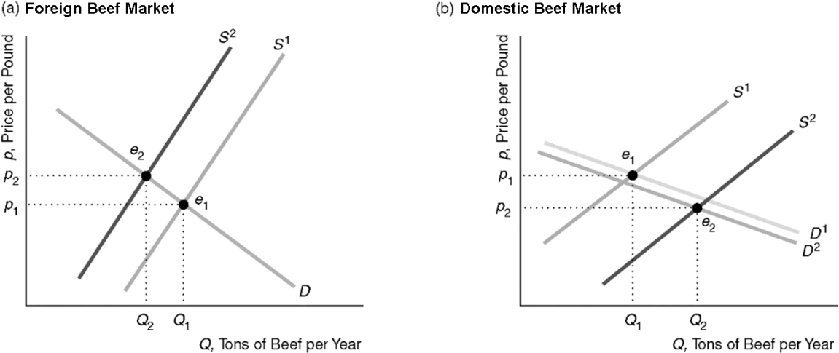

7.2 If the demand curve shifts to the left more than the supply curve shifts to the right, then the equilibrium quantity falls. However, under no circumstance does the equilibrium price increase, because the leftward shift in demand and the rightward shift in supply both work to lower the equilibrium price.

7.3 Both the demand and supply of guns have increased; that is, demand shifted up to the right and supply shifted down to the right. However, the results suggest that the increase in demand was greater than the increase in supply and this led to an increase in both equilibrium price and quantity.