|  |  |
| --- | --- |
| 2 | the economic problem |

 Chapter

Answers to the Review Quizzes

Page 32

1. How does the production possibilities frontier illustrate scarcity?

The unattainable combinations of production that lie *beyond* the *PPF* illustrate the concept of *scarcity*. There simply are not enough resources to produce any of these combinations of outputs. Additionally, while moving along the *PPF* to increase the production of one good requires that the production of another good be reduced, which also illustrates scarcity.

2. How does the production possibilities frontier illustrate production efficiency?

The combinations of outputs that lie on the *PPF* illustrate the concept of production efficiency. These points are the maximum production points possible and are attained only by producing the goods and services at the lowest possible cost. Any point inside the frontier reflects production where one or both outputs may be increased without decreasing the other output level. Clearly, such points cannot be production efficient.

3. How does the production possibilities frontier show that every choice involves a tradeoff?

Movements along the *PPF* illustrate that producing more of one good requires producing less of the other good. This observation reflects the result that a *tradeoff* must be made when producing output efficiently.

4. How does the production possibilities frontier illustrate opportunity cost?

The negative slope of the production possibility curve illustrates the concept of *opportunity cost*. Moving along the production possibility frontier, producing additional units of a good requires that the output of another good must fall. This sacrifice is the opportunity cost of producing more of the first good.

5. Why is opportunity cost a ratio?

The slope of the *PPF* is a *ratio* that expresses the quantity of lost production of the good on the *y*-axis to the increase in the production of the good on the *x*-axis moving downward along the *PPF*. The steeper the slope, the greater ratio and the greater is the opportunity cost of increasing the output of the good measured on the horizontal axis.

6. Why does the PPF bow outward and what does that imply about the relationship between opportunity cost and the quantity produced?

Some resources are better suited to produce one type of good or service, like pizza. Other resources are better suited to produce other goods or services, like DVDs. If society allocates resources wisely, it will use each resource to produce the kind of output for which it is best suited. Consider a *PPF* with pizza measured on the *x*-axis and DVDs measured on the *y*-axis. A small increase in pizza output when pizza production is relatively *low* requires only a small increase in the use of those resources still good at making pizza and not good at making DVDs. This yields a small decrease in DVD production for a large increase in pizza production, creating a relatively *low opportunity cost* reflected in the gentle slope of the *PPF* over this range of output. However, the same small increase in pizza output when pizza production is relatively *large* will require society to devote to pizza production those resources that are less suited to making pizza and more suited to making DVDs. This reallocation of resources yields a relatively small increase in pizza output for a large decrease in DVD output, creating a relatively *high opportunity cost* reflected in the steep slope of the *PPF* over this range of output. The opportunity cost of pizza production increases with the quantity of pizza produced as the slope of the *PPF* becomes ever steeper. This effect creates the *bowed out* effect (the concavity of the *PPF* function) and means that as more of a good is produced, the opportunity cost of producing additional units increases.

Page 35

1. What is marginal cost? How is it measured?

*Marginal cost* is the opportunity cost of producing *one more unit* of a good or service. Along a *PPF* marginal cost is reflected in the absolute value of the slope of the *PPF*. In particular, the magnitude of the slope of the *PPF* is the marginal cost of a unit of the good measured along the *x*-axis. As the magnitude of the slope changes moving along the *PPF*, the marginal cost changes.

2. What is marginal benefit? How is it measured?

The *marginal benefit* from a good or service is the benefit received from consuming one more unit of it. It is measured by what an individual is willing to give up (or pay) for an additional unit.

3. How does the marginal benefit from a good change as the quantity produced of that good increases?

As more of a good is consumed, the marginal benefit received from each unit is smaller than the marginal benefit received from the unit consumed immediately before it, and is larger than the marginal benefit from the unit consumed immediately after it. This set of results is known as the principle of *decreasing marginal benefit* and is often assumed by economists to be a common characteristic of an individual’s preferences over most goods and services in the economy.

4. What is allocative efficiency and how does it relate to the production possibilities frontier?

*Production efficiency* occurs when production takes place at a point on the *PPF*. This indicates that all available resources are being used for production and society cannot produce additional units of one good or service without reducing the output of another good or service. *Allocative efficiency*, however, requires that the goods and services produced are those that provide the greatest possible benefit. This definition means that the allocative efficient level of output is the point on the *PPF* (and hence is a production efficient point) for which the marginal benefit equals the marginal cost.

5. What conditions must be satisfied if resources are used efficiently?

Resources are used efficiently when more of one good or service cannot be produced without producing less of another good or service that is *valued more highly*. This is known as *allocative efficiency* and it occurs when: 1) production efficiency is achieved, and 2) the marginal benefit received from the last unit produced is equal to the marginal cost of producing the last unit.

Page 37

1. What generates economic growth?

The two key factors that generate economic growth are *technological change* and *capital accumulation*. Technological change allows an economy to produce more with the same amount of limited resources. Capital accumulation—the growth of capital resources including human capital—means that an economy has increased its available resources for production.

2. How does economic growth influence the production possibilities frontier?

Economic growth shifts the *PPF* outward. Persistent outward shifts in the production possibility frontier—economic growth—are caused by the accumulation of resources, such as more capital equipment or by the development of new technology.

3. What is the opportunity cost of economic growth?

When a society devotes more of its scarce resources to research and development of new technologies, or devotes additional resources to produce more capital equipment, both decisions lead to increased consumption opportunities in future periods at the cost of less consumption today. The loss of consumption today is the opportunity cost borne by society for creating economic growth.

4. Why has Singapore experienced faster economic growth than Australia?

Singapore chose to devote a greater proportion of its available resources to the production of capital than Australia. This allowed Singapore to grow at a faster rate than Australia. By forgoing consumption and producing a greater proportion of capital goods over the last few decades, Singapore was able to achieve consumption goods per person and capital goods per person greater than that in Australia.

5. Does economic growth overcome scarcity?

Scarcity reflects the inability to satisfy all our wants. Regardless of the amount of economic growth, scarcity will remain present because it will never be possible to satisfy all our wants. For instance, it will never be possible to satisfy all the wants of the several thousand people who all would like to ski the best slopes on Vail with only their family and a few best friends present. So economic growth allows more wants to be satisfied but it does not eliminate scarcity.

Page 41

1. What gives a person a comparative advantage?

A person has a comparative advantage in an activity if that person can perform the activity at a lower opportunity cost than anyone else. If the person gives up the least amount of other goods and services to produce a particular good or service, the person has the lowest opportunity cost of producing that good or service.

2. Distinguish between comparative advantage and absolute advantage.

A person has a *comparative advantage* in producing a good when he or she has the lowest opportunity cost of producing it. *Comparative advantage is based on the output forgone.* A person has an *absolute advantage* in production when he or she uses the least amount of *time or resources* to produce one unit of that particular good or service. *Absolute advantage is a measure of productivity in using inputs*.

3. Why do people specialise and trade?

People can compare consumption possibilities from producing all goods and services through *self-sufficiency* against specialising in producing only those goods and services that reflect their comparative advantage and trading their output with others who do the same. People can then see that the consumption possibilities from specialisation and trade are greater than under self-sufficiency. Therefore it is in people’s own *self-interest* to specialise. It was Adam Smith who first pointed out in the *Wealth of Nations* how individuals *voluntarily* engage in this socially beneficial and cooperative activity through the pursuit of their own self-interest, rather than the pursuit of society’s best interests.

4. What are the gains from specialisation and trade?

From society’s standpoint, the total output of goods and services available for consumption is greater with specialisation and trade. From an individual’s perspective, each person who specialises enjoys being able to consume a larger bundle of goods and services after trading with others who have also specialised, than would otherwise be possible under self-sufficiency. These increases are the gains from specialisation and trade for society and for individuals.

5. What is the source of the gains from trade?

As long as people have different opportunity costs of producing goods or services, total output is higher with specialisation and trade than if each individual produced goods and services under self-sufficiency. This increase in output is the gains from trade.

Page 43

1. Why are social institutions such as firms, markets, property rights, and money necessary?

These social institutions are necessary for a decentralised economy to coordinate production. *Firms* are necessary to allow people to specialise. Without firms, specialisation would be limited because a person would need to specialise in the *entire* production of a good or service. With firms people are able to specialise in producing particular bits of a good or service. For a society to enjoy the fruits of specialisation and trade, the individuals who comprise that society must voluntarily desire to specialise in the first place. Discovering trade opportunities after a person has specialised in his or her comparative advantage in production is what allows that person to gain from his or her own specialisation efforts. Trading opportunities can only take place if a *market* exists where people observe prices to discover available trade opportunities. *Money* is necessary to allow low-cost trading in markets. Without money, goods would need to be directly exchanged for other goods, a difficult and unwieldy situation. Finally people must enjoy social recognition of and government protection of *property rights* to have confidence that their commitments to trade arrangements will be respected by everyone in the market.

2. What are the main functions of markets?

The main function of a market is to enable buyers and sellers to get information and to do business with each other. Markets have evolved because they facilitate trade, that is, they facilitate the ability of buyers and sellers to trade with each other.

3. What are the flows in the market economy that go from firms to households and the flows from households to firms?

On the real side of the economy, goods and services flow from firms to households. On the monetary side of the economy, payments for factors of production, wages, rent, interest and profits, flow from firms to households. Flowing from households to firms on the monetary side of the economy are the expenditures on goods and services and on the real side are the factors of production, labour, land, capital and entrepreneurship.

Answers to the Study Plan Problems and Applications

|  |  |  |
| --- | --- | --- |
| Ethanol (barrels per day) |  | Food crops (tonnes per day) |
| 70 | and | 0 |
| 64 | and | 1 |
| 54 | and | 2 |
| 40 | and | 3 |
| 22 | and | 4 |
| 0 | and | 5 |

Use the following information to work Problems 1 to 3. Australia produces ethanol from sugar cane, and the land used to grow sugar cane is used to grow food crops. Suppose that Australia’s production possibilities for ethanol and food crops are as in the table.

1.a. Draw a graph of Australia’s PPF and explain how your graph illustrates scarcity.

Figure 2.1 shows Australia’s *PPF*.

C:\Documents and Settings\usilvge\Desktop\WFH\McTag\Jan 2013\9781442550773 SMS9 jpegs\9781442550773_Figure2.1_Problem1.jpgThe production possibilities frontier indicates scarcity because it shows the limits

to what can be produced. In particular, production   
combinations of ethanol and food crops that   
lie outside the production possibilities frontier  
are not attainable.

b. If Australia produces 40 barrels of ethanol a day, how much food must it produce to achieve production efficiency?

If Australia produces 40 barrels of ethanol per day, it achieves production efficiency if it also produces 3 tonnes of food per day.

c. Why does Australia face a tradeoff on its PPF?

Australia faces a tradeoff on its *PPF* because Australia’s resources and technology are limited. For Australia to produce more of one good, it must shift factors of production away from the other good. Therefore to increase production of one good requires decreasing production of the other, which reflects a tradeoff.

2.a. If Australia increases its production of ethanol from 40 barrels per day to 54 barrels per day, what is the opportunity cost of the additional ethanol?

When Australia is production efficient and increases its production of ethanol from 40 barrels per day to 54 barrels per day, it must decrease its production of food crops from 3 tonnes per day to 2 tonnes per day. The opportunity cost of the additional ethanol is 1 tonne of food per day for the entire 14 barrels of ethanol or 1/14 of a tonne of food per barrel of ethanol.

b. If Australia increases its production of food crops from 2 tonnes per day to 3 tonnes per day, what is the opportunity cost of the additional food?

When Australia is production efficient and increases its production of food crops from 2 tonnes per day to 3 tonnes per day, it must decrease its production of ethanol from 54 barrels per day to 40 barrels per day. The opportunity cost of the additional 1 tonne of food crops is 14 barrels of ethanol.

c. What is the relationship between your answers to parts (a) and (b)?

The opportunity costs of an additional barrel of ethanol and the opportunity cost of an additional tonne of food crop are reciprocals of each other. That is, the opportunity cost of 1 tonne of food crops is 14 barrels of ethanol and the opportunity cost of 1 barrel of ethanol is 1/14 of a tonne of food crops.

3. Does Australia face an increasing opportunity cost of ethanol? What feature of Australia’s PPF illustrates increasing opportunity cost?

Australia faces an increasing opportunity cost of ethanol production. For instance, when increasing ethanol production from 0 barrels per day to 22 barrels the opportunity cost of a barrel of ethanol is 1/22 of a tonne of food while increasing ethanol production another 18 barrels per day (to a total of 40 barrels per day) has an opportunity cost of 1/18 of a tonne of food per barrel of ethanol. The *PPF*’s bowed outward shape reflects the increasing opportunity cost.

Use the data in Problem 1 to work Problems 4 and 5.

4. Define marginal cost and calculate Australia’s marginal cost of producing a tonne of food when the quantity produced is 2.5 tonnes per day.

The marginal cost of a good is the opportunity cost of producing one more unit of the good. When the quantity of food produced is 2.5 tonnes, the marginal cost of a tonne of food is the opportunity cost of increasing the production of food from 2 tonnes per day to 3 tonnes per day. The production of ethanol falls from 54 barrels per day to 40 barrels per day, a decrease of 14 barrels per day. The opportunity cost of increasing food production is the decrease in ethanol produced, so the opportunity cost of producing a tonne of food when 2.5 tonnes of food per day are produced is 14 barrels of ethanol per day.

5. Define marginal benefit, explain how it is measured, and explain why the data in the table does not enable you to calculate Australia’s marginal benefit from food.

The marginal benefit of a good is the benefit received from consuming one more unit of the good. The marginal benefit of a good or service is measured by the most people are willing to pay for one more unit of it. The data in the table do not provide information on how much people are willing to pay for an additional unit of food. The table has no information on the marginal benefit from food.

6. Distinguish between *production efficiency* and *allocative efficiency*. Explain why many production possibilities achieve production efficiency but only one achieves allocative efficiency.

Production efficiency occurs when goods and services are produced at the lowest cost. This definition means that production efficiency occurs at any point *on* the *PPF*. Therefore *all* of the production points on the *PPF* are production efficient. Allocative efficiency occurs when goods and services are produced at the lowest cost *and* in the quantities that provide the greatest possible benefit. The allocatively efficient production point is the *single* point on the *PPF* that has the greatest possible net benefit.

Use the following graphs to work Problems 7 to 10. Harry enjoys tennis but wants a high grade in his economics course. The graphs show his *PPF* for these two “goods” and his MB curve from tennis.

|  |  |
| --- | --- |
| Figures/commonCH2sm2.tif | Figures/commonCH2sm3.tif |

7. What is Harry’s marginal cost of tennis if he plays for (i) 3 hours a week; (ii) 5 hours a week; and (iii) 7 hours a week?

(i) Harry’s marginal cost of an hour of tennis is 1.5 percentage points. When Harry increases the time he plays tennis from 2 hours to 4 hours, his grade in economics falls from 78 per cent to 75 per cent. His opportunity cost of these 2 additional hours of tennis is 3 percentage points, so his marginal cost of playing tennis for the third hour per week is 1.5 percentage points. (ii) Harry’s marginal cost of an hour of tennis is 2.5 percentage points. When Harry increases the time he plays tennis from 4 hours to 6 hours, his grade in economics falls from 75 per cent to 70 per cent. His opportunity cost of these 2 additional hours of tennis is 5 percentage points. So his marginal cost of playing tennis for the fifth hour per week is 2.5 percentage points. (iii) Harry’s marginal cost of an hour of tennis is 5 percentage points. When Harry increases the time he plays tennis from 6 hours to 8 hours, his grade in economics falls from 70 per cent to 60 per cent. His opportunity cost of these 2 additional hours of tennis is 10 percentage points. So his marginal cost of playing tennis for the seventh hour per week is 5 percentage points.

8. a. If Harry uses his time to achieve allocative efficiency, what is his economics grade and how many hours of tennis does he play?

Harry’s grade in economics is 65 per cent and he plays tennis for 7 hours per week. From the answer to part (a), Harry’s marginal cost of playing the third hour a week of tennis is 1.5 percentage points, his marginal cost of playing tennis the fifth hour a week is 2.5 percentage points and his marginal cost of playing tennis the seventh hour a week is 5 percentage points. Plot these three marginal opportunity costs in Figure 2.3 to create Harry’s marginal cost curve. Harry’s opportunity cost of playing tennis increases as he spends more time playing tennis. Harry uses his time efficiently if he plays tennis for 7 hours a week because when he plays 7 hours a week his marginal benefit from the seventh hour of tennis, 5 percentage points, equals his marginal cost, also 5 percentage points. When Harry plays 7 hours of tennis, the *PPF* in Figure 2.2 shows that his grade in economics is 65 per cent.

b. Explain why Harry would be worse off getting a grade higher than your answer to part (a).

If Harry studied for enough hours to get a higher grade, he would have fewer hours to play tennis. Harry’s marginal benefit from tennis would be greater than his marginal cost, so he would be more efficient (better off) if he played more hours of tennis and took a lower grade.

9. If Harry becomes a tennis superstar with big earnings from tennis, what happens to his *PPF*, his *MB* curve, and his efficient time allocation?

If Harry becomes a tennis superstar, his *PPF* does not change. Harry’s *PPF* shows the grade he can produce for different hours of playing tennis and these production possibilities are unaffected by Harry’s superstar status. As a result Harry’s *MC* curve does not change. However Harry’s marginal benefit from playing tennis increases because of his big paydays so his *MB* curve shifts rightward. As a result, Harry’s efficient allocation of time now allocates more time to tennis (and results in a lower grade).

10. If Harry suddenly finds high grades in economics easier to attain, what happens to his *PPF*, his *MB* curve, and his efficient time allocation?

If Harry finds high grades easier to attain, his *PPF* shifts outward. In particular for every level of tennis playing his grade in economics is higher. As a result Harry’s marginal cost of earning a high grade in economics is reduced so that Harry’s *MC* curve shifts downward. Harry’s *MB* curve does not change because Harry’s marginal benefit from playing tennis has not changed. Harry’s efficient time allocation results in Harry increasing the number of hours of tennis he plays.

11. A farm grows wheat and produces pork. The marginal cost of producing each of these products increases as more of it is produced.

a. Make a graph that illustrates the farm’s *PPF*.

The *PPF* is illustrated in Figure 2.4 as *PPF*0. Because the marginal cost of both wheat and pork increase as more of the good is produced, the *PPF* displays increasing opportunity cost so it has the “conventional” bowed-outward shape.

b. The farm adopts a new technology that allows it to use fewer resources to fatten pigs. Use your graph to illustrate the impact of the new technology on the farm’s *PPF*.

The new technology rotates the *PPF* outward from *PPF*0to *PPF*1.

c. With the farm using the new technology described in part (b), has the opportunity cost of producing a tonne of wheat increased, decreased, or remained the same? Explain and illustrate your answer.

The opportunity cost of producing wheat has increased. The opportunity cost of a bushel of wheat is equal to the magnitude of 1/(slope of the *PPF*). As illustrated in Figure 2.4, for each quantity of wheat the slope of *PPF*1 has a smaller magnitude than the slope of *PPF*0 so the opportunity cost of a bushel of wheat is higher along *PPF*1. For a specific example, the opportunity cost of increasing wheat produced from 600 tonnes per year to 800 tonnes per year along *PPF*1 is 6,000 kilograms of pork but is only 3,000 kilograms of pork along *PPF*0.

d. Is the farm more efficient with the new technology than it was with the old one? Why?

The farm is able to produce more with the new technology than with the old, but it is not necessarily more efficient. If the farm was producing on its *PPF* before the new technology and after, the farm was production efficient both before the new technology and after.

Use the following data to work Problems 12 and 13.

In an hour, Sue can produce 40 caps or 4 jackets and Tessa can produce 80 caps or 4 jackets.

12. a. Calculate Sue’s opportunity cost of producing a cap.

Sue forgoes 4 jackets to produce 40 caps, so Sue’s opportunity cost of producing one cap is (4 jackets)/(40 caps) or 0.1 jacket per cap.

b. Calculate Tessa’s opportunity cost of producing a cap.

Tessa forgoes 4 jackets to produce 80 caps, so Tessa’s opportunity cost of producing one cap is (4 jackets)/(80 caps) or 0.05 jacket per cap.

c. Who has a comparative advantage in producing caps?

Tessa’s opportunity cost of a cap is lower than Sue’s opportunity cost, so Tessa has a comparative advantage in producing caps.

d. If Sue and Tessa specialise in producing the good in which each of them has a comparative advantage, and they trade 1 jacket for 15 caps, who gains from the specialisation and trade?

Tessa specialises in caps and Sue specialises in jackets. Both Sue and Tessa gain from trade. Sue gains because she can obtain caps from Tessa at a cost of (1 jacket)/(15 caps), which is 0.067 jacket per cap, a cost that is lower than what it would cost her to produce caps herself. Tessa also gains from trade because she trades caps for jackets for 0.067 jacket per cap, which is higher than her cost of producing a cap.

13. Suppose that Tessa buys a new machine for making jackets that enables her to make 20 jackets an hour. (She can still make only 80 caps per hour.)

a. Who now has a comparative advantage in producing jackets?

Sue forgoes 40 caps to produce 4 jackets, so Sue’s opportunity cost of producing one jacket is (40 caps)/(4 jackets) or 10 caps per jacket. Tessa forgoes 80 caps to produce 20 jackets, so Tessa’s opportunity cost of producing one jacket is (80 caps)/(20 jackets) or 4 caps per jacket. Tessa has the comparative advantage in producing jackets because her opportunity cost of a jacket is lower than Sue’s opportunity cost.

b. Can Sue and Tessa still gain from trade?

Tessa and Sue can still gain from trade because Tessa (now) has a comparative advantage in producing jackets and Sue (now) has a comparative advantage in producing caps. Tessa will produce jackets and Sue will produce caps.

Use the following data to work Problems 14 to 17.

Imports accounted for about 70 per cent of sales of pork meat in Australia. Pork imports from Denmark, Canada, and the United States rose 48 per cent in the past year. Australian producers receive about $2.30 per kilogram, which costs $3 to produce.

14. What does this data suggest about Australia’s comparative advantage in pork meat production?

It suggests that Australia does not have a comparative advantage in pork production.

15. Pork imports had grown rapidly in the previous four years. What does this suggest about the change in Australia’s comparative advantage in this product and why might that change have occurred?

These facts suggest that whilst Australia may have previously had a comparative advantage in pork production, this is no longer the case. Since pork production is relatively labour intensive, relatively higher growth in labour costs in Australia could explain this change. Another factor might have been the boom in the Australian mineral industry causing both a rise in wages and an appreciation of the Australian dollar, making Australian pork production less internationally competitive.

16. Australia exports wine to Canada, while Canada is an important supplier of pork meat to Australia. Construct both an Australian and a Canadian *PPF* for wine and pork which are consistent with this pattern of trade.

With wine on the vertical axis and pork on the horizontal, the Australian PPF would be relatively steep compared with the Canadian, to reflect the higher opportunity cost of Australian pork production in terms of wine.

17. The pork industry had sought restrictions on imports but the government decided that there was no case for restricting imports. What would have been the effect of restrictions on imports on production efficiency in Australia?

Import restrictions would have raised the relative price of pork and increased output in the Australian pork industry, taking resources away from other industries. On the PPF, the production point would have shifted in favour of pork. This would not have changed production efficiency because we would have remained on the PPF. However, allocative efficiency would have worsened, because consumers would not have been able to buy as much pork as they wished at the world price of pork.

18. For 60 years, North Korea has had a centrally planned economy in which the government made the decisions on how resources will be allocated.

a. Why would you expect North Korea’s production possibilities (per person) to be smaller than those of Australia?

North Korea’s economy is almost surely less efficient than the Australian economy. The North Korean central planners do not know people’s production possibilities or their preferences. The plans that are created wind up wasting resources and/or producing goods and services that no one wants. Because firms in North Korea are owned by the government rather than individuals, no one in North Korea has the self-interested incentive to operate the firm efficiently and produce goods and services that consumers desire. Additionally North Korea does not actively trade so North Korea produces most of its consumption goods rather than buying them from nations with a comparative advantage. Because North Korea uses its resources to produce consumption goods, it cannot produce many capital goods so its economic growth rate has been low.

b. What are the social institutions that North Korea might lack that help Australia to achieve allocative efficiency?

Of the four social institutions—firms, money, markets, and property rights—North Korea’s economy has firms and money. Markets, however, are less free of government intervention in North Korea. But the major difference is the property rights in the North Korean economy. In North Korea the government owns most of the firms; that is, the government has the property right to run the producers. Because the firms are not motivated to make a profit, the managers of these firms have little incentive to operate the firm efficiently or to produce the goods and services that consumers desire. In Australia, firms are owned by individuals; that is, people have the property right that allows them to run firms. These owners have the self-interested incentive to operate the firm efficiently and to produce the goods and services people want, an incentive sorely lacking in the North Korean economy.

Use the following information to work Problems 19 and 20.

The Australian Department of Foreign Affairs and Trade China fact sheet shows that Australia imports clothing and electronic products from China and exports natural resource products to China.

|  |  |
| --- | --- |
|  |  |

19. a. Sketch a *PPF* for the production of clothing and resource-based products in China.

The *PPFs* for Questions 19.a and 19.b are illustrated in Figure 2.7 and Figure 2.8 above. The *PPFs* might be linear, though more realistic *PPFs* are bowed out from the origin, as illustrated above. The goods along the two axes are minerals and clothing. The important point about the two *PPFs* is that the opportunity cost of producing clothing is lower in China.

b. Sketch a *PPF* for the production of clothing and resource-based products in Australia.

The slope of each of the *PPFs* is equal to the opportunity cost of producing clothing, so the Australian *PPF* is steeper than China’s *PPF*. The important point about the two *PPFs* is that the opportunity cost of producing minerals is lower in Australia.

c. Sketch a marginal cost curve for the production of clothing in China.

d. Sketch a marginal cost curve for the production of clothing in Australia.

The marginal cost curves for producing clothing are illustrated in Figure 2.9. The marginal cost curves slope upward.

Because clothing is less costly to produce in China than in Australia, the Australian MC curve lies above the Chinese MC curve.

20. Explain how differences in *PPFs* and marginal costs lead to the trade described in the China fact sheet.

Australia imports clothing from China because it is cheaper to import than to produce it in Australia. Fewer mineral resources must be given up to import clothing than would be given up if Australia produced clothing.

21. The Australian Bureau of Agricultural Resource Economics and Sciences reports that pork imports have grown over the last 20 years.

a. What does an increase in pork imports suggest about Australia’s comparative advantage in pork meat production?

It suggests that whilst Australia may have previously enjoyed a comparative advantage in pork production, this may no longer be the case.

b. Occasionally the pork industry expresses concern about imports and seeks restrictions. What would be the effect of restrictions on imports on production efficiency in Australia?

Import restrictions would have raised the relative price of pork and increased output in the Australian pork industry, taking resources away from other industries. On the *PPF*, the production point would have shifted in favour of pork. This would not have changed production efficiency because we would have remained on the *PPF*. However, allocative efficiency would have worsened, because consumers would not have been able to buy as much pork as they wished at the world price of pork.

Answers to the Additional Problems and Applications

Use the following table to work Problems 22 and 23.

The people of Leisure Island have 50 hours of labour a day that can be used to produce entertainment and good food. The table shows the maximum quantity of either entertainment or good food that Leisure Island can produce with different quantities of labour.

|  |  |  |  |
| --- | --- | --- | --- |
| **Labour**  **(hours)** | **Entertainment**  **(units per month)** |  | **Good food**  **(units per month)** |
| 0 | 0 | or | 0 |
| 10 | 20 | or | 30 |
| 20 | 40 | or | 50 |
| 30 | 60 | or | 60 |
| 40 | 80 | or | 65 |
| 50 | 100 | or | 67 |

22. Is an output of 50 units of entertainment and 50 units of good food attainable and efficient? With a production of 50 units of entertainment and 50 units of good food, do the people of Leisure Island face a tradeoff?

An output of 50 units of entertainment and 50 units of good food is attainable but inefficient. With 50 hours of labour Leisure Island can produce 50 units of good food and 60 units of entertainment. The people of Leisure Island do not face a tradeoff because they can have 10 more units of entertainment without forgoing any units of good food.

23. What is the opportunity cost of producing an additional unit of entertainment? Explain how the opportunity cost of a unit of entertainment changes as more entertainment is produced.

The opportunity cost of an additional unit of entertainment increases with increased production of entertainment. The first 20 units of entertainment costs 2 units of good food or each unit of entertainment cost on average 0.1 unit of food. The second 20 units of entertainment costs 5 units of good food or each unit of entertainment cost on average 0.25 unit of food. The third 20 units of entertainment costs 10 units of good food or each unit of entertainment cost on average 0.5 unit of food. The fourth 20 units of entertainment costs 20 units of good food or each unit of entertainment cost on average 1 unit of food. The fifth 20 units of entertainment costs 30 units of good food or each unit of entertainment cost on average 1.5 unit of food.

Use the following table to work Problems 24 and 25.

24. Suppose that Sunland’s production possibilities are given in the table.

|  |  |  |  |
| --- | --- | --- | --- |
| **Food**  **(kilograms per month)** | | **Sunscreen**  **(litres per month)** | |
| 300 | and | | 0 |
| 200 | and | | 50 |
| 100 | and | | 100 |
| 0 | and | | 150 |

a. Draw a graph of Sunland’s *PPF* and explain how your graph illustrates a tradeoff.

Sunland’s *PPF* is illustrated in Figure 2.10. The figure illustrates a tradeoff because moving along Sunland’s *PPF* producing more of one good requires producing less of the other good. Sunland trades off more production of one good for less production of the other.

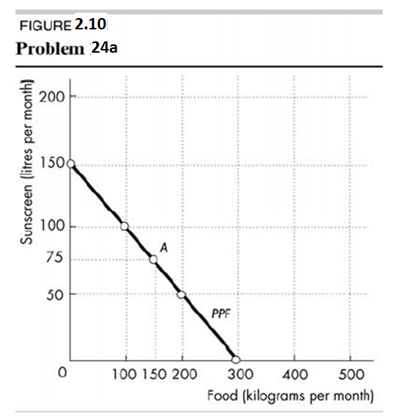b. If Sunland produces 150 kilograms of food per month, how much sunscreen must it produce if it achieves production efficiency?

If Sunland produces 150 kilograms of food per month, then the point labelled A on the *PPF* in Figure 2.10 shows that Sunland must produce 75 litres of sunscreen per month to achieve production efficiency.

c. What is Sunland’s opportunity cost of producing 1 kilogram of food?

Sunland’s *PPF* is linear so the opportunity cost of producing 1 kilogram of food is the same at all quantities.

To illustrate this, we can calculate the opportunity cost of producing a kilogram of food when moving from 0 to 100 kilograms per month. Between these two ranges of production, the quantity of sunscreen produced falls from 150 litres per month to 100 litres per month, a decrease of 50 litres. The opportunity cost is 100 litres of sunscreen to gain 200 kilograms of food. The opportunity cost per kilogram of food equals 0.5 litre of sunscreen.

d. What is Sunland’s opportunity cost of producing 1 litre of sunscreen?

Sunland’s *PPF* is linear so the opportunity cost of producing 1 litre of sunscreen is the same at all quantities. To illustrate this, we can calculate the opportunity cost of producing a litre of sunscreen when moving from 0 to 100 litres per month. Between these two ranges of production, the quantity of food produced falls from 300 kilograms per month to 100 kilograms per month, a decrease of 200 kilograms. The opportunity cost is 200 kilograms of food to gain 100 litres of sunscreen. The opportunity cost per litre of sunscreen equals 2 kilograms of food.

25. What feature of a *PPF* illustrates increasing opportunity cost? Explain why the country’s opportunity cost does or does not increase.

If opportunity costs increase, the *PPF* bows outward. Opportunity costs increase because not all resources are equally productive in all activities. The more of a good we produce the less productive are the additional resources we use to produce it. If resources are equally productive in all uses, then the country’s opportunity cost will not increase.

26. In problem 24, what is the marginal cost of a kilogram of food in Sunland when the quantity produced is 150 kilograms per day? What is special about Sunland’s marginal cost of food?

The marginal cost of producing an extra kilogram of food equals 0.5 litres of sunscreen. Sunland’s production possibility frontier is a straight line and so it has constant marginal cost.

27. The table describes the preferences in Sunland.

|  |  |  |
| --- | --- | --- |
| **Sunscreen**  **(litres per month)** | **Willingness to pay**  **(kilograms of food per litre)** | |
| 25 | 3 |
| 75 | 2 |
| 125 | 1 |

a. What is the marginal benefit from sunscreen and how is it measured?

The marginal benefit from sunscreen is the benefit enjoyed by the person who consumes one more litre of sunscreen. It is equal to the willingness to pay for an additional litre.

b. Draw a graph of Sunland’s marginal benefit from sunscreen.

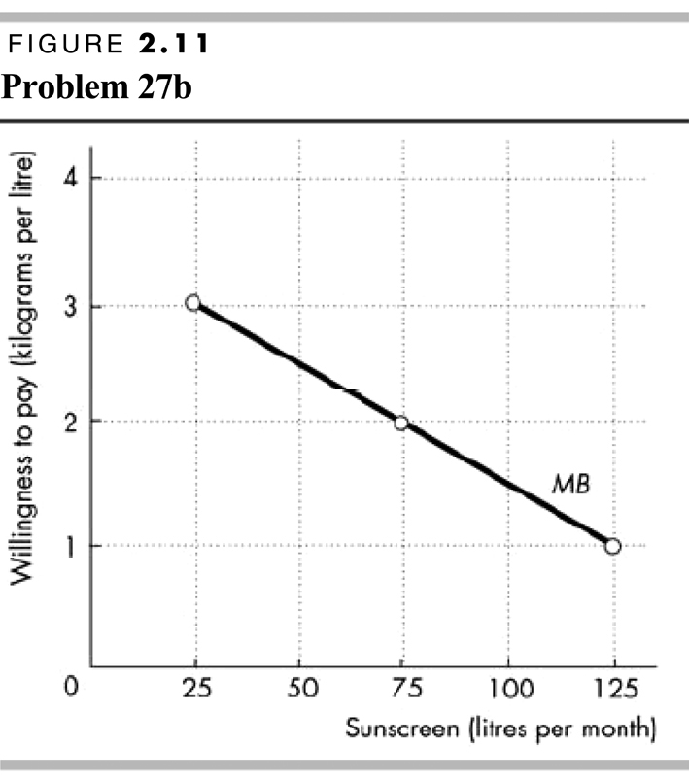To draw the marginal benefit from sunscreen curve, plot the quantity of sunscreen on the *x*-axis and the willingness to pay for sunscreen (that is, the number of kilograms of food that is willingly forgone to get a litre of sunscreen) on the *y*-axis. Figure 2.11 shows this graph.

28. Capital accumulation and technological change bring economic growth, which means that the *PPF* keeps shifting outward: Production that was unattainable yesterday becomes attainable today; production that is unattainable today will become attainable tomorrow. Why doesn’t this process of economic growth mean that scarcity is being defeated and will one day be gone?

Scarcity reflects the existence of unmet wants. People’s wants are infinite—regardless of what a person already possesses, everyone can easily visualise something else he or she wants, if only more time in the day to enjoy their possessions. Because people’s wants are insatiable, scarcity will always exist regardless of economic growth.

Use the following data to work Problems 29 and 30.

Kim can produce 40 pies or 400 cakes an hour. Liam can produce 100 pies or 200 cakes an hour.

29. a. Calculate Kim’s opportunity cost of a pie and Liam’s opportunity cost of a pie.

If Kim spends an hour baking pies, she gains 40 pies but forgoes 400 cakes. Kim’s opportunity cost of 1 pie is (400 cakes)/(40 pies), or 10 cakes per pie. If Liam spends an hour baking pies, he gains 100 pies but forgoes 200 cakes. Liam’s opportunity cost of 1 pie is (200 cakes)/(100 pies), or 2 cakes per pie.

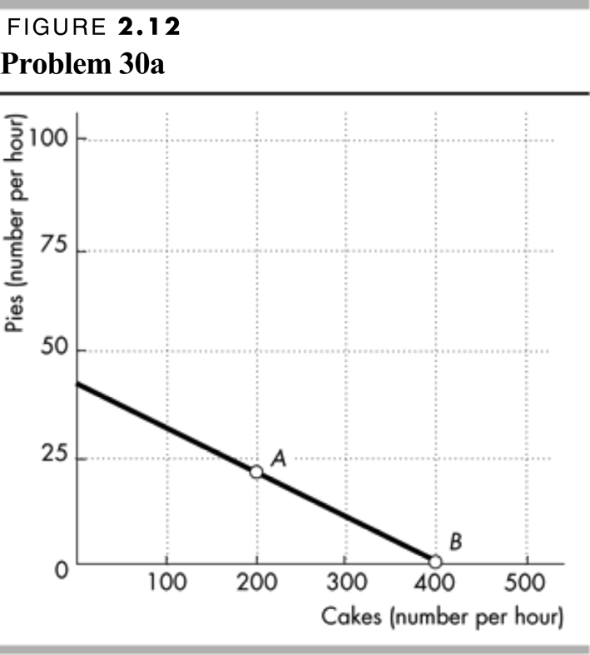b. If each spends 30 minutes of each hour producing pies and 30 minutes producing cakes, how many pies and cakes does each produce?

Kim produces 20 pies and 200 cakes. Liam produces 50 pies and 100 cakes. The total number produced is 70 pies and 300 cakes.

c. Who has a comparative advantage in producing pies? Who has a comparative advantage in producing cakes?

Liam has the comparative advantage in producing pies because his opportunity cost of a pie is less than Kim’s opportunity cost. Kim has the comparative advantage in producing cakes because her opportunity cost of a cake is less than Liam’s opportunity cost.

30. a. Draw a graph of Kim’s *PPF* and Liam’s *PPF*.

Kim’s *PPF* is illustrated in Figure 2.12; Liam’s *PPF* is illustrated in Figure 2.13.

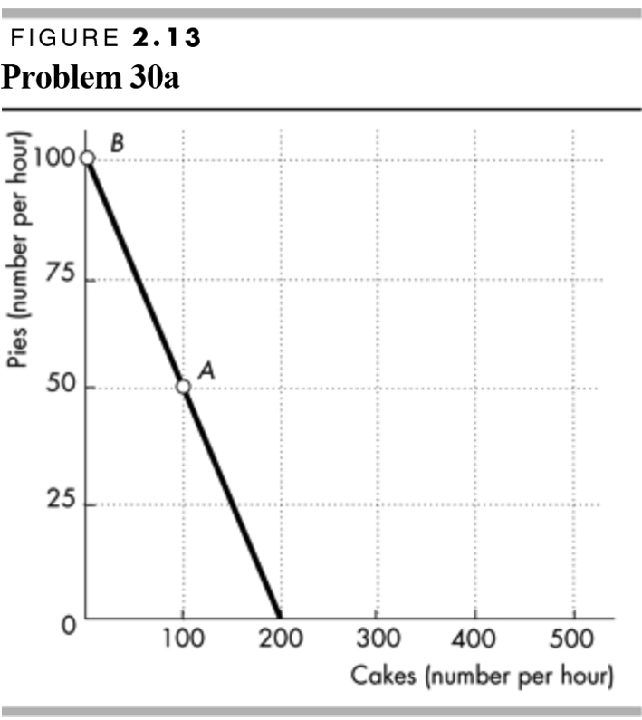 b. On your graph, show the point at which each produces when they spend 30 minutes of each hour producing pies and 30 minutes producing cakes.

Point *A* in both figures shows their production points when each spends 30 minutes making cakes and 30 minutes making pies.

c. On your graph, show what Kim produces and what Liam produces when they specialise.

Kim will specialise in cakes and Liam will specialise in pies. Point *B* in both figures shows the production points when each specialises.

d. When they specialise and trade, what are the total gains from trade?

Kim will specialise in cakes and Liam will specialise in pies. If they specialise and trade, the total production of *both* cakes and pies increase. When each spends 30 minutes making cakes and 30 minutes making pies, together they produce 300 cakes and 70 pies. When they specialise, together they produce 400 cakes and 100 pies. The 100 increase in cakes and the 30 increase pies is the gains from trade.

e. If Kim and Liam share the total gains equally, what trade takes place between them?

Kim will trade 50 cakes (half of the gain in cake production) to Liam in exchange for 15 pies (half of the increase in pie production).

31. Tony and Patty produce skis and snowboards. The first table shows Tony’s production possibilities and the second table shows Patty’s production possibilities. Each week, Tony produces 5 snowboards and 40 skis and Patty produces 10 snowboards and 5 skis.

1. Who has a comparative advantage in producing snowboards? And who has a comparative advantage in producing skis?

|  |  |  |
| --- | --- | --- |
| Tony’s Production Possibilities | | |
| Snowboards  (per week) |  | Skis  (per week) |
| 25 | and | 0 |
| 20 | and | 10 |
| 15 | and | 20 |
| 10 | and | 30 |
| 5 | and | 40 |
| 0 | and | 50 |

The person with a comparative advantage in producing snowboards is the person who has the lower opportunity cost of producing a snowboard.

Tony’s production possibilities show that to produce 5 more snowboards he must produce 10 fewer skis. So Tony’s opportunity cost of producing a snowboard is 2 skis.

|  |  |  |
| --- | --- | --- |
| Patty’s Production Possibilities | | |
| Snowboards  (per week) |  | Skis  (per week) |
| 20 | and | 0 |
| 10 | and | 5 |
| 0 | and | 10 |

Patty’s production possibilities show that to produce 10 more snowboards, she must produce 5 fewer skis. So Patty’s opportunity cost of producing a snowboard is 1/2 a ski. Patty has a comparative advantage in producing snowboards because her opportunity cost of producing a snowboard is less than Tony’s.

Tony has a comparative advantage in producing skis. For each ski produced, Tony must give up making 1/2 a snowboard, whereas for each ski that Patty produces, she must give up making 2 snowboards. So Tony’s opportunity cost of a ski is lower than Patty’s.

1. 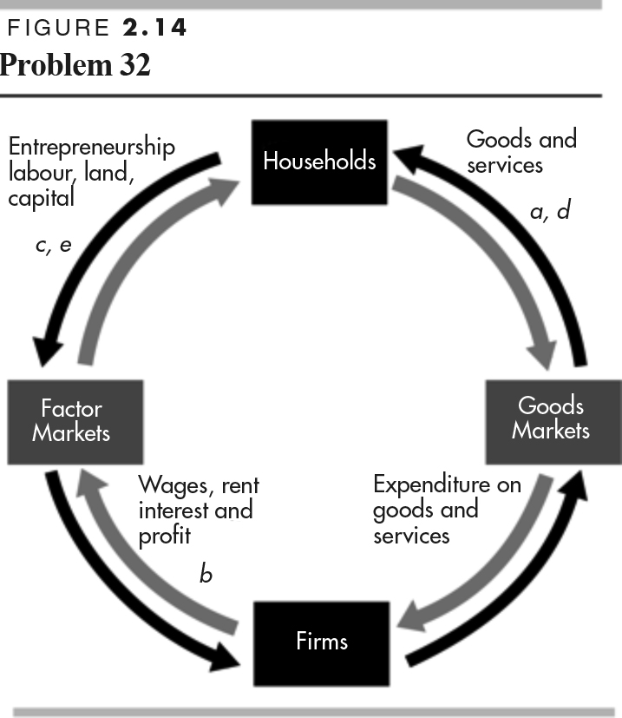 If Tony and Patty specialise and trade 1 snowboard for 1 ski, what are the gains from trade?

Patty has a comparative advantage in producing snowboards, so she specialises in snowboards. Tony has a comparative advantage in producing skis, so he specialises in producing skis. Patty produces 20 snowboards and Tony produces 50 skis.

Before specialising, they produced 15 snowboards (Patty’s 10 plus Tony’s 5) and 45 skis (Tony’s 40 plus Patty’s 5). By specialising, they increase their total output by 5 snowboards and 5 skis. They can share this gain by trading 1 ski for 1 snowboard. Patty can get skis from Tony for less than it costs her to produce them. Tony can buy snowboards from Patty for less than it costs him to produce them. Both Patty and Tony achieve gains from specialisation and trade.

32. Indicate on a graph of the circular flows in the market economy, the real and money flows in   
which the following items belong:

a. You buy an iPad from the Apple Store.

Figure 2.14 shows the circular flows in a market economy. Your purchase of an iPad from Apple is the purchase of a good from a firm. This flow is in the black arrow indicated by point *a* in the figure. When you pay for the iPad, the corresponding money flow is in the grey arrow in the opposite direction to the black arrow labelled *a*.

b. Apple Inc. pays the designers of the iPad.

Apple’s payment to the designers of the iPad is the payment of a wage to a factor of production. This flow is in the grey arrow indicated by point *b* in the figure. The flow of design services from the designer to Apple is in the black arrow in the opposite direction to the grey arrow labelled *b*.

c. Apple Inc. decides to expand and rents an adjacent building.

Apple’s decision to expand by renting a building means that Apple is increasing the capital it uses. This flow is in the black arrow indicated by point *c* in the figure. The flow of the payment for the rental services of the building is in the grey arrow in the opposite direction to the black arrow labelled *c*.

d. You buy a new e-book from Amazon.

Your purchase of an e-book from Amazon is the purchase of a good from a firm. This flow is in the black arrow indicated by point *d* in the figure. When you pay for the e-book, the corresponding money flow is in the grey arrow in the opposite direction to the black arrow labelled *a*.

e. Apple employs a student during the summer.

Apple’s decision to hire a student intern is Apple increasing the labour it uses. The flow of labour services is in the black arrow indicated by point *e* in the figure. The flow of the payment for the labour services is in the grey arrow in the opposite direction to the black arrow labelled *c*.

33. After you have studied *Reading Between the Lines* on pp. 44–45, answer the following questions.

a. Why has the marginal cost of producing food increased?

The marginal cost of producing food is expected to increase with global warming because more resources will be needed to produce a given quantity of food and less resources will be available to produce other goods and services. This loss of production of other goods and services is an increase in the opportunity cost of food.

b. What are the effects of successful agricultural research and development on the production of world food and on its marginal cost of production?

Successful agricultural research and development will produce drought and disease resistant strains of traditional food and find new varieties. The new crops will be more productive than the older varieties because it will be possible to produce more food with a given level of resources than would otherwise have been possible. The extra output of other goods and services that becomes possible because fewer resources are needed to produce the newly developed crops is the fall in the marginal cost of production of food. The marginal cost of food curve moves downwards.

c. What is the opportunity cost of investment in research and development? How would you decide the amount to invest in agricultural research and development?

The opportunity cost of investment in research and development is the next best use of the resources used in producing research and development. One possibility is that fewer goods and services are available for current consumption as resources are moved from consumer good production into producing research and development and current crops forgone.

The level of investment in agricultural research and development should be where the benefit received from the last unit invested is equal to the opportunity cost of the last unit invested. It is the level where the marginal benefit from investment in agricultural research and development is equal to its marginal cost.

34. **Malaria Eradication Back on the Table**

In response to the Gates Malaria Forum in October 2007, countries are debating the pros and cons of eradication. Dr Arata Kochi of the World Health Organization believes that with enough money malaria cases could be cut by 90 per cent, but he believes that it would be very expensive to eliminate the remaining 10 per cent of cases. He concluded that countries should not strive to eradicate malaria.

Source: *The New York Times*, 4 March 2008

a. Is Dr Kochi talking about *production efficiency* or *allocative efficiency* or both?

Dr Kochi is talking about allocative efficiency. His assessment is that the last 10 per cent eradication has such a high marginal cost that it almost surely exceeds its marginal benefit.

b. Make a graph with the percentage of malaria cases eliminated on the *x*-axis and the marginal cost and marginal benefit of driving down malaria cases on the *y*-axis. On your graph:

(i) Draw a marginal cost curve that is consistent with Dr Kochi’s opinion reported in the news clip.

(ii) Draw a marginal benefit curve that is consistent with Dr Kochi’s opinion reported in the news clip.

(iii) Identify the quantity of malaria eradicated that achieves allocative efficiency.

Figure 2.15 shows a marginal cost curve and a marginal benefit curve that are consistent with Dr Kochi’s views. The marginal cost curve rises rapidly after 90 per cent of malaria is eradicated. The allocatively efficient quantity of malaria eradicated is 90 per cent because that is the quantity for which the marginal benefit of eradication equals marginal cost.

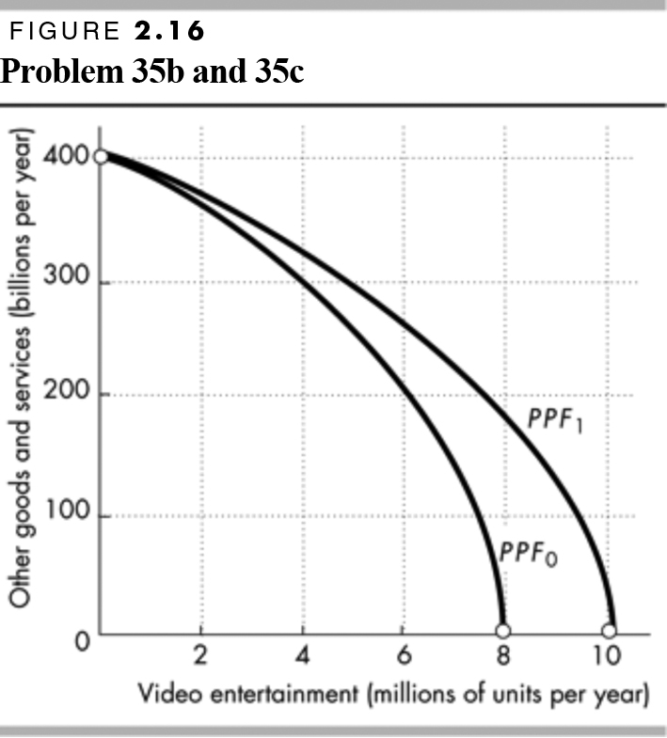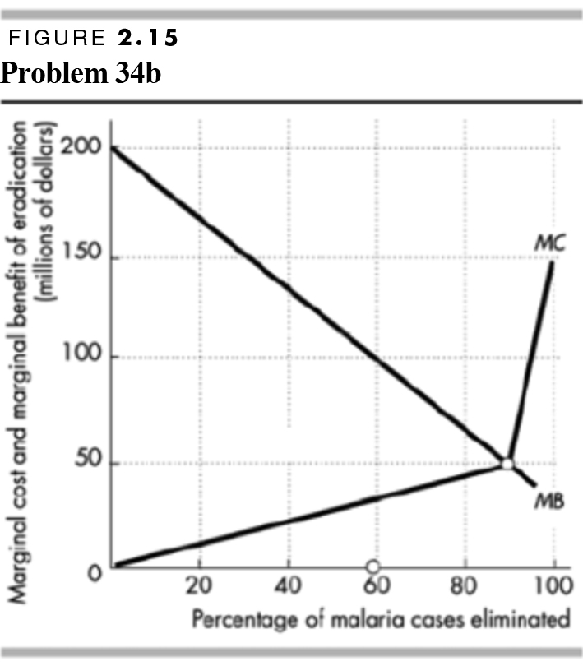

35. **Lots of Little Screens**

Inexpensive broadband access has created a generation of television producers for whom the Internet is their native medium. As they redirect the focus from TV to computers, mobile phones, and iPods, the video market is developing into an open digital network.

Source: *The New York Times*, 2 December 2007

a. How has inexpensive broadband changed the production possibilities of video entertainment and other goods and services?

Inexpensive broadband has increased the production possibilities.

b. Sketch a *PPF* for video entertainment and other goods and services before broadband.

The *PPF* should have video entertainment on one axis and other goods and services on the other as illustrated in Figure 2.16 by *PPF*0. The *PPF* is bowed outward as a conventional *PPF*.

c. Show how the arrival of inexpensive broadband has changed the *PPF*.

The arrival of inexpensive broadband shifts the *PPF* outward as shown by the change from *PPF*0 to *PPF*1 in Figure 2.16. The intersection of the new *PPF* along the axis measuring video entertainment increases and the intersection of the new *PPF* along the axis measuring other goods and services does not change.

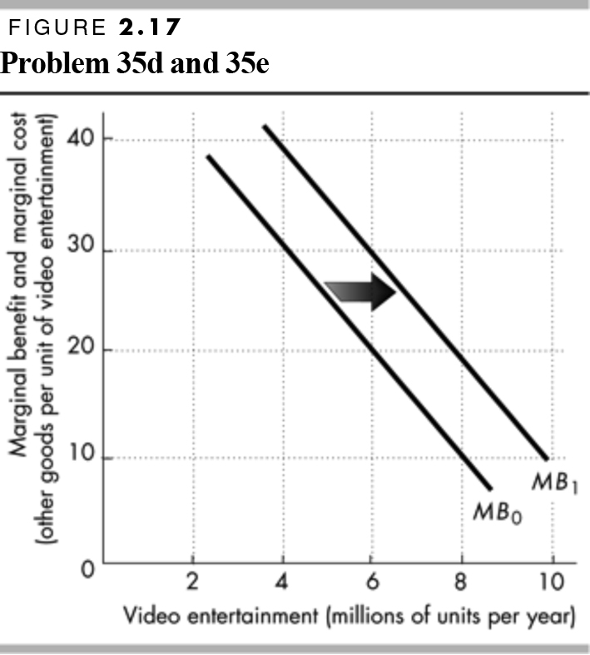d. Sketch a marginal benefit curve for video entertainment.

The marginal benefit curve should be a conventional downward-sloping marginal benefit curve as shown in Figure 2.17. The marginal benefit from video entertainment is measured along the vertical axis and the quantity of video entertainment is measured along the horizontal axis.

e. Show how the new generation of TV producers for whom the Internet is their native medium might have changed the marginal benefit from video entertainment.

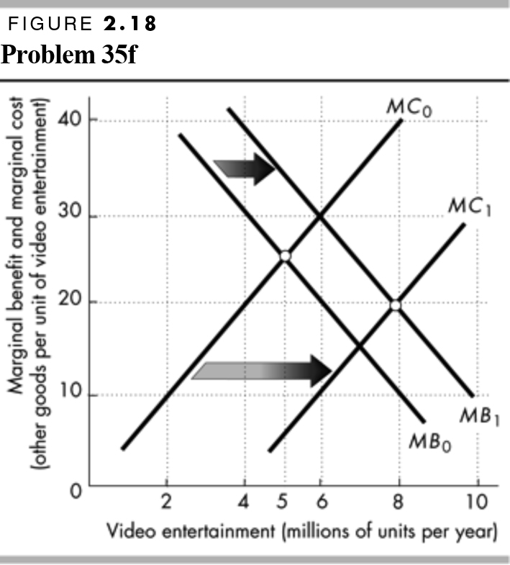The marginal benefit increases because these new producers will be better able to take advantage of the Internet since it is their native medium. Because they will be able to create entertainment designed for the Internet, the marginal benefit from video entertainment increases. In Figure 2.17, the marginal benefit curve shifts rightward from the initial marginal benefit curve, *MB*0, to the new marginal benefit curve, *MB*1.

f. Explain how the efficient quantity of video entertainment has changed.

The arrival of broadband has decreased the marginal cost of providing video entertainment, so the marginal cost curve shifts rightward. This shift is illustrated in Figure 2.18 by the rightward shift of the marginal cost curve from *MC*0 to *MC*1. The arrival of broadband has also increased the marginal benefit of providing video entertainment, so the marginal benefit curve shifts rightward. This shift is illustrated in Figure 2.18 by the rightward shift of the marginal benefit curve from *MB*0 to *MB*1. As Figure 2.18 shows, the allocatively efficient quantity of video entertainment increases. In Figure 2.18, the allocatively efficient quantity increases from 5 million units per year to 8 million units per year.