Chapter 2: Supply and Demand

Main Concepts and Learning Objectives

This chapter provides a quick review of introductory microeconomic information about shifting and moving along supply and demand curves. It builds on this information by showing students how to:
- Use equations to describe supply and demand curves
- Solve for price, given a current quantity and a set of exogenous parameter values
- Solve for equilibrium
- Solve for price elasticity, given a linear demand equation

The following skills are needed to master the material presented in this chapter:
- Introductory microeconomics-level understanding of supply and demand curves, movement along these curves and shifts in these curves. A brief review of these concepts is included in the chapter.
- Basic algebra skills:
  - Solve one equation for one unknown
  - Solve two equations for two unknowns
  - Manipulate an equation to write the equation in a new form
  - Identify slope as the change in the dependent variable over the change in the independent variable

Specifically, students who master the material presented in this chapter will be able to:
- Distinguish between shifts in the demand curve and movements along the demand curve.
- Use a demand equation, along with information about current values of exogenous variable, to solve for the price at which the quantity demanded will be equal to a specified value.
- Distinguish between shifts in the supply curve and movements along the supply curve.
- Use a supply equation, along with information about current values of exogenous variable, to solve for the price at which the quantity supplied will be equal to a specified value.
- Use a supply curve, a demand curve, and information about the values of exogenous variables to compute equilibrium price and quantity.
- Use a supply curve, a demand curve, and information about the values of exogenous variables to compute the impact of a parameter change on equilibrium price and quantity.
- Use information about the slope the demand curve to deduce information about relative magnitudes of changes in price and quantity that will occur in response to shifts in supply.
- Use information about the slope the supply curve to deduce information about relative magnitudes of changes in price and quantity that will occur in response to shifts in demand.

- Write the elasticity formula in a new form that clearly identifies the relationship between slope and elasticity
- Use a linear demand curve, along with information about current P and Q to compute elasticity.

Potential Student Challenges

1. Introductory microeconomics textbooks tend to show supply and demand graphs with P on the vertical axis. It is important to be able think about quantity as the dependent variable, however, in several situations:
- econometric methods are used to estimate demand curves
- marketing analysis of consumer purchasing behavior,
- models that require solving for equilibrium quantity, and
- discussion of elasticity (because the relationship between slope and elasticity is more clear when quantity is the dependent variable).
Nonetheless, introductory microeconomics classes tend to focus on graphs with price on the vertical axis, so the idea that quantity can appear on either side of the equal sign (and on either axis of the graph) can seem confusing. It may be worthwhile to spend time to ensure that students are comfortable with the idea that the supply and demand relationships can be modeled with either price or quantity on the left side of the equal sign (and on the vertical axis of the graph.) It may be helpful to note:
- The demand and supply equations provided in the early sections of this chapter show Q on the left hand side. Indeed, these equations, with Q shown as the dependent variable, correctly depict the marketer’s view – in which the marketer sets price and then observes quantity sold.
- If a demand equation were written to describe the demand curves typically graphed by economists, the dependent variable on the left hand side would be P. Economists think of demand curves this way because we view price as the dependent variable determined in an auction-type market.

2. Students who do not have strong problem-solving skills will find this course to be very challenging. Depending on the math level of the students, it may be important to work on those skills explicitly. For students who find math mysterious, practicing basic problem-solving steps can be very helpful. (Basic steps useful for any problem include:
  - Q identify the question
  - I list all of the information given in the problem (recognizing that information can appear in subtle ways)
  - M choose an appropriate method or strategy
  - A answer or solve the problem.
Students with strong math skills implement these steps without thinking. Students with weak math skills tend to under-invest in the first three steps, and are therefore unable to complete the fourth step. In fact, they may not be familiar with the idea of breaking problems down into steps.

This knowledge will be critical for mastering the material presented in this book. It may be helpful to:
- demonstrate problem-solving steps explicitly in class,
- ask students to practice these steps in groups in class, and
- grade exams in a way that rewards students for showing these steps explicitly.
In addition, it may be helpful to challenge students to create step-by-step instructions to solve a problem and then ask other students to use those instructions to successfully solve a similar problem. If the instruction-writing students are rewarded for successful completion by the students who use their instructions, and if open discussion is permitted, valuable discussions may occur among students. Two worksheets are provided here. The first provides one example of step-by-step (sbs) instructions. The second asks students to create sbs instructions for two problems.

Answers to In-Text Questions

2.1
To solve this problem, we take the demand function given and plug in the price of potatoes (0.25) and the price of butter (2). Since we want to know what price will lead consumers to purchase 8 billion bushels of corn per year, we also plug in 8 for Q^{d}corn. Then we just solve algebraically for our unknown: P_{corn}.

Q^{d}_{corn} = 20 – 4P_{corn} + 8P_{potatoes} – 0.5P_{butter}
(8) = 20 – 4P_{corn} + 8(0.25) – 0.5(2.00)
8 = 20 – 4P_{corn} + 2 – 1
8 = 21 – 4P_{corn}
P_{corn} = 13
P_{corn} = 13/4 = 3.25

Consumers will demand 8 billion bushels when corn is sold at a price of $3.25 per bushel.

If butter rises to $4 a kilogram, the price at which consumers buy 8 billion bushels of corn will drop to $3.00 per bushel. We can figure this out just like we did above, only now we plug in 4 for the price of butter.

Q^{d}_{corn} = 20 – 4P_{corn} + 8P_{potatoes} – 0.5P_{butter}
(8) = 20 – 4P_{corn} + 8(0.25) – 0.5(4.00)
8 = 20 – 4P_{corn} + 2 – 2
8 = 20 – 4P_{corn}
P_{corn} = 12
P_{corn} = 12/4 = 3.00

2.2
To find the equilibrium in this market, we need to find the price that will clear the market. The market clears when quantity supplied equals quantity demanded.

Q^{s}_{corn} = Q^{d}_{corn}

Substituting in the supply and demand functions for Q^{s} and Q^{d} yields:

1.6P_{corn} – 7 = 20 – 2P_{corn}
3.6P_{corn} = 27
P_{corn} = 27/3.6 = 7.50

The equilibrium price is $7.50 because this price satisfies the condition that quantity supplied equal quantity demanded. To find out equilibrium quantity, we substitute the price of $7.50 into either the supply or demand function. We get 5 either way:

Q^{s}_{corn} = 1.6P_{corn} – 7 = 1.6(7.50) – 7 = 12 – 7 = 5
Q^{d}_{corn} = 20 – 2P_{corn} = 20 – 2(7.50) = 20 – 15 = 5

2.3
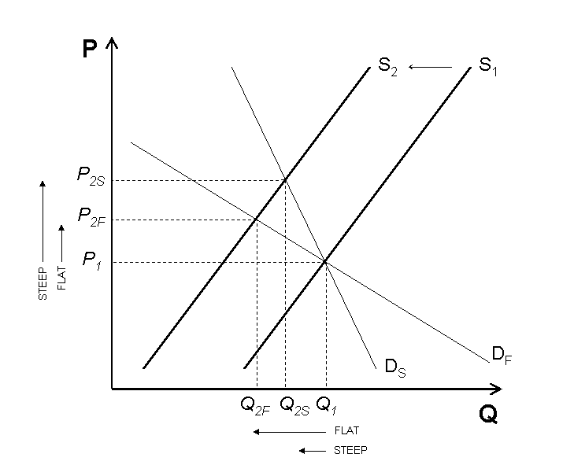

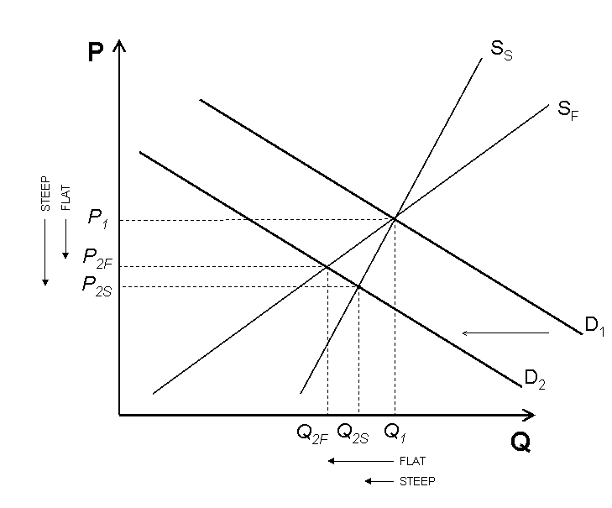

2.4
When price is $3.75 per bushel, quantity demanded is 7.5 billion bushels, so we plug those two numbers in for P and Q to find E^{d} at a price of $3.75:

When price is $5.00 per bushel, quantity demanded is 5 billion bushels, so we use those numbers to find E^{d} at a price of $5.00:

2.5
Recall that the largest total expenditure occurs when price elasticity of demand equals -1. Further recall that the formula for E^{d} can be written as E^{d} = –B(P/Q). If we substitute the linear form of the demand function Q^{d} = A – BP into this equation it yields:

$$E^{d}=−B\left(\frac{P}{A−\text{BP}}\right)$$

Using the values of A and B given by the demand function (14040 and 40, respectively), we can solve for the price, P, that makes E^{d} equal -1.

Multiplying both sides by (14040 – 40P) gives 40P – 14040 = –40P, which solves easily to show that P = $175.50 per room.

Answers to End-of-Chapter Questions

2.1
First, we should plug the exogenous variables into the demand function, so that it gives quantity demanded as a function of only price.

Q^{d}_{corn} = 5 – 2P_{corn} + 4P_{potatoes} – 0.25P_{butter} + .0003M
Q^{d}_{corn} = 5 – 2P_{corn} + 4(0.75) – 0.25(4.00) + .0003(40,000)
Q^{d}_{corn} = 5 – 2P_{corn} + 3 – 1 + 12
Q^{d}_{corn} = 19 – 2P_{corn}

Graphing a linear demand curve is most easily done by finding the x- and y-intercepts. If corn were free (P_{corn} = $0.00), consumers would want 19 billion bushels per year. The price that would make consumers want to purchase no corn whatsoever is found by plugging in 0 for Q^{d}_{corn}. Solving yields P_{corn} = $9.50. This curve can be drawn by plotting those two points and drawing the straight line that connects them:
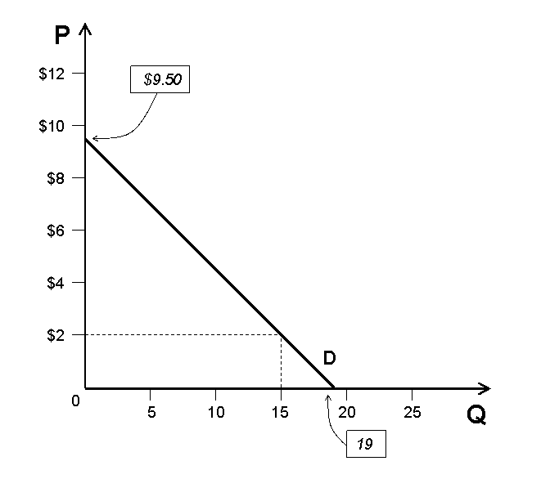
It looks from the drawing like quantity demanded equals 15 billion bushels a year at a price of $2.00, but we can confirm this algebraically by plugging 15 in for Q^{d}corn and solving for P_{corn}.

Q^{d}_{corn} = 19 – 2P_{corn}
15 = 19 – 2P_{corn}
2P_{corn} = 4
P_{corn} = 2

2.2
The solution method to this question is very similar to that for 2.1. First, we plug in endogenous variables to create a function of only P_{corn}:

Q^{s}_{corn} = 9 + 5P_{corn} – 4P_{fuel} – 1.25P_{soybeans}
Q^{s}_{corn} = 9 + 5P_{corn} – 4(1.00) – 1.25(12)
Q^{s}_{corn} = 9 + 5P_{corn} – 4.00 – 15.00
Q^{s}_{corn} = 5P_{corn} – 10

Graphing a linear supply curve is not quite as simple as graphing a linear demand curve (because it is upward-sloping, it only has one positive intercept). We can still find the price that will cause suppliers to supply no corn by plugging 0 in for Q^{s}_{corn} and solving for P_{corn}. If we do that, we get P_{corn} = 2.00. Now we just need any other point, which we can get by plugging in anything higher than 2.00 for P_{corn}, or by plugging any positive number in for Q^{s}_{corn}. Suppose we plug 5.00 in for the price and see that Q^{s}_{corn} = 15.
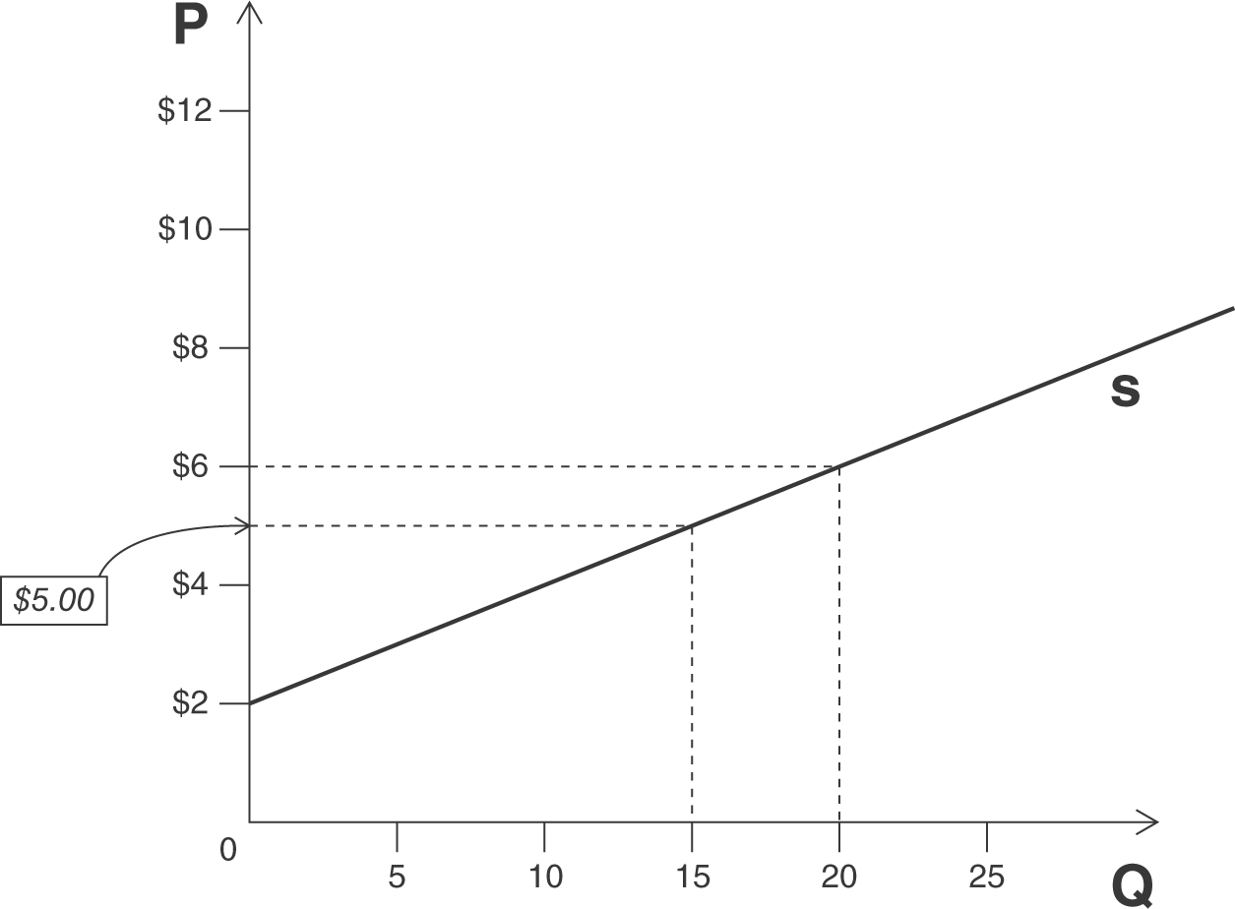
It looks from the drawing like quantity supplied equals 20 billion bushels a year at a price of $6.00, but we can confirm this algebraically by plugging 20 in for Q^{s}corn and solving for P_{corn}.

Q^{s}_{corn} = 5P_{corn} – 10
20 = 5P_{corn} – 10
30 = 5P_{corn}
6 = P_{corn}

2.3
Using the already simplified supply and demand functions from 2.1 and 2.2, all we need to do is set Q^{s}_{corn} = Q^{d}_{corn}.

Q^{s}_{corn} = Q^{d}_{corn}
5P_{corn} – 10 = 19 – 2P_{corn}
7P_{corn} = 29
P_{corn} = 4.14

The equilibrium price is 4.24. Plugging 4.14 into either Q^{s}_{corn} or Q^{d}_{corn} will give the equilibrium quantity, which is

Q^{s}_{corn} = 5P_{corn} – 10 Q^{d}_{corn} = 19 – 2P_{corn}
Q^{s}_{corn} = 5(4.14) – 10 Q^{d}_{corn} = 19 – 2(4.14)
Q^{s}_{corn} = 20.7– 10 Q^{d}_{corn} = 19 – 8.3
Q^{s}_{corn} = 10.7 Q^{d}_{corn} = 10.7

If the price of diesel fuel were to increase to $1.875 per litre, it would shift the supply curve. Going back to the original:
Q^{s}_{corn} = 9 + 5P_{corn} – 4P_{fuel} – 1.25P_{soybeans}
Q^{s}_{corn} = 9 + 5P_{corn} – 4(1.875) – 1.25(12)
Q^{s}_{corn} = 9 + 5P_{corn} – 7.50– 15.00
Q^{s}_{corn} = 5P_{corn} – 13.50

Solving for the new equilibrium is just like before:

Q^{s}_{corn} = Q^{d}_{corn}
5P_{corn} – 13.50 = 19 – 2P_{corn}
7P_{corn} = 32.50
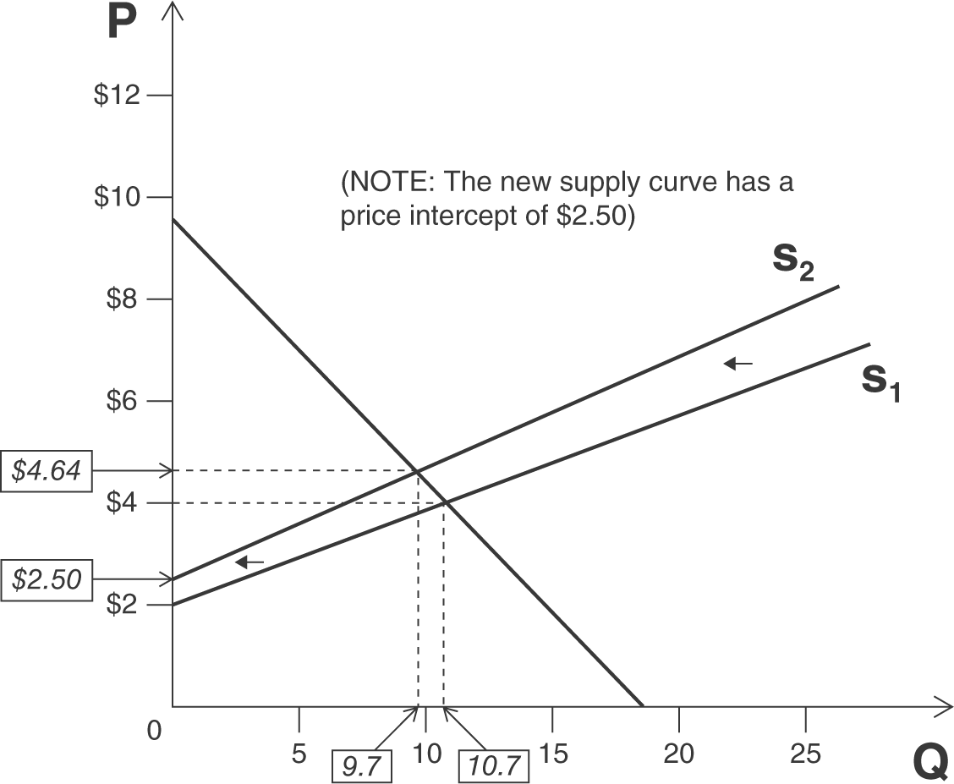
P_{corn} = 4.64

The new equilibrium price is 4.64. Plugging 4.64 into either Q^{s}_{corn} or Q^{d}_{corn} will give the new equilibrium quantity, which is 10.7.

Q^{s}_{corn} = 5P_{corn} – 13.50
Q^{s}_{corn} = 5(4.64) – 13.50
Q^{s}_{corn} = 23.20 – 13.50
Q^{s}_{corn} = 9.7

Q^{d}_{corn} = 19 – 2P_{corn}
Q^{d}_{corn} = 19 – 2(4.64)
Q^{d}_{corn} = 19 – 9.3
Q^{d}_{corn} = 9.7

2.4
Because this government purchase is determined by the relief plan, and is not in response to market prices, this decision to purchase 3.5 billion bushels shifts the demand curve to the right. In other words, at every possible price, the quantity of corn demanded will be 3.5 billion bushels higher. We can show this change by adding 3.5 to the demand curve for corn. This change does not affect the supply curve.

Previously, we had Q^{d}_{corn} = 15 – 2P_{corn}. After we add this government purchase, we have Q^{d}_{corn} = 15 – 2P_{corn} + 3.5, or Q^{d}_{corn} = 18.5 – 2P_{corn}. Supply remains Q^{s}_{corn} = 5P_{corn} – 6.

The first step is the same as in previous problems:

Q^{s}_{corn} = Q^{d}_{corn}
5P_{corn} – 6 = 18.5 – 2P_{corn}
7P_{corn} = 24.50
P_{corn} = 3.50

The new equilibrium price of corn is 3.50. The price has gone up because of the increase in demand; corn is now more valuable than before. Plugging 3.50 into either Q^{s}_{corn} or the new Q^{d}_{corn} will give the new equilibrium quantity, which is 11.5.

Q^{s}_{corn} = 5P_{corn} – 6  Q^{s}_{corn} = 5(3.50) – 6  Q^{s}_{corn} = 17.50 – 6  Q^{s}_{corn} = 11.5 | Q^{d}_{corn} = 18.5 – 2P_{corn}  Q^{d}_{corn} = 18.5 – 2(3.50)  Q^{d}_{corn} = 18.5 – 7  Q^{d}_{corn} = 11.5

2.5
The destruction of the World Trade Center caused a change in both the supply of and the demand for office space in Manhattan. The change in supply was a physical reduction in the available space; the change in demand came from worry from businesspeople about issues of safety. When both supply and demand decrease in this way, the effect on quantity is obvious: there will be less office space rented in Manhattan. What is not clear is the effect on price. If the decrease in supply were greater than the decrease in demand, price would rise; if the other way around, price would fall.

In the long run, after office space is rebuilt, the supply curve would shift back out to (or closer to) its original position. If demand never rebounded, then this would cause an overall reduction in the price of office space.

However, if the area around the World Trade Center were turned into a park, the decrease in supply would be permanent. Further, if demand were to rebound (say because the park causes a lower density of office space, making it a less likely target for another attack, thereby alleviating concerns), this would mean a higher price in the long run. Those who owned the office space not destroyed by the attacks would be the “winners,” as they would see their prices rise. The “losers” would be those who pay higher rents for their office space.

2.6
A ban on Canadian beef would lower the supply of beef available to US consumers, which would cause an increase in the price of beef. Initially, before the price changes, there will not be enough beef to satisfy demand. This will cause upward pressure on prices, driving some consumers out of the market, and leading some suppliers into the market. Depending on how much of the beef being sold in the US was Canadian beef, the increase could be great. Americans will reduce their beef consumption (though more Americans are producing beef than before).

In Canada, beef producers would be supplying too much beef to the market, with no one to buy it. This will cause downward pressure on prices. Because of the decrease in price, some Canadian consumers will enter the market and some producers will leave the market. Canadians will consume more beef (and produce less).

Unless US consumers believed that the health risk associated with Canadian beef also implied health risks associated with US-produced beef, the analysis for the US would not be any different. If US consumers did believe that all beef was unsafe, this would cause a decrease in the demand for beef, which would reverse the price-increasing trend of the ban (making the final effect on price ambiguous) while further reducing beef consumption.

If Canadian consumers believed that their beef was unsafe, there would also be a decrease in demand. This would counter the trend toward consuming more beef (so that the final effect on beef consumption would be ambiguous, but it would further reduce the price.

2.7
Recalling the formula for elasticity of demand (when working with a linear demand curve) is E^{d} = –B(P/Q) or E^{d} = –B(P/(A – BP)), we can just substitute our numbers into the formula. Based on the demand function, A = 1500 and B = 30.

$$E^{d}=−B\left(\frac{P}{A−\text{BP}}\right)$$
E^{d} = –0.67

2.8
The largest total expenditure occurs when price elasticity of demand equals –1.
$$E^{d}=−B\left(\frac{P}{A−\text{BP}}\right)$$

Multiplying both sides by 1500 – 30P yields:

30P – 1500 = –30P
60P = 1500
P = 25

2.9
We are told that the demand curve for jelly beans in Cincinnati is linear, but we are not given the demand function, so we cannot use the same version of the formula for elasticity of demand that we used in 2.8. We must use the formula the way it is written in (4) on page 49 To calculate the changes in Q and P, we use the numbers from both years. Since we’re interested in the elasticity at last year’s price of $6, we plug in last year’s values for P and Q.

The elasticity of demand last year was –3. To figure out at what price the expenditure on jelly beans would have been the highest, we need to figure out at what price the elasticity of demand would have been equal to –1.

In order to do the second part of this problem, we will need to know the demand function. We can notice from above that for this linear demand curve, B is 50,000/2 or 25,000, because a $2 increase in price reduced Q^{d} by 50,000. (Also we could calculate the slope as change in Q^{d} over change in P, as is done above, and arrive at the same result.) So now that leaves just A left to calculate. To do this, we can plug one of our two points into the demand function and solve for A:

Q^{d} = A – 25,000P  100,000 = A – 25,000(4)  200,000 = A | or | Q^{d} = A – 25,000P  50,000 = A – 25,000(6)  200,000 = A

Now we have enough information to use the formula for elasticity of demand the way it’s written in Worked-Out problem 2.4 on page 54:

$$E^{d}=−B\left(\frac{P}{A−\text{BP}}\right)$$

Multiplying both sides by 200,000 – 25,000P yields:

25,000P – 200,000 = –25,000P
50,000P = 200,000
P = 4

2.10
For in-text exercise 2.2 on page 33, the demand and supply functions and the equilibrium price and quantity are as follows:

Q^{d}_{corn} = 20 – 2P_{corn} Q^{s}_{corn} = 1.6P_{corn} – 7
Equilibrium: P_{corn} = 7.50, Q_{corn} = 5

To find the elasticity of demand, we can use almost any version of the formula for the elasticity of demand. Here’s what it looks like if the student uses the formula for elasticity of demand the way it’s written in Worked-Out problem 2.4 on page 54:

$$E^{d}=−B\left(\frac{P}{A−\text{BP}}\right)$$
$E^{d}=−2\left(\frac{7\text{.}\text{50}}{\text{20}−2(7\text{.}\text{50})}\right)$
E^{d} = –3

To find the elasticity of supply, we use formula (7) on page 55, using the slope of the supply function, 1.6, for $\left({ΔQ}/{ΔP}\right)$:

$$E^{s}=\left(\frac{ΔQ}{ΔP}\right)\left(\frac{P}{Q}\right)$$
$$E^{s}=\left(1\text{.}6\right)\left(\frac{7\text{.}\text{50}}{5}\right)$$
E^{s} = 2.4

2.11
This problem is structured differently from previous problems. Here, students are given one price and quantity, and the elasticity, and asked to solve for the demand function. The best way to do this problem is to use the formula for the elasticity of demand as it’s written in (5) on page 49, plugging in the numbers given in the problem (here, I assume Q is measured in millions of litres, students may have plugged in 50,000,000, assuming Q was measured in single litres):

$$E^{s}=−B\left(\frac{P}{Q}\right)$$

Multiplying both sides by 50 yields: –25 = –B, so B = 25.

This can be plugged into the demand function, along with P and Q, to solve for A:

Q^{d}_{gas} = A – BP_{gas}
50 = A – 25(1.00)
50 = A – 25
A = 75

Therefore, the demand function is Q^{d}_{gas} = 75 – 25P_{gas}. (If students used Q to represent one single litre of gasoline, the demand function is Q^{d}_{gas} = 75,000,000 – 25,000,000P_{gas}.

The largest total expenditure occurs when E^{d} = –1. To find this point, we use the formula for the elasticity of demand as it is written in Worked-Out problem 2.4 on page 54. The answer is $1.50. (Note: the specification of Q as a single unit or as a million units will not affect this answer.)

$$E^{d}=−B\left(\frac{P}{A−\text{BP}}\right)$$

Multiplying both sides by 75 – 25P yields:

25P – 75 = –25P
50P = 75
P = 1.50

2.12
The demand function for the Honda Accord is:

Q^{d}_{A} = 430 – 10P_{A} + 10P_{C} – 40P_{G}

When both cars sell for $20,000 and the price of gasoline is $0.75 per litre, Q^{d}_{A} is 400. Recalling that price is in thousands we let P_{A} = P_{C} = 20.

Q^{d}_{A} = 430 – 10(20) + 10(20) – 40(0.75) = 400

To find the cross-price elasticities, it might be easier to rewrite the formula given on page 57 so that it looks more like (4) on page 49:

$$E^{d_{P_{O}}}=\left(\frac{ΔQ}{{ΔP}_{O}}\right)\left(\frac{P_{O}}{Q}\right)$$

The first term will be equal to the coefficients from the demand function for the given price. The cross-price elasticity of the Accord with respect to the price of the Camry is:

Since this number is positive, the Camry must be a substitute for the Accord. The cross-price elasticity of the Accord with respect to the price of the gasoline is:

$$E^{d_{P_{O}}}=−0\text{.}\text{075}$$

Since this number is negative, gasoline must be a complement to the Accord.

2.13
To solve for two unknowns, A and B, we need two equations. The first of these equations will be the demand function itself, with Q^{d} and P plugged in:

Q^{d} = A – BP
60 = A – B(1)
A = B + 60

The second equation will be the formula for elasticity, written as it is in Worked-Out problem 2.4 on page 54:

$$E^{d}=−B\left(\frac{P}{A−\text{BP}}\right)$$

Substituting the equation relating A and B from above gives:

$$E^{d}=−B\left(\frac{P}{(B+\text{60})−\text{BP}}\right)$$

Plugging in the values for E^{d} and P given in the problem yields:

$$−1=−B\left(\frac{1}{(B+\text{60})−B(1)}\right)$$
$$−1=−B\left(\frac{1}{\text{60}}\right)$$
B = 60

From above, A = B + 60, so A = 120.

The demand function, then, is Q^{d} = 120 – 60P.

