Chapter 2

Supply and Demand

■ Solution to Textbook Questions

1. See Figure 2.1 below. The statement ‘Talk is cheap because supply exceeds demand’ makes sense if we interpret it to mean that the quantity supplied of talk exceeds the quantity demanded at a price of zero. (The correct aphorism is ‘Talk is cheap until you hire a lawyer’.)

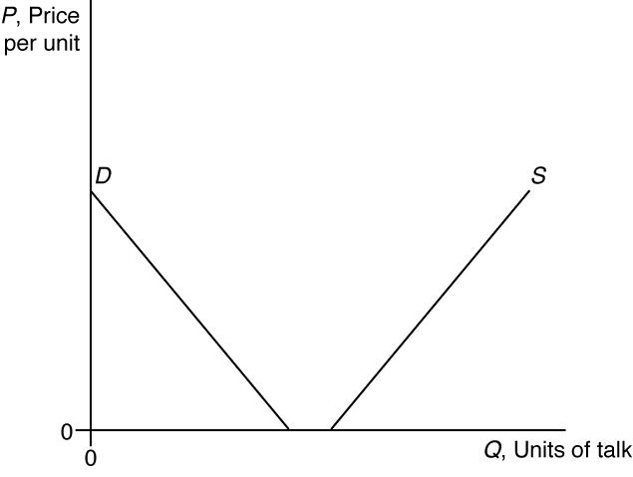

Figure 2.1

2. The increased outsourcing to India caused the demand curve for labour to shift to the right, resulting in a higher wage rate as shown in Figure 2.2. The number of hours worked also increases as a result of the shift in demand, which implies that more people are employed.

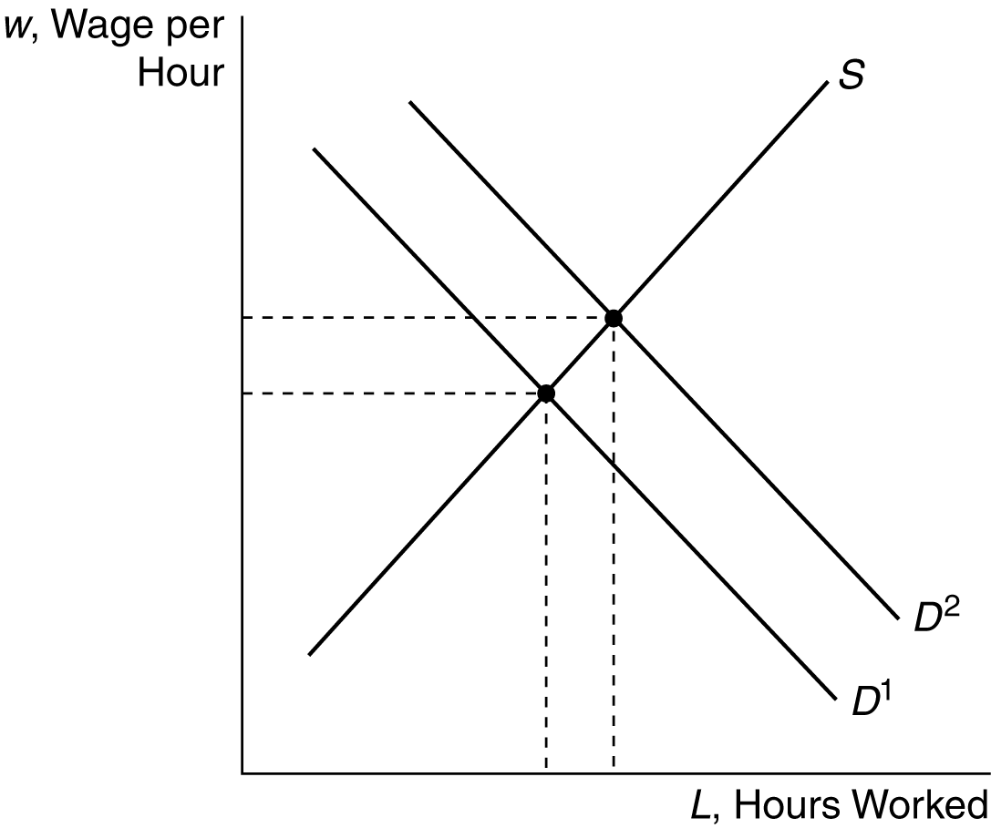

Figure 2.2

3. See Figure 2.3 below. In the short run, the demand curve for newspaper advertising will shift to the left, since the price of a substitute—Internet advertising—is lower. Newspaper ad rates and the equilibrium quantity of newspaper ads will both fall, from P₁ to P₂ and from Q₁ to Q₂, respectively. Over time, the supply curve for newspaper advertising may shift to the left if marginally profitable newspapers are driven from the market by the reduced profits that result. This would result in an even lower equilibrium quantity.

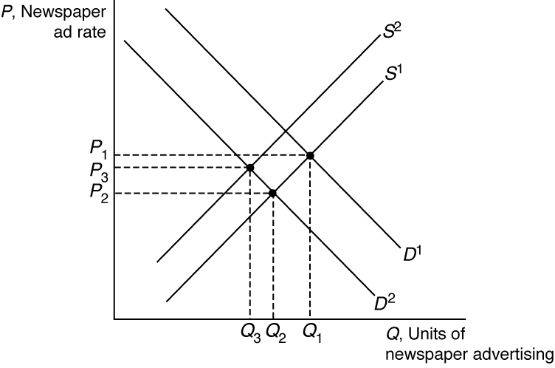

Figure 2.3

4. World demand decreased (China’s decrease in imports) and world supply increased (assuming that the increase in supply from the United States’ bumper crop was greater than the decrease in supply from Asian soy rust). The rightward shift of world supply and the leftward shift of world demand both work to lower the world price of soya beans. See Figure 2.4 below. After accounting for all shifts, the world price of soya beans decreases from P₁ to P₂.

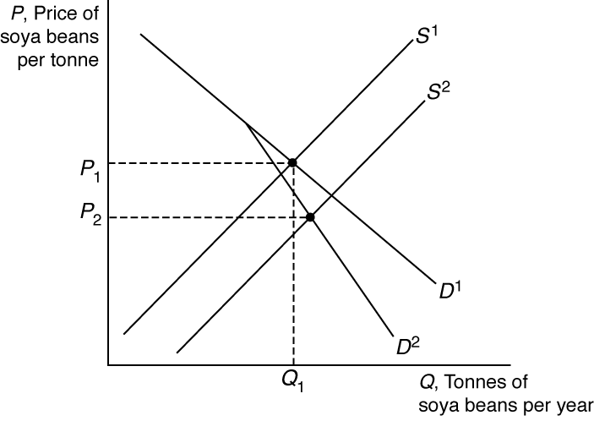

Figure 2.4

In this case, since supply shifted to the right and demand shifted to the left (the shifts were in opposite directions), the price is unambiguously lower. However, we would have to know the magnitude of the shifts to accurately predict the effect quantity.

5.
- The demand for beachfront properties shifts to the left because of the Global Financial Crisis, which causes incomes to decrease (assuming homes are normal goods). The supply, however, might shift to the right as more owners of beach homes are willing to rent their homes to supplement their incomes, which declined due to the GFC.
- When the demand curve shifts to the left and the supply curve shifts to the right, the price unambiguously drops, although the quantity exchanged can increase, remain the same or decrease, depending on the magnitude of the shifts. See Figure 2.5 below.

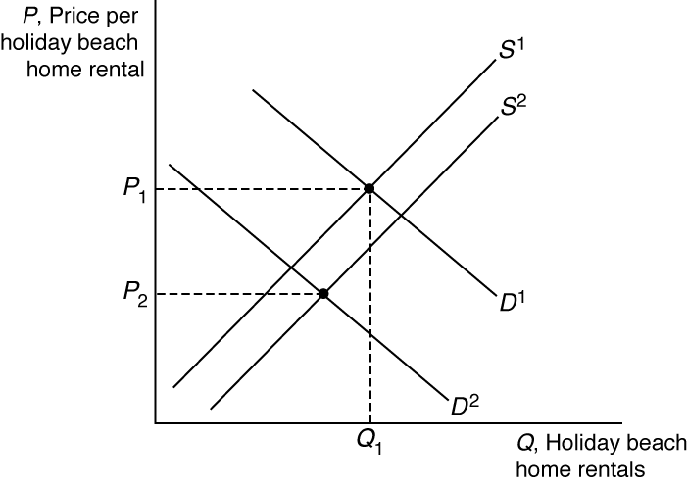

Figure 2.5

6. The ban would shift the demand curve to the left, reducing quantity and price. Thus, it would help protect the beluga sturgeon. However, if a black market were to develop there would be no change in demand and the fish would not be protected.

7. The quota on specialists would alter the supply curve. In Figure 2.6 below, the unregulated supply curve, S, shifts inward once the quota on domestic specialists is reached. The new supply curve, S¹, results in higher prices for specialists’ services due to higher salaries for specialists. Consumers are harmed because of the increase in price and decrease in quantity.

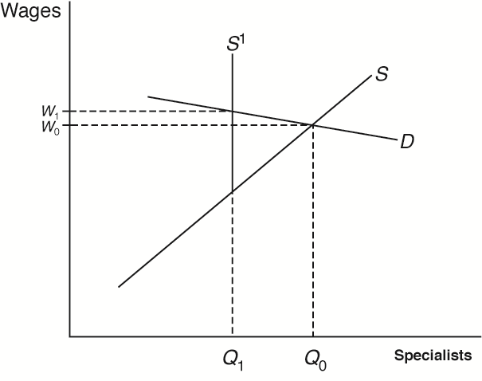

Figure 2.6

8. See Figure 2.7 below. Since prices rose after the rent control was removed, the rent control was a binding price ceiling at a price below what would have been the equilibrium price (P*). Under the rent control price, quantity demanded (Q_{D}) exceeded quantity supplied (Q_{S}) and there was a shortage of apartments (Q_{D} − Q_{S}). Equilibrium under rent control occurred at the intersection of the price ceiling and the supply curve. Without the price ceiling, equilibrium is at the intersection of the demand and supply curves, and equilibrium price and quantity are higher.

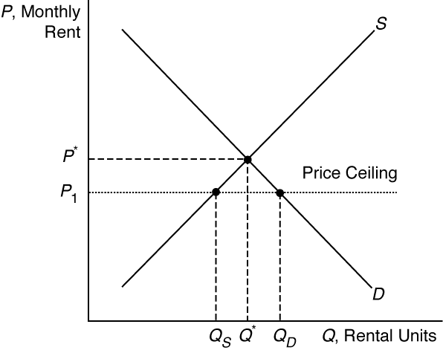

Figure 2.7

■ Solution to Textbook Problems

9 . The town’s total demand function can be derived mathematically as follows:

Q = Q₁ + Q₂ = (120 − P) + (60 − 0.5P) = 180 − 1.5P

Graphically, the town’s total demand function is the horizontal sum of the demand functions for students and for other town residents. See Figure 2.8 below.

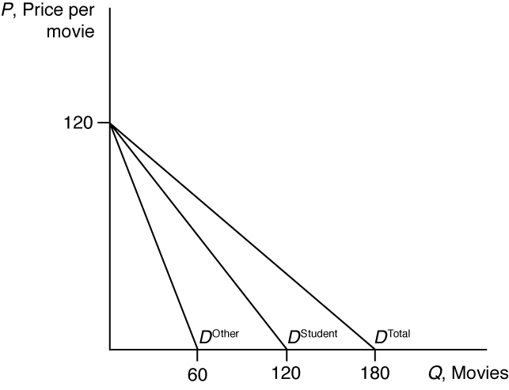
Figure 2.8

10. We have:
Q₁ = 120 − P for P ≤ 120
= 0 for P > 120

Q₂ = 120 − 2P for P ≤ 60
= 0 for P > 60

Thus, the demand function is:
Q = Q₁ + Q₂ = 240 − 3P for P ≤ 60
= 120 − P for 60 < P ≤ 120
= 0 for P > 120

For graphing purposes, we need the inverse demand function:
P = 80 − (1/3) Q₁ for 60 ≤ Q ≤ 240
= 120 − Q₂ for Q ≤ 60

See Figure 2.9 below. Line ad is the demand function for students and Line ed is the demand function for other people. Line abc is the total demand function.

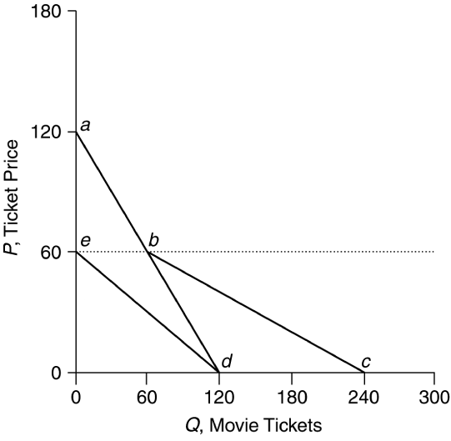

Figure 2.9
- In equilibrium, quantity demanded, Q_{d} = a − bP, is set equal to quantity supplied, Q_{s} = c + eP:

a − bP = c + eP

By solving this equation for P, we find that the equilibrium price is:
P = (a − c)/(b + e)

By substituting this expression for P into either the demand function or the supply function, we find that the equilibrium quantity is:

Q = (ae + bc)/(b + e)

12. Because the temperature enters the supply function with a positive constant, increases in temperature will shift the supply curve rightward, increasing the equilibrium quantity at each price. To calculate the change in price at equilibrium, solve the equations simultaneously for price:
Q_{d} = a − bP and Q_{s} = c + eP + ft

Our equilibrium condition is:
Q_{d} = Q_{s}

Substituting,
a − b P_{e} = c + e P_{e} + ft

Solve for the equilibrium price, P_{e}:
P_{e} = (a − c − ft)/(b + e)

Substitute the expression for P_{e} into either the demand function or the supply function and solve for the equilibrium quantity, Q_{e}:

Q_{e} = (cb + ae + bft)/(b + e)

Therefore,
ΔP_{e} = [−f/(b + e)]Δt and ΔQ_{e} = [bf/(b + e)]Δt

13. At equilibrium, Q_{d} = Q_{s}. Equating the right sides of the logarithmic supply and demand functions and using algebra, we find:
0.2 + 0.55 ln(P) = 2.6 − 0.2 ln(P) + 0.15 ln(P_{t})
0.75ln(P) = 2.4 + 0.15ln(P_{t})
ln(P) = 3.2 + 0.2ln(P_{t})

We then set P_{t} = 110 and solve for ln(P):
ln(P) = 3.2 + 0.2(4.7) = 4.14

Now we exponentiate ln(P) to obtain the equilibrium price:
P_{e} = $62.80 per ton

Substituting P into the supply function and exponentiating, we determine the equilibrium quantity:
Q_{e} = 11.91 million tons per year
See Figure 2.10 below. The demand function for processing tomatoes can be calculated by exponentiating both sides of the logarithmic function:
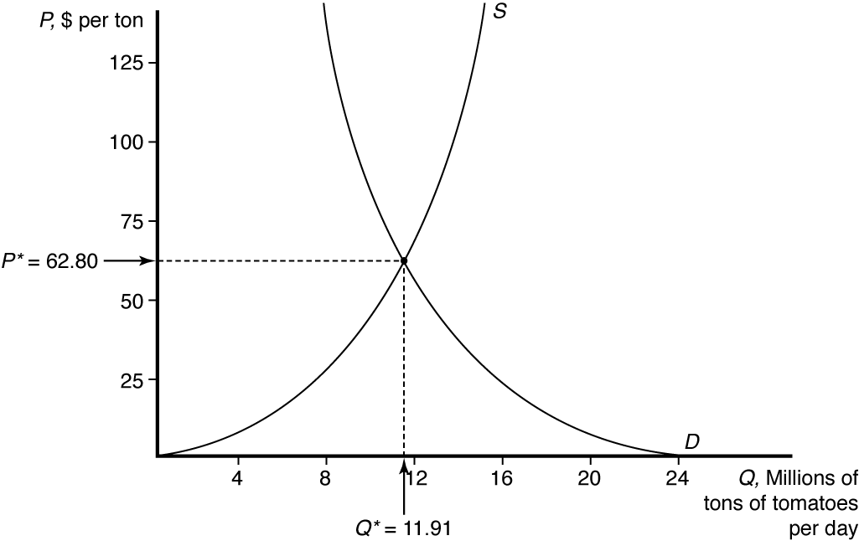
Figure 2.10

14. At $65 per ton, ln(Q_{s}) = 0.2 + 0.55 ln(65) = 2.496. Exponentiating,
Q_{s} = 12.13 million tons

On firms’ demand,
ln(Q_{d}) = 2.6 + 0.2 ln(65) + 0.15 ln(110) = 2.470

Exponentiating,
Q_{d} = 11.82 million tons

Therefore, the government buys 12.13 − 11.82 = 0.31 million tons. See
Figure 2.11 below.

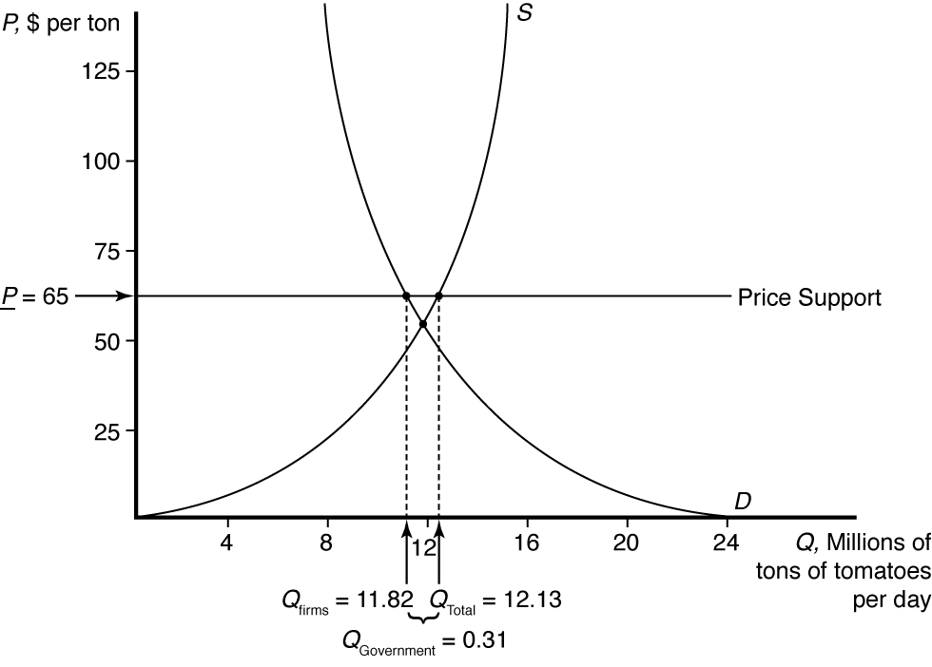

Figure 2.11

15. Exponentiate both sides of the supply function:

Taking the derivative with respect to P, we have:

Therefore, the higher the price, the higher the quantity of processing tomatoes supplied.

