______________________________________________

Chapter 2: Economic Theories, Data, and Graphs
______________________________________________

This chapter provides an introduction to the methods economists use in their research. We integrate a detailed discussion of graphing into our discussion of how economists present economic data and how they test economic theories.
In our experience, students typically do not learn enough about the connection between theory and evidence, and how both are central to understanding economic phenomena. We therefore recommend that considerable emphasis be placed on Figure 2-1, illustrating the process of going from model building to generating hypotheses to confronting data and testing hypotheses, and then returning to model building (or rebuilding). There is no real beginning or end to this process, so it is difficult to call economics an entirely “theory driven” or “data driven” discipline. Without the theory and models, we don’t know what to look for in the data; but without experiencing the world around us, we can’t build sensible models of human behaviour and interaction through markets. The scientific approach in economics, as in the “hard” sciences, involves a close relationship between theory and evidence.
***

The chapter is divided into four major sections. In the first section, we make the important distinction between positive and normative statements and advice. Students must understand this distinction, and that the progress of any scientific discipline relies on researchers’ ability to separate what evidence suggests is true from what they would like to be true. We conclude this section by explaining why economists are often seen to disagree even though there is a great deal of agreement among them on many specific issues. This leads to a box on where economists typically get jobs and the kind of work they often do.

The second section explains the elements of economic theories and how they are tested. We emphasise how a theory’s or model’s definitions and assumptions lead, through a process of logical deduction, to a set of conditional predictions. We then examine the testing of theories. It is here that we focus on the interaction of theory and empirical observation (Figure 2-1). We emphasize the importance of the distinction between correlation and causation, with a simple example.
The chapter’s third section deals with economic data. We begin by explaining the construction of index numbers, and we use them to compare the volatility of two sample time series. Index numbers are so pervasive in discussions of economic magnitudes that students must know what these are and how they are constructed. We then make the distinction between cross-sectional and time-series data, and at this point students are introduced to two types of graph.
This brings us to the chapter’s final section, on graphing. We show how a relation can be expressed in words, in a table, in an equation, or on a graph. We then go into considerable detail on linear functions, slope, non-linear functions, and functions with minima and maxima. In this discussion, the student is introduced to the concept of the margin, described as the change in Y in response to a one-unit change in X. In all cases, the graphs apply to real-world situations rather than abstract variables. Pollution abatement, hockey-stick production, firm profits, and fuel consumption are our main examples.

Answers to Study Exercises

Question 1
a) normative (“The government should impose…” is inherently a value judgement.)
b) positive (In principle, we could determined the impact that foreign aid actually has.)
c) positive (In principle, we could determine the extent to which fee increases affect access.)
d) normative (What is or is not unfair is clearly based on a value judgement.)
e) normative (Use of the expression “too much” is a value judgement.)

Question 2
a) In the Canadian wheat sector, the amount of rainfall on the Canadian prairies is an exogenous variable; the amount of wheat produced is an endogenous variable.
b) To the Canadian market for coffee, the world price of coffee is exogenous; the price of a cup of coffee at Tim Horton’s is endogenous.
c) To any individual student, the widespread unavailability of student loans is exogenous; their own attendance at university or college is endogenous.
d) To any individual driver, the tax on gasoline is exogenous; his or her own decision regarding which vehicle to purchase is endogenous.

Question 3
a) models (or theories)
b) endogenous; exogenous
c) (conditional) prediction; empirical
d) (positively) correlated; causal
e) self-interest; utility; profits
Question 4
The observed correlation cannot lead to a certain inference about causality. It is consistent with the theory that the increase in demand for homes leads to an increase in the price of lumber (which is generally a pretty sensible theory!), but it is also consistent with a different theory – one in which some unobserved factor leads to both the increase in demand for homes and separately to the increase in the price of lumber. Correlation does not imply causality!

Question 5
a) These data are best illustrated with a time-series graph, with the month shown on the horizontal axis and the exchange rate shown on the vertical axis.
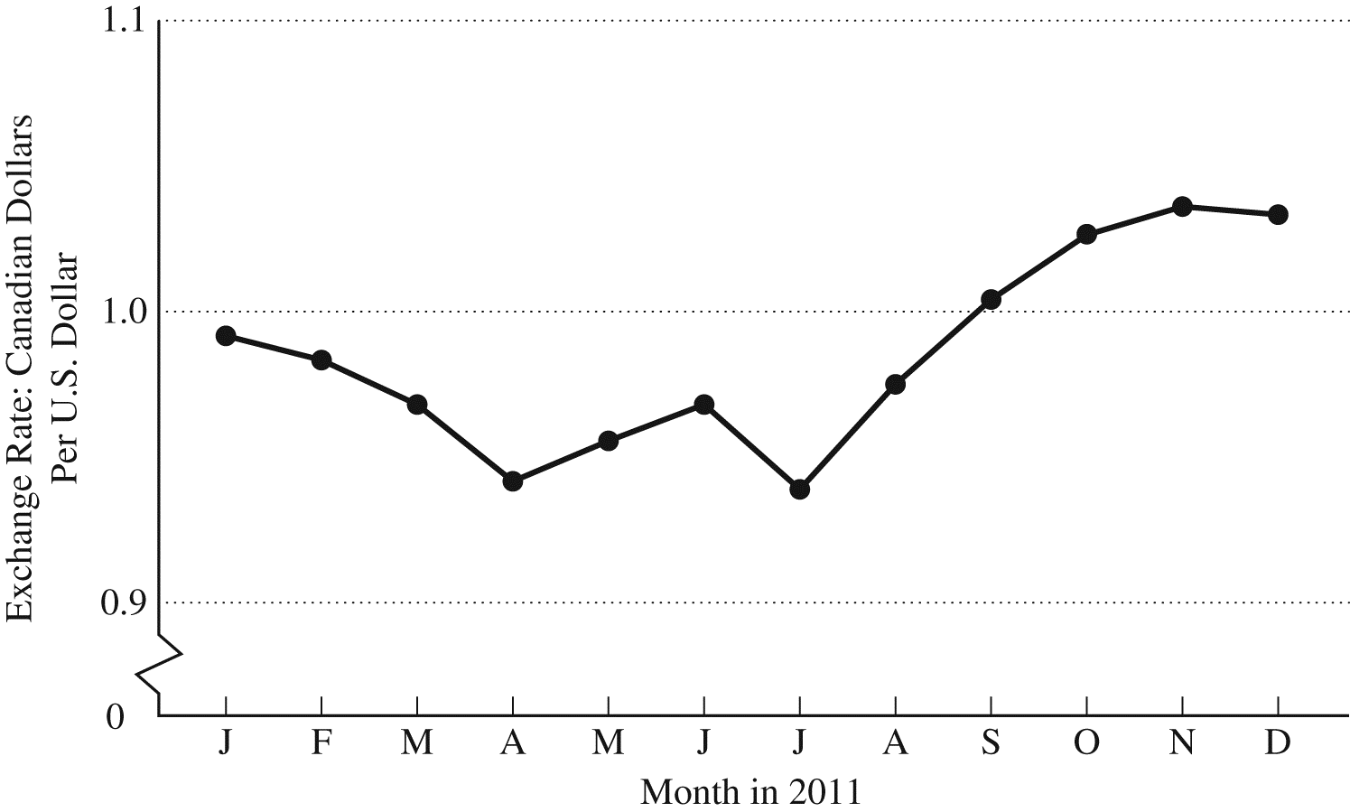
b) These cross-sectional data are best illustrated with a bar chart.
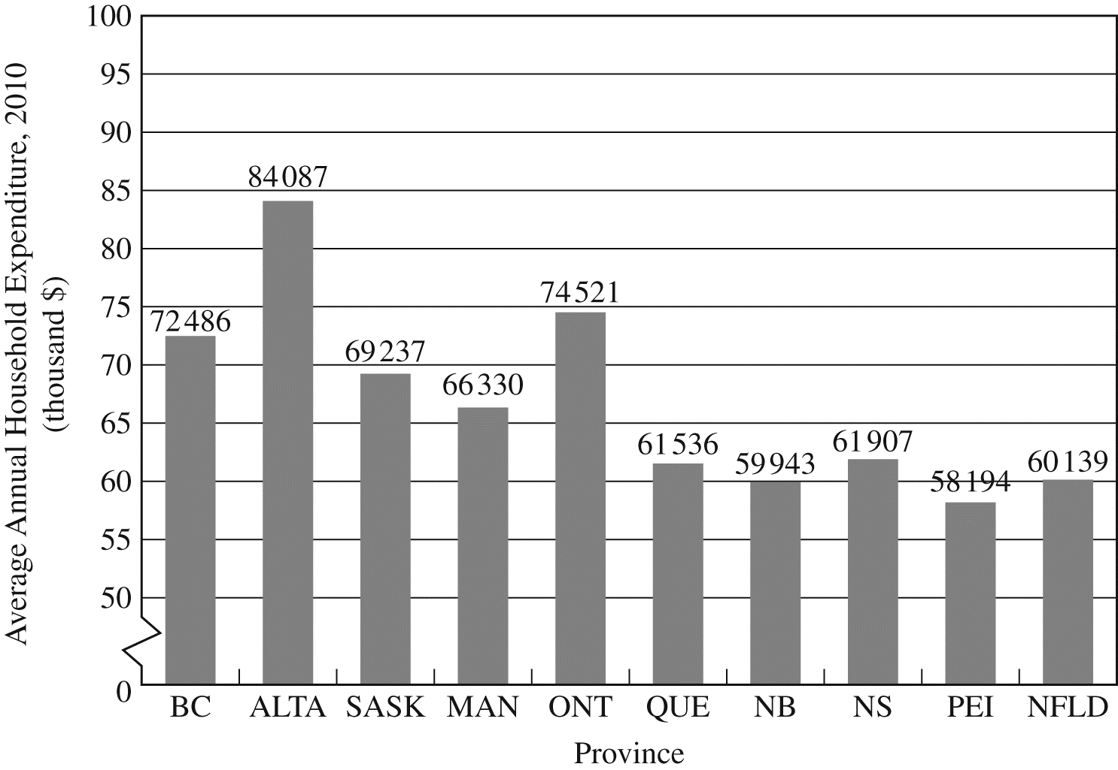
c) These cross-sectional data are best illustrated in a scatter diagram; the “line of best fit” is clearly upward sloping, indicating a positive relationship between average investment rates and average growth rates.

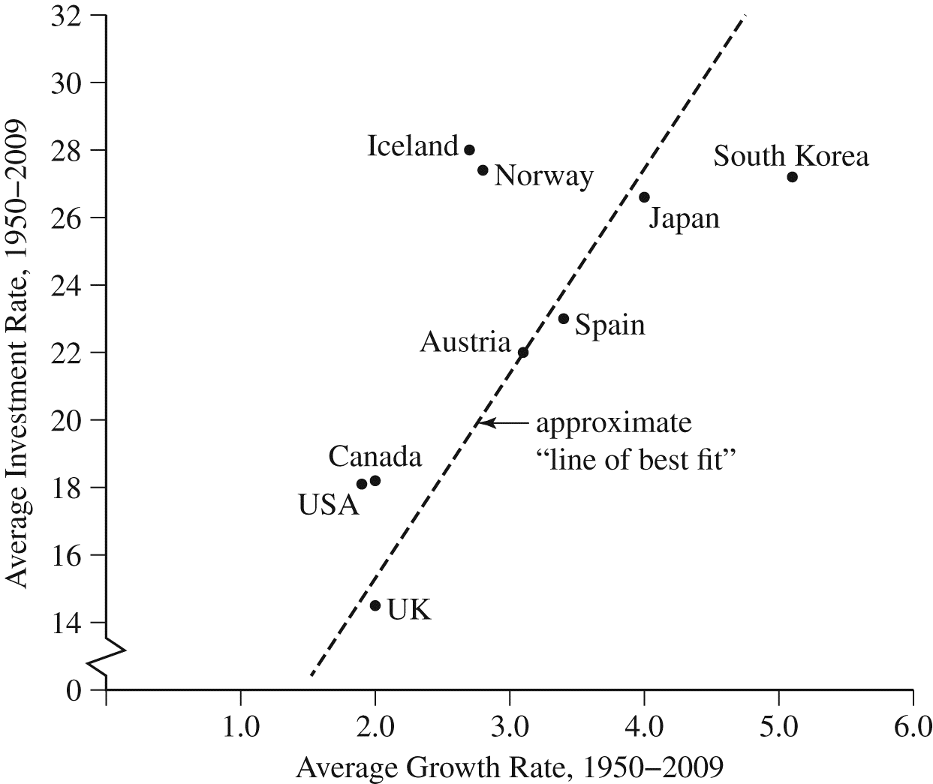

Question 6
a) Using 2000 as the base year means that we choose $85 as the base price. We thus divide the actual prices in all years by $85 and then multiply by 100. In this way, we will determine, in percentage terms, how prices in other years differ from prices in 2000. The index values are as follows:

Year | Price ($) | Physics textbook price index
2000 | 85 | (85/85) × 100 = 100
2001 | 87 | (87/85) × 100 = 102.4
2002 | 94 | (94/85) × 100 = 110.6
2003 | 104 | (104/85) × 100 = 122.4
2004 | 110 | (110/85) × 100 = 129.4
2005 | 112 | (112/85) × 100 = 131.8
2006 | 120 | (120/85) × 100 = 141.2
2007 | 125 | (125/85) × 100 = 147.1
2008 | 127 | (127/85) × 100 = 149.4
2009 | 127 | (127/85) × 100 = 149.4
2010 | 130 | (130/85) × 100 = 152.9

b) The price index in 2005 is 131.8, meaning that the price of the physics textbook is 31.8 percent higher in 2005 than in the base year, 2000.
c) From 2007 to 2010, the price index increases from 147.1 to 152.9⎯but this is not an increase of 5.8 percent. The percentage increase in the price index from 2007 to 2010 is equal to [(152.9-147.1)/147.1]×100 = 3.94 percent.
d) These are time-series data because the data are for the same product at the same place but at different points in time.

Question 7
a) Using Calgary as the “base university” means that we choose $6.25 as the base price. Thus we divide all actual prices by $6.25 and then multiply by 100. In this way, we will determine, in percentage terms, how prices at other universities differ from Calgary prices. The index values are as follows:

University | Price per pizza | Index of pizza prices
Dalhousie | $6.50 | (6.50/6.25)×100 = 104
Laval | 5.95 | (5.95/6.25)×100 = 95.2
McGill | 6.00 | (6.00/6.25)×100 = 96
Queen’s | 8.00 | (8.00/6.25)×100 = 128
Waterloo | 7.50 | (7.50/6.25)×100 = 120
Manitoba | 5.50 | (5.50/6.25)×100 = 88
Saskatchewan | 5.75 | (5.75/6.25)×100 = 92
Calgary | 6.25 | (6.25/6.25)×100 = 100
UBC | 7.25 | (7.25/6.25)×100 = 116
Victoria | 7.00 | (7.00/6.25)×100 = 112

b) The university with the most expensive pizza is Queen’s, at $8.00 per pizza. The index value for Queen’s is 128, indicating that pizza there is 28 percent more expensive than at Calgary.
c) The university with the least expensive pizza is Manitoba, at $5.50 per pizza. The index value for Manitoba is 88, indicating that the price of pizza there is only 88 percent of the price at Calgary. It is therefore 12 percent cheaper than at Calgary.
d) These are cross-sectional data. The variable is the price of pizza, collected at different places at a given point in time (March 1, 2016). If the data had been the prices of pizza at a single university at various points in time, they would be time-series data.
Question 8

Year | Exports | Export Index | Imports | Import Index
2005 | 8662 | (8662/8662)(100) = 100 | 3139 | (3139/3139)(100) = 100
2006 | 8899 | (8899/8662)(100) = 102.7 | 2977 | (2977/3139)(100) = 94.8
2007 | 9331 | (9331/8662)(100) = 107.7 | 3124 | (3124/3139)(100) = 99.5
2008 | 9302 | (9302/8662)(100) = 107.4 | 3010 | (3010/3139)(100) = 95.9
2009 | 7902 | (7902/8662)(100) = 91.2 | 2945 | (2945/3139)(100) = 93.8

a) Using 2005 as the base year for an index number requires that we divide the value of exports (and imports) in each year by the value in 2005, and then multiply the result by 100. This is done in the table above.
b) It appears that exports were more volatile over this period than imports. Exports increased over four years by over 7 percent and then fell suddenly by approximately 20 percent. Imports trended downwards by about 6 percent over the five years with some smaller fluctuations.
c) From 2007 to 2009, the export index falls from 107.7 to 91.2. The percentage change is equal to (91.2 - 107.7)/107.7 which is -15.3 percent. For imports the percentage change is (93.8 - 99.5)/99.5 which is -5.7 percent.
d) The global financial crisis began in the fall of 2008 and a large recession followed. Most international trade fell sharply from 2007 to 2009, including Canadian exports. This is likely the best explanation of the observed decline in Canada’s energy exports.

Question 9
a) Along Line A, Y falls as X rises; thus the slope of Line A is negative. For Line B, the value of Y rises as X rises; thus the slope of Line B is positive.
b) Along Line A, the change in Y is –4 when the change in X is 6. Thus the slope of Line A is ΔY/ΔX = -4/6 = -2/3. The equation for Line A is:
Y = 4 – (2/3)X
c) Along Line B, the change in Y is 7 when the change in X is 6. Thus the slope of Line B is ΔY/ΔX = 7/6. The equation for Line B is:
Y = 0 + (7/6)X
Question 10
Given the tax-revenue function T = 10 + .25Y, the plotted curve will have a vertical intercept of 10 and a slope of 0.25. The interpretation is that when Y is zero, tax revenue will be $10 billion. And for every increase in Y of $100 billion, tax revenue will rise by $25 billion. The diagram is as shown below:

Question 11
- For each relation, plot the values of Y for each value of X. Construct the following table:

(i) Y = 50 + 2X |  | (ii) Y = 50 + 2X + .05X² |  | (iii) Y = 50 + 2X - .05X²
X | Y | X | Y | X | Y
0 | 50 | 0 | 50 | 0 | 50
10 | 70 | 10 | 75 | 10 | 65
20 | 90 | 20 | 110 | 20 | 70
30 | 110 | 30 | 155 | 30 | 65
40 | 130 | 40 | 210 | 40 | 50
50 | 150 | 50 | 275 | 50 | 25

Now plot these values on scale diagrams, as shown below. Notice the different vertical scale on the three different diagrams.

b) For part (i), the slope is positive and constant and equal to 2. For each 10-unit increase in X, there is an increase in Y of 20 units. For part (ii), the slope is always positive since an increase in X always leads to an increase in Y. But the slope is not constant. As the value of X increases, the slope of the line also increases. For part (iii), the slope is positive at low levels of X. But the function reaches a maximum at X=20, after which the slope becomes negative. Furthermore, when X is greater than 20, the slope of the line becomes more negative (steeper) as the value of X increases.
c) For part (i), the marginal response of Y to a change in X is constant and equal to 2. This is the slope of the line. In part (ii), the marginal response of Y to a change in X is always positive, but the marginal response increases as the value of X increases. This is why the line gets steeper as X increases. For part (iii), the marginal response of Y to a change in X is positive at low levels of X. But after X=20, the marginal response becomes negative. Hence the slope of the line switches from positive to negative. Note that for values of X further away from X=20, the marginal response of Y to a change in X is larger in absolute value. That is, the curve flattens out as we approach X=20 and becomes steeper as we move away (in either direction) from X=20.

Question 12
The four scale diagrams are shown on the next page, each with different vertical scales. In each case, the slope of the line is equal to ΔY/ΔX, which is often referred to as “the rise over the run” –the amount by which Y changes when X increases by one unit. (For those students who know calculus, the slope of each curve is also equal to the derivative of Y with respect to X, which for these curves is given by the coefficient on X in each equation.)
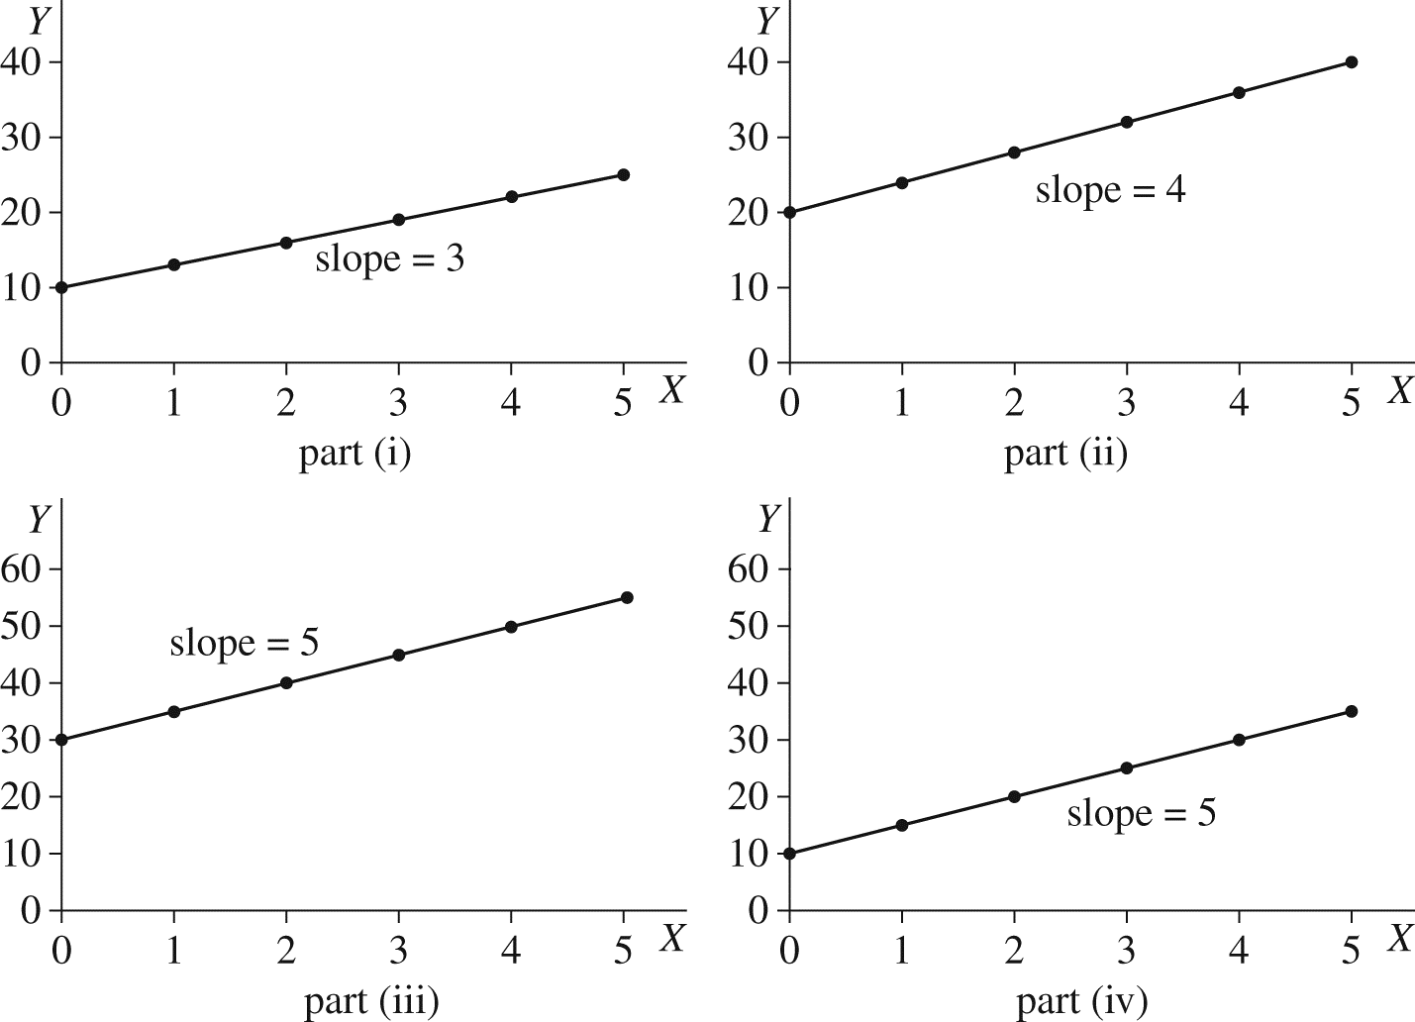

Question 13
This is a good question to make sure students understand the importance of using weighted averages rather than simple averages in some situations.
a) The simple average of the three regional unemployment rates is equal to (5.5 + 7.2 + 12.5)/3 = 8.4. Is 8.4% the “right” unemployment rate for the country as a whole? The answer is no because this simple, unweighted (or, more correctly, equally weighted) average does not account for the fact that the Centre is much larger in terms of the labour force than either the West or East, and thus should be given more weight than the other two regions.
b) To solve this problem, we construct a weighted average unemployment rate. We do so by constructing a weight for each region equal to that region’s share in the total labour force. From the data provided, the country’s total labour force is 17.2 million. The three weights are therefore:
West: weight = 5.3/17.2 = 0.308

Centre: weight = 8.4/17.2 = 0.488

East: weight = 3.5/17.2 = 0.203
These weights should sum exactly to 1.0, but due to rounding they do not quite do so. Using these weights, we now construct the average unemployment rate as the weighted sum of the three regional unemployment rates.
Canadian weighted unemployment rate = (.308 × 5.5) + (.488 × 7.2) + (.203 × 12.5) = 7.75
This is a better measure of the Canadian unemployment rate because it correctly weights each region’s influence in the national total. Keep in mind, however, that for many situations the relevant unemployment rate for an individual or a firm may be the more local one rather than the national average.

Question 14
The six required diagrams are shown below. Note that we have not provided specific units on the axes. For the first three figures, the tax system provides good examples. In each case, think of earned income as being shown along the horizontal axis and taxes paid shown along the vertical axis. The first diagram might show a progressive income-tax system where the marginal tax rate rises as income rises. The second diagram shows a proportional system with a constant marginal tax rate. The third diagram shows marginal tax rates falling as income rises, even though total tax paid still rises as income rises.
For the second set of three diagrams, imagine the relationship between the number of rounds of golf played (along the horizontal axis) and the golf score one achieves (along the vertical axis). In all three diagrams the golf score falls (improves) as one golfs more times. In the first diagram, the more one golfs the more one improves on each successive round played. In the second diagram, the rate of improvement is constant. In the third diagram, the rate of improvement diminishes as the number of rounds played increases. The actual relationship probably has bits of all three parts—presumably there is a lower limit to one’s score so eventually the curve must flatten out.

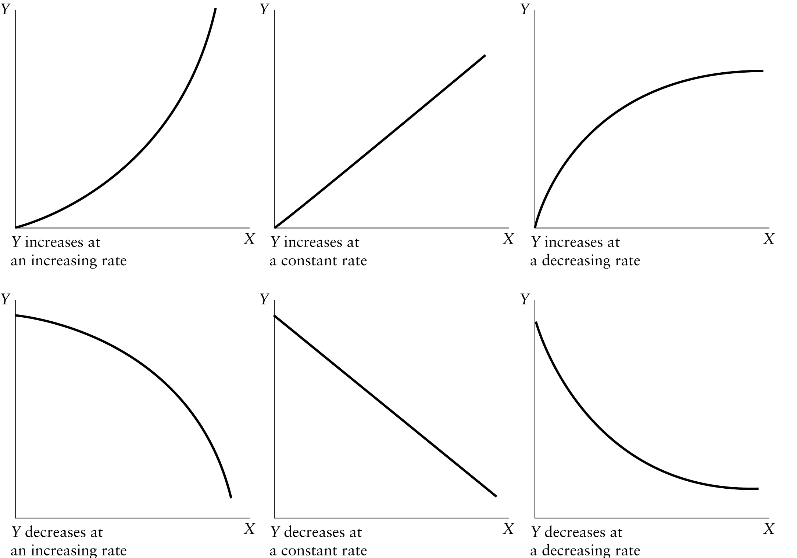

Question 15
a) The slope of the straight line connecting two points is equal to the change in Y between the points divided by the change in X between the points. In this case, the change in Y from the first point to the second is 3; the change in X is 9. Thus the slope of the straight line is 3/9 = 1/3.
b) From point A to point B, the change in Y is 20 and the change in X is -10. Thus the slope of the straight line is -20/10 = -2.
c) The slope of the function is the change in Y brought about by a one-unit change in X, which is given by the coefficient on X, -0.5.
d) The slope of the function is the change in Y brought about by a one-unit change in X, which is given by the coefficient on X, 6.5.
e) The slope of the function is the change in Y brought about by a one-unit change in X, which is given by the coefficient on X, 3.2.
f) The Y intercept of a function is the value of Y when X equals 0. In this case the Y intercept is 1000.
g) The Y intercept of a function is the value of Y when X equals 0. In this case the Y intercept is - 100.
h) The X intercept of a function (if it exists) is the value of X when Y equals 0. In this case, when Y equals 0 we have the equation 0 = 10 – 0.1X which yields -10 = -0.1X which gives us X = 100.
i) The equation for advertising (A) as a function of revenues (R) is A = 100,000 + (0.15)R.

Question 16
a) The slope of any curve at any point is equal to the slope of a tangent line to that curve at that point. At point A on the curve shown in the question, the slope of the tangent line is ½ = 0.5, and hence this is the slope of the curve at point A. For point B, the slope of the tangent line is 1 and so this is the slope of the curve at point B. For point C, the slope of the tangent line is 2/.5 = 4 and so this is the slope of the curve at point C.
b) The marginal cost of producing good X is shown by the slope of the curve (the change in total cost as output increases by one unit). The slope is clearly rising as the monthly level of production rises, showing that marginal cost increases as output increases.
c) The slope of the function is positive and increasing (getting steeper) as the level of monthly production increases.
*****

