2 | the economic problem
 Chapter

Answers to the Review Quizzes
Page 34
1. How does the production possibilities frontier illustrate scarcity?
The unattainable combinations of production that lie beyond the PPF illustrate the concept of scarcity. There simply are not enough resources to produce any of these combinations of outputs. Additionally, while moving along the PPF to increase the production of one good requires that the production of another good be reduced, which also illustrates scarcity.
2. How does the production possibilities frontier illustrate production efficiency?
The combinations of outputs that lie on the PPF illustrate the concept of production efficiency. These points are the maximum production points possible and are attained only by producing the goods and services at the lowest possible cost. Any point inside the frontier reflects production where one or both outputs may be increased without decreasing the other output level. Clearly, such points cannot be production efficient.
3. How does the production possibilities frontier show that every choice involves a tradeoff?
Movements along the PPF frontier illustrate that producing more of one good requires producing less of other good. This observation reflects the result that a tradeoff must be made when producing output efficiently.
4. How does the production possibilities frontier illustrate opportunity cost?
The negative slope of the production possibility curve illustrates the concept of opportunity cost. Moving along the production possibility frontier, producing additional units of a good requires that the output of another good must fall. This sacrifice is the opportunity cost of producing more of the first good.
5. Why is opportunity cost a ratio?
The slope of the PPF is a ratio that expresses the quantity of lost production of the good on the y-axis to the increase in the production of the good on the x-axis moving downward along the PPF. The steeper the slope, the greater ratio, and the greater is the opportunity cost of increasing the output of the good measured on the horizontal axis.
6. Why does the PPF bow outward and what does that imply about the relationship between opportunity cost and the quantity produced?
Some resources are better suited to produce one type of good or service, like pizza. Other resources are better suited to produce other goods or services, like DVDs. If society allocates resources wisely, it will use each resource to produce the kind of output for which it is best suited. Consider a PPF with pizza measured on the x-axis and DVDs measured on the y-axis. A small increase in pizza output when pizza production is relatively low requires only a small increase in the use of those resources still good at making pizza and not good at making DVDs. This yields a small decrease in DVD production for a large increase in pizza production, creating a relatively low opportunity cost reflected in the gentle slope of the PPF over this range of output. However, the same small increase in pizza output when pizza production is relatively large will require society to devote to pizza production those resources that are less suited to making pizza and more suited to making DVDs. This reallocation of resources yields a relatively small increase in pizza output for a large decrease in DVD output, creating a relatively high opportunity cost reflected in the steep slope of the PPF over this range of output. The opportunity cost of pizza production increases with the quantity of pizza produced as the slope of the PPF becomes ever steeper. This effect creates the bowed out effect (the concavity of the PPF function) and means that as more of a good is produced, the opportunity cost of producing additional units increases.
Page 37
1. What is marginal cost? How is it measured?
Marginal cost is the opportunity cost of producing one more unit of a good or service. Along a PPF marginal cost is reflected in the absolute value of the slope of the PPF. In particular, the magnitude of the slope of the PPF is the marginal cost of a unit of the good measured along the x-axis. As the magnitude of the slope changes moving along the PPF, the marginal cost changes.
2. What is marginal benefit? How is it measured?
The marginal benefit from a good or service is the benefit received from consuming one more unit of it. It is measured by what an individual is willing to give up (or pay) for an additional that last unit.
3. How does the marginal benefit from a good change as the quantity produced of that good increases?
As the more of a good is consumed, the marginal benefit received from each unit is smaller than the marginal benefit received from the unit consumed immediately before it, and is larger than the marginal benefit from the unit consumed immediately after it. This set of results is known as the principle of decreasing marginal benefit and is often assumed by economists to be a common characteristic of an individual’s preferences over most goods and services in the economy.
4. What is allocative efficiency and how does it relate to the production possibilities frontier?
Production efficiency occurs when production takes place at a point on the PPF. This indicates that all available resources are being used for production and society cannot produce additional units of one good or service without reducing the output of another good or service. Allocative efficiency, however, requires that the goods and services produced are those that provide the greatest possible benefit. This definition means that the allocative efficient level of output is the point on the PPF (and hence is a production efficient point) for which the marginal benefit equals the marginal cost.
5. What conditions must be satisfied if resources are used efficiently?
Resources are used efficiently when more of one good or service cannot be produced without producing less of some of another good or service that is valued more highly. This is known as allocative efficiency and it occurs when: 1) production efficiency is achieved, and 2) the marginal benefit received from the last unit produced is equal to the marginal cost of producing the last unit.
Page 39
1. What generates economic growth?
The two key factors that generate economic growth are technological change and capital accumulation. Technological change allows an economy to produce more with the same amount of limited resources, Capital accumulation, the growth of capital resources including human capital, means that an economy has increased its available resources for production.
2. How does economic growth influence the production possibilities frontier?
Economic growth shifts the PPF outward. Persistent outward shifts in the production possibility frontier—economic growth—are caused by the accumulation of resources, such as more capital equipment or by the development of new technology.
3. What is the opportunity cost of economic growth?
When a society devotes more of its scarce resources to research and development of new technologies, or devotes additional resources to produce more capital equipment, both decisions lead to increased consumption opportunities in future periods at the cost of less consumption today. The loss of consumption today is the opportunity cost borne by society for creating economic growth.
4. Explain why Hong Kong has experienced faster economic growth than the United States.
Hong Kong chose to devote a greater proportion of its available resources to the production of capital than the United States. This allowed Hong Kong to grow at a faster rate than the United States. By foregoing consumption and producing a greater proportion of capital goods over the last few decades, Hong Kong was able to achieve output per person equal to 94 percent of that in the United States.
5. Does economic growth overcome scarcity?
Scarcity reflects the inability to satisfy all our wants. Regardless of the amount of economic growth, scarcity will remain present because it will never be possible to satisfy all our wants. For instance it will never be possible to satisfy all the wants of the several thousand people who all would like to ski the best slopes on Vail with only their family and a few best friends present. So economic growth allows more wants to be satisfied but it does not eliminate scarcity.
Page 43
1. What gives a person a comparative advantage?
A person has a comparative advantage in an activity if that person can perform the activity at a lower opportunity cost than anyone else, If the person gives up the least amount of other goods and services to produce a particular good or service, the person has the lowest opportunity cost of producing that good or service.
2. Distinguish between comparative advantage and absolute advantage.
A person has a comparative advantage in producing a good when he or she has the lowest opportunity cost of producing it. Comparative advantage is based on the output forgone. A person has an absolute advantage in production when he or she uses the least amount of time or resources to produce one unit of that particular good or service. Absolute advantage is a measure of productivity in using inputs.
3. Why do people specialize and trade?
People can compare consumption possibilities from producing all goods and services through self-sufficiency against specializing in producing only those goods and services that reflect their comparative advantage and trading their output with others who do the same. People can then see that the consumption possibilities from specialization and trade are greater than under self-sufficiency. Therefore it is in people’s own self-interest to specialize. It was Adam Smith who first pointed out in the Wealth of Nations how individuals voluntarily engage in this socially beneficial and cooperative activity through the pursuit of their own self-interest, rather than for society’s best interests.
4. What are the gains from specialization and trade?
From society’s standpoint, the total output of goods and services available for consumption is greater with specialization and trade. From an individual’s perspective, each person who specializes enjoys being able to consume a larger bundle of goods and services after trading with others who have also specialized, than would otherwise be possible under self-sufficiency. These increases are the gains from specialization and trade for society and for individuals.
5. What is the source of the gains from trade?
As long as people have different opportunity costs of producing goods or services, total output is higher with specialization and trade than if each individual produced goods and services under self-sufficiency. This increase in output is the gains from trade.
Page 45
1. Why are social institutions such as firms, markets, property rights, and money necessary?
These social institutions factors necessary for a decentralized economy to coordinate production. Firms are necessary to allow people to specialize. Without firms, specialization would be limited because a person would need to specialize in the entire production of a good or service. With firms people are able to specialize in producing particular bits of a good or service. For a society to enjoy the fruits of specialization and trade, the individuals who comprise that society must voluntarily desire to specialize in the first place. Discovering trade opportunities after a person has specialized in his or her comparative advantage in production is what allows that person to gain from his or her own specialization efforts. Trading opportunities can only take place if a market exists where people observe prices to discover available trade opportunities. Money is necessary to allow low-cost trading in markets. Without money, goods would need to be directly exchanged for other goods, a difficult and unwieldy situation. Finally people must enjoy social recognition of and government protection of property rights to have confidence that their commitments to trade arrangements will be respected by everyone in the market.
2. What are the main functions of markets?
The main function of a market is to enable buyers and sellers to get information and to do business with each other. Markets have evolved because they facilitate trade, that is, they facilitate the ability of buyers and sellers to trade with each other.
3. What are the flows in the market economy that go from firms to households and the flows from households to firms?
On the real side of the economy, goods and services flow from firms to households. On the monetary side of the economy, payments for factors of production, wages, rent, interest, and profits, flow from firms to households. Flowing from households to firms on the monetary side of the economy are the expenditures on goods and services and on the real side are the factors of production, labor, land, capital, and entrepreneurship.
Answers to the Study Plan Problems and Applications
Use the following data to work Problems 1 to 3.
Brazil produces ethanol from sugar, and the land used to grow sugar can be used to grow food crops. The table to the right sets out Brazil’s production possibilities for ethanol and food crops.
Ethanol  (barrels per day) |  | Food crops  (tons per day)
70 | and | 0
64 | and | 1
54 | and | 2
40 | and | 3
22 | and | 4
0 | and | 5
1. a. Draw a graph of Brazil’s PPF and explain how your graph illustrates scarcity.
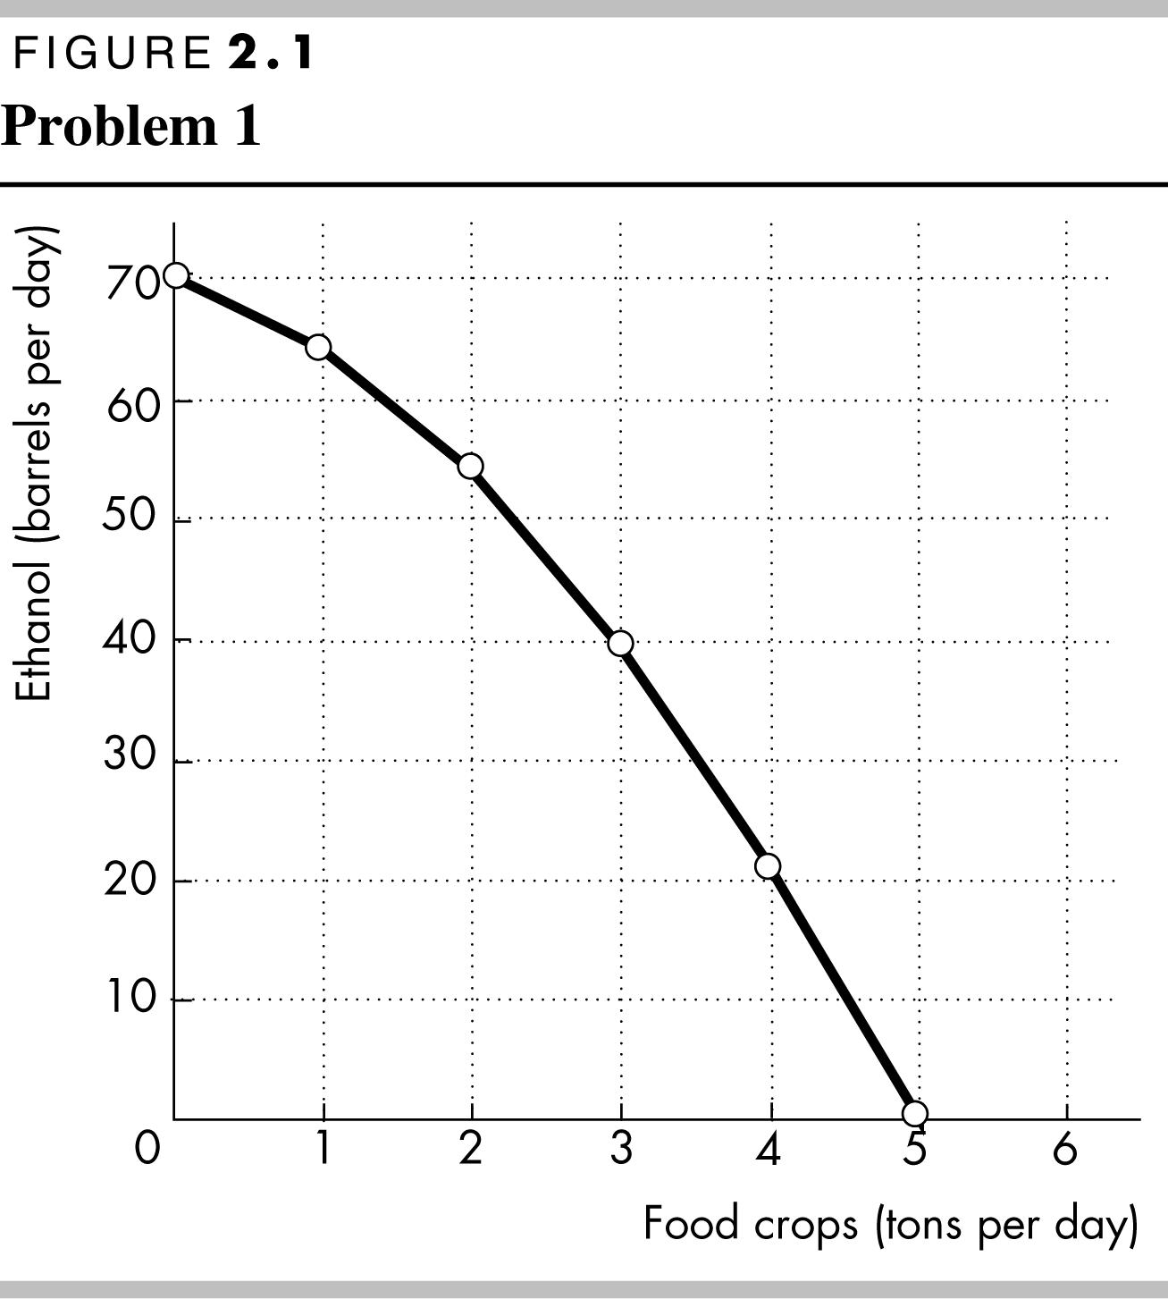
Figure 2.1 shows Brazil’s PPF. The production possibilities frontier indicates scarcity because it shows the limits to what can be produced. In particular, production combinations of ethanol and food crops that lie outside the production possibilities frontier are not attainable.
b. If Brazil produces 40 barrels of ethanol a day, how much food must it produce to achieve production efficiency?
If Brazil produces 40 barrels of ethanol per day, it achieves production efficiency if it also produces 3 tons of food per day.
c. Why does Brazil face a tradeoff on its PPF?
Brazil faces a tradeoff on its PPF because Brazil’s resources and technology are limited. For Brazil to produce more of one good, it must shift factors of production away from the other good. Therefore to increase production of one good requires decreasing production of the other, which reflects a tradeoff.
2. a. If Brazil increases ethanol production from 40 barrels per day to 54 barrels per day, what is the opportunity cost of the additional ethanol?
When Brazil is production efficient and increases its production of ethanol from 40 barrels per day to 54 barrels per day, it must decrease its production of food crops from 3 tons per day to 2 tons per day. The opportunity cost of the additional ethanol is 1 ton of food per day for the entire 14 barrels of ethanol or 1/14 of a ton of food per barrel of ethanol.
b. If Brazil increases food production from 2 tons per day to 3 tons per day, what is the opportunity cost of the additional food?
When Brazil is production efficient and increases its production of food crops from 2 tons per day to 3 tons per day, it must decrease its production of ethanol from 54 barrels per day to 40 barrels per day. The opportunity cost of the additional 1 ton of food crops is 14 barrels of ethanol.
c. What is the relationship between your answers to parts (a) and (b)?
The opportunity costs of an additional barrel of ethanol and the opportunity cost of an additional ton of food crop are reciprocals of each other. That is, the opportunity cost of 1 ton of food crops is 14 barrels of ethanol and the opportunity cost of 1 barrel of ethanol is 1/14 of a ton of food crops.
3. Does Brazil face an increasing opportunity cost of ethanol? What feature of Brazil’s PPF illustrates increasing opportunity cost?
Brazil faces an increasing opportunity cost of ethanol production. For instance, when increasing ethanol production from 0 barrels per day to 22 barrels the opportunity cost of a barrel of ethanol is 1/22 of a ton of food while increasing ethanol production another 18 barrels per day (to a total of 40 barrels per day) has an opportunity cost of 1/18 of a ton of food per barrel of ethanol. The PPF’s bowed outward shape reflects the increasing opportunity cost.
Use the above table (for Problems 1 to 3) to work Problems 4 and 5.
4. Define marginal cost and calculate Brazil’s marginal cost of producing a ton of food when the quantity produced is 2.5 tons per day.
The marginal cost of a good is the opportunity cost of producing one more unit of the good. When the quantity of food produced is 2.5 tons, the marginal cost of a ton of food is the opportunity cost of increasing the production of food from 2 tons per day to 3 tons per day. The production of ethanol falls from 54 barrels per day to 40 barrels per day, a decrease of 14 barrels per day. The opportunity cost of increasing food production is the decrease in ethanol product, so the opportunity cost of producing a ton of food when 2.5 tons of food per day are produced is 14 barrels of ethanol per day.
5. Define marginal benefit. Explain how it is measured and why the data in the table does not enable you to calculate Brazil’s marginal benefit from food.
The marginal benefit of a good is the benefit received from consuming one more unit of the good. The marginal benefit of a good or service is measured by the most people are willing to pay for one more unit of it. The data in the table do not provide information on how much people are willing to pay for an additional unit of food. The table has no information on the marginal benefit of food.
6. Distinguish between production efficiency and allocative efficiency. Explain why many production possibilities achieve production efficiency but only one achieves allocative efficiency.
Production efficiency occurs when goods and services are produced at the lowest cost. This definition means that production efficiency occurs at any point on the PPF. Therefore all of the production points on the PPF are production efficient. Allocative efficiency occurs when goods and services are produced at the lowest cost and in the quantities that provide the greatest possible benefit. The allocatively efficient production point is the single point on the PPF that has the greatest possible benefit.
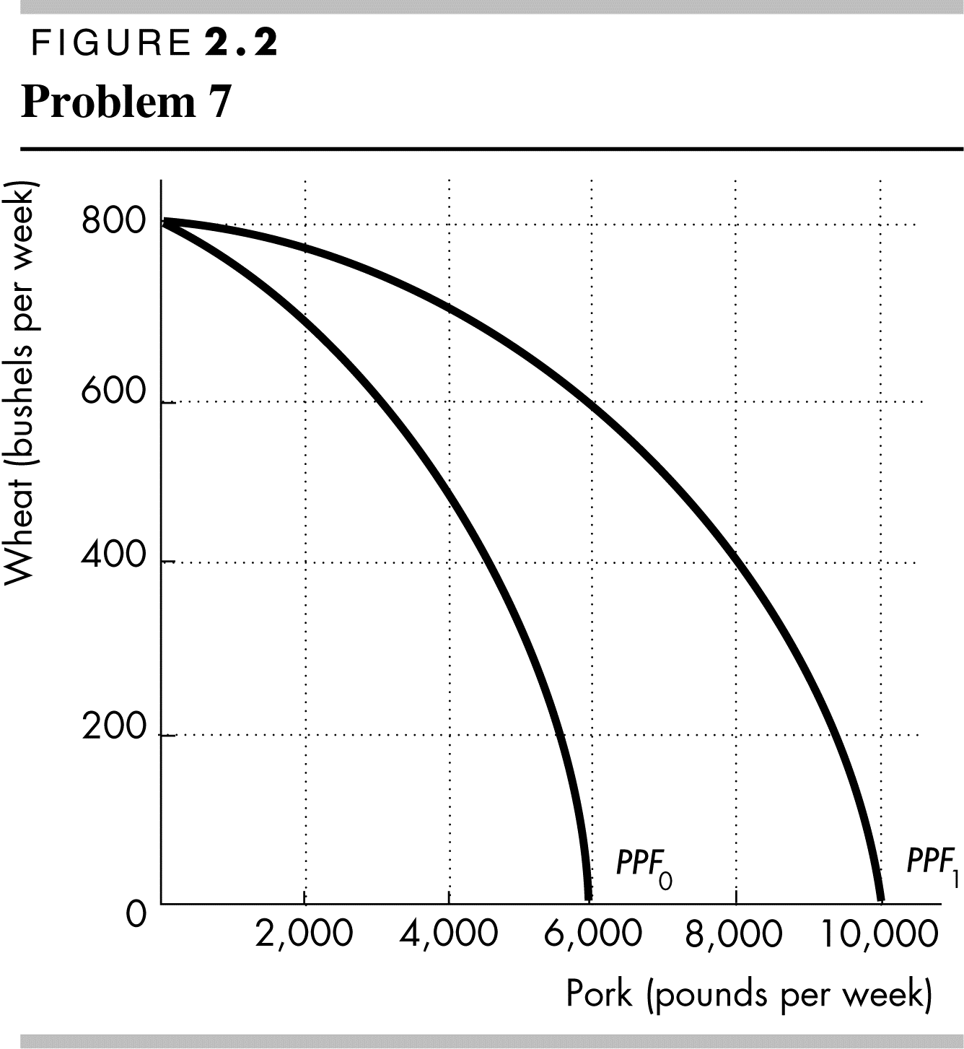
7. A farm grows wheat and produces pork. The marginal cost of producing each of these products increases as more of it is produced.
a. Make a graph that illustrates the farm’s PPF.
The PPF is illustrated in Figure 2.2 as PPF₀. Because the marginal cost of both wheat and pork increase as more of the good is produced, the PPF displays increasing opportunity cost so it has the “conventional” bowed-outward shape.
b. The farm adopts a new technology that allows it to use fewer resources to fatten pigs. On your graph sketch the impact of the new technology on the farm’s PPF.
The new technology rotates the PPF outward from PPF₀ to PPF_{1.}
c. With the farm using the new technology described in part (b), has the opportunity cost of producing a ton of wheat increased, decreased, or remained the same? Explain and illustrate your answer.
The opportunity cost of producing wheat has increased. The opportunity cost of a bushel of wheat is equal to the magnitude of 1/(slope of the PPF). As illustrated in Figure 2.2, for each quantity of wheat the slope of PPF₁ has a smaller magnitude than the slope of PPF₀ so the opportunity cost of a bushel of wheat is higher along PPF₁. For a specific example, the opportunity cost of increasing wheat product from 600 bushels per week to 800 bushels per week along PPF₁ is 6,000 pounds of pork but is only 3,000 pounds of pork along PPF₀.
d. Is the farm more efficient with the new technology than it was with the old one? Why?
The farm is able to produce more with the new technology than with the old, but it is not necessarily more efficient. If the farm was producing on its PPF before the new technology and after, the farm was production efficient both before the new technology and after.
8. In one hour, Sue can produce 40 caps or 4 jackets and Tessa can produce 80 caps or 4 jackets.
a. Calculate Sue’s opportunity cost of producing a cap.
Sue forgoes 4 jackets to produce 40 caps, so Sue’s opportunity cost of producing one cap is (4 jackets)/(40 caps) or 0.1 jacket per cap.
b. Calculate Tessa’s opportunity cost of producing a cap.
Tessa forgoes 4 jackets to produce 80 caps, so Tessa’s opportunity cost of producing one cap is (4 jackets)/(80 caps) or 0.05 jacket per cap.
c. Who has a comparative advantage in producing caps?
Tessa’s opportunity cost of a cap is lower than Sue’s opportunity cost, so Tessa has a comparative advantage in producing caps.
d. If Sue and Tessa specialize in producing the good in which they have a comparative advantage, and they trade 1 jacket for 15 caps, who gains from the specialization and trade?
Tessa specializes in caps and Sue specializes in jackets. Both Sue and Tessa gain from trade. Sue gains because she can obtain caps from Tessa at a cost of (1 jacket)/(15 caps), which is 0.067 jacket per cap, a cost that is lower than what it would cost her to produce caps herself. Tessa also gains from trade because she trades caps for jackets for 0.067 jacket per cap, which is higher than her cost of producing a cap.
9. Suppose that Tessa buys a new machine for making jackets that enables her to make 20 jackets an hour. (She can still make only 80 caps per hour.)
a. Who now has a comparative advantage in producing jackets?
Sue forgoes 40 caps to produce 4 jackets, so Sue’s opportunity cost of producing one jacket is (40 caps)/(4 jackets) or 10 caps per jacket. Tessa forgoes 80 caps to produce 20 jackets, so Tessa’s opportunity cost of producing one jacket is (80 caps)/(20 jackets) or 4 caps per jacket. Tessa has the comparative advantage in producing jackets because her opportunity cost of a jacket is lower than Sue’s opportunity cost.
b. Can Sue and Tessa still gain from trade?
Tessa and Sue can still gain from trade because Tessa (now) has a comparative advantage in producing jackets and Sue (now) has a comparative advantage in producing caps. Tessa will produce jackets and Sue will produce caps.
c. Would Sue and Tessa still be willing to trade 1 jacket for 15 caps? Explain your answer.
Sue and Tessa will not be willing to trade 1 jacket for 15 caps. In particular, Sue, whose comparative advantage lies in producing caps, can produce 1 jacket at an opportunity cost of only 10 caps. So Sue will be unwilling to pay any more than 10 caps per jacket.
10. For 50 years, Cuba has had a centrally planned economy in which the government makes the big decisions on how resources will be allocated.
a. Why would you expect Cuba’s production possibilities (per person) to be smaller than those of the United States?
Cuba’s economy is almost surely less efficient than the U.S. economy. The Cuban central planners do not know people’s production possibilities or their preferences. The plans that are created wind up wasting resources and/or producing goods and services that no one wants. Because firms in Cuba are owned by the government rather than individuals, no one in Cuba has the self-interested incentive to operate the firm efficiently and produce goods and services that consumers desire. Additionally Cuba does not actively trade so Cuba produces most of its consumption goods rather than buying them from nations with a comparative advantage. Because Cuba uses its resources to produce consumption goods, it cannot produce many capital goods so its economic growth rate has been low.
b. What are the social institutions that Cuba might lack that help the United States to achieve allocative efficiency?
Of the four social institutions, firms, money, markets, and property rights, Cuba’s economy has firms and money. Markets, however, are less free of government intervention in Cuba. But the major difference is the property rights in the Cuban economy. In Cuba the government owns most of the firms; that is, the government has the property right to run the producers. Because the firms are not motivated to make a profit, the managers of these firms have little incentive to operate the firm efficiently or to produce the goods and services that consumers desire. In the United States, firms are owned by individuals; that is, people have the property right that allows them to run firms. These owners have the self-interested incentive to operate the firm efficiently and to produce the goods and services people want, an incentive sorely lacking in the Cuban economy.
Answers to Additional Problems and Applications
Use the table to work Problems 11 and 12. Suppose that Yucatan’s production possibilities are given in the table.
Food  (pounds per month) |  | Sunscreen  (gallons per month)
300 | and | 0
200 | and | 50
100 | and | 100
0 | and | 150
11. a. Draw a graph of Yucatan’s PPF and explain how your graph illustrates a tradeoff.
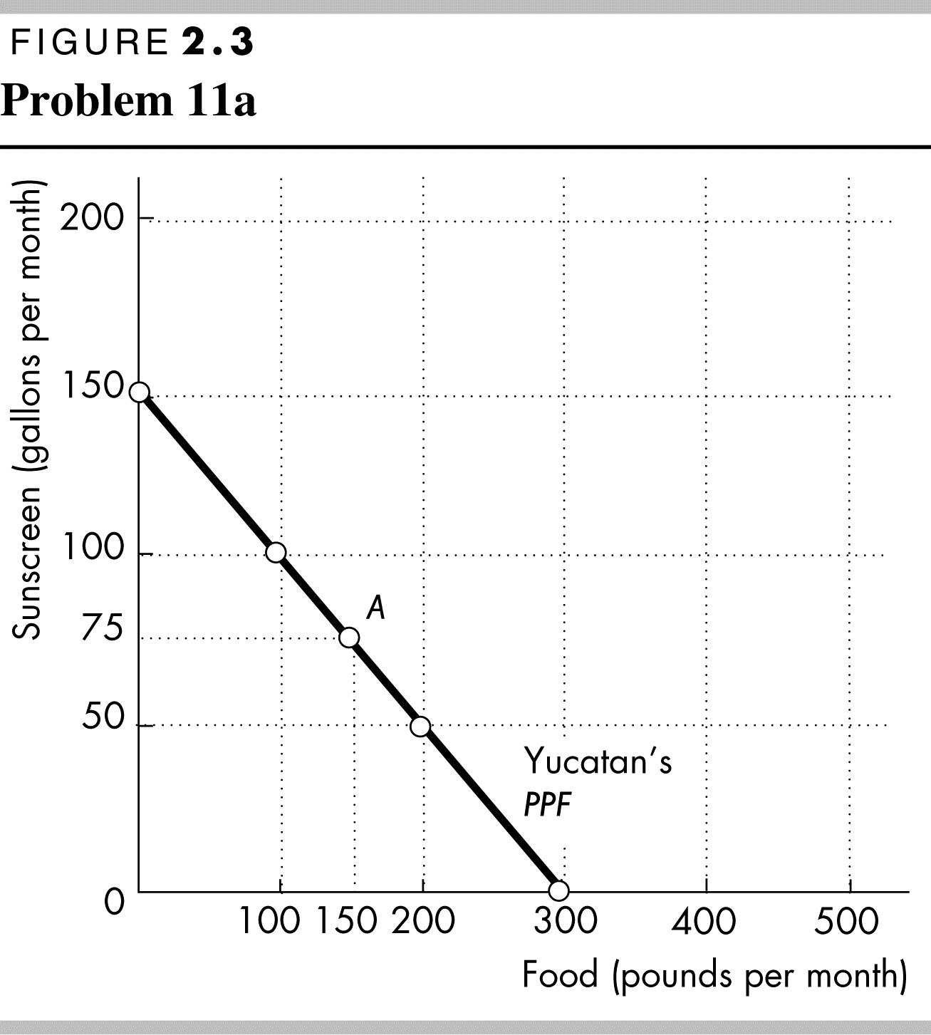
Yucatan’s PPF is illustrated in Figure 2.3. The figure illustrates a tradeoff because moving along Yucatan’s PPF producing more of one good requires producing less of the other good. Yucatan trades off more production of one good for less production of the other.
b. If Yucatan produces 150 pounds of food per month, how much sunscreen must it produce if it achieves production efficiency?
If Yucatan produces 150 pounds of food per month, then the point labeled A on the PPF in Figure 2.11 shows that Yucatan must produce 75 gallons of sunscreen per month to achieve production efficiency.
c. What is Yucatan’s opportunity cost of producing (i) 1 pound of food and (ii) 1 gallon of sunscreen?
Yucatan’s PPF is linear so the opportunity cost of producing 1 pound of food is the same at all quantities. Calculate the opportunity cost of producing 1 pound of food when increasing the production of food from 0 to 100 pounds per month. Between these two ranges of production, the quantity of sunscreen produced falls from 150 gallons per month to 100 gallons per month, a decrease of 50 gallons. The opportunity cost is 50 gallons of sunscreen to gain 100 pounds of food. The opportunity cost per pound of food equals (50 gallons of sunscreen)/(100 pounds of food), or an opportunity cost of 0.5 gallon of sunscreen per pound of food.
Yucatan’s PPF is linear so the opportunity cost of producing 1 gallon of sunscreen is the same at all quantities. Calculate the opportunity cost of producing 1 gallon of sunscreen when increasing the production of sunscreen from 0 to 50 gallons per month. Between these two ranges of production, the quantity of food produced falls from 300 pounds per month to 200 pounds per month, a decrease of 100 pounds. The opportunity cost is 100 pounds of food to gain 50 gallons of sunscreen, or (100 pounds of food)/(50 gallons of sunscreen) which yields an opportunity cost of 2.0 pounds of food per gallon of sunscreen.
e. What is the relationship between your answers to part (c)?
Answers (c) and (d) reflect the fact that opportunity cost is a ratio. The opportunity cost of gaining a unit of a good moving along the PPF equals the quantity of the other good or service forgone divided by the quantity of the good or service gained. The opportunity cost of one good, food, is equal to the inverse of the opportunity cost of the other good, sunscreen.
12. What feature of a PPF illustrates increasing opportunity cost? Explain why Yucatan’s opportunity cost does or does not increase.
If opportunity costs increase, the PPF bows outward. Yucatan’s PPF is linear and along a linear PPF the opportunity cost is constant. Yucatan does not face an increasing opportunity cost of food because the opportunity cost remains constant, equal to 0.5 gallons of sunscreen per pound of food. Yucatan’s resources must be equally productive in both activities.
13. In problem 11, what is the marginal cost of 1 pound of food in Yucatan when the quantity produced is 150 pounds per day? What is special about the marginal cost of food in Yucatan?
The marginal cost of a pound of food in Yucatan is constant at all points along Yucatan’s PPF and is equal to 0.5 gallons of sunscreen per pound of food. The special point about Yucatan’s marginal cost is the fact that the marginal cost is constant. This result reflects Yucatan’s linear PPF.
14. The table describes the preferences in Yucatan.
Sunscreen  (gallons per month) | Willingness to pay  (pounds of food per gallon)
25 | 3
75 | 2
125 | 1
a. What is the marginal benefit from sunscreen and how is it measured?
The marginal benefit from sunscreen is the benefit enjoyed by the person who consumes one more gallon of sunscreen. It is equal to the willingness to pay for an additional gallon. For example, in the table when 75 gallons of sunscreen are produced, the marginal benefit of a gallon is 2 pounds of food per gallon.
b. Use the table in Problem 11. What does Yucatan produce to achieve allocative efficiency?
To achieve allocative efficiency, the marginal benefit of a gallon of sunscreen must equal the marginal cost of a gallon of sunscreen. Yucatan’s marginal cost of a gallon of sunscreen is 2 pounds of food per gallon. When Yucatan produces 75 gallons of sunscreen, the table shows that Yucatan’s marginal benefit is 2 pounds of food per gallon. Therefore allocative efficiency is achieved when 75 gallons of sunscreen and, from the PPF, 150 pounds of food are produced.
15. U.K. Music Stores Squeezed off Main Street
Music retailing is changing: Sony Music and Amazon are selling online, discount stores are selling at low prices, and Main Street music retailers are all struggling.
Source: The Economist, 20 January 2007
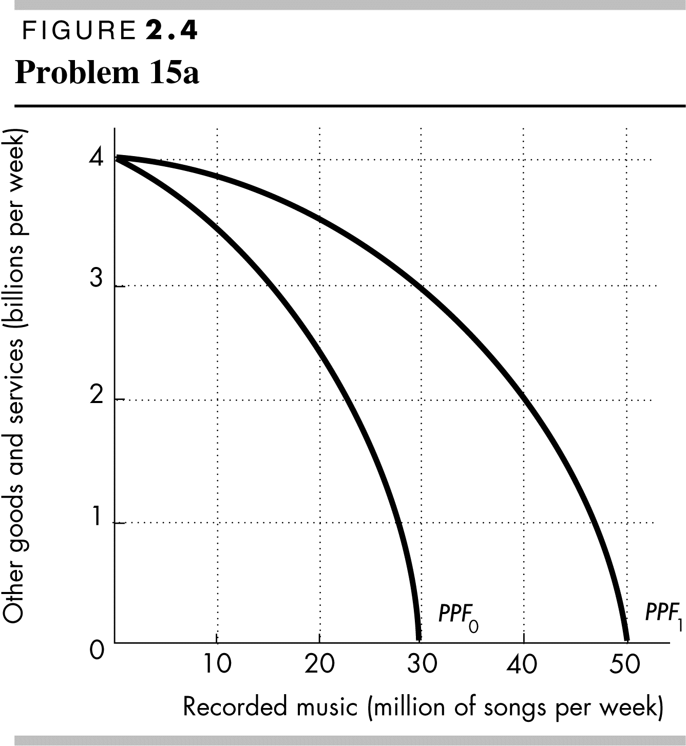
a. Draw the PPF curves for Main Street music retailers and online music retailers before and after the Internet became available.
Before there was an Internet, there were no online retailers and the production possibilities frontier was PPF₀ in Figure 2.4. After the Internet was developed, online retailers were created and started to sell songs. The Internet is a technological advance that rotates the production possibilities frontier outward to PPF₁ in Figure 2.4.
b. Draw the marginal cost and marginal benefit curves for Main Street music retailers and online music retailers before and after the Internet became available.
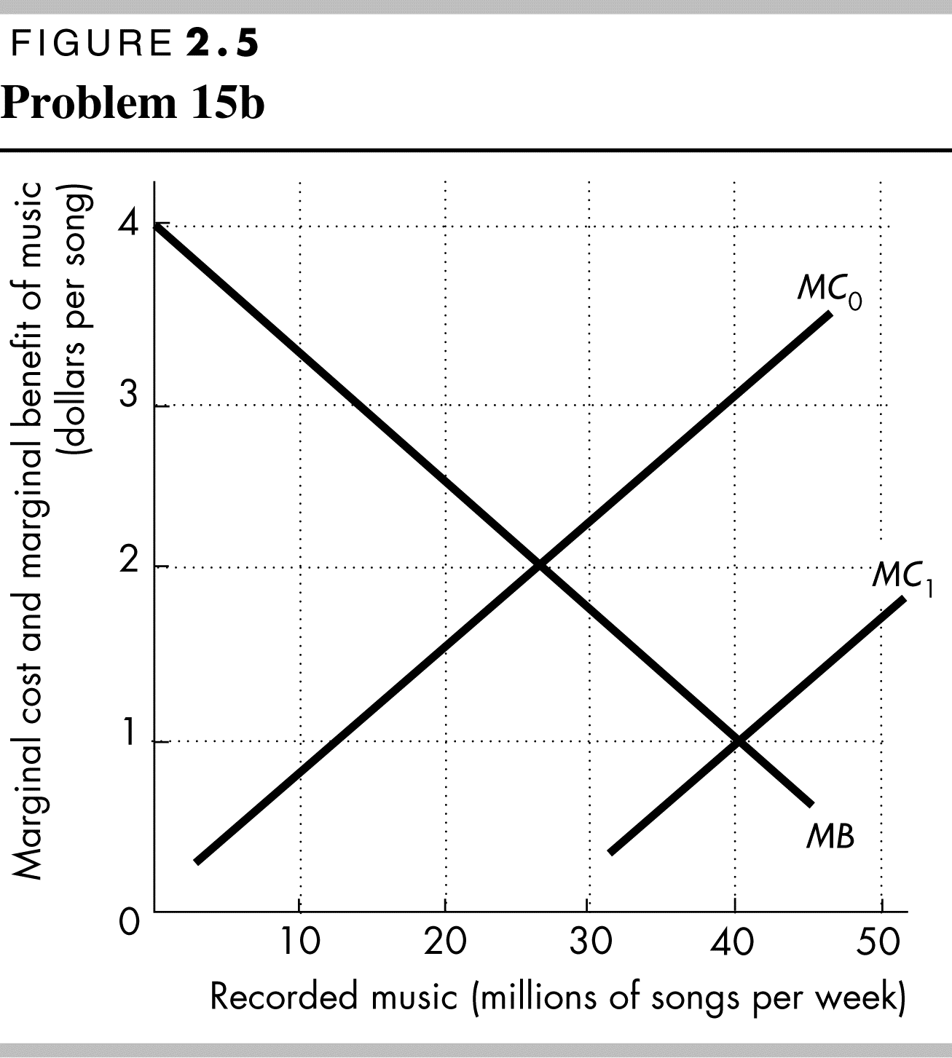
Online music retailers have a lower marginal cost of delivering recorded music than do main street music retailers. The marginal benefit for recorded music is the same regardless of whether the music came from an online store or a main street store. Therefore in Figure 2.5 the marginal benefit curve for recorded music is MB, the marginal cost of main street stores is MC₀, and the marginal cost of online stores is MC₁.
c. Explain how changes in production possibilities, preferences or both have changed the way in which recorded music is retailed.
The change in production possibilities, which created lower-cost online recorded music stores, have changed the way recorded music is purchased. Because the marginal cost of buying recorded music is less using an online store, today most recorded music is purchased from online stores. Consequently main street music stores are disappearing as they go bankrupt and fail.
Use the following news clip to work Problems 16 and 17.
Malaria Eradication Back on the Table
In response to the Gates Malaria Forum in October 2007, countries are debating the pros and cons of eradication. Dr. Arata Kochi of the World Health Organization believes that with enough money malaria cases could be cut by 90 percent, but it would be very expensive to eliminate the remaining10 percent of cases, so countries should not strive to eradicate malaria.
Source: The New York Times, March 4, 2008
16. Is Dr. Kochi talking about production efficiency or allocative efficiency or both?
Dr. Kochi is talking about allocative efficiency. His assessment is that the last 10 percent eradication has such a high marginal cost that it almost surely exceeds its marginal benefit.
17. Make a graph with the percentage of malaria cases eliminated on the x-axis and the marginal cost and marginal benefit of driving down malaria cases on the y-axis. On your graph:
(i) Draw a marginal cost curve and marginal benefit curve that are consistent with Dr. Kochi’s opinion.
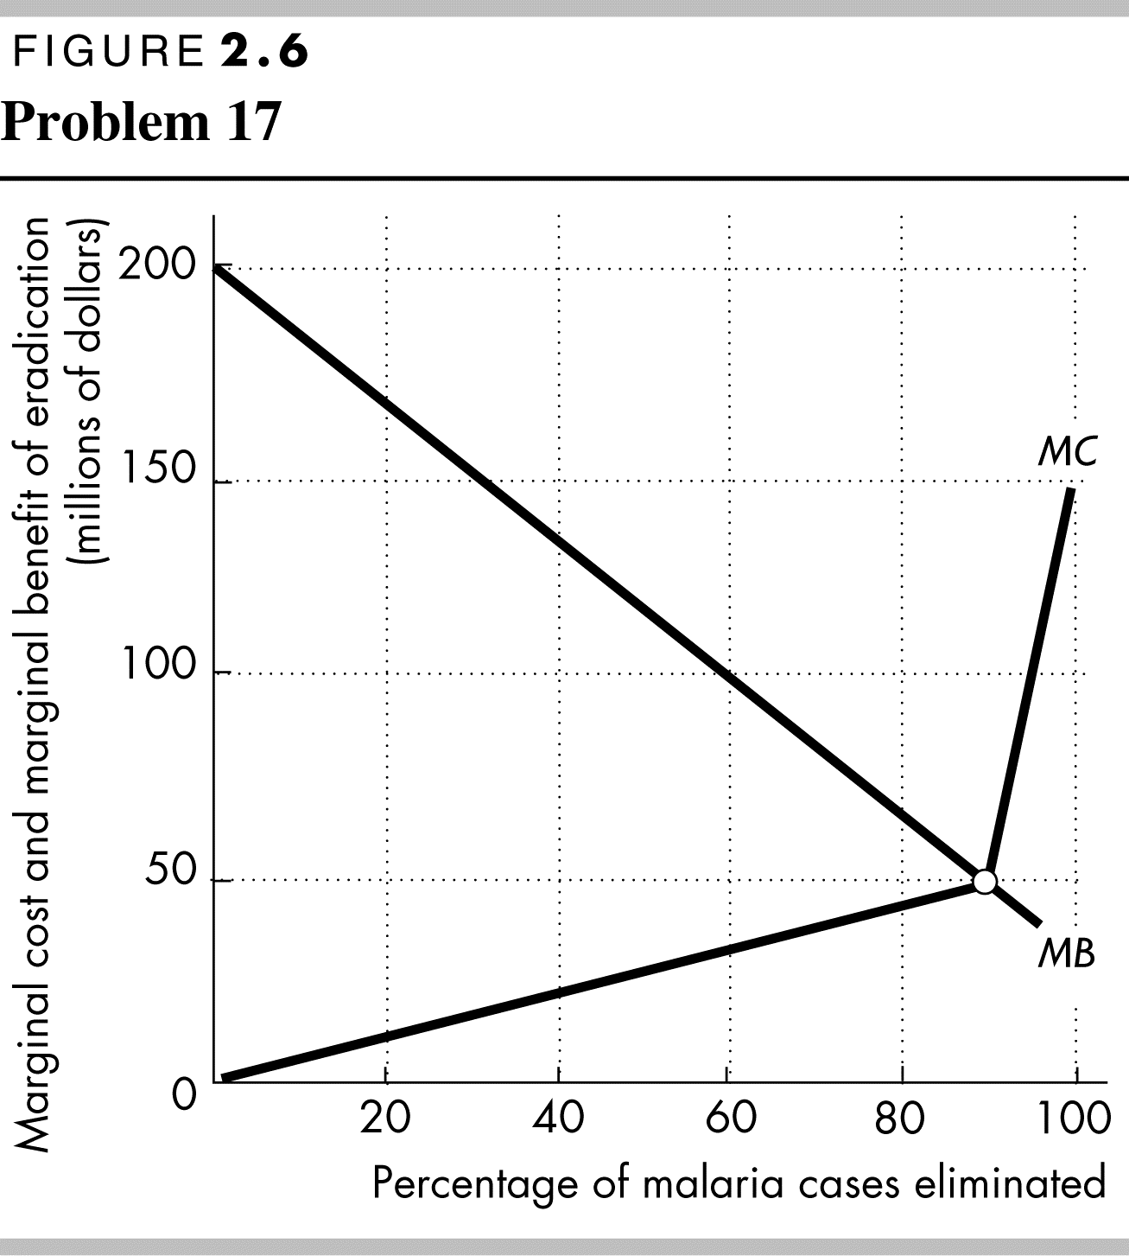
(ii) Identify the quantity of malaria eradicated that achieves allocative efficiency.
Figure 2.6 shows a marginal cost curve and a marginal benefit curve that are consistent with Dr. Kochi’s views. Dr. Kochi believes that the last 10 percent of malaria would be very expensive to eradicate. The marginal cost curve in the figure reflects this view because the marginal cost curve rises rapidly after 90 percent of malaria is eradicated. The marginal benefit curve is downward sloping, reflecting diminishing marginal benefit from malaria eradication. The allocatively efficient quantity of malaria eradicated is 90 percent because that is the quantity for which the marginal benefit of eradication equals the marginal cost of eradication. This outcome demonstrates Dr. Kochi’s conclusion that countries should not attempt to completely
18. Capital accumulation and technological change bring economic growth: Production that was unattainable yesterday becomes attainable today; production that is unattainable today will become attainable tomorrow. Why doesn’t economic growth bring an end to scarcity one day?
Scarcity is always being defeated yet will never suffer defeat. Scarcity reflects the existence of unmet wants. People’s wants are infinite—regardless of what a person already possesses, everyone can easily visualize something else he or she wants, if only more time in the day to enjoy their possessions. Because people’s wants are insatiable, scarcity will always exist regardless of economic growth.
19. Toyota Plans to Build a Better Company
Toyota will continue to produce 3 million cars per year and use the balance of its resources to upgrade its workers’ skills and create new technology. In three years’ time, Toyota plans to produce better cars and be more productive.
Source: Financial Post, April 7, 2014
a. What is the opportunity cost of upgrading its workers’ skills and creating new technology?
The opportunity cost of upgrading workers’ skills and creating new technology is the next best alternative forgone by these changes. The story indicates that the next best alternative for Toyota is building new cars, so the opportunity cost of upgrading workers’ skills and creating new technology is the current production of new cars that are forgone.
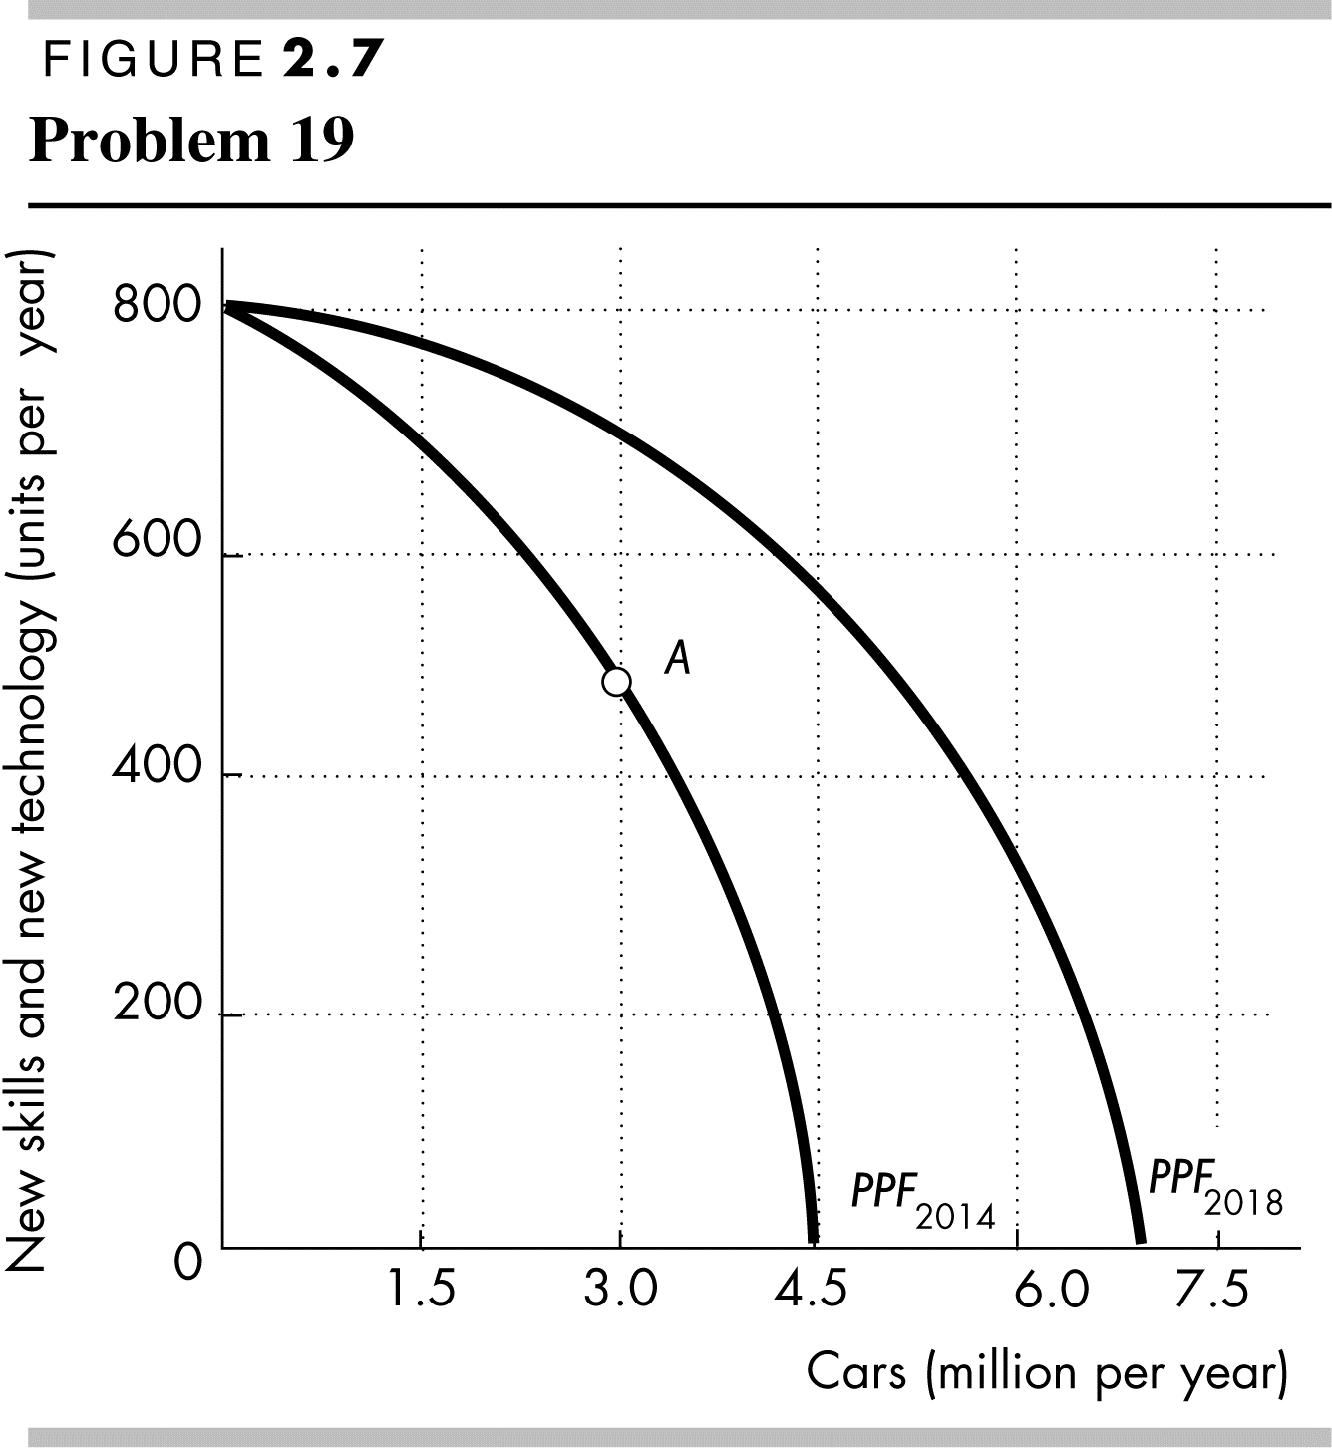
b. Sketch Toyota’s PPF and mark its production point in 2014. Now show on your graph Toyota’s PPF in 2018.
Figure 2.7 shows Toyota's PPF in 2014 and in 2018. The upgrade in workers’ skills and the new technology shift Toyota’s PPF outward so that its PPF in 2018 lies beyond its PPF in 2014. Toyota’s production point in 2014 is labeled A.

Use the following data to work Problems 20 and 21.
Kim can produce 40 pies or 400 cakes an hour. Liam can produce 100 pies or 200 cakes an hour.
20. a. Calculate Kim’s opportunity cost of a pie and Liam’s opportunity cost of a pie.
If Kim spends an hour baking pies, she gains 40 pies but forgoes 400 cakes. Kim’s opportunity cost of 1 pie is (400 cakes)/(40 pies), or 10 cakes per pie. If Liam spends an hour baking pies, he gains 100 pies but forgoes 200 cakes. Liam’s opportunity cost of 1 pie is (200 cakes)/(100 pies), or 2 cakes per pie.
b. If each spends 30 minutes of each hour producing pies and 30 minutes producing cakes, how many pies and cakes does each produce?
Kim produces 20 pies and 200 cakes. Liam produces 50 pies and 100 cakes. The total number produced is 70 pies and 300 cakes.
c. Who has a comparative advantage in producing (i) pies and (ii) cakes?
Liam has the comparative advantage in producing pies because his opportunity cost of a pie is less than Kim’s opportunity cost. Kim has the comparative advantage in producing cakes because her opportunity cost of a cake is less than Liam’s opportunity cost.
21. a Draw a graph of Kim’s PPF and Liam’s PPF and show the point at which each produces when they spend 30 minutes of each hour producing pies and 30 minutes producing cakes.
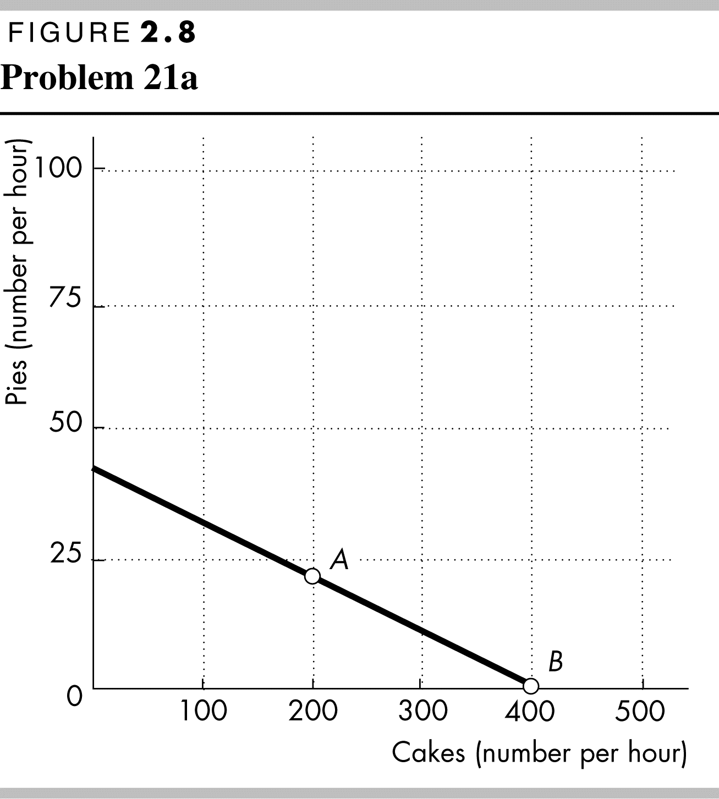 | 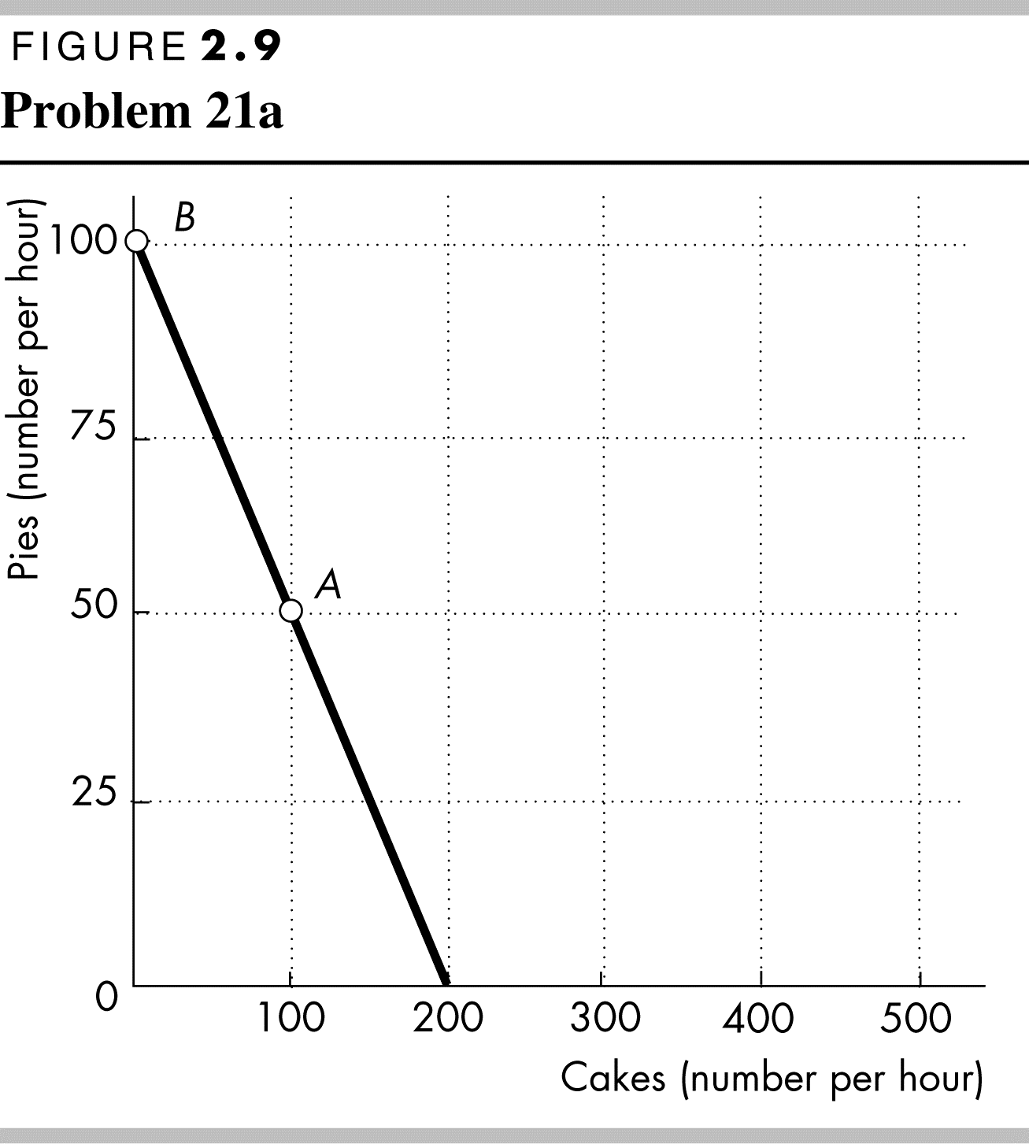
Kim’s PPF is illustrated in Figure 2.8; Liam’s PPF is illustrated in Figure 2.9.
Point A in both figures shows their production points when each spends 30 minutes making cakes and 30 minutes making pies.
b. On your graph, show what Kim produces and what Liam produces when they specialize.
Kim will specialize in cakes and Liam will specialize in pies. Point B in both figures shows the production points when each specializes.
c. When they specialize and trade, what are the total gains from trade?
Kim will specialize in cakes and Liam will specialize in pies. If they specialize and trade, the total production of both cakes and pies increase. When each spends 30 minutes making cakes and 30 minutes making pies, together they produce 300 cakes and 70 pies. When they specialize, together they produce 400 cakes and 100 pies. The 100 increase in cakes and the 30 increase pies is the gains from trade.
d. If Kim and Liam share the total gains equally, what trade takes place between them?
Kim will trade 50 cakes (half of the gain in cake production) to Liam in exchange for 15 pies (half of the increase in pie production).
Tony’s Production Possibilities |  |  |  | Patty’s Production Possibilities
Snowboards  (units per week) |  | Skis  (units per week) |  | Snowboards  (units per week) |  | Skis  (units per week)
25 | and | 0 |  | 20 | and | 0
20 | and | 10 |  | 10 | and | 5
15 | and | 20 |  | 0 | and | 10
10 | and | 30
5 | And | 40
0 | And | 50

22. Tony and Patty produce skis and snowboards. The tables show their production possibilities. Tony produces 5 snowboards and 40 skis a week; Patty produces 10 snowboards and 5 skis a week.
a. Who has a comparative advantage in producing (i) snowboards and (ii) skis?
(i) Tony’s opportunity cost of a snowboard is (10 skis)/(5 snowboards), or 2 skis per snowboard. Patty’s opportunity cost of a snowboard is (5 skis)/(10 snowboards), or 0.5 skis per snowboard. Patty’s opportunity cost of a snowboard is lower than Tony’s opportunity cost, so Patty has the comparative advantage.
(ii) Tony’s opportunity cost of a ski is (5 snowboards)/(10 skis), or 0.5 snowboards per ski. Patty’s opportunity cost of a ski is (10 snowboards)/(5 skis), or 2.0 snowboards per ski. Tony’s opportunity cost of a ski is lower than Patty’s opportunity cost, so Tony has the comparative advantage.
b. If Tony and Patty specialize and trade 1 snowboard for 1 ski, what are the gains from trade?
Tony has a comparative advantage in producing skis, so he specializes in producing skis. Patty has a comparative advantage in producing snowboards, so she specializes in snowboards. Tony now produces 50 skis and Patty produces 20 snowboards. Before specializing they produced a total of 45 skis (Tony’s 40 plus Patty’s 5) and 15 snowboards (Tony’s 5 plus Patty’s 10). By specializing, the total production of skis increases by 5 and the total production of snowboards increases by 5. This increase in total production is the gains from trade. By trading 1 ski for 1 snowboard, they can share these gains. Tony obtains snowboards from Patty for less than it costs him to produce them and Patty obtains skis from Tony for less than it costs her to produce them.
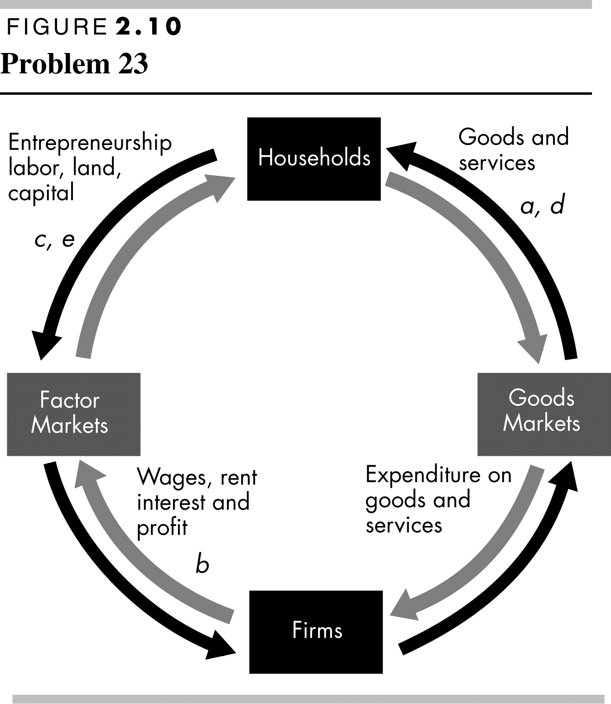
23. Indicate on a graph of the circular flows in the market economy, the real and money flows in which the following items belong:
a. You buy an iPad from the Apple Store.
Figure 2.10 shows the circular flows in a market economy. Your purchase of an iPad from Apple is the purchase of a good from a firm. This flow is in the black arrow indicated by point a in the figure. When you pay for the iPad, the corresponding money flow is in the grey arrow in the opposite direction to the black arrow labeled a.
b. Apple Inc. pays the designers of the iPad.
Apple’s payment to the designers of the iPad is the payment of a wage to a factor of production. This flow is in the grey arrow indicated by point b in the figure. The flow of design services from the designer to Apple is in the black arrow in the opposite direction to the grey arrow labeled b.
c. Apple Inc. decides to expand and rents an adjacent building.
Apple’s decision to expand by renting a building means that Apple is increasing the capital it uses. This flow is in the black arrow indicated by point c in the figure. The flow of the payment for the rental services of the building is in the grey arrow in the opposite direction to the black arrow labeled c.
d. You buy a new e-book from Amazon.
Your purchase of an e-book from Amazon is the purchase of a good from a firm. This flow is in the black arrow indicated by point d in the figure. When you pay for the e-book, the corresponding money flow is in the grey arrow in the opposite direction to the black arrow labeled d.
e. Apple Inc. hires a student as an intern during the summer.
Apple’s decision to hire a student intern is Apple increasing the labor it uses. The flow of labor services is in the black arrow indicated by point e in the figure. The flow of the payment for the labor services is in the grey arrow in the opposite direction to the black arrow labeled c.
Economics in the News
24. After you have studied Reading Between the Lines on pp. 46–47, answer the following questions.
a. How has “fracking” changed U.S. production possibilities?
Fracking has expanded U.S. production possibilities.
b. How have advances in technologies for producing other goods and services changed the U.S. production possibilities?
The advances in technology have expanded U.S. production possibilities.
c. If “fracking” had been the only technological advance, how would the PPF have changed?
If fracking had been the only technological advance, the PPF would have rotated outward. The maximum quantity of other goods and services would not have changed but the maximum quantity of oil and gas would have increased. For any quantity of other goods and services, more oil and gas could be produced after the introduction of fracking technology.
d. If “fracking” had been the only technological advance, how would the opportunity cost of producing oil and gas have changed? Would it have been lower or higher than it actually was?
If fracking had been the only technological advance, the PPF would have rotated so that for any quantity of other goods and services the slope of the new PPF would be smaller than the slope of the initial PPF. Consequently, for any quantity of other goods and services the opportunity cost of producing oil and gas would be lower after the fracking technology was used.
25. Lots of Little Screens
Inexpensive broadband access has created a generation of television producers for whom the Internet is their native medium. As they redirect the focus from TV to computers, cell phones, and iPods, the video market is developing into an open digital network.
Source: The New York Times, December 2, 2007
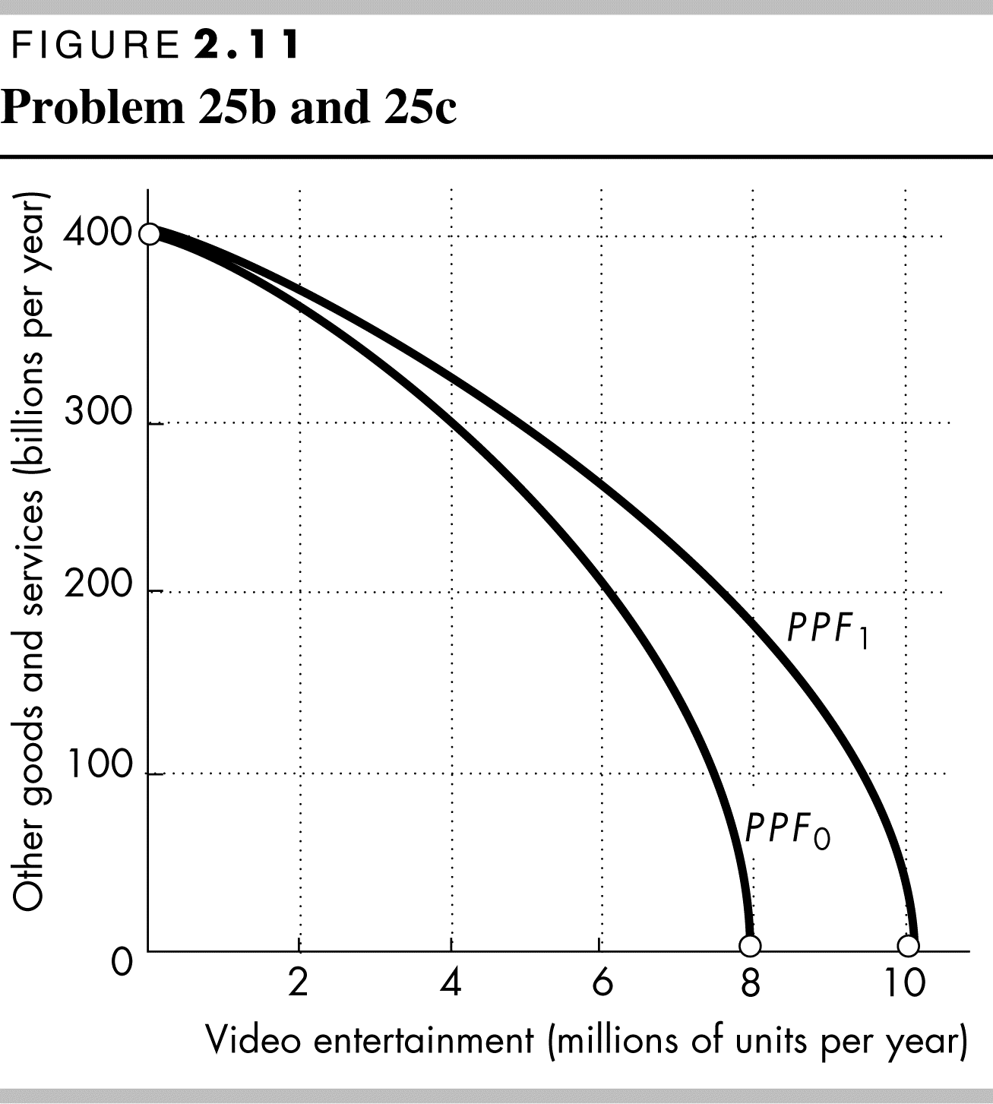
a. How has inexpensive broadband changed the production possibilities of video entertainment and other goods and services?
Inexpensive broadband has increased the production possibilities.
b. Sketch a PPF for video entertainment and other goods and services before broadband.
The PPF should have video entertainment on one axis and other goods and services on the other as illustrated in Figure 2.11 by PPF₀. The PPF is bowed outward as a conventional PPF.
c. Show how the arrival of inexpensive broadband has changed the PPF.
The arrival of inexpensive broadband shifts the PPF outward as shown by the change from PPF₀ to PPF₁ in Figure 2.11. The intersection of the new PPF along the axis measuring video entertainment increases and the intersection of the new PPF along the axis measuring other goods and services does not change.
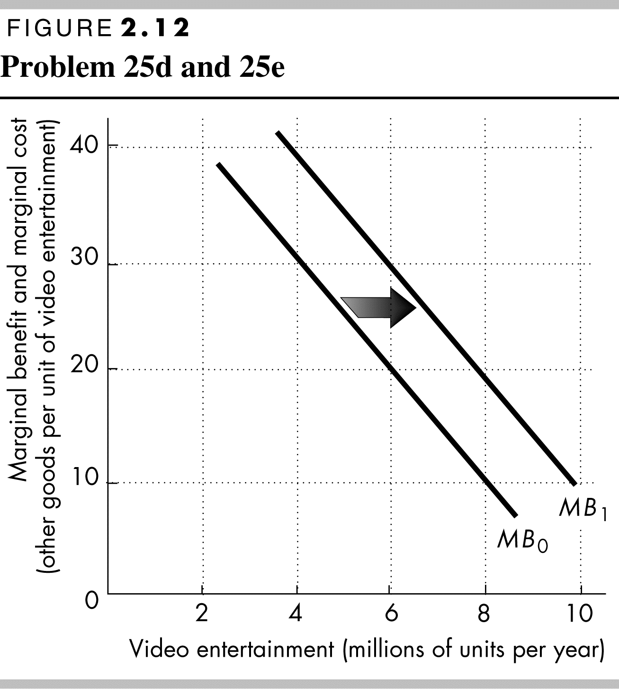
d. Sketch a marginal benefit curve for video entertainment.
The marginal benefit curve should be a conventional downward-sloping marginal benefit curve as shown in Figure 2.12. The marginal benefit from video entertainment is measured along the vertical axis and the quantity of video entertainment is measured along the horizontal axis.
e. Show how the new generation of TV producers for whom the Internet is their native medium might have changed the marginal benefit from video entertainment.
The marginal benefit increases because these new producers will be better able to take advantage of the Internet since it is their native medium. Because they will be able to create entertainment designed for the Internet, the marginal benefit from video entertainment increases. In Figure 2.12, the marginal benefit curve shifts rightward from the initial marginal benefit curve, MB₀, to the new marginal benefit curve, MB₁.

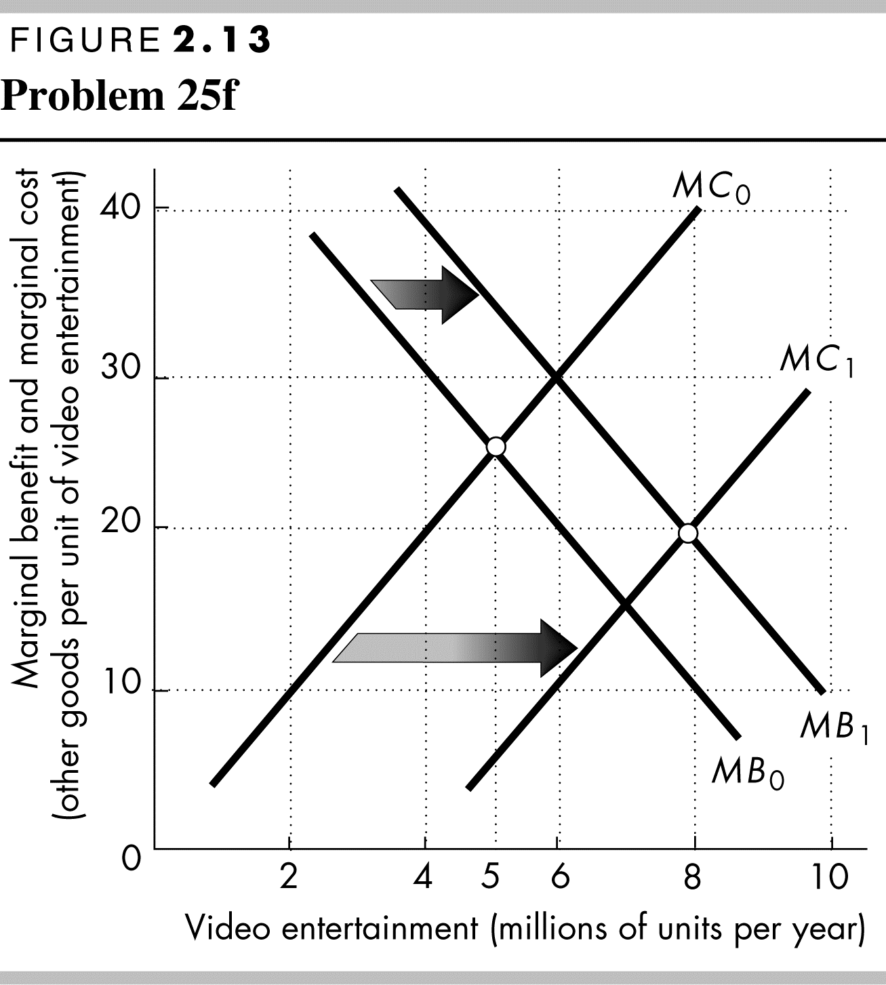
f. Explain how the efficient quantity of video entertainment has changed.
The arrival of broadband has decreased the marginal cost of providing video entertainment, so the marginal cost curve shifts rightward. This shift is illustrated in the Figure 2.13 by the rightward shift of the marginal cost curve from MC₀ to MC₁. As Figure 2.13 shows, the allocatively efficient quantity of video entertainment increases. In Figure 2.13, the allocatively efficient quantity increases from 5 million units per year to 8 million units per year.

