Chemical Principles   
Global Edition

CHAPTER

2

|  |  |
| --- | --- |
| Learning Objectives | Check Your Understanding |
| 2-1 Describe the structure of an atom and its relation to the physical properties of  elements. | How does  differ from  What is the atomic number of each carbon atom? The atomic mass? |
| 2-2 Define ionic bond, covalent bond, hydrogen bond, molecular weight, and mole. | Differentiate an ionic bond from a covalent bond. |
| 2-3 Diagram three basic types of chemical reactions. | This chemical reaction below is used to  remove chlorine from water. What type of reaction is it?  HClO + Na2SO3 → Na2SO4 + HCl |
| 2-4 List several properties of water that are important to living systems. | Why is the polarity of a water molecule  important? |
| 2-5 Define acid, base, salt, and pH. | Antacids neutralize acid by the following  reaction.  Mg(OH)2 + 2HCl → MgCl2 + H2O  Identify the acid, base, and salt. |
| 2-6 Distinguish organic and inorganic  compounds. | Define organic. |
| 2-7 Define functional group. | Add the appropriate functional group(s) to the ethyl group below to produce each of the following compounds: ethanol, acetic acid, acetaldehyde, ethanolamine, diethyl ether. |
| 2-8 Identify the building blocks of carbohydrates. | Give an example of a monosaccharide, a  disaccharide, and a polysaccharide. |
| 2-9 Differentiate simple lipids, complex  lipids, and steroids. | How do simple lipids differ from complex lipids? |
| 2-10 Identify the building blocks and structure of proteins. | What two functional groups are in all amino acids? |
| 2-11 Identify the building blocks of nucleic acids. | How do DNA and RNA differ? |
| 2-12 Describe the role of ATP in cellular  activities. | Which can provide more energy for a cell and why: ATP or ADP? |

New in This Edition

• A discussion of the relationship between starch and normal microbiota has been added.

Chapter Summary

Introduction (p. 50)

ASM 3.2: The interactions of microorganisms among themselves and with their environment are determined by their metabolic abilities   
(e.g., quorum sensing, oxygen consumption, nitrogen   
transformations).

ASM 6.2: Microorganisms provide essential models that give us   
fundamental knowledge about life processes.

1. The science of the interaction between atoms and molecules is called chemistry.

2. The metabolic activities of microorganisms involve complex chemical reactions.

3. Microbes break down nutrients to obtain energy and to make new cells.

The Structure of Atoms (pp. 51–52)

1. An atom is the smallest unit of a chemical element that exhibits the properties of that   
element.

2. Atoms consist of a nucleus, which contains protons and neutrons, and electrons, which move around the nucleus.

3. The atomic number is the number of protons in the nucleus; the total number of protons and neutrons is the atomic mass.

Chemical Elements (p. 51)

4. Atoms with the same number of protons and the same chemical behavior are classified as the same chemical element.

5. Chemical elements are designated by abbreviations called chemical symbols.

6. About 26 elements are commonly found in living cells.

7. Atoms that have the same atomic number (are of the same element) but different atomic masses are called isotopes.

Electronic Configurations (p. 52)

8. In an atom, electrons are arranged around the nucleus in electron shells.

9. Each shell can hold a characteristic maximum number of electrons.

10. The chemical properties of an atom are due largely to the number of electrons in its outermost shell.

How Atoms Form Molecules: Chemical Bonds (pp. 53–55)

1. Molecules are made up of two or more atoms; molecules consisting of at least two   
different kinds of atoms are called compounds.

2. Atoms form molecules in order to fill their outermost electron shells.

3. Attractive forces that bind two atoms together are called chemical bonds.

4. The combining capacity of an atom—the number of chemical bonds the atom can form with other atoms—is its valence.

Ionic Bonds (p. 53)

5. A positively or negatively charged atom or group of atoms is called an ion.

6. A chemical attraction between ions of opposite charge is called an ionic bond.

7. To form an ionic bond, one ion is an electron donor, and the other ion is an electron   
acceptor.

Covalent Bonds (pp. 53–54)

8. In a covalent bond, atoms share pairs of electrons.

9. Covalent bonds are stronger than ionic bonds and are far more common in organic   
molecules.

Hydrogen Bonds (pp. 54–55)

10. A hydrogen bond exists when a hydrogen atom covalently bonded to one oxygen or   
nitrogen atom is attracted to another oxygen or nitrogen atom.

11. Hydrogen bonds form weak links between different molecules or between parts of the same large molecule.

Molecular Mass and Moles (p. 55)

12. The molecular mass is the sum of the atomic masses of all the atoms in a molecule.

13. A mole of an atom, ion, or molecule is equal to its atomic or molecular mass expressed in grams.

Chemical Reactions (pp. 56–57)

1. Chemical reactions are the making or breaking of chemical bonds between atoms.

2. A change of energy occurs during chemical reactions.

3. Endergonic reactions require more energy than they release; exergonic reactions release more energy.

4. In a synthesis reaction, atoms, ions, or molecules are combined to form a larger   
molecule.

5. In a decomposition reaction, a larger molecule is broken down into its component   
molecules, ions, or atoms.

6. In an exchange reaction, two molecules are decomposed, and their subunits are used to synthesize two new molecules.

7. The products of reversible reactions can readily revert to form the original reactants.

Important Biological Molecules (pp. 57–73)

Inorganic Compounds (pp. 57–59)

1. Inorganic compounds are usually small, ionically bonded molecules.

Water (pp. 57–58)

2. Water is the most abundant substance in cells.

3. Because water is a polar molecule, it is an excellent solvent.

4. Water is a reactant in many of the decomposition reactions of digestion.

5. Water is an excellent temperature buffer.

Acids, Bases, and Salts (p. 58)

6. An acid dissociates into H+ and anions.

7. A base dissociates into OH− and cations.

8. A salt dissociates into negative and positive ions, neither of which is H+ or OH−.

Acid–Base Balance: The Concept of pH (pp. 58–59)

9. The term pH refers to the concentration of H+ in a solution.

10. A solution of pH 7 is neutral; a pH value below 7 indicates acidity; pH above 7 indicates alkalinity.

11. The pH inside a cell and in culture media is stabilized with pH buffers.

Organic Compounds (pp. 59–73)

1. Organic compounds always contain carbon and hydrogen.

2. Carbon atoms form up to four bonds with other atoms.

3. Organic compounds are mostly or entirely covalently bonded.

Structure and Chemistry (pp. 60–61)

4. A chain of carbon atoms forms a carbon skeleton.

5. Functional groups of atoms are responsible for most of the properties of organic   
molecules.

6. The letter R may be used to denote the remainder of an organic molecule.

7. Frequently encountered classes of molecules are R—OH (alcohols) and R—COOH   
(organic acids).

8. Small organic molecules may combine into very large molecules called macromolecules.

9. Monomers usually bond together by dehydration synthesis, or condensation reactions, that form water and a polymer.

10. Organic molecules may be broken down by hydrolysis, a reaction involving the splitting of water molecules.

Carbohydrates (pp. 61–62)

11. Carbohydrates are compounds consisting of atoms of carbon, hydrogen, and oxygen, with hydrogen and oxygen in a 2:1 ratio.

12. Monosaccharides contain from three to seven carbon atoms.

13. Isomers are two molecules with the same chemical formula but different structures and properties—for example, glucose (C6H12O6) and fructose (C6H12O6).

14. Monosaccharides may form disaccharides and polysaccharides by dehydration synthesis.

Lipids (pp. 62–66)

15. Lipids are a diverse group of compounds distinguished by their insolubility in water.

16 Simple lipids (fats) consist of a molecule of glycerol and three molecules of fatty acids.

17. A saturated lipid has no double bonds between carbon atoms in the fatty acids; an unsaturated lipid has one or more double bonds. Saturated lipids have higher melting points than unsaturated lipids.

18. Phospholipids are complex lipids consisting of glycerol, two fatty acids, and a phosphate group.

19. Steroids have carbon ring structures; sterols have a functional hydroxyl group.

Proteins (pp. 66–70)

20. Amino acids are the building blocks of proteins.

21. Amino acids consist of carbon, hydrogen, oxygen, nitrogen, and sometimes sulfur.

22. Twenty amino acids occur naturally in proteins.

23. By linking amino acids, peptide bonds (formed by dehydration synthesis) allow the   
formation of polypeptide chains.

24. Proteins have four levels of structure: primary (sequence of amino acids), secondary   
(helices or pleated), tertiary (overall three-dimensional structure of a polypeptide), and quaternary (two or more polypeptide chains).

25. Conjugated proteins consist of amino acids combined with inorganic or other organic compounds.

Nucleic Acids (pp. 70–72)

26. Nucleic acids—DNA and RNA—are macromolecules consisting of repeating   
nucleotides.

27. A nucleotide is composed of a pentose, a phosphate group, and a nitrogen-containing base. A nucleoside is composed of a pentose and a nitrogen-containing base.

28. A DNA nucleotide consists of deoxyribose (a pentose) and one of the following nitrogen-containing bases: thymine or cytosine (pyrimidines) or adenine or guanine (purines).

29. DNA consists of two strands of nucleotides wound in a double helix. The strands are held together by hydrogen bonds between purine and pyrimidine nucleotides: AT and GC.

30. Genes consist of sequences of nucleotides.

31. An RNA nucleotide consists of ribose (a pentose) and one of the following nitrogen-containing bases: cytosine, guanine, adenine, or uracil.

Adenosine Triphosphate (ATP) (p. 72)

32. ATP stores chemical energy for various cellular activities.

33. When the bond to ATP’s terminal phosphate group is hydrolyzed, energy is released.

34. The energy from oxidation reactions is used to regenerate ATP from ADP and inorganic phosphate.

The Loop loop_icon

1. Have students study Chapter 2 and use the Study Questions as a self-test.

2. Have students study Chapter 2 and take a pretest for Chapter 5. Pretests can be administered individually during office hours, in open laboratories, during study sessions, or online. Students who score at least 9 points out of 15 questions from the Chapter 2 Test Bank show mastery. A student who does not achieve mastery can study and take a   
second chapter test.

3. Students with some chemistry but less than one year of college chemistry may find it   
useful to have the last half of this chapter, “Important Biological Molecules,” which   
begins on page 57, used as an introduction to Chapter 5, “Microbial Metabolism.”

Exploring the Microbiome

Feed Our Intestinal Bacteria, Feed Ourselves: A Tale of Two Starches

This chapter includes coverage of the role that carbohydrates play in the cell. The Exploring the Microbiome segment suggests that specific carbohydrates in conjunction with certain   
microbes produce short-chain fatty acids, which may play a role in electrolyte absorption and prevention of colorectal cancer.

Discussion questions:

* Are there other (possibly) more efficient ways to obtain these short-chain fatty acids?
* Does research performed on mice translate to people?
* Could the same benefit of short-chain fatty acids be achieved by simply consuming those directly?
* Relevant publication: Sivaprakasam S., Prasad P.D., and Singh N. (2016) Benefits of short-chain fatty acids and their receptors in inflammation and carcinogenesis.   
  Pharmacology & Therapeutics, 164: 144-151.

Answers

|  |  |  |
| --- | --- | --- |
| Figure Questions | | |
| Figure | Question | Answer |
| 2.1 | What is the atomic number of this atom? | Six. It is carbon. |
| 2.2 | What is an ionic bond? | An ionic bond is an attraction between atoms that have lost or gained electrons (ions). |
| 2.3 | What is a covalent bond? | A covalent bond is formed by the sharing of electrons between atoms. |
| 2.4 | Which chemical elements are usually involved in hydrogen bonding? | Hydrogen and oxygen or nitrogen.  A hydrogen bond is an attraction between a hydrogen atom that is covalently bonded to one oxygen or nitrogen atom and  another oxygen or nitrogen atom. |
| 2.5 | What happens during ionization? | An atom or molecule gains or loses  electrons. |
| 2.6 | How do acids and bases differ? | Acids dissociate into an anion and a  hydrogen ion (H+). Bases dissociate into  a cation and a hydroxide ion (OH–). |
| 2.7 | At what pH are the concentrations of  H+ and OH− equal? | 7 |
| 2.8 | What is the difference between a  polymer and a monomer? | A polymer consists of smaller molecules called monomers. |
| 2.9 | How do saturated and unsaturated fatty acids differ? | Unsaturated lipids have one or more  double bonds between carbon atoms. |
| 2.10 | Where are phospholipids found in cells? | Membranes |
| 2.11 | Where are sterols found in cells? | Membranes |
| 2.12 | What distinguishes one amino acid from another? | Side groups called R groups. |
| 2.13 | Which isomer is always found in  proteins? | l-isomers |
| 2.14 | How are amino acids related to proteins? | Proteins are composed of amino acids. |
| 2.15 | What property of a protein enables it to carry out specific functions? | The three-dimensional shape |
| 2.17 | How are DNA and RNA similar in  structure? | Both are polymers of nucleotides. |
| 2.18 | How is ATP similar to a nucleotide in RNA? In DNA? | Ribose is the sugar in the adenosine  nucleotides in ATP and RNA. Deoxyribose is the sugar in the adenosine in DNA. |

Review

1. Isotopes are atoms that have the same number of protons but different number of   
neutrons.

2. 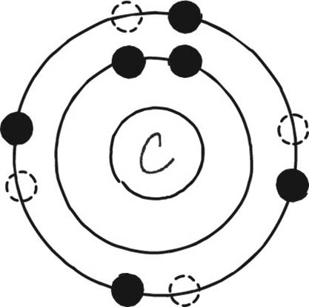

3. a. Ionic

b. Single covalent bond

c. Double covalent bonds

d. Hydrogen bond

4. a. False. It is an endergonic reaction, meaning that energy is directed inward.

b. False. Exchange reactions are part synthesis and part decomposition.

5. The H+ concentration of the broth is 10−6 moles/liter, so its pH is −log10[10−6] = −(−6) = 6. To maintain the pH of a medium, pH buffers are used.

6. a. Lipid

b. Protein

c. Carbohydrate

d. Nucleic acid

7. a. Amino acids

b. Right to left

c. Left to right

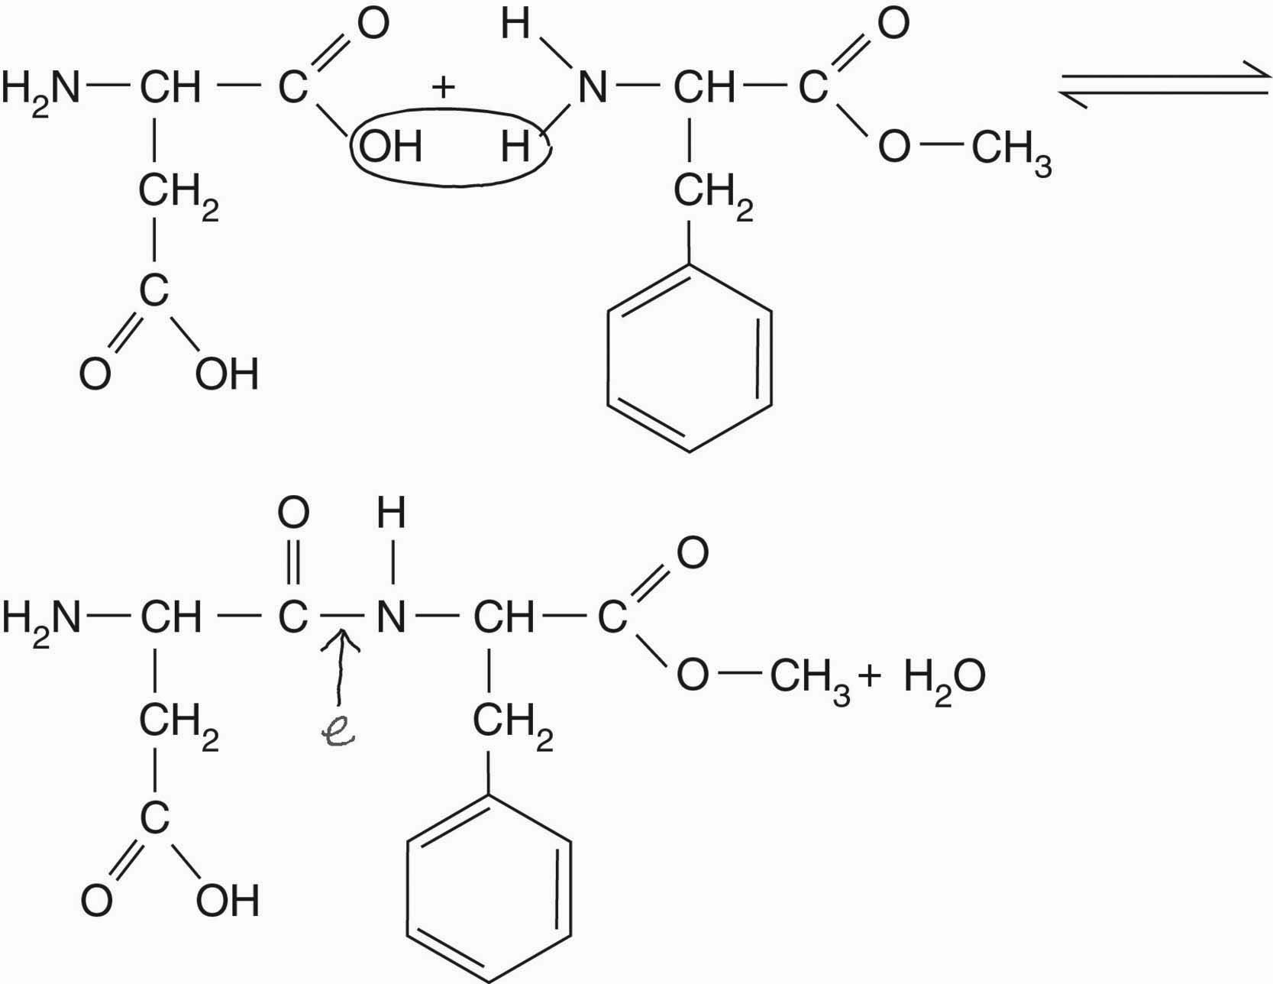

8. 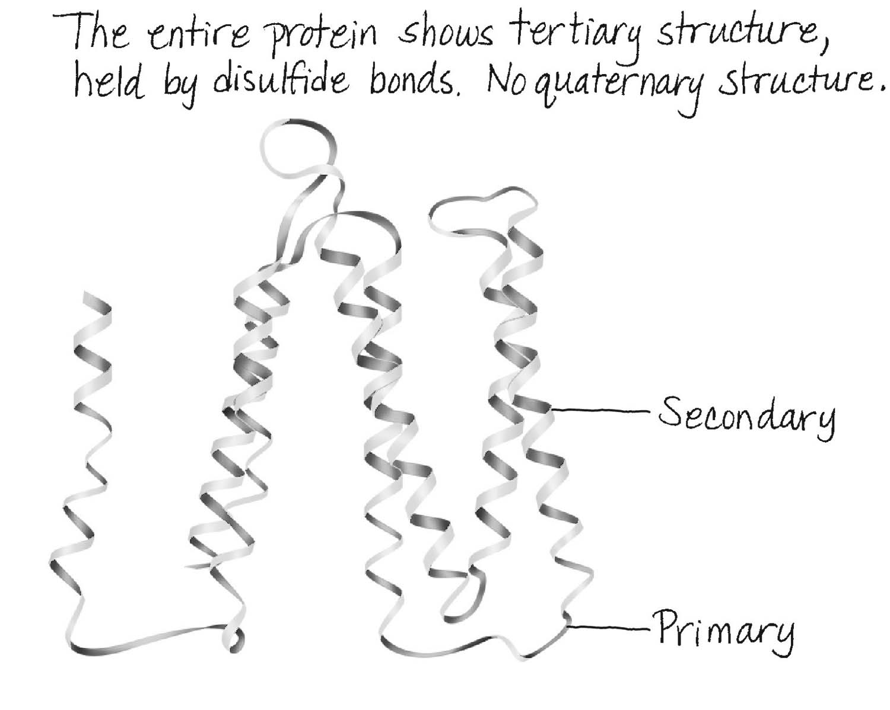

9. 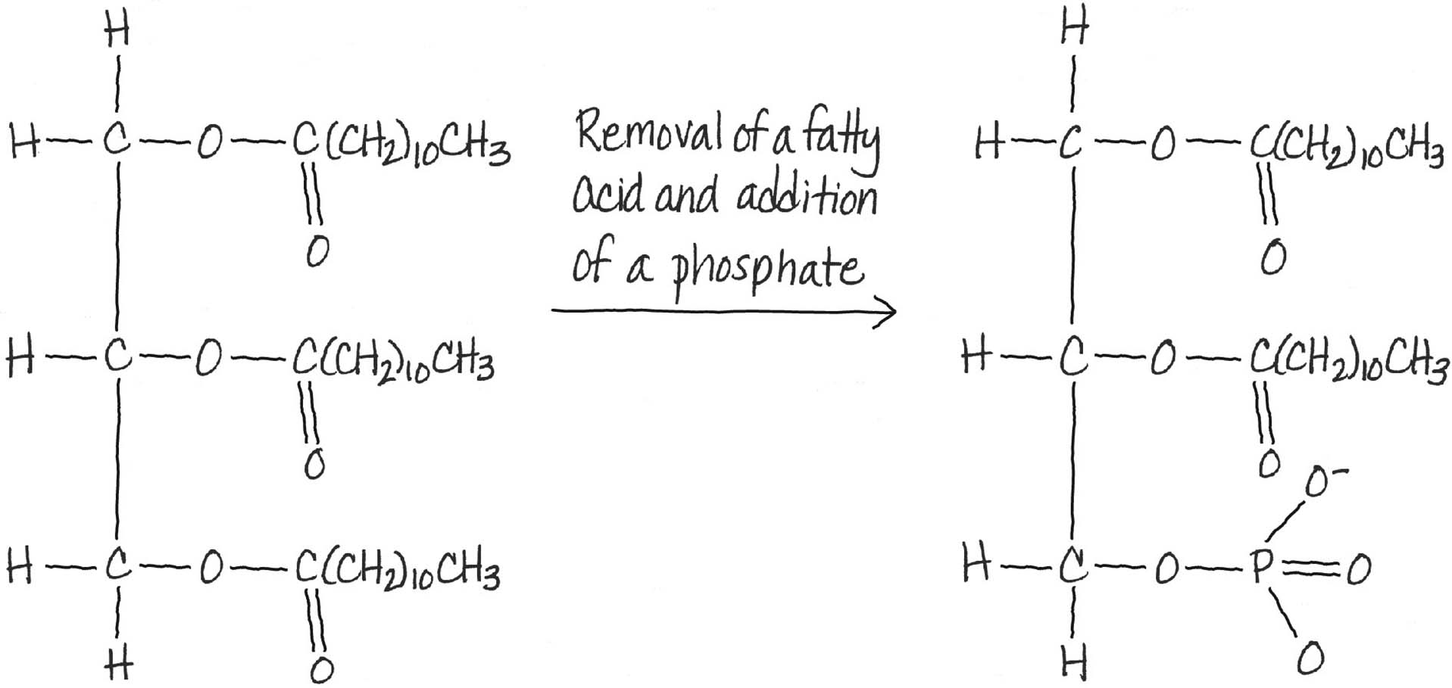

10. Cellulose

Multiple Choice

1. c 6. c

2. b 7. a

3. b 8. a

4. e 9. b

5. b 10. c

Analysis

1. a. Synthesis reaction

b. H2CO3 is an acid.

2. ATP and DNA have 5-carbon sugars. ATP has ribose, and DNA has deoxyribose; ATP and DNA contain the purine, adenine.

3. To maintain the proper fluidity, the percentage of unsaturated lipids decreases at the higher temperature.

4. These animals have cellulose-degrading bacteria in specialized structures in their   
digestive tracts.

Clinical Applications and Evaluation

1. PHB is a fatty acid used as an energy storage molecule by Ralstonia.

2. T. ferrooxidans can oxidize sulfur (“thio”) as well as iron (“ferro”). The oxidation of   
sulfide in pyrite produces sulfuric acid, which dissolves the limestone. Gypsum forms in a subsequent exchange reaction.





3. a. Amino acid

b. Phenylalanine is not present in the baby’s blood.

c. The phenylalanine from the aspartame (see Review question 7) will accumulate in their bodies.

4. Amphotericin B would not work against most bacteria because they lack sterols. Fungi have sterols and are generally susceptible to amphotericin B. Human cells have sterols.

5. Methionine and cysteine

Case Study: A Fussy Baby

Background

The alarm clock was set to go off at 6:00 am. Staring at it, Harold saw it change from 5:58 to 5:59 am. He reached over and turned it off, gently shook Naomi awake, then grabbed the video monitor to check on Amica. He was relieved to see his daughter was still asleep. Amica had passed a rough night, waking up on multiple occasions. Two weeks earlier, Naomi had noticed small, irregular, white patches inside of Amica’s mouth. She had become increasingly irritable, only breastfeeding or taking the bottle for short periods. Naomi experienced discomfort while nursing Amica, so she purchased some over-the-counter ointment.

Five days ago, the patches in Amica’s mouth returned and both Naomi and Amica were more irritable. Amica kept on spitting out the pacifier that Harold gave her. At his wits’ end, Harold searched the Internet for answers after he returned Amica to her crib for the fifth time that night. He came across pictures of similar-looking patches in the mouths of babies. Could it be thrush?

It had been two weeks; it was definitely time to bring Amica to the pediatrician. Dr. Kelly Warner examined a fussy Amica. Her vitals were normal: her temperature was 36.9°C (98.4°F), pulse 120 bpm (beats per minute), and blood pressure 75/55. However, Dr. Warner noticed a reddish rash in Amica’s diaper area. Harold told her they were treating it with zinc ointment and that it had shown improvement. Harold also mentioned the increased discomfort that Naomi had experienced during breastfeeding recently.

“You are right, this is thrush,” said Dr. Warner. “Everybody has microbes in their mouth, including the organism that causes thrush. In healthy people the growth of the yeast, *Candida albicans* that causes thrush is kept in check by other microbes living in the mouth.”

“Also,” continued Dr. Warner, “milk is such a rich source of organic compounds such as  
carbohydrates and proteins, the very nutrients that the yeast uses to grow.”

“So why did the microbes in Amica’s mouth not prevent this overgrowth?” asked Harold.   
“Is she sick?”

“No, she is not sick. Infants just have an underdeveloped microbiome in their mouth. It takes time for the balance to be established. If Naomi experiences discomfort during breastfeeding, she probably has the yeast on her skin and it gets passed back and forth between Naomi and Amica. Both should be treated at the same time.”

“Naomi has been using ointments” said Harold.

“I know” said Dr. Warner. “She should stop for now. Most of the time thrush disappears on its own, but since you say it’s been going on for two weeks now, I will prescribe something and give you instructions for both Naomi and Amica so they can both get better.”

“And what about the diaper rash?” asked Harold. “The diaper rash is caused by the same   
microbe. Make sure to keep the diaper area as dry as possible and wash your hands thoroughly before and after diaper changes. You may use a wet wash cloth to wipe Amica’s tongue gently after feeding to remove excess milk.” replied the Dr. Warner.

Questions

1. Could the patches in Amica’s mouth, and Noami’s discomfort be related?
2. What is the role of carbohydrates and proteins in cells?

Answers

1. Yes, the fungus that causes thrush can also cause irritation of the breast.
2. Carbohydrates and proteins are nutrients. Carbohydrates are a source of energy,   
   proteins provide amino acids.