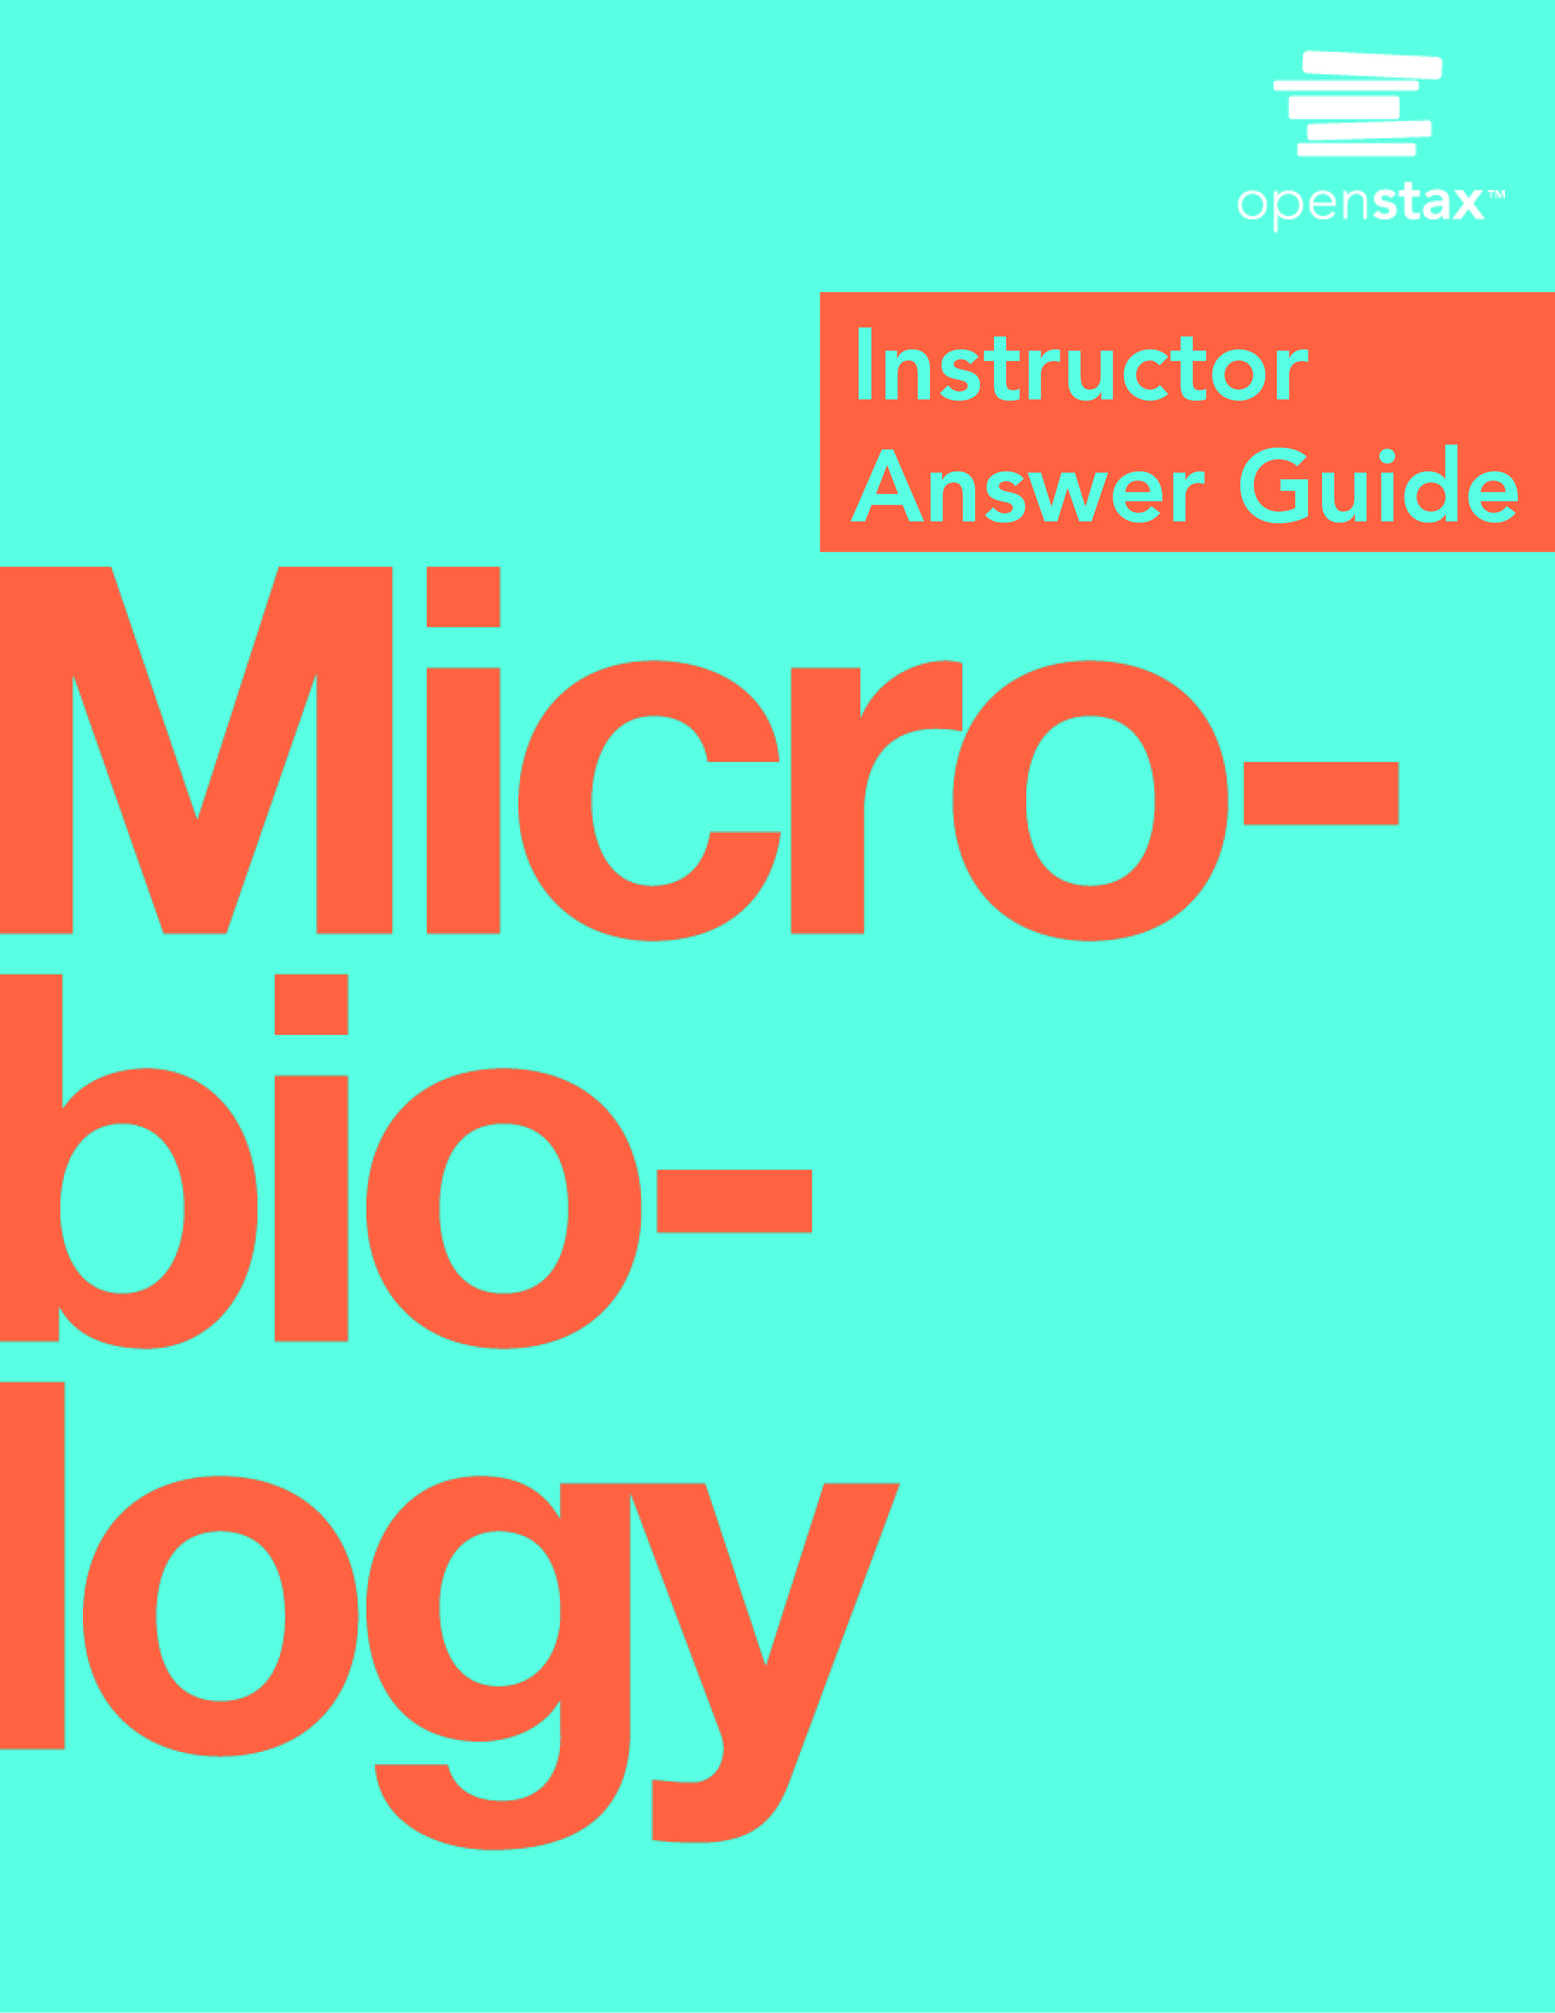

**OpenStax *Microbiology***

**Chapter 1: An Invisible World**

**Multiple Choice**

1. Which of the following foods is NOT made by fermentation?

A. beer

B. bread

C. cheese

D. orange juice

Answer

D

2. Who is considered the “father of Western medicine”?

A. Marcus Terentius Varro

B. Thucydides

C. Antonie van Leeuwenhoek

D. Hippocrates

Answer

D

3. Who was the first to observe “animalcules” under the microscope?

A. Antonie van Leeuwenhoek

B. Ötzi the Iceman

C. Marcus Terentius Varro

D. Robert Koch

Answer

A

4. Who proposed that swamps might harbor tiny, disease-causing animals too small to see?

A. Thucydides

B. Marcus Terentius Varro

C. Hippocrates

D. Louis Pasteur

Answer

B

5. Which of the following was NOT a kingdom in Linnaeus’s taxonomy?

A. animal

B. mineral

C. protist

D. plant

Answer

C

6. Which of the following is a correct usage of binomial nomenclature?

A. Homo Sapiens

B. homo sapiens

C. Homo sapiens

D. Homo Sapiens

Answer

C

7. Which scientist proposed adding a kingdom for protists?

A. Carolus Linnaeus

B. Carl Woese

C. Robert Whittaker

D. Ernst Haeckel

Answer

D

8. Which of the following is NOT a domain in Woese and Fox’s phylogenetic tree?

A. Plantae

B. Bacteria

C. Archaea

D. Eukarya

Answer

A

9. Which of the following is the standard resource for identifying bacteria?

A. Systema Naturae

B. Bergey’s Manual of Determinative Bacteriology

C. Woese and Fox’s phylogenetic tree

D. Haeckel’s General Morphology of Organisms

Answer

B

10. Which of the following types of microorganisms is photosynthetic?

A. yeast

B. virus

C. helminth

D. alga

Answer

D

11. Which of the following is a prokaryotic microorganism?

A. helminth

B. protozoan

C. cyanobacterium

D. mold

Answer

C

12. Which of the following is acellular?

A. virus

B. bacterium

C. fungus

D. protozoan

Answer

A

13. Which of the following is a type of fungal microorganism?

A. bacterium

B. protozoan

C. algae

D. yeast

Answer

D

14. Which of the following is not a subfield of microbiology?

A. bacteriology

B. botany

C. clinical microbiology

D. virology

Answer

B

**Fill in the Blank**

15. Thucydides is known as the father of _______________.

Answer

Scientific history

16. Researchers think that Ötzi the Iceman may have been infected with _____ disease.

Answer

Lyme

17. The process by which microbes turn grape juice into wine is called _______________.

Answer

fermentation

18. In binomial nomenclature, an organism’s scientific name includes its ________ and __________.

Answer

genus, species

19. Whittaker proposed adding the kingdoms ________ and ________ to his phylogenetic tree.

Answer

Protista and Monera

20. __________ are organisms without membrane-bound nuclei.

Answer

Prokaryotes

21. ______ are microorganisms that are not included in phylogenetic trees because they are acellular.

Answer

Viruses

22. A ________ is a disease-causing microorganism.

Answer

pathogen

23. Multicellular parasitic worms studied by microbiologists are called ___________.

Answer

helminths

24. The study of viruses is ___________.

Answer

virology

25. The cells of prokaryotic organisms lack a _______.

Answer

nucleus

**Short Answer**

26. What did Thucydides learn by observing the Athenian plague?

Answer

He saw that people who had been infected by the disease but recovered did not become infected again when they came into contact with sick people. This shows an early understanding of the concept of immunity.

27. Why was the invention of the microscope important for microbiology?

Answer

With a light microscope, scientists could finally see different kinds of microbes and observe their characteristics.

28. What are some ways people use microbes?

Answer

People can use microbes to make fermented foods, to clean up the environment, and to prevent and treat infectious diseases.

29. What is a phylogenetic tree?

Answer

A phylogenetic tree is a diagram showing how different organisms are thought to be evolutionarily related.

30. Which of the five kingdoms in Whittaker’s phylogenetic tree are prokaryotic, and which are eukaryotic?

Answer

Prokaryotic: Monera; Eukaryotic: Protista, Animalia, Fungi, Plantae

31. What molecule did Woese and Fox use to construct their phylogenetic tree?

Answer

small subunit rRNA

32. Name some techniques that can be used to identify and differentiate species of bacteria.

Answer

Gram staining, DNA/RNA analysis, biochemical assays, and serological testing

33. Describe the differences between bacteria and archaea.

Answer

Archaea and bacteria have different evolutionary histories, genes, metabolic pathways, cell walls, and membrane lipids.

34. Name three structures that various protozoa use for locomotion.

Answer

They can use hair-like cilia, tail-like flagella, or pseudopods (“false feet”).

35. Describe the actual and relative sizes of a virus, a bacterium, and a plant or animal cell.

Answer

A virus is about 100 nm and is 10 times smaller than a bacterium (~1 µm), which is at least 10 times smaller than a plant or animal cell (10–100 µm).

**Critical Thinking**

36. Explain how the discovery of fermented foods likely benefited our ancestors.

Answer

Besides enhancing the taste of many foods, fermentation is one of the oldest methods of preserving perishable foods. This means fermented foods lasted longer and were less likely to spoil and cause illness.

37. What evidence would you use to support this statement: Ancient people thought that disease was transmitted by things they could not see.

Answer

The Romans built sewer and water systems to protect against disease. The concept of quarantining people with leprosy is found in the Bible. The Roman Marcus Terentius Varro proposed that disease could be caused by “certain minute creatures . . . which cannot be seen by the eye.”

38. Why is using binomial nomenclature more useful than using common names?

Answer

In binomial nomenclature, each organism has a unique name. Common names can vary between different countries or even within a country. It can also be difficult to come up with common names for very similar organisms.

39. Label the three Domains found on modern phylogenetic trees.

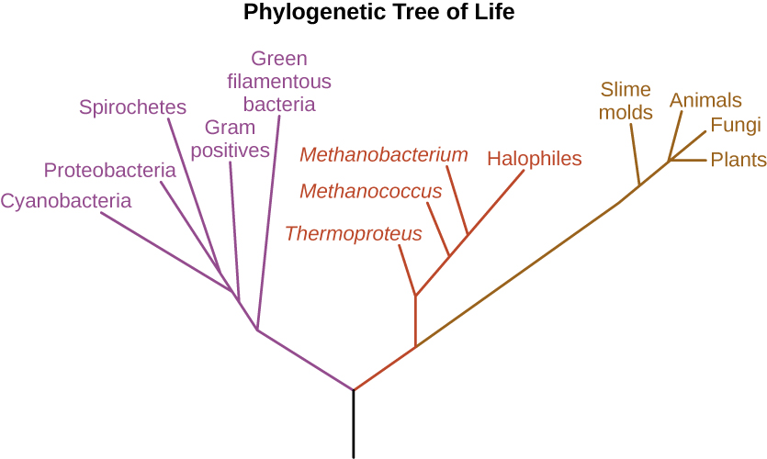

Answer

Bacteria (purple), Archaea (red), Eukarya (brown)

40. Contrast the behavior of a virus outside versus inside a cell.

Answer

Inside a host cell, viruses are able to reproduce. A virus is unable to reproduce when it is outside of a cell.

41. Where would a virus, bacterium, animal cell, and a prion belong on this chart?

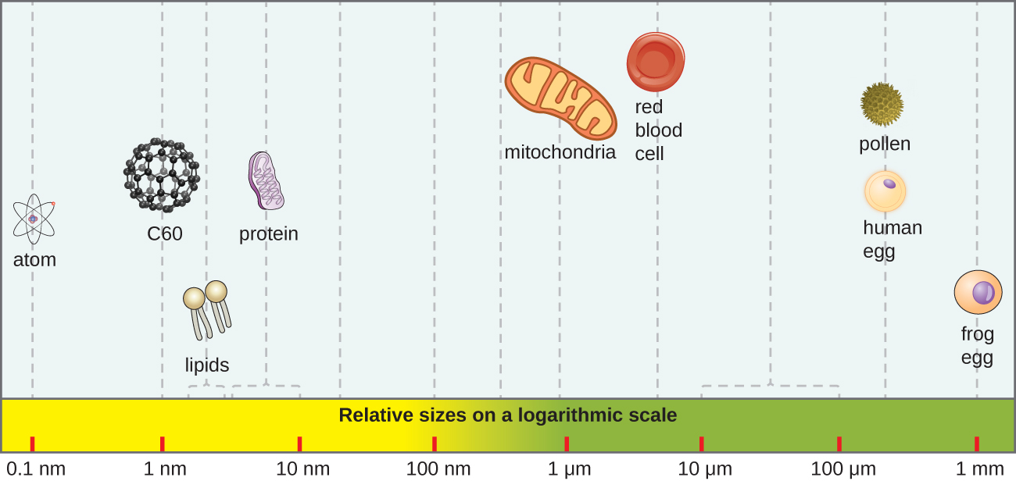

Answer

Virus at ~100 nm, bacterium at ~1 μm, animal cell at between 10–100 µm. Since a prion is a protein, it would be located at about 10 nm.

This file is copyright 2016, Rice University. All Rights Reserved.