LEARNING OBJECTIVES
LO 2-1 Identify the various levels in the Global Marketing Experience Curve.

LO 2-2 Learn the essential information components for assessing a global market opportunity.

LO 2-3 Define the key regional market zones and their marketing challenges.

LO 2-4 Describe the strategies for entering new global markets.

LO 2-5 Recognize key factors in creating a global product strategy.

LO 2-6 Learn the importance of ethics in marketing strategy, the value proposition, and the elements of the marketing mix.

LO 2-7 Recognize the significance of sustainability as part of the marketing strategy and the use of the triple bottom line as a metric for evaluating corporate performance.

Chapter Outline
- MARKETING IS NOT LIMITED BY BORDERS | 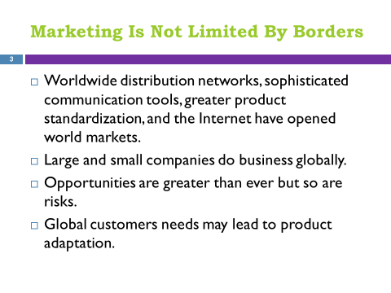
- THE GLOBAL EXPERIENCE LEARNING CURVE  - Companies with No Foreign Marketing  - Companies with Foreign Marketing  - International Marketing  - Global Marketing | 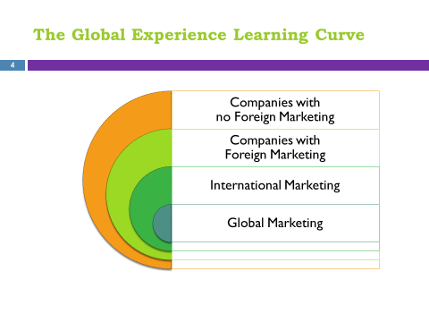  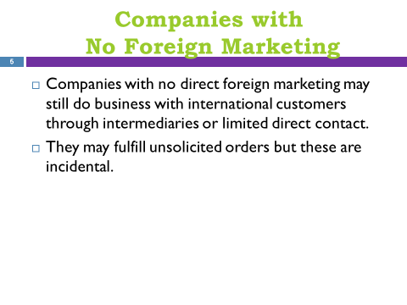  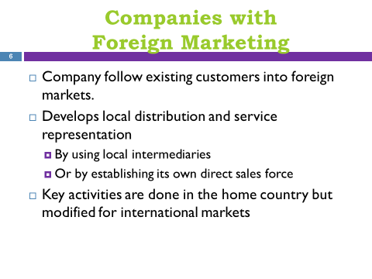  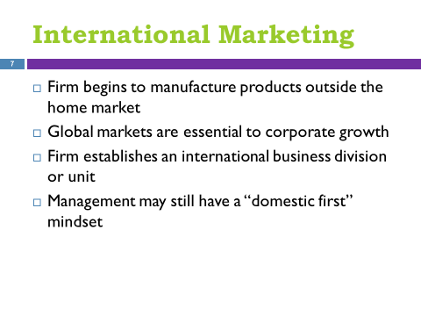  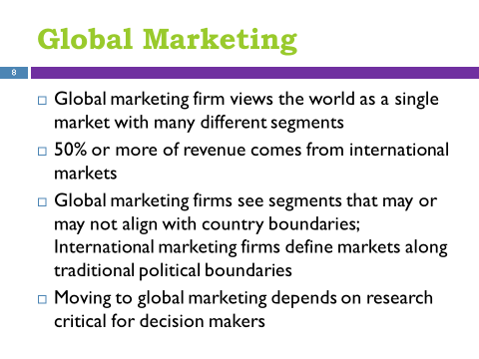  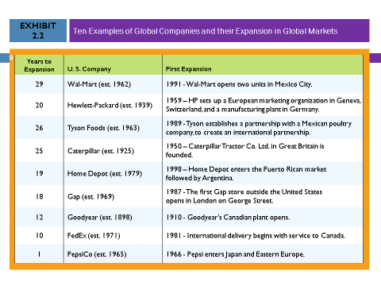
- Essential Information  - Economic  - Culture, Societal Trends  - Business Environment  - Political and Legal  - Specific Market Conditions | 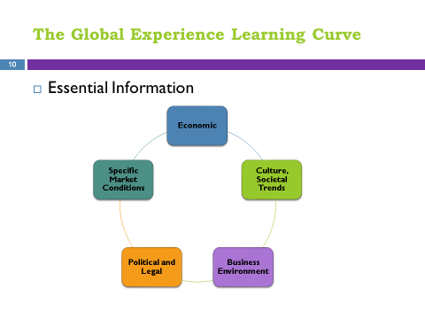
- Emerging Markets | 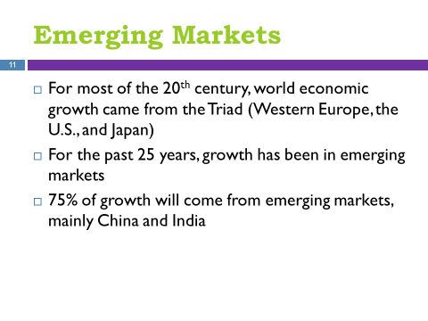
- Multinational Regional Market Zones  - Europe  - Americas  - Asia | 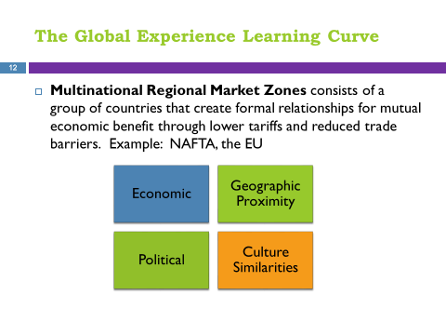  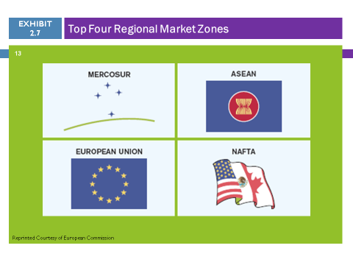
- SELECT THE GLOBAL MARKET  - Identify Selection criteria  - Company review | 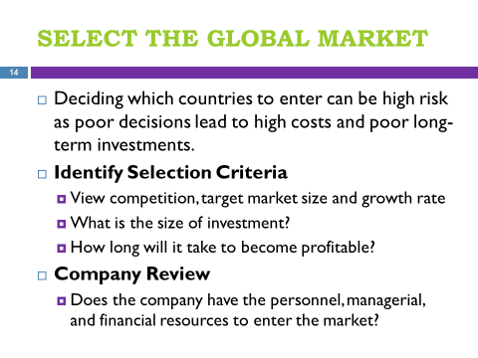  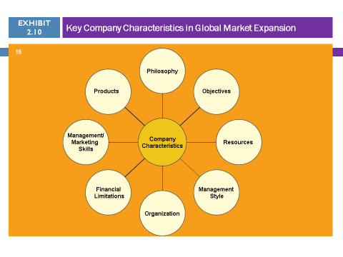
- DEVELOP GLOBAL MARKET STRATEGIES  - Market Entry Strategies  - Exporting  - Internet  - Exporter and Distributor  - Distributors  - Direct Sales Force  - Contractual Agreements  - Licensing  - Franchising  - Strategic Alliances  - International Joint Venture | 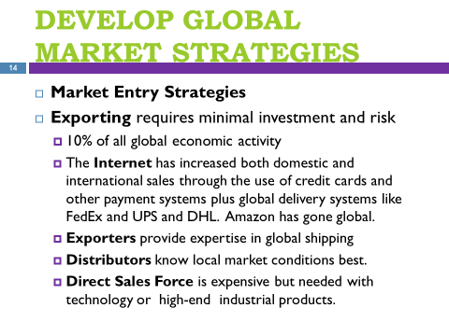  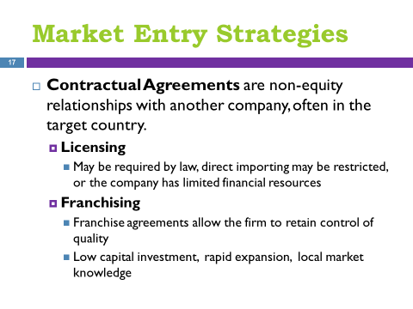  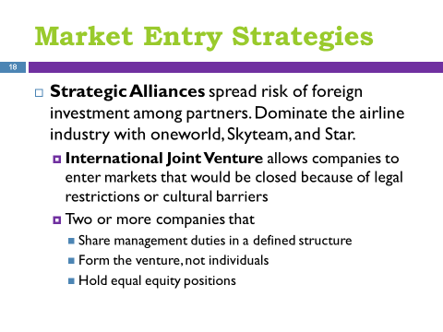  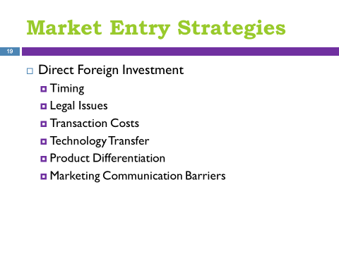
    - Direct Foreign Investment
- Organizational Structure | 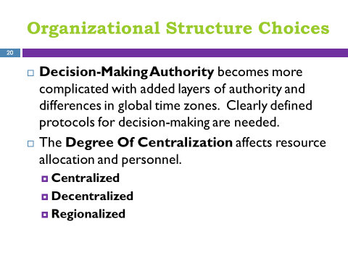  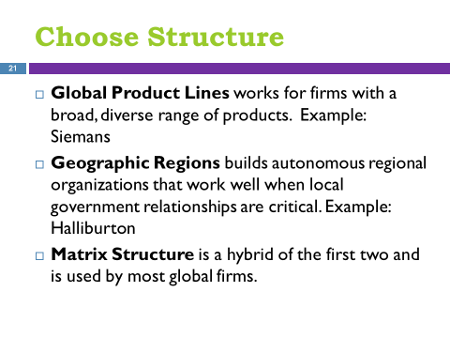
- Product | 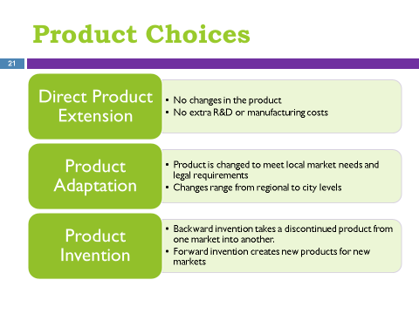
- Consumers  - Quality  - Fitting the Product to the Culture  - Brand Strategy  - Country of Origin | 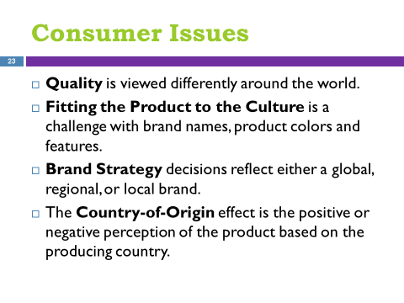
- Market Channels  - Channel Structures  - Channel Factors  - Cost  - Capital  - Coverage  - Character  - Continuity | 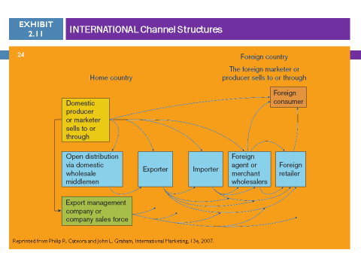  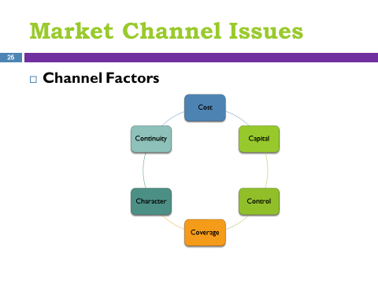
- Marketing Communications  - Advertising  - Personal Selling  - Sales promotion  - Public Relations | 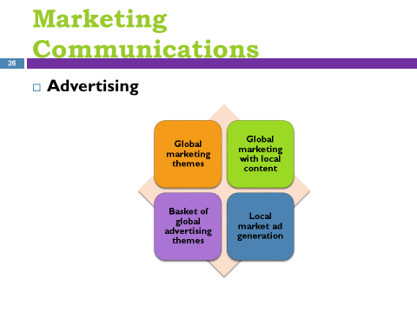  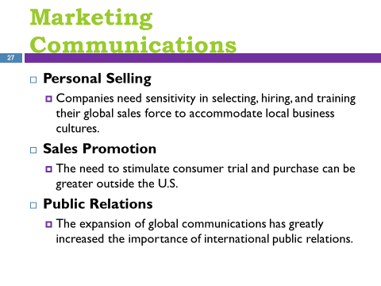
- Pricing  - One World Price  - Local Market Conditions Price  - Cost-Based Price  - Price Escalation  - Product export costs  - Tariffs, import fees, taxes  - Exchange rate fluctuations  - Middlemen and transportation costs  - Global Pricing Issues | 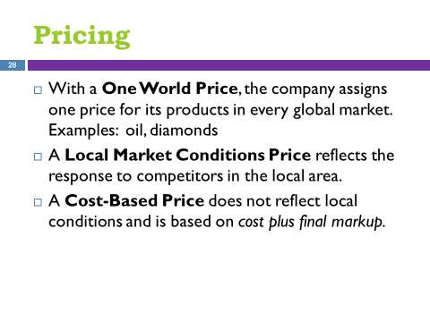  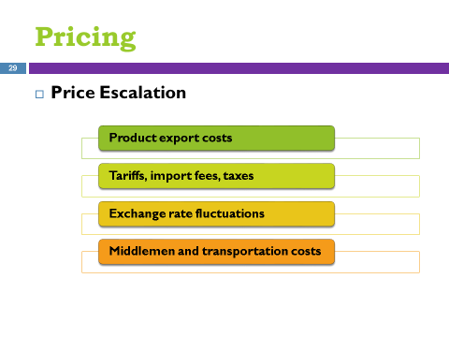  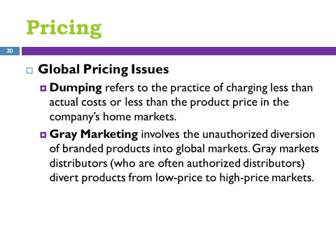
- ETHICS: AT THE CORE OF SUCCESSFUL MARKETING MANAGEMENT  - Ethics and the Value Proposition | 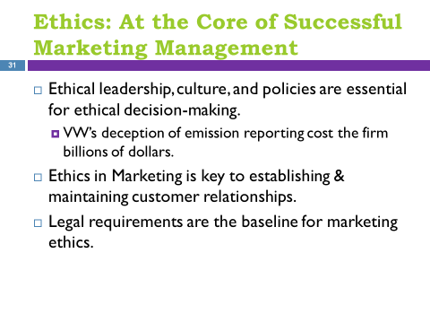  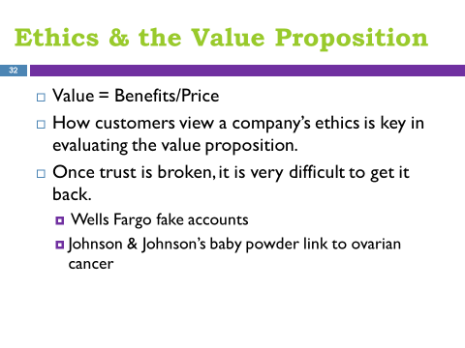
- Ethics and the Elements of the Marketing Mix  - Product  - Price  - Distribution  - Promotion | 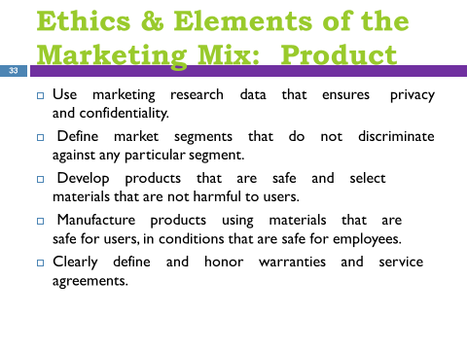  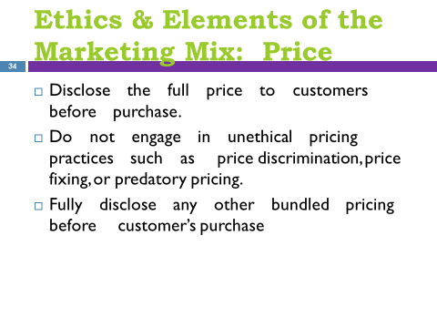  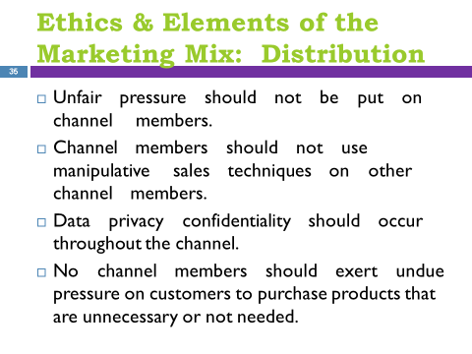  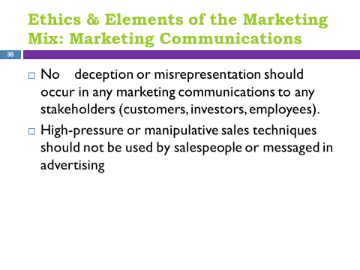
- Code of Marketing Ethics | 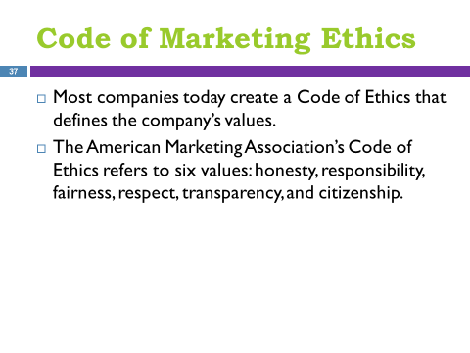
- SUSTAINABILITY: NOT JUST THE RIGHT THING TO DO BUT A GOOD MARKETING STRATEGY  - Triple Bottom Line: The Link between Doing Well and Doing Good | 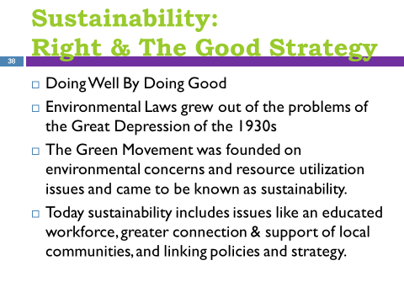  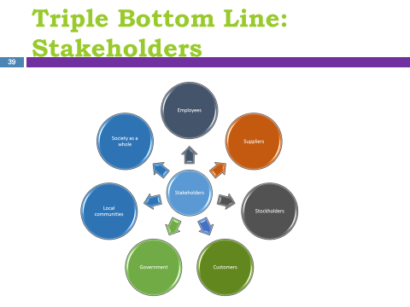  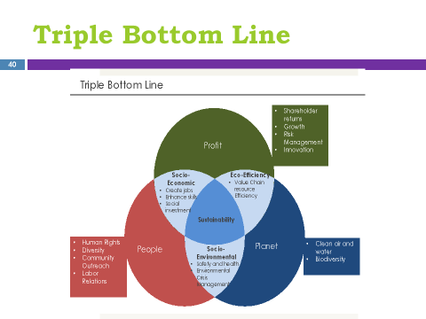
- SUMMARY

KEY TERMS
developed economies Specific economies that have fueled world economic growth for much of the 20th century, including Western Europe, the United States, and Japan.
emerging markets Growing economies that have developed over the last 25 years that are projected to contribute toward 75 percent of world economic growth over the next 20 years.
regional market zones A group of countries that create formal relationships for mutual economic benefit through lower tariffs and reduced trade barriers.
European Union A successful regional marketing zone founded more than 50 years ago by six European countries (Belgium, France, Italy, Luxembourg, The Netherlands, and West Germany) with the Treaty of Rome that now includes 25 countries.
NAFTA (North American Free Trade Agreement) Created to eliminate tariffs between Canada, Mexico, and the United States, and stands as the single largest economic alliance today.
MERCOSUR Inaugurated in 1995, it is the most powerful market zone in South America and includes the major economies of South America: Argentina, Bolivia, Brazil, Chile, Paraguay, and Uruguay.
ASEAN Founded in 1967, it is the most important Asian market zone and includes 10 countries running the entire length of the Pacific Rim (Brunei Darussalam, Indonesia, Malaysia, Philippines, Cambodia, Laos, Myanmar, Singapore, Thailand, and Vietnam).
exporting The most common method for entering foreign markets, it offers firms the ability to penetrate foreign markets with minimal investment and very little risk.
distributors Represent the company and often many others in foreign markets.
contractual agreements Enduring, nonequity relationships with another company that allow a company to expand its participation in a foreign market.
licensing When a firm offers other manufacturers the right to use their brand in exchange for a set fee or percentage of sales.
franchising A contractual agreement in which a firm provides a contracted company in a foreign market with a bundle of products, systems, services, and management expertise in return for local market knowledge, financial consideration, and local management experience.
strategic alliances A market entry strategy designed to spread the risk of foreign investment among its partners. Examples of strategic alliances would be international joint ventures or direct foreign investment.
joint ventures A strategic alliance formed by legal entities consisting of a partnership of two or more participating companies that share management duties and a defined management structure in which every partner holds an equity position.
direct foreign investment A strategic alliance with long-term implications in which a company moves
decision-making authority An issue that arises when companies grow internationally and lines of authority become longer and more complicated resulting in difficulty in defining decision-making protocols.
degree of centralization The degree to which decisions are made at the firm’s home office.
global product lines A broad, diverse range of products with global functionality
geographic regions An international organizational structure that divides international markets by geography, building autonomous regional organizations that perform business functions in the geographic area.
matrix structure An international organizational structure that encourages regional autonomy among organizations while building product competence in key areas around the world.
country-of-origin effect The influence of the country of manufacture, assembly, or design on a customer’s positive or negative perception of a product.
global marketing themes Global advertising strategy in which a basic template is used for global ads that allows for slight modifications depending on local markets
global marketing with local content Global advertising strategy in which a firm keeps the same global marketing theme as the home market but adapts it with local content
basket of global marketing themes Global advertising strategy in which distinct ads built around several marketing messages are created that local marketers can select from to best fit their specific market situation
local market ad generation Global marketing strategy in which a firm allows local marketers to create local ads that do not necessarily coordinate with its global marketing messages.
transfer pricing The cost companies charge internally to move products between subsidiaries or divisions.
dumping A global pricing issue that refers to the practice of charging less than their actual costs or less than the product price in the firm’s home markets.
gray market A global pricing issue that references the unauthorized diversion of branded products into global markets.
Marketing ethics A philosophy that encompasses a societal and professional standard of right and fair practices that are expected of marketing managers in their oversight of strategy formulation, implementation, and control.
Triple bottom line (TBL) A metric for evaluating not only the financial results of the company but the broader social equity, economic, and environmental considerations as well.

APPLICATION QUESTIONS
- You are the marketing manager for a small company located in the United States that manufactures specialized parts for high-end ink-jet printers. The company’s largest customer (Hewlett Packard) has asked your company to supply parts to 10 of its distribution and repair sites around the world. The company has never sold products outside the United States, so this represents a significant step for the company. What stage in the global experience learning curve is the company likely entering and why? Identify the activities the company should undertake at this stage.
Companies with No Foreign Marketing – the company has no formal international channel relationship or global marketing strategy targeted at international customers. The company should begin to develop local distribution and service representation in the foreign market. This can be done in one or two ways. One method is to identify local intermediaries in the appropriate international market and create a formal relationship. The second approach is for the company to establish its own direct sales force in major markets thereby expanding the company’s direct market reach.

- You are the market research director for a consumer product company. You have been asked to evaluate China as a potential market for your company’s products and begin a search of secondary data. What types of information would you consider in assessing China? How would you find information on these issues?
Economic
An accurate understanding of the current economic environment is essential. At the same time additional economic data on consumer spending per capita are also needed to facilitate decision making. A wide array of data is available online on the subject of “doing business in China”; some is available at no cost and other data is available for a fee.
Culture, Societal Trends
Understanding a global market’s culture and social trends is fundamental for consumer products. Cultural values, symbols and rituals, and cultural differences affect people’s perception of products. This information can be gathered at a high level by researching news articles about China. More detailed info can be provided by fee-based services, including consultants who are experts in these topics.
Specific Market Conditions
Before entering a foreign market a company has some understanding of the specific market conditions for their own products as a result of their business knowledge. However, it is unlikely a company has in depth knowledge about market trends, competitors and unique market characteristics. The more a company knows about the local market environment the better they will be able to leverage their investment in that market. As in the two items above, there will be high level information available through industry journals and fee-based services. For specific industry assessments, the services of a local consultant or a global consultancy with local employees will be very useful and likely worth the investment.

- You are the marketing manager for Oxymoron Detergent and have been tasked with introducing this product into Argentina. What six factors would you need to consider in determining the proper channel of distribution for the introduction of Oxymoron detergent?
In selecting a channel partner, companies should consider six strategic objectives known as the Six C’s of channel strategy: cost, capital, control, coverage, character, and continuity offer a checklist for evaluating channel options.

- The marketing manager for McDonald’s has been asked to develop a code of marketing ethics for the company. Develop a marketing code of ethics for McDonald’s, keeping in mind that the company has stores all over the world.

The marketing mix (“4 Ps”) is a good framework for considering different categories of behavior specific to marketing that should be addressed in a code of marketing ethics. Particular attention should be given to standards regarding marketing communications (truthful, clear) and product (safety, quality, green packaging).

After creating their own version, students will benefit from reviewing the several codes of conduct (for Directors, Suppliers, and Employees) that is shown on the McDonald’s website. While much broader than just marketing, these documents will give students a sense of how seriously large corporations like McDonald’s take the subject of ethics.

http://corporate.mcdonalds.com/mcd/investors/corporate-governance/codes-of-conduct.html

- The CEO of Timberland has called and asked you to develop a triple bottom line report for the company. What might be included in a TBL report for Timberland?

Here, students should focus not on developing a code of behavior, but rather a progress report on how well Timberland is doing in the key areas of the Triple Bottom Line. Exhibit 2.14 can be used as an outline for the report.

- Profit
  - Shareholder returns (e.g., earnings per share)
  - Growth rates (revenues, earnings, market share)
  - Risk management (key areas of risk such as regulation or lawsuits)
  - Innovation (recent product, process, or other innovations)
- People
  - Human rights (labor practices used by those producing products)
  - Diversity (progress in meeting diversity quotas)
  - Community outreach (charitable giving, employee involvement)
  - Labor relations (union relations, efforts to organize, employee satisfaction)
- Planet
  - Air, water (antipollution efforts, use of renewable energy sources)
  - Biodiversity (sustainability efforts, use of “green” packaging, use of recyclable materials in production of products)

MANAGEMENT DECISION CASE
Selling to the Bottom of the Pyramid
Marketing Unilever Products in Rural Villages Around the World

Instructors leading a discussion about this case will find a review of the two HBR articles by Simanis & Duke and Mahajan to be very helpful*. One way to introduce the case is to ask students why a company would even bother marketing to a target market made up of consumers with such limited financial resources. The answers could focus on both the opportunity for significant revenues as well as on the benefits provided to consumers. Students should be able to list potential products that consumers in developed economies regularly enjoy but are not available to BOPM consumers (take an imaginary stroll down the Health & Beauty aisles of your favorite discount store). The questions below provide opportunities for discussion on whether and what to market to BOPMs from both revenue maximization and ethical standpoints. This case provides another opportunity to reinforce the definition of value and to emphasize that value should be considered from the perspective of the consumer. A concluding point that should become clear is that marketing to BOPMs is a more complex proposition than marketing in traditional markets. Consequently, it is probably only the largest consumer products companies and ones with sophisticated marketing organizations that should take on this interesting challenge.

Questions for Consideration:

- Is Unilever providing value to their Indian customers? In what ways? Consider the four types of utility when forming your answer.

Value is defined in this chapter as a ratio of the bundle of benefits a customer receives from an offering compared to the costs incurred by the customer in acquiring that bundle of benefits. In light of that definition, the very small unit size of the Wheel detergent product and the very low price are significant factors in evaluating value. A point to emphasize is that marketers can change the value equation by manipulating the bundle of benefits, the cost to acquire or both. In the case of BOPM markets, the emphasis is on significantly lowering the cost to acquire, sometimes by reducing some of the benefits. However, customers are willing to forego some of the benefits to have the opportunity to realize any of the benefits of the product.

Form utility is created when the firm converts raw materials into finished products, a utility provided in the Unilever example, but not in any way unique to the BOPM context. Time utility is not of particular importance as the product is presumably available throughout the year and at appropriate times of day. Ownership utility is enabled through the small packets offered at very low prices which make the ownership of the product possible. The most significant example is Place utility, which is facilitated through the army of Shakti women who make the product available in the villages where people live.

- Considering the competition Unilever is receiving from Procter & Gamble and other companies, in what creative ways could Unilever change their Wheel detergent product offering to differentiate it from competitors’ offerings?
Differentiation comes with increasing the relative perceived value. Assuming that Unilever has lowered their prices as much as possible, they would need to focus on expanding the bundle of benefits. The product could be improved by adding ingredients that make it more effective, perhaps in some way specific to the environments in which it is used (e.g., hard or soft water or less than pure water). A more likely opportunity would be to augment the product with information, training or even entertainment.

- What principles should be used to determine if a product is a good fit for a BOPM market? Are there products that should not be offered to BOPM consumers? Should this issue be decided by marketers, governments or consumers?

Potential principles for “good BOPM fit” could include:

- Product is able to be produced and packaged in units small enough that the costs to product and distribute can lead to a price that is affordable by BOPM consumers.
- The resulting package size needs to be meaningful/practical.
- A distribution method is available or can be developed that supports that cost structured needed to keep unit prices at the appropriate level.
- An adequate number of consumers will consider this product (in a small unit size and at a very low price) to be something that would be worth spending some of their limited resources to acquire. This could be determined through marketing research.

The question of what products are appropriate for BOPM markets should lead to interesting discussions about whether consumers in BOPM markets require different kinds of consideration in this regard. If it is acceptable to sell candy to middle class American families, are BOPM families not also entitled to the benefits of enjoying candy? There are products that are harmful and therefore questionable from an ethical standpoint. However, while well-intentioned, efforts to discriminate among consumers based on their ability to pay can be problematic. Students will disagree on the role that marketers or governments should play in deciding whether a product is an appropriate use of discretionary income. However, this decision is likely best made by consumers. The marketer’s key responsibilities are to offer a product that provides value and then to communicated that value (product attributes/benefits and costs) in an accurate, clear and complete manner.

- Is it ethical for marketers to try to make money off people who are living at a subsistence level? Should companies only market their products to people in certain income classes? What factors should a marketer take into consideration when trying to answer these questions?

The ethics of selling certain kinds of products is a fair question for marketers to consider regardless of the income level of their target markets. Students will be able to list products that could fit into this category: those that hurt customers’ health (e.g., cigarettes, sugary drinks consumed in excess). However, as discussed in Question 3, marketers should be careful when taking on the role of “values police”; here, the definition of value could be reinforced with a focus on it being defined from the perspective of the consumer. In today’s connected world, even BOPM markets are likely aware of an array of products that are outside of their reach due to high prices. This issue will often take care of itself as consumers with very limited resources are more likely to be more careful in how they use those scarce resources. The key factor that marketers should consider is determining what the value elements are for this unique target market. The experience of Unilever and other successful BOPM marketers is that being able to offer the product at the appropriate price point is critical to success and this necessarily requires a very small quantity of the product that may moderate the amount of potential harm for questionable products.

* E. Simanis & D. Duke, “Profits at the Bottom of The Pyramid,” Harvard Business Review, 92(10), (2014), pp. 86-93.

V. Mahajan, “How Unilever Reaches Rural Consumers in Emerging Markets,” Harvard Business Review Digital Articles, (2016), pp. 2-6.

SUGGESTED VIDEO
YUM! BrandsS (11:30 Minutes)
Description: YUM! Brands customizes its marketing approach to expand to global markets. Peter Bassi (President of YUM! Restaurants International) describes 7 key marketing perspectives that company focuses on to be competitive and successful on a global scale.
1. What central changes are contributing to the growth of Yum! Brands in global markets?
Ongoing changes leading to the growth in the global fast food market
- Rise of the middle class in emerging economies such as China and India
- Growth in the number of working women and their changing lifestyles
- Fast food affordability and easy accessibility
- Growth in the promotional activities by fast food companies

2. Give some examples of ways that you believe Yum! Brands will have to adapt its offerings to appeal to global customers in different countries.
Taco Bell (India) - Crunchy potato tacos and extra-spicy burritos filled with paneer, the rubbery, fresh Indian cheese.
Pizza Hut (Japan) – Seafood Mix Pizza [tomato sauce and cheese plus shrimp, squid, tuna, mayonnaise, broccoli, and onions]
KFC (China) - Chicken congee [rice porridge] and pepper beef rice.

Global Marketing: Domino’s Abroad (4:18 minutes)
Description: Domino's Pizza is the world's largest pizza delivery chain, with stores in over 80 countries worldwide and over half its sales outside the United States. In order to satisfy consumer preferences in that many markets, Domino's must understand its global customers and adjust its marketing mix to meet local needs. The video describes Domino's marketing efforts in several countries.
- When going global, one of the most fundamental decisions marketers must make is the standardization/localization decision regarding the different elements of the marketing mix. For the Product component of the mix, Domino’s chose a localization strategy, modifying the product to regional tastes. Some companies choose a standardization approach, keeping the product essentially the same as the one offered in domestic markets.
  - What are the pros and cons of standardization?
  - Considering the markets in India, do you believe Domino’s could have been as successful with this one-size-fits-all approach?
The major benefit to standardization is cost. For manufactured products, localization can be an expensive process, involving retooling and specialized training of workers. While Domino’s has a finely-tuned process of making pizzas in the flavors offered in the U.S., using different ingredients on a pizza is a much simpler modification. There are other downstream costs of localization, however, For example, Domino’s cannot use existing photographs or video of their pizzas for ads in countries that have different pizza offerings.
Another argument for standardization is that the world is becoming smaller (or “flatter” as author Thomas Friedman contends.). Particularly since pizza is a youth-oriented product, global customers may tolerate—or even prefer—products that are “western” or American. This could, of course, also backfire as there will be consumers who will resent Americans trying to force their cultural preferences upon locals.
  - What steps could you take as a marketing manager to determine which approach—localization or standardization—would be most effective for moving into India or any other new region/country?
The clear answer is to do some research. Marketers can start by looking at the experience of competitors or businesses with similar products (what did KFC do, for example?). Hiring local employees who were raised in the region can be a great source of information. Focus groups, surveys and in Domino’s case, taste tests, will help support decision making. Fast food restaurants have an advantage over other types of global businesses in that they can do real time product testing, trying new recipes and then making modifications based on order volume and customer feedback.

Friedman, T. L. (2005). The world is flat: A brief history of the twenty-first century. New York: Farrar, Straus and Giroux.

