LEARNING OBJECTIVES
LO 2-1 Examine the concept of value and the elements and role of the value chain.
LO 2-2 Understand the conditions required for successful marketing planning, that marketing planning is focused on the value proposition, and that marketing planning is a dynamic process.
LO 2-3 Identify various types of organizational strategies.
LO 2-4 Conduct a situation analysis.
LO 2-5 Use the framework provided for marketing planning, along with the content in future chapters, to build a marketing plan.

Chapter Outline
- VALUE IS AT THE CORE OF MARKETING | 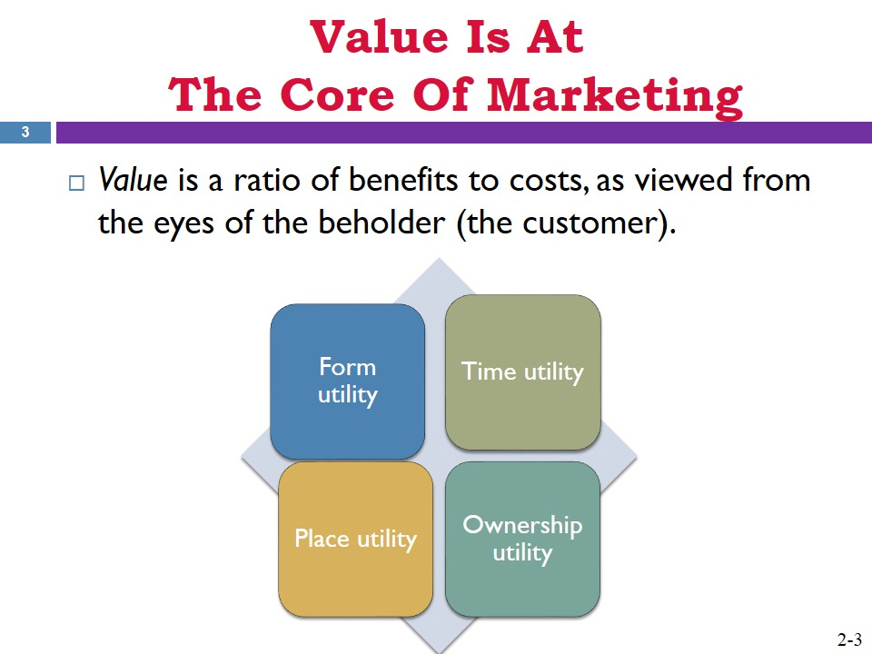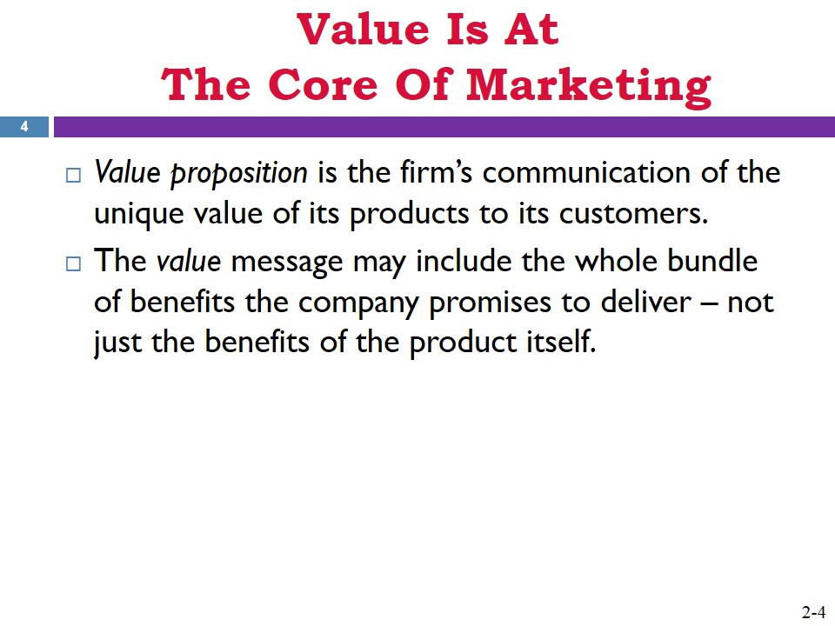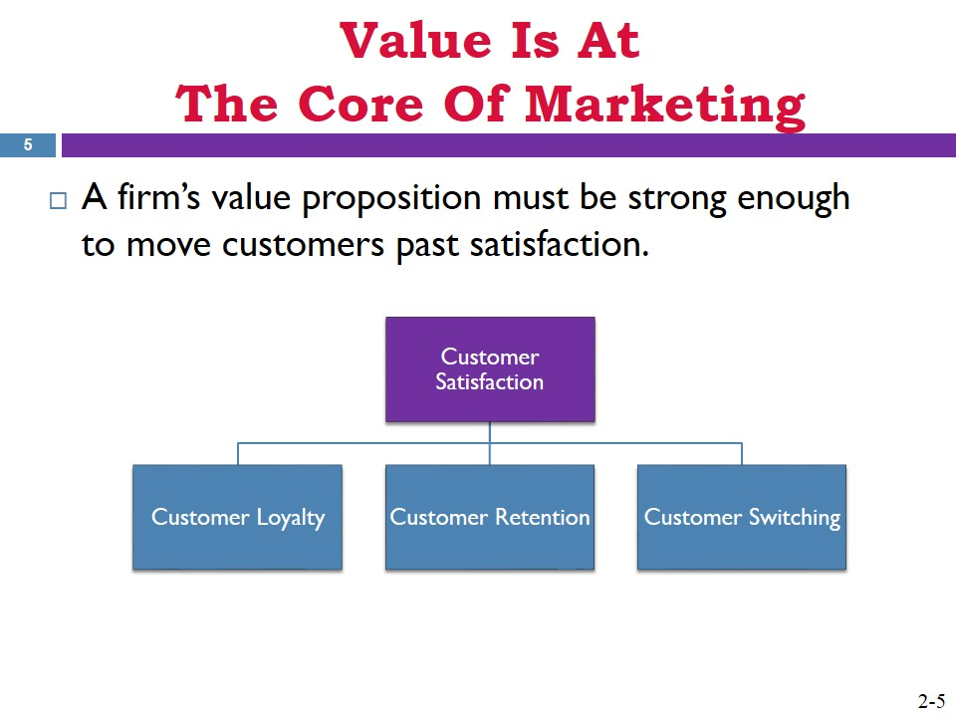
- The Value Chain | 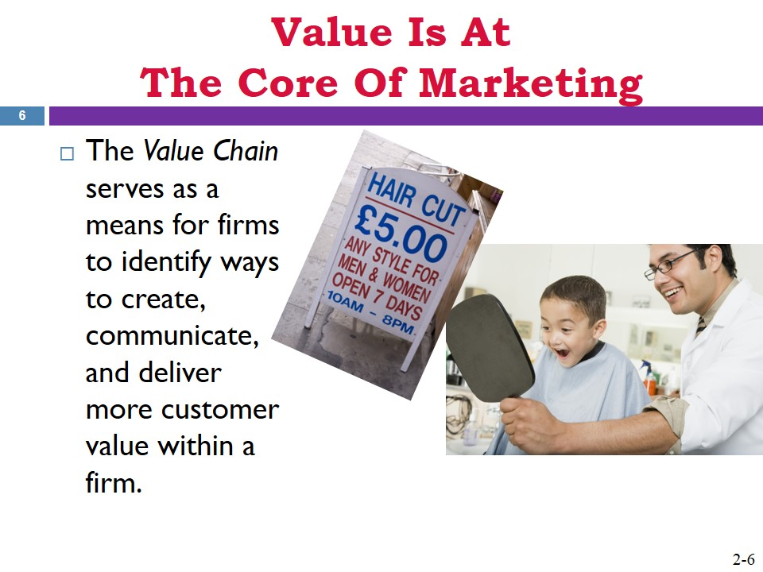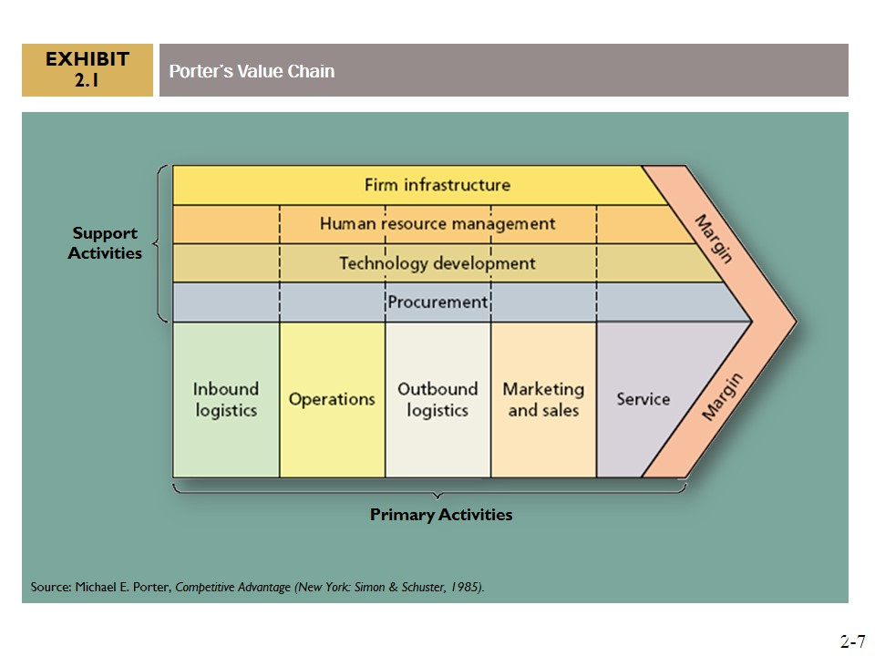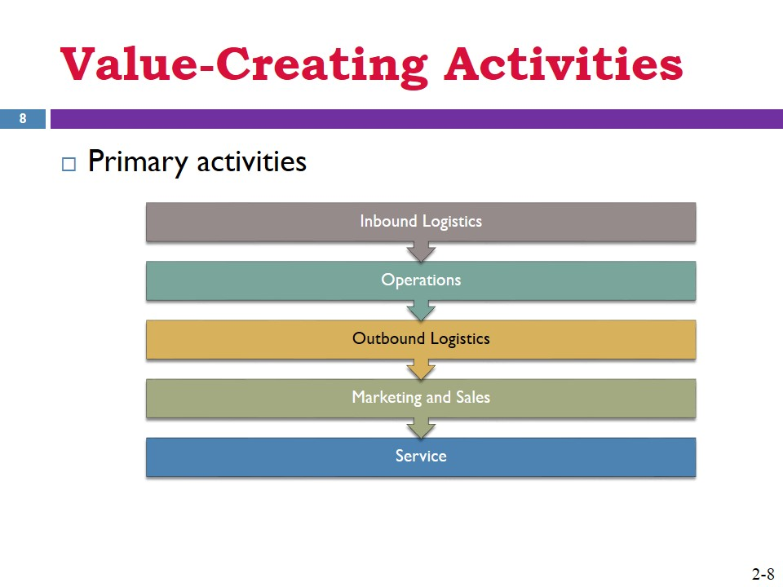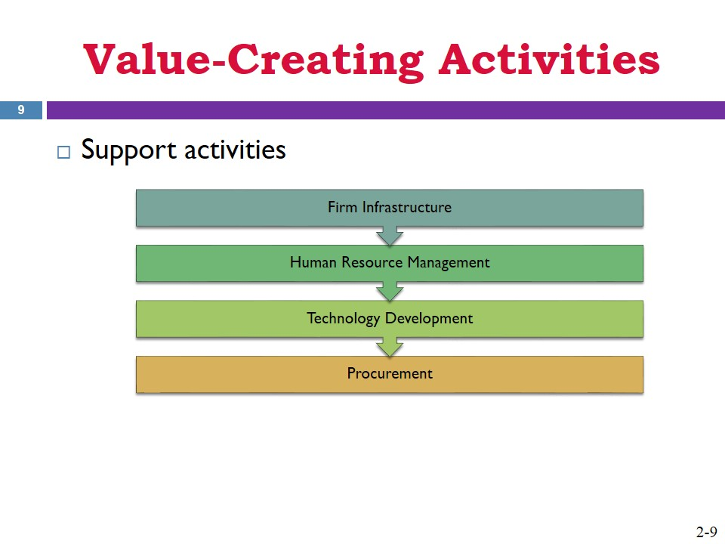
- Planning for the Value Offering | 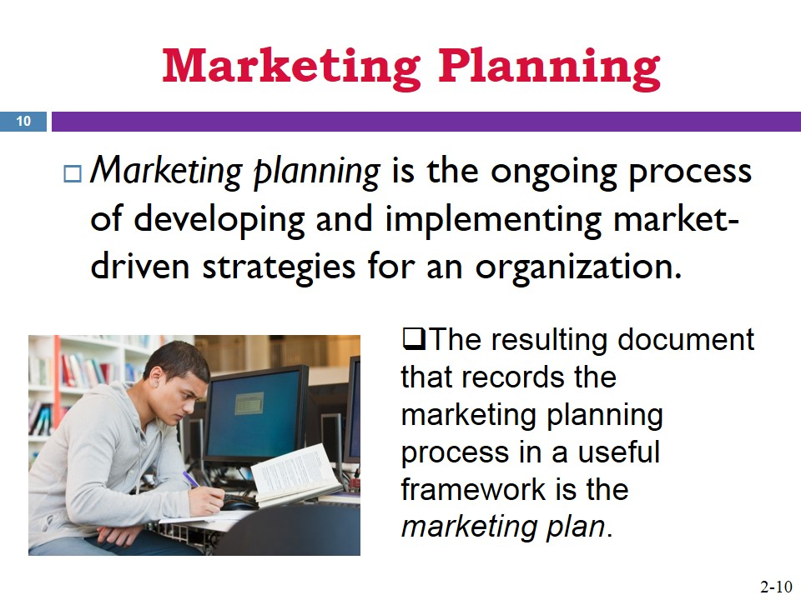
- MARKETING PLANNING IS BOTH STRATEGIC AND TACTICAL | 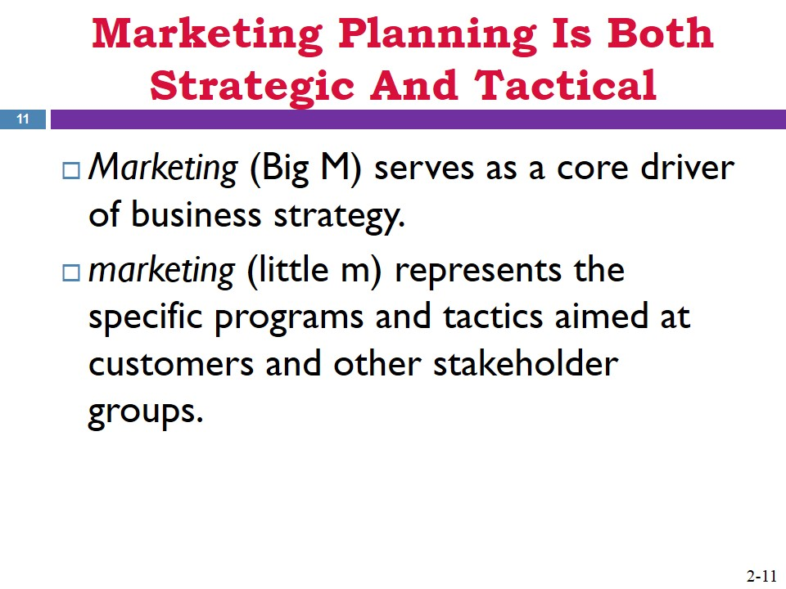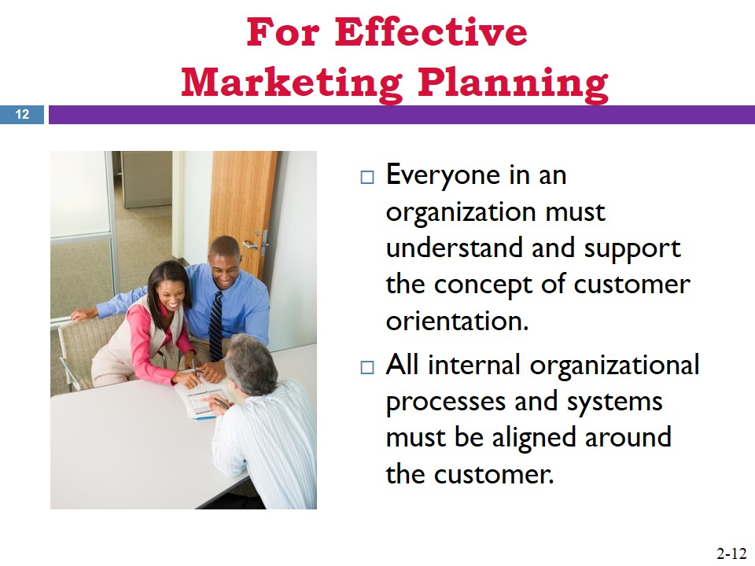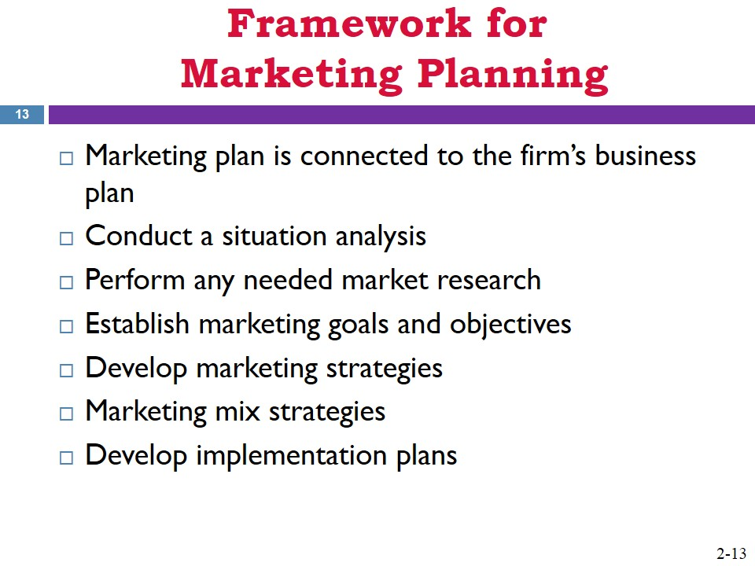
- ELEMENTS OF MARKETING PLANNING  - Connecting the Marketing Plan to the Firm’s Business Plan | 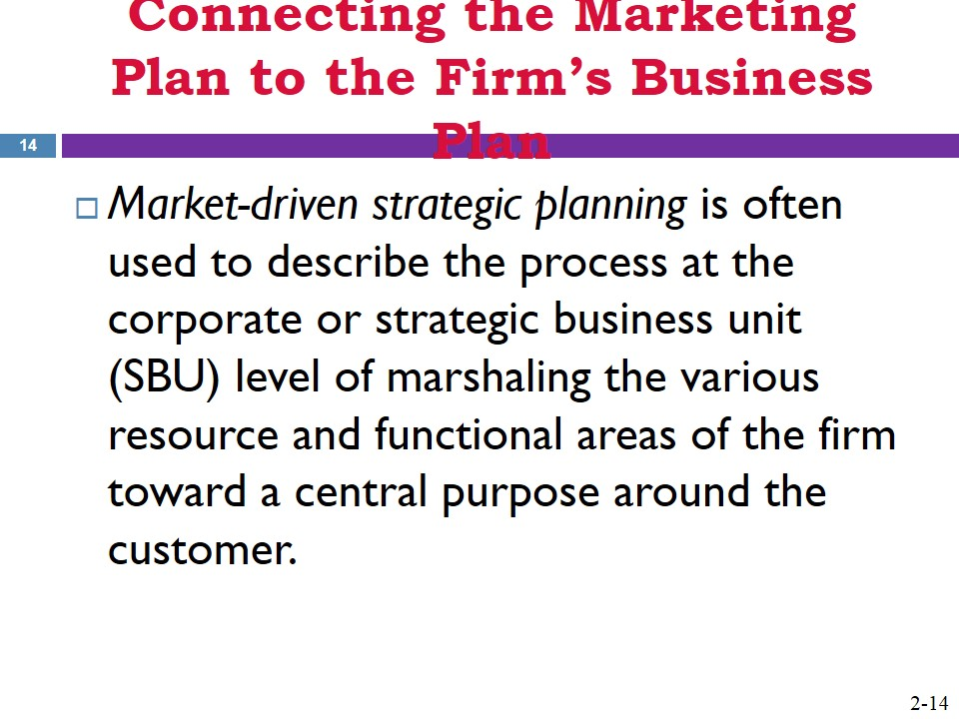
- Portfolio Analysis  - Functional Level Plans | 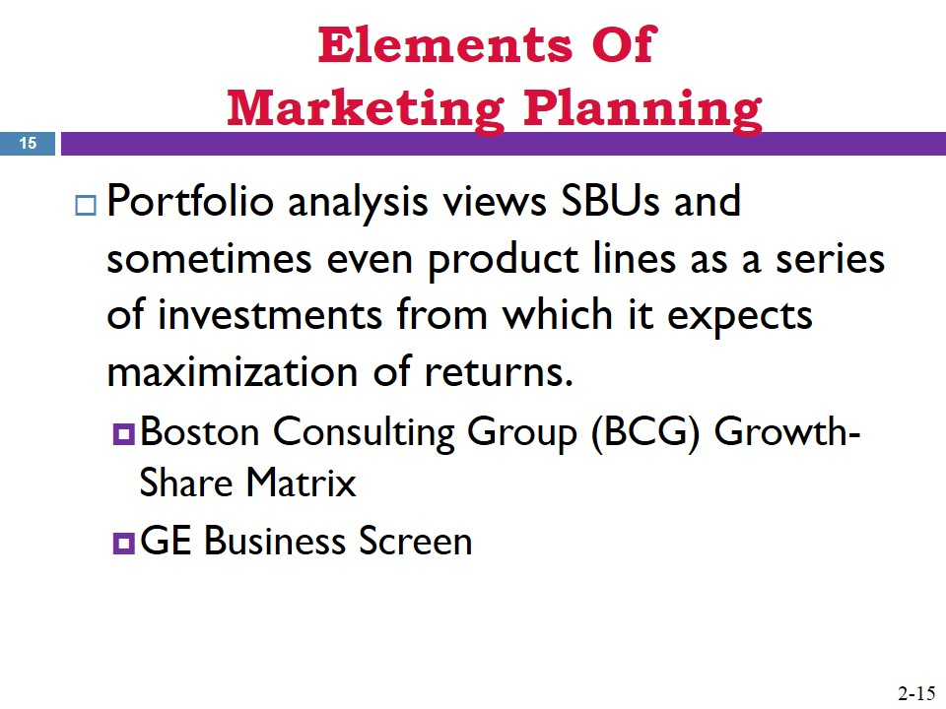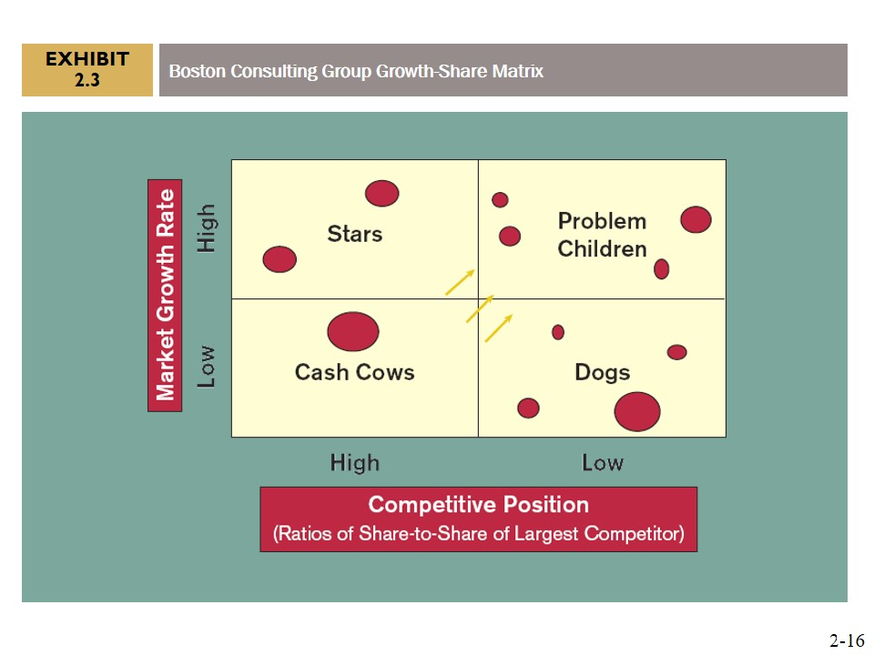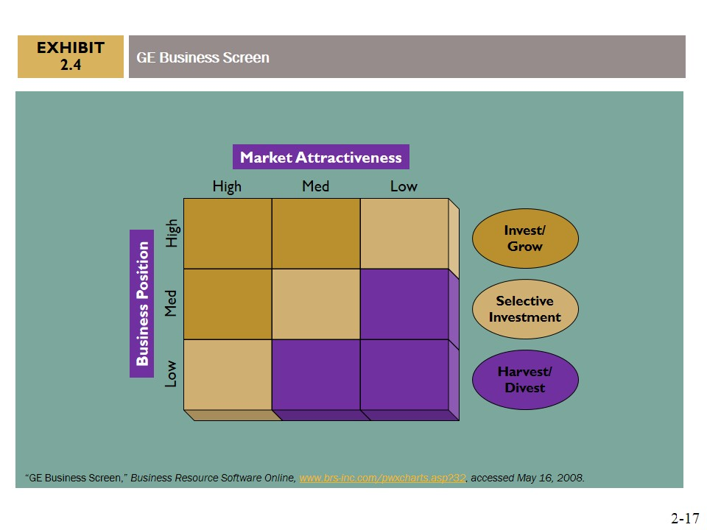
- Organizational Mission, Vision, Goals, and Objectives | 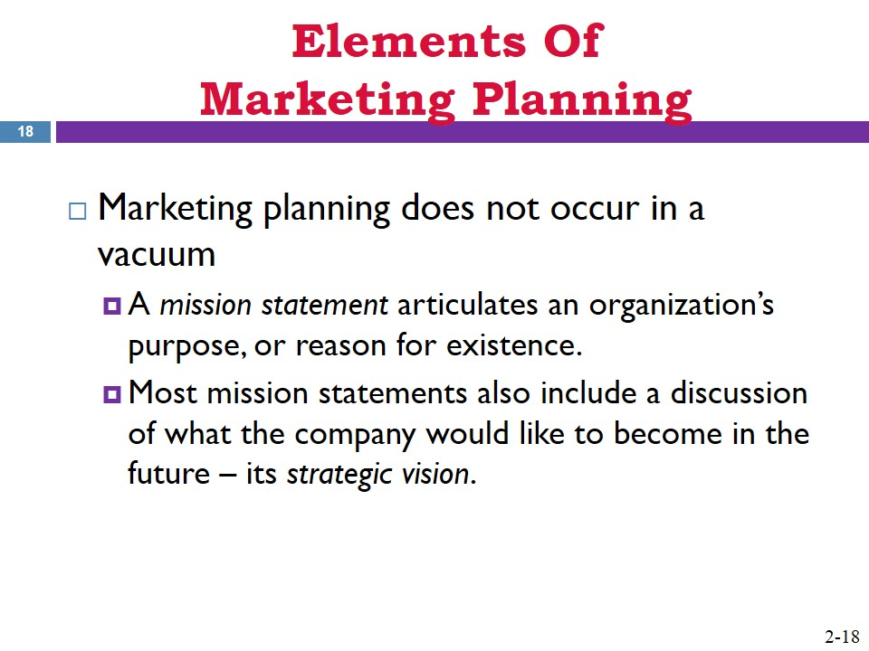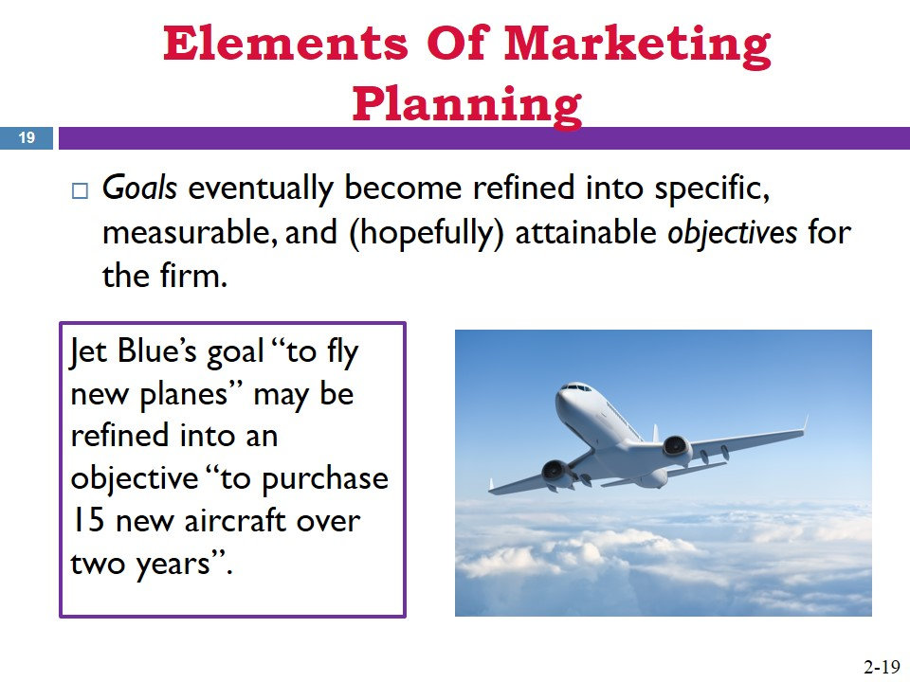
- Organizational Strategies  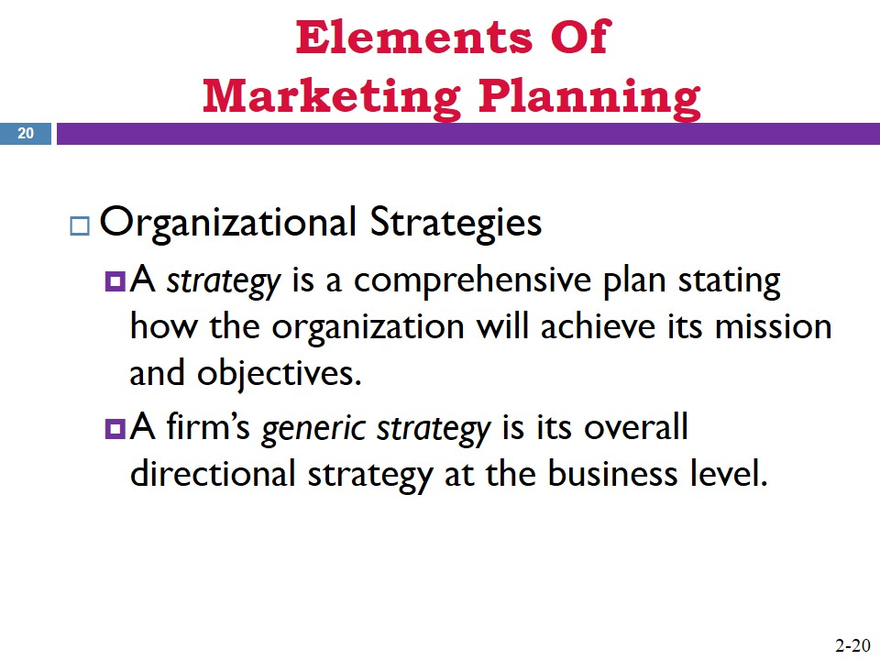  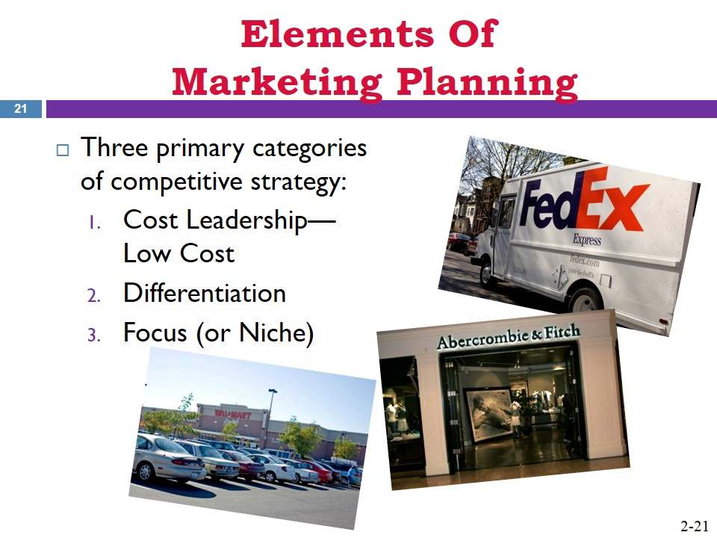  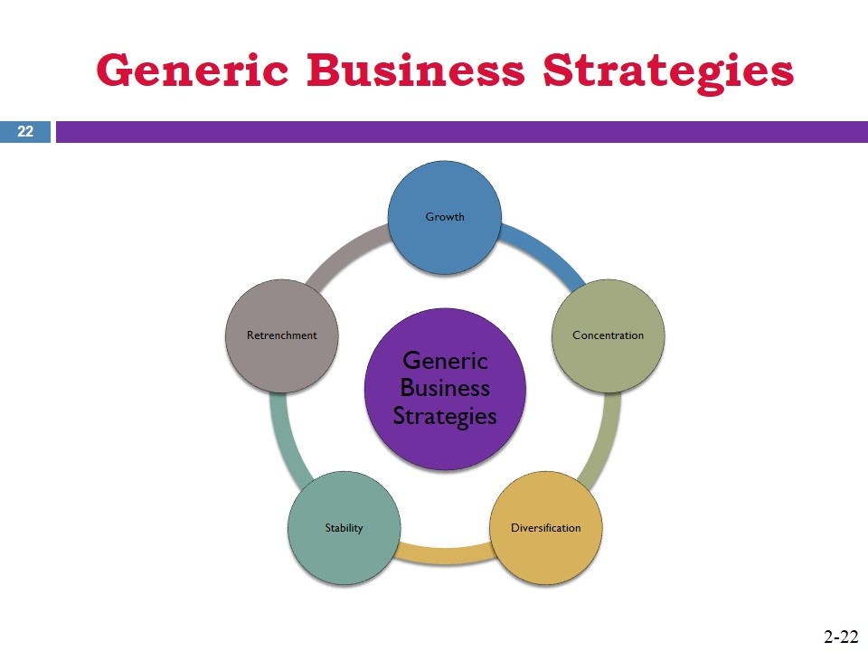 | 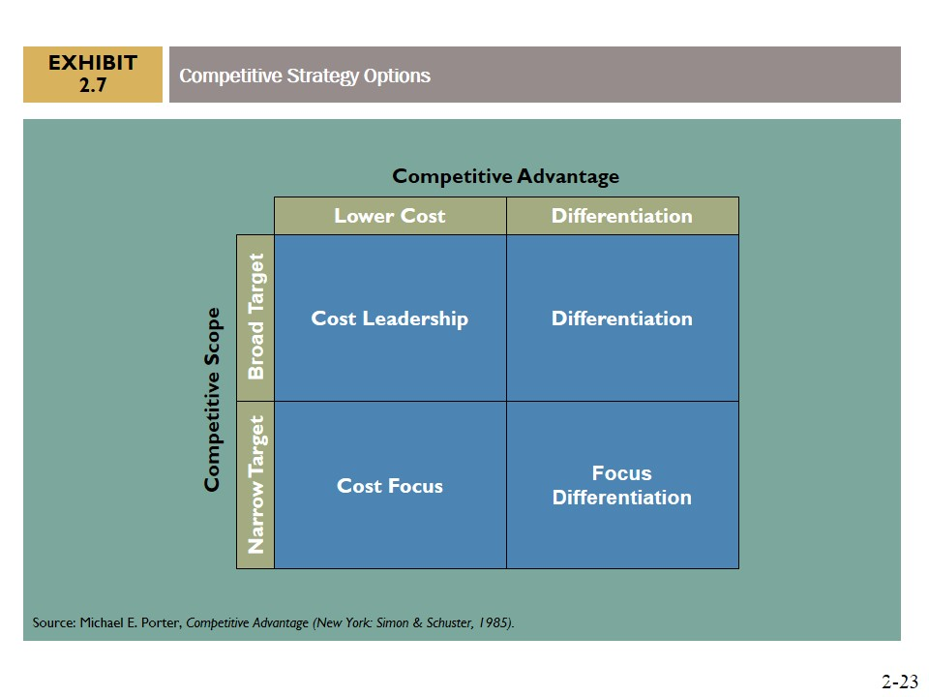  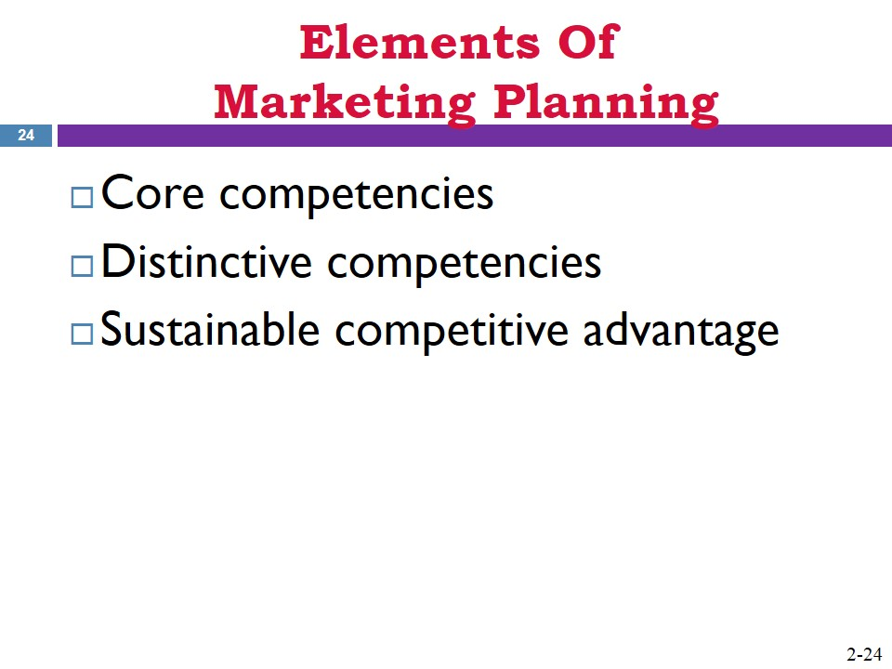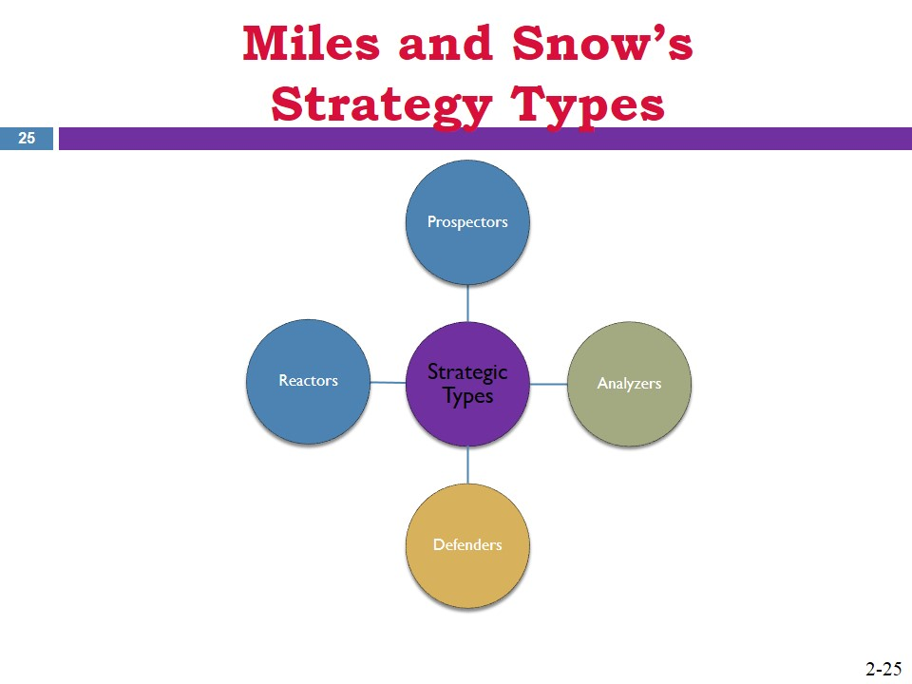
- Situation Analysis  - Macro-Level External Environmental Factors | 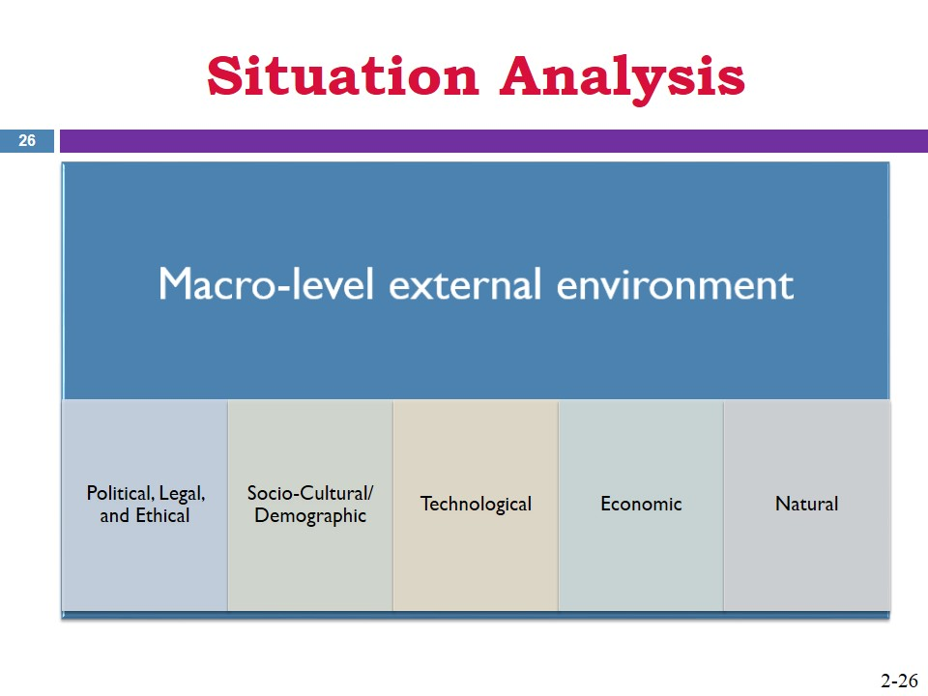
- Competitive Environmental Factors | 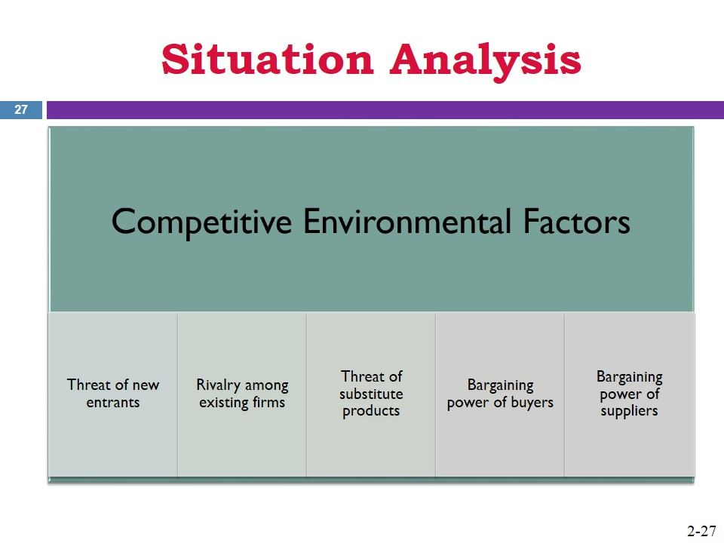  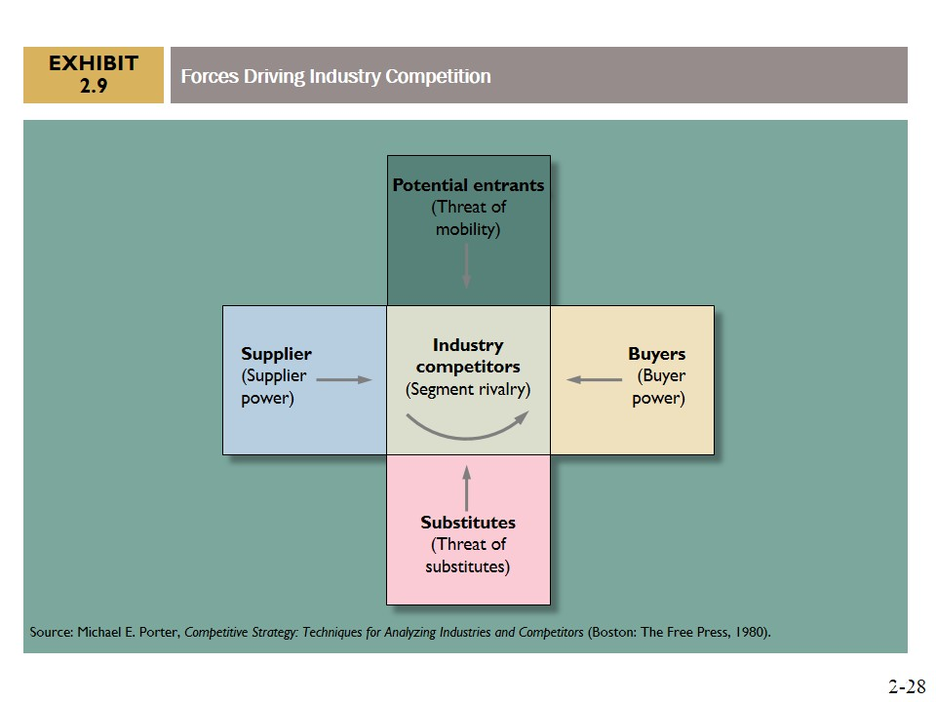
- Internal Environmental Factors | 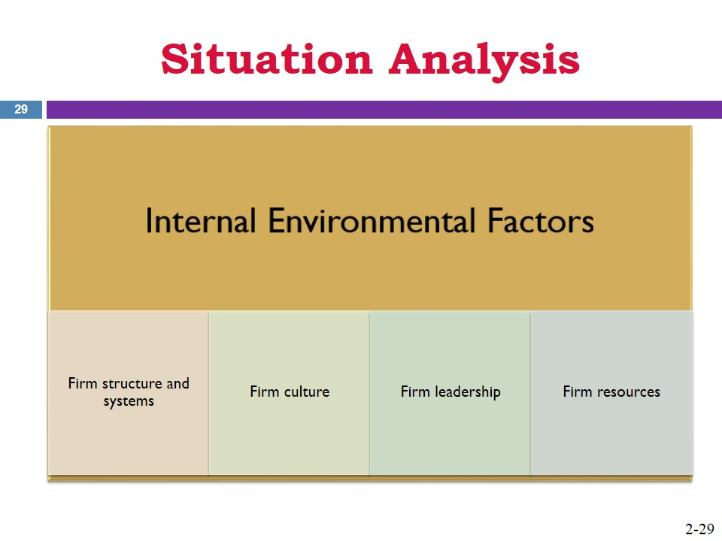
- Summarize the Situation Analysis into a SWOT | 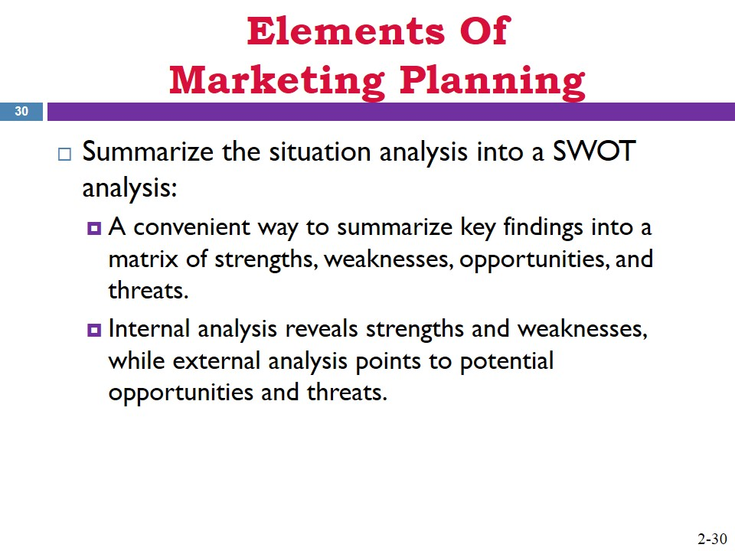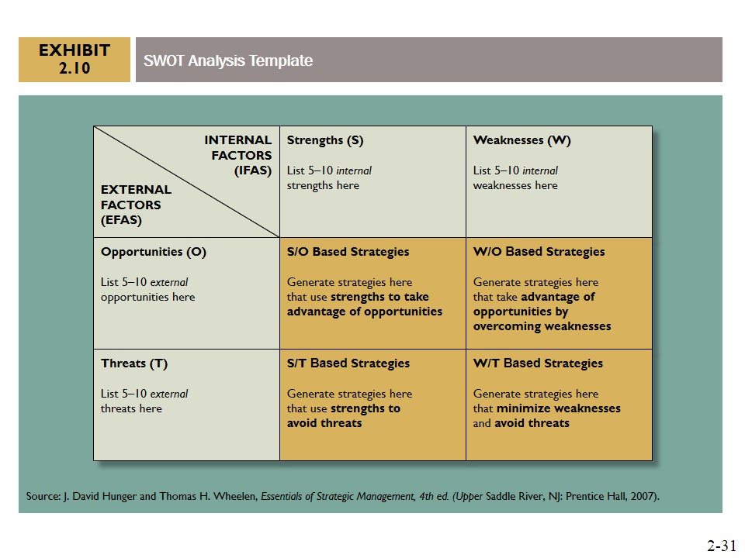
- Additional Aspects of Marketing Planning  - Perform Any Needed Market Research  - Establish Marketing Goals and Objectives  - Develop Marketing Strategies | 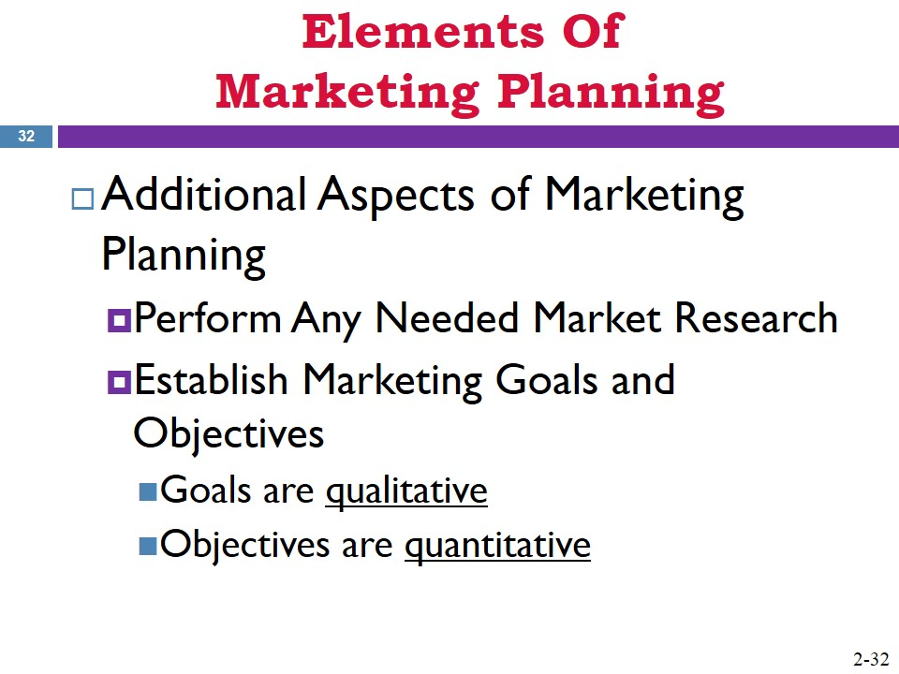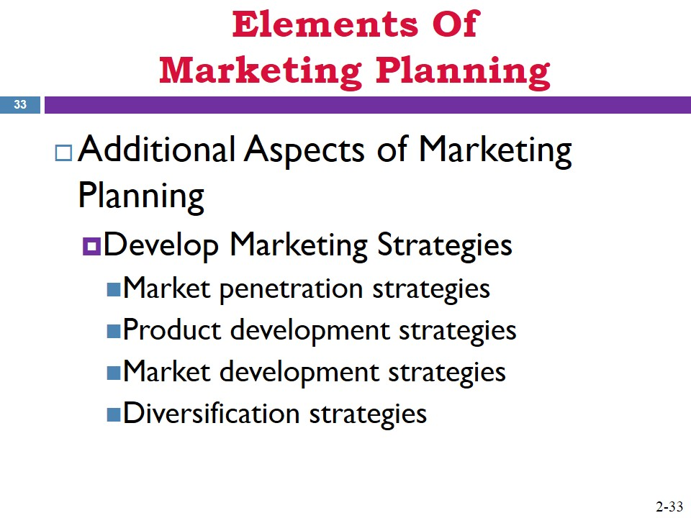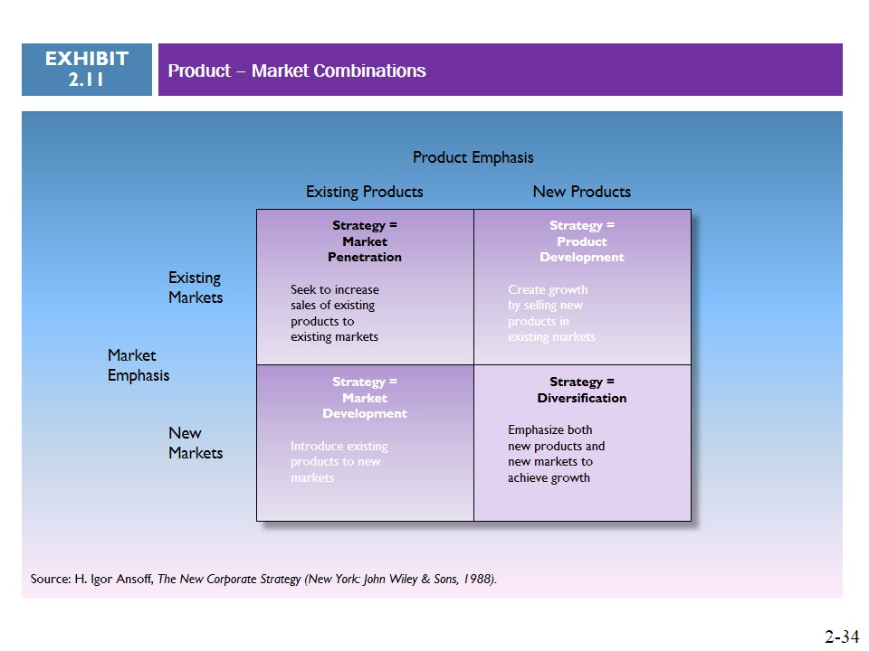
- Create an Implementation Plan Including Forecast, Budget, and Appropriate Marketing Metrics  - Develop Contingency Plans | 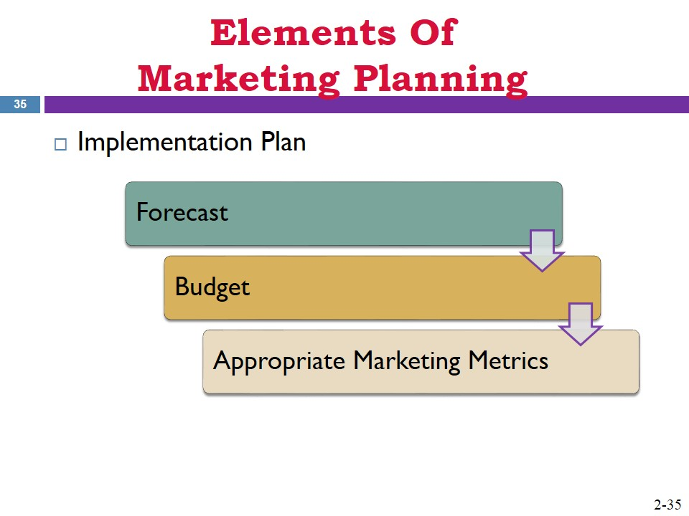  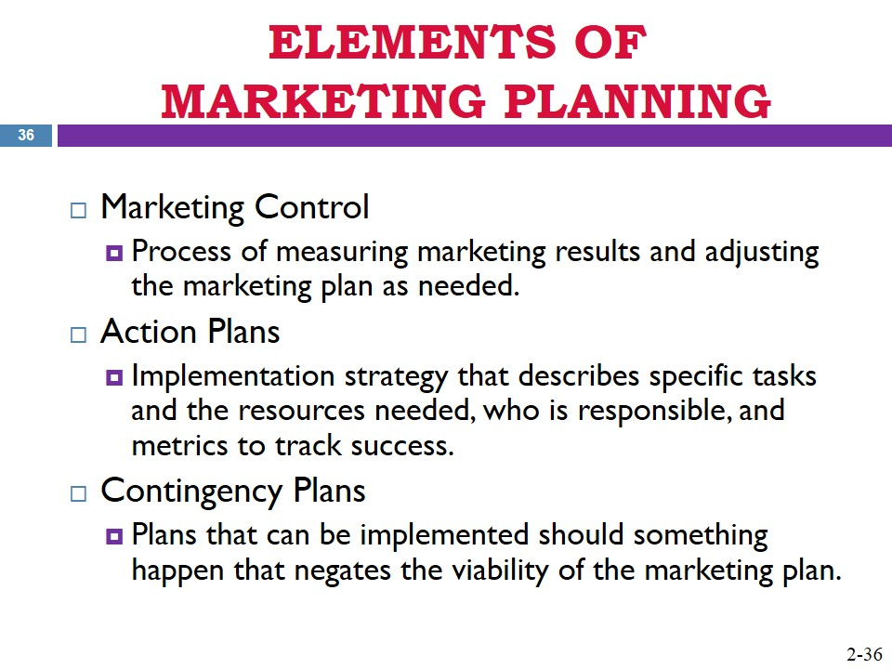
- Tips for Successful Marketing Planning | 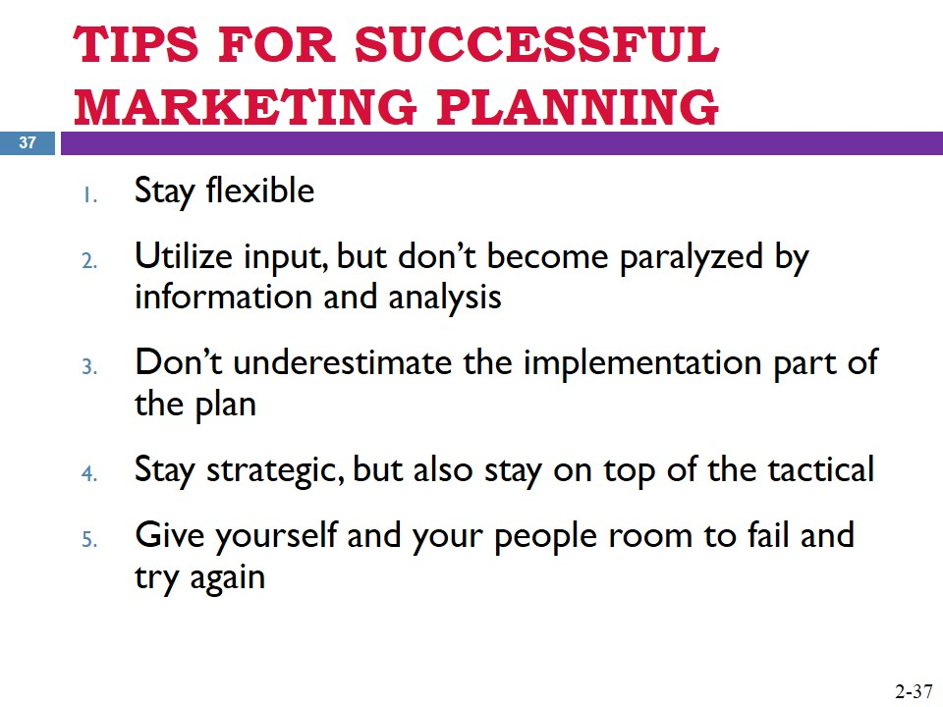
- VISIT THE APPENDIX FOR AN EXAMPLE MARKETING PLAN
- SUMMARY

ETHICAL DIMENSION 2
Ethical Perspective
- Senior Management: How should senior management incorporate ethical standards at all stages of the marketing planning process?
Ethical standards should be included into the formality of the marketing planning process. This means that firms must develop an acceptable ethical code of conduct that is pervasive throughout the organization.

- Marketing Managers: A company’s brands can be quickly impacted by negative publicity surrounding ethical scandals. How might they be impacted and what might a marketing manager do to reestablish a brand damaged in this way?
Firms can benefit from the following: take responsibility, fire or punish those responsible, admit your errors, address policy and business practice changes, and promote the changes about the firm to the marketplace.

- The Public: Company image and trust can be regained by a CEO’s quick public acknowledgment of an ethics problem accompanied by plans for changes in practice. What could HP’s CEO have done better?
One of the things that could have help with the scandal would have been a faster response by the CEO in the intervention, once the story became a headline in the media.

KEY TERMS
benefits The advantageous outcome from the advantage found in a product feature.
utility The want-satisfying power of a good or service. There are four types of utility: form utility, time utility, place utility, and ownership utility.
value proposition The whole bundle of benefits a company promises to deliver to the customer, not just the benefits of the product itself.
customer satisfaction The level of liking an individual harbors for an offering.
customer loyalty A customer’s commitment to a company and its products and brands for the long run.
customer retention Low propensity among a firm’s customer base to consider switching to other providers.
value chain The synthesis of activities within a firm involved in designing, producing, marketing, delivering, and supporting its products or services.
value-creating activities Activities within a firm’s value chain that act to increase the value of its products and services for its customers. These can take the form of either primary activities or support activities.
marketing planning The ongoing process of developing and implementing market-driven strategies for an organization.
marketing plan The resulting document that records the marketing planning process in a useful framework.
market-driven strategic planning The process at the corporate or strategic business unit (SBU) level of a firm that acts to marshal the various resource and functional areas toward a central purpose around the customer.
corporate-level strategic plan An umbrella plan for the overall direction of the corporation developed above the strategic business unit (SBU) level.
SBU-level strategic plan Planning that occurs within each of the firm’s strategic business units (SBUs) designed to meet individual performance requirements and contribute satisfactorily to the overall corporate plan.
portfolio analysis A tool used in strategic planning for multibusiness corporations that views SBUs, and sometimes even product lines, as a series of investments from which it expects maximization of returns.
Boston Consulting Group (BCG) Growth-Share Matrix A popular approach for in-firm portfolio analysis that categorizes business units’ level of contribution to the overall firm based on two factors: market growth rate and competitive position.
GE business screen A popular approach for in-firm portfolio analysis that categorizes business units’ level of contribution to the overall firm based on two factors: business position and market attractiveness.
functional-level plans Plans for each business function that makes up one of the firm’s strategic business units (SBUs). These include core business functions within each SBU such as operations, marketing, finance, as well as other pertinent operational areas.
mission statement The verbal articulation of an organization’s purpose, or reason for existence.
strategic vision Often included within a firm’s mission statement, it is a discussion of what the company would like to become in the future.
goals General statements of what the firm wishes to accomplish in support of the mission and vision.
objectives Specific, measurable, and potentially attainable milestones necessary for a firm to achieve its goals.
strategy A comprehensive plan stating how the organization will achieve its mission and objectives.
generic strategy An overall directional strategy at the business level.
competitive strategy An organization-wide strategy designed to increase a firm’s performance within the marketplace in terms of its competitors.
core competencies The activities a firm can do exceedingly well.
distinctive competencies A firm’s core competencies that are superior to those of their competitors.
sustainable competitive advantage The resulting advantage a firm has when it invests in distinctive competencies.
strategic type Firms of a particular strategic type have a common strategic orientation and a similar combination of structure, culture, and processes consistent with that strategy. Four strategic types are prospectors, analyzers, defenders, and reactors—depending on a firm’s approach to the competitive marketplace.
first-mover advantages When a firm introduces a new market offering, thus defining the scope of the competitive marketplace.
situation analysis An analysis of the macro and micro-level environment within which a firm’s marketing plan is being developed.
SWOT analysis A convenient framework used to summarize key findings from a firm’s situational analysis into a matrix of strengths, weaknesses, opportunities, and threats.
market penetration strategies Strategies designed to involve investing against existing customers to gain additional usage of existing products.
product development strategies Strategies designed to recognize the opportunity to invest in new products that will increase usage from the current customer base.
market development strategies Strategies designed to allow for expansion of the firm’s product line into heretofore untapped markets, often internationally.
diversification strategies Strategies designed to seize on opportunities to serve new markets with new products.
marketing control The process of measuring marketing results and adjusting the firm’s marketing plan as needed.

APPLICATION QUESTIONS
- What is a value proposition? For each of these brands, articulate your perception of their key value proposition:
A company’s value proposition consists of the sum total of benefits that the firm promises that a customer will receive in return for the customer's business. In other words, the value proposition equals what the customer gets for what the customer pays.
Caterpillar earth mover – higher standards than the competition
Apple iPad – delivers a more flexible and rewarding computinh experience
Facebook– high value social community
McDonald’s hamburgers – delivers a consistent product
FedEx overnight delivery service – fast and guaranteed urgent delivery

- Consider the concept of the value chain. Identify a firm that you believe does an especially good job of investing in elements in the value chain in order to gain higher profit margins versus competition. Which two or three elements in the value chain does that firm handle especially well? For each of those elements, what do they do that is better than their competition?
The value chain concept holds that every organization represents a synthesis of activities involved in designing, producing, promoting, delivering, and supporting its products.
Example firm: Nike, Inc., in the past few years, the company has devoted much energy to the developing information systems, logistics, and supply-chain management.
Inbound logistics – how the firm goes about sourcing raw materials for production
Operations – how the firm converts the raw materials into final products
Outbound logistics – how the firm transports and distributes the final products to the marketplace
Marketing and sales – how the firm communicates the value proposition to the marketplace – market leader!
Service – how the firm supports customers during and after the sale

- Why is it so important for marketing managers, when engaged in marketing planning, to successfully deal with both Marketing (Big M) and marketing (little m) elements? What would be the likely negative outcome if a marketing plan paid a lot of attention to strategies and little attention to tactics? What would be the likely negative outcome of the reverse?
Marketing managers must be able to grasp both the big picture of strategy formulation and the details of tactical implementation. In fact, many a marketing plan has failed because either the formulation of the strategies was flawed or their implementation was poorly executed. A well-written marketing plan must fully address both Marketing (Big M) and marketing (little m) elements.
Possible negative outcomes of a bad strategy would include lack of an understanding of markets, competitors, and other external forces, coupled with little attention to internal capabilities.
Possible negative outcomes of a bad tactics would include imprecise programs and tactics not aimed at the proper customers. This could include poor brand image, poor messaging by the salespeople, poor advertisements, poor customer service, poor packaging, and poor product features to name a few.

- Consider firms in any area of the retail business. Using Miles and Snow’s Strategy Types, identify the following: (1) a firm that you believe is a prospector; (2) a firm that you believe is an analyzer; (3) a firm that you believe is a defender; and (4) a firm that you believe is a reactor. What characteristics of each led you to conclude they belong in their respective strategy type?
Prospector – Example: Apple consistently produces market leading innovative products and services.
Analyzer – Example: Microsoft, most successful products are imitations of other products already in the marketplace.
Defender – Example: Porsche, rarely ventures outside of the high-end performance vehicle market.
Reactor – Firm lacks any coherent strategic plan or apparent means of effectively competing – reactors do well to merely survive in the competitive marketplace. Example: Hard to find because they do not survive long. Think of failed companies.

- Historically, the theme park industry in Orlando is heavily impacted by a large number of macro-level external environmental factors. From each of the five major categories of macro-level external factors, identify a specific example of how some element within that category might impact a theme park’s marketing planning for the next couple of years. Be sure to explain why you believe each of your examples will be important for marketing managers to consider as they develop their marketing plans.
Political, legal, and ethical – As traditional labor union attempt to grow through the recruitment of non-traditional workers, they may target the growing number of theme park employees.
Socio-cultural/Demographic – The growth in young people in the United States due to the “Baby Boomlet” will possibly result in more visitors to the parks.
Technological – The growth in 3D motion-simulator ride technology may present new opportunities in the near future.
Economic – The recent poor economic times for many middle class families may result in declining admissions due to a lack of discretionary income.
Natural – As the amusement parks attempt to add additional locations or grow current locations, they may face pressure from the various environmental groups as they acquire additional land.

MANAGEMENT DECISION CASE: Hewlett-Packard and the Case
Questions for Consideration
- As HP continues to make changes to its overall strategy, what other aspects of the situation analysis beyond those element mentioned above should Meg Whitman and other leaders pay special attention to?
HP could break-up to create value and/or make key acquisitions to improve its strategic position.

- What strengths does HP have that they can use to take advantage of various opportunities or minimize threats in the external environment?
The core of computing (CPU, main memory, and IO) has not changed in many years.
HP has experienced in all aspects of computer design and construction
HP is the only vendor that excels in three principal types of computing: work-group computers for offices; enterprise computers for home and personal use; and supercomputing, used in high-tech industrial and government systems.
HP also makes all the servers and support systems with its computers, so everything works in concert together.
“The Strengths of Hewlett-Packard” By Daniel Westlake, eHow Contributor ‘Read more: http://www.ehow.com/list_6938201_strengths-hewlett_packard.html#ixzz2mKwuyr00

- Given what you know about HP and its situation, what product-market strategy or strategies would you recommend the company adopt to improve its performance and return on investment?
Student answers will vary.

SUGGESTED VIDEO
BP: Transforming its Strategy "Beyond Petroleum" (7:52 minutes)
Description: Senior Vice President of BP Global Brand and Marketing & Innovation speaks on one of their Brand Values "going green" and having a lower impact on the environment by designing an innovative gas station and apply to their other 25,000 sites.
- Are people more likely to purchase gas from BP because of its commitment to the environment?
Notwithstanding tis environmental efforts, BP is still under pressure to create value for its customers. Some customers will welcome the "going green" commitment and reward BP. However, some customers while applauding the company will still not buy if the things they value more are not there.

- In light of the recent crisis in the Gulf of Mexico, how does BP convince the public that they are sincere about caring about the environment?
BP has an uphill battle in this matter. BP needs not only to perform the activities to demonstrate its sincerity, the company will also need to have the patience to give the market time to adjust.

