Chapter 2
Developing Marketing Strategies and a Marketing Plan

Tools For Instructors

- Brief Chapter Outline
- Learning Objectives
- Chapter Overview (“Summing Up”)
- Extended Chapter Outline with Teaching Tips
- PowerPoint Slides with Teaching Notes
- Answers to End of Chapter Learning Aids
- Chapter Case Study
- Additional Teaching Tips

Brief Chapter Outline

What is a Marketing Strategy?
The Marketing Plan
Growth Strategies
Summing Up
End of Chapter Learning Aids
Case Study: The Great Yogurt Battle

Learning Objectives

LO1 Define a marketing strategy.
LO2 Describe the elements of a marketing plan.
LO3 Analyze a marketing situation using SWOT analyses.
LO4 Describe how a firm chooses which consumer group(s) to pursue with its marketing efforts.
LO5 Outline the implementation of the marketing mix as a means to increase customer value.
LO6 Summarize portfolio analysis and its use to evaluate marketing performance.
LO7 Describe how firms grow their business.

Chapter Overview (“Summing Up”)

LO1 Define a marketing strategy.

A marketing strategy identifies (1) a firm’s target markets(s), (2) a related marketing mix (four Ps), and (3) the bases on which the firm plans to build a sustainable competitive advantage. Firms use four macro strategies to build their sustainable competitive advantage. Customer excellence focuses on retaining loyal customers and excellent customer service. Operational excellence is achieved through efficient operations and excellent supply chain and human resource management. Product excellence entails having products with high perceived value and effective branding and positioning. Finally, locational excellence entails having a good physical location and Internet presence.

LO2 Describe the elements of a marketing plan.

A marketing plan is composed of an analysis of the current marketing situation, its objectives, the strategy for the four Ps, and appropriate financial statements. A marketing plan represents the output of a three-phase process: planning, implementation, and control. The planning phase requires that managers define the firm’s mission and vision and assess the firm’s current situation. It helps answer the questions, “What business are we in now, and what do we intend to be in the future?” In the second phase, implementation, the firm specifies, in more operational terms, how it plans to implement its mission and vision. Specifically, to which customer groups does it wish to direct its marketing efforts, and how does it use its marketing mix to provide good value? Finally, in the control phase, the firm must evaluate its performance using appropriate metrics to determine what worked, what didn’t, and how performance can be improved in the future.

LO3 Analyze a marketing situation using SWOT analyses.

SWOT stands for strengths, weaknesses, opportunities, and threats. A SWOT analysis occurs during the second step in the strategic planning process, the situation analysis. By analyzing what the firm is good at (its strengths), where it could improve (its weaknesses), where in the marketplace it might excel (its opportunities), and what is happening in the marketplace that could harm the firm (its threats), managers can assess their firm’s situation accurately and plan its strategy accordingly.

LO4 Describe how a firm chooses which consumer group(s) to pursue with its marketing efforts.

Once a firm identifies different marketing opportunities, it must determine which are the best to pursue. To accomplish this task, marketers go through a segmentation, targeting, and positioning (STP) process. Firms segment various markets by dividing the total market into those groups of customers with different needs, wants, or characteristics who therefore might appreciate products or services geared especially toward them. After identifying the different segments, the firm goes after, or targets, certain groups on the basis of the firm’s perceived ability to satisfy the needs of those groups better than competitors and do so profitably. To complete the STP process, firms position their products or services according to the marketing mix variables so that target customers have a clear, distinctive, and desirable understanding of what the product or service does or represents relative to competing products or services.

LO5 Outline the implementation of the marketing mix as a means to increase customer value.

The marketing mix consists of the four Ps—product, price, promotion, and place—and each P contributes to customer value. To provide value, the firm must offer a mix of products and services at prices their target markets will view as indicating good value. Thus, firms make trade-offs between the first two Ps, product and price, to give customers the best value. The third P, promotion, informs customers and helps them form a positive image about the firm and its products and services. The last P, place, adds value by getting the appropriate products and services to customers when they want them and in the quantities they need.

LO6 Summarize portfolio analysis and its use to evaluate marketing performance.

Portfolio analysis is a management tool used to evaluate the firm’s various products and businesses—its “portfolio”—and allocate resources according to which products are expected to be the most profitable for the firm in the future. A popular portfolio analysis tool developed by the Boston Consulting Group classifies all products into four categories. The first, stars, are in high growth markets and have high market shares. The second, cash cows, are in low-growth markets, but have high market share. These products generate excess resources that can be spun off to products that need them. The third category, question marks, are in high-growth markets, but have relatively low market shares. These products often utilize the excess resources generated by the cash cows. The final category, dogs, are in low-growth markets and have relatively low market shares. These products are often phased out.

LO7 Describe how firms grow their business.

Firms use four basic growth strategies: market penetration, market development, product development, and diversification. A market penetration strategy directs the firm’s efforts toward existing customers and uses the present marketing mix. In other words, it attempts to get current customers to buy more. In a market development strategy, the firm uses its current marketing mix to appeal to new market segments, as might occur in international expansion. A product development growth strategy involves offering a new product or service to the firm’s current target market. Finally, a diversification strategy takes place when a firm introduces a new product or service to a new customer segment. Sometimes a diversification strategy relates to the firm’s current business, such as when a women’s clothing manufacturer starts making and selling men’s clothes, but a more risky strategy is when a firm diversifies into a completely unrelated business.

Extended Chapter Outline With Teaching Tips

What Is A Marketing Strategy?

Customer excellence (PPT slide 2-5)

Retaining Loyal Customers

Providing Outstanding Customer Service

Operational excellence (PPT slide 2-6)

Product Excellence (PPT slide 2-8)

Locational Excellence (PPT slide 2-9)

Multiple Sources of Advantage
Check Yourself: Several questions are offered for students to check their understanding of core concepts. (PPT slide 2-11)
- What are the various components of a marketing strategy?
Answer: A marketing strategy includes a firm’s target market(s), a related marketing mix, and the bases upon which the firm plans to build a sustainable competitive advantage.
- List the four macro strategies that can help a firm develop a sustainable competitive advantage.
Answer: The four microstrategies that can help a firm develop a sustainable competitive advantage include customer excellence, operational excellence, product excellence, and locational excellence.

The Marketing Plan (PPT Slide 2-12)

Step 1: Define the business mission. (PPT slide 2-14)

Step 2. Conduct a situation analysis. (PPT slide 2-16)

Step 3: Identify and evaluate opportunities using STP (segmentation, targeting, and positioning). (PPT slide 2-17, 18)

Segmentation

Targeting

Positioning

Step 4: Implement the marketing mix and allocate resources. (PPT slide 2-20)

Product and Value Creation (PPT slide 2-21)

Price and Value Capture (PPT slide 2-22)

Place and Value Delivery ((PPT slide 2-23)

Promotion and Value Communication (PPT slide 2-24)

Step 5: Evaluate performance using marketing metrics. (PPT slide 2-25)

Who is Accountable for Performance?

Performance Objectives and Metrics

Financial Performance Metrics

Portfolio Analysis

Stars

Cash Cows

Questions Marks

Dogs

Strategic planning is not sequential.
Check Yourself: Several questions are offered for students to check their understanding of core concepts. (PPT slide 2-27)
- What are the five steps in creating a marketing plan?
Answer: The five steps in creating a marketing plan are defining a business mission and objectives, evaluating a situation analysis, identifying opportunities, implementing a marketing mix, and evaluating performance using marketing matrix.
- What tool helps a marketer conduct a situation analysis?
Answer: A SWOT analysis helps a marketer conduct a situation analysis.
- What is STP?
Answer: STP is Segmentation, Targeting, and Positioning.
- What do the four quadrants of the portfolio analysis represent?
Answer: Stars, Cash Cows, Question Marks, Dogs.

Growth Strategies (PPT Slide 2-28)

Market penetration (PPT slide 2-29)

Market development and the case for global expansion (PPT slide 2-30)

Product Development (PPT slide 2-31)

Diversification (PPT slide 2-33)
Check Yourself: Several questions are offered for students to check their understanding of core concepts. (PPT slide 2-34)
- What are the four growth strategies?
Answer: They are market penetration strategy, market development strategy, product development strategy, and diversification strategy.
- What type of strategy is growing the business from existing customers?
Answer: The type of strategy that grows a business from existing customers is market penetration strategy.
- Which strategy is the riskiest?
Answer: The diversification strategy is the riskiest, because unrelated diversifications do not capitalize on either core strengths associated with markets or with products.

Powerpoint Slides With Teaching Notes

Power Point Slide | Teaching Notes
- Developing Marketing Strategies and a Marketing Plan
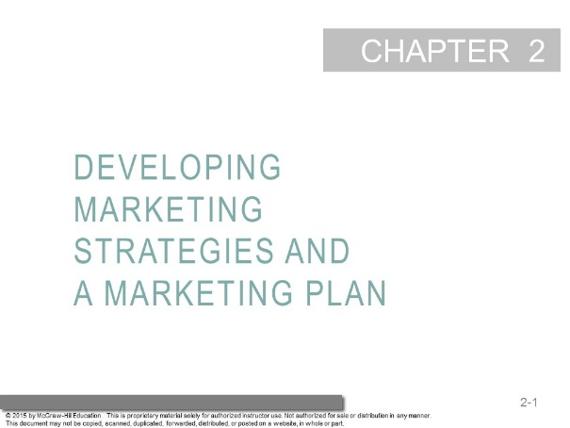
- Learning Objectives  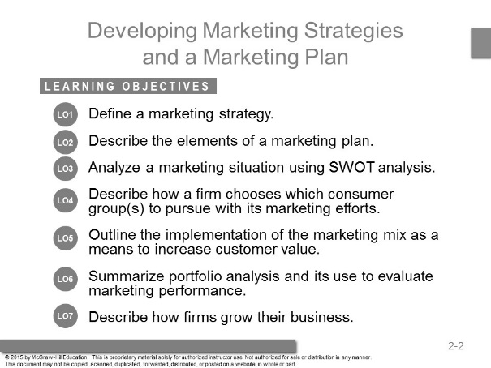 | These questions are the learning objectives guiding the chapter and will be explored in more detail in the following slides.
- Nike  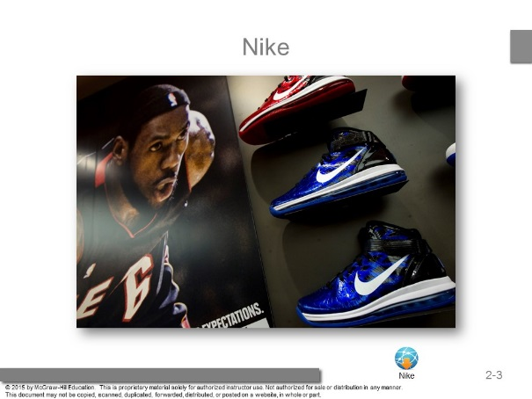 | Students will most likely be familiar with Nike products.  Ask Students to comment on any commercials they can recall and the company itself. Students will start to mention many topics in the chapter including target markets, marketing mix and sustainable competitive advantage.
- Sustainable Competitive Advantage  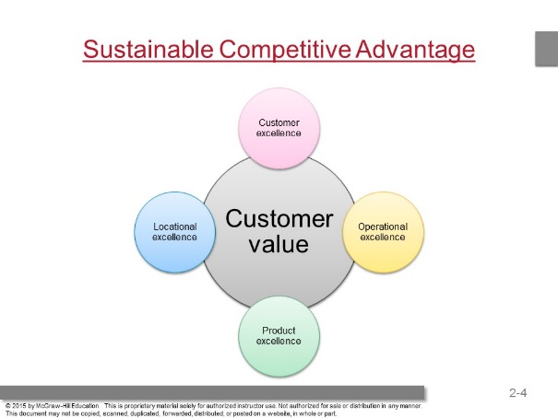 | This slide covers the four strategies to create and deliver value and a sustainable competitive advantage.  Ask students to think of companies who they are very loyal to in many categories (food, electronics, and personal care)? Is it their product, location, operational, or customer excellence that draws the student’s loyalty?
- Customer Excellence  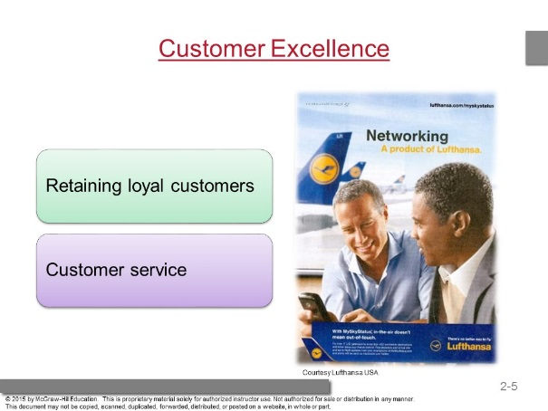 | Luthansa airlines retains customers by offering the best possible service at the best possible price.  Ask students what this might include for an airline? For economy they offer meals, free drinks and fun toiletries and for the first class customer massages, manicures and stand-up bars in flight.
- Operational Excellence  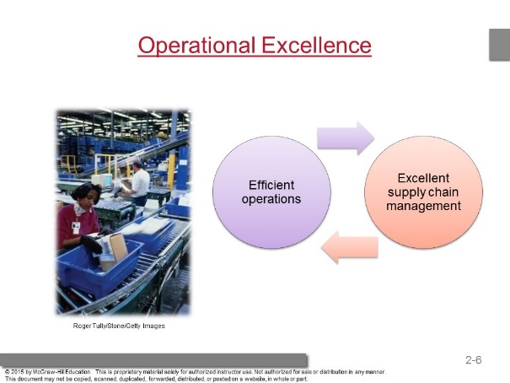 | The text highlights how firms can use the various elements of the marketing mix to achieve a competitive advantage.  In recent years, firms such as Wal-Mart have achieved competitive advantage by utilizing operational excellence.  That is, by controlling price and how products are delivered to their stores, they have been able to offer customers low prices on a wide array of goods.  This is made possible through the use of efficient operations and excellent relationships with suppliers.
- New Balance – Can America Compete?   | Marketing the “Made in America” concept. This clip features the New Balance brand. The clip focuses on the value found in U.S. made brands and evaluating the cost vs. time factor.  Note: Please make sure that the video file is located in the same folder as the PowerPoint slides.
- Product Excellence  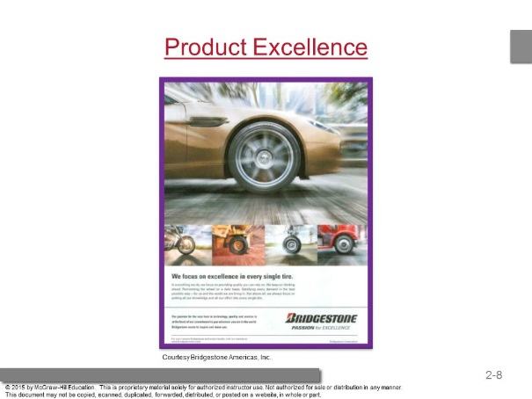 | Ask students how this is an example of product excellence.  Students might say it is product excellence because of the high quality of the product.  Point out the fact that expensive should NOT be confused with the fact that the product has a clear and distinctive brand image and that it is clearly positioned.
- Locational Excellence  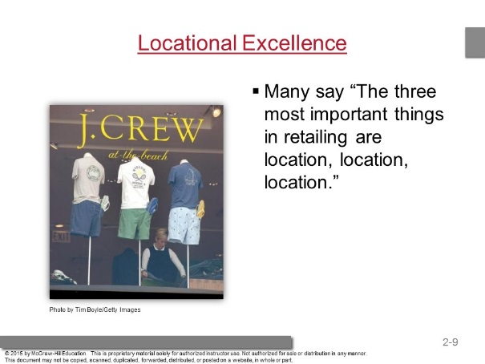 | A competitive advantage based on location is sustainable because it is not easily duplicated.
- What Competitive Advantage?  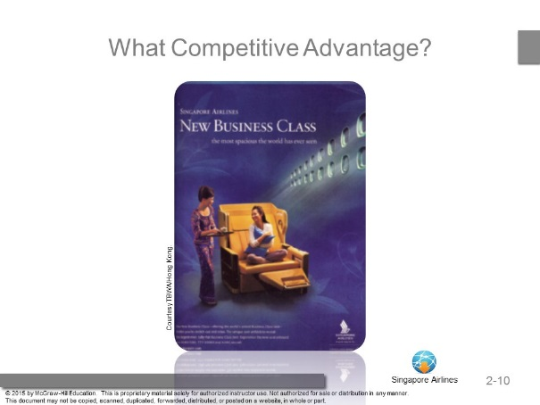 | Ask students which of the four value choices is Singapore Airlines using?  Singapore Airlines is using customer excellence to create and deliver value and to develop sustainable competitive advantages.
- Check Yourself  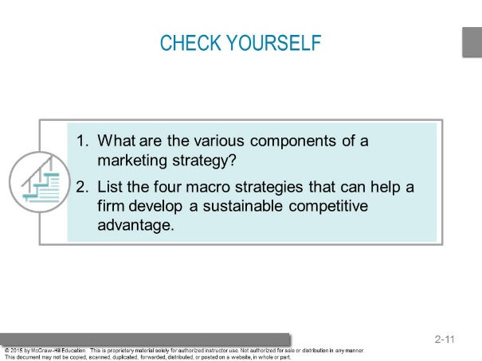 | 1. Identifies a firm’s target market, related marketing mix — their four Ps — and the bases upon which the firm plans to build a sustainable competitive advantage.  2. Customer excellence, operational excellence, product excellence, locational excellence.
- The Marketing Plan  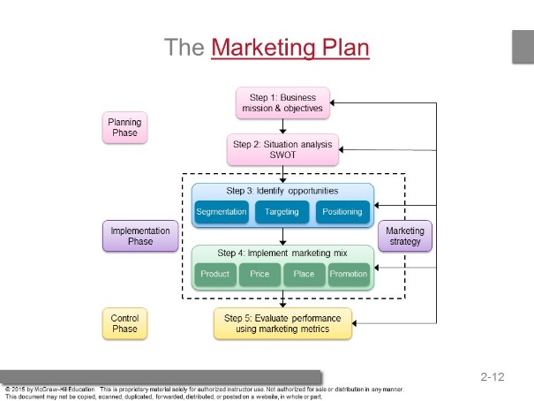 | Explain to students that the marketing plan should be a written plan yet many companies do not write it down.  Ask students why companies tend to not write down marketing plans. The most likely answer is that they don’t take the time or haven’t organized the strategy.
- Three Phases of a Strategic Plan  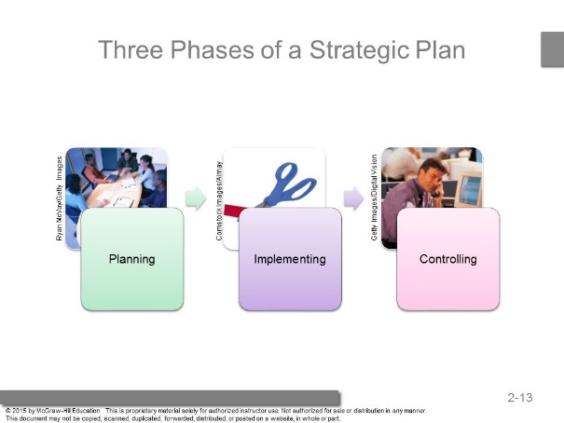 | A poorly executed plan leads to failure, regardless of how good or solid the plan may be.  The world is full of good plans poorly executed. When initially introduced, diapers designed differently for boys and girls bombed because the market was not ready for the product; through improved execution, the diaper manufacturer ultimately found success.  However, even well-executed plans require monitoring and updating, because the needs of any market constantly change.
- Step One: Defining the Mission and/or Vision  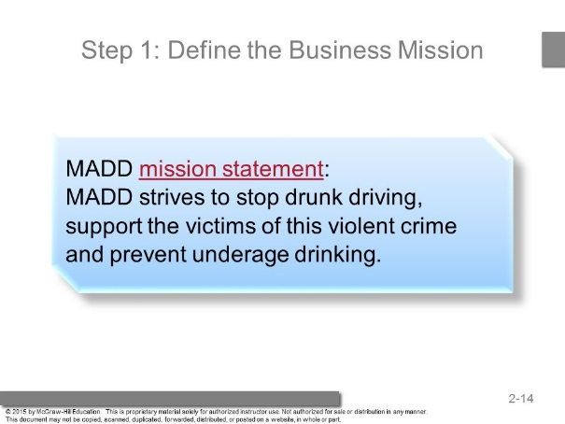 | Group activity: Students should develop a mission statement for their school.  The resultant mission statement would offer a good way to assess and set student expectations.
- MADD Promotion  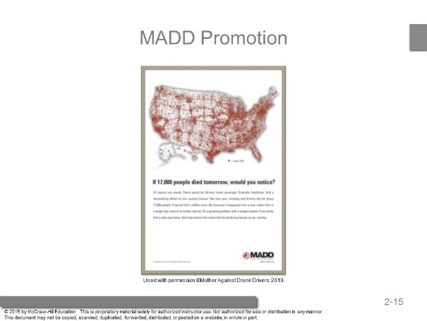 | Notice how MADD works to translate its Mission Statement into action through its promotion efforts
- Step Two: Conduct a Situation Analysis Using SWOT  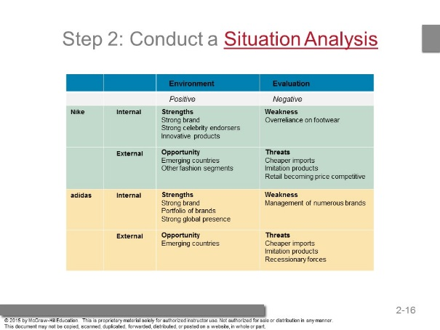 | A SWOT analysis is comprehensive, in that it offers both an internal and an external assessment. The firm therefore must possess expertise in both what the firm can provide and what the market wants the firm to provide.  Students can take a few minutes and fill in a SWOT analysis for their in-class exercise of building a marketing plan for their college.
- Step Three: Identifying and Evaluating Opportunities Using STP  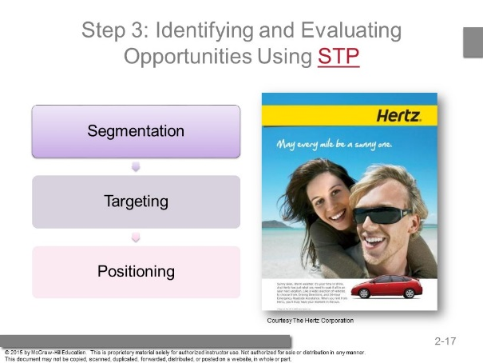 | After completing the situation audit, the next step is to identify and evaluate opportunities for increasing sales and profits using STP (segmentation, targeting, and positioning).  With STP, the firm first divides the marketplace into subgroups or segments, determines which of those segments it should pursue or target, and finally decides how it should position its products and services to best meet the needs of those chosen targets.
- Hertz: Segmentation, Targeting, Positioning  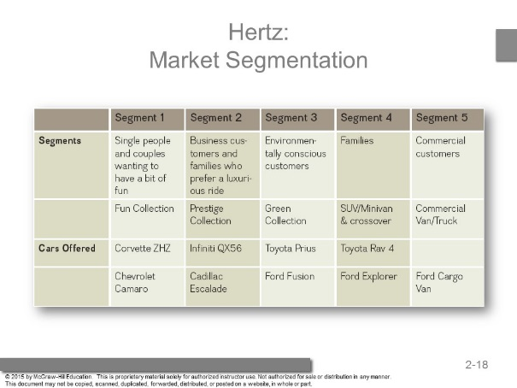 | Hertz offers different vehicles to meet the transportation needs of diverse segments. Each class of automobile offers something to please every segment.
- What Segments?  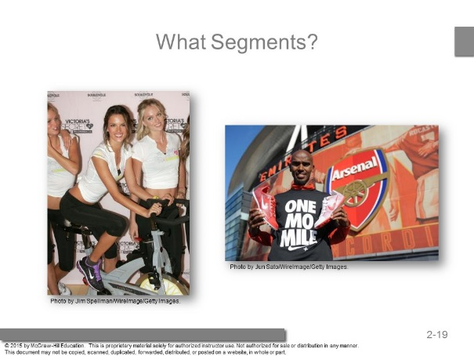 | Ask students what segments is Nike going after?
- Step Four: Implement Marketing Mix and Allocate Resources  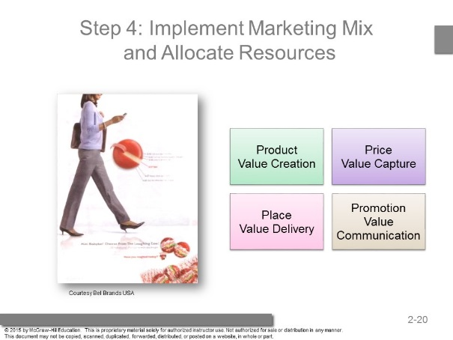 | In all firms, resources are scarce and must be allocated so that they create the most value for the firm.  Ask Students to point out the elements of the marketing mix in this ad? They will certainly see the value creation in the product and the promotion which targets busy women.
- Product and Value Capture  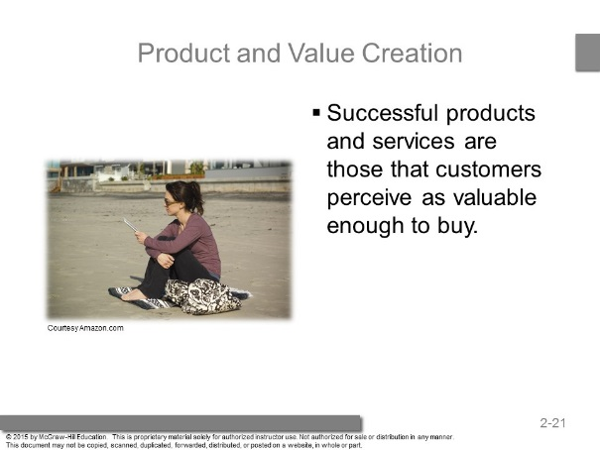 | Because the key to the success of any marketing program is the creation of value, firms attempt to develop products and services that customers perceive as valuable enough to buy.
- Price and Value Capture  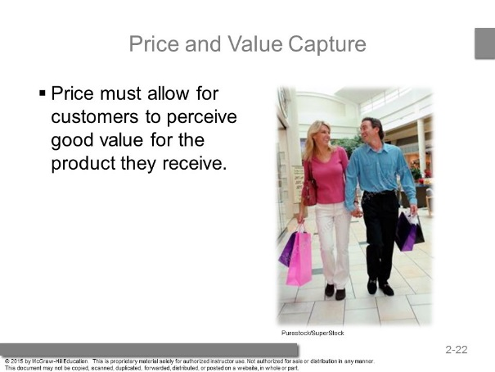 | These will be covered in the pricing chapters later in the book. It is worth spending some time on Value-based pricing.  Show students two differently priced products from the same category and ask students which one they view as better value and why?  For example, an Apple iPod vs. a Microsoft Zune player. Or alternatively Aquafina vs. Perrier. Also explain that in this course, more discussion of value will be done throughout the semester.
- Place and Value Delivery  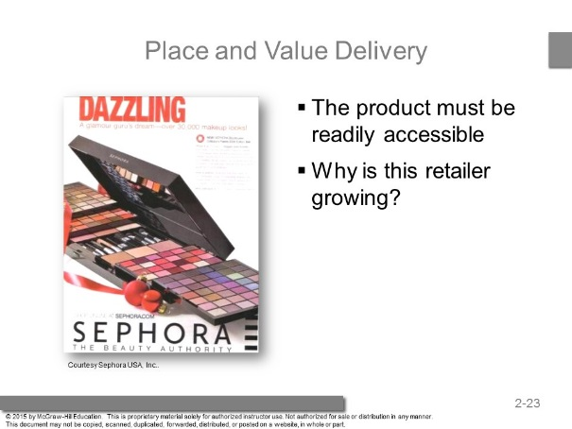 | Getting the product to consumers at the exact moment they desire it is difficult.  Firms therefore are experimenting with different forms of distribution, such as vending machines for cell phones, to offer consumers 24/7 access to products.  Staples has incorporated web kiosks in their stores to access Staples.com. Thus, consumers are able to buy products that are out of stock in-store.  Ask students if they are familiar with Sephora, if they like it, and why? Most likely they will be very fond of this retailer. They offer an incredible assortment in a well-organized, well lighted, exciting retail environment.
- Promotion and Value Communication  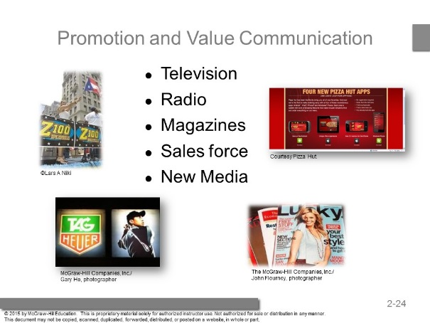 | Consumers enter into an exchange only if they know that the firm’s product or service appears in the marketplace. This is why promotion is so important. They won’t buy if they don’t know about it.
- Step Five: Evaluate Performance and Make Adjustments  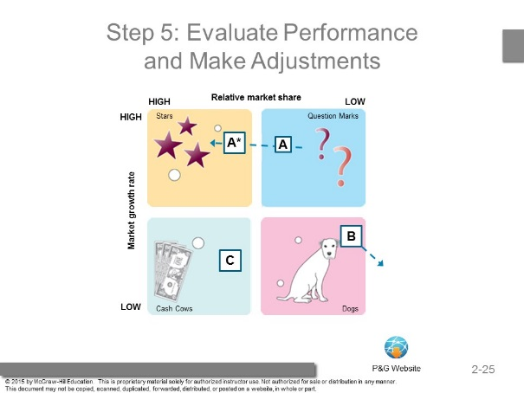 | Firms cannot simply remain content with a strategy for too long. Over time, all strategies must be revised to adjust to new markets, new competitors, and new technologies.  The firm must recognize not only its failures, but also its successes to ensure continued success. The full description of the Boston Consulting Group Matrix is found in the Appendix to Chapter One. In general it is an example of portfolio analysis.  Visit the P&G website and ask students to recognize stars, cash cows and question marks (newer products). You won’t find any dogs at the P&G website.
- Which Quadrant?  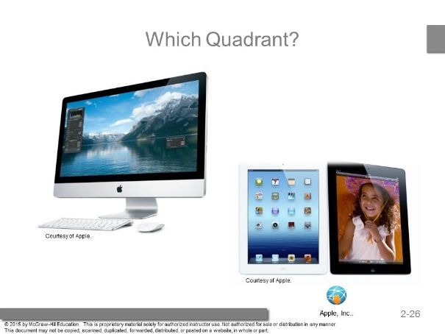 | Ask students to identify which quadrant of the Boston Consulting Group portfolio analysis do these products belong to?  The Apple iMac Desktop would be considered a cash cow, while the iPad would be considered a Star.
- Check Yourself  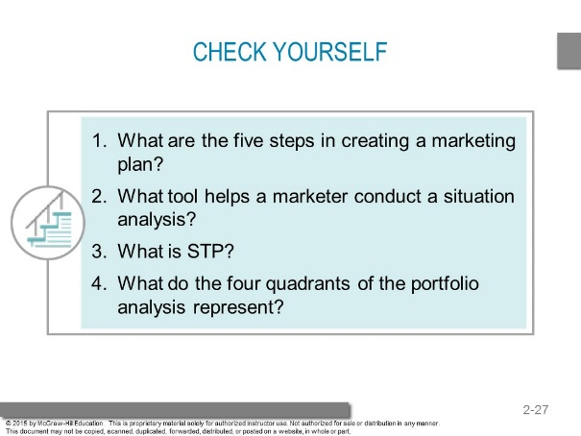 | - Business mission and objectives, situation analysis and SWOT, identify opportunities, implement marketing mix, evaluate performance using marketing metrics.  - SWOT analysis (strengths, weaknesses, opportunities, threats)  - Segmentation, Targeting, Positioning  - Stars, Cash Cows, Question Marks, Dogs
- Growth Strategies  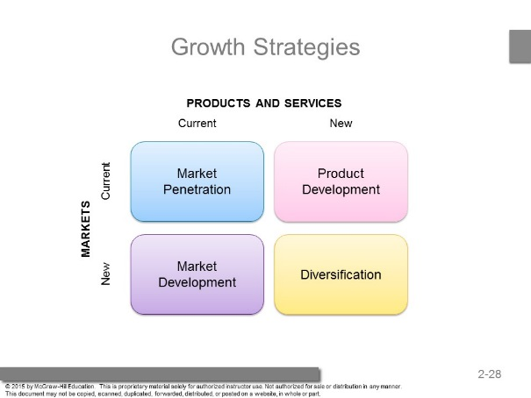 | The growth strategies model is crucial for students to understand.  Fundamentally, all strategies involve one or a combination of the four factors pictured in this slide. Each can be used to achieve different objectives.
- Market Penetration  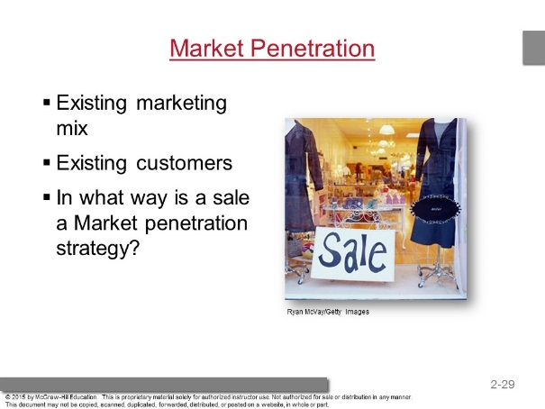 | Sales encourage current users to consume more of the current product mix, but they also bring new customers to the business.  Many strategies can be used to get current consumers to consume more of your product.  The web link is for a YouTube ad where Heinz asked customers to make videos and submit for the uses of Heinz.  This is one of many ads that were submitted. (Reminder - always check YouTube links before class).  Group activity: Ask students to brainstorm ways in which firms can get current consumers to consume more.  Example solutions might include coupons, loyalty cards, or serving size changes.
- Market Development Strategy  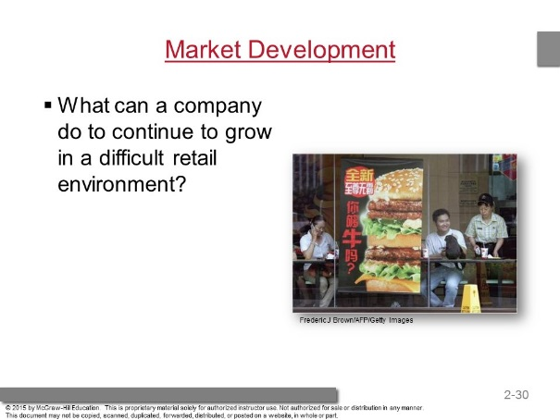 | This might include targeting growing ethnic groups in the U.S. or global expansion, which is a popular way for many firms to improve their profitability.  Ask international students, if you have them in your class, what types of products and brands are entering their markets?
- Product Development  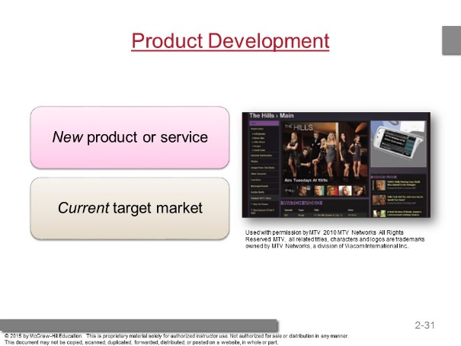 | A product development strategy requires that the firm understands its current consumers’ needs/wants well enough to identify other products/services that would be attractive to them.  Ask students for examples of products that are targeted to them by companies who already have their business. They will no doubt mention many food products including drinks, candy and fast food.
- Game On – Clash of the Video Games  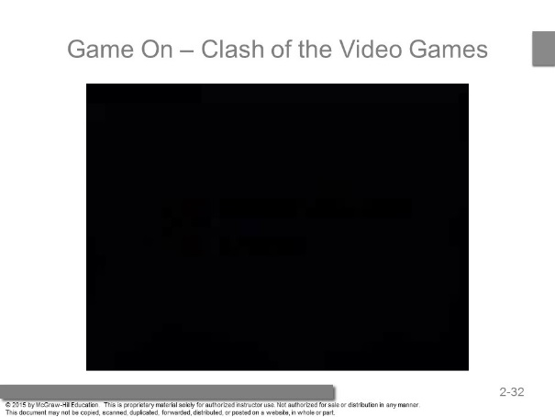 | This clip focuses on marketing the “next best thing” in the gaming industry.  Focuses on battling for the gaming market share and influencing spending of discretionary income.  Note: Please make sure that the video file is located in the same folder as the PowerPoint slides.
- Diversification  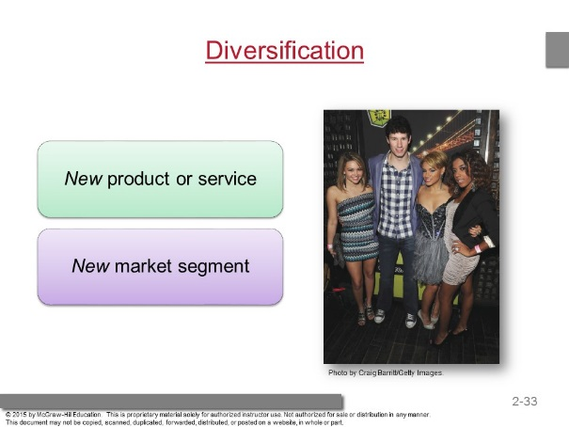 | A diversification strategy introduces a new product or service to a market segment that currently is not served.  Diversification opportunities may be either related or unrelated. In a related diversification opportunity, the current target market and/or marketing mix shares something in common with the new opportunity.  In other words, the firm might be able to purchase from existing vendors, use the same distribution and/or management information system, or advertise in the same newspapers to target markets that are similar to their current consumers.  In contrast, in an unrelated diversification, the new business lacks any common elements with the present business.
- Check Yourself  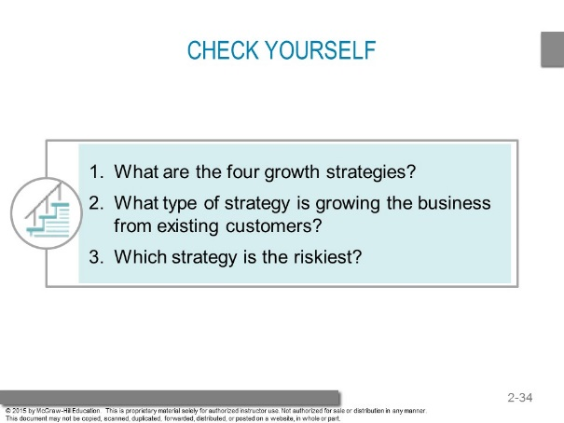 | - Market penetration, market development, product development, diversification  - Product development and market penetration  - Diversification

Answers To End Of Chapter Learning Aids

Marketing Applications

- How have Nike and Adidas created sustainable competitive advantages for themselves?

Nike and Adidas have created sustainable competitive advantages for themselves by building brand awareness through strategic sponsorships, unique advertising campaigns, and efficient operations.

- Perform a SWOT analysis for the company that made your favorite shoes.

Students’ answers will vary. Each answer should include strengths and weaknesses that are internal to the shoe manufacturer and opportunities and threats that are external to the manufacturer. Strengths for shoes might include: brand reputation, technology, fit. Weaknesses might include: lack of innovation, poor promotions, etc. Opportunities might revolve around new markets, global expansion, and trends in footwear. Threats might come from competitors, the economy, etc.

- How does Adidas segment its market? Describe the primary target markets for Adidas. How does it position its various offerings so that it appeals to these different target markets?

Adidas segments its markets based on product type and strategic business unit (SBU). For example, Adidas is divided into multiple SBU’s including: soccer, running, basketball, and tennis. Within each of these SBU’s is a primary target market. The primary target market will consist of heavy, recreational users of the product category. Adidas positions its products within each of its SBU’s to compete on price, but Adidas also positions itself as a performance brand.

- How does Hertz add value for business customers through the implementation of the four Ps?

Hertz positions itself as a quality car and truck rental company that is top of mind for its target segments. One of Hertz’s primary market segments is business customers. Hertz uses the four P’s to create value for its business customers:

- Product: Hertz uses its Prestige Collection, which features the Cadillac Escalade and Infiniti QX56, to target business customers.

- Price: Hertz offers business customers special deals and discounts for business travel. In addition, business customers can sign up for Hertz’s loyalty rewards program for further discounts.

- Promotion: Hertz uses marketing communications to tell their business customers that Hertz will help them enjoy their journey and reduce their travel time.

- Place: Hertz makes it easy for business customers to rent cars on business travel. Business customers are allowed to go through a separate line, or often bypass the lines altogether, to be on their way faster.

- Dyson successfully sells its fans and heaters for $150 to $400, whereas most fans sell for $20. Explain what is the value it creates, and how this affects the price it can charge.

Dyson fans and fan heaters draw in and redirect surrounding air without potentially dangerous or fast spinning blades or visible heating elements. These sculpturally beautiful appliances are perceived by consumers to be a valuable alternative to products that haven’t significantly changed since the early 1900s.

- Of the four growth strategies described in the chapter, which is the most risky? Which is the easiest to implement? Why?

Of the four growth strategies, diversification is the most risky because it involves significant reallocation of resources. Diversification requires firms to invest in both new products and new markets. Market penetration is probably the easiest to implement because it requires initiatives to get more of your current customers to purchase more of your current products. Programs that offer sales, discounts, two-for-one, or BOGO specials can assist in a market penetration strategy.

- Choose three companies. You believe the first builds customer value through product excellence, the second through operational excellence, and the third through customer excellence. Justify your answer.

Customer excellence is achieved when a firm develops value-based strategies for retaining loyal customers and provides outstanding customer service. Students may provide examples of local firms or larger firms such as Nordstrom’s, Amazon.com, Zappos.com, and Ritz Carlton. Firms that have a competitive advantage through product excellence have products with high perceived value and effective branding and positioning. Students might choose companies like Coca-Cola, Nike, and Apple. Operational excellence occurs through efficient operations and excellent supply chain and human resource management. Companies with operational excellence include Dell, Toyota, and Walmart. Students should justify their answers.

- You are on the job market and have received offers from three very different firms. Develop a marketing plan to help market yourself to prospective employers.

Answers will vary based upon the three companies the student would select. The student should include details in each of the following areas:

1. Executive summary.
2. Company overview.
3. Objectives or goals.
4. Situation analysis.
5. Market/product/customer analysis.
6. Marketing strategy.
7. Financial projections.
8. Implementation plan.
9. Evaluation and control metrics.

Quiz Yourself

- Even when large discount retailers enter a market, a few small, local retailers survive and prosper. These small retailers have probably developed a(n) ________ that allows them to survive.

A. advertising campaign
B. plan to evaluate results
C. sustainable competitive advantage
D. set of performance metrics
E. SWOT analysis

The other items listed could help the retailers to develop or evaluate a plan to achieve a sustainable competitive advantage, but on their own they will not be enough. Small retailers usually cannot compete with larger competitors on price. But they might survive by offering services their customers value (and are willing to pay extra to get), by offering specialty products not carried by larger retailers, or by locating in places where the larger stores don't want to (or can't) locate.

- Many of today's college graduates will make their livings providing goods and services to "baby boomers," the large group of Americans born in the period after World War II. Baby boomers are a _________________ market segment.

A. psychological
B. behavioral
C. social
D. product-based
E. demographic

This segment is being formed using age, a demographic factor.

Net Savvy

- The mission statement for Quaker Oats cites its origins, “inspired by the power and wholesome goodness of the amazing oat.” Frito-Lay looks a little more to the present, citing its mission “To be the world’s favorite snack and always within arm’s reach.” These different perspectives also reflect the quite different positioning adopted by each company. Visit the websites of each and review the descriptions of the company, its mission, and its values. Now consider what it means when you learn that both brands are owned by PepsiCo. What is PepsiCo’s mission statement? Do you believe these two disparate mission statements reflect what the firms do and who they are portrayed in the media? Justify your answer.

PepsiCo’s mission statement is, “Our mission is to be the world's premier consumer products company focused on convenient foods and beverages. We seek to produce financial rewards to investors as we provide opportunities for growth and enrichment to our employees, our business partners and the communities in which we operate. And in everything we do, we strive for honesty, fairness and integrity.”

Students should discuss the difference between the two mission statements and how they relate to PepsiCo’s mission statement. How do both Frito Lay and Quaker Oats live up to PepsiCo’s mission statement? Are they aligned or misaligned?

- More and more firms seem to be entering the dating service industry. Visit www.eharmony.com and tour its website to find the types of activities and methods such companies use to help match compatible couples. Then visit www.match.com and do the same. What are the similarities and differences of these two online dating services? Pick one and perform a SWOT analysis for it.

Students can apply what they have learned to a novel service area they might not have considered before. To obtain an understanding of how a company like eHarmony attempts to match singles, students must consider what factors affect online dating services in the guise of a SWOT analysis.

 | Positive | Negative
Internal | Strengths  - At-home convenience factor  - Multiple matching criteria  - Low client risk | Weaknesses  - No guarantee that matches will be good or safe  - Requires client subscription to enable communication between matches
External | Opportunities  - Use matching criteria for couples to provide inexpensive counseling  - International expansion | Threats  - Many no-charge opportunities for singles to meet, online or off  - Potential for sexual predators to use the service negatively

- Black and Decker (www.blackanddecker.com) and DeWalt (www.dewalt.com) are owned by the same parent company, and both sell similar products. Visit each of their websites and identify what markets each brand targets. Next, discuss how the two companies use the marketing mix differently to target these unique target markets.

Strategy | DeWalt | Black & Decker
Target Market | Professional User | Homeowner/DIYer
Product | Professional Use | Occasional Use
Pricing | Premium | Value
Place | ACE Hardware, Contractor Supply, etc. | Home Depot, Target, etc.
Promotion | Field Marketing | National T.V. Advertising  Merchandising

Case Study: The Great Yogurt Battle

- Perform a SWOT analysis for each of the companies mentioned in this case study. How are the results similar? How do they differ?

SWOT analysis: Pinkberry

 | Positive | Negative
Internal | Strengths  - Contains probiotics | Weaknesses  - Limited number of seasonal exotic flavors
External | Opportunities  - Frozen yogurt is a growing part of the $25 billion frozen dessert market | Threats  - Successful competitors

SWOT analysis: TCBY

 | Positive | Negative
Internal | Strengths  - Customers enjoy self-service | Weaknesses  - Higher per-serving cost
External | Opportunities  - Frozen yogurt is a growing part of the $25 billion frozen dessert market | Threats  - Successful competitors

SWOT analysis: Red Mango

 | Positive | Negative
Internal | Strengths  - Store design  - New Greek-style yogurt | Weaknesses  - Limited locations
External | Opportunities  - Frozen yogurt is a growing part of the $25 billion frozen dessert market | Threats  - Successful competitors

- Which growth strategies seem most likely for each of the companies mentioned in this case? Why?

Pinkberry: Pinkberry stresses health and style and this is a growing market. It can continue this growth by using a market penetration strategy.

TCBY: TCBY gives customers more choices and more control over portions. However, it has the highest costs. It may be able to use a product development strategy to have offerings that are more profitable.

Red Mango: Red Mango targets young college consumers and can add more markets by using a market development strategy.

- What sorts of marketing metrics would be most helpful for a brand manager of a frozen yogurt chain?

Student will answer with different metrics. Here are some of the things they need to consider. Some commonly used metrics to assess performance include revenues, or sales, and profits. An attempt to maximize one metric may therefore lower another. Thus, managers must under-stand how their actions affect multiple performance metrics. The metrics used to evaluate a firm vary depending on (1) the level of the organization at which the decision is made and (2) the resources the manager controls.

Additional Teaching Tips

In this chapter, the goal is to introduce students to an overview of the marketing plan, the concept of customer value, and the utility of the SWOT matrix. It is important to teach students that the importance of the marketing plan is to communicate the value proposition to consumers and to provide direction on how that will be achieved.

The utility of the marketing plan must be conveyed throughout the course. Teach students that the marketing plan is a subset of the business plan that forms the foundational strategy of business. Students come to realize the importance of the marketing plan when the instructor frequently makes connection to its purpose not only on the day the concept is taught but also throughout the course.

Customer value is a difficult concept for students to grasp. Instructors may want to ask students to write down something they find of value and what aspects lead to creating that value. The instructor can then ask what they would trade for that value. It is important that instructors communicate that value is more than monetary worth and can’t easily be measured. As a result, marketers must conduct target market research in order to create the value proposition of their marketing strategy.

The SWOT matrix may be easily demonstrated by dividing your class into groups and having each group contribute one item to each of the four quadrants using the college they are attending (common ground for all students) or a major chain food (such as McDonald’s) so that all students are familiar with strengths, weaknesses, opportunities, and threats that may apply. Students can work as a group and then each group may put their items on the white boar to form a collective classroom SWOT. Instructors should then make the link that the opportunities and strengths should filter into the marketing message delivered in advertising campaigns and other marketing tools. Online tip: Instructors may want to divide their class by last name A-E Strengths, F-J Weaknesses, and so forth to answer a discussion board question using the same concept. Students could then complete an individual SWOT as an assignment. Another option would be to use the same concepts and integrate it as an online team assignment where each team forms their respective completed SWOT.

Remember to review the Newsletter for Instructors and its accompanied PowerPoint presentation, which integrates examples and discussion from the newsletter. Each newsletter contains over ten article abstracts on hot topics, plus a selection of current commercials and videos for you to use with your class. The newsletter also includes a guide that explains where the articles, commercials, and videos best fit in your Marketing course.

