# Chapter 2: Quality Theory

***Chapter Outline***

* Quality Theory
  + - What is Theory?
    - Leading Contributors to Quality Theory
      * W. Edward Deming
      * Joseph M. Duran
      * Kaoru Ishikawa
      * Armand Feigenbaum
      * Philip Crosby
      * Genichi Taguchi
      * The Rest of the Pack
    - Viewing Quality from a Contingency Perspective
    - Resolving the Differences in Quality Approaches: An Integrative Approach

## Overview

When the author discusses theory, he is not being philosophical; rather he discusses the major “players” and their contributions to the subject. On page 26, the point is made that “there is not a unified theory explaining quality improvement.” The author also makes a statement that quality improvement is positively linked to employee morale. He links quality improvement to the classic Theory X approach to management (and Theory Z for that matter).



# *Discussion Questions*

1. Define theory. Why are theories important for managing quality in the supply chain?

The author states that in order for a theory to be complete, it has to answer these questions:

* What?
* How?
* Why?
* Who?
* Where?
* When?

How does *practice* relate *to theory*? You might also ask how this relates to the classic definition of theory that we have studied in other disciplines.

The model the text presents is illustrated in Figure 2-1. A positive correlation is presented between Quality Improvement and Worker Morale. To verify the model, we conduct statistical research. This will either prove or disprove the theory.

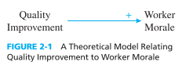

**2. Describe the differences between induction and deduction. If you developed a theory based solely on your experiences of quality practices in business organizations, would you be basing your theory on induction or deduction? Why**?

On page 25, the text discusses a Morale Check at a Chicago-based company just after the Cubs won the World Series. Morale is found to be positive. Students must decide: is this inductive or deductive? What are examples of inductive and deductive theory from the class’s perspective. If one looks at the classic theories – Evolution, Relatively, Theory X, Y, and Z – are they individually inductive or deductive?

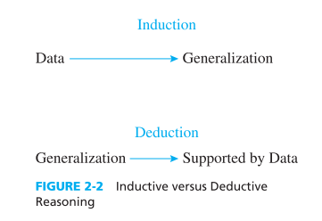

If the theory is generated by observation and experience, the theory is inductive. If the theory is developed through the Scientific method, it is deductive. Does the fact that in the case the Cubs just won the World Series apply? Does this make the theory deductive or inductive?

3. Do you believe that the development of a unified theory of quality management is possible? What is a unified theory?

On page 26, “A Closer Look at Quality - The Product That is Quality” looks at the different approaches to quality. As you discuss the key players, this might be a good question to keep going on the side.

Einstein spent most of his later life searching for a unified theory in physics. He failed. Do unified theories exist in any discipline? What would the implications be if there was a unified theory for quality management? If you contrast the approaches of the major players, do they all take the same approach? Does the fact that we are dealing with people affect this situation?

4. Why do managers need to be cautious about purchasing material (e.g., courses, workbooks, videos, and so on) on quality management from trainers and consultants? How would you go about selecting this type of material?

In the quoted article, *The Product That is Quality*, the statement is made that, “Within each approach, corporate managers are confronted by a numbing maze of acronyms and buzzwords. There is TQC, TQM, fishbone diagramming, cause and effect, poka yoke, big Q, and little q.” An entire industry has sprung up just to provide material to support quality initiatives. The Juran Institute sells a $15,000 do-it-yourself kit complete with 16 videotapes, 10 workbooks, a leader’s manual, overhead transparencies, and a five-day course to teach someone how to run the tapes.

Harvard’s Garvin observes that all of the Baldrige Award winners had developed their own approach to quality. The most effective way to develop a solid quality approach is to have it developed in-house.

5. Briefly describe the contributions W. Edwards Deming made to the field of quality management. Why do you believe he is the most influential quality expert?

Deming outlined 14 points for management:

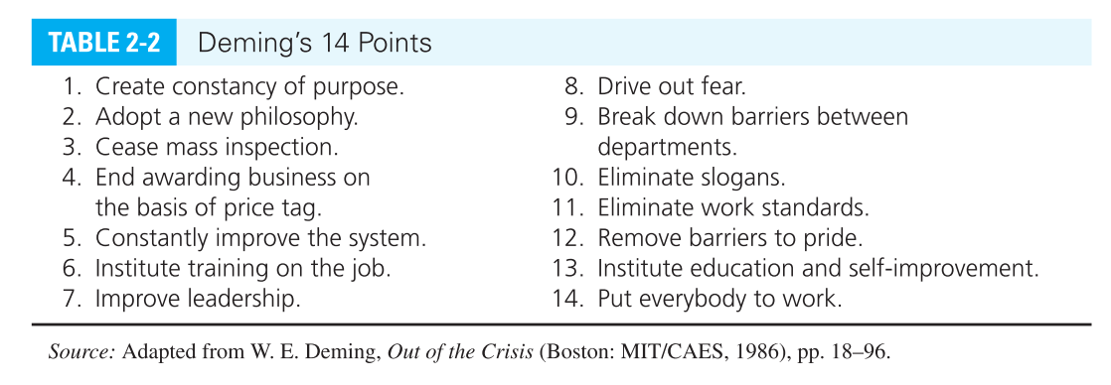

In the 1950s, Japanese-made products were frequently called inferior, tinny, and shoddy. Today, names such as Toyota and Sony are equated with high-quality manufacturing.

Deming stressed that consumers are well served by insisting that service and product providers deliver high quality. He believed that the more consumers demand high-quality products and services, the more firms will continually aspire to higher levels of performance. As opposed to 20 years ago, consumers now expect high-quality products at a reasonable cost.

6. Deming believed poor quality was not the fault of workers but resulted from poor management of the system for quality improvement. Do you agree with Deming’s stand on this issue? Why or why not?

Answers here will vary. Some things to consider: Deming raises the topic of “continual, never-ending improvement.” How does this place the responsibility for quality on the shoulders of management? What does this philosophy say about Deming’s general approach to management? A key motivator in our culture is looking for the source of the problem. Deming places the problem in management’s lap.

How do today’s management philosophies either support or deny this approach? Think about Theory X and Y. Research Ouchi’s Theory Z. Also consider Maslow’s hierarchy of needs. Is there commonality in these philosophies?

7. Deming was not an advocate of mass inspection as a means of ensuring product quality. Please explain Deming’s beliefs in this area.

Taken out of context, the statement is curious. However, from page 29, we read: “Eliminate the need for inspection on a mass basis by building quality into the product in the first place.”

Is Deming discussing the place that quality must have in the general context of the process? Is quality a feature that you add on at the end of the process? How revolutionary is this statement? How does the popular literature about management address this attitude? If you tie this back to the discussion of Jack Welch in Chapter 1, the importance of visionary leadership is identified. Goldratt[1] discusses the theory of constraints. He says that constraints, or bottlenecks, affect the flow of product through the system. Can quality be a constraint?

**8. Select one of Deming’s 14 points for management and describe how this point could have resulted in quality improvements in a business or volunteer organization with which you have been involved.**

Every successful manager can point to failures in his or her past. The difference between a successful manager and an unsuccessful manager is how he or she reacts to those failures. Although this concept is seldom discussed, writers like Deming and Juran are sharing the remedies, either made or observed, to past failures.

The success of these writers is based upon the fact that they can help the new manager avoid the common, but not obvious, pitfalls. Any person who has had a position of authority should be able to read Deming’s list and identify a mistake that was made relating to each one. This should prove to be a fascinating classroom session, especially if the professor joins in the discussion and adds his or her own experiences.

**9. Briefly describe the contributions that Joseph M. Juran made to the field of quality management. What do you believe was Juran’s most significant contribution?**

Juran discusses three processes: planning, control, and improvement. He states that these processes are sequential: first planning, then control, and then improvement. Juran’s emphasis is on continued improvement – control, not breakthrough. Juran uses Pareto’s law, the 80%/20% rule, to identify the quality problems.

**10. Is the concept of scientific management compatible with employee empowerment? Why or why not?**

Frederick W. Taylor launched scientific management. It separated planning from execution. Taylor gave the planning function to managers and engineers. He limited supervisors and workers to the function of executing the plans. The result of the “Taylor Revolution” was centralizing the quality function. How does this approach fit within the framework established by Deming? Taylor published his treatise in 1911. How has the culture of the workplace evolved since then?

**11. Does the phrase “quality is the responsibility of the quality department” reflect a healthy perspective of quality management? Please explain your answer.**

This revolves around the question, “Whose job is quality?” By centralizing quality, Taylor removed it from the day-to-day operation of the company. As the topic of quality is removed from the production floor, what is management’s response going to be? If we look back at Juran, is this now a control or a breakthrough function? Why?

Taylor notes that by delegating quality to the quality manager, the line supervisors and managers could devote their own time to other matters. As they did so, they became progressively less and less informed about quality. When a quality problem developed, management lacked the expertise needed to choose a proper course of action.

**12. Briefly describe the Japanese quality revolution following World War II. What can modern day managers learn from studying the history of this era?**

After the war, the industrial leaders in Japan turned their attention toward improving the quality of Japanese manufactured goods. The quality revolution in Japan was initiated through the following steps:

* They sent teams abroad to learn how foreign countries achieved quality.
* They translated foreign literature into Japanese.
* They invited Deming to lecture in Japan and listened carefully to Deming's views on quality.

To the credit of the Japanese people, they implemented what they learned about quality management, and in many cases, eventually improved on what they learned. The result was a virtual quality revolution in Japan in the years following World War II.

**13. What was Joseph Juran’s primary contribution to quality thinking in America? Discuss Juran’s three-step process to improving quality.**

Juran’s three-step process was:

* Planning
* Control
* Improvement

This three-step process emphasized control over breakthrough. This was a major step towards ongoing quality improvement, rather than mass inspections. This approach moved the process of quality to the lowest possible level.

**14. *Hothouse quality* refers to those quality programs that receive a lot of hoopla and no follow-through. Provide several examples of management practices that can lead to hothouse quality. How can hothouse quality be avoided?**

Management practices that are focused on achieving short-term objectives and/or immediate results are susceptible to hothouse quality. Hothouse quality programs often promise dramatic increases in performance over a relatively short period of time.

Consistently productive decision makers typically see this as an unrealistic goal, and avoid these types of programs. Less successful decision makers and decision makers desperate to see quality improvement quickly may be more prone to investigate these programs.

**15. Compare and contrast Deming’s, Juran’s, and Crosby’s perspectives of quality management. What are the major similarities and differences between their perspectives?**

Deming addressed the entire process and focused primarily on the assertion that poor quality is not the fault of the worker, but is the fault of the system. Deming also strongly opposed the creation of quality inspection departments. He felt that quality should not be the responsibility of the quality inspection departments. It should be built into the product.

Juran's work focuses on the idea that organizational quality problems are largely the result of insufficient and ineffective planning for quality. In addition, Juran fleshed out many of the implementation issues involved with quality through his trilogy.

Crosby made two key points in his arguments about the responsibility of the quality department, and not the individual worker. Crosby has enjoyed the most commercial success of the three. First, he argued that quality, as a managed process, could be a source of profit for an organization. Second, Crosby adopted a "zero defects" approach to quality management, and emphasized the behavioral and motivational aspects of quality improvement rather than statistical approaches.

Similarities: All three men were very passionate about the role of quality in business organizations, and felt that quality is a process that must be deliberately managed. In addition, all three of them saw quality as the focal point for organizational performance and effectiveness.

Differences: Deming and Juran were more statistically oriented in their approach than Crosby. The each emphasized different aspects of quality management in their approaches. Crosby's zero defects approach probably goes further than would be advocated by Deming or Juran. Crosby was also more prolific than Deming and Juran in terms of the production of quality-related materials (e.g., videos, workbooks, lecture series, etc.).

**16. Describe Taguchi’s perspective of ideal quality. Does this perspective have practical applications? If you were a manager, would you consider using the Taguchi method? Why?**

Table 2-4 on page 37 provides an overview of the Taguchi method.



Taguchi accomplishes these steps by emphasizing a three-fold approach to quality:

The definition of quality

The quality loss function

The concept of robust design

A key element of the Taguchi concept is that of robust design. This states that products and services should be designed so that they are inherently defect-free and of high quality. Taguchi sets his target high. The overall effect of this is desirable and accomplishable.

**17. Why do you think that reengineering programs have such a high failure rate? Can you think of ways to improve the success rate of reengineering programs?**

Reengineering bypasses the analysis and design steps and tries to piggyback on the past successes of others. Reengineering programs have experienced a high failure rate primarily because they tend to oversimplify extremely complex organizational issues, and as a result, do not focus managers on the attention to detail and analysis that is necessary to effect meaningful (and effective) organizational change. Reengineering programs would probably be more successful if they were combined with more traditional and well-founded approaches to effective organizational change.

**18. Describe how the contingency perspective helps us understand why a single approach to quality management may never emerge.**

The text states that firms that are successful in quality do not adopt a blanket “Deming approach to quality.” These firms utilize the applicable approaches that help them improve. The author discusses this as the *contingency perspective*.

The direction is that different quality problems mandate different quality improvement approaches. On page 40, the author states: *From your own perspective, you need to make correct quality-related decisions. In doing this, you should consider the different quality experts in this chapter and choose those concepts and approaches that make sense for you*.

**19. How can a philosophy of quality improvement help a firm in its overall efforts of improving the quality of its products and services?**

The one common element of all theseapproaches is that quality cannot be an adjunct to the process. Quality must be an integral part of the development. For this to happen, a philosophy of quality improvement must be ingrained into the corporate culture. The point is made that quality starts in the design phase and continues through the product manufacture

Any major change to a corporate culture must have full support from top management. Quality is not any different.

**20. Do you believe that CEOs and business managers should be skeptical about the quality movement, or should they embrace the quality movement and try to involve their firms in as many quality initiatives as possible? Please explain your answer**.

The key to this question may be the phrase "as many quality initiatives as possible." Any project requires planning. The more of an effect a project will have on a firm, the more careful the planning must be. Integrating a quality program is no exception. Every part of the firm is affected. Poor planning can be disastrous.

***Case 2-1: Rheaco, Inc.: Making a Quality Turnabout byAsking for Advice***

***Discussion Questions:***

1. Many companies fail in their efforts to improve quality without ever having asked for advice. In your opinion, what are some of the reasons that inhibit firms from asking for timely advice? If you were a manager at Rheaco, would you have sought out an agency like the ARRI?

Many companies get into “fire fighting mode.” They are so busy solving immediate problems that no one has time to dig into the cause of the problems.

Many of Deming’s 14 points speak to this problem:



Adopting a new philosophy (point 2), driving out fear (point 8), and remove barriers to pride (point 12), all seem to be based on point 7, improve leadership. The problem is that sometimes leadership does not realize that they are the roadblocks.

Firms can be insulated. Cultures can be stagnant. One solution is ensuring that management participates in professional organizations. Another solution might be encouraging employees to continue their education and bring in ideas from their classes. A firm such as ARRI can be in the vanguard of conceptual development. The major problem is finding out that they exist.

**2. Discuss ARRI’s recommendations to Rheaco. How did these recommendations help Rheaco improve its product quality?**

First, AARI helped Rheaco develop an Enterprise Excellence Plan, which acted as a roadmap for Rheaco's improvement efforts. Consistent with this effort, AARI helped Rheaco implement several standard quality improvement programs, including cellular manufacturing, just-in-time inventory control, total quality management, and employee empowerment. Through this process, AARI worked in partnership with Rheaco to implement the recommended initiatives and to gradually turn over the change process to Rheaco itself. Other improvements were made, particularly in the areas of shipping and receiving, inventory control, and human resource management. Collectively, these changes had a profound influence on Rheaco's ability to improve its product quality.

A key statement is made on page 46: *After ARRI had been working with Rheaco for a period of time, the company started identifying and correcting problem on its own, which is exactly what is supposed to happen.*

#### People want to succeed. In an environment where success is rewarded, people will thrive and bring the company along with them.

**3. ARRI’s initial evaluation of Rheaco indicated that Rheaco’s employees, despite the company’s difficulties, had an overall positive attitude. Do you believe that this factor contributed to ARRI’s ability to provide Rheaco advice? Why or why not?**

Most students will say that the attitude of Rheaco's employees was a significant factor in AARI's ability to provide Rheaco advice. As discussed in Chapter 1, it is impossible to implement quality without the commitment and action of employees. Because Rheaco's employees had a positive attitude, the company started its quality improvement efforts with one major obstacle already overcome. It would have been much more difficult for Rheaco to accomplish what it did if it would have had to first convince its employees that it was doing the right thing.

However, it is important to understand why the employees’ morale was positive in the first place? How does management style enter into this? Could this enterprise have been possible if management did not establish a positive environment? Figure 2.6 on page 44 identifies the role of leadership. In this diagram, everything revolves around leadership.

***Case 2-2: Has Disney Developed a Theory of Quality Guest Services Management?***

***Discussion Questions:***

**1. Is Disney’s level of emphasis on anticipating the behavior of its guests appropriate, or does the company expend too much effort in this area? Explain your answer.**

Before Disneyland, carnivals had a reputation as being seedy and unscrupulous. Walt Disney saw the need for a family-friendly wholesome theme park. In fact, Disneyland was the very first theme park. The success of Disneyland and Disneyworld justifies the process.

All successful theme parks have followed the Disney model. Deming’s 14 points continuously emphasizes the value of customer satisfaction. The guest is the customer.

**2. Is it appropriate to think in terms of developing a “theory” of how guests will behave in a theme park or any other setting? If so, why?**

On page 26 the text discusses this topic thusly:

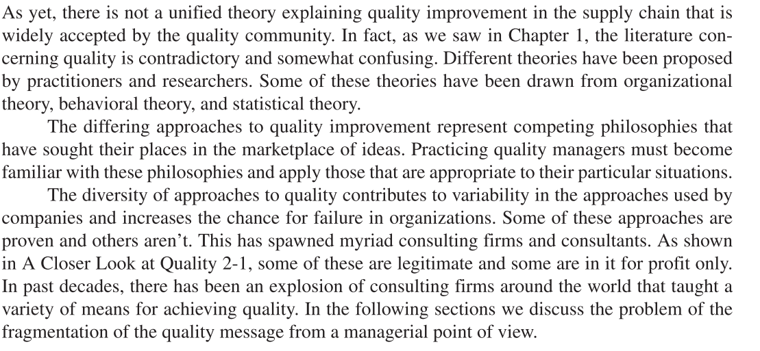

The text goes on to discuss this topic in A Closer Look At Quality 2-1:

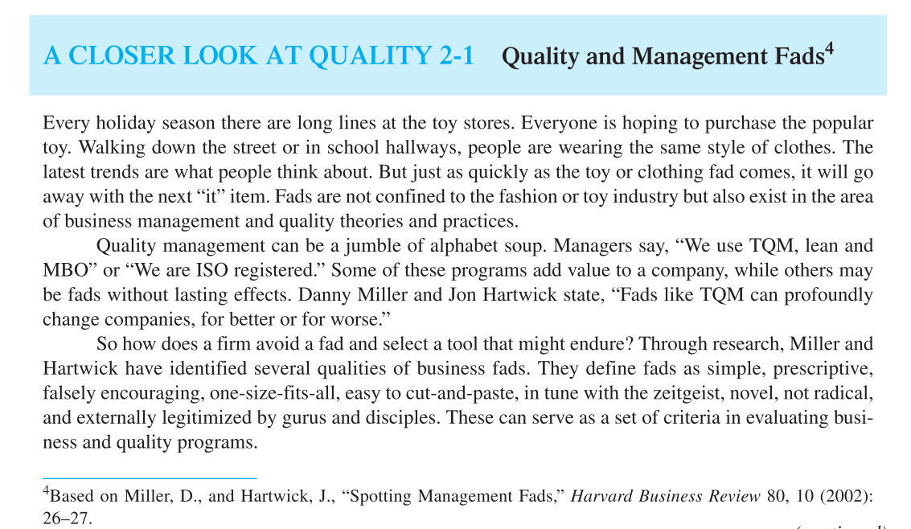

Is there a difference between the way theme parks anticipate their guests’ behavior and the way a supermarket arranges their shelving display to optimize sales?

**3. Think about the last time that you visited a theme park. Were your expectations met? Did you have a sense that the operator of the park attempts to “anticipate” the behavior of the guests? If so, provide some specific examples.**

This question can best be answered on a personal basis. What experiences did the class have at theme parks? Theme parks are not inexpensive places. Was the general consensus that value was there? Will they return? Who is the audience that the theme park targets: parents, children, or subsections of the population?

An interesting aspect is the question: Why was Disneyland, Paris not as successful as other Disney efforts?

1. http://www.goldratt.com/