CHAPTER 2

DEMAND, SUPPLY, AND EQUILIBRIUM ANALYSIS

1. MARKET ANALYSIS
2. MARKET DEMAND

Demand Schedule and Demand Curve

Changes in Demand

1. MARKET SUPLY

Supply Schedule and Supply Curve

Changes in Supply

1. WHEN IS A MARKET IN EQUILIBRIUM

Case Study 2-1: Equilibrium Price by Auction Theories of Profit

1. ADJUSTMENT TO CHANGES IN DEMAND AND SUPPLY: COMPARATIVE STATIC ANALYSIS

Adjustment to Changes in Demand

Adjustment to Changes in Supply

Case Study 2-2: Changes in Demand and Supply and Coffee Prices

1. DOMESTIC DEMAND AND SUPPLY, IMPORTS, AND PRICES

Case Study 2-3: The Large US Automotive Trade Deficit Keeps US Auto Prices Down

1. INTERFERING WITH VERSUS WORKING THROUGH THE MARKET

Case Study 2-4: Rent Control—The Best Way to Destroy New York City!

Case Study 2-5: Is the US Farm Support Program on the Way Out?

Case Study 2-6: Working Through the Market with an Excise Tax

Case Study 2-7: Fighting the Drug War by Reducing Demand and Supply

Box 2 – Managerial Economics at Work: Nonclearing Financial and Other Markets

SUMMARY

DISCUSSION QUESTIONS

PROBLEMS

SPREADSHEET PROBLEMS

APPENDIX TO CHAPTER 2: The Algebra of Demand, Supply, and Equilibrium

Market Equilibrium Algebraically

Shifts in Demand and Supply, and Equilibrium

The Effect of an Excise Tax

APENDIX PROBLEMS

SUPPLEMENTARY READINGS

KEY TERMS (in the order of their appearance)

|  |  |
| --- | --- |
|  |  |
| Market | Auction |
| Perfectly competitive market | Comparative static analysis |
| Market demand schedule | Excess demand |
| Law of demand | Excess supply |
| Market demand curve | Price ceiling |
| Market supply schedule | Price floor |
| Market supply schedule | Excise tax |
| Equilibrium price | Incidence of a tax |
| Surplus | Import tariff |
| Shortage | Nonclearing market |

ANSWERS TO DISCUSSION QUESTIONS

1. The demand for a commodity increases (i.e., shifts to the right) with an increase in consumers’ incomes, with an increase in the price of substitute commodities, and with an increase in the number of consumers in the market. An increase in the price of complementary commodities will reduce the demand for the commodity.
2. A fall in the price of a commodity, holding everything else constant, results and is referred to as an increase in the quantity demanded.
3. When an individual’s income rises, while holding everything else the same, that person’s demand for a normal good increases or shifts to the right, so that the individual will demand more of the good at each price of the good.
4. If the supply curve is positively sloped, a rise in the price of the commodity leads to an increase in the quantity of the commodity.  
   1. An improvement in technology shifts the supply curve to the right.
   2. An increase in input prices shifts the supply curve to the left.
   3. If both occur, the supply curve will shift to the right or to the left depending on the relative strength of the two opposing forces.
5. At Q=4, the price of $1.50 that consumers are willing to pay for the commodity (point C on the D curve) exceeds the price of $0.75 that producers require to supply 4 units of the commodity (point N on the S curve). As a result, producers will expand output to the equilibrium level of Q=6 (point E on the D and S curves), which is exactly equal to the quantity of the commodity that consumers are willing to purchase at P=$1.00.
6. At Q=8, the price of $1.25 that producers require to supply 8 units of the commodity (point K on the S curve) exceeds the price of $0.50 that consumers are willing to pay for the commodity (point G on the D curve). As a result, producers will reduce output to the equilibrium level of Q=6 (point E on the D and S curves), which is exactly equal to the quantity of the commodity that consumers are willing to purchase at P=$1.00.
7. An increase in both demand and supply leads to an increase in quantity, but the price can rise, fall, or remain unchanged depending on the size of the relative shift in the demand and supply curves.
8. At PT=$1.50, the United States would want to import 450 million yards of textiles, while the rest of the world would like to export 150 million yards (see Panel B of Figure 2-9). Thus, the price of textiles increases. As it does, quantity of textile imports demanded by the United States decreases while the quantity of textile exports supplied by the rest of the world increases until the equilibrium price of $2 is reached at which QD= QS.
9. The price of textiles in the United States will exceed the price of textiles abroad by the cost of transportation of $1 per yard. A smaller quantity of textiles will then be traded.
10. Even though trade restrictions lead to higher consumer prices, governments usually impose trade restrictions to protect domestic jobs in sectors in which the country is less efficient than foreign producers.  
    1. A price ceiling is effective only if it is below the equilibrium price. On the other hand, a price floor is effective only if it is above the equilibrium price.
    2. Rent control is an example of an effective price ceiling. Rent control laws resulted in a shortage of apartments and many other distortions in the housing.
11. One example of an effective price floor was the price support program in US agriculture. It resulted in huge farm surpluses and other distortions in US agriculture. The same is true for most other advanced nations.
12. It does not make any difference whether the tax is collected from buyers or sellers. The net after-tax price paid by buyers and the net after-tax price received by sellers are the same in either case.
13. The size of a prohibitive tariff in Figure 2-9 (in the absence of transportation costs) is $2 per year of textile imported. The reason is that the tariff of $2 per yard of imported textile makes the price of a year imported textile equal to the pretrade price of textiles in the United States, so that there is no reason to import foreign textiles (assuming that they are not of better quality).

ANSWERS TO PROBLEMS

1. By substituting P=$6 into the demand equation or function, we get QD = 60 - 10(6) = 0  
   By substituting P=$5 into the demand equation, we get QD = 60 - 10(5) = 10.  
     
   If P=$4, QD = 60 - 10(4) = 20.  
   If P=$3, QD = 60 - 10(3) = 30.  
   If P=$2, QD = 60 - 10(2) = 40.  
   If P=$1, QD = 60 - 10(1) = 50.  
   If P=$0, QD = 60 - 10(0) = 60.  
     
   The above values for the quantity demanded are those given by the demand schedule.

|  |  |  |  |  |  |  |  |  |  |
| --- | --- | --- | --- | --- | --- | --- | --- | --- | --- |
| *P($)* | 8 | 7 | 6 | 5 | 4 | 3 | 2 | 1 | 0 |
| *QD’* | 0 | 10 | 20 | 30 | 40 | 50 | 60 | 70 | 80 |

1. See Figure 1 bellow. D' represents an increase in demand because consumers demand more of the commodity at each and every price.

Figure 1

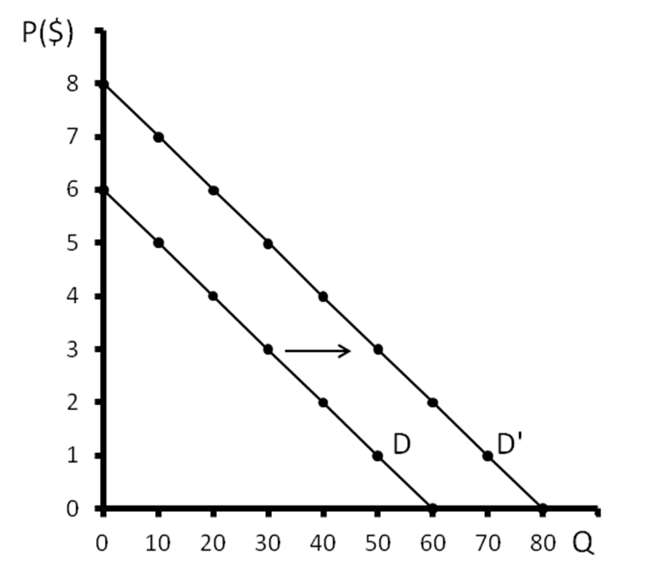

|  |  |  |  |  |  |  |  |
| --- | --- | --- | --- | --- | --- | --- | --- |
| *P($)* | 6 | 5 | 4 | 3 | 2 | 1 | 0 |
| *QS* | 60 | 50 | 40 | 30 | 20 | 10 | 0 |

|  |  |  |  |  |  |  |  |
| --- | --- | --- | --- | --- | --- | --- | --- |
| *P($)* | 6 | 5 | 4 | 3 | 2 | 1 | 0 |
| *QS* | 80 | 70 | 60 | 50 | 40 | 30 | 20 |

* 1. See Figure 2 bellow.

Figure 2

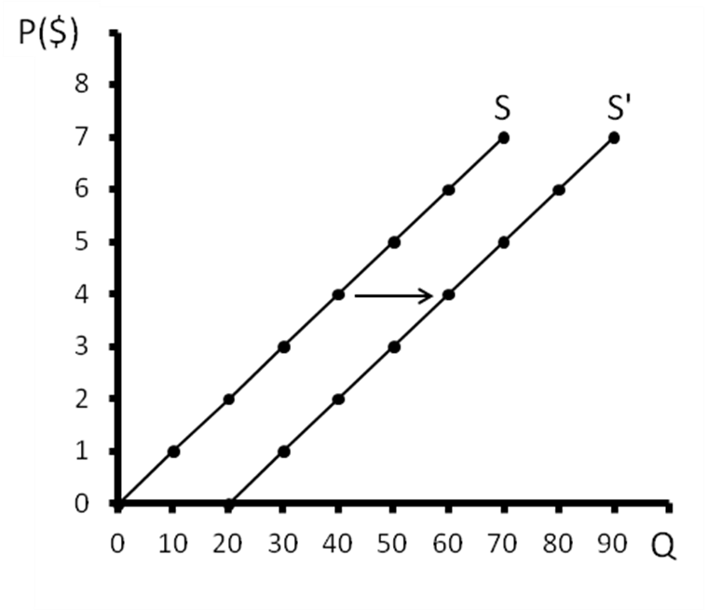

* 1. The shift from S to S' (an increase in supply) may result from an improvement in technology, a reduction in the price of resources going into the production of the commodity, or more favorable weather (for an agricultural commodity).
  2. Market Supply Schedule, Market Demand Schedule, and Equilibrium

|  |  |  |  |  |
| --- | --- | --- | --- | --- |
| Price | Quantity Supplied | Quantity Demanded | Surplus (+) or Shortage (-) | Pressure on Price |
| $6 | 60 | 0 | 60 | Down |
| 5 | 50 | 10 | 40 | Down |
| 4 | 40 | 20 | 20 | Down |
| 3 | 30 | 30 | 0 | Equilibrium |
| 2 | 20 | 40 | -20 | Up |
| 1 | 10 | 50 | -40 | Up |
| 0 | 0 | 60 | -60 | Up |

* 1. See Figure 3 bellow.

Figure 3

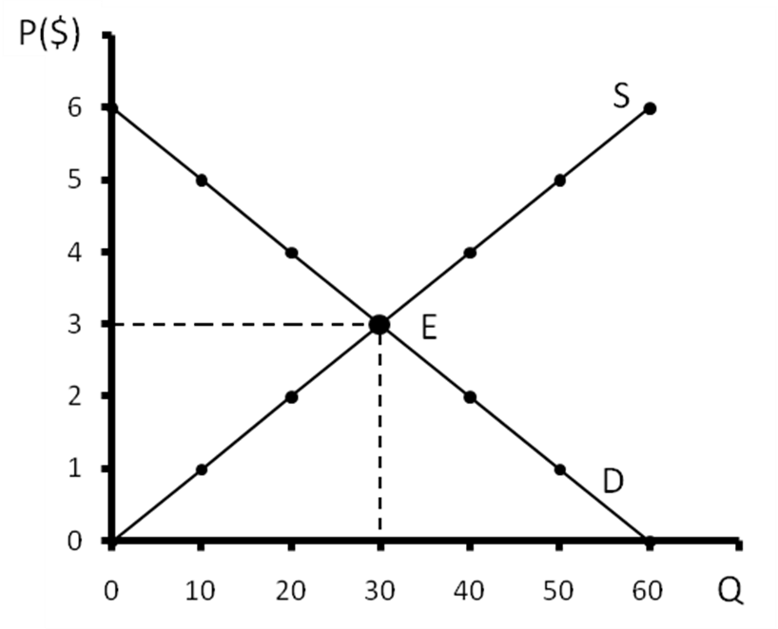

Setting QD equal to QS, we get the equilibrium price (P*).

|  |  |  |  |  |
| --- | --- | --- | --- | --- |
|  |  | QD | = | QS |
| 60 | - | 10P | = | 10P |
|  |  | |  | | --- | | 60 | | = | 20P |
|  |  | P* | = | 3 |

Substituting P*=3 into either the D or S function, we get the equilibrium quantity (Q*)

|  |  |  |  |  |  |  |  |  |  |  |  |  |  |  |  |  |  |  |  |  |  |  |  |  |  |  |  |  |  |  |  |  |  |
| --- | --- | --- | --- | --- | --- | --- | --- | --- | --- | --- | --- | --- | --- | --- | --- | --- | --- | --- | --- | --- | --- | --- | --- | --- | --- | --- | --- | --- | --- | --- | --- | --- | --- |
| |  |  |  |  |  | | --- | --- | --- | --- | --- | | QD | = | 60 | - | 10P* | | QD | = | 60 | - | 10(3) | | QD | = | 60 | - | 30 | | QD | = | 30 |  |  | | |  |  |  | | --- | --- | --- | | QS | = | 10P* | | QS | = | 10(30) | | QD | = | 30 | | QD | = | 30 | |
| Q*=30 | |

* 1. Market Supply Schedule, Market Demand Schedule, and Equilibrium

|  |  |  |  |  |
| --- | --- | --- | --- | --- |
| Price | Quantity Supplied | Quantity Demanded | Surplus (+) or Shortage (-) | Pressure on Price |
| $6 | 80 | 30 | 60 | Down |
| 5 | 70 | 30 | 40 | Down |
| 4 | 60 | 40 | 20 | Down |
| 3 | 50 | 50 | 0 | Equilibrium |
| 2 | 40 | 60 | -20 | Up |
| 1 | 30 | 70 | -40 | Up |
| 0 | 20 | 80 | -60 | Up |

* 1. See Figure 4 bellow.

Figure 4

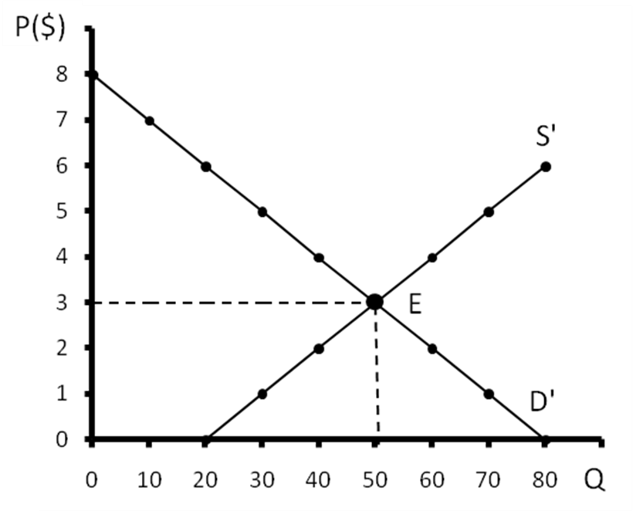

* 1. An increase in both D and S will increase the equilibrium quantity but may increase, decrease, or leave the price unchanged. In Figure 5, the equilibrium price remained unchanged because the demand curve and supply curve shifted by an equal amount. See Figure 5 bellow.

Figure 5

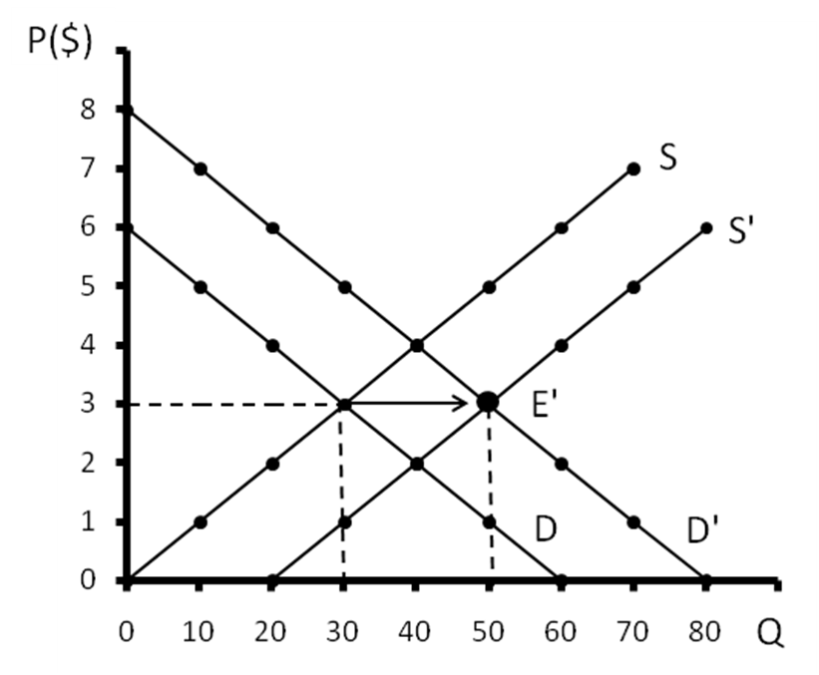

* 1. See Figure 6.

Figure 6

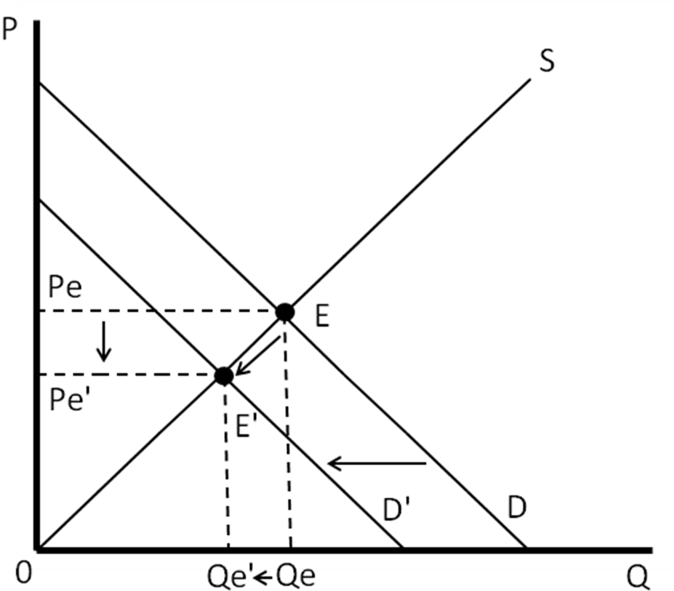

* 1. See Figure 7 bellow.

Figure 7

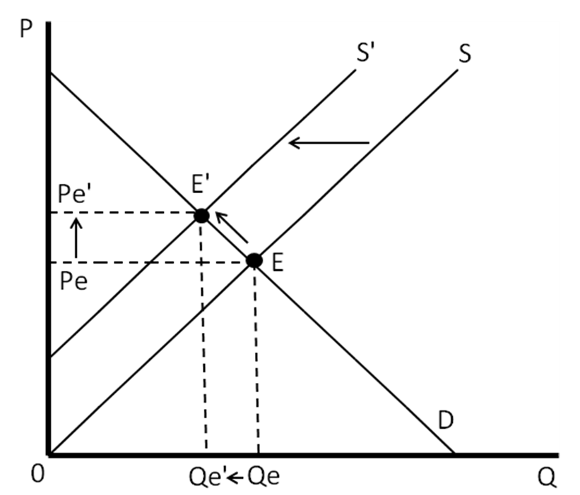

* 1. See Figures 8, 9 and 10 bellow.

|  |  |
| --- | --- |
| Figure 8 | Figure 9 |
| Figure 10 | |

* 1. See Figures 11, 12 and 13.

Figure 11

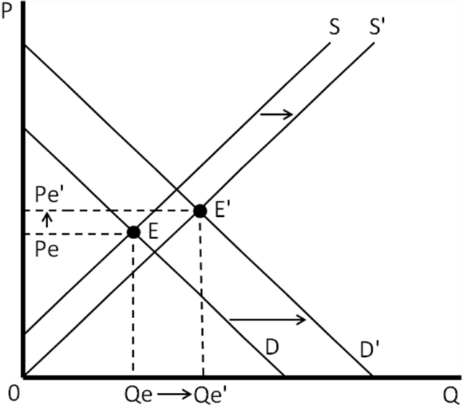

Figure 12

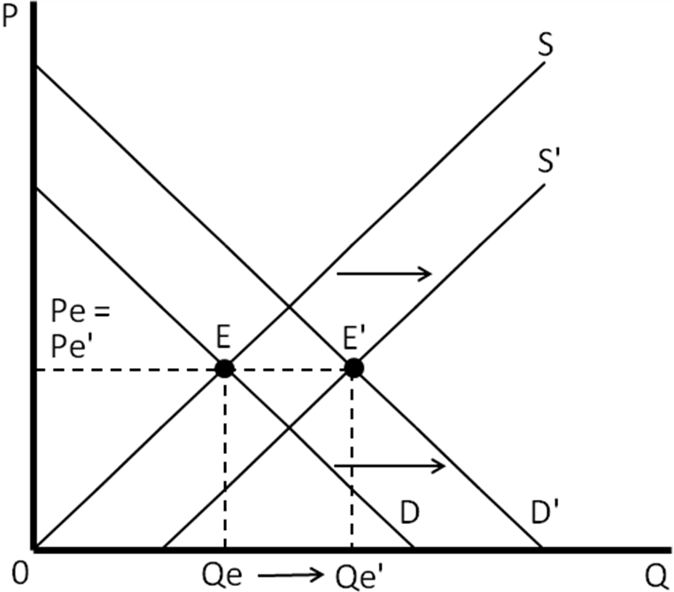

Figure 13

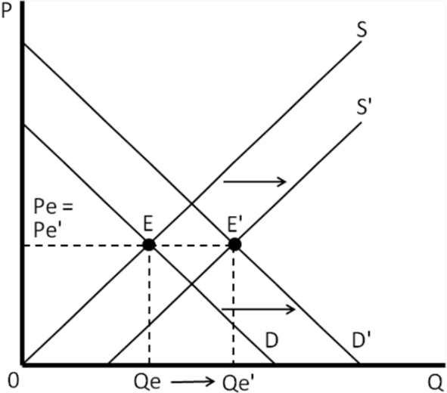

* 1. See Figures 14, 15 and 16..

Figure 14

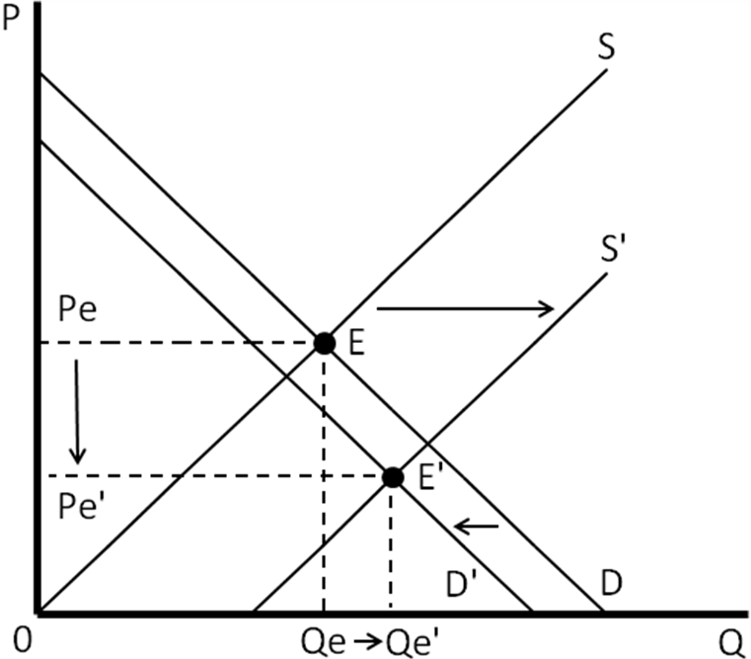

Figure 15

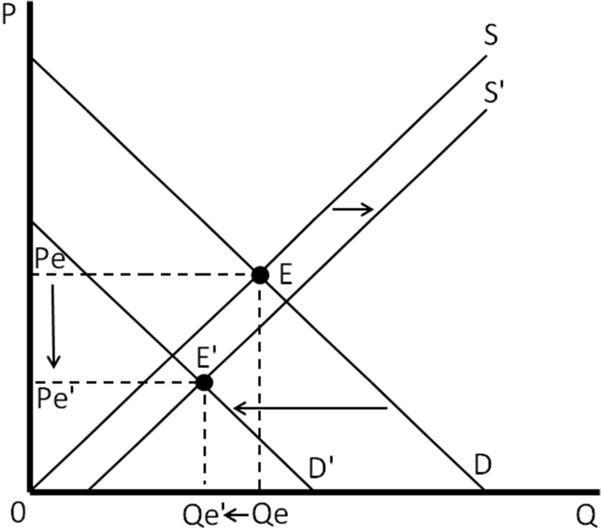

Figure 16

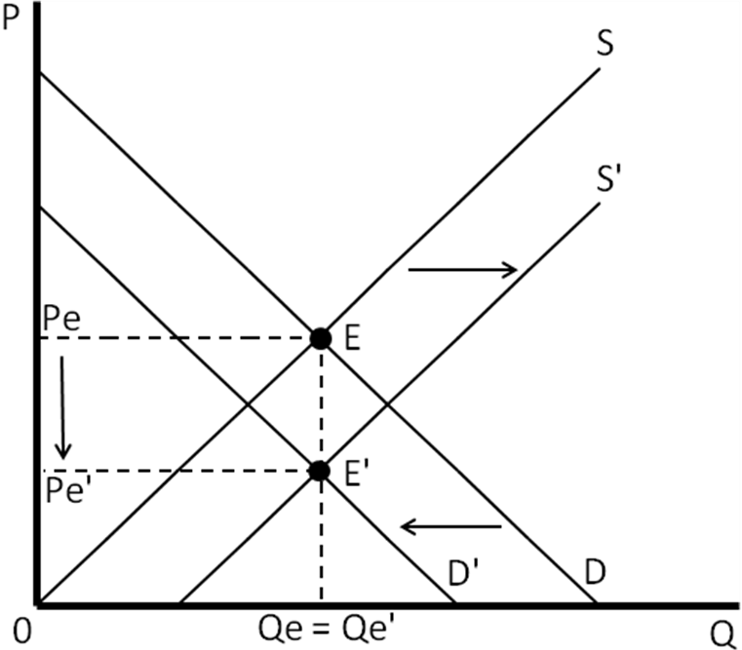

* 1. See Figures 17, 18 and 19.

Figure 17

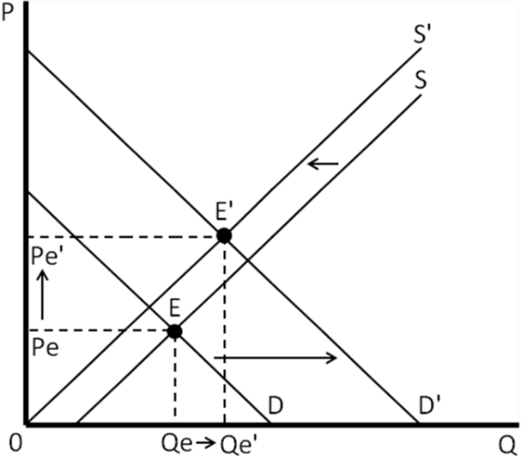

Figure 18

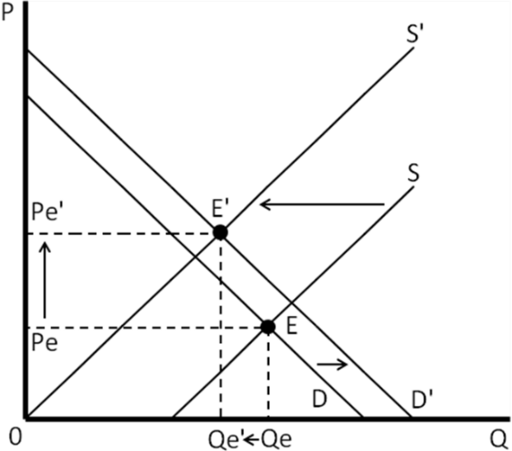

Figure 19

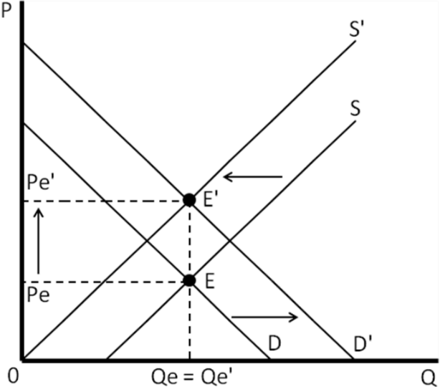

* 1. The demand for hamburgers increases, and this results in a higher price and quantity.
  2. The supply of hamburgers declines, and this results in an increase in the equilibrium price and a reduction in the equilibrium quantity.
  3. The supply of hamburgers increases and this lowers the equilibrium price and increases the quantity purchased.
  4. The demand for hamburgers increases and this has the same effect as in part (a).
  5. A per unit subsidy is the opposite of a per unit tax; the per unit subsidy increases the supply of hamburgers and this has the same effect as in part (c).

1. If the cost of transporting of textiles is $1 per yard and the cost of transportation falls equally on US consumers and foreign on producers of textiles, the US consumer would pay $2.50 per yard of foreign textiles imported and foreign textile producers would receive $1.50 per yard of textiles exported. From Figure 20 below, we can calculate that 150 million yards of textiles will be traded instead of 300 million yards in the absence of transportation costs.

|  |
| --- |
|  |

Figure 20

* 1. A price ceiling of P=$2 results in a shortage of the commodity of 20 units.
  2. A price ceiling of P=$3 has no effect.
  3. A price ceiling higher than P=$3 has no effect.
  4. A price floor of P=$5 leads to a surplus of the commodity of 40 units.
  5. A price floor of P=$4 leads to a surplus of 20 units.
  6. A price floor equal or smaller than P=$3 has no effect.

1. See Figure 21 and 22.

Figure 21

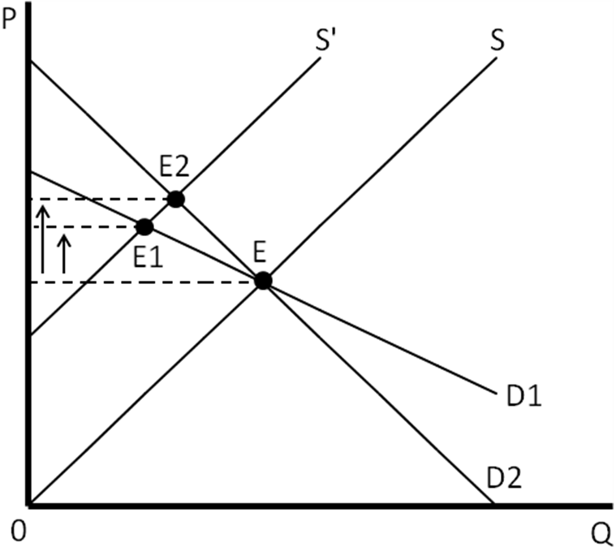

Figure 22

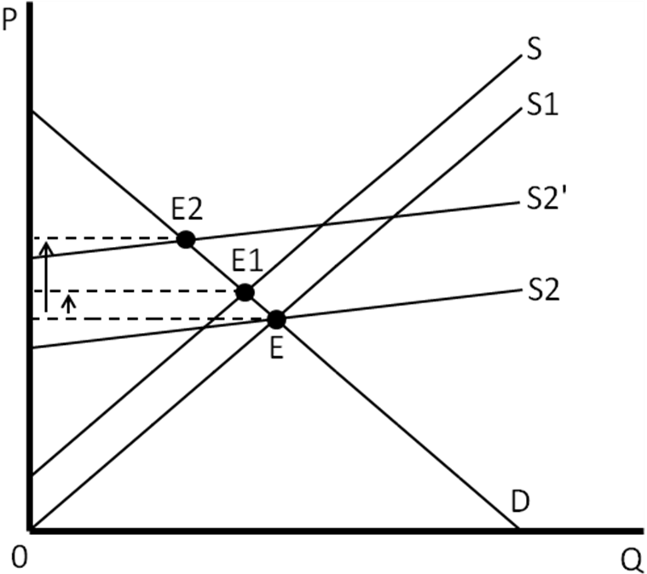

ANSWERS TO SPREADSHEET PROBLEMS

1. The spreadsheet should look like the following.

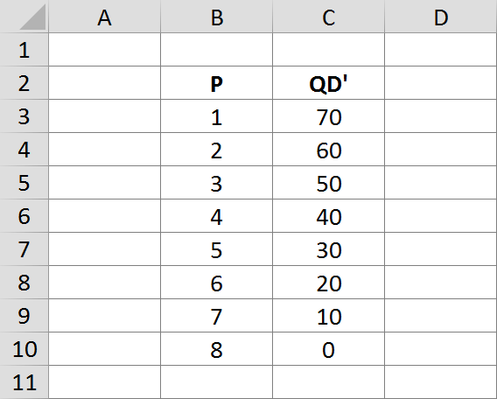


2. The equilibrium price is 50.
3. The equilibrium price is 70. The price went up because less was supplied at every price.

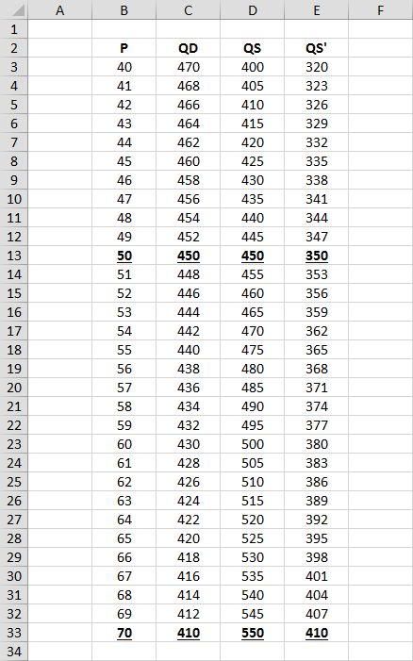

1. If there is a price ceiling of $50, then *QD* = 450, which is greater than the equilibrium quantity of 410. *QS*= 350, though, which is less than the amount demanded, so there is a shortage of 100.

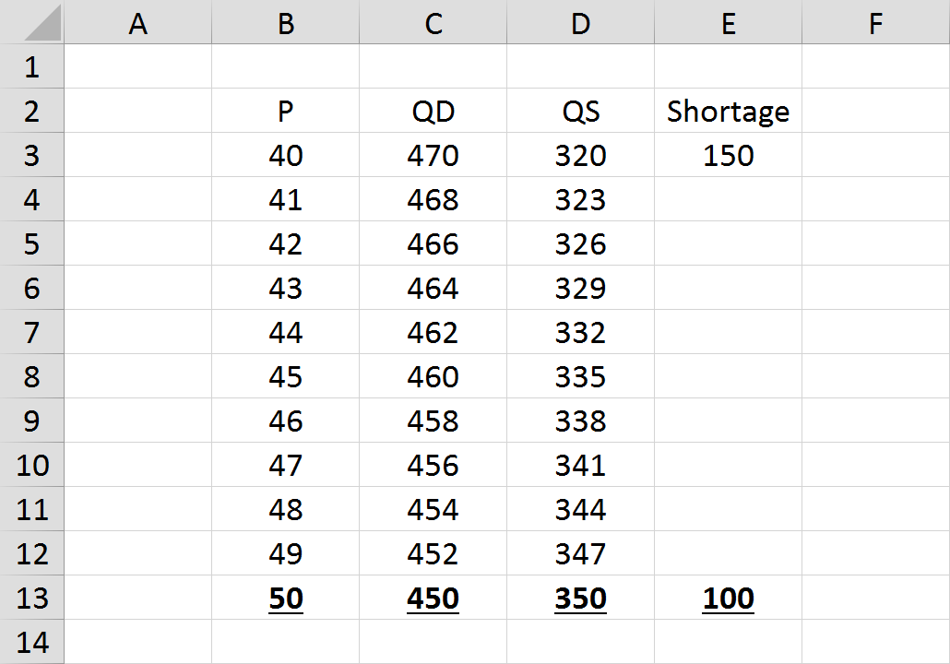

1. In equilibrium, Q=80 and P=20. The first chart shows the price on the horizontal axis and the quantity on the vertical axis. The second graph has the axis reversed.

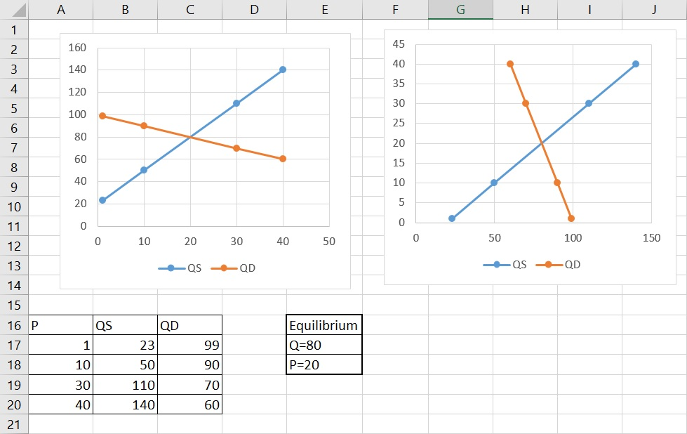

ANSWERS TO APPENDIX PROBLEMS

1. With QD' = 80 – 10P and QS = 10P, we find the equilibrium price P* and quantity Q*, as follows:

|  |  |  |  |  |  |  |
| --- | --- | --- | --- | --- | --- | --- |
| QD' | = | QS |  |  |  |  |
| 80-10P | = | 10P |  | Q* | = | 10P |
| 20P | = | 80 |  | Q* | = | 10($4) |
| P | = | $4 |  | Q* | = | 40 |

1. With QD = 60 – 10P and QS' = 20 + 10P, we find the equilibrium price P* and quantity Q*, as follows:

|  |  |  |  |  |  |  |
| --- | --- | --- | --- | --- | --- | --- |
| QD | = | QS' |  | Q* | = | 60-10(2) |
| 60-10P | = | 20+10P |  | Q* | = | 40 |
| 20P | = | 40 |  | or | | |
| P* | = | 2 |  | Q* | = | 20+10(2) |
|  |  |  |  | Q* | = | 40 |

1. With QD' = 80 – 10P and QS' = 20 + 10P, we find the equilibrium price P* and quantity Q*, as follows:

|  |  |  |  |  |  |  |
| --- | --- | --- | --- | --- | --- | --- |
| QD=80-10P |  | QS'=20+10P |  |  |  |  |
|  |  |  |  |  |  |  |
| QD | = | QS' |  | Q* | = | 80-10(3) |
| 80-10P | = | 20+10P |  | Q* | = | 50 |
| 20P | = | 60 |  | or | | |
| P* | = | 3 |  | Q* | = | 20+10(3) |
|  |  |  |  | Q* | = | 50 |

as shown by point E' in figure in the solution to Problem 7. Figure is redrawn bellow.

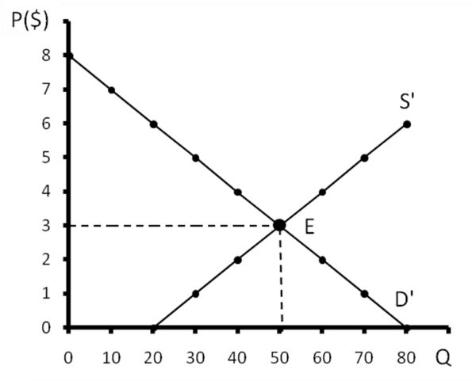

* 1. With the excise tax of $2 per unit, QS shifts up and to the left to QS” = -20 +10P. See the calculations and the figure below:

|  |  |  |  |  |  |  |
| --- | --- | --- | --- | --- | --- | --- |
| QD=60-10P |  | QS''=-20+10P |  |  |  |  |
|  |  |  |  |  |  |  |
| QD | = | QS'' |  | Q* | = | 60-10(4) |
| 60-10P | = | -20+10P |  | Q* | = | 20 |
| 20P | = | 80 |  | or | | |
| P* | = | 4 |  | Q* | = | -20+10(4) |
|  |  |  |  | Q* | = | 20 |

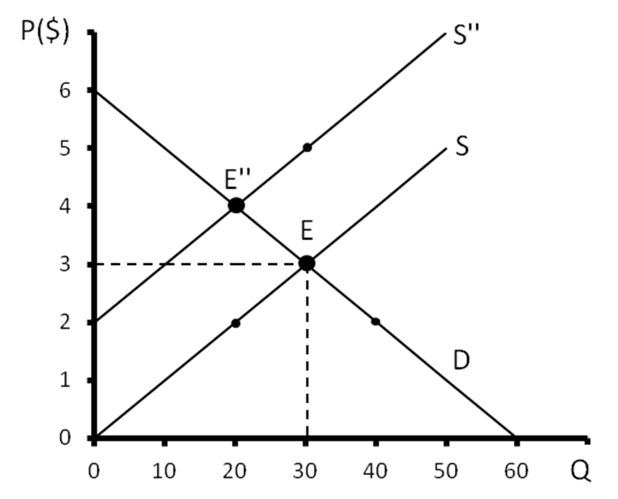

* 1. From the figure, we see that consumers pay a price of $4 per unit and producers receive $2 per unit net of the tax. Therefore, half of the excise tax will fall on consumers and half on producers.