**Managerial Economics:**

**A Problem-Solving Approach**

**4th Edition**

*End-of-Chapter Individual Problems - Key*

Table of Contents

Chapter 1 7

1-1 Goal Alignment at a Small Manufacturing Concern 7

1-2 Goal Alignment at a Small Manufacturing Concern (cont.) 7

1-3 Goal Alignment at a Small Manufacturing Concern (cont.) 8

1-4 Goal Alignment at New York City schools 8

1-5 Goal Alignment between Airlines and Flight Crews 8

1-6 Goal Alignment between Hospitals and the British Government 8

Chapter 2 9

2-1 Airline Delays 9

2-2 Selling Used Cars 9

2-3 Flood Insurance 9

2-4 France’s Labor Unions Force Early Closing Times 9

2-5 Kraft and Cadbury 10

2-6 Price of Breast Reconstruction Versus Breast Augmentation 10

Chapter 3 11

3-1 Concert Opportunity Cost 11

3-2 Concert Opportunity Cost 2 11

3-3 Housing Bubble 11

3-4 Opportunity Cost 11

3-5 Starbucks 12

3-6 Dropping University Courses 12

Chapter 4 13

4-1 Extent Versus Discrete Problems 13

4-2 Game Day Shuttle Service 13

4-3 Paid for Grades 13

4-4 Supplier Bids 14

4-5 Processing Insurance Claims 14

4-6 Copier Company 14

Chapter 5 15

5-1 George’s T-Shirt Shop 15

5-2 Net Present Value 15

5-3 Doctor’s Human Capital 15

5-4 Solar Panel Installation 15

5-5 Toy Trucks 16

5-6 Running a Hotel During a Recession 16

Chapter 6 17

6-1 Elasticity of T-Shirt Sales 17

6-2 Demand Curves with Same Values 17

6-3 Increasing Movie Ticket Prices 17

6-4 Nike Demand (inelastic) 17

6-5 Promotional Pricing 18

6-6 Bar Nuts 18

Chapter 7 19

7-1 Scale and Scope 19

7-2 Brand Extensions 19

7-3 Rangers’ T-Shirts 19

7-4 Average and Marginal Costs 19

7-5 Learning Curves 20

7-6 Multiconcept Restaurants Are a Growing Trend 20

Chapter 8 21

8-1 Widget Market 21

8-2 Cotton Prices 21

8-3 Hand Sanitizer 21

8-4 Chocolate Candy Bars Market 22

8-5 Demand Shifts 22

8-6 Valentine’s Day 23

Chapter 9 24

9-1 Faculty Housing Benefits 24

9-2 Snacks, Beer, and Marijuana 24

9-3 Entry and Elasticity 24

9-4 Competitive Industries 25

9-5 Economic Profit 25

9-6 Economics Versus Business 25

Chapter 10 26

10-1 High Rivalry 26

10-2 Increasing Customer Value 26

10-3 Intangible Resources 26

10-4 Five Forces and the Airline Industry 26

10-5 Smartphone Market 27

10-6 Salons and Teeth Whitening 27

Chapter 11 28

11-1 Explain the Peso Devaluation 28

11-2 Flight to Safety 28

11-3 The Russian Ruble 28

11-4 The Carry Trade 29

11-5 Dollar Devaluation 29

11-6 Effect of Expectations on the Exchange Rate 29

Chapter 12 30

12-1 Parking Lot Optimization 30

12-2 Parking at Cowboys Stadium 30

12-3 App Pricing for Droids 30

12-4 Macintosh Versus iPhone 31

12-5 Concert Prices 31

12-6 Radio Stations and Rock Concerts 31

Chapter (13)-14 32

14-1 Barbie Dolls and Accessories 32

14-2 German Brothels 32

14-3 Selling Salsa 32

14-4 Microwave Ovens 32

14-5 Music Pricing 33

14-6 Bundling 33

Chapter 15 35

15-1 To Vote or Not to Vote 35

15-2 To Vote or Not to Vote Part II 35

15-3 Compatibility 35

15-4 Salary Negotiation 35

15-5 Renegotiating Employment Contracts 36

15-6 Entry Game with Withdrawal 37

Chapter 16 38

16-1 Newspaper Bargaining 38

16-2 Airline Merger 38

16-3 House Closing 38

16-4 A City and Its Unions 38

16-5 Entering International Markets 39

16-6 PBMs 39

Chapter 17 41

17-1 Global Expansion 41

17-2 Game Show Uncertainty 41

17-3 Ad Agencies 42

17-4 Disposing of Used Assets 42

17-5 Saint Petersburg Gambles 42

17-6 Hiring 43

Chapter 18 44

18-1 Effects of Collusion 44

18-2 Reserve Prices 44

18-3 Reserve Prices II 45

18-4 Asset Auctions in Sweden 45

18-5 Art Auctions 45

18-6 Contractor Bidding 45

Chapter 19 47

19-1 Leasing Residuals 47

19-2 College Degrees Required for Police Officers 47

19-3 Bicycle Insurance and Information Asymmetry 47

19-4 Job Auction 47

19-5 “Soft Selling” and Adverse Selection 48

19-6 Hiring Employees 48

Chapter 20 49

20-1 Extended Warranties 49

20-2 Business Loan 49

20-3 Locator Beacons for Lost Hikers 49

20-4 Auto Insurance 49

20-5 BPO Services 50

20-6 Frequent Flyers 50

Chapter 21 51

21-1 Real Estate Agents 51

21-2 Airline Departures 51

21-3 Incentive Conflicts 51

21-4 Public School Principals 51

21-5 Venture Capital 52

21-6 Meeting Milestones 52

Chapter 22 53

22-1 Transfer Pricing 53

22-2 Transfer Prices Set by Headquarters 53

22-3 Chargebacks 54

22-4 Divisional Profit Measure 54

22-5 Furniture Forecasting 54

22-6 Jet Turbine Design 55

Chapter 23 56

23-1 Local Phone Companies 56

23-2 Integration of Physician Groups and Testing Services 56

23-3 Online Cosmetics 56

23-4 Wedding Dresses 56

23-5 Herbicide Integration 57

23-6 Loyalty Payments 57

# Chapter 1

*Short Answer Key:*

## 1-1 Goal Alignment at a Small Manufacturing Concern

The owners of a small manufacturing concern have hired a manger to run the company with the expectation that he will buy the company after five years. Compensation of the new Vice President is a flat salary plus 75% of the first $150,000 profit, then 10% of profit over $150,000. Purchase price for the company is set at 4.5 times earnings (profit), computed as average annual profitability over the next five years.

a. Plot the annual compensation of the vice president as a function of annual profit.

*Assume for now the VP has a base salary of 50,000. If so, when P≤$150000, his compensation can be determined by the equation C = 50000+0.75(P). When P≥150000, compensation is determined by the equation C=(50000+0.75(150000)) + 0.1P, which means C=162500+0.1P. The plot for compensation can be seen below.*

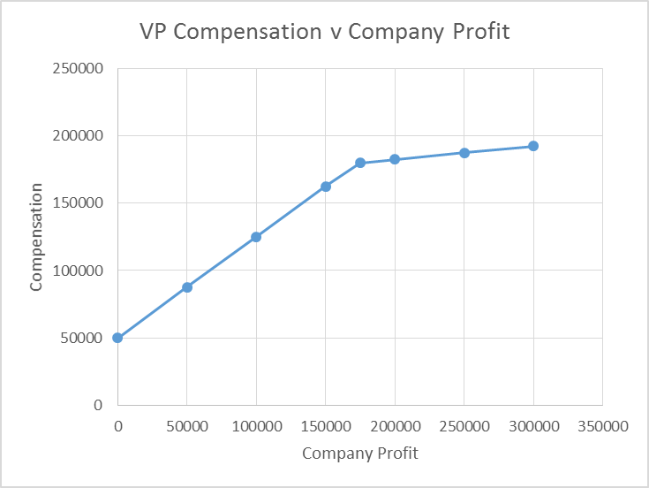

b. Assume the company will be worth $10million in five years. Plot the profit of buying the company as a function of annual profit.

*The purchase price will be 4.5x earnings, calculated as 4.5x average annual profitability. Therefore, the profitability of the purchase can be seen by the equation Ppurchase = 10,000,000 – 4.5(Pannual). The plot of this equation can be seen below.*

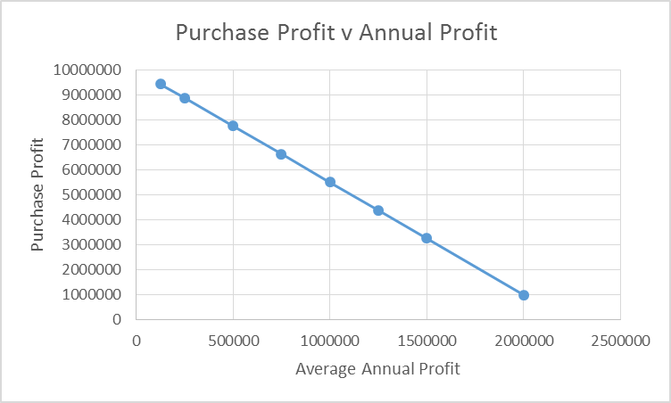

## 1-2 Goal Alignment at a Small Manufacturing Concern (cont.)

Does this contract align the incentives of the new vice president with the profitability goals of the owners?

*No. Both the purchase price and the profit sharing create perverse incentives. The VP keeps $0.75 of each dollar earned up to $150,000, but only $0.10 of each dollar earned after $150K. Since earning more requires more effort (increasing marginal effort), he has little incentive to earn more than $150,000. And every dollar the VP earns raises the price that he will eventually pay for the company by $4.50, effectively penalizing him for increasing company profitability.*

## 1-3 Goal Alignment at a Small Manufacturing Concern (cont.)

Re-design the contract to better align the incentives of the new vice president with the profitability goals of the owners.

*One approach would be to establish a purchase price at the initiation of the contract. This would encourage the VP to make the company as profitable as possible, as it the increases to his marginal wealth of 10% above 150000 are not offset by the dramatic increases in purchase price. Also, this encourages him to make the company as profitable as possible as it will ultimately be his once the 5 years have passed.*

## 1-4 Goal Alignment at New York City schools

1,800 New York City teachers who lost their jobs earlier this year have yet to apply for another job despite the fact that there are 1,200 openings. Why not?

*New York is the only city in the U.S. where teachers are guaranteed pay for life even if their school closes and they no longer have a permanent job. The policy costs DOE more than $100 million per year in salary and benefits. Those teachers go into the Absent Teacher Reserve pool, where they can be used as substitutes. The average salary for an ATR pool teacher? $82,000, with some making $100,000. Some teachers have been in the pool since 2006.*

## 1-5 Goal Alignment between Airlines and Flight Crews

Planes frequently push back from the gate on time, but then wait 2 feet away from the gate until it is time to queue up for take-off. This increases fuel consumption, and increases the time that passengers must sit in a cramped plane awaiting take-off. Why does this happen?

*Airlines are often evaluated and measured by their “on time” performance metrics. As this refers to boarding times rather than the time of actual departure, airlines would rather board the planes on time and wait on the tarmac than leaves passengers waiting at the gate.*

## 1-6 Goal Alignment between Hospitals and the British Government

In 2008, the Labour party in Britain promised that patients would have to wait for no more than four hours to be seen in an emergency room. How is the National Health Service meeting this performance goal?

*To meet this performance goal, seriously ill patients are being kept in ambulances. Thousands of people a year are having to wait outside the emergency departments because the trusts will not let them in until they will be able to be treated within four hours in accordance with the Labour pledge and government targets. In addition to keeping people outside, this also has reduced the ability of the ambulances to respond to emergency calls, leading to serious problems throughout the region.*

# Chapter 2

*Short Answer Key:*

## 2-1 Airline Delays

How will commercial airlines respond to the threat of new $27,500 fines for keeping passengers on the tarmac for more than three hours? What inefficiency will this create?

*Carriers say that to avoid those fines, they will aggressively cancel flights before and during storms—even if the bad weather never materializes. The threats could foreshadow significant changes in air travel, making it even less reliable for millions of road warriors and vacationers. By canceling flights, it could take days for all travelers to get home when storms strike. [*[*link*](http://managerialecon.blogspot.com/2010/03/unintended-consequences.html)*].*

## 2-2 Selling Used Cars

I recently sold my used car. If no new production occurred for this transaction, how could it have created value?

*The value of my willingness-to-sell was less than the buyer's willingness-to-pay. Any transaction price between these allows for a voluntary exchange in which we both benefit. Since we are both better off, value was created.*

## 2-3 Flood Insurance

The U.S. government subsidizes flood insurance because those who want to buy it live in the flood plain and cannot get it at reasonable rates. What inefficiency does this create?

*Subsidies are like taxes in this case. Taxation will keep some efficient transactions from being consummated because potential transactions where the difference in buyer and seller valuation is positive will no longer cover the amount of the tax to be paid. This prevents the asset from moving to its highest valued use. With a subsidy, transactions in which the assets moves from a higher valued use to a lower valued use can be consummated so long as the difference is less than the amount of the subsidy. This moves the asset to a lower valued use. With flood insurance worth an expected $20,000, homeowners would be willing to spend $120,000 to build a house that they value at only $100,000. Wealth is destroyed.*

## 2-4 France’s Labor Unions Force Early Closing Times

In 2013, France’s labor unions won a case against Sephora to prevent the retailer from staying open late, and forcing its workers to work “antisocial hours”. The cosmetic store does about 20 percent of its business after 9 p.m., and the 50 sales staff who work the late shift are paid an hourly rate that is 25 percent higher than the day shift. Many of them are students or part time workers, who are put out of work by these new laws. Identify the inefficiency, and figure out a way to profit from it.

*The inefficiency in this situation stems from the fact that the staff working the late shift valued the opportunity to work at the 25 percent increased wage more than not working during “antisocial hours”. This regulation has not only diminished the value to the company, who is losing 20 percent of its business, but also the workers, who are now unemployed.*

## 2-5 Kraft and Cadbury

When Kraft recently bid $16.7 billion for Cadbury, Cadbury**’**s market value rose, but Kraft**’**s market value fell by more. What does this tell you about the value-creating potential of the deal?

*It means that Kraft's shareholders, and potential shareholders, think that Kraft’s profits will fall. This would be the case if Kraft's $16.7 billion bid is greater than the present value of the expected future profits from the Cadbury unit. Essentially, the combined market value of the firms separately is greater than the market value of the firms together. The market thinks that combining these assets will destroy value.*

## 2-6 Price of Breast Reconstruction VersusBreast Augmentation

Two similar surgeries, breast reconstruction and breast augmentation, have different prices. Breast augmentation is cosmetic surgery not covered by health insurance. Patients who want the surgery must pay for it themselves. Breast reconstruction following breast removal due to cancer is covered by insurance. The price for one of the surgeries has increased by about 10% each year since 1995, whereas the other has increased by only 2%per year. Which of the surgeries has the lower inflation rate? Why?

*Market pressure comes from two sources: consumers who can choose not to purchase, and competitors who can offer lower prices. Breast augmentation is subject to both of these forces, and thus has a lower price, while breast reconstruction is covered by insurance where the consumer pressure is weaker.*

# Chapter 3

## 3-1 Concert Opportunity Cost

You won a free ticket to see a Bruce Springsteen concert (assume the ticket has no resale value). U2 has a concert the same night, and this represents your next-best alternative activity. Tickets to the U2 concert cost $80, and on any particular day, you would be willing to pay up to $100 to see this band. Assume that there are no additional costs of seeing either show. Based on the information presented here, what is the opportunity cost of seeing Bruce Springsteen?

*$20. Opportunity cost is the value of your next best alternative. In this case, your next best alternative is attending the U2 concert. Your value for this alternative is $100 with a corresponding cost of $80 leaving a net value of $20.*

*Note: This question is adapted from Paul J. Ferraro and Laura O. Taylor (2005) "Do Economists Recognize an Opportunity Cost When They See One? A Dismal Performance from the Dismal Science", Contributions to Economic Analysis & Policy: Vol. 4: No. 1, Article 7.*

## 3-2 Concert Opportunity Cost 2

You were able to purchase two tickets to an upcoming concert for $100 apiece when the concert was first announced three months ago. Recently, you saw that StubHub was listing similar seats for $225 apiece. What does it cost you to attend the concert?

*What you paid three months ago is irrelevant to your costs now. The decision you are facing is to attend the concert or not. If you do not attend, you can sell the tickets for $225 (ignoring any brokering fees and hassle costs). Thus, you forego $450 to attend the concert.*

## 3-3 Housing Bubble

Because of the housing bubble, many houses are now selling for much less than their selling price just two to three years ago. There is evidence that homeowners with virtually identical houses tend to ask for more if they paid more for the house. What fallacy are they making?

*These two homeowners have virtually identical houses that should sell at virtually identical prices. The purchase price from years ago is a sunk cost and therefore irrelevant to the pricing decision. They are committing the sunk cost fallacy.*

## 3-4 Opportunity Cost

The expression “3/10, net 45” means that the customers receive a 3% discount if they pay within 10 days; otherwise, they must pay in full within 45 days. What would the seller’s cost of capital have to be in order for the discount to be cost justified? (Hint: Opportunity Cost)

*The "opportunity cost" of receiving a late payment is the foregone benefit of receiving the money early.  This is determined by a firm’s cost of capital.  A 3% interest rate for 35 days corresponds to an annual rate of about 3%*(365/35)=31%.*

## 3-5 Starbucks

Starbucks is hoping to make use of its excess restaurant capacity in the evenings by experimenting with selling beer and wine. It speculates that the only additional costs are hiring more of the same sort of workers to cover the additional hours and costs of the new line of beverages. What hidden costs might emerge?

*There could be many hidden costs. Here are a few examples:*

* *Some of Starbucks current baristas are underage and are not permitted to serve alcohol. Hiring new bartenders may raise the labor costs.*
* *The storage and preparation of cold drinks, like beer and wine, differs considerably from the storage and preparation of hot drinks, like coffee. This suggests two separate “production lines” at each store.*
* *The Starbucks brand is known for signaling a quiet, comfy place to linger in small groups or alone. Serving alcohol may change the atmosphere enough that traditional coffee drinkers in the afternoon and early evening will be turned off.*
* *The Starbucks brands is also known for high quality coffees that are high quality partly because of the care in choosing beans, roasting them and brewing on the premises. It is not clear that there is much scope for care in 'preparing' beer and wine beverages to add similar value. If not, this brand extension could dilute the signal of the brand.*

## 3-6 Dropping University Courses

Students doing poorly in courses often consider dropping the courses. Many universities will offer a refund before a certain date. Should this affect a student’s drop decision?

*Before this date, the tuition is avoidable. After this date, it is sunk. Before this date, students compare the expected benefits to the tuition cost. After this date, they compare the expected benefits only to avoiding the hassle costs of continuing to participate in the course.*