Chapter 2

Accounting Fundamentals Review

# Highlights

* Bookkeeping and Accounting
* The Accounting Equation
* Recording Changes to the Accounting Equation
* Generally Accepted Accounting Principles
* The Hospitality Business Cycle

# Learning Outcomes

1. Restate the difference between bookkeeping and accounting.
2. Explain the basic accounting equation and how it is modified using debits and credits.
3. Identify GAAP and state why each exists.
4. Describe how accounting is used in the hospitality business cycle.</BL>

# Lecture Outline

## Bookkeeping and Accounting

* In the hospitality industry, **bookkeepers** of all types perform the critically important task of initially recording financial transactions in a business.
* If the bookkeeping tasks of the servers, bartenders, kitchen staff, and managers of a restaurant, and the front desk, controller and other staff of a hotel are not properly performed, the resulting financial data generated by these business’s accountants will not be accurate and decisions made based upon the numbers supplied are likely to be flawed.
* Bookkeeping forms the foundation of accurate financial reporting and analysis (see Figure 2.1).
* As a hospitality manager, it is important that you ensure precise and timely bookkeeping and accounting methods to produce the accurate financial data you will analyze to make good decisions.

### Figure 2.1: Transaction Recording and Analysis

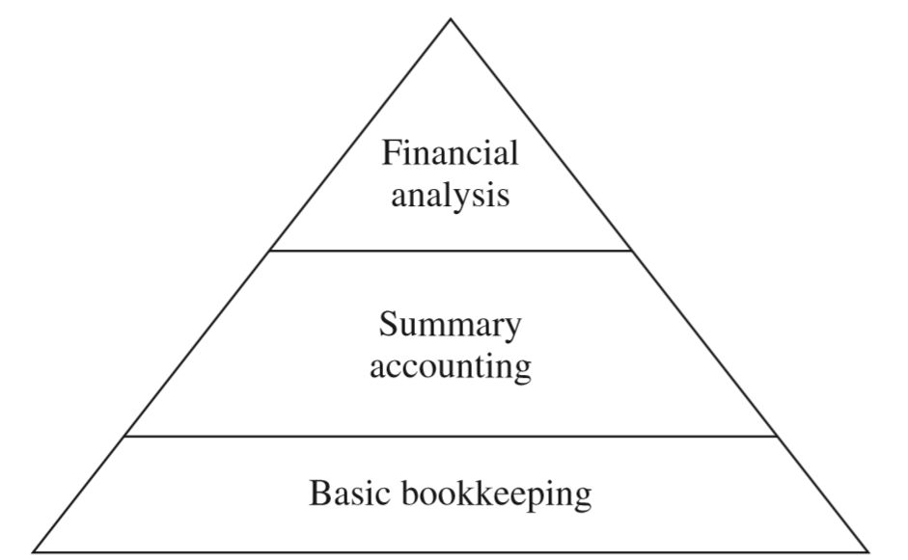

## The Accounting Equation

* An **account** is a device used to record increases or decreases in the assets, liabilities or owners’ equity portion of a business.
* There is a very specific and unchanging relationship between assets, liabilities, and owners’ equity. This relationship is expressed in a mathematical formula so precise, clear-cut, and unchanging that it is actually called “**The** **Accounting Equation”**. The Accounting Equation states that, for every business:

**Assets = Liabilities + Owners’ Equity**

* Using basic algebra, variations of this equation can be developed:

**Assets = Liabilities + Owners’ Equity**

**Assets - Liabilities = Owners’ Equity**

**Assets - Owners’ Equity = Liabilities**

* Owners’ equity accounts include two major sub-categories called permanent accounts and temporary accounts. **Permanent owners’ equity accounts** include items such as stock (or owner’s investment) and **retained earnings** (accumulated account of profits over the life of the business that have not been distributed as dividends).
* **Dividends** are money paid out of net income to stockholders as a return on their investment in the company’s stocks.
* **Temporary owners’ equity accounts** include revenue (increase owners’ equity) and expense accounts (decrease owners’ equity). At the end of the accounting period, the temporary accounts are **closed out** (their balances reduced to zero). The resulting current period's net profit or loss is used to update the balance of the permanent owners’ equity account (in retained earnings).
* The permanent and temporary owners’ equity accounts are shown in the following modification of The Accounting Equation:

**Assets = Liabilities**

**+ Permanent Owners’ equity (Stocks + Retained Earnings)**

**+ Temporary Owners’ equity (Revenue - Expenses**

* The balance sheet and the income statement are developed from The Accounting Equation. The **balance sheet** is an accounting summary that closely examines the financial condition of a business, by reporting the value of a company’s total assets, liabilities and owners’ equity on a specified date.
* The **income statement** reports in detail and for a very specific time period, a business’s revenue from all its revenue producing sources, the expenses required to generate those revenues, and the resulting profits or losses (net income).

## Recording Changes to the Accounting Equation

* Every time a business makes a financial transaction, it has an effect on (changes) The Accounting Equation. Accountants must report changes to The Accounting Equation while always ensuring that the formula stays in balance.
* Additions to or subtractions from one of the sides of the equation *must* be counterbalanced with an equal addition to, or subtraction from, the other side of the scale if the formula is to stay in balance, and the equation will remain in its mandatory “equal” position. (see figure 2.3)

### Figure 2.3 Graphical representation of the accounting equation

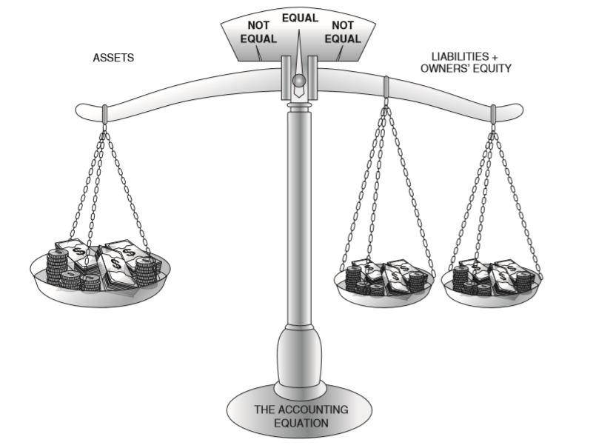

* It is also possible to make changes (additions or subtractions) to only one side of the equation. For example, an equal dollar value added to and then subtracted from the asset total would not cause the overall formula to be out of balance.

### Double-Entry Accounting

* **Double entry accounting** (sometimes called double entry bookkeeping) requires that the person recording a financial transaction make at least two separate accounting entries (changes to its accounts) every time a financial transaction modifies The Accounting Equation of a business.
* The double-entry accounting system originated in Medieval Europe. According to most historians, the system was first devised and used extensively by Venice (Italy) merchants in the mid-1400s. A double-entry system simply means each transaction made is recorded twice instead of once.
* A double entry system is used to catch recording errors and to accurately track the various streams of money in and out of businesses.

### The Journal and General Ledger

* When utilizing the double entry accounting system, each of a business’s individual transactions are originally recorded in the business’s unique journalof financial transactions. A **journal**, then, is the written record of a specific business’s financial transactions. A **journal entry** is made to a specific account when changes to The Accounting Equation are recorded.
* The up-to-date balances of all a business’s individual asset, liability, and owners’ equity, (as well as revenue and expense) accounts are maintained in its **general ledger**.
* Important concepts for an accountant to remember about maintaining a business’s general ledger are:
* The Accounting Equation, which is the summary of a business’s asset, liability and owners’ equity accounts, must always stay in balance.
* The Accounting Equation is affected every time a business makes a financial transaction.
* Each financial transaction is to be recorded twice in a double entry accounting system thus minimizing the chance of making an error in recording.
* The original records of a business’s financial transactions are maintained in its journal, and each financial transaction recorded is called a journal entry.
* The current balances of each of a business’s individual asset, liability and owners’ equity accounts are totaled and maintained in its general ledger.

### Credits and Debits

* The asset, liability and owners’ equity portions of the Accounting Equation can be broken down into smaller units called accounts. Because of their shape, accountants often call these individual accounts **“T” accounts.**

### Figure 2.5 “T” accounts

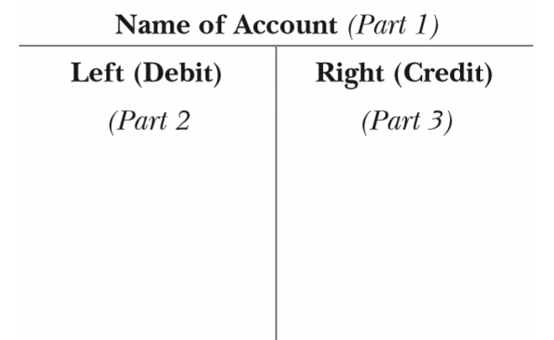



* A T account consists of three main parts:

Part 1: The top of the T is used for identifying the name of the account.

Part 2: The left side of a T account is called the **debit** side. Each journal entry made on the *left* side of a T account is always called a **debit entry**.

Part 3: The right side of a T account is called the **credit** side. Each journal entry made on the *right* side of a T account is always called a **credit entry**.

* The manner in which an accountant uses T accounts to make a journal entry can be conceptualized in much the same way as the scale in The Accounting Equation.

### Figure 2.6 Journal entry principles

1. To make a complete journal entry, at least two different accounts must be used to record the event (when using double-entry accounting).
2. Each journal entry must consist of at least one debit entry and one credit entry.
3. The total of all debit entries in a transaction must always equal the total of all credit entries.
4. When the above principles are followed, the accounting equation will always be in balance. If the equation is not in balance, an error has been made in recording one or more journal entries and must be corrected.

* Sometimes those who are new to double-entry accounting can make mistakes because it is easy to forget that a “debit” is made on the left side of a T account and a “credit” is made on the right side.
* It is easy to remember the correct way to make the entries, however, if you just remember that the word “debit” has one less letter in it than does the word “credit”; and it is also true that the word “left” has one less letter than the word “right!” Thus,

Five letters: Debit = Left

Six letters: Credit = Right

* Within each of the three major components of The Accounting Equation, accountants create individual T accounts to clarify the financial standing of the business. Some of these accounts include:

|  |  |  |
| --- | --- | --- |
| **Asset Accounts** | **Liability Accounts** | **Owners’ Equity Accounts** |
| **CURRENT ASSETS** | **CURRENT LIABILITIES** | **PERMANENT ACCOUNTS** |
| Cash | Accounts payable | Stock *(or owners’ investment)* |
| Accounts receivable | Taxes due and payable | Retained earnings |
| Inventories | Notes payable |  |
|  |  |  |
| **FIXED ASSETS** | **LONG-TERM DEBTS PAYABLE** | **TEMPORARY ACCOUNTS** |
| Furniture, Fixtures, and Equipment |  | Revenue accounts |
| Buildings |  | Expense accounts |
| Land |  |  |
| Accumulated depreciation *(contra asset account)* |  |  |

* **Depreciation** is a method of allocating the cost of a fixed asset over the useful life of the asset. Once fully depreciated, the value of the asset at the end of its useful life is called its **salvage value**.
* **Accumulated depreciation** is a record and accumulation of all depreciation expense charges that occur over the life of the asset. It is listed as a **contra asset** and represents deductions to a fixed asset’s value. Contra assets, like accumulated depreciation, behave *opposite* of all other asset accounts with regard to debits and credits.
* **Accounts receivable** (often shortened to AR) represent the amount of money owed to a business *by others* (such as customers) and thus is considered to be one of that business’s asset accounts.
* **Accounts payable** (often shortened to AP) represents the amount of money owed by the business *to others* (such as suppliers), and as a result is considered to be one of that business’s liability accounts.
* The difference between a T account’s total debits and total credits is called the **account balance.** A T account set up to monitor the value of an asset account will, in most cases, have a debit balance. This is so because additions to the current balance of an asset account are (simply by tradition) recorded on the left (debit) side of a T account. Reductions in the value of an asset account are recorded (again simply by tradition) on the right (credit) side of its T account.

### FIGURE 2.7 Normal balances of T accounts

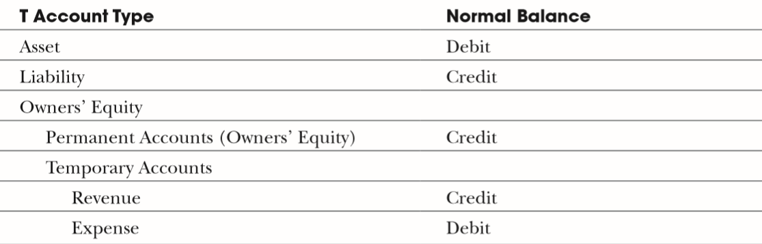

* Debit and credit entries have a different impact on each of the three major components of The Accounting Equation (see Figure 2.9).

### FIGURE 2.8 Impact of debit and credit entries on the accounting equation components

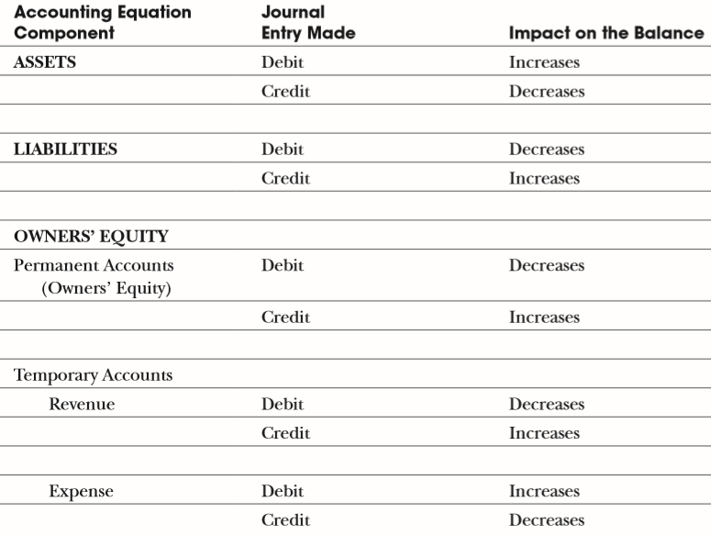

### Figure 2.9 Left hand (debits) and right hand (credits)

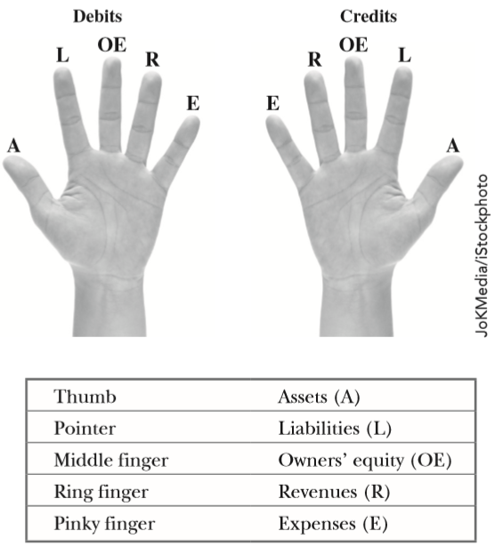

* Increases ↑ and decreases ↓ in accounts can then be summarized (see Figure 2.10)

### Figure 2.10 Increases and decreases in accounts

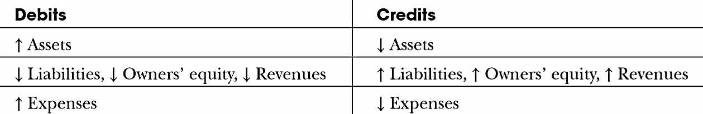

### Figure 2.11 Using hands to remember increases and decreases of accounts

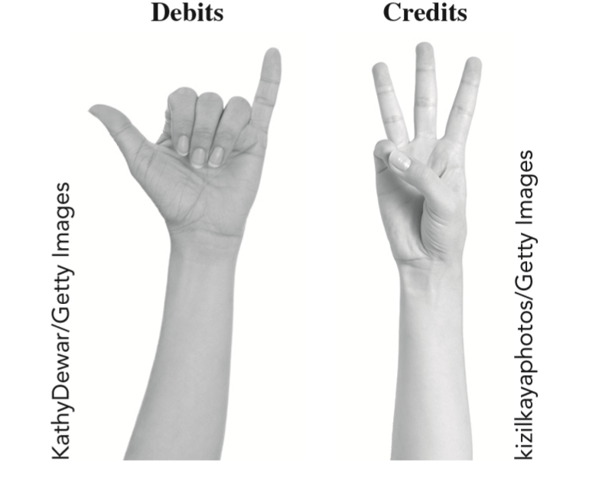

* Two of the most important and frequently used T accounts are revenue and expense accounts. These two account types belong to the owners’ equity portion of the accounting equation and are summarized, and closed out, at the end of each accounting period.
* Interestingly, hotel managers use a variation of these T accounts when maintaining the **folios** (bills) of their hotel guests. Guest folios can actually be considered “individual accounts” (accounts for each guest), and as a result, debit and credit entries for these accounts follow most of the same rules as those for all other T accounts.

## Generally Accepted Accounting Principles

* Professionals in the field of accounting have worked hard to develop and consistently follow **generally accepted accounting principles (GAAP)**, in order to describe the best method of recording any financial transaction and to ensure that readers of financial statements can immediately depend upon their accuracy.
* Generally accepted accounting principles are developed by the **Financial Accounting Standards Board (FASB)**, a private body whose mission is to establish and improve standards of financial accounting and reporting for the guidance and education of the public, including issuers, auditors and users of financial information. As a result of their importance, accountants, auditors and controllers all utilize GAAP.
* Eleven of the most critical generally accepted accounting principles all hospitality managers simply must recognize include:
* Distinct business entity principle
* Going concern principle
* Monetary unit principle
* Time period principle
* Cost principle
* Consistency principle
* Matching principle
* Materiality principle
* Objectivity principle
* Conservatism principle
* Full disclosure principle

### The Distinct Business Entity Principle

* The **distinct business entity** **principle** states that a business’s financial transactions should be kept completely separate from those of its owners.
* There are three basic types of business ownership in the United States:
* A **corporation**, commonly called a **C corporation**, is a legal entity that is separate and distinct from its owners. It is allowed to own assets, incur liabilities and sell shares of ownership, among other things.
* A **Limited Liability Corporation** **(L.L.C.)** isa special (state authorized) form of a corporation that is typically regulated by the state in which it is formed. An LLC limits the potential losses incurred by its owners only to what they have invested in the business.
* A **Sub S corporation** is another type of corporation that is granted special status under U.S. tax laws. These laws are very specific about how and when this type corporation can be formed and the number of **stockholders** (company owners) it can have.
* A **partnership** is simply a business entity where two or more individuals agree to share ownership. Its profits are taxed differently than those profits earned by a corporation.
* In a **limited liability partnership (LLP)** one or more general partners manage the business and are liable for its debts and one or more limited partners invest in the business but have limited personal liability for its debts.
* A **proprietorship** is a business owned by a single individual. A **sole proprietor** pays personal (but not corporate) income tax on profits made by the business and also has unlimited liability for the debts and other obligations incurred by the business.

### The Going Concern Principle

* The **going concern principle** means that accountants make the assumption that the business will be ongoing (continue to exist) indefinitely and that there is no intention to **liquidate** (sell) all of the assets of the business.
* The going concern principle clearly directs accountants to record the value of a business’s assets only at the price paid for them, so that readers of a financial statement know that asset values represent a business’s true cost, and not the cost of liquidation or replacement.

### The Monetary Unit Principle

* The **monetary unit principle** means that financial statements must be prepared in a specific currency denomination. In the United States, the U.S. dollar is the monetary unit used for preparing financial statements.
* Fulfilling the monetary unit principle can be quite complicated, since companies often operate in more than one country, and use more than one currency in their operating transactions.

### The Time Period Principle

* The **time period principle** requires a business to identify the time period for which its financial transactions are reported.
* A **fiscal year** consists of 12 consecutive months (but not necessarily beginning in January and ending in December like a **calendar year**).
* A fiscal year-end financial report would provide owners with the information they need to file their taxes and make other needed financial management decisions.
* The amount of time included in any summary of financial information is called an **accounting period**. The managers of a business may be most interested in monthly, weekly, or even daily financial summary reports.

### The Cost Principle

* The **cost principle** requires accountants to record all business transactions at their cash cost.
* Just as the going concern principle requires accountants to value a business’s assets at their purchase price, with few exceptions, it requires businesses to set the value of the items it intends to sell at the price the business actually paid for them.

### The Consistency Principle

* The **consistency principle** of accounting states that a business must select and consistently report financial information under the rules of the specific reporting system it elects to use.
* In an **accrual accounting** system, revenue is recorded when it is earned, regardless of when it is collected, and expenses are recorded when they are incurred, regardless of when they are paid. The result is a more accurate reflection of a business’s true *monthly* profitability.
* A **cash accounting** system records revenue as being earned when it is actually received and records expenditures when they are actually paid, regardless of when they were incurred.
* Most hotels and restaurants choose to use the accrual accounting system, recording their revenue when their customers make purchases, rather than when these customers actually pay their bills.
* Similarly, when an expense such as a tax payment is paid at one time for an entire year, rather than recording it when it is actually paid , in the accrual accounting system, 1/12 of the tax expense is assigned to each of the 12 monthly revenue and expense summaries prepared.

### The Matching Principle

* The **matching principle** is designed to closely match expenses incurred to the actual revenue those expenses helped generate. This principle applies to those organizations that elect to use an accrual system of accounting.

### The Materiality Principle

* The consistency and matching principles require accountants to expense the cost of certain long-life assets like furniture and equipment over the time period in which they will help a business generate revenue. The **materiality principle**, however, allows accountants, under very strict circumstances, to vary from these two important principles.
* The **materiality principle** means that if the value of an item is deemed to be not significant, then other accounting principles may be ignored if it is not practical to use them.

### The Objectivity Principle

* The **objectivity principle** states that financial transactions must have a confirmable (objective) basis in fact. While all of the generally accepted accounting principles have great value, it is this one that most ensures that a business’s financial statements can be trusted to be reliable.
* Sales should have substantiating evidence to prove that they actually occurred, such as guest checks, bank card statements, or various sales records maintained in an electronic cash register or computer.
* Before they can be recorded as having been incurred or paid, expenses must be verified with evidence such as delivery slips or original invoices supplied by vendors, cancelled checks or documented **electronic funds transfers (EFTs).**

### The Conservatism Principle

* The **conservatism principle** requires the accountants of a business to be conservative when reporting its revenue (and thus not to report it until it is actually earned) and realistic when reporting its expense and other liabilities.

### The Full Disclosure Principle

* The **full disclosure principle** requires that any past or even *future* event which could materially affect the financial standing of the business and that cannot be easily discerned from reading the business’s financial statements must be separately reported.
* These reports, prepared in the form of footnotes, must be attached to the financial statements prepared by the business’s accountants.
* Accountants use full disclosure footnotes to report events that have not happened yet but may, if they do occur, considerably change the conclusions drawn by readers of a business’s financial statements. Examples of such events include significant lawsuits, changing from a cash to an accrual accounting system, significant tax disputes, modifying depreciation schedules, unusual events that occurred after the financial statements were actually prepared, or any other atypical or non-recurring event that could materially affect the business.

## The Hospitality Business Cycle

* An accounting period is the time frame included in the financial transaction summaries prepared by a business. Regardless of the time frame involved, each of these accounting summaries will consist of common components that make up a complete **hospitality business cycle** (see Figure 2.13).

### FIGURE 2.13 Hospitality business cycle

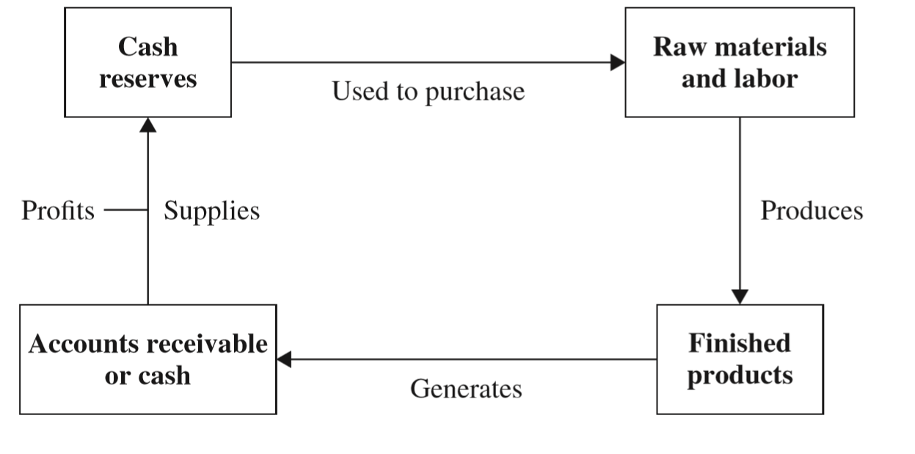

* Business cycles most often begin by utilizing cash to secure raw materials for processing by workers who create finished products (meals are produced, and guest rooms are prepared).
* The sale of these products creates cash or accounts receivables owned by the business. The money resulting from these sales is then used to buy additional products or, if profits are generated, some of it may be retained by the business. Then the business cycle begins again.
* Examples of processes in which an automated accounting system can improve accuracy, save time, and reduce operating costs include
* **Revenue collection:** Invoice generation, payment collections, payment reminders, and up-to-date customer account balances can all be easily managed with automated accounting systems.
* **Bill payment:** Due and payable invoices for goods and services purchased by a restaurant or hotel can be easily matched against approved purchase orders, assigned to the proper department or area, and then automatically paid when managers choose to automate the bill payment process.
* **Expense management:** Automated systems that address employee expenses can create, and submit for approval, expense reports for sales and other administrative staff. Doing so allows managers to easily monitor budgeted versus actual expenses. They can even flag for review expense reports that exceed predetermined and allowable amounts or limits.
* **Reconciliation with bank records:** Matching and reconciling a business’s bank records with its internal financial records can be a time-consuming and tedious process. Automated systems that allow a business to match its online banking records with those records it maintains internally can save significant amounts of time and money and allow managers to spot irregularities immediately.
* **Financial reporting:** Automated accounting systems can create, and even automatically disseminate in electronic form, important financial documents and statements to those who have been selected to receive them. These reports can range from summaries of daily operating activities statistics to up-to-date income statements and balance sheets.

# Consider the Cost: Suggested Answers

1. The advantages that accrue from operating a business as a sole proprietorship are many. Perhaps the most important of these is the complete control that can be exercised by the business owner. There are other advantages. These include the ability of the sole proprietor to sell or transfer ownership of the business without approval from any other entity. In addition, no corporate tax payments are required when operating as a sole proprietorship. This, of course, is not true if the business is operated as a C-Corp.

Additional advantages to operating a business as a sole proprietorship include the minimal legal cost required to initially form the business entity and minimal reporting requirements related to business taxes (because taxes are paid on the owners own income tax form), and relatively few, if any, state-required reporting of the business’s operating structure.

1. There are a number of advantages that accrue when operating the business as a C-Corp or LLC. Perhaps the most important of these is the limited liability enjoyed by owners of the business. Students should be reminded that under the sole proprietor and partnership models, a business owner is personally liable for the debts of a business. When operating as a C-Corp or LLC, however, an owner’s liability is limited to the amount of his or her investment.

Additional advantages to operating a business as a C-Corp or LLC include the fact that all members can be involved with the management of the business. When operated as an LLC favorable tax treatment also accrues to the business’s owners. An additional advantage of operating as a C Corp. or LLC is that the business entity itself can establish credit separate from the credit obtained by its owners.

While both of the sole proprietorship and the C Corp. and LLC structures have advantages, instructors can also point out disadvantages to each. The major teaching point in this case study is that the initial selection of an appropriate operating entity is an important one for all hospitality business owners.

# Apply What You Have Learned: Suggested Answers

1. In meeting with the SBA, an individual’s accounting knowledge, including knowledge of GAAP, will be of critical importance. SBA officials will want to be sure that a potential borrower has the business skills to be a successful entrepreneur and thus have increased chances of repaying the money he or she seeks to borrow. They know that industry-specific knowledge and culinary skills are not sufficient to ensure the profitable operation of a business entity. They will want to be sure that they can depend on the accuracy of the financial records submitted by those asking for SBA’s assistance in securing funding.
2. Food distributors are always one of a food service operation’s most important vendors. When a business such as the one referenced in this case study will be new, vendors will want to be assured that those to whom they will sell products will be able to properly analyze their business’s financial reports. When they can, these hospitality business operators will be able to make informed decisions in such areas as purchasing food and controlling cash flow, and thus will be in a good position to pay their bills on time.
3. Most accountants and other financial professionals will charge by the hour for their services. If an operation’s financial records reflect compliance with GAAP when they are presented to the accountant it selects to employ, it will save a great deal of time in the preparation of tax and related required filings. Thus, performing accounting tasks properly not only assists in the proper financial analysis of a business, it will also save money when the business’s taxes and other financial filings are prepared.

# Exam Bank

1. Which is the foundation of accurate financial reporting and analysis?
2. **Bookkeeping**
3. Managerial accounting
4. Summary accounting
5. Cost analysis

Answer: A

Shuffle Answers: Yes

Difficulty level: Easy

Learning Outcome: 2.1: Restate the difference between bookkeeping and accounting.

1. In the hospitality industry, a property management system (PMS) is used to record
2. **customer transactions that take place at a hotel’s front desk.**
3. changes to the value of a business’s property.
4. and value a restaurant’s food and beverage inventory levels.
5. the amount of income and expense incurred by a business in defined accounting period.

Answer: A

Shuffle Answers: Yes

Difficulty level: Easy

Learning Outcome: 2.1: Restate the difference between bookkeeping and accounting.

1. In the hospitality industry, a point of sale (POS) system is used to record
2. **guest sales, payments and other information.**
3. rooms sold to guests.
4. the activities occurring in a hotel’s housekeeping department.
5. changes in a business’s balance sheet.

Answer: A

Shuffle Answers: Yes

Difficulty level: Medium

Learning Outcome: 2.1: Restate the difference between bookkeeping and accounting.

1. Which would be the first action to occur in a hospitality business’s transaction recording and analysis process?
2. **Guest purchase**
3. Financial analysis
4. Summary accounting
5. Basic bookkeeping

Answer: A

Shuffle Answers: Yes

Difficulty level: Medium

Learning Outcome: 2.1: Restate the difference between bookkeeping and accounting.

1. Which would be the final action to occur in a hospitality business’s transaction recording and analysis process?
2. **Financial analysis**
3. Guest purchase
4. Summary accounting
5. Basic bookkeeping

Answer: A

Shuffle Answers: Yes

Difficulty level: Medium

Learning Outcome: 2.1: Restate the difference between bookkeeping and accounting.

1. Which portion of a hospitality business’s transaction and analysis process would most often by undertaken by the business’s owner or general manager?
2. **Financial analysis**
3. Recording of guest purchases
4. Summary accounting
5. Basic bookkeeping

Answer: A

Shuffle Answers: Yes

Difficulty level: Hard

Learning Outcome: 2.1: Restate the difference between bookkeeping and accounting.

1. Which is the basic accounting equation that is applicable to every business?
2. Assets = Liabilities + Owners’ Equity
3. Assets = Owners’ Equity – Liabilities
4. Assets + Liabilities = Owners’ Equity
5. Assets + Owners’ Equity = Liabilities

Answer: A

Shuffle Answers: Yes

Difficulty level: Easy

Learning Outcome: 2.2: Explain the basic accounting equation and how it is modified using debits and credits.

1. What is the primary device that accountants use to record increases or decreases in the assets, liabilities or owners’ equity portion of a business’s basic accounting equation?
2. **Account**
3. Schedule
4. Ledger
5. Journal

Answer: A

Shuffle Answers: Yes

Difficulty level: Easy

Learning Outcome: 2.2: Explain the basic accounting equation and how it is modified using debits and credits.

1. Which is the accounting summary that presents the financial condition, or financial health, of a business?
2. **Balance Sheet**
3. Income Statement
4. Profit and Loss Statement
5. Statement of Cash Flows

Answer: A

Shuffle Answers: Yes

Difficulty level: Medium

Learning Outcome: 2.2: Explain the basic accounting equation and how it is modified using debits and credits.

1. Which is the accounting statement that reports in detail, and for a very specific time period, a business’s revenue, the expenses required to generate its revenues, and the business’s profits or losses for that period?
2. **Income Statement**
3. Expense Statement
4. Balance Statement
5. Statement of Cash Flows

Answer: A

Shuffle Answers: Yes

Difficulty level: Medium

Learning Outcome: 2.2: Explain the basic accounting equation and how it is modified using debits and credits.

1. Which describes the impact of a credit entry?
2. **↓ Assets ↑ Liabilities ↑ Owners’ Equity ↑ Revenues ↓ Expenses**
3. ↑ Assets ↓ Liabilities ↓ Owners’ Equity ↓ Revenues ↑ Expenses
4. ↑ Assets ↑ Liabilities ↓ Owners’ Equity ↑ Revenues ↓ Expenses
5. ↓ Assets ↓ Liabilities ↑ Owners’ Equity ↑ Revenues ↓ Expenses

Answer: A

Shuffle Answers: Yes

Difficulty level: Hard

Learning Outcome: 2.2: Explain the basic accounting equation and how it is modified using debits and credits.

1. Which describes the impact of a debit entry?
2. **↑ Assets ↓ Liabilities ↓ Owners’ Equity ↓ Revenues ↑ Expenses**
3. ↓ Assets ↑ Liabilities ↑ Owners’ Equity ↑ Revenues ↓ Expenses
4. ↑ Assets ↑ Liabilities ↓ Owners’ Equity ↑ Revenues ↓ Expenses
5. ↓ Assets ↓ Liabilities ↑ Owners’ Equity ↑ Revenues ↓ Expenses

Answer: A

Shuffle Answers: Yes

Difficulty level: Hard

Learning Outcome: 2.2: Explain the basic accounting equation and how it is modified using debits and credits.

1. A restaurant owner who takes home steaks for grilling at a private party she is hosting for her friends, without properly reflecting this in the restaurant’s accounting records, is violating the
2. **Distinct Business Entity Principle.**
3. Cost Principle.
4. Matching Principle.
5. Full Disclosure Principle.

Answer: A

Shuffle Answers: Yes

Difficulty level: Easy

Learning Outcome: 2.3: Identify GAAP and state why each exists.

1. A restaurant owner records his purchases of food and beverage as an expense when they are purchased, and who does not record end of accounting period inventory values is violating the
2. **Matching Principle.**
3. Materiality Principle.
4. Objectivity Principle.
5. Full Disclosure Principle.

Answer: A

Shuffle Answers: Yes

Difficulty level: Easy

Learning Outcome: 2.3: Identify GAAP and state why each exists.

1. The GAAP referred to as the Time Period Principle is concerned with a business’s
2. **identification of the dates for which financial transactions have been recorded.**
3. status as an ongoing concern.
4. use of a single currency when preparing its financial records.
5. consistent use of either an accrual or cash accounting system.

Answer: A

Shuffle Answers: Yes

Difficulty level: Medium

Learning Outcome: 2.3: Identify GAAP and state why each exists.

1. Which GAAP states that recorded financial transactions must have a confirmable (provable) basis in fact?
2. **Objectivity Principle**
3. Conservatism Principle
4. Matching Principle
5. Consistency Principle

Answer: A

Shuffle Answers: Yes

Difficulty level: Medium

Learning Outcome: 2.3: Identify GAAP and state why each exists.

1. Which GAAP prevents a business from switching back and forth between an accrual and a cash accounting system in the same accounting period?
2. **Consistency Principle**
3. Conservatism Principle
4. Matching Principle
5. ObjectivityPrinciple

Answer: A

Shuffle Answers: Yes

Difficulty level: Medium

Learning Outcome: 2.3: Identify GAAP and state why each exists.

1. Which GAAP applies only to those businesses that use an accrual system of accounting?
2. **Matching Principle**
3. Conservatism Principle
4. ConsistencyPrinciple
5. ObjectivityPrinciple

Answer: A

Shuffle Answers: Yes

Difficulty level: Hard

Learning Outcome: 2.3: Identify GAAP and state why each exists.

1. Which GAAP would be most relevant if a hotel, in the near future, expected to face the payment of a significant amount of money resulting from a lawsuit that it was very likely to lose?
2. **Full Disclosure Principle**
3. Conservatism Principle
4. ConsistencyPrinciple
5. ObjectivityPrinciple

Answer: A

Shuffle Answers: Yes

Difficulty level: Hard

Learning Outcome: 2.3: Identify GAAP and state why each exists.

1. As the first step in the hospitality business cycle, a hospitality operation uses its cash or credit reserves to
2. **purchase products for resale to guests.**
3. produce finished goods.
4. generate accounts receivable.
5. create profits.

Answer: A

Shuffle Answers: Yes

Difficulty level: Easy

Learning Outcome: 2.4: Describe how accounting is used in the hospitality business cycle.

1. In the hospitality business cycle, the sale to guests of a hospitality business’s products or services creates either cash or
2. **an account receivables.**
3. an account payable.
4. a financial profit.
5. a credit to a deprecation account.

Answer: A

Shuffle Answers: Yes

Difficulty level: Easy

Learning Outcome: 2.4: Describe how accounting is used in the hospitality business cycle.

1. What would be the impact on a restaurant’s financial accounts when it purchases steaks for resale to guests?
2. **Decrease in cash, increase in inventory value**
3. Decrease in cash, decrease in inventory value
4. Increase in cash, increase in inventory value
5. Increase in cash, decrease in inventory value

Answer: A

Shuffle Answers: Yes

Difficulty level: Medium

Learning Outcome: 2.4: Describe how accounting is used in the hospitality business cycle.

1. Electronically matching and reconciling a business’s bank records with its internal financial records is a typical feature of
2. **automated accounting.**
3. accrual accounting.
4. cash accounting.
5. managerial accounting.

Answer: A

Shuffle Answers: Yes

Difficulty level: Medium

Learning Outcome: 2.4: Describe how accounting is used in the hospitality business cycle.

1. Which is the first step in implementing an automated accounting system?
2. **Eliminating paper**
3. Syncing data
4. Sharing data
5. Adding additional features

Answer: A

Shuffle Answers: Yes

Difficulty level: Hard

Learning Outcome: 2.4: Describe how accounting is used in the hospitality business cycle.

1. When using double entry accounting, what is the minimum number of accounts that will be affected when a restaurant sells a food item to a customer?
2. **2**
3. 4
4. 3
5. 1

Answer: A

Shuffle Answers: Yes

Difficulty level: Hard

Learning Outcome: 2.4: Describe how accounting is used in the hospitality business cycle.