Chapter 2

Job-Order Costing: Calculating Unit Product Costs

Questions

**2-1** Job-order costingis used in situations where many different products, each with individual and unique features, are produced each period.

**2-2** In absorption costing,all manufacturing costs, both fixed and variable, are assigned to units of product—units are said to *fully absorb manufacturing costs*. Conversely, all nonmanufacturing costs are treated as period costs and they are not assigned to units of product.

**2-3** Normal costing systems apply overhead costs to jobs by multiplying a predetermined overhead rate by the actual amount of the allocation incurred by the job.

**2-4** Unit product cost is computed by taking the total manufacturing costs assigned to a job and dividing it by the number of units contained in the job.

**2-5** The first step is to estimate the total amount of the allocation base (the denominator) that will be required for next period’s estimated level of production. The second step is to estimate the total fixed manufacturing overhead cost for the coming period and the variable manufacturing overhead cost per unit of the allocation base. The third step is to use the cost formula *Y* = *a* + *bX* to estimate the total manufacturing overhead cost (the numerator) for the coming period. The fourth step is to compute the predetermined overhead rate.

**2-6** The job cost sheet is used to record all costs that are assigned to a particular job. These costs include direct materials costs traced to the job, direct labor costs traced to the job, and manufacturing overhead costs applied to the job. When a job is completed, the job cost sheet is used to compute the unit product cost.

**2-7** Some production costs such as a factory manager’s salary cannot be traced to a particular product or job, but rather are incurred as a result of overall production activities. In addition, some production costs such as indirect materials cannot be easily traced to jobs. If these costs are to be assigned to products, they must be allocated to the products.

**2-8** If actual manufacturing overhead cost is applied to jobs, the company must wait until the end of the accounting period to apply overhead and to cost jobs. If the company computes actual overhead rates more frequently to get around this problem, the rates may fluctuate widely due to seasonal factors or variations in output. For this reason, most companies use predetermined overhead rates to apply manufacturing overhead costs to jobs.

**2-9** The measure of activity used as the allocation base should drive the overhead cost; that is, the allocation base should cause the overhead cost. If the allocation base does not really cause the overhead, then costs will be incorrectly attributed to products and jobs and product costs will be distorted.

**2-10** Assigning manufacturing overhead costs to jobs does not ensure a profit. The units produced may not be sold and if they are sold, they may not be sold at prices sufficient to cover all costs. It is a myth that assigning costs to products or jobs ensures that those costs will be recovered. Costs are recovered only by selling to customers—not by allocating costs.

**2-11** No, you would not expect the total applied overhead for a period to equal the actual overhead for that period. This is because the applied overhead relies on a predetermined overhead rate that is based on estimates in the numerator and denominator.

**2-12** When a company applied less overhead to production than it actually incurs, it creates what is known as underapplied overhead. When it applies more overhead to production than it actually incurs, it results in overapplied overhead.

**2-13** A plantwide overhead rate is a single overhead rate used throughout a plant. In a multiple overhead rate system, each production department may have its own predetermined overhead rate and its own allocation base. Some companies use multiple overhead rates rather than plantwide rates to more appropriately allocate overhead costs among products. Multiple overhead rates should be used, for example, in situations where one department is machine intensive and another department is labor intensive.

Chapter 2: Applying Excel

The completed worksheet is shown below.

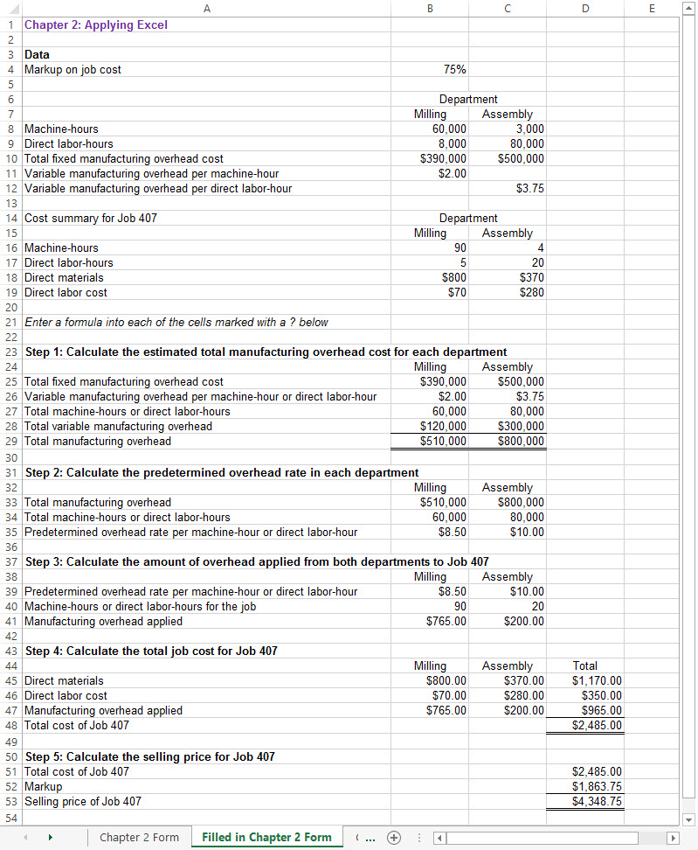

Chapter 2: Applying Excel (continued)

The completed worksheet, with formulas displayed, is shown below.

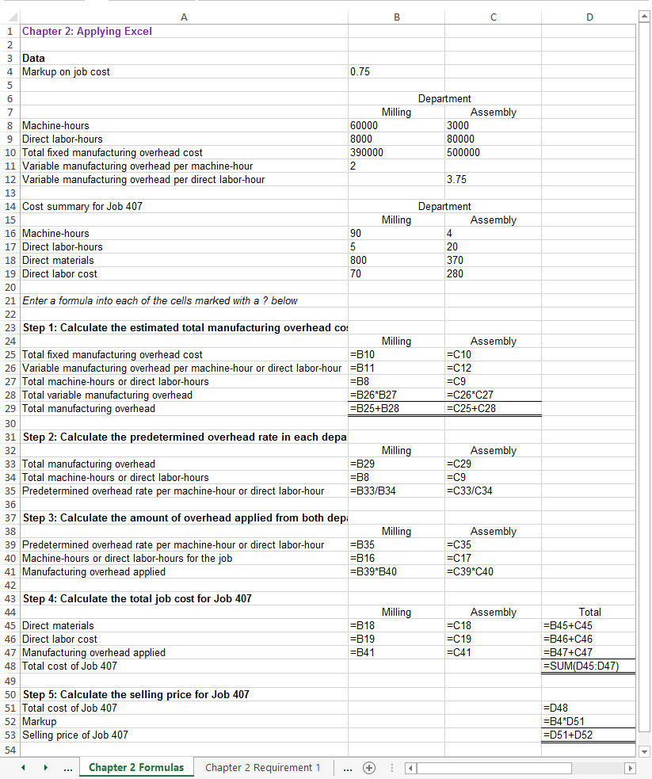

Chapter 2: Applying Excel (continued)

[Note: To display formulas in Excel 2013, select File > Options > Advanced > Display options for this worksheet > Show formulas in cells instead of their calculated amounts. To display the formulas in other versions of Excel, consult Excel Help.]

Chapter 2: Applying Excel (continued)

1. When the total fixed manufacturing overhead cost for the Milling Department is changed to $300,000, the worksheet changes as show below:

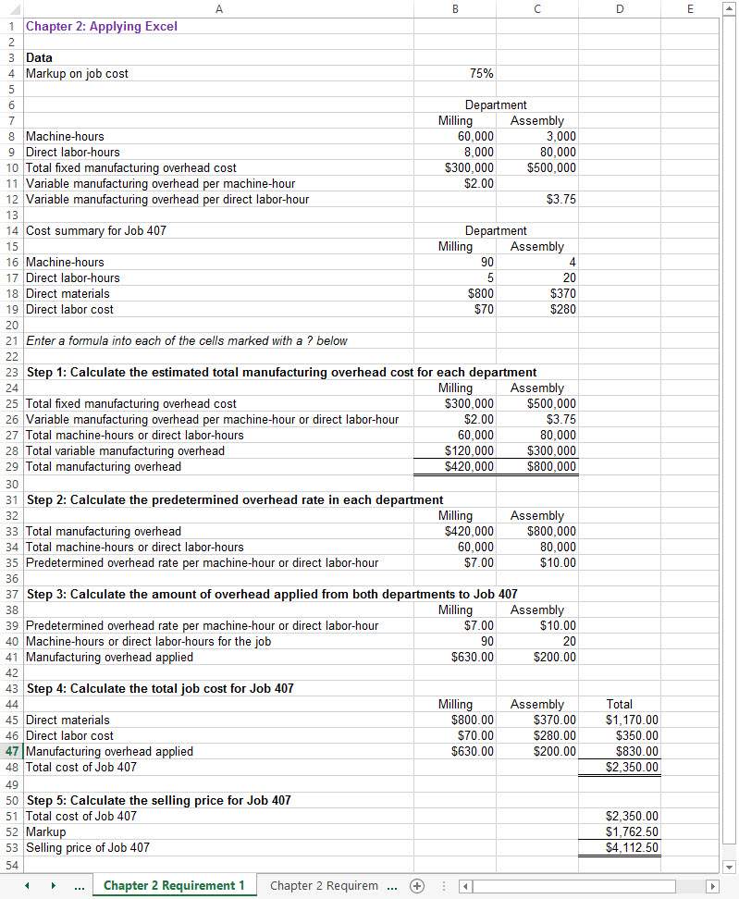

Chapter 2: Applying Excel (continued)

The selling price of Job 407 has dropped from $4,348.75 to $4,112.50 because the fixed manufacturing overhead in the Milling Department decreased from $390,000 to $300,000. This reduced the predetermined overhead rate in the Milling Department from $8.50 per machine-hour to $7.00 per machine-hour and hence the amount of overhead applied to Job 407 in the Milling Department.

Chapter 2: Applying Excel (continued)

2. For the new Job 408, the worksheet should look like the following:

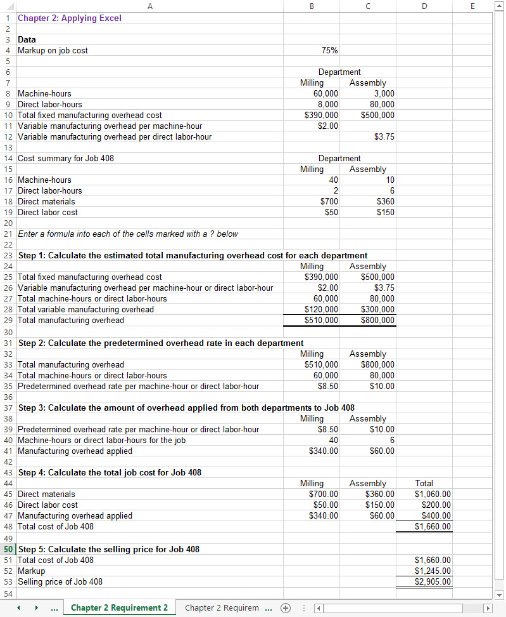

Chapter 2: Applying Excel (continued)

3. When the total number of machine-hours in the Assembly Department increases from 3,000 machine-hours to 6,000 machine-hours, the worksheet looks like the following:

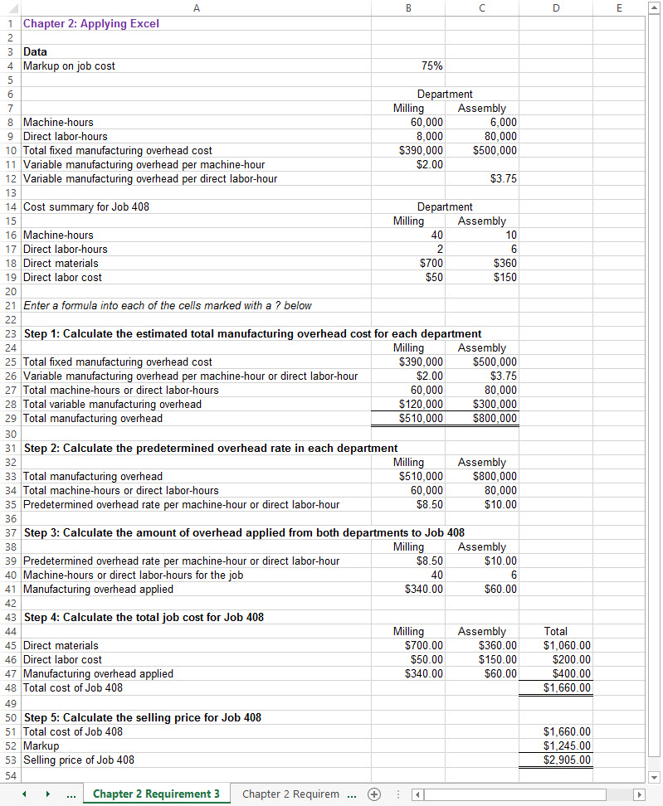

Chapter 2: Applying Excel (continued)

The selling price for Job 408 is not affected by this change. The reason for this is that the total number of machine-hours in the Assembly Department has no effect on any cost. There would have been a change in costs and in the selling price if the total machine-hours in the Milling Department would have changed. This is because the predetermined overhead rate in that department is based on machine-hours and any change in the total machine-hours would affect the magnitude of the predetermined overhead rate in that department.

Chapter 2: Applying Excel (continued)

4. When the total number of direct labor-hours in the Assembly Department decreases from 80,000 direct labor-hours to 50,000 direct labor-hours, the worksheet looks like the following:

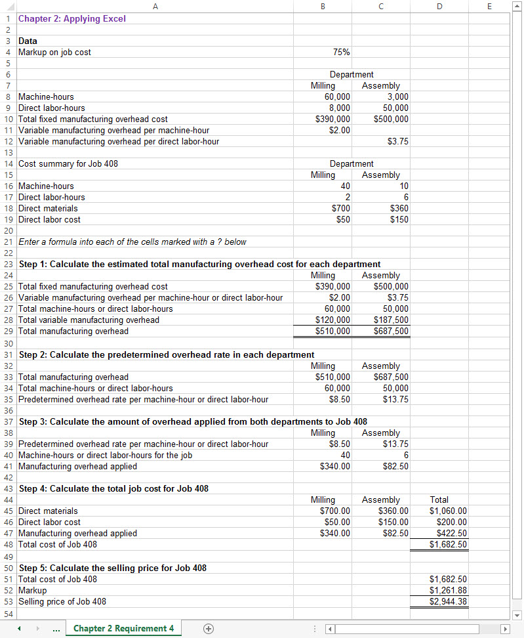

Chapter 2: Applying Excel (continued)

The selling price of Job 408 has increased from $2,905.00 to $2,944.38. This occurs because the decrease in the total number of direct labor-hours in the Assembly Department increases the predetermined overhead rate in that department from $10.00 per direct labor-hour to $13.75 per direct labor-hour. In effect, the same total fixed manufacturing overhead cost is spread across fewer total direct labor-hours.

**The Foundational 15**

1. The first step is to calculate the estimated total overhead costs in Molding and Fabrication:

Molding: Using the equation *Y* = *a* + *bX*, the estimated total manufacturing overhead cost is computed as follows:

Y = $10,000 + ($1.40 per MH)(2,500 MHs)

|  |  |  |
| --- | --- | --- |
|  | Estimated fixed manufacturing overhead | $10,000 |
|  | Estimated variable manufacturing overhead:  $1.40 per MH × 2,500 MHs | 3,500 |
|  | Estimated total manufacturing overhead cost | $13,500 |

Fabrication: Using the equation *Y* = *a* + *bX*, the estimated total manufacturing overhead cost is computed as follows:

Y = $15,000 + ($2.20 per MH)(1,500 MHs)

|  |  |  |
| --- | --- | --- |
|  | Estimated fixed manufacturing overhead | $15,000 |
|  | Estimated variable manufacturing overhead:  $2.20 per MH × 1,500 MHs | 3,300 |
|  | Estimated total manufacturing overhead cost | $18,300 |

The second step is to combine the estimated manufacturing overhead costs in Molding and Fabrication ($13,500 + $18,300 = $31,800) to enable calculating the predetermined overhead rate as follows:

|  |  |  |
| --- | --- | --- |
| Estimated total manufacturing overhead (a) | $31,800 |  |
| Estimated total machine-hours (MHs) (b) | 4,000 | MHs |
| Predetermined overhead rate (a) ÷ (b) | $7.95 | per MH |

2. The manufacturing overhead applied to Jobs P and Q is computed as follows:

|  |  |  |  |
| --- | --- | --- | --- |
|  | *Job P* | | *Job Q* |
| Actual machine-hours worked (a) | | 2,300 | 1,700 |
| Predetermined overhead rate per MH (b) | | $7.95 | $7.95 |
| Manufacturing overhead applied (a) × (b) | | $18,285 | $13,515 |

**The Foundational 15**

3. The total manufacturing cost assigned to Job P is computed as follows:

|  |  |  |
| --- | --- | --- |
|  | *Job P* | |
| Direct materials | | $13,000 |
| Direct labor | | 21,000 |
| Manufacturing overhead applied | | 18,285 |
| Total manufacturing cost | | $52,285 |

4. Job P’s unit product cost is computed as follows:

|  |  |  |
| --- | --- | --- |
|  | | *Job P* |
| Total manufacturing cost (a) | $52,285 | |
| Number of units (b) | 20 | |
| Unit product cost (rounded) (a) ÷ (b) | $2,614 | |

5. The total manufacturing cost assigned to Job Q is computed as follows:

|  |  |  |
| --- | --- | --- |
|  | *Job P* | |
| Direct materials | | $  8,000 |
| Direct labor | | 7,500 |
| Manufacturing overhead applied | | 13,515 |
| Total manufacturing cost | | $29,015 |

6. Job Q’s unit product cost is computed as follows:

|  |  |  |
| --- | --- | --- |
|  | | *Job P* |
| Total manufacturing cost (a) | $29,015 | |
| Number of units (b) | 30 | |
| Unit product cost (rounded) (a) ÷ (b) | $967 | |

7. The selling prices are calculated as follows:

|  |  |  |  |
| --- | --- | --- | --- |
|  | *Job P* | | *Job Q* |
| Total manufacturing cost | | $52,285 | $29,015 |
| Markup (based on 80%) | | 41,828 | 23,212 |
| Total price for the job (a) | | $94,113 | $52,227 |
| Number of units in the job (b) | | 20 | 30 |
| Selling price per unit (rounded) (a) ÷ (b) | | $4,706 | $1,741 |

**The Foundational 15**

8. The cost of goods sold is the sum of the manufacturing costs assigned to Jobs P and Q:

|  |  |
| --- | --- |
| Total manufacturing cost assigned to Job P | $52,285 |
| Total manufacturing cost assigned to Job Q | 29,015 |
| Cost of goods sold | $81,300 |

9. Molding: Using the equation *Y* = *a* + *bX*, the estimated total manufacturing overhead cost is computed as follows:

Y = $10,000 + ($1.40 per MH)(2,500 MHs)

|  |  |  |
| --- | --- | --- |
|  | Estimated fixed manufacturing overhead | $10,000 |
|  | Estimated variable manufacturing overhead:  $1.40 per MH × 2,500 MHs | 3,500 |
|  | Estimated total manufacturing overhead cost | $13,500 |
|  |  |  |

The predetermined overhead rate in Molding is computed as follows:

|  |  |  |
| --- | --- | --- |
| Estimated total manufacturing overhead (a) | $13,500 |  |
| Estimated total machine-hours (MHs) (b) | 2,500 | MHs |
| Predetermined overhead rate (a) ÷ (b) | $5.40 | per MH |

Fabrication: Using the equation *Y* = *a* + *bX*, the estimated total manufacturing overhead cost is computed as follows:

Y = $15,000 + ($2.20 per MH)(1,500 MHs)

|  |  |  |
| --- | --- | --- |
|  | Estimated fixed manufacturing overhead | $15,000 |
|  | Estimated variable manufacturing overhead:  $2.20 per MH × 1,500 MHs | 3,300 |
|  | Estimated total manufacturing overhead cost | $18,300 |
|  |  |  |

The predetermined overhead rate in Fabrication is computed as follows:

|  |  |  |
| --- | --- | --- |
| Estimated total manufacturing overhead (a) | $18,300 |  |
| Estimated total machine-hours (MHs) (b) | 1,500 | MHs |
| Predetermined overhead rate (a) ÷ (b) | $12.20 | per MH |

**The Foundational 15**

10. The applied overhead from Molding is computed as follows:

|  |  |  |  |
| --- | --- | --- | --- |
|  | *Job P* | | *Job Q* |
| Machine-hours worked on job (a) | | 1,700 | 800 |
| Molding overhead rate (b) | | $5.40 | $5.40 |
| Manufacturing overhead applied (a) × (b) | | $9,180 | $4,320 |

11. The applied overhead from Fabrication is computed as follows:

|  |  |  |  |
| --- | --- | --- | --- |
|  | *Job P* | | *Job Q* |
| Machine-hours worked on job (a) | | 600 | 900 |
| Fabrication overhead rate (b) | | $12.20 | $12.20 |
| Manufacturing overhead applied (a) × (b) | | $7,320 | $10,980 |

12. The unit product cost for Job P is computed as follows:

|  |  |  |  |  |  |
| --- | --- | --- | --- | --- | --- |
|  |  | | |  | |
| Direct materials | | |  | | $13,000 | |
| Direct labor | | |  | | 21,000 | |
| Manufacturing overhead applied: | |  | | |  | |
| Molding Department | | $9,180 | | |  | |
| Fabrication Department | | 7,320 | | | 16,500 | |
| Total manufacturing cost (a) |  | | | $50,500 | | |
| Number of units in the job (b) |  | | | 20 | | |
| Unit product cost (a) ÷ (b) |  | | | $2,525 | | |

13. The unit product cost for Job Q is computed as follows:

|  |  |  |  |  |  |
| --- | --- | --- | --- | --- | --- |
|  |  | | |  | |
| Direct materials | | |  | | $8,000 | |
| Direct labor | | |  | | 7,500 | |
| Manufacturing overhead applied: | |  | | |  | |
| Molding Department | | $4,320 | | |  | |
| Fabrication Department | | 10,980 | | | 15,300 | |
| Total manufacturing cost (a) |  | | | $30,800 | | |
| Number of units in the job (b) |  | | | 30 | | |
| Unit product cost (rounded) (a) ÷ (b) |  | | | $1,027 | | |

**The Foundational 15**

14. The selling prices are calculated as follows:

|  |  |  |  |
| --- | --- | --- | --- |
|  | *Job P* | | *Job Q* |
| Total manufacturing cost | | $50,500 | $30,800 |
| Markup (based on 80%) | | 40,400 | 24,640 |
| Total price for the job (a) | | $90,900 | $55,440 |
| Number of units in the job (b) | | 20 | 30 |
| Selling price per unit (a) ÷ (b) | | $4,545 | $1,848 |

15. The cost of goods sold is the sum of the manufacturing costs assigned to Jobs P and Q:

|  |  |
| --- | --- |
| Total manufacturing cost assigned to Job P | $50,500 |
| Total manufacturing cost assigned to Job Q | 30,800 |
| Cost of goods sold | $81,300 |

**Exercise 2-1** (10 minutes)

The estimated total manufacturing overhead cost is computed as follows:

Y = $94,000 + ($2.00 per DLH)(20,000 DLHs)

|  |  |  |
| --- | --- | --- |
|  | Estimated fixed manufacturing overhead | $  94,000 |
|  | Estimated variable manufacturing overhead: $2.00 per DLH × 20,000 DLHs | 40,000 |
|  | Estimated total manufacturing overhead cost | $134,000 |

The plantwide predetermined overhead rate is computed as follows:

|  |  |  |
| --- | --- | --- |
| Estimated total manufacturing overhead (a) | $134,000 |  |
| Estimated total direct labor hours (b) | 20,000 | DLHs |
| Predetermined overhead rate (a) ÷ (b) | $6.70 | per DLH |

**Exercise 2-2** (10 minutes)

|  |  |
| --- | --- |
| Actual direct labor-hours (a) | 10,800 |
| Predetermined overhead rate (b) | $23.40 |
| Manufacturing overhead applied (a) × (b) | $252,720 |

**Exercise 2-3** (10 minutes)

1. Total direct labor-hours required for Job A-500:

|  |  |
| --- | --- |
| Direct labor cost (a) | $153 |
| Direct labor wage rate per hour (b) | $17 |
| Total direct labor hours (a) ÷ (b) | 9 |

Total manufacturing cost assigned to Job A-500:

|  |  |
| --- | --- |
| Direct materials | $231 |
| Direct labor | 153 |
| Manufacturing overhead applied ($14 per DLH × 9 DLHs) | 126 |
| Total manufacturing cost | $510 |

2. Unit product cost for Job A-500:

|  |  |
| --- | --- |
| Total manufacturing cost (a) | $510 |
| Number of units in the job (b) | 40 |
| Unit product cost (a) ÷ (b) | $12.75 |

**Exercise 2-4** (10 minutes)

1 and 2.

The total direct labor-hours required for Job N-60:

|  |  |  |
| --- | --- | --- |
|  | Assembly | Testing & Packaging |
| Direct labor cost (a) | $180 | $40 |
| Direct labor wage rate per hour (b) | $20 | $20 |
| Total direct labor hours (a) ÷ (b) | 9 | 2 |

The total manufacturing cost and unit product cost for Job N-60 is computed as follows:

|  |  |  |  |  |  |
| --- | --- | --- | --- | --- | --- |
|  |  | |  | | |
| Direct materials ($340 + $25) | |  | | $365 | | |
| Direct labor ($180 + $40) | |  | | 220 | | |
| Assembly Department ($16 per DLH × 9 DLHs) | | $144 | | |  | |
| Testing & Packaging Department ($12 per DLH × 2 DLHs) | | 24 | | | 168 | |
| Total manufacturing cost | |  | $753 | | | |
|  | |  |  | | | |
| Total manufacturing cost (a) | |  | $753 | | | |
| Number of units in the job (b) | |  | 10 | | | |
| Unit product cost (a) ÷ (b) | |  | $75.30 | | | |

**Exercise 2-5** (10 minutes)

1 and 2.

The total direct labor-hours required in Finishing for Job 700:

|  |  |
| --- | --- |
|  | Finishing |
| Direct labor cost (a) | $128 |
| Direct labor wage rate per hour (b) | $16 |
| Total direct labor hours (a) ÷ (b) | 8 |

The total manufacturing cost and unit product cost for Job 700 is computed as follows:

|  |  |  |  |  |  |
| --- | --- | --- | --- | --- | --- |
|  |  | |  | | |
| Direct materials ($410 + $60) | |  | | $470 | | |
| Direct labor ($128 + $48) | |  | | 176 | | |
| Finishing Department ($18 per DLH × 8 DLHs) | | $144 | | |  | |
| Fabrication Department (110% × $60) | | 66 | | | 210 | |
| Total manufacturing cost | |  | $856 | | | |
|  | |  |  | | | |
| Total manufacturing cost (a) | |  | $856 | | | |
| Number of units in the job (b) | |  | 15 | | | |
| Unit product cost (rounded) (a) ÷ (b) | |  | $57.07 | | | |

Exercise 2-6 (10 minutes)

1. The estimated total overhead cost is computed as follows:

Y = $680,000 + ($0.50 per DLH)(80,000 DLHs)

|  |  |
| --- | --- |
| Estimated fixed overhead cost | $680,000 |
| Estimated variable overhead cost: $0.50 per DLH × 80,000 DLHs | 40,000 |
| Estimated total overhead cost | $720,000 |

The predetermined overhead rate is computed as follows:

|  |  |  |
| --- | --- | --- |
| Estimated total overhead (a) | $720,000 |  |
| Estimated total direct labor-hours (b) | 80,000 | DLHs |
| Predetermined overhead rate (a) ÷ (b) | $9.00 | per DLH |

2. Total manufacturing cost assigned to Xavier:

|  |  |
| --- | --- |
| Direct materials | $38,000 |
| Direct labor | 21,000 |
| Overhead applied ($9.00 per DLH × 280 DLHs) | 2,520 |
| Total manufacturing cost | $61,520 |

**Exercise 2-7** (20 minutes)

1. Step 1: The total direct labor-hours required for Job Omega:

|  |  |
| --- | --- |
| Direct labor cost (a) | $345,000 |
| Direct labor wage rate per hour (b) | $15 |
| Total direct labor hours worked (a) ÷ (b) | 23,000 |

Step 2: Derive the plantwide predetermined overhead rate:

|  |  |  |
| --- | --- | --- |
| Manufacturing overhead applied to Job Omega (a) | $184,000 |  |
| Direct labor hours worked on Job Omega (b) | 23,000 |  |
| Plantwide predetermined overhead rate (a) ÷ (b) | $8.00 | per DLH |

2. The job cost sheet for Job Alpha is derived as follows: (note that direct materials is the plug figure)

|  |  |
| --- | --- |
| Direct materials (plug figure) | $  280,000 |
| Direct labor (54,500 DLHs × $15 per DLH) | 817,500 |
| Manufacturing overhead applied ($8 per DLH × 54,500 DLHs) | 436,000 |
| Total job cost (given) | $1,533,500 |

**Exercise 2-8** (10 minutes)

|  |  |
| --- | --- |
| Direct material | $10,000 |
| Direct labor | 12,000 |
| Manufacturing overhead applied: |  |
| $12,000 × 125% | 15,000 |
| Total manufacturing cost | $37,000 |
|  |  |
| Total manufacturing cost (a) | $37,000 |
| Number of units in job (b) | 1,000 |
| Unit product cost (a) ÷ (b) | $37 |

**Exercise 2-9** (30 minutes)

1. The estimated total overhead cost is computed as follows:

Y = $1,980,000 + ($2.00 per MH)(165,000 MHs)

|  |  |
| --- | --- |
| Estimated fixed overhead | $1,980,000 |
| Estimated variable overhead: $2.00 per MH × 165,000 MHs | 330,000 |
| Estimated total overhead cost | $2,310,000 |

The plantwide predetermined overhead rate is computed as follows:

|  |  |  |
| --- | --- | --- |
| Estimated total overhead (a) | $2,310,000 |  |
| Estimated total machine-hours (b) | 165,000 | MHs |
| Predetermined overhead rate (a) ÷ (b) | $14.00 | per MH |

2. Total manufacturing cost assigned to Job P90:

|  |  |
| --- | --- |
| Direct materials | $1,150 |
| Direct labor | 830 |
| Overhead applied ($14 per MH × 72 MHs) | 1,008 |
| Total manufacturing cost | $2,988 |

3a. Given that the company is operating at 50% of its manufacturing capacity, an argument can made that the company should pursue any business opportunities that generate a positive a contribution margin. Based on the information provided, it appears that Job P90 does generate a positive contribution margin as shown below:

|  |  |  |
| --- | --- | --- |
| Sales |  | $2,500 |
| Direct materials | $1,150 |  |
| Direct labor | 830 |  |
| Variable overhead applied ($2.00 per MH × 72 MHs) | 144 | 2,124 |
| Contribution margin |  | $   376 |

**Exercise 2-9** (continued)

3b. The CFO’s argument is based on the assertion that Job P90 does not generate enough revenue to cover the cost of the manufacturing resources that it consumes. However, given that the company is operating at 50% of its manufacturing capacity, the overhead costs applied to Job P90 in requirement 2 do not represent the cost of the overhead resources consumed making Job P90. In other words, the overhead applied in requirement 2 includes a charge for used and unused capacity. This reality provides instructors an opportunity to introduce students to the main idea underlying Appendix 2B.

If we estimate a capacity-based overhead rate for the company and apply overhead costs to Job P90 using this rate, it reveals that the revenue generated by the job ($2,500) is still insufficient to cover its manufacturing costs of $2,556, as computed below:

The estimated total overhead cost (at capacity) is computed as follows (keep in mind that 165,000 MHs ÷ 50% = 330,000 MHs):

Y = $1,980,000 + ($2.00 per MH)(330,000 MHs)

|  |  |
| --- | --- |
| Estimated fixed overhead | $1,980,000 |
| Estimated variable overhead: $2.00 per MH × 330,000 MHs | 660,000 |
| Estimated total overhead cost | $2,640,000 |

The predetermined capacity-based overhead rate is computed as follows:

|  |  |  |
| --- | --- | --- |
| Estimated total overhead (a) | $2,640,000 |  |
| Estimated total machine-hours (b) | 330,000 | MHs |
| Predetermined overhead rate (a) ÷ (b) | $8.00 | per MH |

The total manufacturing cost assigned to Job P90 (using a capacity-based overhead rate):

|  |  |
| --- | --- |
| Direct materials | $1,150 |
| Direct labor | 830 |
| Overhead applied ($8 per MH × 72 MHs) | 576 |
| Total manufacturing cost | $2,556 |

**Exercise 2-10** (10 minutes)

1. Yes, overhead should be applied to Job W at year-end.

Because $6,000 of overhead was applied to Job V on the basis of $8,000 of direct labor cost, the company’s predetermined overhead rate must be 75% of direct labor cost.

|  |  |
| --- | --- |
| Job W direct labor cost (a) | $4,000 |
| Predetermined overhead rate (b) | 0.75 |
| Manufacturing overhead applied to Job W (a) × (b) | $3,000 |

2. The direct materials ($2,500), direct labor ($4,000), and applied overhead ($3,000) for Job W will be included in Work in Process on Sigma Corporation’s balance sheet.

**Exercise 2-11** (30 minutes)

Note to the instructor: This exercise can be used as a launching pad for a discussion of Appendix 2B.

1. The estimated total fixed manufacturing overhead can be computed using the data from any of quarters 1-3. For illustrative purposes, we’ll use the first quarter as follows:

|  |  |  |
| --- | --- | --- |
|  | Total overhead cost (First quarter) | $300,000 |
|  | Variable cost element ($2.00 per unit × 80,000 units) | 160,000 |
|  | Fixed cost element | $140,000 |
|  |  |  |

2. The fixed and variable cost estimates from requirement 1 can be used to estimate the total manufacturing overhead cost for the fourth quarter as follows:

Y = $140,000 + ($2.00 per unit)(60,000 units)

|  |  |  |  |  |
| --- | --- | --- | --- | --- |
|  | Estimated fixed manufacturing overhead | | $140,000 | |
|  | Estimated variable manufacturing overhead $2.00 per unit × 60,000 units | | 120,000 | |
|  | Estimated total manufacturing overhead cost | | $260,000 | |
|  |  | |  | |
| The estimated unit product cost for the fourth quarter is computed as follows:  Direct materials | | $180,000 | |
| Direct labor | | 96,000 | |
| Manufacturing overhead | | 260,000 | |
| Total manufacturing costs (a) | | $536,000 | |
| Number of units to be produced (b) | | 60,000 | |
| Unit product cost (rounded) (a) ÷ (b) | | $8.93 | |
|  | |  | |

**Exercise 2-11** (continued)

3. The fixed portion of the manufacturing overhead cost is causing the unit product costs to fluctuate. The unit product cost increases as the level of production decreases because the fixed overhead is spread over fewer units.

4. The unit product cost can be stabilized by using a predetermined overhead rate that is based on expected activity for the entire year. The cost formula created in requirement 1 can be adapted to compute the annual predetermined overhead rate. The annual fixed manufacturing overhead is $560,000 ($140,000 per quarter × 4 quarters). The variable manufacturing overhead per unit is $2.00. The cost formula is as follows:

Y = $560,000 + ($2.00 per unit × 200,000 units)

|  |  |  |
| --- | --- | --- |
|  | Estimated fixed manufacturing overhead | $560,000 |
|  | Estimated variable manufacturing overhead $2.00 per unit × 200,000 units | 400,000 |
|  | Estimated total manufacturing overhead cost | $960,000 |
|  |  |  |

The annual predetermined overhead rate is computed as follows:

|  |  |  |
| --- | --- | --- |
| Estimated total manufacturing overhead (a) | $960,000 |  |
| Estimated total units produced (b) | 200,000 |  |
| Predetermined overhead rate (a) ÷ (b) | $4.80 | per unit |

Using a predetermined overhead rate of $4.80 per unit, the unit product costs would stabilize as shown below:

|  |  |  |  |  |  |
| --- | --- | --- | --- | --- | --- |
|  |  | Quarter | | | |
|  |  | First | Second | Third | Fourth |
|  | Direct materials | $240,000 | $120,000 | $ 60,000 | $180,000 |
|  | Direct labor | 128,000 | 64,000 | 32,000 | 96,000 |
|  | Manufacturing overhead: at $4.80 per unit | 384,000 | 192,000 | 96,000 | 288,000 |
|  | Total cost (a) | $752,000 | $376,000 | $188,000 | $564,000 |
|  | Number of units produced (b) | 80,000 | 40,000 | 20,000 | 60,000 |
|  | Unit product cost (a) ÷ (b) | $9.40 | $9.40 | $9.40 | $9.40 |

**Exercise 2-12** (20 minutes)

1. The estimated total manufacturing overhead cost is computed as follows:

Y = $650,000 + ($3.00 per MH)(100,000 MHs)

|  |  |
| --- | --- |
| Estimated fixed manufacturing overhead | $650,000 |
| Estimated variable manufacturing overhead: $3.00 per MH × 100,000 MHs | 300,000 |
| Estimated total manufacturing overhead cost | $950,000 |

The plantwide predetermined overhead rate is computed as follows:

|  |  |  |
| --- | --- | --- |
| Estimated total manufacturing overhead (a) | $950,000 |  |
| Estimated total machine-hours (b) | 100,000 | MHs |
| Predetermined overhead rate (a) ÷ (b) | $9.50 | per MH |

2. Total manufacturing cost assigned to Job 400:

|  |  |
| --- | --- |
| Direct materials | $   450 |
| Direct labor | 210 |
| Manufacturing overhead applied ($9.50 per MH × 40 MHs) | 380 |
| Total manufacturing cost | $1,040 |

3. The unit product cost of Job 400 is computed as follows:

|  |  |
| --- | --- |
| Total manufacturing cost (a) | $1,040 |
| Number of units in the job (b) | 52 |
| Unit product cost (a) ÷ (b) | $20 |

4. The selling price per unit is computed as follows:

|  |  |
| --- | --- |
| Total manufacturing cost | $1,040 |
| Markup (120% of manufacturing cost) | 1,248 |
| Selling price for Job 400 (a) | $2,288 |
| Number of units in Job 400 (b) | 52 |
| Selling price per unit (a) ÷ (b) | $44 |

**Exercise 2-12** (continued)

5. Possible critiques of Moody’s pricing tactics include (1) relying on a plantwide overhead rate to allocate overhead costs to jobs may distort the cost base used for cost-plus pricing, (2) relying on an absorption approach may allocate unused capacity costs to jobs thereby distorting the cost base for cost-plus pricing, and (3) relying on absorption cost-plus pricing ignores the customers’ willingness to pay based on their perceived value of the product or service.

**Exercise 2-13** (20 minutes)

1. Cutting Department:

The estimated total manufacturing overhead cost in the Cutting Department is computed as follows:

Y = $264,000 + ($2.00 per MH)(48,000 MHs)

|  |  |  |
| --- | --- | --- |
|  | Estimated fixed manufacturing overhead | $264,000 |
|  | Estimated variable manufacturing overhead $2.00 per MH × 48,000 MHs | 96,000 |
|  | Estimated total manufacturing overhead cost | $360,000 |
|  |  |  |

The predetermined overhead rate is computed as follows:

|  |  |  |
| --- | --- | --- |
| Estimated total manufacturing overhead (a) | $360,000 |  |
| Estimated total machine-hours (b) | 48,000 | MHs |
| Predetermined overhead rate (a) ÷ (b) | $7.50 | per MH |

Finishing Department:

The estimated total manufacturing overhead cost in the Finishing Department is computed as follows:

Y = $366,000 + ($4.00 per DLH)(30,000 DLHs)

|  |  |  |
| --- | --- | --- |
|  | Estimated fixed manufacturing overhead | $366,000 |
|  | Estimated variable manufacturing overhead $4.00 per DLH × 30,000 DLHs | 120,000 |
|  | Estimated total manufacturing overhead cost | $486,000 |
|  |  |  |

The predetermined overhead rate is computed as follows:

|  |  |  |
| --- | --- | --- |
| Estimated total manufacturing overhead (a) | $486,000 |  |
| Estimated total direct labor-hours (b) | 30,000 | DLHs |
| Predetermined overhead rate (a) ÷ (b) | $16.20 | per DLH |

**Exercise 2-13** (continued)

|  |  |  |  |
| --- | --- | --- | --- |
| 2. | Total manufacturing cost assigned to Job 203: |  |  |
|  | Direct materials ($500 + $310) |  | $  810 |
|  | Direct labor ($108 + $360) |  | 468 |
|  | Cutting Department (80 MHs × $7.50 per MH) | $600 |  |
|  | Finishing Department (20 DLH × $16.20 per DLH) | 324 | 924 |
|  | Total manufacturing cost |  | $2,202 |
|  |  |  |  |

3. Yes; if some jobs require a large amount of machine time and a small amount of labor time, they would be charged substantially less overhead cost if a plantwide overhead rate based on direct labor hours were used. It appears, for example, that this would be true of Job 203 which required considerable machine time to complete, but required a relatively small amount of labor hours.

**Exercise 2-14** (10 minutes)

1. The estimated total overhead cost is computed as follows:

Y = $4,800,000 + ($0.05 per DL$)($8,000,000)

|  |  |
| --- | --- |
| Estimated fixed overhead | $4,800,000 |
| Estimated variable overhead: $0.05 per DL$ × $8,000,000 DL$ | 400,000 |
| Estimated total overhead cost | $5,200,000 |

The predetermined overhead rate is computed as follows:

|  |  |  |
| --- | --- | --- |
| Estimated total overhead (a) | $5,200,000 |  |
| Estimated total direct labor-dollars (b) | 8,000,000 | DL$ |
| Predetermined overhead rate (a) ÷ (b) | $0.65 | per DL$ |

2. Total cost assigned to *You Can Say That Again*:

|  |  |
| --- | --- |
| Direct materials | $1,259,000 |
| Direct labor | 2,400,000 |
| Overhead applied ($0.65 per DL$ × $2,400,000) | 1,560,000 |
| Total job cost | $5,219,000 |

**Exercise 2-15** (45 minutes)

1a. The first step is to calculate the estimated total overhead costs in Molding and Fabrication:

Molding: Using the equation *Y* = *a* + *bX*, the estimated total manufacturing overhead cost would be calculated as follows:

Y = $700,000 + ($3.00 per MH)(20,000 MHs)

|  |  |
| --- | --- |
| Estimated fixed manufacturing overhead | $700,000 |
| Estimated variable manufacturing overhead: $3.00 per MH × 20,000 MHs | 60,000 |
| Estimated total manufacturing overhead cost | $760,000 |

Fabrication: Using the equation *Y* = *a* + *bX*, the estimated total manufacturing overhead cost would be calculated as follows:

Y = $210,000 + ($1.00 per MH)(30,000 MHs)

|  |  |
| --- | --- |
| Estimated fixed manufacturing overhead | $210,000 |
| Estimated variable manufacturing overhead: $1.00 per MH × 30,000 MHs | 30,000 |
| Estimated total manufacturing overhead cost | $240,000 |

The second step is to combine the estimated manufacturing overhead costs in Molding and Fabrication ($760,000 + $240,000 = $1,000,000) to enable calculating the predetermined overhead rate as follows:

|  |  |  |
| --- | --- | --- |
| Estimated total manufacturing overhead (a) | $1,000,000 |  |
| Estimated total machine-hours (b) | 50,000 | MHs |
| Predetermined overhead rate (a) ÷ (b) | $20.00 | per MH |

**Exercise 2-15** (continued)

1b. Total manufacturing cost assigned to Jobs D-70 and C-200:

|  |  |  |  |  |
| --- | --- | --- | --- | --- |
|  | *D-70* | | *C-200* | |
| Direct materials | $  700,000 | | $  550,000 | |
| Direct labor | 360,000 | | 400,000 | |
| Manufacturing overhead applied ($20.00 per MH × 20,000 MHs; $20.00 per MH × 30,000 MHs) | 400,000 | | 600,000 | |
| Total manufacturing cost | $1,460,000 | | $1,550,000 | |
|  | |  | |  | |
| 1c. Bid prices for Jobs D-70 and C-200: | |  | |  | |
|  | *D-70* | | | *C-200* | |
| Total manufacturing cost (a) | $1,460,000 | | $1,550,000 | | |
| Markup percentage (b) | 150% | | 150% | | |
| Bid price (a) × (b) | $2,190,000 | | $2,325,000 | | |

1d. Because the company has no beginning or ending inventories and only Jobs D-70 and C-200 were started, completed, and sold during the year, the cost of goods sold is equal to the sum of the manufacturing costs assigned to both jobs of $3,010,000 (=$1,460,000 + $1,550,000).

**Exercise 2-15** (continued)

2a. Molding Department:

Using the equation *Y* = *a* + *bX*, the estimated total manufacturing overhead cost would be depicted as follows:

Y = $700,000 + ($3.00 per MH)(20,000 MHs)

|  |  |
| --- | --- |
| Estimated fixed manufacturing overhead | $700,000 |
| Estimated variable manufacturing overhead: $3.00 per MH × 20,000 MHs | 60,000 |
| Estimated total manufacturing overhead cost | $760,000 |

The predetermined overhead rate is computed as follows:

|  |  |  |
| --- | --- | --- |
| Estimated total manufacturing overhead (a) | $760,000 |  |
| Estimated total machine-hours (b) | 20,000 | MHs |
| Predetermined overhead rate (a) ÷ (b) | $38.00 | per MH |

Fabrication Department:

Using the equation *Y* = *a* + *bX*, the estimated total manufacturing overhead cost would be depicted as follows:

Y = $210,000 + ($1.00 per MH)(30,000 MHs)

|  |  |
| --- | --- |
| Estimated fixed manufacturing overhead | $210,000 |
| Estimated variable manufacturing overhead: $1.00 per MH × 30,000 MHs | 30,000 |
| Estimated total manufacturing overhead cost | $240,000 |

The predetermined overhead rate is computed as follows:

|  |  |  |
| --- | --- | --- |
| Estimated total manufacturing overhead (a) | $240,000 |  |
| Estimated total direct labor-hours (b) | 30,000 | MHs |
| Predetermined overhead rate (a) ÷ (b) | $8.00 | per MH |

**Exercise 2-15** (continued)

2b. Total manufacturing costs assigned to Jobs D-70 and C-200:

|  |  |  |  |  |  |  |
| --- | --- | --- | --- | --- | --- | --- |
|  | | *D-70* | | | *C-200* | |
| Direct materials | | $  700,000 | | | $  550,000 | |
| Direct labor | | 360,000 | | | 400,000 | |
| Molding Department (14,000 MHs × $38 per MH; 6,000 MHs × $38 per MH) | | 532,000 | | | 228,000 | |
| Fabrication Department (6,000 MH × $8 per MH; 24,000 MH × $8 per MH) | | 48,000 | | | 192,000 | |
| Total manufacturing cost | | $1,640,000 | | | $1,370,000 | |
| 2c. Bid prices for Jobs D-70 and C-200: | | | |  | |  | |
|  | | *D-70* | | | | *C-200* | |
| Total manufacturing cost (a) | | $1,640,000 | | | $1,370,000 | |
| Markup percentage (b) | | 150% | | | 150% | |
| Bid price (a) × (b) | | $2,460,000 | | | $2,055,000 | |

2d. Because the company has no beginning or ending inventories and only Jobs D-70 and C-200 were started, completed, and sold during the year, the cost of goods sold is equal to the sum of the manufacturing costs assigned to both jobs of $3,010,000 (=$1,640,000 + $1,370,000).

3. The plantwide and departmental approaches for applying manufacturing overhead costs to products produce identical cost of goods sold figures. However, these two approaches lead to different bid prices for Jobs D-70 and C-200. The bid price for Job D-70 using the departmental approach is $270,000 (=$2,460,000 ‒ $2,190,000) higher than the bid price using the plantwide approach. This is because the departmental cost pools reflect the fact that Job D-70 is an intensive user of Molding machine-hours. The overhead rate in Molding ($38) is much higher than the overhead rate in Fabrication ($8). Conversely, Job C-200 is an intensive user of the less-expensive Fabrication machine-hours, so its departmental bid price is $270,000 lower than the plantwide bid price.

**Exercise 2-15** (continued)

Whether a job-order costing system relies on plantwide overhead cost allocation or departmental overhead cost allocation does not usually have an important impact on the accuracy of the cost of goods sold reported for the company as a whole. However, it can have a huge impact on internal decisions with respect to individual jobs, such as establishing bid prices for those jobs. Job-order costing systems that rely on plantwide overhead cost allocation are commonly used to value ending inventories and cost of goods sold for external reporting purposes, but they can create costing inaccuracies for individual jobs that adversely influence internal decision making.

**Problem 2-16** (30 minutes)

1a. The estimated total overhead cost is computed as follows:

Y = $784,000 + ($2.00 per DLH)(140,000 DLHs)

|  |  |
| --- | --- |
| Estimated fixed manufacturing overhead | $   784,000 |
| Estimated variable manufacturing overhead: $2.00 per DLH × 140,000 DLH | 280,000 |
| Estimated total manufacturing overhead cost | $1,064,000 |

The predetermined overhead rate is computed as follows:

|  |  |  |
| --- | --- | --- |
| Estimated total manufacturing overhead (a) | $1,064,000 |  |
| Estimated total direct labor-hours (b) | 140,000 | DLH |
| Predetermined overhead rate (a) ÷ (b) | $7.60 | per DLH |

1b. Total manufacturing cost assigned to Job 550:

|  |  |
| --- | --- |
| Direct materials | $175 |
| Direct labor | 225 |
| Manufacturing overhead applied ($7.60 per DLH × 15 DLH) | 114 |
| Total manufacturing cost of Job 550 | $514 |

1c. The selling price for Job 550 is computed as follows:

|  |  |  |
| --- | --- | --- |
|  | *Job 550* | |
| Total manufacturing cost | $   514 |
| Markup (200%) | 1,028 |
| Selling price | $1,542 |

**Problem 2-16** (continued)

2a. The estimated total overhead cost is computed as follows:

Y = $784,000 + ($4.00 per MH)(70,000 MHs)

|  |  |
| --- | --- |
| Estimated fixed manufacturing overhead | $   784,000 |
| Estimated variable manufacturing overhead: $4.00 per MH × 70,000 MHs | 280,000 |
| Estimated total manufacturing overhead cost | $1,064,000 |

The predetermined overhead rate is computed as follows:

|  |  |  |
| --- | --- | --- |
| Estimated total manufacturing overhead (a) | $1,064,000 |  |
| Estimated total machine-hours (b) | 70,000 | MHs |
| Predetermined overhead rate (a) ÷ (b) | $15.20 | per MH |

2b. Total manufacturing cost assigned to Job 550:

|  |  |
| --- | --- |
| Direct materials | $175 |
| Direct labor | 225 |
| Manufacturing overhead applied ($15.20 per MH × 5 MH) | 76 |
| Total manufacturing cost of Job 550 | $476 |

2c. The selling price for Job 550 is computed as follows:

|  |  |  |
| --- | --- | --- |
|  | *Job 550* | |
| Total manufacturing cost | $   476 |
| Markup (200%) | 952 |
| Selling price | $1,428 |

3. The price for Job 550 using direct labor-hours as the allocation base ($1,542) is $114 higher than the price derived using machine-hours as the allocation base ($1,428). If machine-hours is the better choice for an allocation base, then if Landen continues to use direct labor-hours as its overhead allocation base, it will overprice jobs that are intensive users of direct labor-hours and non-intensive users of machine-hours. In a bidding situation, Landen will tend to lose bids on jobs such as Job 550 if its competitors have more accurate cost accounting systems.

**Problem 2-17** (20 minutes)

1. The predetermined plantwide overhead rate is computed as follows:

|  |  |  |
| --- | --- | --- |
| Estimated manufacturing overhead (a) | $1,400,000 |  |
| Estimated total direct labor-hours (b) | 80,000 | DLHs |
| Predetermined overhead rate (a) ÷ (b) | $17.50 | per DLH |

The overhead applied to Job Bravo is computed as follows:

|  |  |  |
| --- | --- | --- |
| Direct labor-hours worked on Bravo (a) | 14 |  |
| Predetermined overhead rate (b) | $17.50 | per DLH |
| Overhead applied to Bravo (a) × (b) | $245 |  |

2. The predetermined overhead rate in Assembly is computed as follows:

|  |  |  |
| --- | --- | --- |
| Estimated manufacturing overhead (a) | $600,000 |  |
| Estimated total direct labor-hours (b) | 50,000 | DLHs |
| Predetermined overhead rate (a) ÷ (b) | $12.00 | per DLH |

The predetermined overhead rate in Fabrication is computed as follows:

|  |  |  |
| --- | --- | --- |
| Estimated manufacturing overhead (a) | $800,000 |  |
| Estimated total machine-hours (b) | 100,000 | MHs |
| Predetermined overhead rate (a) ÷ (b) | $8.00 | per MH |

The overhead applied to Job Bravo is computed as follows:

|  |  |  |  |  |  |
| --- | --- | --- | --- | --- | --- |
|  | | Assembly | | Fabrication | Total |
| Quantity of allocation base used (a) | | 11 | 6 |  |
| Predetermined overhead rate (b) | | $12.00 | $8.00 |  |
| Overhead applied to Bravo (a) × (b) | | $132 | $48 | $180 |

**Problem 2-18** (15 minutes)

1. The estimated total overhead cost is computed as follows:

Y = $350,000 + ($1.00 per DLH)(20,000 DLHs)

|  |  |
| --- | --- |
| Estimated fixed overhead | $350,000 |
| Estimated variable overhead: $1.00 per DLH × 20,000 DLHs | 20,000 |
| Estimated total overhead cost | $370,000 |

The predetermined overhead rate is computed as follows:

|  |  |  |
| --- | --- | --- |
| Estimated total overhead (a) | $370,000 |  |
| Estimated total direct labor-hours (b) | 20,000 | DLHs |
| Predetermined overhead rate (a) ÷ (b) | $18.50 | per DLH |

2. Total manufacturing cost assigned to Mr. Wilkes:

|  |  |
| --- | --- |
| Direct materials | $590 |
| Direct labor | 109 |
| Overhead applied ($18.50 per DLH × 6 DLH) | 111 |
| Total cost assigned to Mr. Wilkes | $810 |

3. The price charged to Mr. Wilkes is computed as follows:

|  |  |  |
| --- | --- | --- |
|  | *Job 550* | |
| Total manufacturing cost | $   810 |
| Markup (40%) | 324 |
| Selling price | $1,134 |

**Problem 2-19** (20 minutes)

1. Molding Department:

The estimated total manufacturing overhead cost in the Molding Department is computed as follows:

Y = $497,000 + $1.50 per MH × 70,000 MHs

|  |  |  |
| --- | --- | --- |
|  | Estimated fixed manufacturing overhead | $497,000 |
|  | Estimated variable manufacturing overhead: $1.50 per MH × 70,000 MHs | 105,000 |
|  | Estimated total manufacturing overhead cost | $602,000 |
|  |  |  |

The predetermined overhead rate is computed as follows:

|  |  |  |  |
| --- | --- | --- | --- |
|  | Estimated total manufacturing overhead (a) | $602,000 |  |
|  | Estimated total machine-hours (b) | 70,000 | MHs |
|  | Predetermined overhead rate (a) ÷ (b) | $8.60 | per MH |

Painting Department:

The estimated total manufacturing overhead cost in the Painting Department is computed as follows:

Y = $615,000 + $2.00 per DLH × 60,000 DLHs

|  |  |  |
| --- | --- | --- |
|  | Estimated fixed manufacturing overhead | $615,000 |
|  | Estimated variable manufacturing overhead:  $2.00 per DLH × 60,000 DLHs | 120,000 |
|  | Estimated total manufacturing overhead cost | $735,000 |
|  |  |  |

The predetermined overhead rate is computed as follows:

|  |  |  |  |
| --- | --- | --- | --- |
|  | Estimated total manufacturing overhead (a) | $735,000 |  |
|  | Estimated total DLHs (b) | 60,000 | DLHs |
|  | Predetermined overhead rate (a) ÷ (b) | $12.25 | per DLH |

**Problem 2-19** (continued)

|  |  |  |
| --- | --- | --- |
| 2. | Molding Department overhead applied:  110 machine-hours × $8.60 per machine-hour | $   946 |
|  | Painting Department overhead applied:  84 direct labor-hours × $12.25 per DLH | 1,029 |
|  | Total overhead cost | $1,975 |

3. Total cost of Job 205:

|  |  |  |  |
| --- | --- | --- | --- |
|  | Molding  Dept. | Painting  Dept. | Total |
| Direct materials | $   770 | $1,332 | $2,102 |
| Direct labor | 525 | 1,470 | 1,995 |
| Manufacturing overhead applied | 946 | 1,029 | 1,975 |
| Total manufacturing cost | $2,241 | $3,831 | $6,072 |

Unit product cost for Job 205:

|  |  |  |
| --- | --- | --- |
| Total manufacturing cost (a) | $6,072 |  |
| Number of units in the job (b) | 50 | units |
| Unit product cost (a) ÷ (b) | $121.44 | per unit |

**Problem 2-20** (45 minutes)

1a. The first step is to calculate the total estimated overhead costs in ICU and Other:

ICU: Using the equation *Y* = *a* + *bX*, the estimated total overhead cost would be calculated as follows:

Y = $3,200,000 + ($236 per patient-day)(2,000 patient-days)

|  |  |  |
| --- | --- | --- |
|  | Estimated fixed overhead | $3,200,000 |
|  | Estimated variable overhead: $236 per patient-day × 2,000 patient-days | 472,000 |
|  | Estimated total overhead cost | $3.672,000 |

Other: Using the equation *Y* = *a* + *bX*, the estimated total overhead cost would be calculated as follows:

Y = $14,000,000 + ($96 per patient-day)(18,000 patient-days)

|  |  |  |
| --- | --- | --- |
|  | Estimated fixed overhead | $14,000,000 |
|  | Estimated variable overhead: $96 per patient-day × 18,000 patient-days | 1,728,000 |
|  | Estimated total overhead cost | $15.728,000 |

The second step is to combine the estimated overhead costs in ICU and Other ($3,672,000 + $15,728,000 = $19,400,000) to enable calculating the predetermined overhead rate as follows:

|  |  |  |  |
| --- | --- | --- | --- |
|  | Estimated total overhead (a) | $19,400,000 |  |
|  | Estimated total patient-days (b) | 20,000 | patient-days | |
|  | Predetermined overhead rate (a) ÷ (b) | $970 | per patient-day | |

**Problem 2-20** (continued)

1b. The total cost assign to Patients A and B is computed as follows:

|  |  |  |
| --- | --- | --- |
|  | Patient A | Patient B |
| Direct materials | $  4,500 | $  6,200 |
| Direct labor | 25,000 | 36,000 |
| Overhead applied ($970 per patient-day × 14 patient days; ($970 per patient-day × 21 patient days) | 13,580 | 20,370 |
| Total cost | $43,080 | $62,570 |

2a. The overhead rate in ICU is computed as follows:

Y = $3,200,000 + ($236 per patient-day)(2,000 patient-days)

|  |  |  |  |  |
| --- | --- | --- | --- | --- |
|  | | Estimated fixed overhead | $3,200,000 | |
|  | | Estimated variable overhead: $236 per patient-day × 2,000 patient-days | 472,000 | |
|  | | Estimated total overhead cost | $3,672,000 | |
|  |  | | |  |

The predetermined overhead rate is computed as follows:

|  |  |  |  |
| --- | --- | --- | --- |
|  | Estimated total overhead (a) | $3,672,000 |  |
|  | Estimated total patient-days (b) | 2,000 | patient-days | |
|  | Predetermined overhead rate (a) ÷ (b) | $1,836 | per patient-day | |

The overhead rate in Other is computed as follows:

Y = $14,000,000 + ($96 per patient-day)(18,000 patient-days)

|  |  |  |  |
| --- | --- | --- | --- |
|  | Estimated fixed overhead | $14,000,000 | |
|  | Estimated variable overhead: $96 per patient-day × 18,000 patient-days | 1,728,000 | |
|  | Estimated total overhead cost | $15,728,000 | |
|  |  | |  |

The predetermined overhead rate is computed as follows:

|  |  |  |  |
| --- | --- | --- | --- |
|  | Estimated total overhead (a) | $15,728,000 |  |
|  | Estimated total patient-days (b) | 18,000 | patient-days | |
|  | Predetermined overhead rate (rounded) (a) ÷ (b) | $873.78 | per patient-day | |

**Problem 2-20** (continued)

|  |  |  |  |  |  |
| --- | --- | --- | --- | --- | --- |
| 2b. | The total cost assigned to Patient A: | |  |  | |
|  | Direct materials |  | | | $  4,500 | |
|  | Direct labor |  | | | 25,000 | |
|  | ICU ($1,836 per patient-day × 0 patient-days) | $       0 | | |  | |
|  | Other ($873.78 per patient day × 14 patient-days) (rounded to nearest dollar) | 12,233 | | | 12,233 | |
|  | Total cost assigned to Patient A | |  | | $41,733 | |

|  |  |  |  |  |  |
| --- | --- | --- | --- | --- | --- |
|  | The total cost assigned to Patient B: | |  |  | |
|  | Direct materials |  | | | $  6,200 | |
|  | Direct labor |  | | | 36,000 | |
|  | ICU ($1,836 per patient-day × 7 patient-days) | $12,852 | | |  | |
|  | Other ($873.78 per patient day × 14 patient-days) (rounded to nearest dollar) | 12,233 | | | 25,085 | |
|  | Total cost assigned to Patient B | |  | | $67,285 | |

3. Relying on just one predetermined overhead rates overlooks the fact that some departments are more intensive users of overhead resources than others. As the name implies, patients in the ICU require more intensive (and expensive) care than other patients in other departments. Broadly, speaking, relying on only one overhead rate, will most likely overcost patients with less severe illnesses and undercost patients with more severe illnesses.

**Problem 2-21** (30 minutes)

1. The plantwide predetermined overhead rate is computed as follows:

|  |  |  |
| --- | --- | --- |
| Estimated manufacturing overhead (a) | $600,000 |  |
| Estimated total direct labor-hours (b) | 60,000 | DLHs |
| Predetermined overhead rate (a) ÷ (b) | $10 | per DLH |

The overhead applied to Job A is computed as follows:

|  |  |  |
| --- | --- | --- |
| Direct labor-hours worked on Job A (a) | 15 |  |
| Predetermined overhead rate (b) | $10 | per DLH |
| Overhead applied to Job A (a) × (b) | $150 |  |

The overhead applied to Job B is computed as follows:

|  |  |  |
| --- | --- | --- |
| Direct labor-hours worked on Job B (a) | 9 |  |
| Predetermined overhead rate (b) | $10 | per DLH |
| Overhead applied to Job B (a) × (b) | $90 |  |

2. The predetermined overhead rate in Machining is computed as follows:

|  |  |  |
| --- | --- | --- |
| Estimated manufacturing overhead (a) | $500,000 |  |
| Estimated total machine-hours (b) | 50,000 | MHs |
| Predetermined overhead rate (a) ÷ (b) | $10 | per MH |

The predetermined overhead rate in Assembly is computed as follows:

|  |  |  |
| --- | --- | --- |
| Estimated manufacturing overhead (a) | $100,000 |  |
| Estimated total direct labor-hours (b) | 50,000 | DLHs |
| Predetermined overhead rate (a) ÷ (b) | $2 | per DLH |

The overhead applied to Job A is computed as follows:

|  |  |  |  |  |  |  |
| --- | --- | --- | --- | --- | --- | --- |
|  | | Machining | | Assembly | Total |  |
| Quantity of allocation base used (a) | | 11 | 10 |  |  |
| Predetermined overhead rate (b) | | $10 | $2 |  |  |
| Overhead applied to Job A (a) × (b) | | $110 | $20 | $130 |  |

**Problem 2-21** (continued)

The overhead applied to Job B is computed as follows:

|  |  |  |  |  |  |  |
| --- | --- | --- | --- | --- | --- | --- |
|  | | Machining | | Assembly | Total |  |
| Quantity of allocation base used (a) | | 12 | 5 |  |  |
| Predetermined overhead rate (b) | | $10 | $2 |  |  |
| Overhead applied to Job B (a) × (b) | | $120 | $10 | $130 |  |

3. The plantwide approach will overcost jobs that are intensive users of Assembly and minimal users of Machining. Conversely, it will undercost products that are intensive users of Machining and minimal users of Assembly. These cost distortions will adversely impact the company’s pricing process. Jobs that get overcosted will have selling prices that are greater than the prices that would be established using departmental overhead allocation. Jobs that get undercosted will have selling prices that are less than the prices that would be established using departmental overhead allocation.

**Case 2-22** (60 minutes)

|  |  |  |
| --- | --- | --- |
| 1. | a. |  |

b. The manufacturing overhead cost applied to the Koopers job is computed as follows:

$9,500 × 140% = $13,300

|  |  |  |  |  |  |
| --- | --- | --- | --- | --- | --- |
| 2. | a. |  | Fabricating Department | Machining Department | Assembly Department |
|  |  | Estimated manufacturing overhead cost (a) | $350,000 | $400,000 | $ 90,000 |
|  |  | Estimated direct labor cost (b) | $200,000 | $100,000 | $300,000 |
|  |  | Predetermined overhead rate (a) ÷ (b) | 175% | 400% | 30% |

|  |  |  |  |
| --- | --- | --- | --- |
|  | b. | Fabricating Department: |  |
|  |  | $2,800 × 175% | $4,900 |
|  |  | Machining Department: |  |
|  |  | $500 × 400% | 2,000 |
|  |  | Assembly Department: |  |
|  |  | $6,200 × 30% | 1,860 |
|  |  | Total applied overhead | $8,760 |

3. The bulk of the labor cost on the Koopers job is in the Assembly Department, which incurs very little overhead cost. The department has an overhead rate of only 30% of direct labor cost as compared to much higher rates in the other two departments. Therefore, as shown above, use of departmental overhead rates results in a relatively small amount of overhead cost being charged to the job.

Use of a plantwide overhead rate in effect redistributes overhead costs proportionately between the three departments (at 140% of direct labor

**Case 2-22** (continued)

cost) and results in a large amount of overhead cost being charged to the Koopers job, as shown in Part 1. This may explain why the company

bid too high and lost the job. Too much overhead cost was assigned to the job for the kind of work being done on the job in the plant.

On jobs that require a large amount of labor in the Fabricating or Machining Departments the opposite will be true, and the company will tend to charge too little overhead cost to the jobs if a plantwide overhead rate is being used. The reason is that the plantwide overhead rate (140%) is much lower than the rates would be if these departments were considered separately.

4. The company’s bid was:

|  |  |
| --- | --- |
| Direct materials | $ 4,600 |
| Direct labor | 9,500 |
| Manufacturing overhead applied (see requirement 1b) | 13,300 |
| Total manufacturing cost | $27,400 |
| Bidding rate | × 1.5 |
| Total bid price | $41,100 |

If departmental overhead rates had been used, the bid would have been:

|  |  |
| --- | --- |
| Direct materials | $ 4,600 |
| Direct labor | 9,500 |
| Manufacturing overhead applied (see requirement 2b) | 8,760 |
| Total manufacturing cost | $22,860 |
| Bidding rate | × 1.5 |
| Total bid price | $34,290 |

Note that if departmental overhead rates had been used, Teledex Company would have been the low bidder on the Koopers job because the competitor underbid Teledex by only $2,000.

Appendix 2A

Activity-Based Absorption Costing

**Exercise 2A-1** (20 minutes)

1. Activity rates are computed as follows:

|  |  |  |  |  |  |
| --- | --- | --- | --- | --- | --- |
| Activity Cost Pool | (a)  Estimated  Overhead  Cost | (b)  Expected  Activity | | (a) ÷ (b)  Activity  Rate | |
| Machine setups | $72,000 | 400 | setups | $180 | per setup |
| Special processing | $200,000 | 5,000 | MHs | $40 | per MH |
| General factory | $816,000 | 24,000 | DLHs | $34 | per DLH |

**Exercise 2A-1** (continued)

2. Overhead is assigned to the two products as follows:

*Hubs:*

|  |  |  |  |  |  |  |
| --- | --- | --- | --- | --- | --- | --- |
|  | Activity Cost Pool | (a) Activity Rate | | (b) Activity | | (a) × (b) ABC Cost |
|  | Machine setups | $180 | per setup | 100 | setups | $ 18,000 |
|  | Special processing | $40 | per MH | 5,000 | MHs | 200,000 |
|  | General factory | $34 | per DLH | 8,000 | DLHs | 272,000 |
|  | Total |  |  |  |  | $490,000 |

*Sprockets:*

|  |  |  |  |  |  |  |
| --- | --- | --- | --- | --- | --- | --- |
|  | Activity Cost Pool | (a) Activity Rate | | (b) Activity | | (a) × (b) ABC Cost |
|  | Machine setups | $180 | per setup | 300 | setups | $ 54,000 |
|  | Special processing | $40 | per MH | 0 | MHs | 0 |
|  | General factory | $34 | per DLH | 16,000 | DLHs | 544,000 |
|  | Total |  |  |  |  | $598,000 |

**Exercise 2A-1** (continued)

2. Each product’s unit product cost is computed as follows:

|  |  |  |
| --- | --- | --- |
|  | Hubs | Sprockets |
| Direct materials | $32.00 | $18.00 |
| Direct labor: |  |  |
| $15 per DLH × 0.80 DLHs per unit | 12.00 |  |
| $15 per DLH × 0.40 DLHs per unit |  | 6.00 |
| Overhead: |  |  |
| $490,000 ÷ 10,000 units | 49.00 |  |
| $598,000 ÷ 40,000 units |  | 14.95 |
| Unit product cost | $93.00 | $38.95 |

**Exercise 2A-2** (45 minutes)

1. The unit product costs under the company's traditional costing system would be computed as follows:

|  |  |  |  |
| --- | --- | --- | --- |
|  | Rascon | Parcel | Total |
| Number of units produced (a) | 20,000 | 80,000 |  |
| Direct labor-hours per unit (b) | 0.40 | 0.20 |  |
| Total direct labor-hours (a) × (b) | 8,000 | 16,000 | 24,000 |

|  |  |  |
| --- | --- | --- |
| Total manufacturing overhead (a) | $576,000 |  |
| Total direct labor-hours (b) | 24,000 | DLHs |
| Predetermined overhead rate (a) ÷ (b) | $24.00 | per DLH |

|  |  |  |
| --- | --- | --- |
|  | Rascon | Parcel |
| Direct materials | $13.00 | $22.00 |
| Direct labor | 6.00 | 3.00 |
| Manufacturing overhead applied: |  |  |
| 0.40 DLH per unit × $24.00 per DLH | 9.60 |  |
| 0.20 DLH per unit × $24.00 per DLH |  | 4.80 |
| Unit product cost | $28.60 | $29.80 |

**Exercise 2A-2** (continued)

2. The unit product costs using activity-based absorption costing can be computed as follows:

|  |  |  |  |  |  |
| --- | --- | --- | --- | --- | --- |
| Activity Cost Pool | Estimated  Overhead  Cost* | (b)  Expected Activity | | (a) ÷ (b)  Activity Rate | |
| Labor related | $288,000 | 24,000 | direct labor-hours | $12.00 | per direct labor-hour |
| Engineering design | $288,000 | 6,000 | engineering-hours | $48.00 | per engineering-hour |
|  | $576,000 |  |  |  |  |

*The total estimated manufacturing overhead cost of $576,000 is split evenly between the two activity cost pools.

Manufacturing overhead is assigned to the two products as follows:

Rascon:

|  |  |  |  |  |  |  |
| --- | --- | --- | --- | --- | --- | --- |
|  | Activity Cost Pool | (a) Activity Rate | | (b) Activity | | (a) × (b) ABC Cost |
|  | Labor related | $12 | per DLH | 8,000 | DLHs | $  96,000 |
|  | Engineering design | $48 | per engineering-hour | 3,000 | engineering-hours | 144,000 |
|  | Total |  |  |  |  | $240,000 |

Parcel:

|  |  |  |  |  |  |  |
| --- | --- | --- | --- | --- | --- | --- |
|  | Activity Cost Pool | (a) Activity Rate | | (b) Activity | | (a) × (b) ABC Cost |
|  | Labor related | $12 | per DLH | 16,000 | DLHs | $192,000 |
|  | Engineering design | $48 | per engineering-hour | 3,000 | engineering-hours | 144,000 |
|  | Total |  |  |  |  | $336,000 |

**Exercise 2A-2** (continued)

The unit product costs combine direct materials, direct labor, and overhead costs:

|  |  |  |
| --- | --- | --- |
|  | Rascon | Parcel |
| Direct materials | $13.00 | $22.00 |
| Direct labor | 6.00 | 3.00 |
| Manufacturing overhead ($240,000 ÷ 20,000 units; $336,000 ÷ 80,000 units) | 12.00 | 4.20 |
| Unit product cost | $31.00 | $29.20 |

3. The unit product cost of the high-volume product, Parcel, declines under the activity-based approach, whereas the unit product cost of the low-volume product, Rascon, increases. This occurs because half of the overhead is applied on the basis of engineering design hours instead of direct labor-hours. When the overhead was applied on the basis of direct labor-hours, most of the overhead was applied to the high-volume product. However, when the overhead is applied on the basis of engineering-hours, more of the overhead cost is shifted over to the low-volume product. Engineering-hours is a product-level activity, so the higher the volume, the lower the unit cost and the lower the volume, the higher the unit cost.

**Exercise 2A-3** (45 minutes)

1. The predetermined overhead rate is computed as follows:



The unit product costs under the company’s traditional costing system are computed as follows:

|  |  |  |
| --- | --- | --- |
|  | *Deluxe* | *Standard* |
| Direct materials | | $72.00 | $53.00 |
| Direct labor | | 19.00 | 15.20 |
| Manufacturing overhead (1.0 DLH × $6.50 per DLH; 0.8 DLH × $6.50 per DLH) | | 6.50 | 5.20 |
| Unit product cost | | $97.50 | $73.40 |

**Exercise 2A-3** (continued)

2. The activity rates are computed as follows:

|  |  |  |  |  |  |
| --- | --- | --- | --- | --- | --- |
|  | *(a)* |  |  |  |  |
|  | *Estimated* | *(b)* | |  | |
|  | *Overhead* | *Total* | | *(a) ÷ (b)* | |
| *Activity Cost Pool* | *Cost* | *Expected Activity* | | *Activity Rate* | |
| Supporting direct labor | $200,000 | 50,000 | DLHs | $4 | per DLH |
| Batch setups | $75,000 | 300 | setups | $250 | per setup |
| Safety testing | $50,000 | 100 | tests | $500 | per test |

Manufacturing overhead is assigned to the two products as follows:

*Deluxe Product:*

|  |  |  |  |  |  |  |
| --- | --- | --- | --- | --- | --- | --- |
|  | Activity Cost Pool | (a) Activity Rate | | (b) Activity | | (a) × (b) ABC Cost |
|  | Supporting direct labor | $4 | per DLH | 10,000 | DLHs | $  40,000 |
|  | Batch setups | $250 | per setup | 200 | setups | 50,000 |
|  | Safety testing | $500 | per test | 30 | tests | 15,000 |
|  | Total |  |  |  |  | $105,000 |

*Standard Product:*

|  |  |  |  |  |  |  |
| --- | --- | --- | --- | --- | --- | --- |
|  | Activity Cost Pool | (a) Activity Rate | | (b) Activity | | (a) × (b) ABC Cost |
|  | Supporting direct labor | $4 | per DLH | 40,000 | DLHs | $160,000 |
|  | Batch setups | $250 | per setup | 100 | setups | 25,000 |
|  | Safety testing | $500 | per test | 70 | tests | 35,000 |
|  | Total |  |  |  |  | $220,000 |

**Exercise 2A-3** (continued)

Activity-based absorption costing unit product costs are computed as follows:

|  |  |  |
| --- | --- | --- |
|  | *Deluxe* | *Standard* |
| Direct materials | $ 72.00 | $53.00 |
| Direct labor | 19.00 | 15.20 |
| Manufacturing overhead ($105,000 ÷ 10,000 units; $220,000 ÷ 50,000 units) | 10.50 | 4.40 |
| Unit product cost | $101.50 | $72.60 |

**Problem 2A-4** (60 minutes)

1. a. When direct labor-hours are used to apply overhead cost to products, the company’s predetermined overhead rate would be:



|  |  |  |  |  |
| --- | --- | --- | --- | --- |
|  | b. |  | Model | |
|  |  |  | X200 | X99 |
|  |  | Direct materials | $ 72 | $ 50 |
|  |  | Direct labor: $20 per hour × 1.8 hours and 0.9 hours | 36 | 18 |
|  |  | Manufacturing overhead:  $50 per hour × 1.8 hours and 0.9 hours | 90 | 45 |
|  |  |
|  |  | Total unit product cost | $198 | $113 |

2. a. Predetermined overhead rates for the activity cost pools:

|  |  |  |  |  |  |  |  |
| --- | --- | --- | --- | --- | --- | --- | --- |
|  | Activity Cost Pool | (a) Estimated  Total Cost | (b) Estimated  Total Activity | | | (a) ÷ (b) Activity Rate | |
|  | Machine setups | $360,000 | 150 | setups | $2,400 | | per setup | |
|  | Special processing | $180,000 | 12,000 | MHs | $15 | | per MH | |
|  | General factory | $1,260,000 | 36,000 | DLHs | $35 | | per DLH | |

**Problem 2A-4** (continued)

The overhead applied to each product can be determined as follows:

*Model X200*

|  |  |  |  |  |  |  |
| --- | --- | --- | --- | --- | --- | --- |
|  | Activity Cost Pool | (a) Activity Rate | | (b) Activity | | (a) × (b) ABC Cost |
|  | Machine setups | $2,400 | per setup | 50 | setups | $120,000 |
|  | Special processing | $15 | per MH | 12,000 | MHs | 180,000 |
|  | General factory | $35 | per DLH | 9,000 | DLHs | 315,000 |
|  | Total manufacturing overhead cost (a) |  |  |  |  | $615,000 |
|  | Number of units produced (b) |  |  |  |  | 5,000 |
|  | Overhead cost per unit (a) ÷ (b) |  |  |  |  | $123.00 |

*Model X99*

|  |  |  |  |  |  |  |
| --- | --- | --- | --- | --- | --- | --- |
|  | Activity Cost Pool | (a) Activity Rate | | (b) Activity | | (a) × (b) ABC Cost |
|  | Machine setups | $2,400 | per setup | 100 | setups | $   240,000 |
|  | Special processing | $15 | per MH | 0 | MHs | 0 |
|  | General factory | $35 | per DLH | 27,000 | DLHs | 945,000 |
|  | Total manufacturing overhead cost (a) |  |  |  |  | $1,185,000 |
|  | Number of units produced (b) |  |  |  |  | 30,000 |
|  | Overhead cost per unit (a) ÷ (b) |  |  |  |  | $39.50 |

**Problem 2A-4** (continued)

b. The unit product cost of each model under the activity-based approach would be computed as follows:

|  |  |  |  |
| --- | --- | --- | --- |
|  |  | Model | |
|  |  | X200 | X99 | |
|  | Direct materials | $  72.00 | $50.00 | |
|  | Direct labor:  $20 per DLH × 1.8 DLHs, 0.9 DLHs | 36.00 | 18.00 | |
|  | Manufacturing overhead (above) | 123.00 | 39.50 | |
|  | Total unit product cost | $231.00 | $107.50 | |

Comparing these unit cost figures with the unit costs in Part 1(b), we find that the unit product cost for Model X200 has increased from $198 to $231, and the unit product cost for Model X99 has decreased from $113 to $107.50.

3. It is especially important to note that, even under activity-based costing, 70% of the company’s overhead costs continue to be applied to products on the basis of direct labor-hours:

|  |  |  |  |  |
| --- | --- | --- | --- | --- |
| Machine setups (number of setups) | $  360,000 |  | 20 | % |
| Special processing (machine-hours) | 180,000 |  | 10 |  |
| General factory (direct labor-hours) | 1,260,000 |  | 70 |  |
| Total overhead cost | $1,800,000 |  | 100 | % |

Thus, the shift in overhead cost from the high-volume product (Model X99) to the low-volume product (Model X200) occurred as a result of reassigning only 30% (=20% + 10%) of the company’s overhead costs.

The increase in unit product cost for Model X200 can be explained as follows: First, where possible, overhead costs have been traced to the products rather than being lumped together and spread uniformly over production. Therefore, the special processing costs, which are traceable to Model X200, have all been assigned to Model X200 and none assigned to Model X99 under the activity-based approach. It is common in industry to have some products that require special handling or special processing of some type. This is especially true in modern factories that produce a variety of products. Activity-based costing provides a vehicle for assigning these costs to the appropriate products.

**Problem 2A-4** (continued)

Second, the costs associated with the batch-level activity (machine setups) have also been assigned to the specific products to which they relate. These costs have been assigned according to the number of setups completed for each product. However, because a batch-level activity is involved, another factor affecting unit costs comes into play. That factor is batch size. Some products are produced in large batches and some are produced in small batches. *The smaller the batch, the higher the per unit cost of the batch activity.* In the case at hand, the data can be analyzed as follows:

|  |  |  |  |
| --- | --- | --- | --- |
|  | Model X200: |  |  |
|  | Cost to complete one setup (see requirement 2a) | $2,400 | (a) |
|  | Number of units processed per setup  (5,000 units per setup ÷ 50 setups = 100 units) | 100 units | (b) |
|  | Setup cost per unit (a) ÷ (b) | $24 |  |
|  |  |  |  |
|  | Model X99: |  |  |
|  | Cost to complete one setup (see requirement 2a) | $2,400 | (a) |
|  | Number of units processed per setup  (30,000 units per setup ÷ 100 setups = 300 units) | 300 units | (b) |
|  | Setup cost per unit (a) ÷ (b) | $8 |  |

Thus, the cost per unit for setups is three times as great for Model X200, the low-volume product, as it is for Model X99, the high-volume product. Such differences in cost are obscured when direct labor-hours (or any other volume measure) is used as a basis for applying overhead cost to products.

In sum, overhead cost has shifted from the high-volume product to the low-volume product as a result of more appropriately assigning some costs to the products on the basis of the activities involved, rather than on the basis of direct labor-hours.

**Problem 2A-5** (60 minutes)

1. The company’s estimated direct labor-hours can be computed as follows:

|  |  |
| --- | --- |
| Deluxe model: 5,000 units × 2 DLHs per unit | 10,000 DLHs |
| Regular model: 40,000 units × 1 DLH per unit | 40,000 DLHs |
| Total direct labor hours | 50,000 DLHs |

Using just direct labor-hours as the base, the predetermined overhead rate would be:



The unit product cost of each model using the company’s traditional costing system would be:

|  |  |  |
| --- | --- | --- |
|  | Deluxe | Regular |
| Direct materials | $  40 | $25 |
| Direct labor | 38 | 19 |
| Manufacturing overhead: |  |  |
| $18 per DLH × 2 DLHs | 36 |  |
| $18 per DLH × 1 DLH |  | 18 |
| Total unit product cost | $114 | $62 |

2. Predetermined overhead rates are computed below:

|  |  |  |  |  |
| --- | --- | --- | --- | --- |
|  | Activity Cost Pool | (a)  Estimated Overhead Cost | (b)  Expected  Activity | (a) ÷ (b)  Activity Rate |
|  | Purchasing | $204,000 | 600 purchase orders | $340 per purchase order |
|  | Processing | $182,000 | 35,000 machine-hours | $5.20 per  machine-hour |
|  | Scrap/rework | $379,000 | 2,000 orders | $189.50 per order |
|  | Shipping | $135,000 | 900 shipments | $150 per shipment |

**Problem 2A-5** (continued)

3. a. The overhead applied to each product can be determined as follows:

*The Deluxe Model*

|  |  |  |  |  |  |  |  |  |
| --- | --- | --- | --- | --- | --- | --- | --- | --- |
|  | Activity Cost Pool | | (a) Activity Rate | | (b) Activity | | | (a) × (b) ABC Cost |
|  | Purchasing | $340 | | per PO | | 200 | POs | $  68,000 |
|  | Processing | $5.20 | | per MH | | 20,000 | MHs | 104,000 |
|  | Scrap/rework | $189.50 | | per order | | 1,000 | tests | 189,500 |
|  | Shipping | $150 | | per shipment | | 250 | shipments | 37,500 |
|  | Total overhead cost (a) |  | |  | |  |  | $399,000 |
|  | Number of units produced (b) |  | |  | |  |  | 5,000 |
|  | Overhead cost per unit (a) ÷ (b) |  | |  | |  |  | $79.80 |

*The Regular Model*

|  |  |  |  |  |  |  |  |  |  |
| --- | --- | --- | --- | --- | --- | --- | --- | --- | --- |
|  | Activity Cost Pool | | (a) Activity Rate | | (b) Activity | | | (a) × (b) ABC Cost | |
|  | Purchasing | $340 | | per PO | | 400 | POs | | $136,000 |
|  | Processing | $5.20 | | per MH | | 15,000 | MHs | | 78,000 |
|  | Scrap/rework | $189.50 | | per order | | 1,000 | orders | | 189,500 |
|  | Shipping | $150 | | per shipment | | 650 | shipments | | 97,500 |
|  | Total overhead cost (a) |  | |  | |  |  | | $501,000 |
|  | Number of units produced (b) |  | |  | |  |  | | 40,000 |
|  | Overhead cost per unit (a) ÷ (b) |  | |  | |  |  | | $12.53 |

**Problem 2A-5** (continued)

b. Using activity-based absorption costing, the unit product cost of each model would be:

|  |  |  |
| --- | --- | --- |
|  | Deluxe | Regular |
| Direct materials | $  40.00 | $25.00 |
| Direct labor | 38.00 | 19.00 |
| Manufacturing overhead (above) | 79.80 | 12.53 |
| Total unit product cost | $157.80 | $56.53 |

4. Unit costs appear to be distorted as a result of using direct labor-hours as the base for assigning overhead cost to products. Although the deluxe model requires twice as much labor time as the regular model, it still is not being assigned enough overhead cost, as shown in the analysis in part 3(a).

When the company’s overhead costs are analyzed on an activities basis, it appears that the deluxe model is more expensive to manufacture than the company realizes. Note that the deluxe model accounts for a majority of the machine-hours worked, even though it accounts for only 20% (= 10,000 DLHs ÷ 50,000 DLHs) of the company’s direct labor-hours. Also, it requires just as many scrap/rework orders as the regular model, and scrap/rework orders are very costly to the company.

When activity-based absorption costing is used and the company’s transactions are analyzed by product, the overhead cost increases for the deluxe model from $36.00 per unit to $79.80 per unit. This suggests that less than half the overhead cost is being assigned to the deluxe model that ought to be assigned, and unit costs for the deluxe model are understated. If these costs are being used as a basis for pricing, then the selling price for the deluxe model may be too low. This may be the reason why profits have been steadily declining over the last several years. It may also be the reason why sales of the deluxe model have been increasing rapidly.

**Case 2A-6** (90 minutes)

1. a. The predetermined overhead rate would be computed as follows:



b. The unit product cost per pound, using the company’s present costing system, would be:

|  |  |  |
| --- | --- | --- |
|  | Kenya Dark | Viet  Select |
| Direct materials (given) | $4.50 | $2.90 |
| Direct labor (given) | 0.34 | 0.34 |
| Manufacturing overhead: 0.02 DLH × $44 per DLH | 0.88 | 0.88 |
| Total unit product cost | $5.72 | $4.12 |

2. a. Overhead rates for each activity cost pool:

|  |  |  |  |  |  |
| --- | --- | --- | --- | --- | --- |
| Activity Cost Pools | (a)  Estimated Overhead Costs | (b)  Expected  Activity | | (a) ÷ (b)  Activity Rate | |
| Purchasing | $560,000 | 2,000 | orders | $280 | per order |
| Material handling | $193,000 | 1,000 | setups | $193 | per setup |
| Quality control | $90,000 | 500 | batches | $180 | per batch |
| Roasting | $1,045,000 | 95,000 | hours | $11 | per hour |
| Blending | $192,000 | 32,000 | hours | $6 | per hour |
| Packaging | $120,000 | 24,000 | hours | $5 | per hour |

**Case 2A-6** (continued)

Before we can determine the amount of overhead cost to assign to the products we must first determine the activity for each of the products in the six activity centers. The necessary computations follow:

|  |
| --- |
| Number of purchase orders: |
| Kenya Dark: 80,000 pounds ÷ 20,000 pounds per order = 4 orders |
| Viet Select: 4,000 pounds ÷ 500 pounds per order = 8 orders |
| Number of setups: |
| Kenya Dark: (80,000 pounds ÷ 5,000 pounds per batch) × 2 setups per batch = 32 setups |
| Viet Select: (4,000 pounds ÷ 500 pounds per batch) × 2 setups per batch = 16 setups |
| Number of batches: |
| Kenya Dark: 80,000 pounds ÷ 5,000 pounds per batch = 16 batches |
| Viet Select: 4,000 pounds ÷ 500 pounds per batch = 8 batches |
| Roasting hours: |
| Kenya Dark: 1.5 hours × (80,000 pounds ÷ 100 pounds) = 1,200 hours |
| Viet Select: 1.5 hours × (4,000 pounds ÷ 100 pounds) = 60 hours |
| Blending hours: |
| Kenya Dark: 0.5 hour × (80,000 pounds ÷ 100 pounds) = 400 hours |
| Viet Select: 0.5 hour × (4,000 pounds ÷ 100 pounds) = 20 hours |
| Packaging hours: |
| Kenya Dark: 0.3 hour × (80,000 pounds ÷ 100 pounds) = 240 hours |
| Viet Select: 0.3 hour × (4,000 pounds ÷ 100 pounds) = 12 hours |

**Case 2A-6** (continued)

The overhead applied to each product can be determined as follows:

|  |  |  |  |  |  |  |
| --- | --- | --- | --- | --- | --- | --- |
|  | *Kenya Dark* |  | |  | |  |
|  | *Activity Cost Pool* | Activity Rate | | Expected Activity | | Amount |
|  | Purchasing | $280 | per order | 4 | orders | $ 1,120 |
|  | Material handling | $193 | per setup | 32 | setups | 6,176 |
|  | Quality control | $180 | per batch | 16 | batches | 2,880 |
|  | Roasting | $11 | per roasting hour | 1,200 | roasting hours | 13,200 |
|  | Blending | $6 | per blending hour | 400 | blending hours | 2,400 |
|  | Packaging | $5 | per packaging hour | 240 | packaging hours | 1,200 |
|  | Total |  |  |  |  | $26,976 |

|  |  |  |  |  |  |  |
| --- | --- | --- | --- | --- | --- | --- |
|  | *Viet Select* |  | |  | |  |
|  | *Activity Cost Pool* | Activity Rate | | Expected Activity | | Amount |
|  | Purchasing | $280 | per order | 8 | orders | $2,240 |
|  | Material handling | $193 | per setup | 16 | setups | 3,088 |
|  | Quality control | $180 | per batch | 8 | batches | 1,440 |
|  | Roasting | $11 | per roasting hour | 60 | roasting hours | 660 |
|  | Blending | $6 | per blending hour | 20 | blending hours | 120 |
|  | Packaging | $5 | per packaging hour | 12 | packaging hours | 60 |
|  | Total |  |  |  |  | $7,608 |

**Case 2A-6** (continued)

b. According to the activity-based absorption costing system, the manufacturing overhead cost per pound is:

|  |  |  |
| --- | --- | --- |
|  | Kenya  Dark | Viet  Select |
| Total overhead cost assigned (above) (a) | $26,976 | $7,608 |
| Number of pounds manufactured (b) | 80,000 | 4,000 |
| Cost per pound (a) ÷ (b) | $0.34 | $1.90 |

c. The unit product costs according to the activity-based absorption costing system are:

|  |  |  |
| --- | --- | --- |
|  | Kenya  Dark | Viet  Select |
| Direct materials (given) | $4.50 | $2.90 |
| Direct labor (given) | 0.34 | 0.34 |
| Manufacturing overhead | 0.34 | 1.90 |
| Total unit product cost | $5.18 | $5.14 |

3. MEMO TO THE PRESIDENT: Analysis of JSI’s data shows that several activities other than direct labor drive the company’s manufacturing overhead costs. These activities include purchase orders issued, number of setups for material processing, and number of batches processed. The company’s present costing system, which relies on direct labor time as the sole basis for assigning overhead cost to products, significantly undercosts low-volume products, such as the Viet Select coffee, and significantly overcosts high-volume products, such as our Kenya Dark coffee.

An implication of the activity-based approach is that our low-volume products may not be covering the costs of the manufacturing resources they use. For example, Viet Select coffee is currently priced at $5.15 per pound ($4.12 plus 25% markup), which is only one cent higher than its activity-based cost of $5.14 per pound. Under our present costing and pricing system, our high-volume products, such as our Kenya Dark coffee, may be subsidizing our low-volume products. Some adjustments in prices may be required.

**Case 2A-6** (continued)

ALTERNATIVE SOLUTION:

Most students will compute the manufacturing overhead cost per pound of the two coffees as shown above. However, the per pound cost can also be computed as shown below. *This alternative approach provides additional insight into the data and facilitates emphasis of some points made in the chapter.*

|  |  |  |  |  |  |
| --- | --- | --- | --- | --- | --- |
|  | Kenya Dark | |  | Viet Select | |
|  | Total | Per Pound (÷ 80,000) |  | Total | Per Pound (÷ 4,000) |
| Purchasing | $  1,120 | $0.014 |  | $2,240 | $0.560 |
| Material handling | 6,176 | 0.077 |  | 3,088 | 0.772 |
| Quality control | 2,880 | 0.036 |  | 1,440 | 0.360 |
| Roasting | 13,200 | 0.165 |  | 660 | 0.165 |
| Blending | 2,400 | 0.030 |  | 120 | 0.030 |
| Packaging | 1,200 | 0.015 |  | 60 | 0.015 |
| Total | $26,976 | $0.337 |  | $7,608 | $1.902 |

Note particularly how batch size impacts unit cost data. For example, the cost to the company to process a purchase order is $280, regardless of how many pounds of coffee are contained in the order. Twenty thousand pounds of the Kenya Dark coffee are purchased per order (with four orders per year), and just 500 pounds of the Viet Select coffee are purchased per order (with eight orders per year). Thus, the purchase order cost *per pound* for the Kenya Dark coffee is just 1.4 cents, whereas the purchase order cost *per pound* for the Viet Select coffee is 40 times as much, or 56 cents. As stated in the text, this is one reason why unit costs of low-volume products, such as the Viet Select coffee, increase so dramatically when activity-based costing is used.

Appendix 2B

The Predetermined Overhead Rate  
and Capacity

**Exercise 2B-1** (20 minutes)

1. There were no beginning or ending inventories, so all of the jobs were started, finished, and sold during the month. Therefore cost of goods sold equals the total manufacturing cost. We can verify that by computing the cost of goods sold as shown below:

|  |  |
| --- | --- |
| Manufacturing costs charged to jobs: |  |
| Direct materials | $  5,350 |
| Direct labor (all variable) | 8,860 |
| Manufacturing overhead applied  (150 hours × $82 hour) | 12,300 |
| Total manufacturing cost charged to jobs | 26,510 |
| Add: Beginning work in process inventory | 0 |
|  | 26,510 |
| Deduct: Ending work in process inventory | 0 |
| Cost of goods manufactured | $26,510 |

|  |  |
| --- | --- |
| Beginning finished goods inventory | $        0 |
| Add: Cost of goods manufactured | 26,510 |
| Goods available for sale | 26,510 |
| Deduct: Ending finished goods inventory | 0 |
| Cost of goods sold | $26,510 |

At the end of the month, the cost of unused capacity is computed as shown below:

|  |  |
| --- | --- |
| Amount of the allocation base at capacity (a) | 180 hours |
| Actual amount of the allocation base (b) | 150 hours |
| Unused capacity in hours (a) – (b) | 30 hours |
|  |
| Unused capacity in hours (a) | 30 hours |
| Predetermined overhead rate (b) | $82 per hour |
| Cost of unused capacity (a) × (b) | $2,460 |

**Exercise 2B-1** (continued)

Consequently, the income statement, prepared for internal management purposes, would appear as follows:

|  |  |  |
| --- | --- | --- |
| Wixis Cabinets Income Statement | | |
| Sales |  | $43,740 |
| Cost of goods sold (see above) |  | 26,510 |
| Gross margin |  | 17,230 |
| Other expenses: |  |  |
| Cost of unused capacity | $2,460 |  |
| Selling and administrative expenses | 8,180 | 10,640 |
| Net operating income |  | $  6,590 |

2. When the predetermined overhead rate is based on capacity, unused capacity costs ordinarily arise because manufacturing overhead usually contains significant amounts of fixed costs. Suppose, for example, that manufacturing overhead includes $10,000 of fixed costs and the capacity is 100 hours. Then the portion of the predetermined overhead rate that represents fixed costs is $10,000 divided by 100 hours or $100 per hour. Because the plant is seldom (if ever) operated beyond capacity, less than $10,000 will ordinarily be applied to jobs. In other words, $100 per hour multiplied by something less than 100 hours always yields less than $10,000. Therefore, unused capacity costs will arise.

**Exercise 2B-2** (30 minutes)

1. The overhead applied to Mrs. Brinksi’s account would be computed as follows:

|  |  |  |
| --- | --- | --- |
|  | Last Year | This Year |
| Estimated overhead cost (a) | $310,500 | $310,500 |
| Estimated professional staff hours (b) | 4,600 | 4,500 |
| Predetermined overhead rate (a) ÷ (b) | $67.50 | $69.00 |
| Professional staff hours charged to Ms. Brinksi’s account | × 2.5 | × 2.5 |
| Overhead applied to Ms. Brinksi’s account | $168.75 | $172.50 |

2. If the actual overhead cost and the actual professional hours charged turn out to be exactly as estimated there would be no cost of unused capacity.

|  |  |  |
| --- | --- | --- |
|  | Last Year | This Year |
| Predetermined overhead rate (see above) | $67.50 | $69.00 |
| Actual professional staff hours charged to clients’ accounts (by assumption) | × 4,600 | × 4,500 |
| Overhead applied | $310,500 | $310,500 |
| Actual overhead cost incurred (by assumption) | 310,500 | 310,500 |
| Cost of unused capacity | $         0 | $         0 |

3. If the predetermined overhead rate is based on the professional staff hours available, the computations would be:

|  |  |  |
| --- | --- | --- |
|  | *Last Year* | *This Year* |
| Estimated overhead cost (a) | $310,500 | $310,500 |
| Professional staff hours available (b) | 6,000 | 6,000 |
| Predetermined overhead rate (a) ÷ (b) | $51.75 | $51.75 |
| Professional staff hours charged to Ms. Brinksi’s account | × 2.5 | × 2.5 |
| Overhead applied to Ms. Brinksi’s account | $129.38 | $129.38 |

**Exercise 2B-2** (continued)

4. If the actual overhead cost and the actual professional staff hours charged to clients’ accounts turn out to be exactly as estimated, the cost of unused capacity would be calculated as shown below.

|  |  |  |
| --- | --- | --- |
|  | Last Year | This Year |
| Amount of the allocation base at capacity (a) | 6,000 | 6,000 |
| Actual amount of the allocation base (b) | 4,600 | 4,500 |
| Unused capacity in hours (a) – (b) | 1,400 | 1,500 |
|  |  |  |
| Unused capacity in hours (a) | 1,400 | 1,500 |
| Predetermined overhead rate (b) | $51.75 | $51.75 |
| Cost of unused capacity (a) × (b) | $72,450 | $77,625 |

Proponents of this method of computing predetermined overhead rates suggest that the cost of unused capacity should be treated as a period expense that is disclosed separately on the income statement.

**Problem 2B-3** (60 minutes)

1. The overhead applied to the Verde Baja job is computed as follows:

|  |  |  |
| --- | --- | --- |
|  | Last Year | This Year |
| Estimated studio overhead cost (a) | $160,000 | $160,000 |
| Estimated hours of studio service (b) | 1,000 | 800 |
| Predetermined overhead rate (a) ÷ (b) | $160 | $200 |
| Verde Baja job’s studio hours | × 40 | × 40 |
| Overhead applied to the Verde Baja job | $6,400 | $8,000 |

2. If the predetermined overhead rate is based on the hours of studio service at capacity, the computations would be:

|  |  |  |
| --- | --- | --- |
|  | Last Year | This Year |
| Estimated studio overhead cost at capacity (a) | $160,000 | $160,000 |
| Hours of studio service at capacity (b) | 1,600 | 1,600 |
| Predetermined overhead rate (a) ÷ (b) | $100 | $100 |
| Verde Baja job’s studio hours | × 40 | × 40 |
| Overhead applied to the Verde Baja job | $4,000 | $4,000 |

3. The cost of unused capacity for both years is computed as follows:

|  |  |  |
| --- | --- | --- |
|  | Last Year | This Year |
| Amount of the allocation base at capacity (a) | 1,600 | 1,600 |
| Actual amount of the allocation base (b) | 750 | 500 |
| Unused capacity in hours (a) – (b) | 850 | 1,100 |
|  |  |  |
| Unused capacity in hours (a) | 850 | 1,100 |
| Predetermined overhead rate (b) | $100 | $100 |
| Cost of unused capacity (a) × (b) | $85,000 | $110,000 |

Proponents of this method suggest that the cost of unused capacity should be treated as a period expense that is disclosed separately on the income statement.**Problem 2B-3** (continued)

4. Platinum Track’s fundamental problem is the competition that is drawing customers away. The competition is able to offer the latest equipment, excellent service, and attractive prices. The company must do something to counter this threat or it will ultimately face failure.

Under the conventional approach in which the predetermined overhead rate is based on the estimated studio hours, the apparent cost of the Verde Baja job has increased between last year and this year. That happens because the company is losing business to competitors and therefore the company’s fixed overhead costs are being spread over a smaller base. This results in costs that seem to increase as the volume declines. Under this method, Platinum Track’s managers may be misled into thinking that the problem is rising costs and they may be tempted to raise prices to recover their apparently increasing costs. This would almost surely accelerate the company’s decline.

Under the alternative approach, the overhead cost of the Verde Baja job is stable at $4,000 and lower than the costs reported under the conventional method. Under the conventional method, managers may be misled into thinking that they are actually losing money on the Verde Baja job and they might refuse such jobs in the future—another sure road to disaster. This is much less likely to happen if the lower cost of $4,000 is reported. It is true that the cost of unused capacity under the alternative approach is much larger than under the conventional approach and is growing. However, if it is properly labeled as the cost of unused capacity, management is much more likely to draw the appropriate conclusion that the real problem is the loss of business (and therefore more idle capacity) rather than an increase in costs.

While basing the predetermined rate on capacity rather than on estimated activity will not solve the company’s basic problems, at least this method is less likely to send managers misleading signals.

**Case 2B-4** (120 minutes)

1a.

|  |  |  |
| --- | --- | --- |
| Vault Hard Drives, Inc.  Income Statement: Traditional Approach | | |
| Sales (150,000 units × $60 per unit) |  | $9,000,000 |
| Cost of goods sold: |  |  |
| Variable manufacturing |  |  |
| (150,000 units × $15 per unit) | $2,250,000 |  |
| Manufacturing overhead applied |  |  |
| (150,000 units × $25 per unit) | 3,750,000 | 6,000,000 |
| Gross margin |  | 3,000,000 |
| Selling and administrative expenses |  | 2,700,000 |
| Net operating income |  | $   300,000 |

1b.

|  |  |  |
| --- | --- | --- |
| Vault Hard Drives, Inc.  Income Statement: New Approach | | |
| Sales (150,000 units × $60 per unit) |  | $9,000,000 |
| Cost of goods sold: |  |  |
| Variable manufacturing |  |  |
| (150,000 units × $15 per unit) | $2,250,000 |  |
| Manufacturing overhead applied |  |  |
| (150,000 units × $20 per unit) | 3,000,000 | 5,250,000 |
| Gross margin |  | 3,750,000 |
| Other expenses: |  |  |
| Cost of unused capacity [(200,000 units – 160,000 units) × $20 per unit] |  | 800,000 |
| Selling and administrative expenses |  | 2,700,000 |
| Net operating income |  | $  250,000 |

**Case 2B-4** (continued)

2. Under the traditional approach, all of the company’s fixed manufacturing overhead must be included in either cost of goods sold (in the income statement) or ending inventory (in the balance sheet) at the end of an accounting period. For each additional unit produced but not sold, it enables the company to include an extra $25 of fixed overhead in ending inventory, which in turn lowers the company’s cost of goods sold by $25.

Since the company has net operating income of $300,000 when it produces 160,000 units and sells 150,000 units, it needs to produce enough additional units, beyond 160,000 units, to raise net operating by $200,000 to achieve a desired profit of $500,000. The following computations show that the company would need to produce 8,000 more units (or 168,000 units in total) to achieve net operating income of $500,000.

|  |  |
| --- | --- |
| Additional net operating income required to attain target net operating income ($500,000 – $300,000) (a) | $200,000 |
| Fixed overhead applied to each unit of additional inventory (b) | $25 per unit |
| Additional output required to attain target net operating income (a) ÷ (b) | 8,000 units |
| Estimated number of units produced | 160,000 units |
| Actual number of units to be produced | 168,000 units |

* Although overapplied overhead is not explored in detail until the next chapter, astute students may be curious to know that this answer of 168,000 units assumes that the overapplied overhead of $200,000 is closed entirely to Cost of Goods Sold.

**Case 2B-4** (continued)

3.Under the new approach, all of the company’s fixed manufacturing overhead must be included in either cost of goods sold (in the income statement), ending inventory (in the balance sheet), or cost of unused capacity (in the income statement) at the end of an accounting period. For each additional unit produced but not sold, it enables the company to include an extra $20 of fixed overhead in ending inventory, which in turn lowers the company’s cost of unused capacity by $20.

Since the company has net operating income of $250,000 when it produces 160,000 units and sells 150,000 units, it needs to produce enough additional units, beyond 160,000 units, to raise net operating by $250,000 to achieve a desired profit of $500,000. The computations below show that the company would need to produce 12,500 more units (or 172,500 units in total) to achieve net operating income of $500,000.

|  |  |
| --- | --- |
| Additional net operating income required to attain target net operating income ($500,000 – $250,000) (a) | $250,000 |
| Fixed overhead applied to each unit of additional inventory (b) | $20 per unit |
| Additional output required to attain target net operating income (a) ÷ (b) | 12,500 units |
| Estimated number of units produced | 160,000 units |
| Actual number of units to be produced | 172,500 units |

4. Net operating income is more volatile under the new method than under the old method. The reason for this is that the reported profit per unit sold is higher under the new method by $5, the difference in the predetermined overhead rates. As a consequence, swings in sales in either direction will have a more dramatic impact on reported profits under the new method.

**Case 2B-4** (continued)

5. The “hat trick” is a bit harder to perform under the new method. Under the old method, the target net operating income can be attained by producing an additional 8,000 units. Under the new method, the production would have to be increased by 12,500 units. Again, this is a consequence of the difference in predetermined overhead rates. The drop in sales has had a more dramatic effect on net operating income under the new method as noted above in part (4). In addition, because the predetermined overhead rate is lower under the new method, producing excess inventories has less of an effect per unit on net operating income than under the traditional method and hence more excess production is required.

6. One can argue that whether the “hat trick” is unethical depends on the level of sophistication of the owners of the company and others who read the financial statements. If they understand the effects of excess production on net operating income and are not misled, it can be argued that the hat trick is not unethical. However, if that were the case, there does not seem to be any reason to use the hat trick. Why would the owners want to tie up working capital in inventories just to artificially attain a target net operating income for the period? And increasing the rate of production toward the end of the year is likely to increase overhead costs due to overtime and other costs. Building up inventories all at once is very likely to be much more expensive than increasing the rate of production uniformly throughout the year. In this case, we assumed that there would not be an increase in overhead costs due to the additional production, but that is likely not to be true.

In our opinion, the hat trick is unethical unless there is a good reason for increasing production other than to artificially boost the current period’s net operating income. It is certainly unethical if the purpose is to fool users of financial reports such as owners and creditors or if the purpose is to meet targets so that bonuses will be paid to top managers.