Chapter
2

Management Theory:
Essential Background for the Successful Manager

CHAPTER CONTENTS

Major Questions the Student Should Be Able to Answer 2
Mapping the Class: Chapter Outline 3
Overview of the Chapter 4
Classroom Outline 6
Challenge: Major Questions 41
Management in Action 44
Legal/Ethical Challenge 46
Group Exercise 48
Video Cases 50
Manager’s Hot Seat 52

MAJOR QUESTIONS THE STUDENT SHOULD BE ABLE TO ANSWER

2.1 Evolving Viewpoints: How We Got to Today’s Management Outlook
MAJOR QUESTION: What’s the payoff in studying different management perspectives, both yesterday’s and today’s?

2.2 Classical Viewpoint: Scientific and Administrative Management
MAJOR QUESTION: If the name of the game is to manage work more efficiently, what can the classical viewpoints teach me?

2.3 Behavioral Viewpoint: Behaviorism, Human Relations, and Behavioral Science
MAJOR QUESTION: To understand how people are motivated to achieve, what can I learn from the behavioral viewpoint?

2.4 Quantitative Viewpoint: Management Science and Operations Research
MAJOR QUESTION: If the manager’s job is to solve problems, how might the two quantitative approaches help?

2.5 Systems Viewpoint
MAJOR QUESTION: How can the exceptional manager be helped by the systems viewpoint?

2.6 Contingency Viewpoint
MAJOR QUESTION: In the end, is there one best way to manage in all situations?

2.7 Quality-Management Viewpoint
MAJOR QUESTION: Can the quality-management viewpoints offer guidelines for true managerial success?

2.8 The Learning Organization in an Era of Accelerated Change
MAJOR QUESTION: Organizations must learn or perish. How do I build a learning organization?

MAPPING THE CLASS: CHAPTER OUTLINE

2.1 Evolving Viewpoints: How We Got to Today’s Management Outlook
- Creating Modern Management: The Handbook of Peter Drucker
- Six Practical Reasons for Studying This Chapter
- Two Overarching Perspectives about Management: Historical & Contemporary

2.2 Classical Viewpoint: Scientific and Administrative Management
- Scientific Management: Pioneered by Taylor & the Gilbreths
- Administrative Management: Pioneered by Fayol & Weber
- The Problem with the Classical Viewpoint: Too Mechanistic

2.3 Behavioral Viewpoint: Behaviorism, Human Relations, and Behavioral Science
- Early Behaviorism: Pioneered by Munsterberg, Follett, & Mayo
- The Human Relations Movement: Pioneered by Maslow & McGregor
- The Behavioral Science Approach

2.4 Quantitative Viewpoint: Management Science and Operations Research
- Management Science: Using Mathematics to Solve Management Problems
- Operations Management: Being More Effective

2.5 Systems Viewpoint
- The Systems Viewpoint
- The Four Parts of a System

2.6 Contingency Viewpoint
- Gary Hamel: Management Ideas Are Not Fixed, They’re a Process
- Evidence-Based Management: Facing Hard Facts, Rejecting Nonsense

2.7 Quality-Management Viewpoint
- Quality Control & Quality Assurance
- Total Quality Management: Creating an Organization Dedicated to Continuous Improvement

2.8 The Learning Organization in an Era of Accelerated Change
- The Learning Organization: Handling Knowledge & Modifying Behavior
- How to Build a Learning Organization: Three Roles Managers Play

OVERVIEW OF THE CHAPTER
2.1 Evolving Viewpoints: How We Got to Today’s Management Outlook
There are six good reasons for studying theoretical perspectives: 1) Understanding of the present, 2) Guide to action, 3) Source of new ideas, 4) Clues to meaning of your managers’ decisions, 5) Clues to meaning of outside events, and 6) Producing positive results. There are two perspectives about management: historical and contemporary. Historical includes three viewpoints: classical, behavioral, and quantitative. Contemporary includes systems, contingency, and quality-management.
2.2 Classical Viewpoint: Scientific and Administrative Management
The classical viewpoint, which emphasized finding ways to manage work more efficiently, had two branches—scientific and administrative. In general, classical management assumes that people are rational. Scientific management emphasized the scientific study of work methods to improve the productivity of individual workers. Administrative management is concerned with managing the total organization.
2.3 Behavioral Viewpoint: Behaviorism, Human Relations, and Behavioral Science
The behavioral viewpoint emphasized the importance of understanding human behavior and of motivating employees toward achievement. The behavioral viewpoint developed over three phases: (1) early behaviorism, (2) the human relations movement, and (3) behavioral science. The three people who pioneered behavioral theory were Hugo Munsterberg, Mary Parker Follett, and Elton Mayo. Mayo hypothesized the Hawthorne effect—namely, that employees worked harder if they received added attention, if they thought that managers cared about their welfare and that supervisors paid special attention to them. The two theorists who contributed most to the human relations movement—which proposed that better human relations could increase worker productivity—were Abraham Maslow and Douglas McGregor. Behavioral science relies on scientific research for developing theories about human behavior that can be used to provide practical tools for managers.
2.4 Quantitative Viewpoint: Management Science and Operations Research
Quantitative management is the application to management of quantitative techniques, such as statistics and computer simulations. Two branches of quantitative management are management science and operations management. Management science focuses on using mathematics to aid in problem solving and decision making. Operations management focuses on managing the production and delivery of an organization’s products or services more effectively.
2.5 Systems Viewpoint
A system is a set of interrelated parts that operate together to achieve a common purpose. The systems viewpoint regards the organization as a system of interrelated parts. The four parts of a system are inputs, transformational processes, outputs, and feedback. An open system continually interacts with its environment. A closed system has little interaction with its environment. The systems viewpoint has led to the development of complexity theory, the study of how order and pattern arise from very complicated, apparently chaotic systems.
2.6 Contingency Viewpoint
The contingency viewpoint emphasizes that a manager’s approach should vary according to—that is, be contingent on—the individual and the environmental situation. Evidence-based management means translating principles based on best evidence into organizational practice, bringing rationality to the decision-making process.

2.7 Quality-Management Viewpoint
The quality-management viewpoint includes quality control, quality assurance, and total quality management. Quality refers to the total ability of a product or service to meet customer needs. Quality control is defined as the strategy for minimizing errors by managing each stage of production. Quality assurance focuses on the performance of workers, urging employees to strive for “zero defects.” Total quality management (TQM) is a comprehensive approach—led by top management and supported throughout the organization—dedicated to continuous quality improvement, training, and customer satisfaction.
2.8 The Learning Organization in an Era of Accelerated Change
A learning organization is an organization that actively creates, acquires, and transfers knowledge within itself and is able to modify its behavior to reflect new knowledge. To create a learning organization, managers must perform three key functions or roles: (1) build a commitment to learning, (2) work to generate ideas with impact, and (3) work to generalize ideas with impact.

CLASSROOM OUTLINE

The Manager’s Toolbox: Mind-sets: How Do You Go about Learning?
Our mind-set can be a barrier to learning since our mind-set determines what ideas we think are important and what ideas we ignore. Most people have either a fixed mind-set or a growth mind-set. If you have a fixed mind-set, you are likely to believe that your basic qualities such as your intelligence are carved in stone. If you have a growth mind-set, you are likely to believe that your basic qualities can be changed through your effort and you will be concerned about improving. If you have a fixed-mind set, you can apply yourself to develop a growth mind-set.
Possible Topics for Discussion:
- Which type of mind-set are you? What can a person begin to do to move from a fixed mind-set to a growth mind-set?
- Describe a time that you displayed a fixed mind-set. How did this mind-set impact your performance?
- How can managers foster growth mind-sets in the employees they manage?

2.1 Evolving Viewpoints: How We Got to Today’s
Management Outlook (pp. 42-44)
What’s the payoff in studying different management perspectives, both yesterday’s and today’s?

Section 2.1describes two principal theoretical perspectives—the historical and the contemporary. There are six reasons for studying theoretical perspectives: 1) understanding of the present, 2) guide to action, 3) source of new ideas, 4) clues to meaning of your managers’ decisions, 5) clues to meaning of outside events, and 6) producing positive results.
One way that you could begin your coverage of these topics is to profile Businessweek’s list of some of the biggest ideas over the past 100 years. A timeline of key breakthroughs in management and marketing is profiled at: http://www.bloomberg.com/ss/09/03/0312_game_changing_timeline/1.htm. You could show the students the slideshow and discuss how each big idea corresponds to the theoretical perspectives of management described in the textbook.
Possible Topics for Discussion:
- There is an old adage that “Those who fail to learn from history are doomed to repeat it.” How can that sentiment be applied to the study of management?
- What do you see as the idea that will have the most profound impact on management practice over the next 10-15 years? Defend your point of view.
- Assume you want to implement some of the theories that you have learned about in this course at your employer, but your boss is opposed to you implementing anything “theoretical.” How could you overcome your boss’ resistance to applying management theory?
Major Idea Outline:
1) Evolving Viewpoints: How We Got to Today’s Management Outlook
A. Managers will benefit from learning management theory, including historical and contemporary theories.
B. Peter Drucker was the creator and inventor of modern management.
C. Six Practical Reasons for Studying This Chapter
- Understanding of the present
- Guide to action
- Source of new ideas
- Clues to meaning of your managers’ decisions
- Clues to meaning of outside events
- Producing positive results

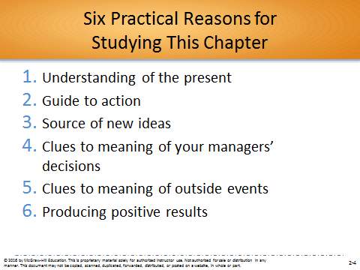

Interactive Classroom Material:
EXAMPLE: Pages from a Game Company’s Employee Guide in Flatness Lies Greatness: (p. 43)
This Example discusses how corporate hierarchy can lead to restrictions on an organization’s ability to function efficiently. Flat organizations, defined as those with few or no levels of management (as we discuss further in Chapter 8), may allow for fewer organizational barriers between the organization and customers. Rotating leaders, who change based on each project, may also assist in “flattening” the organization.
YOUR CALL
Why do you think, then, that many organizations resist using flat structures? Do you think studying management theory could help you answer this question?
Many organizations may resist using flat organizations because of the need to have multiple layers of oversight and control over daily activities. There is a belief that flatter organizations may be more efficient, but taller ones allow for greater supervision over processes. Some organizations may also believe that concepts such as rotating leaders may slow down the process as a new leader would have a learning curve each time he or she enters a project. Studying management theory would help students better understand the different types of management thought, its evolution and best practices. This would provide insight on why some organizations choose a flatter or taller approach to organizing, as well as the benefits and challenges associated with each.
Additional Activities:
One way to build on this Example is to have the students read Valve’s “Handbook for New Employees.” The document profiles interesting insights into how the company operates. The document is currently available at: http://media.steampowered.com/apps/valve/Valve_NewEmployeeHandbook.pdf. Consider using the following discussion questions:
Assume it is your first day of your new job at Valve and you are instructed to read the Handbook. What would be your reactions after reading the document?
Describe the advantages and disadvantages of the processes Valve uses for performance feedback and compensation.
Discuss why Valve places so much emphasis on the hiring process.

D. Two Overarching Perspectives about Management
1. The historical perspective includes three viewpoints – classical, behavioral, and quantitative.
2. The contemporary perspective also includes three viewpoints—systems, contingency, and quality-management.

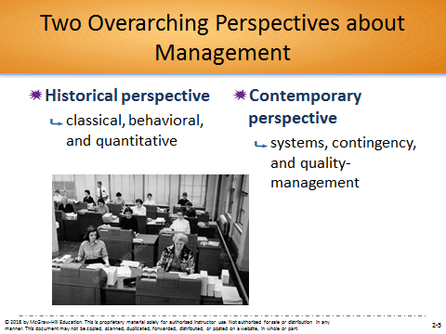

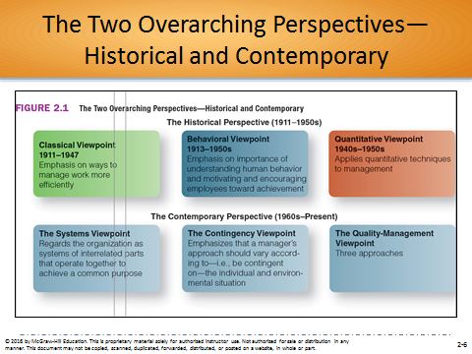

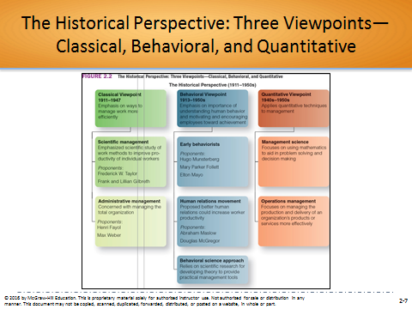

2.2 Classical Viewpoint: Scientific & Administrative Management (pp. 45-48)
If the name of the game is to manage work more efficiently, what can the classical viewpoint teach me?
The three historical management viewpoints include (1) the classical, described in this section; (2) the behavioral; and (3) the quantitative. The classical viewpoint, which emphasized ways to manage work more efficiently, had two approaches: (a) scientific management and (b) administrative management. Scientific management, pioneered by Frederick W. Taylor and Frank and Lillian Gilbreth, emphasized the scientific study of work methods to improve the productivity of individual workers. Administrative management, pioneered by Henri Fayol and Max Weber, was concerned with managing the total organization.

One way that you could begin your coverage of these topics is to have the students watch the video “Ford and Taylor Scientific Management.” This 7-minute video describes steps taken to make cars quickly and at a low price using the principles of scientific management. The video is currently available at: https://www.youtube.com/watch?v=kZdGstEv-mc
Possible Topics for Discussion:
- Do you believe that simply paying workers more money is an effective way to overcome the limitations of jobs developed based on the principles of scientific management? Defend your point of view.
- As noted in the video “Ford and Taylor Scientific Management,” Frederick Taylor reportedly said “Hardly a workman can be found who doesn’t devote his time to studying just how slowly he can work.” Evaluate the extent to which you share Taylor’s views.
- What comes to your mind when you hear the word “bureaucracy?” Do you feel the term’s negative connotation is warranted? Defend your point of view.
Major Idea Outline:
A. An early classical pioneer, Frank Gilbreth, coined the term “therblig,” physical motions you perform from time to time.
1. By identifying the therbligs in a job, Frank and Lillian Gilbreth were able to eliminate motions while reducing fatigue.
2. There are three historical management viewpoints or approaches: the classical viewpoint, the behavioral viewpoint, and the quantitative viewpoint.
3. The classical viewpoint, which emphasized finding ways to manage work more efficiently, had two branches—scientific and administrative.

(Answer is A)
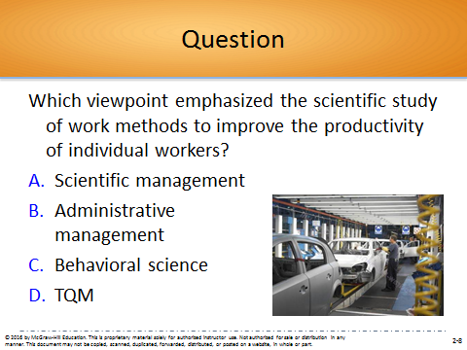

B. Scientific Management: Pioneered by Taylor and the Gilbreths
1. Scientific management emphasized the scientific study of work methods in order to improve the productivity of individual workers.

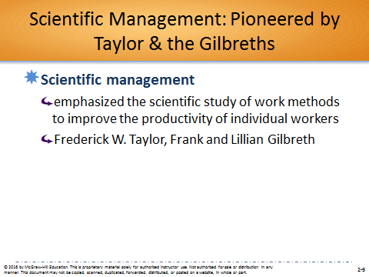

2. Frederick Taylor and the four principles of scientific management.
a. Taylor believed that managers could eliminate soldiering, deliberately working at less than full capacity, by applying four principles of science.
(1) Evaluate a task by scientifically studying each part of the task.
(2) Carefully select workers with the right abilities for the task.
(3) Give workers the training and incentives to do the task with the proper work methods.
(4) Use scientific principles to plan the work methods.

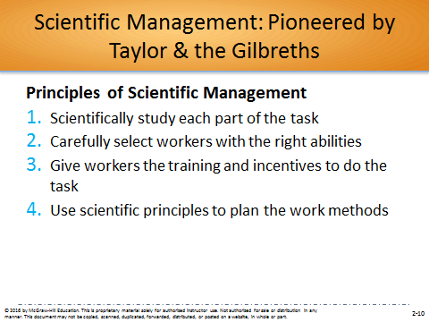

b. Taylor used motion studies, in which he broke down each worker’s job into basic physical units, and then trained workers to use the best possible methods.
c. He suggested using a differential rate system in which more efficient workers earned higher wages.
d. Taylor believed that, if used correctly, the principles of scientific management could enhance productivity.
3. Frank and Lillian Gilbreth were a husband-and-wife team of industrial engineers.
a. The Gilbreths expanded on Taylor’s motion studies, using movie cameras to film workers at work.
C. Administrative Management: Pioneered by Fayol & Weber
1. Administrative management is concerned with managing the total organization rather than individual workers.
2. Henry Fayol was the first to systemize the study of management behavior.
a. Fayol was the first to identify the major functions of management – planning, organizing, leading and controlling.

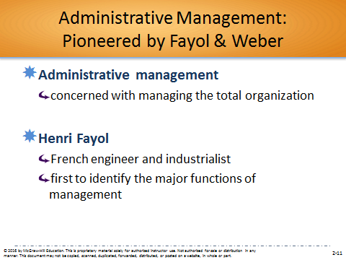

3. German sociologist Max Weber described a bureaucracy as a rational, efficient, ideal organization based on principles of logic.

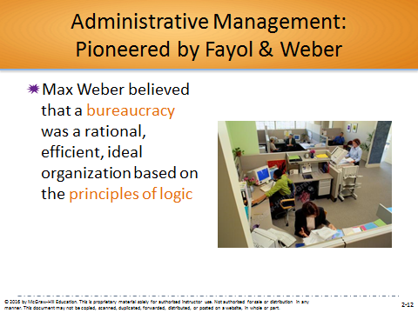

a. Weber’s work occurred in late 19th century Germany when many people were in positions of authority because of their social status.
b. A better-performing organization should have five positive bureaucratic features:
(1) A well-defined hierarchy of authority
(2) Formal rules and procedures
(3) A clear division of labor
(4) Impersonality
(5) Careers based on merit
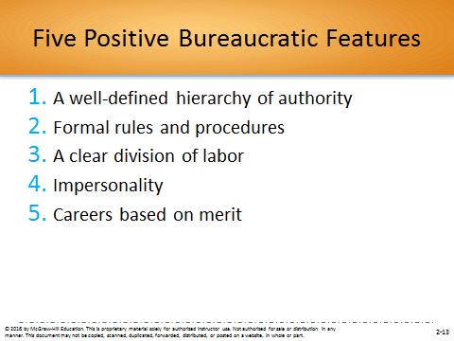

D. The Problem with the Classical Viewpoint: Too Mechanistic
1. The essence of the classical viewpoint was that work activity could be approached rationally.
2. The flaw with this viewpoint is that it is mechanistic: it tends to view humans as cogs within a machine.
3. Human needs are not given importance.

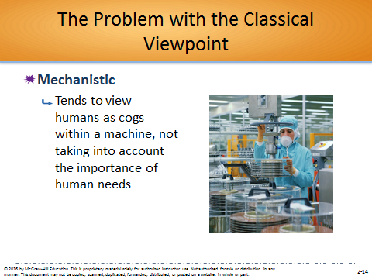

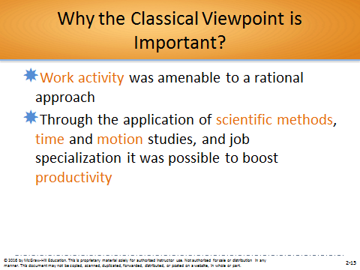

2.3 Behavioral Viewpoint: Behaviorism, Human Relations, & Behavioral Science (pp. 49-52)
To understand how people are motivated to achieve, what can I learn from the behavioral viewpoint?
The behavioral viewpoint emphasized the importance of understanding human behavior and of motivating employees toward achievement. This viewpoint developed over three phases: (1) Early behaviorism was pioneered by Hugo Munsterberg, Mary Parker Follett, and Elton Mayo. (2) The human relations movement was pioneered by Abraham Maslow and Douglas McGregor. (3) The behavioral science approach relied on scientific research for developing theories about behavior useful to managers.
One way that you could begin your coverage of these topics is to have the students watch the classic video “The Year They Discovered People.” This 14-minute video from 1974 examines the Hawthorne studies through the eyes of the men and women who worked in the plants at the time. The video is currently available at: https://www.youtube.com/watch?v=D3pDWt7GntI.
Possible Topics for Discussion:
- Explain how the behavioral viewpoint discussed in Section 2.3 is different from the classical viewpoint you learned about in Section 2.2.
- As discussed in the video “The Year They Discovered People,” what were the key contributions of the Hawthorne studies?
- In the video “The Year They Discovered People,” it was noted that firms were trying to find the right balance between the worker and his job. As we approach the 100-year anniversary of the Hawthorne studies, are we any closer to achieving that balance? Defend your point of view.
Major Idea Outline:
(Correct answer is C)
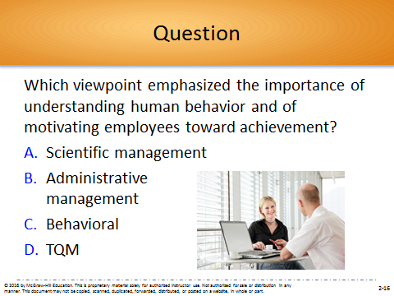

A. The behavioral viewpoint emphasized the importance of understanding human behavior and of motivating employees toward achievement.

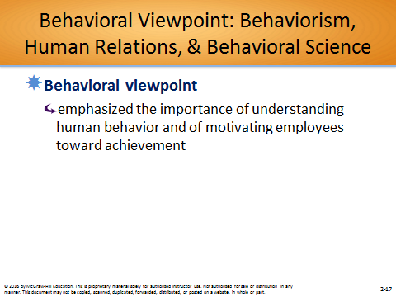

B. The behavioral viewpoint developed over three phases: early behaviorism, the human relations movement, and behavioral science.

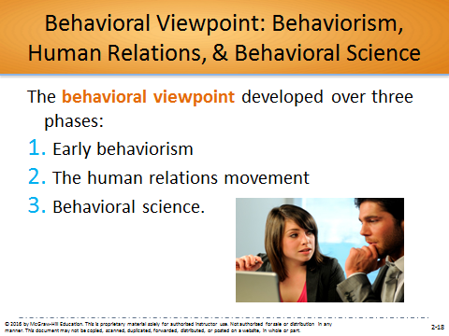

B. Early Behaviorism: Pioneered by Munsterberg, Follett & Mayo
1. Hugo Munsterberg and the first application of psychology to industry
a. Called “the father of industrial psychology,” Munsterberg suggested that psychologists could contribute to industry in three ways:
(1) Study jobs and determine which people are best suited to specific jobs.
(2) Identify the psychological conditions under which employees will do their best work.
(3) Devise management strategies that would influence employees to follow management’s interests.
b. His ideas led to the field of industrial psychology, the study of human behavior in work places.

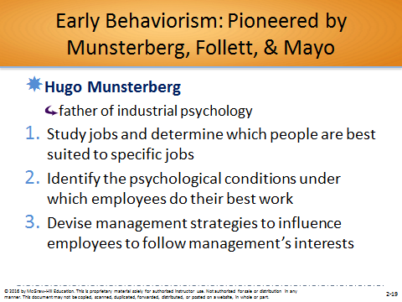

2. Mary Parker Follett was a Massachusetts social worker and social philosopher who believed in power sharing among employees and managers
a. Instead of following the usual hierarchical arrangement, Follett thought organizations should become more democratic.
(1) Organizations should be operated as “communities.”
(2) Conflicts should be resolved by having managers and workers talk over differences and find solutions, a process she called integration.
(3) The work process should be under the control of workers with the relevant knowledge.

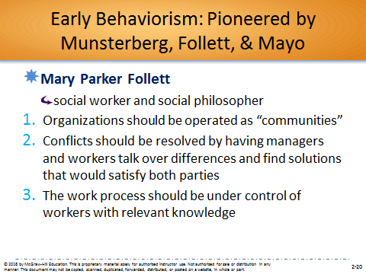

3. Elton Mayo and the supposed “Hawthorne effect”
a. Conducted by Elton Mayo at Western Electric’s Hawthorne plant, the Hawthorne studies began with an investigation into whether workplace lighting level affected worker productivity.
b. Mayo found that worker performance varied but tended to increase over time.
c. Mayo hypothesized the Hawthorne effect—employees worked harder if they received added attention.
d. Although the design of the studies has been criticized, they drew attention to the importance of “social man.”
- This led to the human relations movement in the 1950s and 1960s.

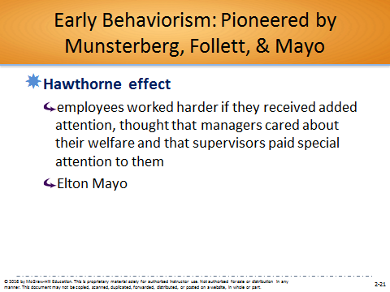

C. The Human Relations Movement: Pioneered by Maslow and McGregor
1. The human relations movement proposed that better human relations could increase worker productivity.

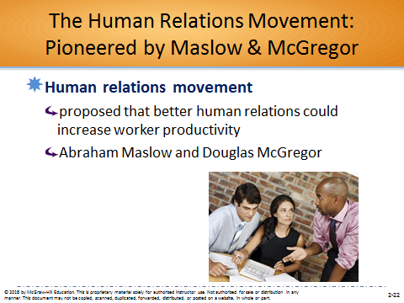

2. Abraham Maslow and the hierarchy of needs
a. Abraham Maslow believed that some human needs must be satisfied before others.
b. In 1943 Maslow proposed his hierarchy of human needs: physiological, safety, social, esteem, and self-actualization.

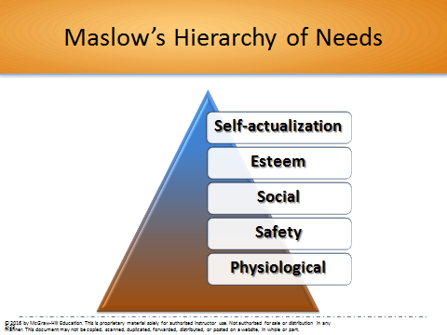

3. Douglas McGregor and Theory X versus Theory Y
a. Douglas McGregor realized that managers needed to be aware of their attitudes toward employees.
b. Theory X represents a pessimistic, negative view of workers – workers are considered to be irresponsible, hate work, and would rather be led than lead.
c. Theory Y represents an optimistic, positive view of workers.

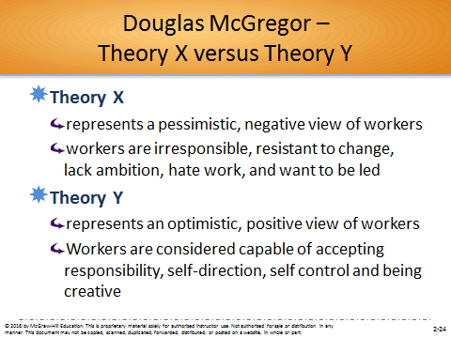

4. Theory X/Theory Y is important because it helps managers understand how their beliefs affect their behaviors.
5. Managers can be more effective when they consider how their behavior is shaped by their expectations about human behavior – the self-fulfilling prophecy.

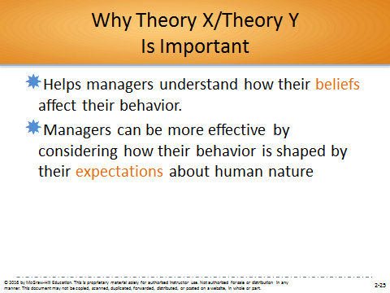

SELF-ASSESSMENT 2.1 (p. 51)
What Is Your Orientation toward Theory X/Theory Y?
Go to connect.mheducation.com and take Self-Assessment 2.1.
Student Questions:
- To what extent do you think your results are an accurate reflection of your beliefs about others? Are you surprised by the results?
Student feelings will differ based on their results on the assessment. Some students may be surprised at how much they may be Theory X or Y oriented. For those who are more Theory Y motivated, they may be surprised at how much they believe employees can contribute to the workplace, whether through creativity and/or an increase in motivation. For those who are more Theory X motivated, they may be surprised at how little they trust employees and believe in close supervision.
- As a leader of a student or work-related project team, how might your results affect your approach toward leading others? Explain.
Student responses will differ based on their assessment results. Those with a Theory X orientation should take the approach of close supervision of team member responsibilities, the setting of clearly defined responsibilities, and the limitation of flexibility in project duties. Those with Theory Y orientation should take the approach of accountability, yet flexibility for team members to set their own goals and approaches to getting the job done.
- If an employee doesn’t seem to show ambition, can that be changed? Discuss.
Student responses will depend on their orientation toward Theories X or Y. Those with a Theory X orientation may believe that employee ambitions, or lack of them, cannot be changed. These students may accept this lack of ambition and instead opt for close supervision and accountability. Those with a Theory Y orientation may believe that employees can be motivated to be more ambitious in getting the job done. This is because theory Y oriented individuals believe that employees do want to do well and can be motivated without micromanagement.
Additional Activities:
You can also consult the Connect Instructors Manual for the post-assessment activity and corresponding PowerPoint slides used for this Self-Assessment in Connect. In this activity, students should be assigned to groups based on their Self-Assessment scores. Students with Theory X orientation should be grouped together and students with Theory Y orientation should be grouped together. Students with Theory X orientation should discuss the dangers of this type of orientation. What types of industries does this theory work for, if any? Students with Theory Y orientation should do the same for this theory. Each group should nominate one person to write their responses on the board. The class should then discuss which theory makes more sense in the 21st century.

D. The Behavioral Science Approach
1. The human relations movement came to be considered too simplistic for practical use.
2. Behavioral science relies on scientific research for developing theories about human behavior that can be used to provide practical tools for managers.

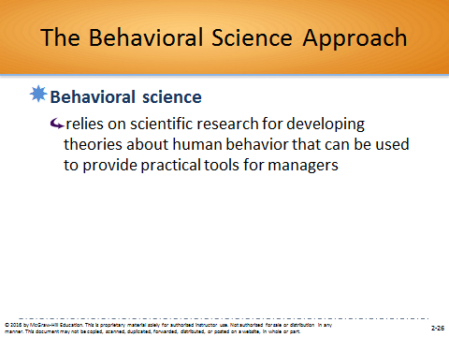

Interactive Classroom Material:
EXAMPLE: Application of Behavioral Science Approach: The Open-Plan Office—Productivity Enhancer or Productivity Killer? (p. 52)
In today’s offices, many managers and employees are in an open floorplan using communal tables. This leads to many interruptions by fellow employees, causing some employees to create “no interruption” zones. Another way to reduce interruptions is assigned seating, and not-mixing introverts and extroverts so that similar emotional temperaments work together.
YOUR CALL
Is there a case to be made for intermingling employees with different personalities and different skills to foster the potential for stimulating breakthrough ideas? What kind of fellow workers in an open office would you like to be seated with and why?
This Example demonstrates the importance of a proper office layout. There may be a case to be made for intermingling employees with different personalities and skill sets. This could lead to “out-of-the-box” thinking based on conversations and debates between individuals who have different views or ways of thinking. Moreover, having a completely introverted section of the office may lead to a depressed mood and unsocial tendencies for the company as a whole. Mixing introverts and extroverts may lift the mood when appropriate, and also maintain an appropriate level of chatter-free times during the day. For example, those who are not as social may have important ideas to share, and it may be necessary to have some extroverts in the area to solicit these ideas.
Students may prefer introverted or extroverted fellow workers in an open office space, depending on their own personality characteristics. Students should welcome those who are different from them to be seated with them to promote out-of-the box thinking and the sharing of ideas between individuals with different skill sets.
Additional Activities:
One way to build on this Example is to have the students read the HR Magazine article “Beyond the Open Office.” This article from April 2015 summarizes the current thinking and research results on open offices. Consider using the following discussion questions:
Provide recommendations for your employer (or a previous one) on how it could best implement the “hybrid approach” to office layout that seeks a balance between closed and open systems.
Discuss how Big Data (as described in Chapter 1) might help companies to determine the best office layout.
As noted in the HR Magazine article “Beyond the Open Office,” one emerging trend in open offices is office sharing across industries with individuals from noncompetitive industries. Discuss how this practice might be best used at your employer (or a previous one).
Article Citation:
Ward, D. (2015). Beyond the open office. HR Magazine, 60(3), 30-35.
ProQuest Document ID: 1670108474
For instructors interested in learning more about the academic research on office layout, you may consider reading the Journal of Organizational Behavior article “Understanding the Physical Environment of Work and Employee Behavior: An Affective Events Perspective.” The article considers the effects of the physical work environment on office workers.
Article Citation:
Ashkanasy, N. M., Ayoko, O. B., & Jehn, K. A. (2014). Understanding the physical environment of work and employee behavior: An affective events perspective. Journal of Organizational Behavior, 35(8), 1169-1184.
DOI: 10.1002/job.1973

2.4 Quantitative Viewpoints: Management Science & Operations Management (pp. 53-54)
If the manager’s job is to solve problems, how might the two quantitative approaches help?
Section 2.4 describes quantitative viewpoints, which emphasize the application to management of quantitative techniques, such as statistics and computer simulations. Two approaches of quantitative management are management science and operations management.
One way that you could begin your coverage of these topics is to have the students read the Forbes article “KFC Killer: How Popeyes Reinvented Itself to Win the Fried Chicken War,” which describes how Popeyes used data to achieve a strategic turnaround.
Article Citation:
Solomon, B. (2014, November 24). KFC killer: How Popeyes reinvented itself to win the fried chicken war. Forbes.
ProQuest Document ID: 1625308997
http://www.forbes.com/sites/briansolomon/2014/11/05/kfc-killer-how-popeyes-reinvented-itself-to-win-the-fried-chicken-war/
Possible Topics for Discussion:
- Provide examples of how your employer (or a previous one) has used management science and/or operations management to improve its operations.
- How can managers best combine the insights from the behavioral viewpoint discussed in Section with 2.3 with the insights from the quantitative viewpoints discussed in Section 2.4?
- Using the article “KFC Killer: How Popeyes Reinvented itself to Win the Fried Chicken War” as your foundation, discuss how Popeyes used data and the principles of the quantitative viewpoints to achieve its strategic turnaround.
Major Idea Outline:
A. Historical Perspective
1. In World War II the Royal Air Force planners used mathematics and statistics to effectively allocate limited resources.
2. Americans used the British model to form operations research (OR) teams to determine how to deploy military equipment most effectively.
3. After the war, businesses also began using these techniques.
4. OR techniques have evolved into quantitative management, the application of management of quantitative techniques, such as statistics and computer simulations.
5. Two branches of quantitative management are management science and operations management.

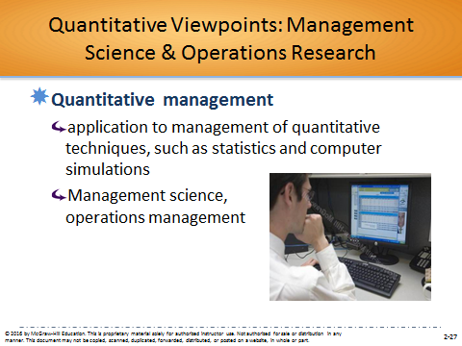

(Correct answer is D)
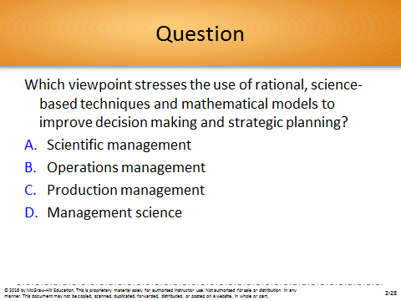

B. Management Science: Using Mathematics to Solve Management Problems
1. Management science focuses on using mathematics to aid in problem solving, decision making, and strategic planning.
- Sometimes management science is called operations research.

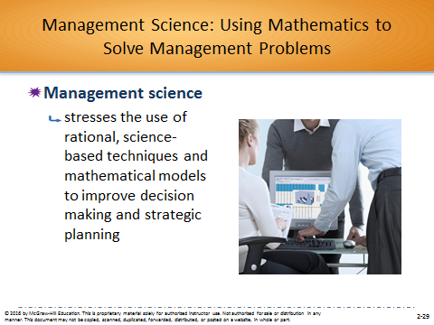

Interactive Classroom Material:
EXAMPLE: Management Science: “Find Me More Music I Like!” (p. 54)
This Example discusses the Music Genome Project and Pandora, which essentially applies management science to music selection. The company reported in 2014 that it had 75 million active listeners.
YOUR CALL
Do you think there’s any room left for experienced human decision makers who don’t rely on numbers? Do you think reliance on the automated recommendation process cheats consumers out of “pleasant surprises” and new discoveries?
There is plenty of room left for human decision makers, such as disc jockeys, to make decisions. For example Apple just released a radio subscription service that will rely on human decision makers to recommend music as opposed to sole algorithmic decisions. Nevertheless, reliance on automated recommendations does not have to cheat consumers out of surprises and new discoveries. Quite the opposite, recommendations for new music can occur once the automated system understands the listener’s preferences. This may actually allow for new discoveries that would not have been made before automated systems. Lastly, research has shown that intuition is important when it comes to these recommendations, and this is something that will be discussed in later chapters.
Additional Activities:
One way to build on this Example is to have the students watch an interview with the CFO of Pandora, Mike Herring, in which he reacts to Apple’s announcement about the introduction of its radio subscription service. In the 2-minute video, the CFO discusses the strengths of Pandora which will allow the firm to maintain a competitive advantage over Apple. Consider using the following discussion questions:
If you are a regular user of Pandora or Netflix, evaluate the extent to which either firm has you pegged. In other words, do the firms accurately predict what music and films you actually like?
How do you react when a firm like Pandora or Netflix gets it “wrong” and recommends something that you disliked? Is it better for the firm’s recommendations to be “sure fire hits” or allow more room for you to be positively surprised by something that you might not have selected on your own?
One of the strengths that Apple believes that it will have with its radio subscription service over its competitors is that it will provide DJs to determine the best flow of songs, something the firm claims people can do better than a computer algorithm. Evaluate the extent to which you believe that this is true and that it will provide value for which consumers will be willing to pay.
Video Link:
http://video.cnbc.com/gallery/?video=3000387059&play=1
C. Operations Management: Being More Effective
1. The techniques of operations management are used when a warehouse store decides when to reorder supplies.
2. Operations management focuses on managing the production and delivery of an organization’s products or services more effectively.

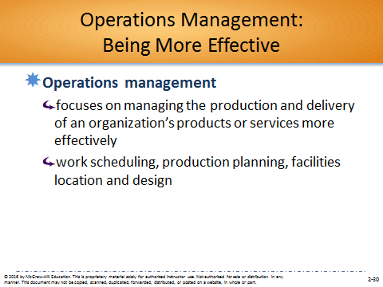
Interactive Classroom Material:
EXAMPLE: Operations Management: Using “the Toyota Way” to Benefit Hospital Patients (p. 54)
This Example discusses “the Toyota Way” systematic approach to producing vehicles, and how this can be applied to hospitals. This includes hospital management coming up with plans to make specific, small changes that can have a major impact. This includes ways to reduce wait times, and even wheeling patients around the facility.
YOUR CALL
Which is the focus of lean management?
Both effectiveness and efficiency are the focus of lean management. Proper operations management would lead to more efficient practices and better utilization of company resources, which in turn would make an organization more effective in accomplishing its strategic goals. However, when lean management leads to a sole focus on efficiency, as opposed to effectiveness, stakeholders may respond in a negative way. For example, if a hospital decided to reduce the number of medication conflict checks for the sake of efficiency, this may lead to an increased chance of a negative medication mix up for patients. This of course would have an adverse effect on a hospital’s effectiveness.
Additional Activities:
One way to build on this Example is to have the students watch the video “Toyota Corolla: A Day in the Life at the Toyota Corolla Factory in Blue Springs, Mississippi.” In this 3-minute video, a manager at Toyota’s plant in Blue Springs, Mississippi discusses the Toyota way of doing things. Consider using the following discussion questions:
Discuss the benefits to Toyota of using quantitative viewpoints of management to improve the firm’s production process.
Discuss why it might have been difficult for Toyota to implement the “Toyota Way” when the firm’s operations in Blue Springs, Mississippi began back in 2008.
Discuss reasons why it might be difficult for automotive firms such as Toyota to implement the principles of the quantitative viewpoints.
Video Link:
https://www.youtube.com/watch?v=OgrsOnym9PA

2.5 Systems Viewpoint (pp. 55-57)
How can the exceptional manager be helped by the systems viewpoint?
Section 2.5 discusses the contemporary management viewpoint of systems. The systems viewpoint sees organizations as a system, either open or closed, with inputs, outputs, transformation processes, and feedback. The systems viewpoint has led to the development of complexity theory, the study of how order and pattern arise from very complicated, apparently chaotic systems.
One way that you could begin your coverage of these topics is to profile the decision of Gap, announced in June 2015, to close 175 of its stores. A 2-minute ABC news video describing the strategic decision is currently available at: http://abc7.com/business/gap-closing-175-namesake-stores-to-boost-brand/788451/. You could also have the students read the Forbes online article “Closing More Stores Doesn't Fix Gap's Biggest Problems.” The article is currently available at: http://www.forbes.com/sites/paularosenblum/2015/06/15/gap-continues-downsizing-closing-an-additional-175-stores/.
Possible Topics for Discussion:
- Use systems theory to identify the most important parts of the system that is your university or academic institution. Specifically, describe important inputs, transformational processes, outputs and feedback important to your school’s success.
- Academic institutions are often described as being “closed” systems. How can the administration of your school seek to become a more open system?
- Use systems theory to describe the strategic reasons why Gap announced in June 2015 that it needed to close 175 of its stores.
Major Idea Outline:
A. In addition to the historical perspective on management, there are three contemporary perspectives: systems, contingency, and quality management.

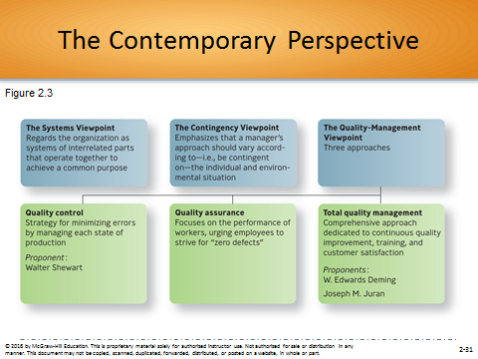

B. The Systems Viewpoint
1. A system is a set of interrelated parts that operate together to achieve a common purpose.
2. The systems viewpoint regards the organization as a system of interrelated parts.
3. The organization is both:
a. a collection of subsystems—parts making up the whole system
b. a part of the larger environment

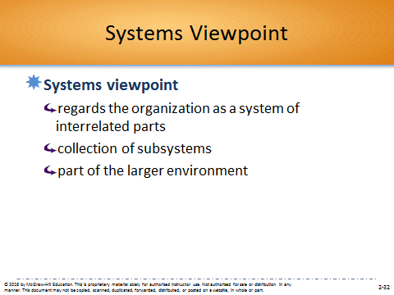

C. The Four Parts of a System
1. Inputs are the people, money, information, and materials required to produce an organization’s goods or services.
2. Outputs are the products, services, profits, losses, employee satisfaction or discontent, and the like that are produced by the organization.
3. Transformation processes are the organization’s capabilities in management and technology that are applied to converting inputs into outputs.
4. Feedback is information about the reaction of the environment to the outputs that affects the inputs.

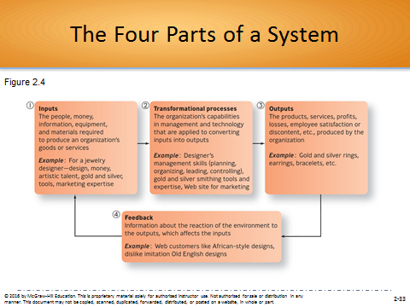

D. Open and Closed Systems
1. Nearly all systems are open systems rather than closed systems.
a. An open system continually interacts with its environment.
b. A closed system has little interaction with its environment; that is, it receives very little feedback from the outside.
2. Any organization that ignores feedback from the environment risks failure.

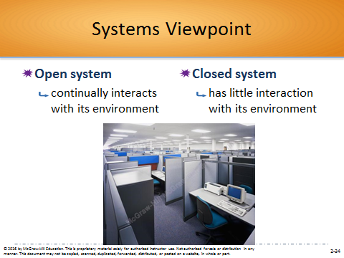

E. Complexity Theory: The Ultimate Open System
1. The systems viewpoint has led to the development of complexity theory, the study of how order and pattern arise from very complicated, apparently chaotic systems.
2. It recognizes that complex systems are networks of interdependent parts that interact with one another according to simple rules.
3. The discipline is used in management to understand how organizations adapt to their environments.

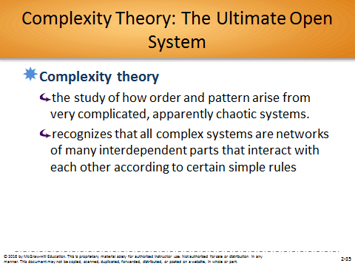

Interactive Classroom Material:
EXAMPLE: Closed versus Open Systems: Penney’s versus Macy’s (p. 57)
This example discusses J.C. Penney’s closed system versus Macy’s open system. Penney’s strategy was based on the premise that customers do not know what they want until you show them, and to get rid of discounts and coupons. This strategy failed. Macy’s believed that many customers do their research before entering the store, and instead focused on personalizing the shopping experience, inventory management and integrated sales, which includes shipping products directly to customers.
YOUR CALL
Besides the retrenching of RadioShack and Staples, can you think of other retail businesses that need a makeover—that should do more to become open systems? What should they do?
There are different businesses that may want to consider more open systems. Furniture retailers such as Marlo’s and IKEA should consider a more personalized, customer-centered approach that relies on inventory management, integrated sales management and personalized service. It should start by understanding that many customers already know what they are looking for when they come to the storefront, and it is now about personalizing the sales experience. IKEA has already started doing this by jump-starting a loyalty program that tracks consumer shopping habits, makes recommendations and provides discounts.
Additional Activities:
One way to build on this Example is to have the students watch the CBS News video “Are Shopping Malls Vanishing?” This 4-minute video further elaborates on the need for retailers to adopt more of an open system mentality in today’s retail environment. Consider using the following discussion questions:
Critique the state of retailing in your community. How many shopping malls have closed or been re-purposed to another function (e.g., are now a church)?
Describe the factors that would encourage you to shop at a bricks-and-mortar retailer rather than online.
Discuss actions steps that should be taken in your community to most effectively use any underutilized and/or closed shopping centers in your area.
Video Link:
http://www.cbsnews.com/videos/are-shopping-malls-vanishing/u
2.6 Contingency Viewpoint (pp. 58-60)
In the end, is there one best way to manage in all situations?

Section 2.6 describes the contingency viewpoint, which emphasizes that a manager’s approach should vary according to the individual and environmental situation.
One way that you could begin your coverage of this view of management is to have the students read the Harvard Business Review article “The Authenticity Paradox.” This article describes how leaders can learn to adapt their leadership approach to the challenges and circumstances they face.
Article Citation:
Ibarra, H. (2015). The authenticity paradox. Harvard Business Review, 93(1), 52-59.
Product #: R1501C-PDF-ENG
Possible Topics for Discussion:
Compare and contrast the contingency viewpoint with the classical viewpoint and the behavioral viewpoint described earlier in the chapter.
Describe key contingency variables that managers should consider when determining which management approach will work best for a specific situation.
Using the Harvard Business Review article “The Authenticity Paradox” as your foundation, discuss ways that you can try different leadership styles and behaviors without feeling “fake.”
Major Idea Outline:
Contingency Viewpoint
A. The classical viewpoints assumed that their approaches were “the one best way” to manage organizations.
- The contingency viewpoint emphasizes that a manager’s approach should vary according to—that is, be contingent on—the individual and environmental situation.

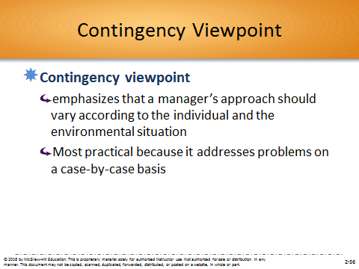

Interactive Classroom Material:
EXAMPLE: The Contingency Viewpoint: What Are the Best Kinds of Benefits? (p. 58)
This Example discusses other forms of compensation than money, such as benefits. Small businesses can offer small incentives that make a difference to employees, such as free beer or a week off for a voluntary cause. Larger organizations can also offer incentives such as having salaried employees take whatever time they feel is appropriate and enforce their own travel and expense policies.
YOUR CALL
Considering these findings and applying a contingency approach to stimulating productivity at work, what different kinds of incentives or benefits would you offer for hourly shift workers, salaried middle managers, and work-at-home employees?
Students’ responses will differ on the approaches, but some ideas may include providing hourly shift workers with a good environment to work for a sense of inclusion in the organization. This positive culture, in addition to the ability for promotion within the organization, would incentivize working for the organization. Salaried middle managers would enjoy the ability to devote time to a work/life balance through company programs aimed at health, family and recreation. Work-at-home employees would enjoy their autonomy and the ability to be accountable for their work without micromanagement. Nevertheless, all different types of employees would value doing work that they enjoy.
Additional Activities:
One way to build on this Example is to have the students read the Fortune article “L.L. Bean Gives Workers an Outdoor Adventure While on the Job.” The article and corresponding web video on the Fortune website describe some of the unique benefits offered by the outdoor goods retailer. Consider using the following discussion questions:
Assume that your employer (or a previous one) offered you additional days of paid time off, under the condition that you spend it with at least one of your co-workers. Is this a benefit that you would find motivating? Explain your point of view.
Critique the advantages and disadvantages of L.L. Bean’s policy of giving workers addition paid time off for outdoor activities with colleagues.
What unique benefits do you feel that your employer (or a previous one) should offer but does not? How could you convince top leadership at the company that this would be a valued employee benefit?
Article Citation:
Zillman, C. (2015, May 1). Outdoor adventures on the job. Fortune, 171(6), 24.
http://fortune.com/2015/04/27/l-l-bean/
- According to Gary Hamel of the Management Innovation Lab, management ideas are not fixed, they are a process.
- Hamel suggests that management should be innovative and this process begins by identifying core beliefs people have about the organization.
- Discovering these core beliefs can be achieved by asking the “right” questions:
  - Is this a belief worth challenging? Is it debilitating? Does it get in the way of an important organizational attribute that we’d like to strengthen?
  - Is this belief universally valid? Are there counterexamples, and if so what do we learn from those cases?
  - How does this belief serve the interests of its adherents? Are there people who draw reassurance and comfort from this belief?
  - Have our choices and assumptions conspired to make this belief self fulfilling? Is this belief true simply because we have made it true – and, if so, can we imagine alternatives?
- Evidence-Based Management
  - Means translating principles based on best evidence into organizational practice, bringing rationality to the decision-making process.

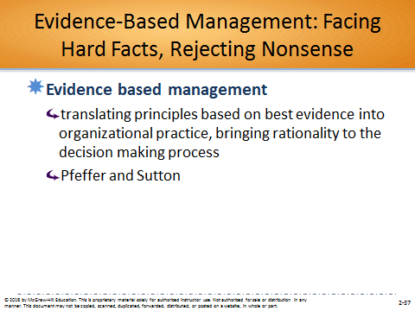

Interactive Classroom Material:
PRACTICAL ACTION: Evidence-Based Management: An Attitude of Wisdom (p. 60)
Management is both an art and a science. Many top executives have no formal training, just a good mix of intuition, judgment and experience, like an artist. However, management also has scientific reasoning through evidence-based management. Evidence-based management has three truths: 1) There are few really new ideas, 2) True is better than new, and 3) Doing well usually dominates.
YOUR CALL
Do you think managers are often driven by fads, by what they’ve read in the latest book or heard in the latest management seminar? Have you ever heard of a manager taking an experimental approach, as in trying out a new idea with an open mind to see what happens? How could you profit by taking an evidence-based approach to the ideas we discussed in this chapter?
Managers may embrace new ways of working with employees, but many are also content with proven ways that they conduct their affairs, especially the ways that they were initially trained and developed while in some sort of manager training. One new way to learn a new management practice is by taking an experimental approach and seeing what happens. This happens a lot in smaller organizations or certain departments of larger organizations, in order to see if a certain management practice has a positive effect on the organization’s efficiency and effectiveness.
Managers can take an evidence-based approach to the ideas learned in this chapter. Managers can challenge the status quo and see if there are more innovative ways to get the job done. Alternative ways can be studied and employee input can be gathered. One example of this is creating a new benefit for employees in order to motivate them. Managers can see an issue that needs to be resolved (i.e., lack of motivation), pose a solution, such as a new benefit, make a prediction and test the prediction, such as offering the benefit and seeing how it works.
Additional Activities:
One way that you could build on this Practical Action is to have the students watch the CBS News video “Zappos Does Away with Bosses, and Not Everyone Likes It.” This two-minute video describes how many employees have left the online retailer Zappos, in response to the firm adopting a “holacracy,” which is a management style that relies of self-management and self-organization. The video could be used as an illustration of how new trends in management should be subject to evidence-based management to determine their effectiveness. Consider using the following discussion questions:
Critique the decision of Zappos to introduce a holacracy. What are the anticipated advantages of such a management system?
Critique the decision of Zappos to offer severance packages to employees who decide they don’t want to work under the new system.
Assume the top leadership at your employer (or a previous one) decided the company should be changed to a holacracy. What advice would you give to the firm’s top management?
Video Link:
http://www.cbsnews.com/news/zappos-does-away-with-bosses-and-not-everyone-likes-it/.
2.7 Quality-Management Viewpoint (pp. 61-62)
Can the quality-management viewpoint offer guidelines for true managerial success?

Section 2.7 describes the quality-management viewpoint. This viewpoint consists of quality control, quality assurance, and the movement of total quality management (TQM), dedicated to continuous quality improvement, training, and customer satisfaction.
One way that you could begin your coverage of these topics is to have the students consider the difficulties hospitals face in measuring quality. This is an important topic for hospitals since they are increasingly being evaluated on various quality metrics, which are often tied to reimbursement rates and/or financial penalties. Moreover, insurance companies, the government, and patients don’t always have the same definition of quality. This issue was explored by the Wall Street Journal in the Special Report “What Quality Measures Should Be Used to Evaluate Health-Care Providers?,” which can be assigned for reading by the students.
Article Citation:
Beck, M. (2015, March 23). What quality measures should be used to evaluate health-care providers? Wall Street Journal Online.
ProQuest Document ID: 1665073067
http://www.wsj.com/articles/what-quality-measures-should-be-used-to-evaluate-health-care-providers-1427079654.
Possible Topics for Discussion:
- Describe the quality control measures or TQM approaches used by your employer (or a previous one) and discuss how they impact management practices at the firm.
- Using the Wall Street Journal article “What Quality Measures Should Be Used to Evaluate Health-Care Providers?” as your foundation, describe the various challenges involved when determining quality metrics for evaluating the performance of hospitals.
- Explain what Scott Wallace meant in the Wall Street Journal article “What Quality Measures Should Be Used to Evaluate Health-Care Providers?” when he stated that many hospitals measure “where the light is good—instead of measuring what matters most to patients.”
Major Idea Outline:
A. The quality-management viewpoint includes quality control, quality assurance, and total quality management.
B. Quality Control and Quality Assurance
1. Quality refers to the total ability of a product or service to meet customer needs.
2. Quality control is defined as the strategy for minimizing errors by managing each stage of production.
a. This uses statistical sampling to locate errors by testing just some of the items in a particular production run.
3. Quality assurance focuses on the performance of workers, urging employees to strive for “zero defects.”
a. It has been less successful because employees often have no control over the design of the work process.

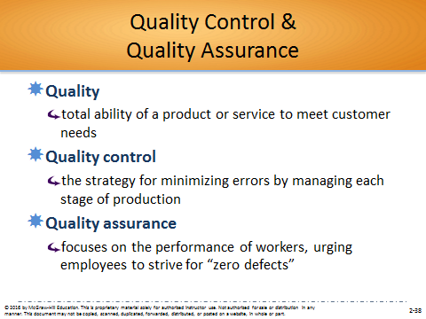

C. Total Quality Management: Creating an Organization Dedicated to Continuous Improvement
1. The inferior quality of Japanese products began to improve with the arrival of two Americans.
2. W. Edwards Deming believed that quality stemmed from “constancy of purpose” along with statistical measurement and reduction of variations in the production process.
a. He also emphasized the human side, saying that managers should stress teamwork.
b. Deming proposed the “85-15 rule”—when things go wrong, there is an 85% chance that the system is at fault, only a 15% chance that the individual worker is at fault.
3. Joseph M. Juran defined quality as “fitness for use” and suggested that companies concentrate on the real needs of customers.
4. Total quality management (TQM) is a comprehensive approach—led by top management and supported throughout the organization—dedicated to continuous quality improvement, training, and customer satisfaction.

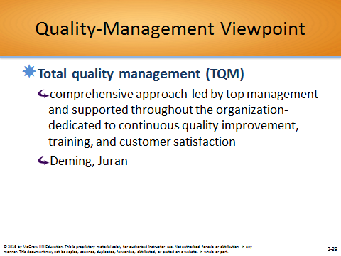

a. TQM has four components:
(1) make continuous improvement a priority
(2) get every employee involved
(3) listen to and learn from customers and employees
(4) use accurate standards to identify and eliminate problems

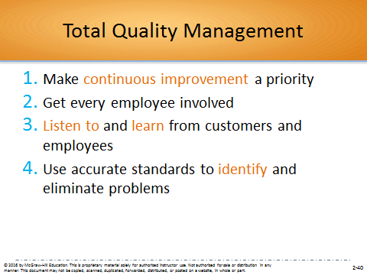

SELF-ASSESSMENT 2.2 (p. 62)
To What Extent Is Your Organization Committed to Total Quality Management?
Go to connect.mheducation.com and take Self-Assessment 2.2.
Student Questions:
- Which of the five dimensions is most and least important to the organization? Are you surprised by this conclusion? Explain.
Students’ responses will vary based on the results of their assessment. Often times students will be surprised to find that their company values one dimension more than the dimension the student thought would be most valued. This often occurs with processes and policy/strategy versus employees.
- Based on the three lowest-rated items in the survey, what advice would you give to senior leaders in the company?
Students should advise the organization to properly allocate resources, provide assistance for employees to achieve strategic resources and reward employees for quality. This advice can be tailored based on the lowest-rated items in the survey.
- Considering all of the questions in the survey, which three do you think are most important in terms of fostering TQM in a company? Why?
Students’ responses will differ, but should outline the concepts discussed in the response to question 2.
Additional Activities:
You can also consult the Connect Instructors Manual for the post-assessment activity and corresponding PowerPoint slides used for this Self-Assessment in Connect. In this activity, students should be grouped based on their Self-Assessment scores. Each group should represent a TQM dimension. Students who scored highly on one dimension should not be in a group representing that particular dimension. Students should review the scenario in the slides. Then, using their assigned dimension, recommend improvements that would assist the organization in the scenario. Each group should share their recommendations with the class.

Group Exercise: Which Are the Best Companies to Work for in the United States and Why?
There is a group exercise available at the end of this manual that describes the best companies to work for.
Exercise Objectives
- To assess your group’s awareness of the best companies to work for in the United States in 2015.
- To discover the different perceptions of these companies and their management practices.

2.8 Quality-Management Viewpoint (pp. 63-64)
The Learning Organization in an Era of Accelerated Change
Learning organizations actively create, acquire, and transfer knowledge within themselves and are able to modify their behavior to reflect new knowledge. There are three ways managers can help build a learning organization.
One way that you could begin your coverage of these topics is to have the students read the HR Magazine article “A Culture of Learning.” This article describes the importance of creating an organizational culture that supports organizational learning.
Article Citation:
Grossman, R. J. (2015). A culture of learning. HR Magazine, 60(4), 36-40, 42.
ProQuest Document ID: 1679859856
Possible Topics for Discussion:
- Discuss the reasons why more companies don’t strive to truly become learning organizations.
- Critique the extent to which your manager (or a previous one) demonstrates the managerial roles and functions that foster a learning organization.
- Using the HR Magazine article “A Culture of Learning” as your foundation, describe action steps that managers should take to create a learning culture.
Major Idea Outline:
A. Organizations, like people, must continually learn new things or face obsolescence.
1. Managers must try to establish a culture that enhances their employees’ ability to learn.
2. Professor Peter Senge coined the term “learning organization” to describe this culture.
B. The Learning Organization: Handling Knowledge and Modifying Behavior
1. A learning organization is an organization that actively creates, acquires, and transfers knowledge within itself and is able to modify its behavior to reflect new knowledge.

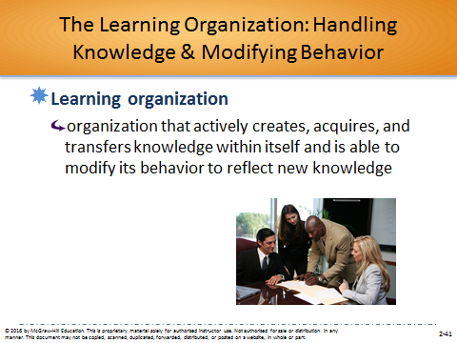

2. A learning organization has three parts:
a. Creating and acquiring knowledge
(1) Managers try to actively infuse their organizations with new ideas and information.
(2) Such knowledge comes from constantly scanning their external environments and employee training and development.
b. Transferring knowledge - managers actively work at transferring knowledge throughout the organization, reducing barriers to sharing information and ideas.
c. Modifying behavior – managers encourage employees to use the new knowledge to change their behavior and help achieve organizational goals
C. How to Build a Learning Organization: Three Roles Managers Play
1. Build a commitment to learning—to lead the way by investing in learning, publicly promoting it, and creating rewards for it.
2. Work to generate ideas with impact—ideas that add value for customers, employees, and shareholders.
3. Work to generalize ideas with impact.
a. The manager can reduce the barriers to learning among employees and within the organization.
b. This involves creating a psychologically safe and comforting environment that increases the sharing of successes, failures, and best practices.

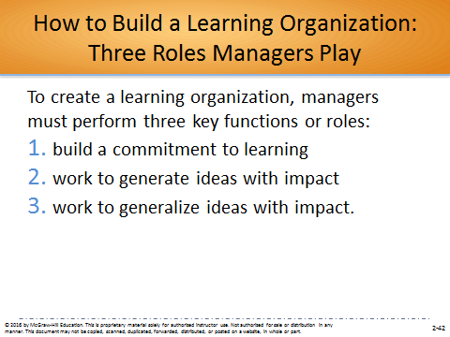

SELF-ASSESSMENT 2.3 (p. 64)
Are You Working for a Learning Organization?
Go to connect.mheducation.com and take Self-Assessment 2.3.
Student Questions:
- What are the strengths and weaknesses of this company in terms of being a learning organization?
Students should base their analysis on strengths and weaknesses associated with information acquisition, information distribution, information interpretation, knowledge integration and organizational memory.
- If you were CEO of this organization, what changes would you make based on your survey results? Explain.
Student changes would be based on survey results, but should include learning from stakeholders (i.e., customers, suppliers, employees, etc.), exchanging knowledge, dialogue and reasoning, and effective retention of information.
- What suggestions would you make for how this organization might (1) build a commitment to learning, (2) work to generate ideas with impact, and (3) work to generalize ideas with impact? Discuss.
The manager can reduce the barriers to learning among employees and within the organization. This involves creating a psychologically safe and comforting environment that increases the sharing of successes, failures, and best practices. This can be accomplished through increased feedback between managers and subordinates, increased group meetings within departments and among departments, and a flatter hierarchy.
- How does the learning score for the organization probably compare with the scores of other organizations you are familiar with?
Student answers will differ based on the learning score achieved. Students may be surprised to find that their organization focuses on certain learning dimensions instead of others.
Additional Activities:
You can also consult the Connect Instructors Manual for the post-assessment activity and corresponding PowerPoint slides used for this Self-Assessment in Connect. In this activity, students should be put into groups based on their Self-Assessment scores. Students who scored highly should be grouped together and students who did not score well should be grouped together. Students who scored well should discuss what their organization is doing to proactively create, acquire and transfer knowledge. Students who did not score highly should discuss how to better create, acquire and transfer knowledge. What could their current organization be doing wrong? Each group should share with the class as a whole.

CHALLENGE: MAJOR QUESTIONS

2.1 What’s the payoff in studying different management perspectives, both yesterday’s and today’s?
In order to understand why present day management theories are the way they are, it is important to see their historical roots. These perspectives from yesterday indicate why there was an evolution in management thought, and the challenges that managers faced in the past, which still may be true today. Yesterday’s management perspectives are not extinct, and many of their components are still in play today; however, it is important to understand why there were refinements in this science. Moreover, seeing these refinements will assist managers evolve today’s management perspectives into new ones for tomorrow.

2.2 If the name of the game is to manage work more efficiently, what can the classical viewpoints teach me?
The classical viewpoints portray an emphasis on ways to manage more efficiently. Scientific management described methods to improve productivity of individual workers, and administrative management was concerned with managing the total organization. The entire issue with the classical viewpoint was that it was too focused on efficiency and viewed humans as cogs within a machine, not taking into account human needs. This often times meant effectivity suffered in the long run.

2.3 To understand how people are motivated to achieve, what can I learn from the behavioral viewpoint?
The behavioral viewpoint emphasized the importance of understanding human behavior and of motivating employees toward achievement. The behavioral viewpoint was focused on human needs and proposed that better human relations could increase worker productivity (human relations movement). In order to figure out how to motivate employees to achieve, managers need to understand their needs and fulfill them, and behavioral scientists such as Maslow provided a way to gauge this.

2.4 If the manager’s job is to solve problems, how might the two quantitative approaches help?
Management science focuses on using mathematics to aid in problem solving and decision making. Concepts such as analytics and Big Data fall into management science and assist in gathering data in order to solve problems. Operations management focuses on managing the production and delivery of an organization’s products or services more effectively. This includes the rational management of resources and distribution of goods and services. Proper operations management solves the problems of inefficient and/or ineffective management of resources by focusing on work scheduling, production planning, facilities location and design, and optimum inventory levels.

2.5 How can the exceptional manager be helped by the systems viewpoint?
The systems viewpoint regards the organization as a system of interrelated parts. Managers can look at the four parts of the system (inputs, transformational processes, outputs and feedback) and allow managers to make adjustments to individual parts in order to promote efficiency and effectivity in the company. Moreover, the systems viewpoint is an open system. Open systems stress multiple feedback from both inside and outside the organization, resulting in a continuous learning process to try to correct old mistakes and avoid new ones.

2.6 In the end, is there one best way to manage in all situations?
There probably is no one best way to manage in all situations. The contingency viewpoint emphasizes that a manager’s approach should vary according to the individual and environmental situation. A manager subscribing to the Gilbreth approach might try to get workers to be more productive by simplifying the steps. A manager of the Theory X/Theory Y persuasion might try to use motivational techniques. But the manager following the contingency viewpoint would simply ask, “What method is the best to use under these particular circumstances?”

2.7 Can the quality-management viewpoints offer guidelines for true managerial success?
The quality-management viewpoint includes quality control, quality assurance, and total quality management. Making sure a good or service is of superb quality is important, but total quality management is a comprehensive approach. It is led by top management and supported throughout the organization—dedicated to continuous quality improvement, training, and customer satisfaction. This includes making continuous improvement a priority, getting every employee involved, listening to and learning from customs and employees, and using accurate standards to identify and eliminate problems.

2.8 Organizations must learn or perish. How do I build a learning organization?
Managers can build a learning organization by utilizing three key functions or roles: (1) build a commitment to learning, (2) work to generate ideas with impact, and (3) work to generalize ideas with impact. First, to instill in employees an intellectual and emotional commitment to the idea of learning, managers need to lead the way by investing in it, publicly promoting it, creating rewards and symbols of it, and performing other similar activities. Second, managers need to try to generate ideas with impact—that is, ideas that add value for customers, employees, and shareholders—by increasing employee competence through training, experimenting with new ideas, and engaging in other leadership activities. Lastly, managers need to reduce the barriers to learning among employees and within their organization.
MANAGEMENT IN ACTION:
GM’s New CEO, Mary Barra, Must Manage a Major Recall

- To what extent is GM using evidence-based management? Are they overdoing it? Explain your rationale.

Evidence-based management means translating principles based on best evidence into organizational practice, bringing rationality to the decision-making process. At GM a higher level team investigated the ignition switch problem in 2011, then for two years tests were conducted and the problem was further investigated. Then in 2014 the executives decided a recall was needed. When the recall was ordered, Barra herself lead a group of senior executives who oversaw everything, including the response, and again investigated what happened during the initial investigation. Some may think that this is overdoing it, but others believe what Barra is saying, which is that GM’s reputation will not be determined by the recall itself, but by the company’s response to it.

- To what extent are the managerial practices being used at GM consistent with principles associated with management science and operations management techniques? Discuss.

After the recall was announced, the organization’s senior leadership team is looking into the progress of the recall, including repair part timing. The team wanted to make sure that the recall was done effectively and efficiently. The team is also investigating whether the initial response, back in 2004, was proper and if a better, more effective and efficient response could have been done when the issue was initially reported.

- Use Figure 2.4 to analyze the extent to which GM is using a systems viewpoint.

Inputs – Resources needed to investigate the recall and perform the services needed to bring the automobiles back in par. This includes labor, parts, information, etc.
Transformational process – GM’s ability to not only repair the automobiles, but provide a comprehensive report to all stakeholders on what happened. This includes Barra’s management skills in the process.
Outputs – The repaired automobile and informational reports needed for stakeholders.
Feedback – The reaction of the stakeholders. Will customers continue to trust GM? It is important to note that another stakeholder, regulators, may actually criminally charge GM for the events that took place. This may lead to a fine of over $1 billion.

- How are the managerial practices being used at GM consistent with a quality-management viewpoint? Explain your rationale.

The senior leadership team is overseeing the recall and making sure that customer needs are being addressed, and that parts are arriving on-time so that the repairs can take place. However, in the past, there was a lack of quality-management. The organization’s engineers knew about the problem in 2004, and met with regulators in 2007, and investigated the matter in 2011 for another two years. The issue is that nothing happened during all this time, and drivers were put in danger due to low-quality products. In essence, total quality management is now being implemented by Barra, but this was not the case for the 10 years when GM knew, but did nothing, about the faulty switch.

- To what extent does GM represent a learning organization? Discuss.

GM is creating and acquiring knowledge about what happened with the faulty ignition switch, and is trying to understand why the issue was not properly reported and investigated. It is transferring this knowledge throughout the organization, and to stakeholders outside the organization. Lastly, Barra is promising to modify the behavior so customers will not lose trust in GM. This last step is important so that this issue will not repeat itself in the future. If the behavior is not modified, then GM has not really learned anything in this entire process.
ESSME
LEGAL/ETHICAL CHALLENGE
.

Is an Apology Enough?

This dilemma involves a scandal at the University of North Carolina (UNC). The issue revolves around whether or not the school’s Department of African and Afro-American Studies offered courses that never met and sponsored hundreds of independent study classes of limited value to student athletes. The university did an internal review and determined the department “offered more than 200 lecture courses that never met. The department also sponsored hundreds of independent study classes of dubious value. Internal reviews have identified forged faculty signatures and more than 500 grades changed without authorization.” Eight employees were fired or resigned, including the Chancellor. The new Chancellor is currently investigating the matter further.

A campus reading specialist, Mary Willingham, who exposed the scandal, was demoted and stripped of her supervisory title and publicly condemned by some school officials. She has even received death threats and continues to be attacked by the executive vice-chancellor and provost.

Assuming that you are the university’s chancellor, what would you do at this point in the scandalous saga?

- Acknowledge wrongdoing, reinstate Mary Willingham to her former position, and continue the internal investigation.

Accepting liability for wrongdoing and reinstating Willingham may provide justice for her, but may create problems for the students who went through the program, and other university stakeholders. This is the basis of Dean and the basketball coach’s argument. Though this argument may be baseless, it may be wise to continue the internal investigation before acknowledging anything.

- Acknowledge wrongdoing, but Mary stays where she is. She should not have blown the whistle to local reporters without first going to upper management at the university.

To accept wrongdoing, but punish Willingham, does not seem like an idle combination. Though she would ideally have gone to upper management, we do not know if those comments would have led to her immediate dismissal or other threats against her. By blowing the whistle to the media, she has created a type of protection whereas her dismissal would not bode well for the university at this point. If the university is to acknowledge wrongdoing, it should consider creating a more open work environment for employees so that there is comfort in going to upper management. Obviously, with the comments made by upper management to this point, that does not seem to be the case.

- Reprimand both James Dean and the basketball coach for their comments, and continue the internal investigation.

James Dean and the basketball coach should probably be reprimanded for their comments against Willingham if those comments are in such a nature as to make her feel unsafe and if they are inciting other, more serious, types of comments, such as death threats. However, until the internal investigation is completed, it may be wise for the university not to reprimand anyone as this would be close to an admission of guilt.

- Invent other options.

Students can be creative here. Maybe Willingham should be part of the investigation in order to bring credibility, or maybe a third party should be hired to conduct the investigation so there are no doubts as to oversight. Overall, it would be wise for all parties to remain silent until the investigation has been concluded.

GROUP EXERCISE: Which Are the Best Companies to Work for in the United States and Why?
Objectives
- To assess your group’s awareness of the best companies to work for in the United States in 2015.
- To discover the different perceptions of these companies and their management practices.
Introduction
To pick the 100 Best Companies to Work For, Fortune partners with the Great Place to Work Institute to conduct the most extensive employee survey in corporate America. Any company that is at least 5 years old and has more than 1,000 U.S. employees is eligible for consideration. Companies nominated for Best Companies to Work For lists must go through an application process and are selected and ranked predominantly on the basis of employees’ response to our Trust Index© Survey (2/3s of the score) which measures employee perception of the workplace. The Culture Audit©, completed by management and evaluated by an independent Great Place to Work team, accounts for approximately 1/3 of the total score. Companies receiving high scores on these assessments appear on our lists; the highest scores enjoy the highest rankings on our lists.
The 100 best companies are chosen on the basis of aggregating information from three criteria. The first is a subjective assessment of each company’s policies and organizational culture. The second is an evaluation of the company based on a 57-item survey given to a random sample of at least 400 employees from each company. The survey assesses topics such as job satisfaction, camaraderie, and attitudes toward management. The third criterion is an evaluation of each company’s demographic makeup and pay and benefits. Overall, each company is scored in four areas: “credibility (communication to employees), respect (opportunities and benefits), fairness (compensation, diversity), and pride/camaraderie (philanthropy, celebrations).” In this exercise, you will consider the extent to which the top 10 companies to work for in 2015 possess these characteristics.
Instructions
Four key organizational characteristics are used to rank all companies being considered as the best place to work:
- Credibility
- Respect
- Fairness
- Pride/Camaraderie
Below is a list, in random order, of the top 10 companies to work for in 2015. After forming groups, your first task is to have each individual guess these companies’ rankings based on the attributes listed above. (Number 1 is the highest ranking and number 10 the lowest.) If you do not know anything about some of these companies, we suggest that you search the Internet prior to conducting your evaluations. Next, share your rankings and come to a consensus ranking.
Here are the companies, in random order:
- Boston Consulting Group, Inc.
- Robert W. Baird & Co.
- Genentech
- Google
- SAS Institute, Inc.
- Camden Property Trust
- Wegmans Food Markets, Inc.
- Edward Jones
- Acuity
- Salesforce.com
Questions for Discussion
- What similarities and differences do you see in management approaches across these companies?
- What theories discussed in this chapter are being used by these companies?
- How different was the group ranking from the individual rankings? Why do you think this occurred?
- Why did the group order its ranking in the way that it did?
- How close was the group ranking to Fortune’s? Your instructor has the results.
- Which of these companies would each of you like to work for? Explain your rationale.
Source: “100 Best Companies to Work For 2015”, Fortune Magazine, http://fortune.com/best-companies/

VIDEO CASES

- Southwest CEO: Get to Know Gary Kelly

Teaching Objective: Help students appreciate the competitive nature of today’s global business environment. Provide an illustration of the various roles an effective manager must fulfill.

Summary: This news clip provides an overview of Southwest Airlines and an introduction to its new CEO, Gary Kelly. Some information about the company’s business model, corporate culture, and management practices is provided, and current challenges facing Southwest Airlines are discussed. Gary Kelly’s low key management style can also be observed.

Questions:
1. What skills does Gary Kelly possess that make him a successful manager?

Kelly’s exceptional conceptual and human skills have contributed to his success as a manager.

2. What have been some important factors in Southwest’s organizational performance?

Low fares have attracted many customers. Since an airline is a service business, responsiveness to customers is a key to success. Southwest understands its dependence upon its employees to perform the behaviors that lead to exemplary customer service, and therefore creates a corporate culture of service and teamwork. Other factors include flying one type of plane, finding profitable markets, and cutting costs through advantageous fuel contracts, and increasing efficiency and financial accountability.

- What challenges lie ahead for Gary Kelly in maintaining and building the company’s competitive advantage?

Challenges include keeping operating costs low in an industry characterized by intense competition and steadily rising fuel prices, finding profitable markets, and maintaining the service culture despite increased demands on employees. To successfully meet these challenges, exceptional strategic planning and highly effective decision making is a must.

- Evolution of Management

Teaching Objective: Help students understand how management has evolved throughout the years.

Summary: This informational video discusses management thought from the early classical approach through the contingency approach. Each approach is discussed and examples are provided from the corresponding time period.

MANAGER’S HOT SEAT

There are no Manager’s Hot Seat exercises for this chapter.

